MISSION PLAN
FLIGHT ID | 20221102I1 | STORM | AL15 / LISA
MISSION ID | 1415A | TAIL NUMBER | NOAA43
TASKING | EMC | PLANNED PATTERN | Butterfly
MISSION SUMMARY
TAKEOFF [UTC] | 0745 | LANDING [UTC] | 1733
TAKEOFF LOCATION | St. Croix | LANDING LOCATION | St. Croix
FLIGHT TIME | 9.8 | BLOCK TIME | 10.0
TOTAL REAL-TIME RADAR ANALYSES  (Transmitted) | 3 (3) | TOTAL DROPSONDES (Good/Transmitted) | 24 (21 / 20)
OCEAN EXPENDABLES (Type) | None | sUAS (Type) | None
APHEX EXPERIMENTS / MODULES | Early Stage Experiment: AIPEX
HRD CREW MANIFEST
LPS ONBOARD | Zawislak | LPS GROUND | Aberson
TDR ONBOARD | Wlson | TDR GROUND | Alvey
ASPEN ONBOARD | J. Zhang | ASPEN GROUND | None
NESDIS SCIENTISTS | P. Chang
GUESTS (Affiliation) | Alexis Wilson (University of Miami)
AOC CREW MANIFEST
PILOTS | Doremus, Keith, Wood
NAVIGATOR | Miller
FLIGHT ENGINEERS | Stokes, Tyson
FLIGHT DIRECTOR | Carpenter
DATA TECHNICIAN | T. Richards
AVAPS | Warnecke

PRE-FLIGHT
Flight Plan | 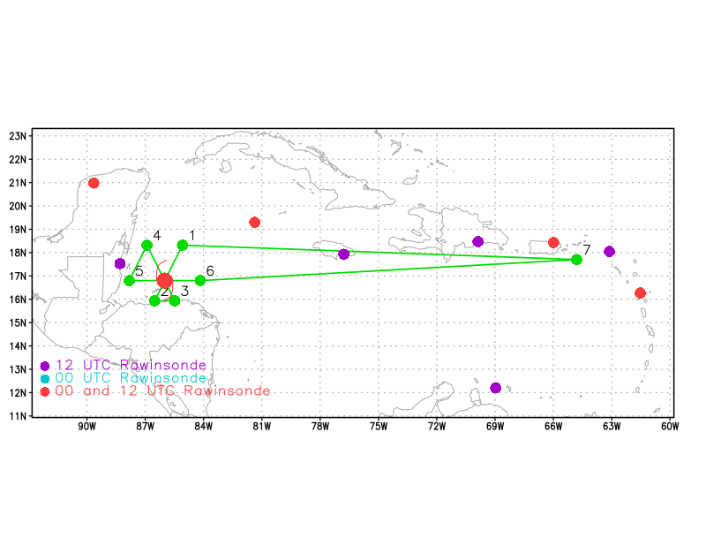  Fly a butterfly pattern, with shortened legs due to the proximity of land, at 10 kft when the Air Force aren’t at 10 kft (they plan to be at 5 kft pressure), 8 kft when they are on station and need to be at 10 kft.
Expendable Distribution | Dropsondes released at the endpoints, midpoints, center, and RMW on each pass
Preflight Weather Briefing | As of 2am ET, NHC has Tropical Storm Lisa located at 17.1N / 85.4W, maximum sustained winds of 60 kt, MSLP of 994 mb, and moving west at 13 kt (15 mph). The storm continues to gain organization, but also appears to be a very small inner core. The last estimate of the eye size was 12 miles. The question is whether Lisa is rapidly strengthening. Given its small size and the favorable environment, RI is fairly likely, though as of 2 AM the MSLP hasn’t fallen much from previous fixes of the storm last night.
Instrument Notes | None; cameras planned to be required when we get on station

IN-FLIGHT
Time [UTC] | Event
0745 | Takeoff from St. Croix
 | Belize radar loop available at https://bmcnoldy.rsmas.miami.edu/tropics/lisa22/Lisa_2-3Nov22_Belize.gif
1027 | Now about 1 hr from the IP. The most recent satellite loop suggests some new convective development on the SEa nd W side within the inner core, though the Belize radar and IR suggests the eyewall is not closed (assuming no attenuation on the radar). There hasn’t been any recon in the storm since we departed, but Teal74 is about to start their first pass from SE to NW.  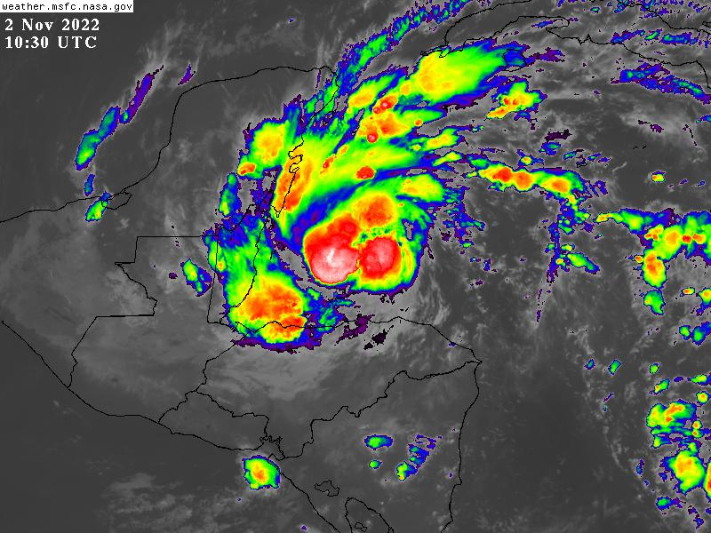  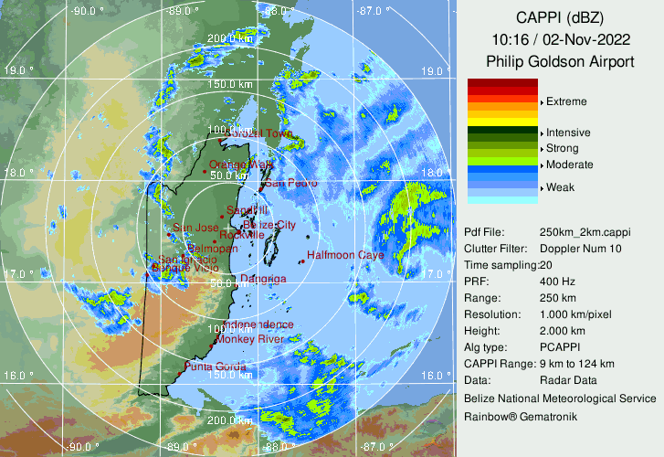
1057 | AF fix  02/10:57:00Z  17.11 deg N 086.51 deg W  989 mb  MAX FL WIND 75 KT 300 / 16 NM 11:07:00Z
1126 | Arrived at IP; Drop #1 IP NE; inbound on 105 nmi radial
1130 | Mostly stratiform inbound; fairly wide swath
1137 | Drop #2, midpoint NE
1140 | Belize radar showed a small eyelike feature that dissipated, replaced by a bigger feature. Early ERC?
1143 | Cloud tops on TDR near center only reaching 8 km height
1148 | Drop #3, RMW NE, 65 kt near surface, but log has it as bad sonde
1150 | Cloud tops to 16 km on west side
1151 | Drop #4, RMW NE, 76 kt near surface
1152 | Tight meso-scale feature just off to theright of aircraft.
1154 | Drop #5, marked center. Mesovortex near the surface to the west of the center. Pattern on hold to get MMR back up  Center mark where high clouds suggest center, so system may be aligned  Sonde 992 mb, surface wind 325/07  02/11:54:28Z  992 mb  MAX FL WIND 62 KT 057 / 36 NM 11:44:00Z
1200 | NHC makes Lisa a hurricane
1202 | Drop #6, RMW SW, bad sonde, not much of an RMW
1207 | Drop #7, midpoint SSW
1212 | Drop #8, endpoint SSW
1219 | 02/12:19:38Z  16.23 deg N 086.57 deg W  MAX FL WIND 76 KT 344 / 75 NM 12:39:10Z
1220 | AF fix  02/12:20:00Z  17.17 deg N 086.82 deg W  992 mb  MAX FL WIND 75 KT 300 / 16 NM 11:07:00Z
1222 | Drop #9, endpoint SE
1228 | Drop #10, midpoint SE  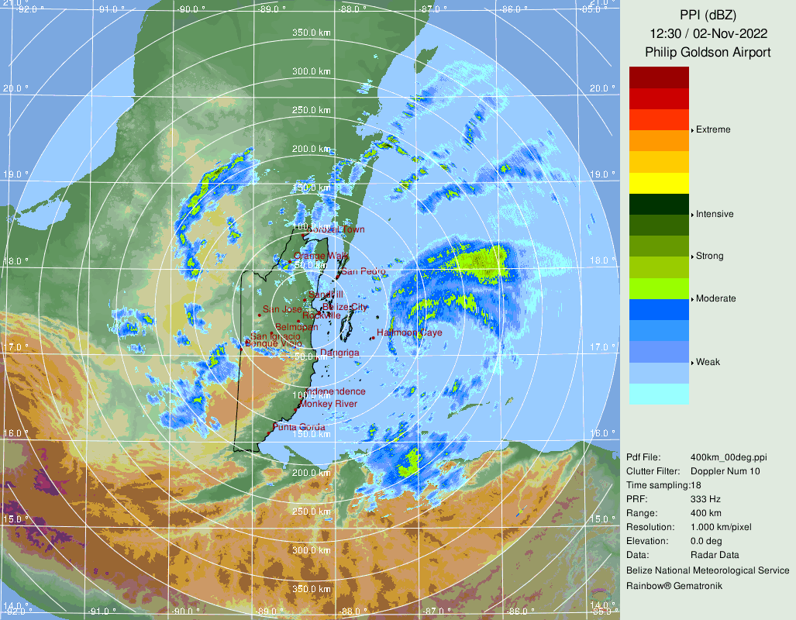
1235 | Drop #11, RMW SE, as much as there is an RMW
1236 | Drop #12, closest approach to center, hook in radar prevents getting to actual center, bad sonde
1237 | Convection to 18 km on NW side
1238 | Drop #13, RMW NW  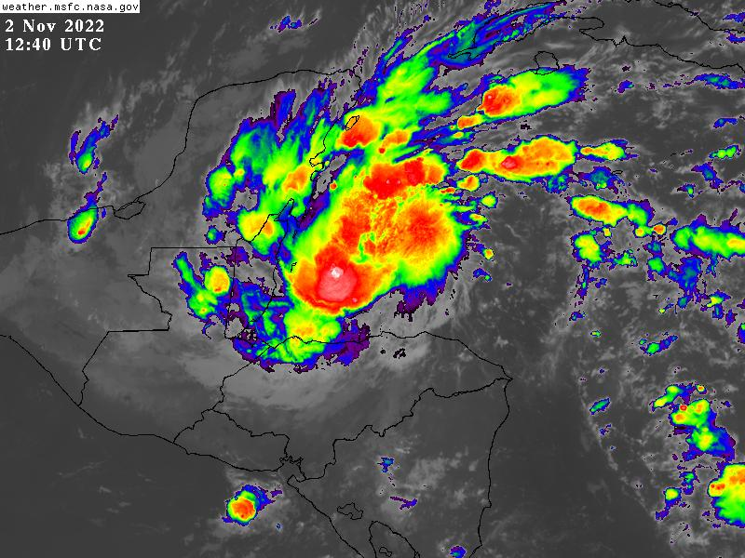
1244 | Drop #14, midpoint NW
 | 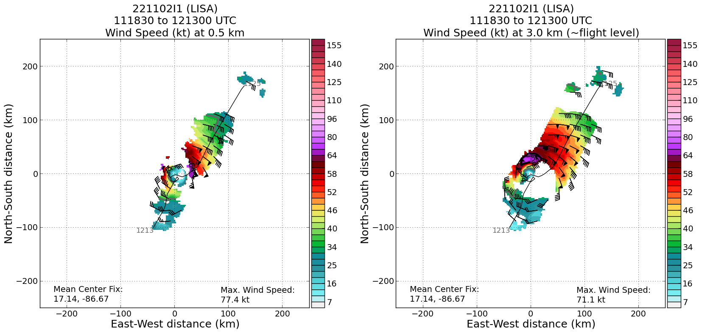
 | 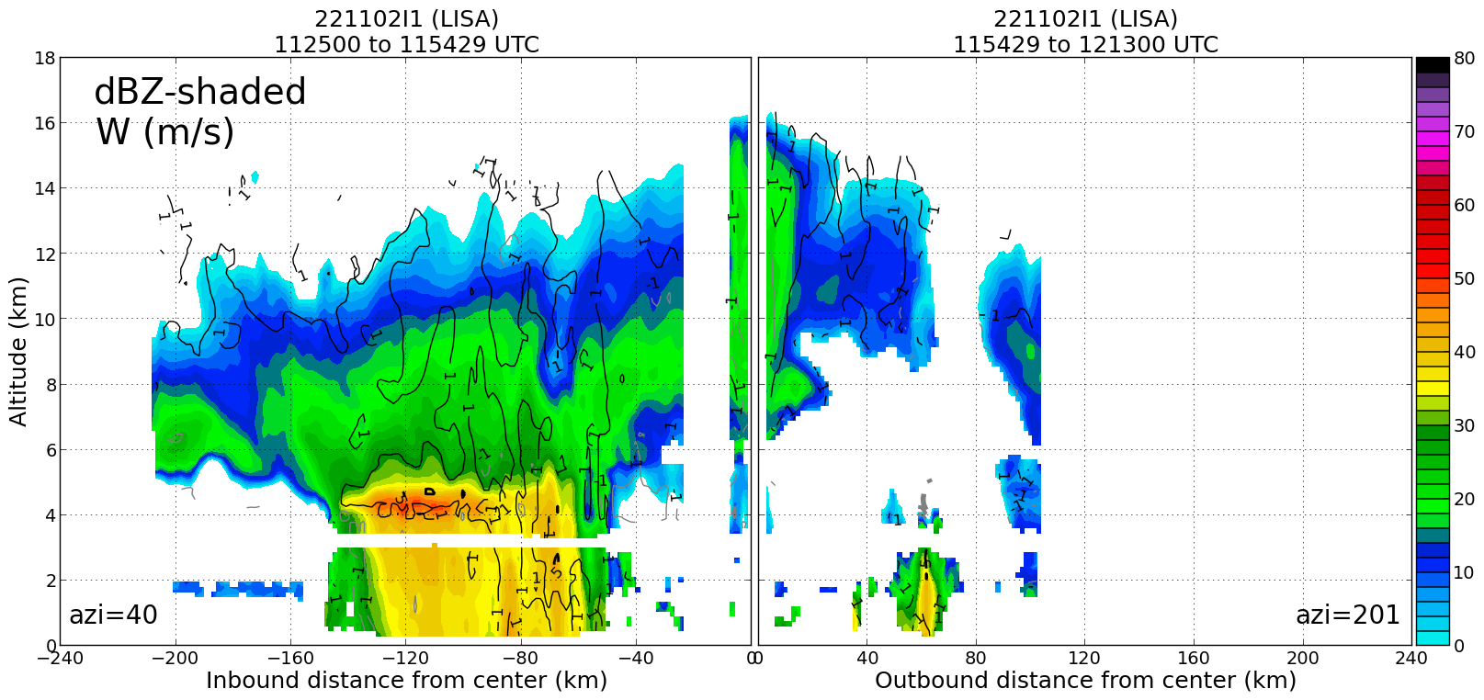
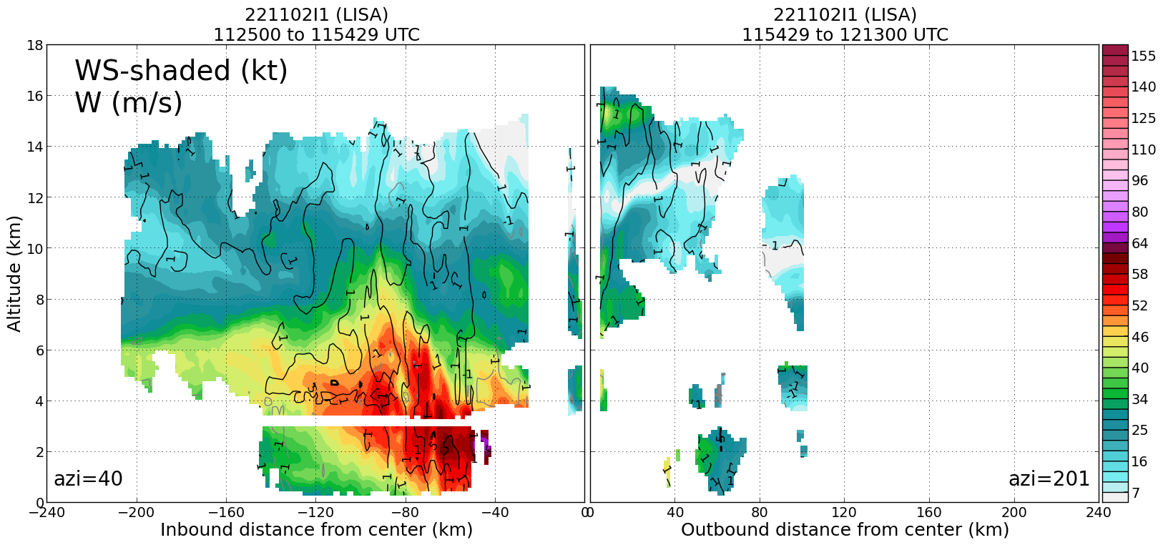
Height of maximum wind speed increases with distance from the center.
Not a lot of tilt, but given the small size of the system, it may be important.
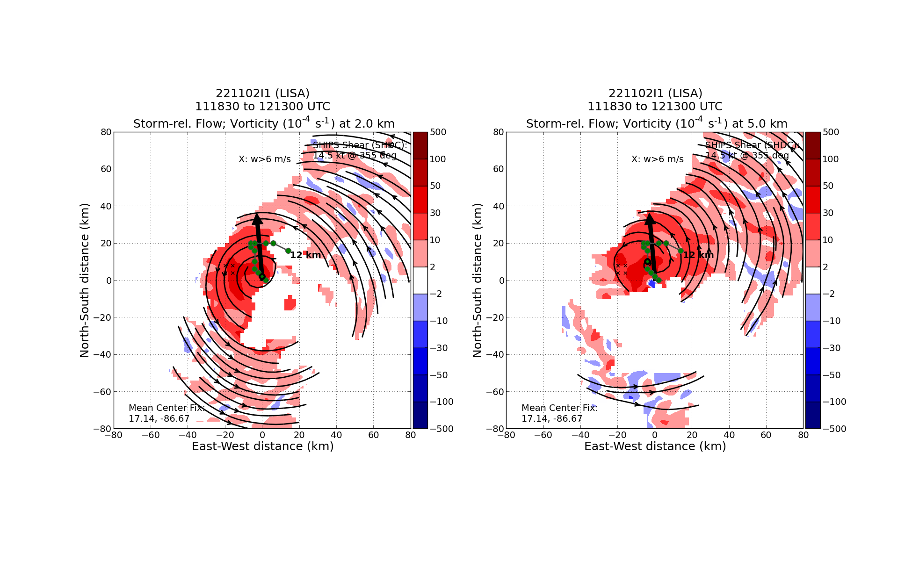
1253 | Drop #15, endpoint NW
 | 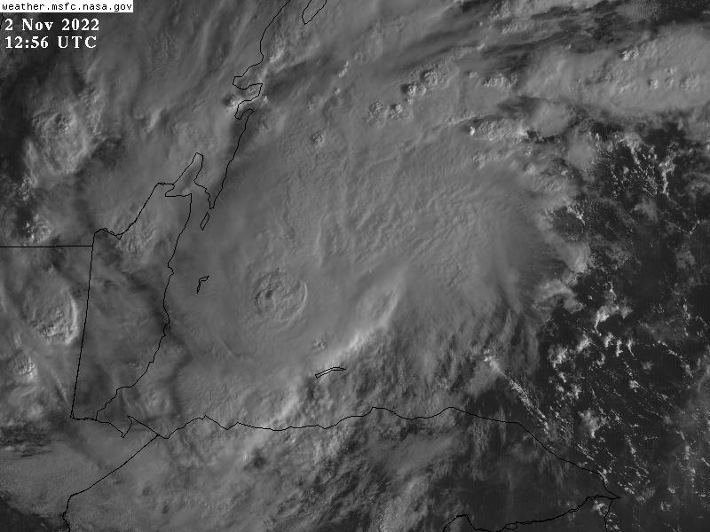
1316 | Drop #16 endpoint W, delayed due to islands below
1322 | Drop #17, midpoint W, no PTH
1323 | Drop #18, midpoint W, replacement, late PTH
1323 | Drop #19, midpoint W, replacement
1328 | Drop #20, RMW W
1330 | Drop #21, center  02/13:29:54Z  17.19 deg N 087.00 deg W  993 mb  MAX FL WIND 76 KT 344 / 75 NM 12:39:10Z
1334 | Drop #22, RMW E
1342 | Drop #23, midpoint E
1355 | Drop #24, endpoint E, headed home
 | 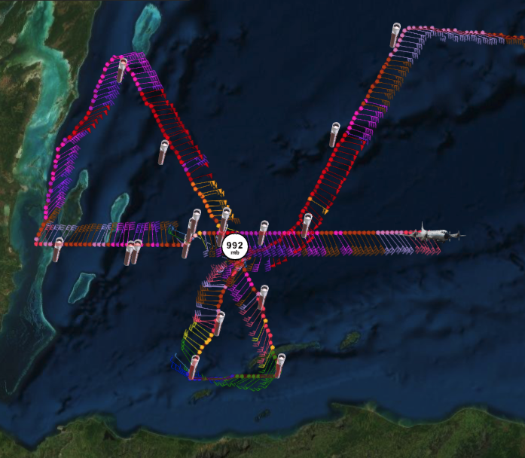
Final TDR composite analyses…should note that the rapid evolution of the inner core makes these a bit more challenging to interpret, at least in reflectivity…

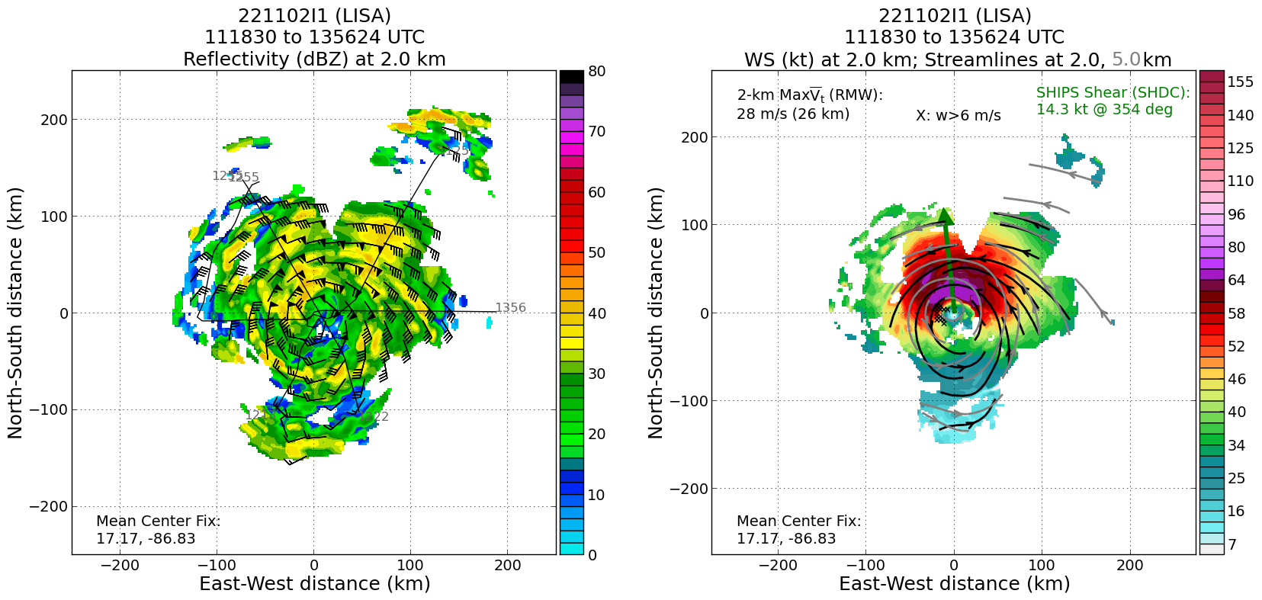
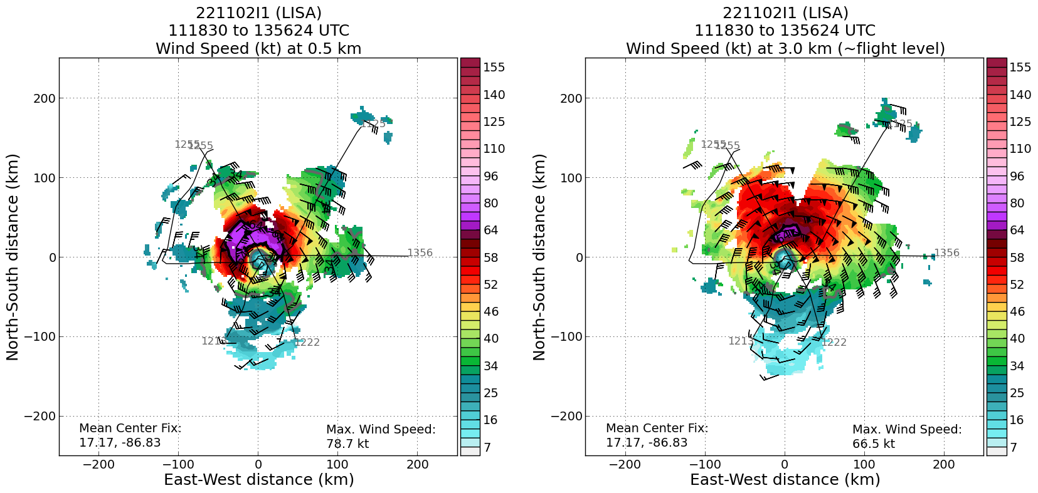

The image above is especially interesting because the swath of hurricane force winds at 0.5 km was much greater than at 3 km (flight level).
1733 | Landed back in St. Croix

POST-FLIGHT
Mission Summary | This mission flew Lisa just as it had reached category 1 hurricane intensity. Between the Air Force fix just prior to N43 arriving in the storm, and the first pass of our flight, it was clear that the flight level winds were up to 75 kt and surface winds just at hurricane strength at 65 kt. The MSLP had dropped to about 990-992 mb. The biggest challenges were fixing a center and dropping the RMW sondes. The flight level winds were not always consistently higher than the surface, so we released a couple of the RMW sondes near the surface wind max, while the others were really just estimates in what was actually fairly broad wind maxima at flight level. As for fixing, the center was really driven by some intense convection developing the western side of the “eye”. These features were basically a mesovortex that was not really accessible by the aircraft. So we did some “closest points of approach” in our fixes. Overall, it was a very interesting inner core structure with rapidly changing precipitation features.  These rapid changes were also seen in the Belize radar. It appeared that the storm was becoming more symmetric in time, but the surface pressure increased slowly during the mission, or at the very least remained mostly steady state. So, Lisa at least during the mission didn’t appear to be rapidly intensifying. Consistent with what we were seeing in the flight level v. SFMR winds, there was an interesting structure to the height of the maximum wind speed on the first inbound leg, with it tilting rapidly radially outward with height. The final TDR composite also showed a much wider radial and azimuthal swath of 64 kt winds at 0.5 vs. at 3 km.  24 dropsondes were released, 20 of which were good, 1 with late PTH, and 3 “bad” that didn’t provide useful data. 20 of the 24 transmitted. 18 sondes are charged to NWS, 6 to ONR.
Actual Standard Pattern Flown | Butterfly at 10 kft pressure altitude, with varying radial leg lengths due to the proximity of land.
APHEX Experiments / Modules Flown | Data collection will support the Early Stage Experiment: Analysis of Intensification Processes (AIPEX), as this was at least a slowly intensifying storm leading up to the flight. No specific modules were flown, but RMW sondes were released for ONR’s Tropical Cyclone Rapid Intensification (TCRI) experiment collaboration.
Plain Language Summary | - As we arrived in the storm, data collected between our first pass and the Air Force Hurricane Hunter plane already in the storm indicated that Lisa intensified to a category 1 hurricane.  - The inner core (within 60 miles of the center of the storm) was rapidly changing with a very small eye being dictated by intense thunderstorms in the western and northwestern eyewall.
Instrument Notes | Issues with more sondes than we’ve had in previous flights. There were a couple launch detect issues, as well as a couple that had trouble picking up PTH. Otherwise, all instruments worked well.
Final Mission Track | 