MISSION PLAN
FLIGHT ID | 20221101I1 | STORM | AL15 / LISA
MISSION ID | 1115A | TAIL NUMBER | NOAA43
TASKING | EMC | PLANNED PATTERN | Butterfly
MISSION SUMMARY
TAKEOFF [UTC] | 1958 | LANDING [UTC] | 0515
TAKEOFF LOCATION | St Croix | LANDING LOCATION | St. Croix
FLIGHT TIME | 9.3 | BLOCK TIME | 9.4
TOTAL REAL-TIME RADAR ANALYSES  (Transmitted) | 3 (3) | TOTAL DROPSONDES (Good/Transmitted) | 18 (18 / 18)
OCEAN EXPENDABLES (Type) | None | sUAS (Type) | None
APHEX EXPERIMENTS / MODULES | Early Stage Experiment: AIPEX
HRD CREW MANIFEST
LPS ONBOARD | Hazelton | LPS GROUND | Holbach
TDR ONBOARD | Hazelton | TDR GROUND | Reasor
ASPEN ONBOARD | Sellwood | ASPEN GROUND | None
NESDIS SCIENTISTS | Sapp, Bjorland
GUESTS (Affiliation) | None
AOC CREW MANIFEST
PILOTS | Abitbol, Rannenberg, Copare
NAVIGATOR | Hough
FLIGHT ENGINEERS | Darby, Pittman
FLIGHT DIRECTOR | Kalen, Holmes
DATA TECHNICIAN | McAlister
AVAPS | Dykeman

PRE-FLIGHT
Flight Plan | Butterfly pattern. No modules planned due to long ferry time.  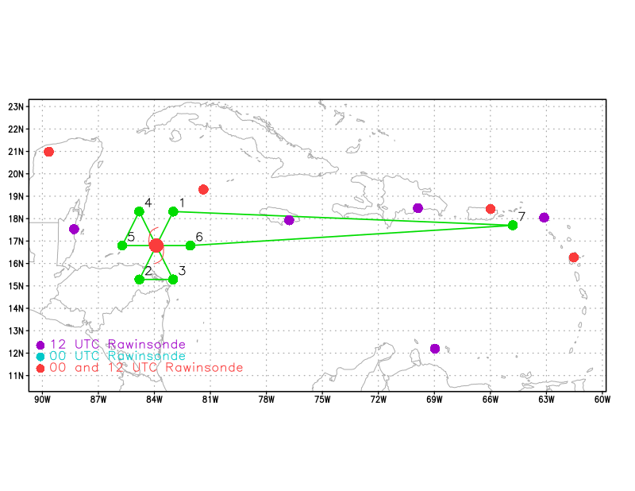  Side note: Conducting NHC Hurricane and Ocean Testbed (HOT) Hackathon during this mission.
Expendable Distribution | 15 planned sondes (endpoints, midpoints, centers). We will add up to 6 RMW/quarterpoint sondes based on the structure of the storm this afternoon.
Preflight Weather Briefing | Tropical Storm Lisa is slowly becoming better organized, with winds increasing to 50 kts. The storm has a chance to become a hurricane within the next 24 hours. Minimum estimated central pressure is 1001 mb at 1400Z.
Instrument Notes

IN-FLIGHT
Time [UTC] | Event
1958 | Takeoff from St. Croix
2021 | Recent GMI overpass suggest an inner core may be forming  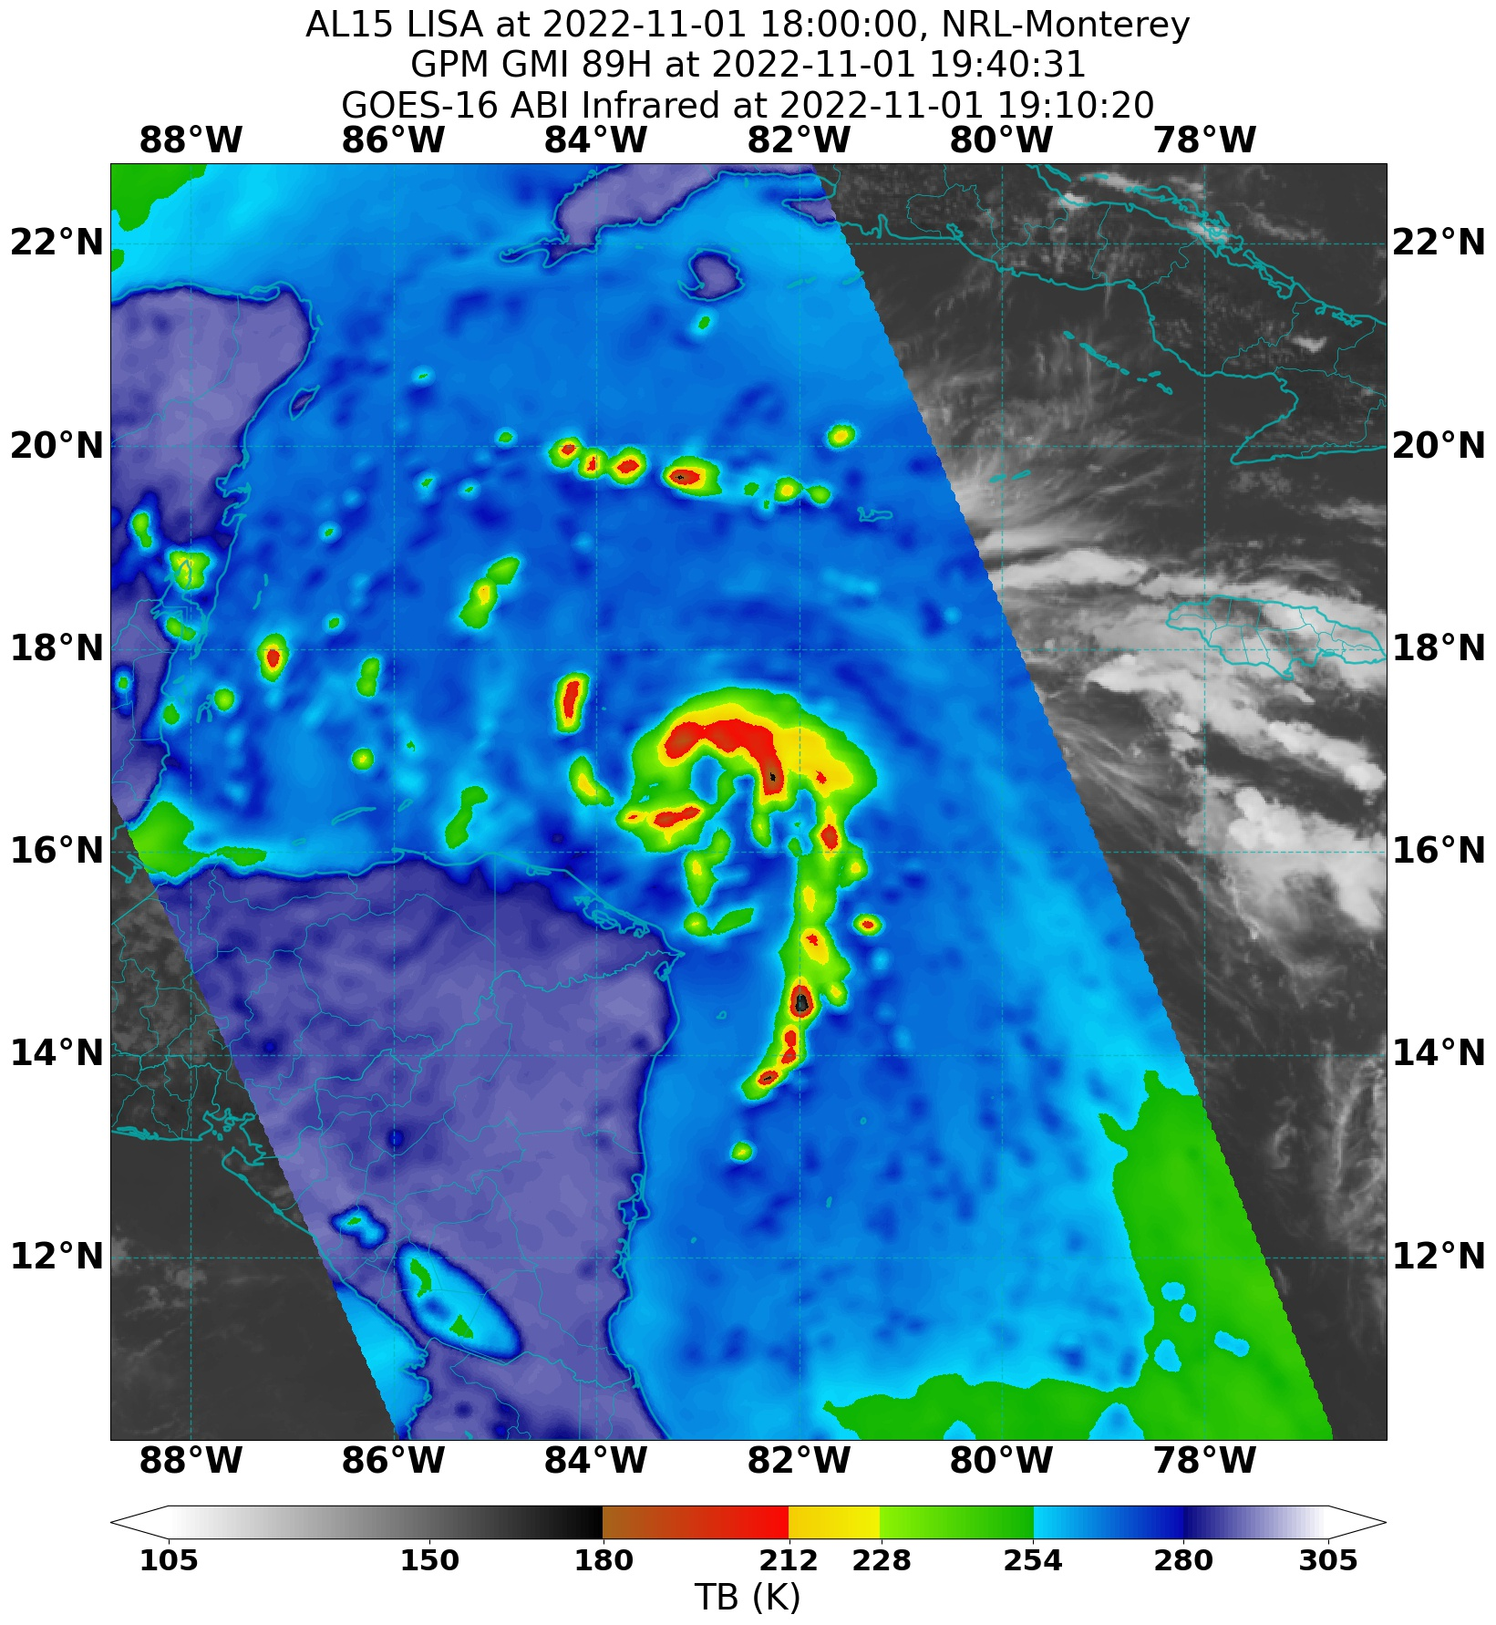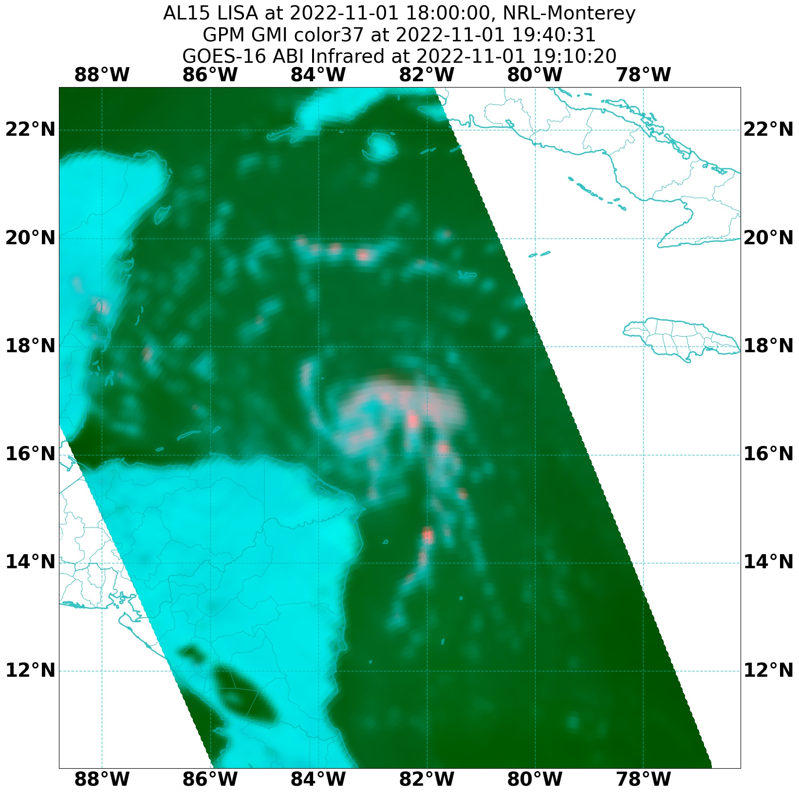
2215 | Approaching outer band  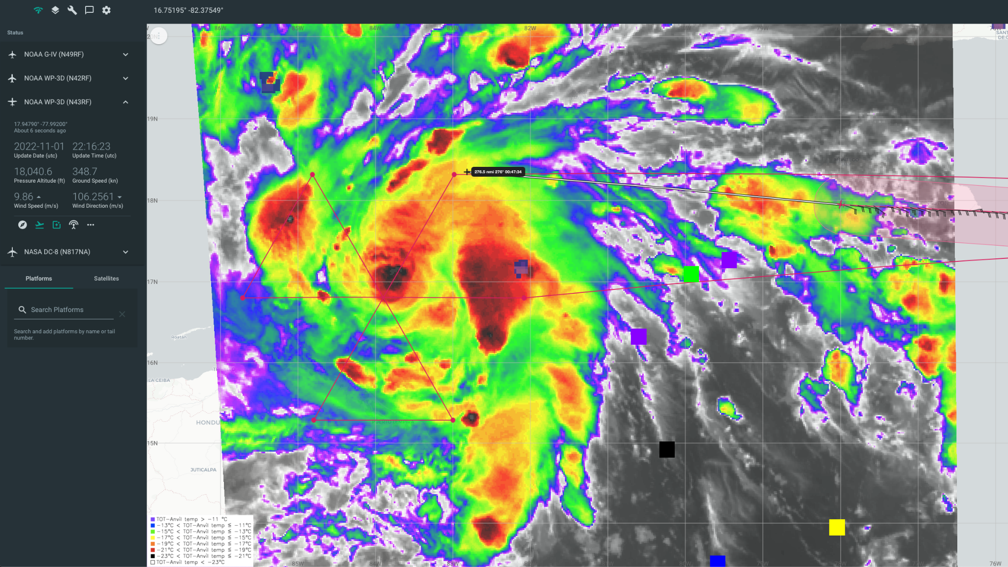
2235 | AF reporting a closed eyewall visible as they approach from the southeast at 5 kft
2239 | AF fix at 16.72N 83.81W, 997 mb extrap. Center sonde had 997 mb with 7 kts. 6 n mi closed eyewall
2244 | Beginning descent to IP. Will be at 10 kft since AF is at 5 kft.
2254 | Seeing some 40-45 dBZ on the MMR off to the left maybe 50 km away. GLM was showing some lightning in that area too.
2259 | Getting into some bands
2302 | IP waiting on sonde because of boat below
2305 | Drop #1 NE
2318 | Drop #2 midpoint
2320 | Small eye wrapped up in an inner band. Nudging west to get a better line to pass through the eye.
2323 | MMR Surface scan mode  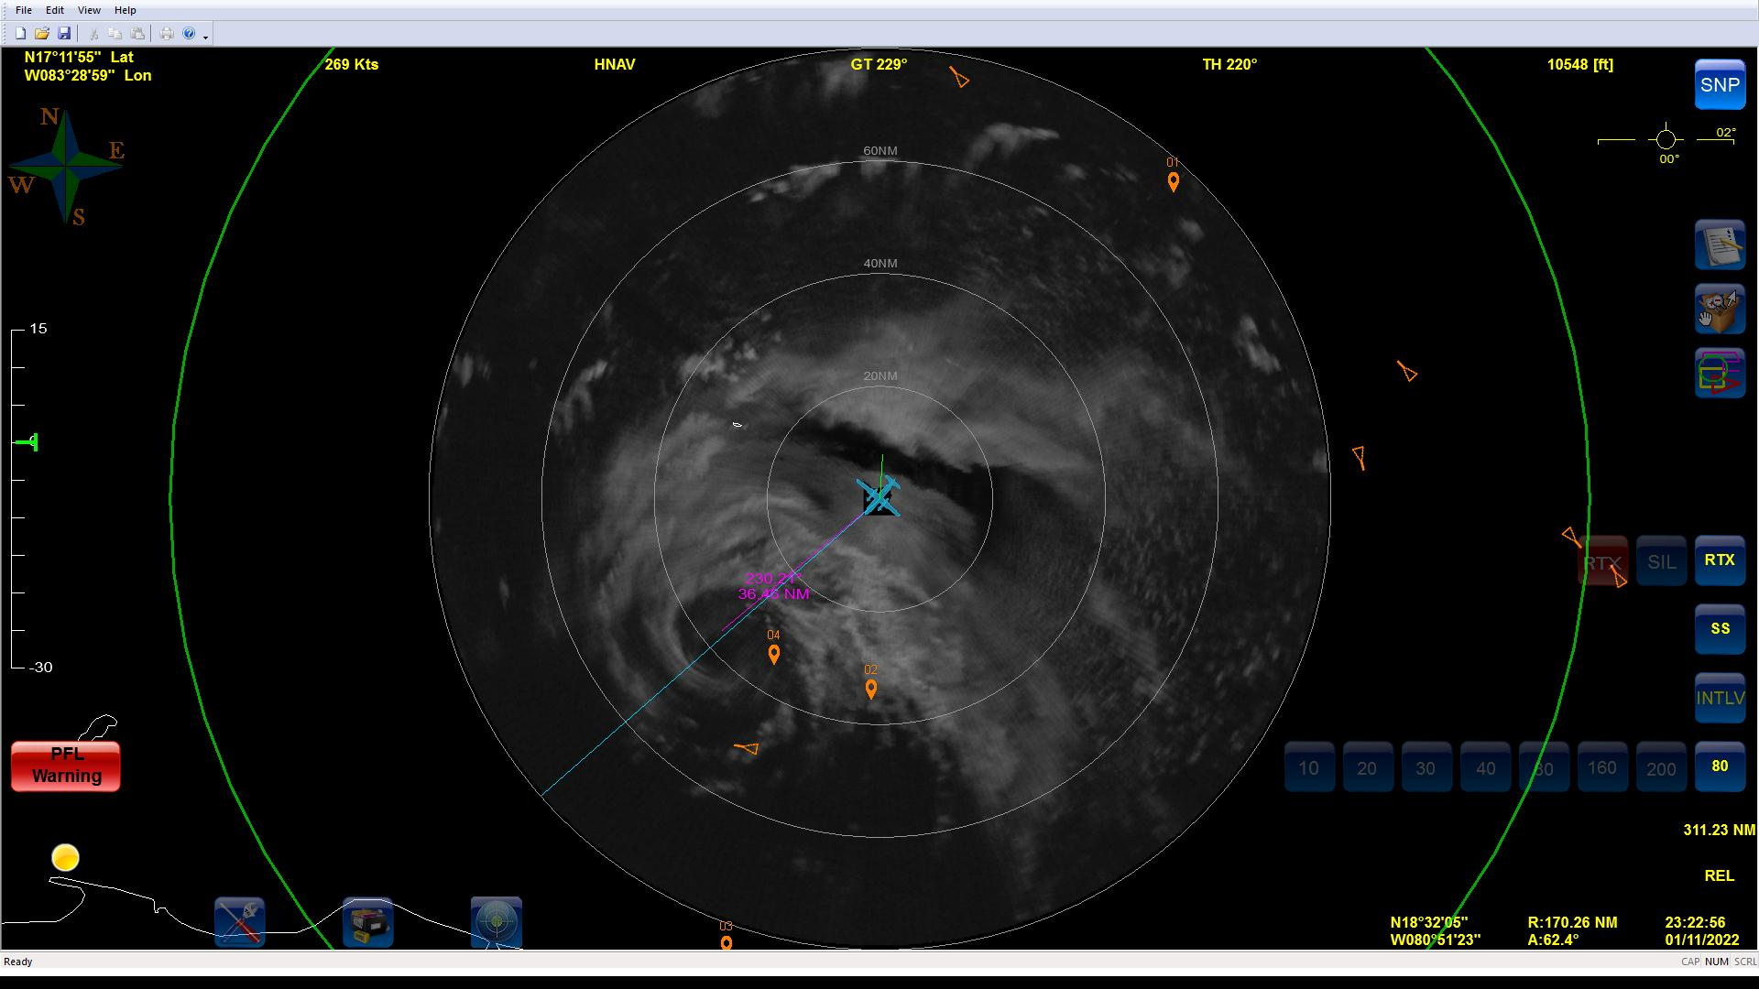
2328 | Drop #3 RMW NE
2332 | Drop #4 center  IWRAP profile from inbound pass shows that near-surface IWRAP winds were stronger than SFMR.  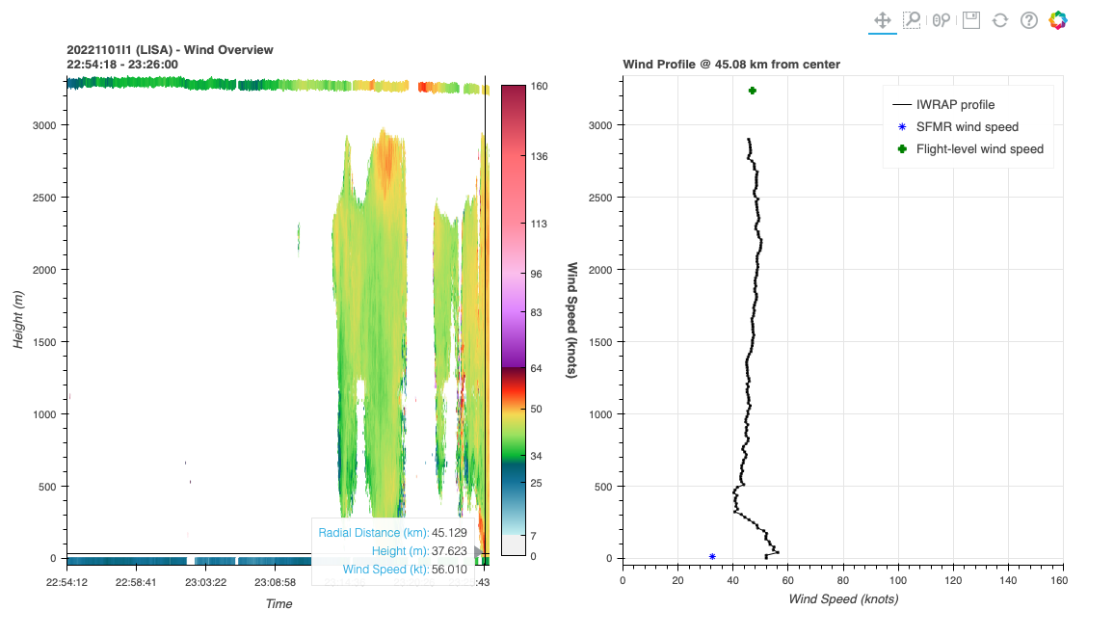  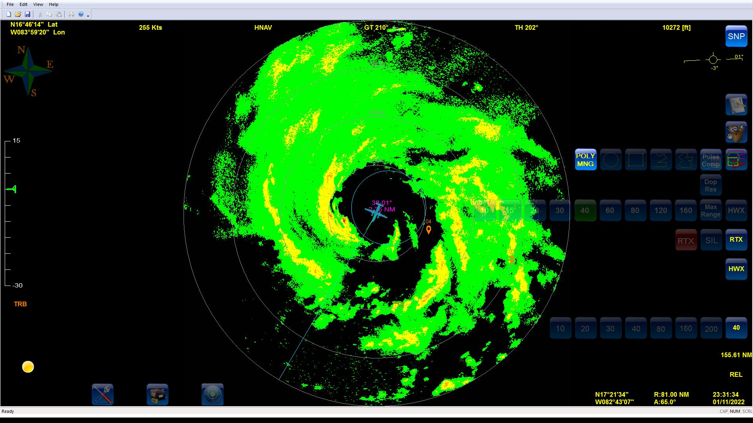
2333 | Drop #5 RMW SW. SFMR was showing similar winds on SW at the NE. Lisa seems like it could be reorganizing. Possibly an ERC/core reorganization. Little sporty on SW side.
2341 | TDR analyses from first leg show that Lisa is fairly well aligned through about 5-6 km  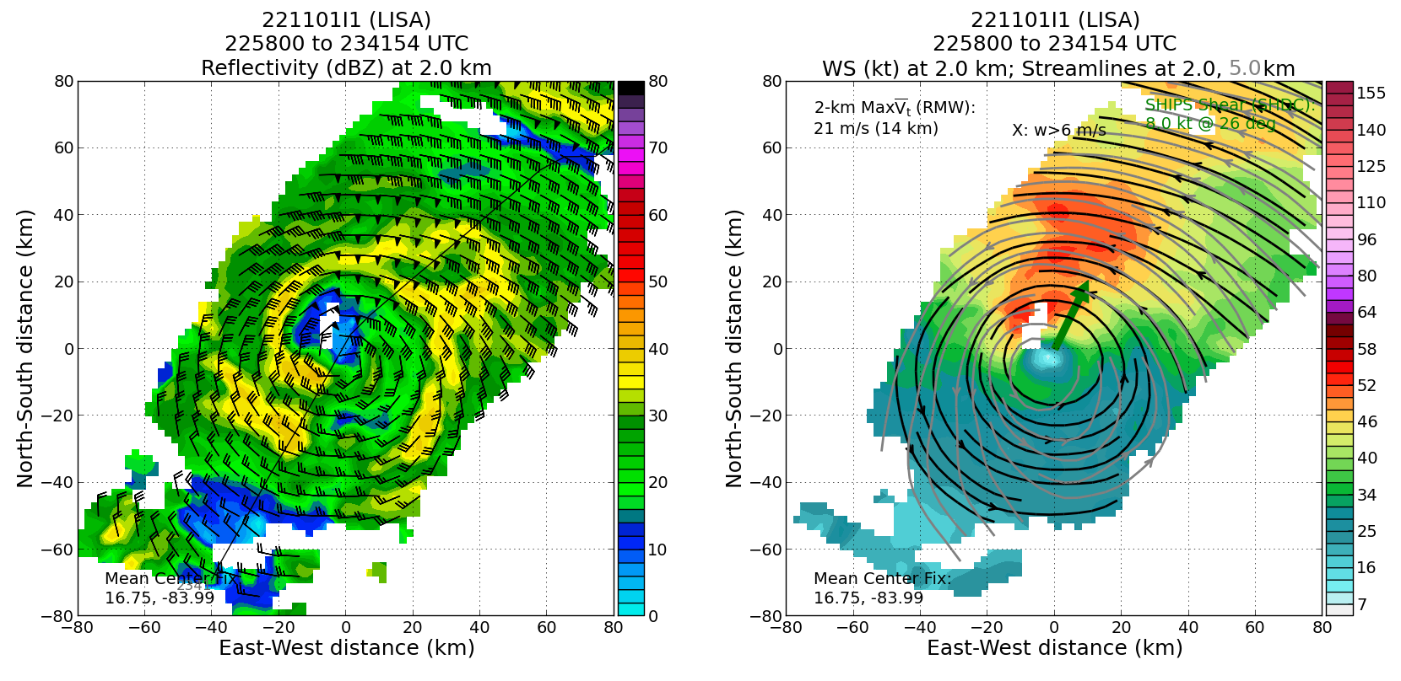  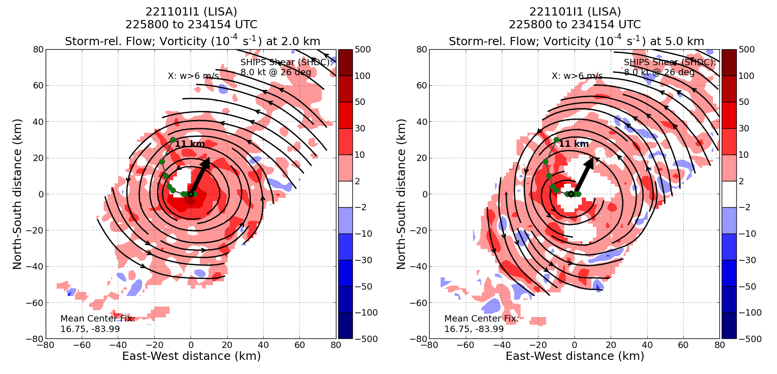
2344 | Turning early to avoid getting too close to Honduras, sonde (Drop #6) at 2341 was both a midpoint and an endpoint drop
2345 | 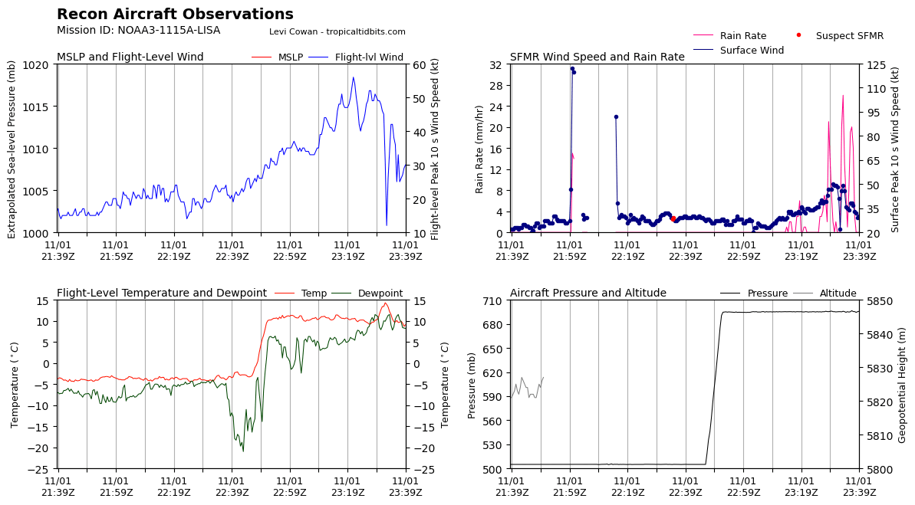  FL and SFMR wind speed time series show broad wind field on NE side, then very sharp and rapid drop-off at the center, followed by equally rapid increase on SW side
0002 | Drop #7 IP SE  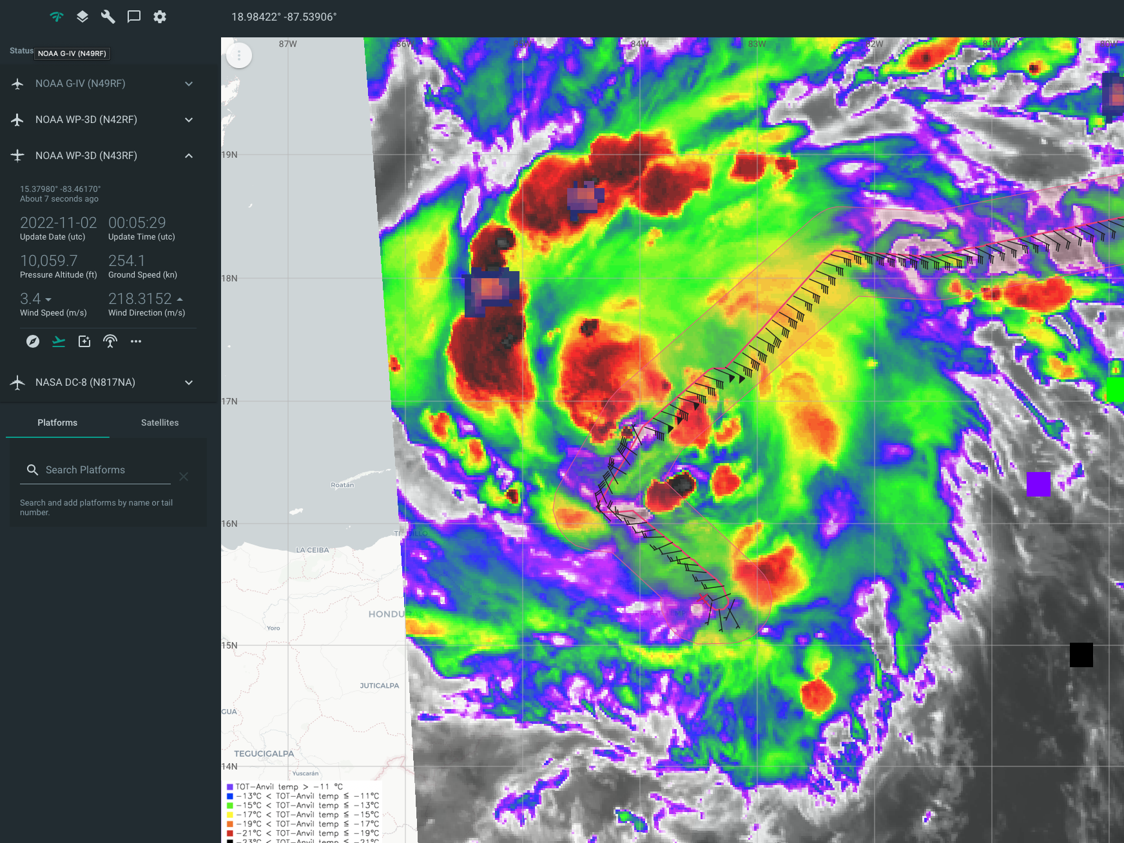
0014 | Drop #8 midpoint
0023 | MMR from second near-center pass  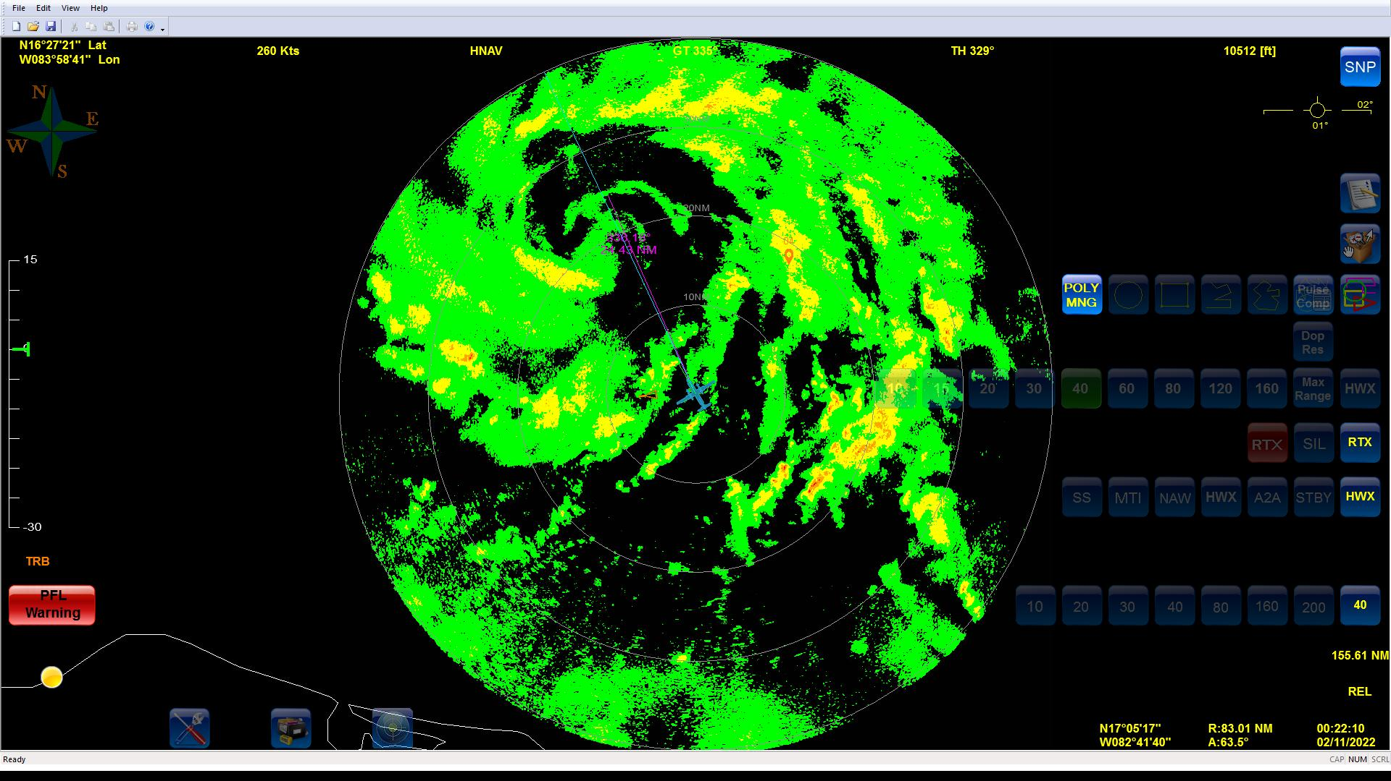  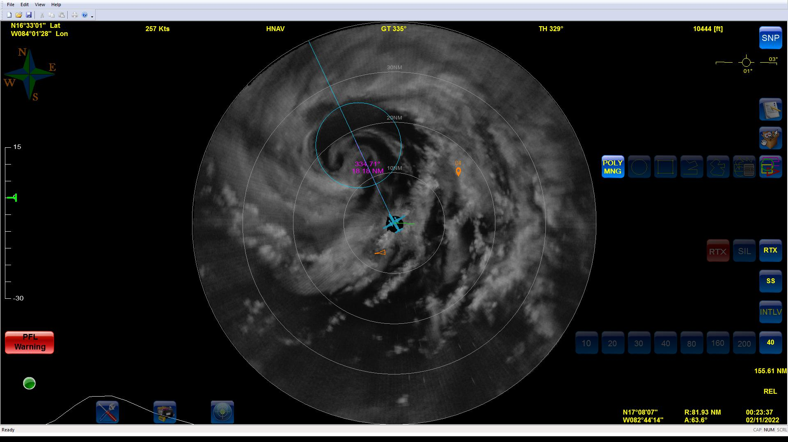  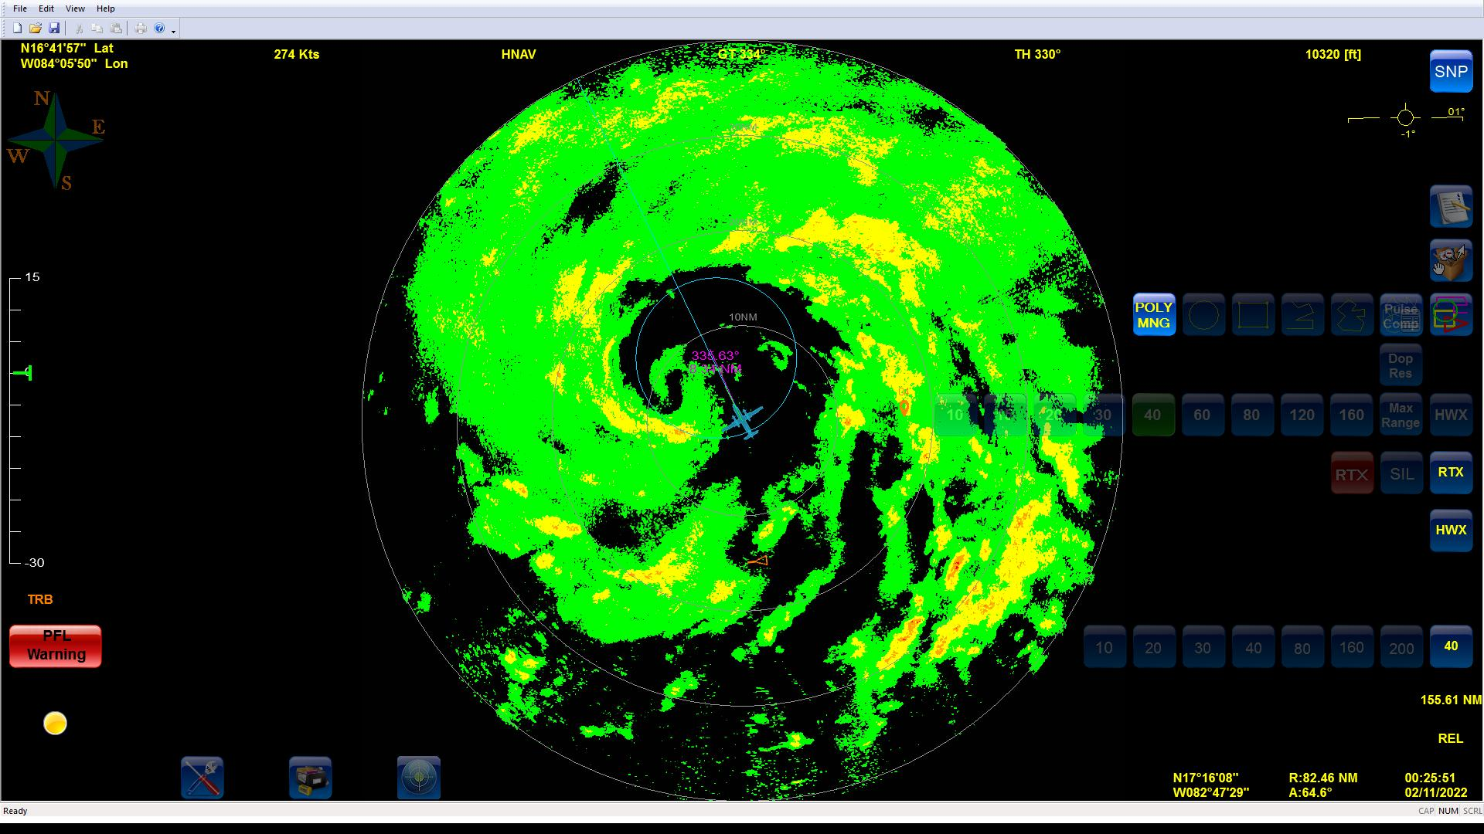
0026 | Drop #9 RMW SE 57 kt surface wind
0028 | No center sonde on this pass. Missing the center to the NE
0029 | Drop #10 RMW NW
0031 | Just under 30 m/s on the SFMR NW
0040 | New MW imagery  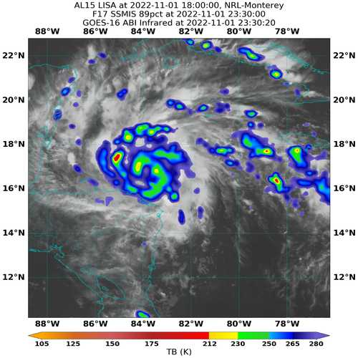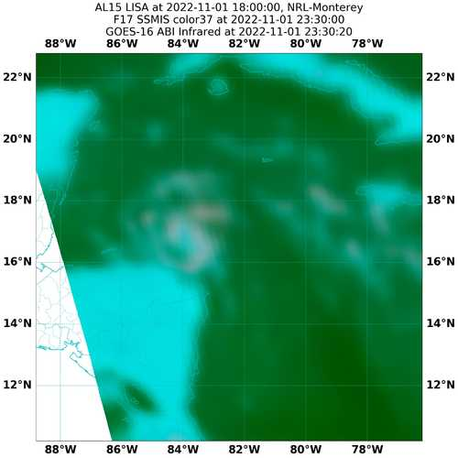
0048 | Drop #12 NW endpoint. Turning into moat to repo
0113 | Drop #13 W IP leg 3. Turned just east of planned IP to avoid a band
0118 | Saw a flash of lightning
0123 | Drop #14 W midpoint
0131 | Going through a pretty hefty band
0136 | 40 dbz on the MMR in the W eyewall. Open SE
0137 | Drop #15 RMW W
0141 | Drop #16 RMW E. No center sonde again because winds never came down much.  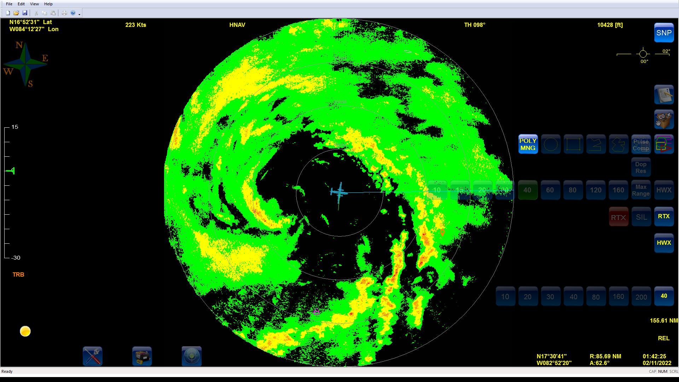  Winds were wanting them to go S. Old small eye seems to be decaying and rotating around something larger.
0150 | Drop #17 Midpoint E
0158 | Drop #18 Endpoint E  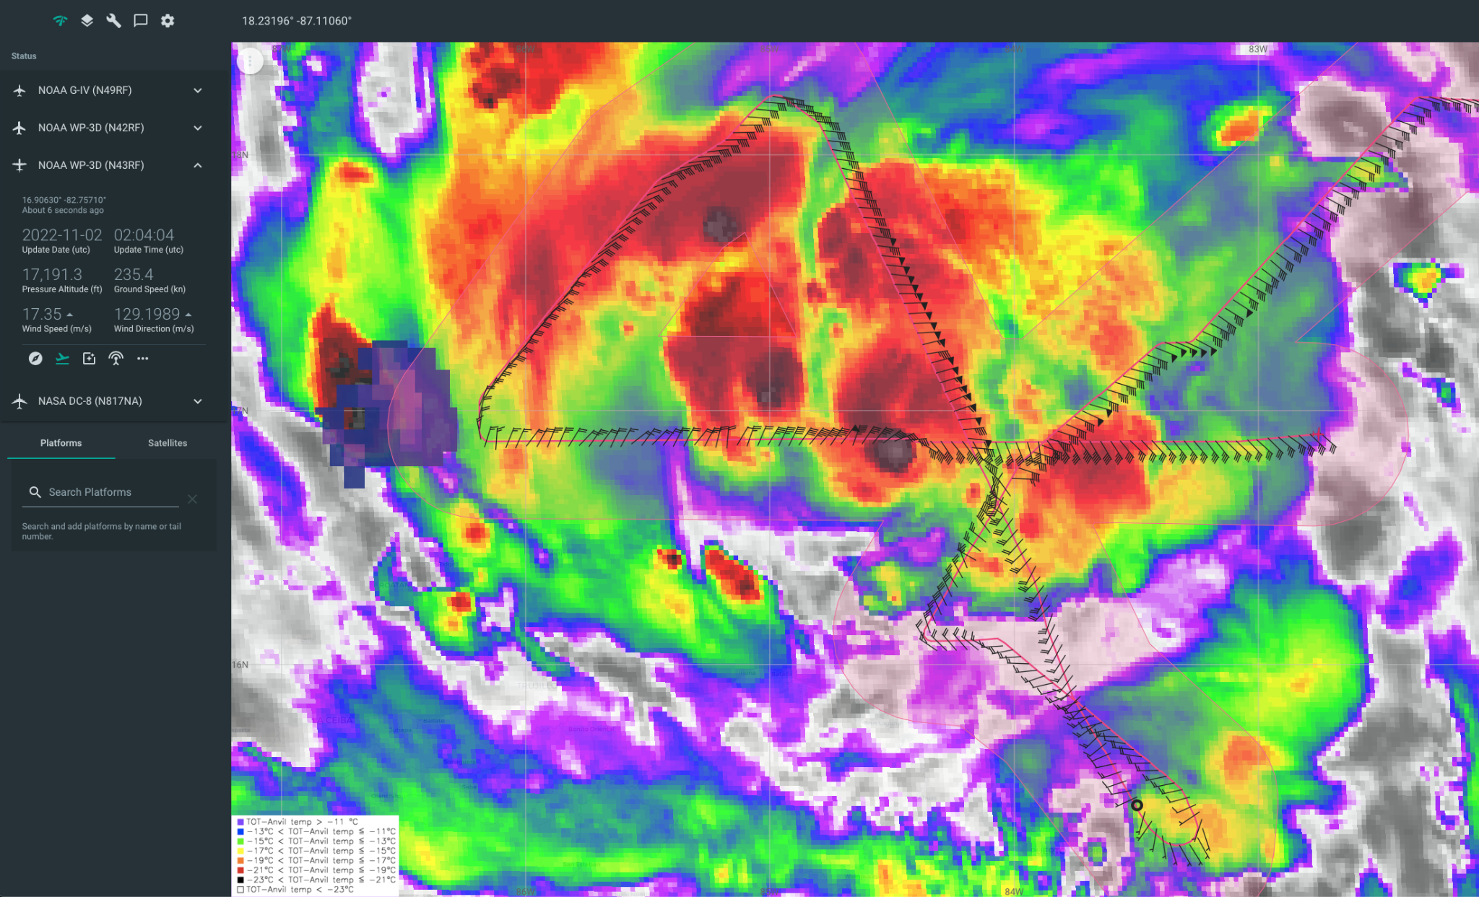
 | 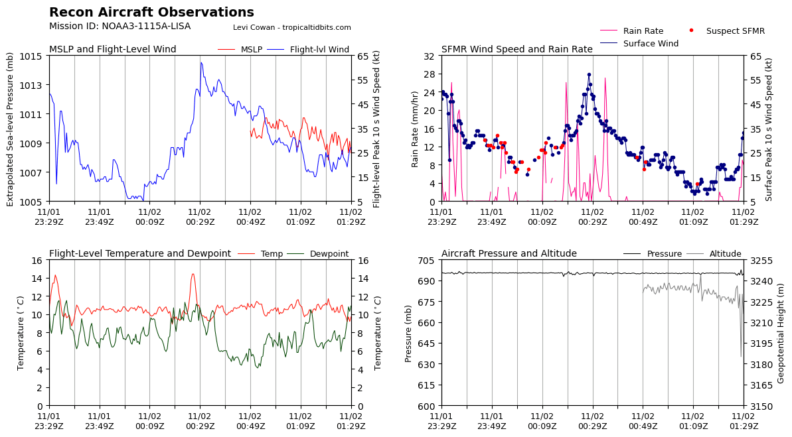

POST-FLIGHT
Mission Summary | Fairly successful mission with 18 dropsondes and 3 TDR analyses. Missed 2 center dropsondes due to challenges with getting close enough to the center without more aggressive hunting.  Lisa has become better organized compared to yesterday; however, it still appears to be ingesting some dry air and undergoing some reorganization.  There was a very small eye present at the start of the mission that seemed to collapse by the end as the TC reorganized.  There was also a very successful Hackathon held at the NHC Hurricane and Ocean Testbed (HOT) to discuss and identify ways to improve the visualization and interpretation of the aircraft data.  We dropped 18 dropsondes total - all were good and transmitted. 12 NWS sondes and 6 ONR dropsondes (the RMWs).
Actual Standard Pattern Flown | Butterfly
APHEX Experiments / Modules Flown | No modules due to the length of the ferry, but with the intensification in the forecast, data collection could support the Early Stage Experiment: Analysis of Intensity Change Processes (AIPEX). Also released dropsondes for ONR’s Tropical Cyclone Rapid Intensification (TCRI) experiment.
Plain Language Summary | - We flew a mission to collect radar and other data in strengthening Tropical Storm Lisa in the Western Caribbean.  - The storm was becoming better organized and was just below hurricane intensity by the end of our flight.  - Several scientists participated in a collaboration with NHC at a testbed at the Hurricane Center during the flight.
Instrument Notes | NaNs in the surface pressure extrapolation due to a GPSalt issue. This was corrected before our final pass.
Final Mission Track | 