MISSION PLAN
FLIGHT ID | 20221031I1 | STORM | AL15 / LISA
MISSION ID | 0615A | TAIL NUMBER | NOAA43
TASKING | EMC | PLANNED PATTERN | Butterfly
MISSION SUMMARY
TAKEOFF [UTC] | 0824 | LANDING [UTC] | 1515
TAKEOFF LOCATION | St. Croix | LANDING LOCATION | St. Croix
FLIGHT TIME | 6.9 | BLOCK TIME | 7.0
TOTAL REAL-TIME RADAR ANALYSES  (Transmitted) | 3 (3) | TOTAL DROPSONDES (Good/Transmitted) | 15 (15 / 15)
OCEAN EXPENDABLES (Type) | None | sUAS (Type) | None
APHEX EXPERIMENTS / MODULES | Genesis Stage Experiment: PREFORM; Early Stage Experiment: AIPEX
HRD CREW MANIFEST
LPS ONBOARD | Zawislak | LPS GROUND | None
TDR ONBOARD | Zawislak | TDR GROUND | Reasor
ASPEN ONBOARD | J. Zhang | ASPEN GROUND | None
NESDIS SCIENTISTS | P. Chang
GUESTS (Affiliation) | Wilson (UM/RSMAS)
AOC CREW MANIFEST
PILOTS | Doremus, Keith, Wood
NAVIGATOR | Miller
FLIGHT ENGINEERS | Stokes, Tyson
FLIGHT DIRECTOR | Carpenter
DATA TECHNICIAN | T. Richards
AVAPS | Warnecke

PRE-FLIGHT
Flight Plan | 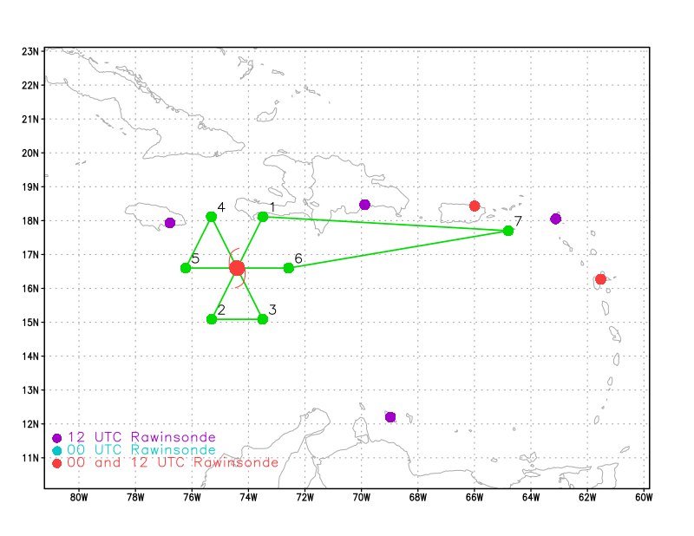  Butterfly pattern at 10 kft, though we’ll look to climb up to 15 kft perhaps on the west side when we’re expected to be in clearer air.
Expendable Distribution | Release dropsondes at endpoints, midpoints, and the center on each pass.
Preflight Weather Briefing | As of 2AM ET, NHC has PTC15 located near 15.8N, 75.5W, has an MSLP of 1007 mb, maximum sustained wind of 35 kt, moving west at 10 kt. While the circulation is fairly clear, though still broad, the convection hasn’t been able to persist on all sides of the circulation. It’s fairly clear that the vertical wind shear is at least moderate as the convection is only persistent in the eastern hemisphere of PTC15. Convection is active since we’re near the peak of the diurnal cycle, but that could wane once we get further into the morning hours. The expectation is that the environment will still not be conducive for intensification today and may continue to struggle.
Instrument Notes

IN-FLIGHT
Time [UTC] | Event
0824 | Takeoff from St. Croix
0948 | Enroute to PTC15 not a whole lot has changed. Convection continues to develop and wane periodically, mainly on the southern and eastern sides of the broad (and possibly elongated) low-level circulation. Even in the normal peak of the diurnal cycle, the convection just isn’t all that persistent, indicative of the shear and dry air inhibiting further development of a storm.
1022 | Arrived at Initial Point (IP); Drop #1
1034 | Drop #2 MP NE
1045 | IR animation continues to show struggling convection oriented in a NE-SW line to the east of the low-level circulation
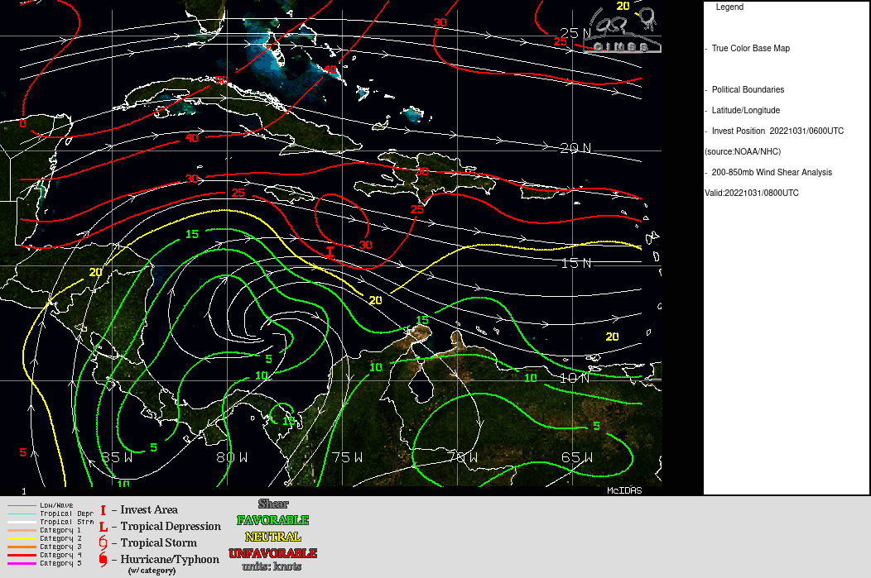
CIMSS shear valid 08 UTC shows 20-25 kt from the WNW, system center is located in a tight shear gradient, with values dropping significantly further to the WSW of the PTC. Indicative of more favorable environment system is forecast to move into.

1049 | Drop #3 Center
1057 | 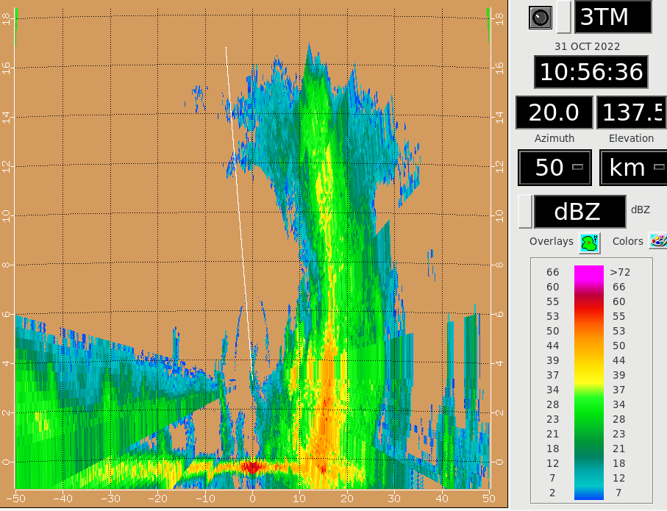
1103 | Drop #4 MP SW
1105 | 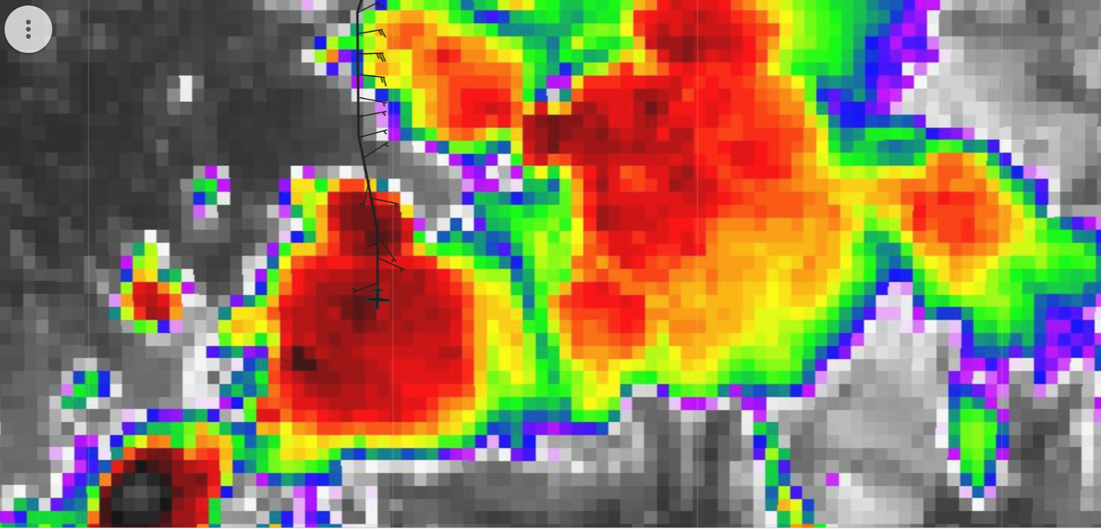  TDR sweep above shows deep convection with echo tops reaching 16 km, in localized region of cold cloud tops on IR image
1114 | 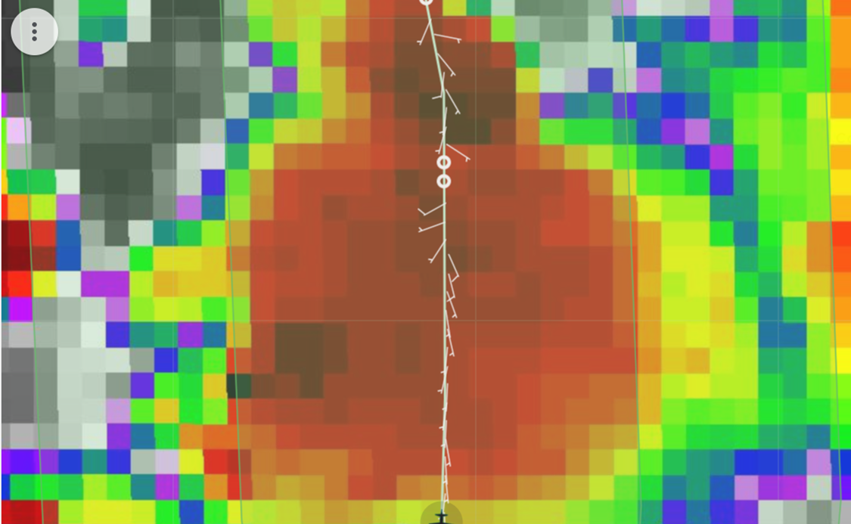  FL winds show disorganized system with broad, likely multiple centers
1114 | Drop #5 EP SW
1137 | Drop #6 EP SE starting SE-NW pass
1141 | Turned inbound for second pass, passing along SW edge of squall line, embedded convective elements just on edge of swath, otherwise primarily stratiform  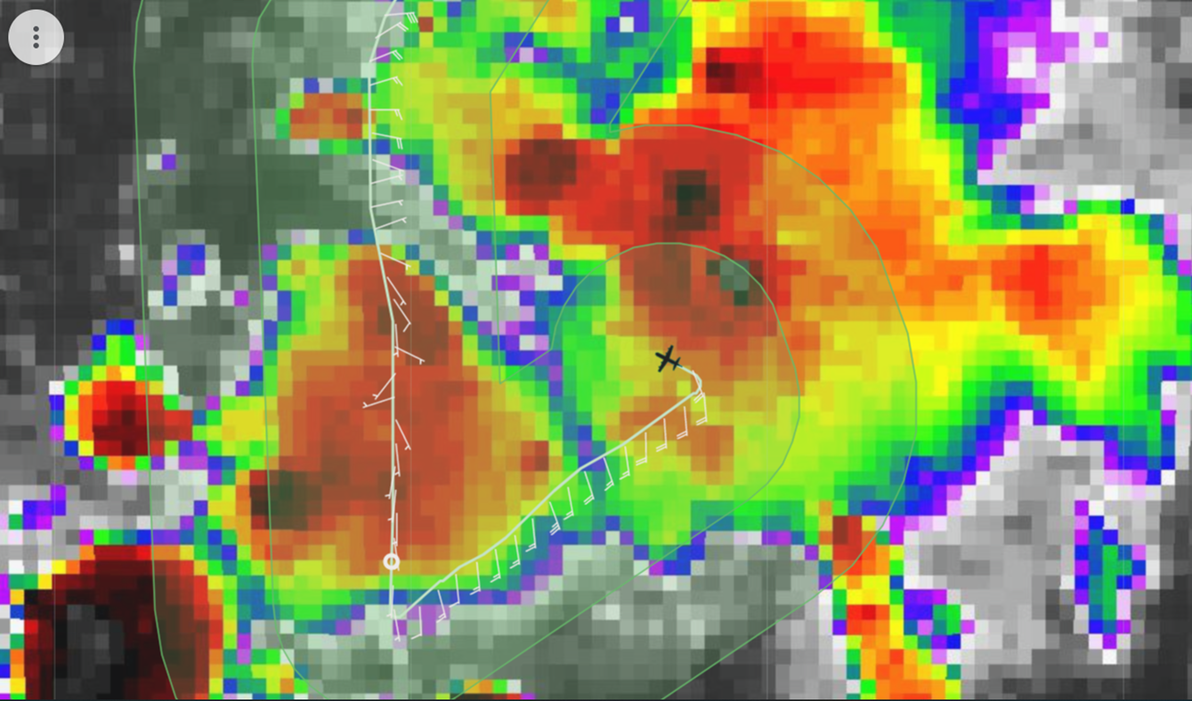
1148 | Drop #7 MP SE
1149 | Analysis from first pass shows southerly flow at 2 km and easterly flow at 5 km. Objective center-finding algorithm unable to determine a center.  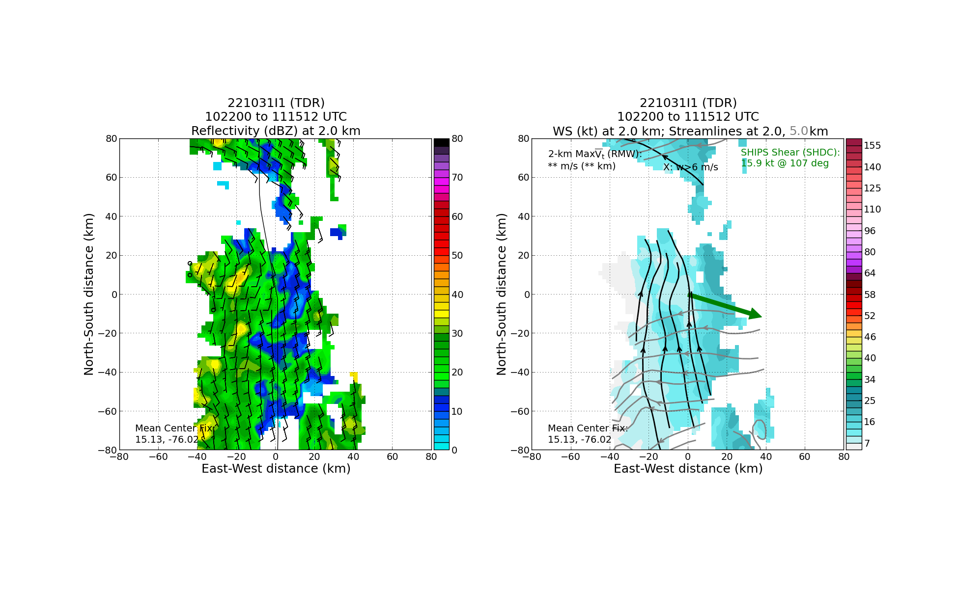
1152 | Analyses at 1-km increments from 2-5 km show that possible LLC, located west of swath (but not identifiable from objective center-finding algorithm) extends up to 3-4 km, above that a possible MLC is located to south.  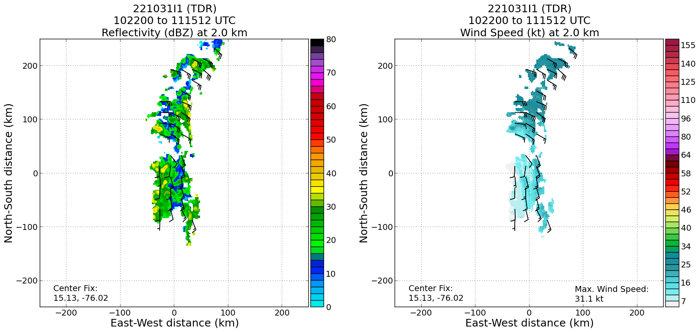  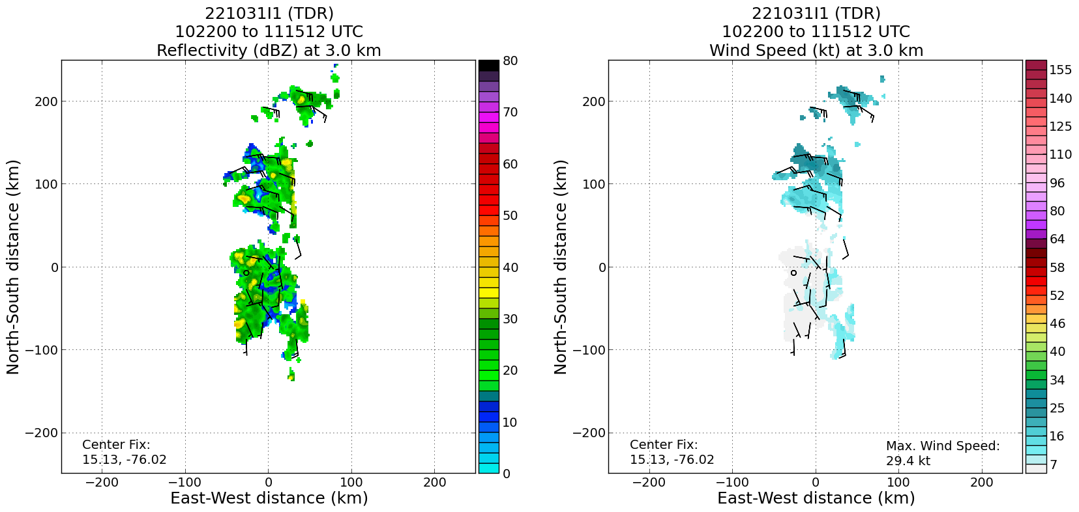  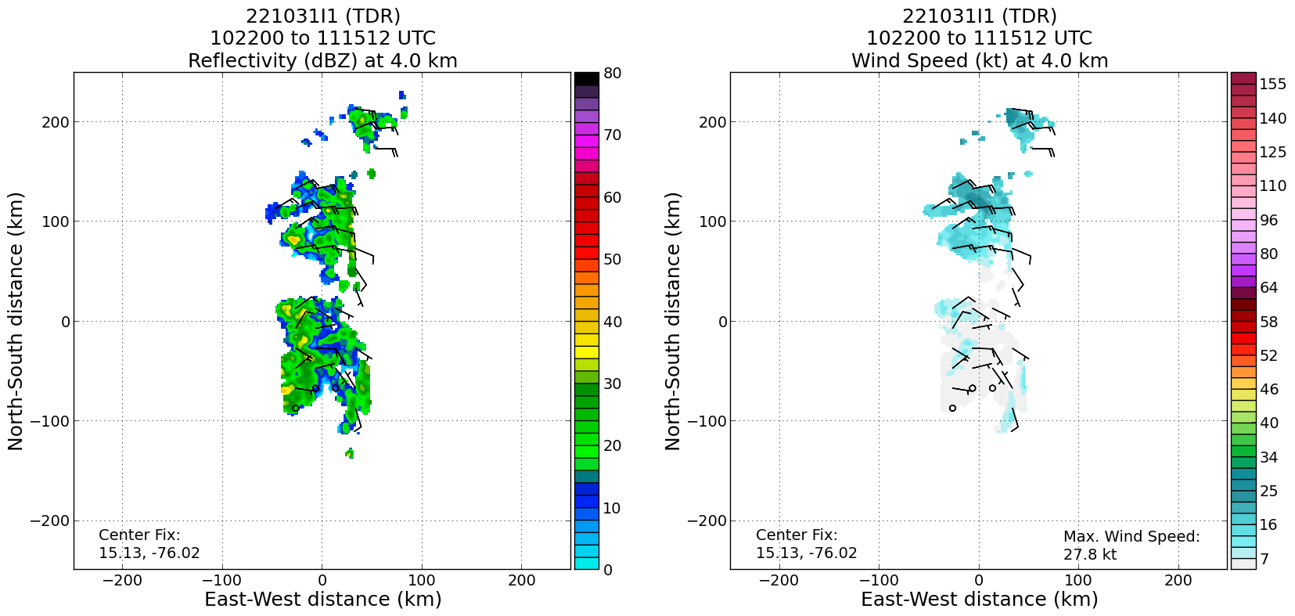  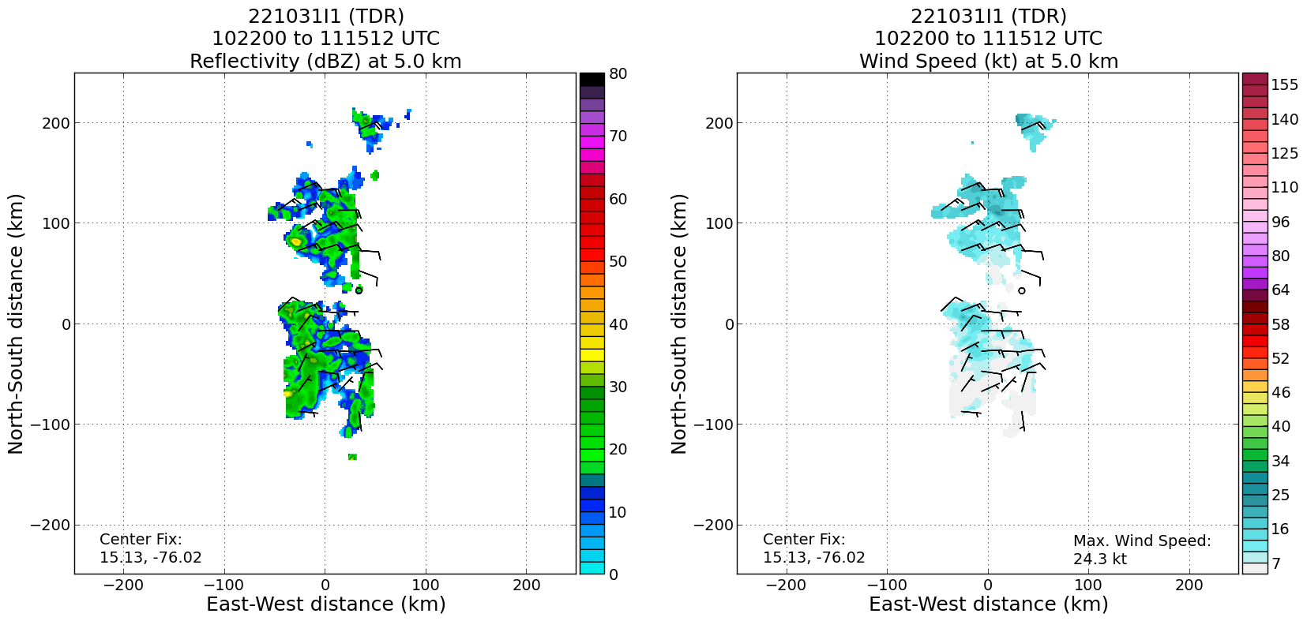
1200 | Drop #8 Center (2nd)
1201 | Climbing to 15 kft on west side for better sonde coverage, both for thermo and for winds
1212 | Drop #9 MP NW
1220 | First visible animation of the day shows LLC displaced to the west of the NE-SW oriented line of precipitation. Isolated regions of lightning in the SW portion of line, plus a few locations at the downwind end of a band to the east of the LLC
1222 | Drop #10 EP NW
1237 | Drop #11 EP W starting W-E pass
1248 | Drop #12 MP W
1303 | Drop #13 Center (3rd)
1314 | Drop #14 MP E  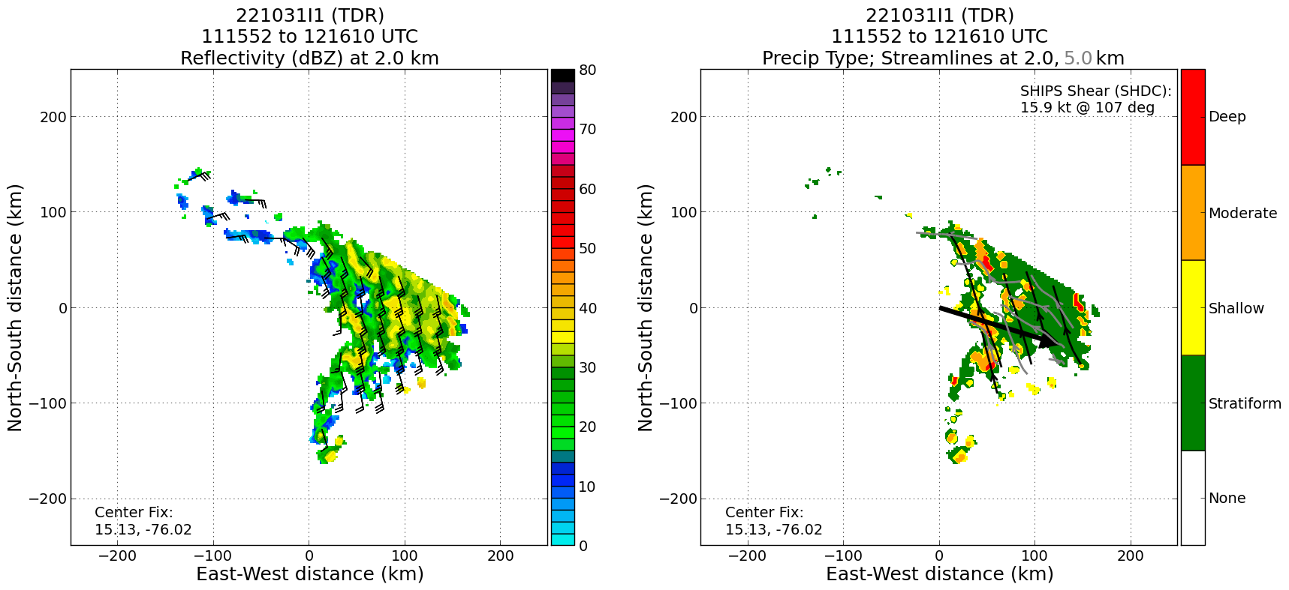
1315 | Plot of precipitation mode from second pass shows widespread areas of stratiform precipitation in the eastern portion of the circulation. Notable areas of moderate convection with some core of embedded deep convection as well
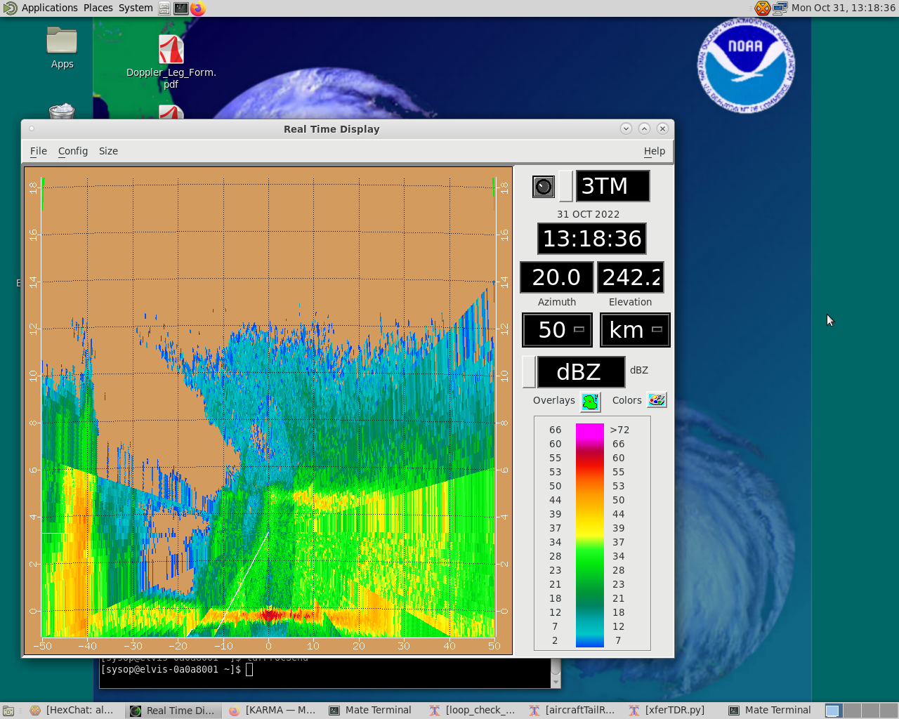

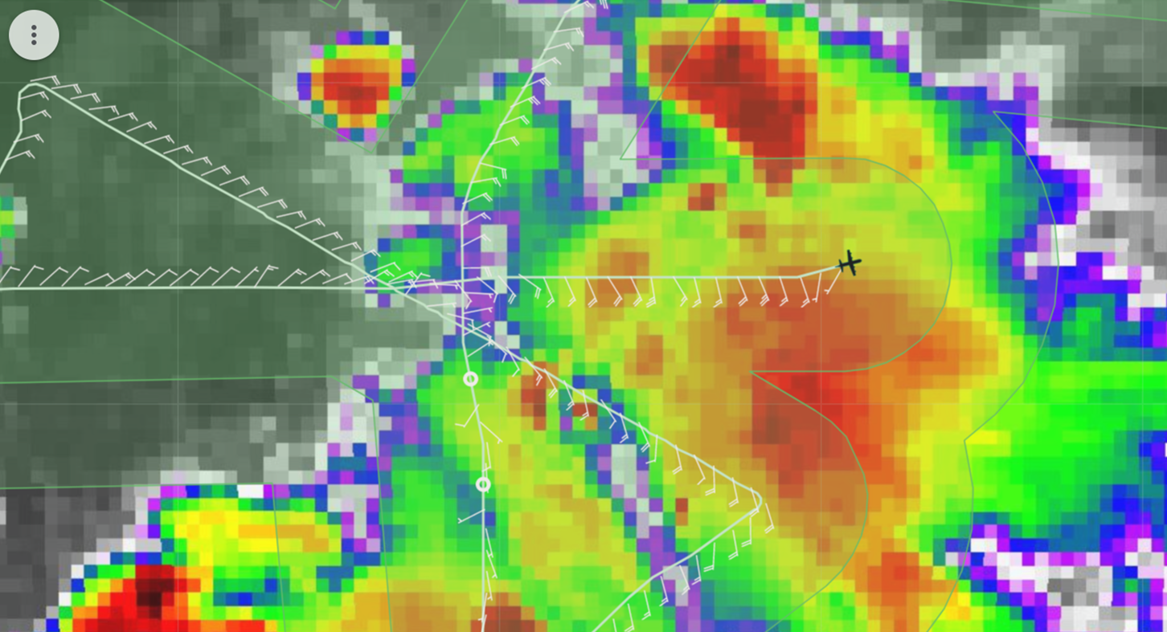

TDR sweep shown above taken from outbound pass to the east shown on the IR satellite image. Radar shows widespread stratiform precipitation on right side of aircraft, with some moderate convection on left side (N of flight track on satellite image). Occasionally the entire sweep domain would fill in with stratiform precipitation here.
1326 | Drop #15 EP E 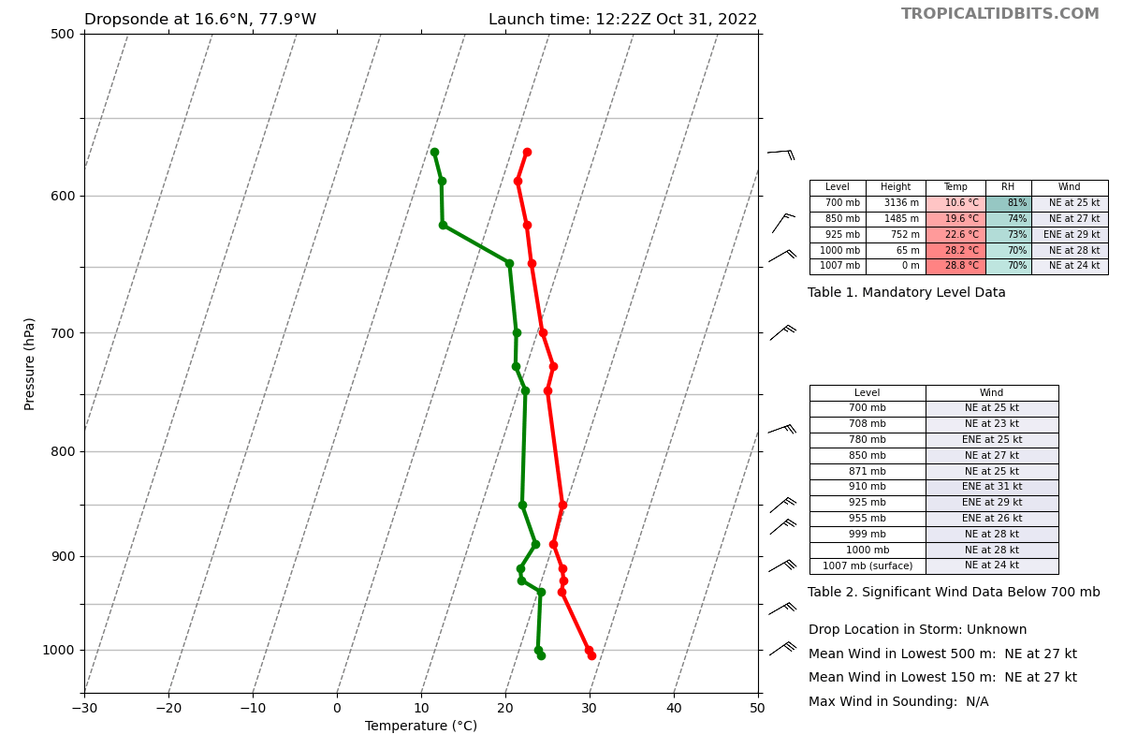Final sonde
1352 | Dropsonde from further NW point shows a fairly moist environment up to 650 hPa. Above that level some indication of drying, but nothing substantial (still 70% humidity). If dry air is affecting convection and the system as a whole, it must be at a higher level.
 | Water vapor animation shows this is likely the case, with very dry mid- to upper-levels. High-altitude drops from, e.g., the G-IV would presumably show this dry upper-level air affecting the system.
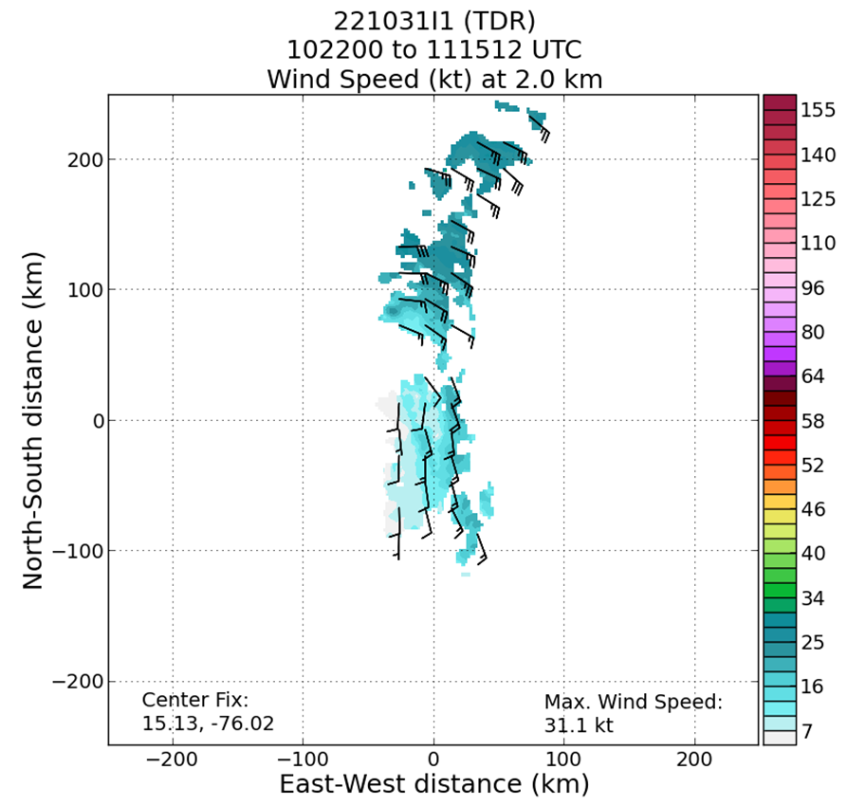
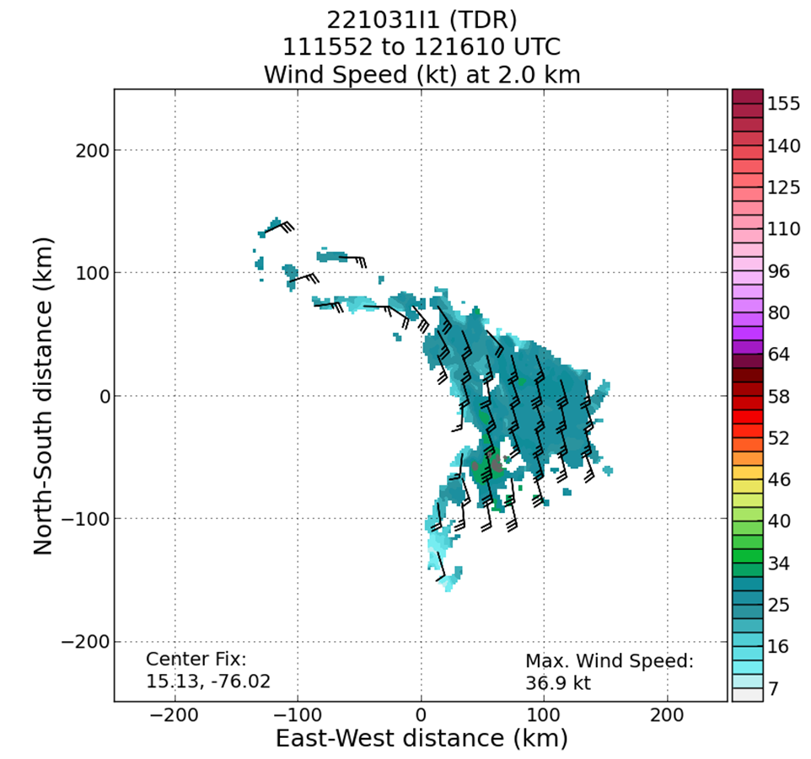
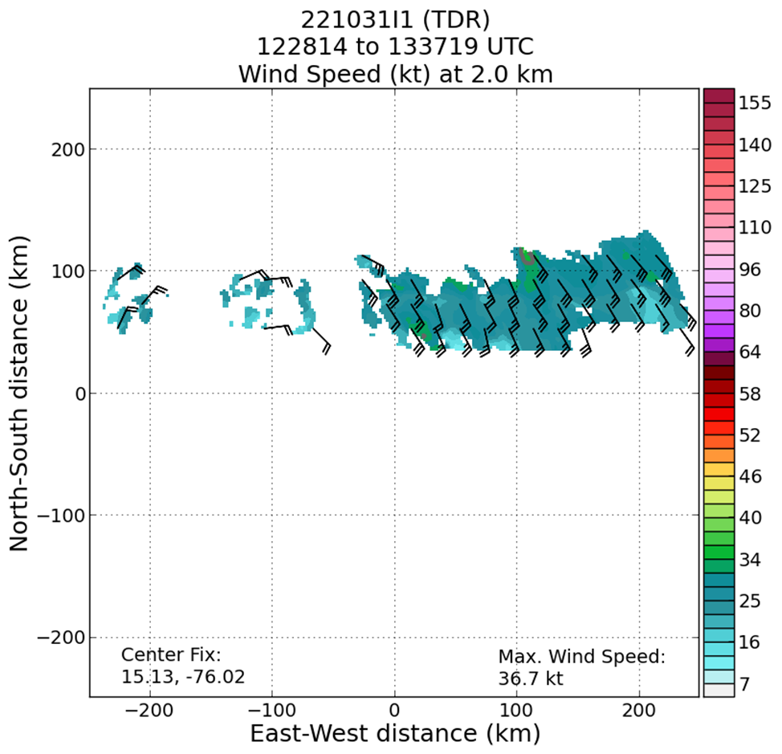
Series of 2-km analyses from the three center passes shows very little change in the structure of the system. Winds are generally 25-30 kt at this altitude, with some isolated spots of 35 kt. The circulation center, if it exists, appears to be in the SW portion of the domain.
1515 | Landed back in St. Croix

POST-FLIGHT
Mission Summary | Mission was successfully flown, with 15 sondes dropped, processed, and transmitted and three TDR analyses processed and transmitted (all charged to NWS). The P-3 climbed to 15 kft on the northwest side of the storm to sample a deeper thermodynamic layer in the absence of scatterers.  AL95 continues to struggle in the presence of moderate to strong west-northwesterly shear. The system has been persistently showing a linear organization of precipitation consisting of primarily stratiform precipitation, but also moderate convection and some isolated cores of deep convection. This precipitation is generally oriented northeast-southwest, positioned to the east of a very visible low-level swirl on satellite imagery. Convection develops and is evident on infrared imagery, but cold cloud tops are unable to persist or consolidate as the convection appears to collapse on satellite imagery. As for the west side, we flew by an isolated deep convective core near the IP of the last pass, but generally the rest of the cloud buildup was shallow. Given the lack of precipitation on one side (west), the dropsondes were keyed in on for their thermodynamic characteristics. The dropsondes from the flight do not show any obvious dry layers, but the highest altitudes reached with the sondes is about 450 hPa so perhaps there was drier air higher up. Water vapor imagery shows widespread areas of significant drying, suggesting that the dry air that is likely causing the collapse of the convection is in the middle to upper levels (e.g., above 450 hPa). The shear will have to relax to allow those shallow clouds to get deeper and moisten up the midlevels.  Overall, PTC15 remains unorganized with a well-defined, but broad low-level circulation. The expectation in the NHC forecast is that the shear should relax later today, perhaps allowing the convection to do more to organize the circulation structure and allow precipitation to persist. There were no issues during the flight of note, though from a pattern perspective, it would have been better to come in from the southwest on the last pass, also at 15 kft to get somewhat deeper dropsonde measurements.
Actual Standard Pattern Flown | Butterfly at 10 kft on the north to south sides and 15 kft on the northwest and west sides of the pattern
APHEX Experiments / Modules Flown | Data collection supported the Genesis Stage Experiment: PREFORM and the Early Stage Experiment: AIPEX as PTC13 has been bordering as a tropical storm over the last 24 hours. No modules were flown.
Plain Language Summary | - This was the third consecutive mission into AL95/PTC13, which has struggled to intensify further. The main factor in its lack of strengthening has been the lack of precipitation coverage around the center, driven by the dry air and vertical wind shear affecting the disturbance. These observations continued to be seen during this flight.  - Although no strengthening was observed, NHC did use the observations from this flight to help classify PTC13 as Tropical Storm Lisa as dropsondes showed a central pressure of about 1003 mb and 35 kt winds measured by instruments onboard.
Instrument Notes | None of note
Final Mission Track | 