MISSION PLAN
FLIGHT ID | 20221030I1 | STORM | AL95
MISSION ID | 02JJA | TAIL NUMBER | NOAA43
TASKING | EMC | PLANNED PATTERN | Lawnmower
MISSION SUMMARY
TAKEOFF [UTC] | 0853 | LANDING [UTC] | 1558
TAKEOFF LOCATION | St. Croix | LANDING LOCATION | St. Croix
FLIGHT TIME | 7.1 | BLOCK TIME | 7.3
TOTAL REAL-TIME RADAR ANALYSES  (Transmitted) | 6 (6) | TOTAL DROPSONDES (Good/Transmitted) | 25 (25 / 25)
OCEAN EXPENDABLES (Type) | None | sUAS (Type) | None
APHEX EXPERIMENTS / MODULES | Genesis Stage Experiment: PREFORM and FAM
HRD CREW MANIFEST
LPS ONBOARD | Zawislak | LPS GROUND | None
TDR ONBOARD | Zawislak | TDR GROUND | Reasor, Fischer
ASPEN ONBOARD | J. Zhang | ASPEN GROUND | None
NESDIS SCIENTISTS | P. Chang
GUESTS (Affiliation) | None
AOC CREW MANIFEST
PILOTS | Doremus, Keith, Wood
NAVIGATOR | Miller
FLIGHT ENGINEERS | Stokes, Tyson
FLIGHT DIRECTOR | Carpenter
DATA TECHNICIAN | T. Richards
AVAPS | Warnecke

PRE-FLIGHT
Flight Plan | 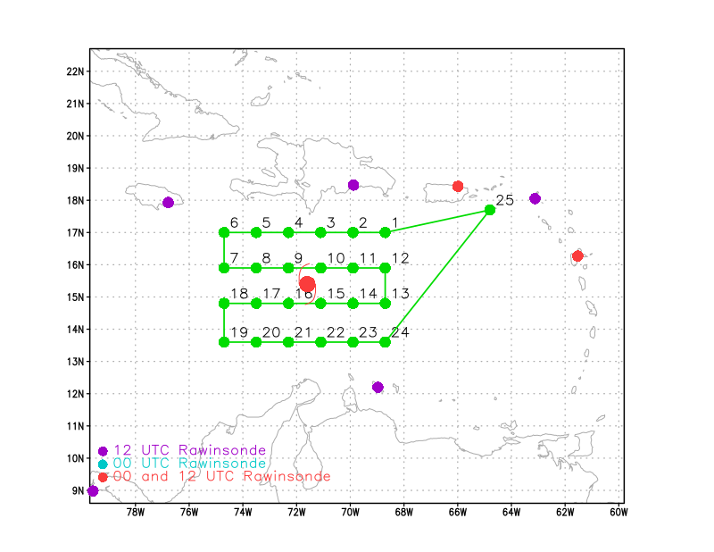  Fly a lawnmower pattern at an altitude as high as possible, except when in precipitation when a lower altitude will be required
Expendable Distribution | Dropsondes released at every green dot in the above image
Preflight Weather Briefing | As of 2 am EDT, NHC currently forecasts a medium (60%) and high (70%) probability of formation in the next 2, 5 days. The area appears somewhat better organized this morning compared to yesterday, with a more concentrated area of convection occurring between 70 and 72W just north of 15N south of Hispaniola. While there is unlikely to be an organized surface circulation, there could be an elongated circulation over a broader area. Convection could be trying to consolidate somewhere in that area, particularly on the east side where it appears to be more persistent. The dropsonde data, especially on the west side of the pattern could be very revealing as to how favorable or unfavorable the environment thermodynamically is for further development. The location and current state of AL95 is: 14.5N / 71.4W, 1007 mb, 20 G 30 kt.
Instrument Notes | [What instruments are working, not working, not functioning nominally, not installed?]

IN-FLIGHT
Time [UTC] | Event
0853 | Takeoff from St. Croix
0946 | Entering the lawnmower at the IP, northernmost east to west leg. Fairly clear of precip. Drop #1 (leg1). Looks like the 2nd leg will have more precip on the line, primarily the eastern side of the pattern. Level at about 21,000 ft.
0958 | Drop #2 (leg1). A little choppy, but not much in the way of radar returns. MMR, nose looks clean. TDR indicates some shallower raining convective cells to the south, but nothing up to our altitude. May just be sitting under some weak anvil.  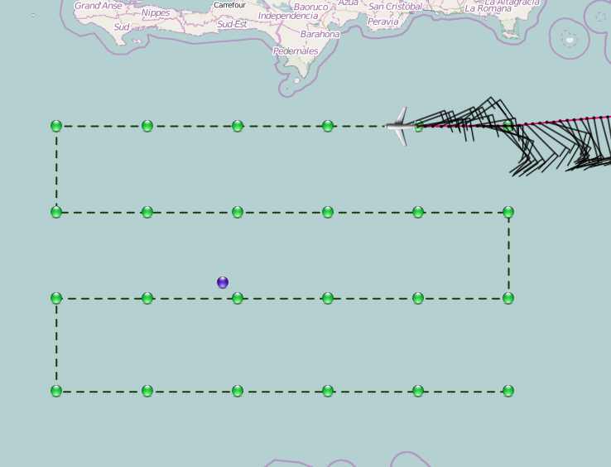  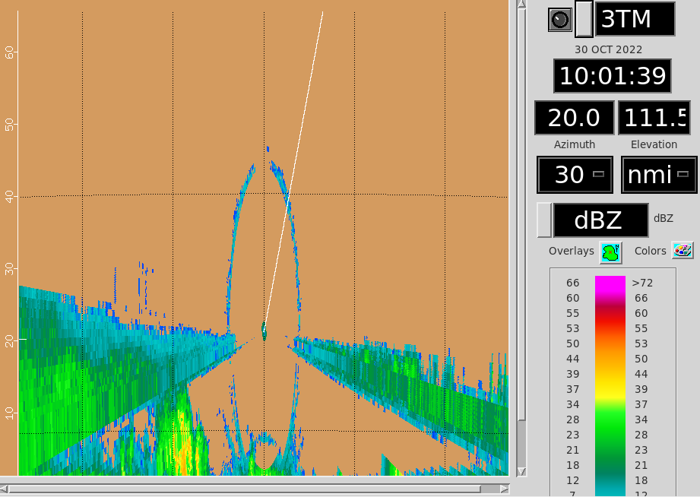
1010 | Drop #3 (leg1); still clear of precip with a line of convection appearing to our north, just off of Hispaniola
1017 | Precipitation picking up some. Bumping around some detrainment layer from convection nearby that is mainly below and around us.  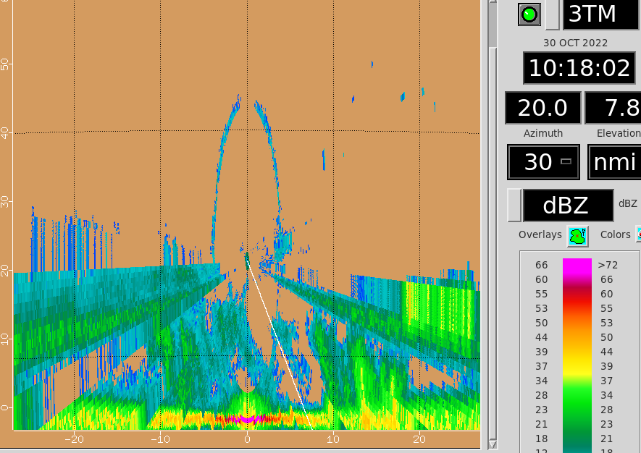
1023 | Drop #4 (leg1); some cells popping up to our altitude, but mostly now visual with decreasing coverage of clouds.
1035 | Drop #5 (leg1); clear of clouds below, but there is a line of convection coming up in about 40 nmi.
1042 | Just passed quickly through the line of convection – topping up just above our altitude  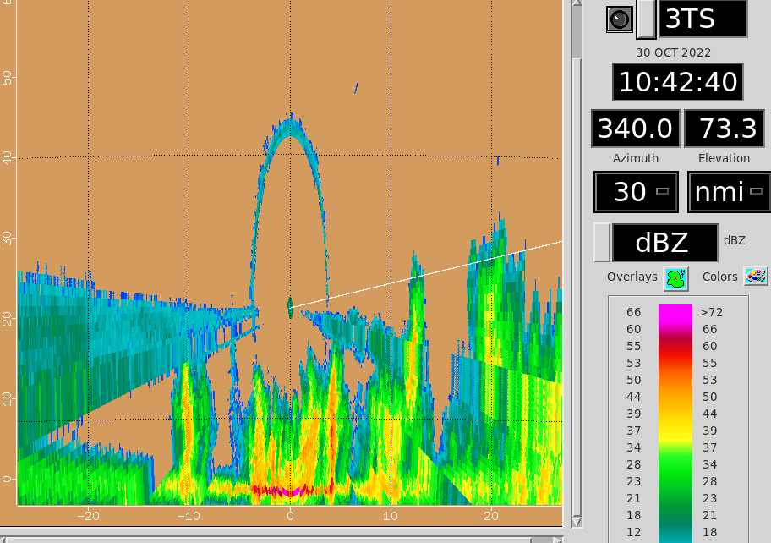  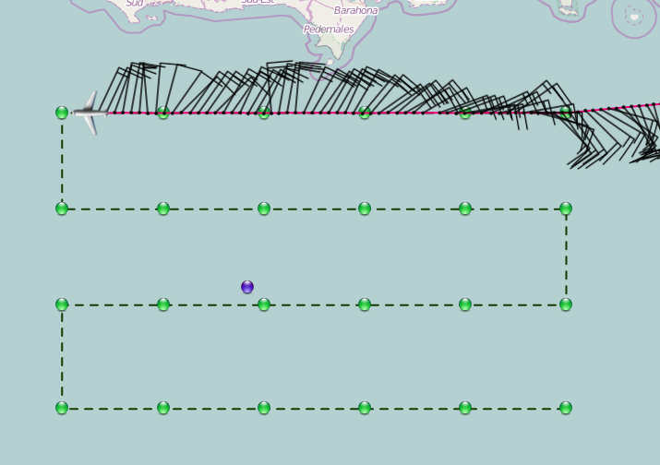
1047 | Drop #6 (end of leg1); some isolated convective cells around reaching our altitude, otherwise all other clouds are very shallow and likely not raining. Turning down to do our next leg (2), which will be west to east.
1049 | Now that the sun is up and we’ve got visual, can see lots of anvil clouds to our east  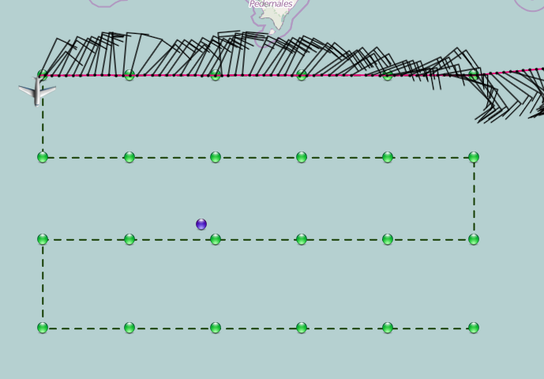  Visual on the one of most widespread convective areas so far up ahead near the next turnpoint
1055 | Passing through another thin convective line; very brief, found a gap. Main precipitation still up ahead near the turn back to the east.
1058 | Drop #7 (leg2, start); in some cloud now, which much more widespread precipitation around.  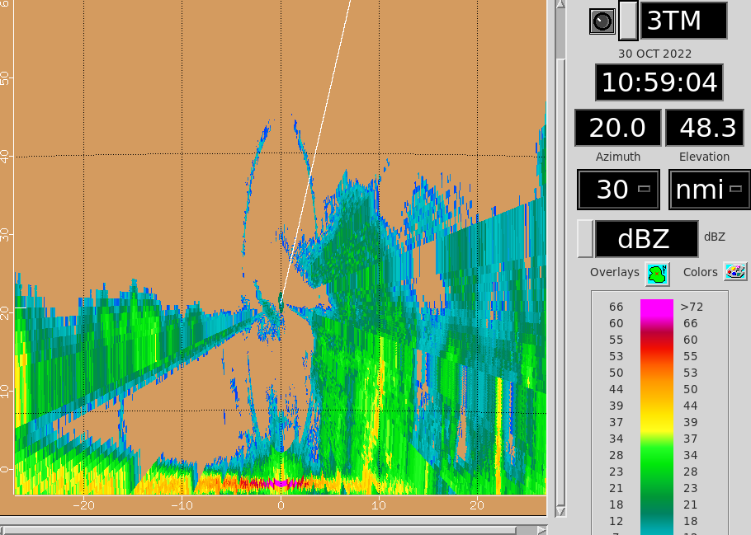
1110 | First TDR analysis shows decent cyclonic curvature in the winds at 5 km, but very little curvature below.  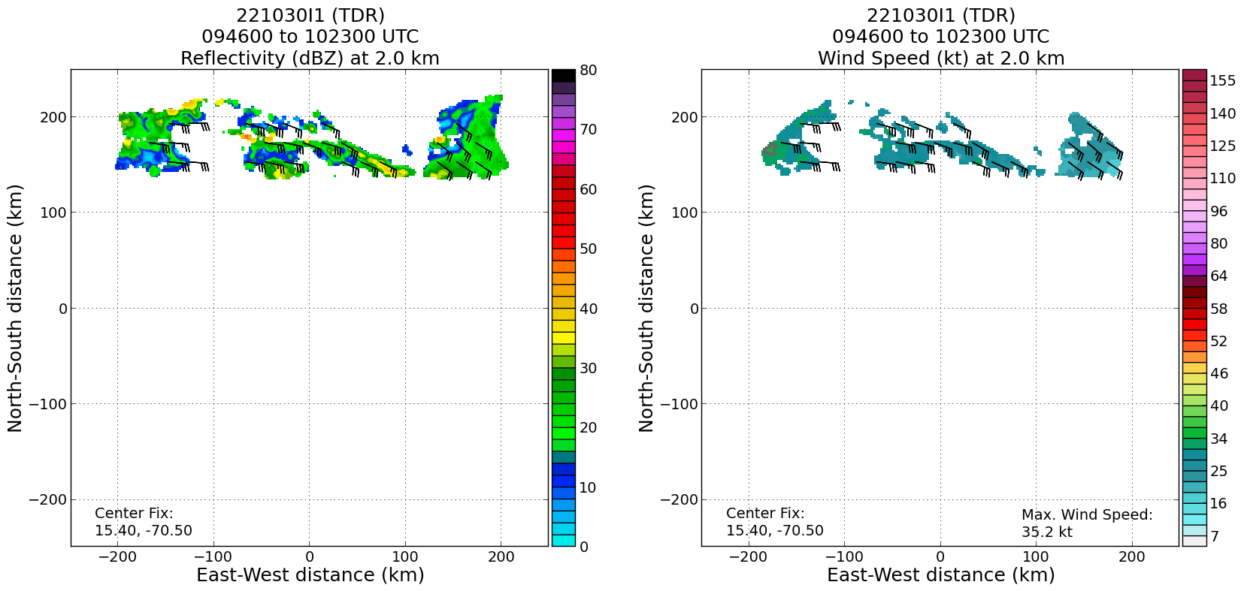  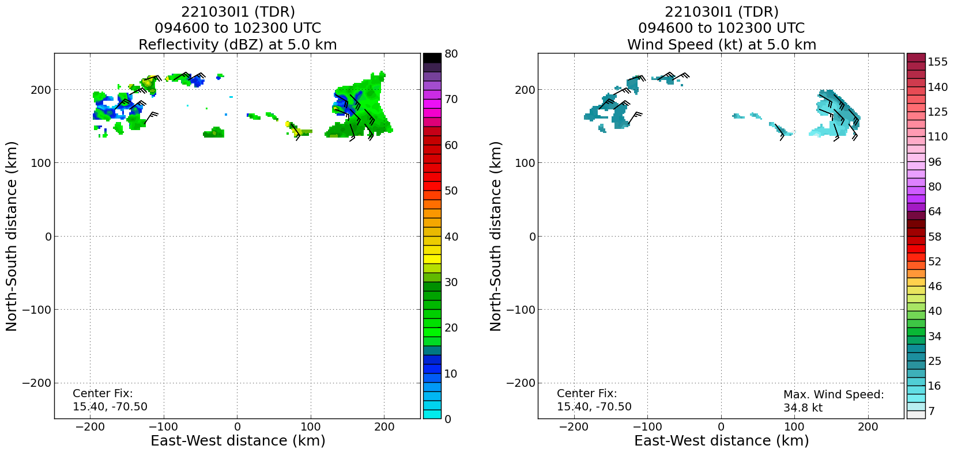
1112 | Drop #8 (leg2); some scattered shallow clouds below; no precip – precip is mainly 20 - 30 nmi to our south
1115 | Drop #9 (leg2), backing up Drop #8 just because it looks like it was weak telemetry
1117 | Some decent convective cells around. Nothing widespread yet, but plenty of good returns for the TDR. Main convective cell still up ahead.  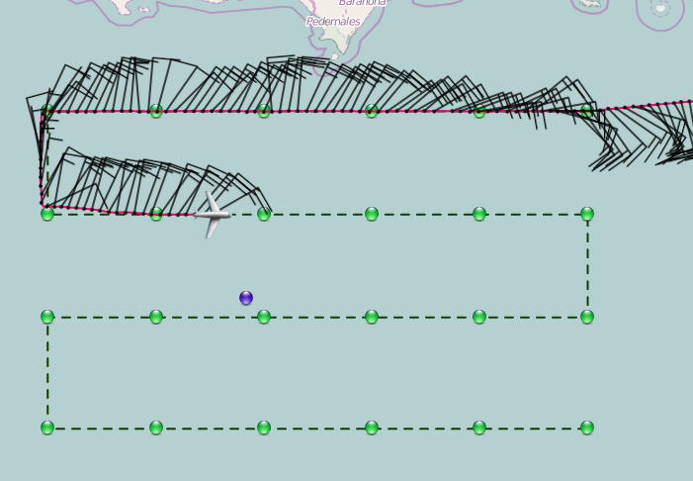  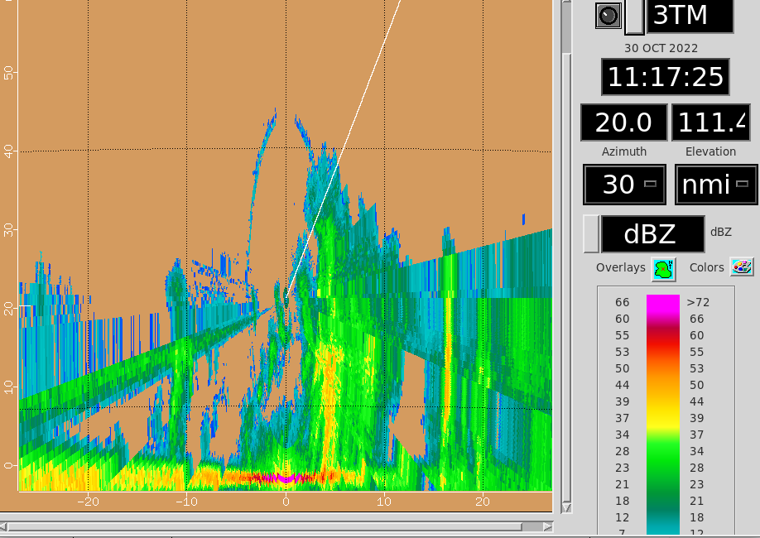
1119 | Climbing up to get another 2000 ft of altitude; clear of the detrainment layer now.
1125 | Drop #10 (leg2 at Pt 9); still lots of stratus deck, convection ahead, but not showing up too much on MMR, nose camera
1127 | Climbing up to 23,000 ft pressure altitude
1130 | Finally seeing the main convective cell that has been building over the last hour or so. It’s just off our track to the south, and not particularly impressive on MMR or nose radar.  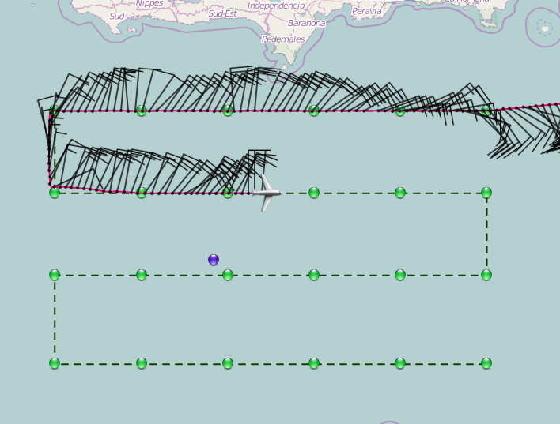
1136 | Devitated to remain just north of the convective cell, but still in range of the TDR  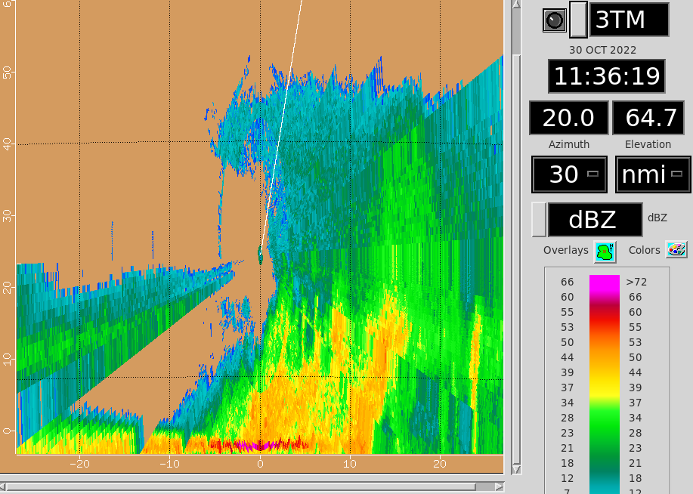
1139 | 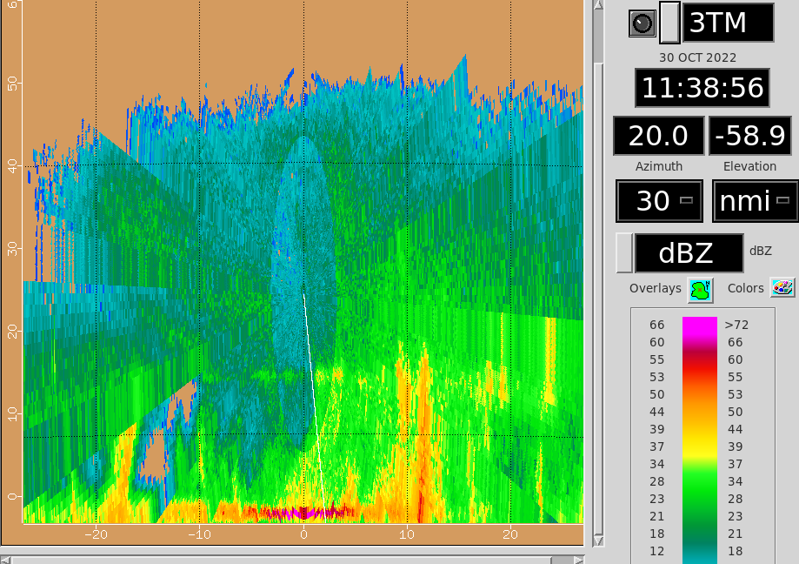
1141 | Drop #11 (leg2 at Pt10); in cloud, but not getting much icing. TDR indicates this is all pretty much stratiform rain  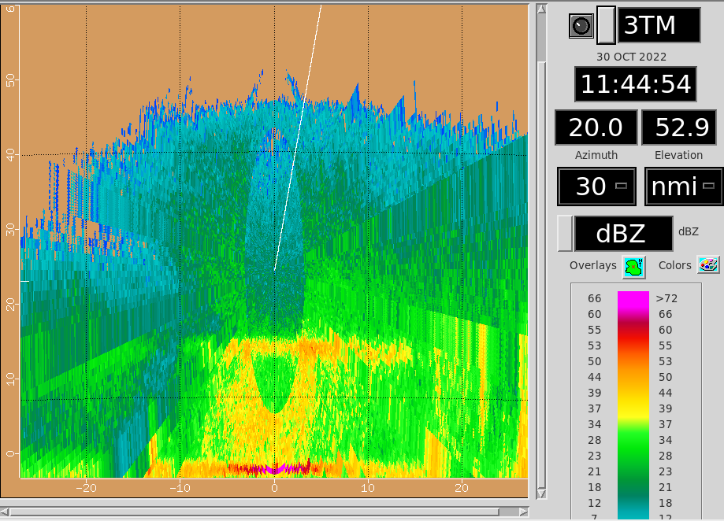  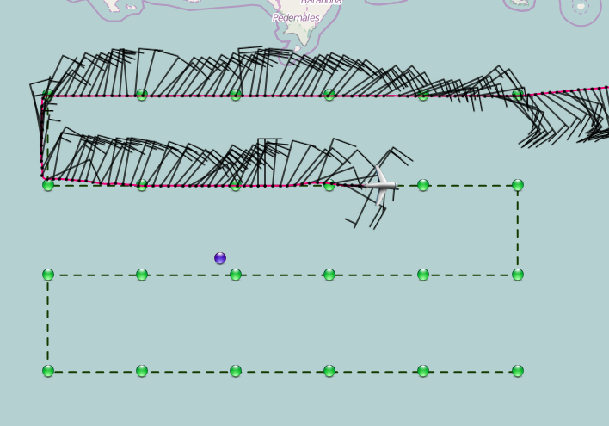
1151 | Drop #12 (leg2 at Pt 11); coming out of what was a pretty long leg through solid stratiform.
1155 | Looks like we’ve also crossed an axis at flight level. Had a hint of that on the first lawnmower leg, and now we’ve gotten a wind shift on the eastern part of this second leg.  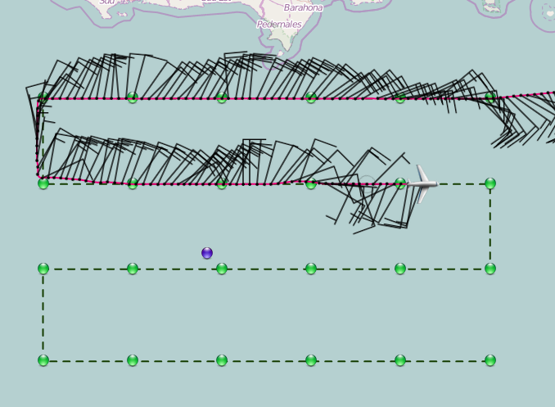
1200 | Satellite loop suggests that the anvil just keeps spreading, so we’re spending a bit more time in the stratiform anvil  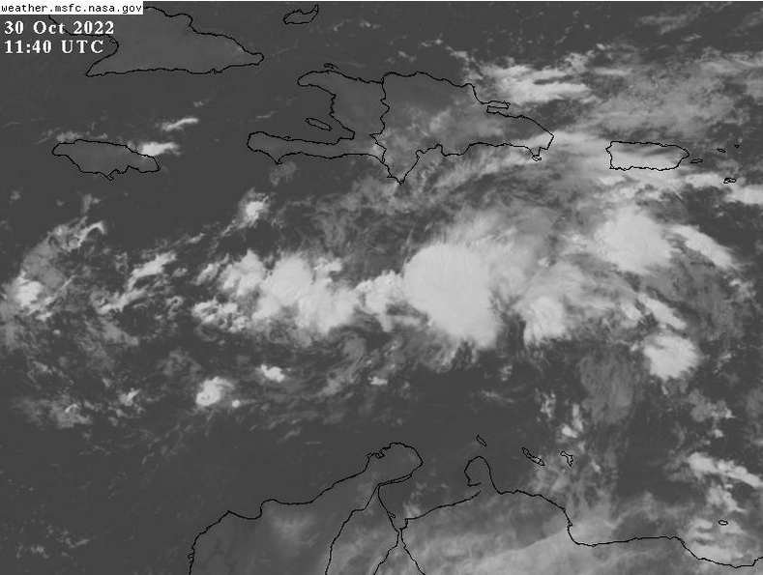
1205 | Drop #13 (leg2 at Pt 12); end of the second lawnmower leg. Lighter returns on the TDR as we have pass through the main convective area. Turning southward to set ourselves up for the third lawnmower leg.
1210 | Still sitting in some detrainment snow. Fairly widespread TDR returns at our altitude and below. Just sub-visual above.  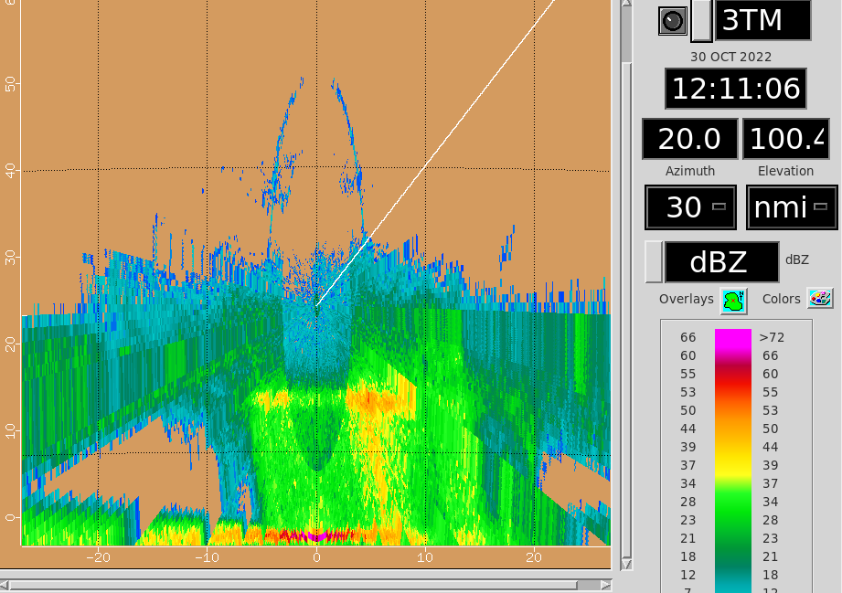  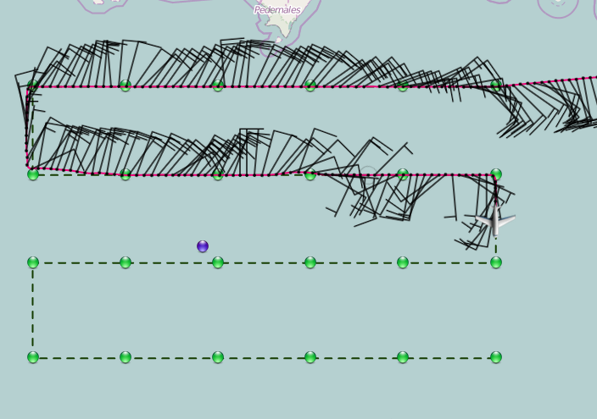
1215 | Now passing a decent convective tower to our east as we get close to our turn point to head west. Still, though, in light snow and not much icing.  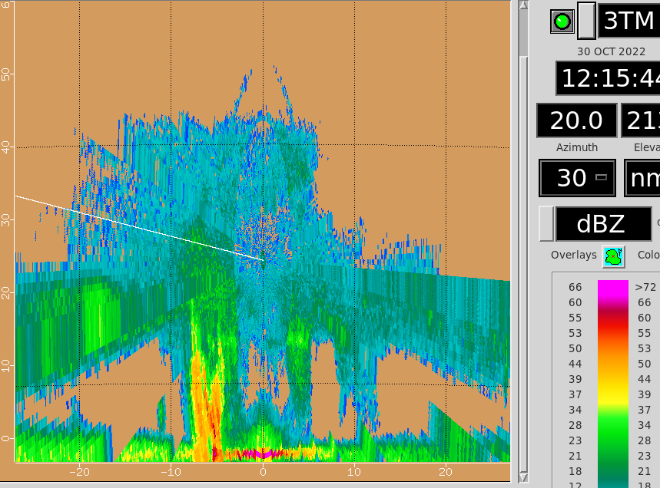
1217 | Drop #14 (leg3 at Pt 13); made the turn onto the third lawnmower leg (east to west).
1230 | Drop #15 (leg3 at P14); in cloud
1235 | The 3rd TDR analysis (the one with the most coverage) indicates better curvature and vorticity in the vicinity of the convective system we flew through in the middle to eastern half of the last lawnmower leg (note that the TDR analysis is being centered east of the center of the lawnmower pattern, so that convection is closer to the western edge of the pass in the analysis)...  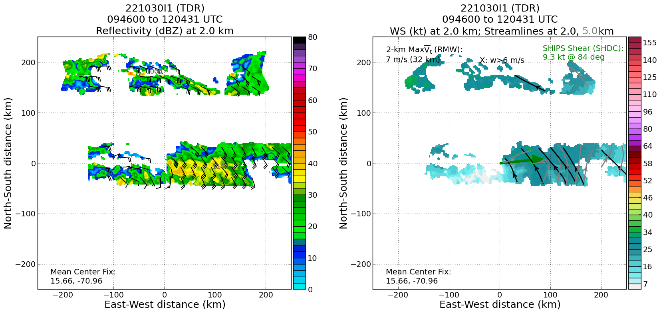  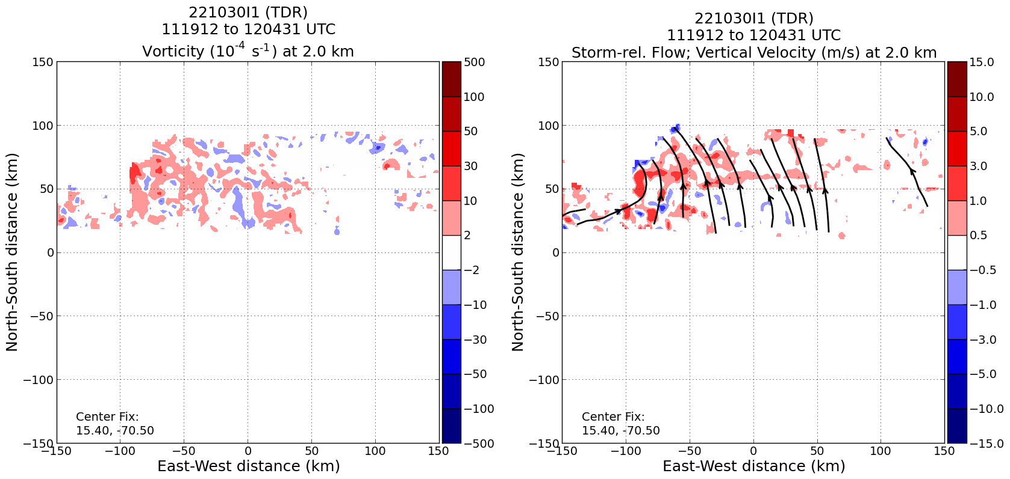  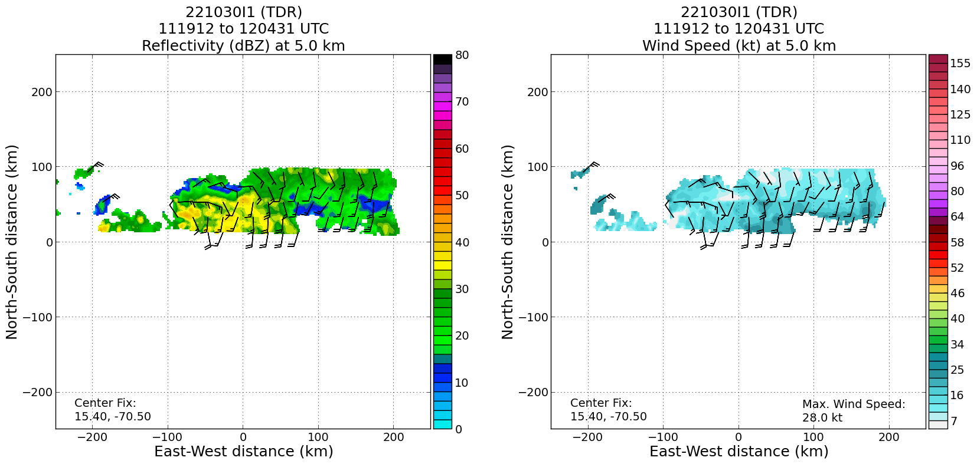  Much tighter curvature at 5 km within the convective system on the last pass – indicative of a convective vortex developing there?
1239 | The convective system is back within view of the TDR, to our north, though not really seeing the “meat” of it this time.  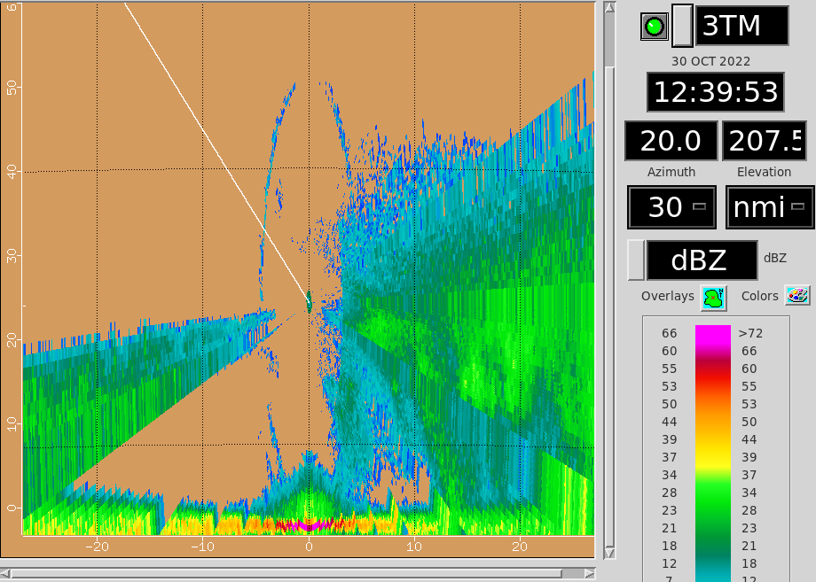  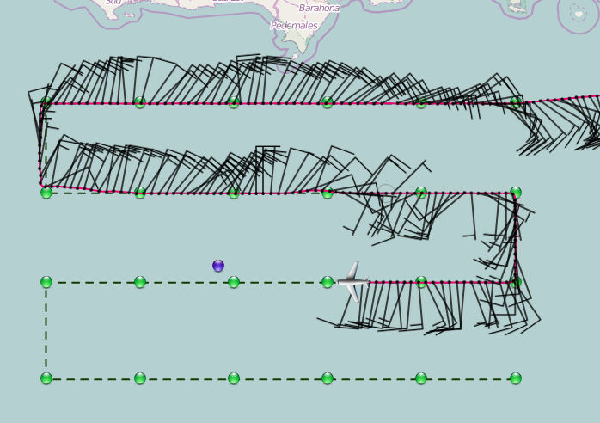
1243 | Drop #16 (leg3 at Pt 15); fairly cloudy below
1246 | According to the satellite loop, we’re flying through the inflowing air (from the south/southwest) into the convective system  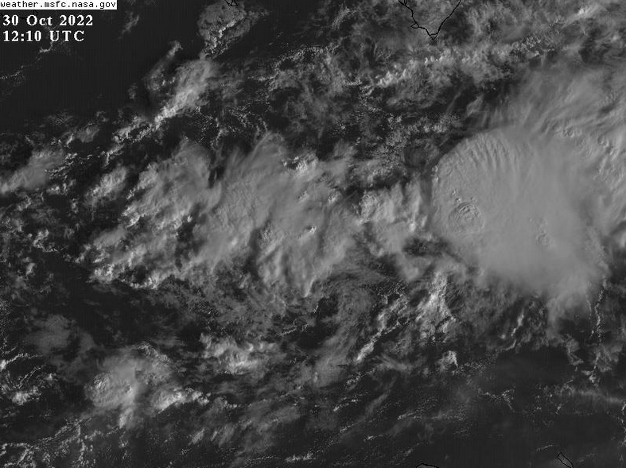
1253 | We ended up skirting the convection to the north, but didn’t have it very well in range – hopefully the TDR analysis will still be productive  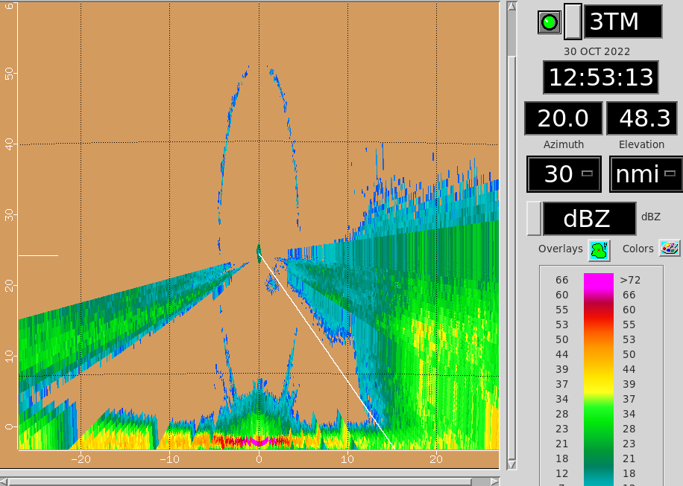
1257 | Drop #17 (leg3 at Pt 16)
1258 | Composite TDR analysis within the domain (first and third analysis, eastern portion of first and second lawnmower legs)...  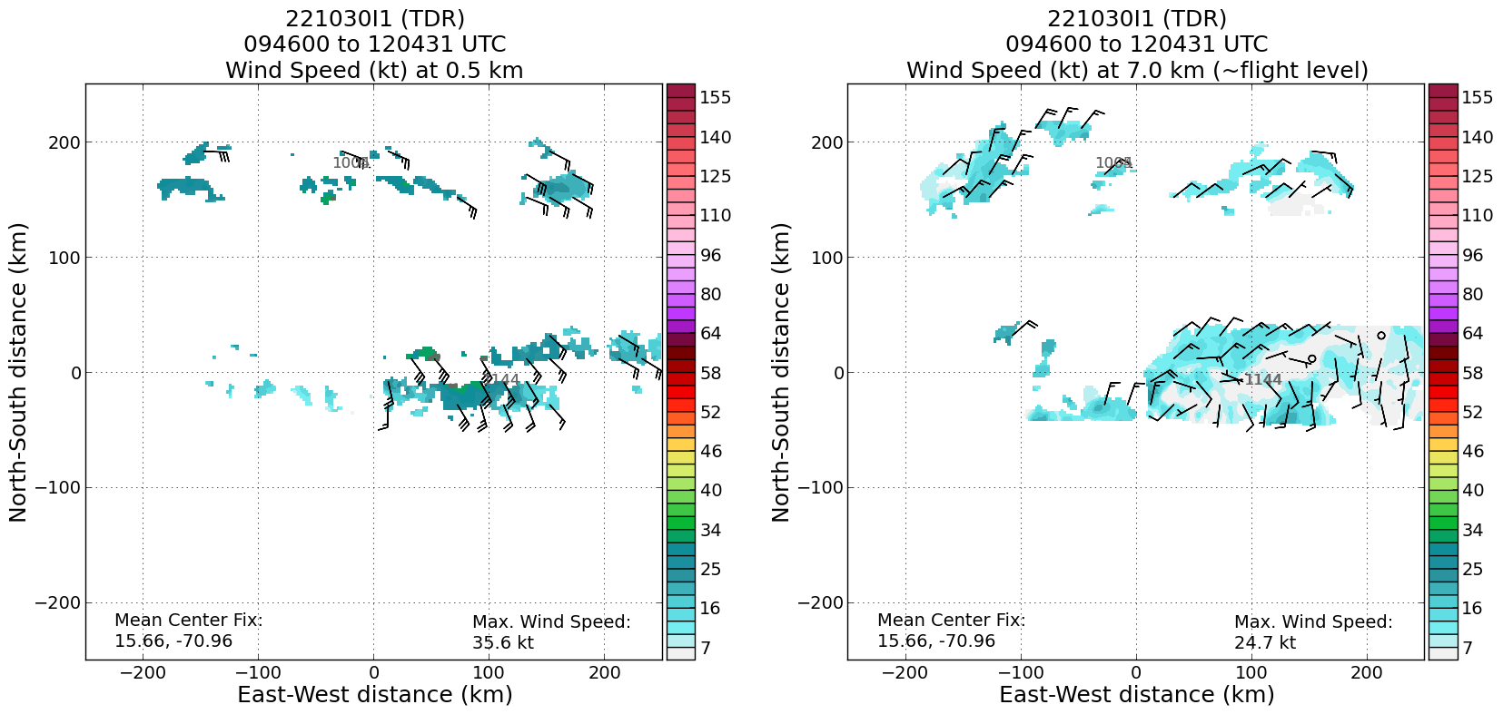  7 km TDR analysis does show that axis on the eastern side of the pattern, but also a weak, but closed circulation primarily in the stratiform portion of the convective system.
1302 | Starting to pick up on the scattered convective cells we’ve been seen developing on the western side of our pattern  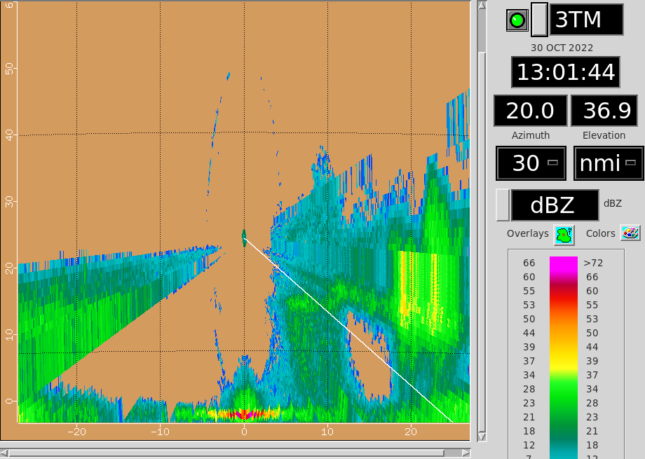  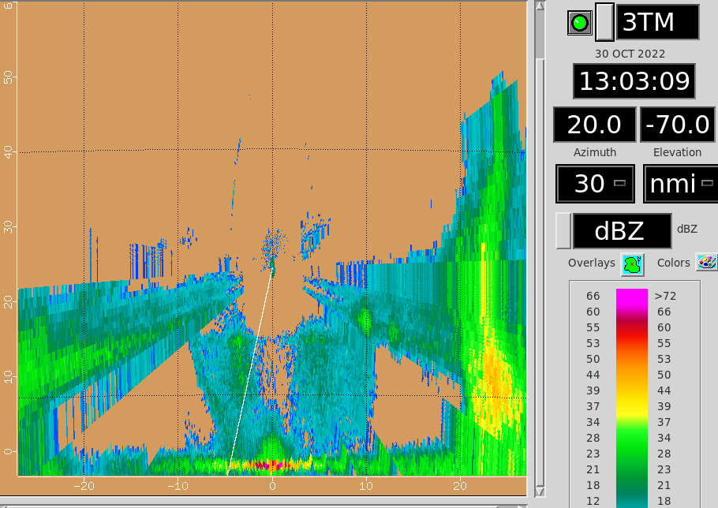
1309 | Drop #18 (leg3 at Pt 17); cloudy below
1319 | Visible satellite loop showing signs of SW low-level flow into main convective region
1321 | Drop #19 (leg3 at Pt 18)
1327 | The convective system we passed through on our second leg has persisted and seems to be the main area of attention in terms of potential spinup, so we would like to get another look at. If permissable by ATC, we’ll set up a sort of SW to NE pass through it from Drop Pt21 back to Drop Pt10.
1333 | Drop #20 (leg3 at Pt 19)
1345 | Drop #21 (leg3 at Pt 20)
1357 | Drop #22 (leg4 at Pt 21)
1357 | Turning inbound for a SSW-NNE pass through main convective area. Descending to 10k ft.
1402 | Convection firing along what appears to be a W-E oriented trough axis
1409 | Drop #23 (leg4 at Pt 22); gonna have to dodge around some convective cells in an inflowing band into the main area of convection -- sort of aiming for a moat
1421 | Drop #24 (leg4 at Pt 23)
1431 | MTS screenshot of mesoscan visible with ongoing final pass through main convective region. An exposed mesovortex can be seen to NW of convection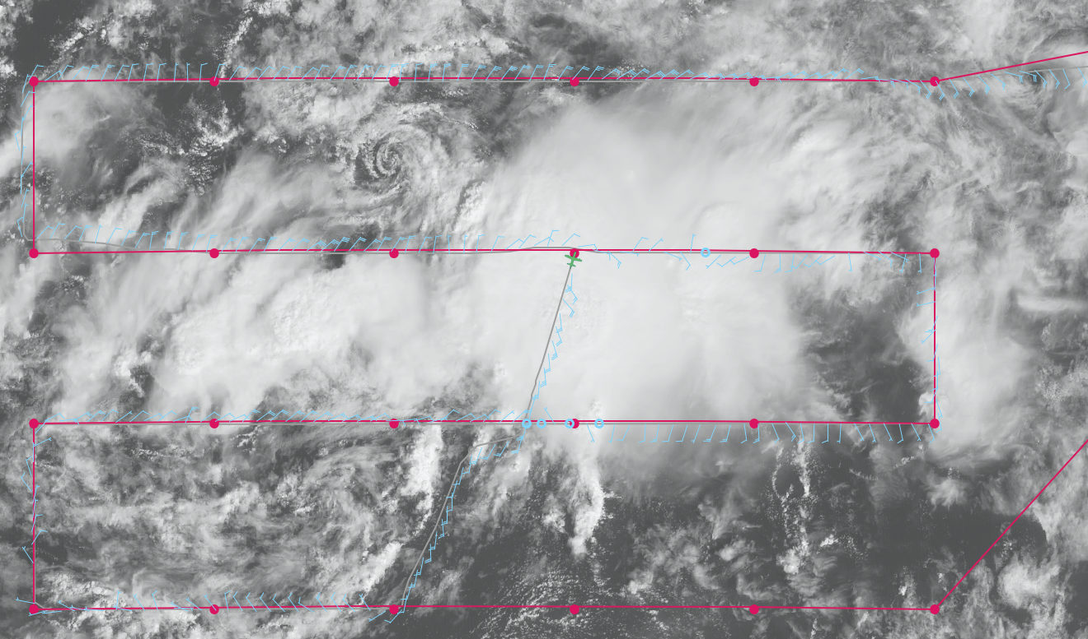
1434 | Drop #25 (leg4 at Pt 24) last report labeled
1504 | MTS screenshot of end of pattern.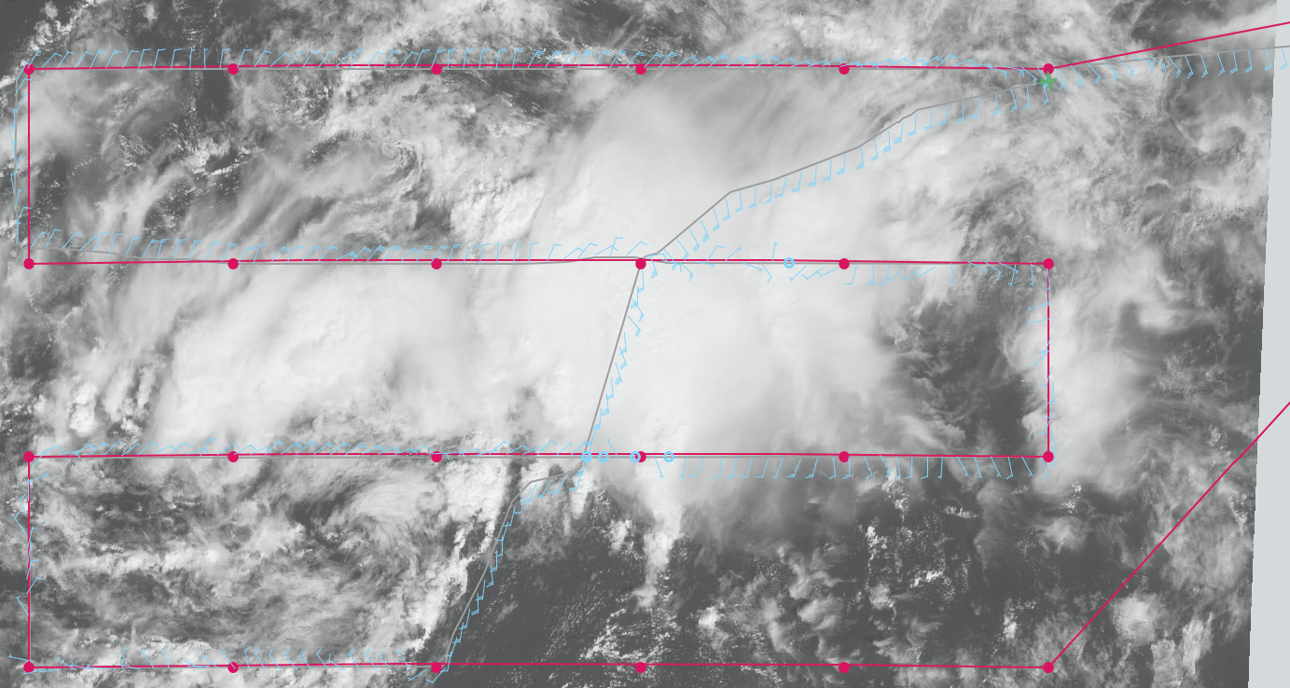
1533 | Final TDR composite shows a low-level trough axis, but no signs of a closed Earth-relative circulation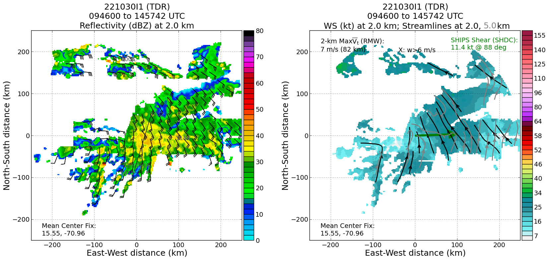
1533 | The last analysis did sample a mesoscale vortex in the mid-levels, as shown at a height of 7 km below: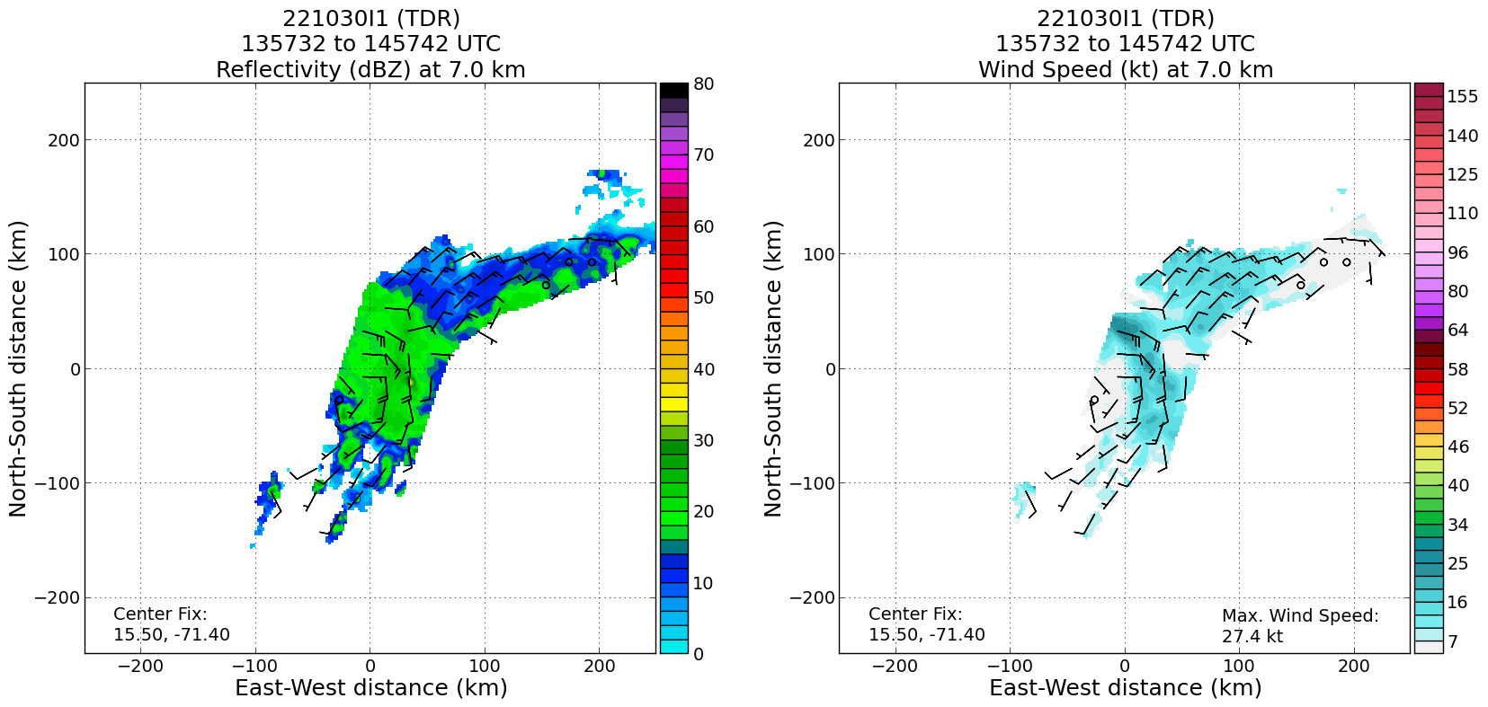

POST-FLIGHT
Mission Summary | This mission successfully flew most of a planned lawnmower pattern in AL95, which continues to slowly organize in the central Caribbean south of Hispaniola. We were able to maintain our higher altitudes (20-25 kft) for the entire lawnmower pattern before descending down to 10 kft pressure altitude to fly an improvised leg from SSW to NNE through the convective system that appeared to be a central player in the further development of AL95. This crossing was done in lieu of flying the last three dropsonde points on the last (southernmost) west to east leg. That convective system, best flown on the 2nd lawnmower leg showed quite a bit of persistence, and appeared to have a midlevel vorticity maximum associated with it. That said, it does appear via satellite and dropsondes that a broad lower-level circulation was present to the west of that convection, although fairly inclusive of the midlevel circulation. Thus, we hypothesize that the formation of a tropical storm out of AL95 will likely be about where convection is able to persist within the broader circulating envelope. Thermodynamically, dry air does still seem to be an inhibitor on the western side of the broader circulation, where the deep convection is having a difficult time persisting or gaining an increase in coverage.  Overall, everything worked fairly well on the flight with several (6) TDR analyses being transmitted, with 25 dropsondes released, all good, all transmitted (and all charged to NWS).
Actual Standard Pattern Flown | Lawnmower with a crossing of the apparent midlevel circulation center within a persistent convective area. Lawnmower at 20-23 kft, while the crossing was at 10 kft.
APHEX Experiments / Modules Flown | Data collection supported the Genesis Stage Experiment: Favorable Air Mass (FAM) and PREFORM (Precipitation During Formation and Observing its Response across Multiple Scales) experiments.
Plain Language Summary | - This operationally-tasked mission by the National Hurricane Center and Environmental Modeling Center observed the early stages of AL95, which has been designated a “high” chance of formation into a tropical cyclone in the next 5 days. The disturbance exhibited fairly clear circulation in the low-levels, though broad, as well as well-defined curvature in the winds in the midlevels of the atmosphere. This circulation structure is favorable for formation of a storm. That said, rainfall is having a hard time persisting in most areas of the broad circulation, likely due to the presence of dry air and some vertical shear of the winds. These factors are currently inhibiting further development.
Instrument Notes | None of note
Final Mission Track | 