MISSION PLAN
FLIGHT ID | 20221007H1 | STORM | AL13 / JULIA
MISSION ID | 0513A | TAIL NUMBER | NOAA42
TASKING | EMC | PLANNED PATTERN | Butterfly
MISSION SUMMARY
TAKEOFF [UTC] | 1901 | LANDING [UTC] | 0205
TAKEOFF LOCATION | Lakeland | LANDING LOCATION | Aruba
FLIGHT TIME | 7.1 | BLOCK TIME | 7.4
TOTAL REAL-TIME RADAR ANALYSES  (Transmitted) | 3 (3) | TOTAL DROPSONDES (Good/Transmitted) | 21 (20 / 20)
OCEAN EXPENDABLES (Type) | None | sUAS (Type) | None
APHEX EXPERIMENTS / MODULES | Early Stage Experiment: AIPEX
HRD CREW MANIFEST
LPS ONBOARD | Zawislak | LPS GROUND | Hazelton
TDR ONBOARD | Zawislak | TDR GROUND | Gamache
ASPEN ONBOARD | Sellwood | ASPEN GROUND | None
NESDIS SCIENTISTS | None
GUESTS (Affiliation) | None
AOC CREW MANIFEST
PILOTS | Mitchell, Capare, Rannenberg
NAVIGATOR | Utama
FLIGHT ENGINEERS | Darby, Pittman, Gee
FLIGHT DIRECTOR | Carpenter, Kalen
DATA TECHNICIAN | McAlister
AVAPS | Dykeman

PRE-FLIGHT
Flight Plan | 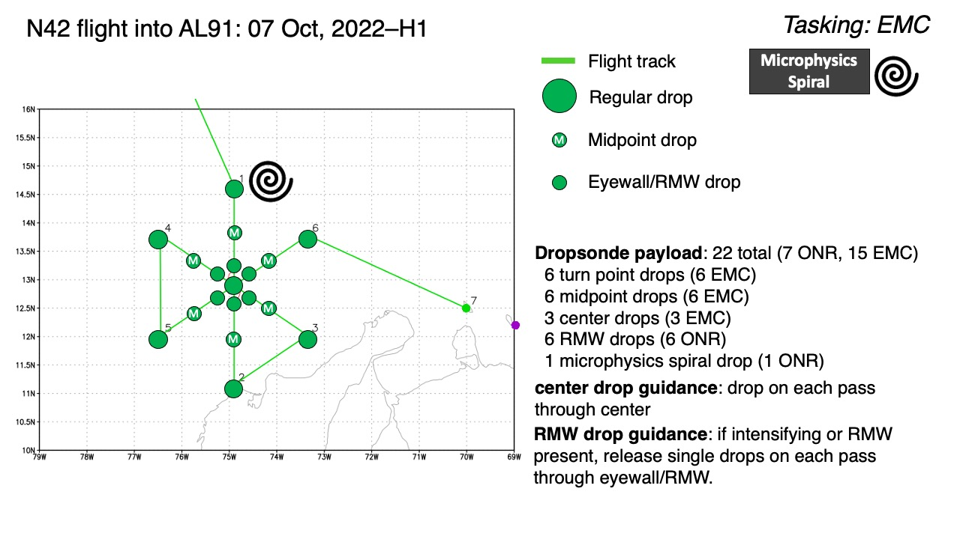  Butterfly with passes from north to south, then southeast to northwest, then a final pass from southwest to northeast. We have a possible microphysics spiral module at the beginning of the pattern at the IP, but its execution will be based on available time and the weather at the point. If there is a lot of deep convection, especially cellular, it may not make sense to do the module. After that, it will be too dark, so the IP is the only potential point to do the module at. Flown altitude should be 10 kft for the entire pattern.
Expendable Distribution | 22 total dropsondes (7 ONR, 15 EMC) – 6 endpoints, 6 midpoints, 6 RMW, 3 center drops, 1 in the microphysics spiral, if flown. The RMW sondes may instead be “quarterpoint” sondes, essentially a sonde that splits the difference between the center dropsonde and the midpoint of each leg. This would be the plan if we can’t find a well-defined RMW, which we don’t expect given the weak state of the storm.
Preflight Weather Briefing | TD13 was upgraded to TS Julia before the mission, as the storm is now clear of the South American continent. The storm appears to be dealing with some residual northerly shear, with the LLC exposed and most deep convection on the south side. The Air Force plane earlier reported a pressure down to 1001 hPa, however. The environmental conditions, though, are forecast to improve overt the next day, especially a weakening of the northerly shear. If the shear weakens, then it’s possible that the storm could rapidly strengthen as it moves towards its landfall in Nicaragua.
Instrument Notes | None noted

IN-FLIGHT
Time [UTC] | Event
1901 | Takeoff from Lakeland, FL
1951 | MW shows deep convection is sheared, but shallow is starting to become a little more symmetric.  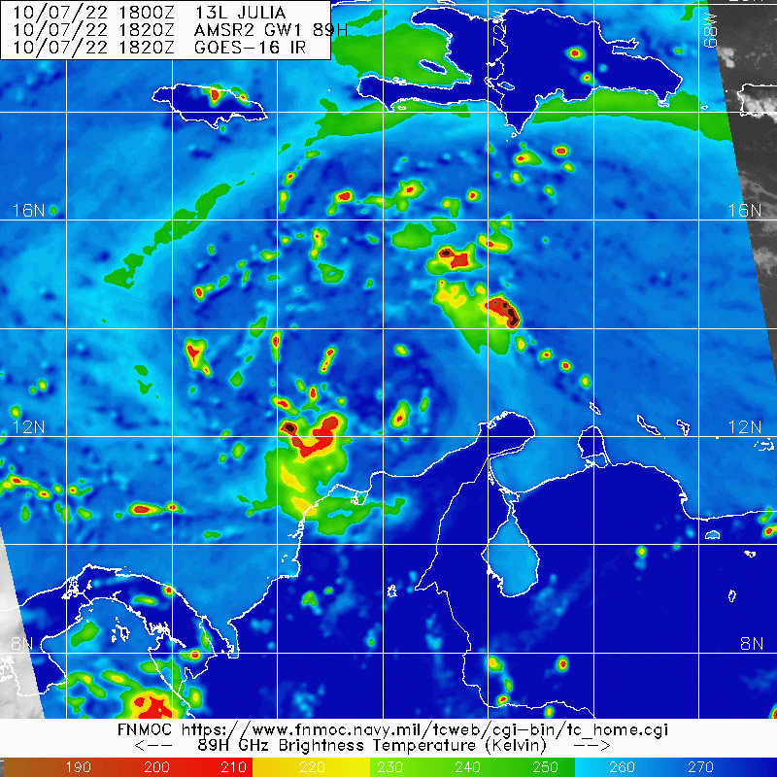  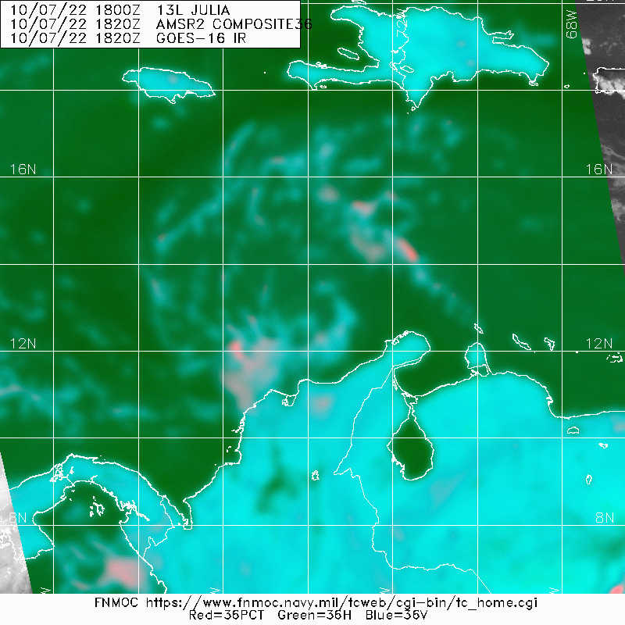
2014 | Debugging potential radarsync issues. The radarsync terminal window has been reported to not be showing any output, yet the status in the Xchat channel for the scripts shows the output that it's waiting for a jobfile (this text should also be showing up in the terminal window). We tested a submission of a jobfile, but still nothing showed up – turned out it was a mistake in the filename of the jobfile submitted, and once corrected and submitted again, the jobfile processing was observed in the radarsync terminal as it normally should. So, there was ultimately no issue except odd to not see the initial status in the radarsync terminal on startup.
2048 | New convective burst is developing south and east, near the low-level circulation center.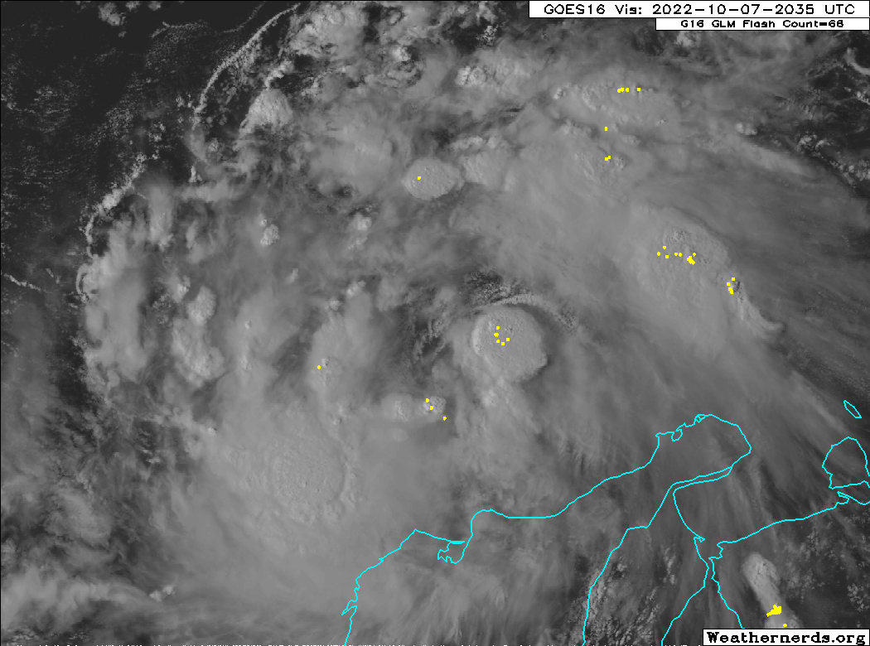
2120 | No spiral at the IP due to convection and lack of uniform stratiform precipitation present. Instead, they will descend down to be established at 10 kft altitude at the initial point (IP).
2136 | Descending to IP
2143 | Established at 10 kft
2144
2201 | Arrived at IP; Sonde #1 – IP/Endpoint (EP) North
2212 | Sonde #2 – Midpoint (MP) North
2215 | Whitecaps noted, tropical storm winds (34 kt) reported at the surface.
2218 | Latest microwave imagery from SSMIS-18 showing the deep convection developing on the south and east sides of the low-level center.  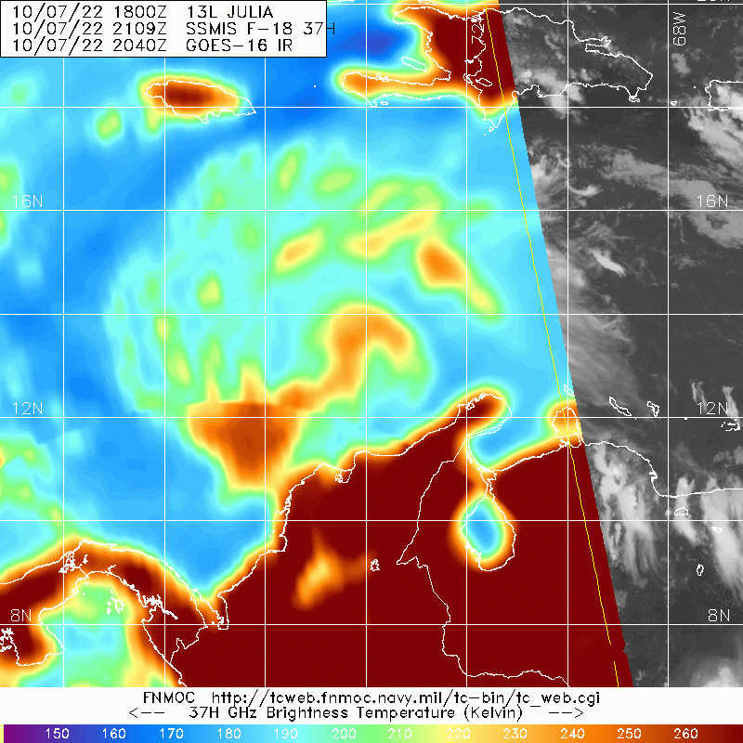
2219 | Sonde #3 – QRTPNT (Quarterpoint) North
2228 | Flight level (FL) winds want to take the airplane to the SE to get through a FL center, but decided to just stay the course, especially considering a deviation to head to the center would take us into intense convection that we really need to avoid.  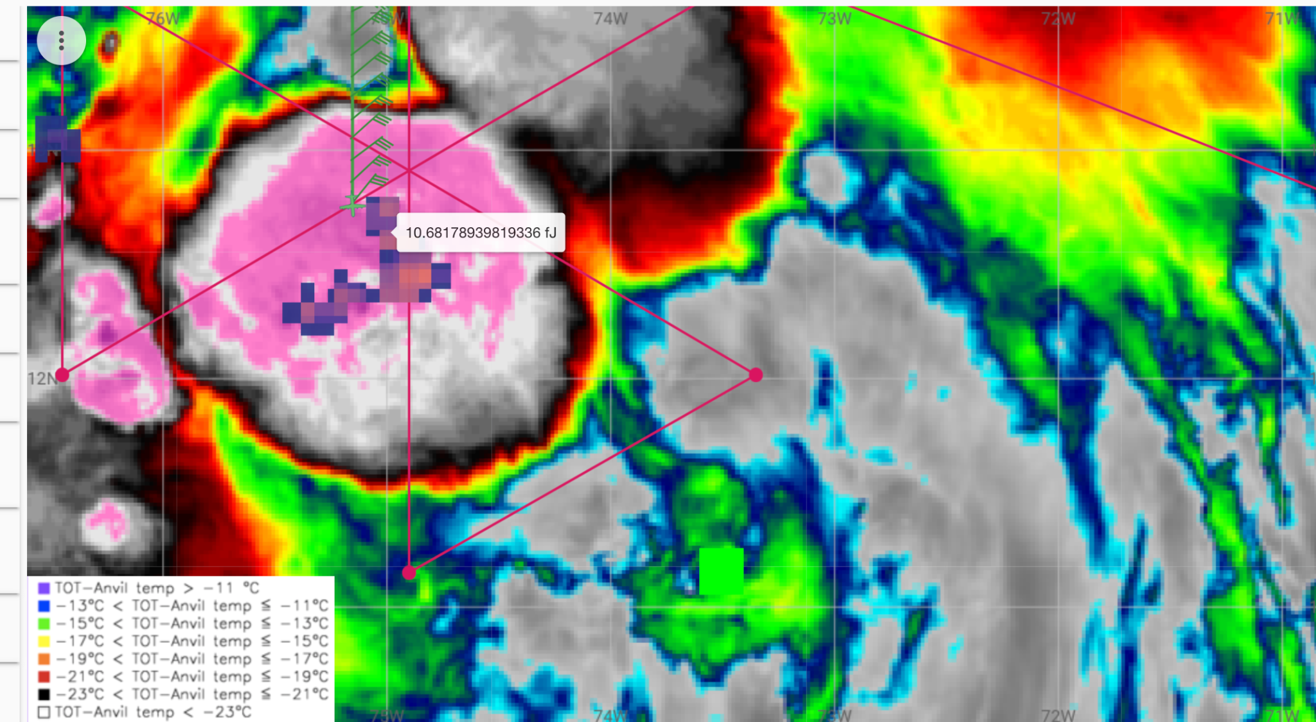
2225 | Sonde #4 – CENTER #1 – but not really at the center since we didn’t deviate to head towards the FL center, so just the closest point of approach (CPA). The sonde indicated sub-1000 mb MSLP, so the extrapolated minimum sea level pressure from the data system of 997 mb may not be too far off.
2230 | Sonde #5 – QTRPNT South
2237 | Some bumps in convective cores – the airplane is deviating around the deepest of the convection, essentially finding a weaving path between the intense convection that developed to the south and to the east. Lots of lightning in the burst to the east of the airplane.
2241 | Some sort of mesoscale convective vortex observed? There was a clear wind shift in the flight level winds as the airplane went through the convective line. Though, the real center could still be further north where there was a more robust curvature of the winds, indicating the center to have been just east of the track as the airplane was deviating to get through the convection.  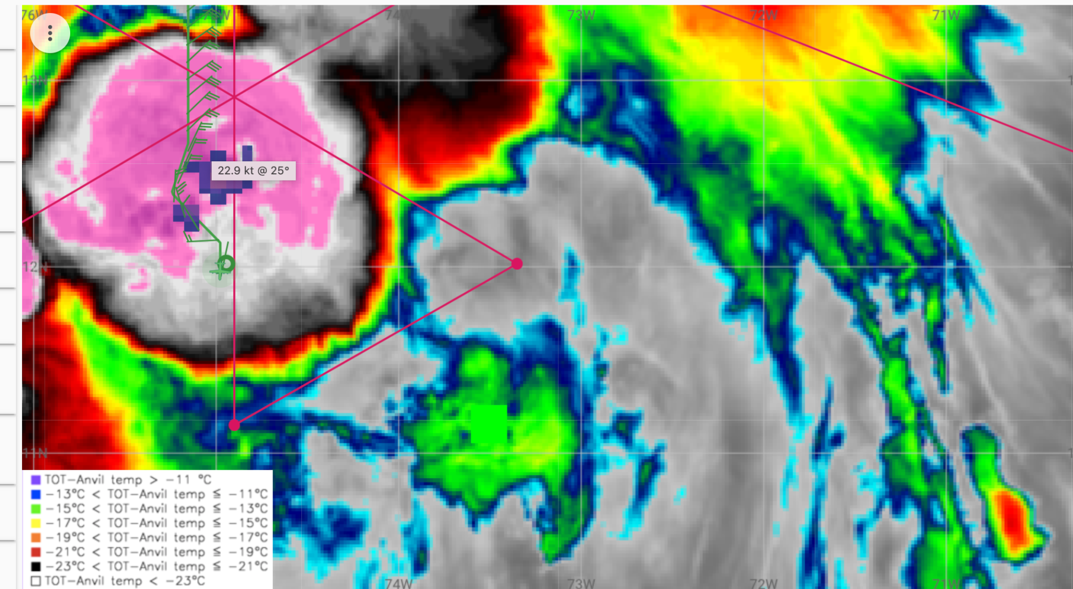
2241 | Sonde #6 – MP South
2248 | Sonde #7 – EP South
2254 | Target the original, but translated center point instead of the shift we went through in the convection for the next pass.
2255 | Another look at recent microwave imagery, showing the very intense convection (scattering in the 91 GHz channel) on both the south and east sides of the circulation. This convection is certainly just about as intense as you will see in an oceanic environment.  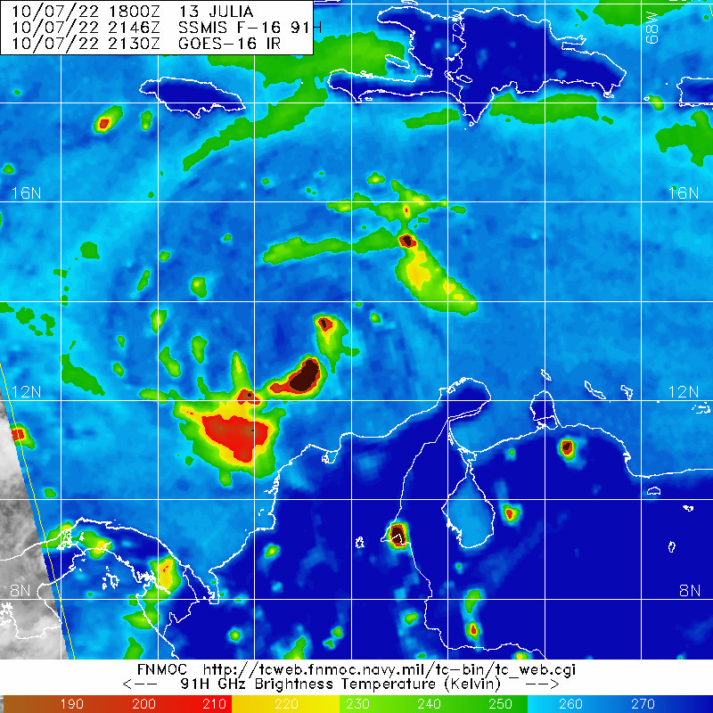  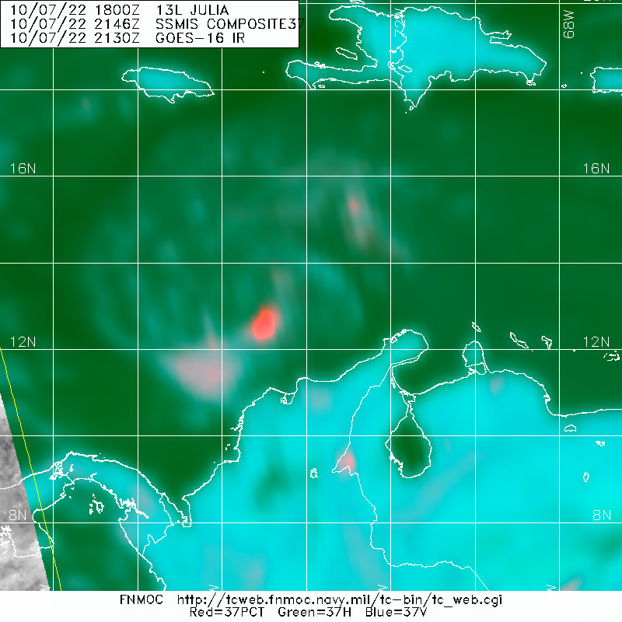
2311 | Sonde #8 – EP SE, now inbound from the southeast to northwest for the 2nd pass
2322 | Sonde #9 – MP SE. The airplane is now tracking more like a 290 degree instead of 300 in order to try and pass closer to the intense convection (without going through it). The suspicion is that the low-level center is either being advected or reformed in the vicinity of the deep convection to the south of where we anticipated the center on the first pass.
2328 | Sonde #10 – QTRPNT SE
2333 | Sonde #11 CENTER #2, but really dropped as a closest point of approach (we never got a wind shift, and are certainly north of the low-level and flight-level center).
2337 | Report from the onboard LPS is that this is about as intense as oceanic deep convection can get. It almost has the characteristics of land-based strong convection. The lightning in the burst is nearly continuous, and the echo top heights were observed at nearly 19 km. Even the 40 dBZ echo tops were reaching 15 km. This burst is at the top percentile of oceanic convection. Could even be described as a “formative” burst, such that it could be developing a new low-level center – actually changing the structure of the storm.
2340 | Sonde #12 – QTRPNT WNW – airplane is still outbound on the 290 degree radial instead of 300, since they’ll need to reposition a bit further south to try and get as close to the low-level center near the convective burst as possible.
2346 | Sonde #13 – MP WNW
2350 | 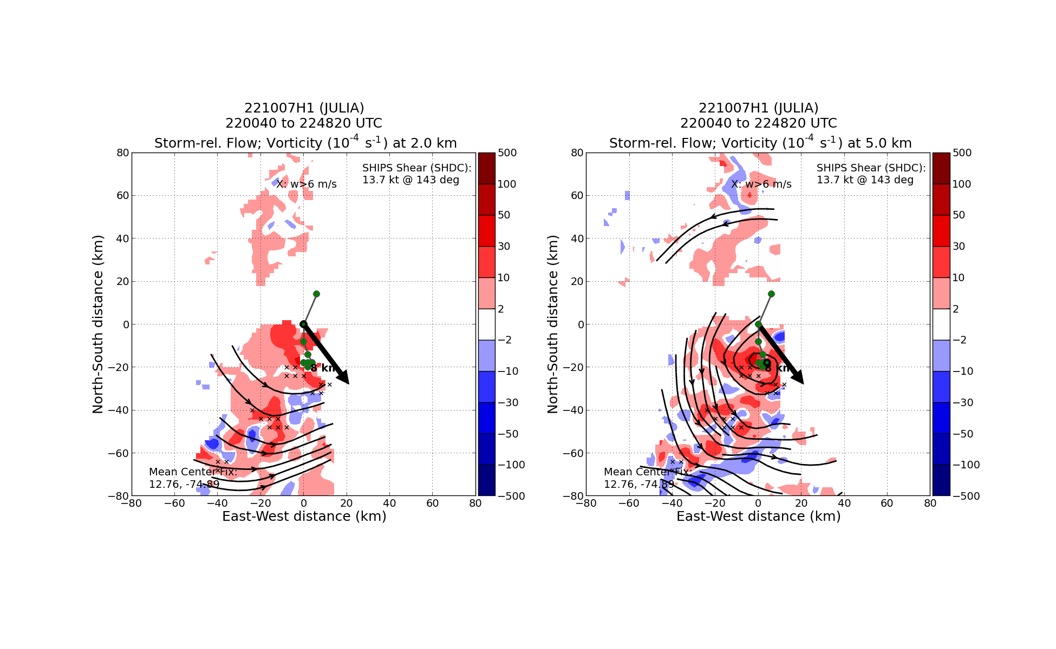  A look at the first TDR analysis from the first pass, relative vorticity and streamlines at 2 and 5 km, showing some tilt to the south with height, which is consistent with the northerly shear that the storm is experiencing.  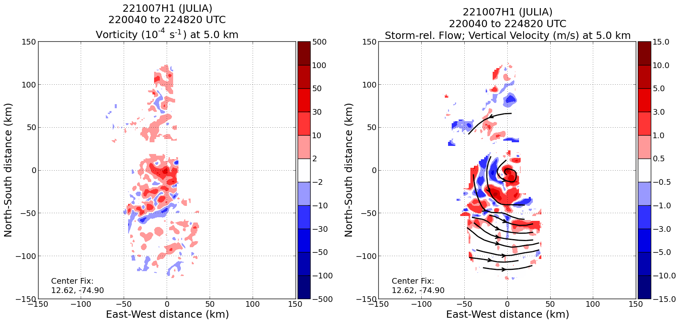  Another look at the TDR analyses from the first pass, this one showing vertical velocity and indicating updrafts of 10-15 m/s right over the center in that intense convective burst which continues to persist even now into the 2nd pass of the storm.
2352 | Gonna cut the outbound leg to the west a little short in order to stay inside a cellular convective line that may be challenging to get through again if we go radially outside of it. This will also shorten the next inbound from the southeast, though we’re not missing much precipitation radially outward of this outer band.
2356 | Sonde #14 – EP WNW, now going to reposition the airplane to the southwest for the third and final pass.
0015 | Sonde #15 – IP/EP SW, now inbound towards the “center” again, from the southwest to the northeast. Tracking 050 degrees heading. This should keep us clear of the intense convection, but close enough to still scan it with the TDR.
0024 | Sonde #16 – QTRPNT SW
0032 | Sonde #17 – CENTER #3, but really a CPA of the center since we didn’t try and find a wind shift.
0033 | Sonde #18 – Backup for #17 since #17 was a possible fast fall
0036 | The intense convective burst is still going strong! Even magenta was seen on the nose radar, and once again TDR sweeps on the airplane are observing a 19 km echo height. The burst continues to impress in its strength and frequent lightning.
0037 | 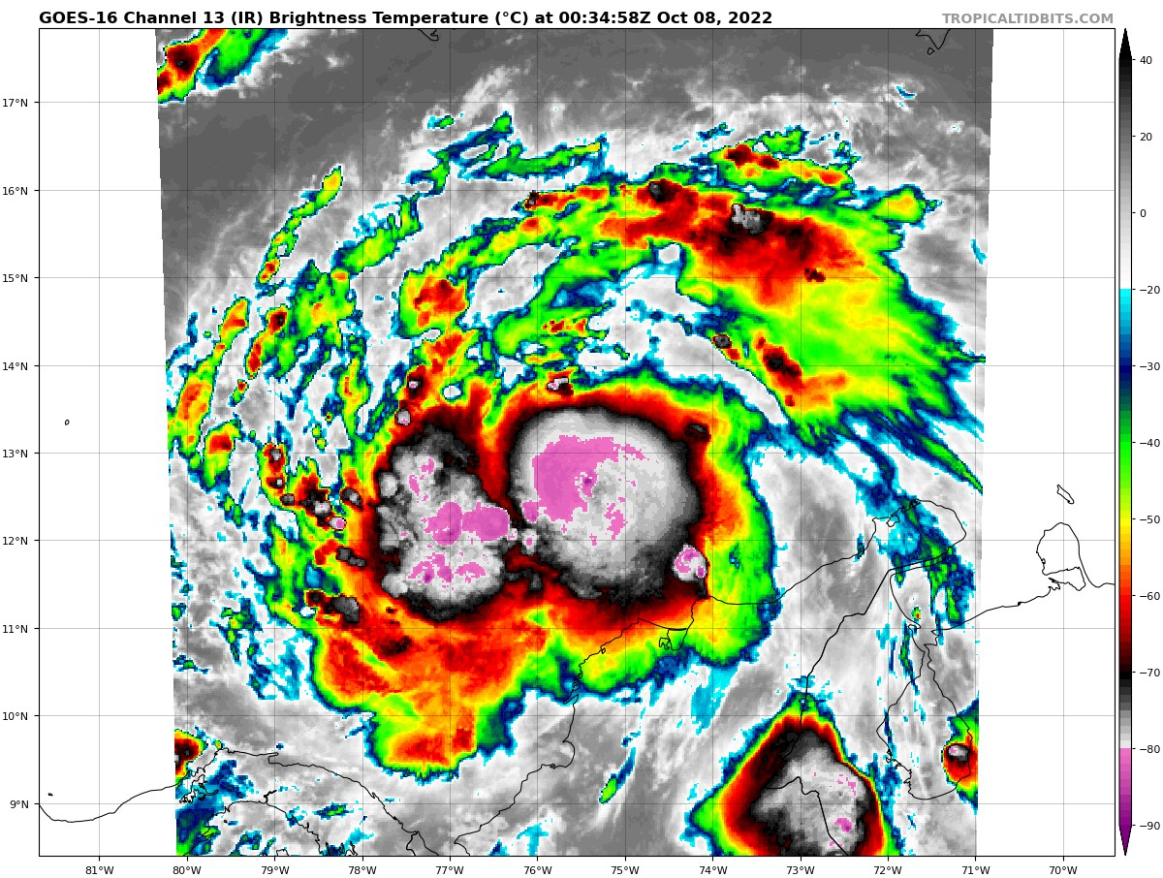
0038 | Sonde #19 — QTRPNT ENE; the airplane continues to fly NE, but will jog a bit more ENE (060 heading) once past the deep convection.
0040 | TDR analysis showing some really impressive outflow in the burst…  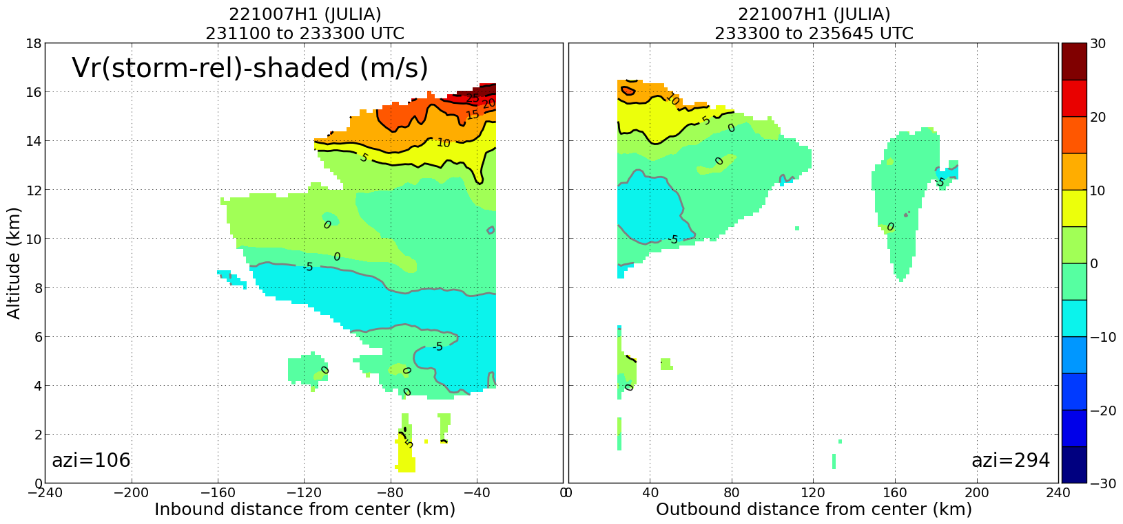
0043 | Sonde #20 – MP ENE
0059 | Sonde #21 – EP NE; the airplane will remain at 10 kft for a few more minutes before speeding up and heading towards Aruba.
0157 | A look at the final TDR merged analysis, showing the high reflectivity associated with the intense convective bursts on the east and south sides, as well as the low-level (2 km) and midlevel (5 km) streamlines, indicating that a broad low-level circulation was observed, as well as hints of a tilted midlevel center (south of the low-level center).  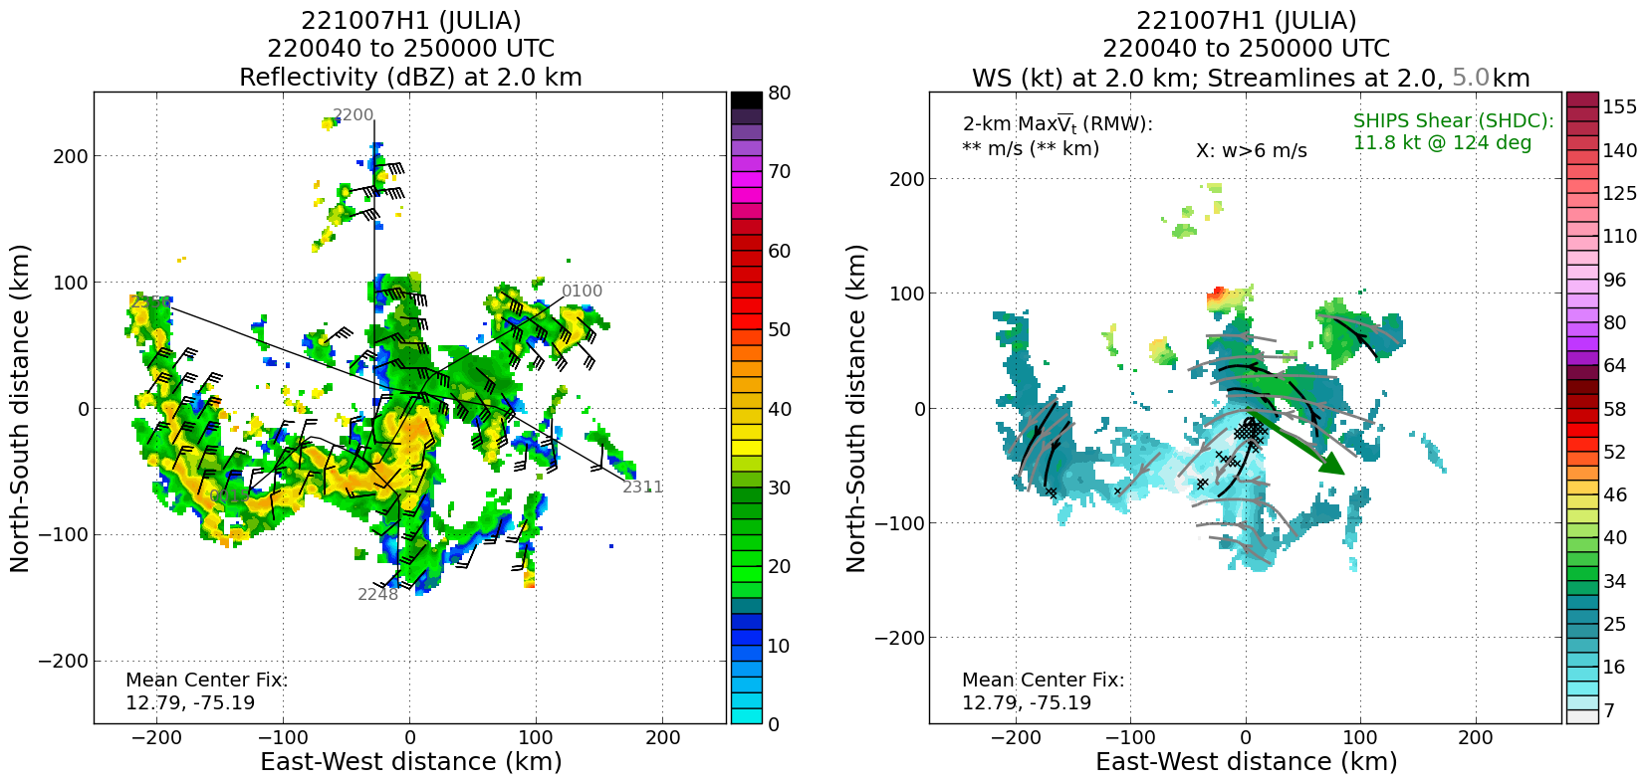

POST-FLIGHT
Mission Summary | We flew a butterfly pattern through Tropical Storm Julia, which had recently been upgraded from a Tropical Depression prior to the flight. As the TS moved offshore of South America, it had gotten into some fairly favorable conditions for intensification. During the flight the most notable feature was the very impressive, intense convective bursts near the center of the TC, to the south and east of the possible low-level center. This deep convection, particularly the longer lasting and more persistent southern burst, appeared to be reforming the center a little bit south of prior estimates. Certainly the convective burst was intense enough to do so, considering all metrics (vertical velocity exceeding 15 m/s; echo top heights above 18 km, 40 dBZ echo tops above 15 km, frequent lightning) put that convective burst in the very top percentile of oceanic convection. Very impressive, and well observed by the TDR on all three passes – observed well enough for us to potentially look at its lifecycle (growing on each pass).  Given the intensity of that convection, though, we had to dodge quite a bit of it, which didn’t permit good center fixes of either the low- or mid-level center. The TDR, though, should help in that assessment. The sondes were also very complete and all worked well, which will provide additional, critical information on not just the locations of the circulations below the flight level, but also what may have been so unique about the low-level instability and thermodynamic environment to support the development and persistence of such strong convection.  For ONR purposes, we were not able to complete the stratiform spiral module near the IP, nor dropped RMW sondes (too broad of an RMW to really target well). That said, we replaced the RMW sondes with quarterpoint sondes (released midway between the midpoint sonde and center sonde). These should still be helpful in the assessment of the storm structure.  21 sondes were released in the pattern, with only one “bad” sonde that appeared to be a fast fall on launch (15 charged to NWS, 6 charged ONR).
Actual Standard Pattern Flown | Butterfly flown at 10 kft pressure altitude
APHEX Experiments / Modules Flown | The data collection was consistent with the objectives of Early Stage: AIPEX and was flown in collaboration with ONR TCRI.
Plain Language Summary | - We flew a mission to collect radar data in Tropical Storm Julia as it was starting to strengthen.  - There was a strong updraft within a precipitation area near the developing center of the storm that persisted throughout the flight and led to a reformation of a new surface center, or moved the low center into that heavy precipitation area. The deep convection was at the top percentile of strength for oceanic convection.
Instrument Notes | None really – an apparent issue with ‘radarsync’ just happened to be a mistake in the job file submission file during a test submission. The test jobfile submission was because the radarsync terminal did not display any output before jobfile submission, which it was believed to do before. It’s still odd that the radarsync terminal did not display a status until the jobfile was submitted.
Final Mission Track | 