MISSION PLAN
FLIGHT ID | 20220811N1 | STORM | AL97 / ITOFS-East #1
MISSION ID | WCWXA AL97 | TAIL NUMBER | NOAA49
TASKING | HRD | PLANNED PATTERN | Survey
MISSION SUMMARY
TAKEOFF [UTC] | 1208 | LANDING [UTC] | 1717
TAKEOFF LOCATION | Sal, Cabo Verde | LANDING LOCATION | Barbados
FLIGHT TIME | 5.2 | BLOCK TIME | 5.3
TOTAL REAL-TIME RADAR ANALYSES  (Transmitted) | None | TOTAL DROPSONDES (Good/Transmitted) | 8 (8/8)
OCEAN EXPENDABLES (Type) | None | sUAS (Type) | None
APHEX EXPERIMENTS / MODULES | ITOFS-East
HRD CREW MANIFEST
LPS ONBOARD | Dunion | LPS GROUND | Zawislak
TDR ONBOARD | Dunion | TDR GROUND | Reasor
ASPEN ONBOARD | Dunion | ASPEN GROUND | None
NESDIS SCIENTISTS | None
GUESTS (Affiliation) | None
AOC CREW MANIFEST
PILOTS | Waddington, Mansour
NAVIGATOR | None
FLIGHT ENGINEERS | None
FLIGHT DIRECTOR | Kalen
DATA TECHNICIAN | Defeo
AVAPS | Lynch

PRE-FLIGHT
Flight Plan | 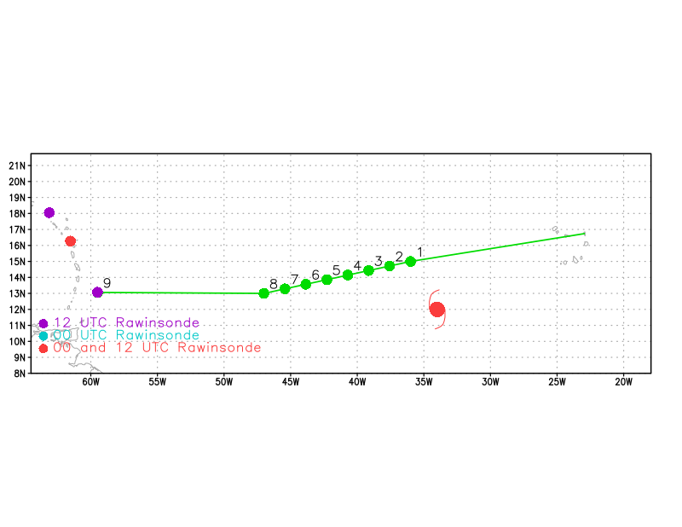
Expendable Distribution | Release a dropsonde at each of the green dots in the above image; Intermediate dropsondes along the track may be requested to target gradient areas
Preflight Weather Briefing | AL97 continues to struggle out in the central Atlantic with little change in look since yesterday. The northern part of the disturbance is entraining dry, SAL air from the northwest, while a plume of moisture from the south on the eastern side of the disturbance is trying to keep some semblance of convection going within the elongated vorticity center. A zonal line of convection once again appears near the SAL boundary in the ITCZ, but it’s doing little to help AL97 get any closer to development. NHC has lowered the chances of development in 2 / 5 days to 0%. Certainly looks like this has become a null case. The goal of today’s flight is simply to release 8 dropsondes in the model sensitivity areas indicated below between 10-15N / 30-50W on the airplane’s ferry to Barbados.  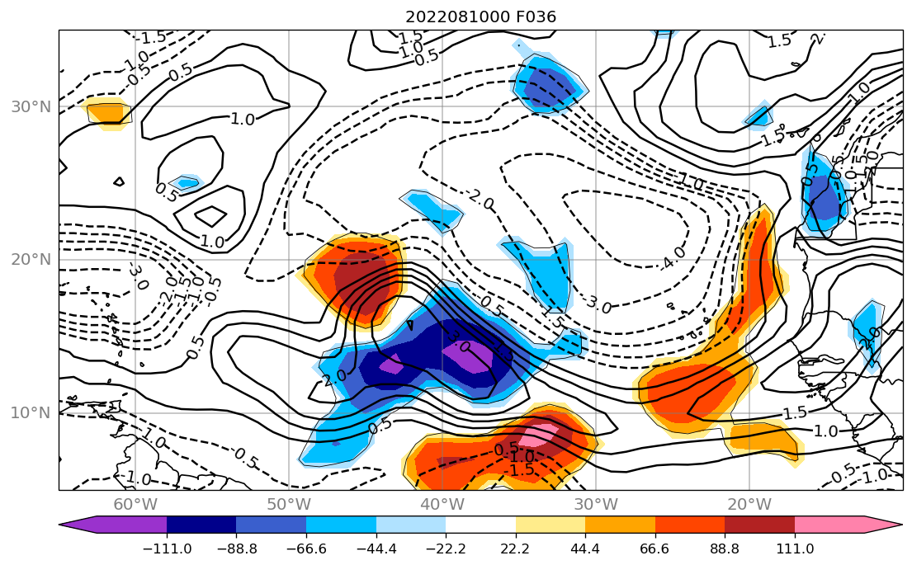  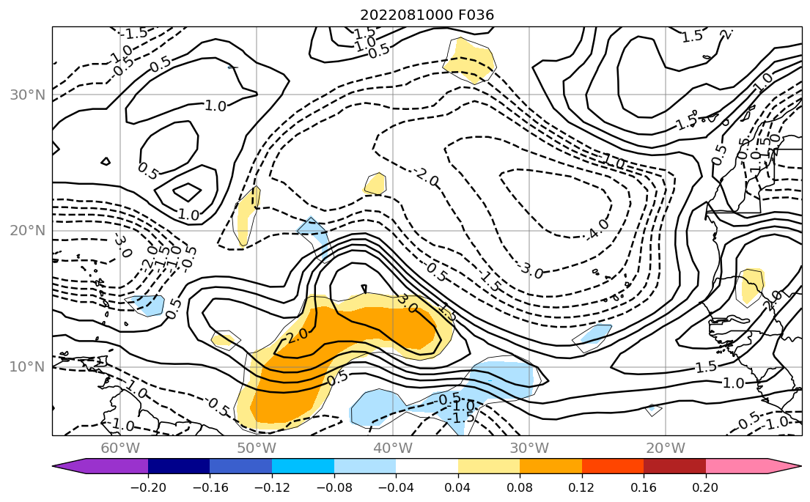  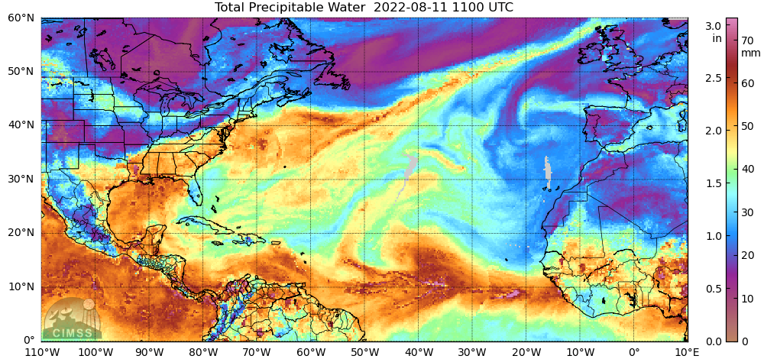  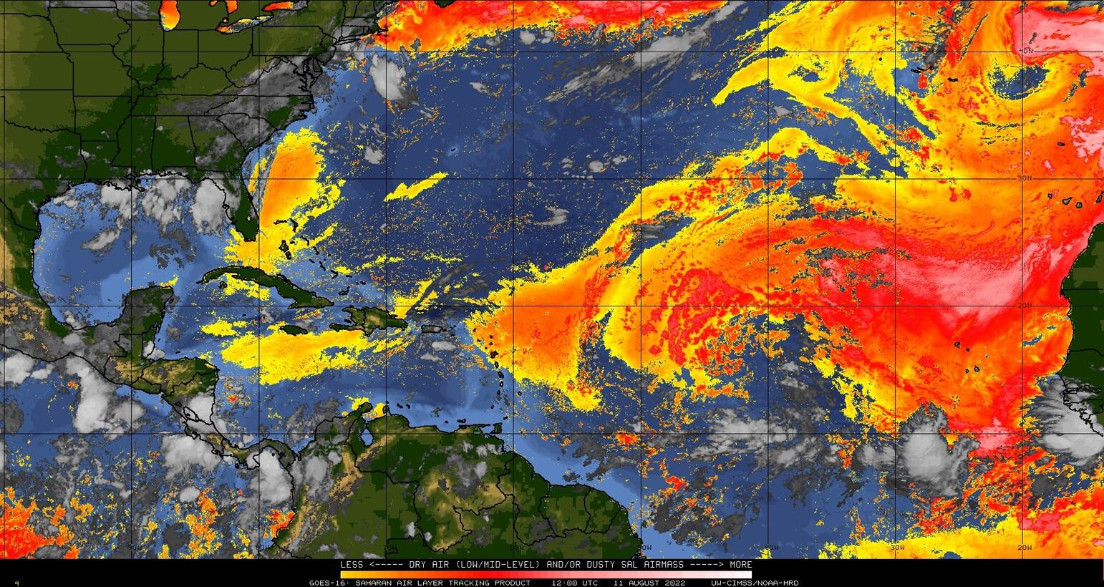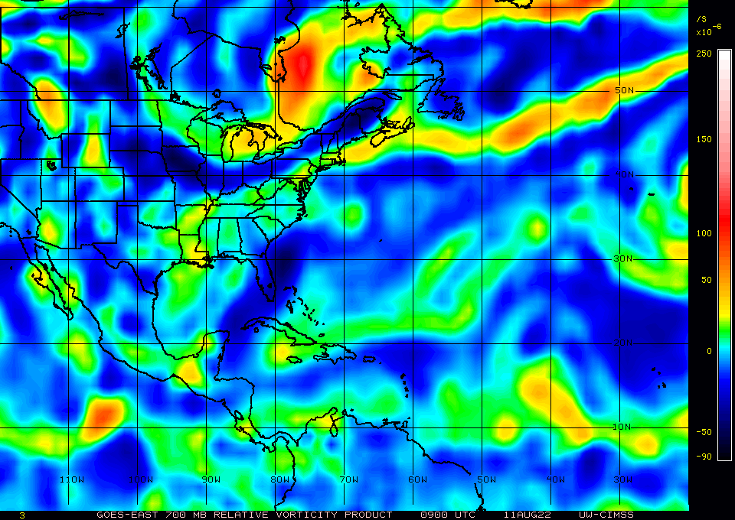
Instrument Notes | None noted

IN-FLIGHT
Time [UTC] | Event
1208 | Takeoff from Sal Island, Cabo Verde
1247 | With AL97 decaying, this mission is simply to release 8 dropsondes in the model sensitivity areas associated with the wave on the ferry to Barbados. The sondes will be released along a string on the ferry path through the disturbance, primarily in the dry, SAL portion of the wave, though the first few sondes should be in the moderately moist plume pushing up from the south from the ITCZ on the eastern side of the disturbance. We will not create TDR analyses given the lack of extent of convection along the path.  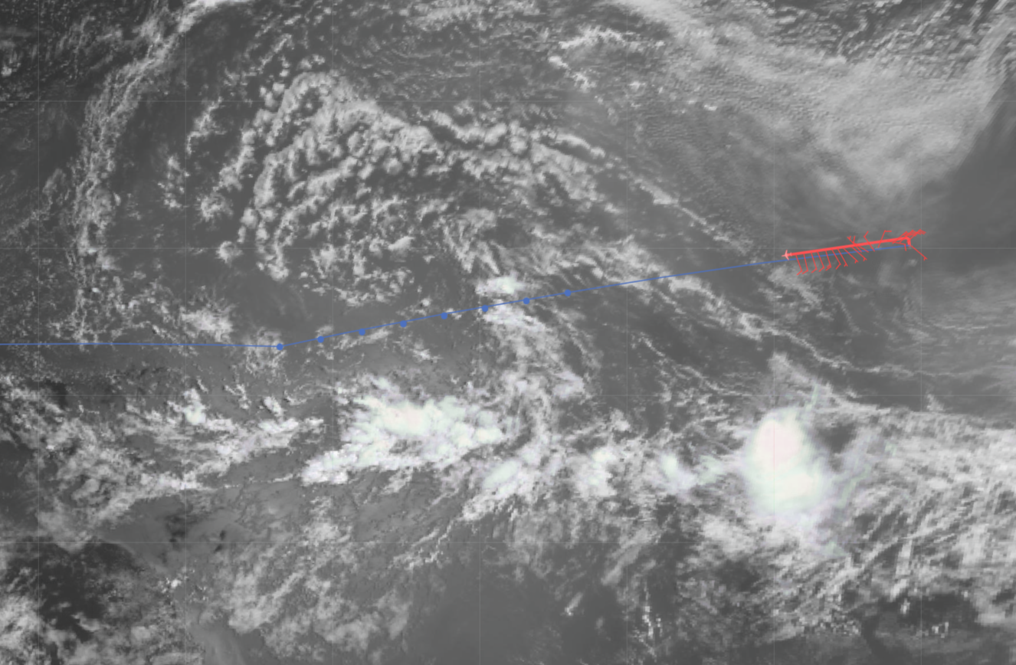  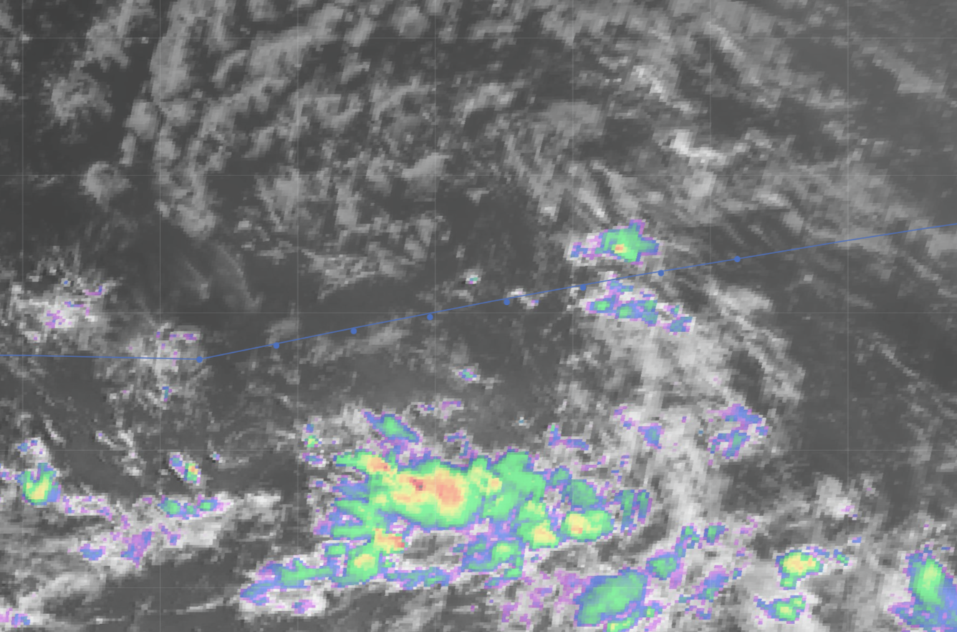
1353 | Going to hit dropsonde PT1 in just a few minutes. Bit of convection to start the string of sondes in the moisture plume coming up from the ITCZ. The TDR will collect data, but no analysis will be produced.  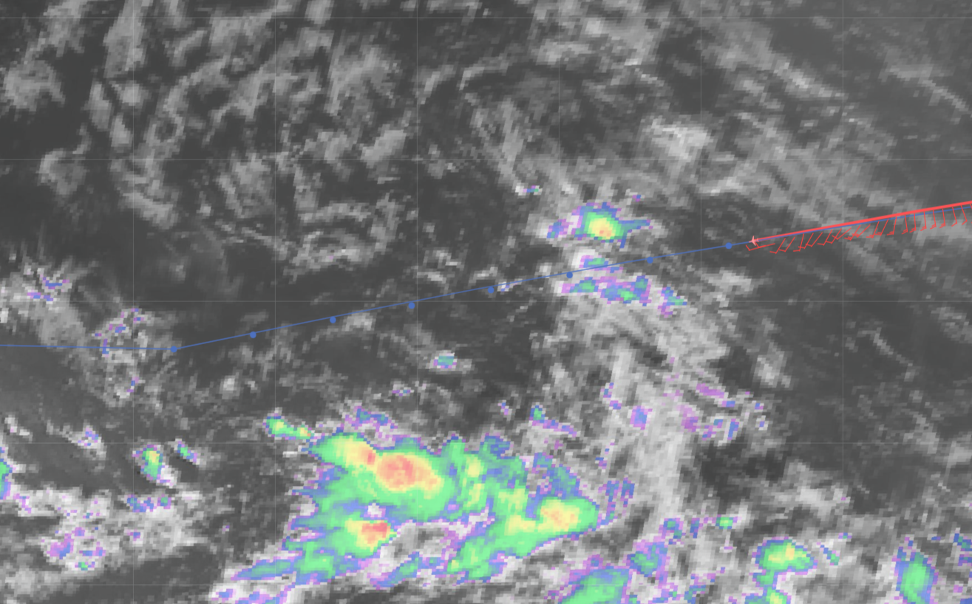
1412 | Past drop PT2, about the fly through the only convection of substance for the leg. PT2 (east) and PT3 (west) actually straddle either side of the convection, which is convenient.  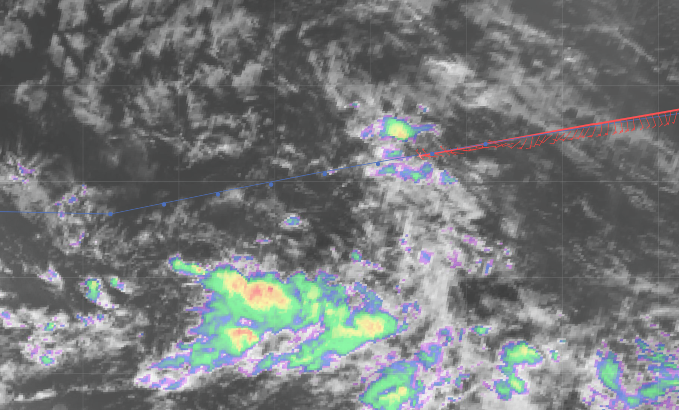
1425 | The G-IV should soon be clear of the convective area  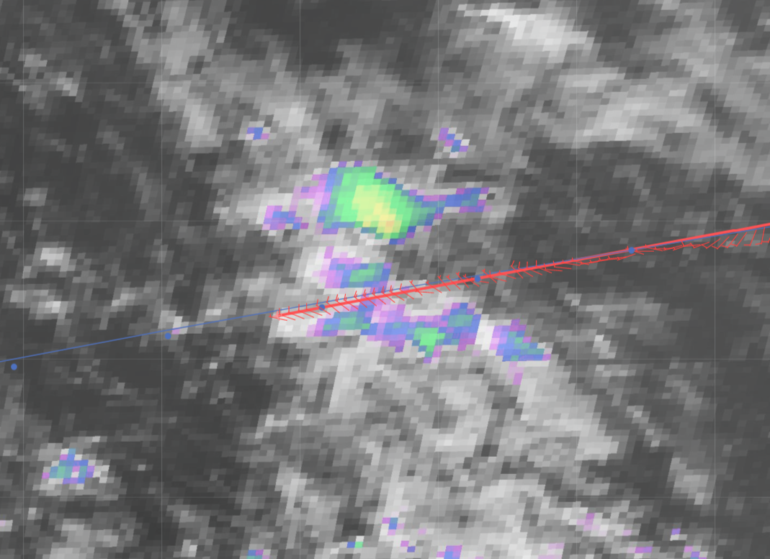
1440 | Reached the midpoint of the string of sondes. A WindBorne balloon was located approximately 75 n mi north of the G-IV at PT4 (W-344 located 2456 ft at 15.557N / 40.875W). This balloon was launched on 8/8 from C.V.  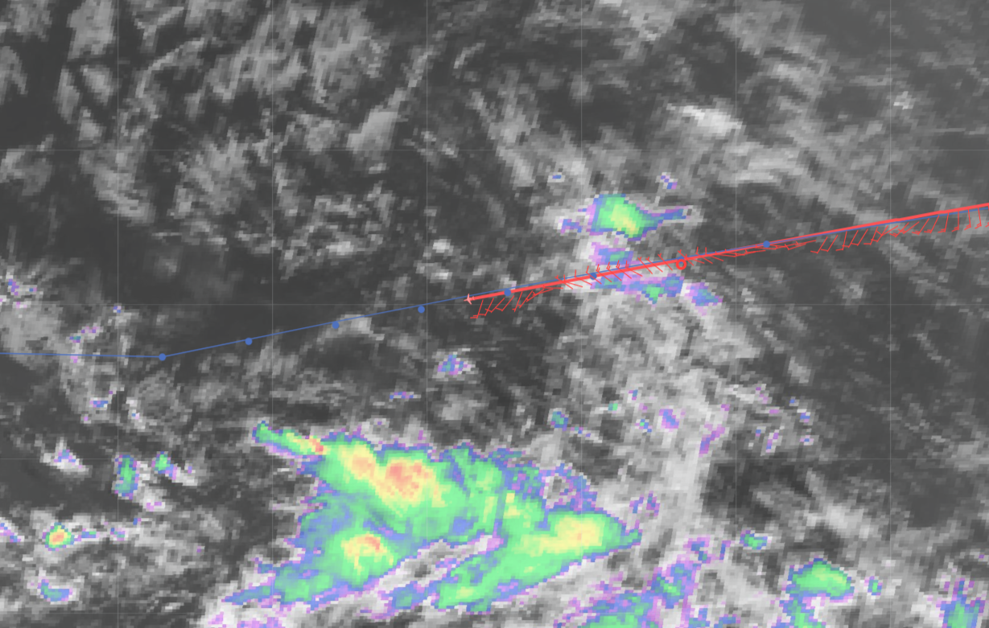  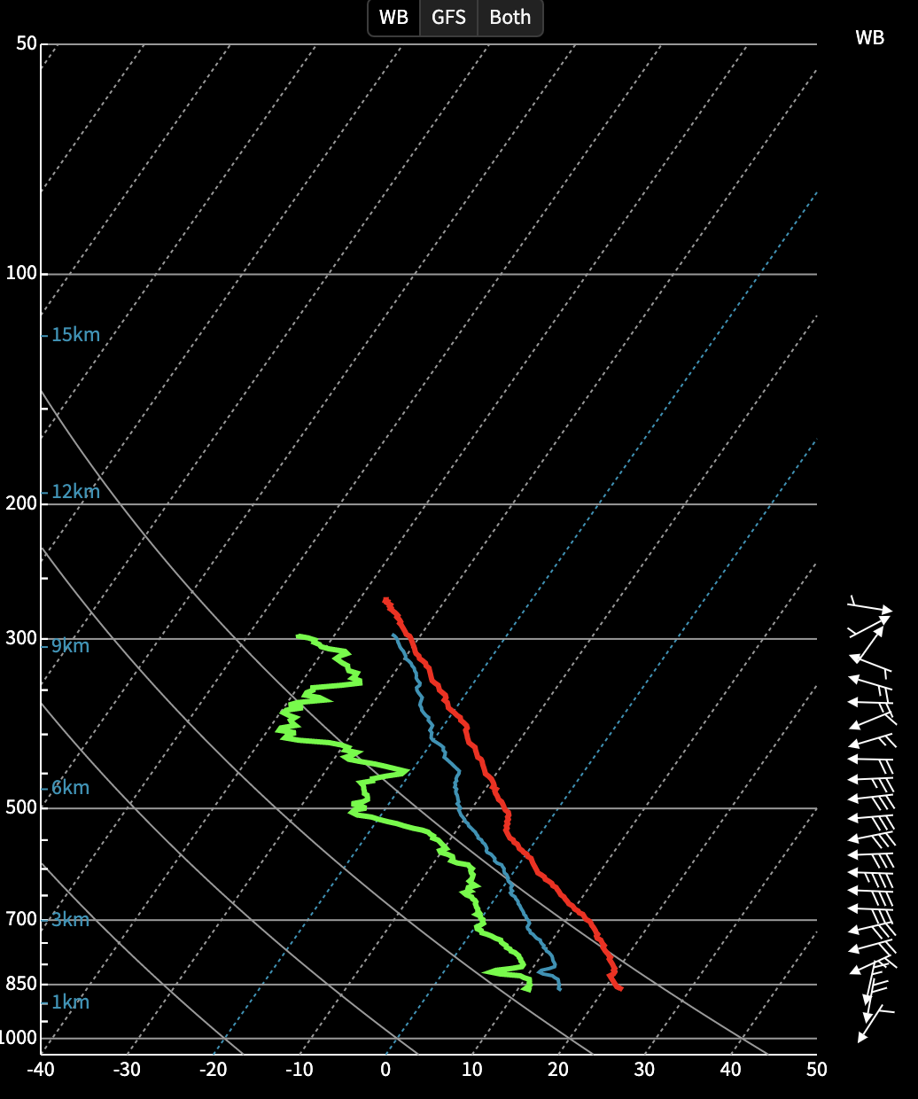
1527 | The string of dropsondes is complete, which ends the relatively brief science portion of the ferry flight. Here is the final track:  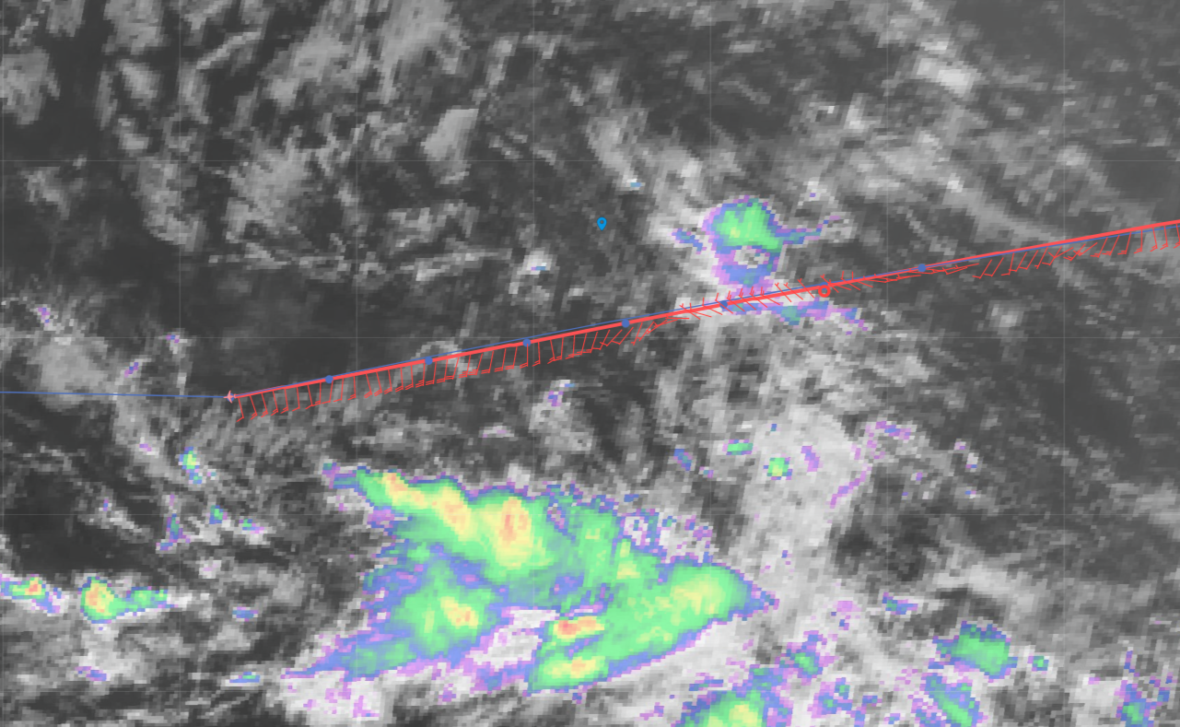  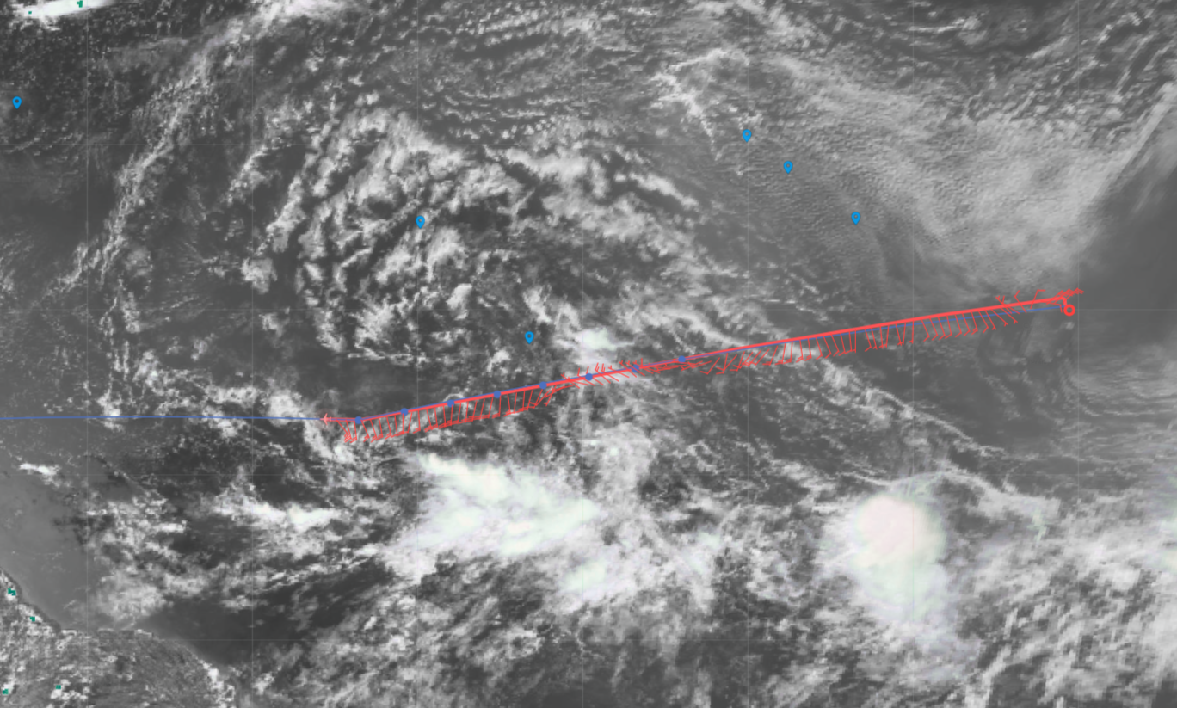  One more look at the TPW and SAL products:  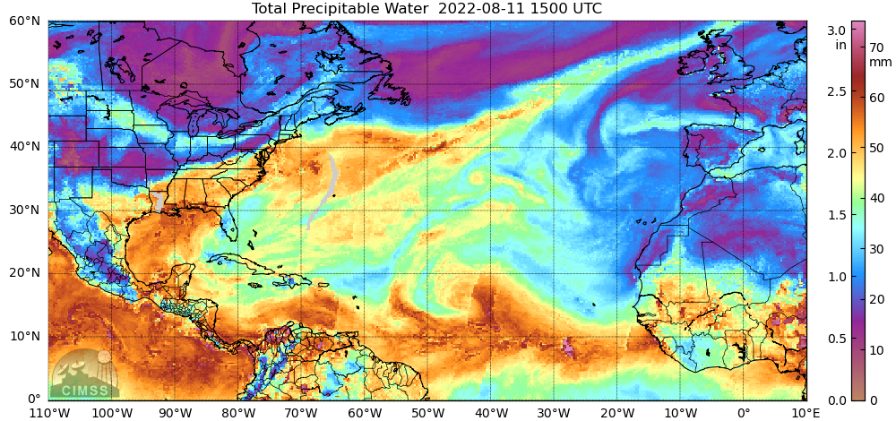  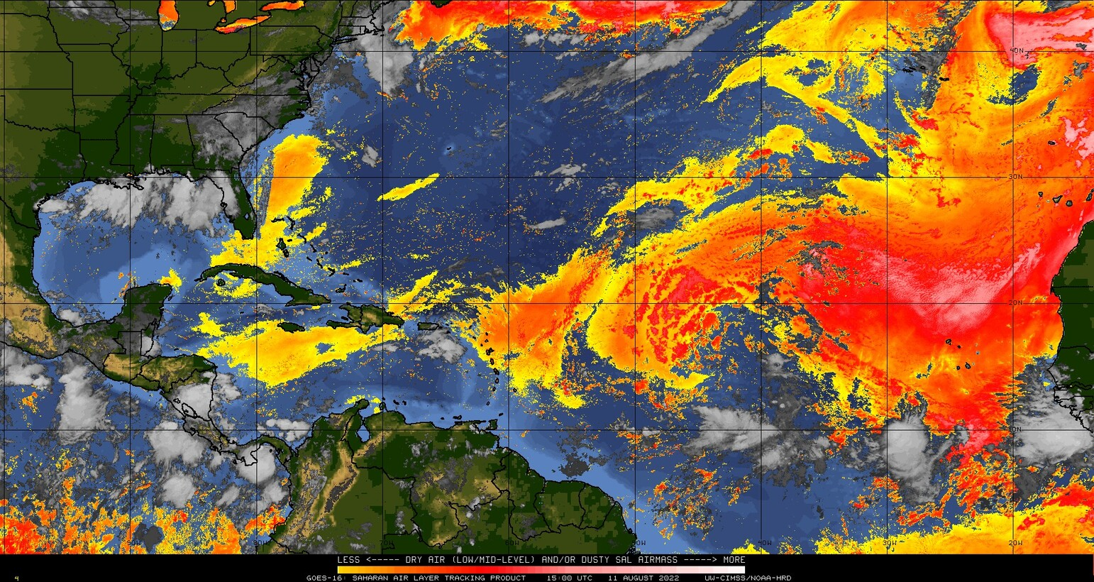  The final satellite loops encompassing the mission so far:
 | Landing in Barbados

POST-FLIGHT
Mission Summary | The final mission in AL97 (now ex-AL97) involved the release of 8 dropsondes in the identified areas of ensemble model sensitivity for track and intensity. AL97 has become engulfed in dry air from the SAL, with only a small sliver of moisture advecting up on its eastern side from the ITCZ. Convection continues to be less widespread and it appears now that AL97 will be decidedly a null case for ITOFS-East’s first deployment.  8 sondes were released (8 were good, 8 were transmitted). All dropsondes charged to HRD.
Actual Standard Pattern Flown | Survey
APHEX Experiments / Modules Flown | The final mission flown in the first deployment for ITOFS-East
Plain Language Summary | - AL97 has more or less dissipated in the central Atlantic, having been overcome by the dry air associated with the Saharan Air Layer that has been following the wave as it has moved from the eastern to central Atlantic.  - Observations targeted in areas in which global forecast models are most sensitive to receiving that wind and humidity information – this is called targeted observations. The goal is to improve the model forecast by strategically placing these observations (dropsondes) in the areas where they will make the most impact in the model after assimilation into the initialization of the model run.
Instrument Notes | None noted
Final Mission Track | 