MISSION PLAN
FLIGHT ID | 20220928H1 | STORM | AL09 / IAN
MISSION ID | 2809A | TAIL NUMBER | NOAA42
TASKING | EMC | PLANNED PATTERN | Butterfly
MISSION SUMMARY
TAKEOFF [UTC] | 0755 | LANDING [UTC] | 1442
TAKEOFF LOCATION | Ellington (TX) | LANDING LOCATION | Ellington (TX)
FLIGHT TIME | 6.8 | BLOCK TIME | 7.0
TOTAL REAL-TIME RADAR ANALYSES  (Transmitted) | 3 (3) | TOTAL DROPSONDES (Good/Transmitted) | 12 (12 / 12)
OCEAN EXPENDABLES (Type) | None | sUAS (Type) | 1 Altius-600
APHEX EXPERIMENTS / MODULES | Mature Stage Experiment: RICO SUAVE
HRD CREW MANIFEST
LPS ONBOARD | Rogers, Cione (Altius) | LPS GROUND | Fischer
TDR ONBOARD | Wadler | TDR GROUND | Fischer
ASPEN ONBOARD | J. Zhang | ASPEN GROUND | None
NESDIS SCIENTISTS | None
GUESTS (Affiliation) | Liccini (Altius), Sosa (Altius), Underwood (AOC), Barlow
AOC CREW MANIFEST
PILOTS | Abitbol, Copare, Wood
NAVIGATOR | Miller
FLIGHT ENGINEERS | Stokes, Gee
FLIGHT DIRECTOR | Holmes, Kalen
DATA TECHNICIAN | MacAlister
AVAPS | Dykeman

PRE-FLIGHT
Flight Plan | 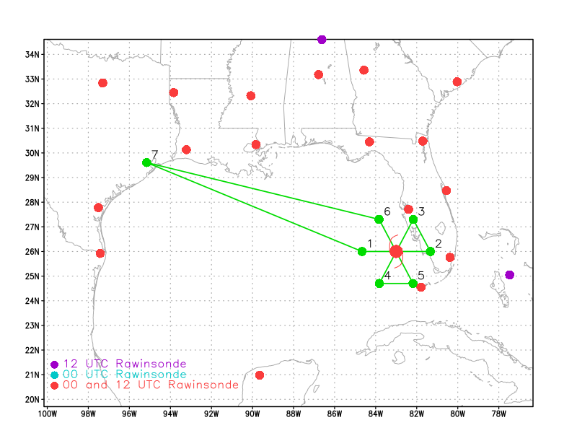  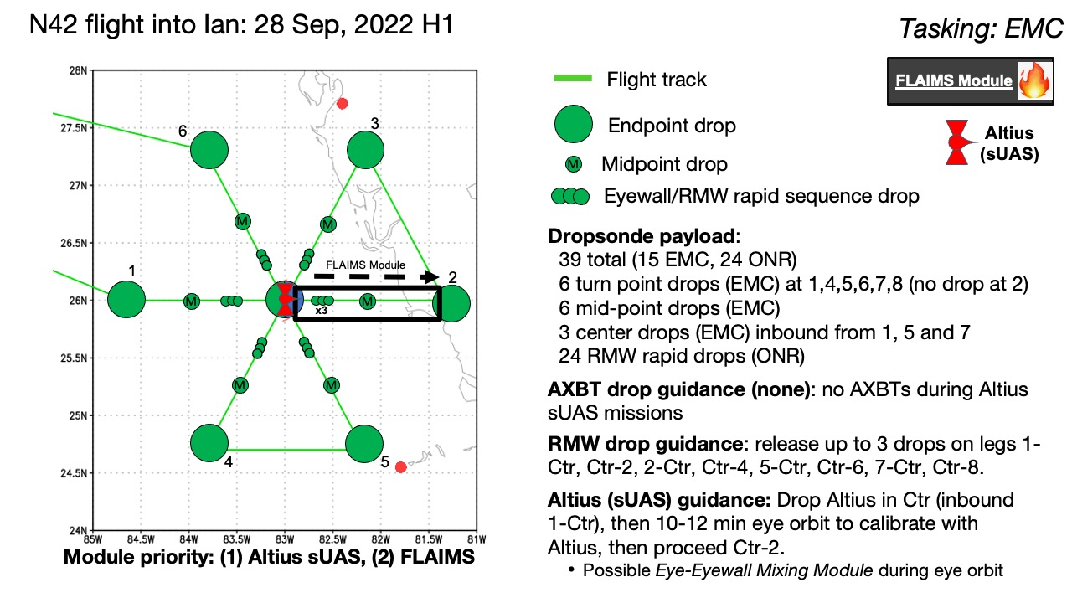  Fly butterfly pattern for EMC tasking, IP on the W side, 90 nmi leg lengths. Will have to trim the radial legs on the east side of the storm due to proximity to the Florida peninsula. In addition to EMC TDR objectives, the primary science objective is launching of Altius sUAS. This will occur during the first inbound leg to the center. Altius will fly a series of patterns including center fixes at 4 kft and potentially down near the surface, circumnavigations at multiple altitudes, and multiple traversals of the eyewall at oblique angles. Also fly a FLAIMS module, reverse track on the east side, fly inbound and then back out before resuming butterfly. Finally, if possible, do an Eye-eyewall Mixing Module, where the P-3 orbits in the eye such that the orbit is accomplished over a 6-minute period.
Expendable Distribution | Dropsondes at all endpoints, midpoints, RMW rapid-fire, and center passes. Release Altius at first eye penetration coming inbound from the west. No AXBTs.
Preflight Weather Briefing | Ian is nearing landfall on the Florida west coast. The storm is currently a Category-3 hurricane, moving toward the NNE at 9 kt. The most recent center fix from the AF had a pressure of 954 hPa. Ian continues to present a mostly clear eye on satellite imagery, though IR imagery over the past 12 h or so has shown indications of southwesterly shear impacting the inner core. There appear to be periodic episodes of convective initiation on the NE (downshear) side, growing cold cloud tops around the NW (downshear left and left of shear) side, becoming most extensive on the SW and S (upshear and upshear right) sides. These are pulsing, with a period of a few hours, suggesting some kind of cycling process for convective evolution indicative of a TC encountering vertical wind shear. Radar also suggests an eyewall replacement cycle may be occurring as well.  Vertical shear appears to have started increasing from the southwest, as indicated by the appearance of restricted outflow on the southwest side as well as the aforementioned cycling of eyewall convection on IR imagery. Dry air is likely also entraining into the system. Despite these apparent unfavorable conditions, Ian has intensified to a Category 4 hurricane, as reflected by the NHC 5am discussion and a recent AF fix showing the MSLP had dropped 10 hPa to 942 hPa and flight-level winds of 140 kt.
Instrument Notes | All instruments are functioning normally.

IN-FLIGHT
Time [UTC] | Event
0755 | Takeoff from Ellington Field
0929 | Near IP, we are going to modify the pattern a bit so that our leg on the east side is along 110 radial instead of 090 radial. This will prevent us having to shave the east leg as much.
0929 | Radar observations from Tampa show a well-defined eye and eyewall, which is weaker on the SE side. Key West radar confirms that side is weaker.
0933 | GOES-16 observations show the eyewall also appears weaker on the SE side, but convection appears quite deep, with frequent lightning in the eyewall.
0954 | Drop 1, W endpt
0958 | Nice presentation on nose radar of inner core, looks like a possible outer eyewall
1003 | Drop 2, W midpt
101110 | Drop 3, 1st W RMW
101140 | Drop 4, 2nd W RMW
101210 | Drop 5, 3rd W RMW
1021 | Updated ground radar animation during time of first pass through western eyewall
1023 | Drop 6, center, 25deg 46min 82deg 51min
1030 | Launch Altius (25.90 N 82.80 W)
1037 | Drop 7, 2nd center
1040 | Drop 8, 1st RMW E
1040 | Drop 9, 2nd RMW E
1041 | Drop 10, 3rd RMW E
1049 | Drop 11, endpt E
1203 | Drop 12, endpt SSW
1208 | Radar animation from Tampa 88D
1212 | Altius splash (last data transmission)
1221 | NOAA 42 light track, Miami radar, and Altius sUAS deployment (courtesy NASA MTS). Images are identical except the radar reflectivity is semi-transparent in the bottom image.  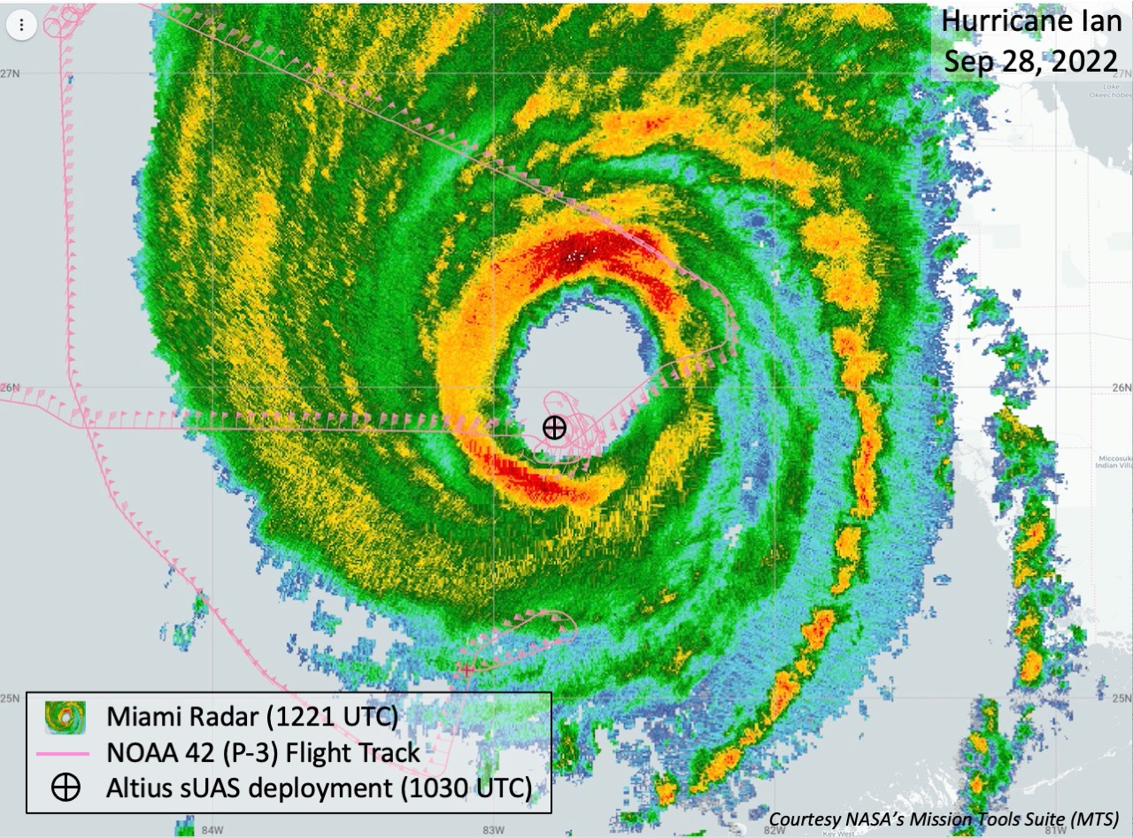  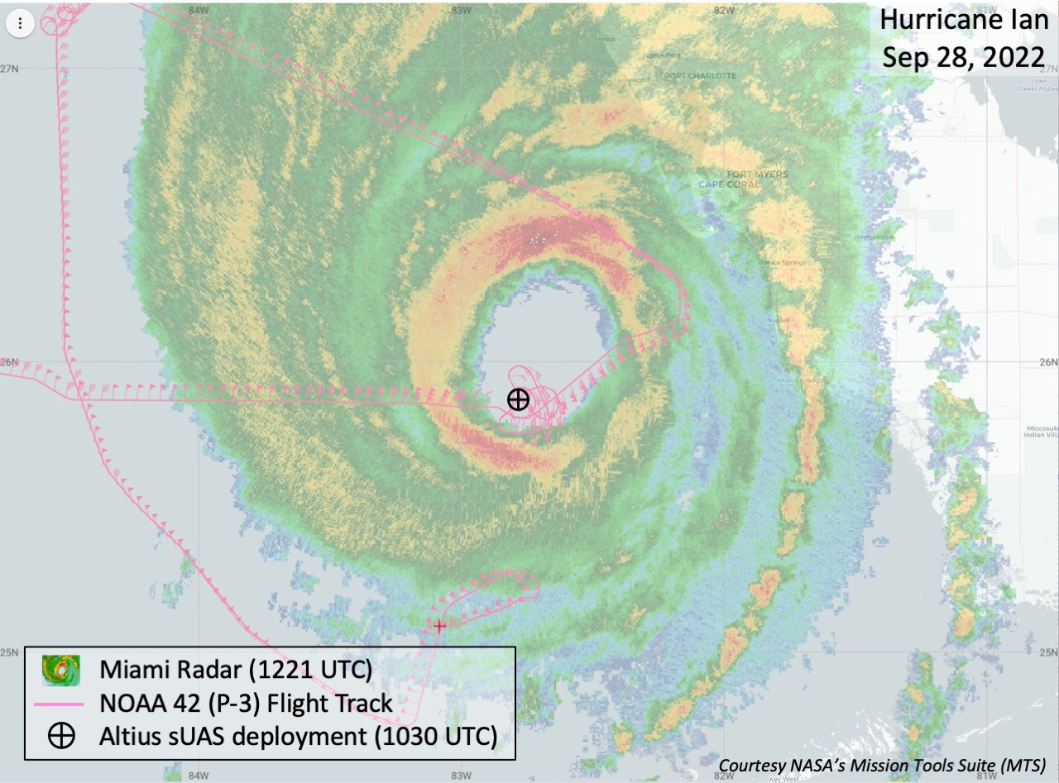
1259 | We attempted a penetration from the SSW, where it looked like, based on nose radar and MMR, there would be a soft spot. As we proceeded inbound, reports from the ground indicated that there were mesovortices oriented along the 240-060 radial. These mesovortices were advecting around the inner edge of the eyewall at a fast speed, > 100 kt. Given our inbound radial, and the advection of the mesovortex, it became evident that we were on track to encounter the mesovortex again. At the same time, I wanted to be sure that we were maintaining communication with the Altius. We were, and were continuing to track it as it was circumnavigating in the eyewall at different altitudes. The battery on the Altius was running out, and the sUAS splashed as we were making our inbound leg. Knowing that the mission with the Altius was complete, and the potential of us encountering another mesovortex, I decided to stop the inbound leg, turn back around, and end the mission.
1430 | 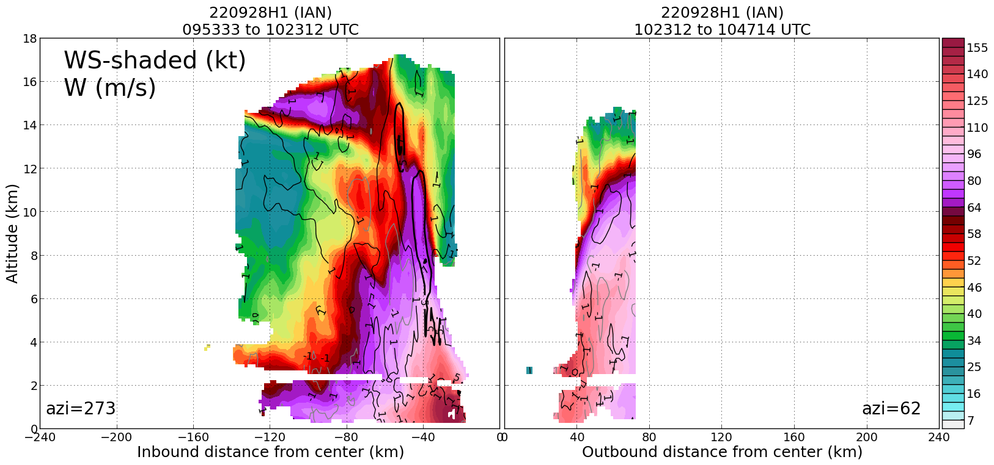  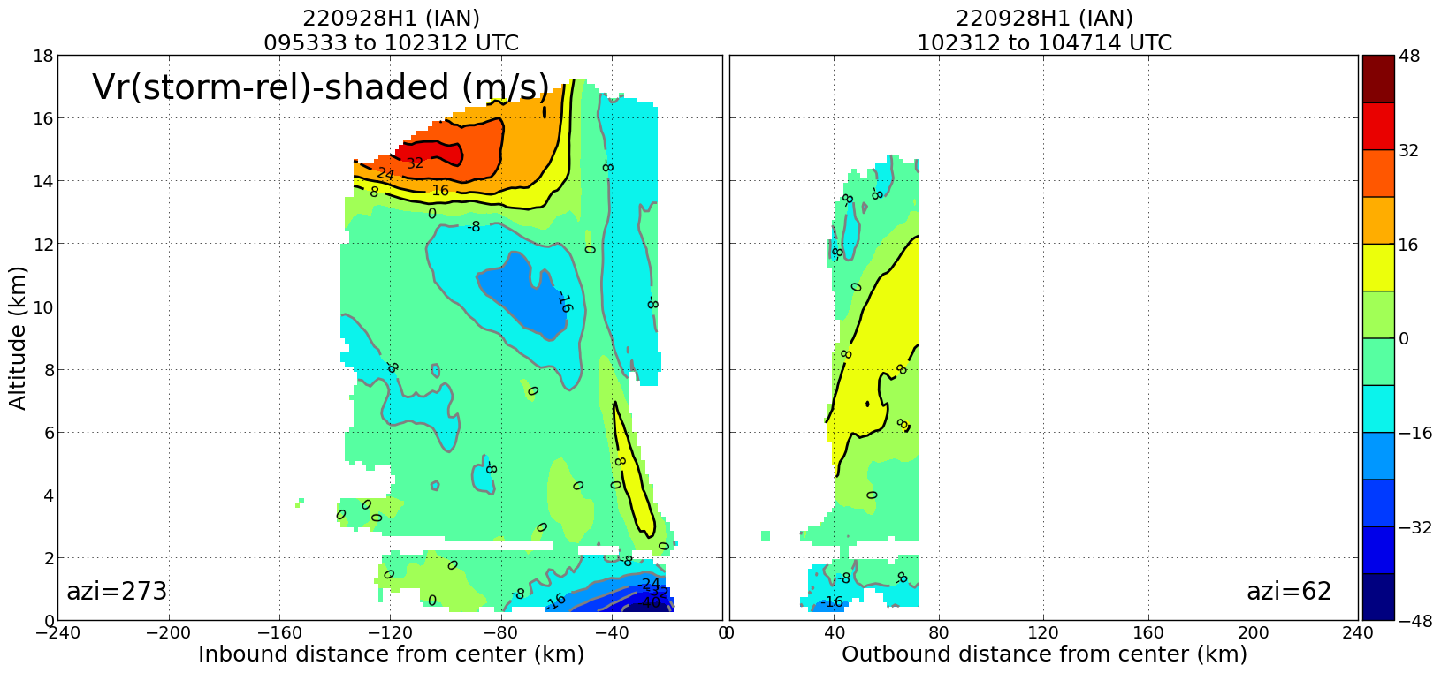  Profiles of wind speed (top) and radial flow (bottom) during W-E pass through Ian. Wind speeds > 155 kt were seen in the radar on the west side, while PBL inflow of 48 m/s was seen (Note that care should be taken in interpreting the radial flow value because we did not strictly follow a radial and some of that value make reflect a projection of tangential flow, particular in this extremely high-gradient region).
1442 | Landed back at Ellington Field

POST-FLIGHT
Mission Summary | Mission had mixed results. On the one hand it was a tremendous success with the Altius-600. We were able to maintain communications with it for almost 2 h. The Altius performed most of its planned tasks, including a center fix at 4500 ft, circumnavigations in the eyewall at multiple altitudes, including down to 500 ft and a little at 200 ft. It measured winds greater than 180 kt.  On the other hand the aircraft encountered extreme turbulence on the first inbound pass in the western eyewall, worse turbulence than I’d ever encountered. The “fishtailing” we experienced was I think a result of extreme horizontal shears which make it harder to control the attitude of the aircraft. Upon entering the eye we did a center fix and launched the Altius. During that period we orbited within the eye to establish communications with the Altius. As we were orbiting we were noticing the eyewall seemed to be contracting and exhibiting polygonal structures, indicative of mesovortices. That is probably what we encountered on our inbound leg. As we exited outbound to the east, we found a relatively calm spot about 60 nmi from the center and then turned downwind. We continued radially outward and eventually settled upon the idea of coming inbound from the SSW. As we were approaching the eyewall we received reports from the ground that there was another mesovortex that was rotating around just to the spot where we were coming inbound. We could have tried to fly downwind and come inbound in the S or SE quadrants, but the mesovortex was also rotating at a high speed. I did not want to get in a race with that feature. I confirmed with the Altius team that we still had communication with the Altius, and if we turned around we would maintain communication. As it turns out the Altius ran out of battery, so that question was moot. Regardless, given the lack of desire to fly into a mesovortex potentially a second time, and having successfully completed the Altius portion of the mission, I decided to abort the inbound leg and reverse track, heading home. As a result, we only obtained one pass through the center, rather than three. However, that one pass did produce some spectacular analyses, including of inflow greater than 45 m/s in the boundary layer (note, though, that care should be taken in interpreting that because we did not strictly follow a radial and some of that value make reflect a projection of tangential flow, particular in this extremely high-gradient region).  The storm was undergoing dramatic structural evolution during our mission, as described above. The evolution likely reflected the end of an eyewall replacement cycle, and the storm was continuing to intensify. Peak FL winds were 160 kt, and SFMR winds were 137 kt, both observed on the W side of the storm. The Altius measured winds as great as 180 kt at 2100 ft. Ian is clearly a dangerous storm as it bears down on the Florida west coast.  12 sondes were dropped, 6 to NWS/EMC and 6 to ONR. One Altius-600 was dropped.
Actual Standard Pattern Flown | Butterfly (note pattern was not completed; see above)
APHEX Experiments / Modules Flown | Data collection supported the Mature Stage Experiment: RICO-SUAVE and RMW rapid-fire for ONR’s Tropical Cyclone Rapid Intensification (TCRI) experiment.
Plain Language Summary
Instrument Notes | All instruments worked.
Final Mission Track | 