MISSION PLAN
FLIGHT ID | 20220927I1 | STORM | AL09 / IAN
MISSION ID | 2509A | TAIL NUMBER | NOAA43
TASKING | EMC | PLANNED PATTERN | Butterfly
MISSION SUMMARY
TAKEOFF [UTC] | 2045 | LANDING [UTC] | 2318
TAKEOFF LOCATION | Lakeland | LANDING LOCATION | Miami
FLIGHT TIME | 2.6 | BLOCK TIME | 3.0
TOTAL REAL-TIME RADAR ANALYSES  (Transmitted) | 2 (2) | TOTAL DROPSONDES (Good/Transmitted) | 10 (10 / 10)
OCEAN EXPENDABLES (Type) | 2 AXBT (UMiami) | sUAS (Type) | None
APHEX EXPERIMENTS / MODULES | Early Stage Experiment: AIPEX; Mature Stage Experiment
HRD CREW MANIFEST
LPS ONBOARD | Holbach | LPS GROUND | Alvey
TDR ONBOARD | Holbach | TDR GROUND | Alvey, X. Chen
ASPEN ONBOARD | Hazelton | ASPEN GROUND | None
NESDIS SCIENTISTS | Chang, Jelenak, Sapp
GUESTS (Affiliation) | Sans Souci (AOC)
AOC CREW MANIFEST
PILOTS | Mitchell, Rannenberg, Keith
NAVIGATOR | Utama
FLIGHT ENGINEERS | Pittman, Tyson, Tuffnell
FLIGHT DIRECTOR | Carpenter, Flaherty
DATA TECHNICIAN | T. Richards
AVAPS | Warnecke

PRE-FLIGHT
Flight Plan | 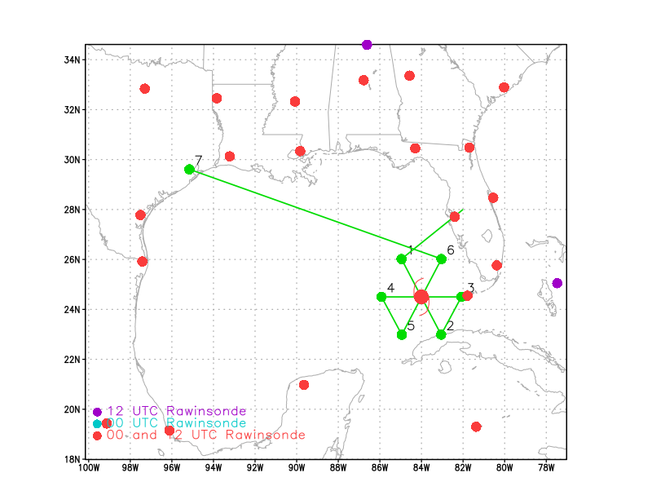  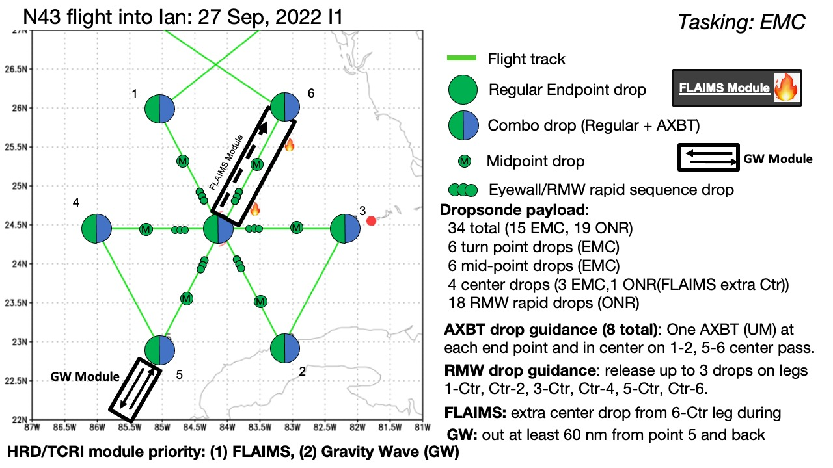  Pattern: Fly butterfly pattern with 105 nmi legs (except when restricted by Cuban overflight clearance)  Altitude: 10 kft (pressure altitude)  Potential add-on Modules: (time permitting)  - FLAIMS Module (AIPEX) >> priority 1  - Gravity Wave Module >> priority 2  Expendables: 34 sondes (all dropsondes transmitted to the GTS); 8 University of Miami AXBTs (shallow water) - all AXBTs transmitted to the AOC ground server if possible
Expendable Distribution | Release sondes at endpoints, midpoints, centers; possible supplemental rapid RMW drops except when restricted by land
Preflight Weather Briefing | Ian is re-strengthening after emerging over the Gulf of Mexico from Cuba with 952 mb pressure on the last AF center pass. Radar data from Key West indicates that an eyewall replacement cycle could be beginning. Overall, the forecast has not changed much other than a continued slight eastward shift in the track.
Instrument Notes | None

IN-FLIGHT
Time [UTC] | Event
2111
2111 | 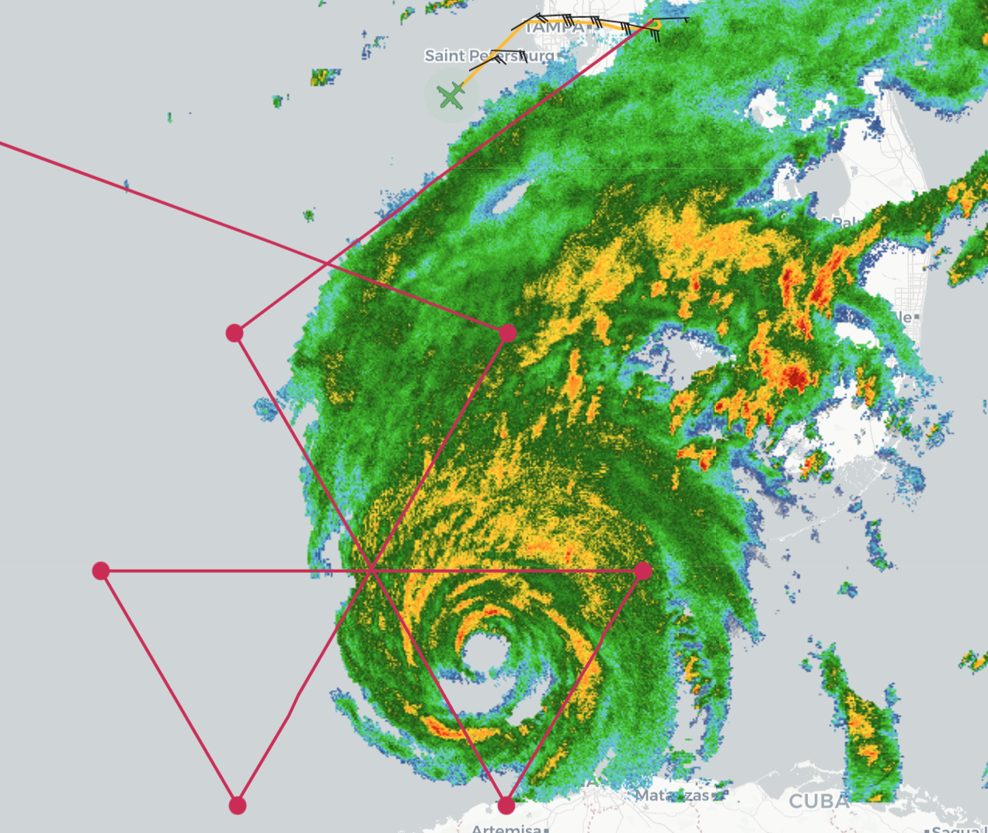
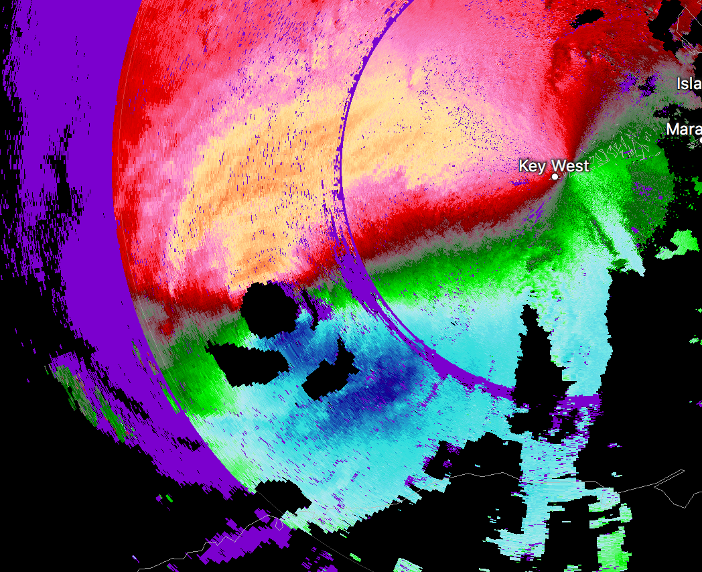
Secondary wind maxima showing up in SE and northern semi-circle from Key West radar base velocity
2134 | IP sonde at 2134Z, AXBT at 2137Z drop #1 for NW-SE pass
2147 | Mid point sonde drop #2
2155 | Major issues with the SFMR in those high rain regions inbound. Winds dropped off when rain spiked. Exactly the scenario Paul and Zorana have been noticing when comparing to IWRAP.  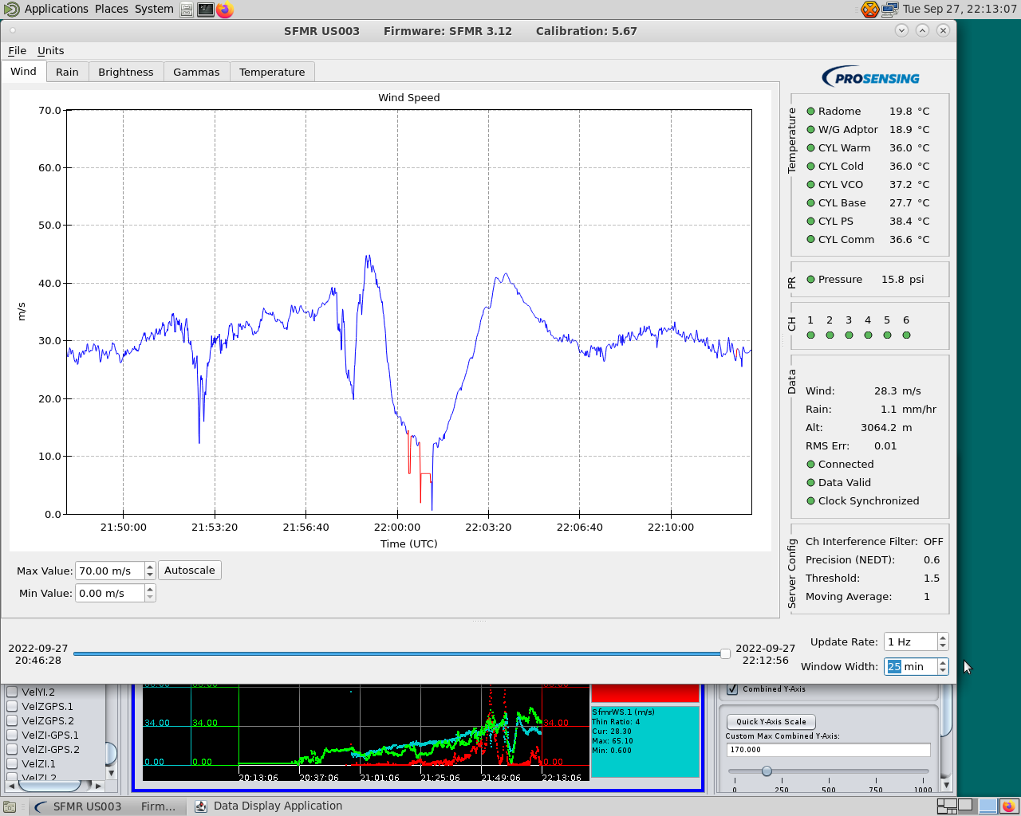  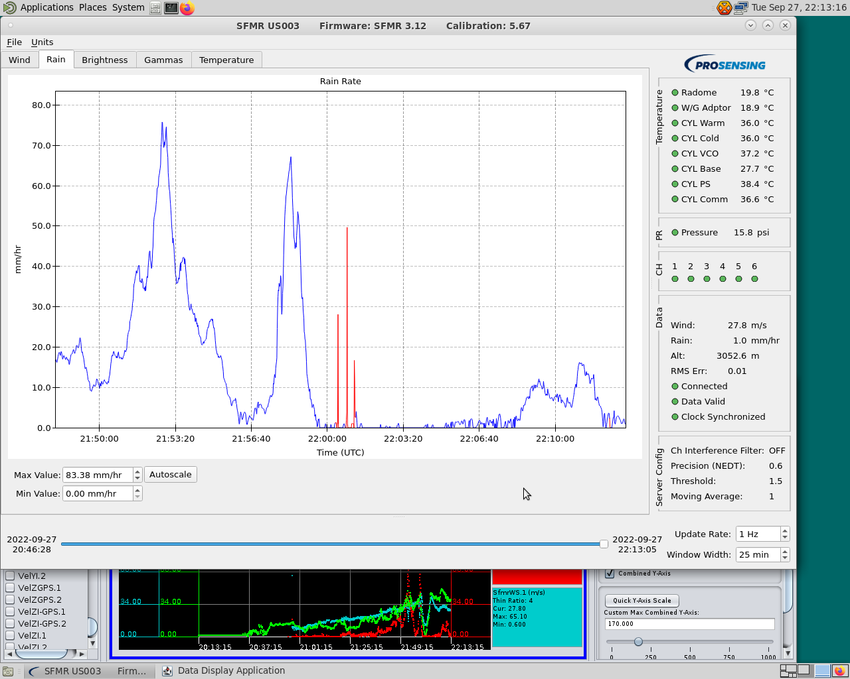
 | 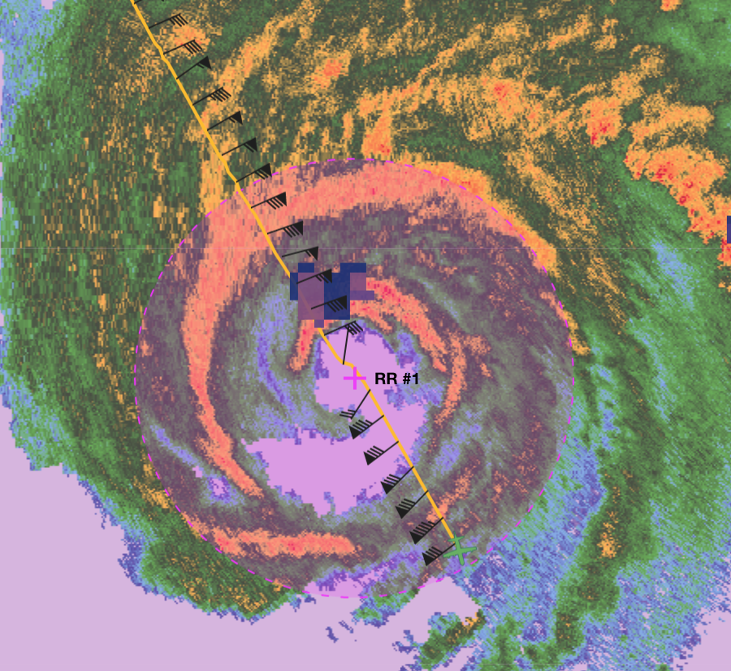
2155 | RMW sequence #1 (drop #3) NW Quadrant, inbound outer band
2156 | RMW sequence #2 (drop #4) NW moat  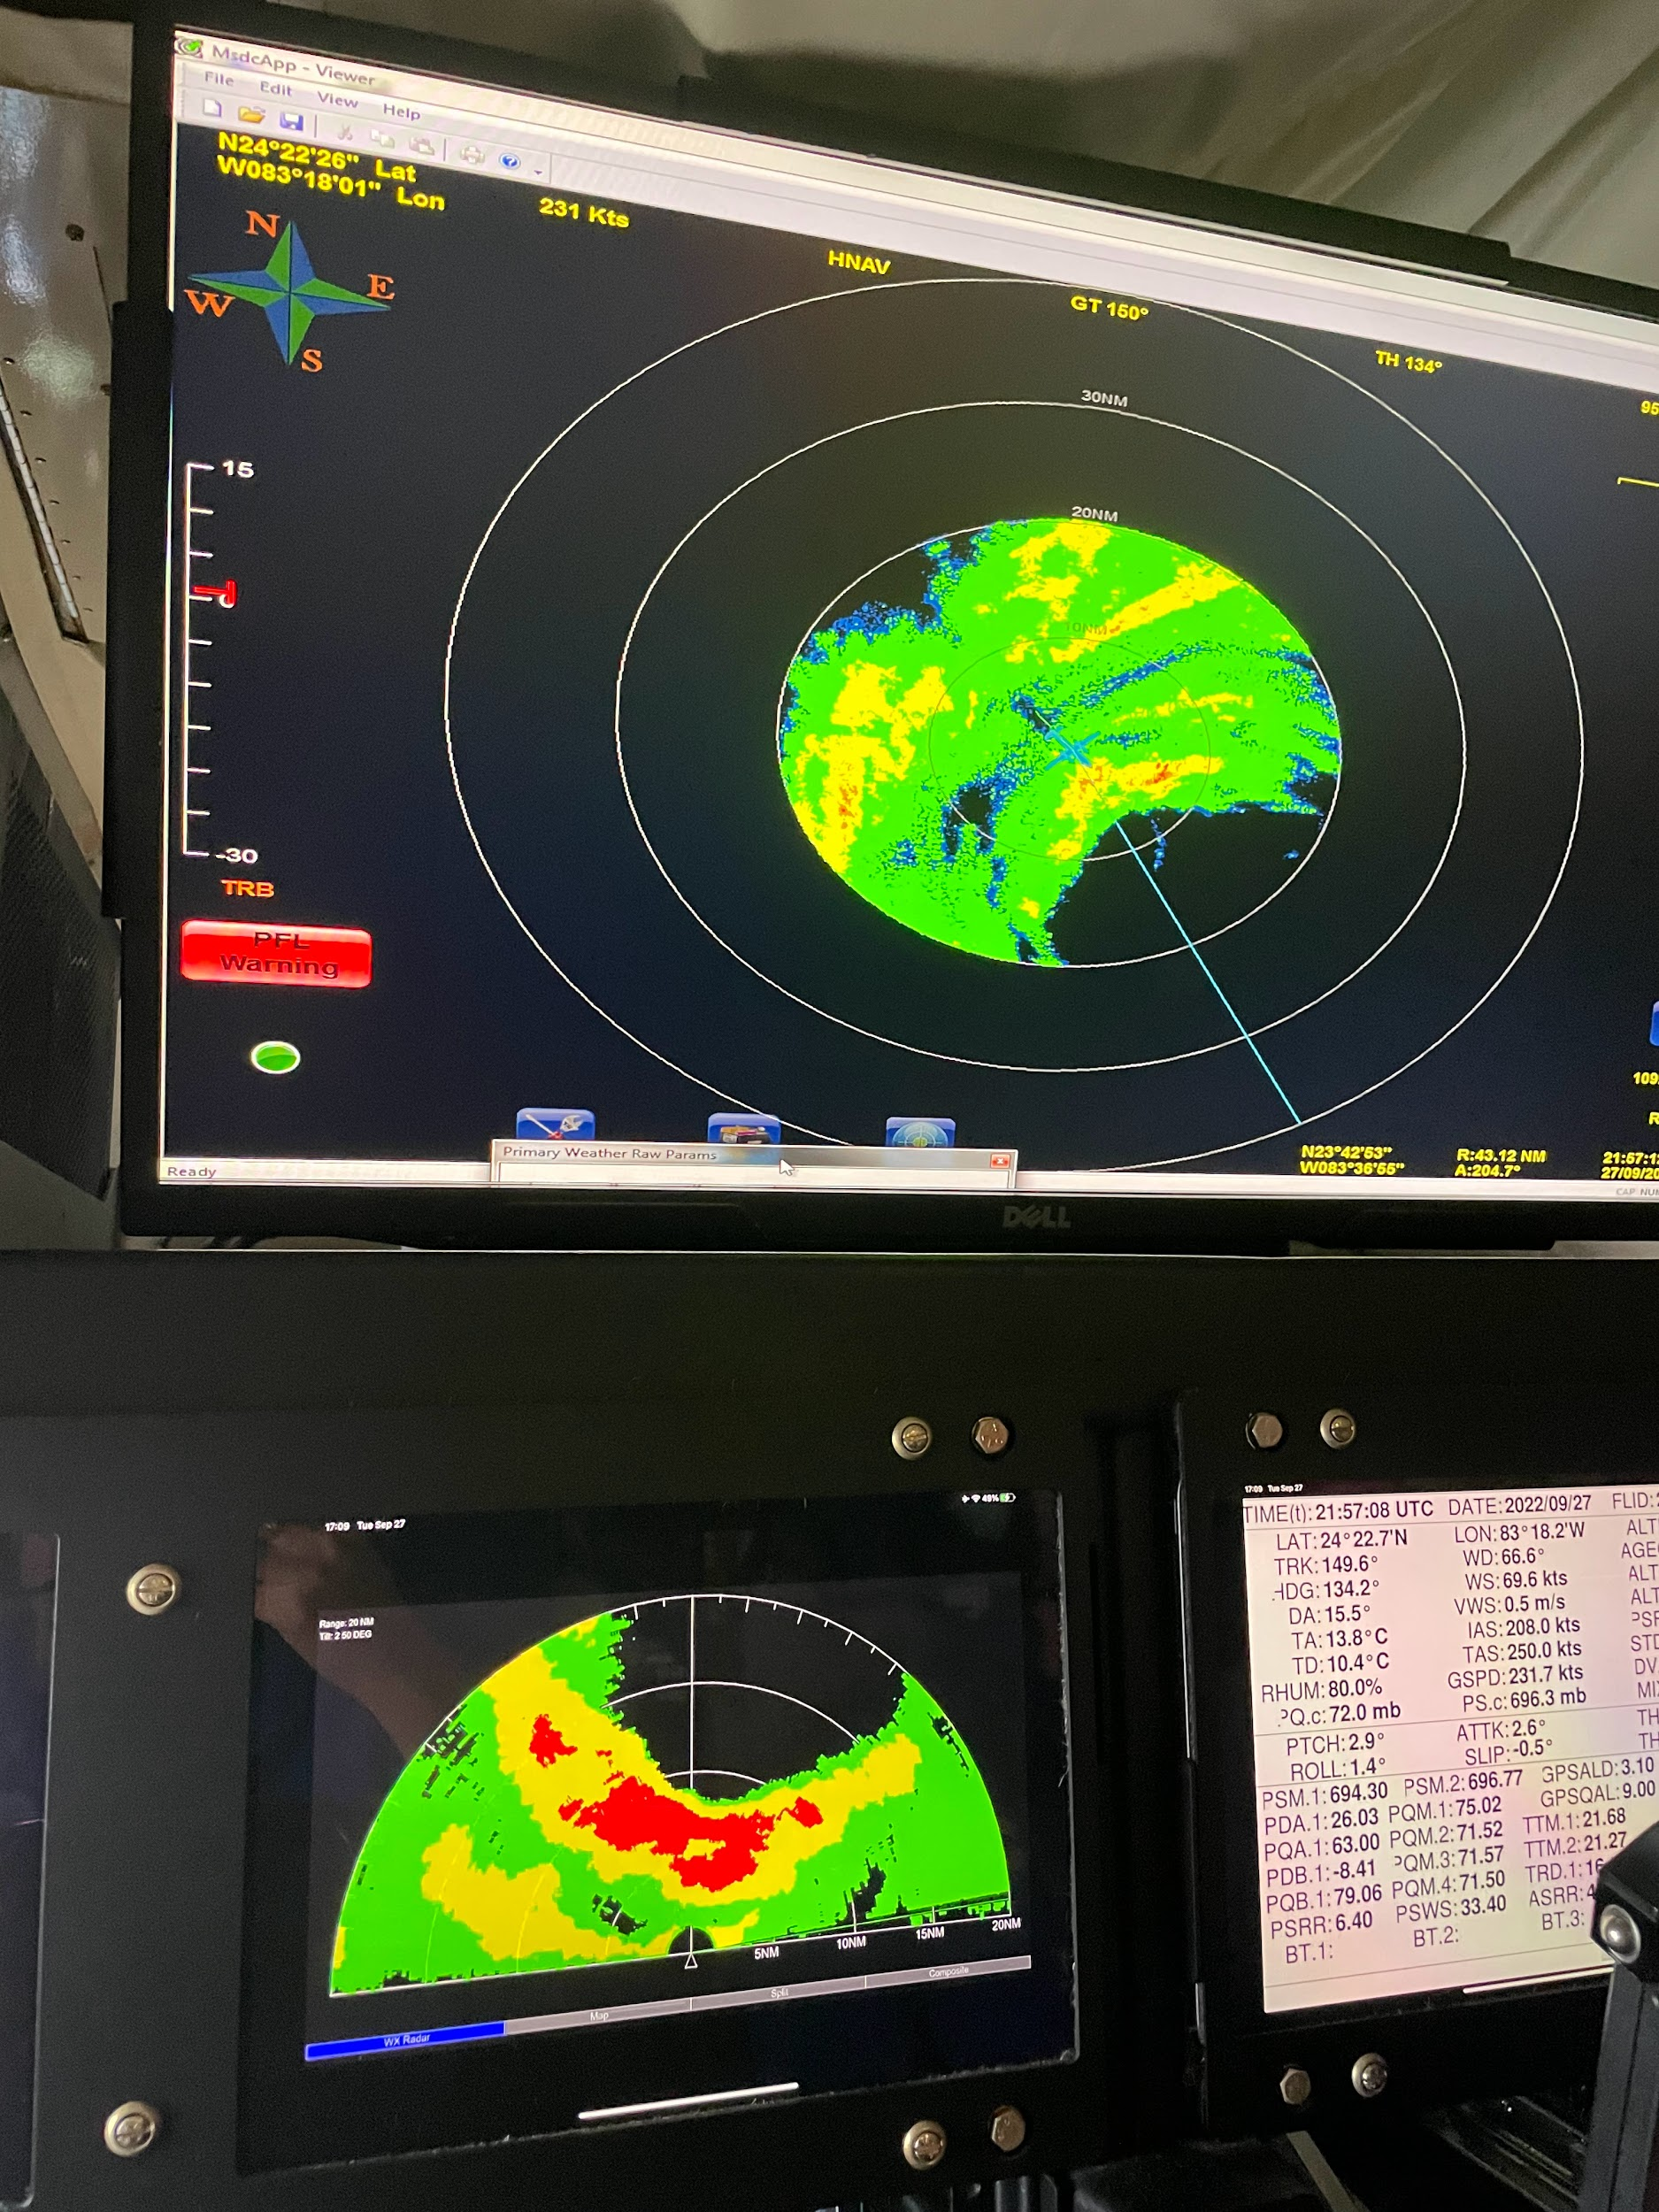
2159 | RMW sequence #3 (drop #5) NW inner wind max
2201 | Center drop #6
2204 | RMW SE drop #7 inner wind max
2205 | RMW SE drop #8 moat
2207 | RMW SE drop #9 outer band
2214 | Endpoint leg 1 drop #10. Leg needed to be cut short because of proximity to Cuba.
2221 | AXBT #2
2318 | On deck at MIA after maintenance issue required an abort

POST-FLIGHT
Mission Summary | Ian was beginning another eyewall replacement cycle during this flight. These ERCs seemed very regular with Ian as our previous flight occurred during a similar period of an ERC.  We were only able to complete one pass through Ian from the NW to SE before having to abort the flight for a maintenance issue. On that pass, our center dropsonde found Ian’s central pressure 949mb with 18 kt of wind indicating Ian’s pressure was continuing to fall. The max 1-sec SFMR winds were around 45 m/s.  Dropsondes: 10 (4 NWS, 6 ONR)  AXBT: 2 UMiami
Actual Standard Pattern Flown | Partial butterfly at 10,000 ft
APHEX Experiments / Modules Flown | Though the storm was mature, it was continuing to intensify and the data collection could be of interest to the Analysis of Intensity Change Processes (AIPEX) under the Early Stage Experiment.
Plain Language Summary | - Ian was beginning another eyewall replacement cycle  - Ian’s central pressure was down to about 947 mb
Instrument Notes | None
Final Mission Track | 