MISSION PLAN
FLIGHT ID | 20220926I1 | STORM | AL09 / IAN
MISSION ID | 1709A | TAIL NUMBER | NOAA43
TASKING | EMC | PLANNED PATTERN | Butterfly
MISSION SUMMARY
TAKEOFF [UTC] | 1948 | LANDING [UTC] | 0120
TAKEOFF LOCATION | Lakeland | LANDING LOCATION | Lakeland
FLIGHT TIME | 5.5 | BLOCK TIME | 5.9
TOTAL REAL-TIME RADAR ANALYSES  (Transmitted) | 2 (2) | TOTAL DROPSONDES (Good/Transmitted) | 17 (17 / 17)
OCEAN EXPENDABLES (Type) | 2 AXBT (UMiami) | sUAS (Type) | None
APHEX EXPERIMENTS / MODULES | Early Stage Experiment: AIPEX
HRD CREW MANIFEST
LPS ONBOARD | Holbach | LPS GROUND | Alvey
TDR ONBOARD | Holbach | TDR GROUND | Alvey
ASPEN ONBOARD | Hazelton | ASPEN GROUND | None
NESDIS SCIENTISTS | Chang, Jelenak, Sapp
GUESTS (Affiliation) | Reeves (AOC)
AOC CREW MANIFEST
PILOTS | Mitchell, Doremous, Keith
NAVIGATOR | Utama
FLIGHT ENGINEERS | Pittman, Tyson, Tuffnell
FLIGHT DIRECTOR | Carpenter, Flaherty
DATA TECHNICIAN | T. Richards
AVAPS | Warnecke

PRE-FLIGHT
Flight Plan | 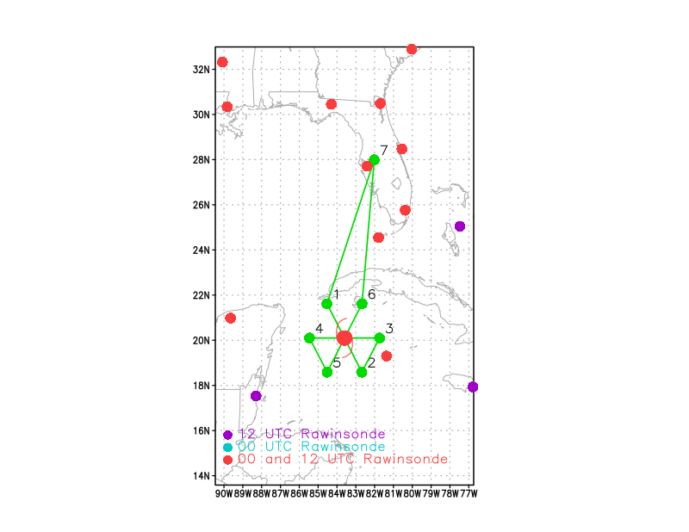  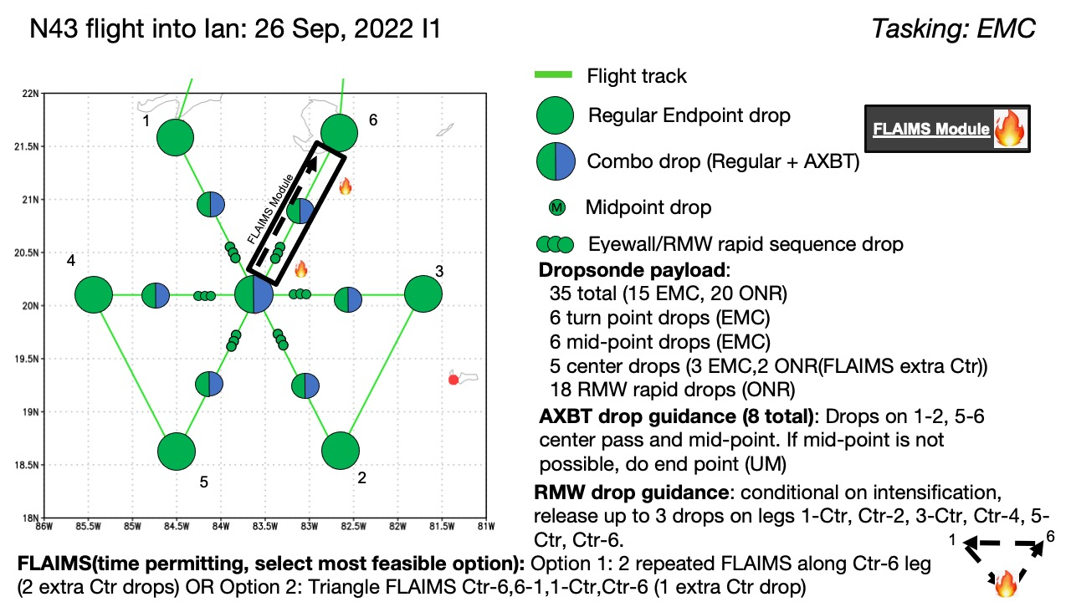  Pattern: Fly butterfly pattern with 105 nmi legs  Altitude: 10 kft (pressure altitude)  Potential add-on Modules: (time permitting)  - FLAIMS Module (AIPEX)  Expendables: 35 sondes (all dropsondes transmitted to the GTS); 8 University of Miami AXBTs (shallow water) - all AXBTs transmitted to the AOC ground server if possible
Expendable Distribution | Release sondes at endpoints, midpoints, centers; possible supplemental rapid RMW drops
Preflight Weather Briefing | Ian is in a favorable environment for intensification characterized by warm SSTs and very low vertical wind shear. This intensification period has been well forecasted by numerical weather models, and it appears that the storm is currently in the midst of an RI period. The only deterring factors from additional RI over the next 24-48 h will be land interaction with Cuba and the potential for EWRC / inner core adjustments.
Instrument Notes

IN-FLIGHT
Time [UTC] | Event
1948 | Takeoff from Lakeland
2030 | Complete satcom outage and lost comms for ~30 mins. Contingencies being made in case of another outage during the pattern. LPS may make a decision to cut legs short and terminate mission early in order to get back on ground before 0330 UTC cut off assimilation window (if another complete comms outage occurs).
 | 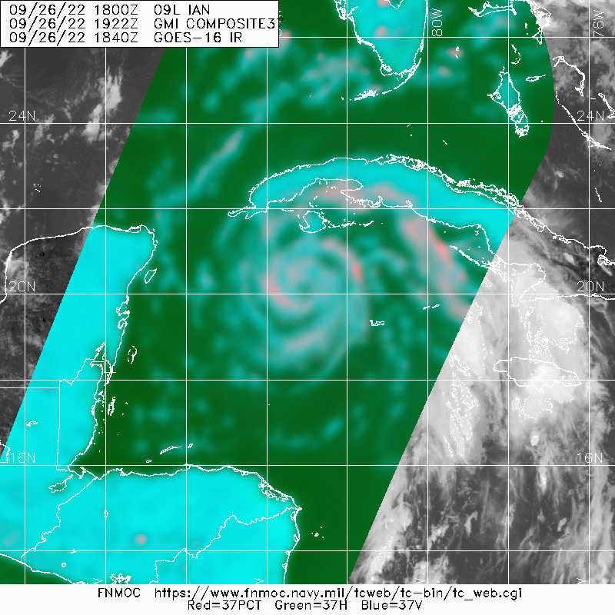
 | 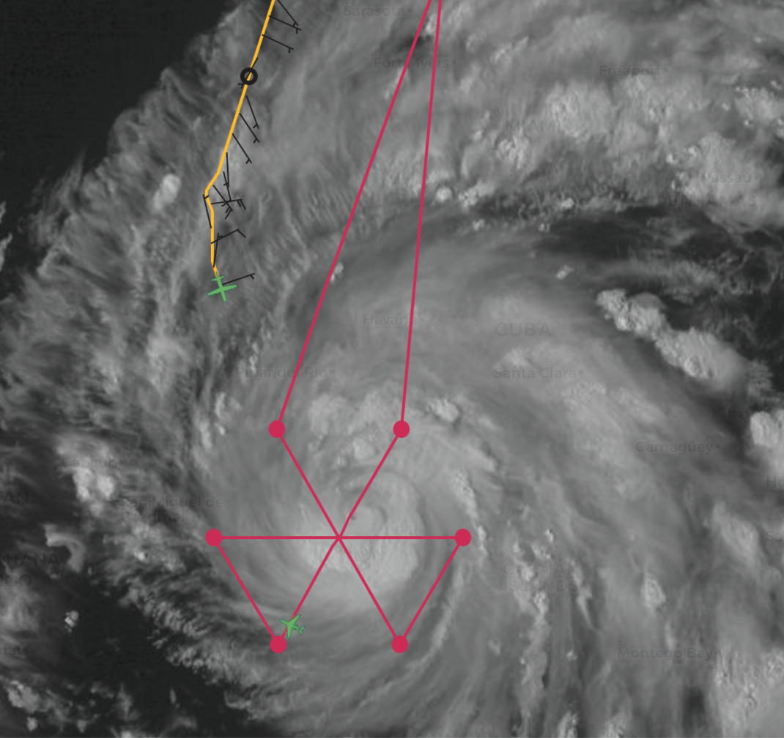
 | Planning 10 kft for first pass, but then AF will arrive and we will likely have to go down to 8 kft
Initial intensity up to 85 kt at NHC 5PM advisory: “The inner core appears
better organized, and the eyewall structure has greatly improved in radar imagery from the Cayman Islands.” The intensity 24 h ago was 40 kt and thus we’re now well into the “RI continuation” phase.
2142 | IP Endpoint Dropsonde #1 (NW-SE leg)
2152 | Midpoint dropsonde #2
 | FLAIMS module is unlikely b/c land could be a problem and we'd like to get back as quick as possible tonight.
Seems like ERC is definitely occuring. Outer eyewall is becoming dominant
released 3 RMW outbound (1 in inner max, 2 in outer max). No inbound RMW because wind/reflectivity structure was misleading (dropsondes #4, 5, 6)
 | No inbound or center BT. Inner eyewall was too small for BT
 | Possible ERC underway, eye appeared to shrink from 10 nmi to 6 nmi through our pass, opening up, will code as spiral band
2215 | Center sonde (#3) 967 mb 14 kts/280
 | Center: 2203Z; RMW SE: 2205Z; RMW SE: 220841Z; RMW SE: 220857Z; midpoint: 2217Z
 | 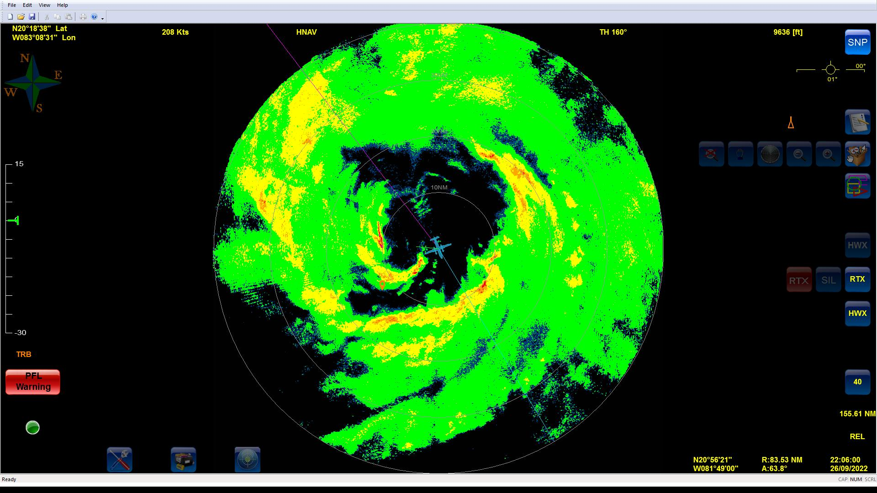
 | 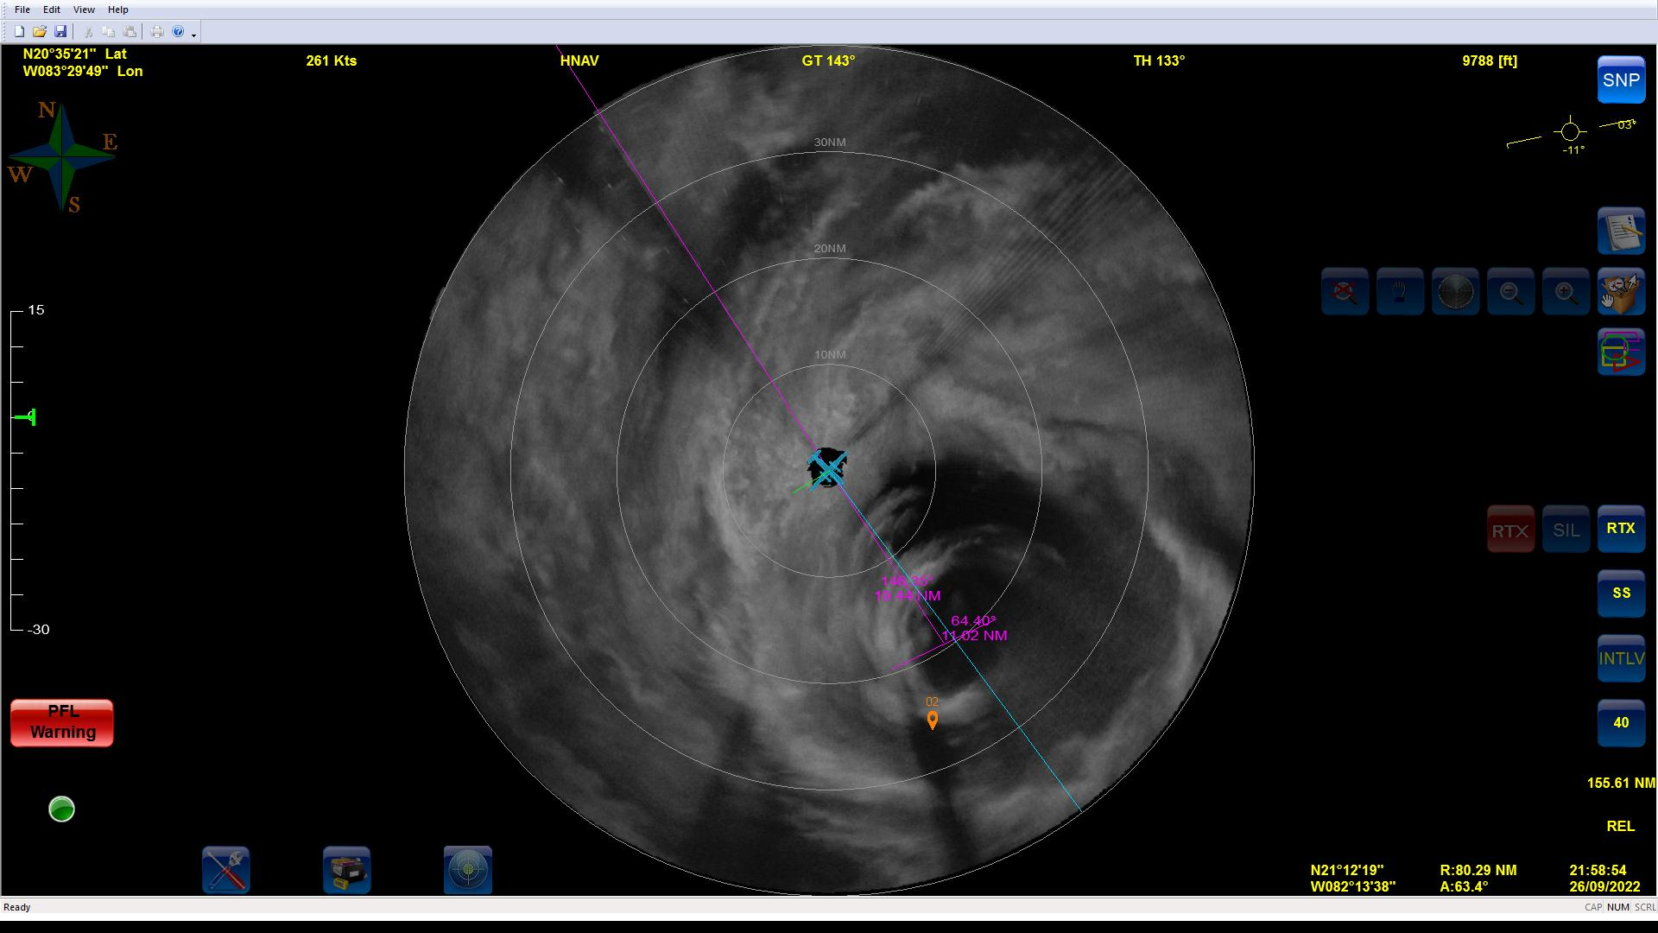
2231 | EP combo drop (dropsonde #8)
 | Turning downwind and descending to 8k feet
 | 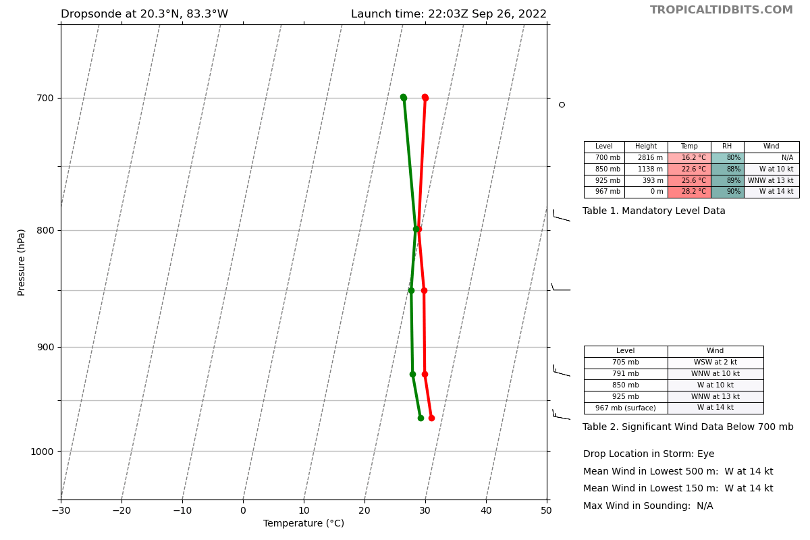
 | ~14 mb drop about 6 hours earlier. Rapidly deepening
 | Endpoint Dropsonde #9, inbound E-W
2307 | 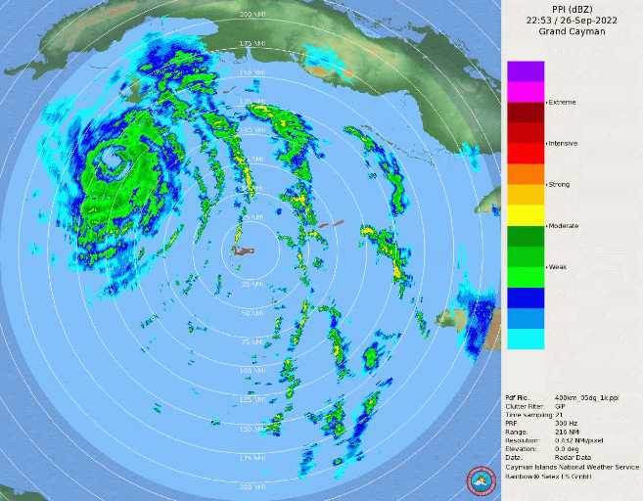  "Inner eyewall" hooklike feature seen on MMR has now rotated around to the north side and eyewall looks to be filling in. Unclear if there was an EWRC or not. Looks like the inner eyewall has filled in more (and/or outer eyewall contracted). Possible that these could also be CBs inside of RMW leading to large pressure drops
2322 | On inbound and outbound for E-W leg RMW drop sequence will try to target 1 outer, 1 between in the moat, and 1 inner eyewall given the current structure
MMR 2nd center pass
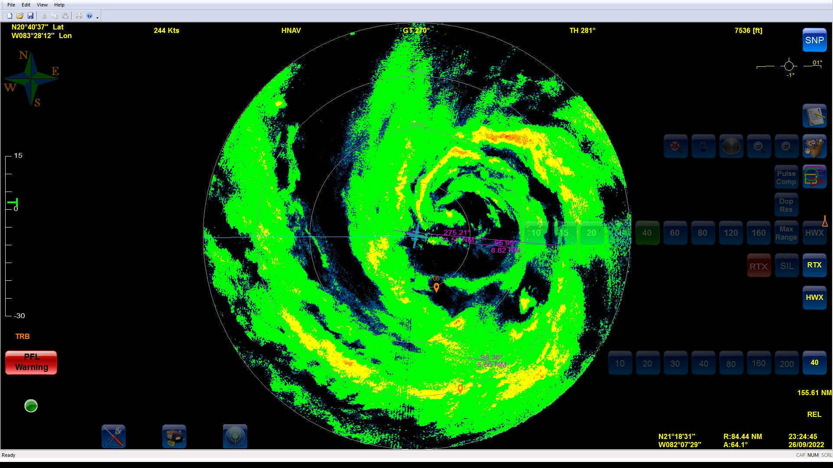
0046 | TDR taken down
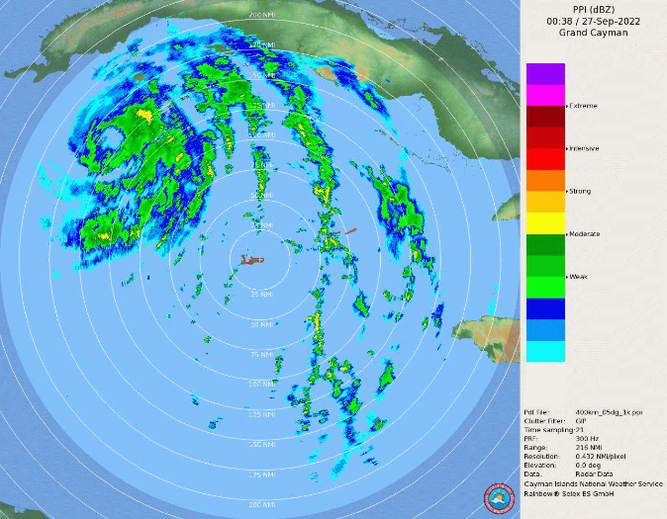
Inner eyewall appear to be decaying / filling in
 | 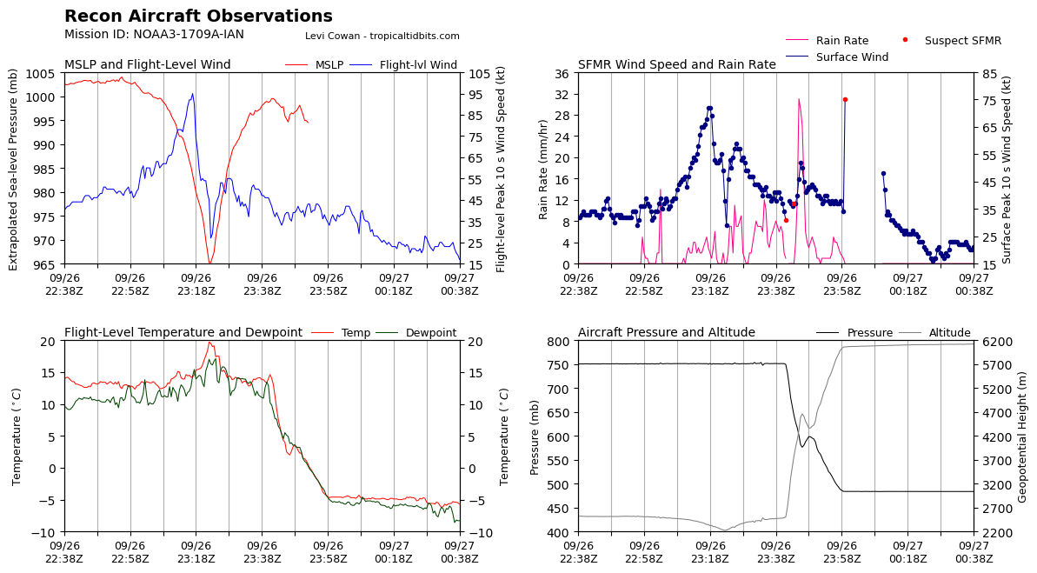
 | 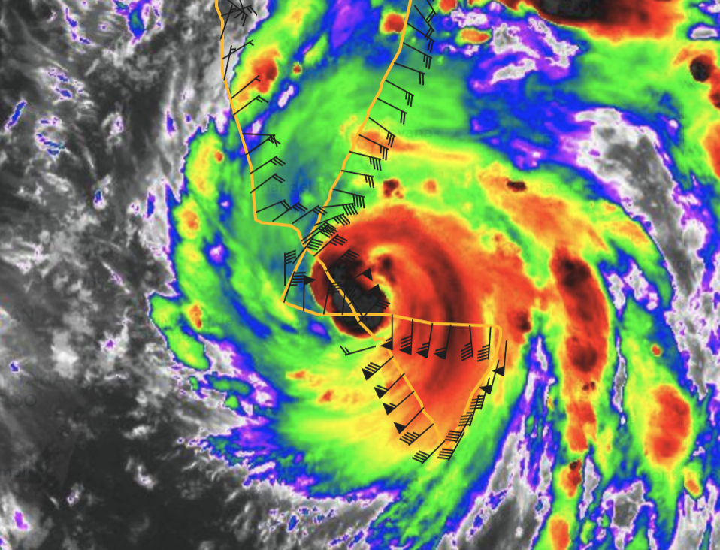
 | 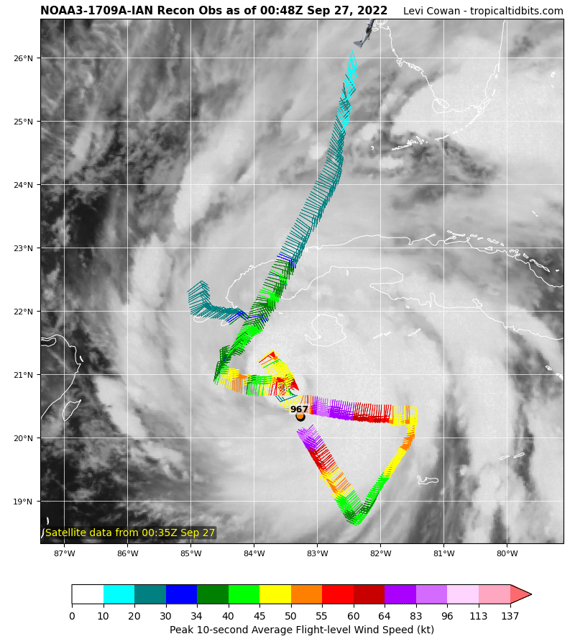
 | 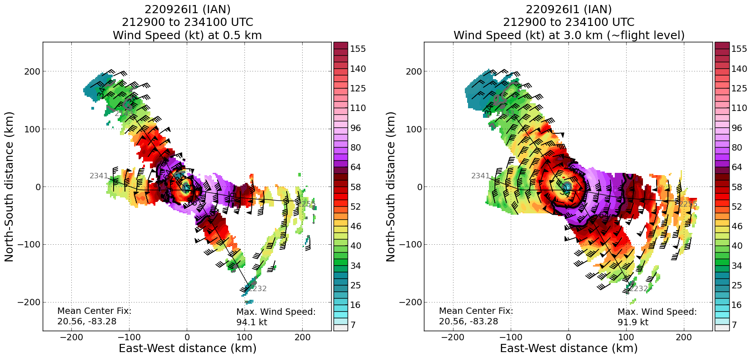
 | RTB just before completion of second center pass

POST-FLIGHT
Mission Summary | Completed a little over 1.5 legs through the storm before having to end the mission early due to maintenance issues. We observed a concentric eyewall type structure where the outer eyewall was more dominant and may have been the end of an eyewall replacement cycle. Minimum sea-level pressure had decreased and winds were increasing.  Sondes: NWS: 8 ONR: 9
Actual Standard Pattern Flown | Partial butterfly
APHEX Experiments / Modules Flown | With rapid intensification ongoing, data collection supports the Early Stage Experiment: Analysis of Intensity Change Processes (AIPEX), though no modules were flown.
Plain Language Summary | - Ian was continuing to strengthen throughout this flight as it entered a region of favorable conditions for strengthening.
Instrument Notes | Had to restart Aft TDR antenna at beginning of flight.
Final Mission Track | 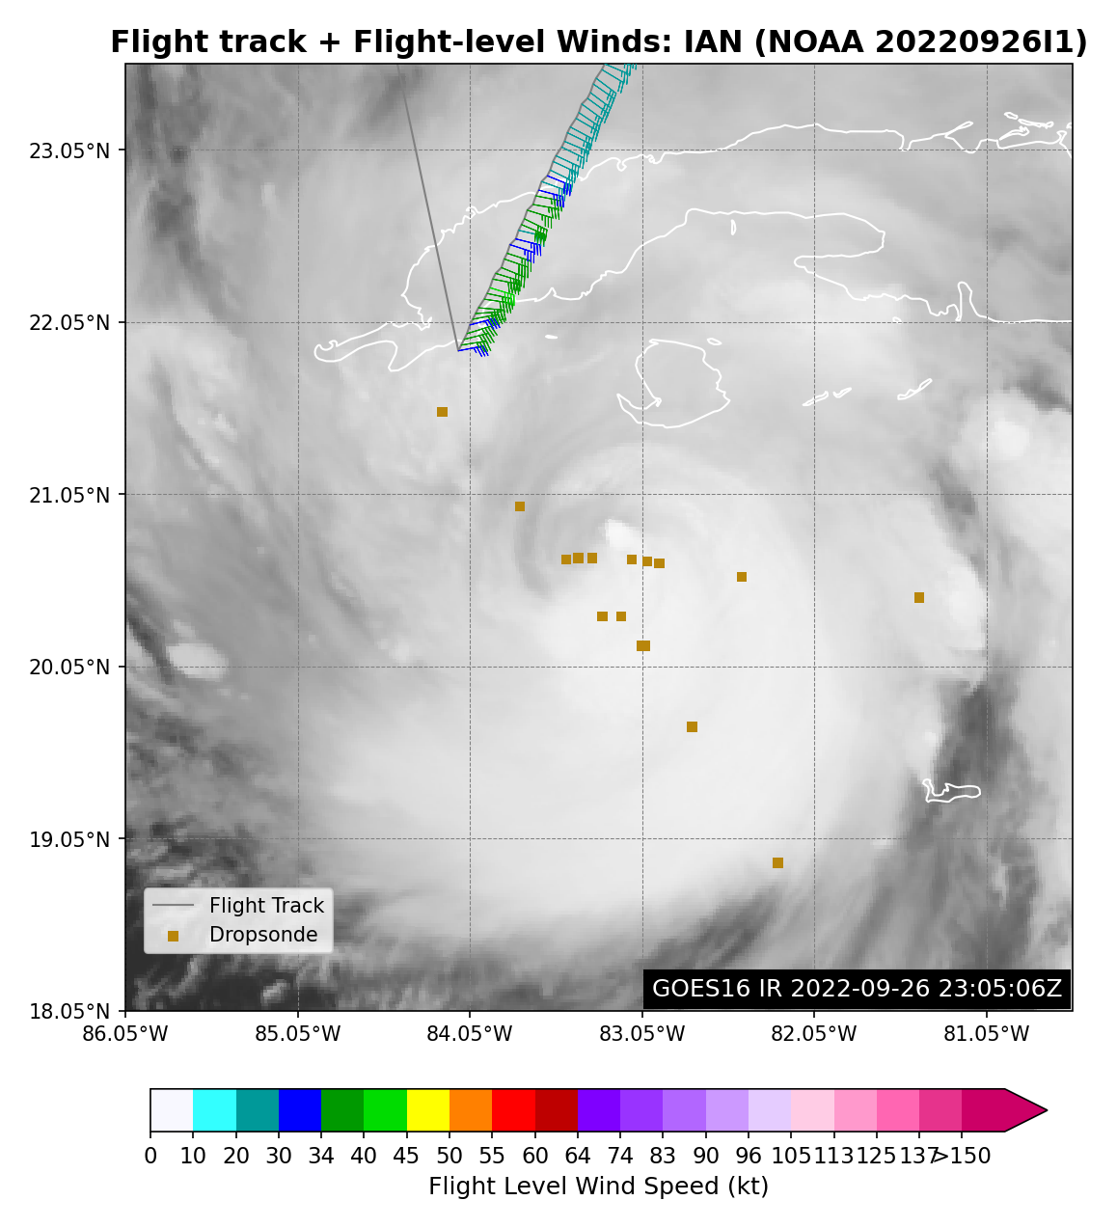  Note: HDOB files for most of the in-storm portion of flight were overwritten on NHC’s archive by the G-IV flights due to their filename convention that doesn’t allow for two files sent at the same HHMM from multiple planes to be saved.

