MISSION PLAN
FLIGHT ID | 20220926H1 | STORM | AL09 / IAN
MISSION ID | 1509A | TAIL NUMBER | NOAA42
TASKING | EMC | PLANNED PATTERN | Butterfly
MISSION SUMMARY
TAKEOFF [UTC] | 0759 | LANDING [UTC] | 1444
TAKEOFF LOCATION | Lakeland | LANDING LOCATION | Lakeland
FLIGHT TIME | 6.8 | BLOCK TIME | 7.0
TOTAL REAL-TIME RADAR ANALYSES  (Transmitted) | 3 (3) | TOTAL DROPSONDES (Good/Transmitted) | 34 (31 / 31)
OCEAN EXPENDABLES (Type) | 8 AXBTs (ONR) | sUAS (Type) | None
APHEX EXPERIMENTS / MODULES | Early Stage Experiment: AIPEX; Mature Stage Experiment: Hurricane Boundary Layer
HRD CREW MANIFEST
LPS ONBOARD | Rogers | LPS GROUND | None
TDR ONBOARD | Rogers | TDR GROUND | Reasor
ASPEN ONBOARD | J. Zhang | ASPEN GROUND | None
NESDIS SCIENTISTS | None
GUESTS (Affiliation) | Gardner (OBS), Licitra (OBS)
AOC CREW MANIFEST
PILOTS | Abitbol, Copare, Wood
NAVIGATOR | Miller
FLIGHT ENGINEERS | Stokes, Gee
FLIGHT DIRECTOR | Kalen, Holmes
DATA TECHNICIAN | MacAlister
AVAPS | Dykeman

PRE-FLIGHT
Flight Plan | 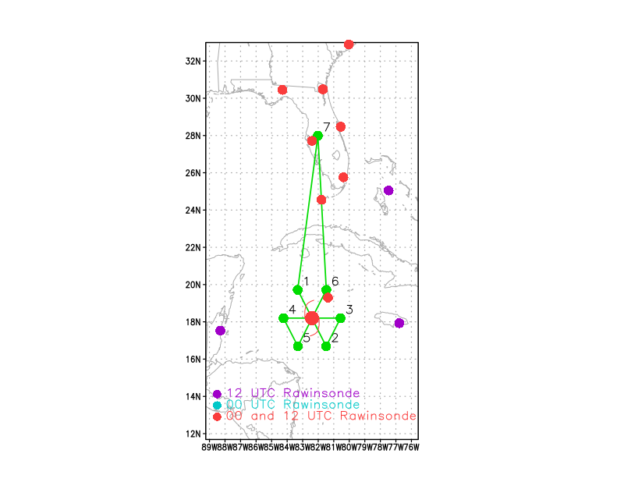  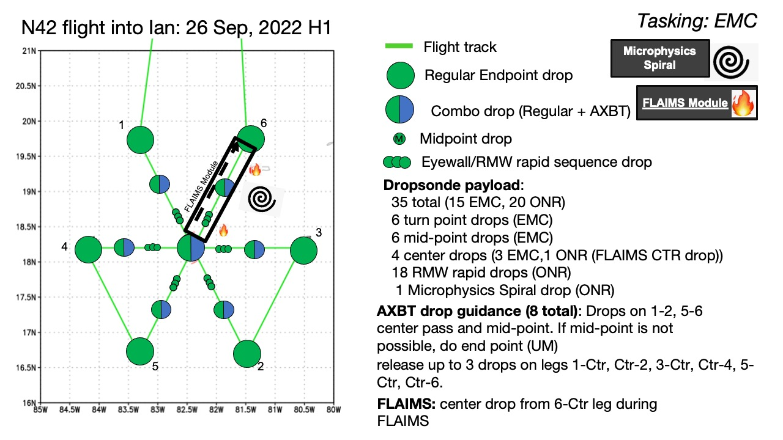  Fly butterfly pattern, 105 nmi leg lengths, IP on the NW and EP on the NE sides. Will only fly the butterfly, with no options for modules, despite the original plan. This is because of crew rest and safety concerns. Fly at 10 kft for first pass, then descend to 8 kft for subsequent passes to deconflict with AF.
Expendable Distribution | Dropsondes at all endpoints, midpoints, and center passes. Also, do rapid-fire sonde drops at all azimuths, assuming there is an identifiable RMW (which is likely for today’s mission). Drop AXBT’s at all endpoints and first and third center pass. Original plan had called for AXBT’s at the midpoints, but because they were all Channel 12’s, dropping them at the midpoints would likely not leave enough time for them to clear. Therefore AXBT’s will be at endpoints.
Preflight Weather Briefing | Ian is continuing to become better organized. The most recent mission with N43 showed that the vortex is now aligned up to about 6 km altitude and has a small tilt of < 20 km toward the SE up to 10 km above that. This is a notably smaller tilt than the previous mission of N42. The satellite presentation does show an improved organization as well, with some areas of cold cloud tops surrounding the amplifying circulation. The coldest cloud tops are in a band wrapping around the north side of the storm. Azimuthal-mean plots of tangential and radial flow from the past 24 h show that a clear RMW has formed below 3 km altitude at a small radius of about 20 km. Interestingly, that same plot shows a broad region of high tangential winds out to 100-120 km, extending up to 6-8 km altitude. Azimuthal-mean radial flow shows a weak midlevel inflow maximum outside this outer wind maximum, with a much weaker signature of low-level inflow supporting the inner wind maximum. It is not known to what extent this type of kinematic structure will affect the ongoing intensification rate of Ian. Today’s mission will presumably shed some insight on that.  The environment is certainly favorable for intensification, and likely rapid intensification. Vertical wind shear is low (< 5 kt), sea-surface temperatures are high (around 30 C), and the environment is expected to remain moist. It will be interesting to see if Ian will intensify as rapidly as most objective, primarily environmentally-based RI guidance indicates. If it is not, it may suggest that more detailed considerations of the inner-core structure should be made to assess and predict short-term intensification rate.
Instrument Notes | All instruments working

IN-FLIGHT
Time [UTC] | Event
0759 | Takeoff from Lakeland
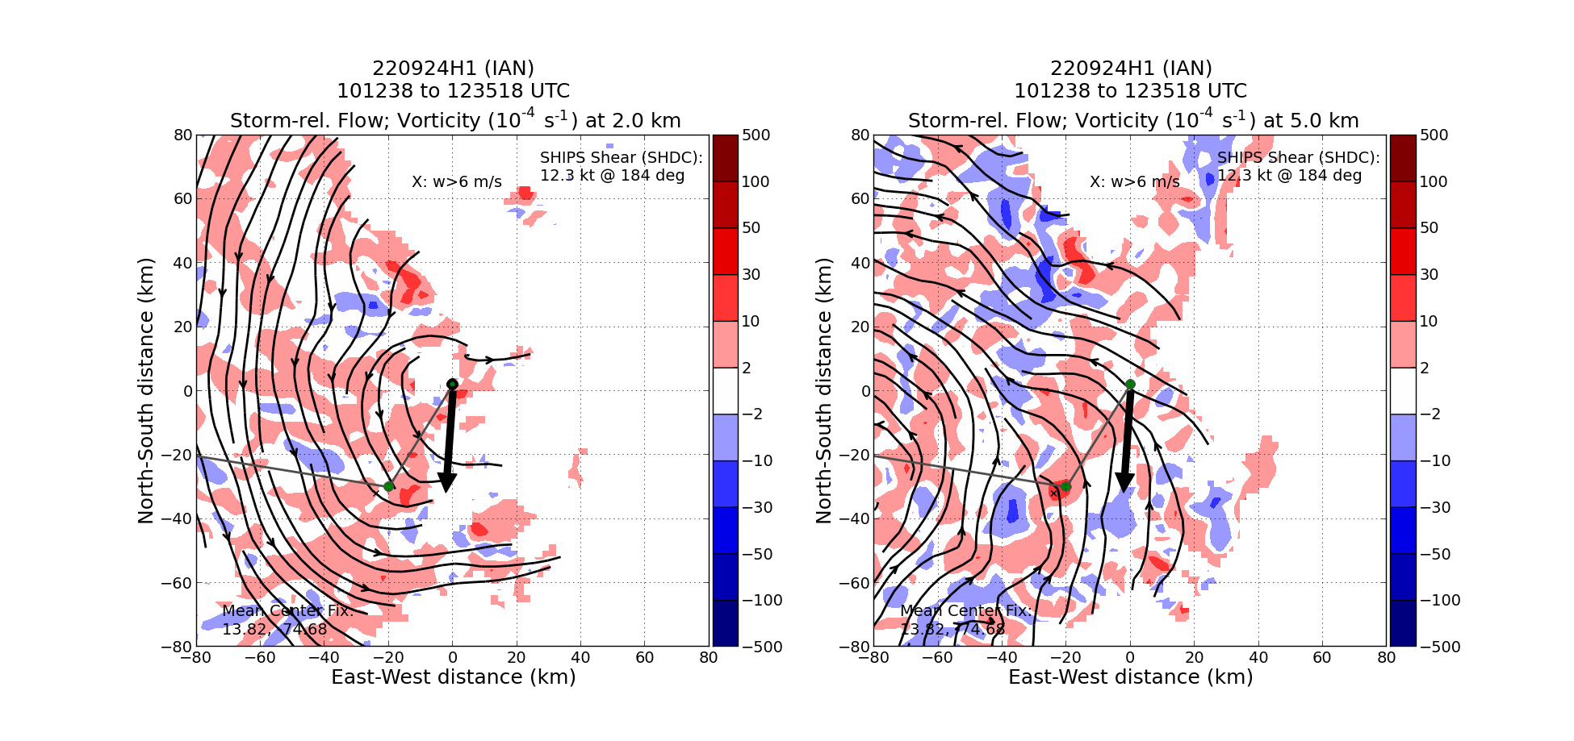
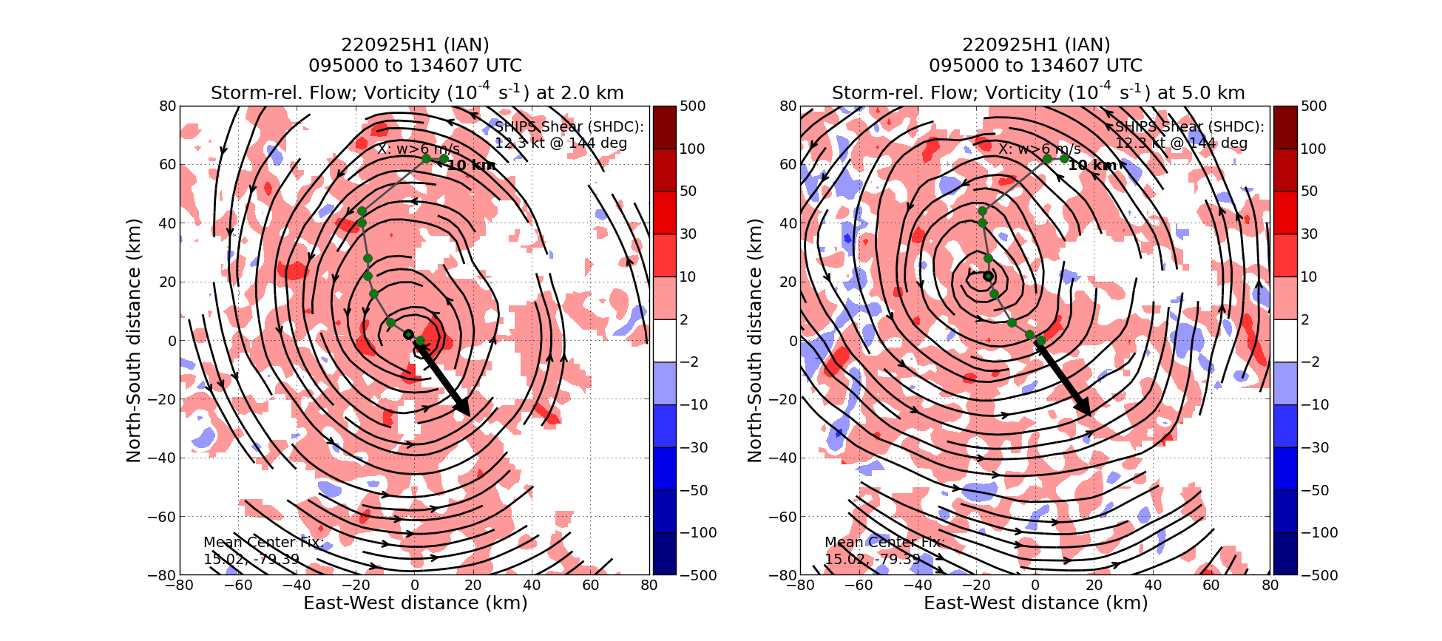
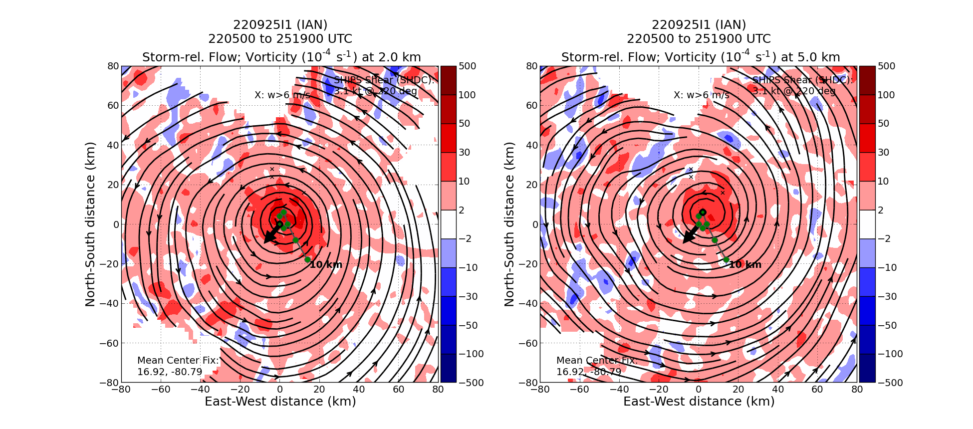
Series of tilt plots from the last three missions into Ian. The first plot is from 24H1, the second from 25H1 (24 h later), and the third from 25I1 (12 h after that). Note the evolution of the 2-5 km tilt – significant (off the domain) to the west during 24H1, then a much-reduced (but still evident) tilt between 2-5 km of 20 km toward the NW during 25H1, and finally an aligned vortex between 2-5 km during 25I1. Above 6 km the vortex remains slightly tilted (about 20 km) toward the SE up to 10 km.
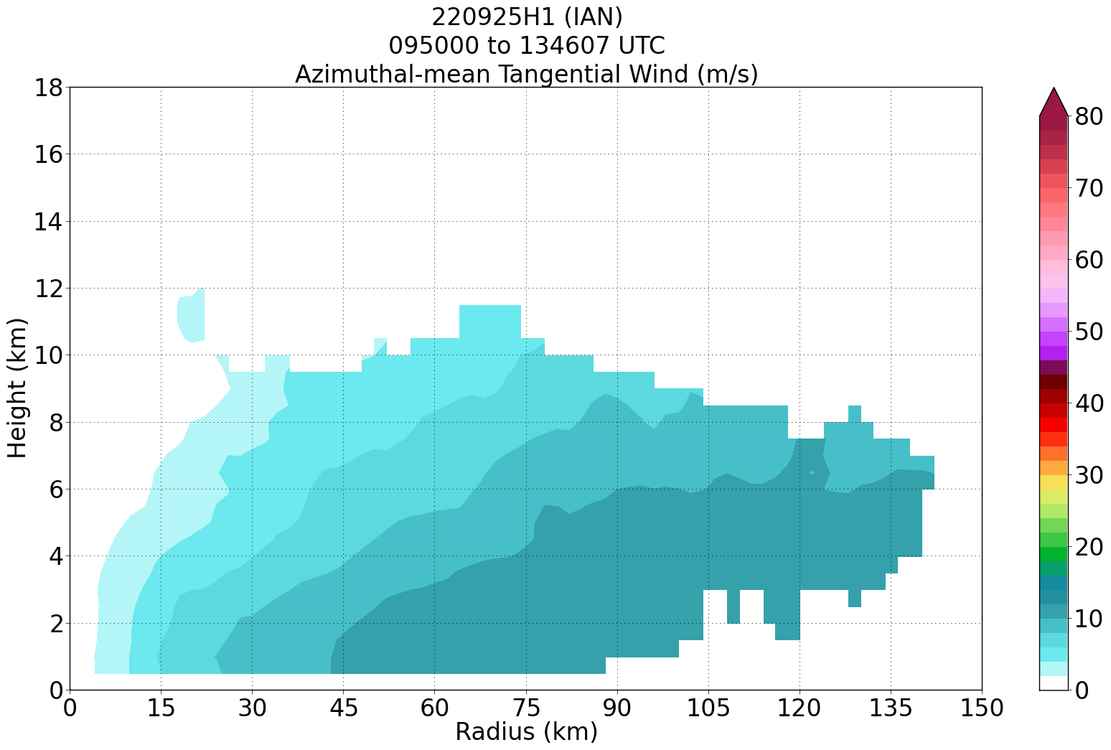
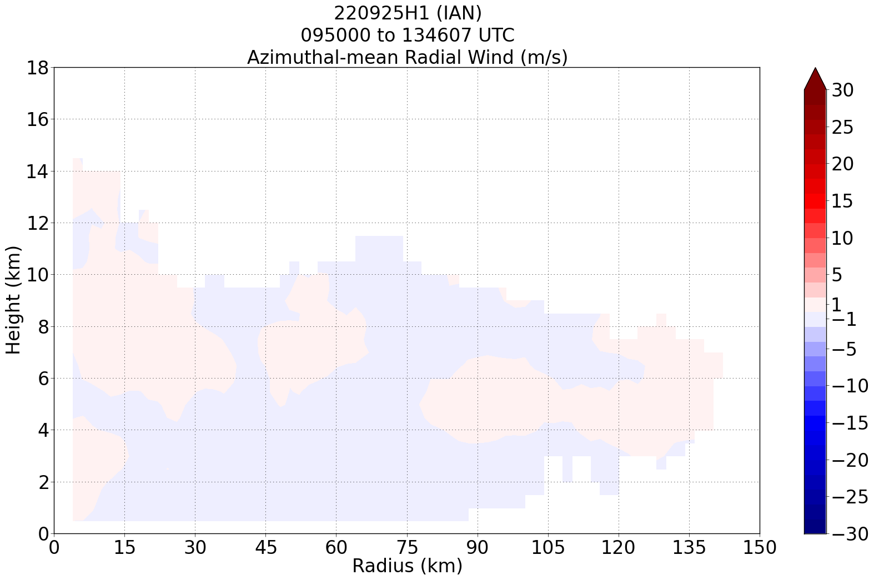
Azimuthal-mean tangential (top) and radial (bottom) flow from 25H1. Note the weak, broad primary circulation with an RMW > 100 km. Very weak (about 1 m/s) radial inflow is evident in the lowest 5 km across all radii.
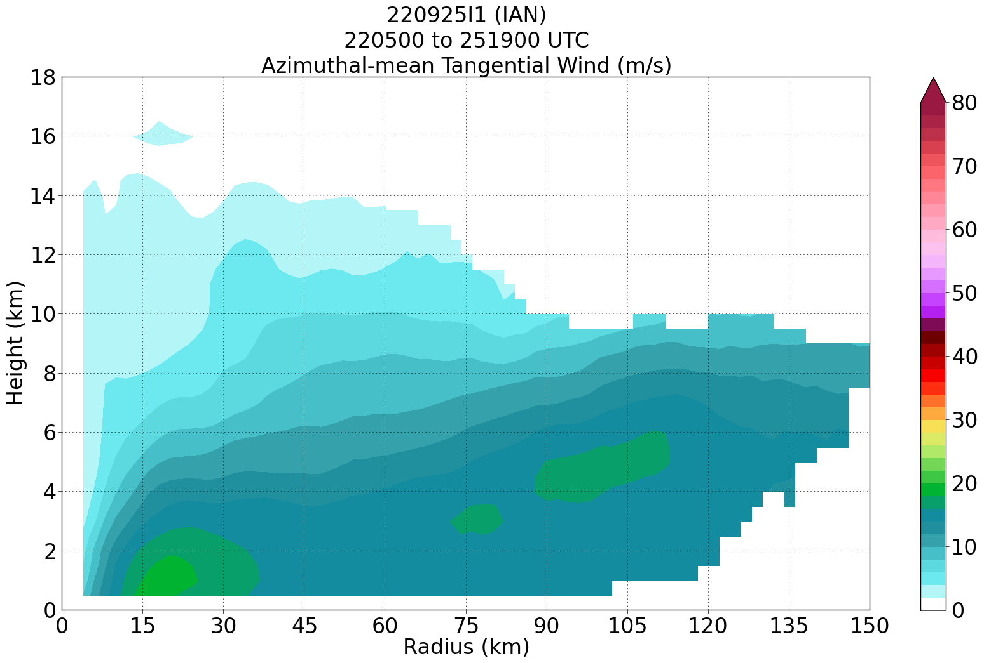
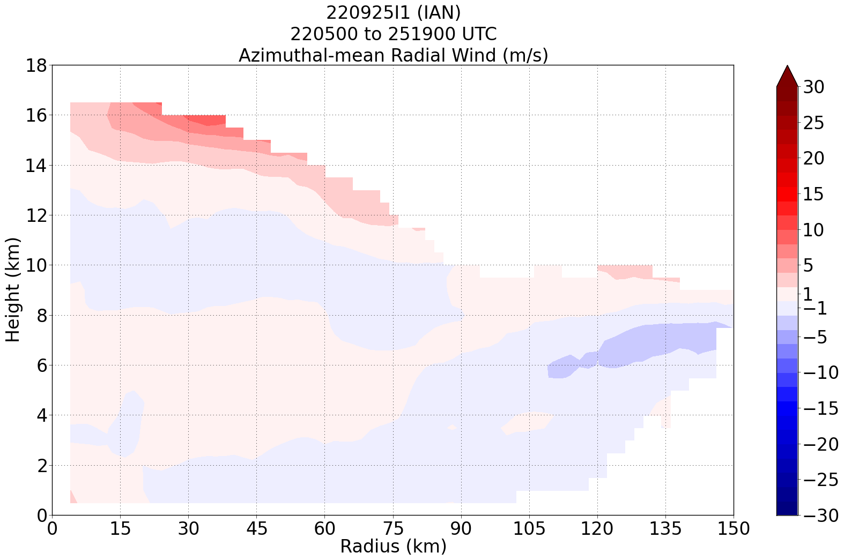
Azimuthal-mean tangential (top panel) and radial (bottom panel) flow for 25I1 (12 h after 25H1). Note the well-defined, but shallow, RMW at about 20 km. Also note the broad primary circulation that extends out to 135 km and up to 8 km. This seems to be a continuation of the broad vortex seen during 25H1. Also note the midlevel maximum in tangential wind at ~100 km radius and 5 km height. Radial flow shows an inflow maximum outside and above this tangential wind maximum. The low-level inflow associated with the inner RMW remains quite weak in this analysis.

It will be interesting to see if this structure observed during 25I1 (broad tangential wind field with a midlevel maximum, midlevel inflow channel at large radii and weak low-level inflow near the inner RMW), will cause Ian’s intensification rate to be slower than what would otherwise be indicated by the extremely favorable environment. Today’s mission could shed some insight on that.
0938 | AXBT1, on approach to IP, SST 29.7 C
0939 | Drop 1, on approach to NW IP
0942 | At IP, widespread stratiform precipitation
0958 | Drop 2, midpoint NW
100245 | Drop 3, 1st RMW NW
100315 | Drop 4, 2nd RMW NW
100345 | Drop 5, 3rd RMW NW
1009 | Eyewall is open on W and NW sides, spiral eyewall structure
1012 | Drop 6, mark center 18deg 23min 82deg 07min, AXBT 2, SST 29.75
101605 | Drop 7, 1st RMW SE
101635 | Drop 8, 2nd RMW SE
101705 | Drop 9, 3rd RMW SE
1025 | Drop 10, midpt SE
1037 | Drop 11, endpt SE, BT 3, SST 29.38
1042 | Pressure from center drop was 978 hPa. I suspect the peak winds we measure won’t "support" that. That's because we have a large storm. That'll keep the maximum winds down, but it'll mean worse damage from the surge, which is especially concerning if it tracks as close to Tampa Bay as the forecast suggests.
1102 | Drop 12, endpt E, AXBT 4, SST 29.88C
1112 | Drop 13, midpt E
112025 | Drop 14, 1st RMW E
112055 | Drop 15, 2nd RMW E
112125 | Drop 16, 3rd RMW E
1139 | Drop 17, center 18 deg 39 min 82 deg 28 min
114135 | Drop 18, 1st RMW W
114205 | Drop 19, 2nd RMW W
114235 | Drop 20, 3rd RMW W
1149 | Drop 21, midpt W
1158 | Drop 22, endpt W, AXBT 5, SST 29.93
1210 | 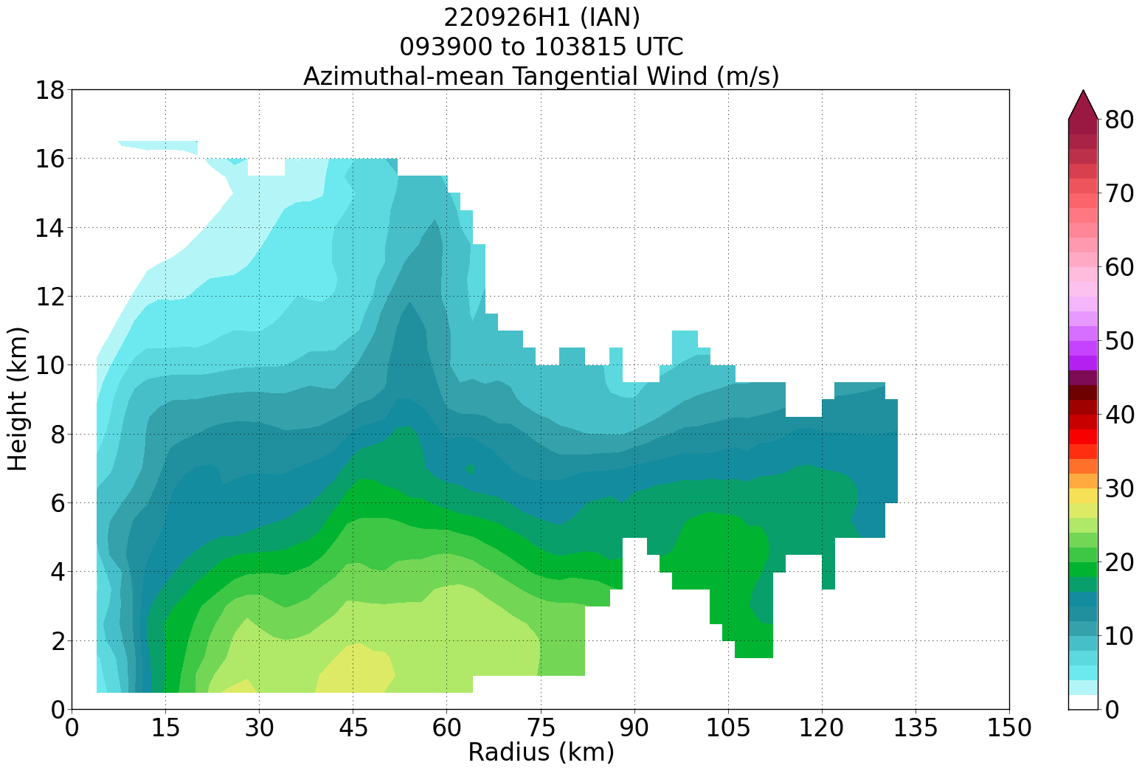  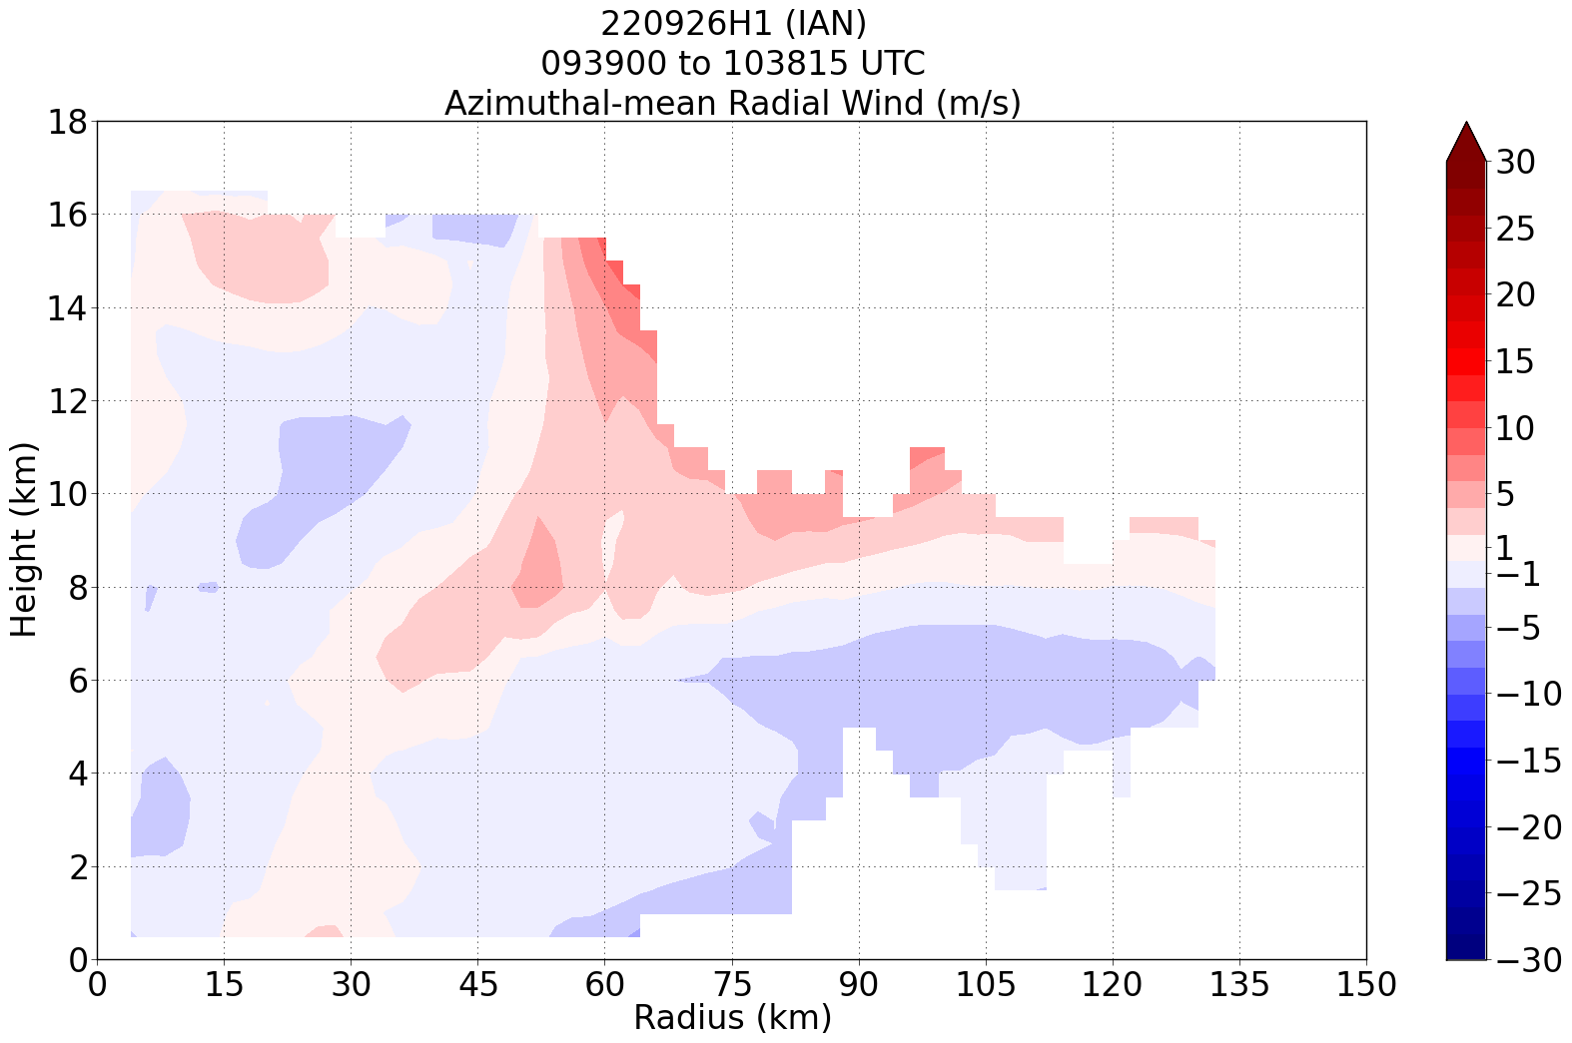  Azimuthal-mean plots of tangential wind (top panel) and radial wind (bottom panel) from first NW-SE pass through Ian today. The primary circulation has strengthened, but it remains a broad and generally shallow vortex. It is not a deep, narrow, intense vortex. The radial flow is consistent with the tangential flow, and it shows a deep layer of generally weak inflow below 7 km outside 30 km radius. There is not an indication, from this analysis and for this leg, of strong PBL inflow. Profile analyses will likely shed more insight on that.  It will be interesting to see if this structure holds once the remaining two passes are included. If so, then I would suspect that the storm will not have intensified much. The fact that SFMR has not shown much, if any, in the way of strengthening supports that notion, though, granted, we have not sampled the northeast quadrant. That may show stronger winds there.
1218 | Drop 23, SW endpt, AXBT 6, SST 29.38
1220 | IR satellite animation showing strong convective bursting within inner core, with signs of convection wrapping around NW quadrant
1231 | Drop 24, SW midpt  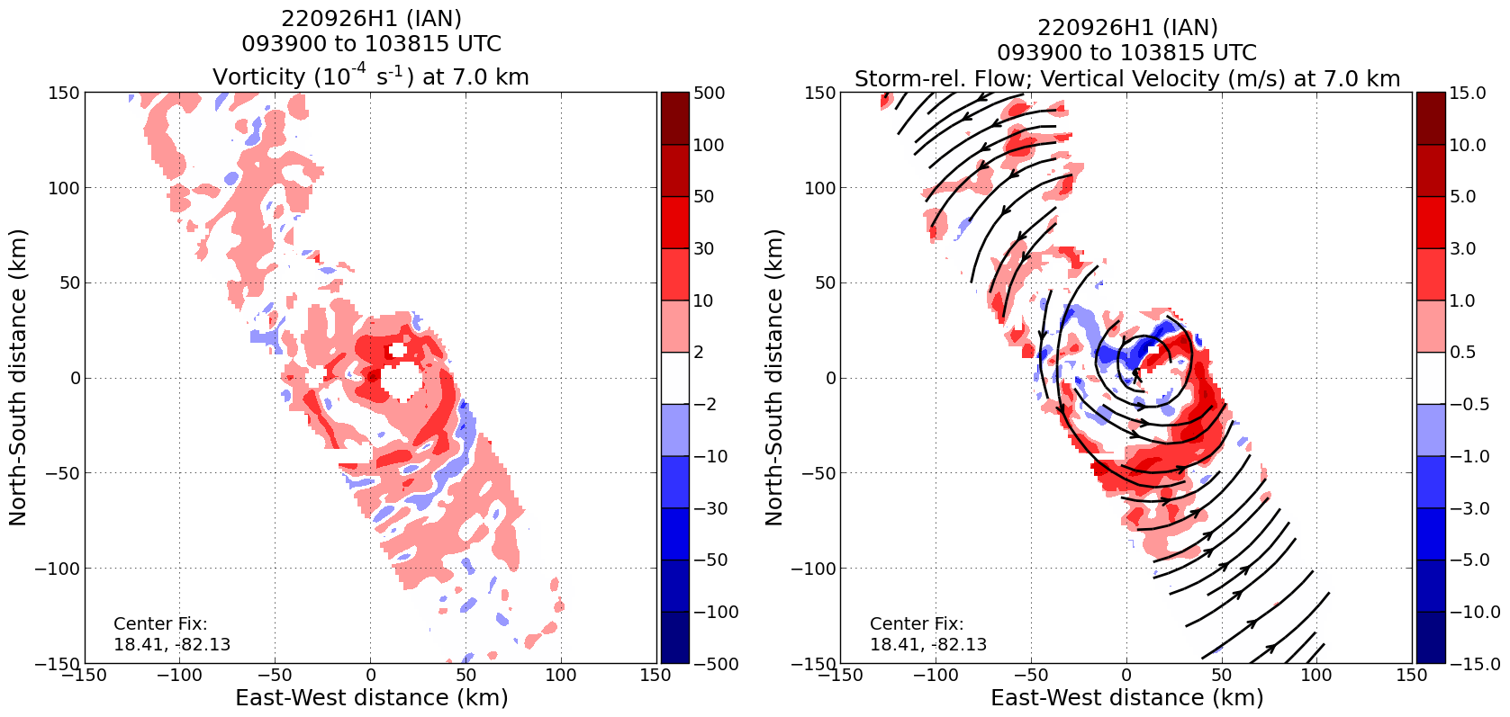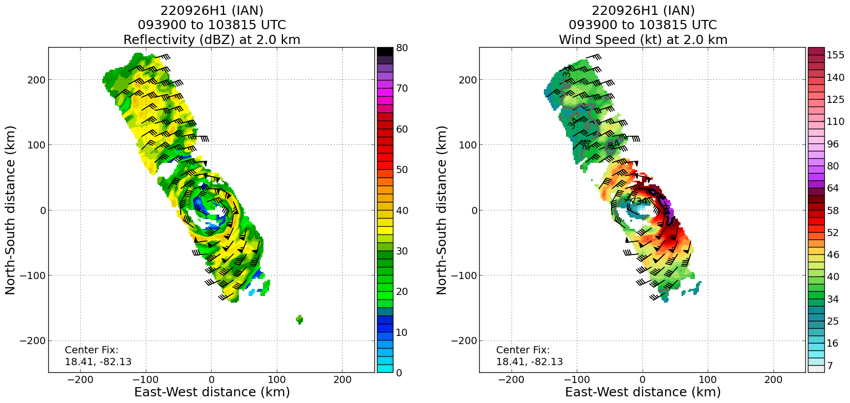  First TDR analysis showed the eyewall resembled a strong convective band curled inward toward the TC center on the NE side of the system. Analysis also showed evidence of subsidence at 7 km altitude in the NW eyewall. Highly asymmetric wind structure too, peak winds of ~65-70 kt on the east side at 2 km.
123635 | Drop 25, 1st RMW SW
123705 | Drop 26, 2nd RMW SW
123735 | Drop 27, 3rd RMW SW
123830 | Drop 28, 4th RMW SW (because first three were a bit early)
1245 | Drop 29, mark center, 18 deg 47 min 82 deg 28 min, AXBT 7, SST 29.6C
125040 | Drop 30, 1st RMW NE
125110 | Drop 31, 2nd RMW NE
125140 | Drop 32, 3rd RMW NE
1259 | Drop 33, midpt NE
1310 | Drop 34, endpt NE, BT 8, 29.4 SST
1417 | Third TDR analysis showed subsidence on the NW side of the inner core. Storm-relative streamlines are consistent with the idea of mid-level dry air being transported into the inner core. There was also a weakening of reflectivity below this height, consistent with subsidence and drying. The subsidence was observed between heights of approximately 5–10 km. This hypothesized ventilation episode may explain why the storm did not deepen appreciably during the flight.  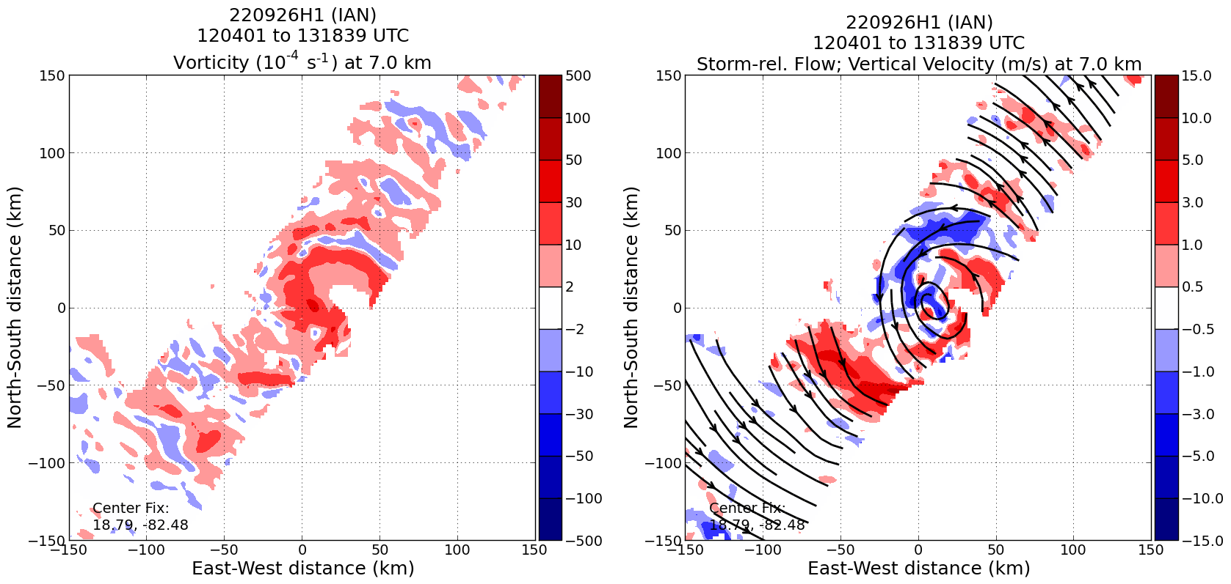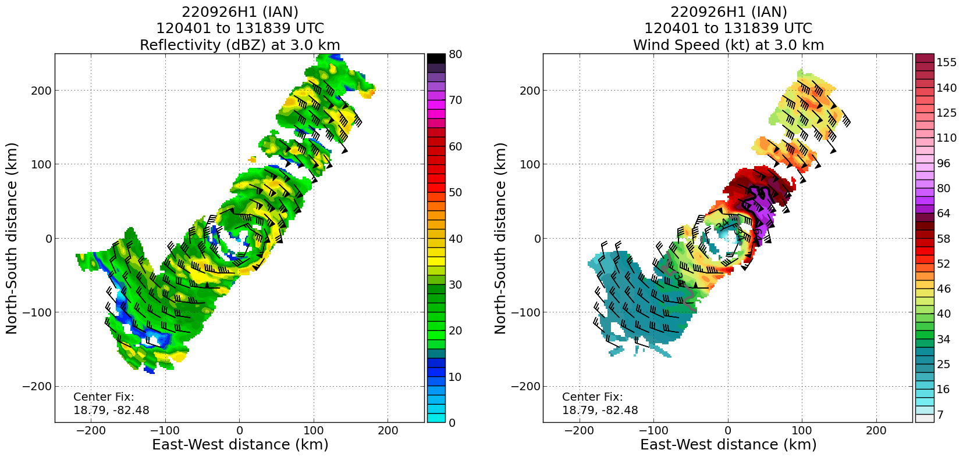
1433 | A 1200 UTC SSMIS overpass shows a gap in convection, consistent with a dry air intrusion, wrapping into the NW side of the inner core, where 91-GHz brightness temps were relatively high (weak convection).  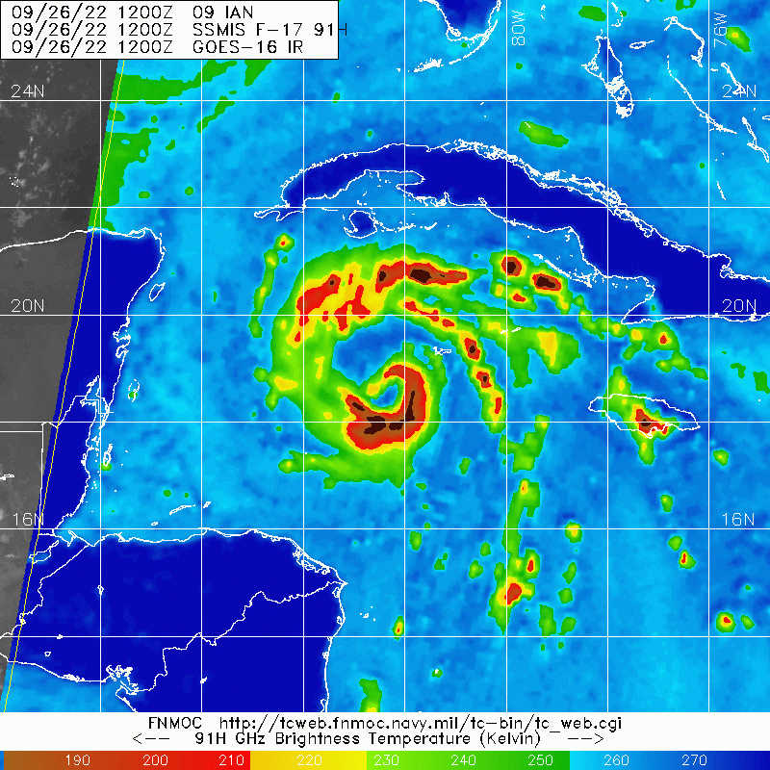
1435 | 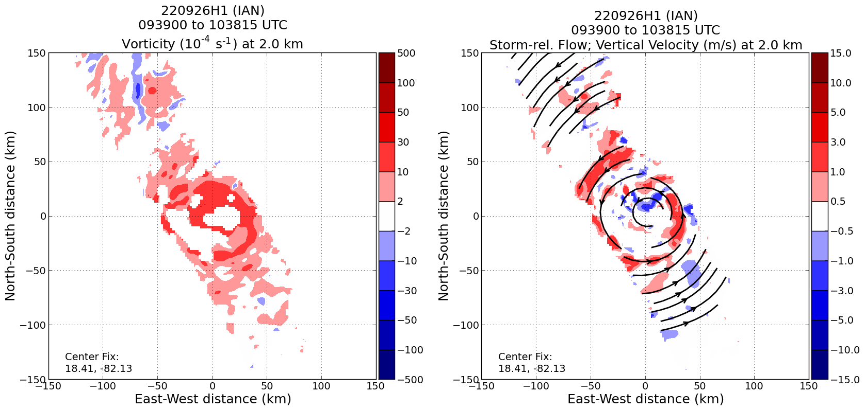  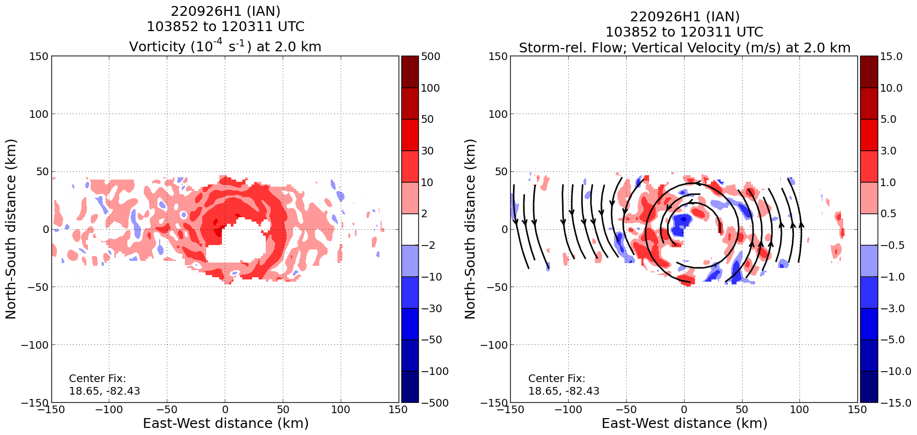  Analyses of vorticity, vertical velocity, and storm-relative flow at 2 km from the first two passes showed what appeared to be a ring of vorticity at about 40 km radius as well as a vorticity monopole at the center.
1444 | Land in KLAL (exact time uncertain/not marked in real time)

POST-FLIGHT
Mission Summary | Mission was flown as planned, standard butterfly pattern. The storm showed a structure that generally appeared consistent with what was observed during the previous mission by N43, 12 h ago. Azimuthal-mean plots of tangential winds showed that the vortex was not very deep, but it was a broad vortex. The winds had intensified some, but not substantially, neither in the azimuthal-mean nor in the individual FL or SF measurements. The strongest SF measurements were 60-65 kt on the east side of the storm. This was not significantly stronger than what was analyzed by NHC at the 5am advisory, just after takeoff. The storm has not begun to rapidly intensify, at least not yet. Central pressures from dropsondes were 983 hPa, perhaps a bit lower than what a 65-kt hurricane would suggest. The large size of the vortex may explain why the pressures are fairly low while the wind speeds are not.  Initially, there was not a lot of deep convection evident in the storm. Most of the rainfall noticed in TDR sweeps appeared to be stratiform. However, as the flight progressed, IR brightness temps cooled, with some values < -80C and a central dense overcast temporarily formed. TDR analyses showed moderate–deep convection in a cyclonically curved band wrapping into the eyewall.  Analyses of vorticity from the first two passes showed what appeared to be a ring of vorticity that was trying to develop at about 40 km. The ring appeared to be at similar radii to the primary azimuthal-mean radius of maximum winds. This was occurring despite the presence of a vorticity monopole, also evident in the plan view plot of vorticity. Above the freezing level, this vorticity ring became more asymmetric and resembled more of a curved banding pattern.  The apparent lack of significant intensification is curious. It is possible the vortex structure (namely, the depth and the size of the primary circulation) may be playing a role in hampering significant intensification. TDR analyses indicated the vortex was relatively broad and shallow. Additionally, the third TDR analysis showed subsidence on the NW side of the inner core. Ground radar observations from the Cayman Islands and a 1200 UTC SSMIS overpass indicated a gap in precipitation/convection wrapping into the NW side of the inner core, consistent with a dry air intrusion. TDR-derived storm-relative streamlines were consistent with the idea of mid-level dry air being transported into the inner core. There was also a weakening of reflectivity below this height, consistent with subsidence and drying. The subsidence was observed between heights of approximately 5–10 km, and it may have been the feature noted in the azimuthal-mean radial inflow noted earlier in this log in the analysis from the previous N43 mission (i.e., NW midlevel inflow that projected onto the azimuthal mean). This hypothesized ventilation episode may also explain why the storm did not deepen appreciably during the flight.  We did release rapid-fire RMW drops at all azimuths around the storm. Ironically perhaps, these drops may be helpful in assessing why Ian was *not* rapidly intensifying. We also released 8 AXBTs, at all end points and on the first and third center passes.  A total of 34 dropsondes were released.
Actual Standard Pattern Flown | Butterfly at 8-10 kft pressure altitude
APHEX Experiments / Modules Flown | With the possibility of imminent rapid intensification, data collection supports the Early Stage Experiment: Analysis of Intensity Change Processes (AIPEX). The RMW rapid-fire sequence was in support of ONR’s Tropical Cyclone Rapid Intensification (TCRI) experiment. Since these were dropped on all six radials, along with 8 AXBTs, this effectively became a module with the Mature Stage Experiment: Hurricane Boundary Layer.
Plain Language Summary
Instrument Notes | All instruments and expendables worked and were transmitted.
Final Mission Track | 