MISSION PLAN
FLIGHT ID | 20220925I1 | STORM | AL09 / IAN
MISSION ID | 1109A | TAIL NUMBER | NOAA43
TASKING | EMC | PLANNED PATTERN | Butterfly
MISSION SUMMARY
TAKEOFF [UTC] | 1954 | LANDING [UTC] | 0301
TAKEOFF LOCATION | Lakeland | LANDING LOCATION | Lakeland
FLIGHT TIME | 7.1 | BLOCK TIME | 7.5
TOTAL REAL-TIME RADAR ANALYSES  (Transmitted) | 3 (3) | TOTAL DROPSONDES (Good/Transmitted) | 21 (20 / 20)
OCEAN EXPENDABLES (Type) | None | sUAS (Type) | None
APHEX EXPERIMENTS / MODULES | Early Stage Experiment: AIPEX
HRD CREW MANIFEST
LPS ONBOARD | Holbach | LPS GROUND | None
TDR ONBOARD | Holbach | TDR GROUND | Gamache
ASPEN ONBOARD | Hazelton | ASPEN GROUND | None
NESDIS SCIENTISTS | Chang, Jelenak, Sapp
GUESTS (Affiliation) | None
AOC CREW MANIFEST
PILOTS | Mitchell, Doremous, Keith
NAVIGATOR | Urato
FLIGHT ENGINEERS | Pittman, Tyson, Tuffnell
FLIGHT DIRECTOR | Carpenter
DATA TECHNICIAN | T. Richards
AVAPS | Warnecke

PRE-FLIGHT
Flight Plan | 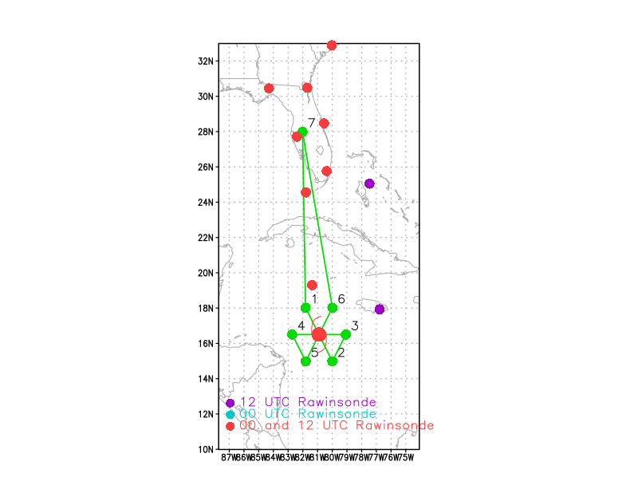  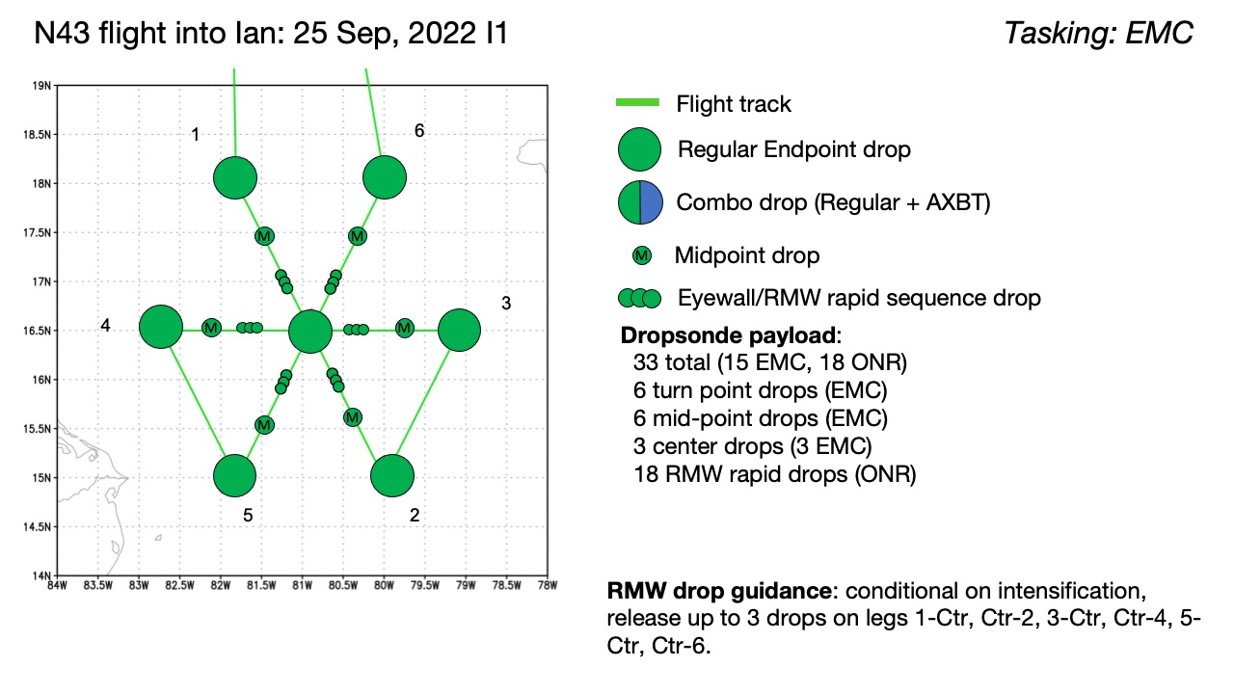  Pattern: Fly butterfly pattern with 105 nmi legs  Altitude: 10 kft (pressure altitude)  Potential add-on Modules: None  Expendables: 33 sondes (all dropsondes transmitted to the GTS); No ONR/NRL AXBTs  Also have the NHC 2330Z fix requirement
Expendable Distribution | Release sondes at endpoints, midpoints, centers; possible supplemental rapid RMW drops conditional upon intensification
Preflight Weather Briefing | As of 5pm ET, Ian is a 40 kt tropical storm with minimum sea-level pressure of 1003 mb moving WNW (300) at 10 kt. From 5pm NHC discussion: “Although the storm has yet to develop an inner core, the conditions over the northwestern Caribbean Sea appear very likely to support strengthening once it becomes better organized. Some dry environmental air may have limited convection today, but the GFS- and ECMWF-simulated satellite imagery indicate that deep convection will increase during the diurnal maximum period overnight. Then, significant strengthening is expected with low deep-layer shear and  high oceanic heat content along the forecast track.”
Instrument Notes | None

IN-FLIGHT
Time [UTC] | Event
1953 | Takeoff from Lakeland
2157 | Picking through outer rain band to IP
2205 | Initial Point (IP) leg 1 drop #1
2219 | Midpoint (MP) drop #2
 | Seeing some sort of possible eyewall-like feature on the MMR surface mode. We are targeting that for our center but winds may end up taking us a different way. Wondering if the center might try to reform near that feature if it is in fact currently south of it
2231 | RMW NW drop #3 10 m = 35 kt
2232 | Center drop # 4 992 mb 155/15kt  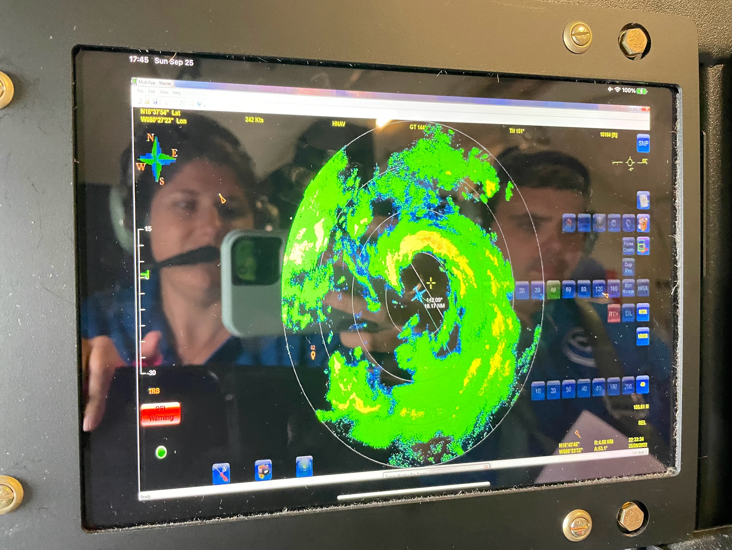
 | Definitely had a nice max wind band in that "eyewall"
2245 | Midpoint drop #5
 | Just some scattered cells out this way in what look like rainbands
2258 | Endpoint (EP) leg 1 drop #6
2324 | IP leg 2 drop #7
 | Going to deviate a little S in about 20 n mi around a cellular rain band then get back on original track once we are beyond it
2335 | Midpoint drop #8
2342 | RMW E drop # 9 No launch detect (Bad sonde)
2343 | RMW E drop #10 10 m = 40 kt
 | Probably won't get a good center fix since the center is tucked up near some convection in the center. Looks hook like on MMR or comma shape
2349 | Center CPA drop #11; Center was to our N tucked up in a cell within the eye  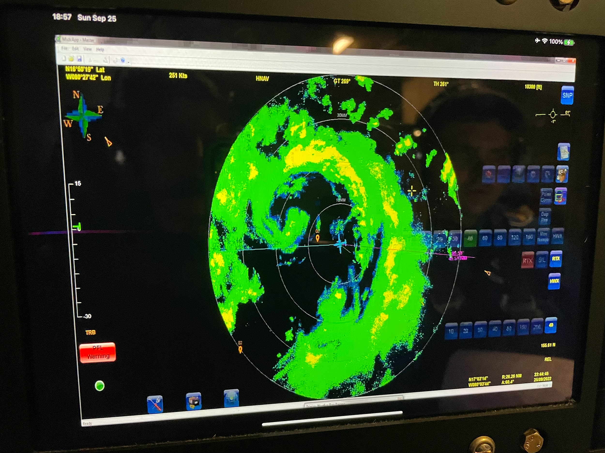
0000 | Midpoint drop #12
0008 | EP leg 2 drop #13
0029 | IP leg 3 drop #14
0041 | Midpoint drop #15
0052 | Center CPA drop #16 992 mb 285/27kt  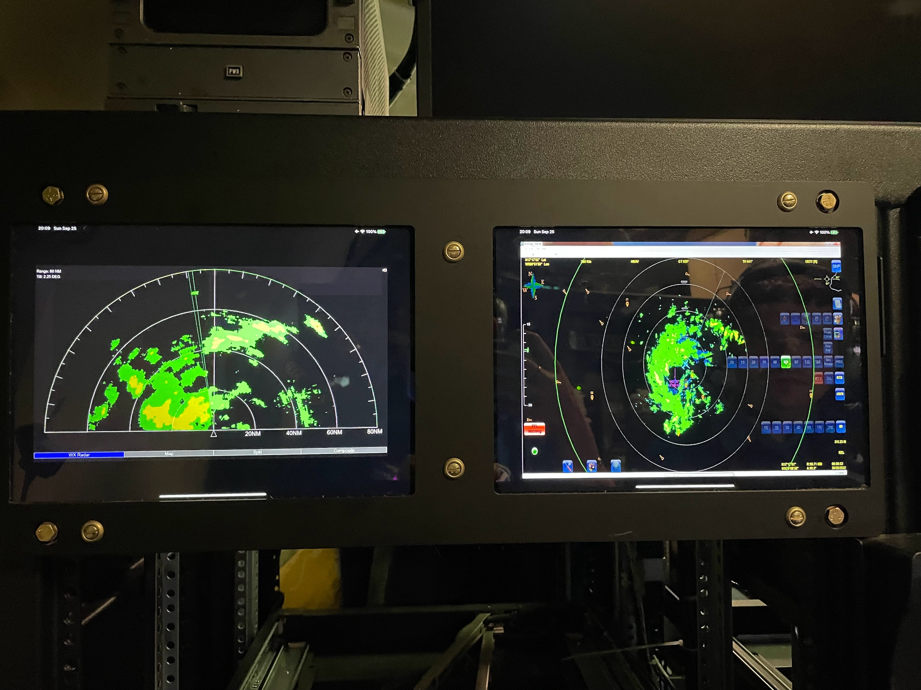
005507 | RMW NE drop #17 no sfc winds
005534 | RMW NE drop #18 10 m = 61 kt
005604 | RMW NE drop #19 10 m = 50 kt
0108 | Midpoint drop #20
0118 | EP leg 3 drop #21. Science complete

POST-FLIGHT
Mission Summary | Ian surprised us with a partial eyewall upon our arrival to the system this evening. On our first pass we found that the pressure had fallen substantially to 991 mb. By the last pass, the MSLP was down to about 989 mb. Peak SFMR 1-sec winds were 27.6 m/s and peak flight-level 1-sec winds were 28.3 m/s.  TDR analyses show that Ian has become more vertically aligned and the RMW has contracted inward. IR satellite imagery also depicts a more organized system. It is possible that this flight sampled Ian’s rapid intensification onset. Still seems as though some dry air may have been wrapping into the system.  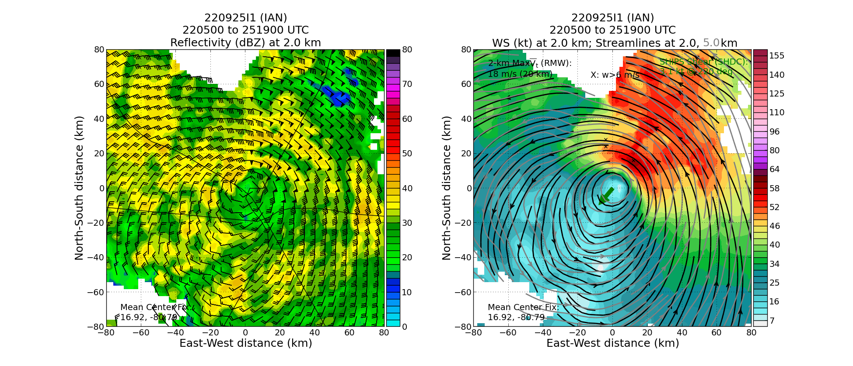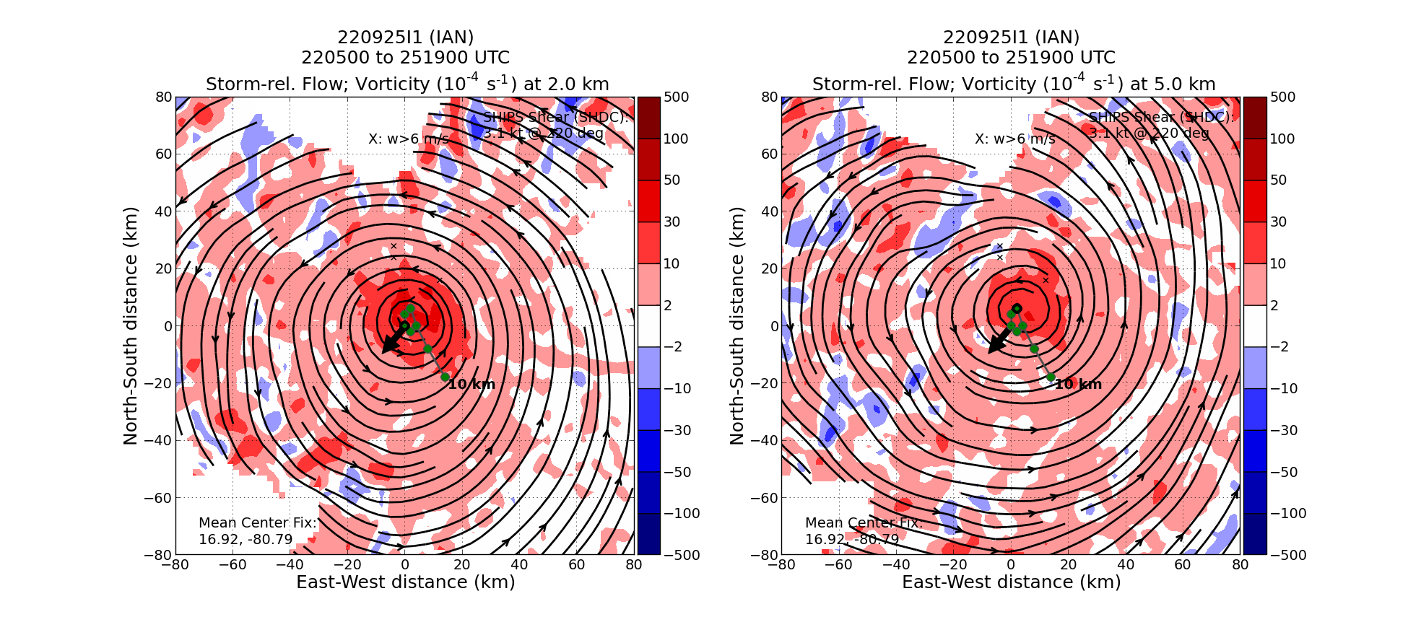  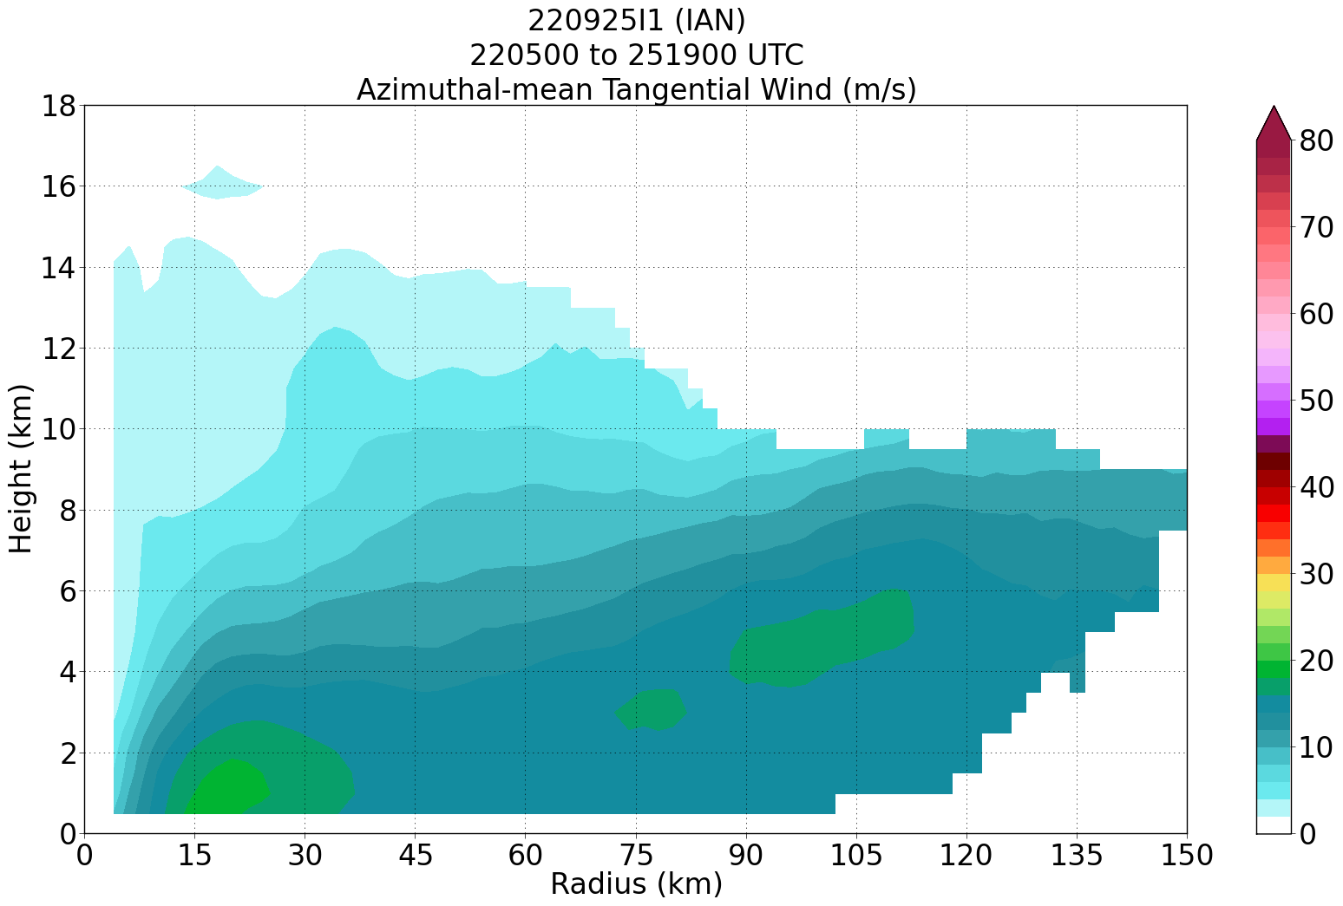  Sondes: NWS: 15 ONR: 6
Actual Standard Pattern Flown | Butterfly
APHEX Experiments / Modules Flown | With rapid intensification likely ongoing now, this data collection effort supports the Early Stage Experiment: Analysis of Intensity Change Processes (AIPEX).
Plain Language Summary | - Ian was beginning to become better organized and may have been starting to rapidly intensify.  - TDR analyses showed that the storm was becoming better aligned with height.
Instrument Notes | None
Final Mission Track | 