MISSION PLAN
FLIGHT ID | 20220925H1 | STORM | AL09 / IAN
MISSION ID | 0809A | TAIL NUMBER | NOAA42
TASKING | EMC | PLANNED PATTERN | Butterfly
MISSION SUMMARY
TAKEOFF [UTC] | 0821 | LANDING [UTC] | 1559
TAKEOFF LOCATION | Aruba | LANDING LOCATION | Lakeland
FLIGHT TIME | 7.6 | BLOCK TIME | 7.9
TOTAL REAL-TIME RADAR ANALYSES  (Transmitted) | 3 (3) | TOTAL DROPSONDES (Good/Transmitted) | 21 (20 / 20)
OCEAN EXPENDABLES (Type) | 3 AXBTs (ONR) | sUAS (Type) | None
APHEX EXPERIMENTS / MODULES | Early Stage Experiment: AIPEX
HRD CREW MANIFEST
LPS ONBOARD | Rogers | LPS GROUND | None
TDR ONBOARD | Rogers | TDR GROUND | Reasor
ASPEN ONBOARD | J. Zhang | ASPEN GROUND | None
NESDIS SCIENTISTS | None
GUESTS (Affiliation) | None
AOC CREW MANIFEST
PILOTS | Abitbol, Copare, Wood
NAVIGATOR | Miller
FLIGHT ENGINEERS | Stokes, Gee
FLIGHT DIRECTOR | Kalen, Holmes
DATA TECHNICIAN | MacAlister
AVAPS | Dykeman

PRE-FLIGHT
Flight Plan | Butterfly pattern, 105 nmi leg lengths, IP on the SW side. Fly at 10 kft. No modules planned. Takeoff from Aruba, land in Lakeland.  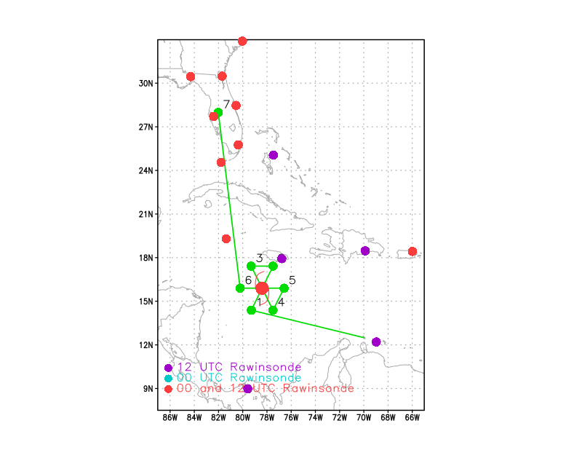  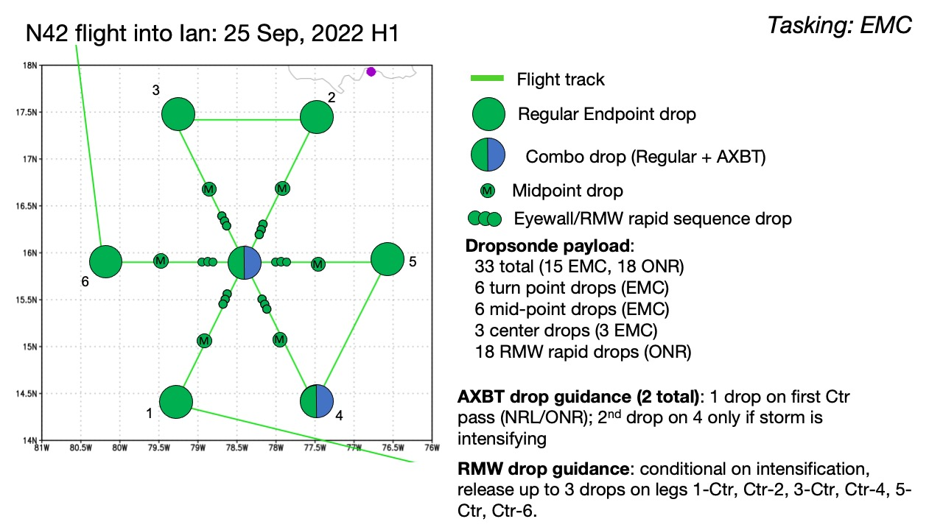
Expendable Distribution | Dropsondes at all endpoints, midpoints, and center fixes when possible. Possible 3-sonde rapid fire sequences across the RMW at all azimuths, assuming there is a clearly-identifiable RMW. Given the continued disorganization of the storm, though, that does not appear likely.
Preflight Weather Briefing | Ian remains a low-end tropical storm for the moment. The structure of the storm is still fairly disorganized. Despite appearances in geostationary imagery (shortwave IR) suggesting that Ian is becoming better-aligned, recent low-level invest missions from the Air Force showed multiple low-level centers within a rather broad cyclonic envelope. The 11PM NHC advisory put Ian at 45 kt, moving toward 290 at 11 kt with a minimum pressure of 1002 hPa. These numbers were obtained via satellite.  Ian is now in a low-shear, high-moisture environment with warm waters (SST 29-30C) and high ocean heat content. The environment is quite favorable for rapid intensification, and RI guidance is all strongly pointing toward RI to occur over the next 24-48 h. The official NHC forecast as of 11PM brings Ian to 120 kt by 72 h. But first the storm has to develop an inner core that will be capable of exploiting this favorable environment. That does not appear to have happened yet. It may happen today, perhaps during this mission.
Instrument Notes | All instruments working.

IN-FLIGHT
Time [UTC] | Event
0821 | Takeoff from Aruba
1010 | Haven't really seen any consolidated core of cold cloud tops today, which is perhaps characteristic of a low-shear environment. Satellite presentation is just a couple of big spiral bands. My thought is that it would indicate that intensification is still not imminent nor ongoing. Idealized modeling studies have suggested that vorticity is aggregating right now, then symmetrization occurs, then the core develops. It’s not clear to me if that’s the case here, since it appears based on satellite presentation that any vorticity is occurring at large radii. It has to get into the core to symmetrize and amplify. The PBL usually starts to organize convection, but this system has been showing vorticity in satellite imagery (vis imagery showing low-level flow) for days now, and no real organization yet. Perhaps Ekman pumping is not strong enough yet to really start to build the core.  This could be an interesting observational study on the process of “core development” in a low-shear environment. Perhaps it is harder to develop/build this core in low shear because you don’t have shear to focus convection. It has to occur from the system itself (i.e. Ekman pumping), which would be slow to occur.
1025 | At IP, Drop 1, SW endpt
1027 | Nice band about 15 nm ahead, in widespread stratiform inside the band, good TDR coverage
1038 | Drop 2, SW midpt
1048 | Drop 3, center mark 14 deg 53 min 79 deg 23 min
105835 | Drop 4, 1st RMW NE (FL RMW)
105905 | Drop 5, 2nd RMW NE
105935 | Drop 6, 3rd RMW NE
1105 | Drop 7, midpt NE
1110 | GOES IR from 1055z  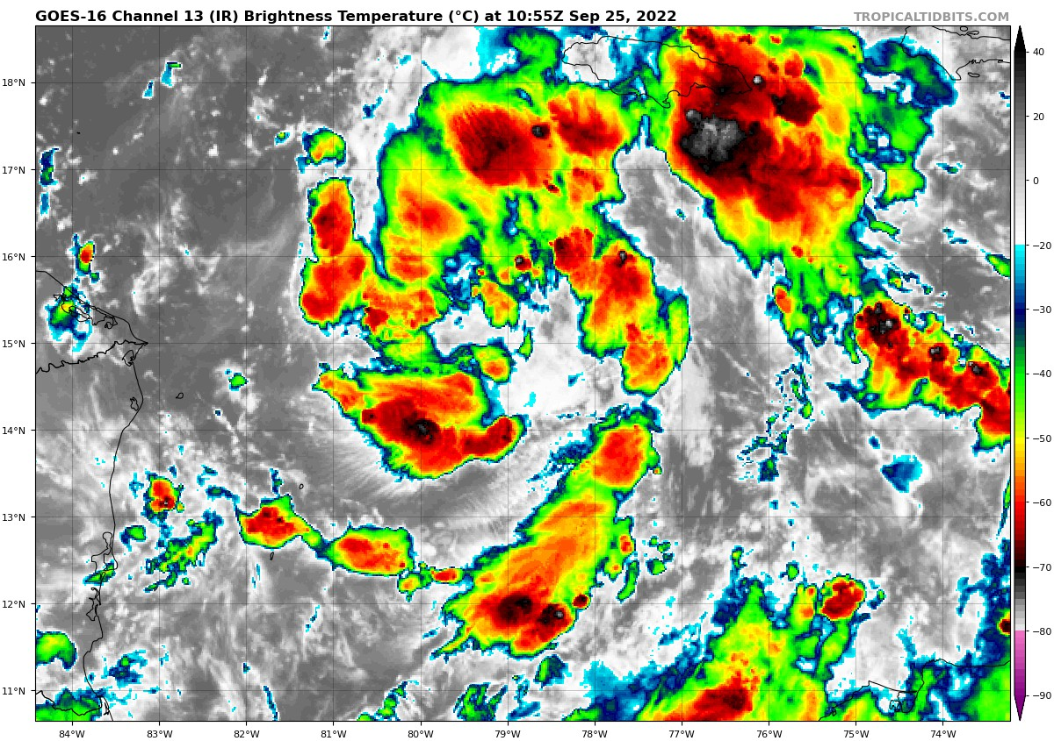
1114 | Drop 8, endpt NE
1116 | 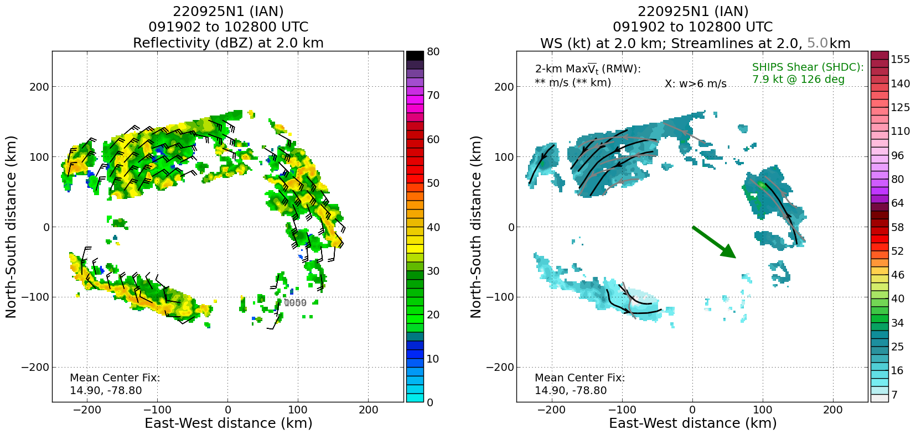  TDR analysis from ongoing G-IV circumnavigation shows what looks like a circulation that is fairly well-aligned between 2 and 5 km, but there is a lack of scatterers at the inner radii. Wind field at 2 km suggests perhaps an elongated circulation oriented SE-NW. Will be good to look at analysis from the first P-3 pass to see what the inner-core structure looks like.
1136 | Drop 9, BT 1, NW endpt, SST 29.95 C
1148 | A preliminary look at the analysis from the first pass: There are certainly more scatterers, and I'd say definitely a clearer circulation center over a deeper layer. The 2-km center is well-defined and slightly SE of the grid origin. Then there is about a 50 km or so tilt to the NW at 5 km and above that a circulation at 8 km that almost looks where the 2-km center is. So it tilts NW b/w 2-5 km, then back toward SE b/w 5-8 km. But for sure it's a deeper vortex today compared to yesterday. We're actually able to see a vortex today.
1149 | Drop 10, NW midpt
1155 | 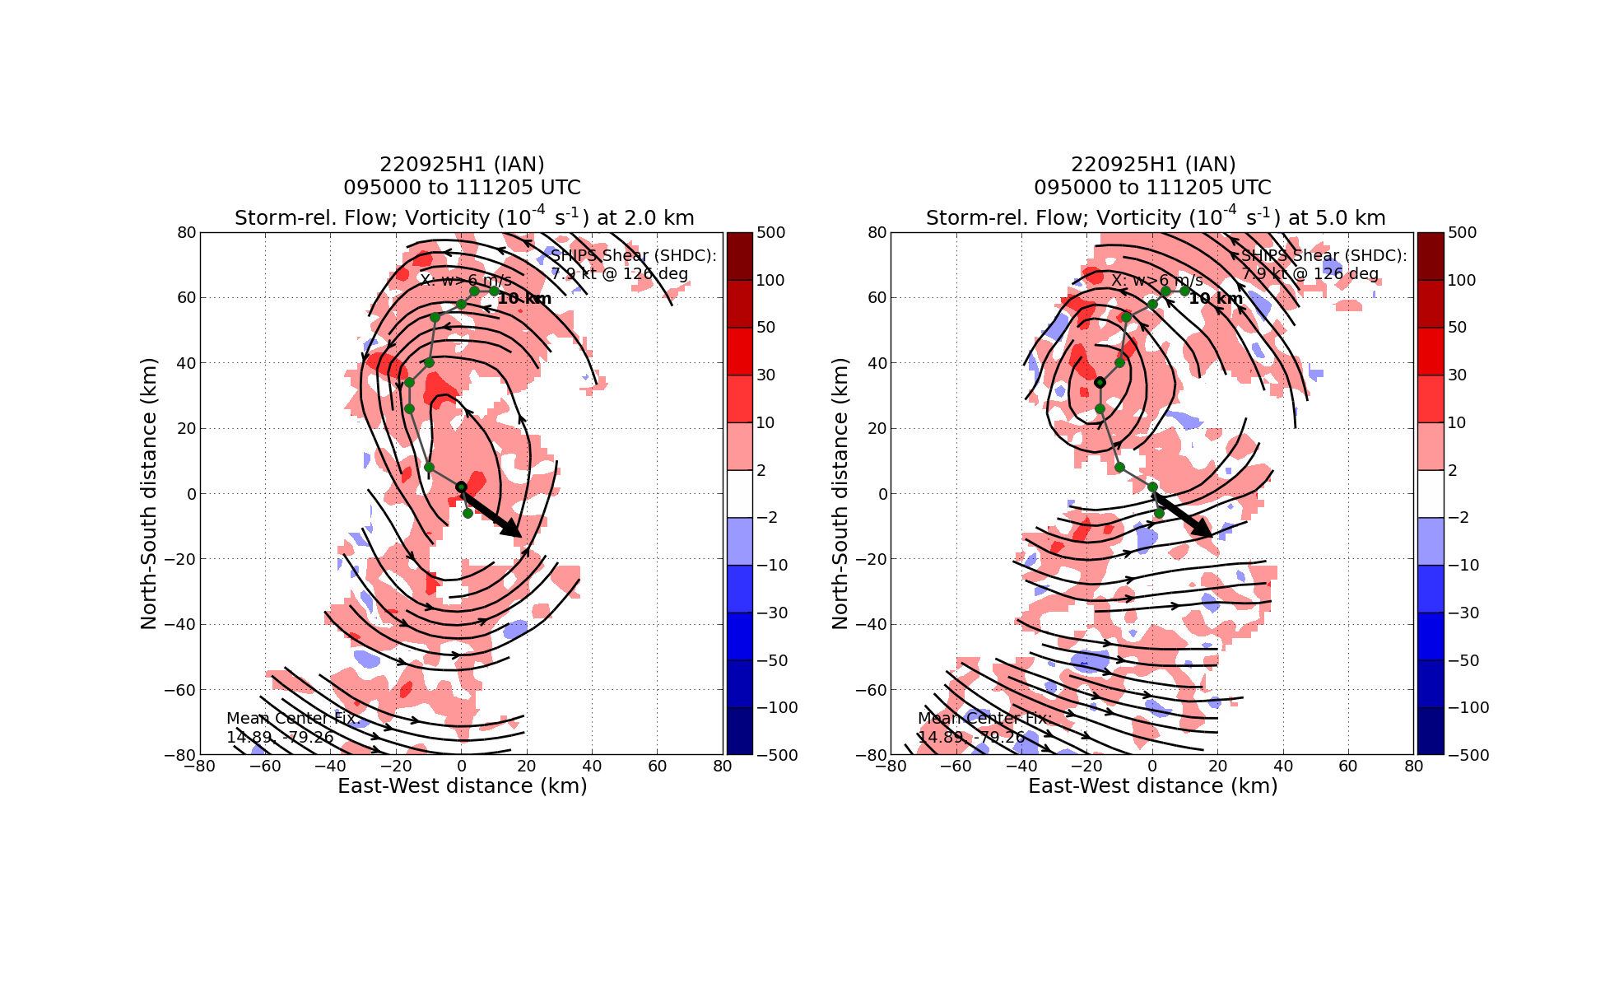  TDR analysis from first pass shows tilt between 2 and 5 km mentioned previously. Displacement is about 40 km to the NW. Above that, tilt rotates anticyclonically to about a 60 km tilt at 10 km. The wind field looks pretty similar to Hermine (2016) – you see the MLC with a co-located vorticity core at 5 km, and underneath that you see the elongated circulation at 2 km. At the northwestern tip of the 2-km circulation you see a local vorticity maximum. It could represent reformation happening underneath the MLC.
1200 | Drop 11 center, BT 2, SST 29.66 C
1214 | Drop 12, midpt SE
1217 | Drop 13, BT 3, SST 29.48 C (cut outbound leg short to avoid weather ahead of us)
1238 | Certificate at www.aoml.noaa.gov expired at 1218 UTC, meaning we no longer have access to real-time radar products. Presumably it’s just a matter of renewing the certificate, but someone at AOML would need to be contacted for that.
1244 | Drop 14, endpt E
124855 | Drop 15, 1st RMW E
124925 | Drop 16, 2nd RMW E
124955 | Drop 17, 3rd RMW E, no launch detect
1258 | Drop 18, midpt E
1258 | Lots of stratiform precipitation on the east side
1312 | Drop 19, center (3rd pass)
1324 | Drop 20, midpt W
1334 | Drop 21, endpt W
1559 | Land in Lakeland

POST-FLIGHT
Mission Summary | Mission was flown as planned. The storm is better organized than yesterday, for sure. Radar analyses from the first pass showed a coherent circulation up to at least 8 km, and the center-finding algorithm could locate a center up to 10 km. The observed structure from first pass showed that the circulation was tilted about 40 km to the NNW between 2 and 5 km, and above that altitude the circulation centers tilted in an anticyclonic fashion, with a maximum tilt of about 60 km between 2 and 10 km. At the location of the 5-km circulation center there was a local vorticity maximum, while at 2 km there was an elongated circulation extending from the SSE-NNW. The NNW tip of that elongated circulation had a local vorticity maximum that was also coincident with the MLC (I.e, at 5 km). This suggested that perhaps reformation was occurring associated with the MLC. Subsequent passes were inconclusive about whether or not this was occurring, but they did show that the 2-5 km tilt had decreased by the end of the mission. Interestingly, the precipitation mode within 50 km of both the LLC and MLC were moderate convection and stratiform precipitation – little to no deep convection. That being said, it is not conclusive that what we saw during today’s mission was a reformation (and it didn’t appear to be a downshear reformation, since the tilt vector was actually upshear). It may have been a repositioning, but it can’t be said whether that repositioning was tied to low-level stretching/reformation or whether it was a mutual advection of the LLC and MLC in the presence of deep convection. Given the absence of actual deep convection, though, this latter mechanism seems unlikely. Further exploration of this data is warranted.  What’s also interesting is that this apparent alignment occurred even though there was no explosive convective development. In fact there was never really a period during this mission when there was an extensive cold cloud shield on IR imagery. There were spiral banding features evident, with little clear indications of convection within the centroid of the circulation. This may have been a case where alignment occurred in the absence of widespread and vigorous deep convection.  We did 2 sets of rapid-fire drops across the RMW, on the east and the northeast legs. The rest of the legs did not have a clear indication of an RMW.  21 sondes were released, 15 NWS and 6 ONR sondes. 20 of those 21 sondes were transmitted. One of the ONR sondes had no launch detect. All 3 AXBTs worked.
Actual Standard Pattern Flown | Butterfly at 10,000 ft pressure altitude
APHEX Experiments / Modules Flown | While no modules were specifically flown (except for the rapid RMW releases for ONR’s Tropical Cyclone Rapid Intensification, TCRI), data collection supports the Early Stage Experiment: Analysis of Intensity Change Processes (AIPEX) experiment considering the near-term potential of Ian to rapidly intensify.
Plain Language Summary
Instrument Notes | Lost access to TDR products at AOML FTP (certificate issue?)
Final Mission Track | 