MISSION PLAN
FLIGHT ID | 20220924H1 | STORM | AL09 / IAN
MISSION ID | 0309A | TAIL NUMBER | NOAA42
TASKING | EMC | PLANNED PATTERN | Butterfly
MISSION SUMMARY
TAKEOFF [UTC] | 0847 | LANDING [UTC] | 1400
TAKEOFF LOCATION | Aruba | LANDING LOCATION | Aruba
FLIGHT TIME | 5.2 | BLOCK TIME | 5.3
TOTAL REAL-TIME RADAR ANALYSES  (Transmitted) | 4 (4) | TOTAL DROPSONDES (Good/Transmitted) | 15 (15 / 15)
OCEAN EXPENDABLES (Type) | None | sUAS (Type) | None
APHEX EXPERIMENTS / MODULES | Early Stage Experiment: AIPEX (Vortex Alignment Module, VAM)
HRD CREW MANIFEST
LPS ONBOARD | Rogers | LPS GROUND | None
TDR ONBOARD | Rogers | TDR GROUND | Reasor
ASPEN ONBOARD | J. Zhang | ASPEN GROUND | None
NESDIS SCIENTISTS | None
GUESTS (Affiliation) | None
AOC CREW MANIFEST
PILOTS | Abitbol, Copare, Wood
NAVIGATOR | Miller
FLIGHT ENGINEERS | Stokes, Gee
FLIGHT DIRECTOR | Kalen, Holmes
DATA TECHNICIAN | MacAlister
AVAPS | Dykeman

PRE-FLIGHT
Flight Plan | Butterfly pattern into TS Ian, leg lengths of 105 nmi with an IP on the east side. Fly at 10 kft for most of the pattern, except for the SW-NE leg, which is also an NHC fix responsibility for 1130 UTC and will be flown at 5 kft pressure altitude. Will not do the VAM in the SW quadrant as planned due to potential interference with the fix requirement. Instead, we will head outbound to the southwest during the final pass, instead of the southeast, and thus effectively get two samples along the anticipated tilt/displacement vector, separated by about 2 h. No Stratiform Spiral Module will occur due to mission length/fueling constraints.  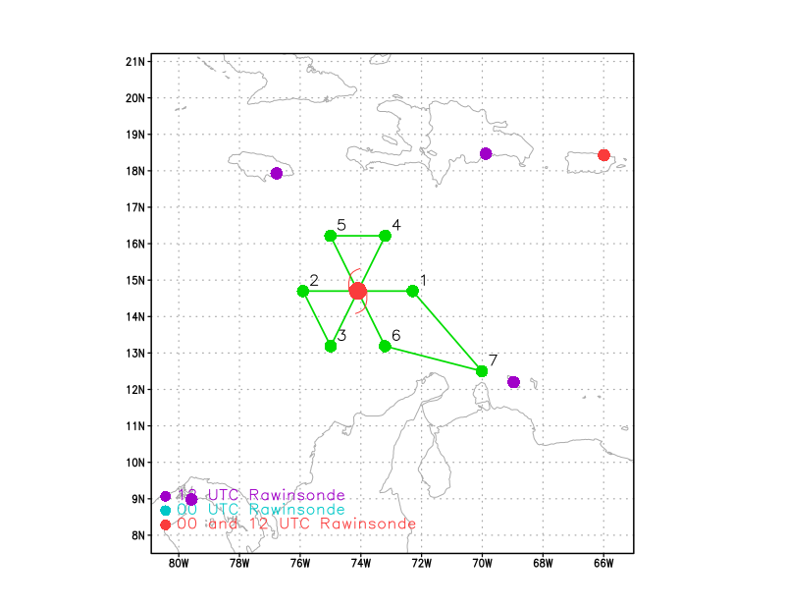  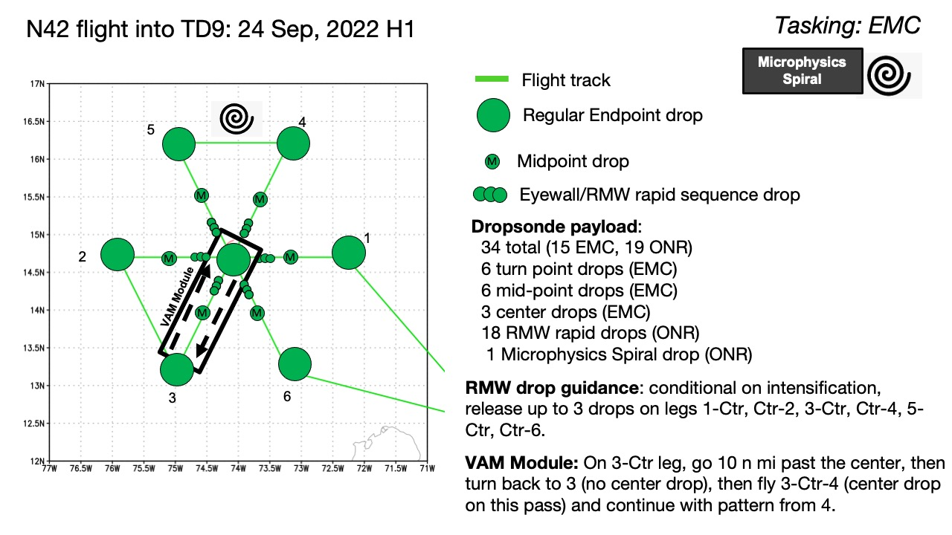
Expendable Distribution | Dropsondes at all endpoints, midpoints and during the center fix. Also, we will drop a sonde on the first inbound from the east, to see how vortex position may change below the aircraft from sonde winds. Do not anticipate a clearly defined RMW today, so RMW rapid-fire drops are not likely. But will monitor FL and SF wind speed time series to see if an RMW is clearly distinguishable.
Preflight Weather Briefing | Ian is slowly organizing and intensifying this morning. Satellite imagery indicates widespread cold cloud tops and lightning, indicative of deep convection, displaced to west and southwest of the identified low-level center (LLC). IR imagery suggests that the northeasterly wind shear that had been hampering Ian’s development is abating, in line with model forecasts, and it appears that deep convection is starting to develop over the LLC. These are all indications that Ian may be becoming better-aligned and stronger, and the most recent NHC discussion increased the intensity to 40 kt based on this improved satellite presentation. It will be interesting to see if this mission can observe the increasing organization and alignment of Ian this morning. Ian remains in a moist environment and will be entering an environment of high SST and ocean heat content, so the environment will become quite favorable for significant strengthening over the next 12-48 h, including possibly rapid intensification.
Instrument Notes | All instruments working fine

IN-FLIGHT
Time [UTC] | Event
0847 | Takeoff from Aruba
0927 | Drop 1, E endpoint (endpt)
0936 | Near E midpoint (midpt), flight-level (FL) winds showing ESE winds, almost a tail wind. Suggests if there is a circulation at this altitude it’s well to the SW of our position.
0936 | Drop 2, E midpt
0941 | Approaching center point, seeing good scatterers now to our south, moderate and deep convection mixed with stratiform, echo tops to 12-14 km. FL winds nearly easterly now, straight tail wind. LLC is not very deep, apparently.
0948 | Drop 3, presumed NHC-defined LLC. FL winds here are still westerly
0959 | Drop 4, W midpt
1001 | Drop 5, W midpt (backup for no winds, though winds came in on the previous drop)
1011 | Drop 6, W endpt
1017 | 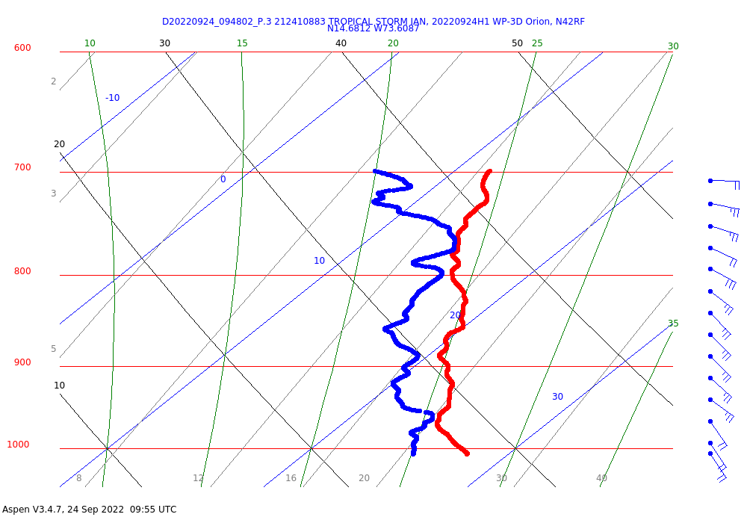  “Center” drop. Winds indicated that the center, if one exists, at FL is quite a bit to the south of the launch location, while the LLC is more to the WSW of the launch location. The depth of the LLC is pretty shallow too, maybe 100 hPa deep.
1034 | Drop 7, SW endpt
1042 | Drop 8, center drop – much much further SW than anticipated
1055 | Drop 9, NE midpt
1110 | When we set up for our inbound leg in the SW quadrant for the NHC fix, we descended to 5 kft. As we did that we noted that FL winds dropped to near zero, indicating we may have hit the center at 5 kft. We subsequently marked that location as the center and are assessing how to proceed with the remainder of the pattern. Waiting to hear back from CARCAH if NHC accepts that location as the center
1122 | Drop 10, NE endpt – really we’re at about 150 nmi from the new marked center
1151 | Drop 11, NW endpt, based on new marked center to the SW
1159 | Drop 12, NW midpt
1212 | Drop 13, center
1222 | Heading outbound along 240 radial. NHC did identify our fix as a new center, commenting that they think the storm may be reforming further south. So now we’re heading along this radial, and roughly along what we think is the new tilt orientation, based on TDR analyses from the second pass. This should give us a second look along this general radial, and effectively satisfy the VAM requirements.
1225 | Drop 14, SW midpt
1230 | 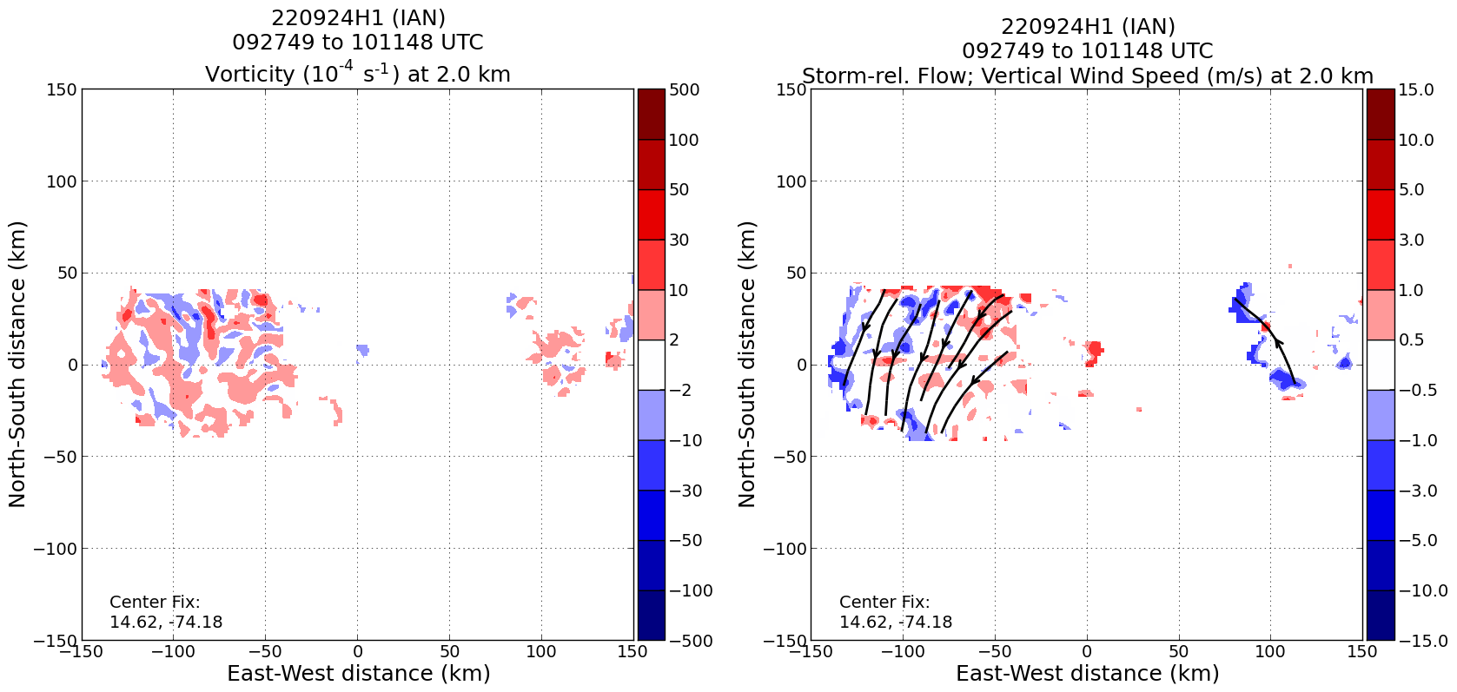  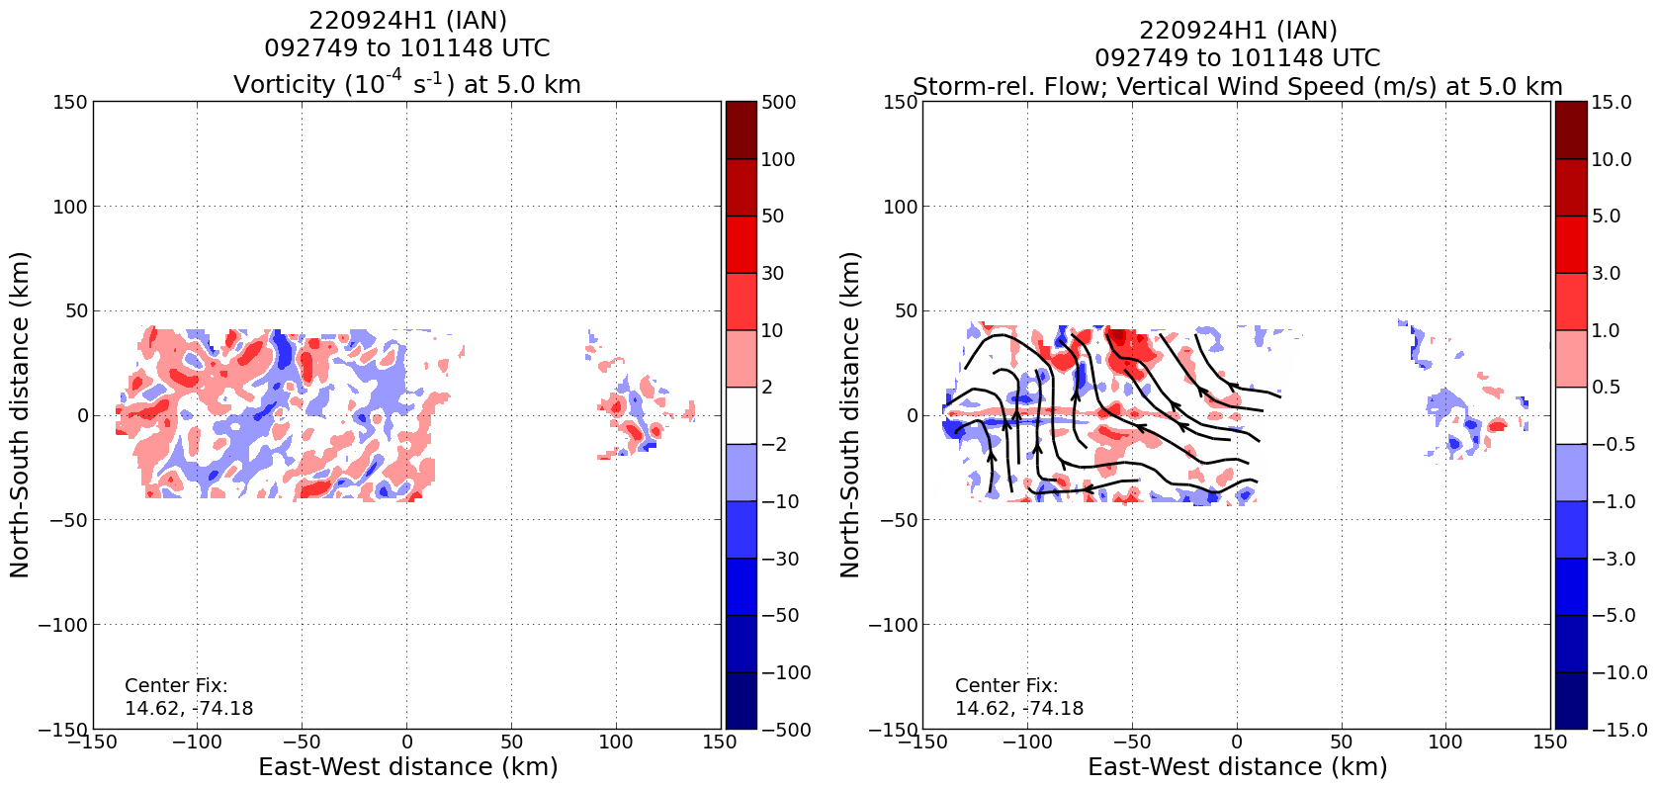  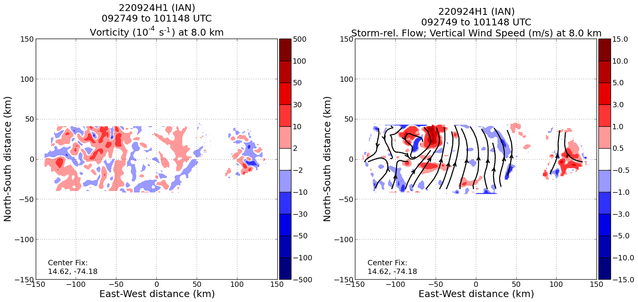  Analyses of vorticity, storm-relative flow, and vertical velocity at 2, 5, and 8 km from first pass above shows complicated structure. Looks like the 2-km center is well to the south of the flight track, while the weak 5-km center is to the west. Another, smaller center at 8 km is apparent too, to the east and northeast of the 5-km center. That is associated with a notable maximum in upward motion and high vorticity. Perhaps that’s associated with a midlevel center?
1232 | 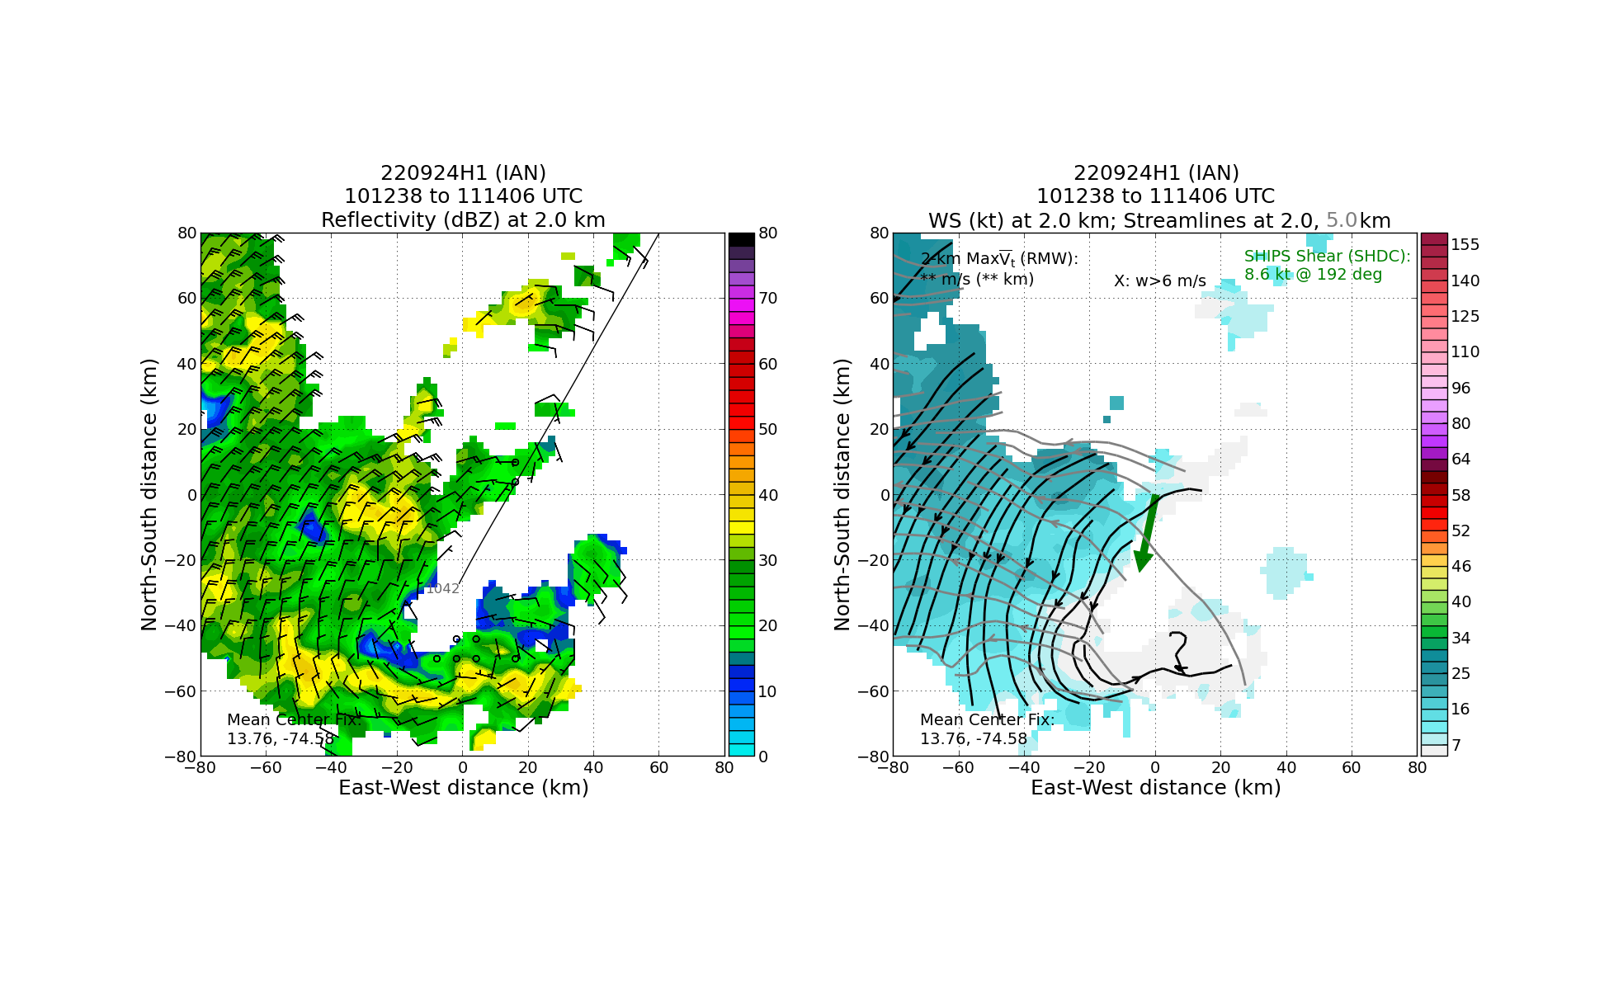  An analysis of streamlines at 2 and 5 km during the second pass above continues to show complicated structure. Low-level center is displaced to the south of the grid origin, while the 5-km center is southwest of the 2-km center.
1236 | Drop 15, SW endpt
1240 | 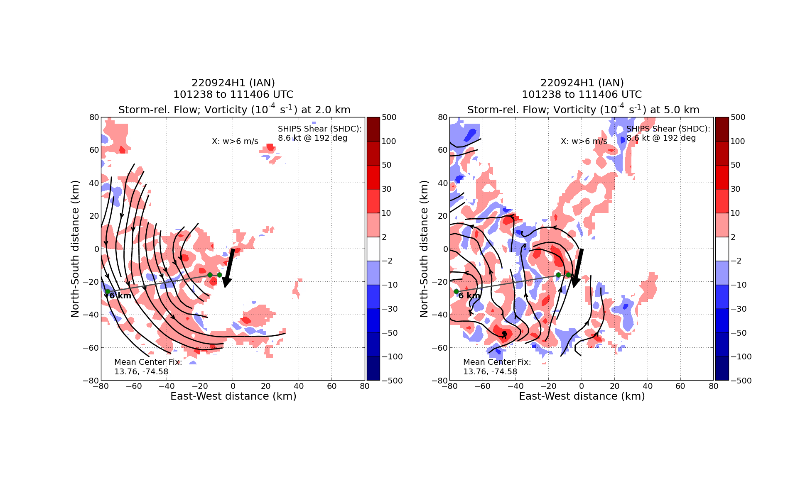  Plot of vorticity and tilt hodograph confirms what was described in earlier figure – tilt toward the northwest between 2 and 6 km
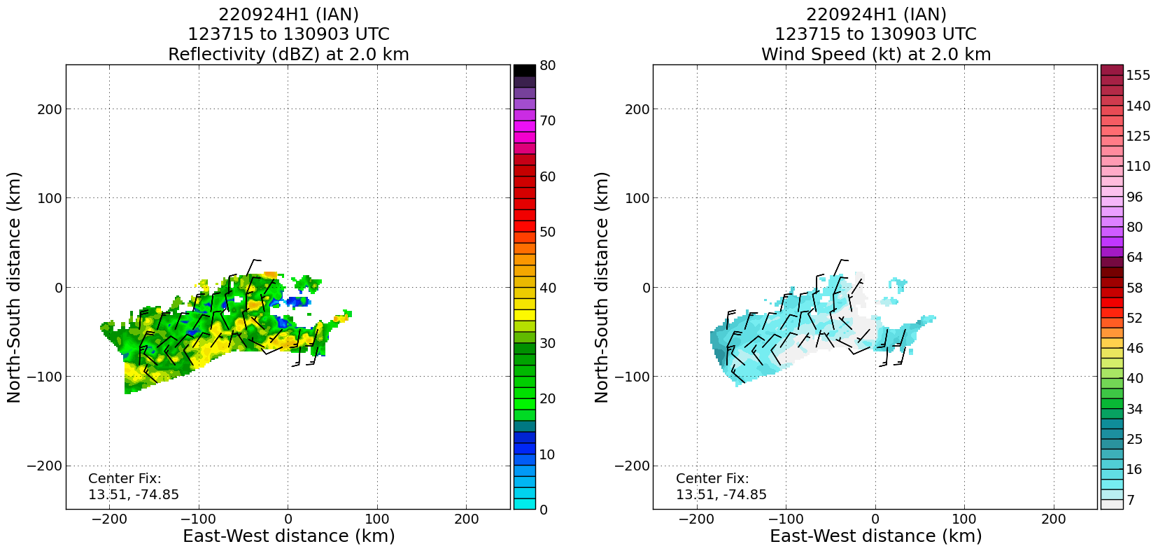
Analysis from the final pass (the second part of the “mini-VAM”) did capture the westerly and southerly flow at 2 km, indicating the location of the LLC.

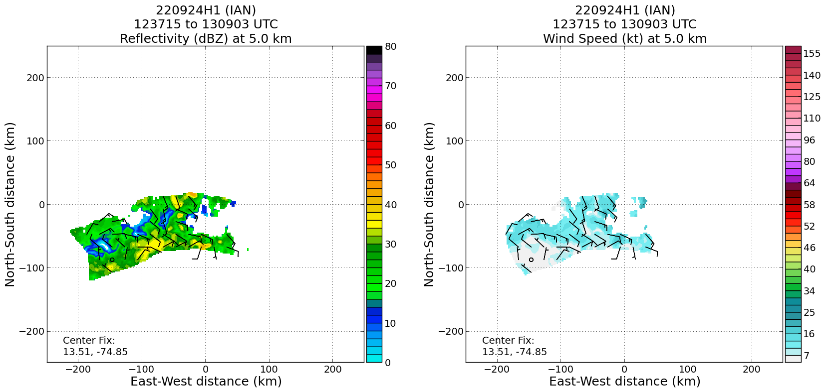
5 km flow from the same pass. A weak suggestion of a circulation center there at about x = -75 km, y = -125 km. That would show a tilt toward the SW with height between 2 and 5 km.

POST-FLIGHT
Mission Summary | Mission accomplished the objectives of 1) accomplishing an 1130Z fix for NHC, 2) Collecting TDR data and transmitting it for model ingest, and 3) flying the Vortex Alignment Module (though modified). When we first arrived at the storm it was clear that the structure was complex. With a tail wind at flight level, any circulation center at that altitude was to our south. We dropped a sonde at the assumed location of the LLC and found that, even at the surface, the winds indicated that the LLC was located SW of that point. Upon descending to 5 kft for the fix leg on the SW side, we fortuitously encountered a FL wind minimum, and we proceeded to mark that as the 5 kft center. We then went outbound to 150 nmi to sample the strong easterly winds there, and also to get confirmation from NHC that they would accept our mark as a re-formed center. They did, and from there we proceeded to anchor the pattern to that center. We went to a point NW from the new center, came inbound, then went outbound along the 240 degree radial to sample that region of the system as well as scatterers that were present there. We then reversed track for about 60 nmi before turning east to head home. We continued collecting TDR data during that whole period.  The passes through the SW quadrant effectively accomplished the VAM. Radar analyses showed circulation centers displaced toward the west between 2-5 km or so. There was little evidence of a circulation center above that altitude, except for a small-scale feature during the first pass that did not appear later. It’s not known whether a MLC did not exist or was just displaced off the domain (to the south, presumably). In any event Ian is still quite disorganized despite the somewhat improving appearance on satellite at the start of the mission.  15 sondes in total were released, all good, were all transmitted, and all charged to NWS. There were no ocean expendables. Four TDR analyses were transmitted.
Actual Standard Pattern Flown | Butterfly with VAM module
APHEX Experiments / Modules Flown | Data collection supports the Early Stage Experiment: Analysis of Intensity Change Processes (AIPEX), and the Vortex Alignment Module (VAM) under AIPEX was flown in collaboration with the ONR TCRI (Tropical Cyclone Rapid Intensification) Experiment.
Plain Language Summary
Instrument Notes | All instruments worked well
Final Mission Track | 