MISSION PLAN
FLIGHT ID | 20220920H1 | STORM | AL07 / FIONA
MISSION ID | 1807A | TAIL NUMBER | NOAA42
TASKING | EMC/NHC | PLANNED PATTERN | Butterfly
MISSION SUMMARY
TAKEOFF [UTC] | 0832 | LANDING [UTC] | 1621
TAKEOFF LOCATION | Aruba | LANDING LOCATION | Lakeland
FLIGHT TIME | 7.8 | BLOCK TIME | 8.0
TOTAL REAL-TIME RADAR ANALYSES  (Transmitted) | 5 (5) | TOTAL DROPSONDES (Good/Transmitted) | 28 (26 / 18)
OCEAN EXPENDABLES (Type) | 5 AXBT (ONR) (5 good) | sUAS (Type) | None
APHEX EXPERIMENTS / MODULES | Early Stage Experiment: AIPEX (FLAIMS, Rapid-fire RMW dropsondes)
HRD CREW MANIFEST
LPS ONBOARD | Rogers | LPS GROUND | None
TDR ONBOARD | Dunion | TDR GROUND | Reasor
ASPEN ONBOARD | Sellwood | ASPEN GROUND | None
NESDIS SCIENTISTS | None
GUESTS (Affiliation) | None
AOC CREW MANIFEST
PILOTS | Abitbol, Copare, Wood
NAVIGATOR | Miller
FLIGHT ENGINEERS | Stokes, Gee
FLIGHT DIRECTOR | Kalen, Holmes
DATA TECHNICIAN | MacAlister
AVAPS | Dykeman

PRE-FLIGHT
Flight Plan | 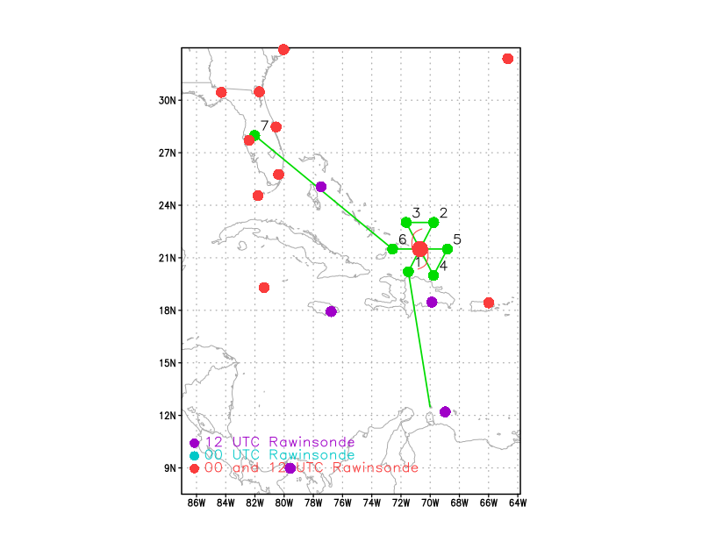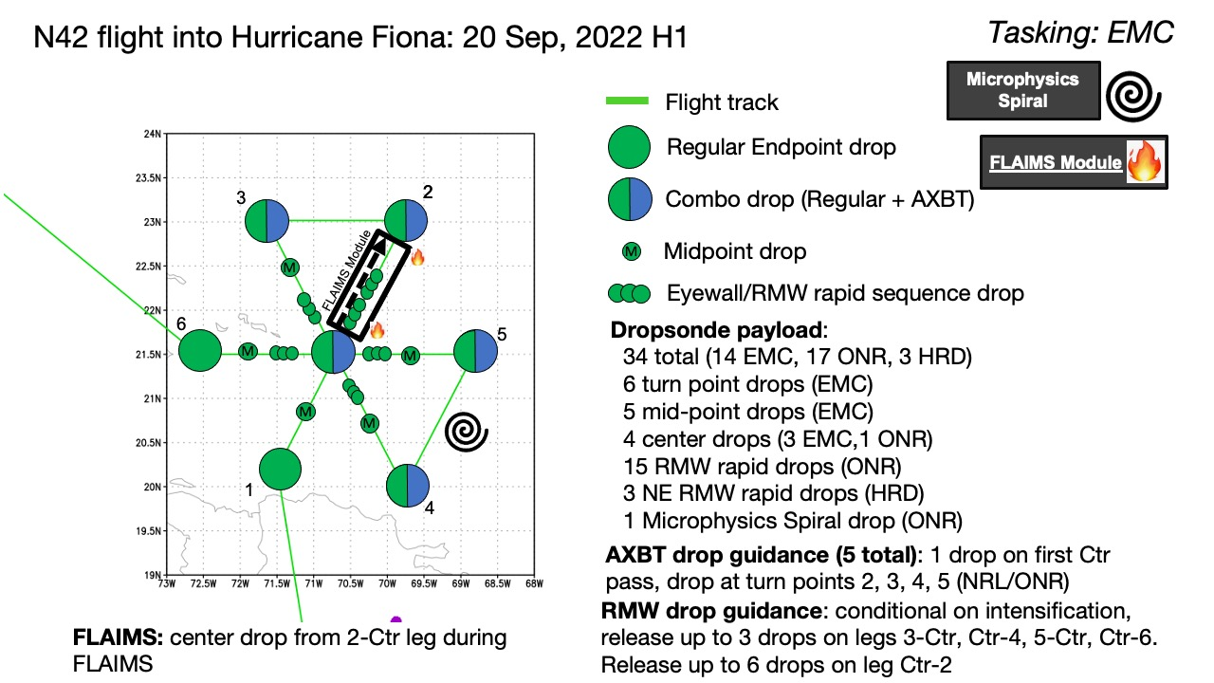  Butterfly pattern, IP on SW side. Leg lengths 105 nmi except first inbound leg, which will be shortened to 75 nmi to give time to descend once crossing over Haiti. Attempted Stratiform Spiral Module, with the target region being on the N side of the storm (DSL, where principal rainband likely connecting to eyewall and where stratiform precipitation is likely to be located). If there’s time, do a FLAIMS module, possible on the E side or an adjusted radial (e.g., 060 instead of 090).
Expendable Distribution | Sondes at all endpoints and midpoints, except no midpoint at the outbound leg to the NE. Rapid-fire 3-sonde sequences on all legs except for inbound from SW. On the first outbound leg to NE, do a 6-sonde rapid-fire sequence. Sonde also dropped at the top of the stratiform spiral, if it is performed. 5 AXBTs, paired with sondes at first center pass and endpoints on the NE, NW, SE, and E sides.
Preflight Weather Briefing | Fiona has been upgraded to a major hurricane prior to takeoff. Satellite imagery shows the eye is clearing out, and most recent aircraft missions have indicated the eye is 10-15 nmi diameter. Satellite imagery also shows, however, indications of southwesterly shear. Additionally, IR imagery shows signature of eyewall convection in shear – convection initiating in the NE (downshear) quadrants and cloud tops cooling as it wraps around to the NW and SW (DSL and USL, respectively) quadrants. Possibility of secondary eyewall formation, likely first on the NE and N sides of the storm. This is the target region for the stratiform spiral module.  Fiona has lifted away from Hispaniola and is tracking toward the NNW over the open waters of the SW Atlantic. Vertical wind shear is moderate and from the SW, but this shear evidently has not prevented Fiona from steadily intensifying, and most recently the TC is on the verge of rapid intensification. The water temperatures are plenty warm and the atmosphere is moist to sustain convection, so other than the marginal shear environment the environment is favorable for intensification.
Instrument Notes

IN-FLIGHT
Time [UTC] | Event
0832 | Takeoff from Aruba
0914 | IR satellite loop showing obscured eye with lightning in N/NW eyewall
0917 | An AMSR2 overpass at 0645Z shows the inner core is fairly asymmetric, with most convection located on the northern side of the circulation. Indicative of some shear? Some signs of a secondary eyewall too.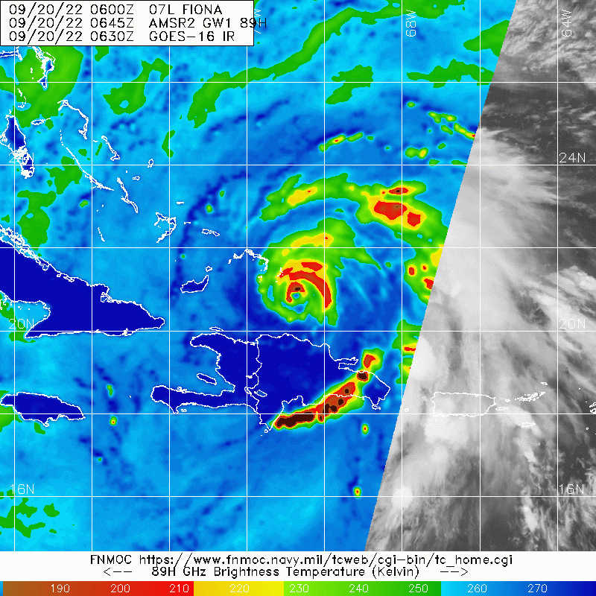
1011 | Persistent lightning activity noted in N eyewall
1013 | Drop 1, SW endpt, 75 nmi from center
1028 | Drop 2, center, AXBT1, SST 29.06
102910 | Drop 3, 1st RMW rapid NE eyewall, no launch detect
102940 | Drop 4, 2nd RMW
103010 | Drop 5, 3rd RMW
103040 | Drop 6, 4th RMW
103110 | Drop 7, 5th RMW
103140 | Drop 8, 6th RMW
 | FL winds show what look like 3, possibly 4 wind maxima, primary one, then a secondary one nearly immediately after it, then a third maximum about 40 nmi from center, and a possible fourth near the end point at 100 nmi
1054 | Drop 9, NE endpt, AXBT2, SST 29.1
1101 | CIMSS VWS (0900z): NW-SE oriented shear gradient showing ~15-20 kt over the western semicircle  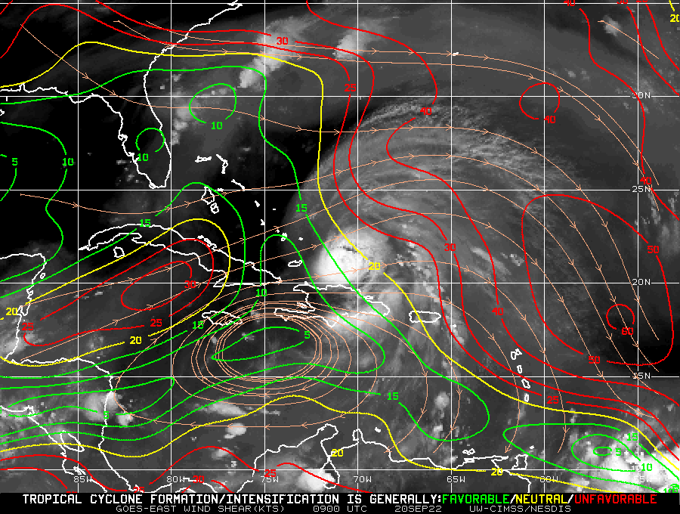
1101 | Lightning appearing in the convective band on the NW side (secondary eyewall?)
1102 | TDR showing widespread stratiform on NE side, where there appear to be a multitude of wind maxima at flight-level
1130 | Drop 10, NE RMW (2nd outbound leg of FLAIMS)
1135 | FL winds show that the third wind maximum strengthened between the first outbound leg to the NE and the subsequent inbound leg. On the inbound leg the third wind max was almost of the same magnitude as the primary eyewall/wind max.
1141 | Drop 11, NE midpt
1204 | First TDR analysis suggest multiple outer wind maxima/eyewalls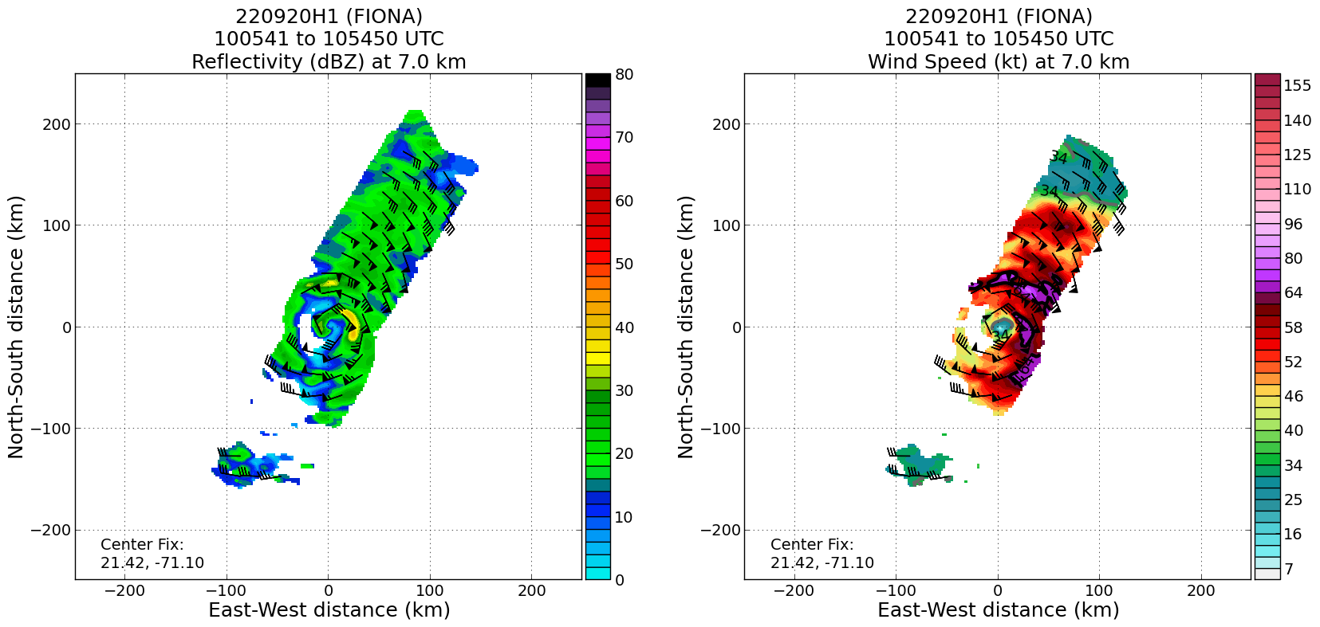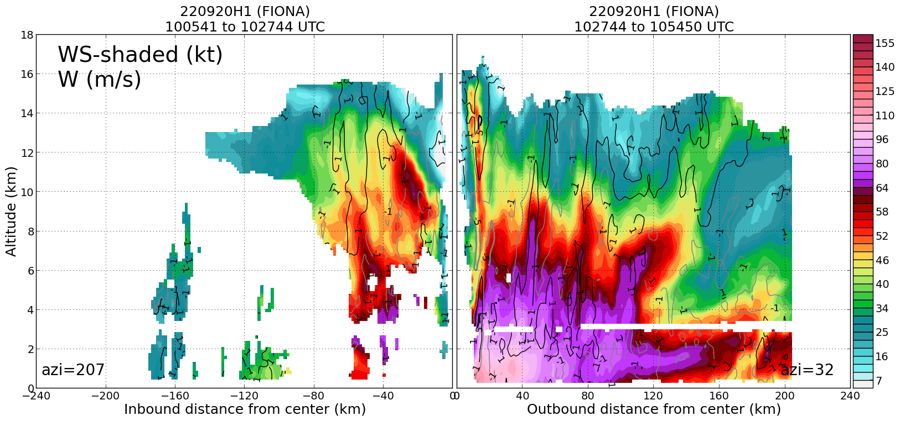
1204 | Second TDR analysis (FLAIMS) shows a very noisy mid-troposphere with signs of wave activity in horizontal and vertical velocity field  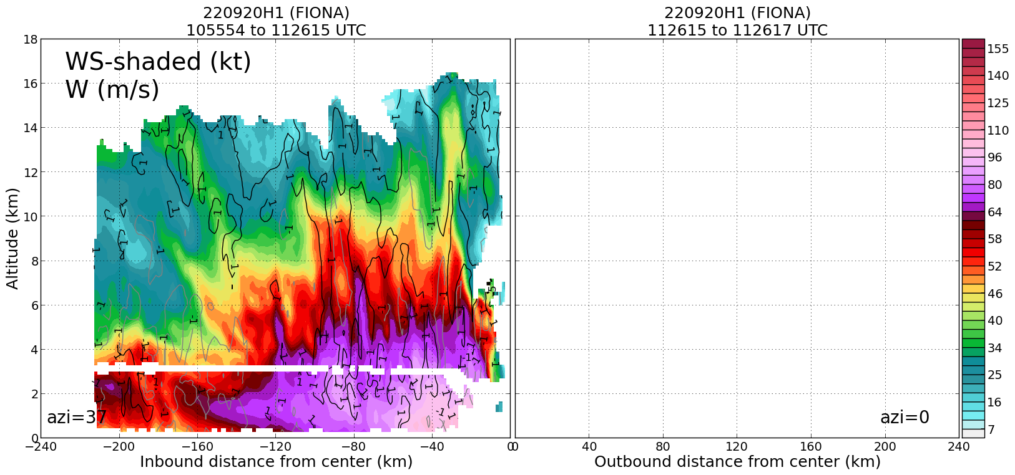
1219 | Drop 12, NW endpt, AXBT3, SST 29.1
1233 | Drop 13, NW midpt
124250 | Drop 14, 1st RMW NW (had to abort remaining launches because too close to land)
1247 | Drop 15, center
1254 | Drop 16, 1st RMW SE (likely missed RMW because had to delay a bit due to proximity to land)
1255 | Drop 17, 2nd RMW SE
1255 | Drop 18, 3rd RMW SE
1251 | NW turnpoint drop shows relatively low RH values within PBL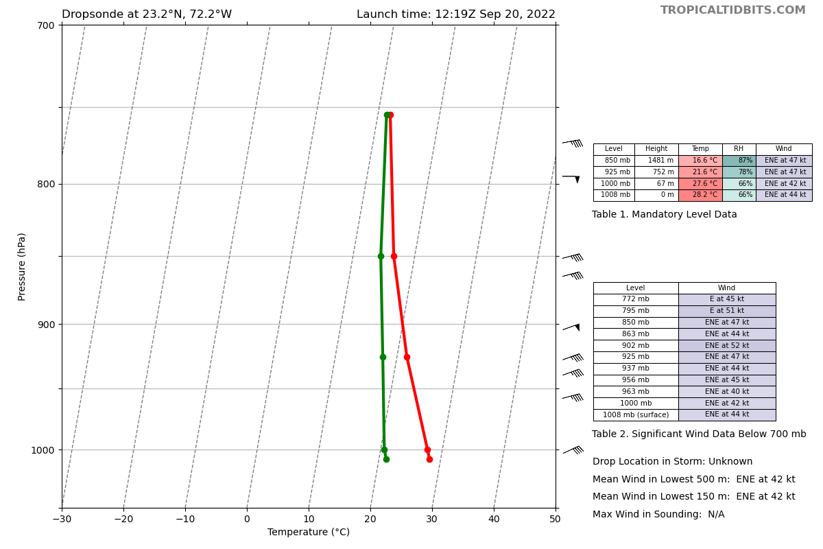
1303 | Drop 19, SE midpt
1312 | FL winds are interesting here. There’s a nice, smooth decline all the way out until we got to this point about 80 nmi from center, then a pronounced outer wind max, both in FL and at SF. It’s very different from the NE side, which showed a noisy FL field with multiple local maxima and minimal reflection at SF. Potential SEF? It’s hard to know, because we’re sampling a different region (upwind). Is that temporal evolution or spatial variation?
1316 | Drop 20, SE endpt, AXBT4, SST 33.75 (suspiciously high)
1327 | Nudging a little closer to this band off our left wing to better capture it with the TDR. Would be cool to see if it's more convective, less stratiform, like I would think it is
1338 | E endpt, AXBT5, SST 29.02 (only one data point though)
1338 | An SSMIS overpass at 1138Z shows signs of a double eyewall structure with additional bands on the east and north side.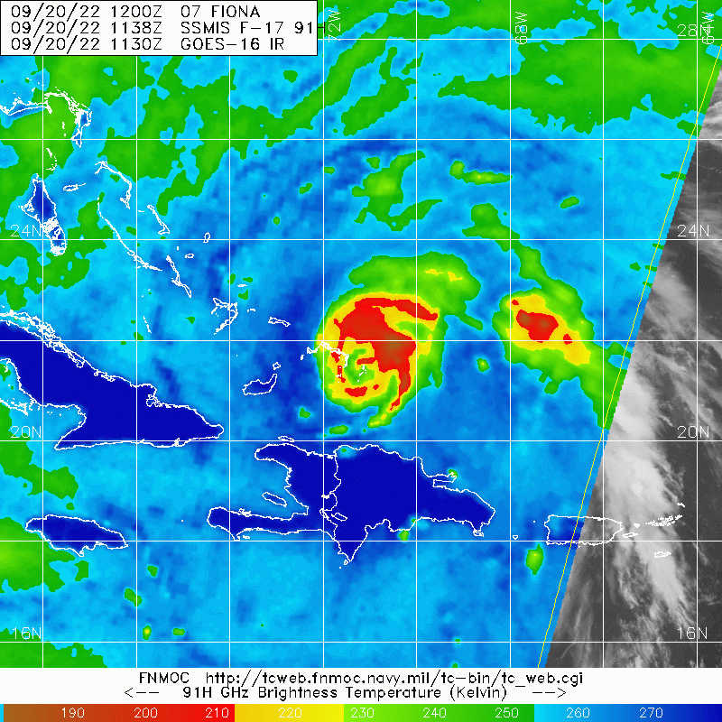
1339 | Drop 21, E endpt (not exactly a coincident drop with BT)
1340 | Dropsonde at SE turnpoint also shows a relatively dry lower-troposphere, with 61% RH at 925 mb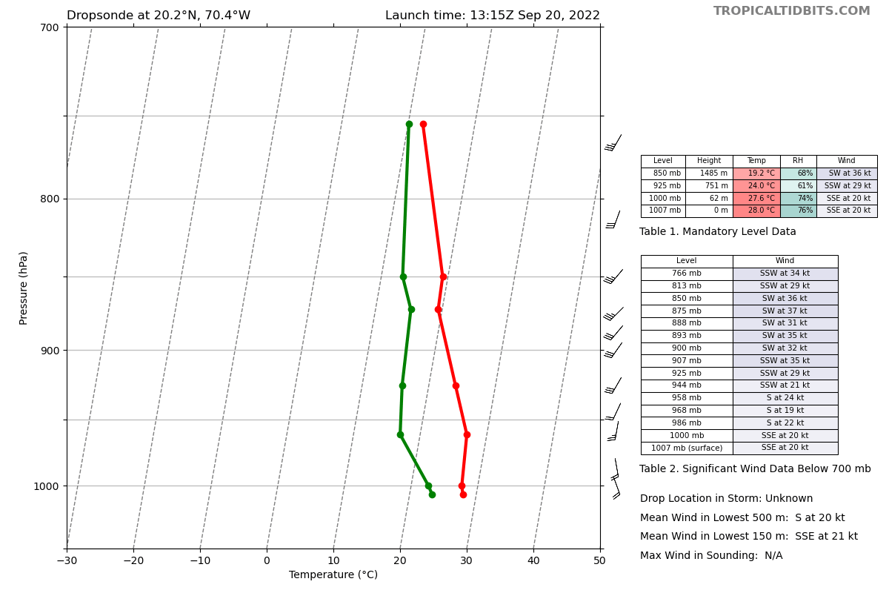
1348 | Drop 22, E midpt
1355 | Drop 23, 1st RMW E
1355 | Drop 24, 2nd RMW E. Reaches PBL around r=80 km.
1356 | Drop 25, 3rd RMW E, I missed the RMW. Extremely flat wind profile. Radar presentation shows we should be well inside the eye, but FL winds remained high for several miles inside where the drop sequence occurred.
1357 | Evidence of a mesoscale descending inflow plume in the downshear-left region from the fourth TDR analysis (azi = 327)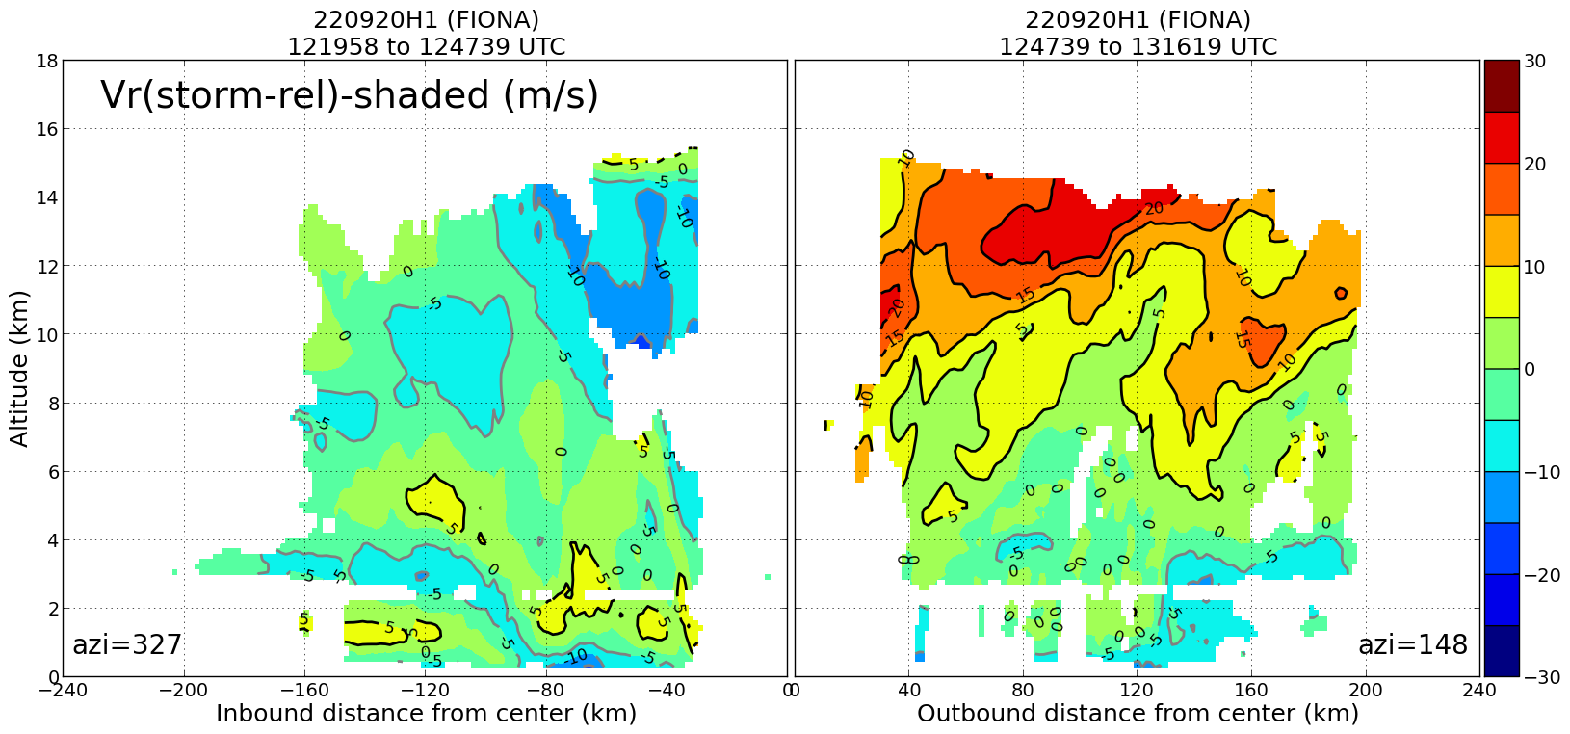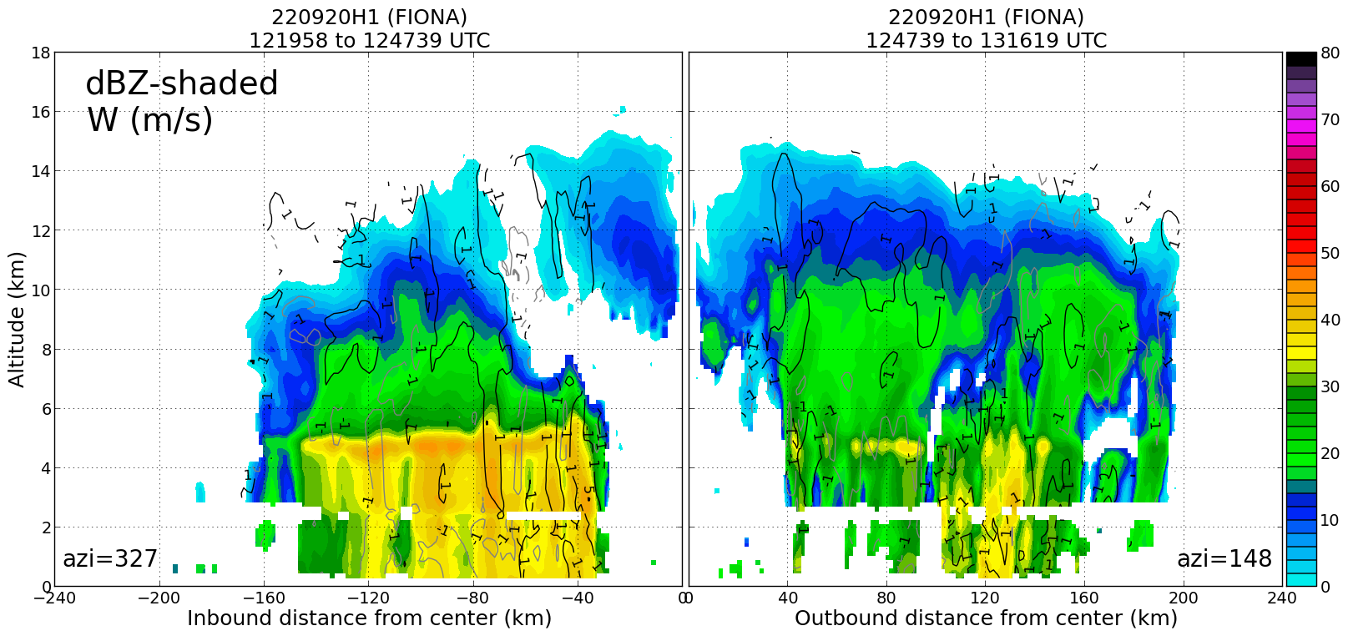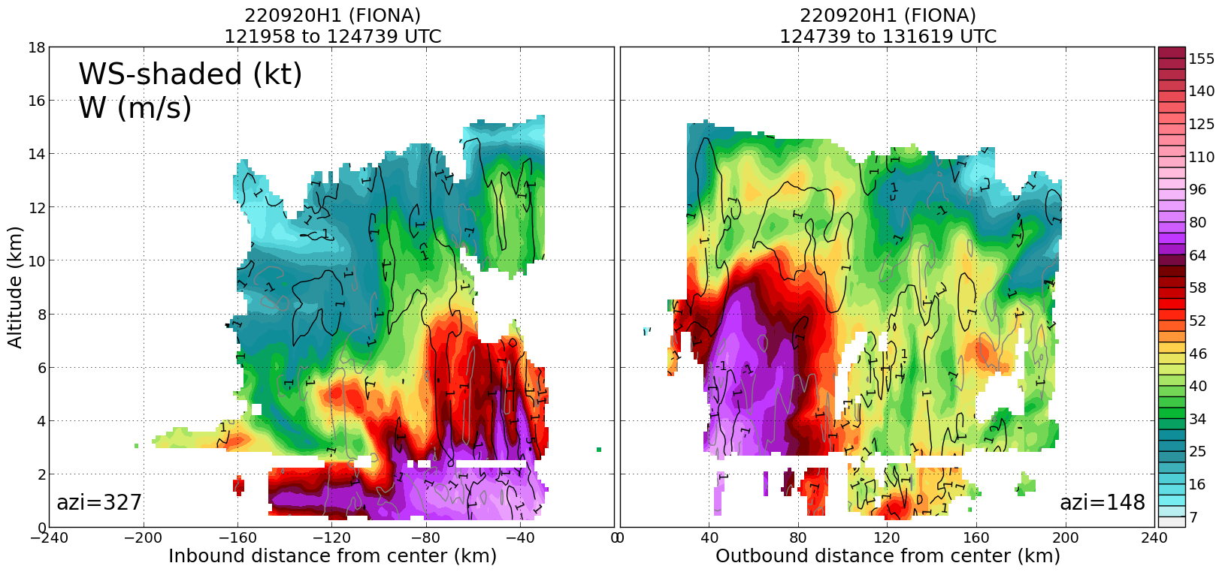
1415 | Drop 26, W midpt
1425 | Drop 27, W endpt
1426 | Drop 28, W endpt (backup for failed sonde)

POST-FLIGHT
Mission Summary | The butterfly pattern was flown successfully. We were able to complete the FLAIMS module on the NE side. We were not able to do a Stratiform Spiral Module, however, because the AF was in the storm at the same time, at 10 kft, and we could not spiral up across their altitude (we were at 8 kft for most of the pattern). We did RMW rapid-fire drops for most of the legs, but there were a few legs near the end of the pattern where we could not do the drops because we were over islands in the Bahamas. The same was the case for some center and midpoint drops.  Fiona appeared to be undergoing an eyewall replacement cycle (ERC) as the aircraft first entered the storm. The first TDR analysis at 1027 UTC showed double eyewalls at radii of approximately 15 and 45 km. Subsequent TDR analyses showed the inner eyewall decayed with time and the outer eyewall became dominant.  Fiona was undergoing what appeared to be an additional secondary eyewall formation (SEF) event during the mission. There was evidence of a mesoscale descending inflow in the northwest (DSL) quadrant, based on TDR profile analyses. At flight-level, there were multiple flight-level wind maxima on the NE side. During the FLAIMS module, it appeared that the tertiary wind maximum (at about 40-50 nmi distance from the center) started as a weaker wind maxima, but increased to being equal to the primary and secondary wind maxima during the second and third passes of FLAIMS. In this quadrant there was not much, if at all, of a reflection of an outer wind maximum in the SFMR winds. In the SE quadrant, however, the precipitation appeared to be more convective. Also, the flight-level winds showed a smooth decrease out to about 80 nmi from the center, where there was a marked secondary wind maximum. There was also a notable wind maximum in the SFMR wind field here. It is not clear how much of this was from temporal evolution of the potentially developing secondary eyewall and how much was spatial variation.  A total of 28 sondes were released. 14 are charged to NWS/EMC, 11 are charged to ONR, and 3 are charged to HRD. 5 AXBTs were dropped for ONR TCRI.
Actual Standard Pattern Flown | Butterfly with FLAIMS module included.
APHEX Experiments / Modules Flown | Data collection supports the Early Stage Experiment: Analysis of Intensity Change Processes (AIPEX), specifically the Flight-level Assessment of Intensification in Moderate Shear (FLAIMS) Module within AIPEX (though the storm counts in the Mature Stage Experiment.
Plain Language Summary | - Flew successful mission sampling Major Hurricane Fiona  - Storm did not intensify notably during the mission, but structure was changing with indication of an outer eyewall formation that replaced the primary eyewall at the start of the mission.
Instrument Notes | All instruments worked well. 27 of 28 dropsondes worked, all AXBTs worked.
Final Mission Track | 