MISSION PLAN
FLIGHT ID | 20220919I1 | STORM | AL07 / FIONA
MISSION ID | 1607A | TAIL NUMBER | NOAA43
TASKING | EMC/NHC | PLANNED PATTERN | Modified Butterfly
MISSION SUMMARY
TAKEOFF [UTC] | 2004 | LANDING [UTC] | 0356
TAKEOFF LOCATION | Lakeland | LANDING LOCATION | Lakeland
FLIGHT TIME | 7.9 | BLOCK TIME | 8.2
TOTAL REAL-TIME RADAR ANALYSES  (Transmitted) | 3 (3) | TOTAL DROPSONDES (Good/Transmitted) | 35 (34 / 25)
OCEAN EXPENDABLES (Type) | 5 AXBT (ONR) (4 good) | sUAS (Type) | None
APHEX EXPERIMENTS / MODULES | Early Stage Experiment: AIPEX
HRD CREW MANIFEST
LPS ONBOARD | Holbach | LPS GROUND | Alaka, Marks
TDR ONBOARD | Holbach | TDR GROUND | Gamache
ASPEN ONBOARD | Murillo | ASPEN GROUND | None
NESDIS SCIENTISTS | Chang, Jelenak, Sapp
GUESTS (Affiliation) | Camposano (CIMAS), Waddington (AOC)
AOC CREW MANIFEST
PILOTS | Mitchell, Doremous, Keith
NAVIGATOR | Utamo
FLIGHT ENGINEERS | Darby, Pittman, Tyson
FLIGHT DIRECTOR | Carpenter
DATA TECHNICIAN | T. Richards
AVAPS | Warnecke

PRE-FLIGHT
Flight Plan | 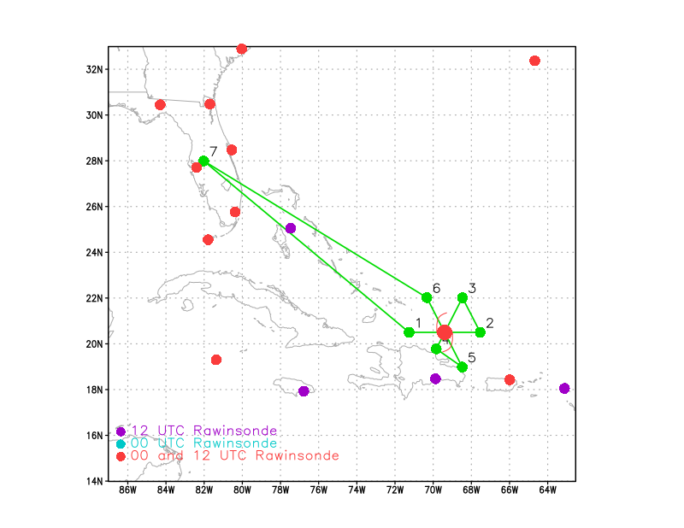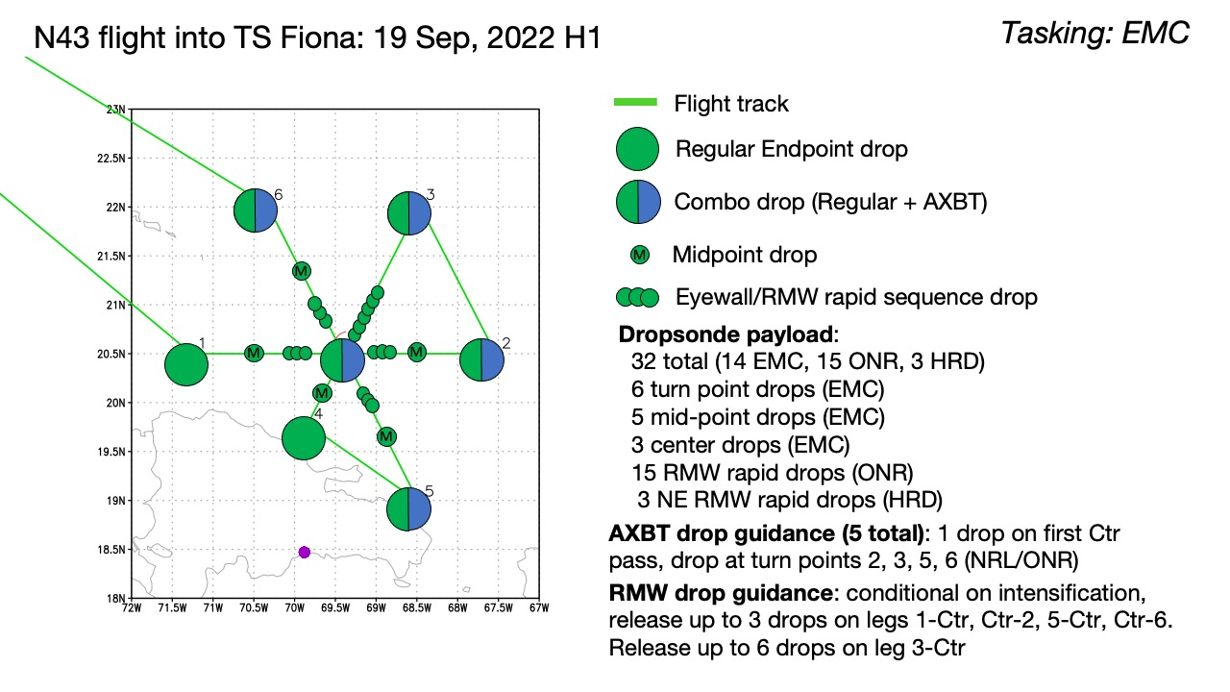  Pattern: Fly modified butterfly pattern with 105 nmi legs (shortened for overland restrictions)  Altitude: 10 kft (pressure altitude)  Potential add-on Modules:  - None
Expendable Distribution | 32 sondes (all dropsondes transmitted to the GTS); 5 ONR/NRL AXBTs (all AXBTs transmitted to the AOC ground server if possible)  - Release sondes at endpoints, midpoints, centers; possible supplemental rapid RMW drops
Preflight Weather Briefing | As of the 21Z advisory from NHC, Fiona’s intensity is 85 kt with a minimum central pressure of 972 mb moving NW at 9 kts. The center of Fiona is now off the northern coast of Hispaniola after passing over the eastern tip of the island last night. The mountains of Hispaniola do not seem to have caused too much weakening of Fiona as it still appears fairly healthy on satellite imagery. We will be the first plane into Fiona since it moved offshore earlier today.  An Air Force Reserve aircraft will be entering the system shortly after us, so we will be at 8 kft pressure altitude. Depending on how close the center is still to the coast of Hispaniola, we may need to modify pt 1- center to be along shore rather than strictly W to E. It is also possible that we may not have enough space for the outbound leg to pt 4, so we may need to exit more toward the S or SE before heading to pt 5.
Instrument Notes | None notes

IN-FLIGHT
Time [UTC] | Event
1955 | 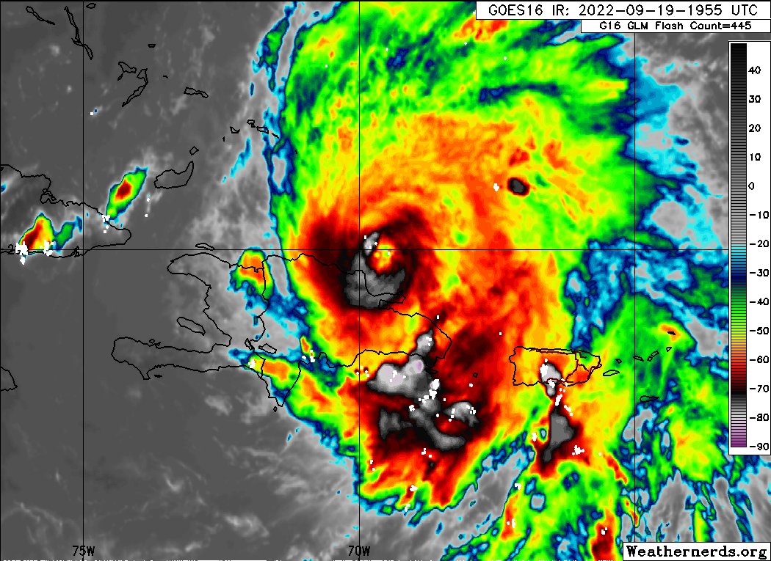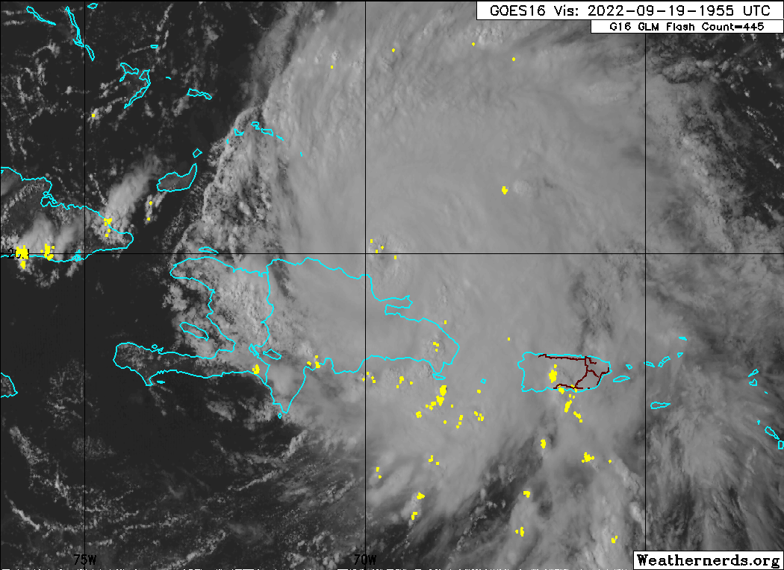
2004 | Take off from KLAL
2039 | After consulting with NHC, decided to add drops on the ferry home every 90-120 n mi as resources allow. Only 3 extra sondes on this flight. Ferry sondes will be charged to NHC.
2115 | 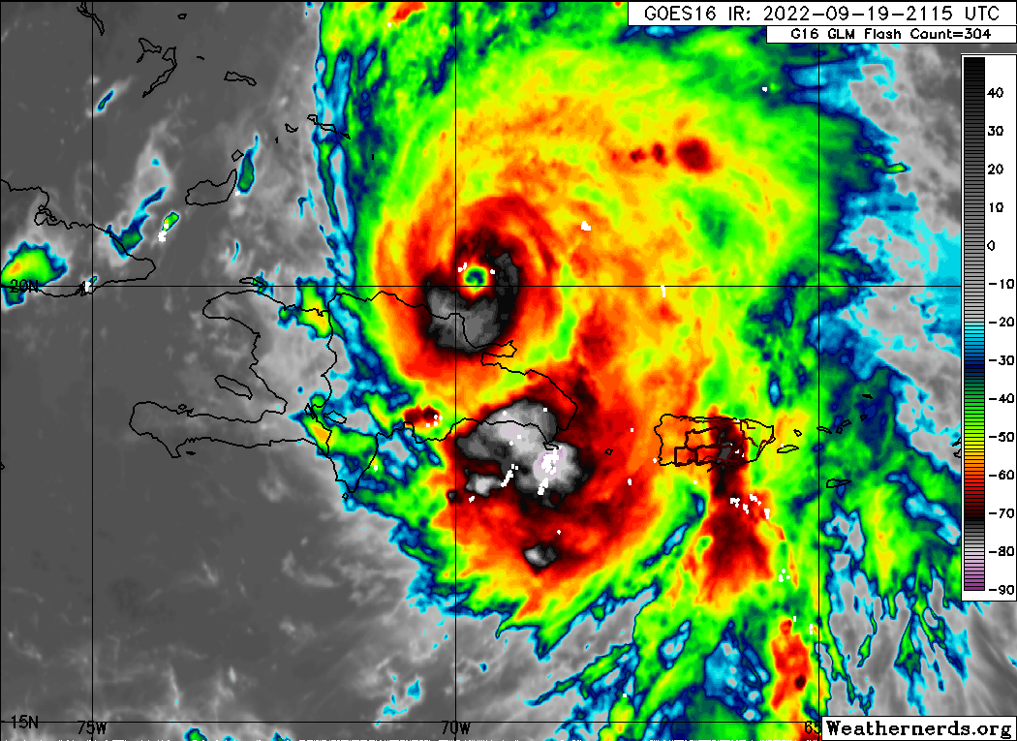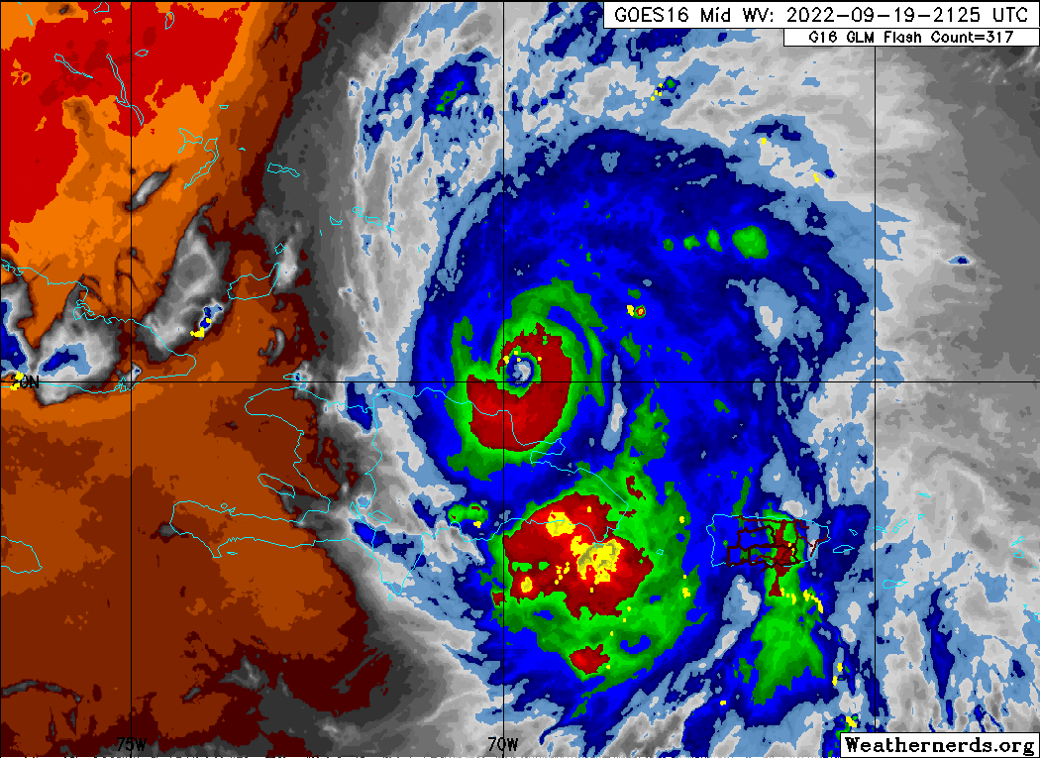
2215 | 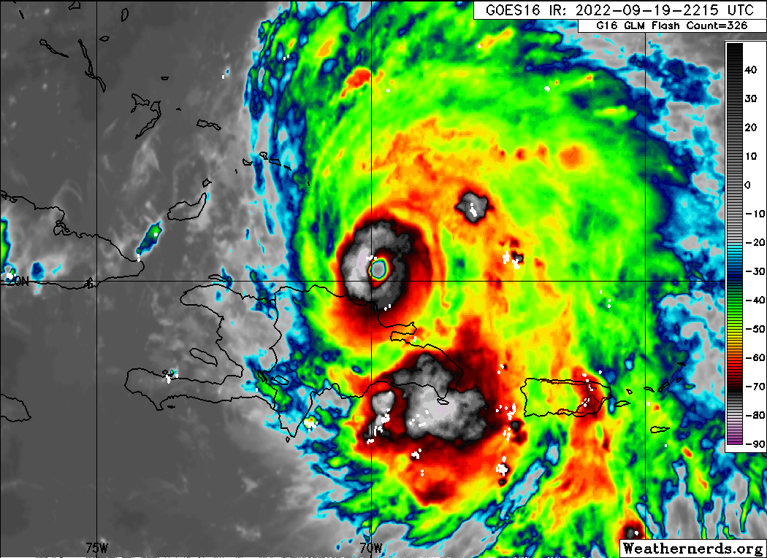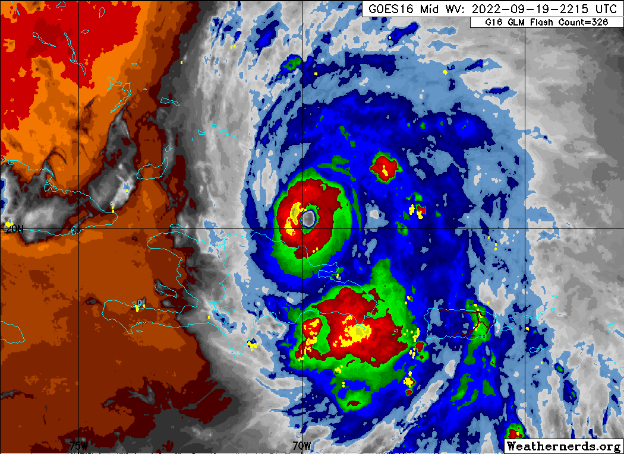
2227 | IP, at 8 kft, track 090, start TDR leg
2228 | Drop #1 (Endpoint W; EMC)  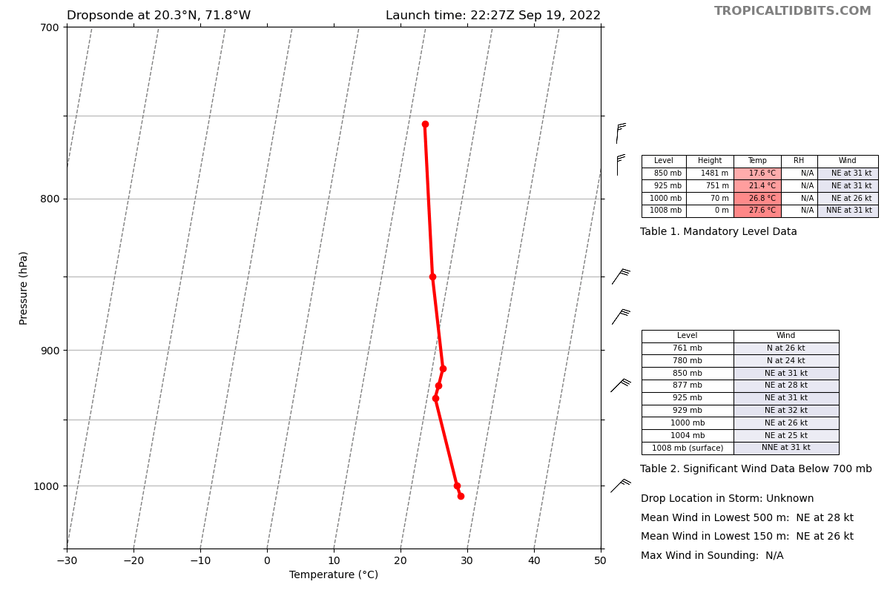
2240 | Drop #2 (Midpoint W; EMC)  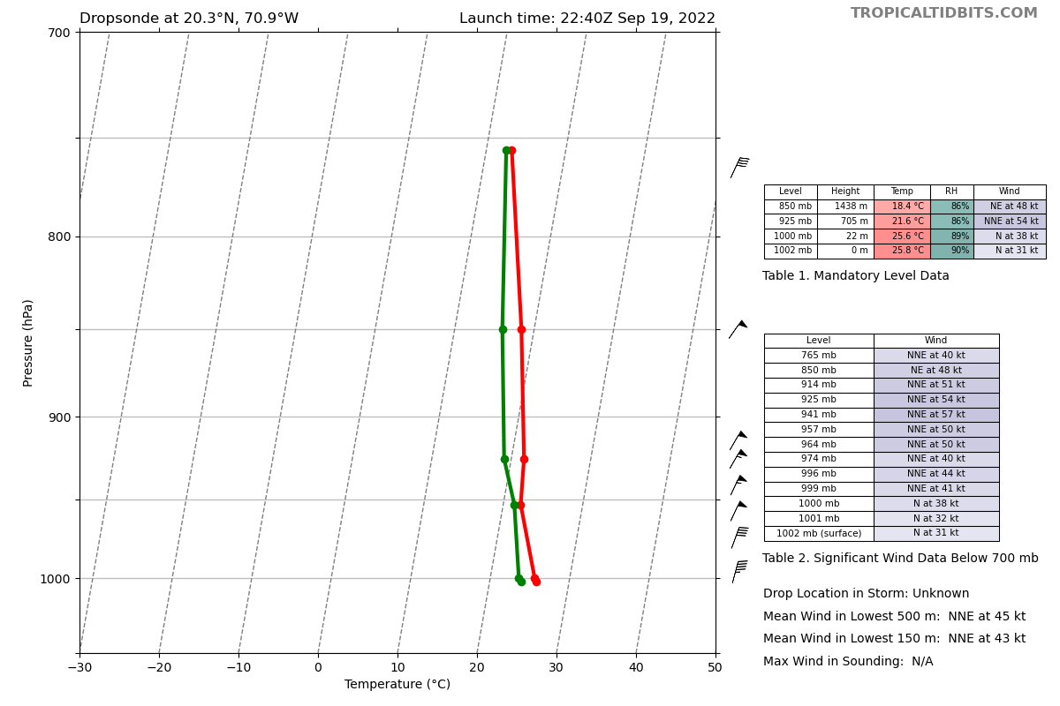
2242 | Fiona’s eye has really cleared out in the last few hours. Deep convection with cloud tops colder than -80C is nearly symmetric around the center. Outflow is very healthy to the N, E, and S. Outflow is a bit limited on the W side likely due to vertical wind shear. Fiona remains impacted by moderate southwesterly wind shear of 20-25 kt  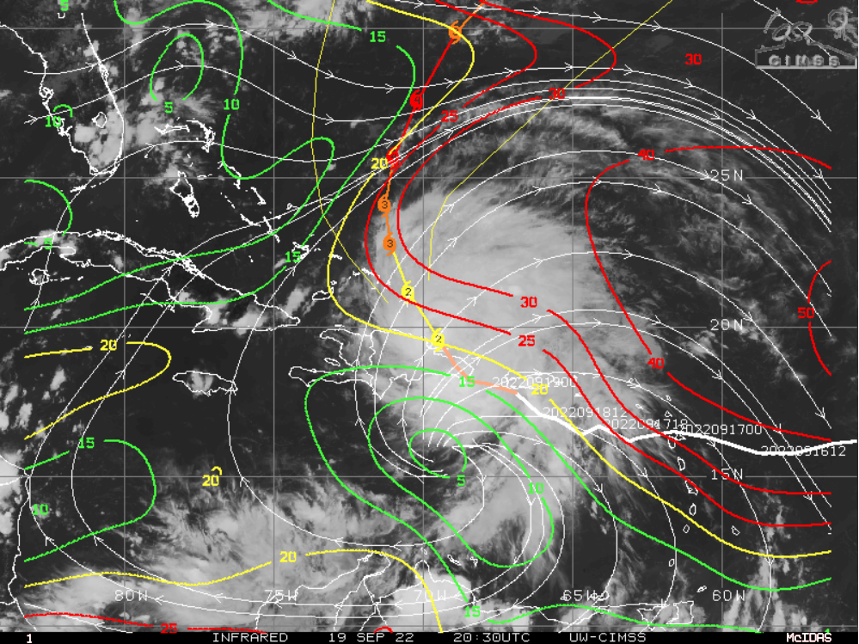
2250 | Drop #3 (RMW W, ONR)  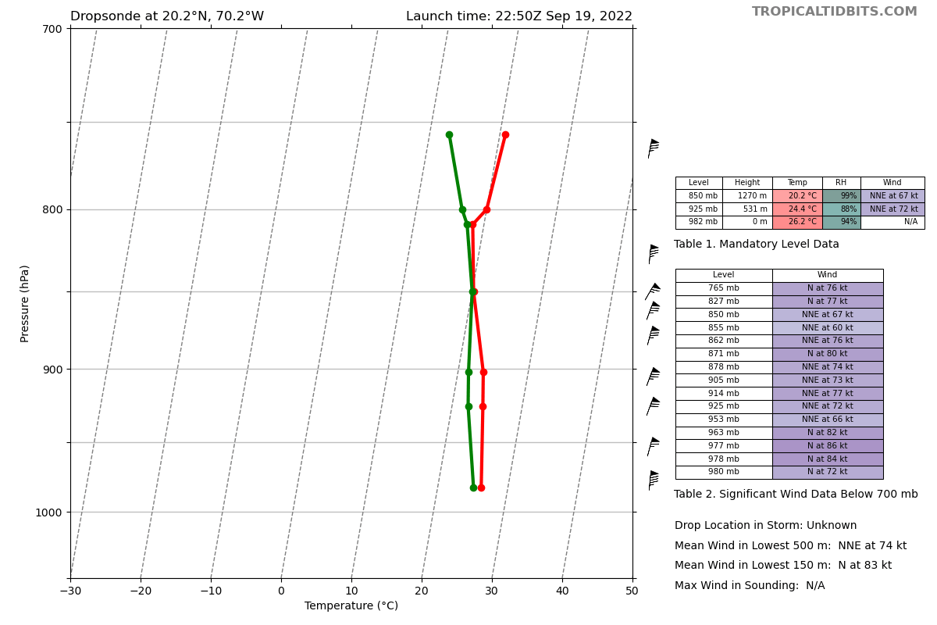
2251 | Drop #4 (RMW W, ONR)  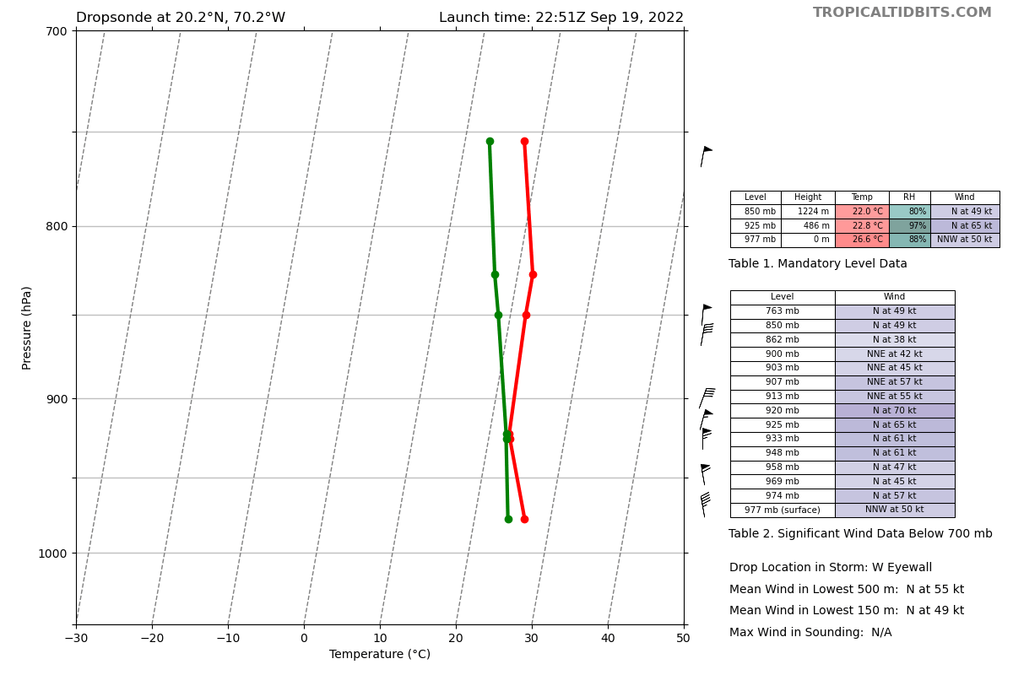
2251 | Drop #5 (RMW W, ONR)  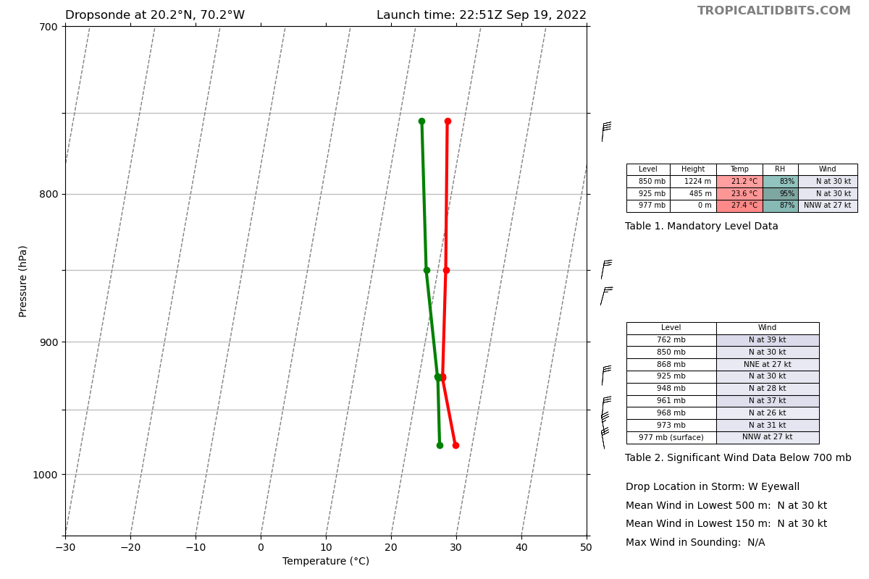
2247 | 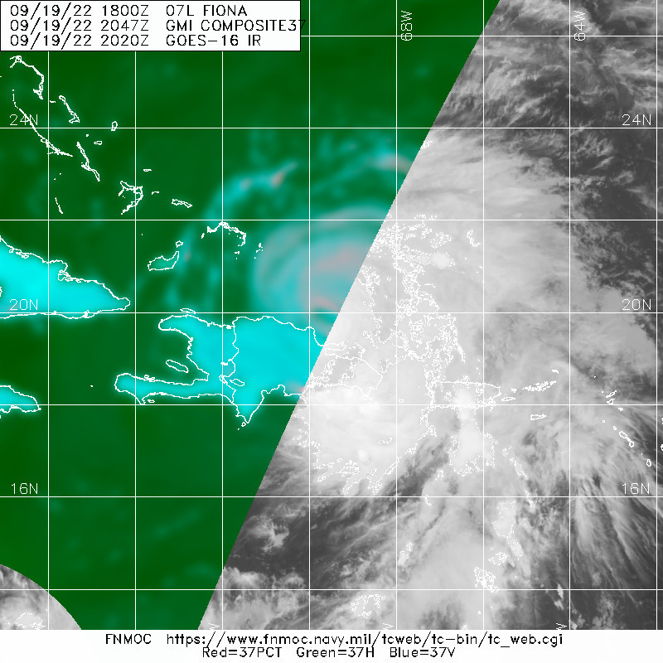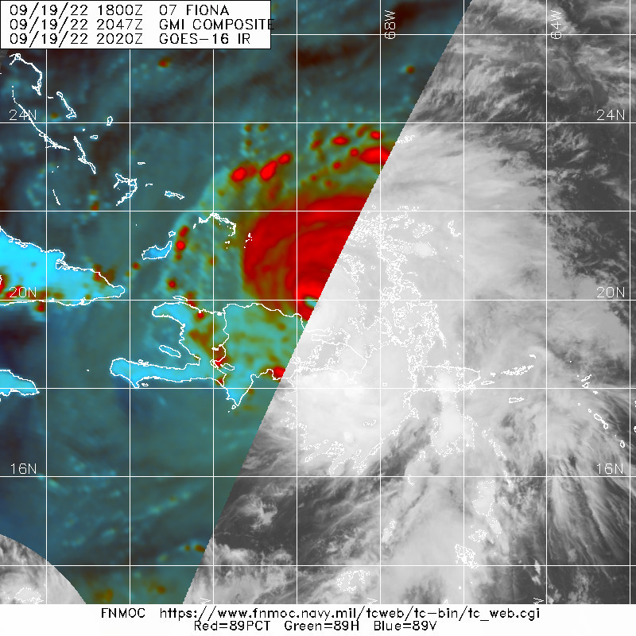
2253 | HRD Workstation (radar) issues. The backup was being used and was having network issues. Switching to the primary to see if that fixes the problem. John Gamache will work with Heather to make sure all software is properly updated. Syncing is an issue between the primary and backup.
2253 | Mark center
22:53:29 | Drop #6 (Center, EMC)  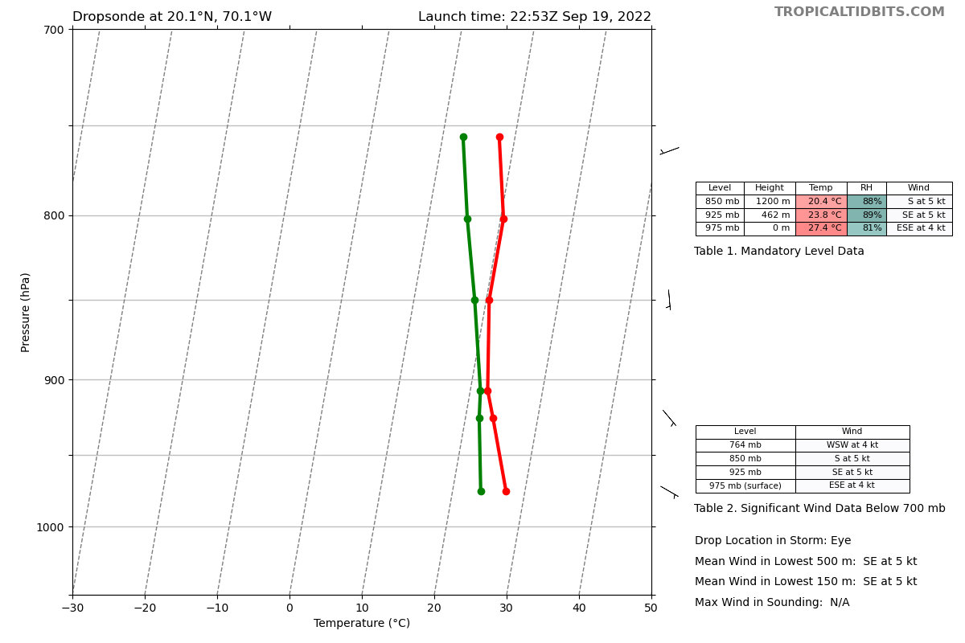
2255 | 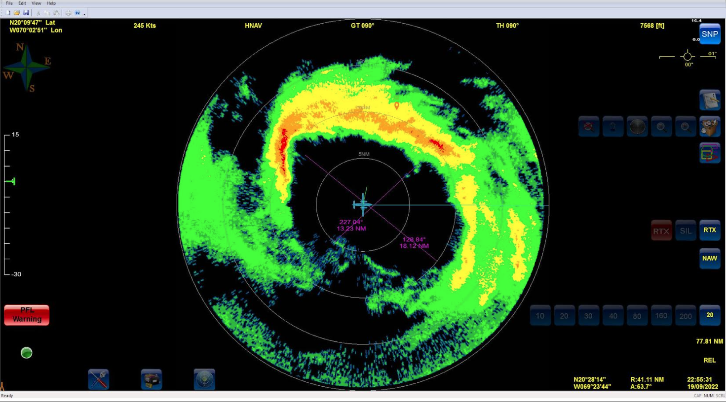
22:58:19 | Drop #7 (RMW E, ONR)
22:58:38 | Drop #8 (RMW E, ONR)
22:58:57 | Drop #9 (RMW E, ONR)
23:09:24 | Drop #10 (Midpoint E, EMC)
2315 | 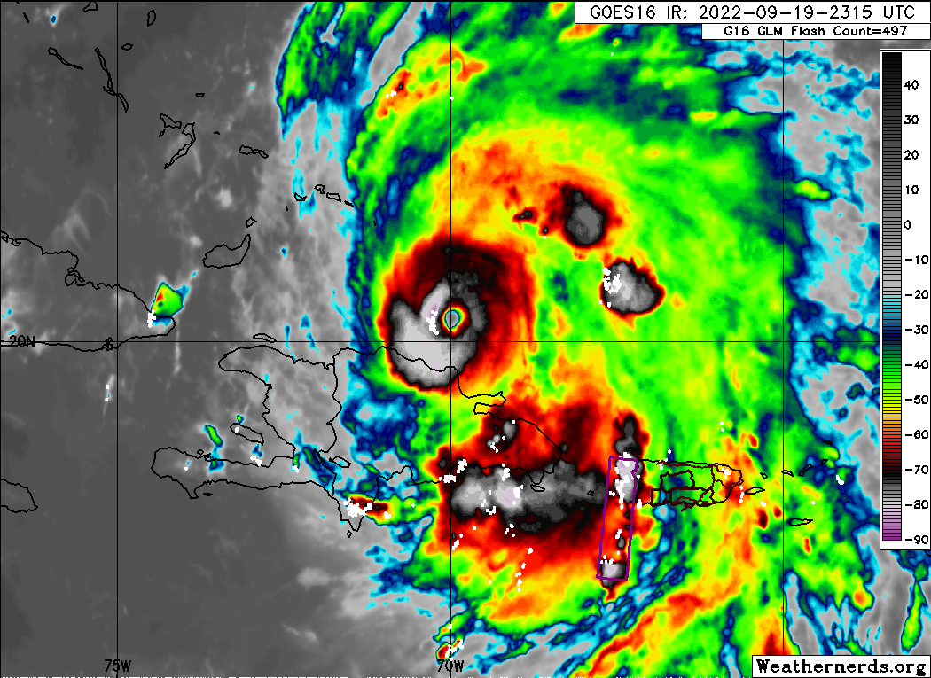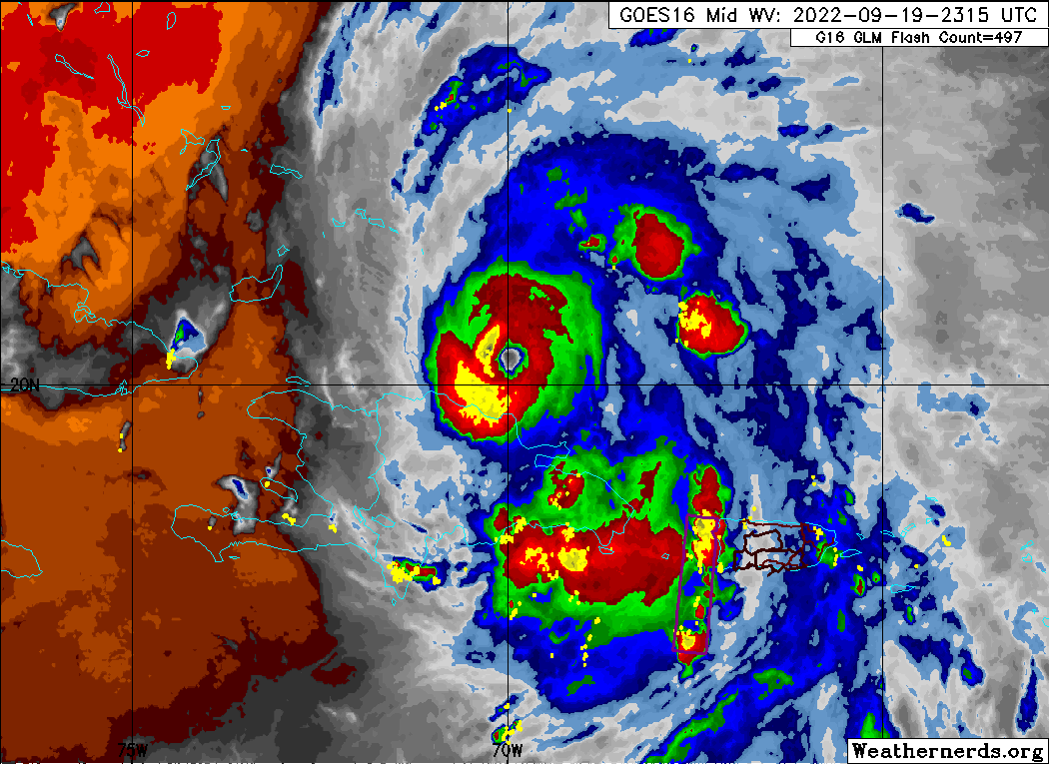
2325 | Ist TDR analysis  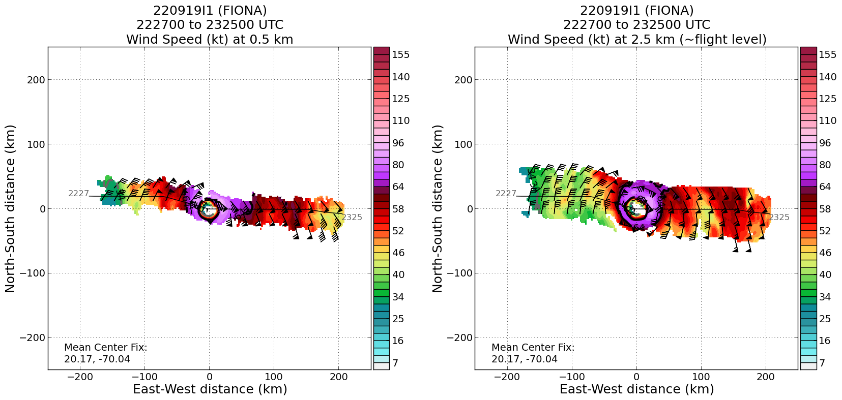  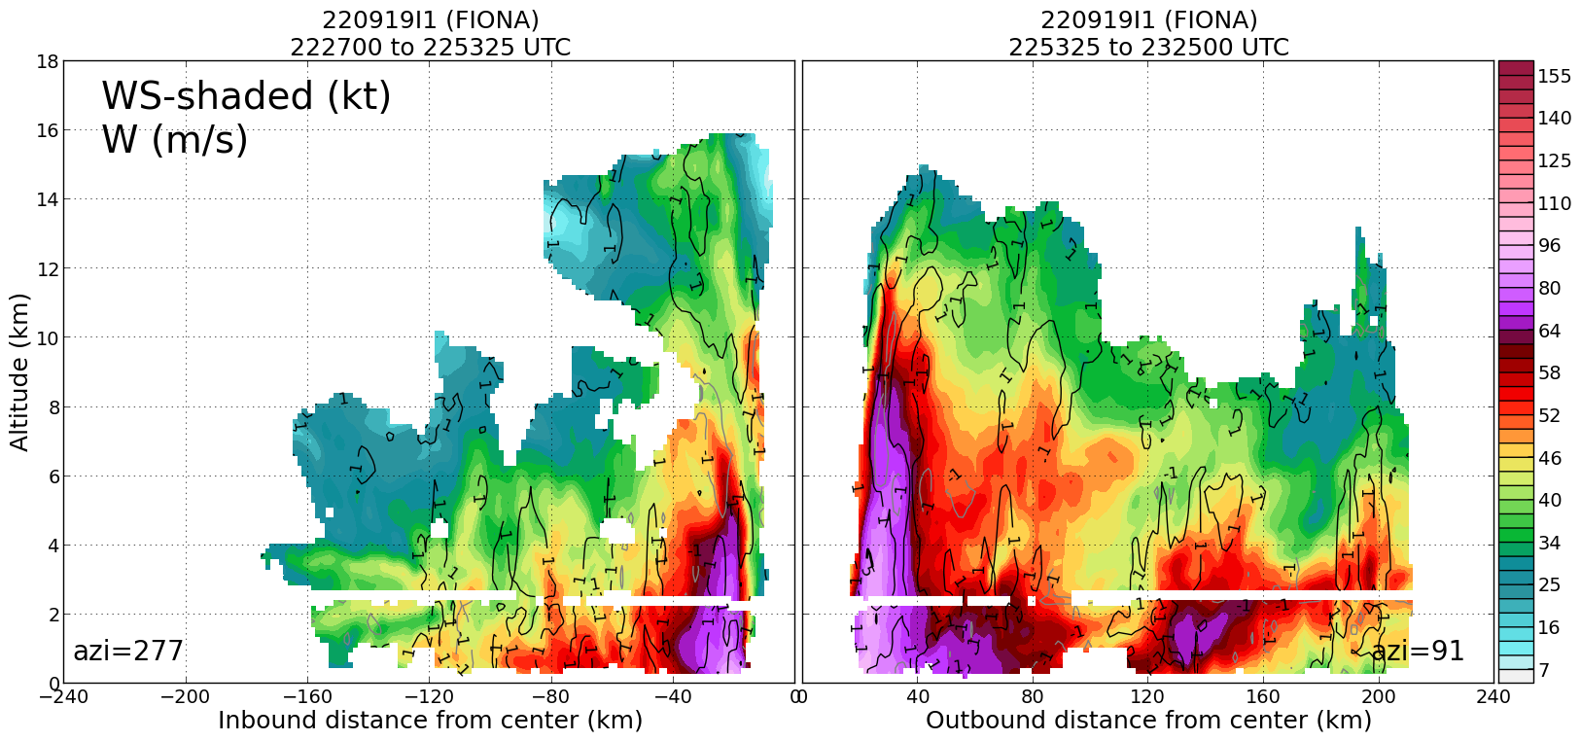
23:24:28 | Drop #11 (Endpoint E, EMC)  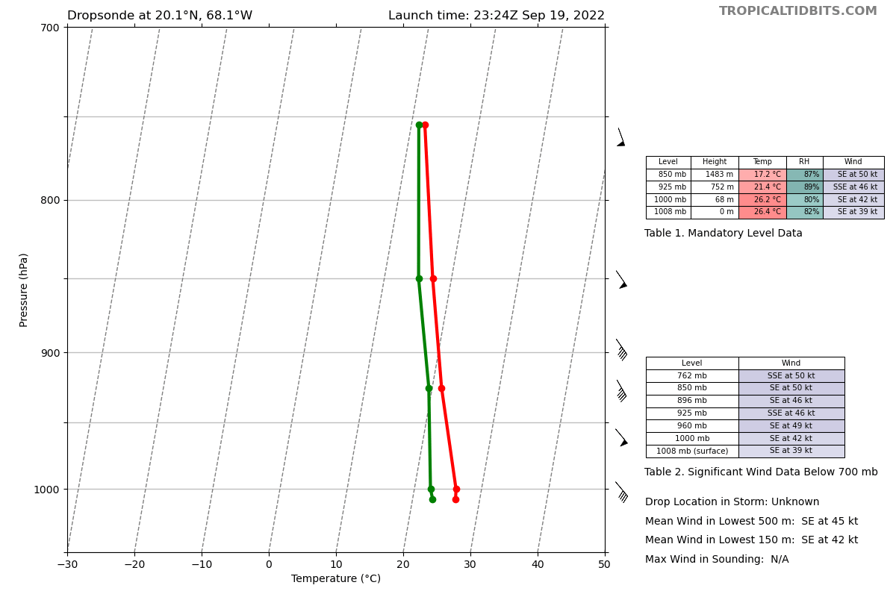
23:30:08 | AXBT #1 (Endpoint E) no SST, bad
2334 | While flying downwind in a moat region to the NE endpoint, cellular rainband ahead and to the right. Moat is between the inner core and rain band.  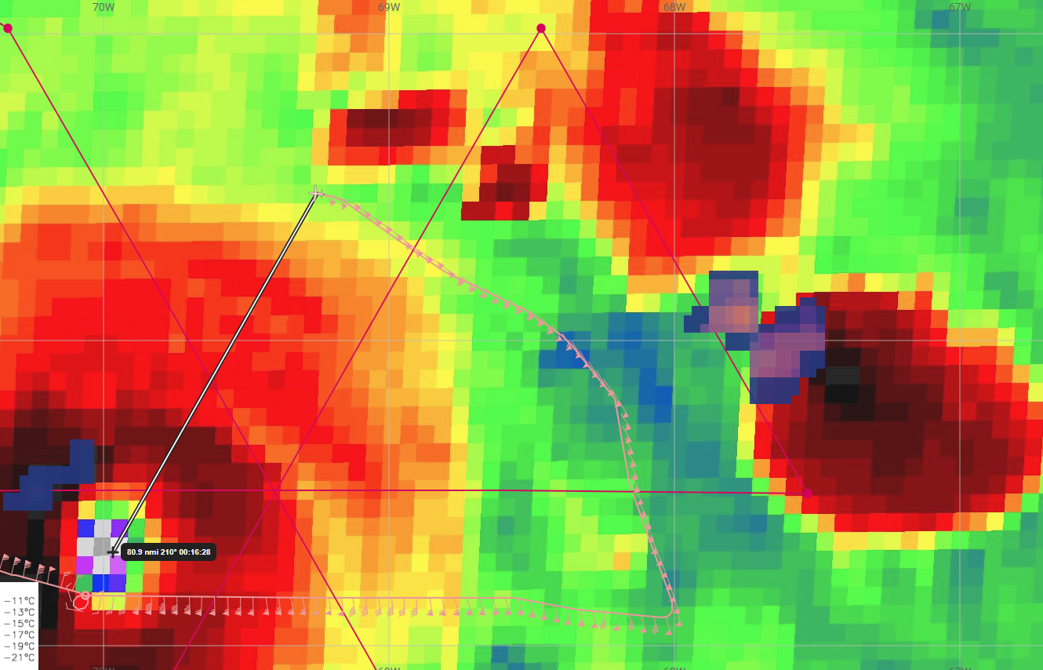
23:53:00 | Drop #12 (Endpoint NE, EMC)
23:53:00 | AXBT #2 (Endpoint NE), SST 29.02 C  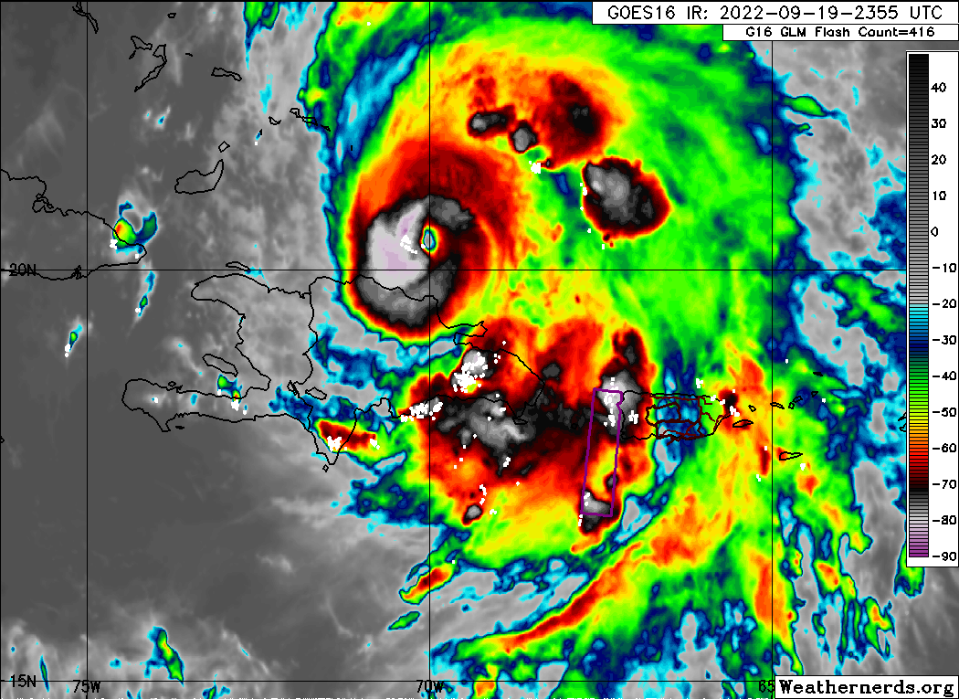
00:00:06 | Mid point drop #13
00:07:35 | Drop #14 (RMW NE, ONR)
00:07:57 | Drop #15 (RMW NE, ONR)
00:08:20 | Drop #16 (RMW NE, ONR)
00:08:43 | Drop #17 (RMW NE, HRD)
00:08:59 | Drop #18 (RMW NE, HRD)
00:09:30 | Drop #19 (RMW NE, HRD)
0010 | 48.6 m/s inbound (SFMR 1 sec)  center is tucked up near SW edge of eyewall  possibly some mesos in the eyewall too  big overhang of the convective anvil on the west side  saw some lightning inbound through NE eyewall
0020 | Holbach: plan is only an EP sonde outbound since the leg will only be about 30 n mi long
00:23:53 | Drop #20 (Center, EMC), orbiting in the eye to get the AXBT set up. Need to not be in Condition 5 to get the AXBT. 4 Orbits for Sim to use if he wants.  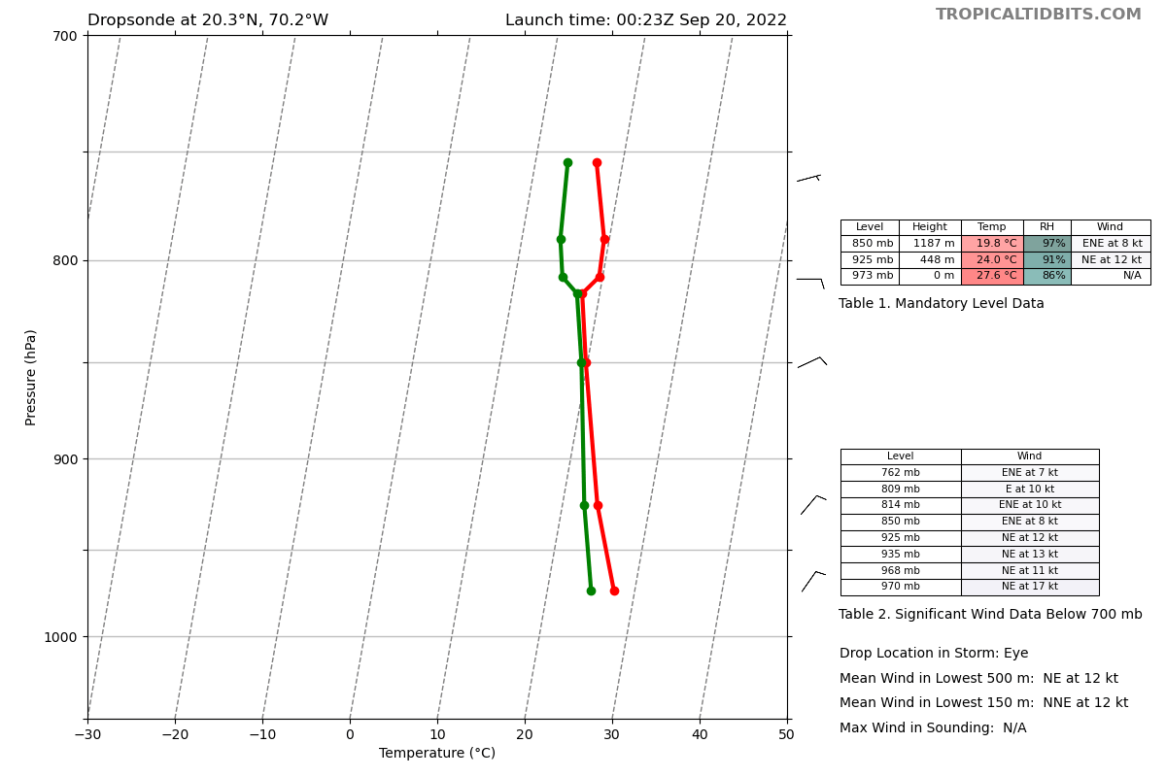
00:23:53 | AXBT #3 (Center), SST 29.06 C  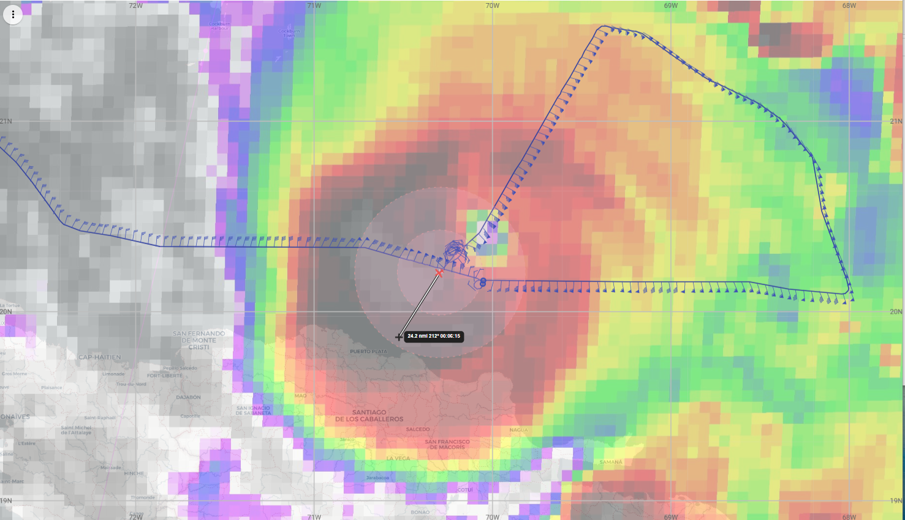
0025 | 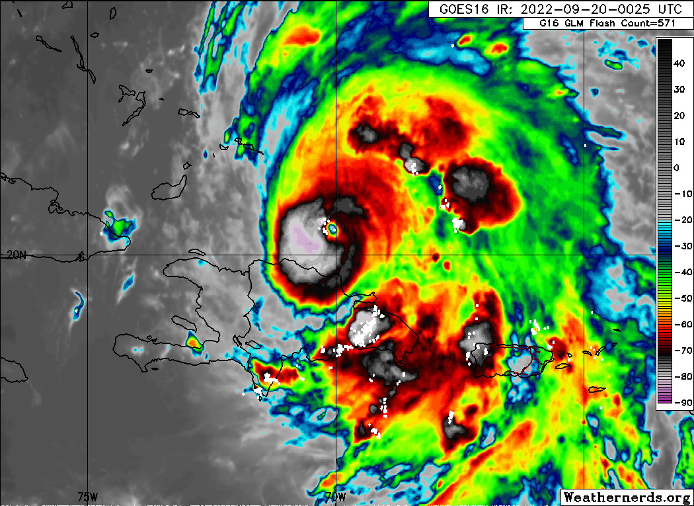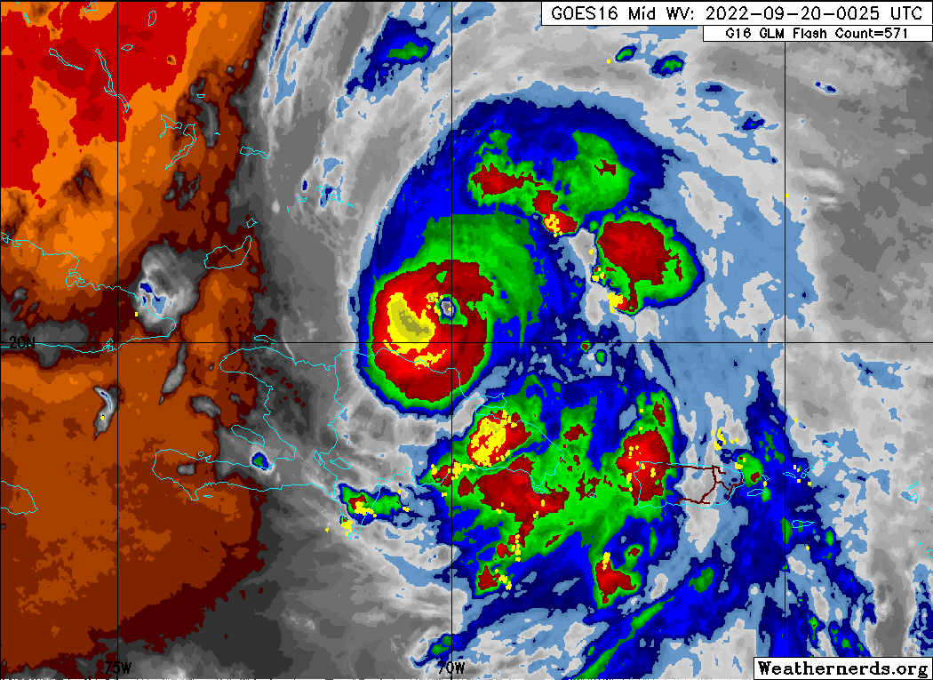  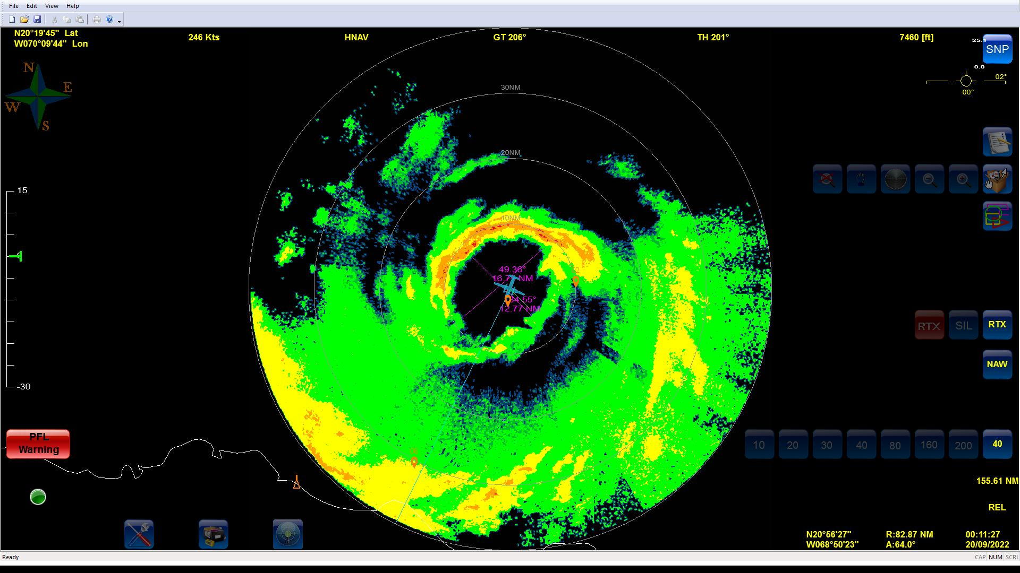
0027 | Holbach: bigger moat on the SW side
00:29:45 | Drop #21 (Endpoint SW, EMC), orbiting to catch up on the drops and other things.
 | Second TDR analysis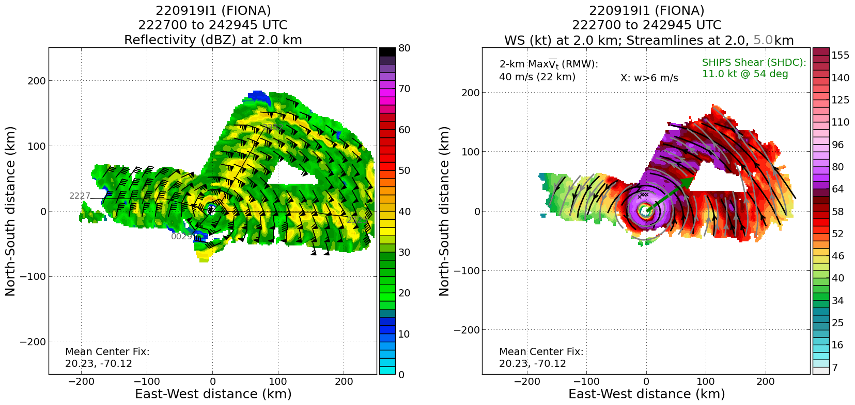
00:47:00 | End orbit, track to pt 5
01:01:51 | At P5 5, orbiting to get AXBT ready
01:05:42 | Drop #22 (Endpoint SE, EMC), tracking NW to center
01:05:42 | AXBT #4 (Endpoint SE), SST 27.96 C
01:19:14 | Drop #23 (Midpoint SE, EMC)
01:20:59 | Drop #24 (RMW SE, ONR), TDR analyses show sharp RMW at 23 km (13 n mi)  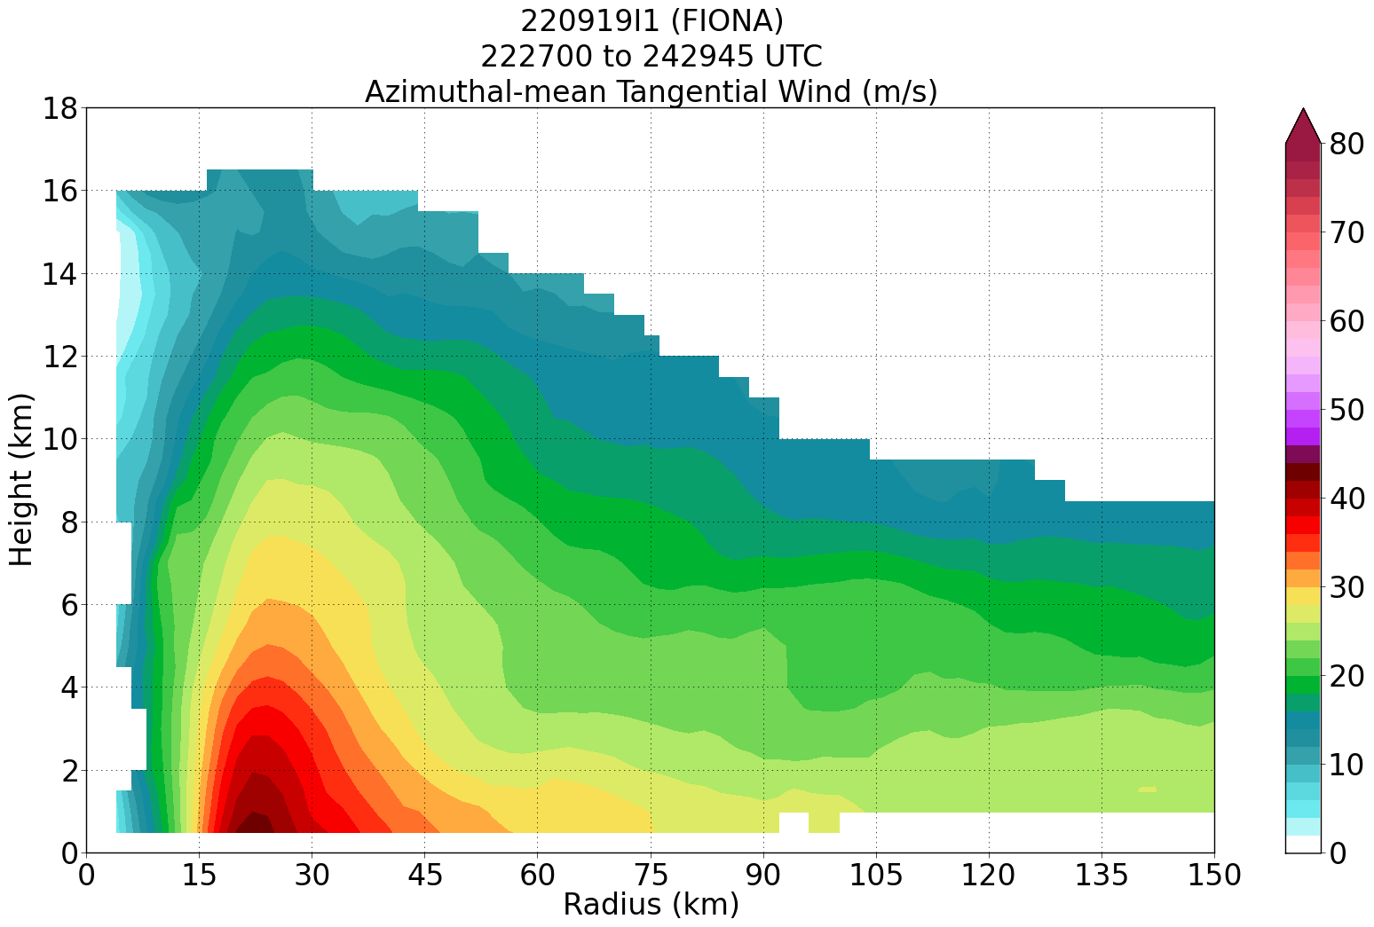
01:21:08 | Drop #25 (RMW SE, ONR)
01:21:36 | Drop #26 (RMW SE, ONR)
01:23:58 | Drop #27 (Center, EMC), passed to the east of the flight level wind center, center
01:25:31 | Drop #28 (RMW NW, ONR)
01:25:58 | Drop #29 (RMW NW, ONR)
01:26:14 | Drop #30 (RMW NW, ONR), strange looking eye on this pass. Looks like a finger sticking into it.  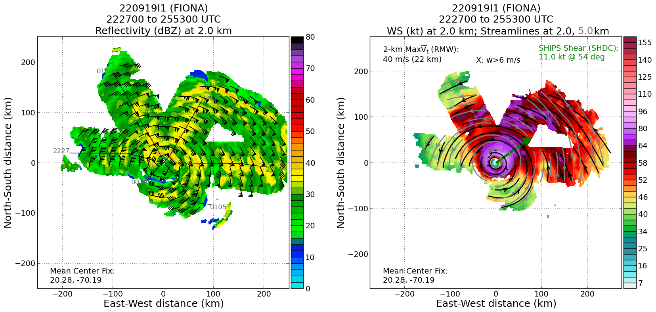  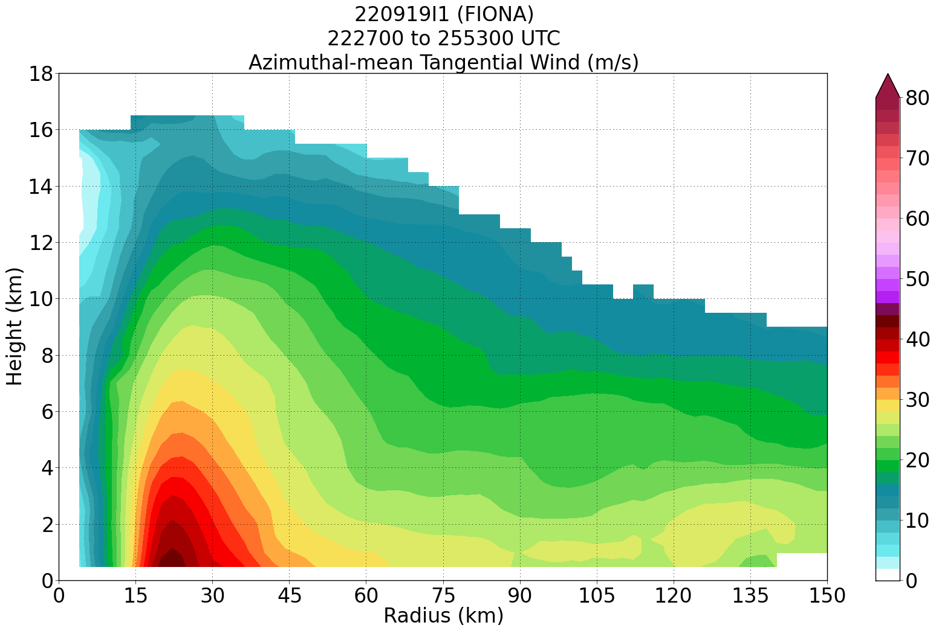  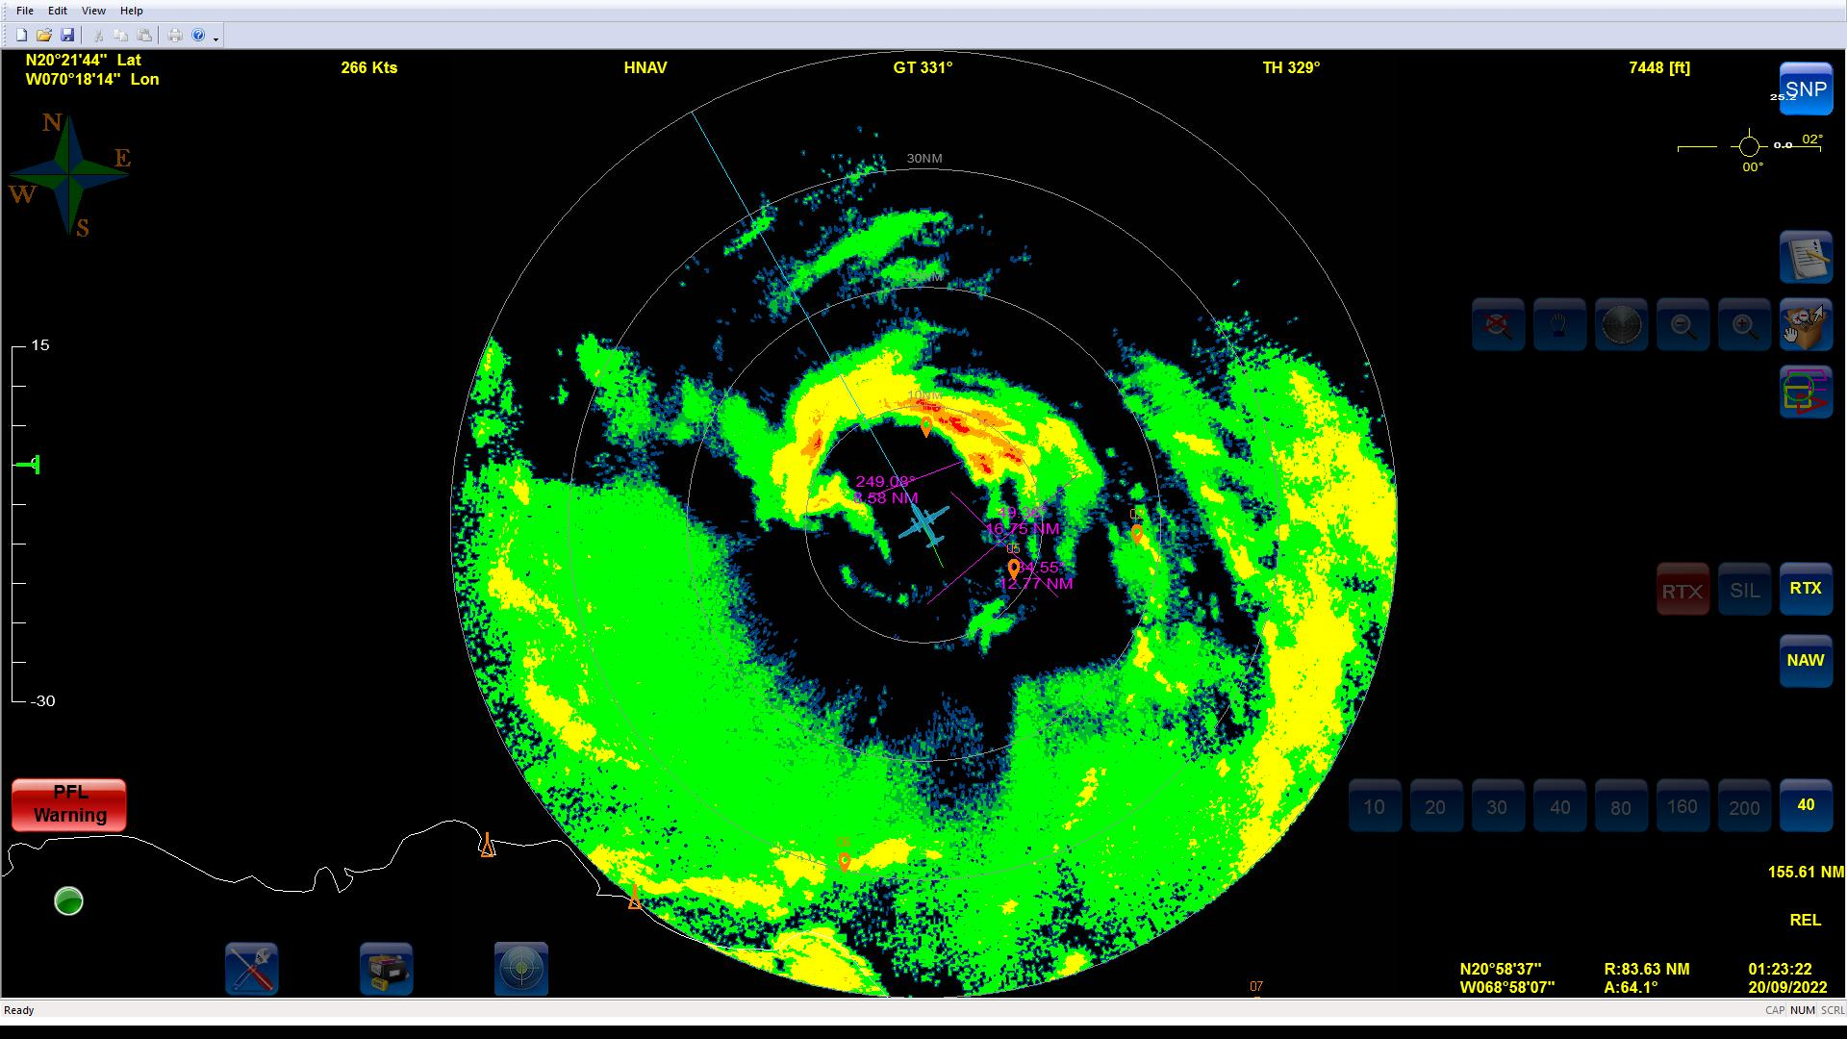
01:36:56 | Drop #31 (Midpoint NW, EMC)
01:50:43 | Drop #32 (Endpoint NW, EMC)
01:50:43 | AXBT #5
02:09:20 | Drop #33 1st ferry drop, fast fall
02:10:00 | Drop #34 backup, fast fall
0215 | 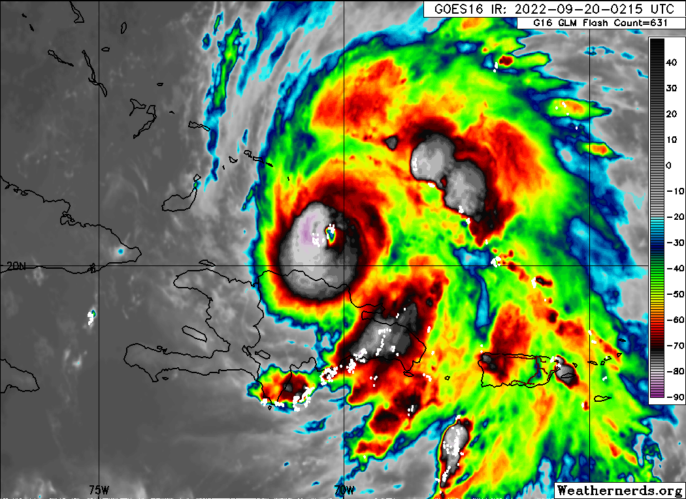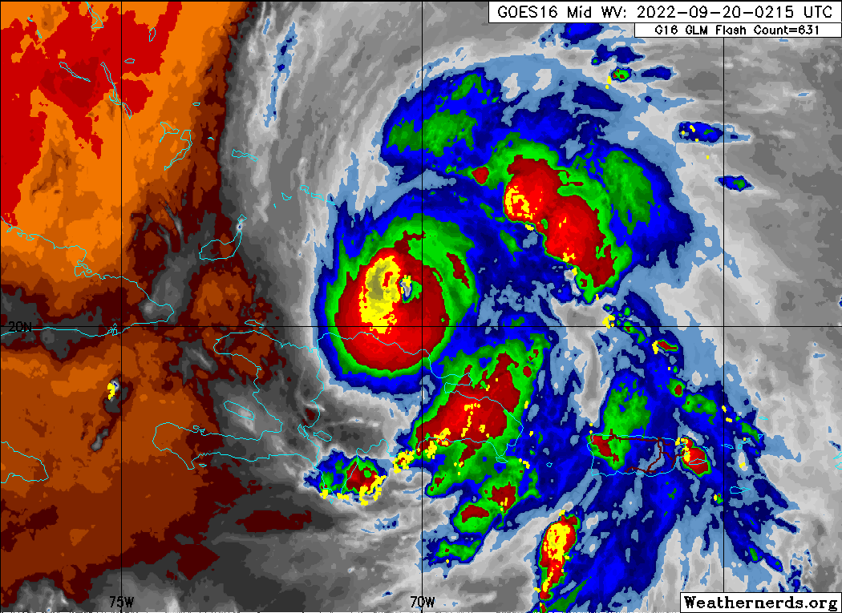
02:34:57 | Drop #35, Ferry drop #2
03:00:40 | Drop #36, Ferry drop #3
0356 | Land Lakeland

POST-FLIGHT
Mission Summary | Overall, the mission was a success. We found Fiona to be intensifying and reached a peak intensity of 95 kt during the flight. Max flight level winds observed were 105 kt and max SFMR were 94 kt. The eye evolved from an elliptical shape to square to open on the S side during each subsequent pass.  Some of the legs had to be modified to account for the location of rainbands or proximity to the coast of Hispaniola. A modified butterfly pattern was flown and 3 TDR analyses were completed and transmitted. There were some challenges with processing sondes. With the shortened legs on the S side and rapid RMW sondes it was hard to keep up with the processing. Ultimately, all end point, mid point, and center sondes were transmitted along with at least 1 RMW from each quadrant. Additional RMW sondes that were not processed during the flight will need to be processed.  Due to N49 aborting their flight, we added on 3 sondes on the ferry back to Lakeland. There were two released at the first point along the transit back and both were fast falls.  Sondes accounting: NWS: 17, ONR: 15, HRD: 3
Actual Standard Pattern Flown | Modified Butterfly
APHEX Experiments / Modules Flown | None, though given the intensification ongoing, data collection could be considered supportive of the Early Stage Experiment: Analysis of Intensity Change Processes (AIPEX).
Plain Language Summary | - Fiona was intensifying after emerging off the coast of Hispaniola shortly before the flight, reaching a peak intensity of 95 kt by the end of the mission.  - Rapid RMW dropsondes were released on many of the passes through the eyewall to sample the rapid changes in the wind and thermodynamic structure that occurs in that region.  - Fiona’s eye structure was rapidly changing throughout the flight.
Instrument Notes | Issue with HRD computer used for TDR during the first leg through the storm. Changes were made to have two computers at that station be able to be used for TDR. Both computers were on, which caused an issue with IP address collisions. Do not have both on at the same time!
Final Mission Track | 