MISSION PLAN
FLIGHT ID | 20220918H1 | STORM | AL07 / FIONA
MISSION ID | 1007A | TAIL NUMBER | NOAA42
TASKING | EMC | PLANNED PATTERN | Modified Butterfly
MISSION SUMMARY
TAKEOFF [UTC] | 0825 | LANDING [UTC] | 1546
TAKEOFF LOCATION | Aruba | LANDING LOCATION | Aruba
FLIGHT TIME | 7.4 | BLOCK TIME | 7.5
TOTAL REAL-TIME RADAR ANALYSES  (Transmitted) | 5 (5) | TOTAL DROPSONDES (Good/Transmitted) | 38 (38 / 38)
OCEAN EXPENDABLES (Type) | 5 AXBT (ONR) | sUAS (Type) | None
APHEX EXPERIMENTS / MODULES | TDR calibration module (San Juan 88D), Early Stage Experiment: AIPEX, TCRI RMWs
HRD CREW MANIFEST
LPS ONBOARD | Rogers | LPS GROUND | Alvey
TDR ONBOARD | Rogers | TDR GROUND | Reasor, Fischer
ASPEN ONBOARD | Sellwood | ASPEN GROUND | None
NESDIS SCIENTISTS | None
GUESTS (Affiliation) | None
AOC CREW MANIFEST
PILOTS | Abitbol, Copare, Wood
NAVIGATOR | Miller
FLIGHT ENGINEERS | Stokes, Gee
FLIGHT DIRECTOR | Kalen, Holmes
DATA TECHNICIAN | McAlister
AVAPS | Dykeman

PRE-FLIGHT
Flight Plan | 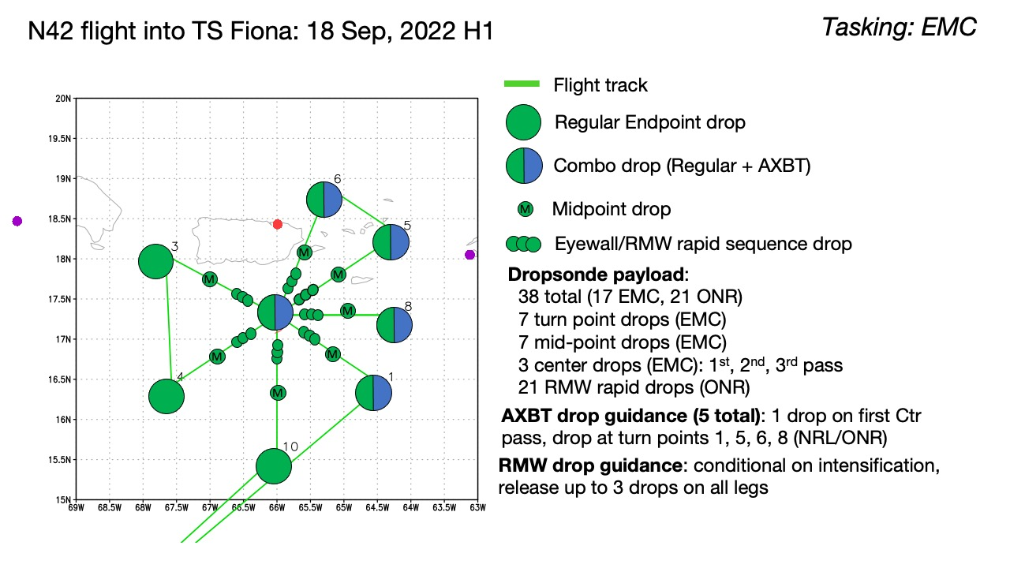  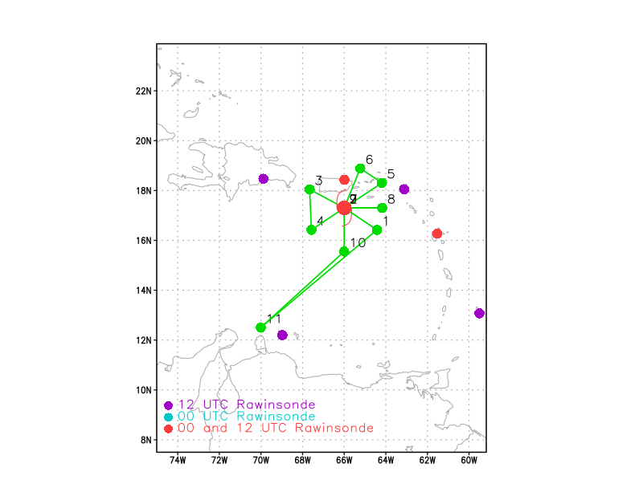  Modified butterfly pattern, IP on SE side. 105 nmi leg lengths, but may have to shave the IP to avoid band of convection with widespread lightning. On NE inbound leg, perform TDR calibration with San Juan 88-D radar – come inbound, then reverse track while traveling perpendicular to beams from 88-D. Should be no problem finding precipitation that meets requirements for calibration. Also perform an outbound leg to east to sample along the expected tilt vector. Pattern will likely be adjusted for presence of land (will not fly over Puerto Rico since highest peaks are 4600 ft and we will be flying at 8000 ft.
Expendable Distribution | Drops at all endpoints, midpoints, center passes, and rapid-fire drops along all azimuths at the RMW. Based on VDM from the most recent AF fix, RMW is expected to be around 40-45 nmi. Fly at 8 kft because AF will be at 10 kft pressure altitude. Drop ONR AXBTs at all endpoints on the east side and the first center pass (all combos with dropsondes). Attempt to drop a sonde co-located with a Saildrone at 17.5N, 66.55W.
Preflight Weather Briefing | Fiona remains a tropical storm, but is slowly intensifying. The 11 PM EDT NHC advisory has Fiona at 50 kt. Satellite presentation at takeoff shows an elongated band oriented north-south on the east side of the circulation. There is not much in the way of cold cloud tops associated with the center, though the most recent IR images show some colder cloud tops starting to develop. Radar from San Juan shows precipitation filling in around the center of circulation.  Deep-layer shear remains fairly light to moderate from the southwest, and it is forecast to remain that way for the next 12-24 h. This likely explains the asymmetric appearance on satellite. It will be interesting to see if the vortex, which appeared to have become aligned at the end of yesterday’s mission, has remained aligned, or if it is misaligned again. Data from the first two radar passes should shed light on the structure of the vortex.
Instrument Notes

IN-FLIGHT
Time [UTC] | Event
0825 | Takeoff from Aruba
0905 | 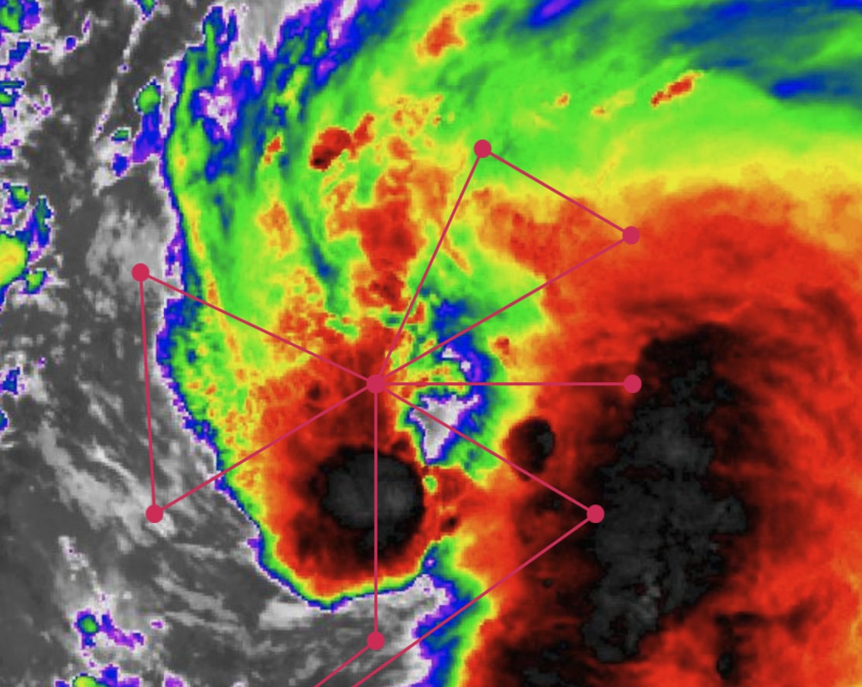
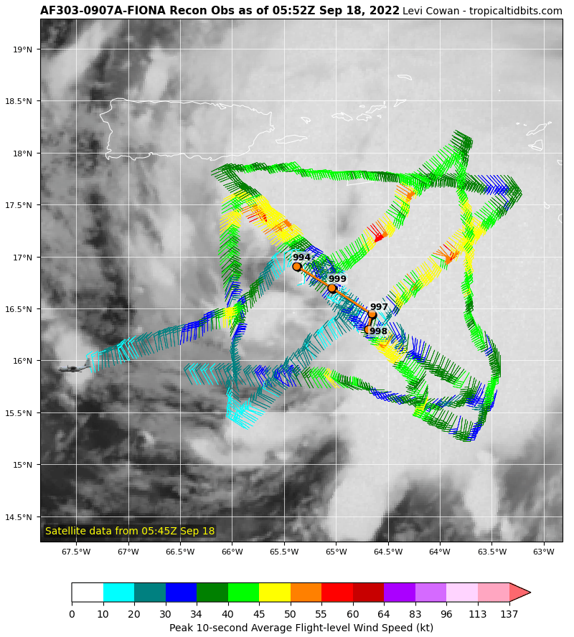
Last Air Force pass was a few mb lower to 994 mb indicating that Fiona is intensifying
0923 | We will have to shave the length of the inbound leg by ~30 nmi because band with widespread lightning will be at that point. We are painting the band on our approach to the IP, though, so will include that data in the first analysis, provided it’s within the analysis domain
0932 | Turning a bit to parallel band on the way to the IP, the band is spiraling inward. Will keep the band about 10-20 nmi off our right wing.
0939 | Deep convection, refs up to 40ish dBZ to 10 km and ETs of 15 km just 10km off our right wing now
0942 | Drop 1, IP endpt SE, AXBT1 measured an SST of 29.25C
 | New convection developing in eastern quadrant and trying to propagate radially inward / fill-in eyewall
095215 | Drop 2, 1st RMW SE
095245 | Drop 3, 2nd RMW SE
095315 | Drop 4, 3rd RMW SE, peak 8-m wind was 59 kt from one of those RMW drops
0959 | Drop 5, center drop, AXBT measured an SST of 29.14C
100425 | Drop 6, 1st RMW NW
100455 | Drop 7, 2nd RMW NW
100530 | Drop 8, 3rd RMW NW
1012 | Drop 9, midpt NW, drop was also 14 nm from Saildrone
1025 | Drop 10, endpt NW
1035 | 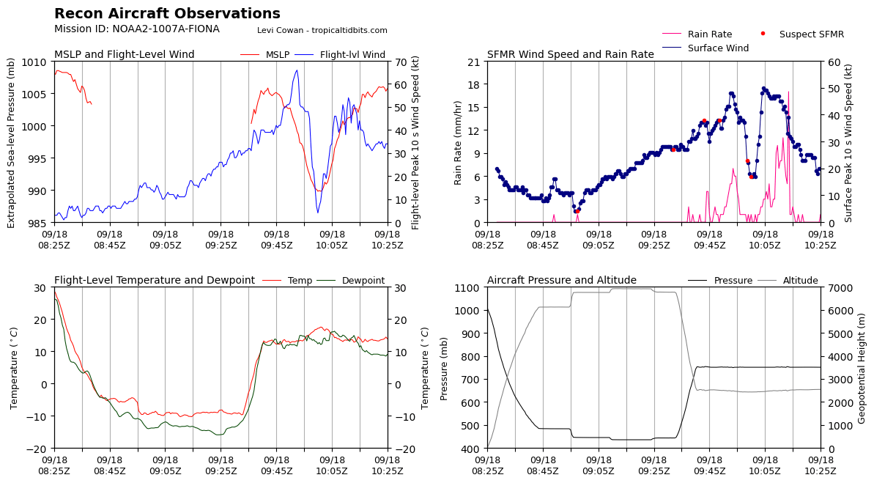  First pass ESE - WNW. 65 kt FL wind
1047 | Drop 11, endpt SW
1100 | Drop 12, midpt SW
110635 | Drop 13, 1st RMW SW
110705 | Drop 14, 2nd RMW SW
110735 | Drop 15, 3rd RMW SW
111255 | Drop 16, center
1108
111715 | Drop 17, 1st RMW NE
111745 | Drop 18, 2nd RMW NE
111815 | Drop 19, 3rd RMW NE
1129 | Drop 20, midpt NE
1142 | Drop 21, endpt NE; AXBT3 measured an SST of 28.82C
1144 | 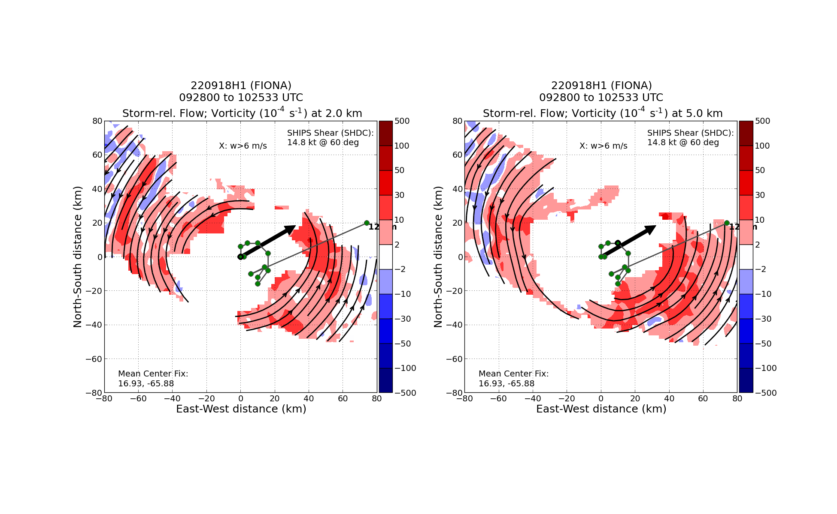  Radar tilt analysis from the first pass showed vortex virtually aligned up to ~11 km, nice anticyclonic curvature with height
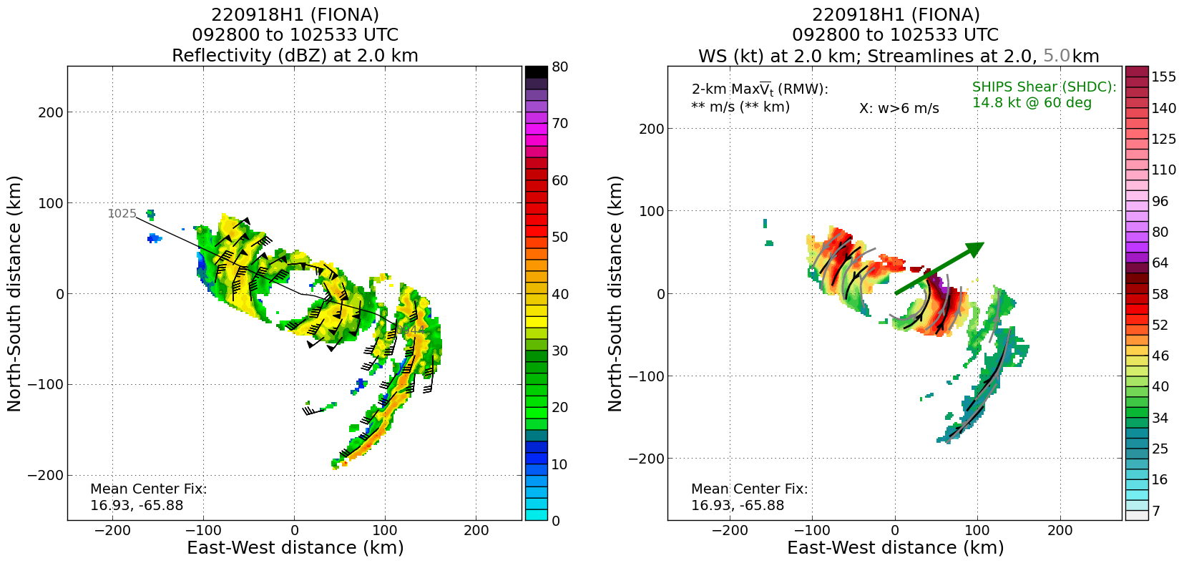
Good coverage on the first pass as well, winds at 2 km of 65-70 kt on the NE side
1152 | 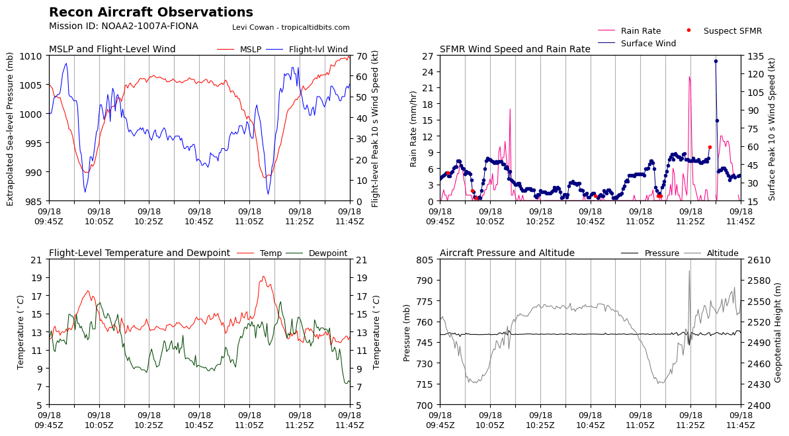  2nd pass through the center - SW to NE
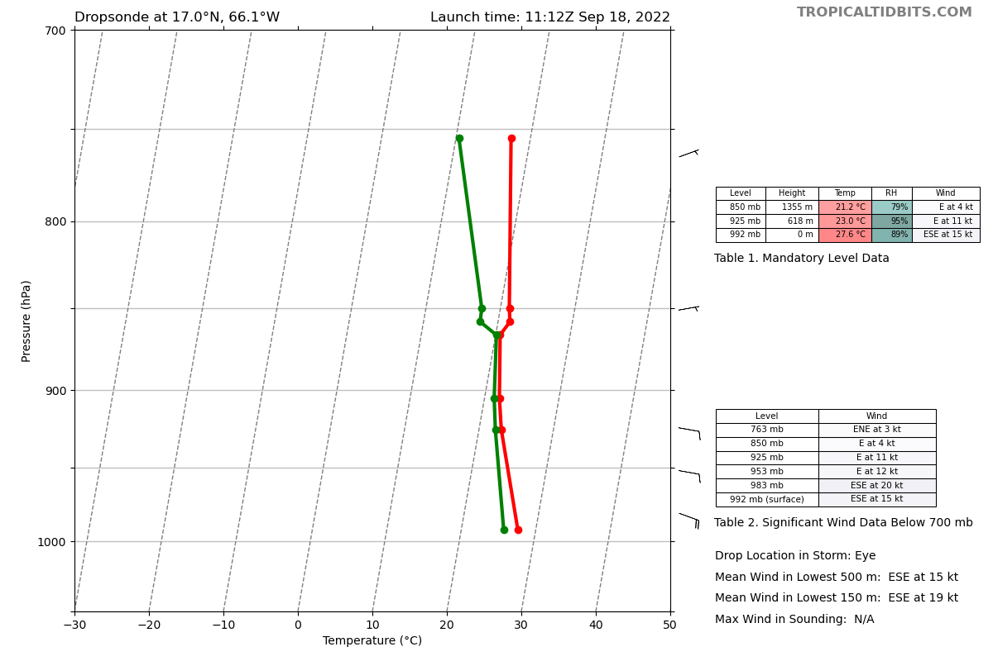
992 mb central pressure with 15 kt winds. Warm core / inversion looks a little more pronounced than 1st eye drop
1156 | Drop 22, center drop; AXBT4 measured an SST of 28.80C
1207 | 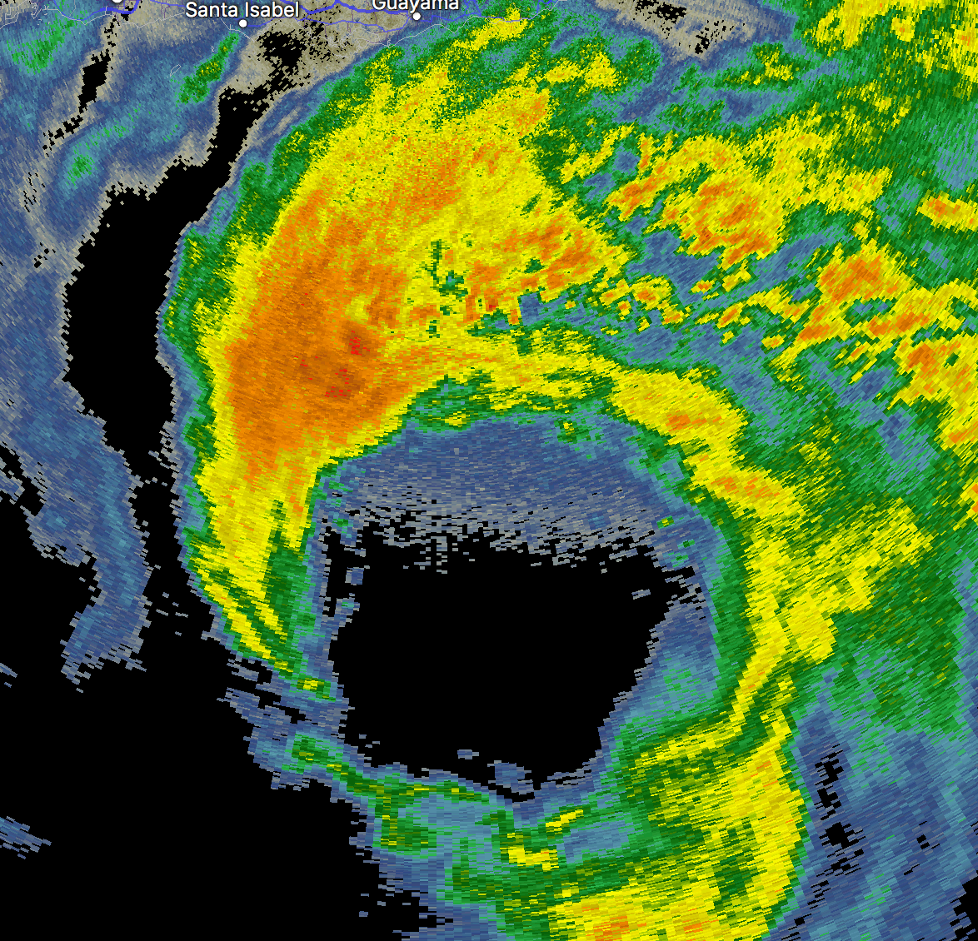  Radar grab at 1146: Interesting polygon eyewall structure (seems abnormal for a TS strength). Stratiform also eroding a bit on the western edge. This could possibly be due to either compensating subsidence from the CB rotating around or downslope flow coming off of PR? I’d speculate it’s more likely the former.
 | 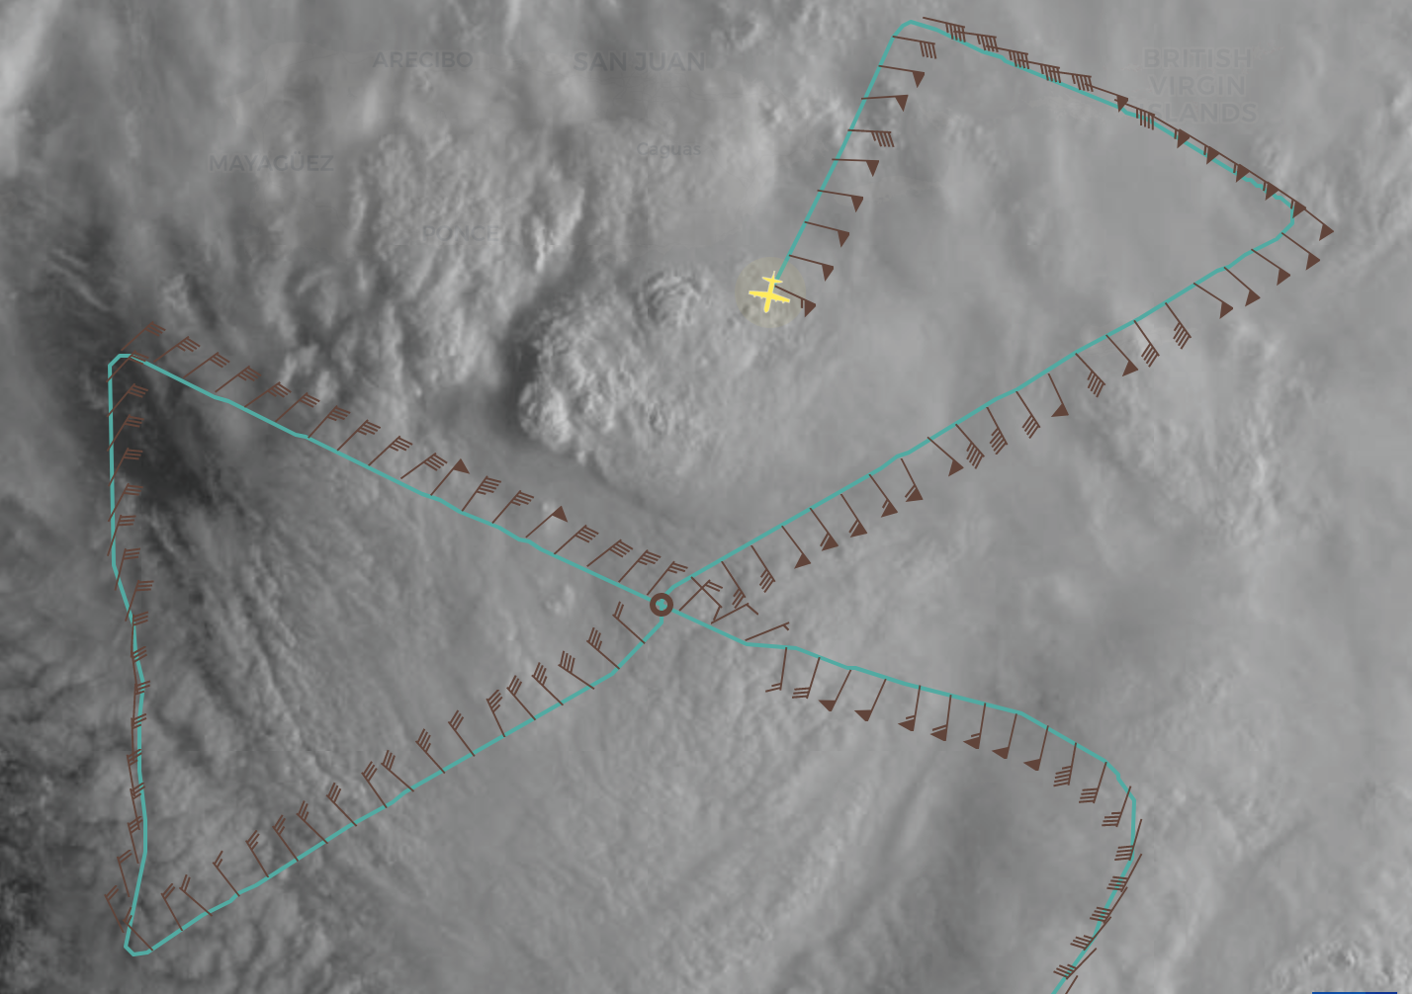
1210 | Drop 23, midpt NE (radar cal inbound leg)
121505 | Drop 24, 1st RMW NE (radar cal inbound leg)
121535 | Drop 25, 2nd RMW NE (radar cal)
121605 | Drop 26, 3rd RMW NE (radar cal)
1222 | Drop 27, center drop
1228 | Large CB has now rotated around to the west side of the storm. Almost looks like a large supercell and appears to be trying to pull the storm back to the W.  1242 - AF just flew through the W side and got 60+ kt SFMR, some of it flagged though. Extrap. Pressure spiked to 985 mb though likely a low estimate given extrapolation’s typical bias.  ​​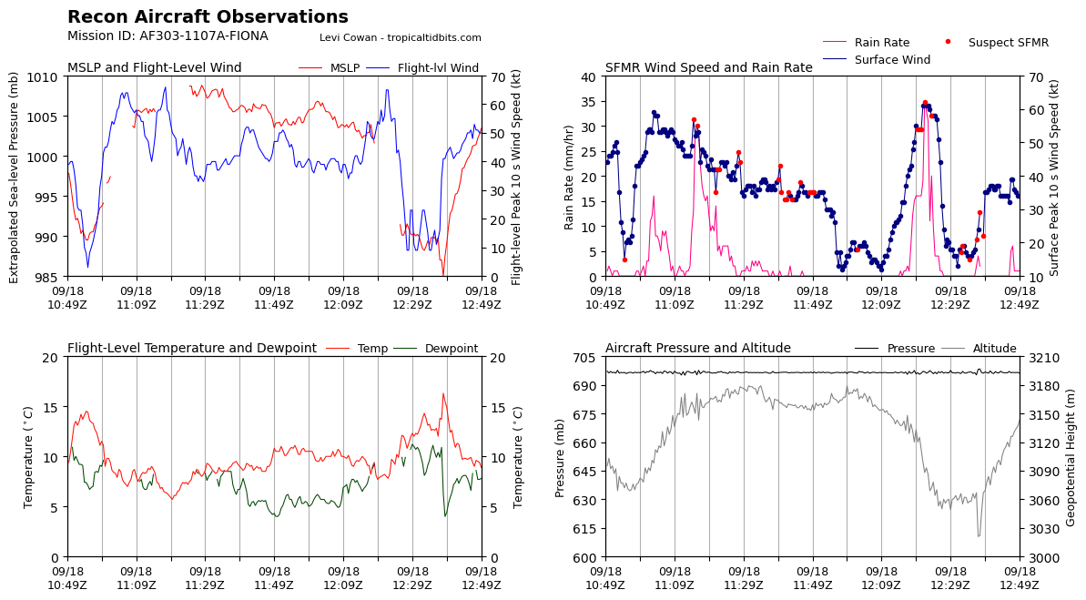
1317 | CB rotating cyclonically around storm can also be seen on satellite
1319
1339 | Looks like Saildrone went through NW eyewall and now eye is going over it via MMR
1350 | Drop 28, E endpt; AXBT5 measured an SST of 28.97C
 | 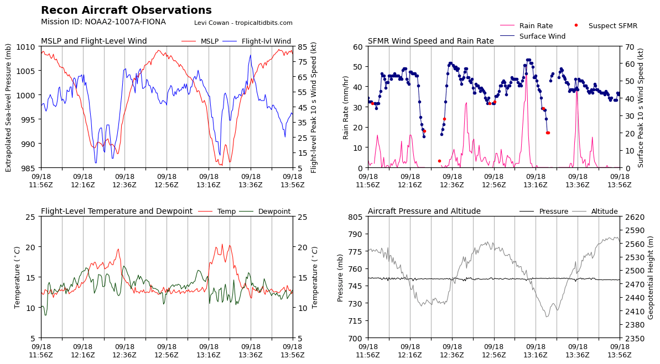
1402 | Drop 29, E midpt
 | 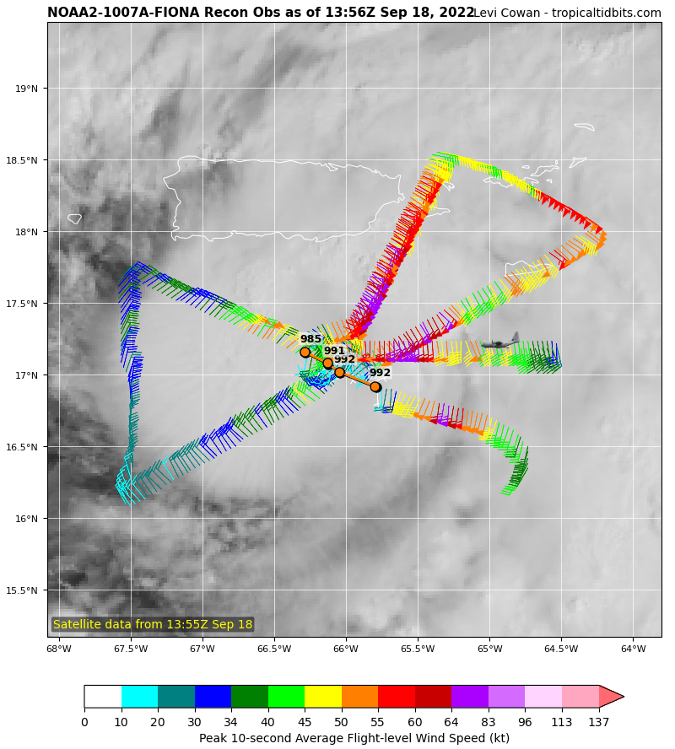
141505 | Drop 30, 1st RMW E
141535 | Drop 31, 2nd RMW E
141605 | Drop 32, 3rd RMW E
1420 | Drop 33, center
142550 | Drop 34, 1st RMW S
142620 | Drop 35, 2nd RMW S
142650 | Drop 36, 3rd RMW S
1428 | Puerto Rico WSR-88D appears to be down now at 1423
1435 | Drop 37, midpt S
1447 | Drop 38, endpt S
1546 | Land in Aruba

POST-FLIGHT
Mission Summary | The mission was flown successfully with all objectives accomplished. We released RMW rapid fires on all azimuths flown, and captured the surface RMW reasonably well on most of them. Five TDR analyses were completed and transmitted to EMC. We accomplished a TDR calibration module near San Juan 88D. There was heavy precipitation along the flight track, so attenuation of TDR may be an issue. But there was so much precipitation there should be good statistics. Flew near Saildrone, dropping a sonde 14 nmi from its location.  Fiona was steadily intensifying during this mission. It may have been rapidly intensifying during the mission, but that will need to be assessed from official sources post-mission. The MSLP from dropsondes dropped only 2 mb, from 992 to 990 mb, over the course of the mission. We did measure peak FL winds of about 75 kt and peak SFMR winds of about 65 kt around the north and east sides of the storm. The storm was aligned up to 11 km (tilt < 20 km), though the 12-km center location bounced around from pass to pass, which may have been due to coverage limitations or perhaps multiple upper-level vorticity maxima that were being picked up by the algorithm. A band of intense convection was evident on the east side of the storm at take-off. As the mission proceeded convection filled in around the center. By the end of the mission there was a nice presentation of convective bursts initiating in the NE and N quadrants (downshear and downshear-left) and wrapping around into the upshear quadrants. In one particular case, evident on San Juan 88D, the burst wrapped around to the upshear side and dissipated on the SW side of the storm (USR quadrant), while another burst appeared to be developing on the E side (DSR). These features exhibited the “cycling” phenomena of eyewall convection often seen in sheared TCs of this intensity. During this time also the eyewall appeared to exhibit a polygonal structure on the San Juan 88D. At the 11am advisory NHC upgraded Fiona to a 70-kt hurricane.  38 dropsondes in total released, all worked well. 21 sondes were from ONR, 17 sondes were from NWS. 5 BTs were dropped, all produced SSTs. A total of 5 TDR analyses were created and transmitted to EMC.
Actual Standard Pattern Flown | Modified butterfly flown at 8 kft pressure altitude
APHEX Experiments / Modules Flown | Data collection supports the Early Stage Experiment: Analysis of Intensity Change Processes (AIPEX) and specifically rapid-fire RMW sondes. Also flew a TDR calibration module within range of the San Juan 88D.
Plain Language Summary
Instrument Notes
Final Mission Track | 