MISSION PLAN
FLIGHT ID | 20220917H1 | STORM | AL07 / FIONA
MISSION ID | 0607A | TAIL NUMBER | NOAA42
TASKING | EMC | PLANNED PATTERN | Modified Butterfly
MISSION SUMMARY
TAKEOFF [UTC] | 0743 | LANDING [UTC] | 1447
TAKEOFF LOCATION | Aruba | LANDING LOCATION | Aruba
FLIGHT TIME | 7.1 | BLOCK TIME | 7.2
TOTAL REAL-TIME RADAR ANALYSES  (Transmitted) | 4 (4) note: not all 4 used in composite | TOTAL DROPSONDES (Good/Transmitted) | 28 (27 / 27)
OCEAN EXPENDABLES (Type) | 1 AXBT (ONR) | sUAS (Type) | None
APHEX EXPERIMENTS / MODULES | Early Stage Experiment: AIPEX (Vortex Alignment Module, VAM)
HRD CREW MANIFEST
LPS ONBOARD | Alvey | LPS GROUND | Hazelton
TDR ONBOARD | Rogers | TDR GROUND | Reasor
ASPEN ONBOARD | Sellwood | ASPEN GROUND | None
NESDIS SCIENTISTS | None
GUESTS (Affiliation) | Stahl (AOML)
AOC CREW MANIFEST
PILOTS | Abitbol, Copare, Wood
NAVIGATOR | Miller
FLIGHT ENGINEERS | Stokes, Gee
FLIGHT DIRECTOR | Kalen, Holmes
DATA TECHNICIAN | McAlister
AVAPS | Dykeman

PRE-FLIGHT
Flight Plan | 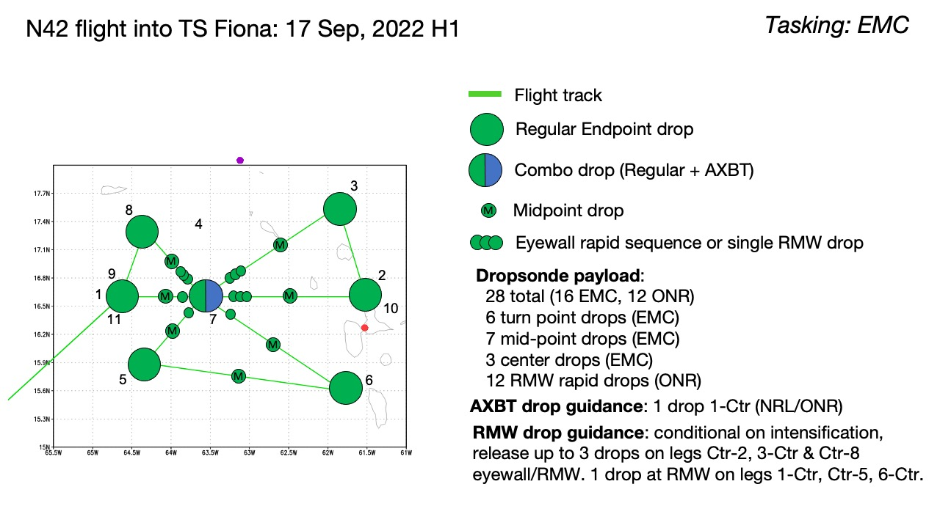  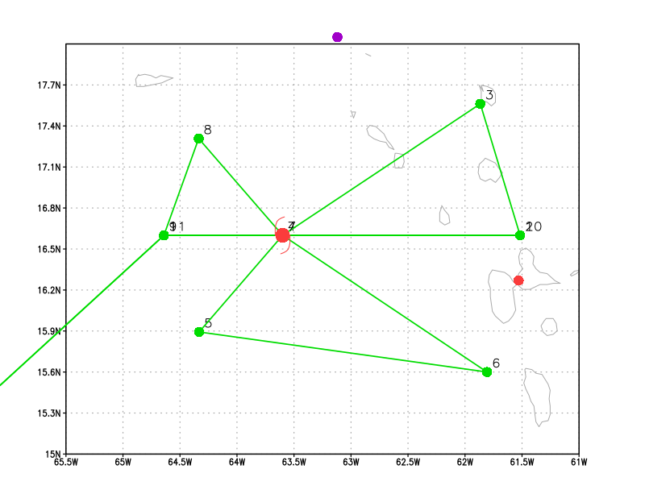  The pattern is a modified butterfly with shortened legs on the west side (no precipitation) and extended legs on the eastern side. One repeat VAM racetrack of the first W-E is planned for the last part of the mission.
Expendable Distribution | Dropsondes are planned at all center, midpoint, endpoints, and RMWs. Rapid RMW sequences are planned for the northern/eastern quadrants. An ONR AXBT deployment is expected for the first center pass.
Preflight Weather Briefing | Fiona has slightly intensified overnight and now has maximum sustained winds of 50 knots and 1000 mb estimated MSLP. Movement is west at 14 mph. Overall, as shown by the ground radar loops from Guadeloupe and Martinique below, the storm structure has improved with a marked increase in convection and stratiform in the downshear (eastern) quadrants. The precipitation still has an asymmetric configuration but appears to be increasing nearer to the low-level center. Although the storm is still in an environment characterized by westerly vertical wind shear, environmental conditions are expected to gradually improve over the next couple of days.
Instrument Notes | All instruments operational

IN-FLIGHT
Time [UTC] | Event
0743 | Takeoff from Aruba
0845 | Descending to Initial Point (IP)
0853 | 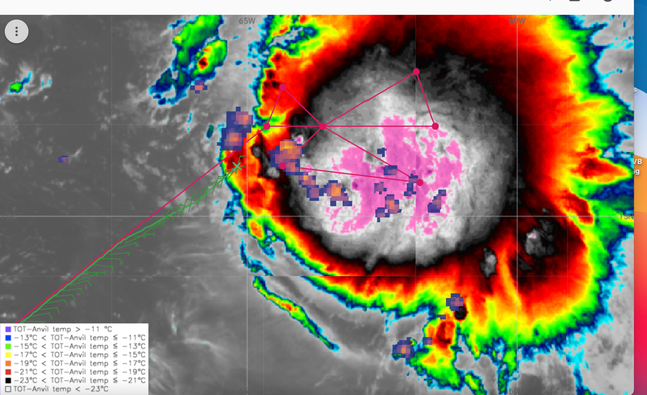
0904 | Dropsonde #1 endpoint W-E leg
091512 | Dropsonde #2 midpoint W-E leg
0924 | Dropsonde #3 AXBT combo, released a little early before center at FD discretion (they wanted to release before convection farther east); measured a 29.39C SST
0930 | RMW sonde #4
0930 | 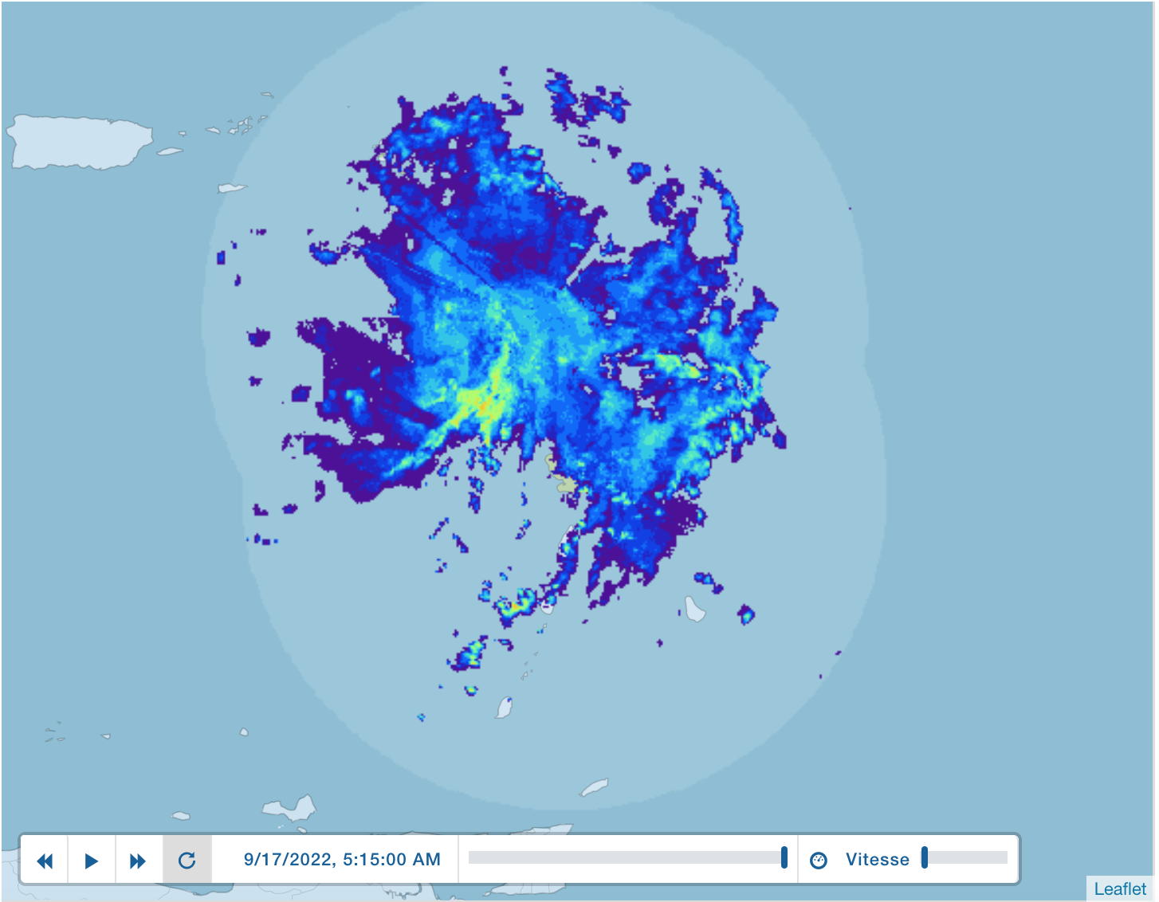
0934 | Center sonde #5. Bad winds so did a 2nd for drop #6
0946 | RMW outbound W-E drop #7
0946 | Strange wind field - Center reformation?  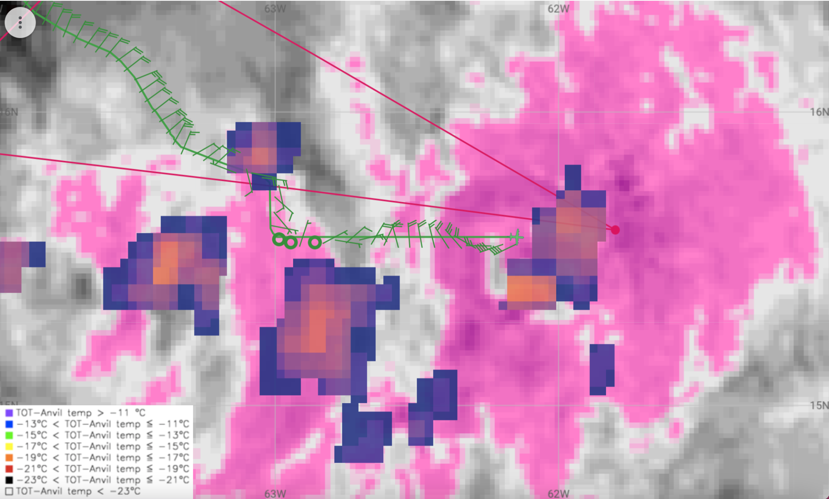
0949 | Midpoint sonde #8
0951 | Did another RMW sonde #9 on secondary wind spike, reforming center?
0952 | Microwave shows the strong curve band but messy center  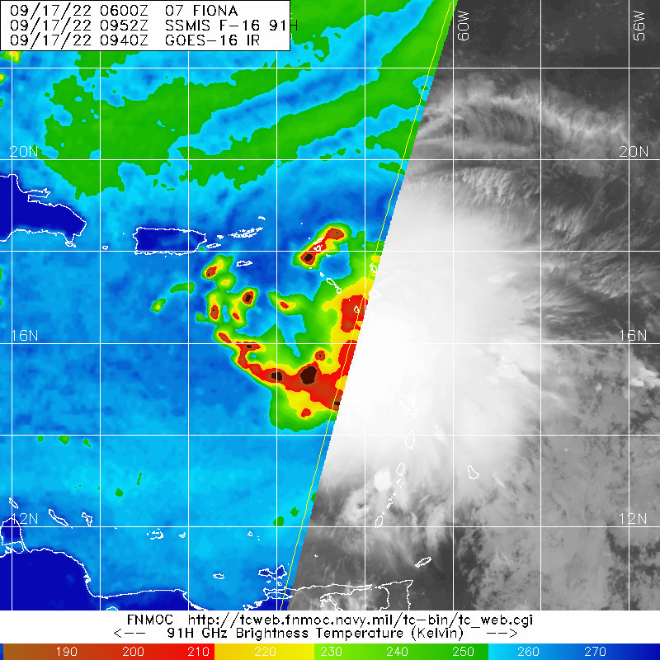
0957 | 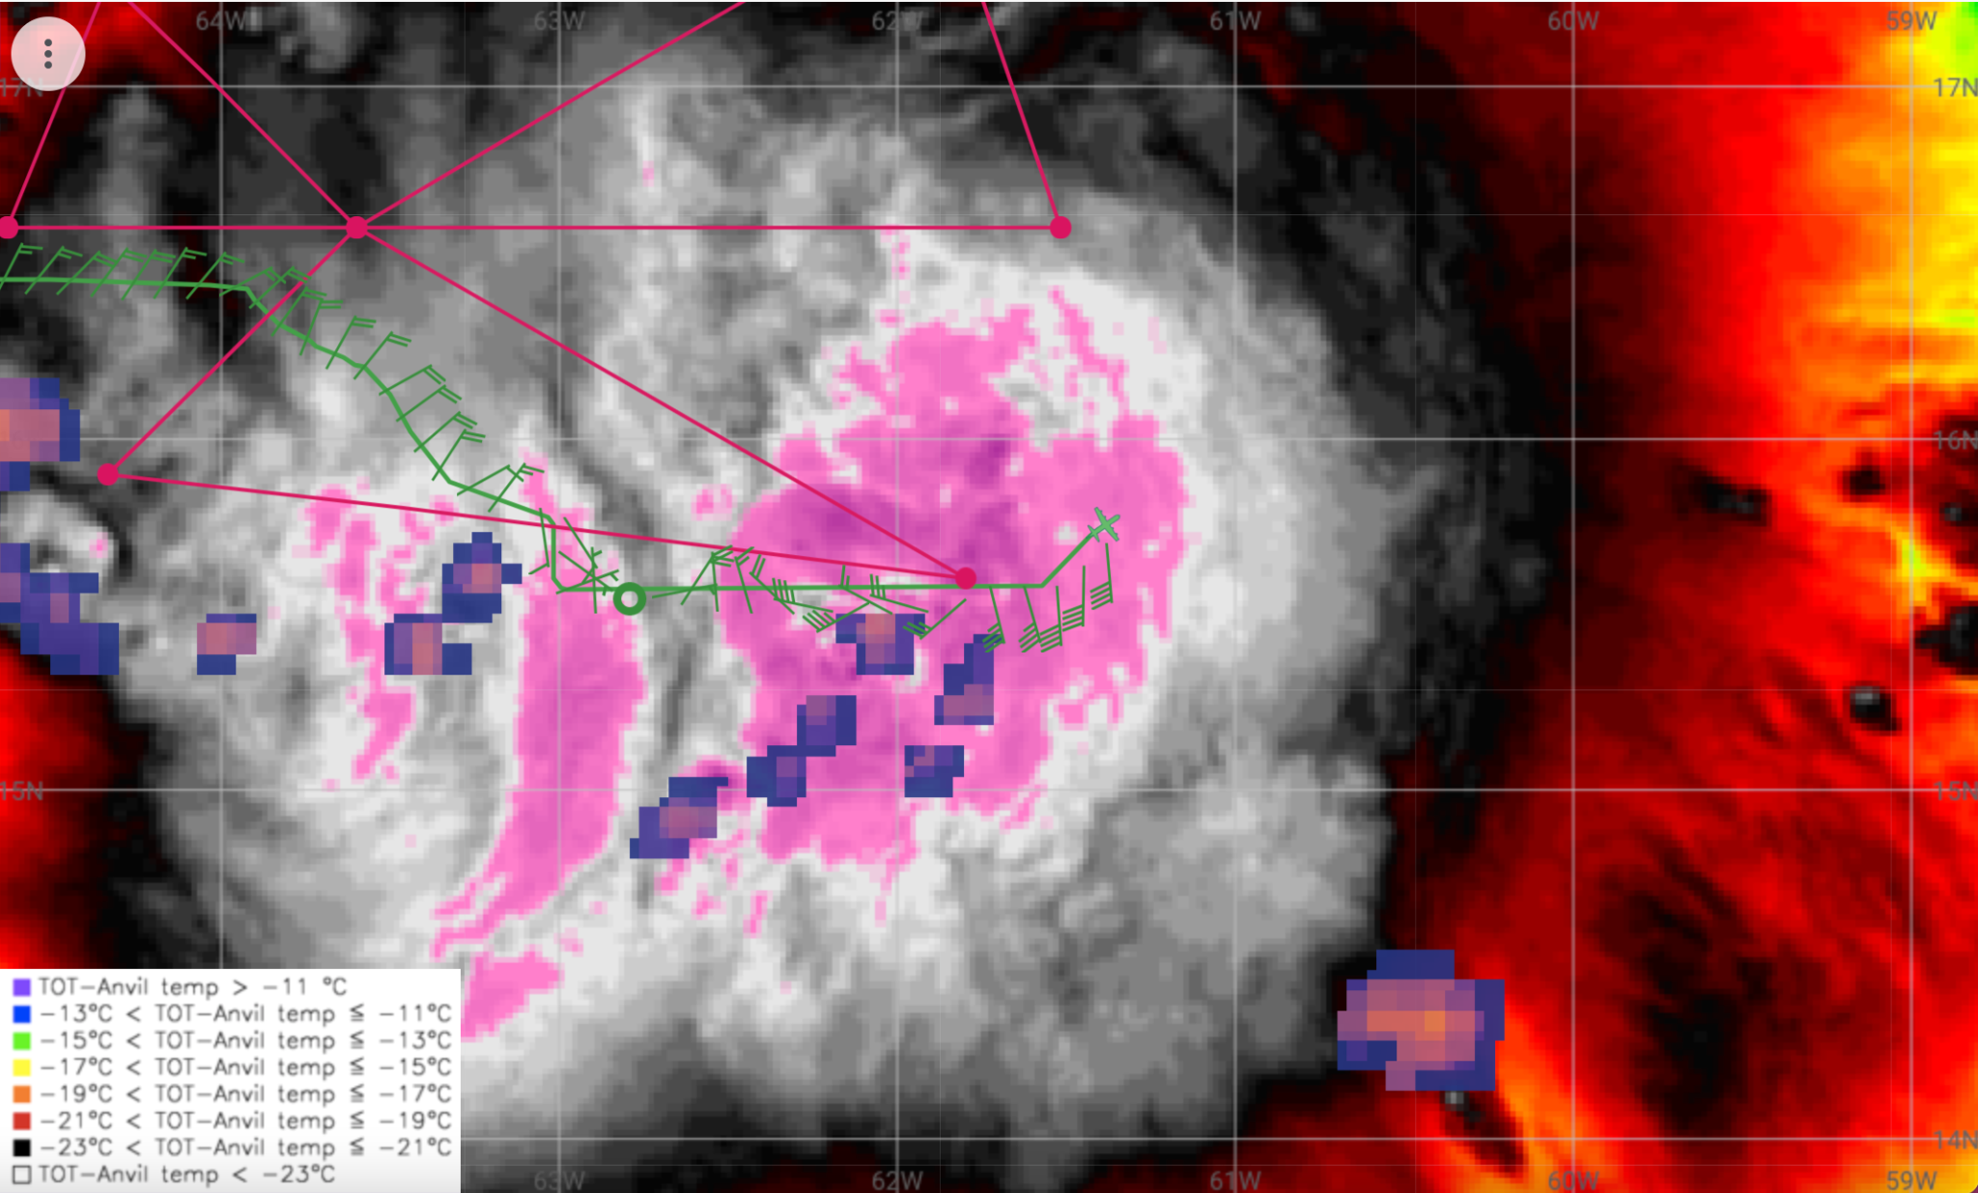
1005 | Endpoint sonde #10
1007 | Radar seems to show the multiple centers as well:  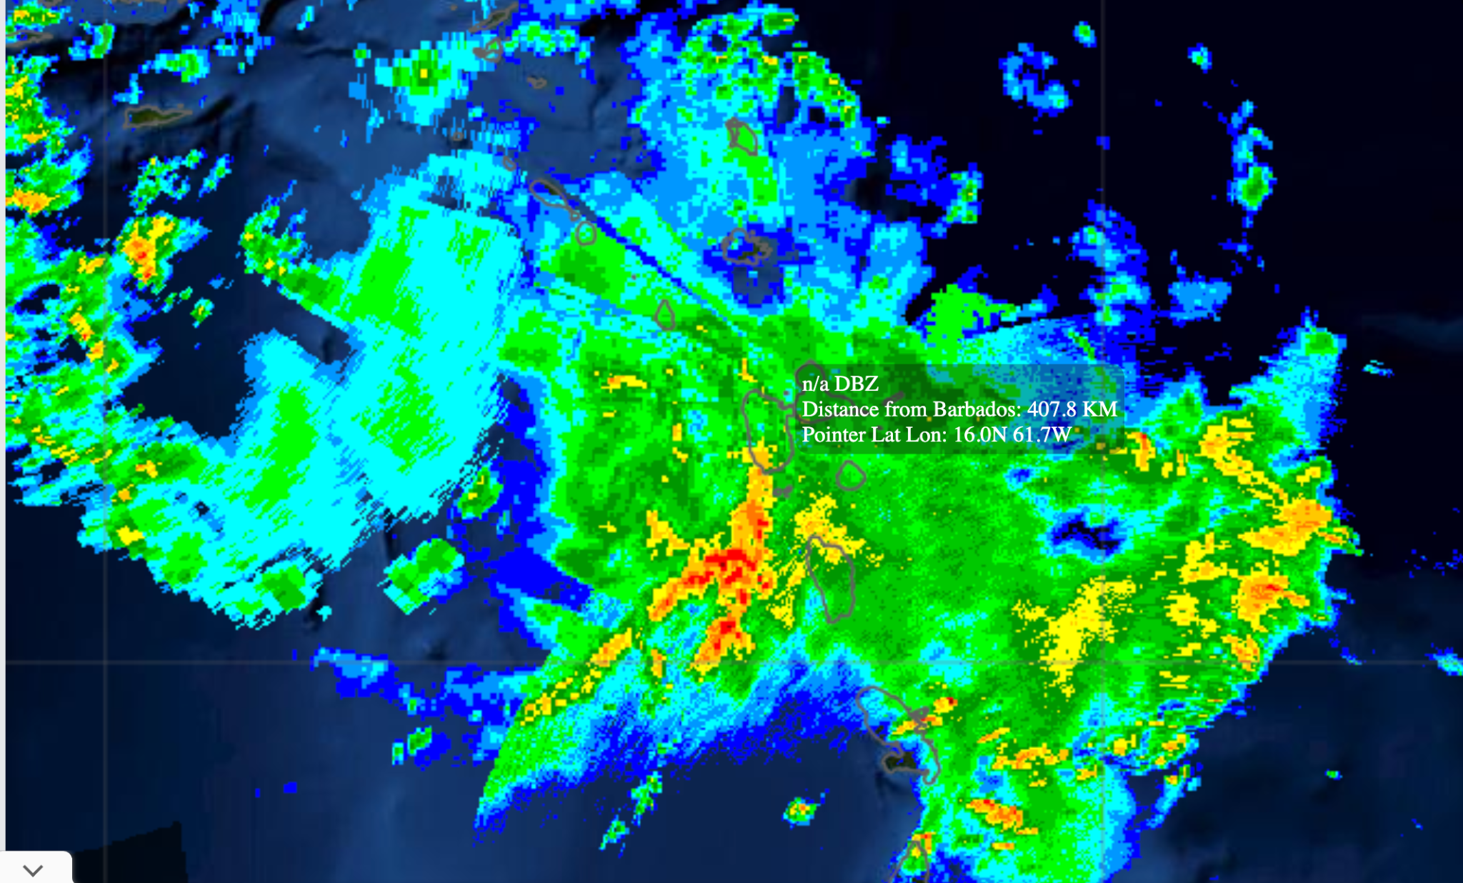
103130 | Endpoint sonde #11 for inbound ENE-SW leg. Readjusted the center position a bit to take the centroid between the weaker farther west center and what appears to be a more robust FL center farther towards the east. Also the inbound leg had cut in a little early on the downwind due to convection and Guadeloupe air space
1039
 | Holding midpoint sonde #12 until after Guadeloupe
1048 | Second center (MLC) appears dominant above ~3 km  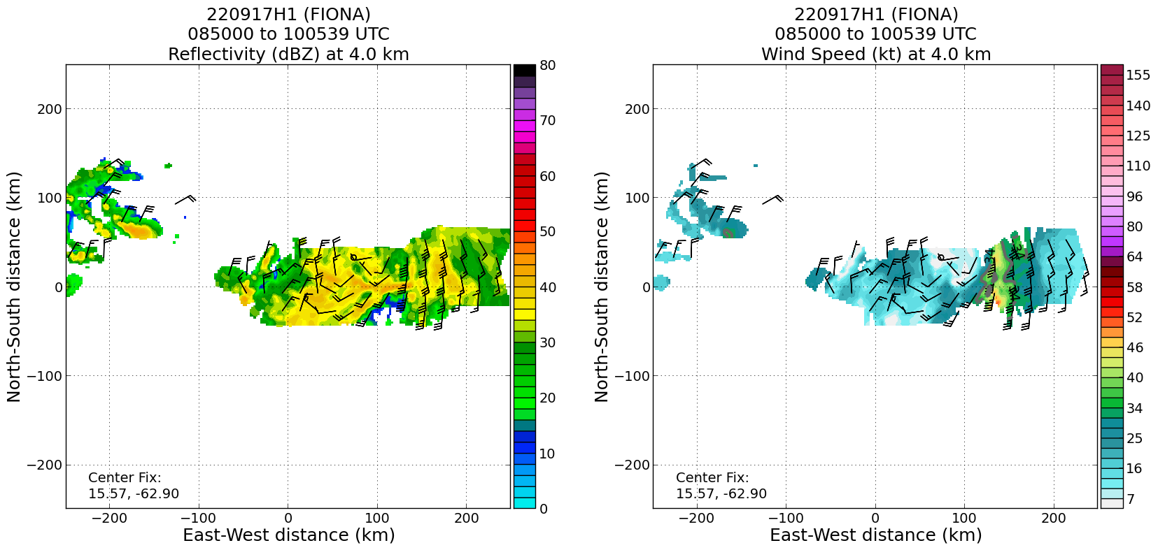
1048 | Midpoint sonde #12
104930 | RMW 1st sonde #13
105030 | RMW 2nd sonde #14
1101 | RMW 3rd sonde #15, secondary wind max (likely associated with other center that’s farther west?)
1110 | Midpoint sonde #16, outbound NE-SW
1111 | No marked center for that second pass
1111 | 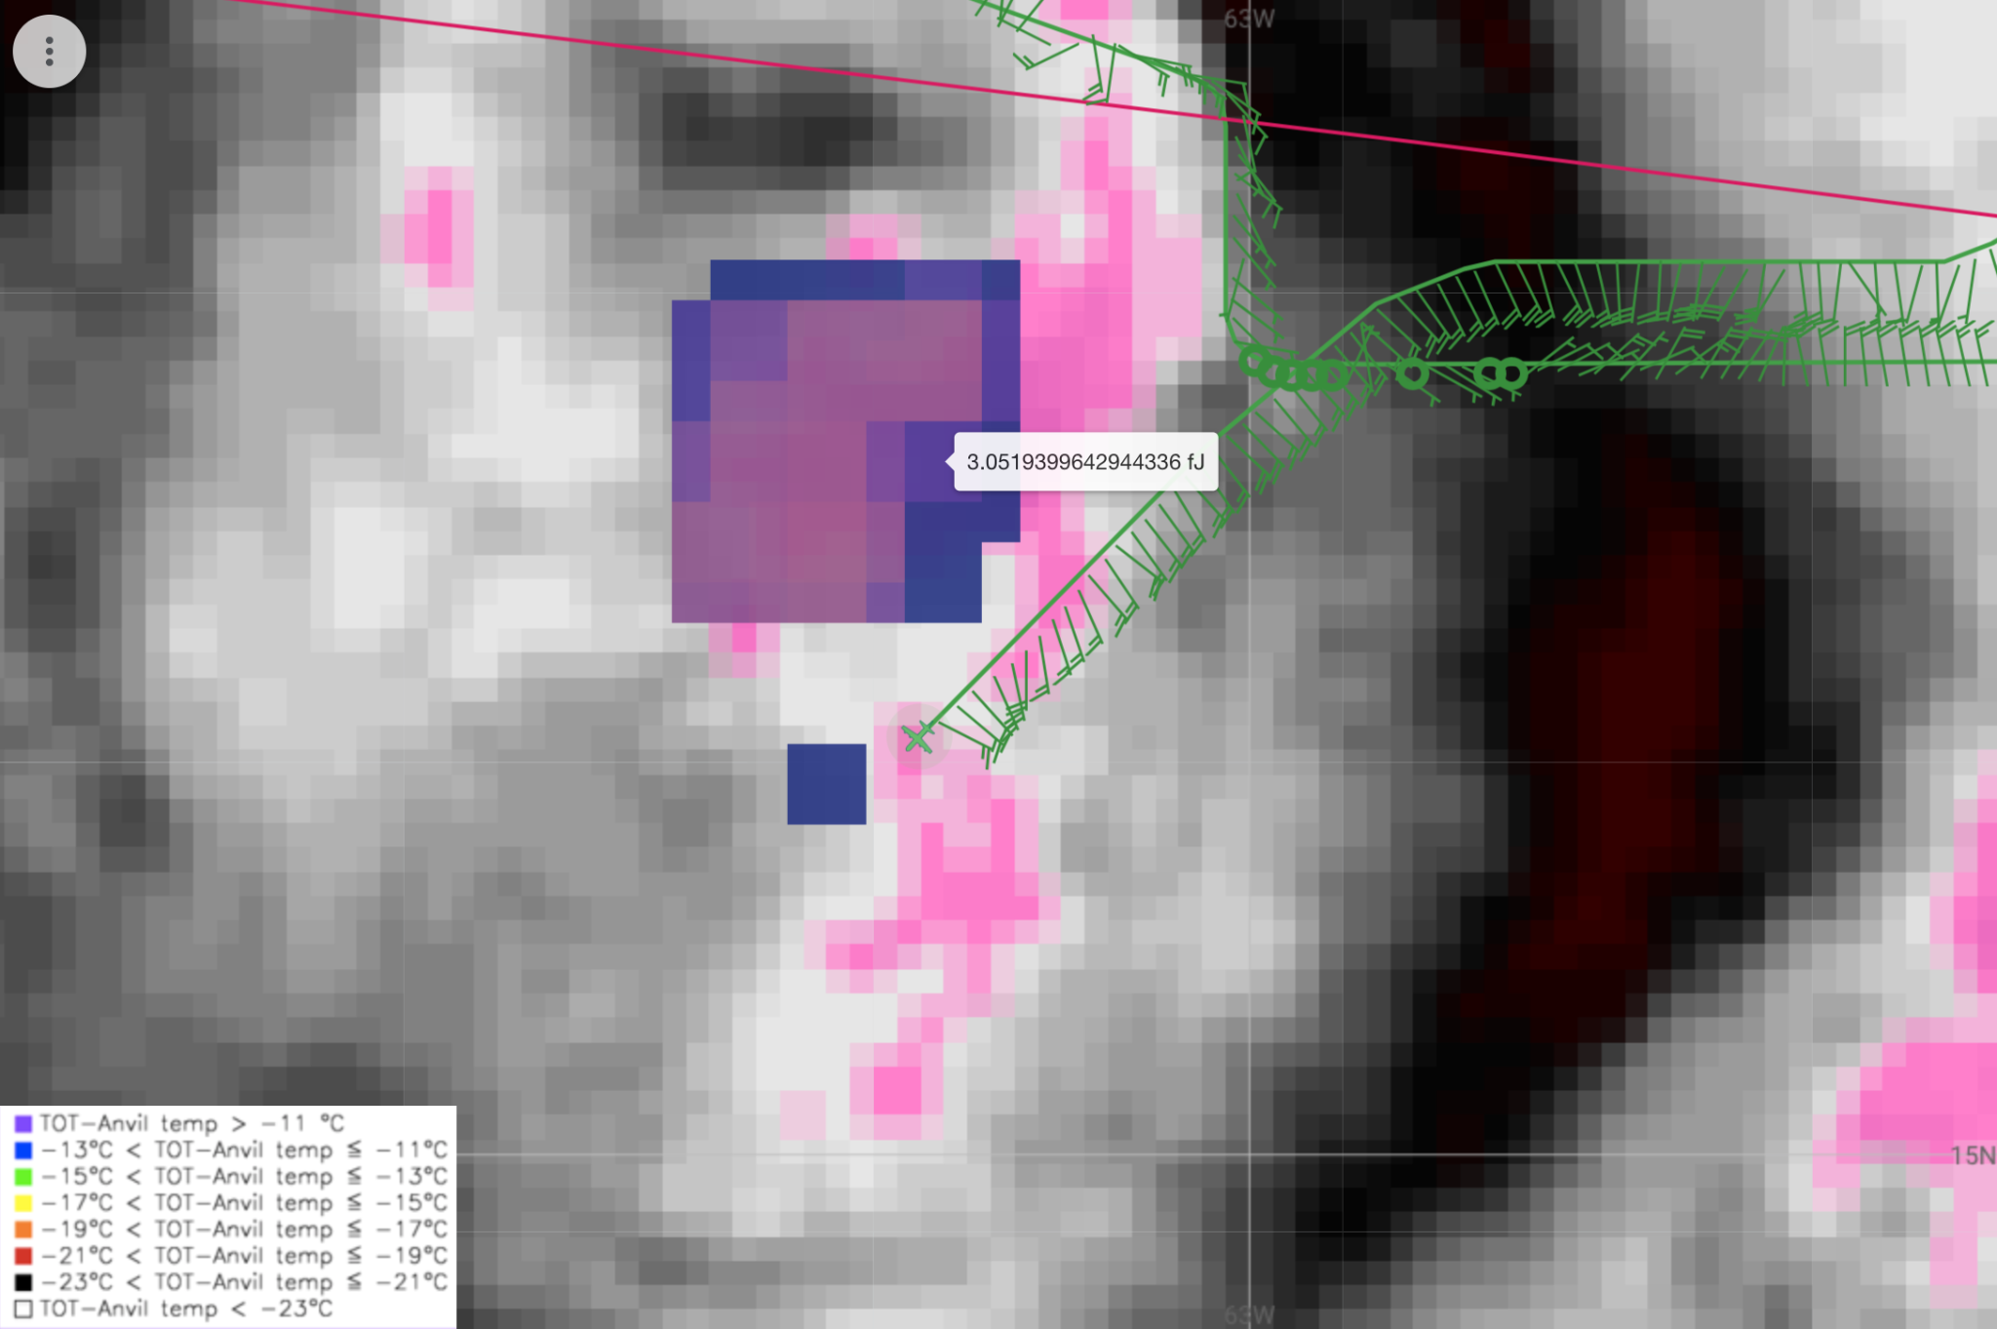  Not much of a wind shift here
1113 | RMW sonde #17 outbound
1117 | Endpoint sonde #18
1123 | 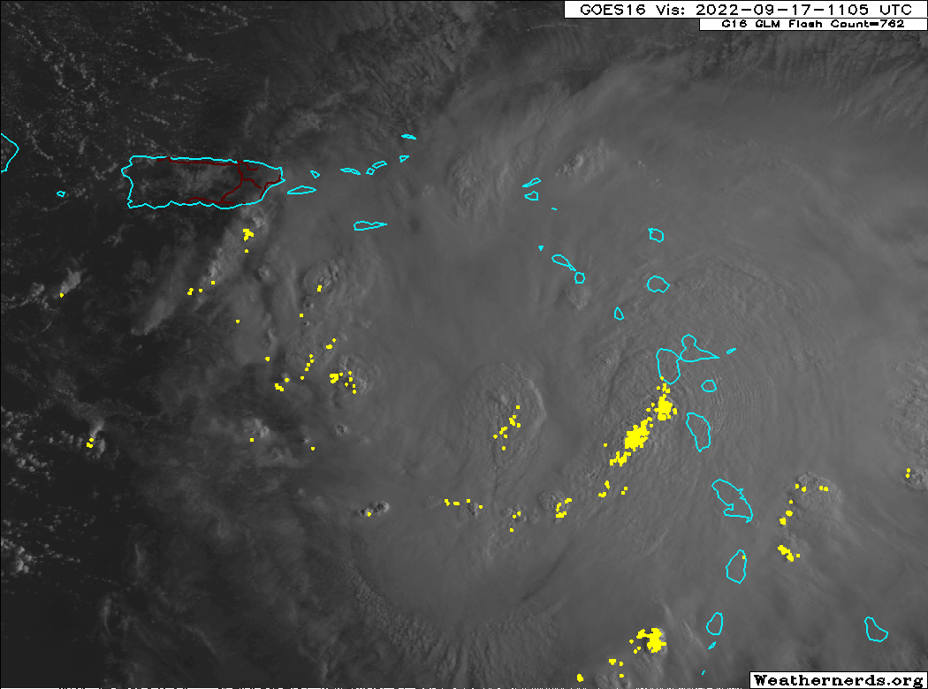
1139 | Drop #19 midpoint of downwind leg
1146 | Endpoint sonde #20. Inbound SE-NW
114930 | RMW sonde #21
120140 | RMW sonde #22
1205 | Center marked and sonde #23 for flight level wind shift
1220 | 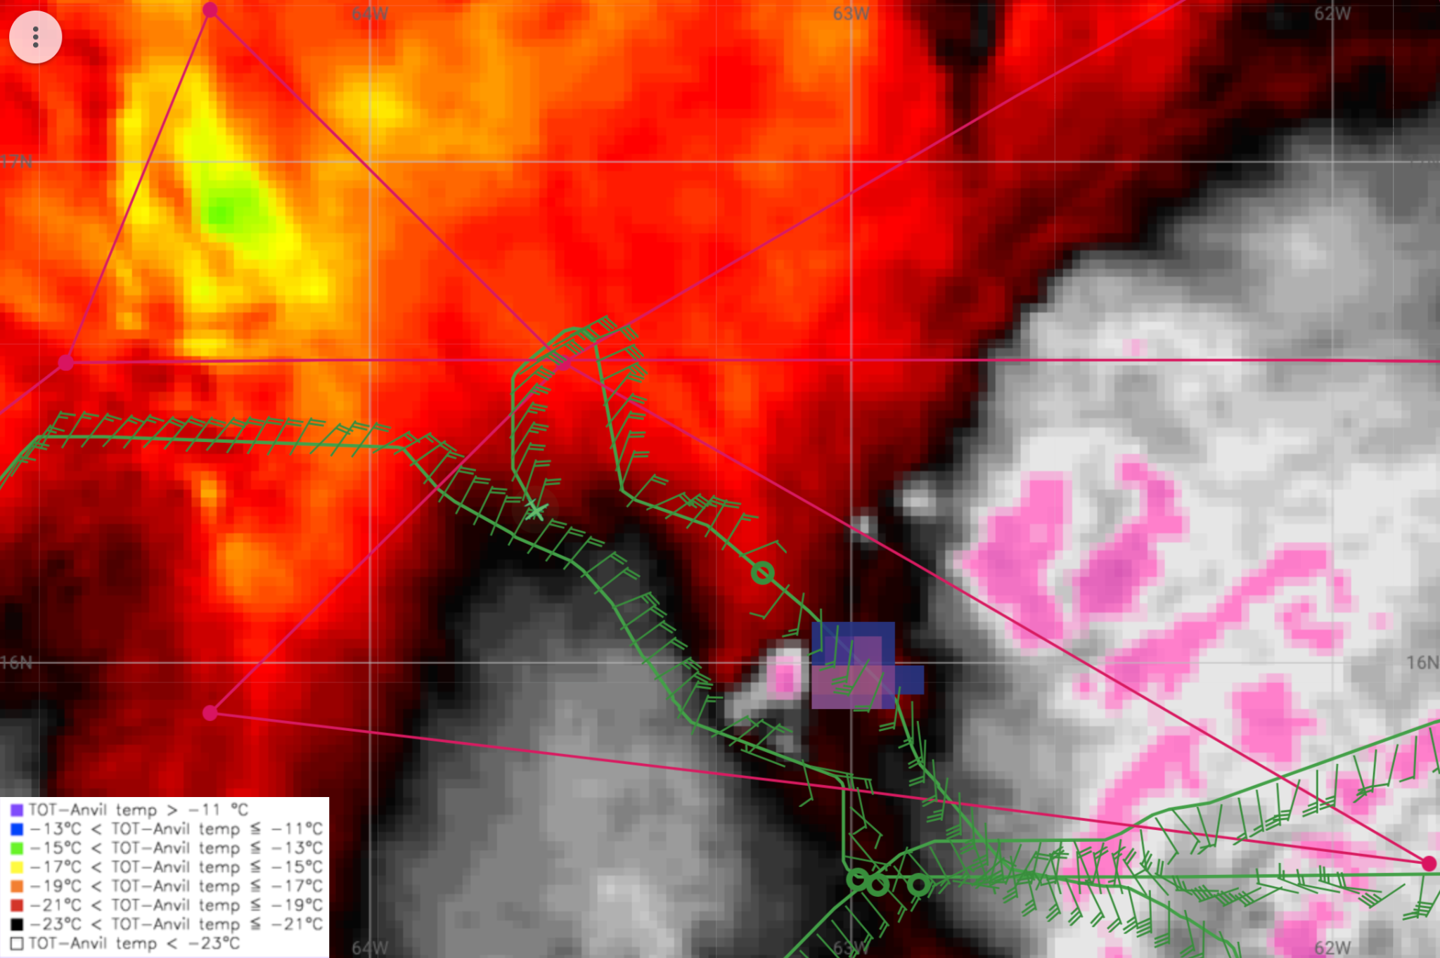
1224 | Downwind leg blending into W-E VAM
1234 | CBs over the developing center along 16N, 63W  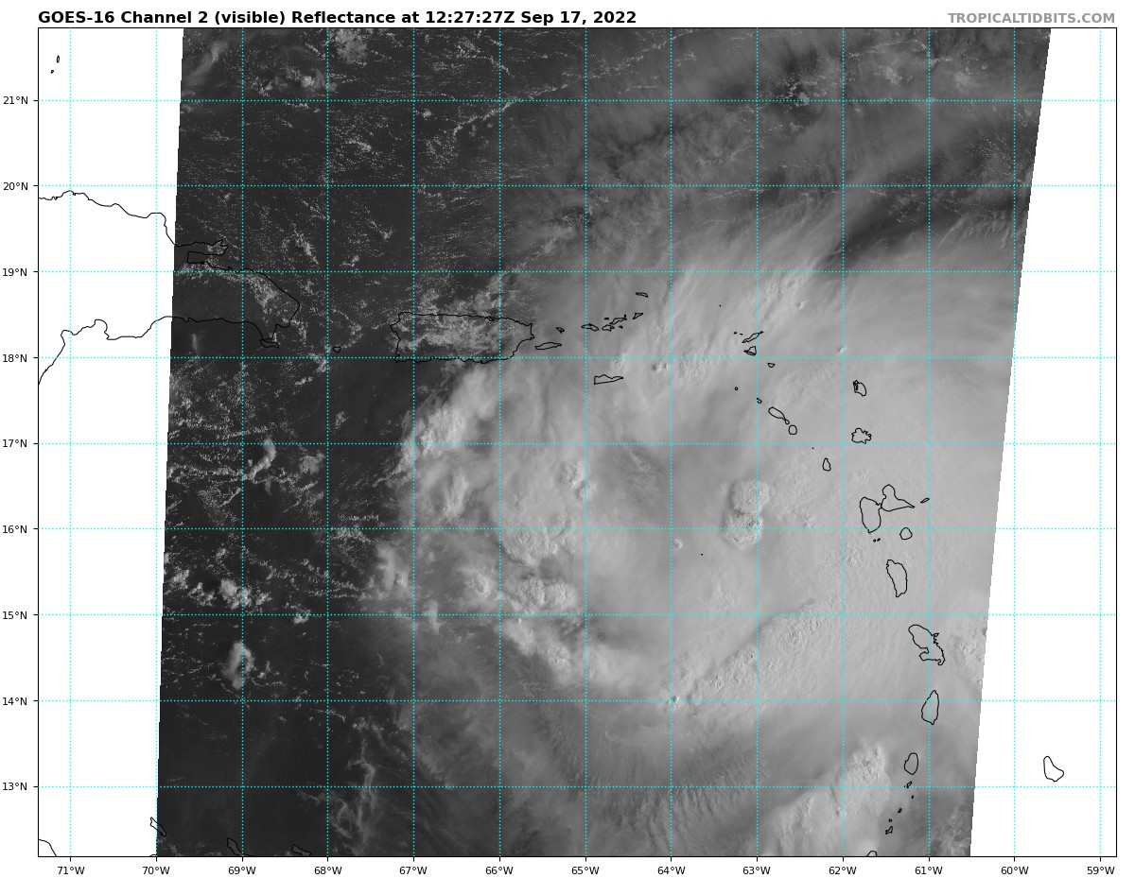
1240 | RMW W-E leg sonde #24 (doing rapid fire sequence here since we didn’t on the first leg to the east earlier in the flight)
1241 | RMW 2nd sonde #25
1241 | RMW 3rd sonde #26
1254 | 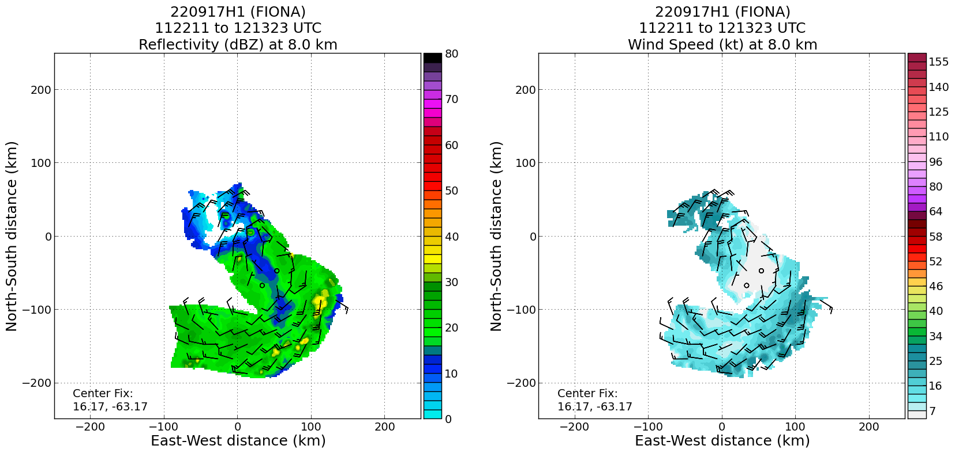  Still some ~W-E (or NW-SE) vortex tilt
1304 | RMW Sonde #27 (E-W)
131030 | RMW Sonde #28 (E-W)
 | 14 EMC and 14 ONR Sondes
1317 | End of science and climbing
1353 | Looks to be aligning somewhat based on the final analysis:  ​​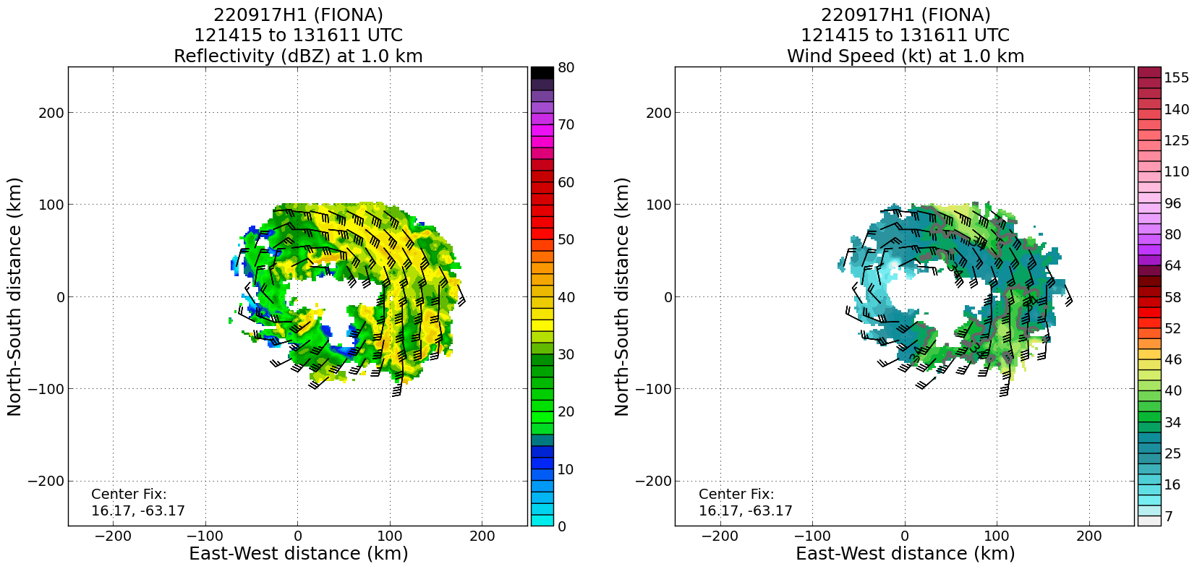  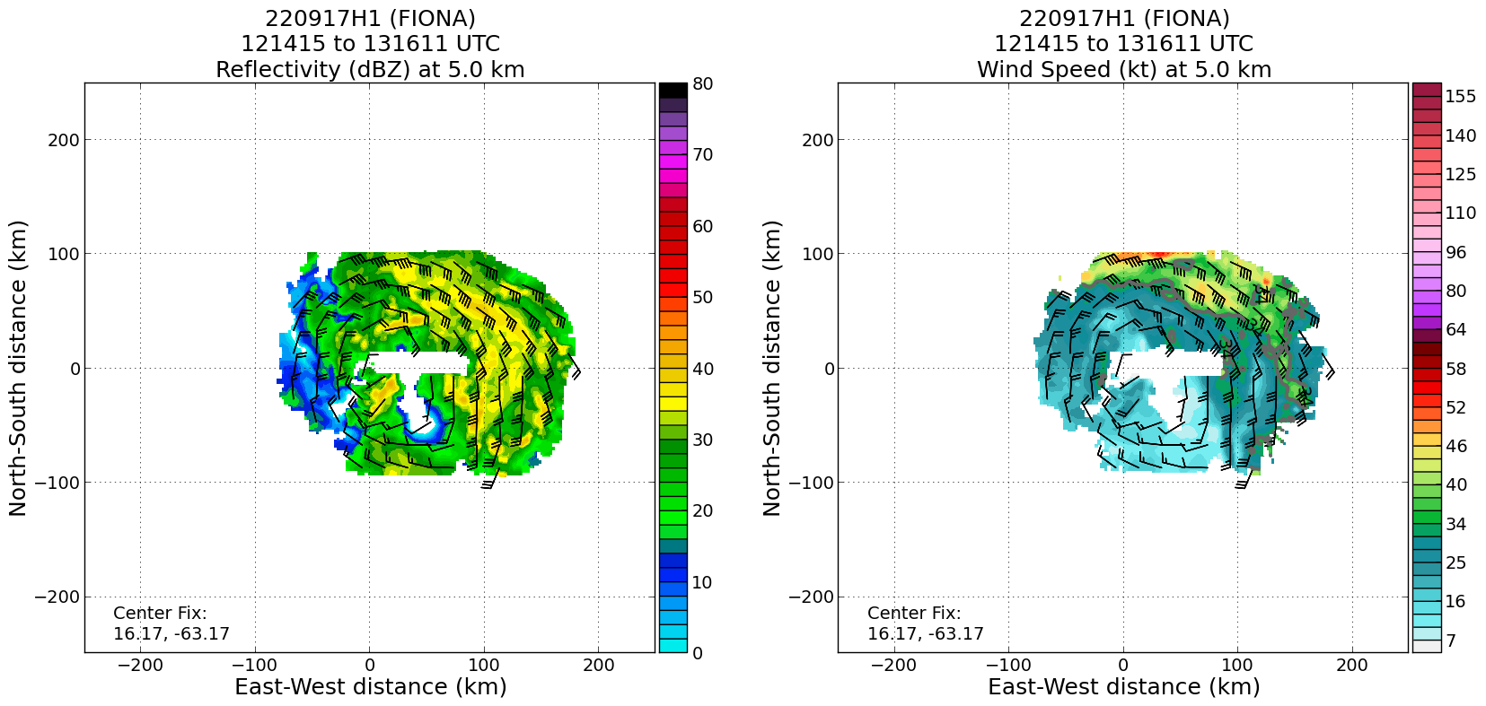  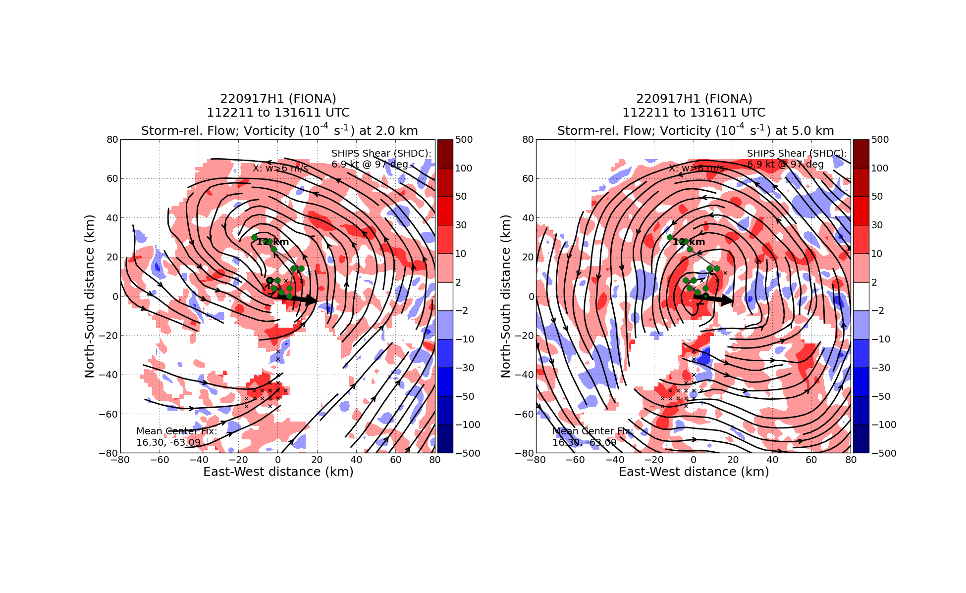

POST-FLIGHT
Mission Summary | Fiona appeared to be re-organizing during the mission, with multiple centers found during the first pass through the storm.  The storm was producing lots of deep convection, and lightning was noted at several points during the mission.  The storm still appeared to be suffering from the effects of mid-level shear, with vortex tilt apparent in TDR analyses.  Towards the end of the mission, a more aligned center appeared to be forming near where the original FL center was estimated to be.  Additional thoughts for post-season and future planning esp. For the VAM module: Because flight didn’t want to overfly the track we wanted W-E we had them fly as close to it on the south end (outbound) and north end (inbound). These created a “box-like” pattern. This still seemed to provide sufficient TDR coverage (painting both sides of the area of interest) and will likely be a common issue in these types of storms and modules due to the intense convection often associated with reformation and near the MLC / downtilt
Actual Standard Pattern Flown | Butterfly modified so the eastern-side legs were longer due to the asymmetric nature of the TC.
APHEX Experiments / Modules Flown | We flew a Vortex Alignment Module (VAM) (part of the Early Stage Experiment: Analysis of Intensity Change Processes [AIPEX]) with E-W and W-E passes across a possible developing center around 16N, 63W at the end of the flight.
Plain Language Summary | - Fiona was still getting organized this morning. Our mission found multiple centers and some indications that shear was still affecting the storm for now. The storm appeared to be trying to form a more organized center near the end of the flight.
Instrument Notes | No issues
Final Mission Track | 