MISSION PLAN
FLIGHT ID | 20220916H1 | STORM | AL07 / FIONA
MISSION ID | 0307A | TAIL NUMBER | NOAA42
TASKING | EMC | PLANNED PATTERN | Modified Butterfly
MISSION SUMMARY
TAKEOFF [UTC] | 0758 | LANDING [UTC] | 1516
TAKEOFF LOCATION | Aruba | LANDING LOCATION | Aruba
FLIGHT TIME | 7.3 | BLOCK TIME | 7.4
TOTAL REAL-TIME RADAR ANALYSES  (Transmitted) | 3 | TOTAL DROPSONDES (Good/Transmitted) | 17 (17 / 17)
OCEAN EXPENDABLES (Type) | 3 AXBT (ONR) | sUAS (Type) | None
APHEX EXPERIMENTS / MODULES | Early Stage Experiment: AIPEX
HRD CREW MANIFEST
LPS ONBOARD | Alvey | LPS GROUND | Dunion
TDR ONBOARD | Rogers | TDR GROUND | Reasor
ASPEN ONBOARD | Sellwood | ASPEN GROUND | None
NESDIS SCIENTISTS | None
GUESTS (Affiliation) | None
AOC CREW MANIFEST
PILOTS | Abitbol, Copare, Wood
NAVIGATOR | Miller
FLIGHT ENGINEERS | Stokes, Gee
FLIGHT DIRECTOR | Kalen, Holmes
DATA TECHNICIAN | McAlister
AVAPS | Dykeman

PRE-FLIGHT
Flight Plan | 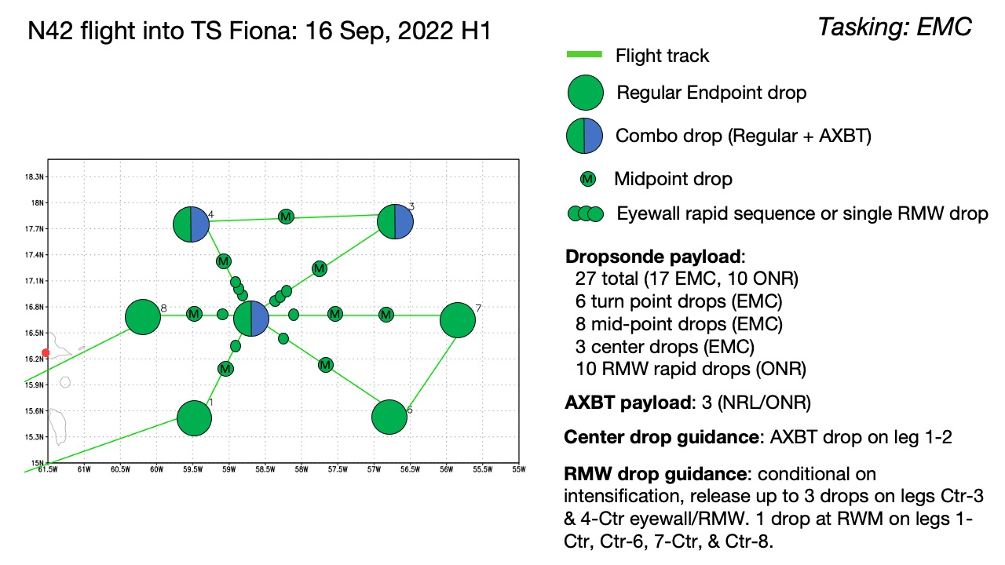  Modified butterfly with 3 center passes. Legs on the east side are extended in length to account for likely mis-alignment and asymmetry of precipitation maximized in eastern quadrants.
Expendable Distribution | Dropsondes at center, midpoints, and endpoints. Two midpoints planned for the extended E-W leg (WP 7-ctr). Will likely not proceed with RMW drops due to lack of organization/intensification. AXBT Combo on first center drop, NE End point, NW end point.
Preflight Weather Briefing | Fiona has changed little in structure over the past 12-24 hours and remains a highly sheared / asymmetric storm with most of the precipitation displaced downshear (east). Current intensity is 50 kt. Little or no intensification is expected in the next 48-72 hours due to persistent westerly wind shear. Fiona has been tracking just south of due west, which is somewhat south of short term forecast guidance and NHC forecasts, likely being steered by the low-level flow (due to the decoupled nature of the storm).
Instrument Notes | None noted

IN-FLIGHT
Time [UTC] | Event
0758 | Takeoff from Aruba
1007 | Initial point (IP), Endpoint sonde #1 released
1015 | GOES IR, N42 planned track, N42 real-time track, and Fiona’s 1015z position (black marker). As noted in the pre-flight briefing, the storm is south and east of the forecasted position - shifting the pattern accordingly.  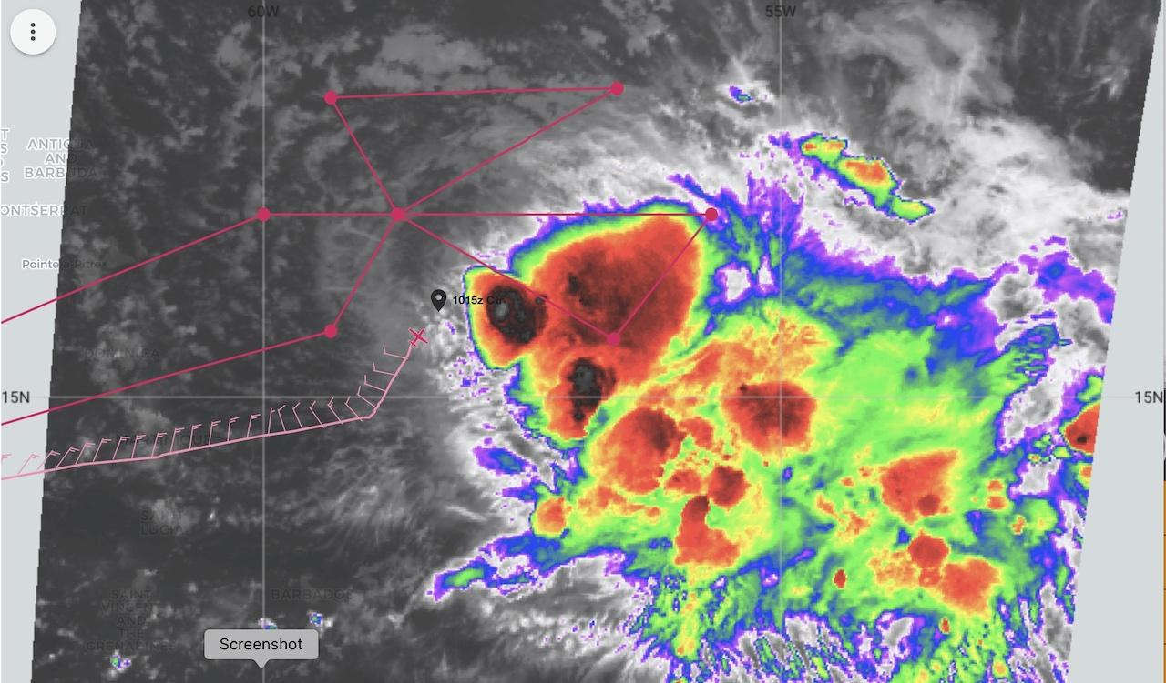
1016 | Dropsonde #2 midpoint SW-NE
1022 | CIMSS low-level (700-850 mb) steering (0900z): analysis showing Fiona tracking south of the subtropical ridge this morning with WSW steering flow. 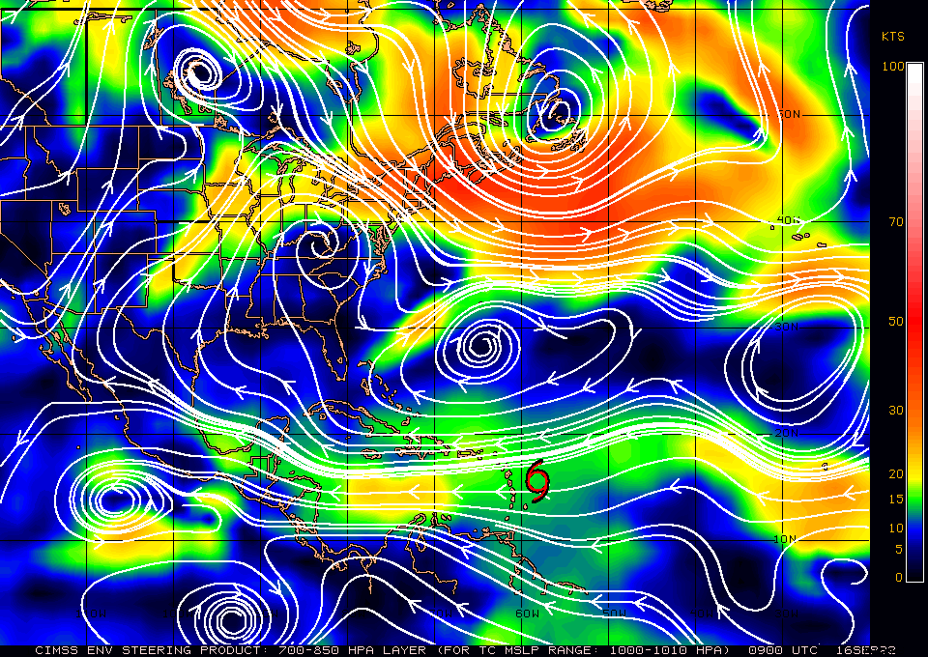
1023 | CIMSS vertical wind shear (0900z): Strong S-N gradient in generally westerly VWS with ~20 kt over the low-level center and 20-25+ kt just north of that center. 15-20 kt of WNW shear indicated in the area of the deep convection that is WSE of the center. Given this VWS set up, it’s perhaps not surprising to see the LLC - deep convection to the ESE set up that we’re seeing this morning.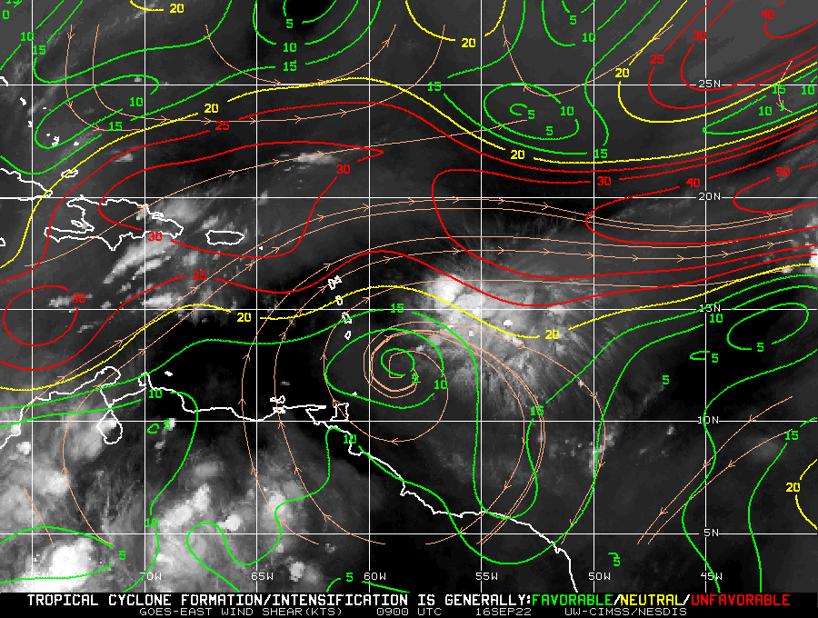
1024 | Mark center, combo AXBT drop #3, measured 29.02C SST
1029 | Deep Convection + stratiform off to our right and anvil overhang on TDR. 35 dBZ up to 15 km
1038 | Midpoint sonde #4 outbound SW-ENE
1052 | Endpoint drop #5 AXBT combo, start of downwind leg to W, measured 28.19C SST
1047 | First GOES vis images coming in- impressive overshooting top near 15.8N 57.8W. Not much lighting in the convective areas this morning, though lightning is firing up near that overshooting top area.  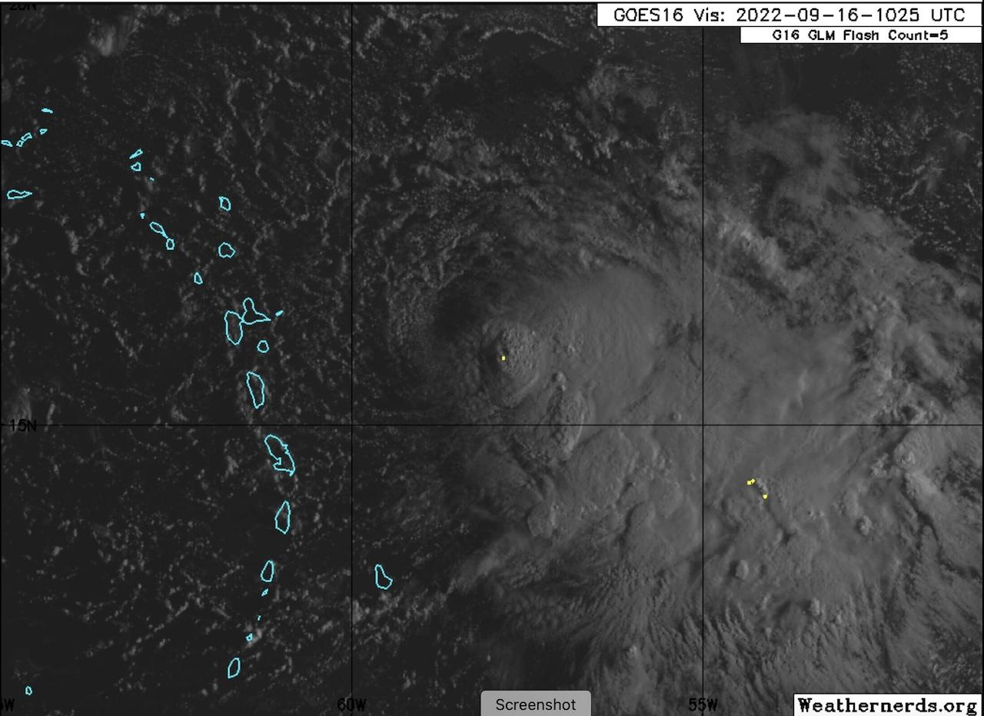  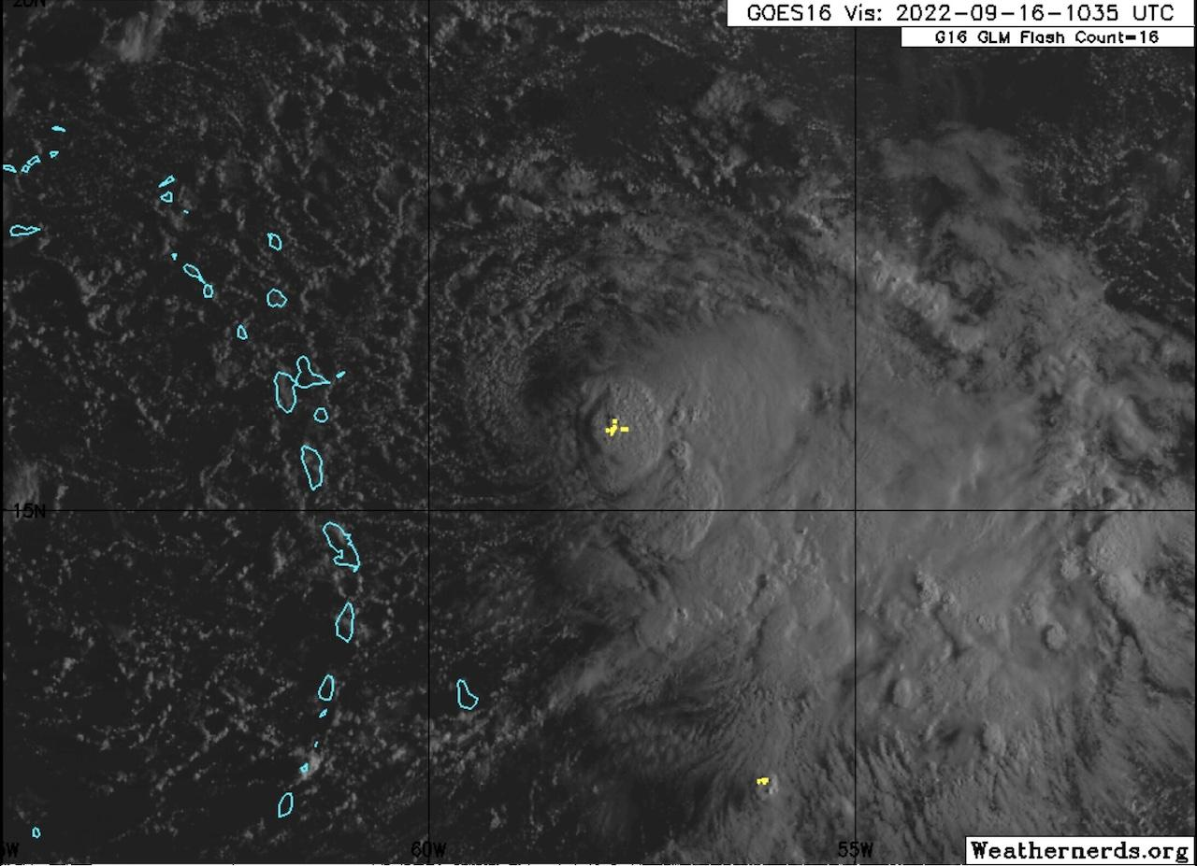
1109 | Drop #6 midpoint of downwind leg
1122 | Drop #7 AXBT combo endpoint and turning inbound for NW-SE leg, measured 28.85C SST
113130 | Drop #8 midpoint
1144 | Center drop #9
1146 | Deep convection to the left of the plane. Interesting slope (toward aircraft) noted on the convective cell. The direction of the slope is different than what I’d maybe expect for deep layer wind shear impacts. Could the MLC be imparting localized shear on the cell?
 | 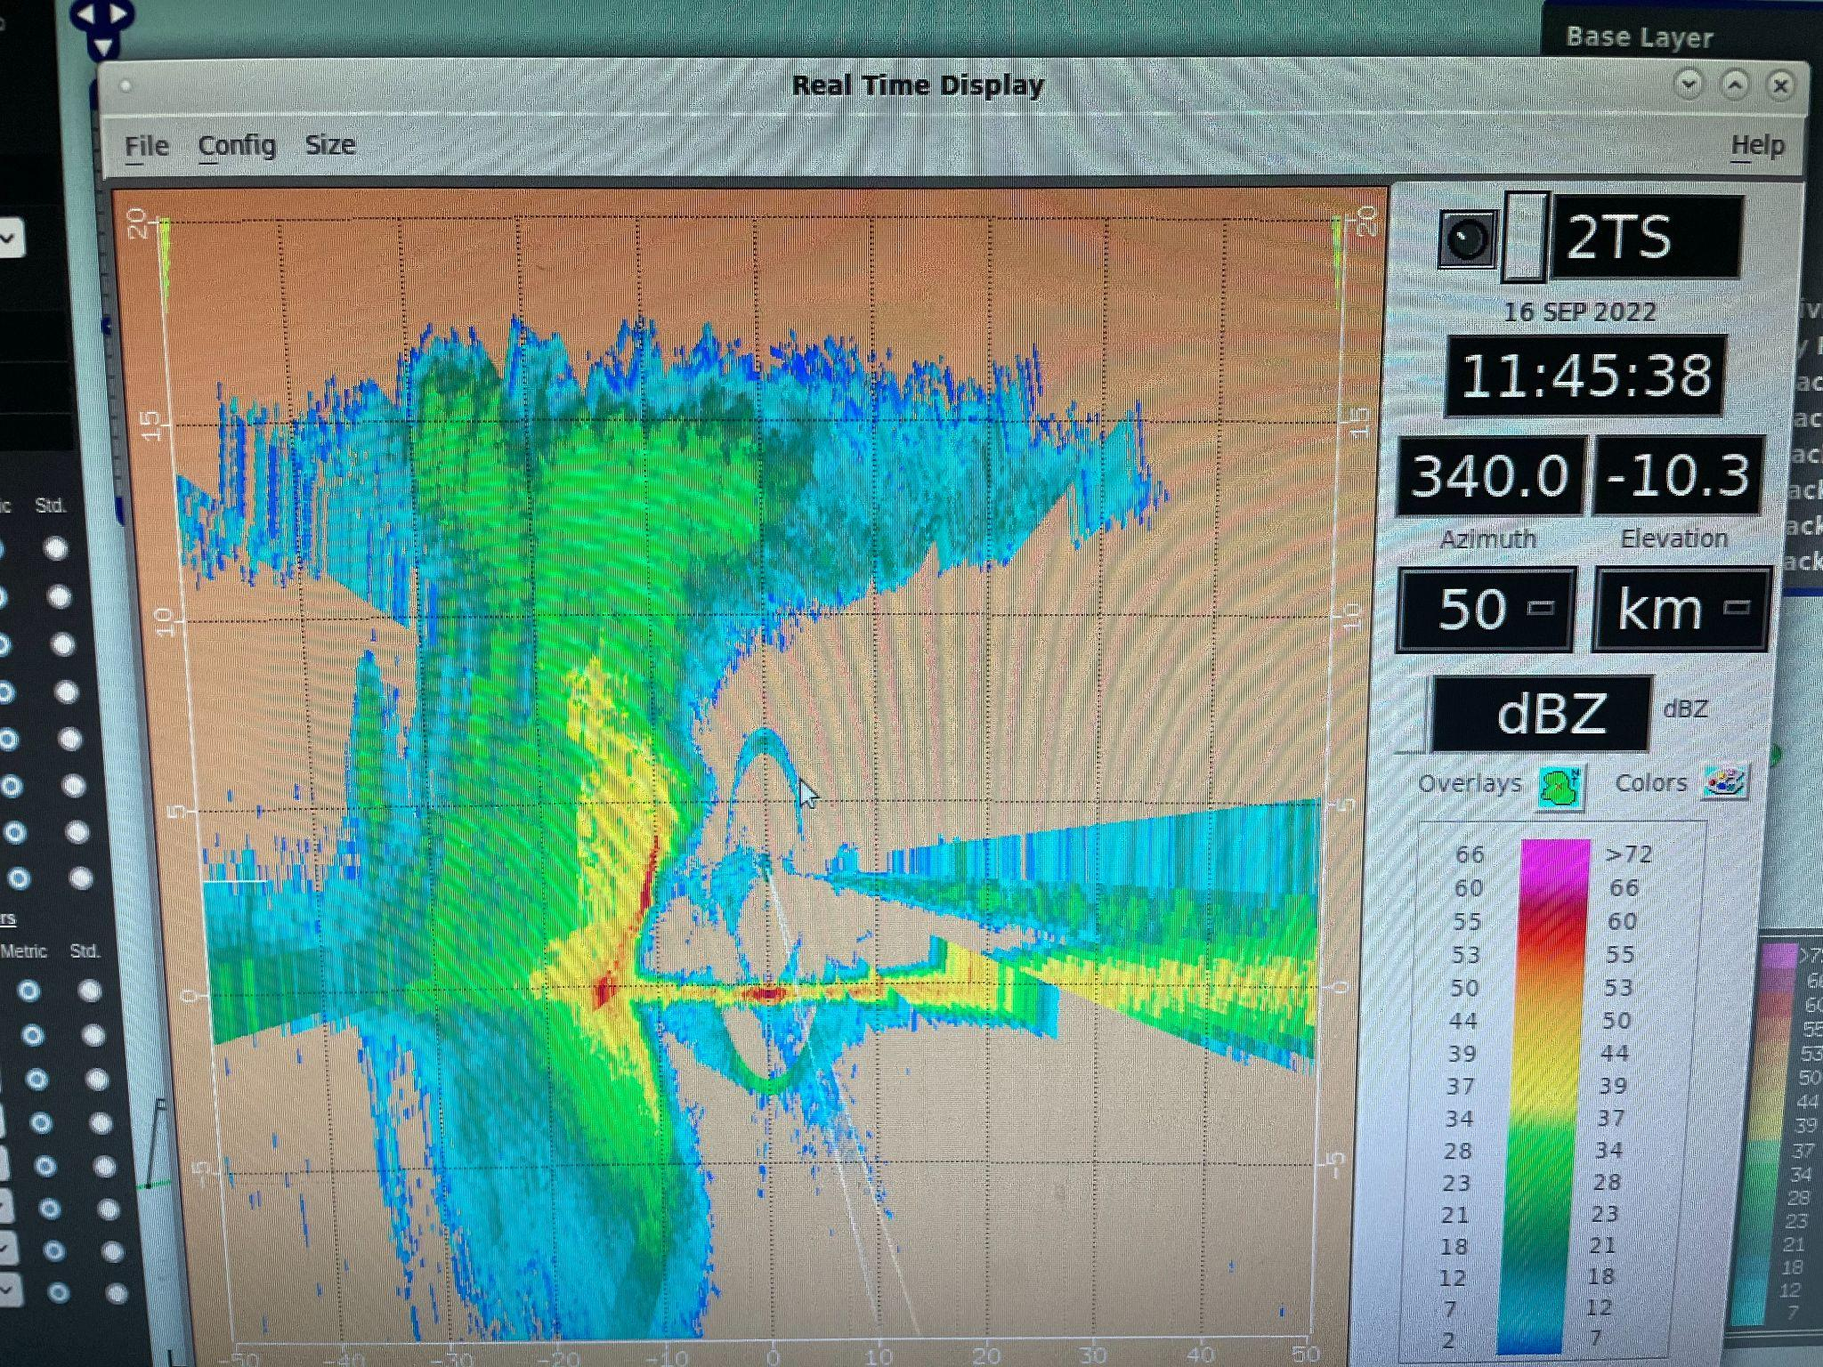
 | 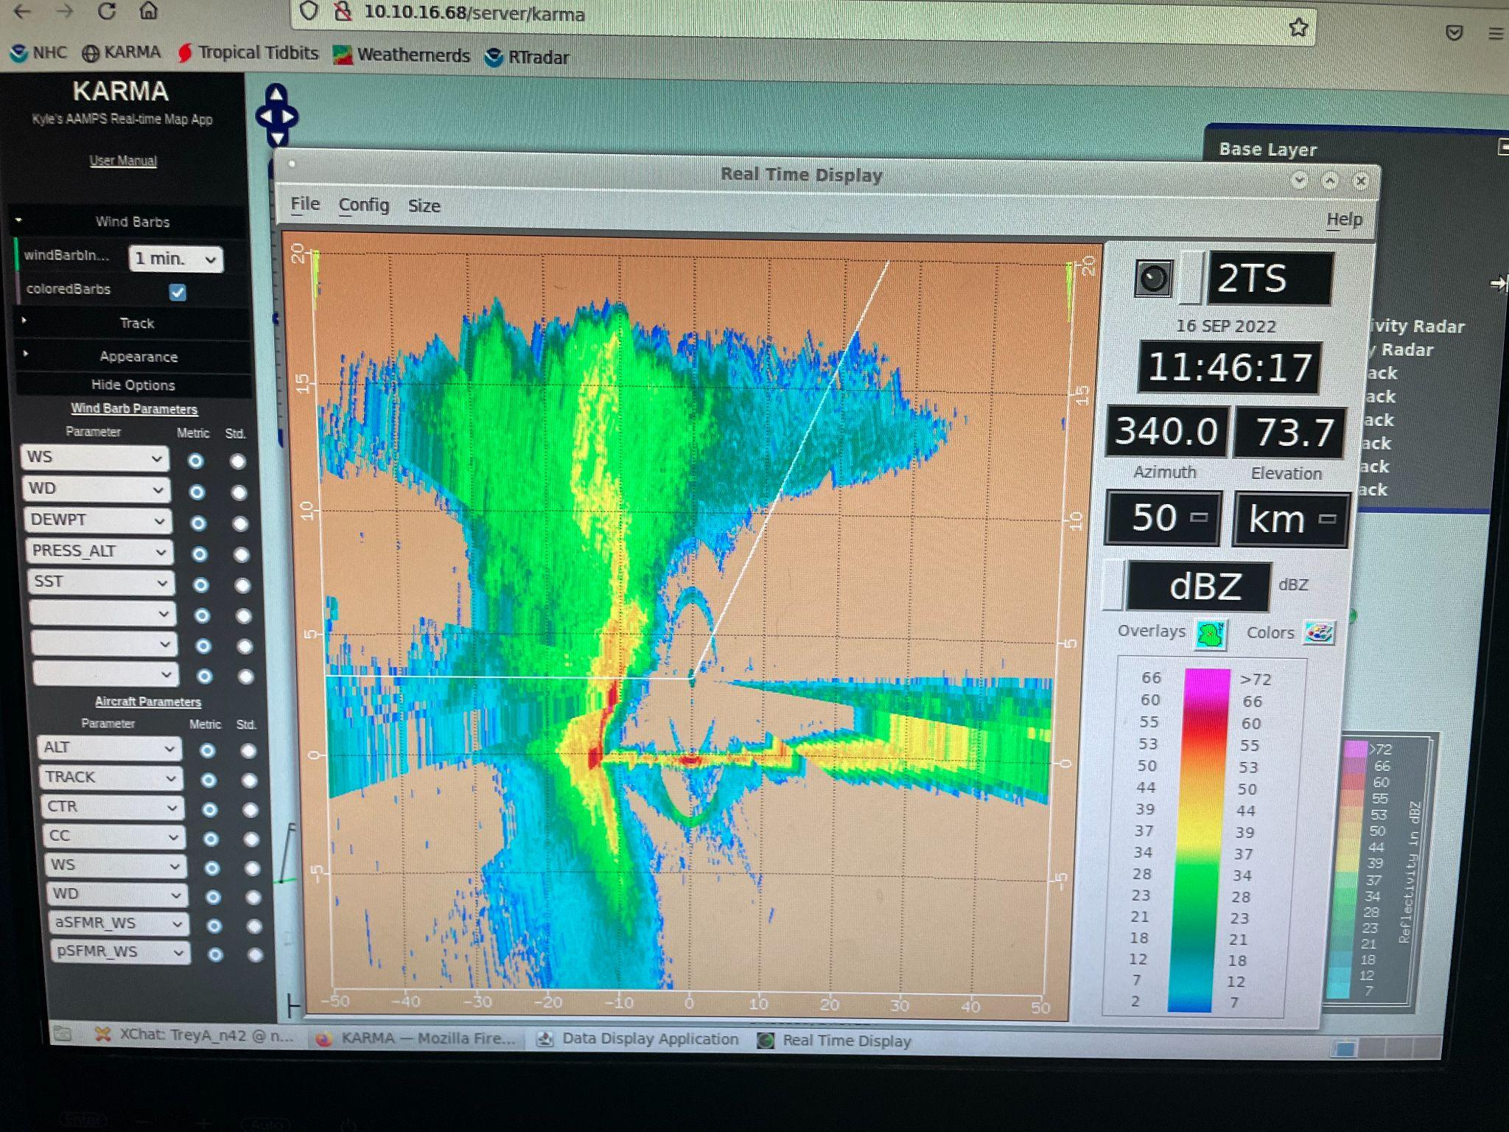
120140 | Midpoint drop #10
 | 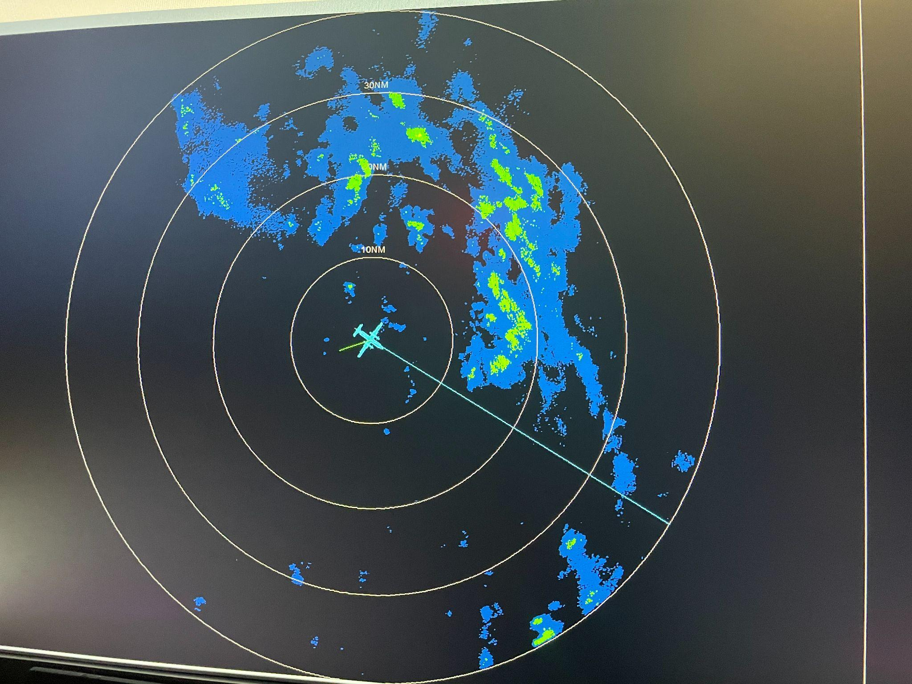
121600 | Endpoint drop #11
123120 | Downwind leg drop #12
1236 | Midpoint 1st sonde #13
1249 | Midpoint 2nd sonde #14
130430 | Center drop #15
1311 | Outbound E-W leg midpoint drop #16
1312 | About 20-30 km tilt downshear (2-5 km centers). Centers above 5 km are way off to the E (outside the domain plotted in the "tilt plot") via TDR analyses (after 1st 2 swaths and downwind)
 | Jog to the south for the FL center
132230 | Endpoint drop #17 E-W leg. End of science
 | TDR observation from chat: According to Michael's method, the 5-km center was at 58.28W and the 5.5-km center was at 58.00W ... about a 30-km jump E
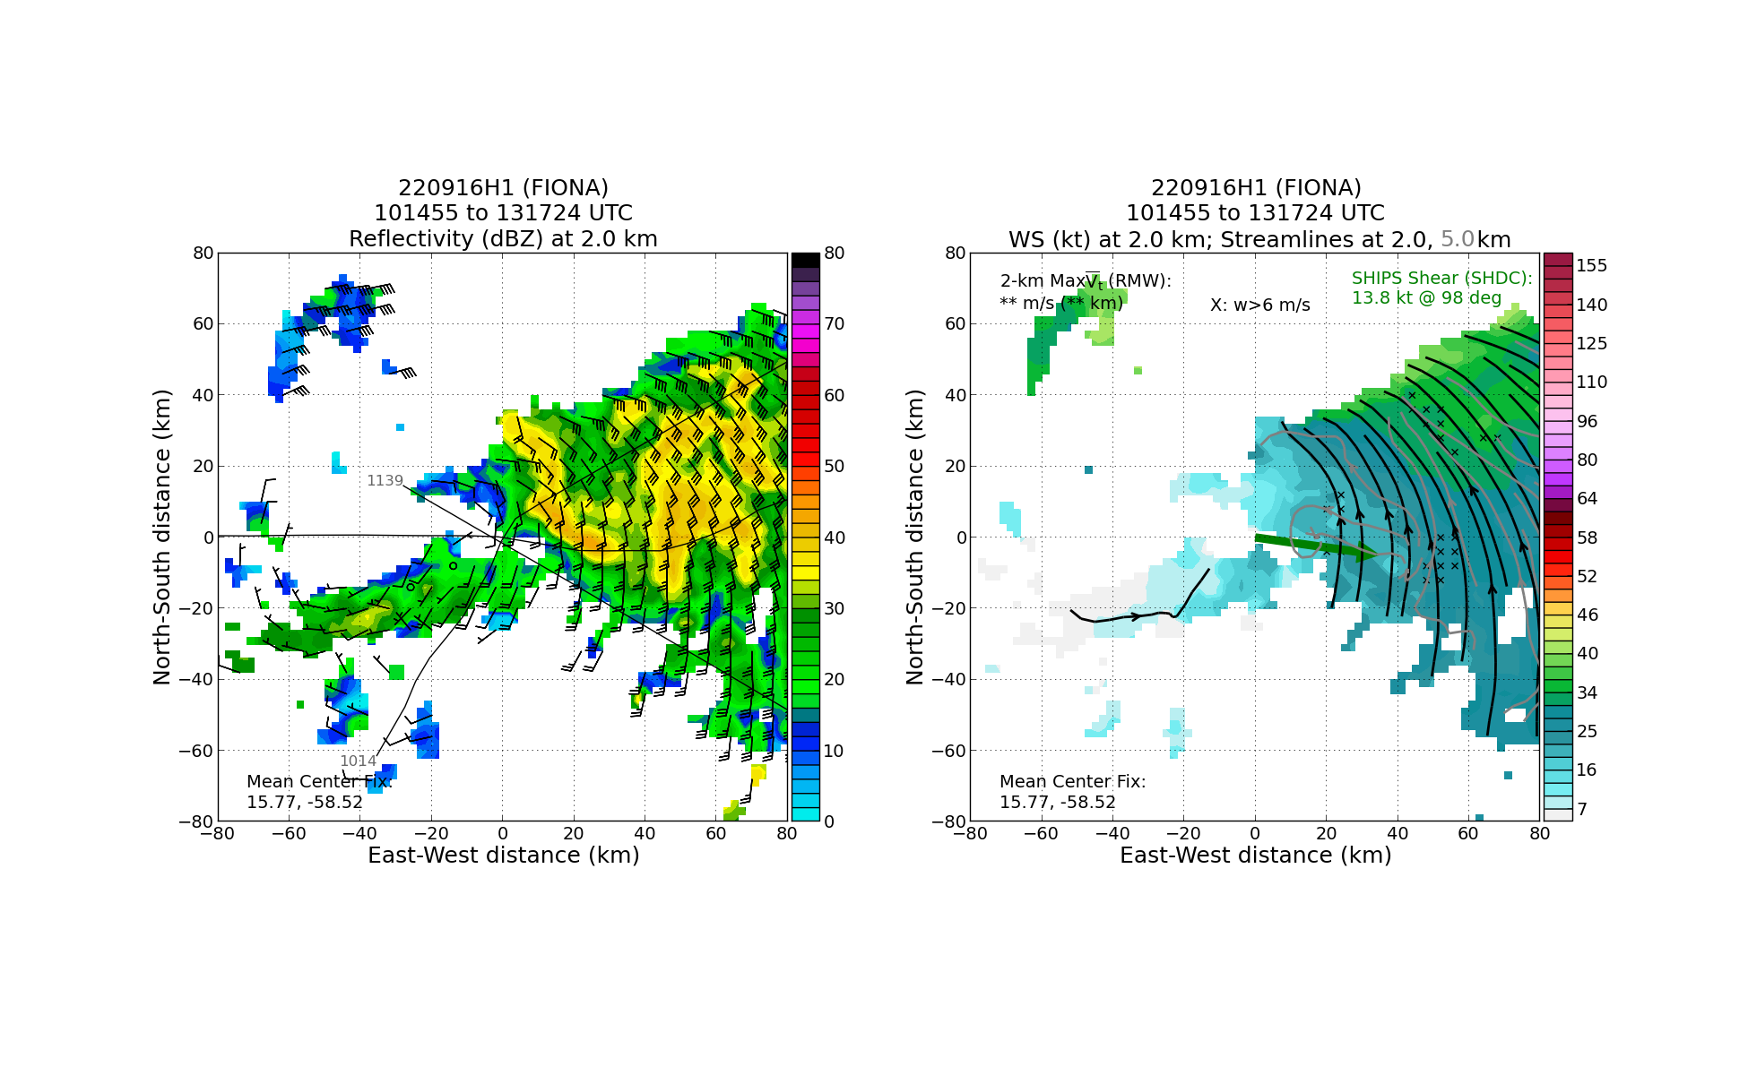
Full TDR analysis shows a generally broad and elongated low level vortex with a smaller scale MLC at 5 km farther to the east. It also appears that the low-level wind field may be trying to amplify along the northeastern edge of the broad low-level wind field near the region of deep convection. Individual swaths don’t show a lot in terms of an organized mid-level center forming where it’s denoted by the streamlines
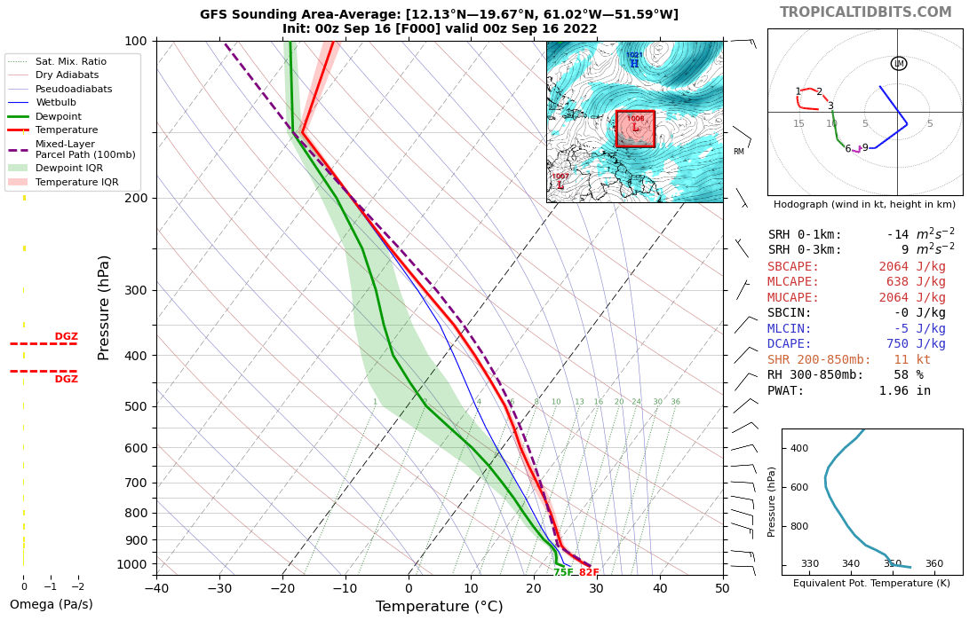
Strong (like 20 m/s) ESE flow between 1-3 km, and moderate NE flow between 4-9 km.
1516 | Landed back in Aruba

POST-FLIGHT
Mission Summary | This was an EMC TDR mission as the primary objective and that was achieved with good azimuthal coverage of precipitation in the downshear quadrants. The butterfly pattern was modified (pre-flight) to extend legs on the east side and have a smaller degree of separation in terms of heading due to most of the precipitation being located in the eastern quadrants. This allowed for pretty good TDR coverage of the tilt (towards the E).  A convective burst developed early in the flight during the 1st 2 passes nearer to the low-level center than earlier convection that had developed before the flight. An interesting tilt in convective features was noted on the second center pass in which they were tilted opposed to the large scale shear vector (westerly). Perhaps this was caused by local shear from the tilt / mid-level vortex. This feature was also associated with lightning and an impressive blow-up of cold cloud tops on IR satellite. It would likely be worthwhile in post-analysis to go back and look at the individual swaths to see if any evolution of the tilt + convection can be determined even though the center-finding algorithm didn’t have enough coverage to find centers from individual swaths in real-time.  We’re also wondering if it might be more useful for tomorrow’s flight and when we do the Vortex Alignment Module (VAM) module in the future to setup the tilt-oriented leg at the very beginning of the flight and then allow some amount of time to pass (1-2 h) before repeating the leg. This would allow for a little more time evolution to occur, wherein the racetrack may not allow enough time for evolution.  17 dropsondes (all charged to NWS), 3 AXBTs for ONR.
Actual Standard Pattern Flown | Modified butterfly
APHEX Experiments / Modules Flown | No modules were flown due to long transit times, but data collection could support the Early Stage Experiment: Analysis of Intensity Change Processes (AIPEX) as the focus on the upcoming evolution will be on the tilt reduction and potential for intensification.
Plain Language Summary | - A successful mission was flown into Tropical Storm Fiona that gathered radar data to be used for improving the model initialization. The storm has a tilted structure with height and asymmetric precipitation mostly located on the eastern side. This is common for weak TCs in a sheared environment. There are some signs that developing convection may be trying to help reduce that tilt, which is critical for increased symmetry and intensification.
Instrument Notes | None noted
Final Mission Track | 