MISSION PLAN
FLIGHT ID | 20220907I1 | STORM | AL06 / EARL
MISSION ID | 1806A | TAIL NUMBER | NOAA43
TASKING | EMC | PLANNED PATTERN | Butterfly
MISSION SUMMARY
TAKEOFF [UTC] | 2024 | LANDING [UTC] | 0437
TAKEOFF LOCATION | St. Croix | LANDING LOCATION | St. Croix
FLIGHT TIME | 8.2 | BLOCK TIME | 8.4
TOTAL REAL-TIME RADAR ANALYSES  (Transmitted) | 8 (8) | TOTAL DROPSONDES (Good/Transmitted) | 26 (26 / 26)
OCEAN EXPENDABLES (Type) | 3 AXBT (ONR) | sUAS (Type) | None
APHEX EXPERIMENTS / MODULES | Early Stage Experiment: AIPEX (FLAIMS), Mature Stage Experiment: Gravity Wave Module
HRD CREW MANIFEST
LPS ONBOARD | Holbach | LPS GROUND | Hazelton
TDR ONBOARD | Holbach | TDR GROUND | Gamache
ASPEN ONBOARD | Aberson | ASPEN GROUND | None
NESDIS SCIENTISTS | Chang, Jelenak, Sapp, Bjorland
GUESTS (Affiliation) | None
AOC CREW MANIFEST
PILOTS | Doremus, Copare, Wood
NAVIGATOR | Utama
FLIGHT ENGINEERS | Darby, Pittman
FLIGHT DIRECTOR | Holmes, Kalen
DATA TECHNICIAN | T. Richards
AVAPS | Warnecke, Sans Souci, McFadden

PRE-FLIGHT
Flight Plan | 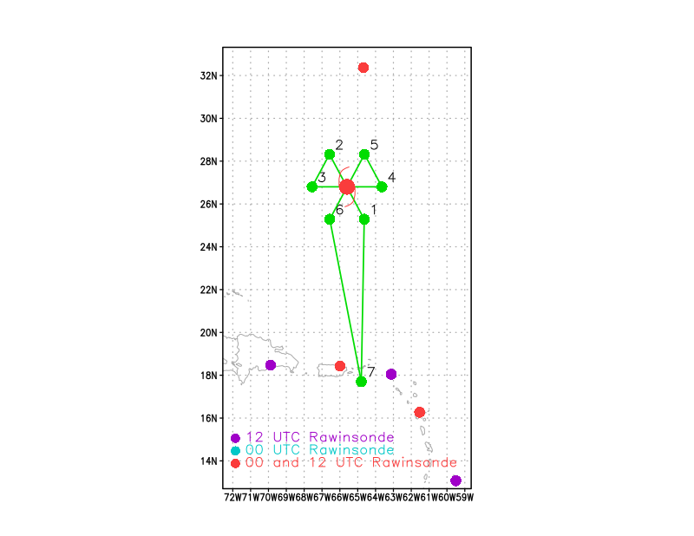  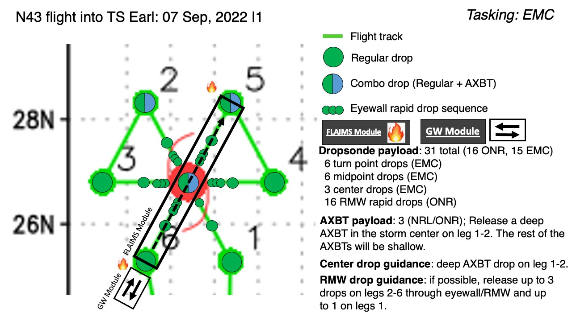  Pattern: Fly butterfly pattern with 105 nmi legs  Altitude: 10 kft (pressure altitude)  Potential add-on Modules:  - Analysis of Intensity Change Processes Experiment (AIPEX) >> Vortex Alignment Module (VAM)  - Analysis of Intensity Change Processes Experiment (AIPEX) >> FLAIMS Module  - Convective Burst Structure and Evolution Module (CBM)  - Rainband Complex Module (RCM)  Load 40 sondes (all dropsondes transmitted to the GTS); 3 ONR/NRL AXBTs- 1 deep water, 2 shallow water (all AXBTs transmitted to the AOC ground server if possible)
Expendable Distribution | Release dropsondes at endpoints, midpoints, centers; possible supplemental rapid sondes across the RMW
Preflight Weather Briefing | Earl is currently a category 1 hurricane with maximum sustained winds of 80 kt. It is still battling some moderate W/SW shear, but has been continuing to slowly strengthen. It is forecast to continue strengthening as it moves N just to the east of Bermuda over the next few days before accelerating off to the NE.  An eye appears to be trying to clear out in satellite imagery and the cloud pattern is more robust than in past days.
Instrument Notes | None noted

IN-FLIGHT
Time [UTC] | Event
2024 | Takeoff from St. Croix
2154 | Initial Point (IP) sonde released just before entering rainband Drop #1
2202 | Just passed through rainband
2208 | Midpoint Drop #2
2208 | 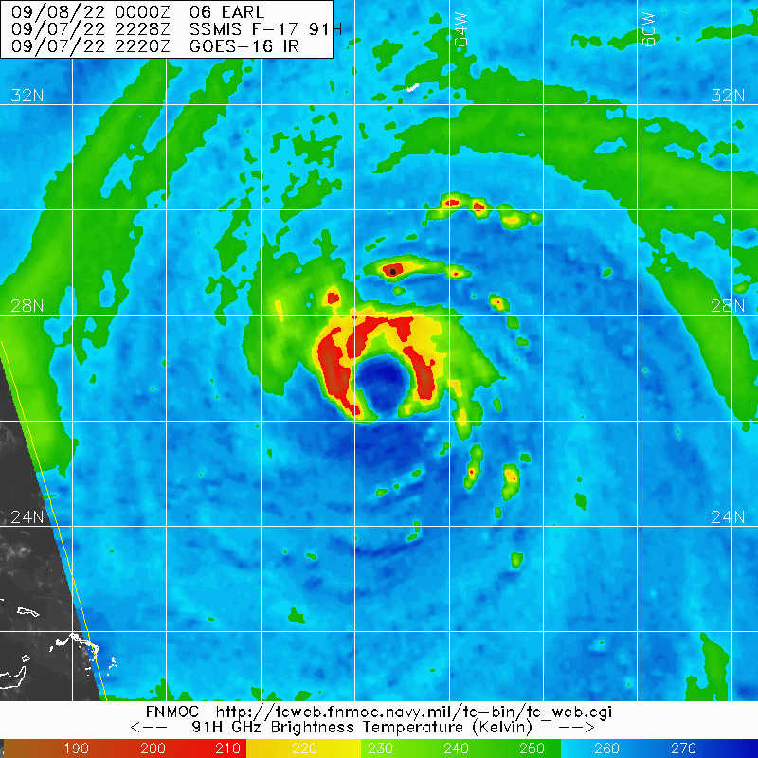
2217 | Estimating 50 n mi diameter eye. Can see the ocean through broken low-level cumulus. Still some cirrus above us despite satellite imagery showing Earl trying to clear out an eye.
2218 | 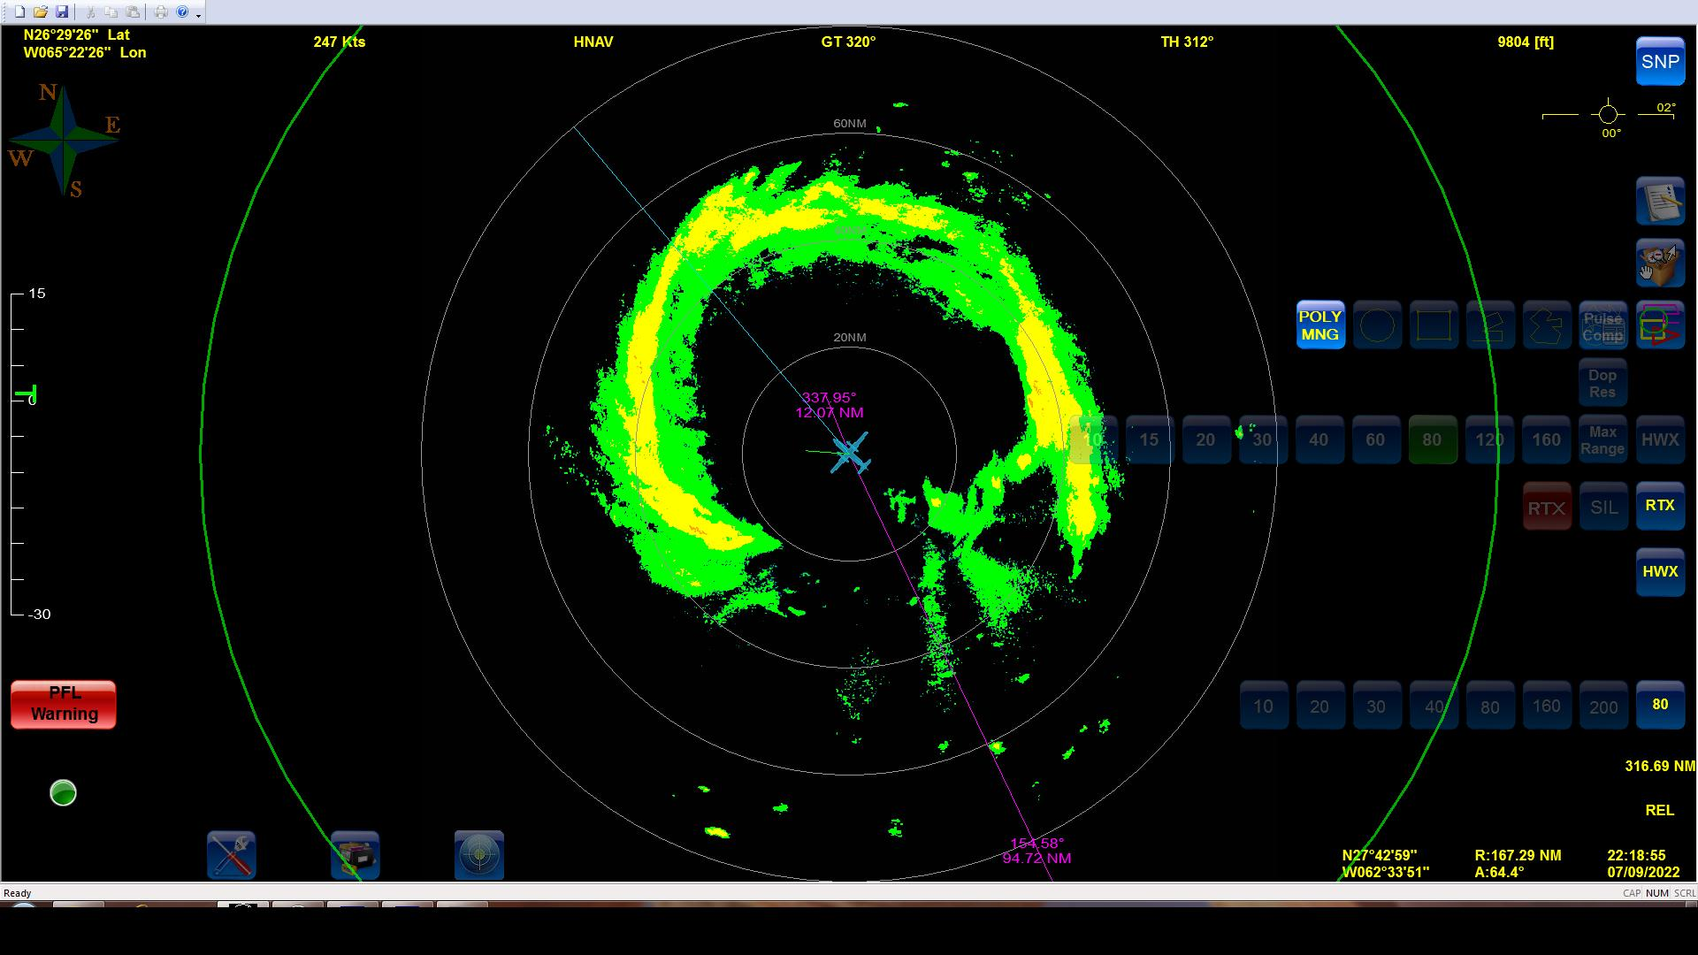
2223 | Center combo drop #3 MSLP 971 mb winds 145/03, AXBT #1 released
222846 | RMW NW 10 m winds 79 kt drop #4
223336 | RMW NW 10 m winds 72 kt (initially no launch detect but some data came in at the bottom) drop #5
222959 | RMW NW 10 m winds 75 kt drop #6
2236 | Midpoint outbound drop #7
2248 | Endpoint (EP) leg 1 drop #8
2302 | AXBT #2 released and measured an SST of 29.22C; had to wait until we were a little further south on downwind leg in clearer air to release BT
2307 | 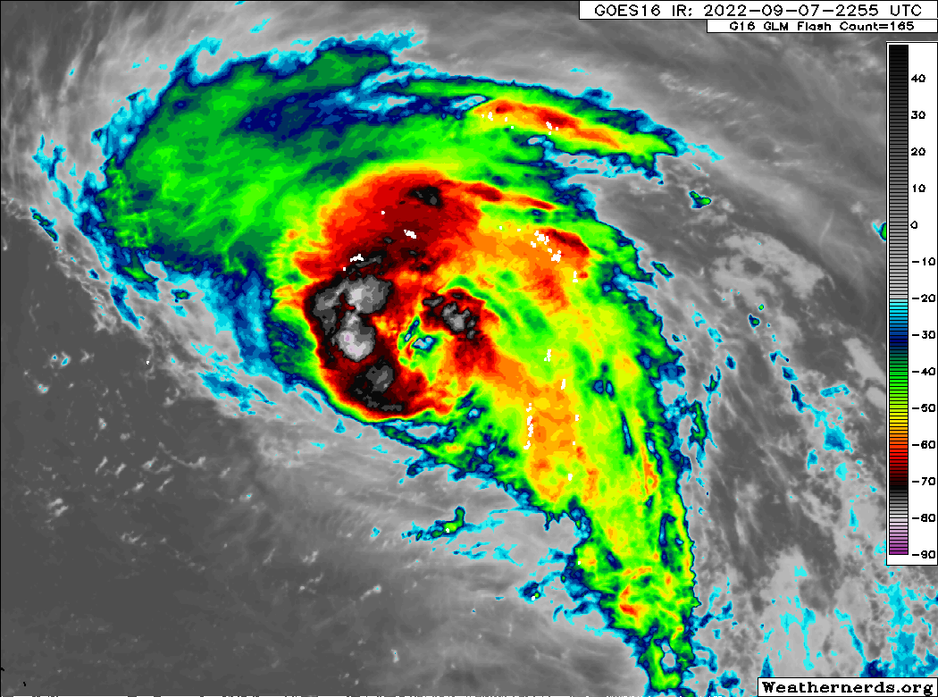  Eye forming on IR
2314 | Beginning to turn inbound for leg 2
2315 | IP leg 2 drop #9
2321 | West endpoint sonde had ~60% RH down to 1000 ft
2325 | First TDR analysis  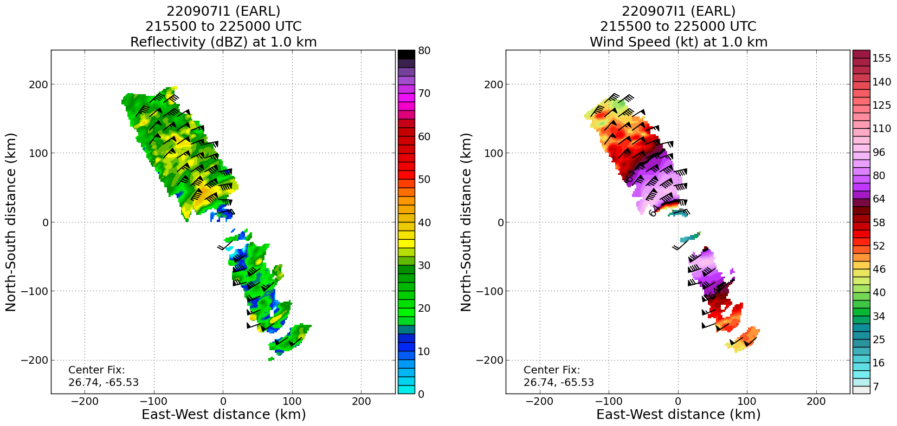
233220 | RMW W 10 m wind 67 kts drop #10
233331 | RMW W 10 m wind 59 kts drop #11
233541 | RMW W 10 m wind 69 kts drop #12
2339 | Center drop #13 MSLP 970 mb winds 355/05
2340 | Eyewall is now somewhat open to the east and filled in more to the south. 1 satcom went down.
234646 | RMW E 10 m wind 61 kts drop #14
234728 | RMW E 10 m wind 85 kts drop #15
234812 | RMW E 10 m wind 83 kts drop #16  Strong winds in the East eyewall  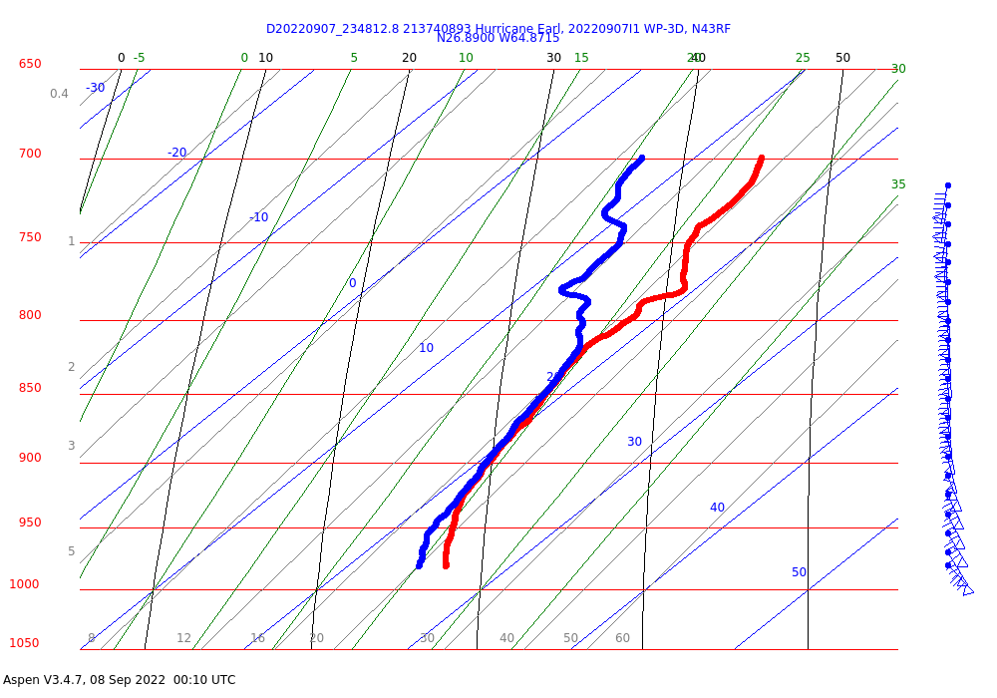
2354 | MMR shows a more closed eyewall  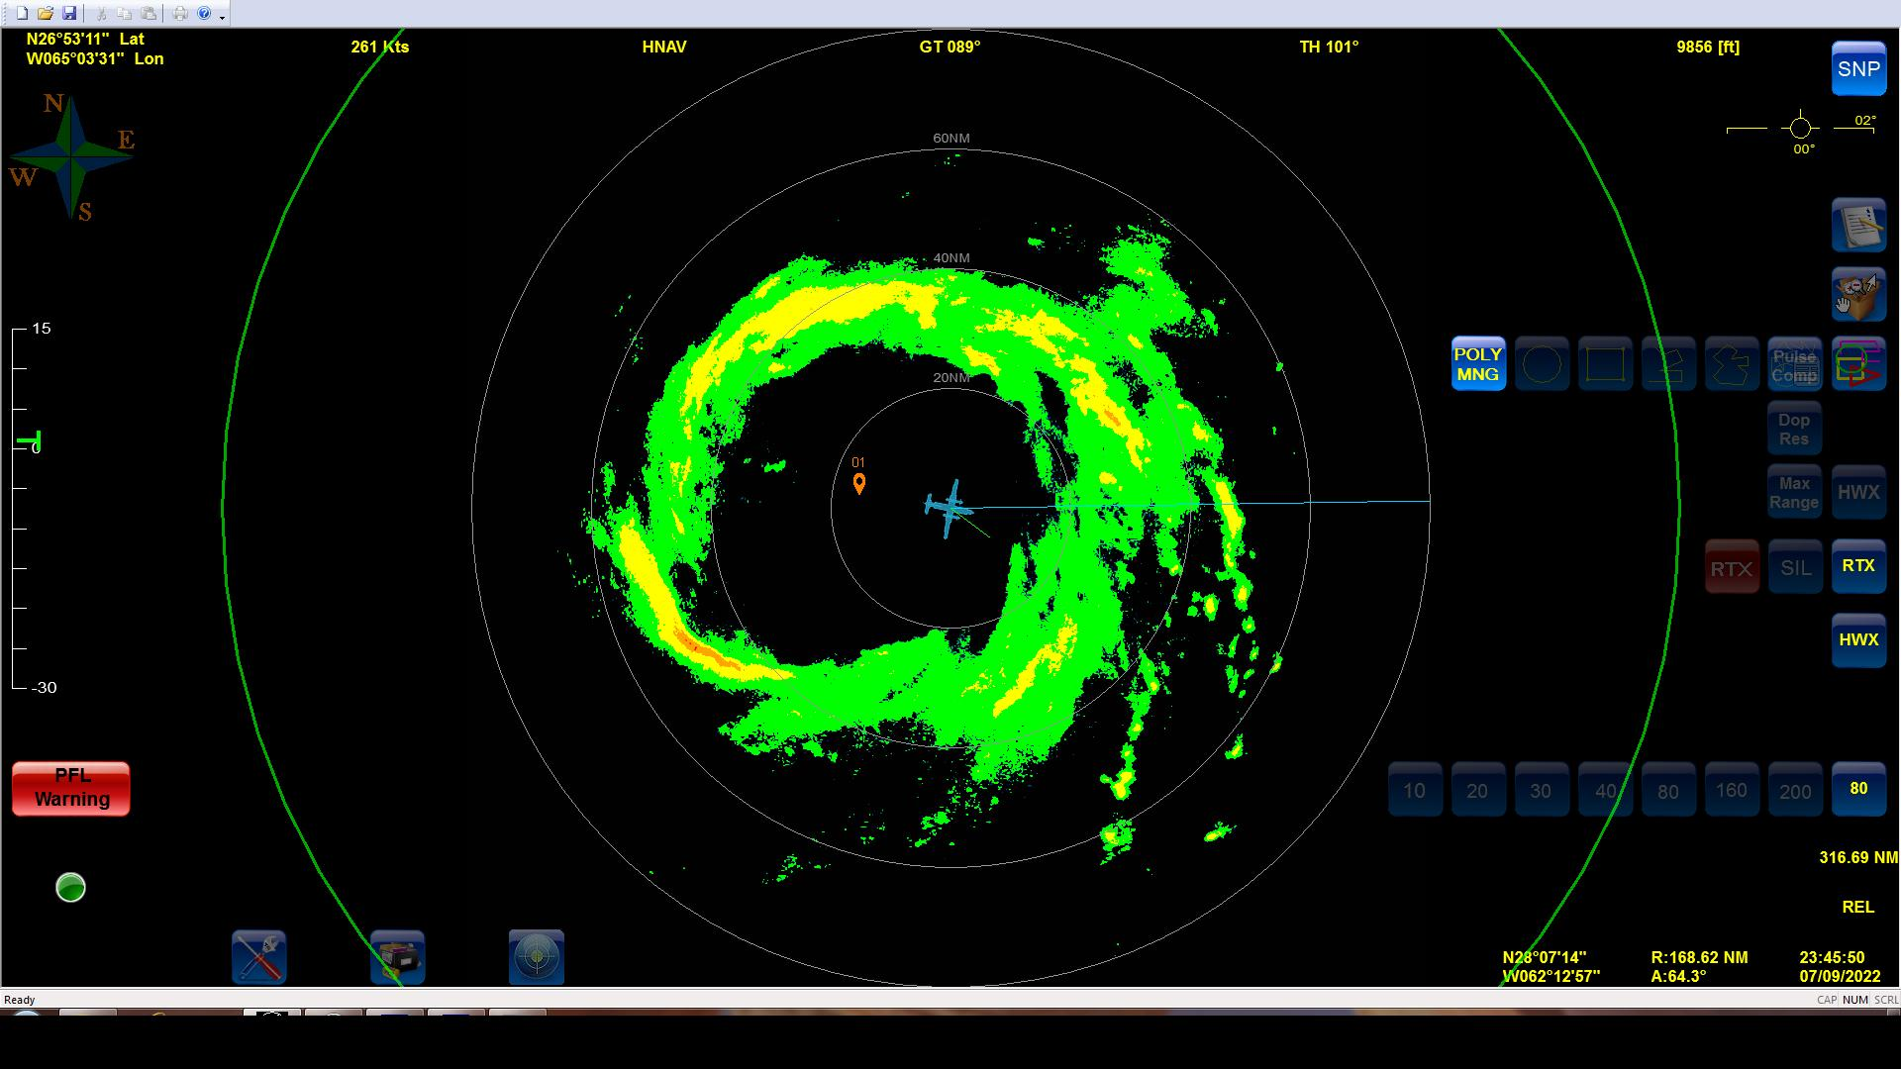
0003 | EP leg 2 drop #17
0024 | AXBT #3 released and measured an SST of 28.96C. Released a few minutes before IP in clearer air.
0028 | Beginning to turn inbound for leg 3
0029 | IP leg 3 drop #18 no GPS initially
0030 | Backup to IP drop #19
0041 | Second analysis composite  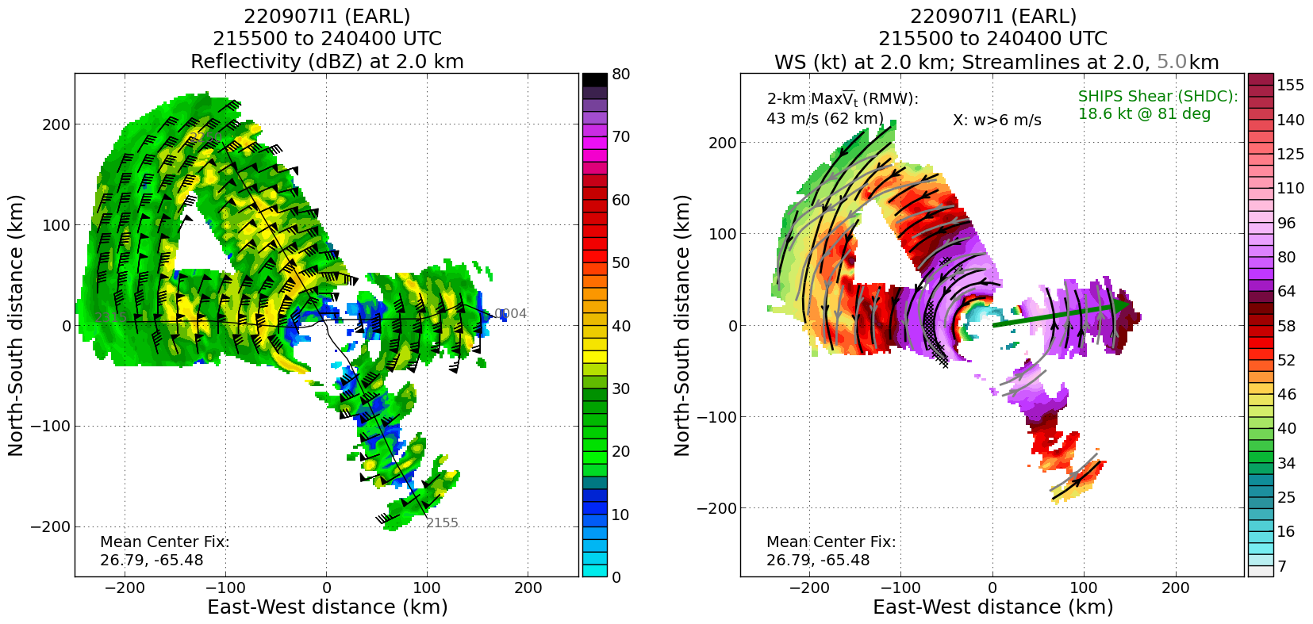
004338 | RMW NE 10 m wind 72 kts drop #20
004444 | RMW NE 10 m wind 79 kts drop #21
0052 | Center drop #22
0058 | 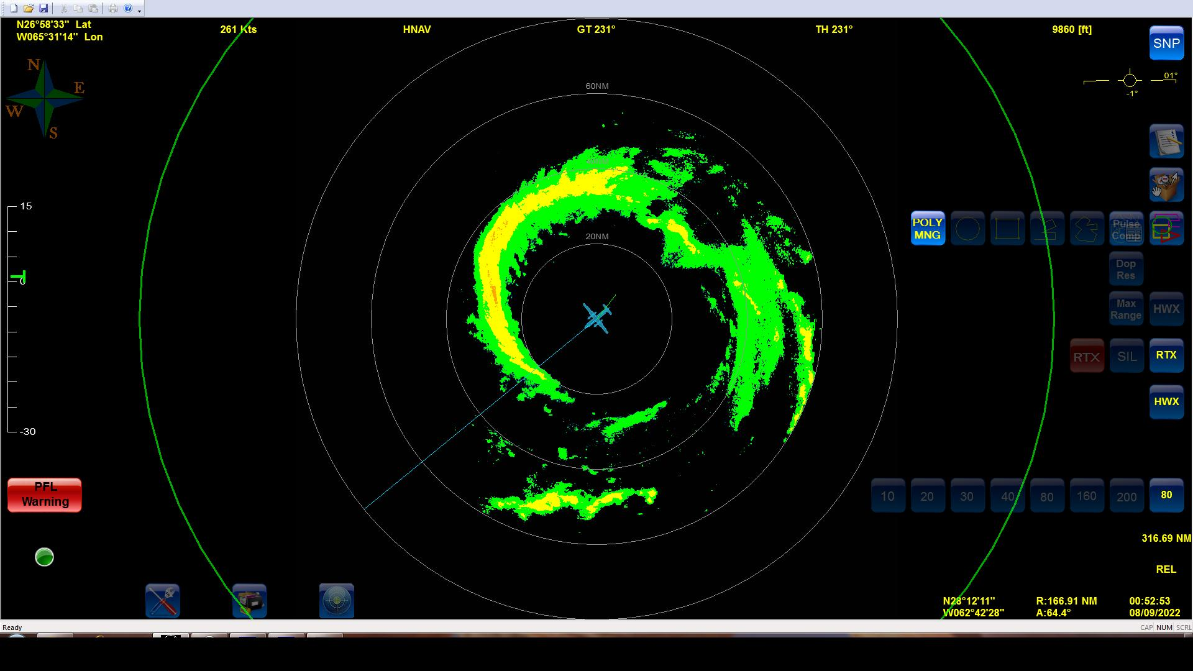
0102 | Turning back inbound to the center for the FLAIMS module
010832 | RMW SW 10 m wind 83 kts drop #23
0111 | Turning to head back out to SW
0112 | 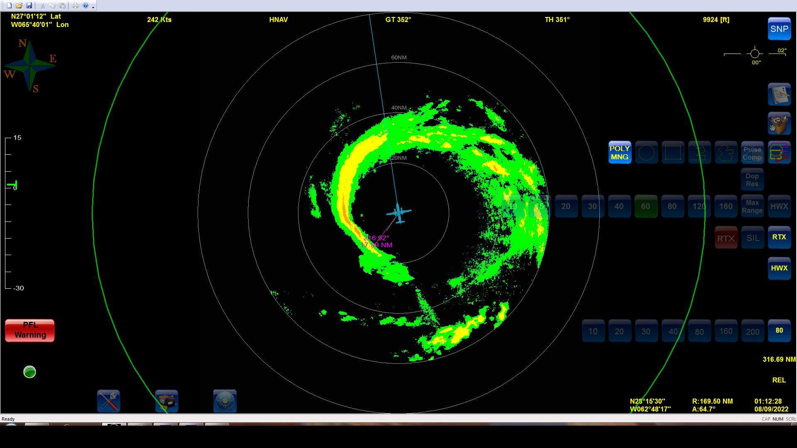
0122 | Turning to head back to center. Needed to adjust inbound track to account for unfavorable eyewall on initial track.
0130 | Troubleshooting TDR. Jobfile was not making its way up to the plane
0147 | IWRAP profile from earlier  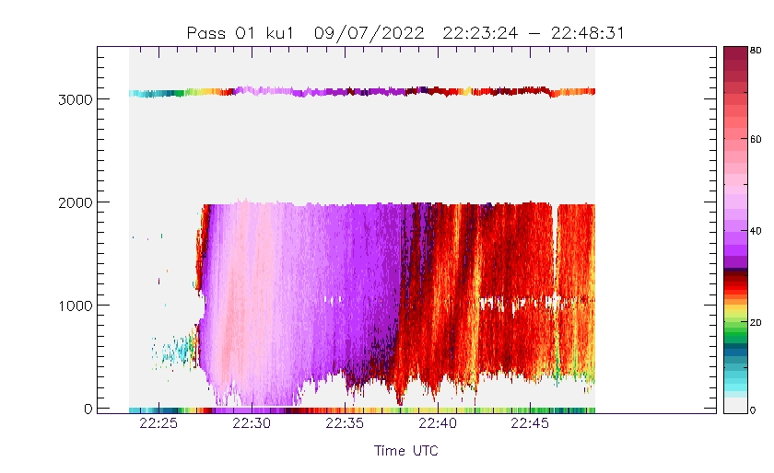
0155 | Special center sonde released in honor of Doc McFadden after his 600th hurricane eyewall penetration. Drop #24.
0202 | Heading outbound to pt 6 after tribute to Doc McFadden
0203 | 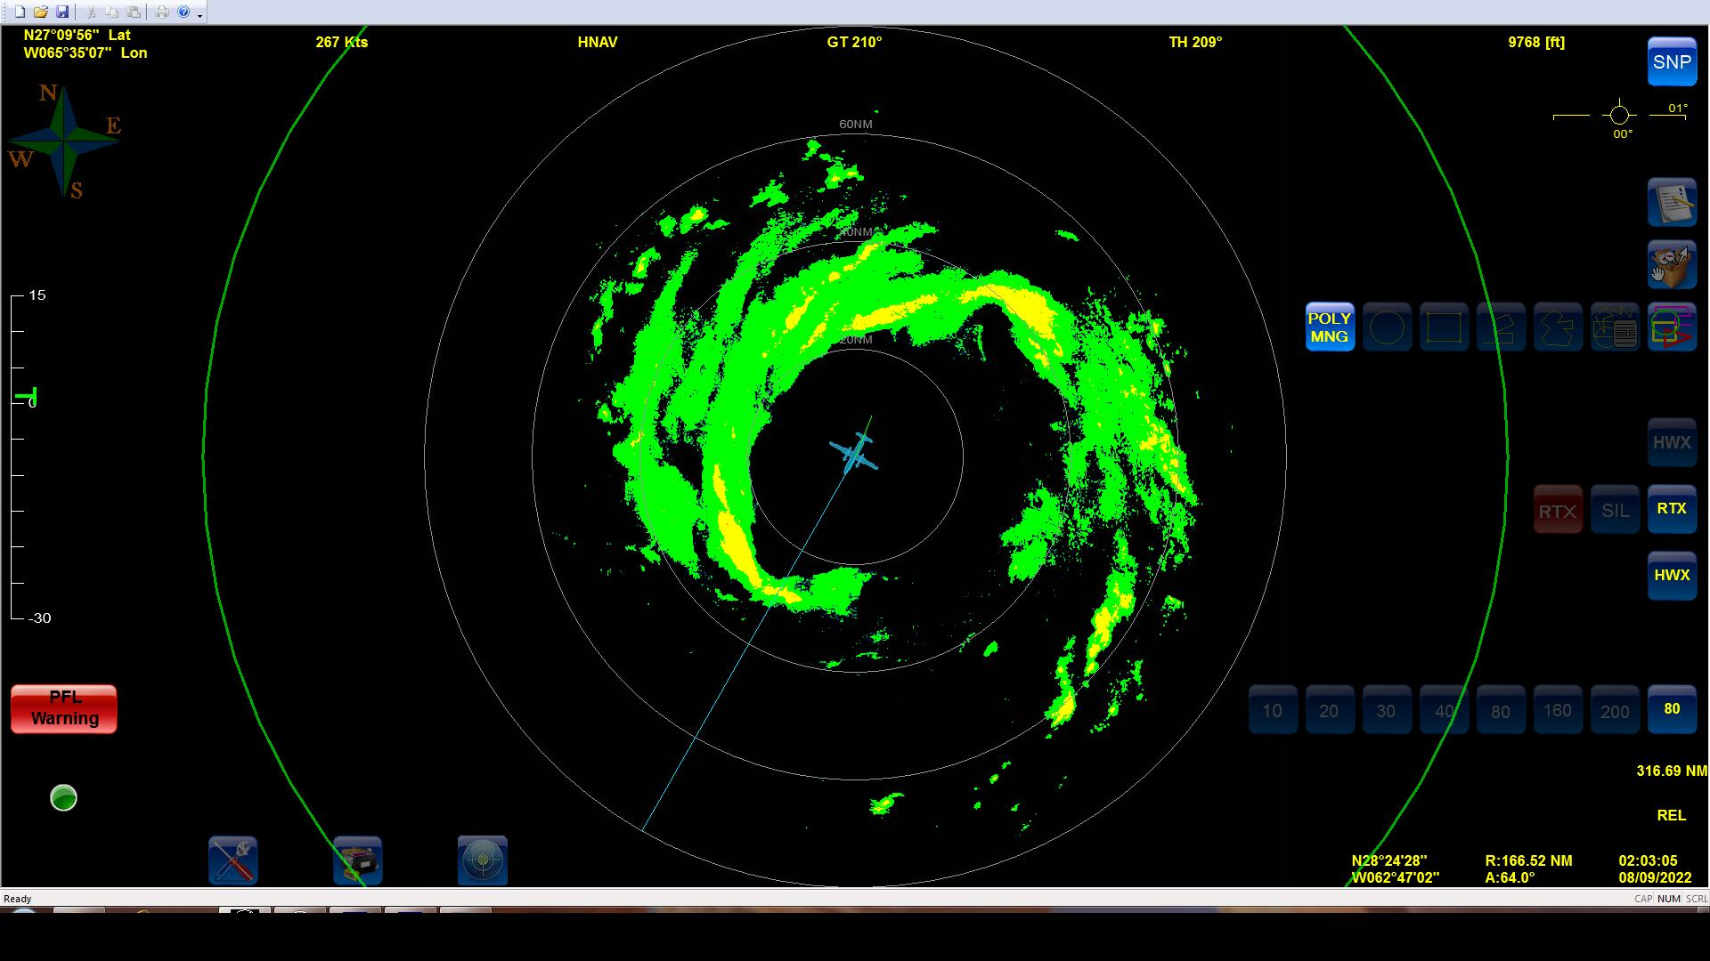
0210 | Storm is basically vertically aligned  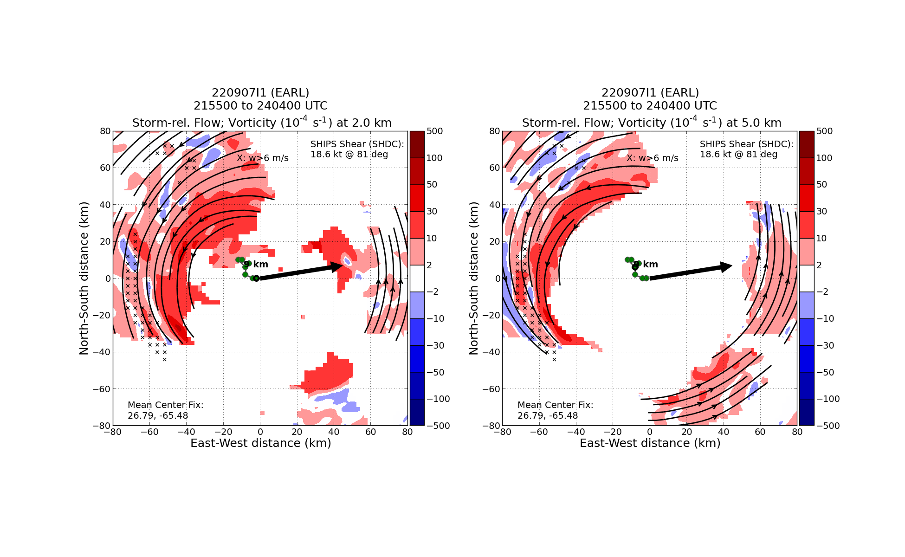
0214 | TDR jobfile problem fixed. Sonia and Todd had to reset some stuff on the ground and the plane.
0216 | Midpoint drop #25
0227 | EP leg 4 drop #26
0242 | Turning back inbound for Gravity Wave module
0258 | Back at pt 6. Science is complete!
0437 | Landed at St. Croix

POST-FLIGHT
Mission Summary | Earl was becoming more symmetric and strengthening throughout the flight. The eye was initially open south on the first pass through, but then closed off on the second pass.  The vortex had become much more aligned by this point, with only ~10 km of tilt.
Actual Standard Pattern Flown | Butterfly with additional FLAIMS and Gravity Wave Modules
APHEX Experiments / Modules Flown | Data collection supports the Early Stage Experiment: Analysis of Intensification Processes (AIPEX), specifically the FLAIMS (Flight-level Assessment of Intensification in Moderate Shear) module. The Gravity Wave Module was also flown near the end of the pattern.
Plain Language Summary | - Earl strengthened into a category 2 hurricane with max winds of 85 kt and minimum sea-level pressure of 970 mb.
Instrument Notes | Brief issue with TDR jobfiles getting up to the plane. Required Sonia and Todd to reset some things on the ground and the aircraft. We were still able to get all of the analyses off in time.
Final Mission Track | 