MISSION PLAN
FLIGHT ID | 20220906H1 | STORM | AL06 / EARL
MISSION ID | 1206A | TAIL NUMBER | NOAA42
TASKING | EMC | PLANNED PATTERN | Butterfly
MISSION SUMMARY
TAKEOFF [UTC] | 0823 | LANDING [UTC] | 1452
TAKEOFF LOCATION | St. Croix | LANDING LOCATION | St. Croix
FLIGHT TIME | 6.5 | BLOCK TIME | 6.7
TOTAL REAL-TIME RADAR ANALYSES  (Transmitted) | 4 | TOTAL DROPSONDES (Good/Transmitted) | 27 (25 / 25)
OCEAN EXPENDABLES (Type) | 2 AXBT (ONR) | sUAS (Type) | None
APHEX EXPERIMENTS / MODULES | Early Stage Experiment: AIPEX (FLAIMS), Stratiform Spiral Module (SSM)
HRD CREW MANIFEST
LPS ONBOARD | Rogers, Alvey | LPS GROUND | Stern (NRL)
TDR ONBOARD | Alvey, Rogers | TDR GROUND | Reasor
ASPEN ONBOARD | J. Zhang | ASPEN GROUND | None
NESDIS SCIENTISTS | None
GUESTS (Affiliation) | None
AOC CREW MANIFEST
PILOTS | Abitbol, Rannenberg, Keith
NAVIGATOR | Hough
FLIGHT ENGINEERS | Stokes, Gee
FLIGHT DIRECTOR | Carpenter
DATA TECHNICIAN | McAllister
AVAPS | Dykeman

PRE-FLIGHT
Flight Plan | 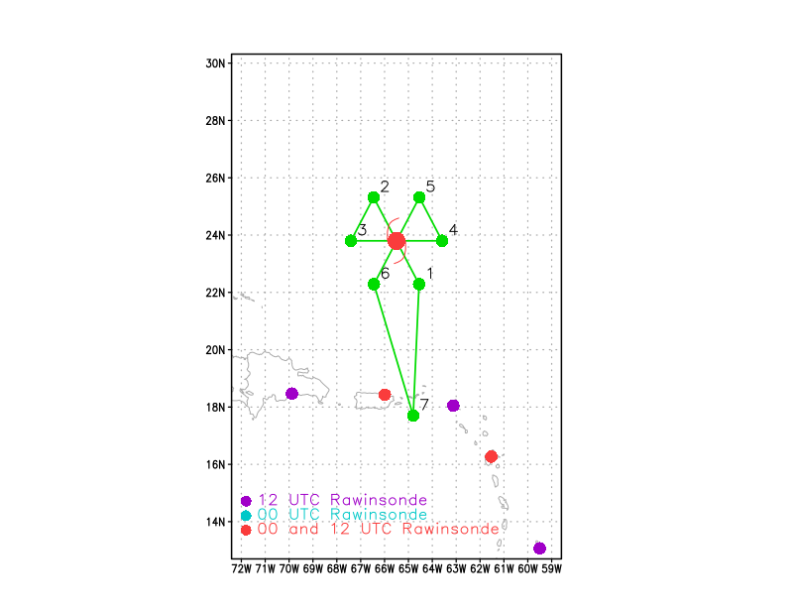  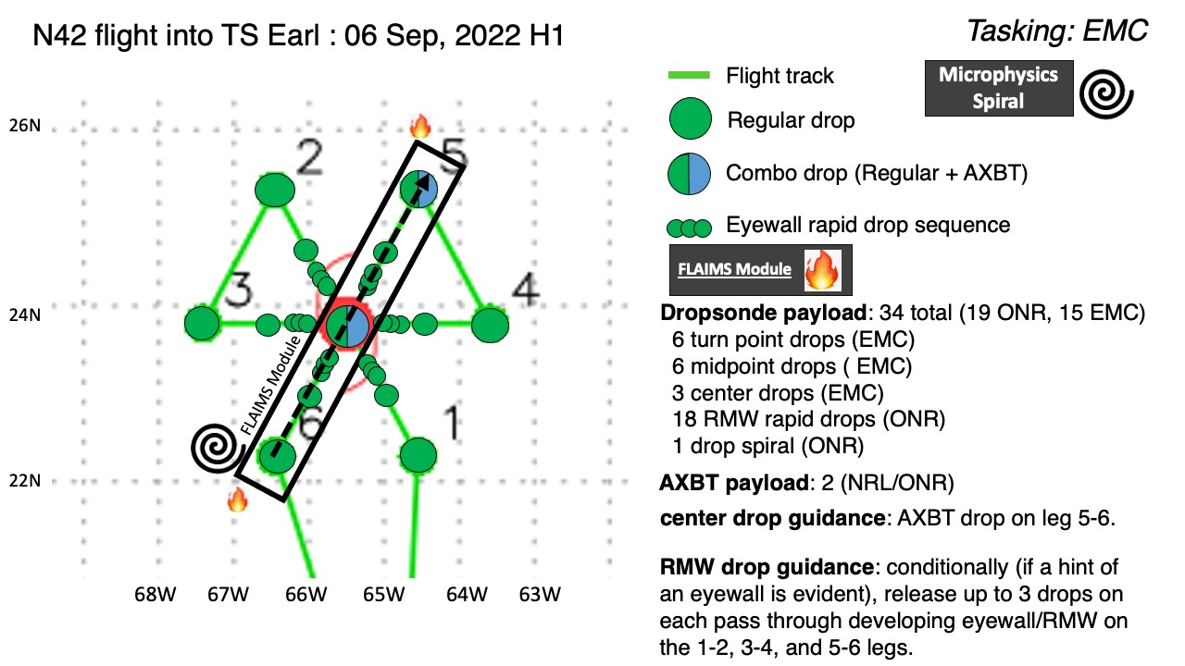
Expendable Distribution | Sondes at endpoints (endpts), midpoints (midpts), radius of maximum wind (RMW) rapid-fire drops on all legs. During two passes of the FLAIMS module, release a single sonde at the RMW. For AXBTs, combo AXBT/sonde at the NE point and during the final center pass.
Preflight Weather Briefing | Earl has undergone some fairly substantial evolution in its structure since our mission yesterday. The mission 12 h ago from NOAA43 indicated that the storm appeared to be in better alignment, with circulation centers from 2-5 km separated by only 20-30 km. Additionally, indications were that convection and lightning were now located upshear, with the potential of precession of the MLC into the upshear quadrants as well. Despite the improved structure in radar, Earl had not yet achieved hurricane status, but it is close. After NOAA43’s mission, and in the overnight hours leading up to our takeoff, the satellite presentation degraded, with cloud tops warming over much of Earl. There is an interesting outward-propagating ring of cold cloud tops, which is a possible gravity wave tied to the diurnal cycle, possibly representing an outward push from the upshear convection locally reducing the shear over the inner core. But with the warming of the cloud tops suggesting a weakening of convection, it is possible that Earl’s tilt had relaxed back to a downshear orientation, with greater displacement/tilt. We will see what the analyses show on this flight.  The environmental conditions remain the same – moderate SW shear, some dry air likely entraining into the circulation. This is also reflected in the appearance of Earl on satellite, with a pronounced spiral band coming in from the SE quadrant and wrapping up into the E and NE side of the storm. On the S and SW sides, Earl is generally void of significant precipitation.
Instrument Notes | All instruments functioning

IN-FLIGHT
Time [UTC] | Event
0823 | Takeoff from St. Croix
0919 | At Initial Point (IP), Drop #1 endpt SE
0930 | Near midpt SE, seeing some precip off our right wing about 40 nmi ahead. What we’ve seen so far has been limited, mostly shallow convection. There is more in this area of precipitation ahead and to the right.
0930 | Drop #2, midpt SE
0931 | NHC 5am discussion drops intensity estimate down to 55 kt, mentions 30-35 kt of SW shear
0941 | Approaching center, MMR shows what appears to be an eyewall, open to the SE
0942 | Drop #3 at center
0943 | FL center looks to be to our left now. Circulation in reflectivity to our NW. Seems to be a tilt.
094950 | Drop #4, NW RMW, #1 of RMW rapid
095020 | Drop #5, NW RMW, #2 of RMW rapid
095050 | Drop #6, NW RMW, #3 of RMW rapid
0955 | Drop #7, midpt NW
1007 | Drop #8, endpt NW
1007 | Cut the outbound leg short a little bit, and saw a possible target location for the microphysics spiral in NW quad. Orbiting a bit while we get clearance to climb to 20 kft.
1015 | Begin microphysics spiral. In a region where TDR is showing stratiform precip up to about 8 km. This should be a good region. Satellite imagery had reported some lightning even getting into the NW region.
1019 | Passed through freezing level, seeing some grains, pilots say still seeing precip on the windshield
1026 | Drop #9, top of microphysics spiral. We got up to 20 kft pressure altitude, 21.5 kft radar altitude, -8 C.
 | 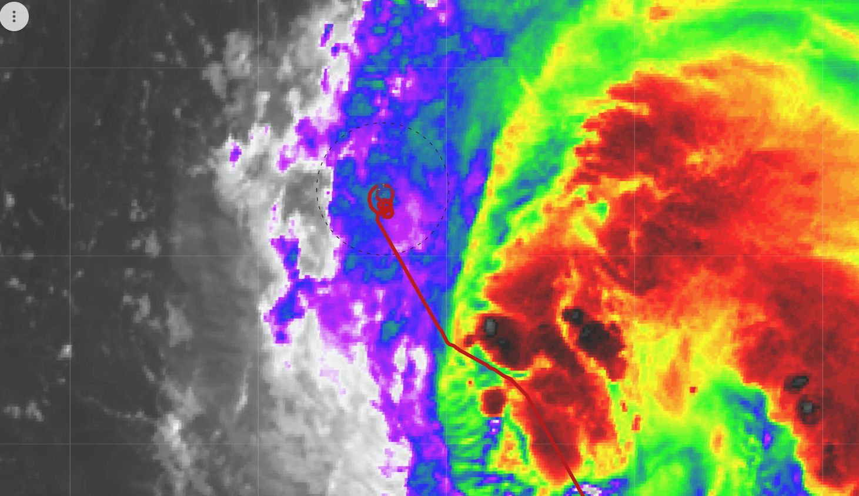
1058 | Drop #10, W endpt, heading inbound
IR at ~1100Z as N42 was approaching the center of Earl on inbound leg from the west on pass #2 of the Butterfly.
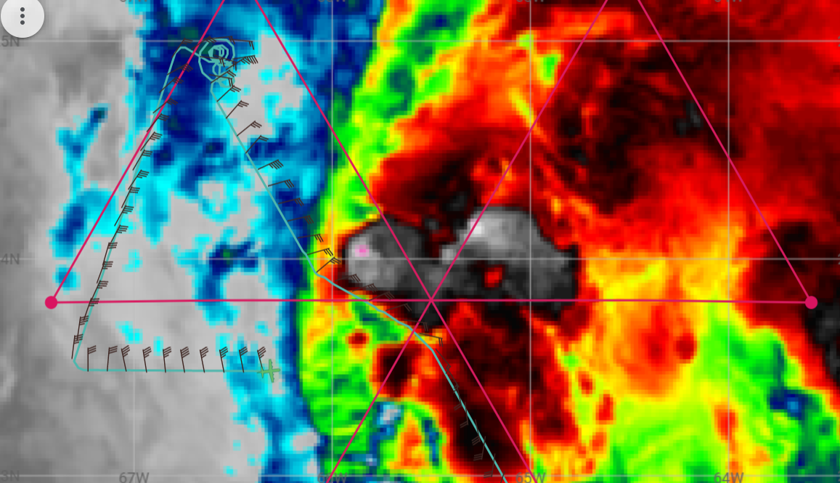
1111 | Inbound from W, not much in the way of scatterers yet, but there is some just ahead of us and to our left
1118 | Mark CPA to center, Drop #12 at center
1126 | Heading outbound, hard to find an RMW, broad circulation
Flight-level wind speed and vertical velocity on inbound leg from the west. Wind field was broad, RMW ill-defined, and no sondes released.

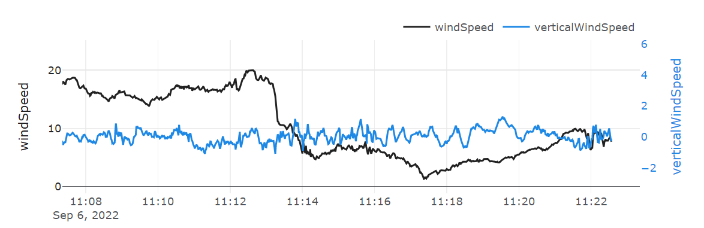
Flight-level wind speed and vertical velocity on the outbound leg to the east. Broad wind field with several embedded maxima, with the peak (~28 m/s) collocated with a ~5 m/s updraft.

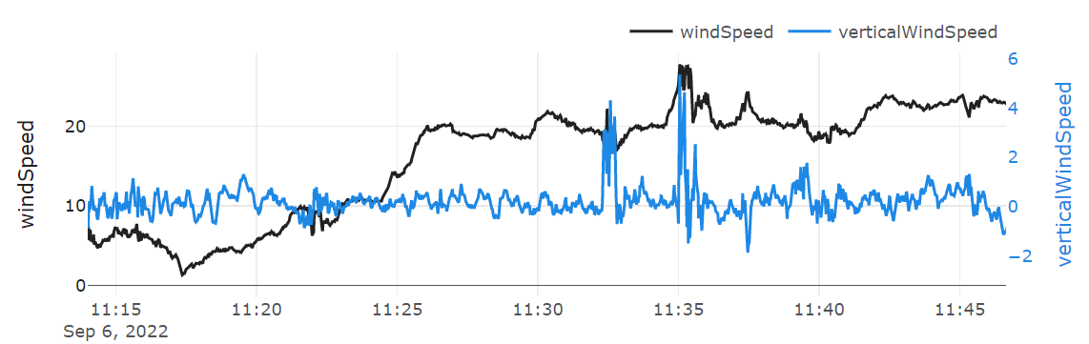
112715 | Drop #13, E RMW, #1 of RMW rapid fire
112745 | Drop #14, E RMW, #2 of RMW rapid fire
112815 | Drop #15, E RMW, #3 of RMW rapid fire
1134 | Center drop found about 998.9 hPa, with about 23 kt at splash. So that would convert to about 997 hPa.
1137 | Drop #16, E midpt
1139 | Heading outbound to E, pretty good chop, scatterers fairly widespread, mostly stratiform but embedded moderate, some deep convection off left wing
1144 | Drop #17, E endpt
CIMSS Analysis from 1030Z: Earl is experiencing 30-35 kt of southwesterly shear, which is an increase from yesterday (and the highest yet for this storm). This might help explain why Earl’s period of prior intensification was halted overnight.

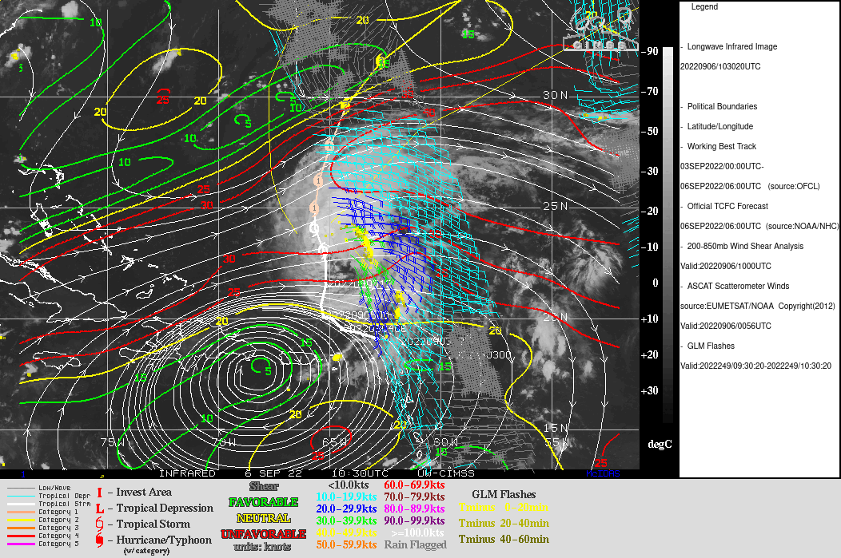
1201 | Drop #18 combo bt 28.70
1205 | About to traverse rain band towards center for FLAIMS module NE-SW
121135 | RMW Rapid drop sequence, Drop #19
1212 | Second RMW rapid, Drop #20
121225 | Third RMW rapid drop #21 failed
1226 | AXBT released and measured an SST of 28.55C near the center
123450 | RMW single sonde, Drop #22
1241 | Drop #23 mid point sonde
1311 | RMW single Drop #24
1328 | Center Drop #25
delayed | 12 m/s draft on that second VAM outbound leg
1335 | Motion of the FL fixes from the W-E pass (around 1130 UTC) and the pass we just completed (final VAM leg inbound) was 045 to the NE. Indications of potential repositioning of the center perhaps?
1342 | mid-point sonde #26 failed
1343 | second midpoint sonde release #27 and end of science
Time series during the 3 NE legs of FLAIMS/VAM modules. The peak winds were slightly higher on the 1st and 3rd legs, but overall it appears the peak winds were approximately steady state during this period, both at flight-level and at the surface.

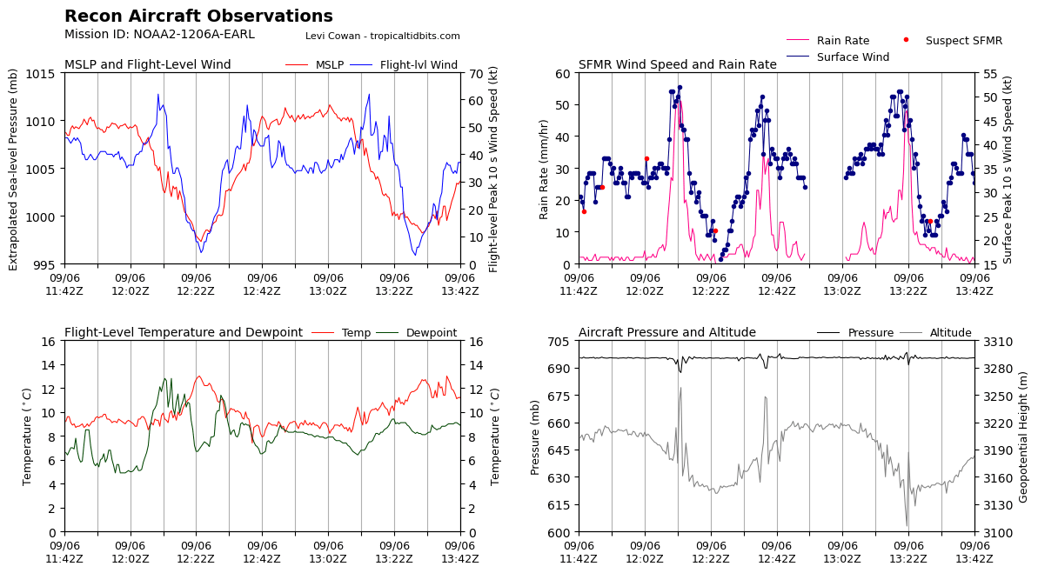
IR and N42 track/winds from 1405Z, as N42 heads back to St. Croix. N42 flew through (or near) a convective burst during the NE passes of the FLAIMS/VAM modules.
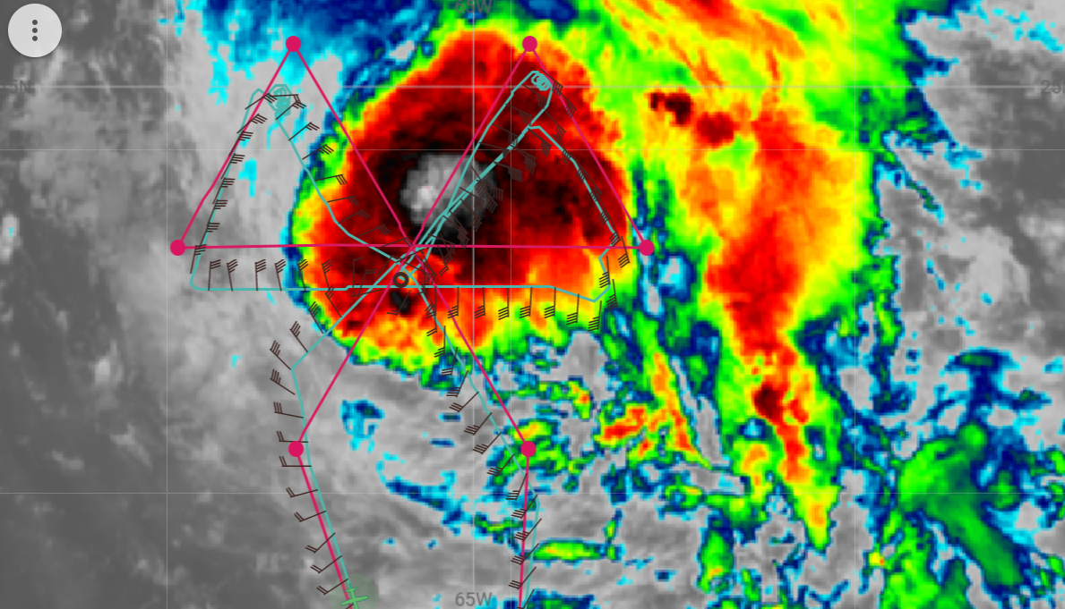
Flight-level wind speed and vertical velocity during the 3 NE FLAIMS/VAM legs and the final outbound SW leg. Moderate to strong updrafts in all 3 NE legs, multiple distinct wind maxima. The strongest updrafts are substantially inward of the peak wind speed.

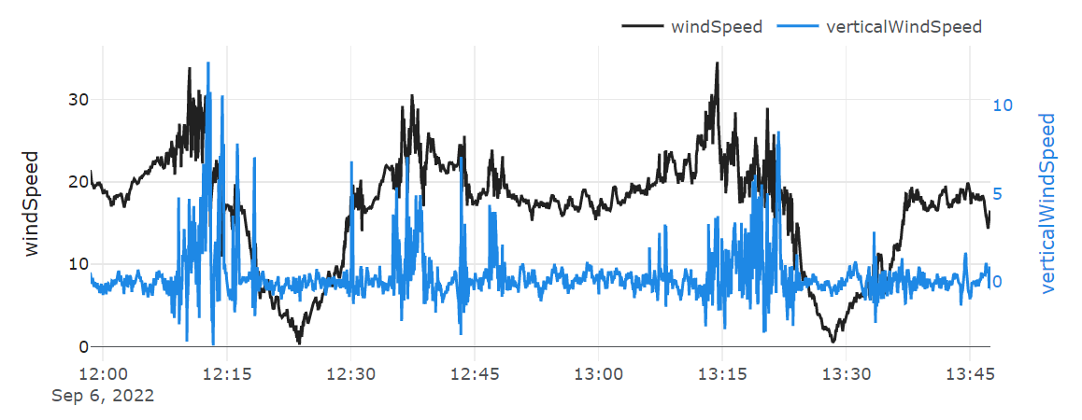
SSMIS overpass at 1123Z (just as N42 was crossing the center on the west to east pass). A partial eyewall to the north is apparent, along with a convective band to the NE (which has been prominent for some time).
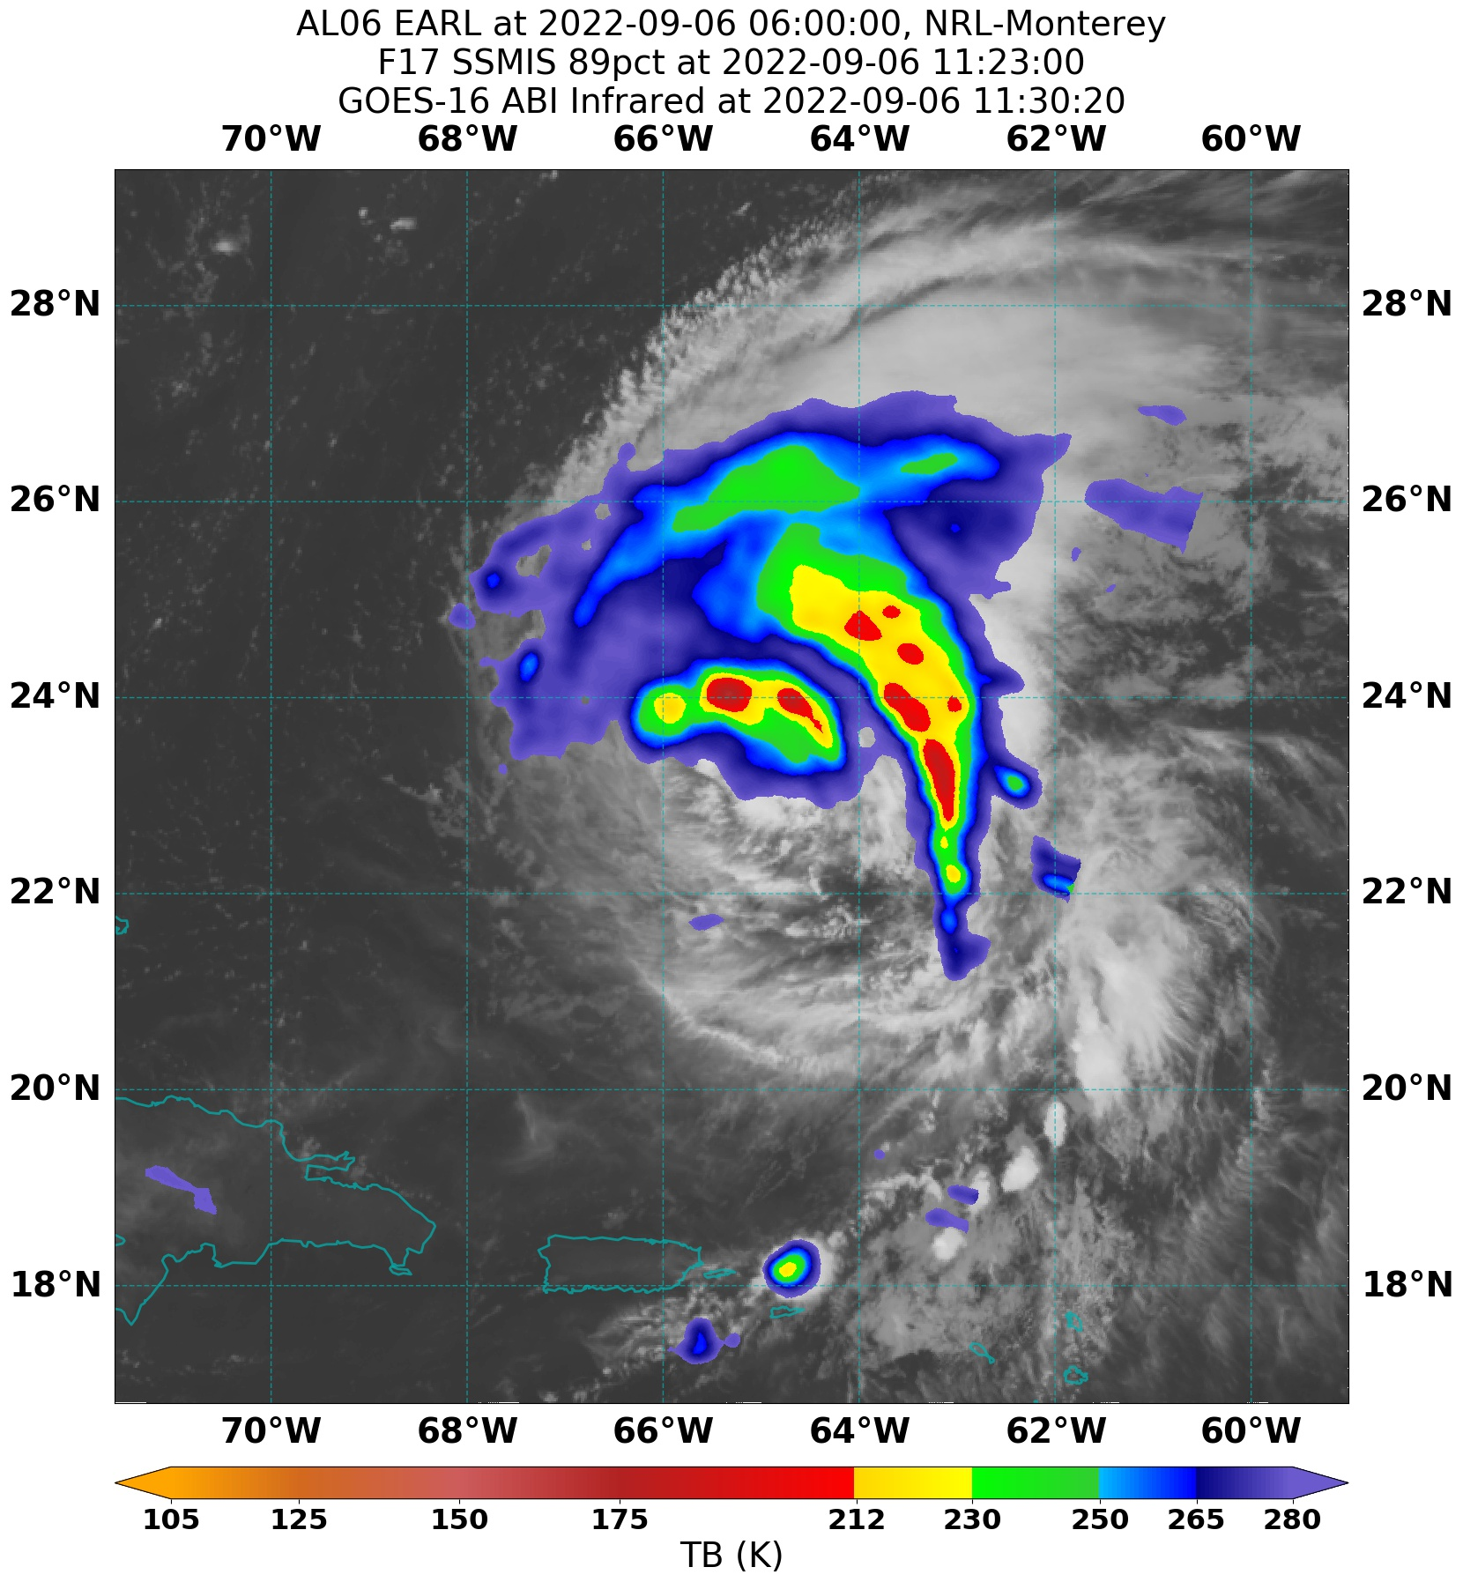

POST-FLIGHT
Mission Summary | We flew an EMC-tasked butterfly mission into TS Earl. Rinse and repeat from the previous day. Pattern was flown as planned. The system is still struggling with shear, after looking a little more organized the previous PM flight. It appeared to have maybe dealt with a dry air intrusion overnight. Overall, the flight seemed more convective than the previous day and more cellular type convection. 0-5 km centers appeared to have a small tilt towards the north with more substantial tilt above those levels (5-8 km) towards the ENE-NE. The mid-upper level vortex appears stronger/more consolidated than previous days despite the continued tilt.  We flew the FLAIMS/VAM modules on the NE side (NE-SW-NE before continuing EMC pattern as final NE-SW leg). We flew inbound to the center, through several stratiform + convective bands. The entire radar domain was filled with scatterers for most of the leg, with moderate chop in some of the banded features. We then reversed track and headed outbound, repeating the leg before reversing for a final, third pass through the northeast quadrant. Through the course of the module, the structure did not appear to change significantly. However, from the first pass at the beginning of the flight, it appeared to have improved organization and potentially a center repositioning (towards N, see above comment about FL wind center jump).
Actual Standard Pattern Flown | Butterfly with additional SSM and FLAIMS/VAM modules
APHEX Experiments / Modules Flown | Data collection supports the Early Stage Experiment: Analysis of Intensity Change Processes (AIPEX), specifically the FLAIMS (Flight-level Assessment of Intensification in Moderate Shear) and the Vortex Alignment Module (VAM). The Stratiform Spiral Module (SSM) was also successfully flown.
Plain Language Summary
Instrument Notes
Final Mission Track | 