MISSION PLAN
FLIGHT ID | 20220905H1 | STORM | AL06 / EARL
MISSION ID | 0906A | TAIL NUMBER | NOAA42
TASKING | EMC | PLANNED PATTERN | Butterfly
MISSION SUMMARY
TAKEOFF [UTC] | 0855 | LANDING [UTC] | 1412
TAKEOFF LOCATION | St. Croix | LANDING LOCATION | St. Croix
FLIGHT TIME | 5.3 | BLOCK TIME | 5.4
TOTAL REAL-TIME RADAR ANALYSES  (Transmitted) | 5 (5) | TOTAL DROPSONDES (Good/Transmitted) | 27 (25 / 25)
OCEAN EXPENDABLES (Type) | 2 AXBT (ONR) | sUAS (Type) | None
APHEX EXPERIMENTS / MODULES | Early Stage Experiment: AIPEX (FLAIMS, VAM)
HRD CREW MANIFEST
LPS ONBOARD | Rogers | LPS GROUND | None
TDR ONBOARD | Alvey, Englert | TDR GROUND | Reasor
ASPEN ONBOARD | J. Zhang, Englert | ASPEN GROUND | None
NESDIS SCIENTISTS | None
GUESTS (Affiliation) | Stern (NRL)
AOC CREW MANIFEST
PILOTS | Abitbol, Rannenberg, Keith
NAVIGATOR | Hough
FLIGHT ENGINEERS | Stokes, Gee
FLIGHT DIRECTOR | Carpenter
DATA TECHNICIAN | McAllister
AVAPS | Dykeman

PRE-FLIGHT
Flight Plan | 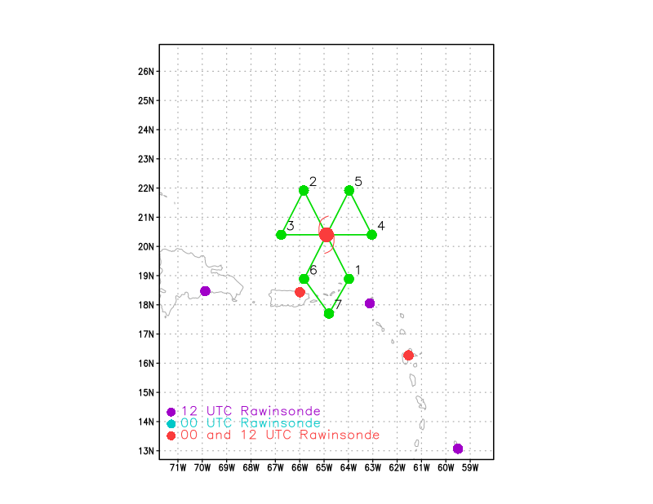  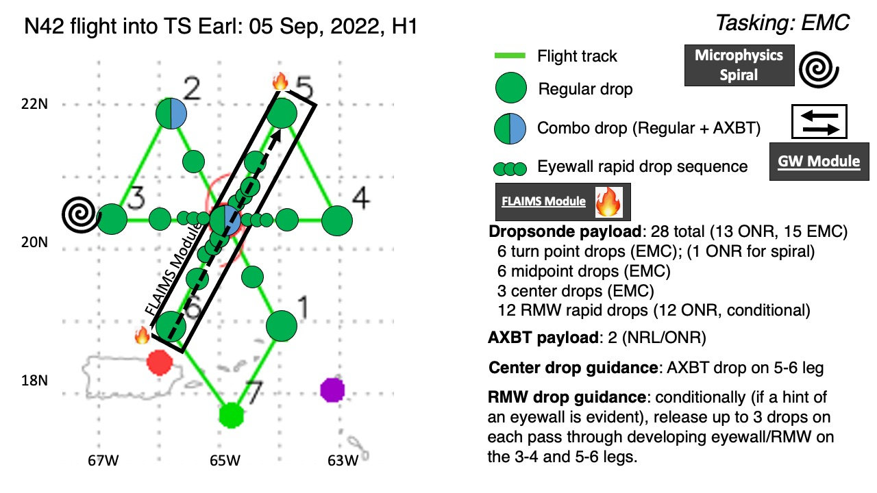  Fly a butterfly pattern, 105 nmi leg length. Initial point (IP) on the SE side. Attempt FLAIMS/VAM (and possible CB) module on the NE inbound leg. Likely will involve full 105 nmi legs, or possibly a bit shorter, passing inbound to center, then outbound back out to some distance (up to 105 nmi), then reverse track back inbound. So it would effectively be three passes through the expected region of highest winds. Will try to set up a radial that would accomplish both the objectives of FLAIMS (passing through the region of highest wind speeds) and VAM (passing through both the LLC and MLC, which is anticipated to be tilted/displaced toward the NE). It will essentially also be a Convective Burst (CB) module, if a CB occurs then, since this is the location where most CB’s have been occurring. Will also try to do a microphysics, Stratiform Spiral Module, probably in the NE part of the storm as that appears to be the downwind portion of a spiral band whose convective elements appear in the SE part of the storm.
Expendable Distribution | Endpoints (endpt), midpoints (midpt), and center dropsondes. Also rapid-fire RMW sondes on the NW, W, E, and NE survey legs, separated by 30 seconds, based on the location of the surface RMW. Will also drop a sonde at the RMW on each of the passes during the FLAIMS module. Drop an AXBT at the endpoint on the NW side and during the second center pass.
Preflight Weather Briefing | Earl continues to contend with moderate to possibly a bit stronger shear. Satellite presentation prior to takeoff showed bursts of convection still occurring to the northeast of the surface center.
Instrument Notes

IN-FLIGHT
0855 | Takeoff from St. Croix
0913 | Extending inbound leg from the SE by about 30 nmi, on way to new extended IP, working through the line of convection in a band SE of center
0929 | On this inbound leg we've shifted a bit toward the right of our plan to try to better sample these scatterers toward our east
0933 | Drop #1 at endpt SE
0936 | More shallow to moderately deep convection to our right. Just scattered cellular.
0948 | Drop #2 at midpt SE
1011 | Near flight-level (FL) center, have shifted flight a bit toward the NE. Looks like a bit of an elongated center, possible indication of a reformation toward the NE happening? Seeing scatterers off the right wind, echo tops about 10 km. Mostly stratiform with some embedded convection.
1012 | Mark center, Drop #3
101600 | Drop #4, #1 of NW rapid-fire
101630 | Drop #5, #2 of NW rapid fire
101700 | Drop #6, #3 of NW rapid fire
1027 | Drop #7, NW endpt (was NW midpt), AXBT #1 released and measure an SST of 28.9C
1042 | Drop #8, W endpt (was W midpt)
105134 | Seeing echo tops up to 17 km
105150 | Drop #9, #1 of rapid fire W RMW
105220 | Drop #10, #2 of rapid fire W RMW
105250 | Drop #11, #3 of rapid fire W RMW, drop failed
1054 | Mark CPA to center
1054 | Drop #12, center, AXBT #2 released and measure an SST of 31.95C
1109 | Drop #13, midpt E
1114 | Drop #14, RMW outbound - this sonde has no T, RH - didn’t send TEMP DROP
1120 | Drop #15, endpt E
1121 | Lots of chop on that outbound leg to the east. Mostly stratiform, but some embedded convective elements. Because of this we won’t be able to do the microphysics spiral there. We’ll try to set up on the northeast side, but that’s not likely – confirmed, no spiral. Too much attenuation on MMR to be comfortable with the notion that there is no convection.
1123 | End outbound leg to E, turn to downwind leg. Will now come inbound along 045 radial.
1142 | Begin inbound leg, 1st leg of FLAIMS/VAM
1206 | Drop #16, surface RMW drop on FLAIMS leg 1
1212 | Early visible images coming in, looking less impressive than how it looks on IR. What looked more impressive in IR shows up as a thin cirrus around the W and S sides.
1215 | AVAPS said they saw a wind of 55 kt at splash on the inbound RMW sonde on that first FLAIMS leg
1221 | Drop #17, FL RMW for FLAIMS, no winds initially, but did come back in
1222 | Drop #18, back up for Drop #17
1237 | Drop #19, endpt NE, start leg #3 of FLAIMS and resume survey pattern from NE-SW
1250 | Drop #20, midpt NE
125408 | Drop #21, #1 of NE surface RMW rapid-fire
125438 | Drop #22, #2 of NE surface RMW
125508 | Drop #23, #3 of NE surface RMW
1257 | Peak SFMR winds on the final FLAIMS pass was up to 29 m/s – was in precip so don’t know how accurate it is. FL and SFMR wind speed time series looks a little sharper, better-defined. Could indicate some improved organization.
1306 | Mark center, 1 kt FL, Drop #24, center drop
1313 | Drop #25, RMW drop SW
1317 | Drop #26, midpt SW
1329 | Drop #27, endpt SW
1412 | Landed in St. Croix

POST-FLIGHT
Mission Summary | We flew an EMC-tasked butterfly mission into Tropical Storm Earl. The pattern was flown as planned. The system is still struggling with shear, with the low-level center (LLC) on visible satellite imagery continuing to appear to be on the western edge of convection to the east and northeast of the LLC. In the early part of the mission and into the main part of it there was an intense convective burst in that region to the east and northeast. Lightning was evident early on, but had decreased in frequency by the time we reached that area.  We flew the FLAIMS/VAM modules on the NE side. We flew inbound to the center, through widespread stratiform precipitation with embedded convective cells. The entire radar domain was filled with scatterers for most of the leg, and light to moderate chop for much of the 105 nmi leg. We then reversed track and headed outbound, repeating the leg before reversing for a final, third pass through the northeast quadrant. Over the course of the three passes, and from an earlier pass and the module, the system seemed to be getting better organized. The time series of FL and SFMR winds showed what appeared to be a bit of tightening up of the wind field. TDR analyses suggested (though not conclusively) that the upper-level (8 km) circulation center had its displacement appear to drop from ~100 to ~60 km during the mission. The LLC appeared to be fairly well-aligned up to about 5 km. SFMR winds indicated winds approaching 60 kt in the NE quadrant, and a dropsonde showed splash winds of about 55 kt. So it appears the system could have been intensifying.  We also successfully performed rapid-fire RMW drops on the NW, W, E, and NE sides, and a supplemental RMW drop on the SW side. We also released a single-RMW sonde on the first FLAIMS leg, and a single-RMW (tied to FL winds) sonde on the second FLAIMS leg.  All TDR analyses were transmitted, as were all drops. All in all, a highly successful mission, accomplishing operational as well as scientific objectives.
Actual Standard Pattern Flown | Butterfly plus additional modules for FLAIMS and VAM
APHEX Experiments / Modules Flown | Data collection supported the Early Stage Experiment: Analysis of Intensity Change Processes (AIPEX), and specifically the FLAIMS (Flight-Level Assessment of Intensification in Moderate Shear) and VAM (Vortex Alignment Module) were flown.
Plain Language Summary
Instrument Notes
Final Mission Track | 