MISSION PLAN
FLIGHT ID | 20220904H1 | STORM | AL06 / EARL
MISSION ID | 0706A | TAIL NUMBER | NOAA42
TASKING | EMC | PLANNED PATTERN | Butterfly
MISSION SUMMARY
TAKEOFF [UTC] | 0904 | LANDING [UTC] | 1403
TAKEOFF LOCATION | St. Croix | LANDING LOCATION | St. Croix
FLIGHT TIME | 5.0 | BLOCK TIME | 5.2
TOTAL REAL-TIME RADAR ANALYSES  (Transmitted) | 1 | TOTAL DROPSONDES (Good/Transmitted) | 16 (16 / 16)
OCEAN EXPENDABLES (Type) | 2 AXBT (ONR) | sUAS (Type) | None
APHEX EXPERIMENTS / MODULES | Early Stage Experiment: AIPEX
HRD CREW MANIFEST
LPS ONBOARD | Rogers | LPS GROUND | None
TDR ONBOARD | Englert, Rogers | TDR GROUND | Fischer
ASPEN ONBOARD | J. Zhang | ASPEN GROUND | None
NESDIS SCIENTISTS | None
GUESTS (Affiliation) | Stern (NRL)
AOC CREW MANIFEST
PILOTS | Abitbol, Rannenberg, Keith
NAVIGATOR | Hough
FLIGHT ENGINEERS | Stokes, Gee
FLIGHT DIRECTOR | Carpenter
DATA TECHNICIAN | McAllister
AVAPS | Dykeman

PRE-FLIGHT
Flight Plan | 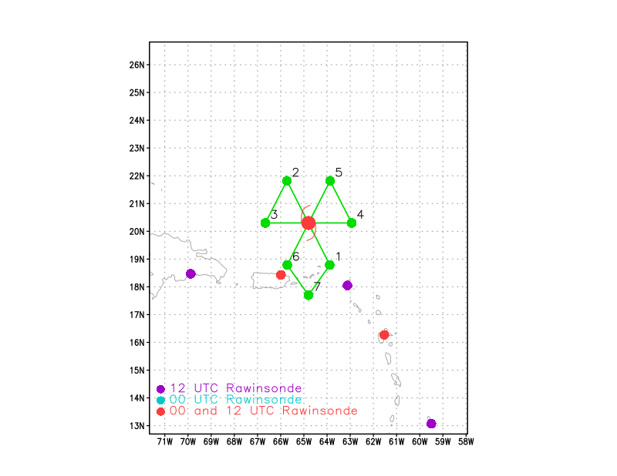  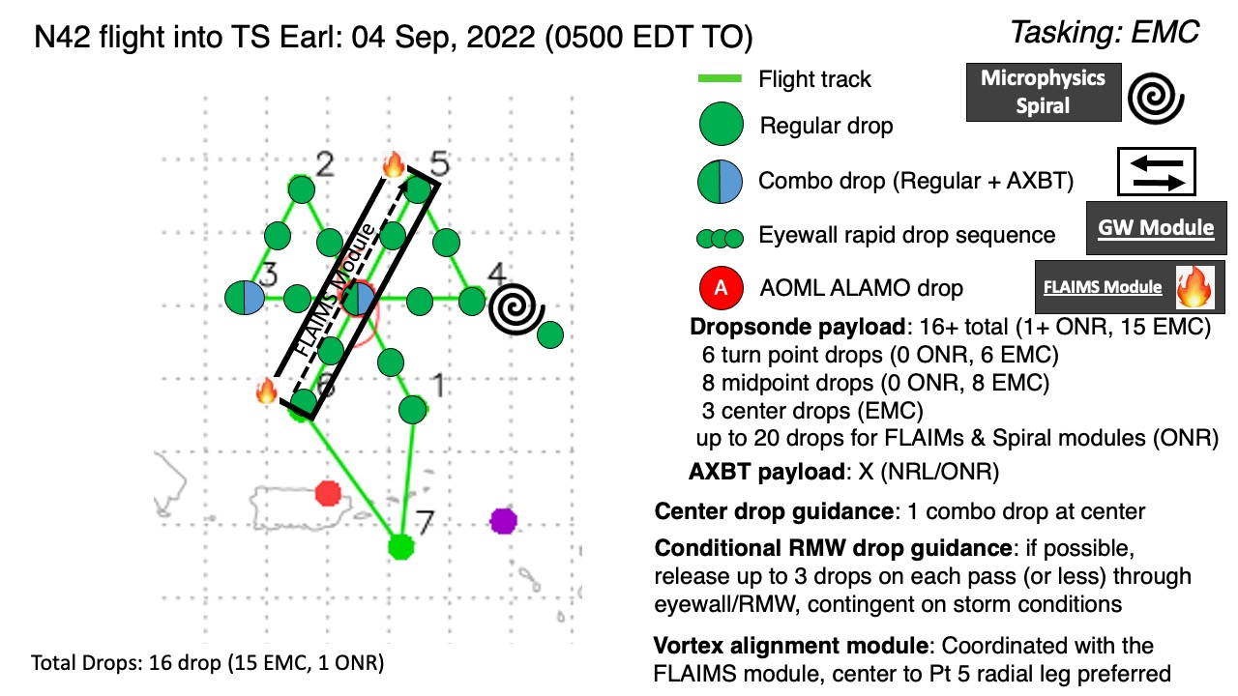  Pattern: Butterfly  Altitude: 10 kft  Fly a butterfly pattern. Possible microphysics spiral on the E side of the storm. Set up a FLAIMS module either on the inbound leg from the NE or adjusted slightly to the south to capture both the midlevel center (MLC) and the flight-level (FL) wind maximum for FLAIMS.
Expendable Distribution | Drops at endpoints, midpoints, center drops. Possible RMW rapid-fire dropsondes if there is an RMW, likely to be on the E, NE, NW sides. Possible drop at the top of a microphysics spiral. BTs on the endpoint on the NW side and on the second center pass.
Preflight Weather Briefing | Earl has intensified some, to a 45 kt tropical storm based on the NHC 11pm advisory. System continues to encounter moderate westerly shear, and appearance on satellite is of a clearly tilted system toward the east. Recent imagery from both satellite and radar indicate another convective burst coincident with the low-level center (LLC), and San Juan radar showed what looked like a mesovortex at the downwind tip of a spiral band associated with the burst. That feature appeared to collapse fairly quickly, however, possibly indicating the continued hostile environment of moderate shear and dry air aloft. Despite these impediments, TC is continuing to slowly intensify. If these impediments relax, it is certainly possible that Earl could align and intensify, possibly rapidly.
Instrument Notes | No known issues

IN-FLIGHT
0904 | Takeoff from STX
0920 | Drop #1 at endpt SE, no PTH initially, but came in
0921 | Drop #2 at endpt SE, backup sonde
0921 | Drop #3 at midpt SE  Communications between aircraft and ground dropped out
0940 | IR satellite loop of storm during time of first pass
0944 | Drop #4 at center of first pass  FL winds show what appears to be a new center along the inbound leg. Could be tied to that burst that developed prior to takeoff
0957 | Shifting pattern based on this new FL center, or at least a FL center well to the S of what was planned.
1004 | Drop #5 endpt NW (was midpt NW)  Satcom outage. Tried rebooting both satcom systems, did not work. Doing more work to try to get it corrected. Orbiting while trying to troubleshoot. If it does not come back up, do we continue the mission? I’m thinking yes – good data to collect for research. This will satisfy TCRI objectives, we have Dan onboard, FLAIMS module can still be flown. Question is to whom the flight will be charged? With no other cases on the horizon for the next 10 days at least we’re thinking it will be ok to proceed with the mission.
1139 | Drop #6 at endpt W (was midpt W); AXBT #1 released and measure an, SST of 29.1C
1140 | Pattern update: still no success getting satcom up. After an extended period of orbiting, trying to get satcom up and trying to determine the plan if we could not get it up, we have decided to proceed with butterfly to collect data. Continue with the outbound leg to the east, then rotate up to an inbound leg along the 030 radial, extending out to SW to complete the butterfly. If there is still no satcom, we will proceed home. If there is satcom, we may continue with possible module work (e.g., FLAIMS).
1148 | On the inbound leg from the W, noted that FL winds indicated a need to shift the aircraft further to the left (north), and what looks like to the north of the surface center as indicated by the MMR in surface roughness mode.
1150 | Marked CPA to center, 19deg 12min N, 65 deg 15 min W
1151 | Drop #7 at FL center; AXBT #2 released and measured an SST of 29.2C
1203 | Pattern update: chaotic wind field at FL, searching for a new FL center. Seems to be a very broad circulation. Not really clear where the center at FL could be at this point. Is it possible it’s weakened and opened up? Perhaps it’s trying to reform?
1212 | TDR off the right side shows extremely high reflectivity, 40-45 dBZ up to 16 km (to our south). MMR is also showing this feature, what looks like a band (developing eyewall?). There’s also another, weaker-looking circular feature on MMR ahead of the flight track, north of the band. Appears to be multiple centers at different altitudes, of different sizes and intensities.
1222 | Drop #8 at midpt E
1235 | Huge convective burst ongoing with frequent lightning activity
1235 | Examination of FL winds on the outbound leg to the E indicated FL RMW was at about 40 nmi. Will target that radius for an RMW rapid-fire sequence on the next inbound leg on the NE side.
1237 | Noticed water along the ceiling, pooling back by the data station. Have removed velcro paneling to let water drain out and dry. Don’t think this will impact the mission.
1248 | Drop #10 at endpt NE (030 radial)
130100 | Drop #11 at midpt NE (also #1 of RMW rapid-fire)
130130 | Drop #12 #2 of RMW rapid-fire
130200 | Drop #13 #3 of RMW rapid-fire
1308 | Satcomm has returned
1312 | Drop #14 at center (CPA)
1316 | 2nd W-E leg of pattern is the first TDR analysis submitted
1323 | Radar loop from TJUA suggests potential vortex repositioning event ongoing with very intense convection near MLC.  Initial convective burst weakens around 12 UTC. Subsequent redevelopment 1230-1300 UTC before weakening again.
1323 | Transient compact circulation signature in Base Velocity dissipates
1324 | Drop #15 at midpt SW
1325 | MTS screenshot of flight pattern overlaid on IR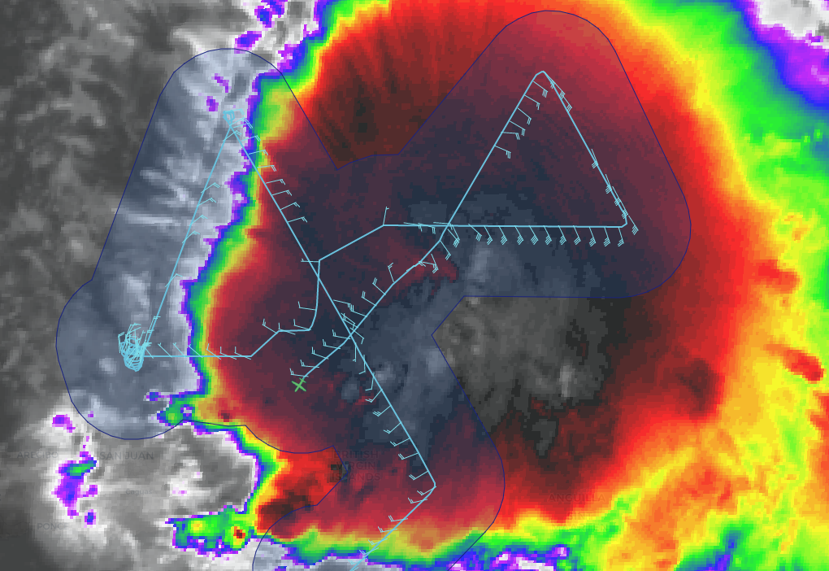
1343 | Drop #16 at endpt SW
 | New deep convection developing farther downtilt. Improved inflow banding structures into center
1407
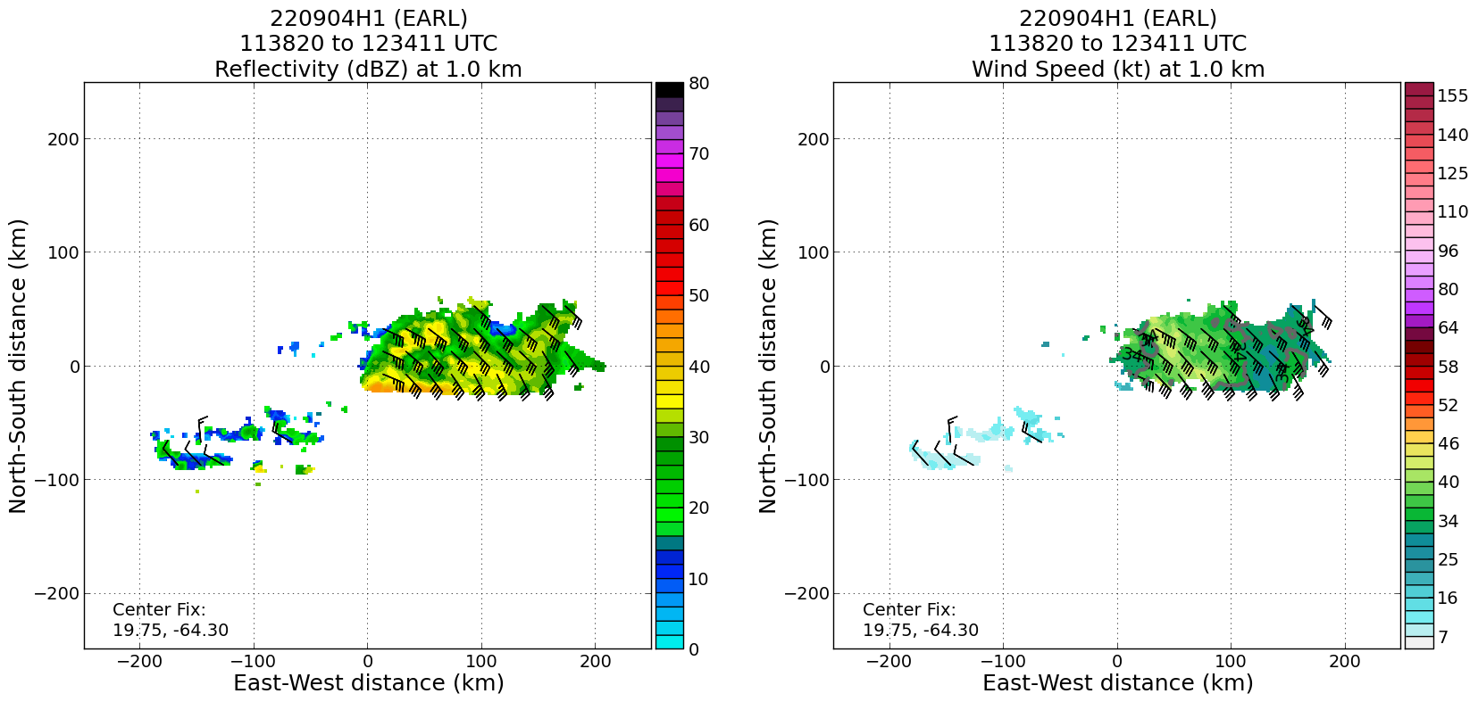

TDR from 2nd center pass at 1211 UTC
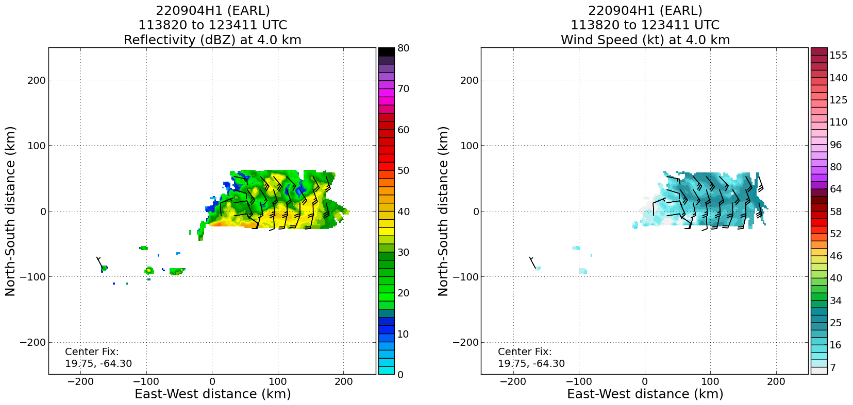
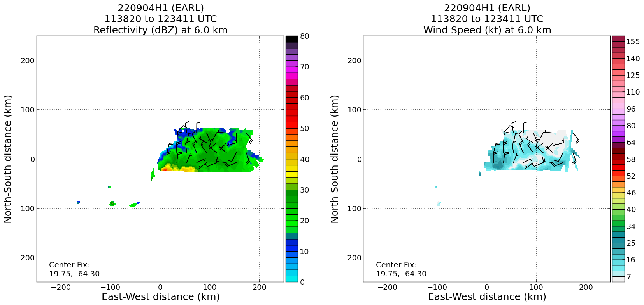

There is still a clear displacement/tilt of the vortex downshear. However, this swath does not include the strongest convection just to the south. It is possible that a convective burst may be reshaping the wind field and another vorticity maximum could be located farther to the south. The next analysis (NE-SW) may be beneficial for full picture interpretation
 | 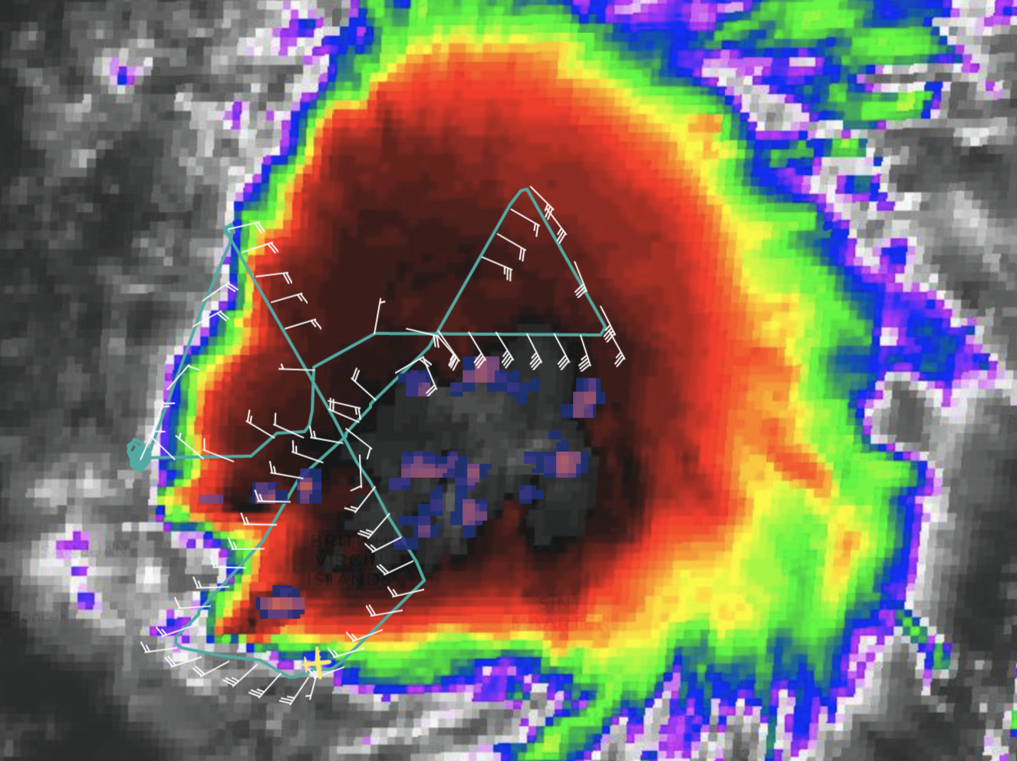
 | 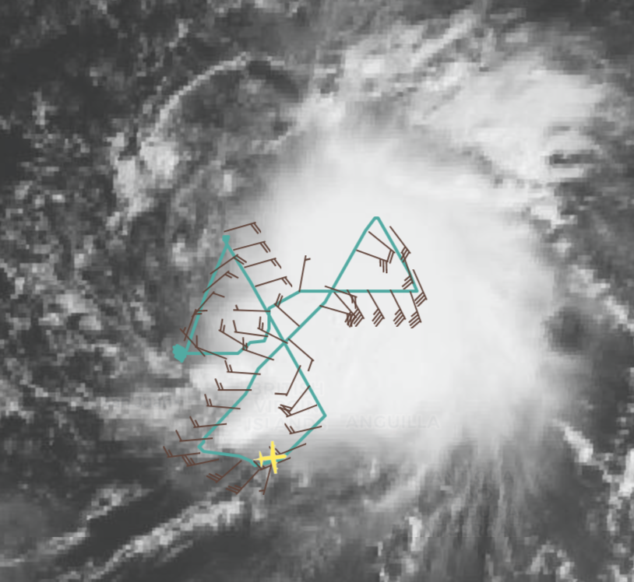
 | 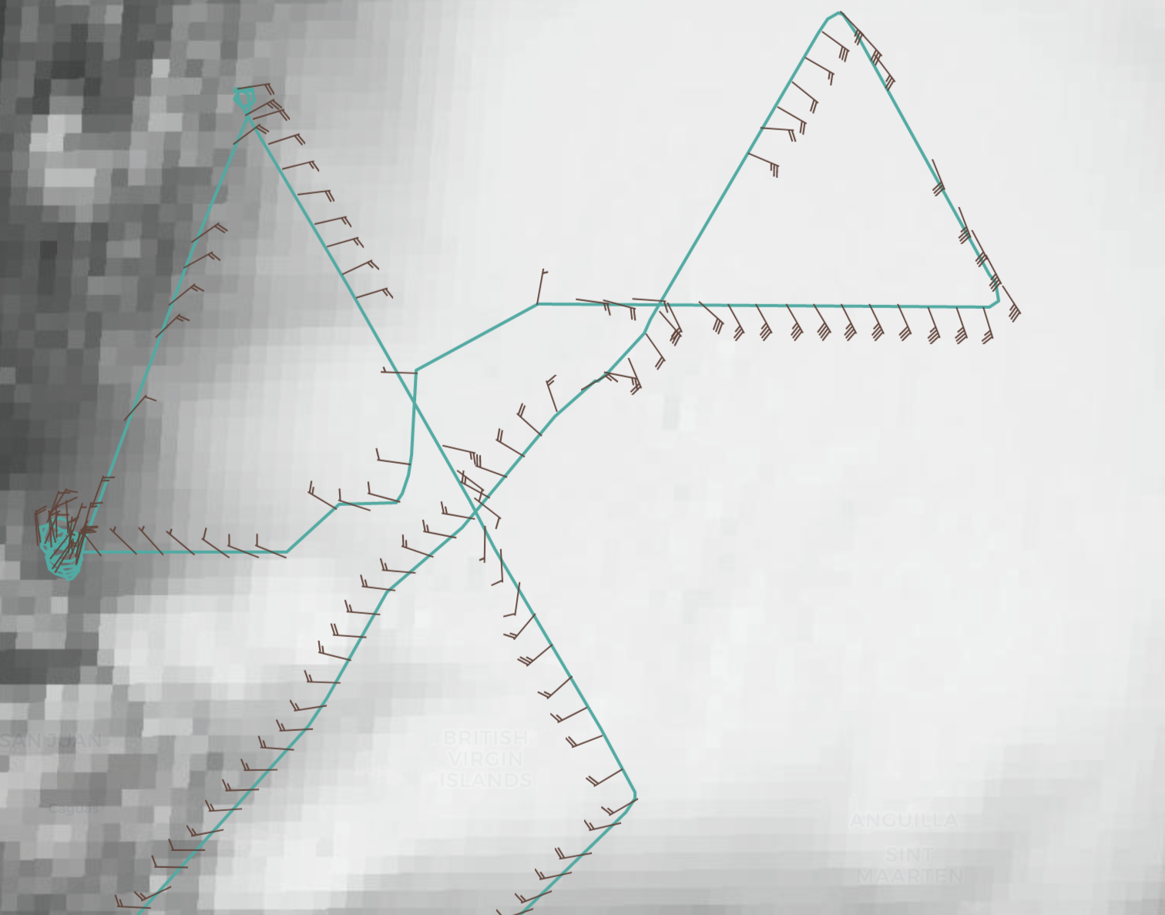
1402 | Landed back at St. Croix

POST-FLIGHT
Mission Summary | We conducted a butterfly pattern, resuming the pattern only after a considerable delay while attempts were made at restoring satcom and decisions were made on how to proceed. Because of this delay we were unable to perform the modules that were desired (FLAIMS, SSM), though we did drop one rapid-fire sonde sequence on the NE inbound leg, centered at around 50 nmi. We also dropped two BTs and dropped and transmitted 16 sondes.  The mission was a struggle for much of the time we were in the storm. The main issue was with the satellite communications, which failed at the end of the first pass, from SE-NW. We proceeded downwind and tried to bring communications back up, but we were unable to. At the time it was uncertain whether we would be able to accomplish the mission of transmitting real-time data (particularly TDR data) to the ground. We therefore orbited west of the storm while plans were made about what to do with the remaining time on station. Ultimately it was decided to proceed with the planned butterfly, and then to get back on the ground to allow time for communications to be restored and the data transmitted. Because of this time constraint, we were unable to fly many of the modules, particularly the FLAIMS and CB module, which would have been extremely interesting in light of the very intense convective burst that was occurring during the pattern. Nevertheless, we did collect TDR data for two passes with good coverage – the outbound leg to the east and the inbound leg from the northeast, that should at least provide some information on the structure of the MLC and LLC and their response to the convection. However, we were unable to process those legs, even on the ground, because we were unable to upload the jobfiles necessary to run the analyses. As a result only the second, W-E pass was processed, and that showed a continued tilt of the MLC east of the LLC (not surprising given the persistent westerly shear). It is hoped that analyses of the other two passes, particularly the NE-SW leg that sampled the intense convective burst, will shed more insight on Earl’s possible restructuring (even in retrospect if it was only temporary).  It’s not certain what was the cause of the satcom issues, but it wasn’t believed to be related to any issues on the aircraft. Troubleshooting both on the aircraft and on the ground suggested that it was related to an issue with INMARSAT. Apparently this is a region of the basin (north of Puerto Rico) that often has problems with satcom. Hopefully tomorrow will work better.
Actual Standard Pattern Flown | Butterfly
APHEX Experiments / Modules Flown | Data collection supports the Early Stage Experiment: Analysis of Intensity Change Processes Experiment (AIPEX). No FLAIMS (Flight Level Assessment of Intensification in Moderate Shear) module (part of AIPEX) was able to be flown, but there was an RMW rapid-fire sequence of dropsondes.
Plain Language Summary
Instrument Notes | Satcom was a major problem with this flight, and prevented us from accomplishing our primary mission objectives (transmission of all data to EMC for data assimilation). This also prevented us from accomplishing our key science objectives (FLAIMS, CB, SSM modules), since we had to leave time to land and try to transmit data from the ground. We were still unable to fully transmit all TDR data because of an inability to upload jobfiles to the radar workstation. It is thought this was related to the aforementioned satcom issues. Hopefully tomorrow’s flight will work better.
Final Mission Track | 