MISSION PLAN
FLIGHT ID | 20220902I1 | STORM | AL91
MISSION ID | 04FFA | TAIL NUMBER | NOAA43
TASKING | EMC | PLANNED PATTERN | Butterfly
MISSION SUMMARY
TAKEOFF [UTC] | 1958 | LANDING [UTC] | 0253
TAKEOFF LOCATION | Barbados | LANDING LOCATION | Barbados
FLIGHT TIME | 6.9 | BLOCK TIME | 7.2
TOTAL REAL-TIME RADAR ANALYSES  (Transmitted) | 5 (5) | TOTAL DROPSONDES (Good/Transmitted) | 15 (15 / 15)
OCEAN EXPENDABLES (Type) | 8 AXBT (ONR) (8 good) | sUAS (Type) | None
APHEX EXPERIMENTS / MODULES | Genesis Stage Experiment: PREFORM; Early Stage Experiment: AIPEX (VAM)
HRD CREW MANIFEST
LPS ONBOARD | Marks | LPS GROUND | Hazelton
TDR ONBOARD | Reasor | TDR GROUND | Gamache
ASPEN ONBOARD | Aberson | ASPEN GROUND | None
NESDIS SCIENTISTS | Chang, Sapp
GUESTS (Affiliation) | None
AOC CREW MANIFEST
PILOTS | Doremus, Copare, Wood
NAVIGATOR | Utama
FLIGHT ENGINEERS | Darby, Pittman
FLIGHT DIRECTOR | Kalen, Holmes
DATA TECHNICIAN | Richards
AVAPS | Warnecke

PRE-FLIGHT
Flight Plan | 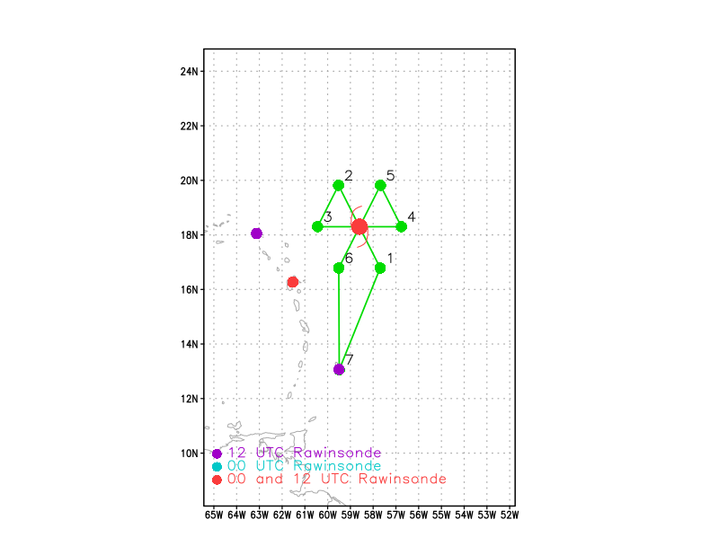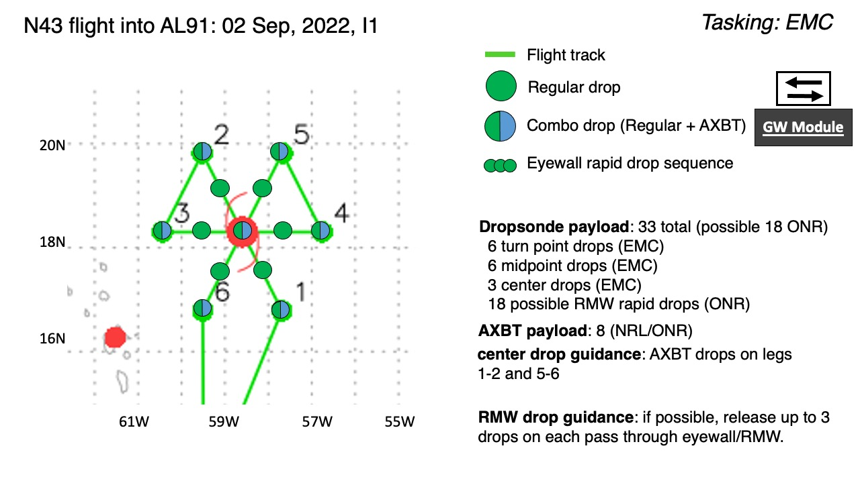  Pattern: Fly butterfly pattern with 105 nmi legs  Altitude: 10 kft (pressure altitude)  On-station time for EMC data collection for the 0000Z assimilation window is between 2100Z and 0300Z.  AXBTs deployed from inside the cabin.  We plan to add on a vortex alignment module (VAM), part of AIPEX, at the end of the second (east-west) leg.
Expendable Distribution | Up to 33 sondes planned (all dropsondes transmitted to the GTS); 8 ONR/NRL AXBTs (all AXBTs transmitted to the AOC ground server if possible)  Release sondes at endpoints, midpoints, centers; possible supplemental rapid RMW drops across RMW/eyewall inbound and outbound.
Preflight Weather Briefing | Storm is not as strong, so we planned to forego the RMW drop sequence unless something changes. We are planning to follow the mission as briefed up to point 4. At that point we are planning to do a VAM module between center and PT 4 at the end of 2nd leg through the storm (West to east leg). That should give us 3 TDR looks at the vortex tilt in about 1.5 h. After the VAM module we plan to head to point 5 and complete our last full pass through the system and then to Barbados.  NHC currently gives the disturbance a 50% chance to develop in the next 48 hrs and 70% in the next 5 days.  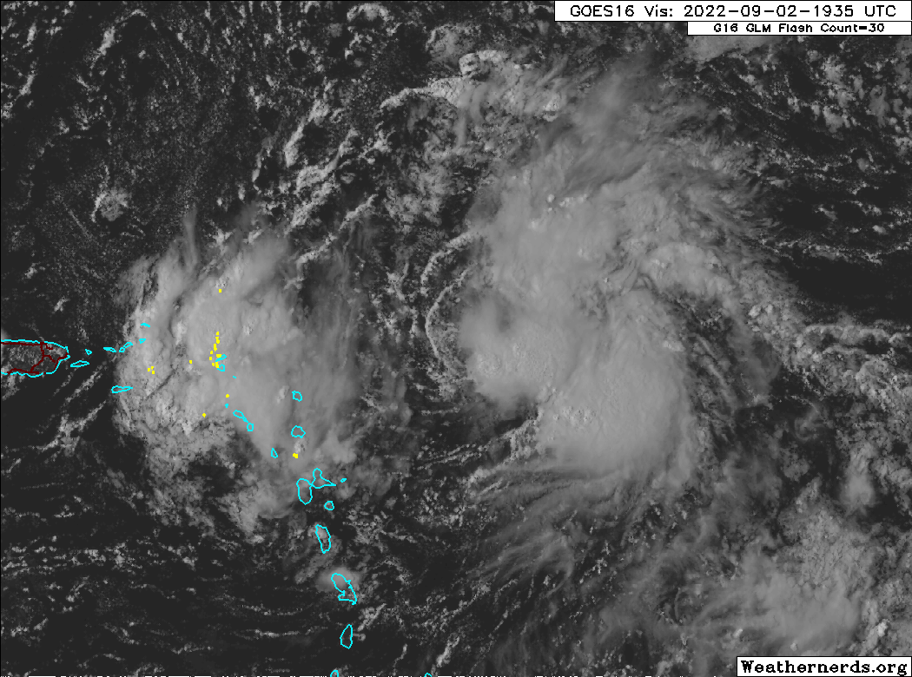

IN-FLIGHT
Time [UTC] | Event
1947 | Start taxi
1958 | Takeoff from Barbados
2036 | Begin descent to 10 kft
2044 | Combo drop #1, AXBT #1 released and measured an SST of 28.92C  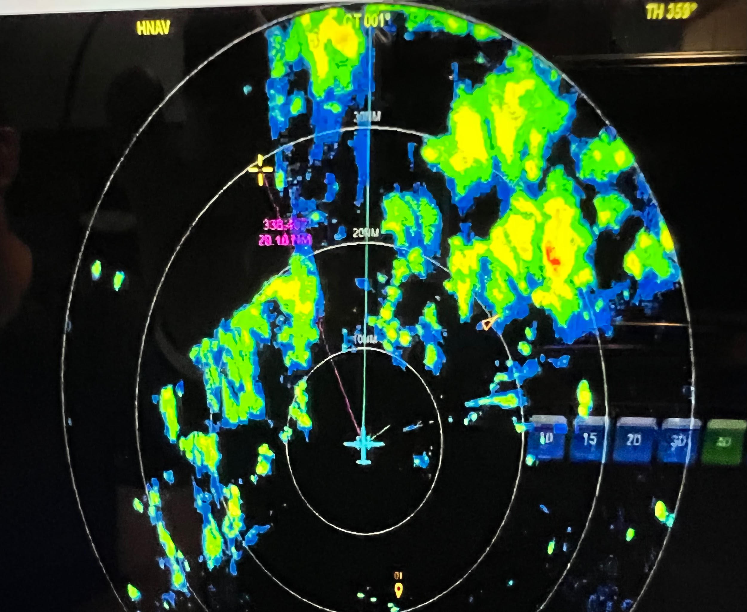
2059 | 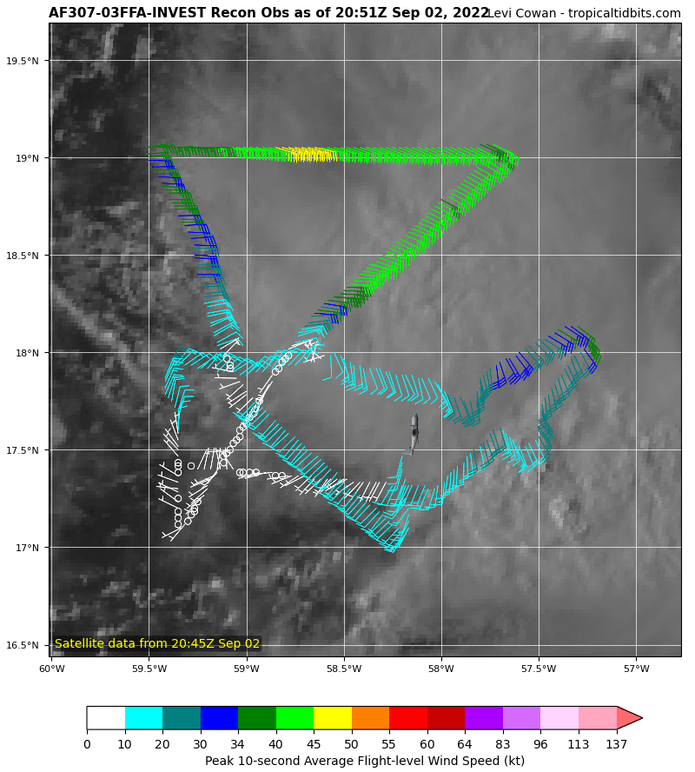  Air Force flight has observed something close to a closed circulation
2102 | Drop #2 mid point, 17.5 N, 58.2 W  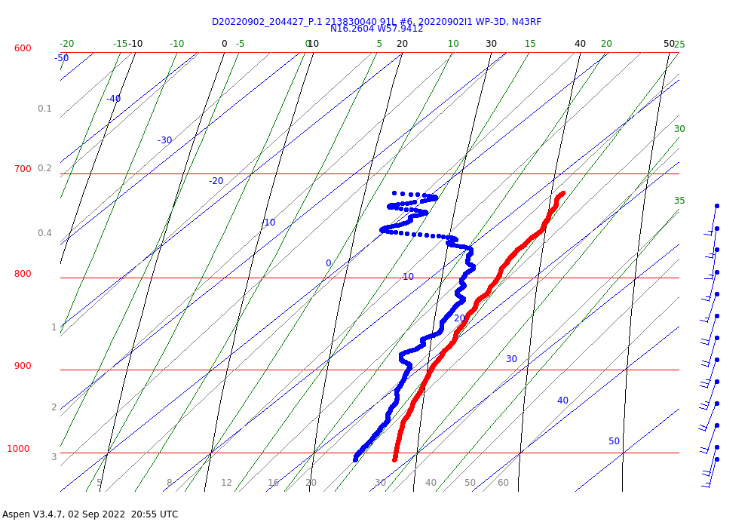
2114 | Drop #3 holding BT till we can put it out safely  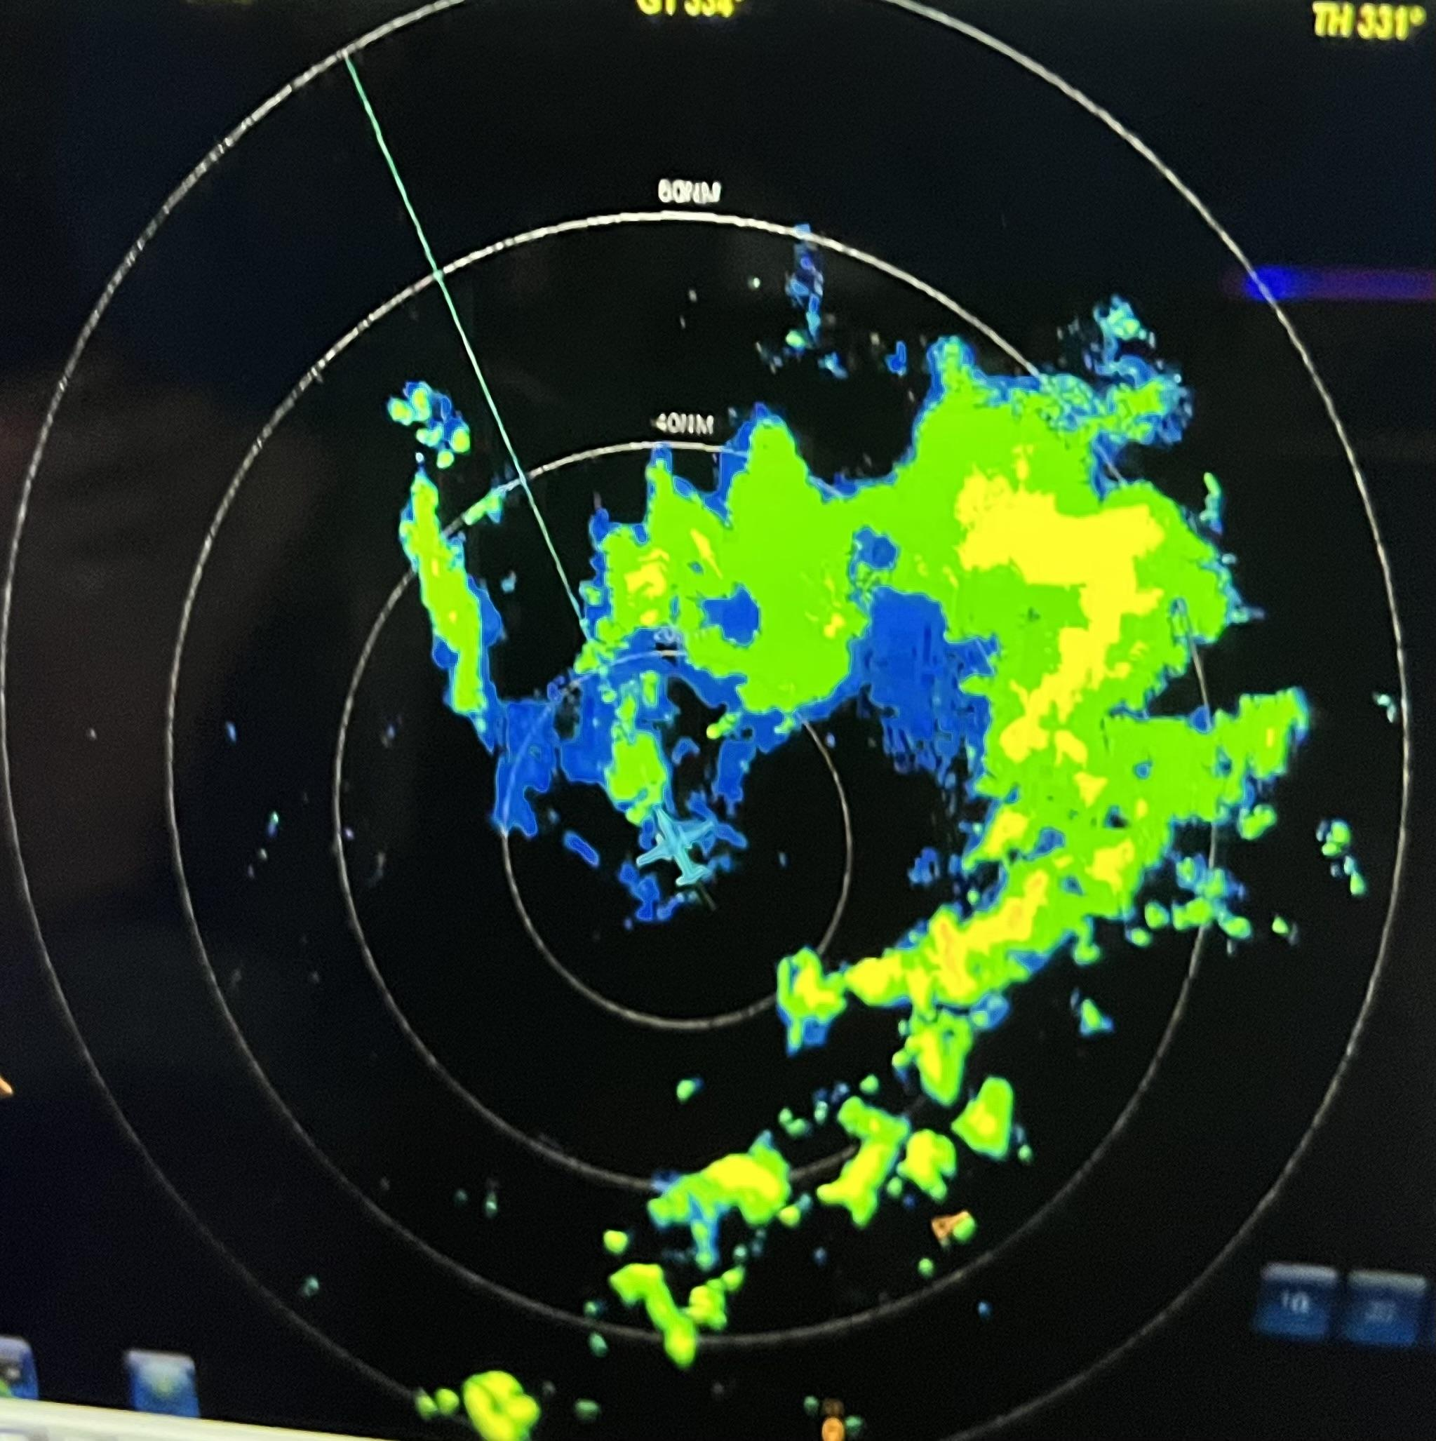
2118 | Drop #4 midpoint, AXBT #2 released and measured an SST of 28.82C
2124 | We are planning to line up our west-east pass from pt 3-4 on the AF fix. However, air space restrictions will limit our leg from 3-center to 80 nm, not 105 nmi
2133 | Some new convection bubbling as we approach sunset  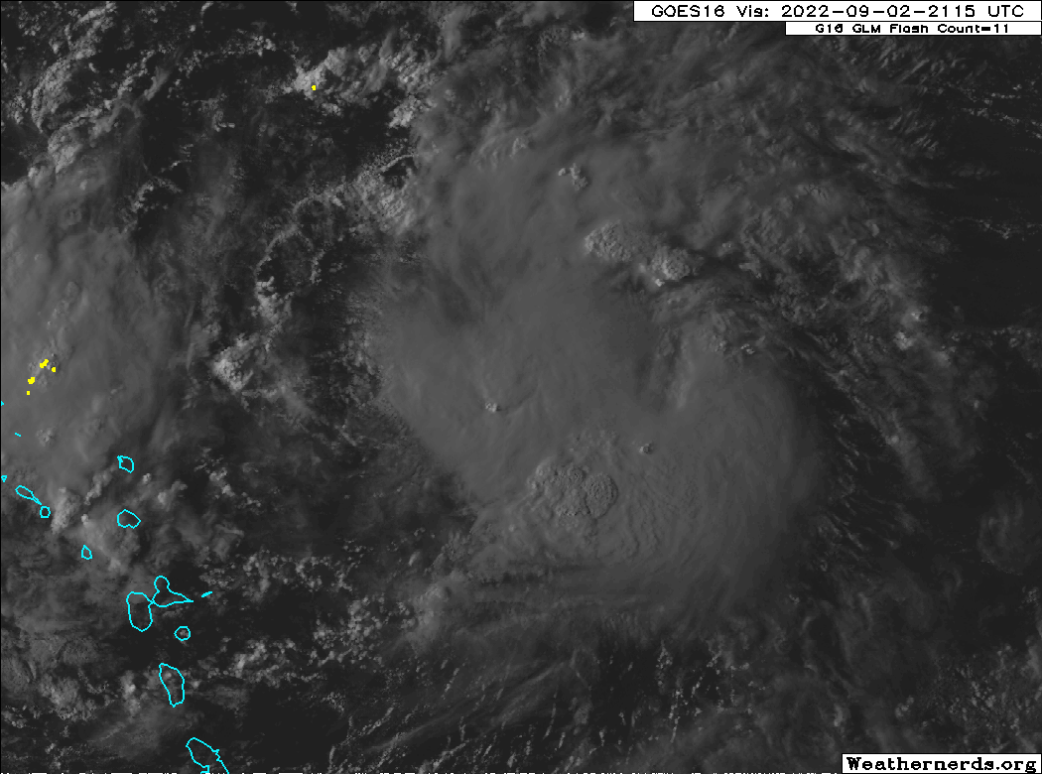
 | 
2139 | Combo Drop #5, AXBT #3 released and measured an SST of 28.83C near 19.86N, 59.55W  Sonde #5 drier than others, still 60-70% RH down to 4 kft  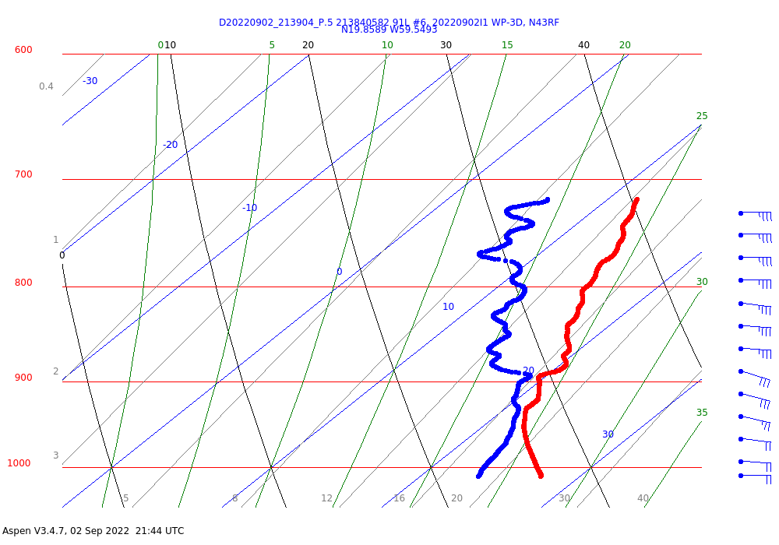
2155 | First set of synoptic plots  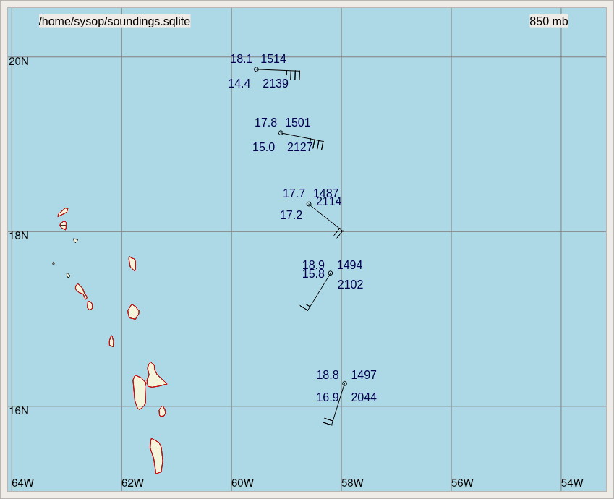
2210 | Combo drop #6, AXBT #4 released and measured an SST of 29.19C. Drop data looks moist.  ​​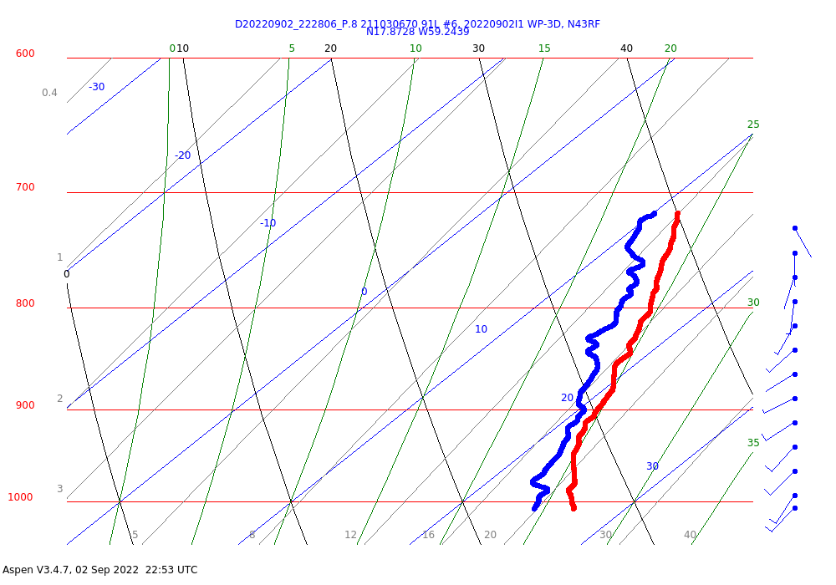
2214 | Some SW->NE tilt  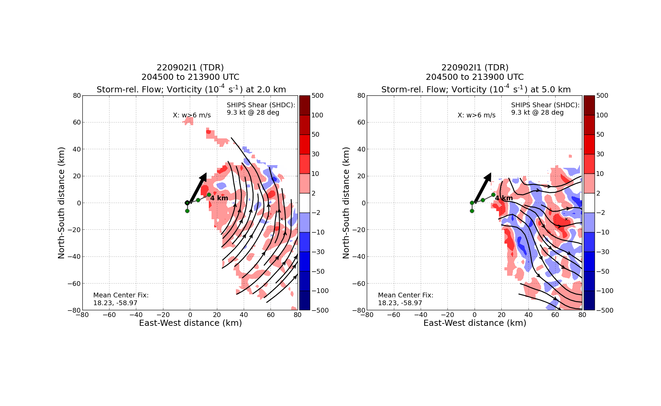
2219 | Drop #7 midpoint, 17.9193N, 59.7913W
2228 | Drop #8 at center fix 10 kft, near 17.8728N, 59.2439W
2240 | Frank notes a crescent band-like feature forming  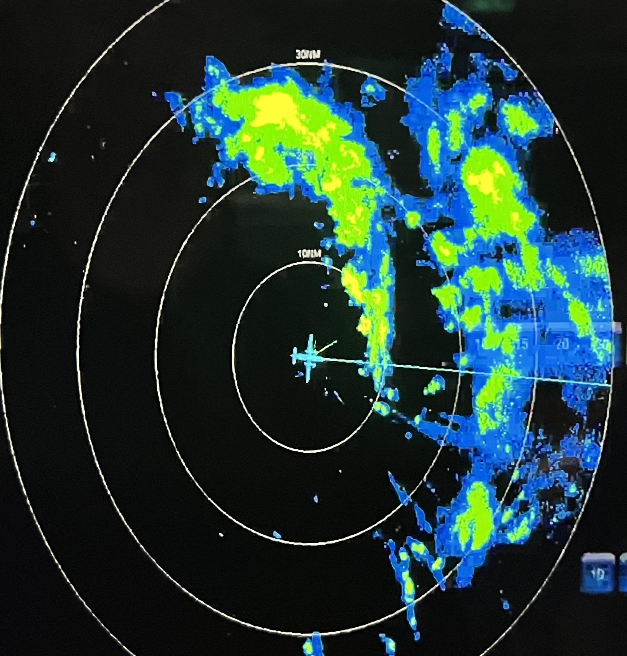
2240 | Drop #9 midpoint near 17.8324N, 58.3513W in massive stratiform area  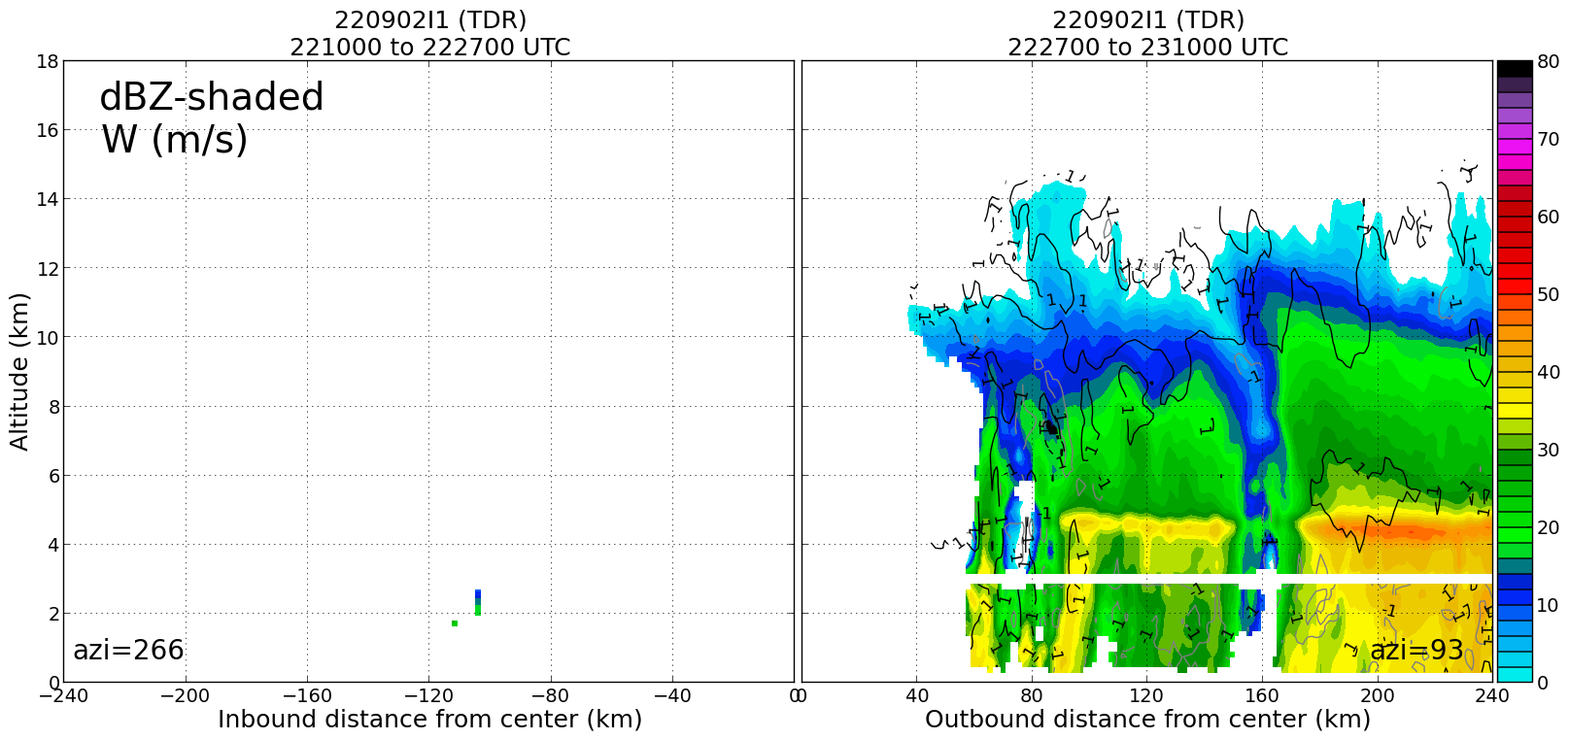  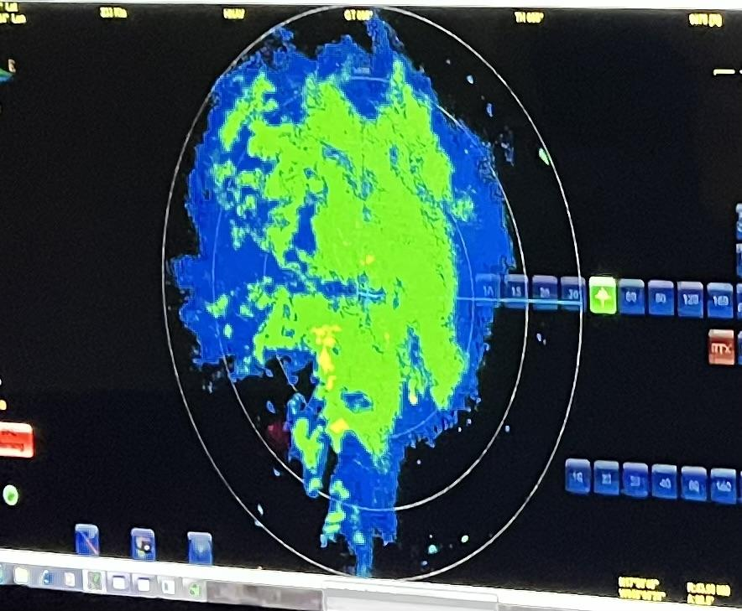
2307 | Drop #10 endpoint
2310 | 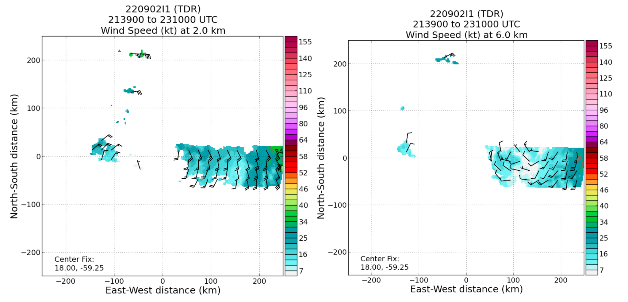  Large tilt between 2 km center and 6 km center. Subjective interpretation differs a bit from objective tilt estimate in the first analysis as shown above
2321 | Tracking 270 degrees back through for VAM leg #2
2325 | CB blowing up over the center
0008 | Higher reflectivities along the flight track from ~3- 7km. Maybe it is attenuation in a high rain-rate region? TDR shows an impressive bright band in the stratiform region too.  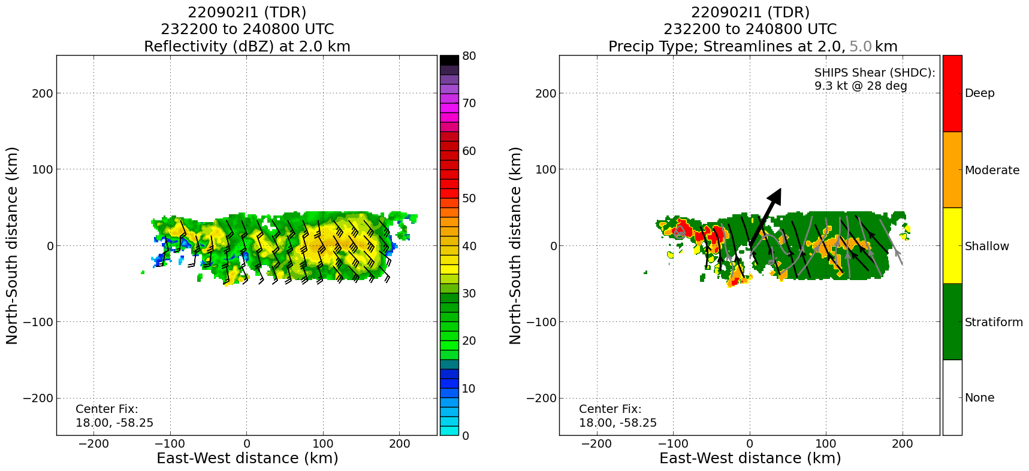  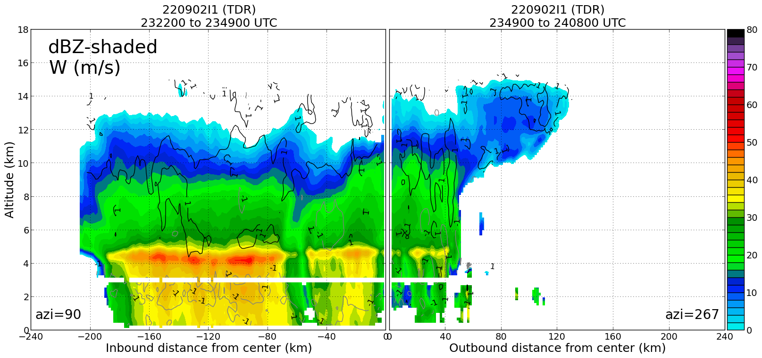  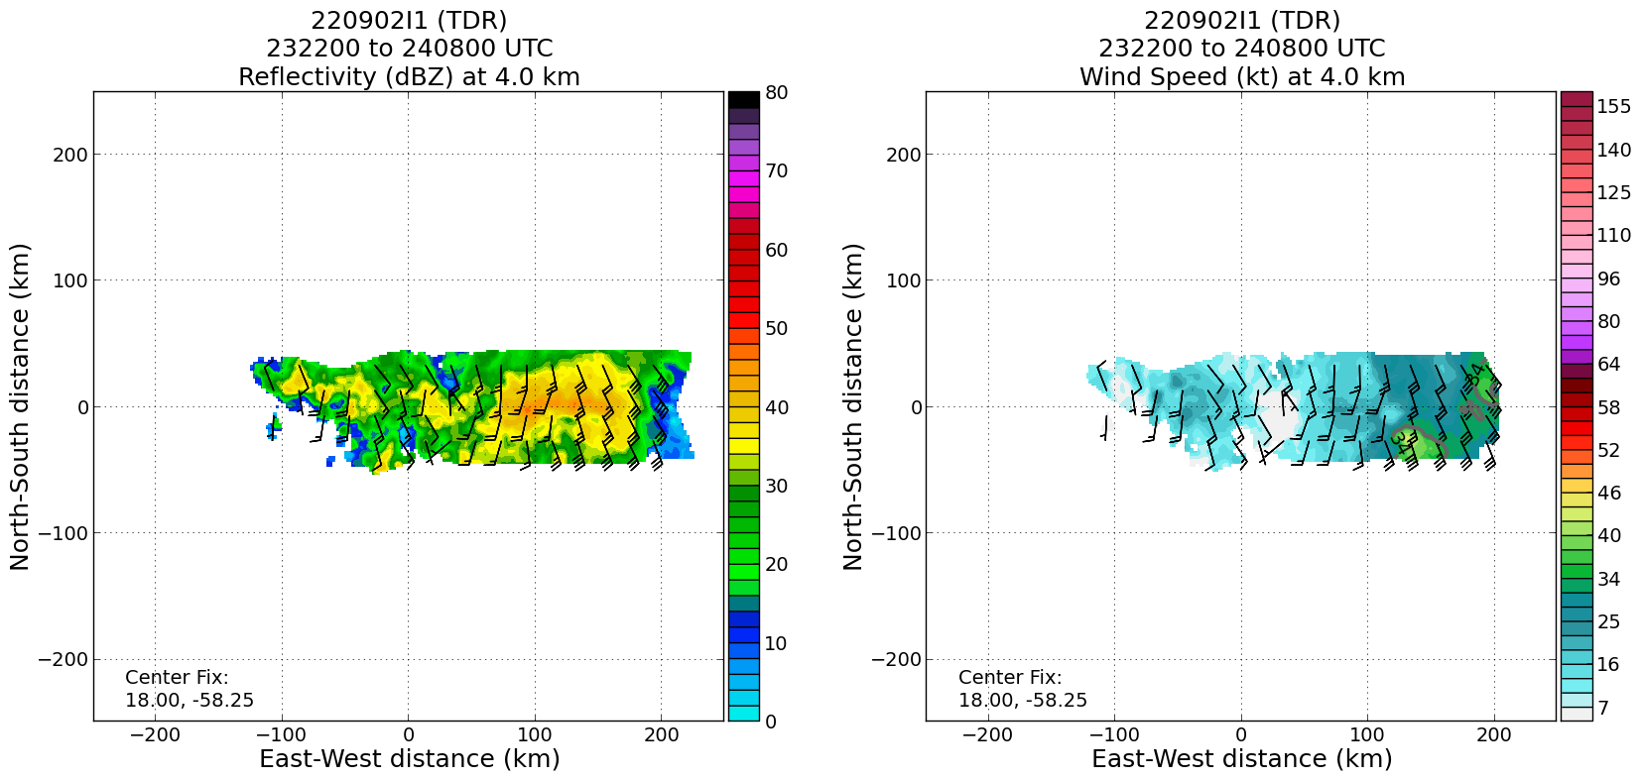  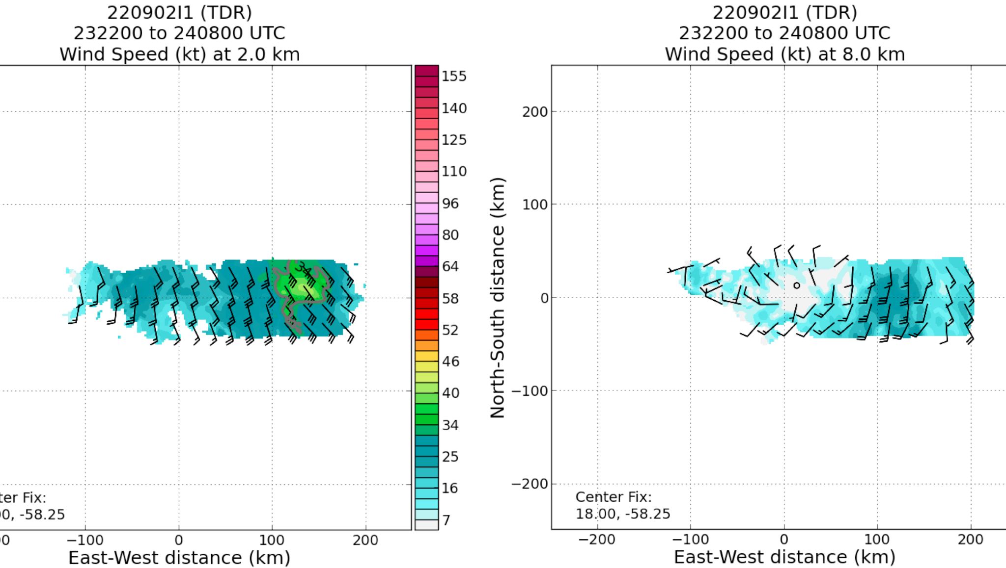  Large 2–8 km tilt. Wind max at 2 km well displaced from circulation center.
0024 | Heading outbound to finish the VAM  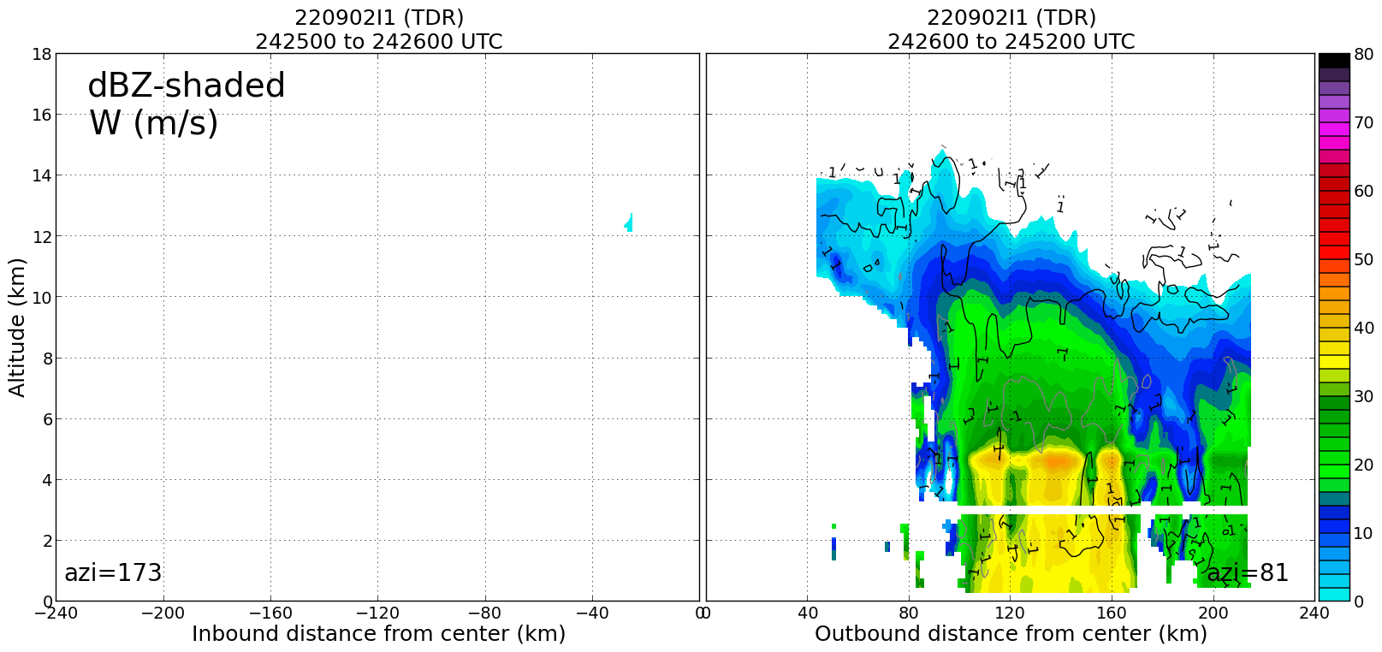
0041 | Revised PT 4 is 18.25 N, 57.65 W
0049 | AXBT #5
0052 | EP Pt 4, turn to track 300 degrees to Pt 5
0114 | Turn to track 210 degrees
0114 | Combo drop #11, AXBT #6 released and measured an SST of 28.66C near 19.4199N, 58.7124W
0125 | Drop #12 mid point drop, 18.7944N, 59.1906W
0136 | Microwave Imagery from ~0036Z suggest most of the deep convection is still east of the LLC
0137 | Combo drop #13, AXBT #7 released and measured an SST of 28.85C
0146 | Drop #14 mid point, 18.0640N, 59.5124W
0155 | 015515 UTC combo drop #15 at EP, AXBT #8 released near  17.0058N, 60.1357W  Science Complete
Final swath and composite analysis show the apparent large tilt (> 100 km) between the low-level (1–3 km) and mid-level (5–7 km) centers. The mid-level circulation is very broad and predominantly within the stratiform region. Deep convection is located nearer the LLC along the western edge of the MLC. Indications of potential upward growth of the low-level vortex with a more compact circulation now up to 4–5 km altitude. The low-level vortex may have an ~30–50 km tilt (as a separate entity from the broad MLC previously discussed).

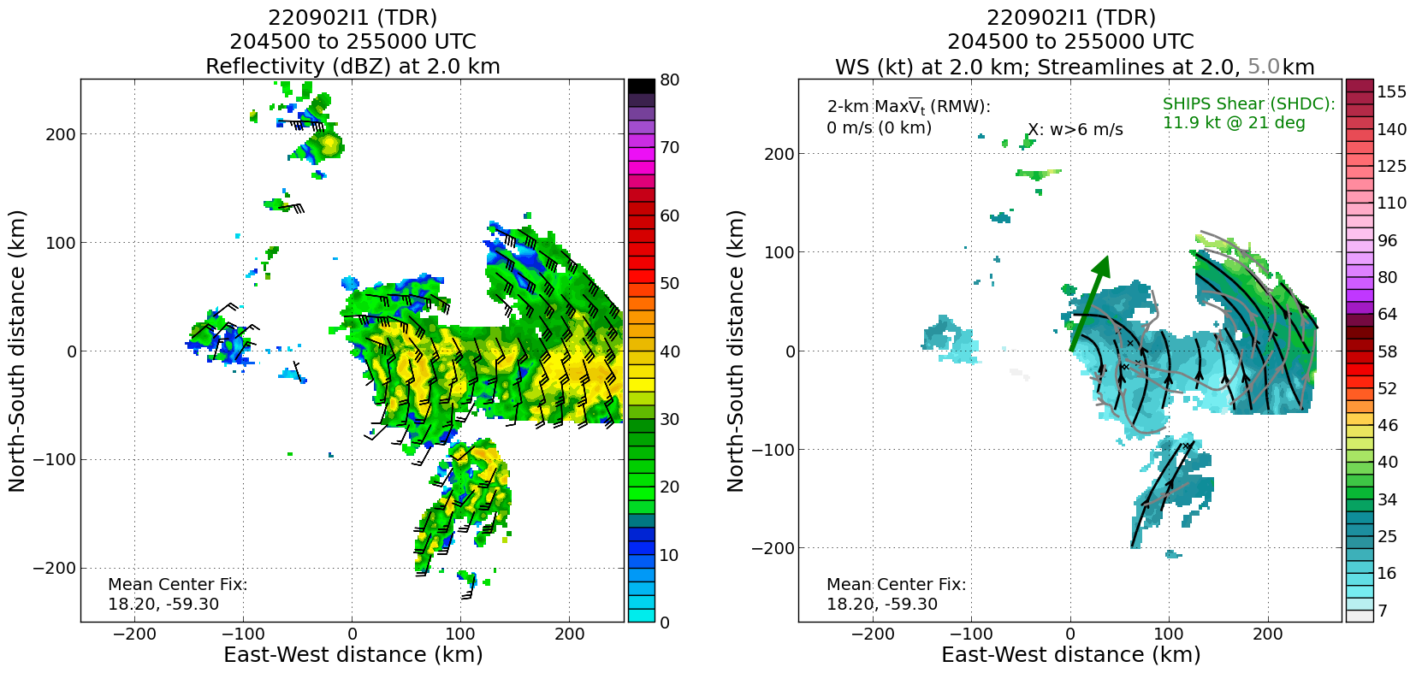

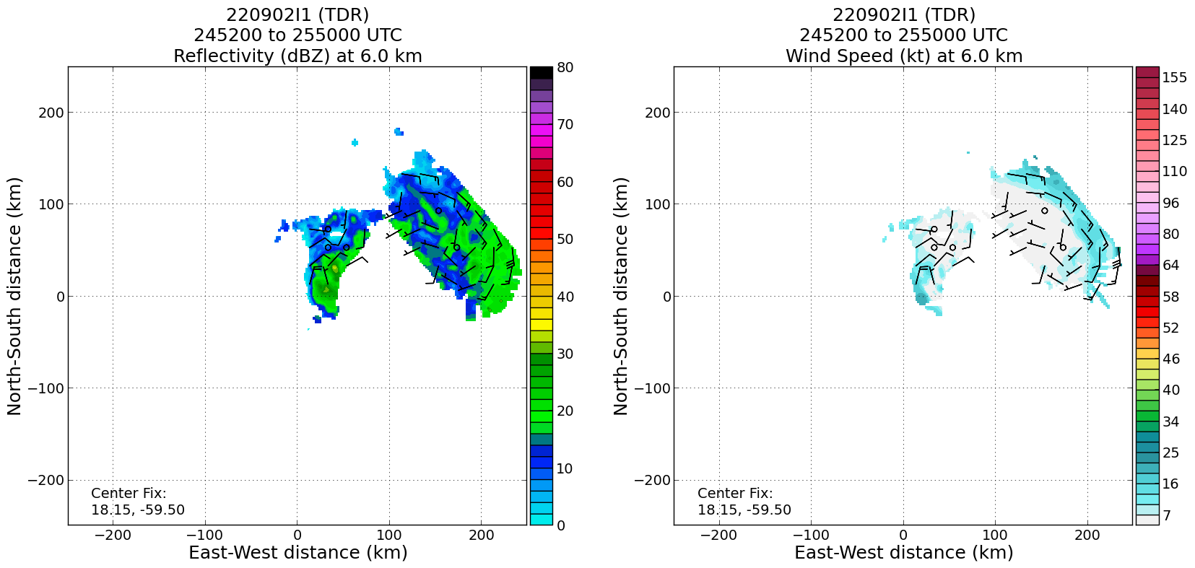
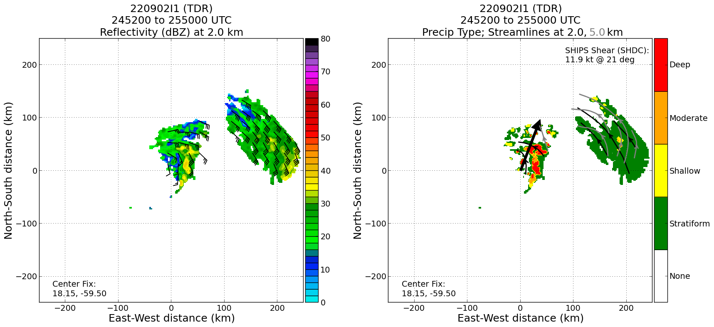

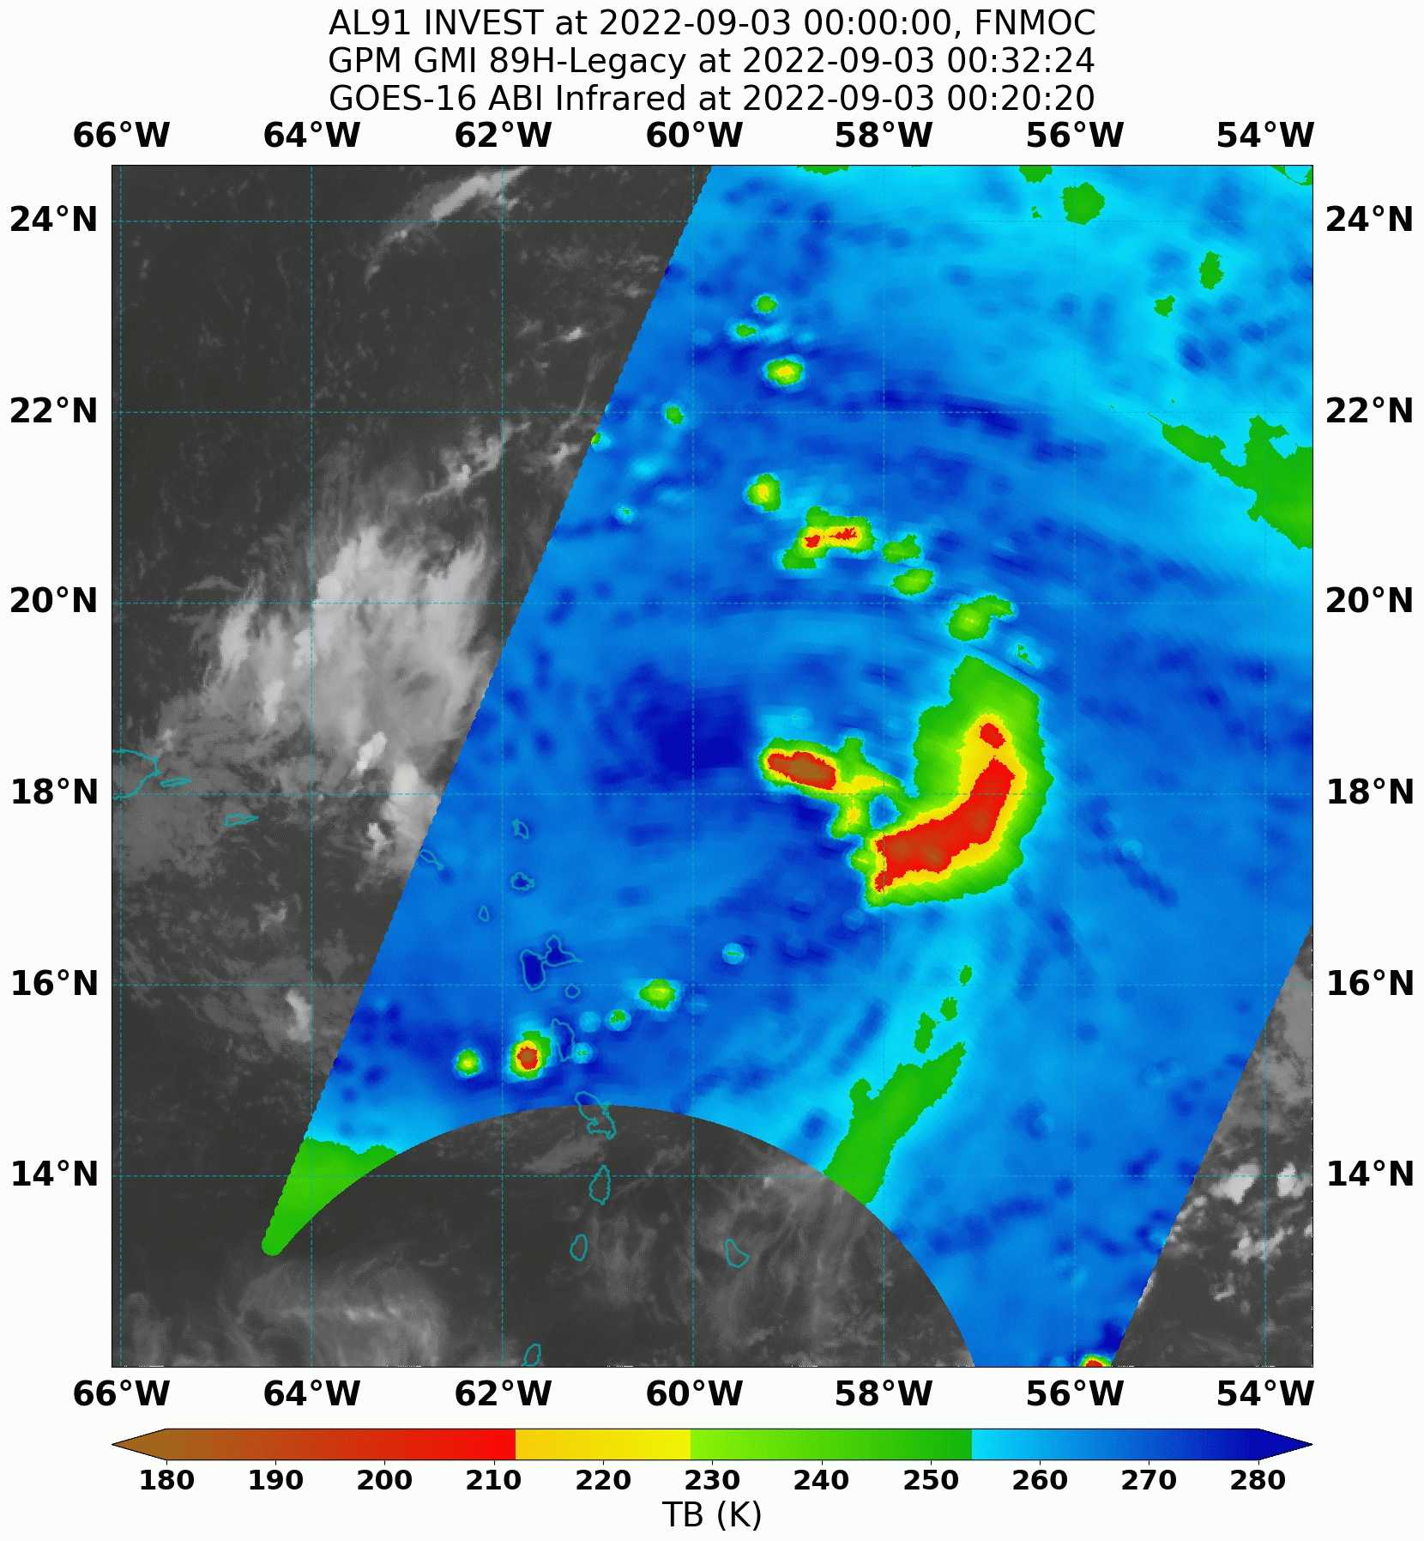
 | 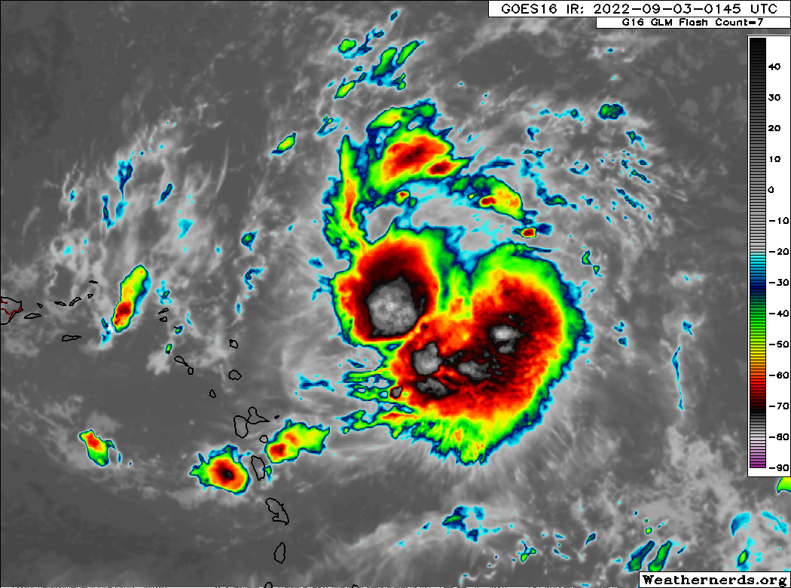
Final 850 hPa and WL150 synoptic maps

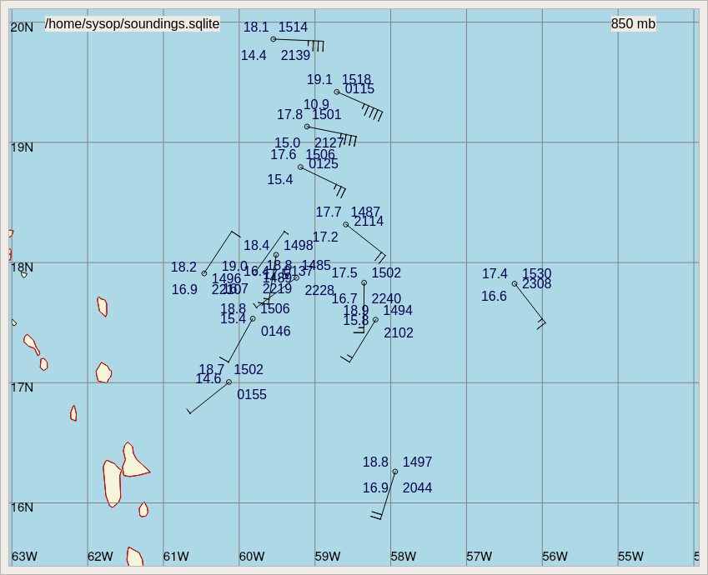

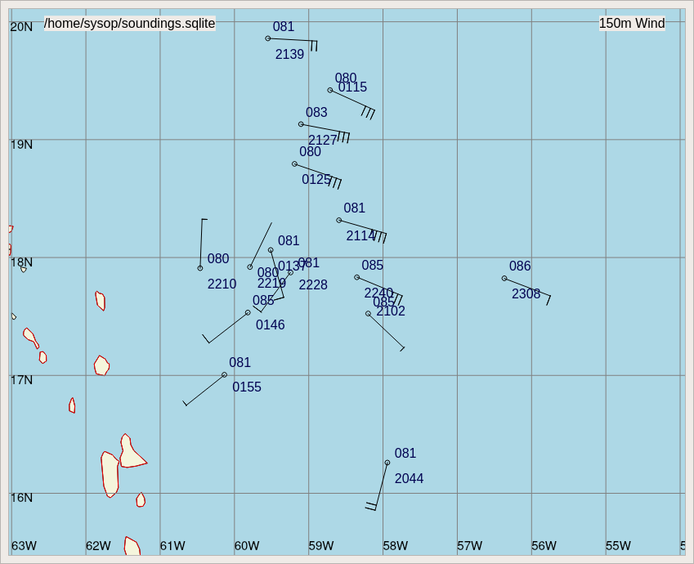

POST-FLIGHT
Mission Summary | We flew a butterfly pattern with a vortex alignment module in AL91. The storm was developing concentrated convection near the center, and appeared to be attempting to align and generate a more defined circulation. This made it a perfect case for the Vortex Alignment Module (VAM).  This is the first time the VAM was successfully flown. The additional legs captured the evolution of both the precipitation and vortex structure near the low- and mid-level centers.  The timing of the module was ideal as an intense convective burst began just prior to the start of the module and continued throughout the module.  Based on the data from this flight and an earlier Air Force flight, the decision was made to upgrade the system to AL06 (TS Earl), which “officially” makes this a genesis mission.
Actual Standard Pattern Flown | Butterfly with inbound and outbound legs for the VAM.  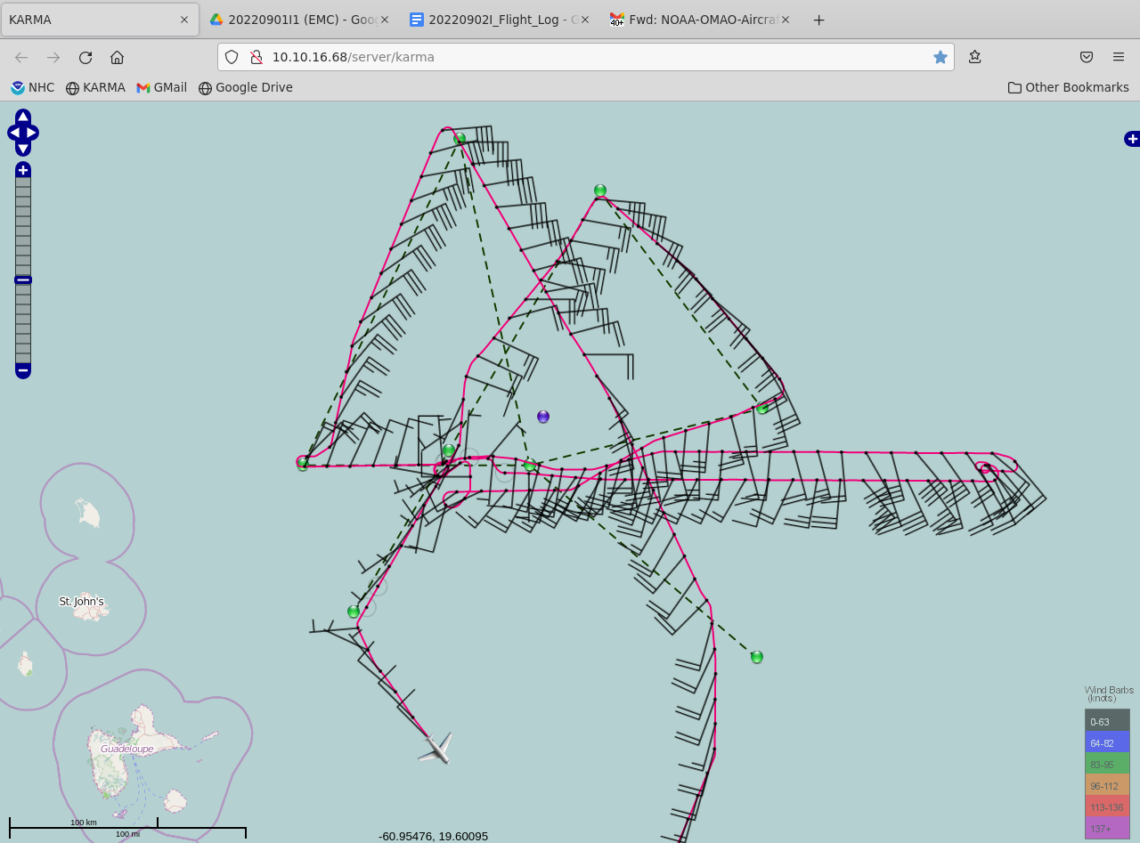
APHEX Experiments / Modules Flown | Data collection supports the Genesis Stage Experiment: PREFORM, as well as the Early Stage Experiment: AIPEX, specifically the Vortex Alignment Module within AIPEX.
Plain Language Summary | - We flew another mission into AL91 to help study the processes that were allowing it to attempt to form into a tropical cyclone. The storm became better organized throughout the day today, and based on Air Force Reserve and our observations NHC upgraded AL91 to Tropical Storm Earl.
Instrument Notes | No issues
Final Mission Track | 