MISSION PLAN
FLIGHT ID | 20220901I1 | STORM | AL91
MISSION ID | 02FFA | TAIL NUMBER | NOAA43
TASKING | EMC | PLANNED PATTERN | Butterfly
MISSION SUMMARY
TAKEOFF [UTC] | 2004 | LANDING [UTC] | 0247
TAKEOFF LOCATION | Barbados | LANDING LOCATION | Barbados
FLIGHT TIME | 6.7 | BLOCK TIME | 6.9
TOTAL REAL-TIME RADAR ANALYSES  (Transmitted) | 4 | TOTAL DROPSONDES (Good/Transmitted) | 18 (18 / 18)
OCEAN EXPENDABLES (Type) | 7 AXBT (ONR) (all good) | sUAS (Type) | None
APHEX EXPERIMENTS / MODULES | Genesis Stage Experiment: PREFORM; Ocean Survey Experiment: Sustained and Targeted Ocean Observations
HRD CREW MANIFEST
LPS ONBOARD | Marks | LPS GROUND | Holbach
TDR ONBOARD | Reasor | TDR GROUND | Gamache
ASPEN ONBOARD | Aberson | ASPEN GROUND | None
NESDIS SCIENTISTS | Chang, Sapp
GUESTS (Affiliation) | None
AOC CREW MANIFEST
PILOTS | Kevin Doremus, Bret Copare, Chris Wood
NAVIGATOR | Andrew Utama
FLIGHT ENGINEERS | Darby, Pittman
FLIGHT DIRECTOR | Quintin Kalen, Holmes
DATA TECHNICIAN | Richards
AVAPS | Warnecke

PRE-FLIGHT
Flight Plan | 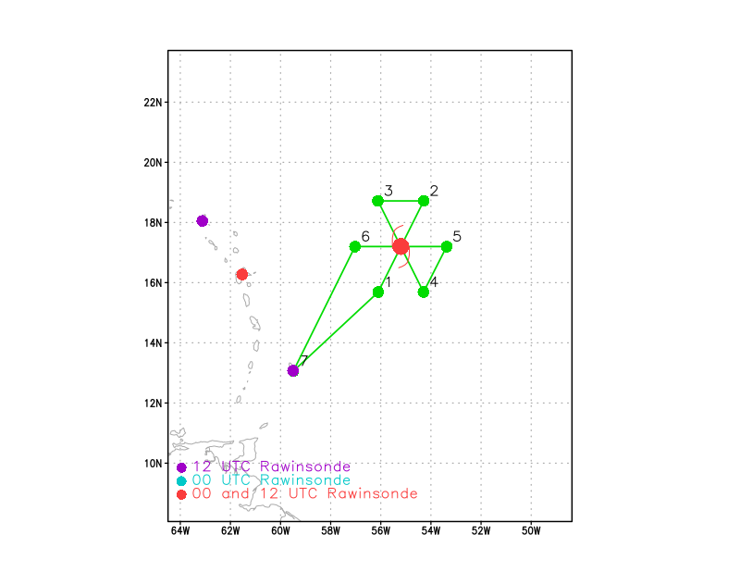  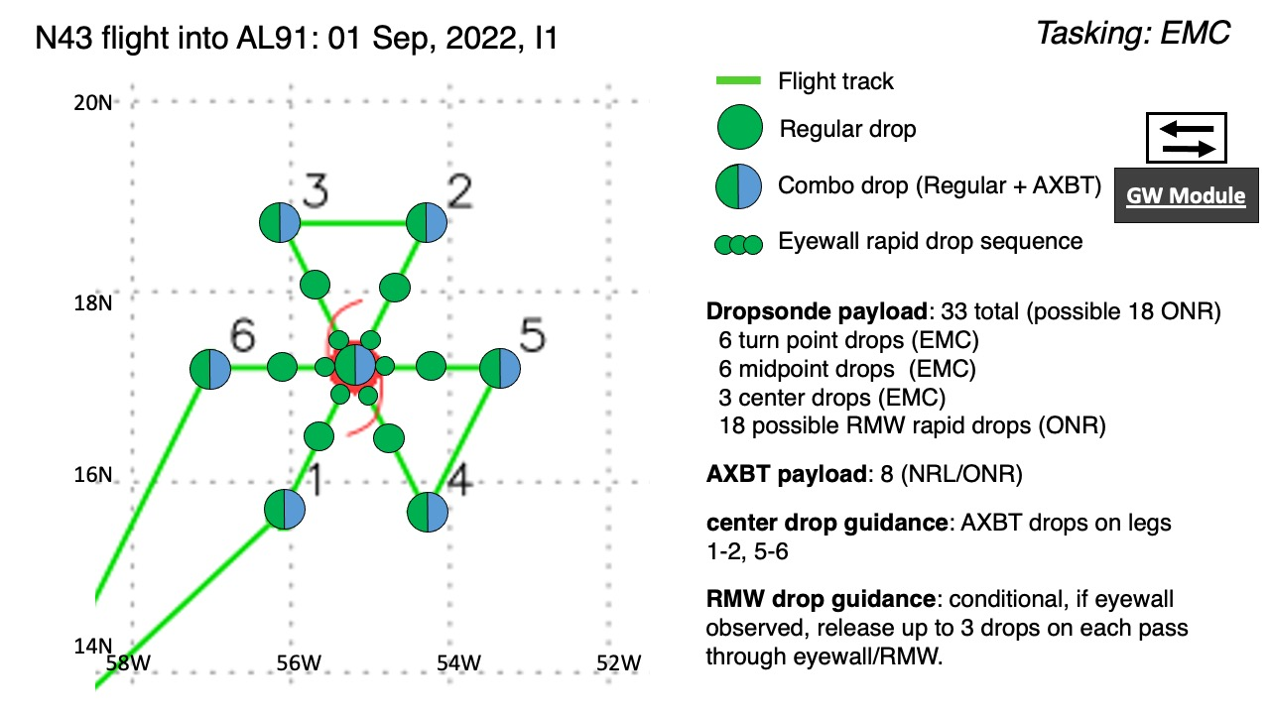  Pattern: Fly butterfly pattern with 105 nmi legs  Altitude: 10 kft (pressure altitude)  On-station time for EMC data collection for the 0000Z assimilation window is between 2100Z and 0300Z.  AXBTs deployed from inside the cabin.
Expendable Distribution | Up to 33 sondes planned (all dropsondes transmitted to the GTS); 8 ONR/NRL AXBTs (all AXBTs transmitted to the AOC ground server if possible).  Release sondes at endpoints, midpoints, centers; possible supplemental rapid RMW drops across RMW/eyewall inbound and outbound.
Preflight Weather Briefing | The storm is much weaker than planned for. We decided to forgo the RMW drop sequence unless something changes. We are planning to follow the mission as briefed up to point 5. At that point we are planning to track to the Saildrone location to drop a sonde and possibly find an area to do a mini convective burst module. Then we plan to head back to point 5 and complete our last full pass through the system and then to Barbados.  NHC currently gives the disturbance a 50% chance to develop in the next 48 hrs and 70% in the next 5 days. There is a lot of dry air surrounding the disturbance that it will need to overcome to develop further.
Instrument Notes | AVAPS, TDR, and MMR are all working.

IN-FLIGHT
Time [UTC] | Event
1959 | Taxiing
2000 | 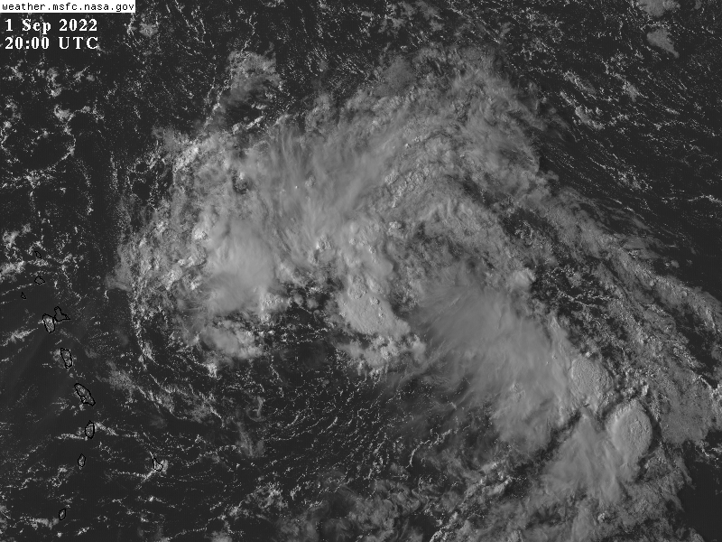  Disturbance is quite unorganized. However, convection continues to initiate.
2004 | Takeoff from Barbados
2028 | Nice clouds on approach to IP with rain shaft obscuring sun
2035
2059 | At the IP, but we are dealing with TEAL departing and waiting for them to clear the airspace. TEAL did not find a low-level circulation and were cleared to depart early. We are orbiting before starting the first leg waiting for clearance to descend. Nice echoes on MMR and plenty of CBs around to our NW and east of our IP. The ones to our east are feeding into the band wrapping around the east side of the LLC.
2110 | Cleared to descend
2113 | Descending and depressurizing for AXBTs. SFMR is acting up.
2122 | IP Track 030 degree azimuth, combo drop #1, AXBT #1. >80% RH and 29.74C on the SST
2124 | Nice burst of convection to the NE of the IP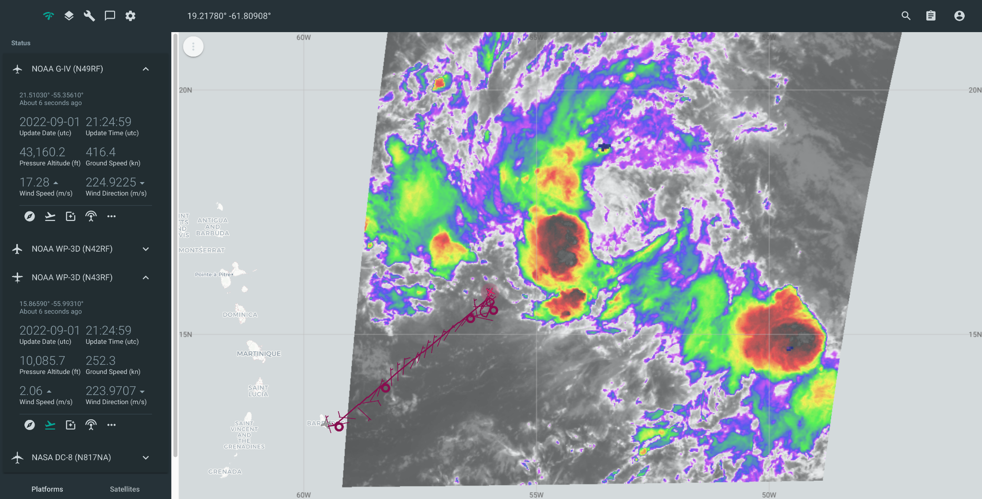
2134 | Drop #2 (no PTH) midpoint. MMR shows plenty of scatterers to the SE. Backup drop #3 released at 213525.
2146 | Center combo drop #4, AXBT #2 released with measured SST of 28.33C  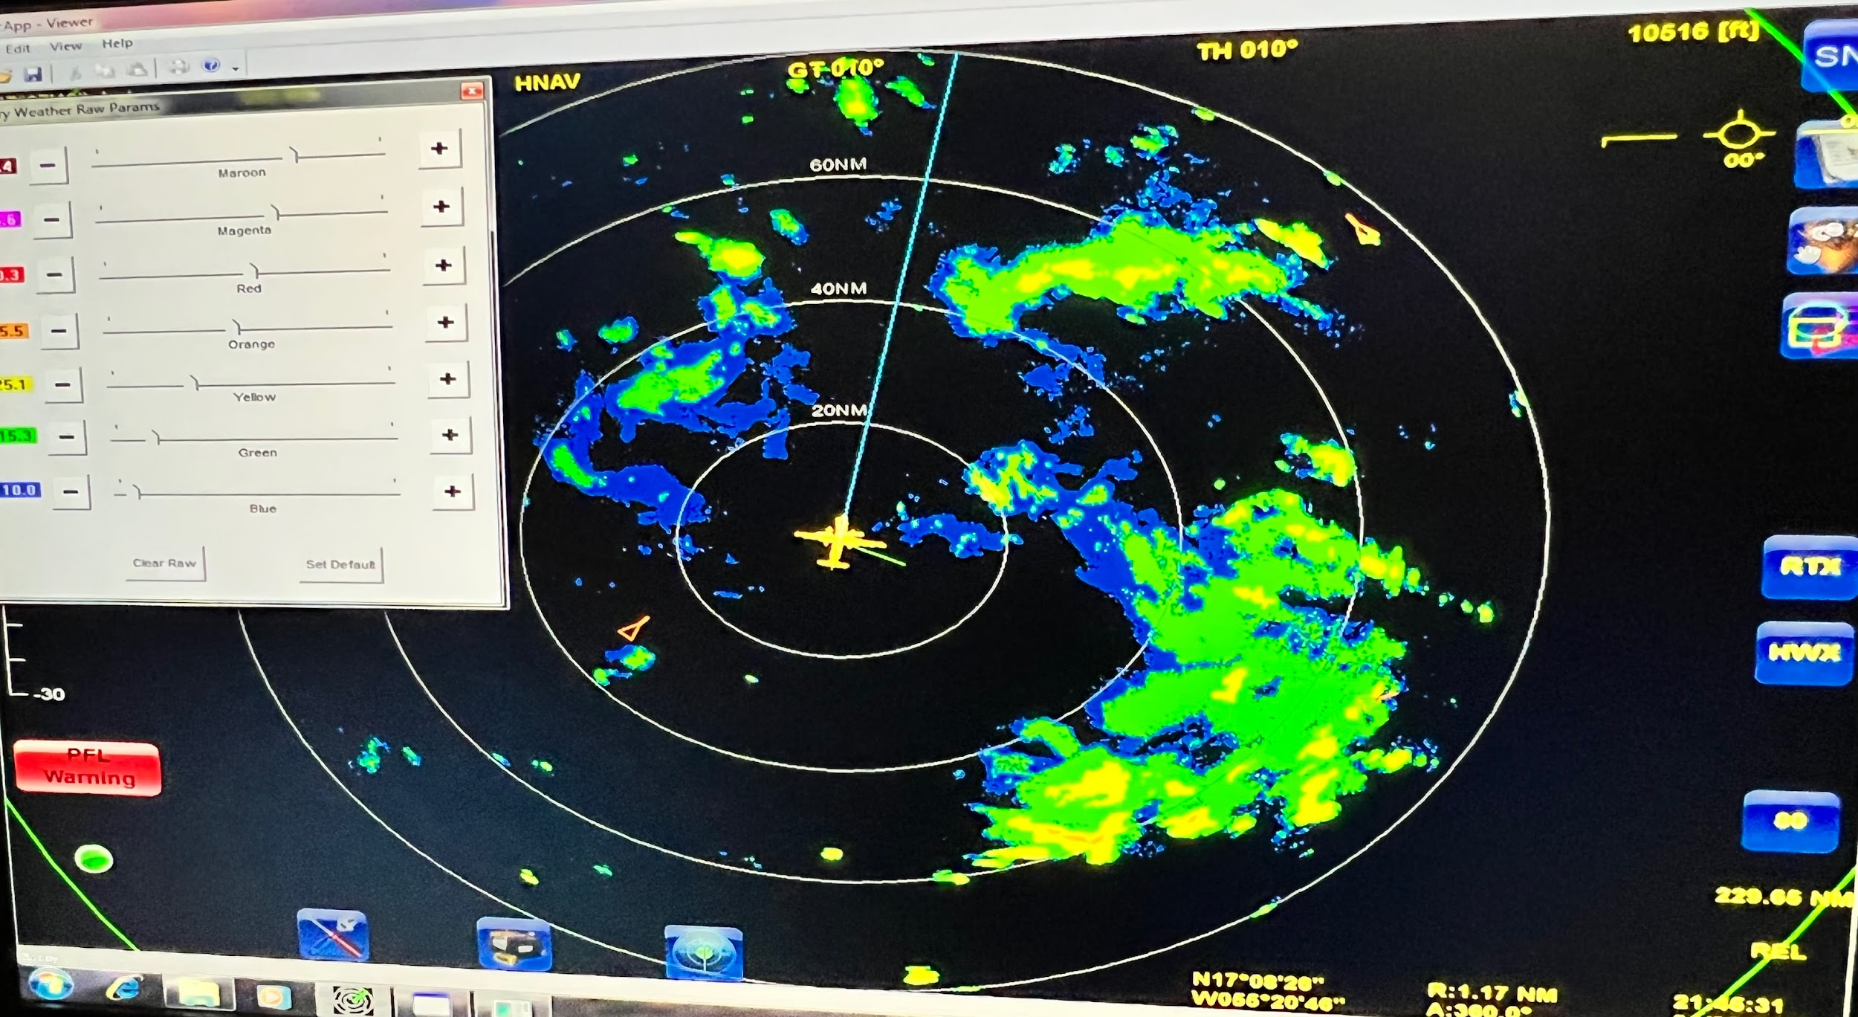
 | 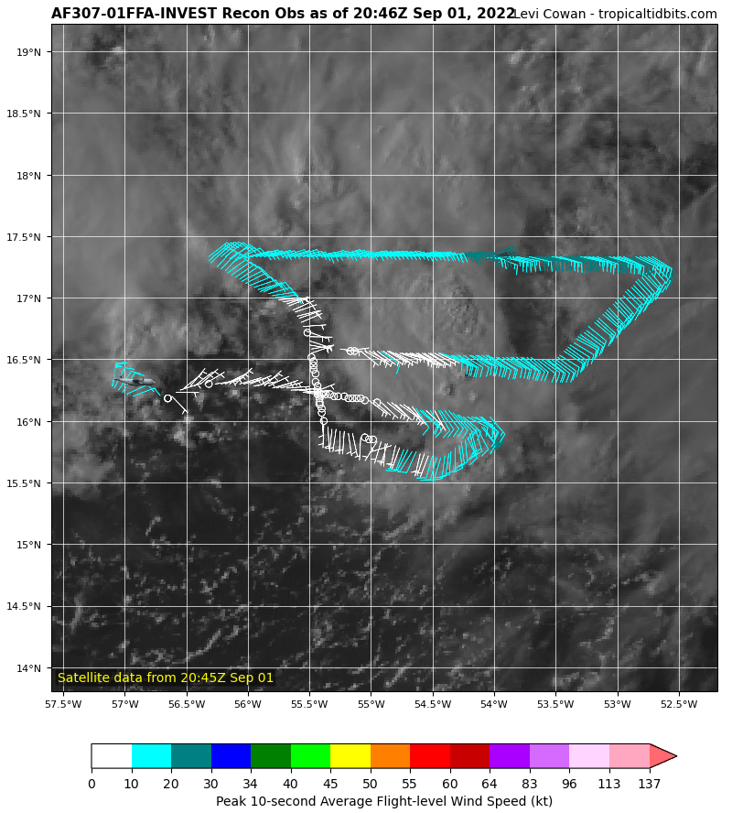AFRES was showing a broad circulation around 16-16.5N, 55.5W. Our FL and MMR echoes suggest that there is a mid-level center near 17.3N, 54W. I wonder if AFRES were further along the low level trough to the west. We have seen that a lot in these developing systems where we chase the little spinners at low levels when the real action is the mid-level center.
2154 | 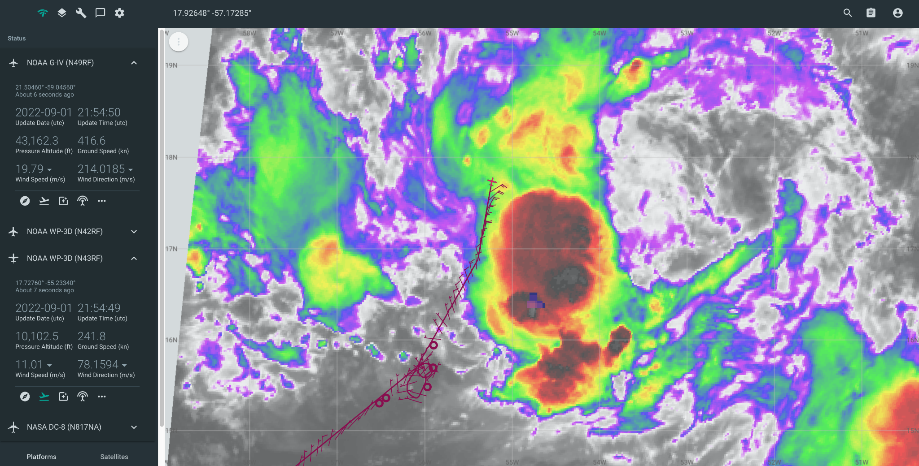
2200 | Drop #5 mid-point passing just north of the convective burst near the mid-level center. A lot of good TDR coverage in stratiform rain. Convection doesn’t have the really high echo tops we saw in earlier missions.
2214 | Combo drop #6, AXBT #3 released with a measured SST of 28.13C.  Surface synoptic map for leg 1 shows lowest heights at inbound midpoint. All sondes along this leg show fairly moist profiles. This is quite different from the first two N43 flights that showed very dry air all the way down to 850mb. Possible that the environment is becoming more conducive for genesis.  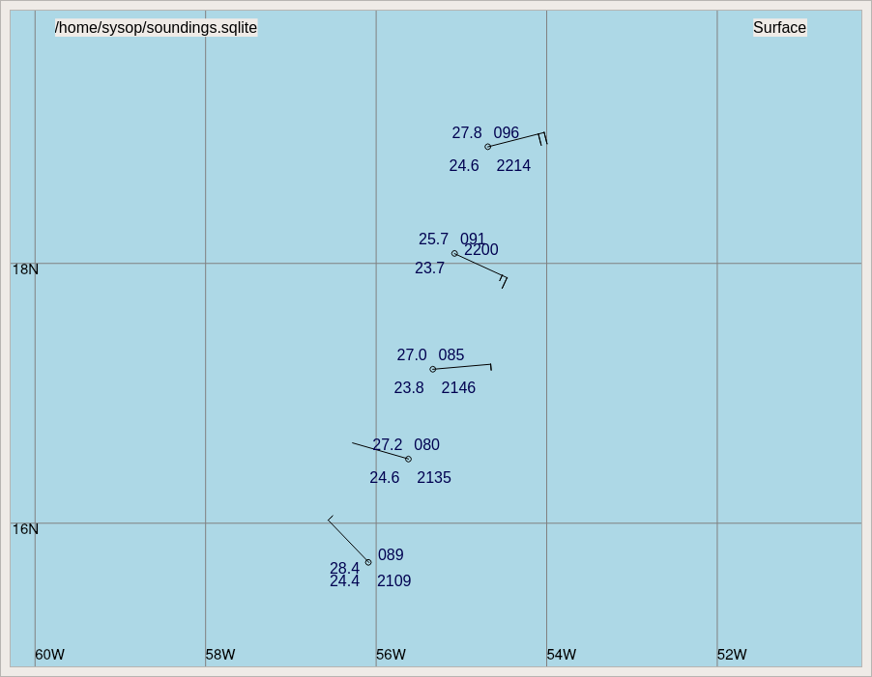  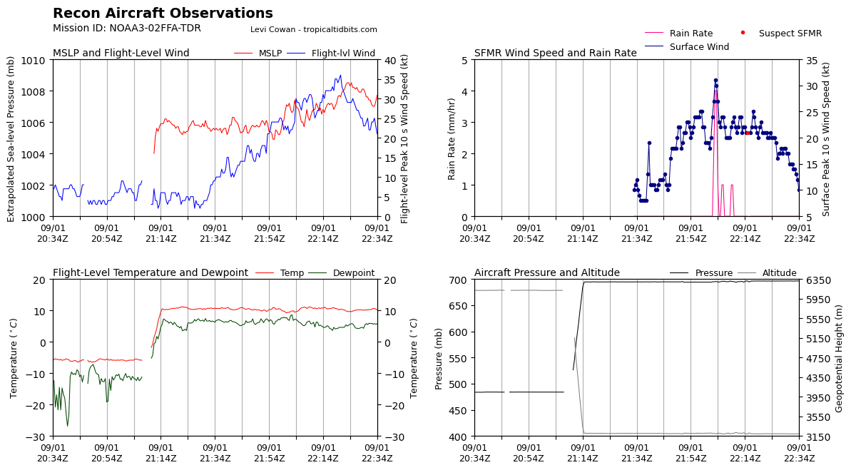
2233 | Turning to track 150 degrees. Plan is to follow the winds on the next inbound leg to see if we can find a mid-level center to fix. Likely will take us into the convection.
2235 | Combo drop #7, AXBT #4 released with a measured SST of 28.47C
2242 | GLM showing some lightning in the southern half of the convection along this leg.  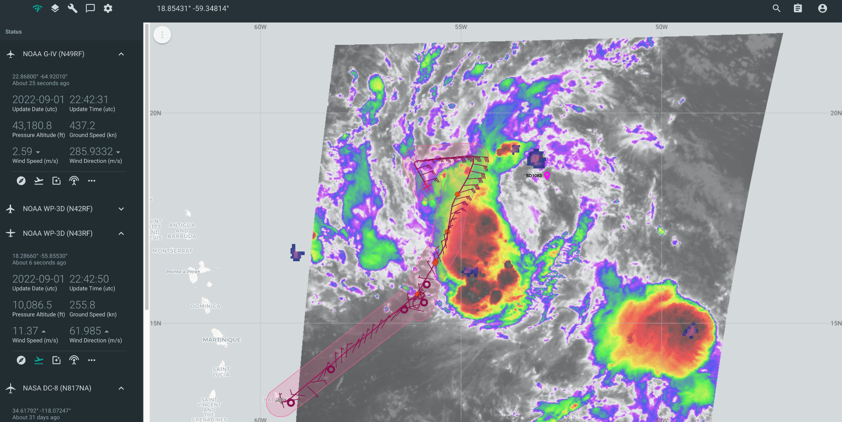
2248 | Drop #8 mid-point; now hunting for mid-level center
2259
2304 | Drop #9 roughly a center point. Tried to follow the winds, but they didn’t completely close off. Large band to the east, mostly stratiform. 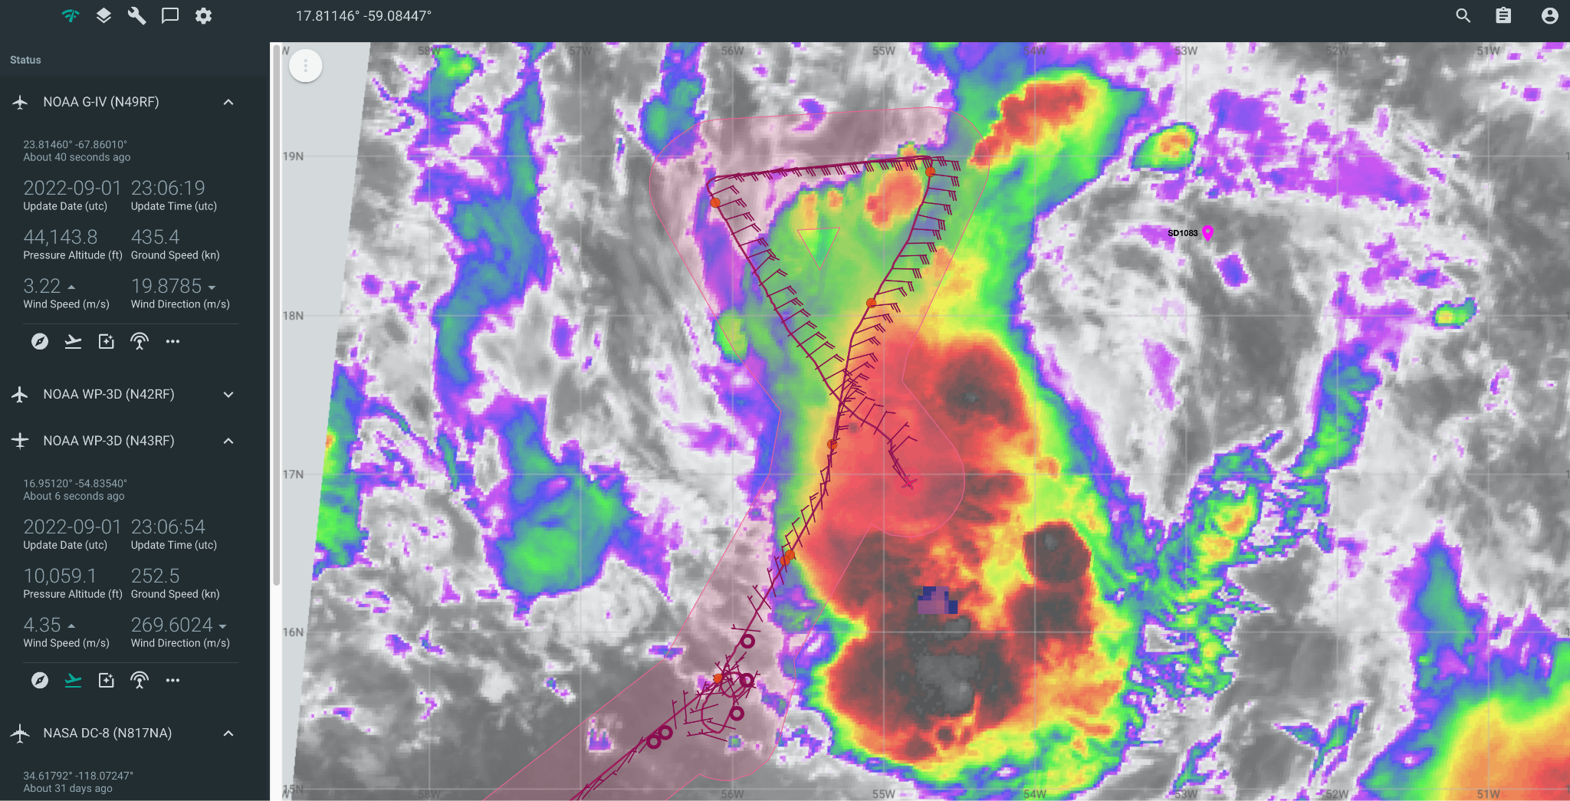
2314 | Sticking with original plan to go to pt 5 then track to the Saildrone, drop there, then head back to pt 5
2314 | Drop #10 mid-point in deep stratiform precip
2321 | AXBT #5 released with measured SST of 28.43C. Dropped a little early to avoid dropping in turbulence at pt 4.
2326 | Drop #11; turning to track 030 up the rainband to point 5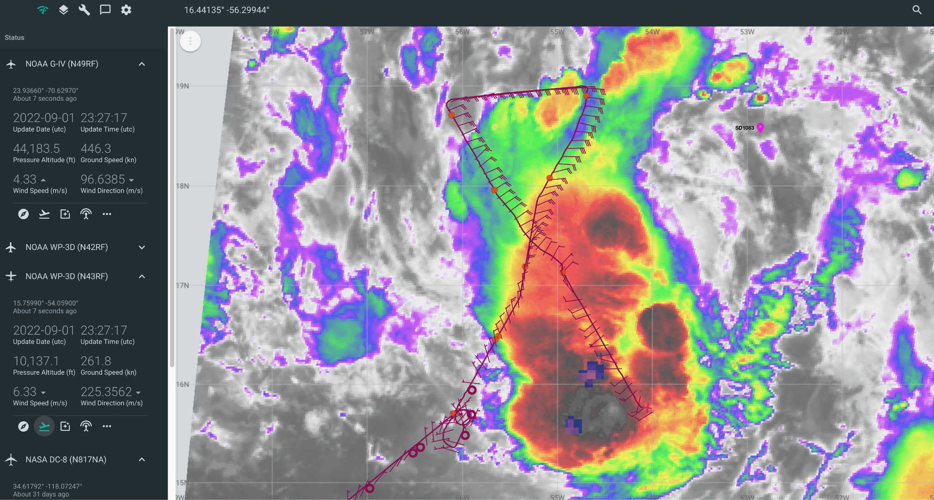
2328 | Trying to find a spot to orbit out of turbulence to deal with a few instrument issues. After everything is sorted out we will track directly to saildrone location instead of pt #5. Still going to do a complete leg from pt 5 to 6. Going to look for a location for a mini convective burst module near pt 6 if time allows. There is currently some convection near pt 6 but it appears to be waning. 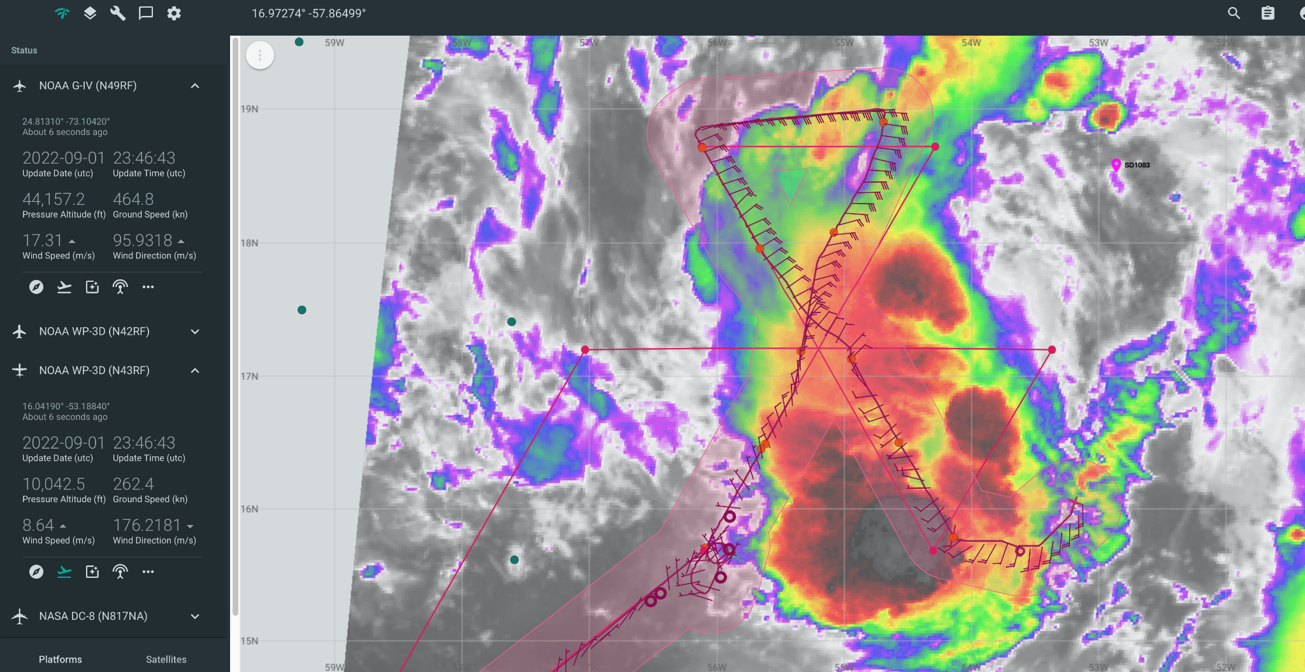  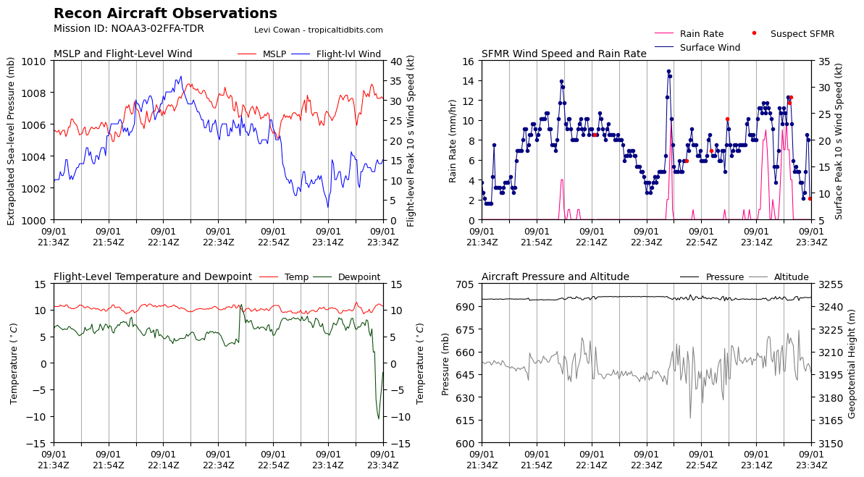
2342 | 850 mb synoptic map from first two legs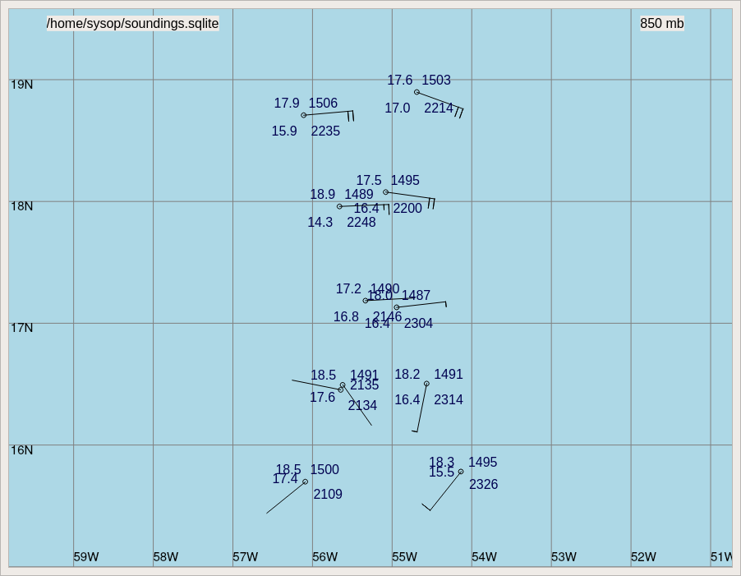
0007 | Nice convective cell with a good bit of lightning near the saildrone.  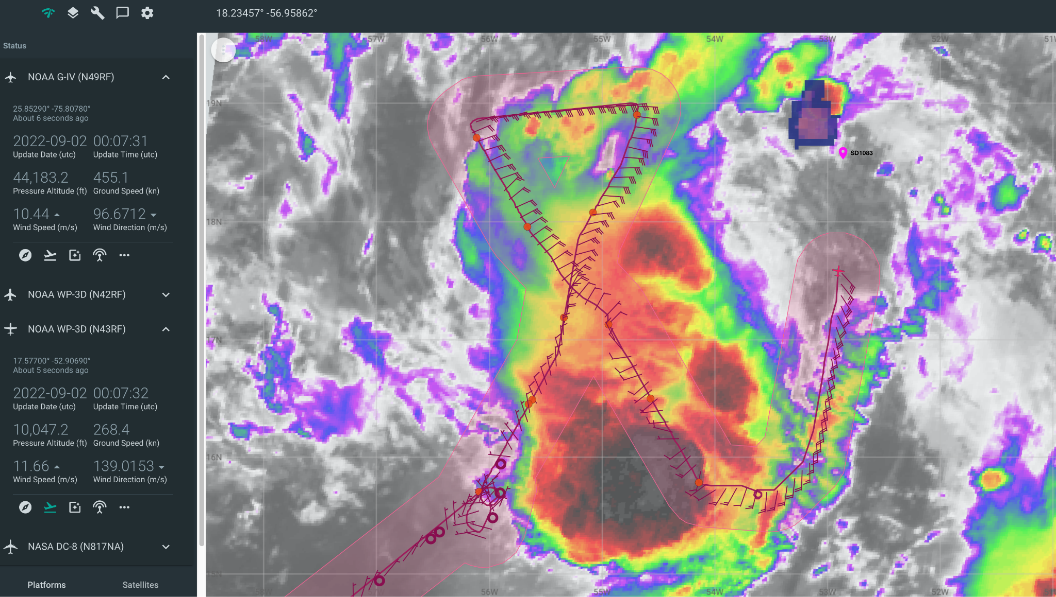
0015 | MMR shows a cell sitting right on top of the Saildrone based on the AIS location.  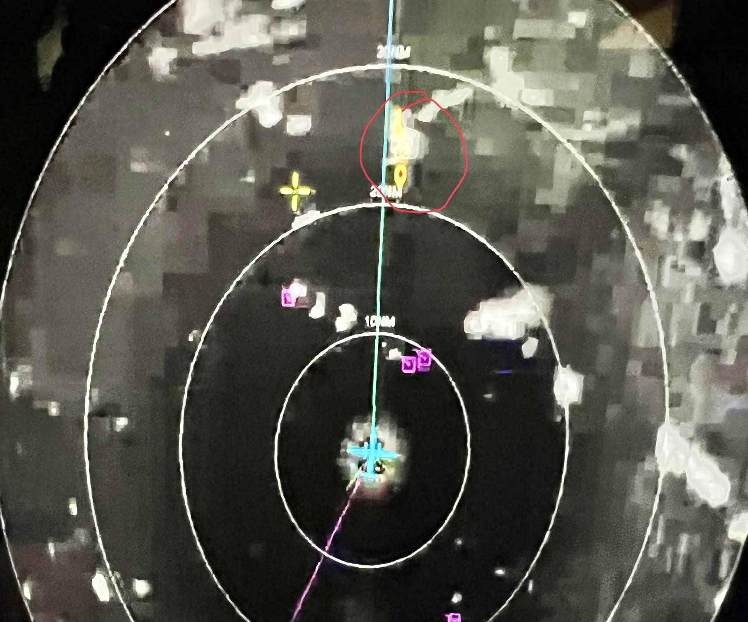
0021 | Drop #12 released 8 nmi south of the Saildrone  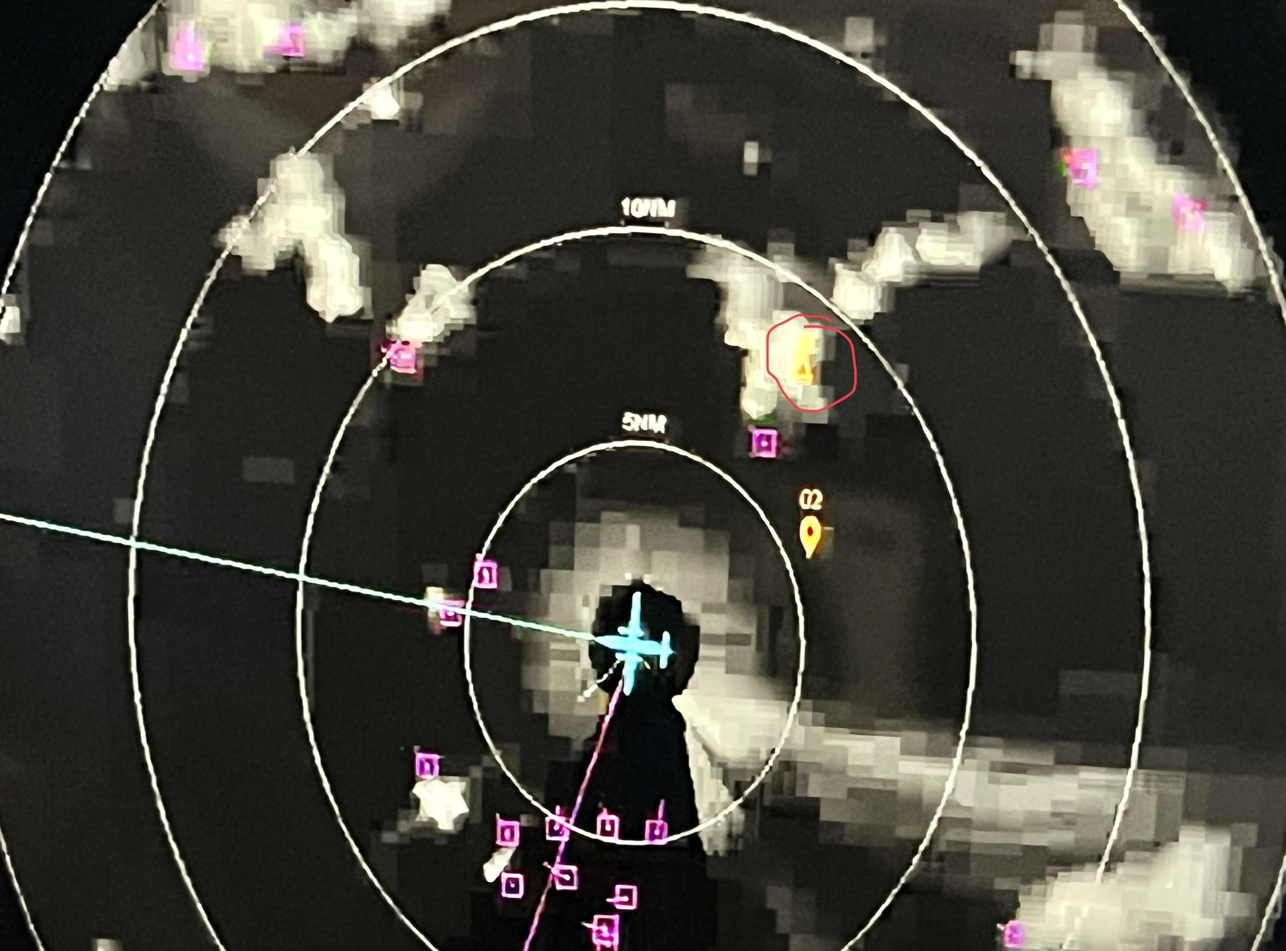  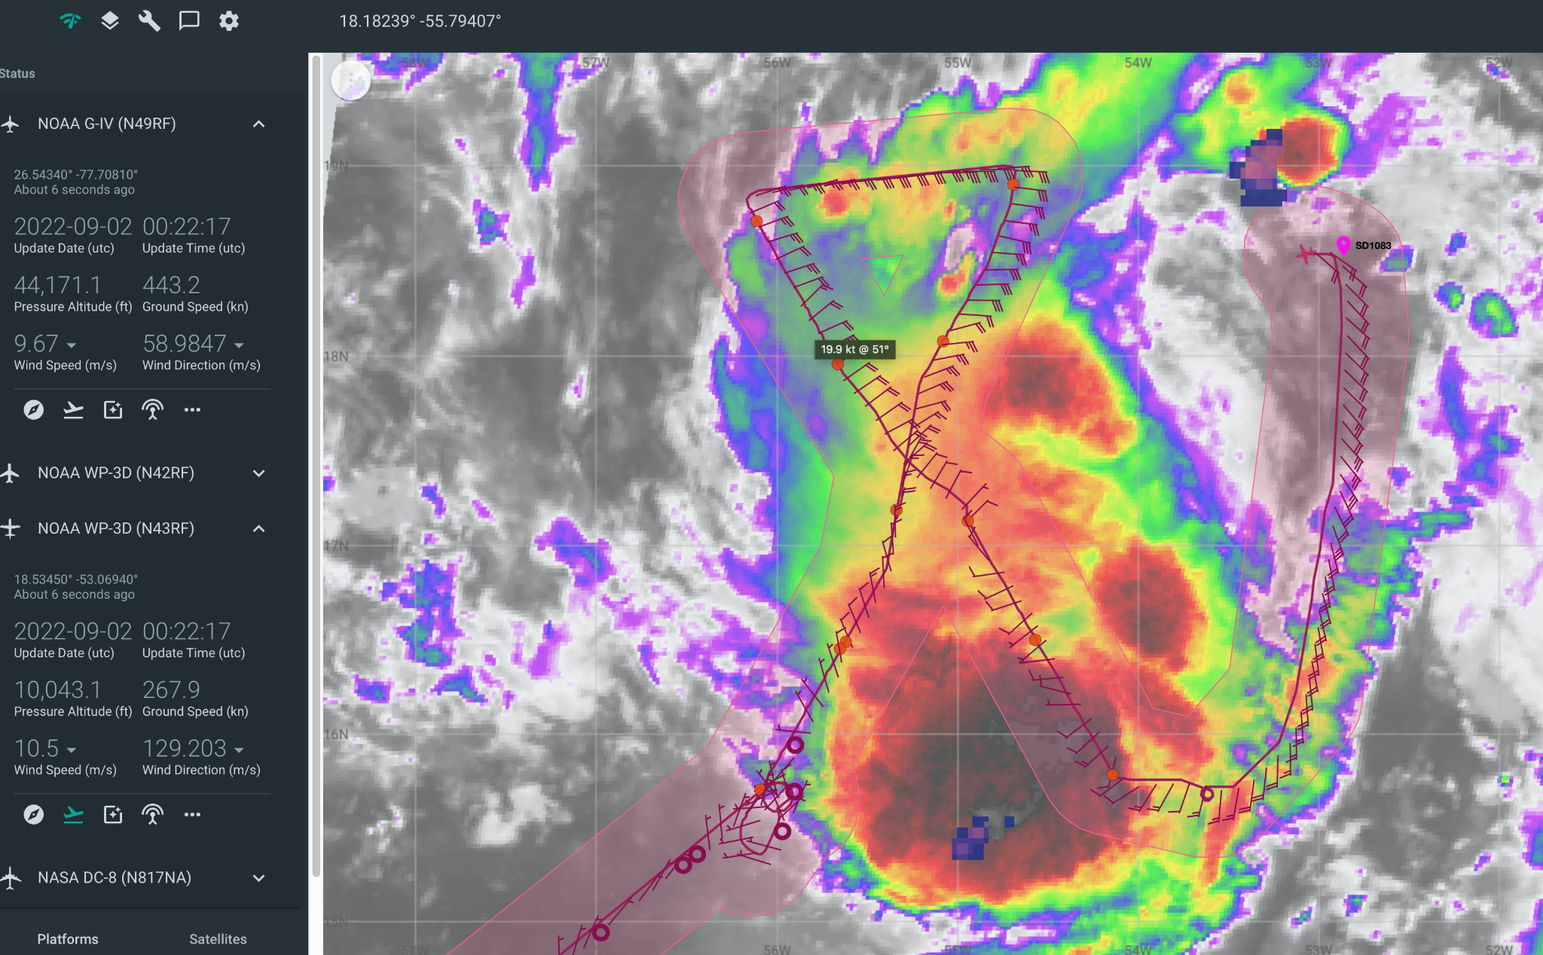
0023 | Turning to track to new pt 5 ~ 10 n mi east of the old pt 5 to use TDR 3 km center for inbound leg.
0040 | Combo at point 5 Drop #13; AXBT #6 drop was good
0045 | Big bumps. May have been an arc cloud we flew over.  Noticed little spots of red on the nose radar.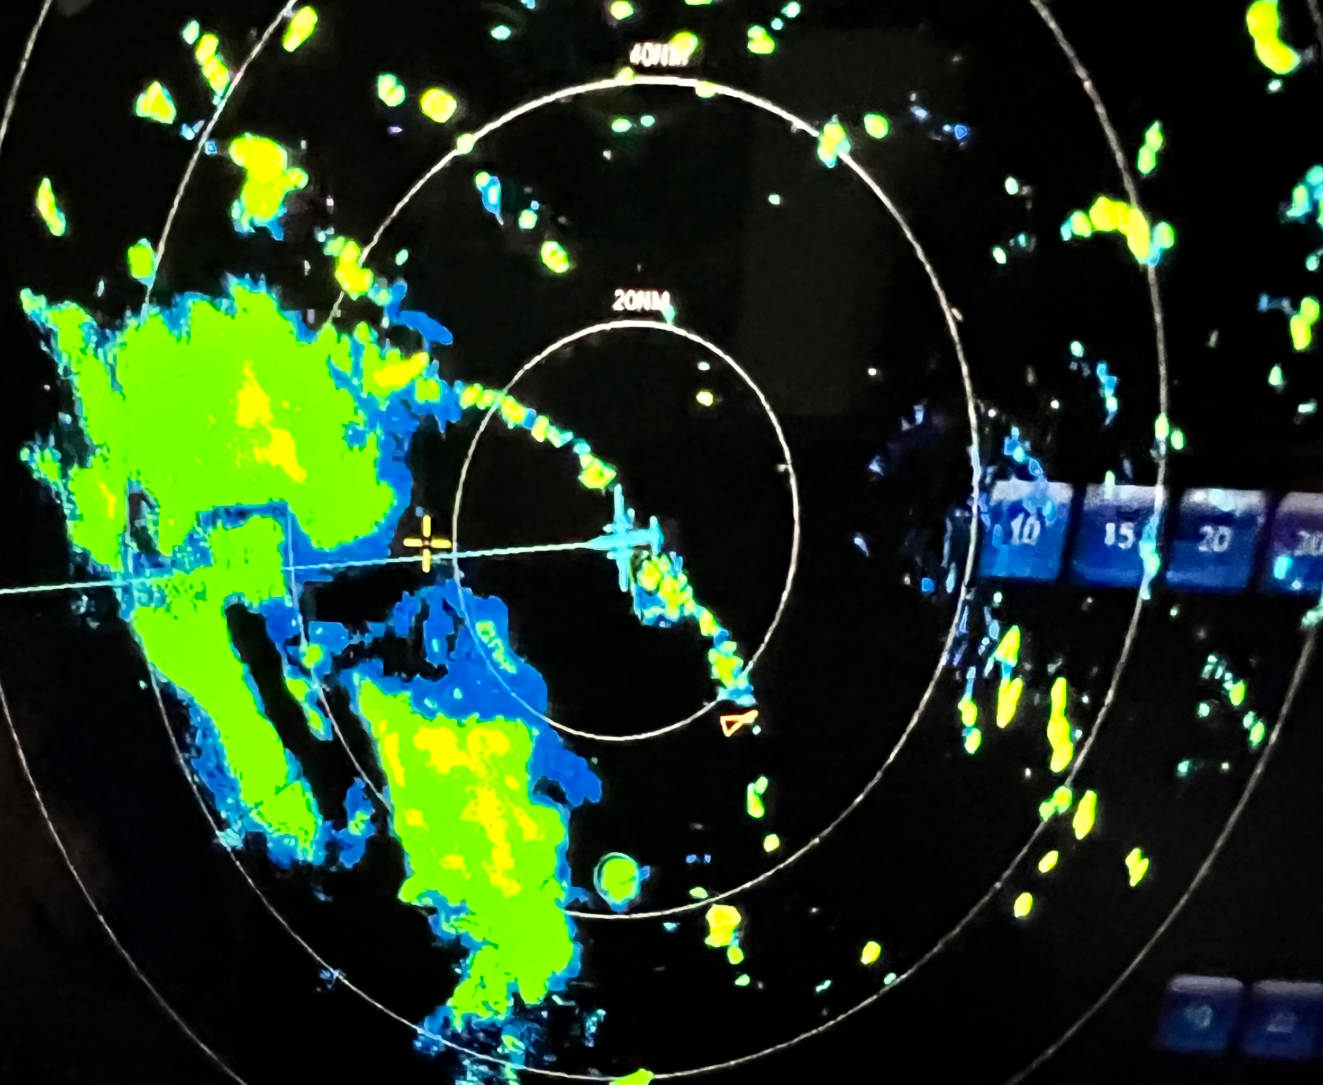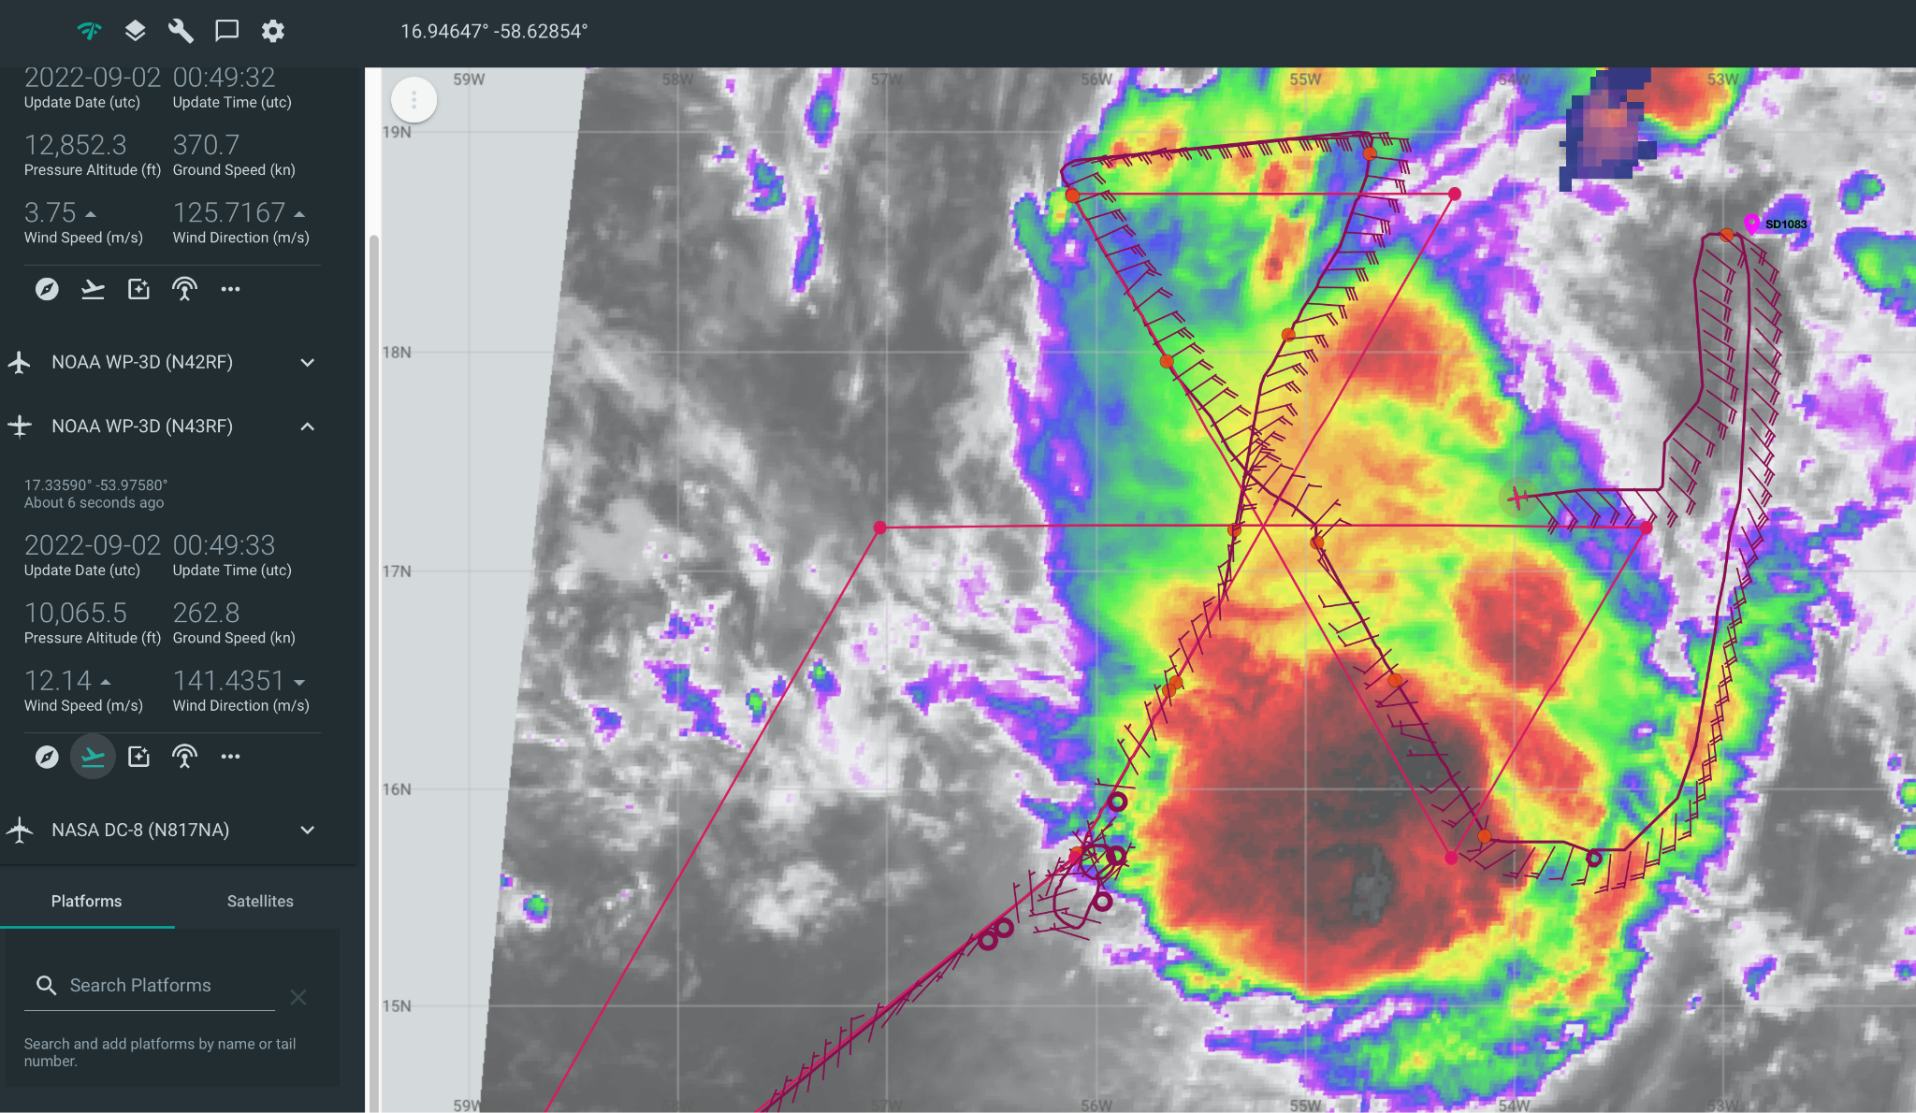
0053 | Drop #14 midpoint released in large stratiform rain area
0103 | Center drop #15 down to 1 kt wind. This is a mid-level center estimate based on flight level winds, but the wind only briefly switched to north and then went back to light easterlies.  Issue with processing this sonde: center, post-splash data removed, could not get this sonde to plot on synoptic charts. ASPEN said that the synoptic map database version has been upgraded and the database format was incorrect. Tried both versions of the Dfile
0110 | Still not much convection on the W side to target for a convective burst module, so suggested cutting the outbound leg short once in the clear then backtrack and go out to the south to get more TDR coverage where the LL center might be trying to form.
0119 | Decision was made to make the western mid-point the new EP for this leg then head for a new pt 7 midway between the original pt 1 and pt 4
0117 | Combo Drop #16; AXBT #7 released at midpoint/EP with a measured SST of 28.34C.
0118 | TDR zoom composite analysis from the first 3 legs shows the tilt between the 2 and 5 km centers subsiding some (~40 km). Circulations are still fairly broad though.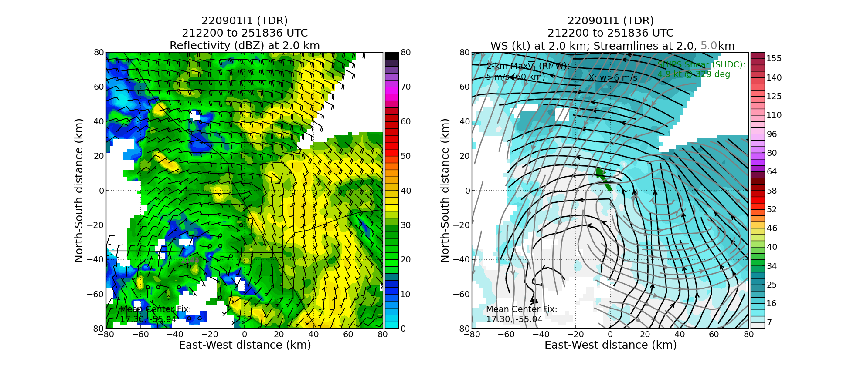  Decent amount of curvature also evident in 1 km swath from leg 3  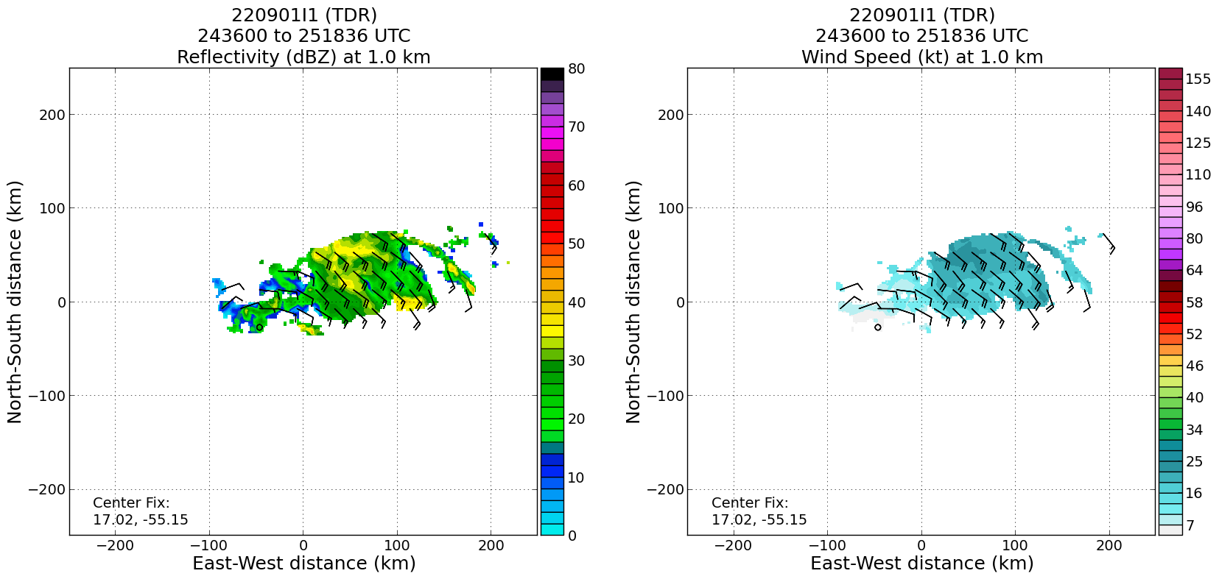
0129 | New growth in a line oriented SW-NE. Looks like a new feeder band getting started.
0129 | Drop #17 this drop may have been in the trough or pretty close, interesting wind direction profile. Two saturated inversions with fairly strong upward motion (2-4 m/s) at the top of each.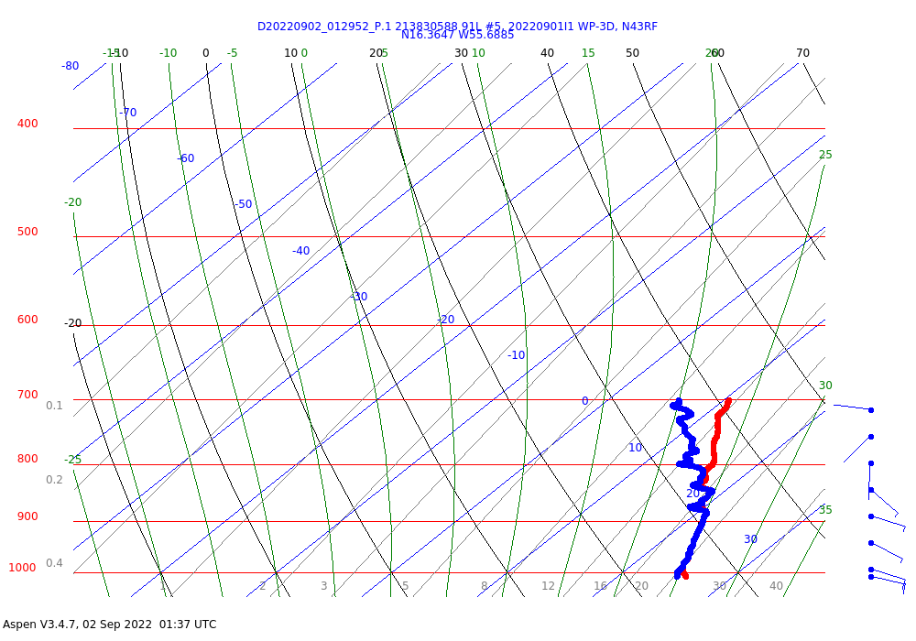
0142 | Drop #18 pt 7 15.5N, 55.25W; end pattern just north of main convective line. Turn to track 235 degrees to Barbados. Leaving TDR on until we clear the band.
0146 | 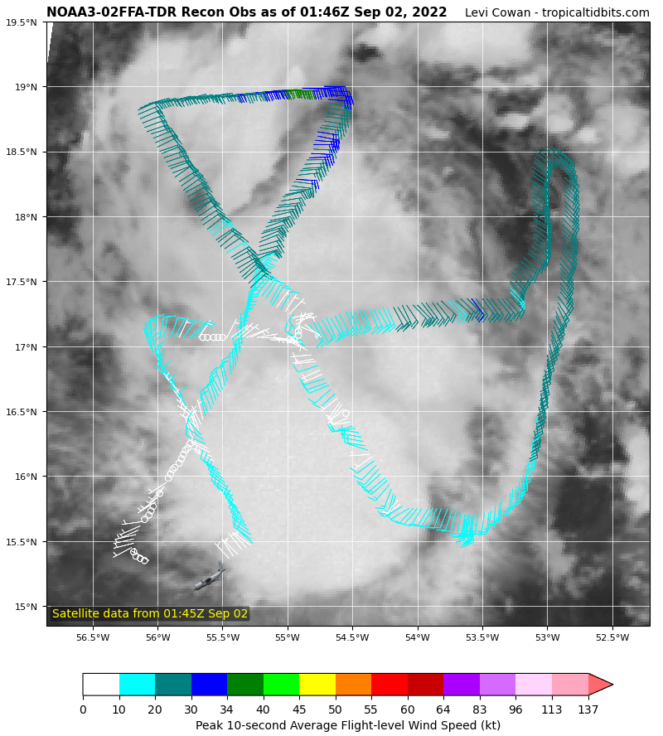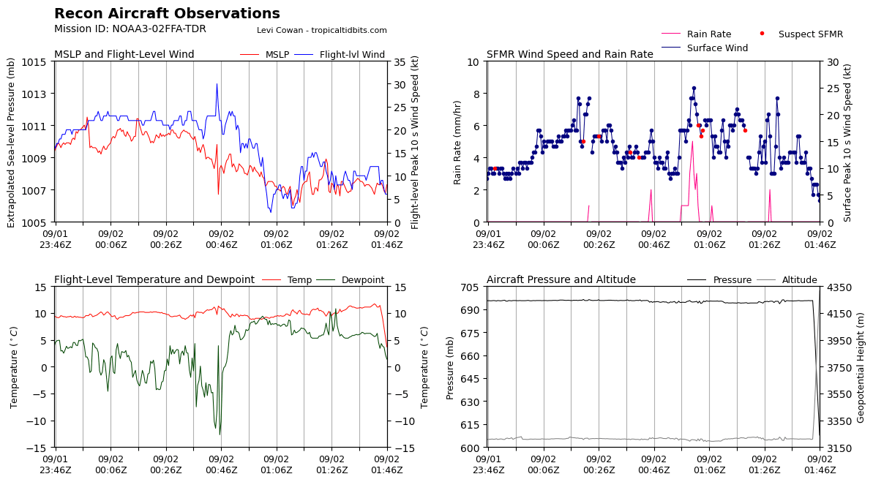
0150 | Shutting down TDR
0157 | Final surface and 850 mb synoptic maps  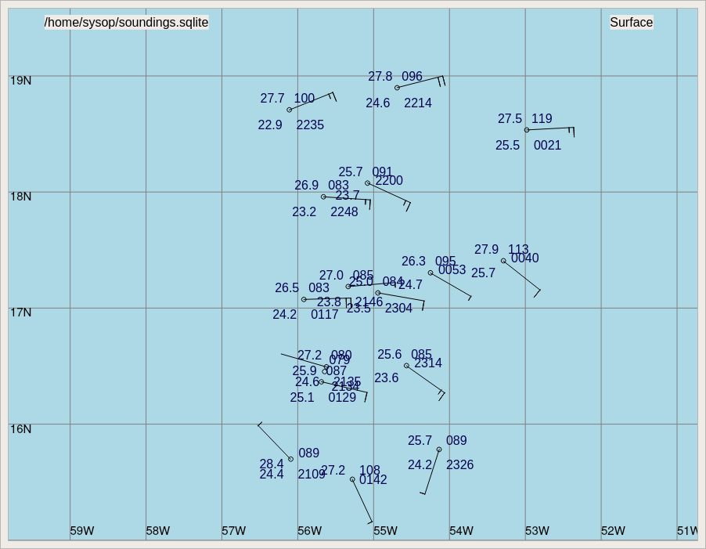  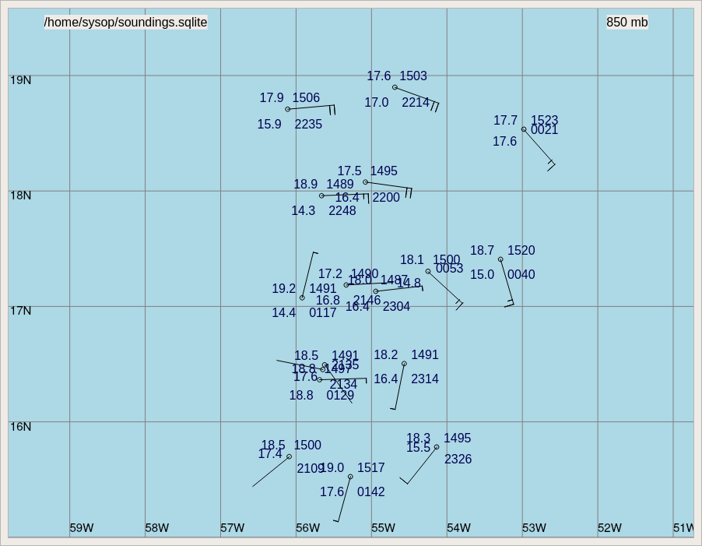
0201

POST-FLIGHT
Mission Summary | The AL91 disturbance became better organized throughout the flight with a fairly well defined mid-level circulation evident in the TDR analysis. The low-level circulation still appears to be more of an open trough, but curvature was present by the end of the flight. Dropsondes showed a more moist low and mid-levels compared to previous flights, perhaps indicating the thermodynamic environment of the disturbance is becoming more favorable for genesis.  18 dropsondes were released in the pattern; all sondes were good, transmitted, and all charged to NWS.
Actual Standard Pattern Flown | 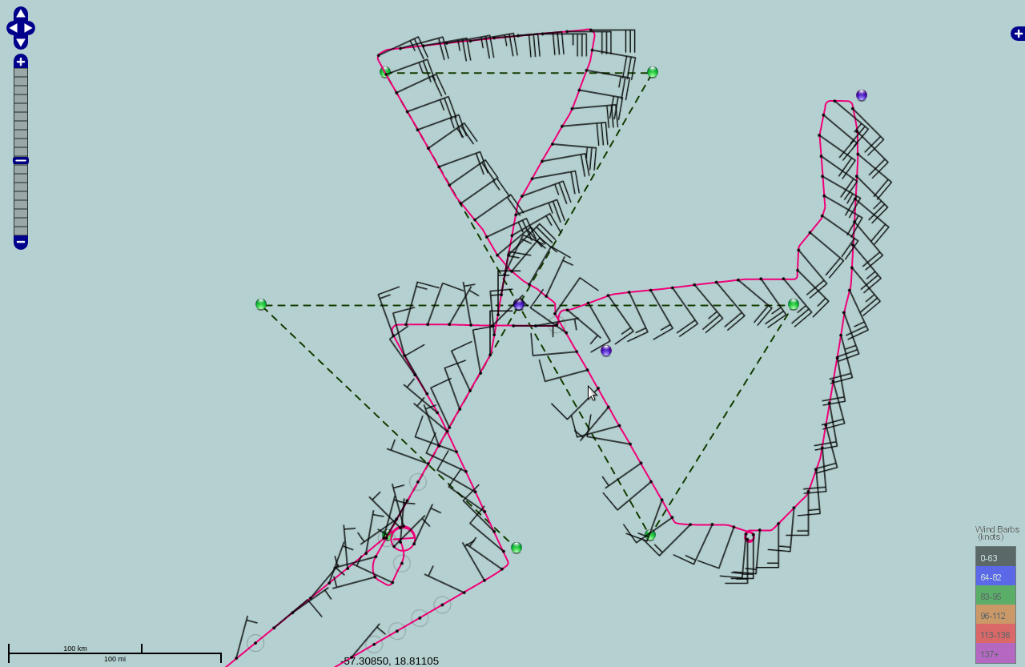  Modified butterfly to provide TDR observations to EMC and NHC for model initialization and situational awareness. We added a module to do an intercomparison with the Saildrone and a dropsonde NE of the center.
APHEX Experiments / Modules Flown | Although this was an operationally tasked butterfly pattern in a pre-genesis system, data collection supports the Genesis Stage Experiment: PREFORM, and the release of a dropsonde near the Saildrone helps support the Ocean Observing Experiment: Sustained and Targeted Ocean Observations. As the storm is also likely developing, the data could also meet the requirements for the Early Stage Experiment: Analysis of Intensity Change Experiment (AIPEX).
Plain Language Summary | - Tail Doppler radar analyses showed that AL91 was tilted to the northeast with height from 2 km to 5 km with the low-level center 40 km SSW of the mid-level center.  - The environment appears to be becoming more favorable for formation of AL91 into a tropical storm.
Instrument Notes | SFMR issues early in the mission that were corrected at the end of the first pass through the storm. May be recoverable.  Interesting comparison of wave height observations from KaIA and Saildrone: https://manati.star.nesdis.noaa.gov/aircraft_images/monitor/hs2022/20220901I1_Tdr_map_no_bg.png
Final Mission Track | 