MISSION PLAN
FLIGHT ID | 20220901H1 | STORM | AL91
MISSION ID | WGWXA | TAIL NUMBER | NOAA42
TASKING | HRD | PLANNED PATTERN | Butterfly
MISSION SUMMARY
TAKEOFF [UTC] | 0732 | LANDING [UTC] | 1454
TAKEOFF LOCATION | Barbados | LANDING LOCATION | Barbados
FLIGHT TIME | 7.4 | BLOCK TIME | 7.5
TOTAL REAL-TIME RADAR ANALYSES  (Transmitted) | 4 (4) | TOTAL DROPSONDES (Good/Transmitted) | 16 (16 / 16)
OCEAN EXPENDABLES (Type) | 8 AXBTs (6 good) | sUAS (Type) | None
APHEX EXPERIMENTS / MODULES | Genesis Experiment: PREFORM; Early Stage Experiment: AIPEX (VAM and Stratiform Spiral Module, SSM)
HRD CREW MANIFEST
LPS ONBOARD | Rogers | LPS GROUND | None
TDR ONBOARD | Englert, Rogers | TDR GROUND | Fischer, Gamache
ASPEN ONBOARD | J. Zhang | ASPEN GROUND | None
NESDIS SCIENTISTS | None
GUESTS (Affiliation) | None
AOC CREW MANIFEST
PILOTS | Abitbol, Rannenberg, Keith
NAVIGATOR | Hough
FLIGHT ENGINEERS | Stokes, Gee
FLIGHT DIRECTOR | Carpenter
DATA TECHNICIAN | McAllister
AVAPS | Dykeman

PRE-FLIGHT
Flight Plan | 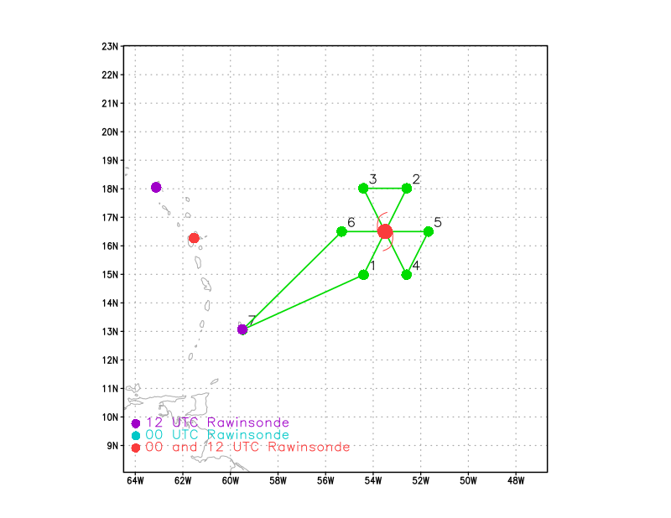  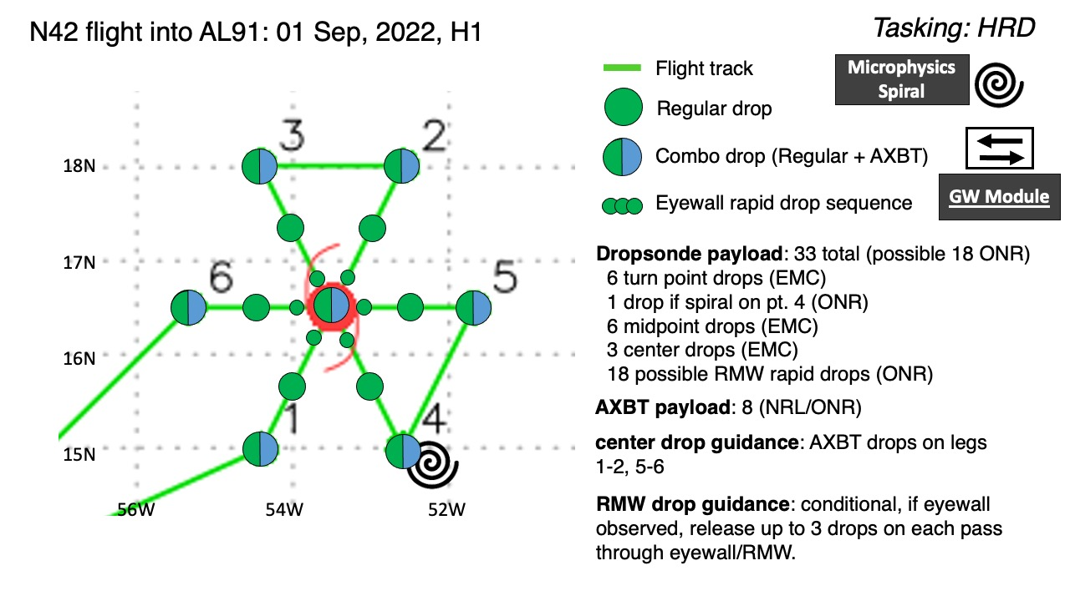  Pattern: Butterfly  Altitude: 10 kft  Fly a butterfly pattern, IP on the SW side. If possible, do a microphysics spiral, likely on the SE side of the pattern. Upon completion of two center passes, use TDR analyses to examine the structure of the storm, in particular noting if possible locations of midlevel center (MLC) and low-level center (LLC). After completion of third pass, if centers can be identified and if there is deep convection in the proximity of the MLC, perform a vortex alignment module (VAM); i.e., fly legs connecting locations of LLC and MLC, extending 20 km beyond each circulation feature, and turn 180 degrees and repeat leg, then return to base.
Expendable Distribution | Release dropsondes at all endpoints and midpoints, and center points. Release AXBTs at all endpoints and first and third center pass. If there is an identifiable radius of maximum wind (RMW), release a high-density sequence of three sondes across the RMW.
Preflight Weather Briefing | AL91 continues to struggle, likely due to the continued presence of mid- and upper-level dry air and vertical wind shear. The convective presentation has shown transient bursts of convection. At the time of take-off there is a N-S line of cold cloud tops to the east of what appears to be either a convection-free MLC or LLC as evidenced by low-level cloud motions. There were some indications of convection and associated cloud shields developing over or near the circulation, but the convection remains rather transient. It is possible that there will be another flare-up of convection, possibly
Instrument Notes

IN-FLIGHT
0732 | Takeoff from Barbados
0842 | Approaching IP, adjusted pattern 0.5 deg south to account for more scatterers developing there, while also being closer enough to where we think the MLC is located
0847 | IR satellite near time of IP
0855 | Shortwave IR satellite loop showing robust MLC
0858 | Drop 1, BT1 at pt 1, endpt SW, no SST
0906 | Drop 2, midpt SW
0907 | During the inbound leg from the SW we may have flown over the LLC (based on satellite examination). Did not see much in terms of structure on the MMR, though, and it was too dark to get any kind of visual confirmation.
0910 | We're flying just to the left of light stratiform and almost non-precipitating anvil, it looks like from TDR sweeps
0913 | Drop 3, BT2, center drop SST 31.5 (questionable?)
0927 | Drop 4, midpt NE
0939 | An SSMIS overpass captured the convective structure of the storm valid at 0735 UTC, with signs of a curved band in the 37-GHz channel  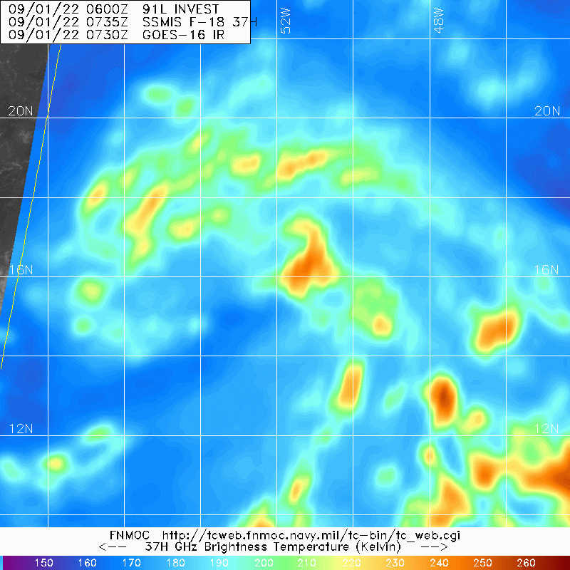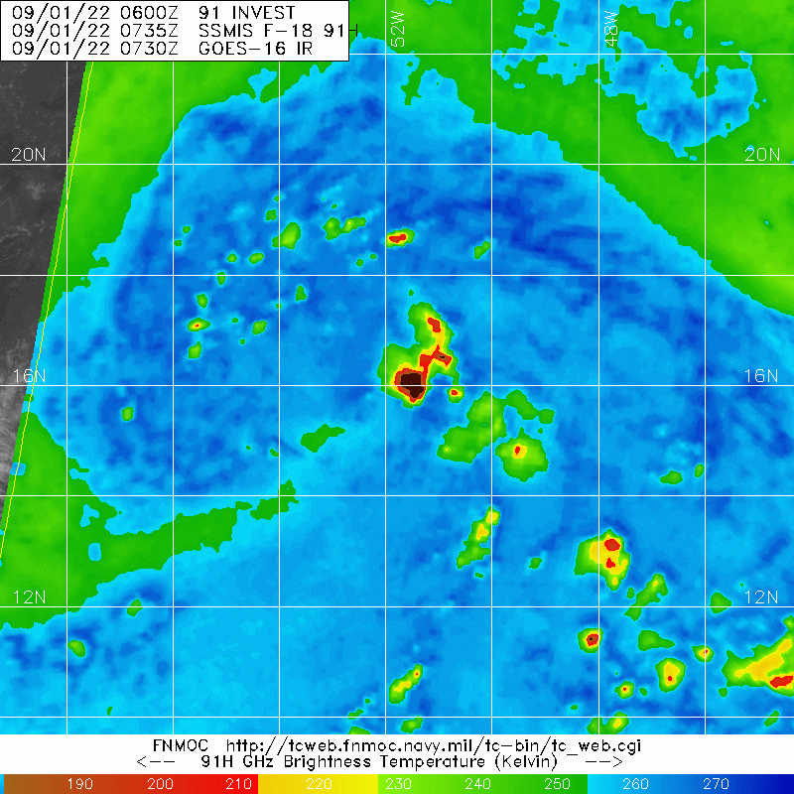
0945 | Strong convection in SE quadrant with IR brightness temperatures approaching -90C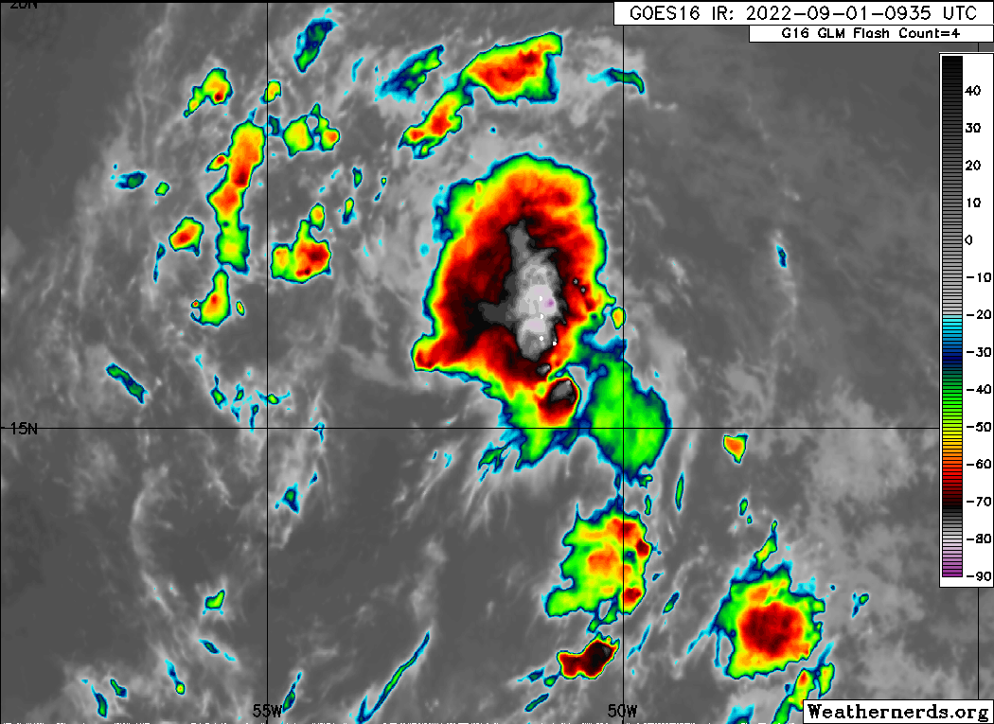
0946 | Drop 5, BT3, NE endpt
0955 | MTS screenshot of first pass overlaid on IR. Aircraft flew just west of strong convection.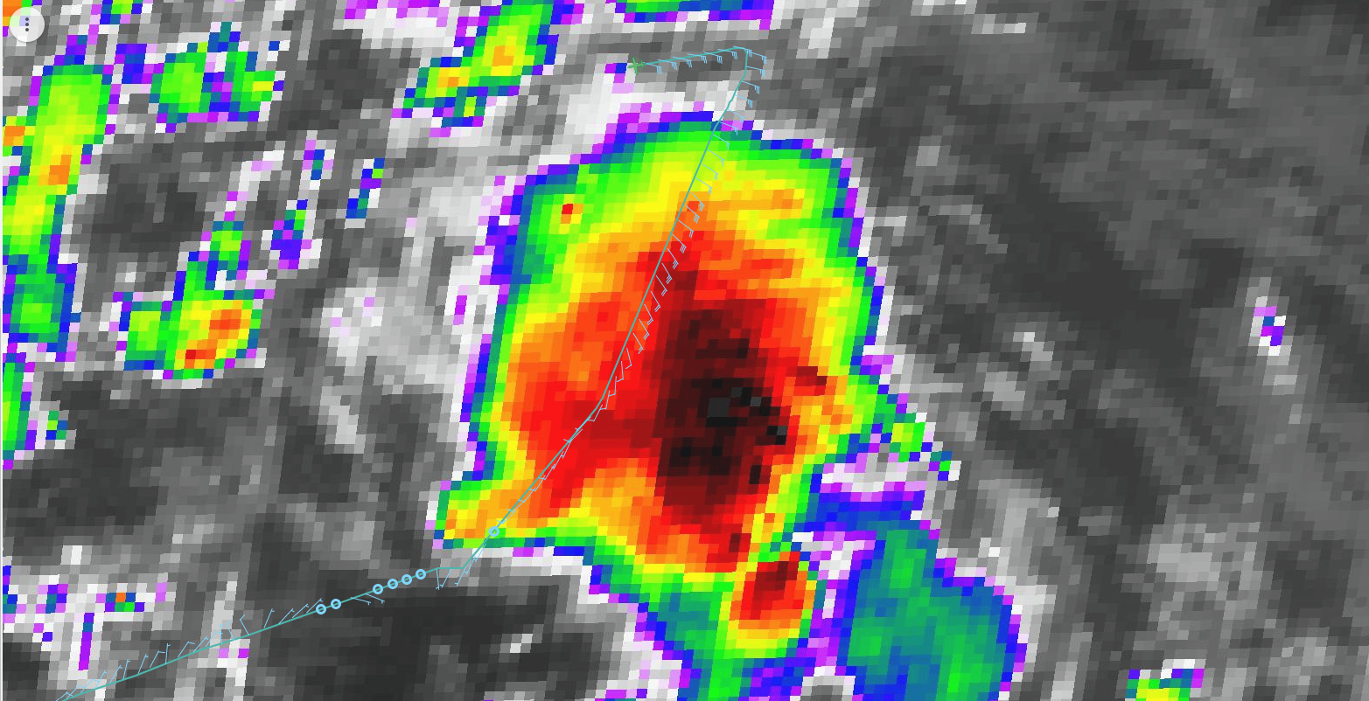
1004 | <RobR_n42> so we're going to do a rapid fire set of drops along the SE and E sides  <RobR_n42> I wanted to see the time series of FL and SFMR winds on this first pass to see if there was even anything like an RMW  <RobR_n42> there was nothing on the SW side, but on the NE side there was a distinct max of about 30 kt across that band we flew through  <RobR_n42> yeah so we'll do a set of 3 ONR drops on the SE and E legs  <RobR_n42> centered at about 60 nm, which is where we saw the peak on the outbound leg to the NE  <RobR_n42> on the W and NW sides we'll just stick with the midpt drop (at 52.5 nm)
1008 | MTS screenshot with TDR range overlaid in swath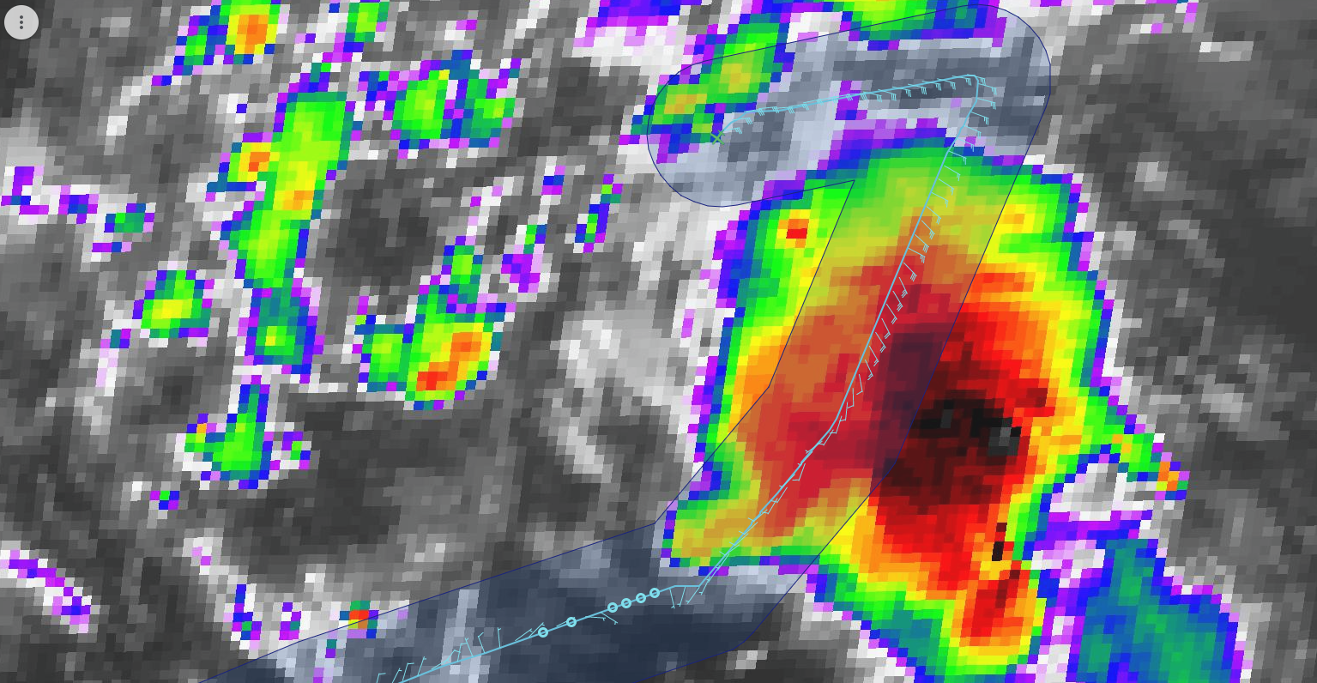
1011 | Drop 6, BT4, NW endpt, SST 28.0
1019 | First TDR analysis showed a wide region of stratiform precip with a convective band wrapping around east side of system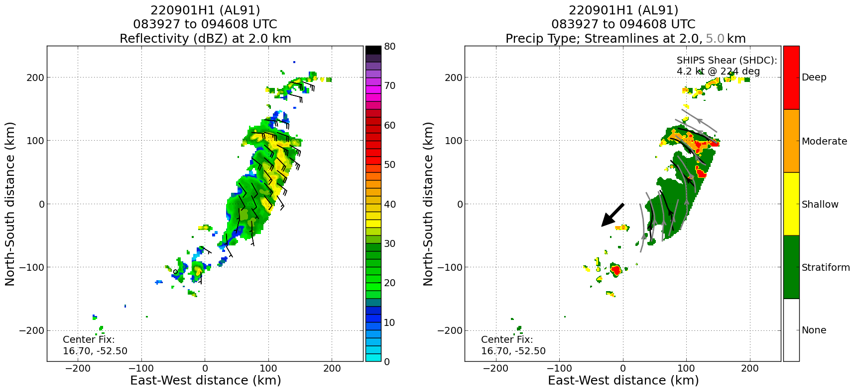
1021 | First TDR analysis suggests some SW-NE tilt of low and midlevel centers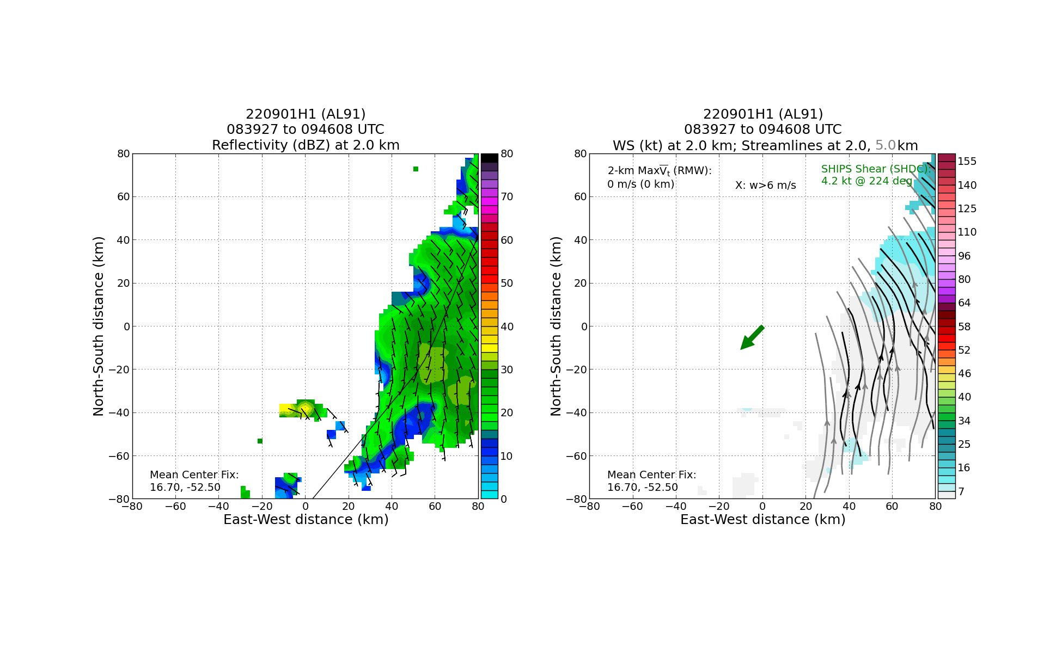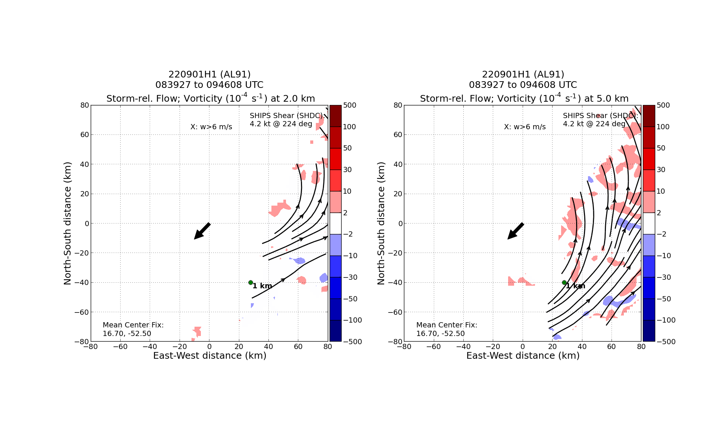
1024 | Drop 7, midpt NW
1038 | Drop 8, 2nd center
1050 | Drop 9, midpt SE
1103 | Drop 10, BT5. endpt SE, no SST
1104 | Persistent convective line on east side of system
1123 | Flying downwind leg toward east side. There’s a N-S line, looks almost like a squall line, that we’re passing east of. There’s another band to our east, so we’re flying in an alley between the two lines. We will set up on the east side and search for a region of stratiform precipitation for a microphysics spiral. That will also provide additional time for us to obtain and analyze the second pass from the TDR. That information will be used to determine if and how we want to do the VAM module. If we can identify a LLC and/or a MLC, and there is some convection within the vicinity of either circulation center, we will perform the module. If not, we will complete a final E-W pass and return home.
1130 | Drop 11, BT6, endpt E, SST 31.9C
1133 | Just north of IP on E side, between lines of convection mentioned above (and well east of where any possible MLC or LLC is thought to be), we’ve begun a microphysics sprial. Flight director and pilots indicate that we are in precip, as does nose camera
1141 | Second TDR analysis shows shallow and moderate convection ~50 km north of MLC. Low-level circulation (albeit not closed) appears near MLC.15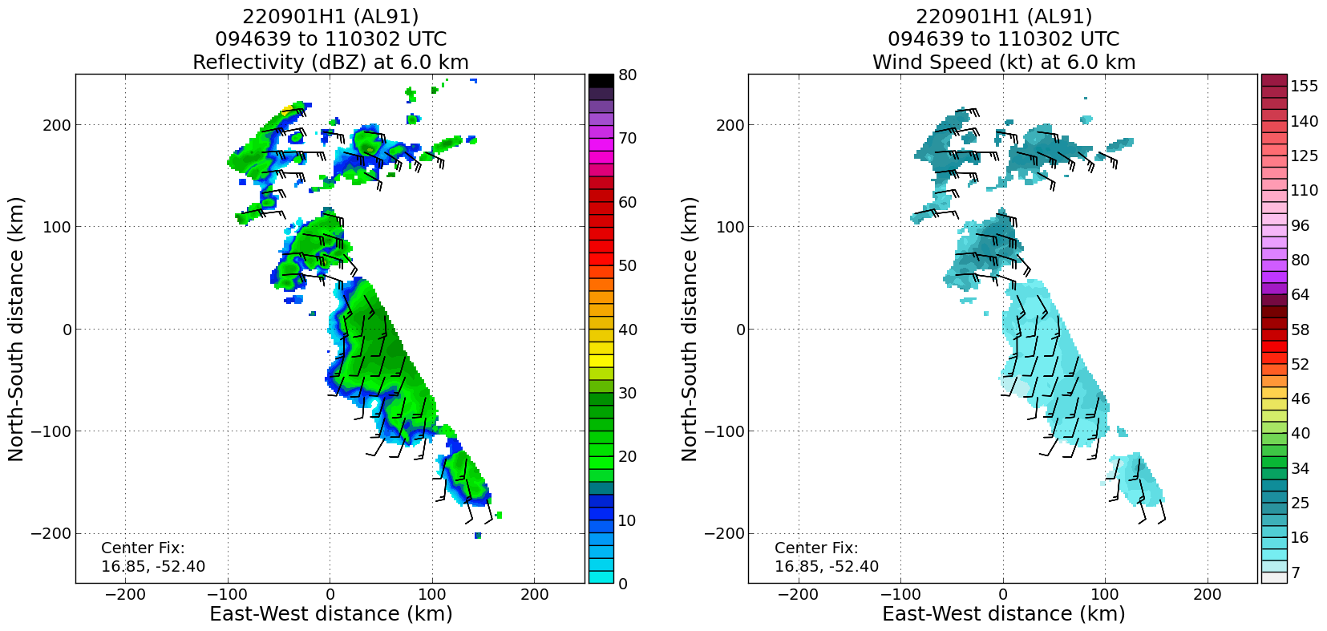
1148 | Drop 12, at top of microphysics spiral
1215 | Drop 13, midpt E
1217 | Heading inbound toward the center on the E side. Will continue this leg outbound to the west. After that, we will head to 17.25N, 52.25W to do a vortex alignment module (VAM). That’s a point near the suspected LLC. From the proceed SW for 40 nmi, then turn 180 degrees and go NE 40 nmi, then turn again and go SW 40 nmi, then return home. There has been some moderate and shallow convection in the vicinity of the MLC. Furthermore, the MLC is displaced slightly toward the SW of where a low-level vorticity maximum is thought to be location (not a closed circulation in low levels, though). So we will fly the module to see if there is any evolution in the MLC and LL”C” over the course of about 30 minutes as a result of the diabatic heating in this shallow and moderate convection.
1227 | Drop 14, BT7, center, no SST
1250 | MTS screenshot of nearly completed butterfly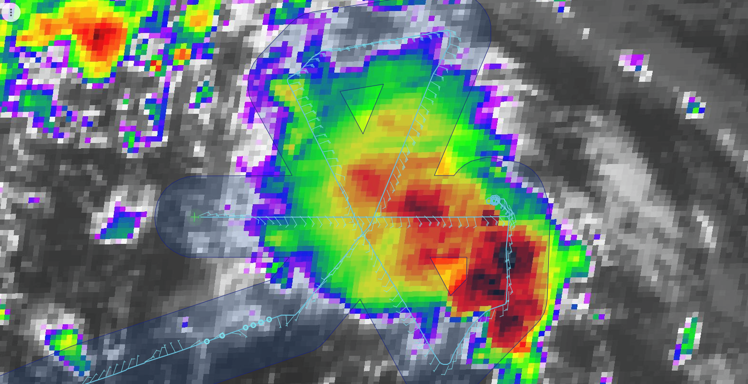
1238 | Drop 15, midpt W
1253 | Drop 16, BT8, endpt W, SST 27.5-28.0; Last drop
1300 | 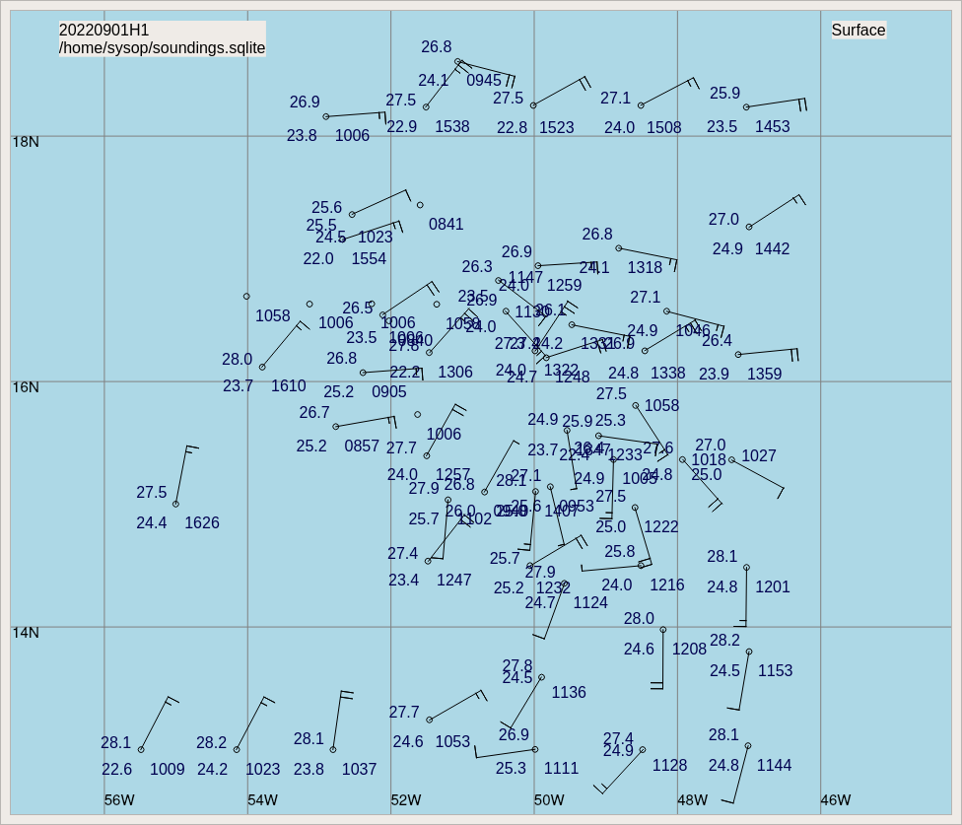
1300 | 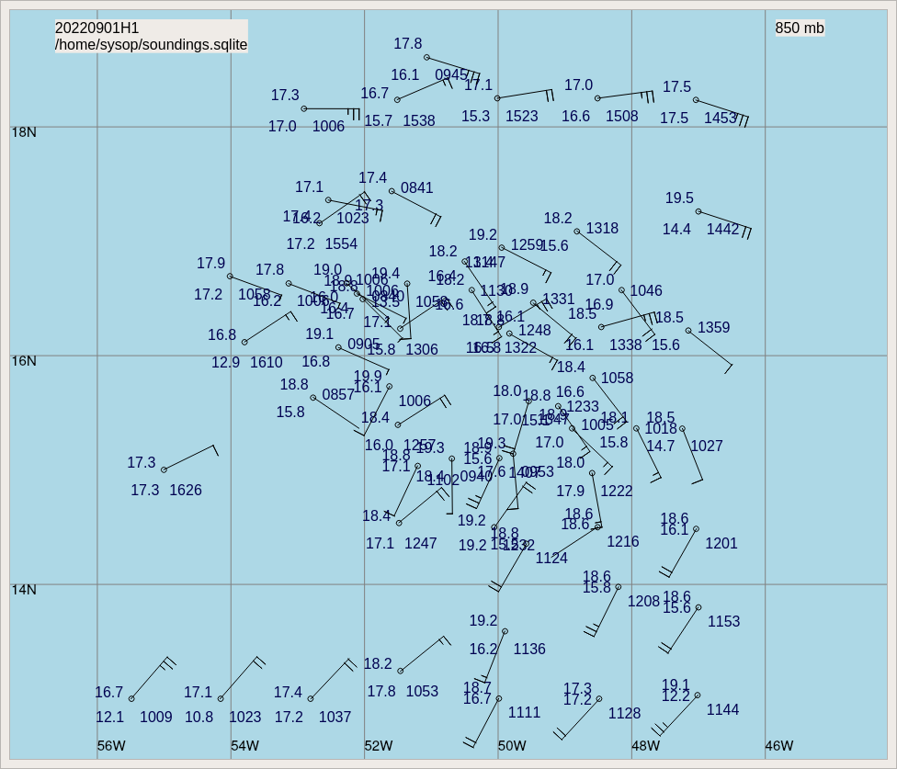
1300 | 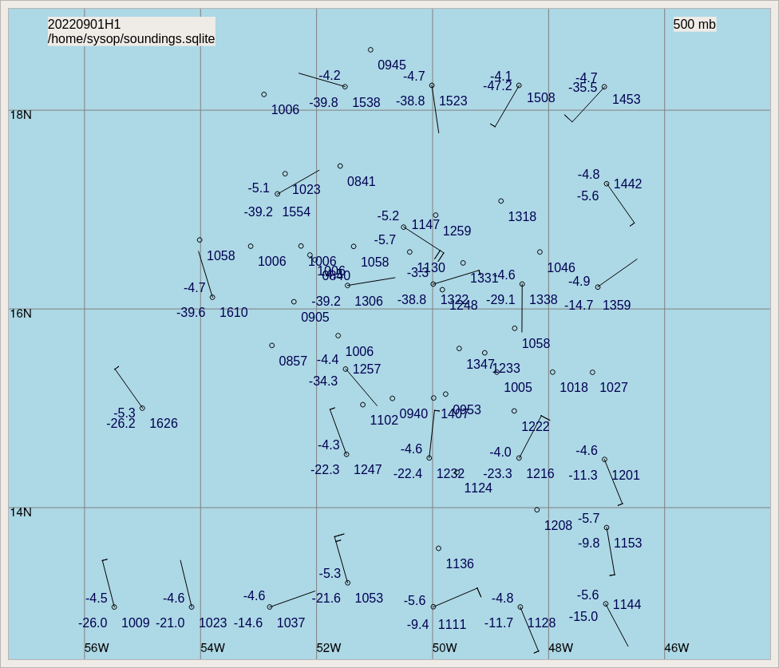
1307 | MTS view of earlier microphysics spiral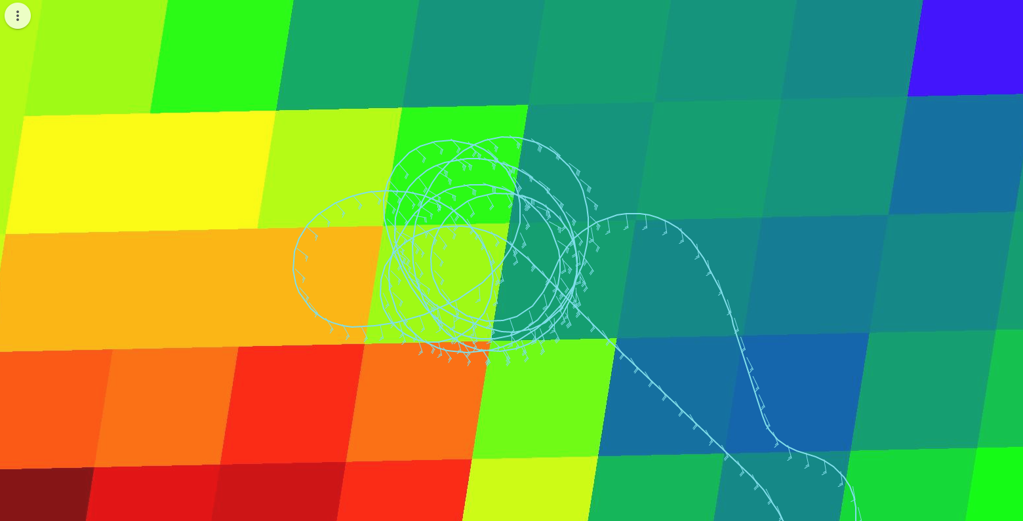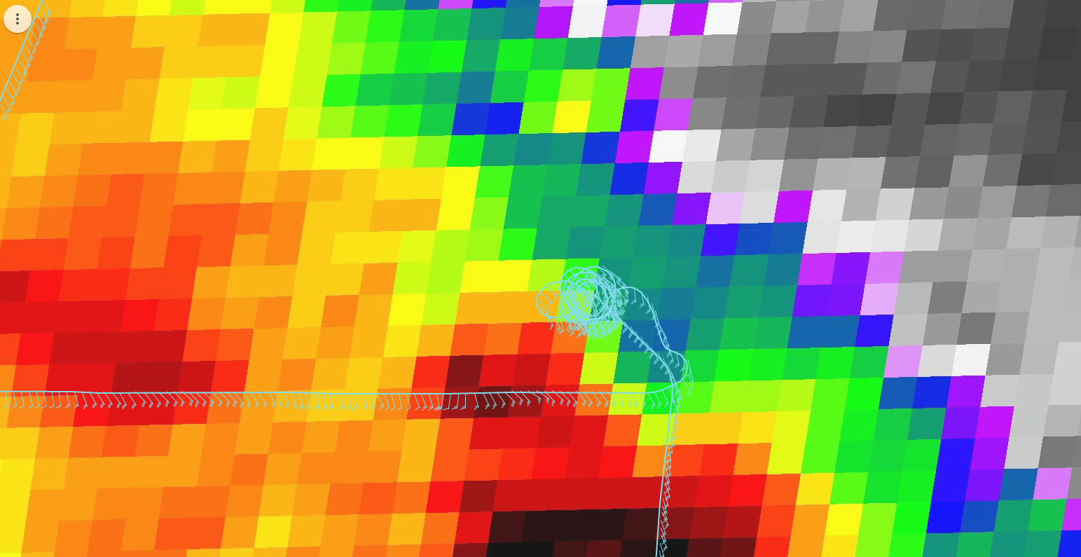
1318 | Begin VAM, at 17.25N, 52.25W, heading SW for 40 nmi
1327 | Little to no scatterers here. IR imagery shows us at the back of the anvil from the convection 100’s of km to the SE. Once in VAM, TDR showed very limited stratiform, mostly non-precipitating anvil. The flight-level winds showed a chaotic wind field, what looked like the flight-level center well west of the anticipated location based on lining up the VAM. Possible that convection there has collapsed (due to dry air?) and the flight-level center moved rapidly toward the west. As a result of these conditions the VAM was scrapped. We will still do a fourth TDR analysis though, to see if the stratiform precipitation.
1333 | MTS screenshot following aborting the VAM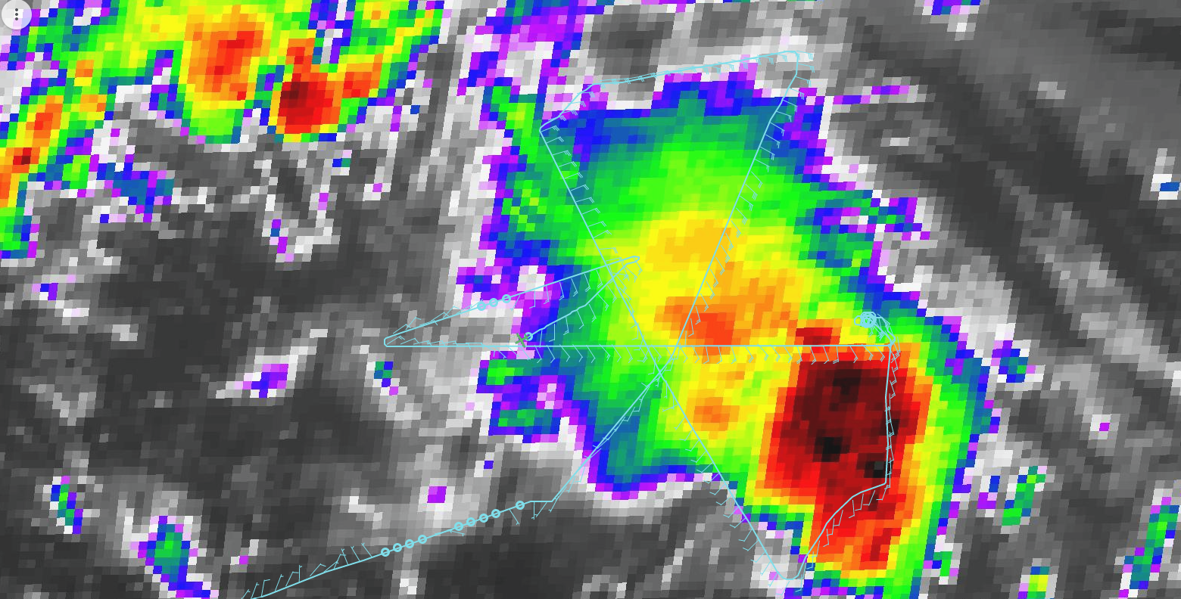
1335 | IR animation showing warming IR near previously detected MLC
1336 | Third TDR analysis shows lack of closed circulation at 2-km and minimal convection near previous MLC location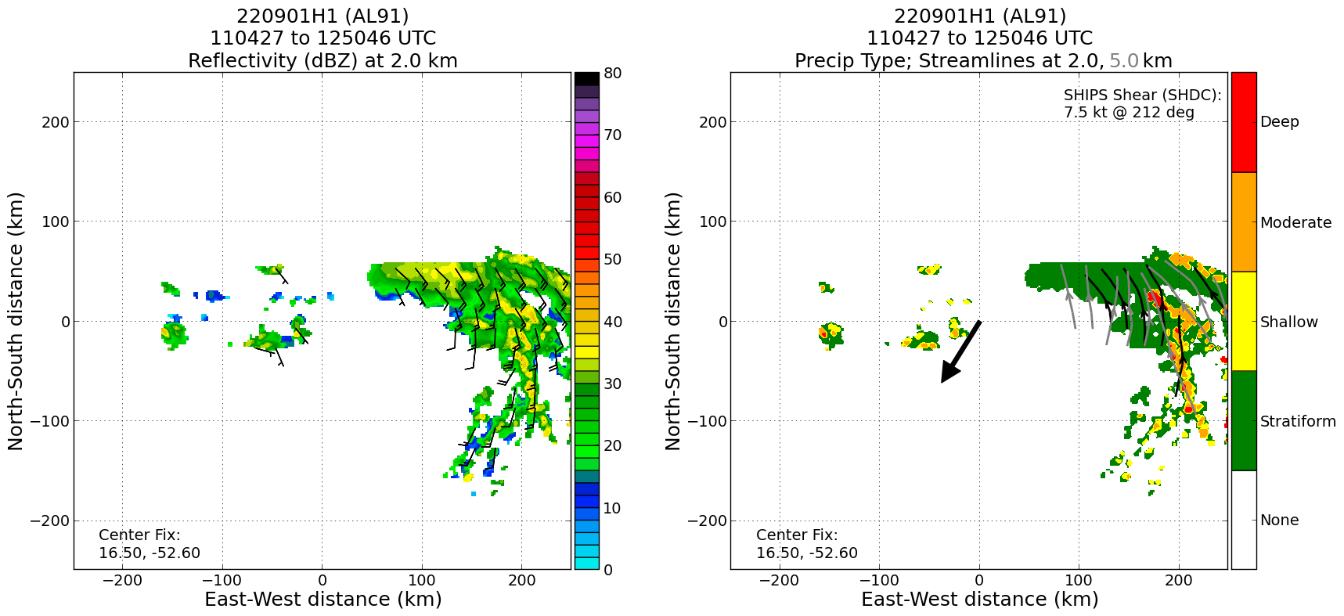

POST-FLIGHT
Mission Summary | We flew a butterfly pattern in AL91. The storm continues to struggle, as has been its history throughout these series of missions. The butterfly was flown essentially as planned. We also flew a microphysics spiral that looks to have collected very good data. It was flown just north of the eastern endpoint. Pilots and Flight Director both reported seeing slush and mixed phase in the ~14-16 kft layer, and ice crystals up near 20 kft. Had to terminate the climb at 20 kft.  Tried to drop high-frequency sondes bracketing the RMW, but there was no real RMW to speak of, just a band of higher winds associated with the band of convection oriented N-S to the east of the pattern. Saw no clearly-defined region of maximum winds on subsequent passes, so no high-frequency drops were released.  We tried to do a vortex alignment module. From the first two radar analyses it appeared that there may have been a slight displacement or tilt of a LLC and MLC (using those terms generously, especially for the low levels) toward the southwest. So we set up a line to run from a northeast point, near where we thought the low-level center was, to the southwest, a distance of 40 nmi. At the time of the second TDR analysis, there was also a fairly widespread coverage of moderate and shallow convection in the envelope of the MLC. When we got to the start of the module, though, it had become clear that the convective structure had degraded. We were on the back edge of an anvil associated with deep convection as well (100s of km) to the southeast of us. TDR showed only limited stratiform precipitation, and mostly non-precipitating anvil. Also, flight-level winds showed a chaotic structure, with multiple circulations and axes. The convection had clearly collapsed, possibly due to dry air, and it’s possible that once that happened, the MLC that was presented was advected by the background flow to the west of our anticipated location. Regardless, we decided to abort the module.
Actual Standard Pattern Flown | Butterfly pattern, with a microphysics spiral. Attempted rapid-fire RMW drops, but no real RMW to target.
APHEX Experiments / Modules Flown | Data collection supports the Genesis Experiment: PREFORM and the Stratiform Spiral Module (SSM) in the Early Stage Experiment.. The Vortex Alignment Module (VAM) of the Early Stage Experiment: AIPEX (VAM) was attempted, but a lack of scatterers and decreasing organization caused us to cancel it.
Plain Language Summary
Instrument Notes | No issues with instruments. All the dropsondes worked well. 4 of 8 BT’s produced sea surface temperatures, and 2 of those were > 31C, and therefore suspect.
Final Mission Track | 