MISSION PLAN
FLIGHT ID | 20220831N1 | STORM | AL91
MISSION ID | WFWXA | TAIL NUMBER | NOAA49
TASKING | HRD | PLANNED PATTERN | Survey/Lawnmower
MISSION SUMMARY
TAKEOFF [UTC] | 1838 | LANDING [UTC] | 0220
TAKEOFF LOCATION | Barbados | LANDING LOCATION | Barbados
FLIGHT TIME | 7.7 | BLOCK TIME | 7.9
TOTAL REAL-TIME RADAR ANALYSES  (Transmitted) | 5 | TOTAL DROPSONDES (Good/Transmitted) | 32 (31 / 31)
OCEAN EXPENDABLES (Type) | None | sUAS (Type) | None
APHEX EXPERIMENTS / MODULES | Genesis Experiment: FAM; Early Stage Experiment: ITOFS
HRD CREW MANIFEST
LPS ONBOARD | None | LPS GROUND | Kaplan
TDR ONBOARD | None | TDR GROUND | Gamache
ASPEN ONBOARD | AOC FD | ASPEN GROUND | None
NESDIS SCIENTISTS | None
GUESTS (Affiliation) | None
AOC CREW MANIFEST
PILOTS | Mansour, Waddington
NAVIGATOR | None
FLIGHT ENGINEERS | None
FLIGHT DIRECTOR | Henning
DATA TECHNICIAN02 | Defeo
AVAPS | Lynch

PRE-FLIGHT
Flight Plan | 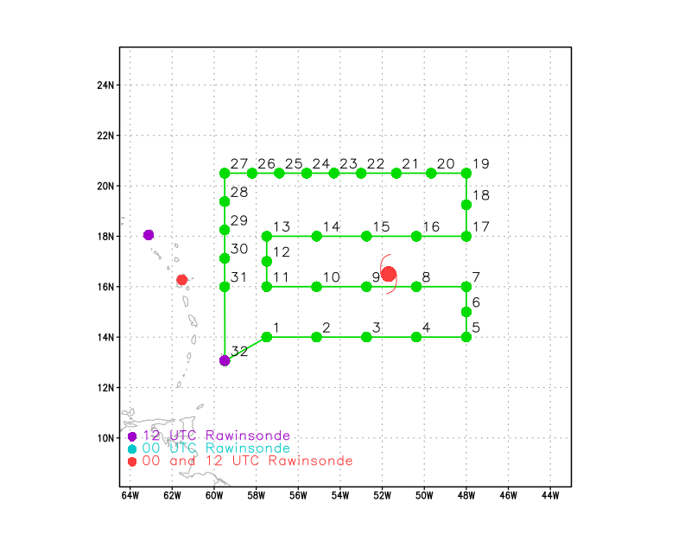
Expendable Distribution | Release a dropsonde at each of the green points in the above image
Preflight Weather Briefing | 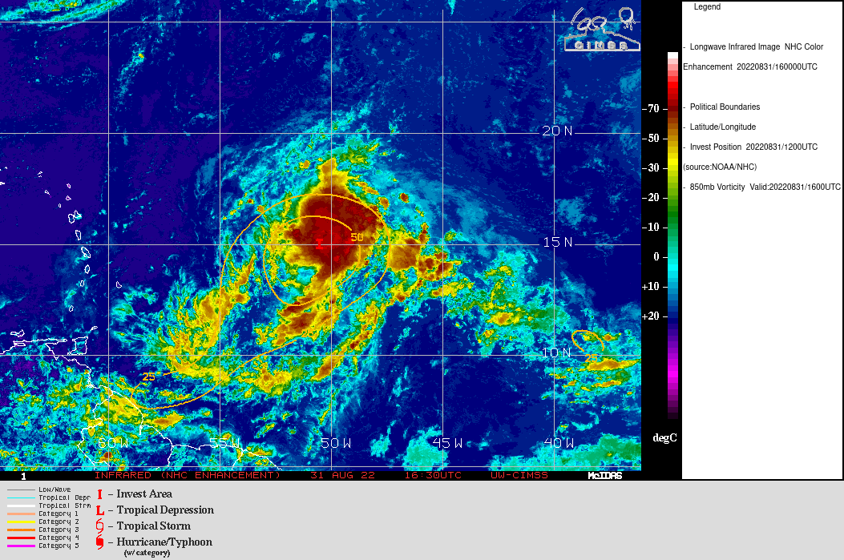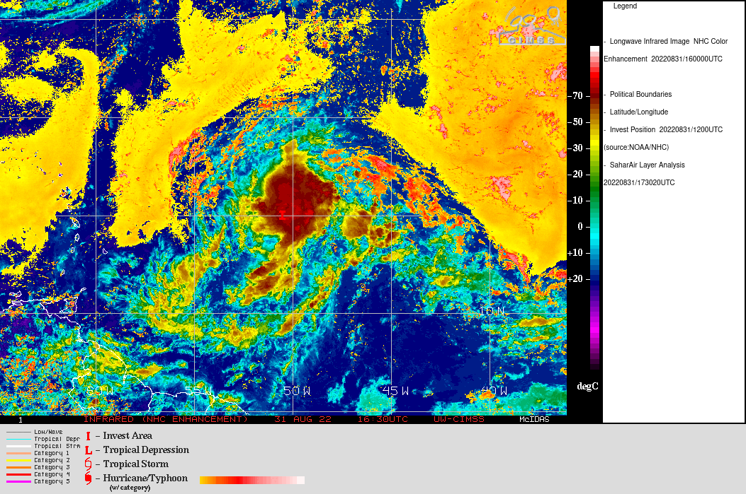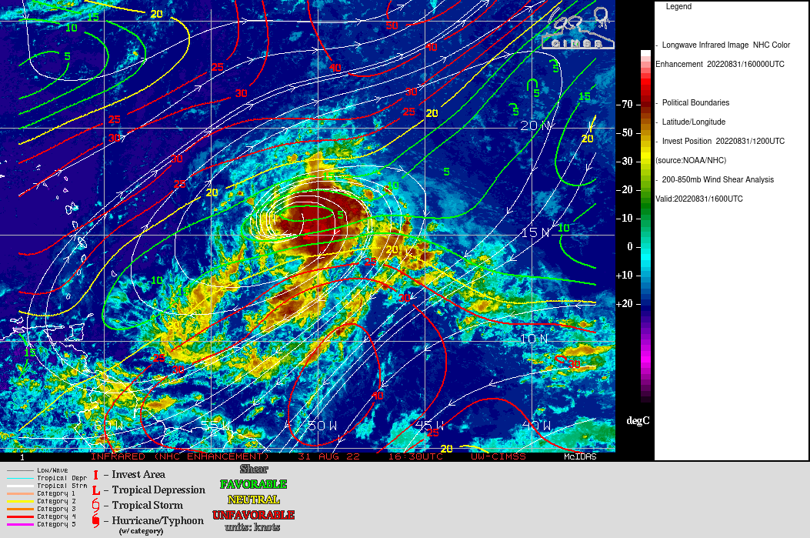
Instrument Notes | AVAPS and TDR operating normally.

IN-FLIGHT
Time [UTC] | Event
 | Plane needed to deviate to the northeast between points 6 and 7 and points 7 and 8 due to convective activity (cloud tops > 50-52 K ft).
2300 | Drop pt 7 stopped sending good data at 974 mb, so no height data for that drop.
2227 | Plane deviated due to convective activity
2302 | 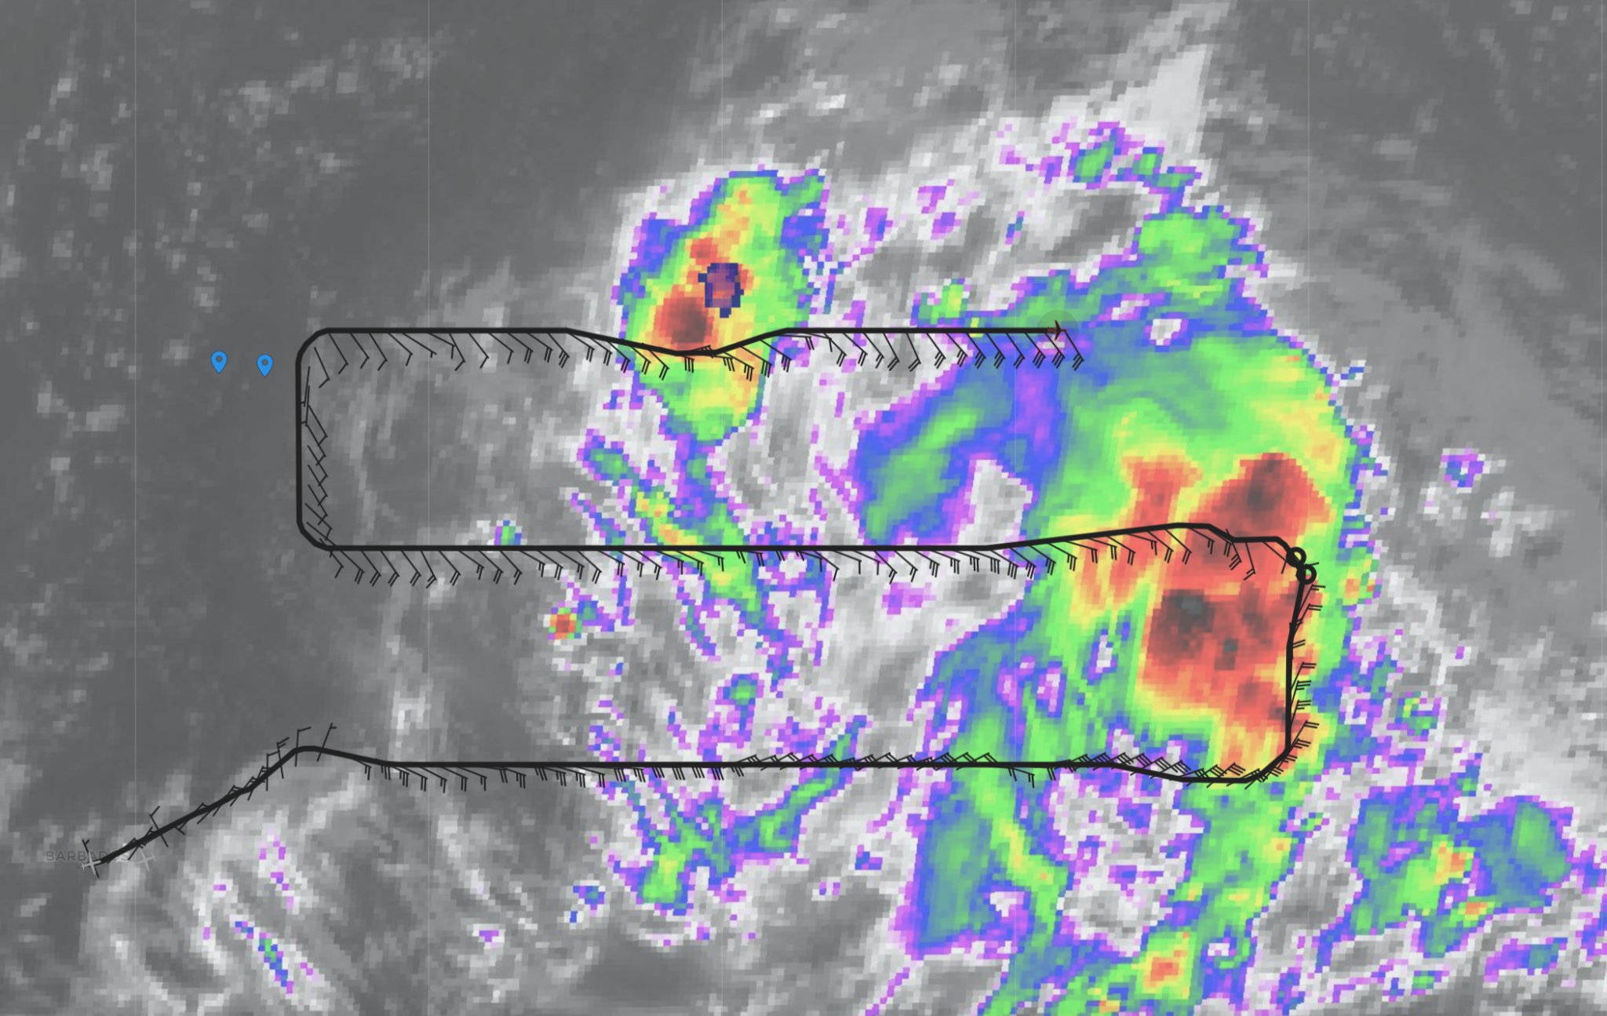
2357 | 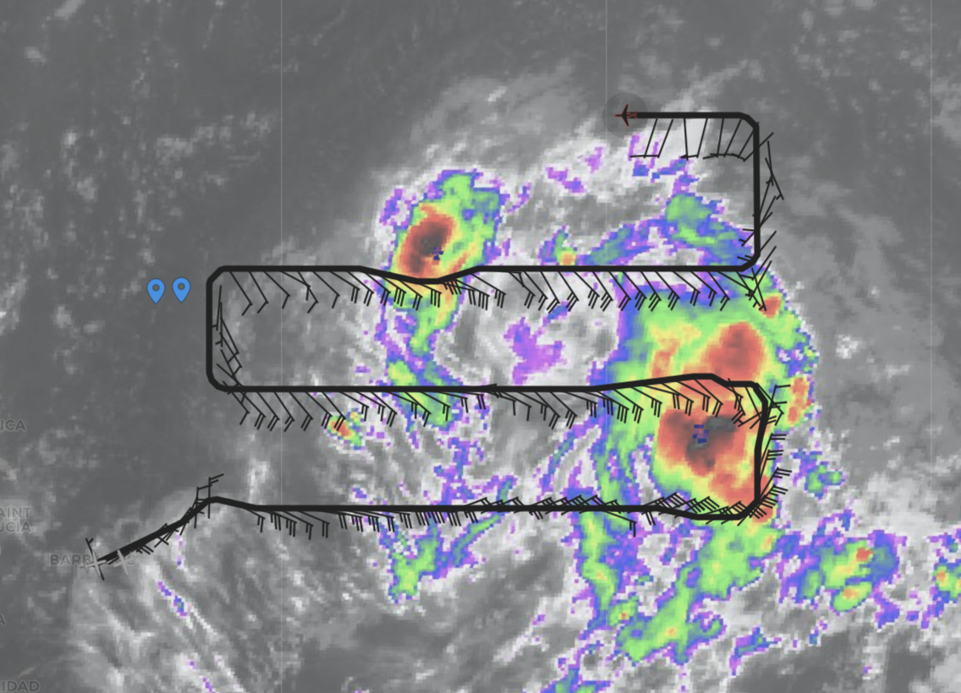

POST-FLIGHT
Mission Summary | 5 TDR analyses were performed and sent to EMC  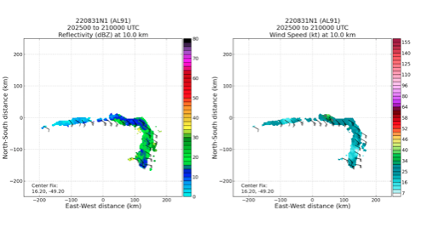  32 dropsondes were released (31 were good and transmitted, 1 was bad) and were all charged to NWS.  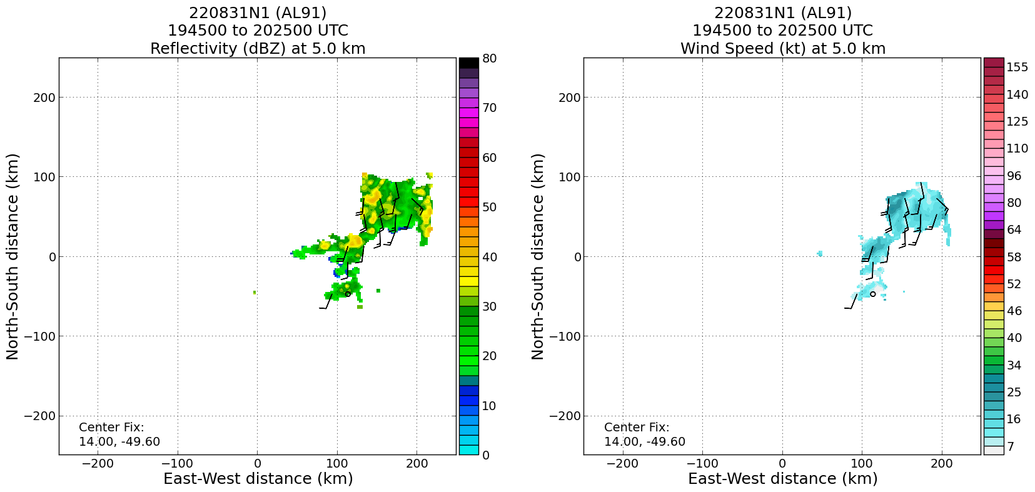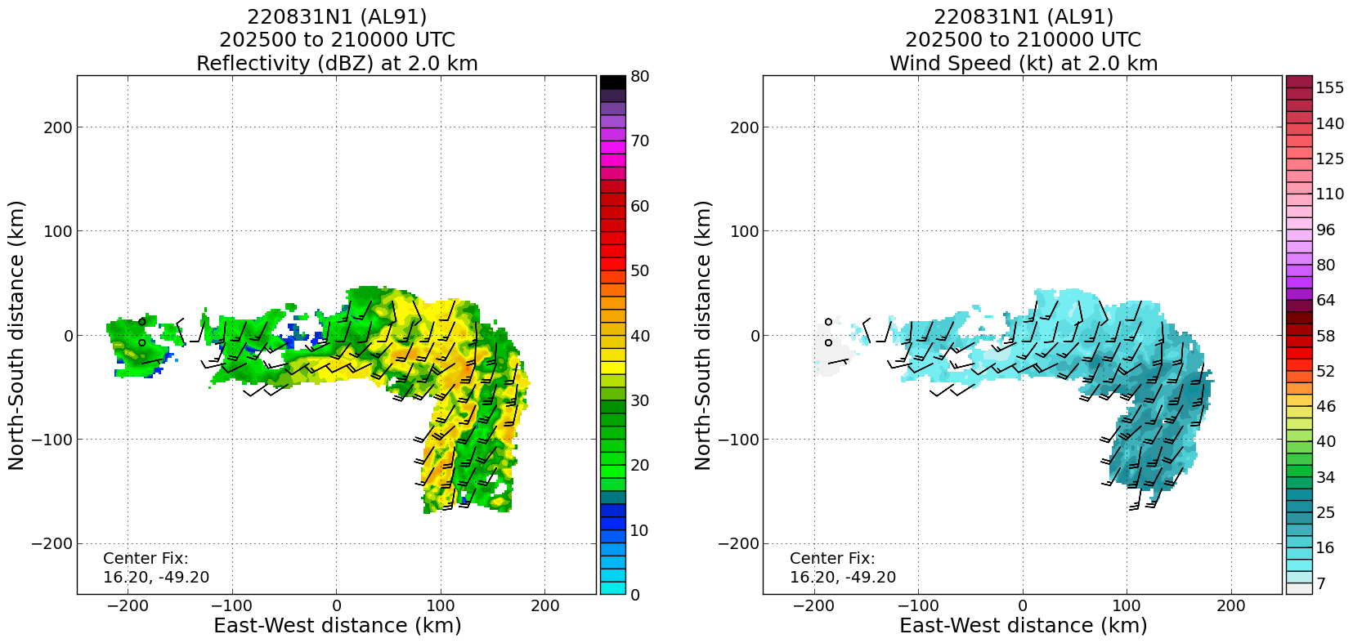
Actual Standard Pattern Flown | Survey / Lawnmower
APHEX Experiments / Modules Flown | Data collection supported the Genesis Experiment: Favorable Air Mass and Early Stage Experiment: ITOFS (Impact of Targeted Observations on Forecasts)
Plain Language Summary
Instrument Notes | TDR worked well. 5 analyses were sent.
Final Mission Track | 