MISSION PLAN
FLIGHT ID | 20220830I1 | STORM | AL91
MISSION ID | WDWXA | TAIL NUMBER | NOAA43
TASKING | HRD | PLANNED PATTERN | Lawnmower
MISSION SUMMARY
TAKEOFF [UTC] | 1953 | LANDING [UTC] | 0346
TAKEOFF LOCATION | Barbados | LANDING LOCATION | Barbados
FLIGHT TIME | 7.9 | BLOCK TIME | 8.2
TOTAL REAL-TIME RADAR ANALYSES  (Transmitted) | 3 | TOTAL DROPSONDES (Good/Transmitted) | 28 (28 / 28)
OCEAN EXPENDABLES (Type) | None | sUAS (Type) | None
APHEX EXPERIMENTS / MODULES | Genesis Experiment: FAM; Early Stage Experiment: ITOFS; Ocean Observing: Sustained and Target Ocean Observations
HRD CREW MANIFEST
LPS ONBOARD | Frank Marks | LPS GROUND | Andy Hazelton
TDR ONBOARD | Paul Reasor | TDR GROUND | Trey Alvey
ASPEN ONBOARD | Sim Aberson | ASPEN GROUND | None
NESDIS SCIENTISTS | Paul Chang
GUESTS (Affiliation) | None
AOC CREW MANIFEST
PILOTS | Doremus, Copare, Chris Wood
NAVIGATOR | Utama
FLIGHT ENGINEERS | Darby, Pittman
FLIGHT DIRECTOR | Quintin Kalen, Holmes
DATA TECHNICIAN | Richards
AVAPS | Warnecke

PRE-FLIGHT
Flight Plan | 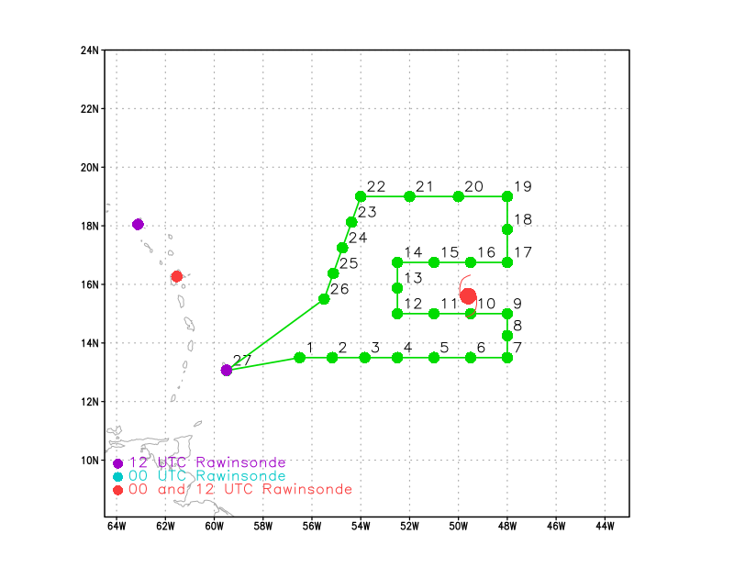  Pattern: Fly lawnmower at max altitude because G-IV mission canceled.  Altitude: 21 kft (pressure altitude)  First wrinkle is adding a drop near Saildrone 1083 between drops 21 & 22 on the last East-West leg on the North side of the pattern.  Second wrinkle is that we moved the first West-East leg south to 12 N from drop 2 to drop 6 to avoid picking through the SW convective system at maximum altitude to provide best drop thermo coverage. We felt that sacrificing TDR coverage for dropsonde coverage was the best option.
Expendable Distribution | Load 30 sondes; release sonde at planned points (green dots in above image). Mo AXBTs for this mission. Release an extra sonde between drops 22 and 23 near the Saildrone.
Preflight Weather Briefing | Invest 91L is over the Central Atlantic. Still looks rather elongated with multiple lobes of convection and an elongated structure on ASCAT. The system continues to struggle with dry air.  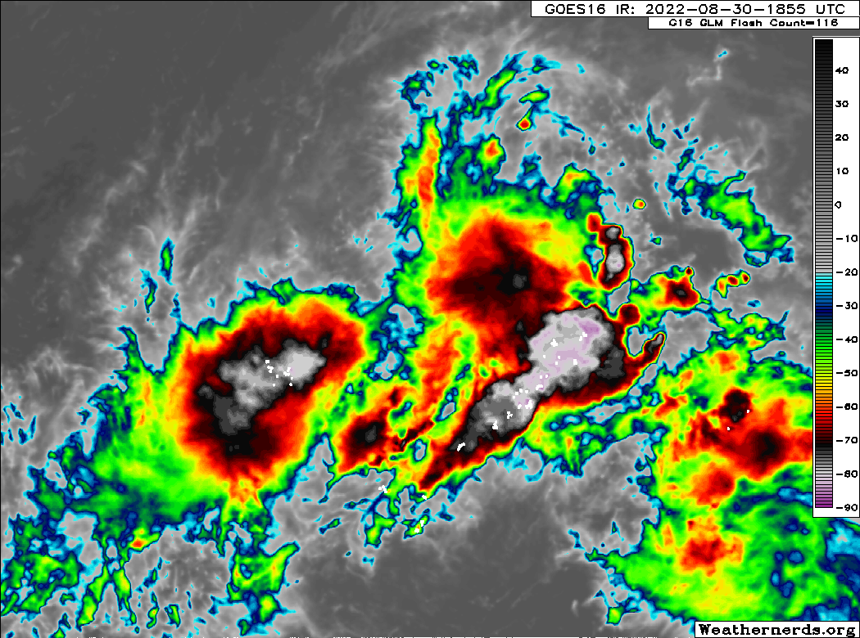
Instrument Notes

IN-FLIGHT
Time [UTC] | Event
1953 | Takeoff from Barbados
2032 | IP drop #1, 12 N, 56.5W  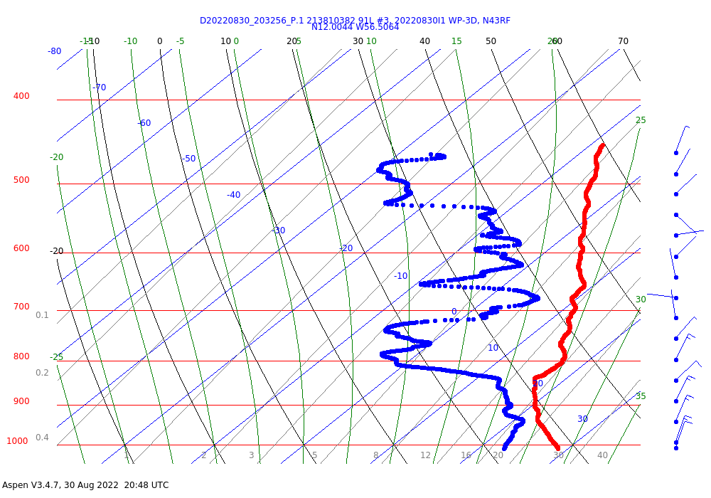  Drop shows several dry air layers as well as a general subsidence signature.
2036 | Convection and lightning in the SE side of the system  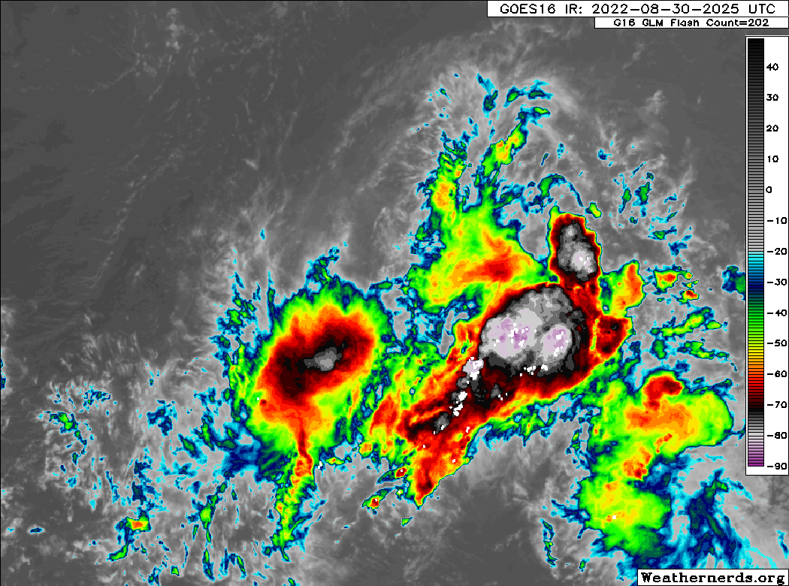  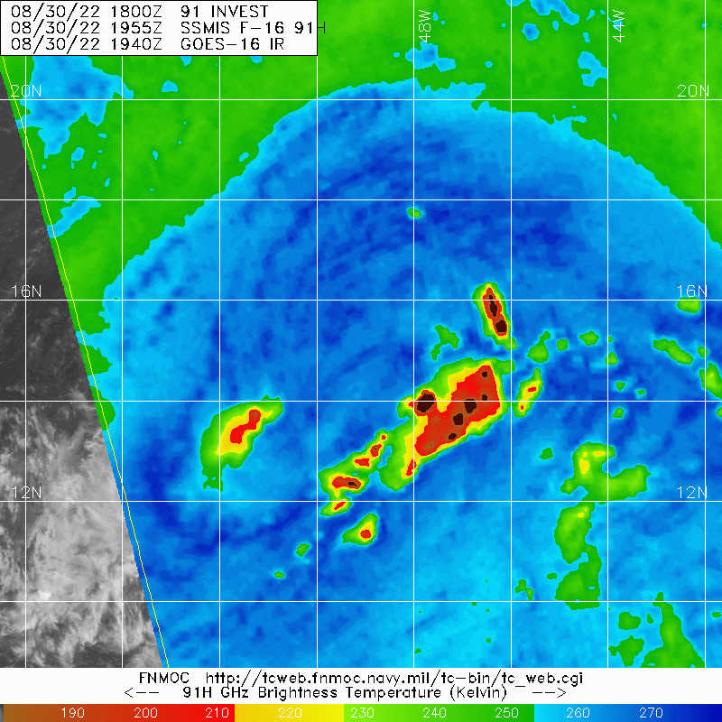
2048 | Drop 2, 12 N 55.1 W
2104 | Drop 3, 12 N, 53.8 W  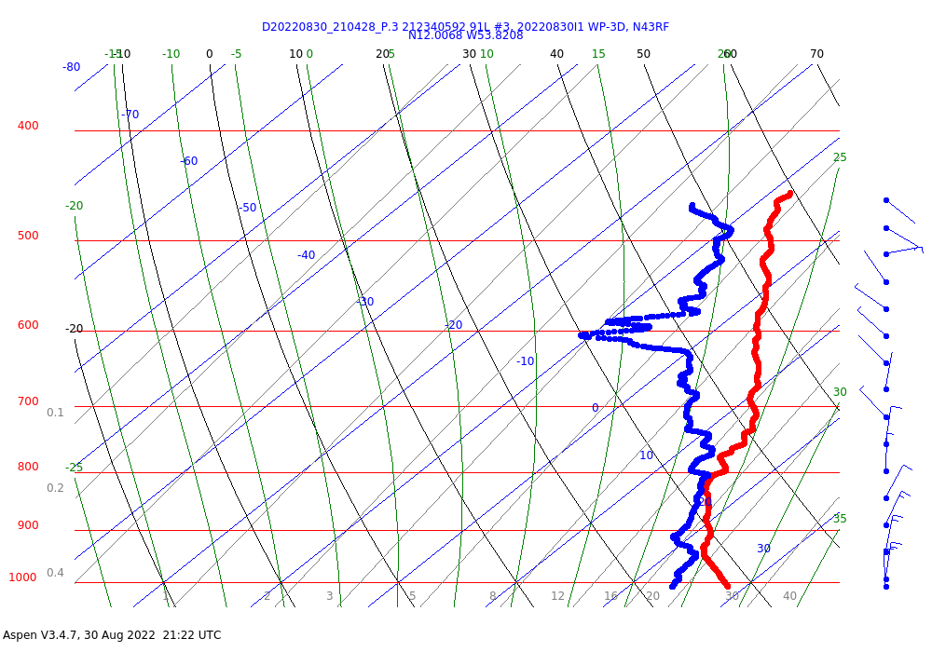  This drop looks a little more moist in the low-mid levels.
2119 | Drop 4, 12 N, 52.5 W. Big flight level wind shift (from NNW to SSW) between drops 3 and 4 as we crossed the cyclonic shear line at altitude along 55.85 W longitude.
2120 | Based on discussion with Andy Hazelton I worked out a plan with the Flight Director to get TDR data along convection near PT 6 & 7. Plan is to shift the track a little W from pt 6-9 to go up the west side of the convection as tight as flight will allow to get TDR. If icing is a problem we will also descend to 10 kft.
2127 | Noted lightning in cells to the right of our track and 20 n mi ahead
2137 | Drop #5, 12N, 50.95W
2148 | Drop #6, 12N, 49.95W. Turn NE. Tracking along the inside of the convective band
2204 | Drop #7 added (12.9N, 48.9W) to fill in a coverage hole due to early release of of drop #6
2210 | Frank notes lots of anvil ice - could be a good microphysics dataset, except 43 has no microphysics
2215 | Shifted our track to 025 to stay west of line. Big cells right around pt 9.
2215 | Drop 8, 13.65N, 48.5W, skipping next sonde due to proximity to point 9
2234 | Drop 9, 15N, 48.35 W  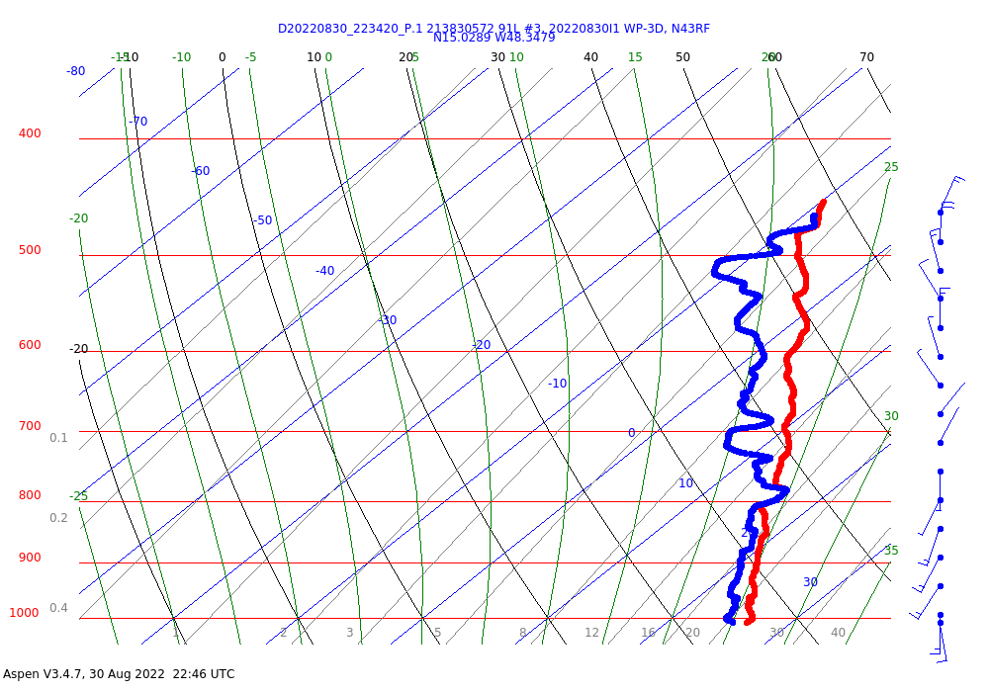  This one looks very moist
2240 | Heading away from convective band  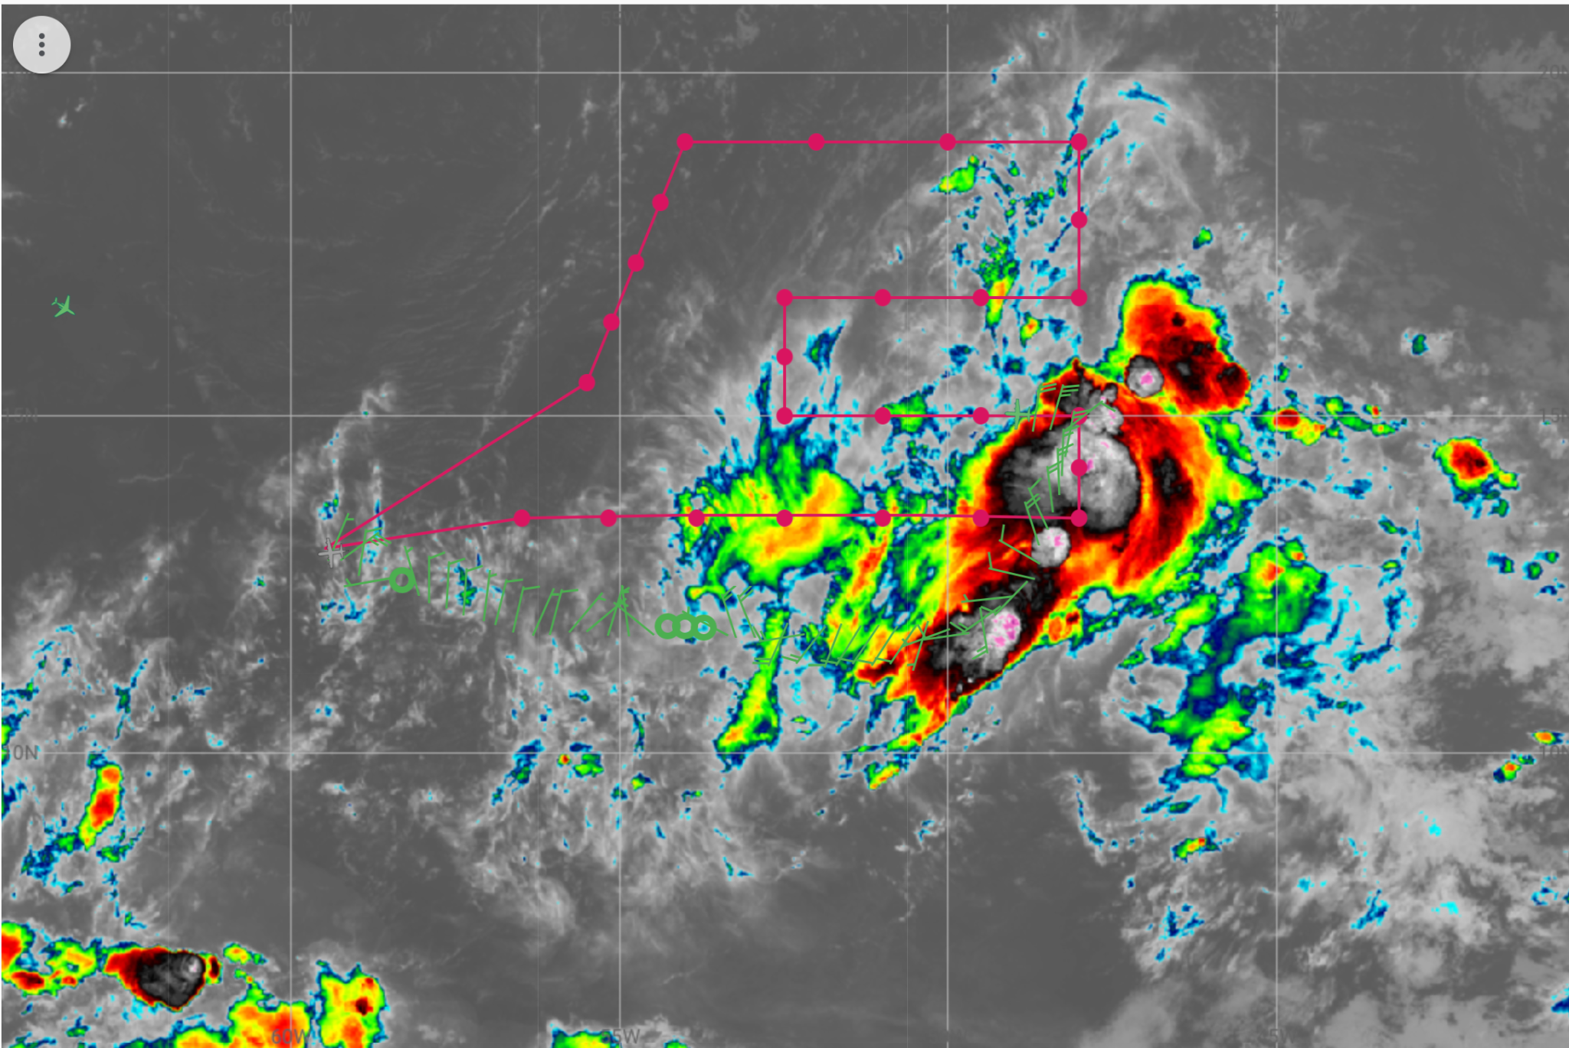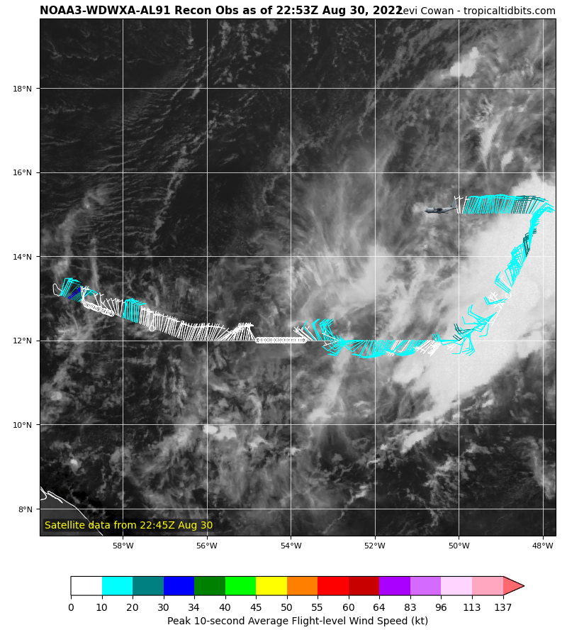
2247 | Drop 10, 15N, 49.85W
2253 | Drop 11, 15N, 51W
2318 | Mid-level center around 7-km evident on TDR  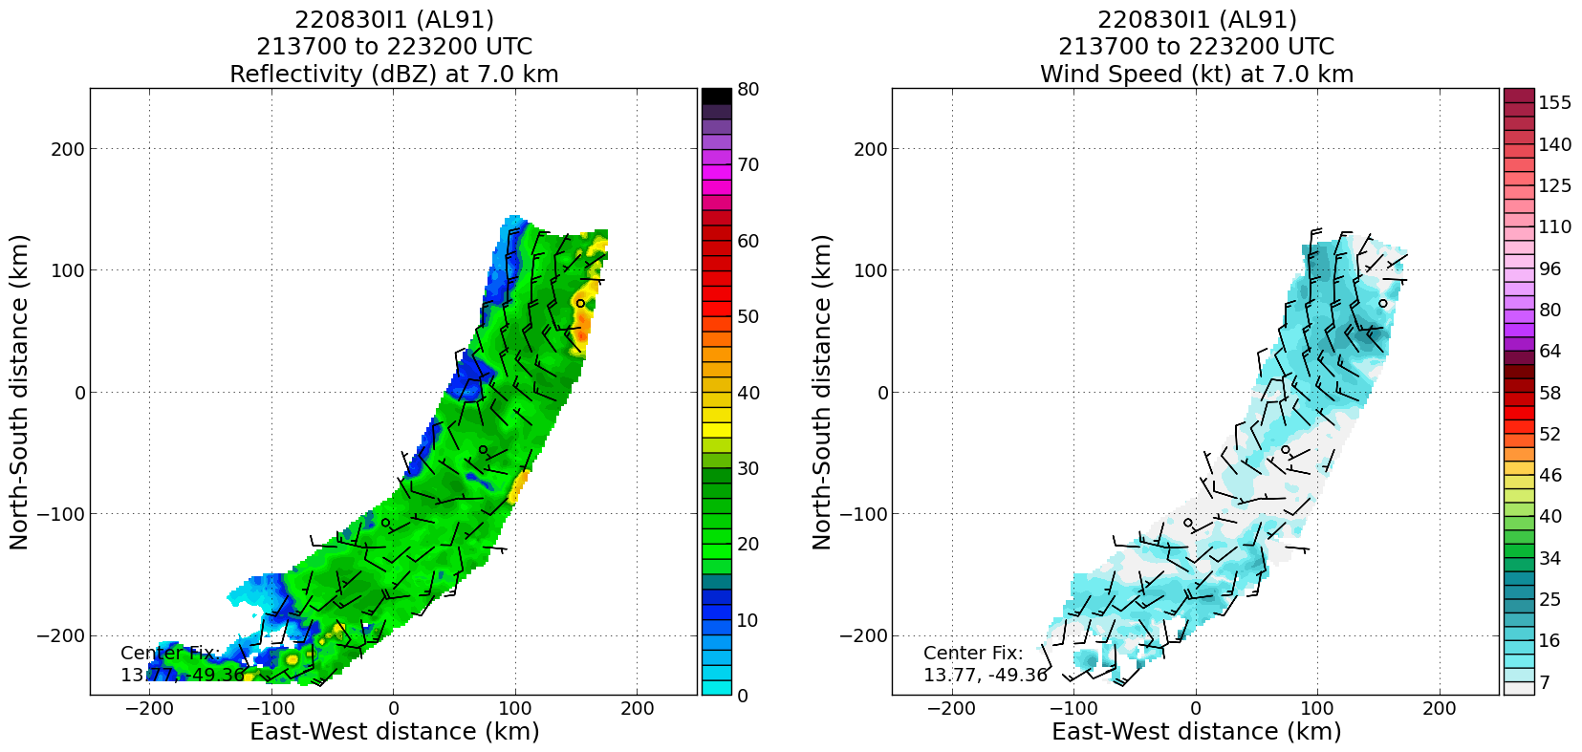  Not as evident at lower levels…  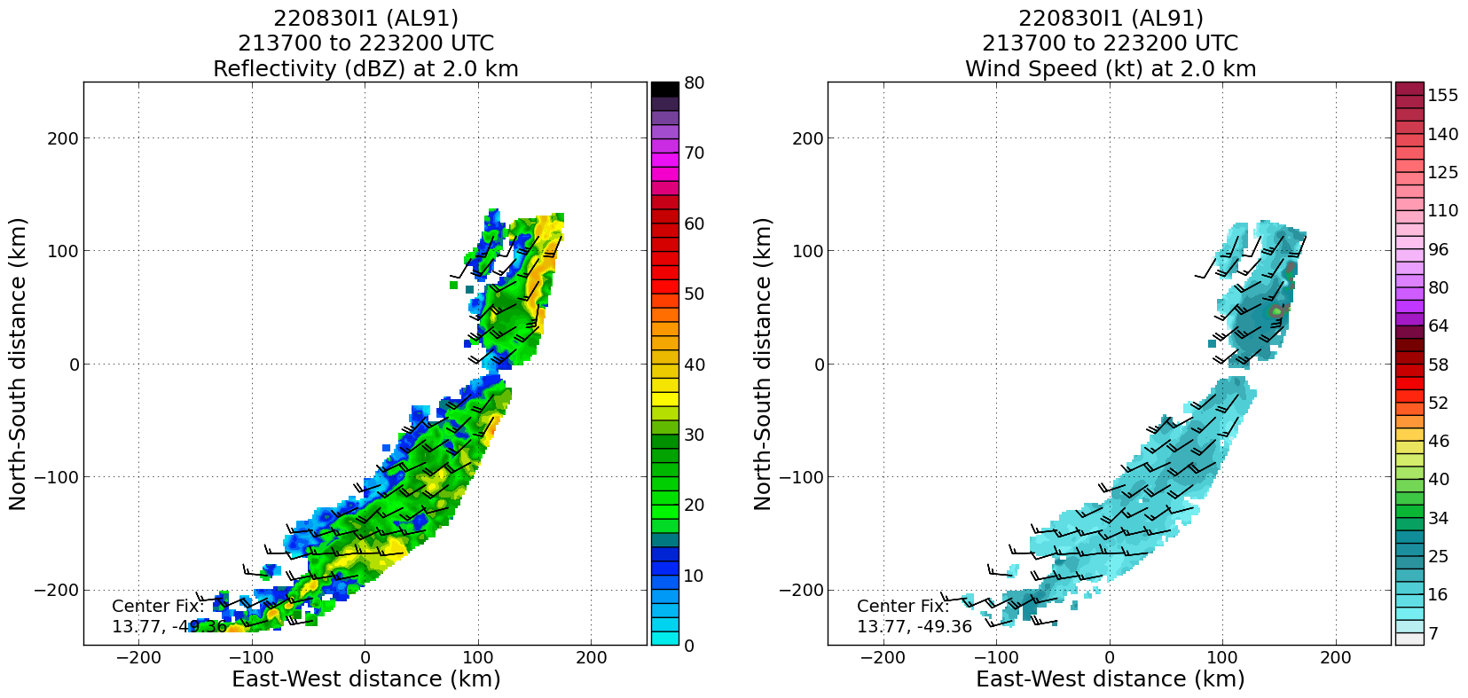
2322 | Drop #12, 15 N, 52.5 W. Turn to track 360 degrees, 17% RH at 700 mb…  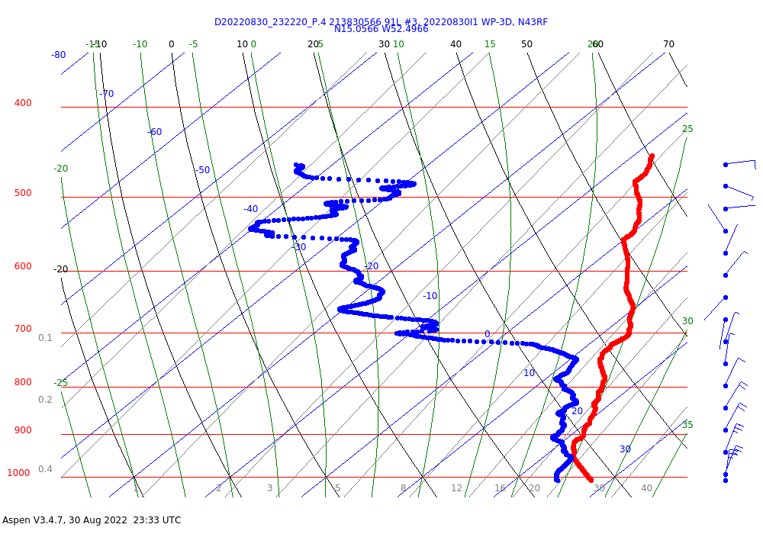  Impressive subsidence/drying signature with this one
 | Paul Chang said that the seas in general were running 6-8 ft to the west of the line, but along that track they went from 9-12 ft
2332 | Drop #13, 15.9 N, 52.5 W
2336 | Synoptic plots from sondes suggest some of the same W→E vortex tilt  850 mb…  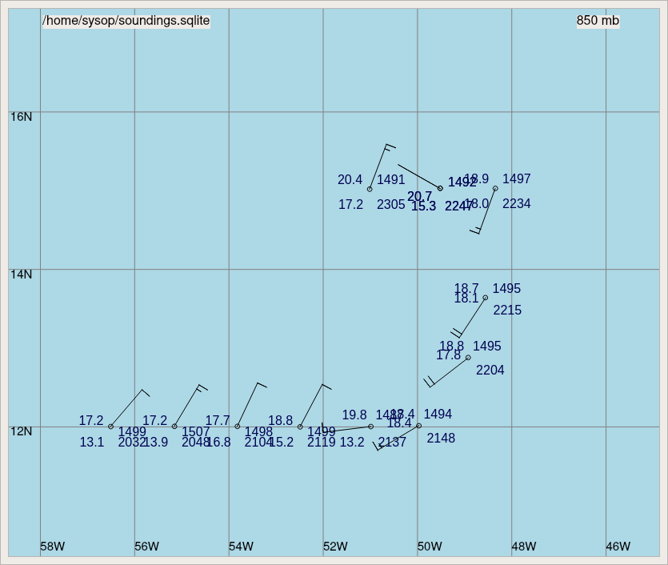  500…  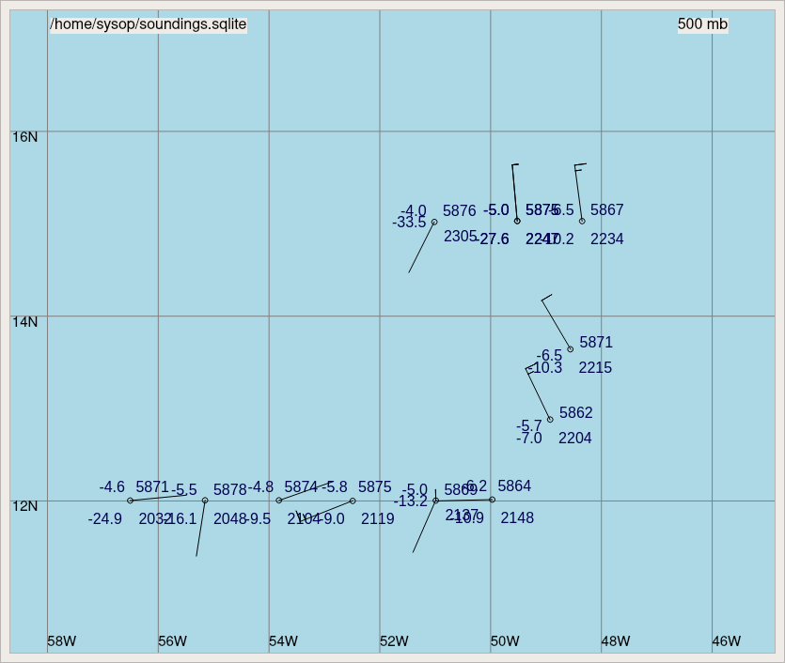
2342 | Drop #14 16.7N 52.5 W. Turn to track 090 degrees.
2354 | Composite analysis shows the mid-level center nicely:  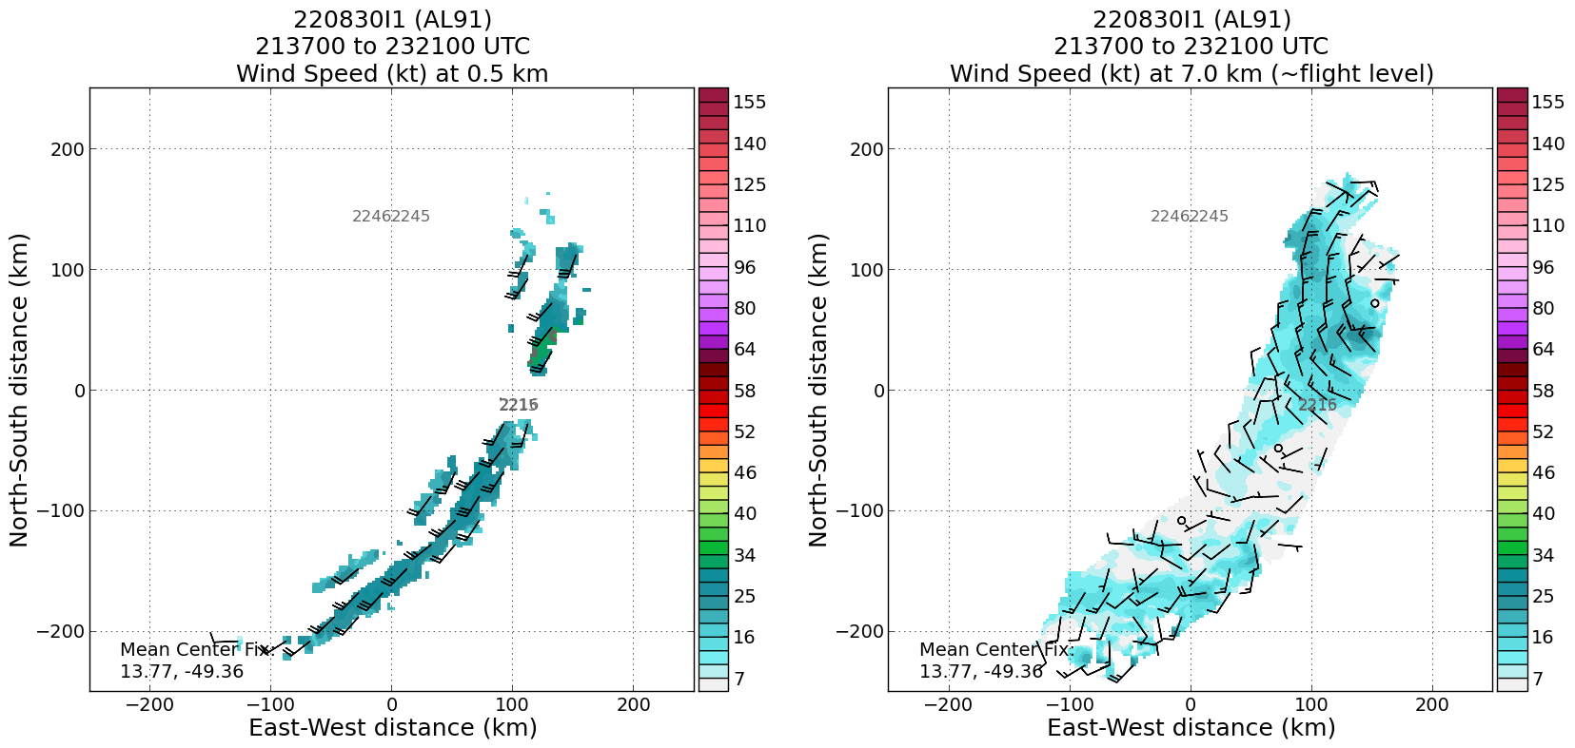
0000 | Drop #15, 16.75N 50.95W
0007 | Wave Data From NESDIS:  https://manati.star.nesdis.noaa.gov/aircraft_images/monitor/hs2022/20220830I1_Al91_map.png  https://manati.star.nesdis.noaa.gov/aircraft_images/monitor/hs2022/20220830I1_Al91_timeseries.png  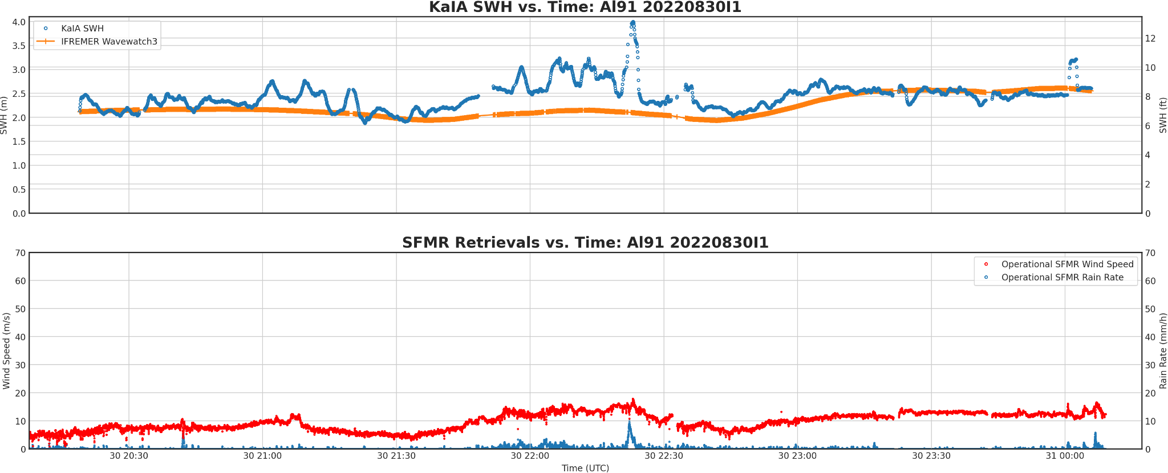
0017 | Drop #16, 16.75 N 49.5 W
0035 | Drop #17, 16.75 N 48.00 W. Turn to track 360 degrees.
0042 | 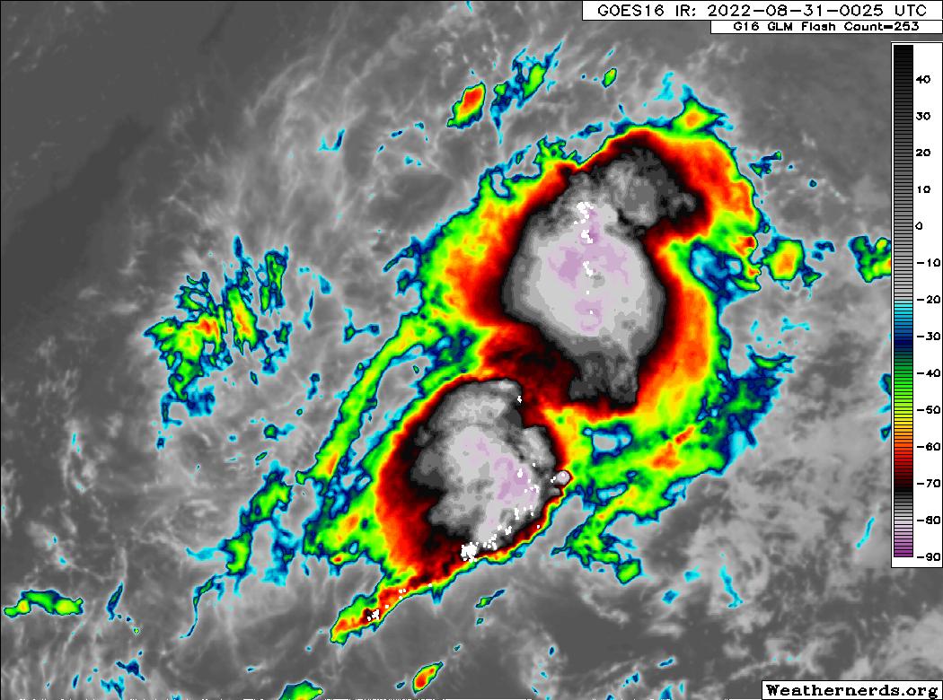  Some healthy and slightly more symmetric convection.
0047 | New sounding synoptic map…  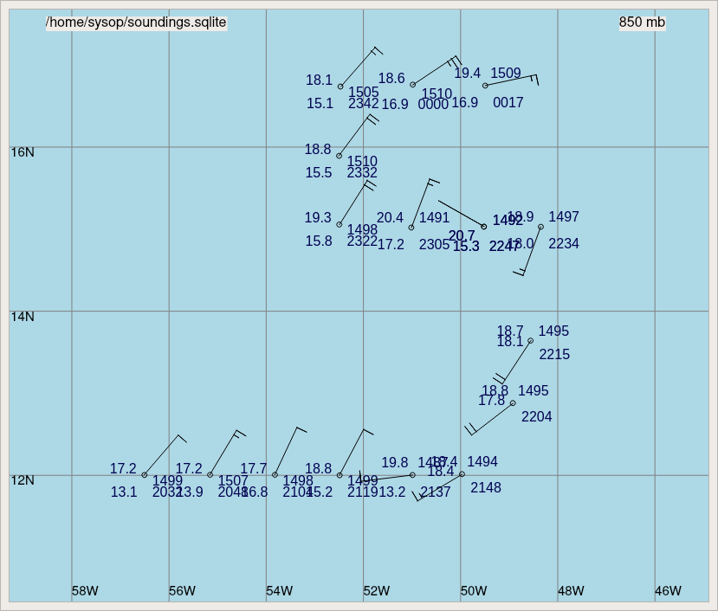
0049 | Drop #18 17.9 N 47.9 W
0101 | Drop #19, 19 N 48 W. Turn to track 270 degrees.
0124 | Drop #20, 19.25 N 50 W. Passing just N of some weak cells.  Very dry layer:  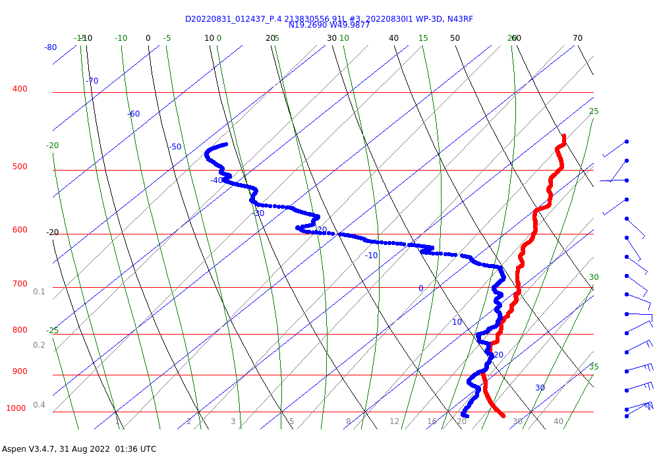
0136 | Recent ASCAT pass shows the broad LLC is still well SW of the convection and MLC that was noted in the radar/sonde data.  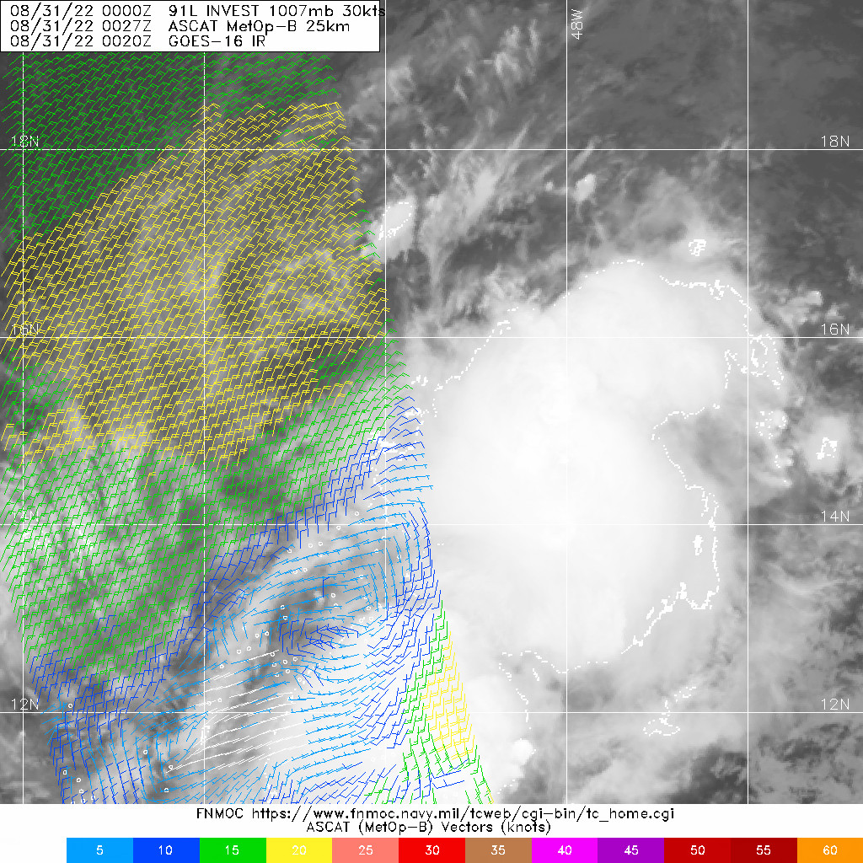
0147 | Drop #21, 19 N, 52 W
0157 | Drop #22 on Saildrone 1083 location: Saildrone 19 02 40N 052 57 37W sonde splash 18.99N 52.94W 7 n mi off  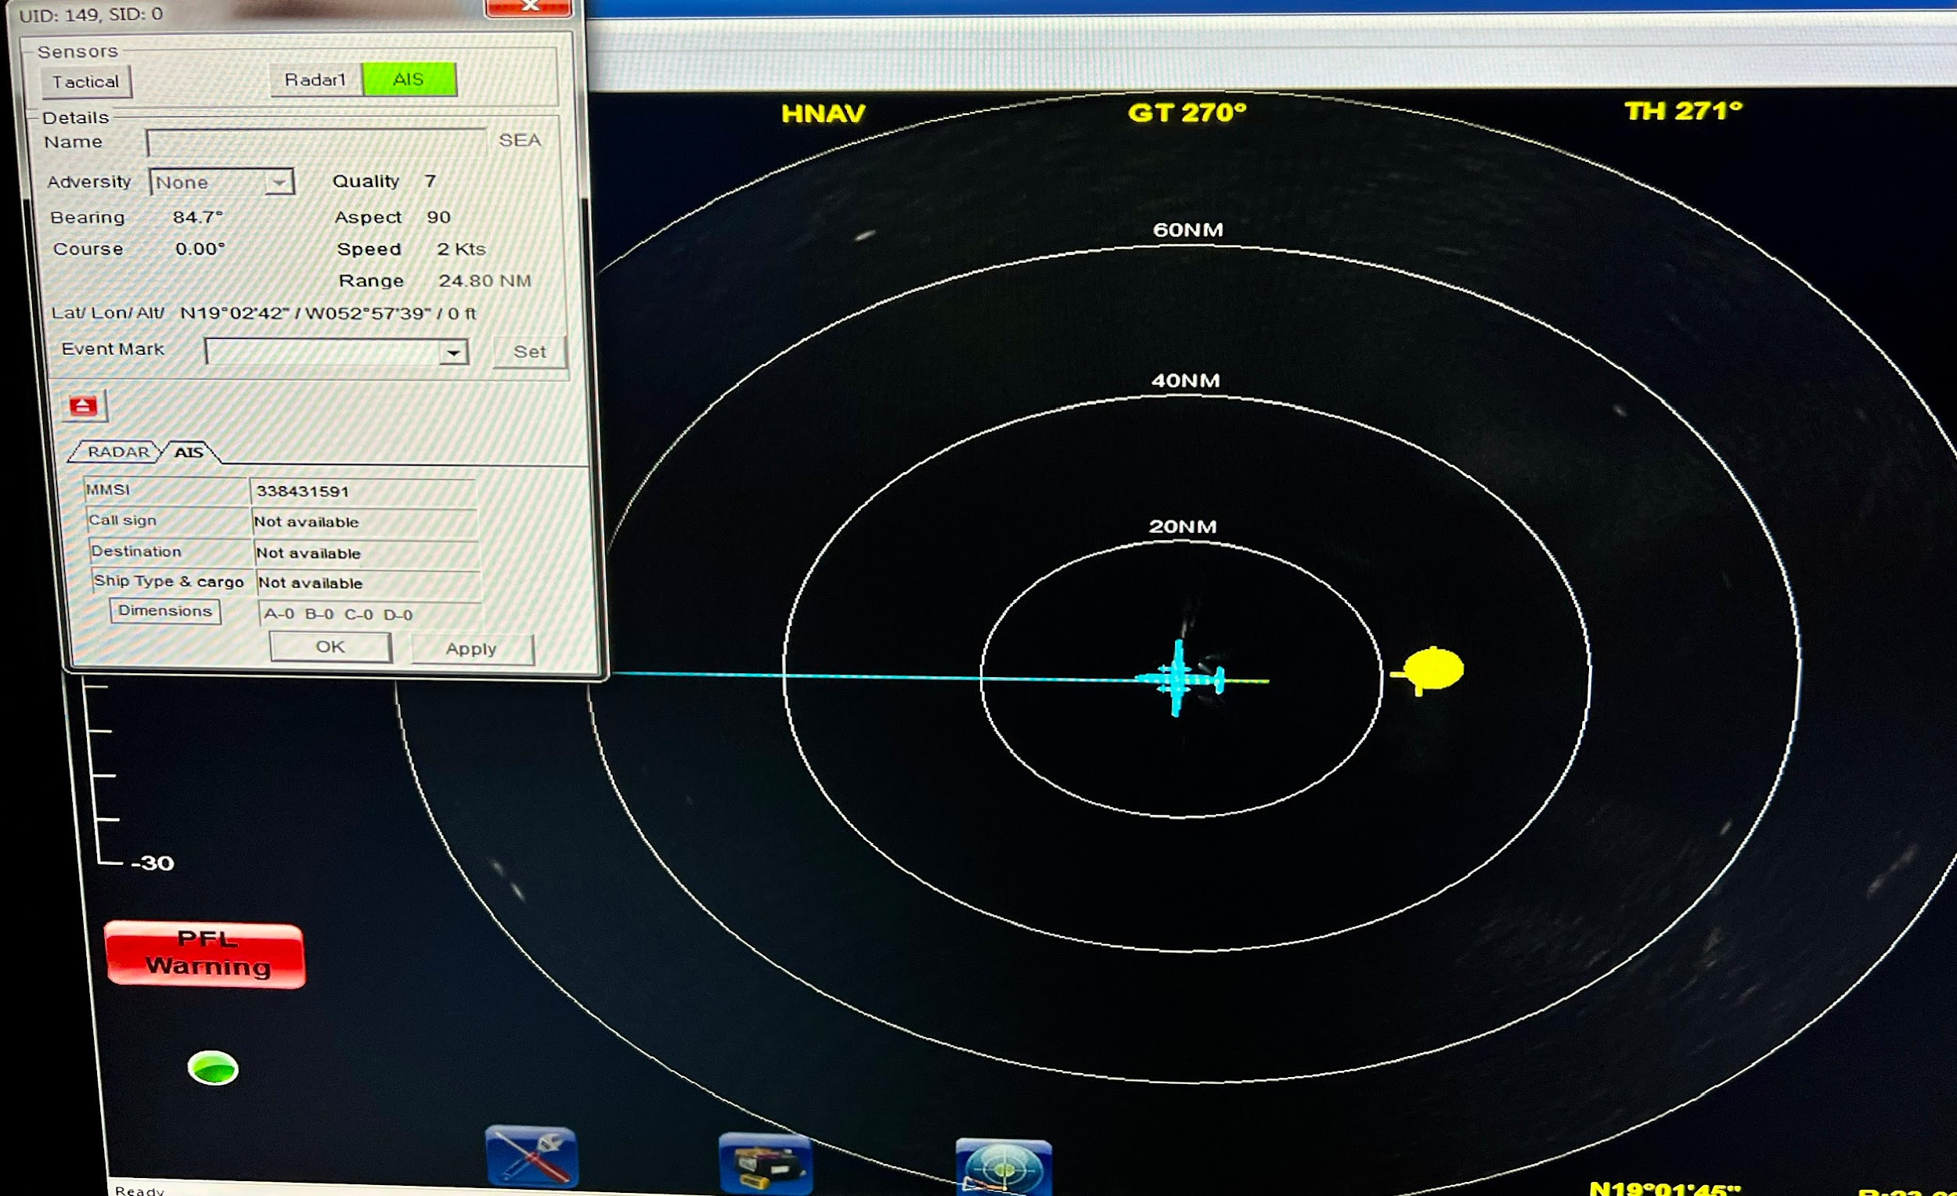
0209 | Drop #23, 19 N, 54 W. Turn to track 200 degrees.
0220 | Drop #24. 18.1 N, 54.4 W
0222 | Drop #25 (backup of 24)
0232 | Drop #26, 17.2 N, 54.8 W
0243 | Drop #27, 16.4N, 55.1 W
0254 | Drop #28, 15.5N, 55.5 W. End of Science.
0300 | Final 850/500 hPa synoptic maps…  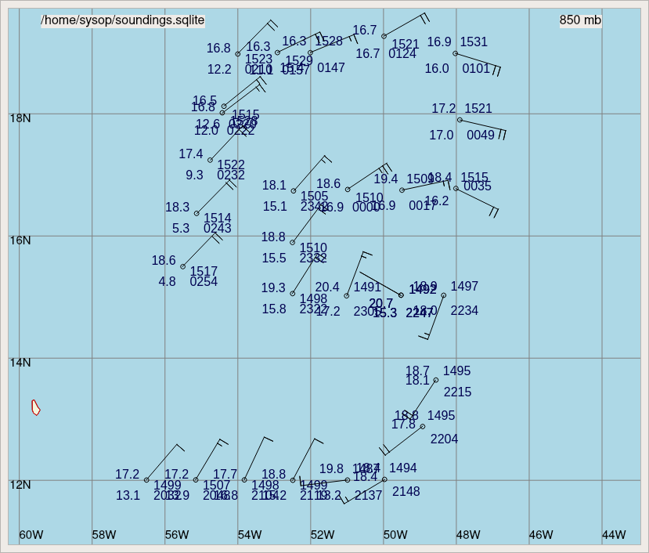  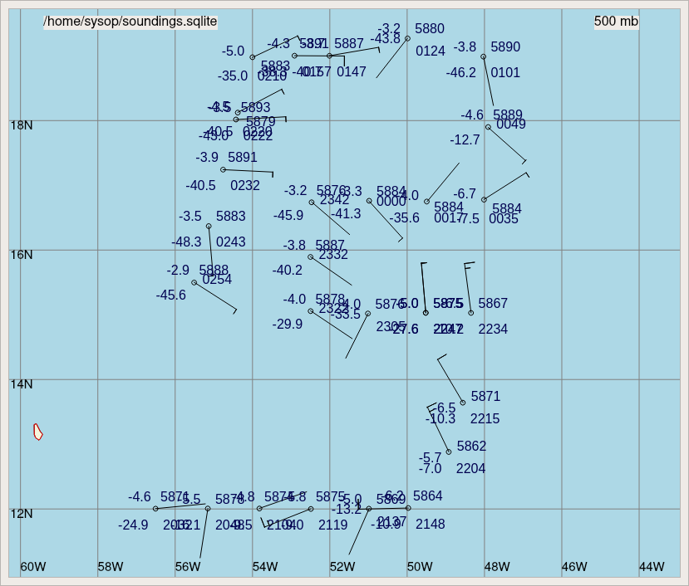

POST-FLIGHT
Mission Summary | We executed the lawnmower pattern with some adjustments on the south side due to convection.  Sondes continued to show some very dry layers in the environment, although there were also some very moist soundings near the convection.  Radar analysis and synoptic plots from the dropsondes showed a mid-level center trying to form in the convection just to the northeast of the first part of the flight track. The low-level center was outside the convection and to the west, however, suggestive of ongoing vortex tilt. It remains to be seen whether this MLC will align with the low-level center and initiate TCG.  28 dropsondes were released in the pattern (XX charged to NWS).
Actual Standard Pattern Flown | Lawnmower with some adjustments on the south side due to convection.
APHEX Experiments / Modules Flown | Genesis research mission with a synoptic surveillance pattern for sampling for the Genesis Stage Experiment: FAMS and Early Stage Experiment: ITOFS  Intercomparison drop near Saildrone 1083 in NW corner of pattern for Ocean Observing: Sustained and Targeted Ocean Observations.
Plain Language Summary | We flew through Invest 91L in the Central Atlantic. The system was slowly getting better organized during our mission, and will help us to better understand the processes that allow disturbances to turn into tropical cyclones.
Instrument Notes | One early dropsonde calibration concern that seemed to be resolved by switching the GPS repeater. It was not a problem with the sondes.  The SFMR seemed to be behaving oddly from about 0100 - 0130 UTC: https://manati.star.nesdis.noaa.gov/aircraft_images/monitor/hs2022/20220830I1_Al91_timeseries.png  Seems like it was likely a post-processing bug, according to Paul Chang: ‘working theory on the SFMR issue....a port server that feeds data that SFMR taps into locked up for a period of time (KARMA was out during this time period which was about the same time as the SFMR issue)...so SFMR was missing data updates it uses for the retrieval process which most likely caused the anomalous behavior’.
Final Mission Track | 