MISSION PLAN
FLIGHT ID | 20220830H1 | STORM | AL91
MISSION ID | WCWXA | TAIL NUMBER | NOAA42
TASKING | HRD | PLANNED PATTERN | Lawnmower
MISSION SUMMARY
TAKEOFF [UTC] | 0920 | LANDING [UTC] | 1725
TAKEOFF LOCATION | Barbados | LANDING LOCATION | Barbados
FLIGHT TIME | 8.1 | BLOCK TIME | 8.3
TOTAL REAL-TIME RADAR ANALYSES  (Transmitted) | 3 | TOTAL DROPSONDES (Good/Transmitted) | 25 (25 / 25)
OCEAN EXPENDABLES (Type) | None | sUAS (Type) | None
APHEX EXPERIMENTS / MODULES | Genesis Experiment: FAM; Early Stage Experiment: ITOFS, Stratiform Spiral Module
HRD CREW MANIFEST
LPS ONBOARD | Rogers | LPS GROUND | None
TDR ONBOARD | Englert, Rogers | TDR GROUND | Fischer
ASPEN ONBOARD | J. Zhang | ASPEN GROUND | None
NESDIS SCIENTISTS | None
GUESTS (Affiliation) | None
AOC CREW MANIFEST
PILOTS | Abitbol, Rannenberg, Keith
NAVIGATOR | Hough
FLIGHT ENGINEERS | Stokes, Gee
FLIGHT DIRECTOR | Carpenter
DATA TECHNICIAN | McAllister
AVAPS | Dykeman

PRE-FLIGHT
Flight Plan | 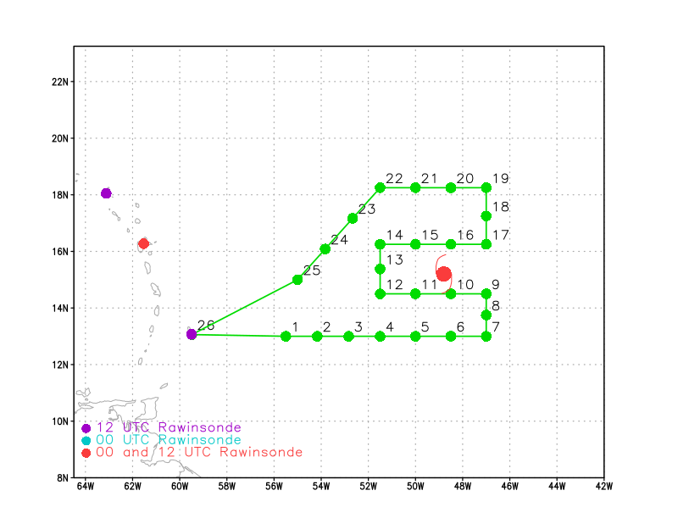  Pattern: Fly lawnmower at max altitude because G-IV mission canceled. If possible, fly a microphysics spiral in stratiform precipitation.  Altitude: 21 kft (pressure altitude)
Expendable Distribution | Load 30 sondes; release sonde at planned points (green dots above); no AXBTs for this mission.
Preflight Weather Briefing | AL91 remains poorly organized as a broad, weak circulation oriented around a SW-NE oriented axis. There has been some convection that has developed, likely tied to the diurnal cycle, in a line along the wave axis. But there are still no signs that convection has consolidated vorticity enough to form a tight, coherent circulation. The convection that has developed has been too scattered and transient, and the circulation is too broad, to accomplish such a consolidation.  AL91 continues to struggle with midlevel dry air around its north and west. There is also significant shear west of the wave axis, which is at least partially driven by the strong northeasterly low-level flow of the parent broad circulation, and also likely tied to an upper-level low to the system’s northwest. There is a line of reduced shear along the wave axis. If convection can develop there and persist, some consolidation could happen. Model guidance has been indicating that genesis and intensification will occur, but not for 2-3 days. So this pattern may persist during that time. Once the system encounters a more favorable (i.e., less dry, lower shear) environment, that is when genesis and intensification may occur.
Instrument Notes

IN-FLIGHT
Time [UTC] | Event
0920 | Takeoff from Barbados
0952 | 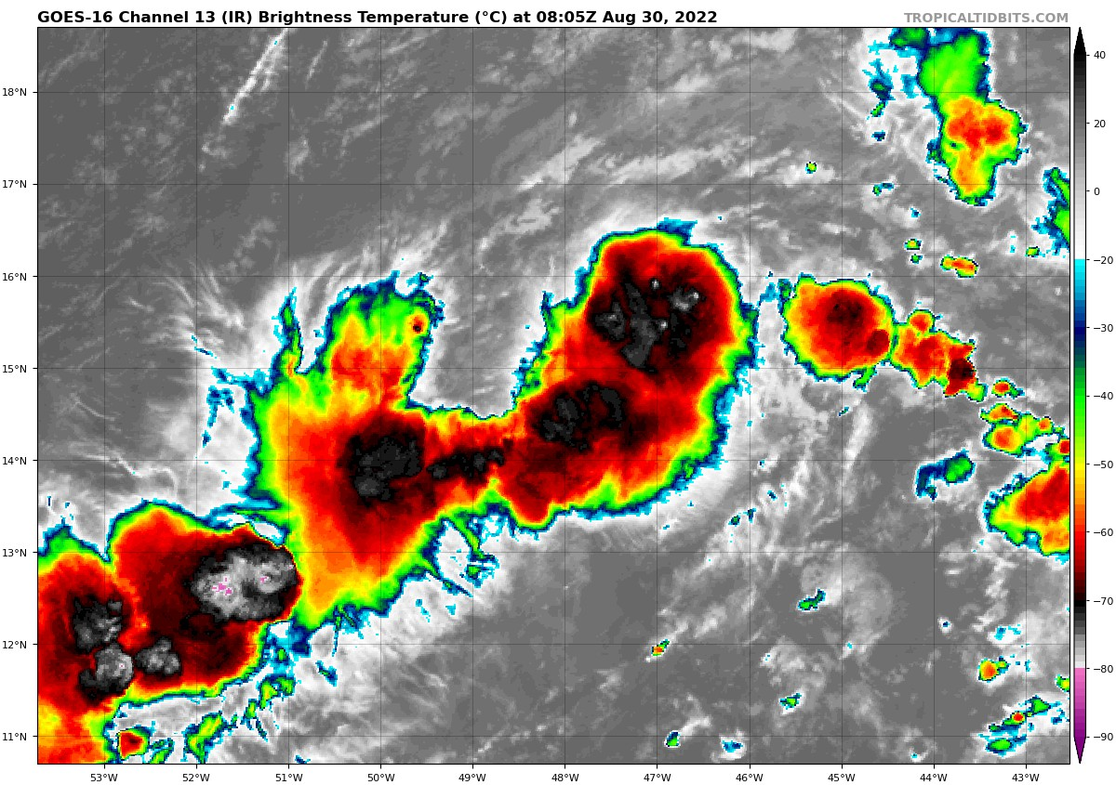  Linear organization of convection. Cells are primarily still transient, though there is vigorous-looking convection in the IR on the northeast tip of the wave axis as well as the southwest end of it. The axis of the line of convection is oriented along the wave axis, northeast-southwest.
1009 | Sonde 1 released at pt 1, looks good
1015 | Climb 1000 ft, up to 24500 ft
1022 | Because of the line of convection ahead of us, we’ll have to deviate a bit to go around it, especially at 24500 ft. We’ll turn left 45 degrees then go parallel to the original line until we find a gap that will allow us to return back to the original line.
1023 | Sonde 2 released at pt 2
1029 | Midway between points 2 and 3, we’re under a non-precipitating anvil. Could be blow-off from convection ahead of us. There are some echoes showing up on TDR, at the edge of the sweep. Seems to be heavy stratiform, no real vertical development.
1038 | Sonde 3 released at pt 3
1054 | Sonde 4 released at pt 4
1054 | 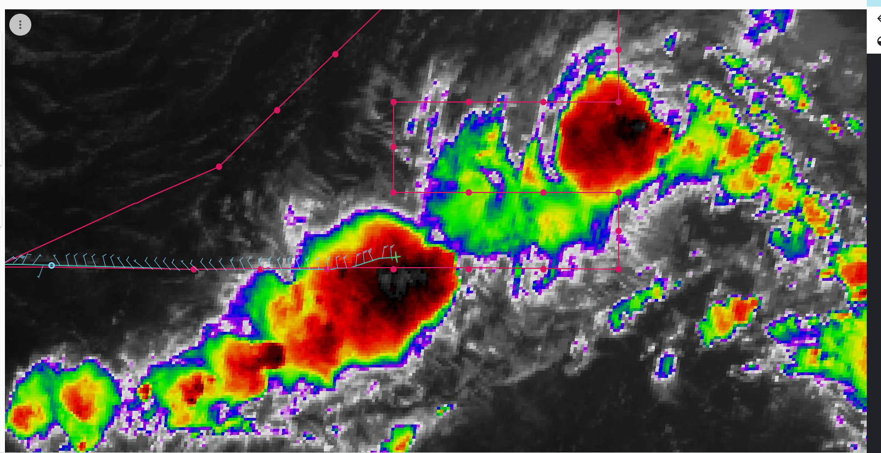Deviating N of active convection
1056 | Frequent lightning in southern convective line 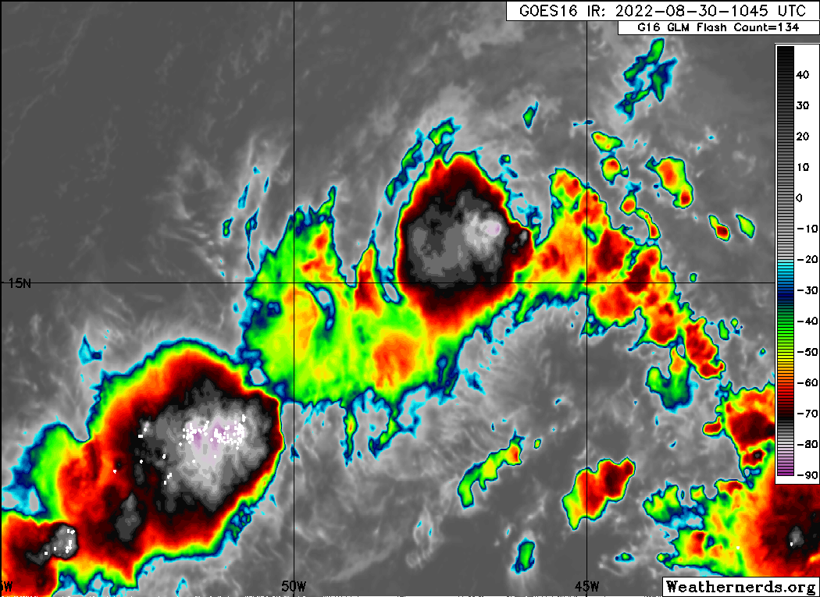
1057 | TDR showing deep convection in the southern convective line, to the south of the aircraft. Echo tops are estimated to be at 16 km.
1100 | Early-morning visible view of the system. Elongated circulation with SW low-level flow on south side of convective burst at crest of wave axis 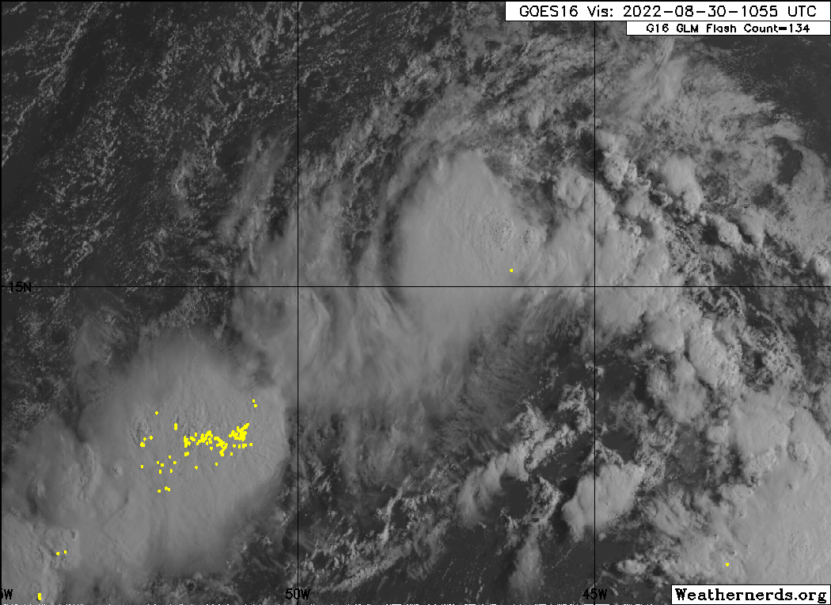
1112 | Sonde 5 at pt 5
1129 | Sonde 6 at pt 6
1139 | First TDR analysis began (center time of 105309 UTC)
1145 | Turn north at point 7, drop sonde 7
1153 | Sonde 8 released at point 8
1159 | Trying to do a spiral at point 9, which is blow-off from a convective cell tied to the tip of the wave axis to the north. However, there is only non-precipitating anvil here, no hydrometeors at flight level. We have decided to cancel the planned spiral at point 9. We are considering a point west of point 9, but that doesn’t look likely either. We may try a spiral later in the pattern, in the northeast portion of the pattern.
1201 | Sonde 9 released at point 9
1214 | First TDR analysis showed a strong convective burst within the convective line. Large reflectivity values (> 30 dBZ) at 14 km. Divergent outflow also seen.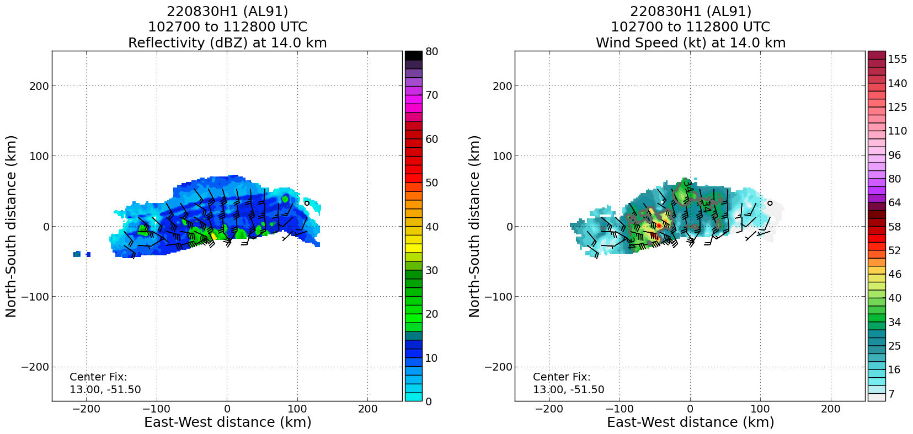
1214 | Sonde 10 released at pt 10  Large region of deep convection  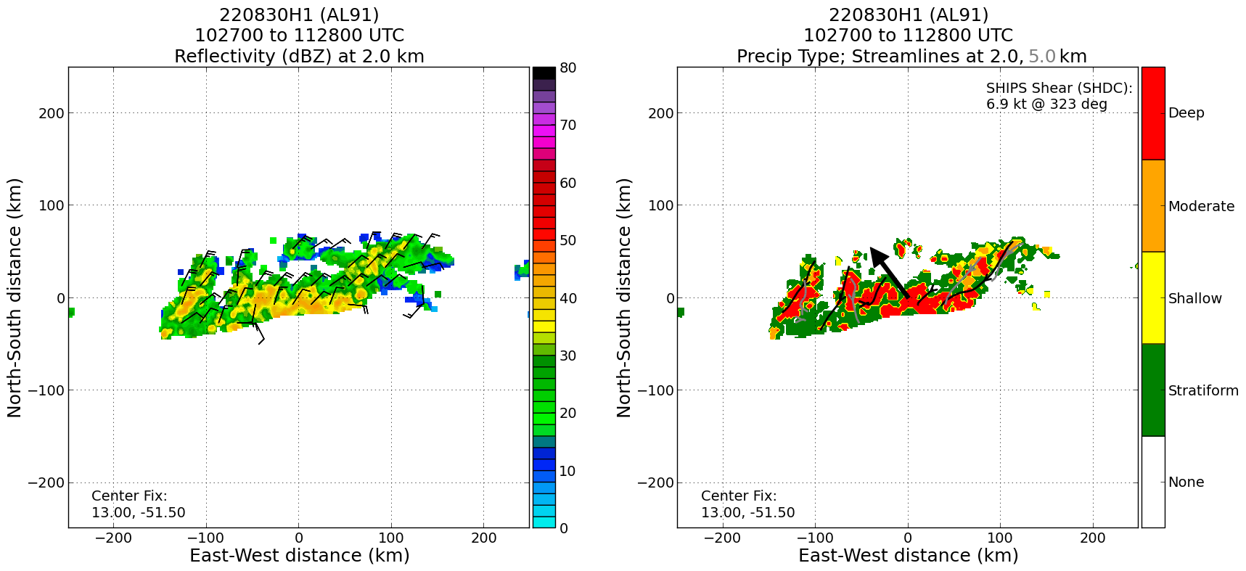
1224 | 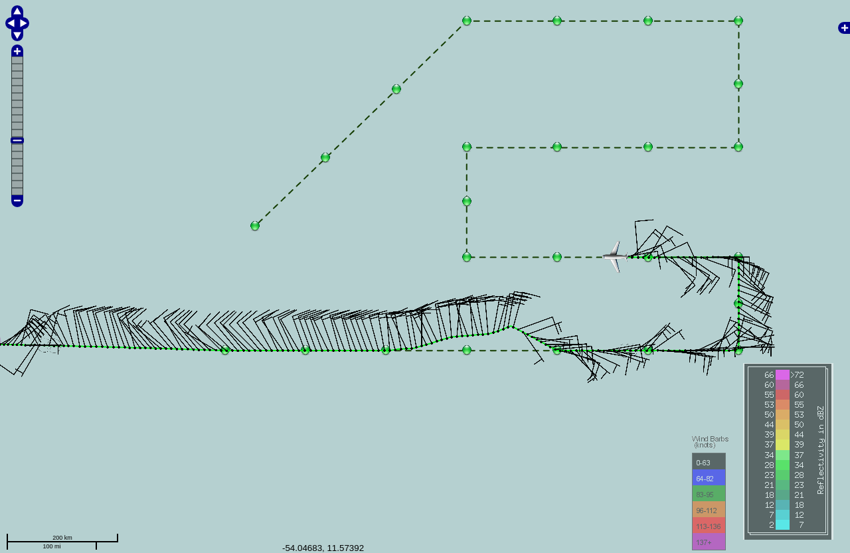  We just passed through the wind shift again. You can see the SW-NE orientation of the shear/trough axis, even up here at 25000 ft.
1233 | Sonde 11 released at point 11
1247 | Sonde 12 released at point 12
1248 | On the dry side of the system. Flight-level relative humidity of ~30-35% seen.
1254 | Climbing to 25000 ft
1257 | Sonde 13 released at point 13
1307 | Sonde 14 released at point 14
1322 | Sonde 15 released at point 15
1323 | Going to try again for a microphysics spiral. This one will likely be at the end of this west-east leg, point 17. This is at the back edge of the main convective burst associated with the northern tip of the wave axis. The air is so dry here, though (25-30% RH), that any hydrometeors ejected from convection probably immediately evaporate or sublimate, hence the cloud tops warm rapidly and collapse. If there is not a target here for a spiral then we will abandon effort for spiral.
 | Considering getting closer to the convective burst to the south of the pattern. Getting close to that particle fountain (to quote houze) would make it more likely to get stratiform. This all says to me that the structure of the convection and convective systems are important for the potential for genesis. By that I mean whether the convection and associated stratiform is long-lived and areally extensive. And those characteristics are set, at least to some extent, by the mesoscale environment, in particular the thermo environment. Clearly this is still not a favorable thermo environment. But it's interesting to see that play out in the frustration with trying to do a spiral when you can’t get to any decent stratiform precipitation. It all collapses immediately, likely b/c of the significant dryness. It will be really interesting to see that transition in the structure of the convection (perhaps through CFAD evolution?) as the thermo environment gets more conducive
1338 | Sonde 16 released at point 16
1400 | Begin microphysics spiral, saw snow on the propellor. Loitered for about 5 minutes, then began descent. Starting altitude was 25000 ft. Dropped sonde at start.  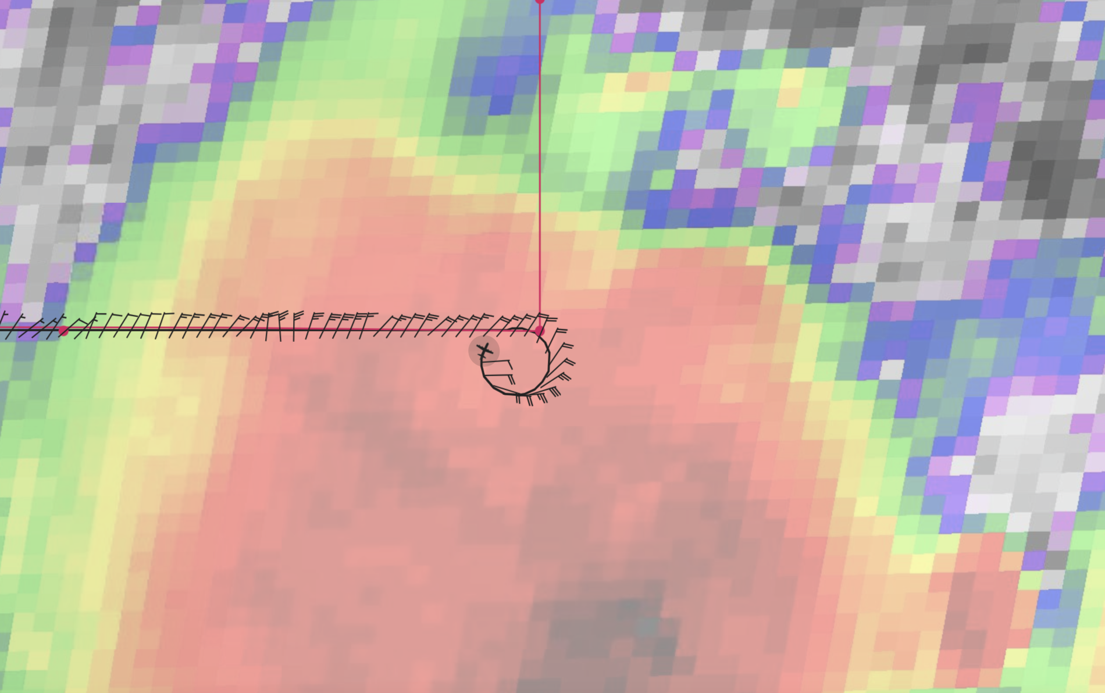
1400 | Sonde 17 released at point 17
1409 | Down to 15,000 ft…  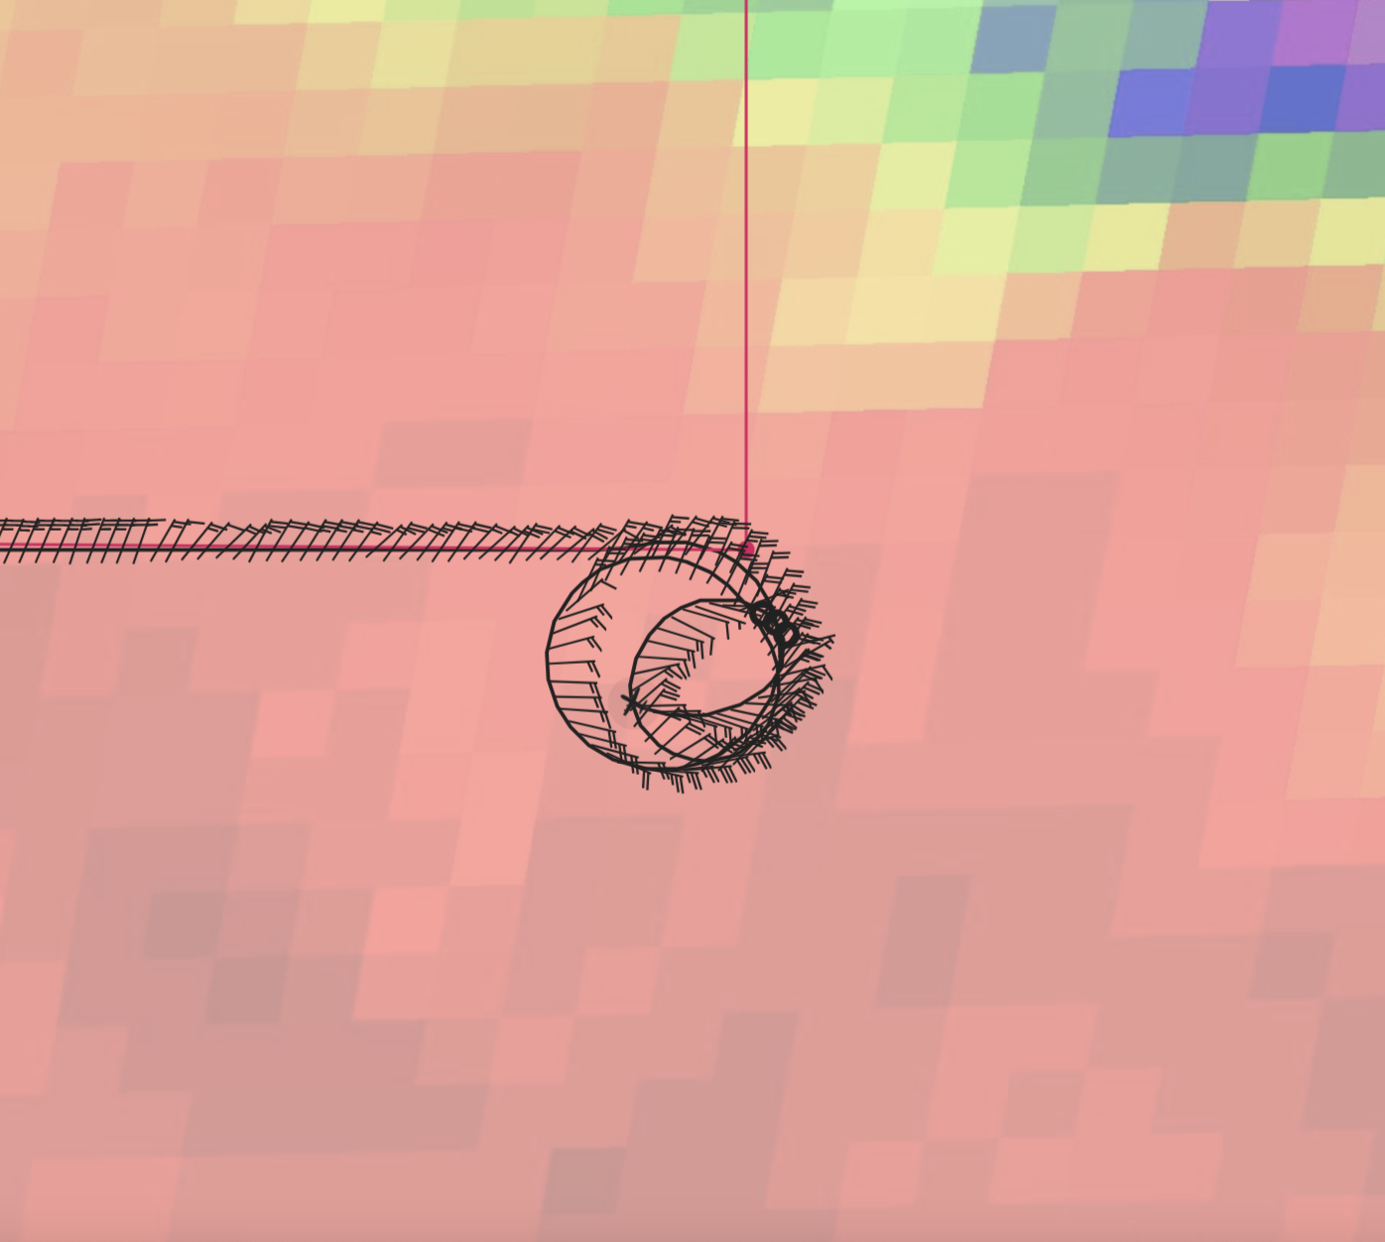
1414 | Down to 10,000 ft…clearing up a bit, areas of virga  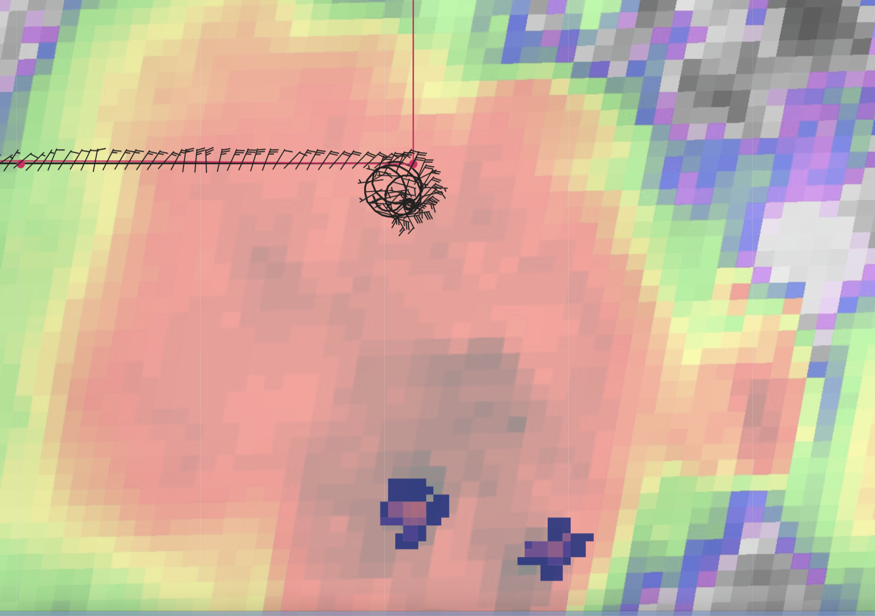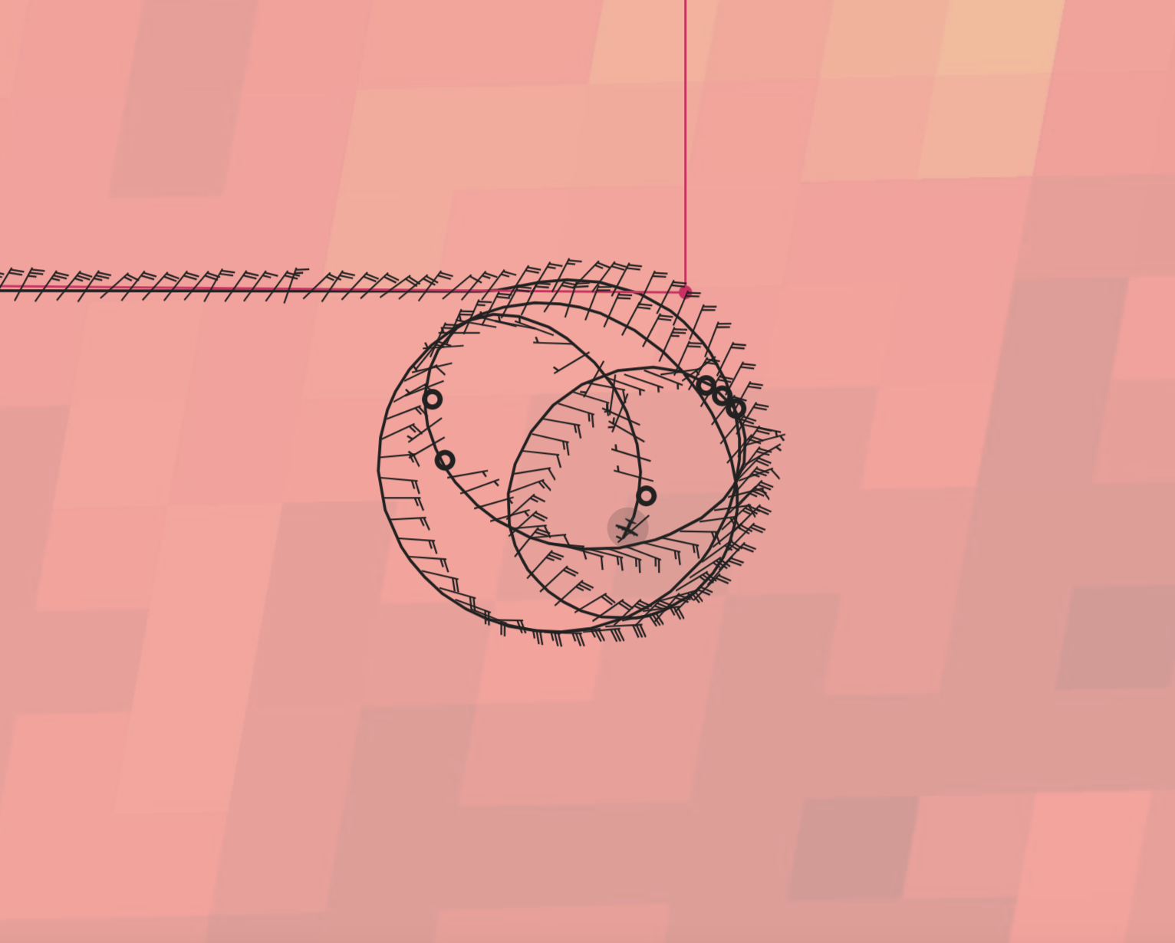
1420 | Spiraling up through 13,000 ft  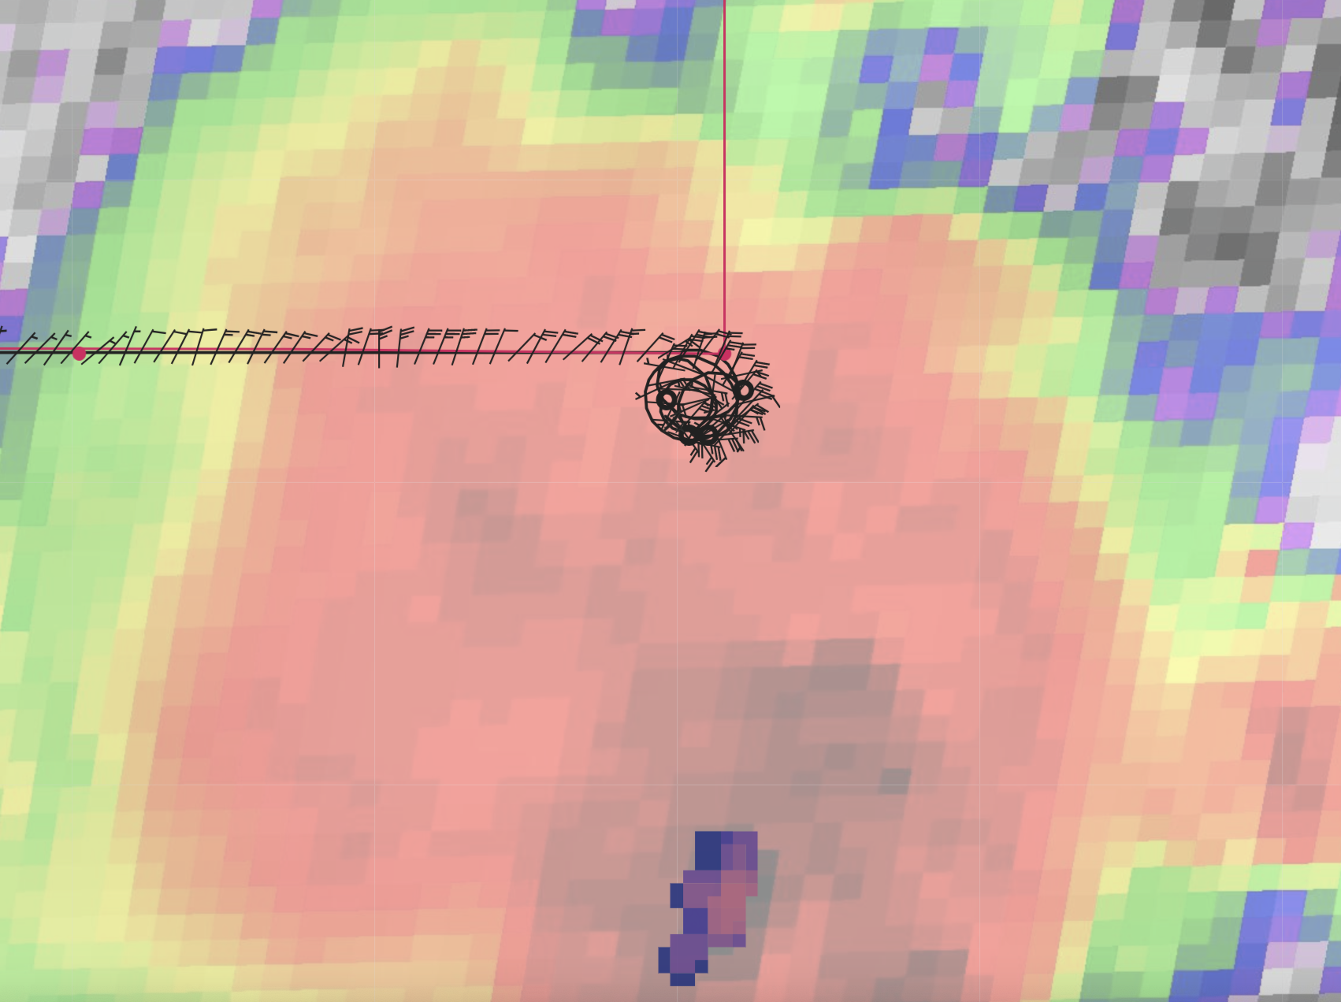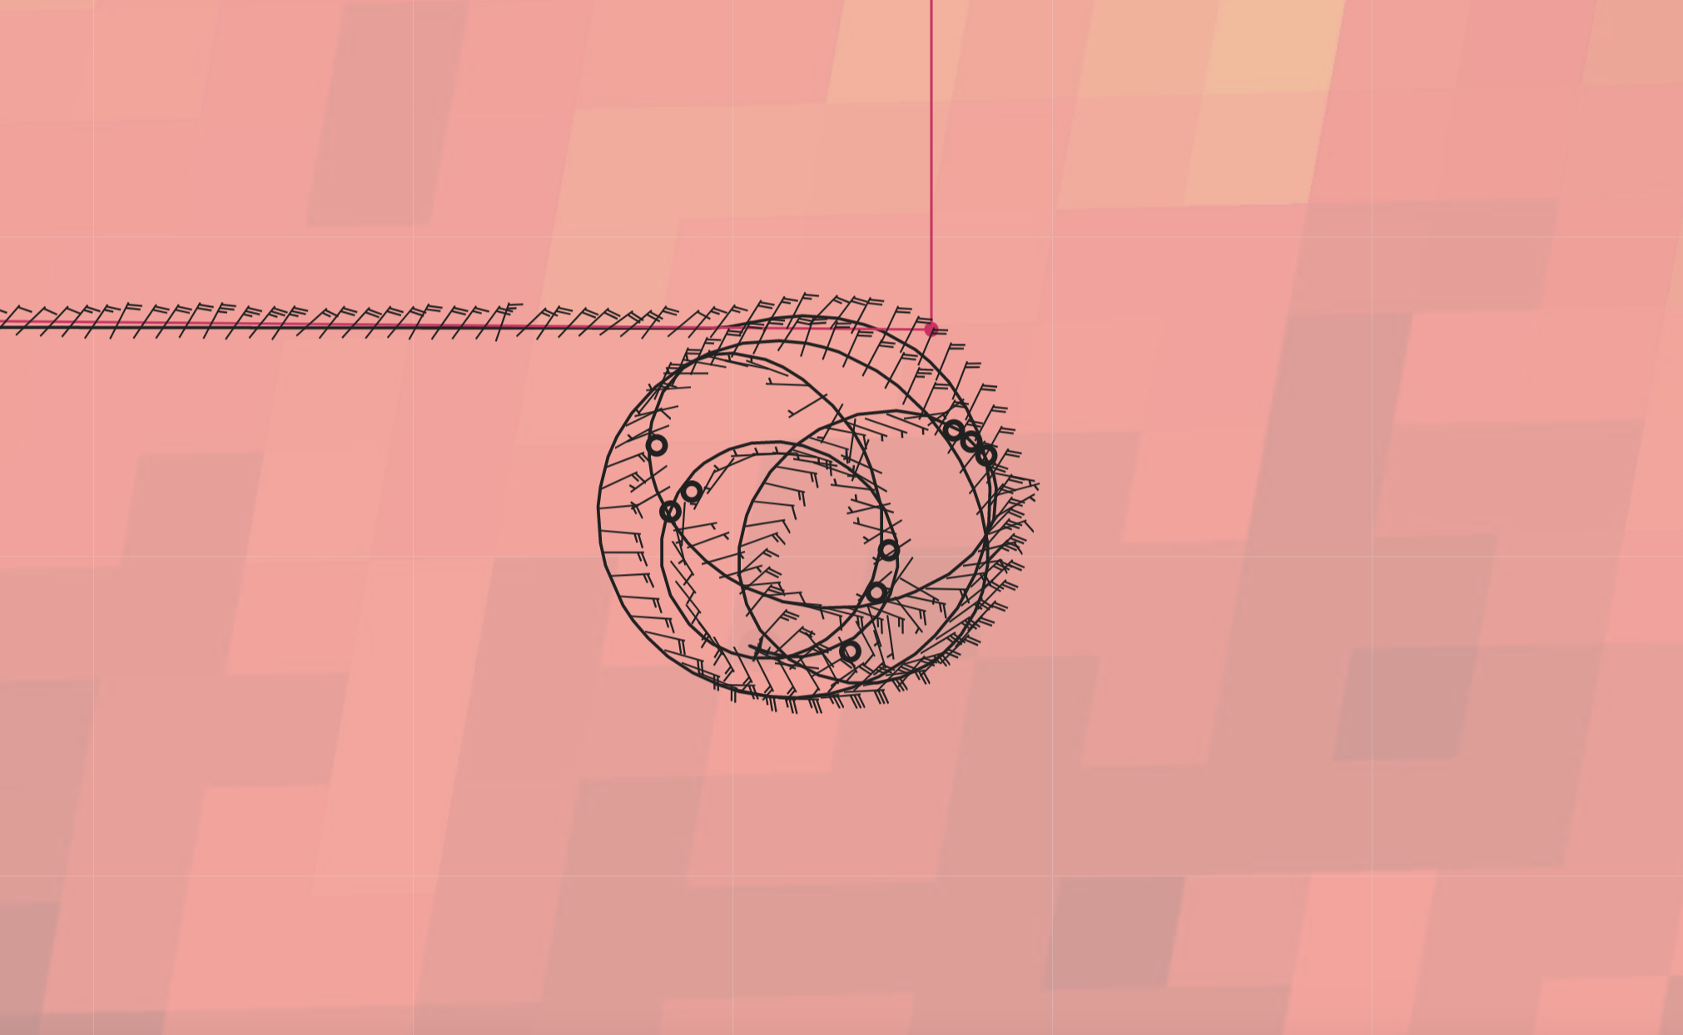
1428 | Spiraling up through 21,000 ft. IR suggests that the anvil is dissipating, but some new convection is developing about 60 nmi south. So the spiral was being flown in between convective peaks while the anvil was dissipating some. Suspect that this convective burst area is evolving very quickly, so the descending hydrometeor profile may look different from the subsequent ascending profile.  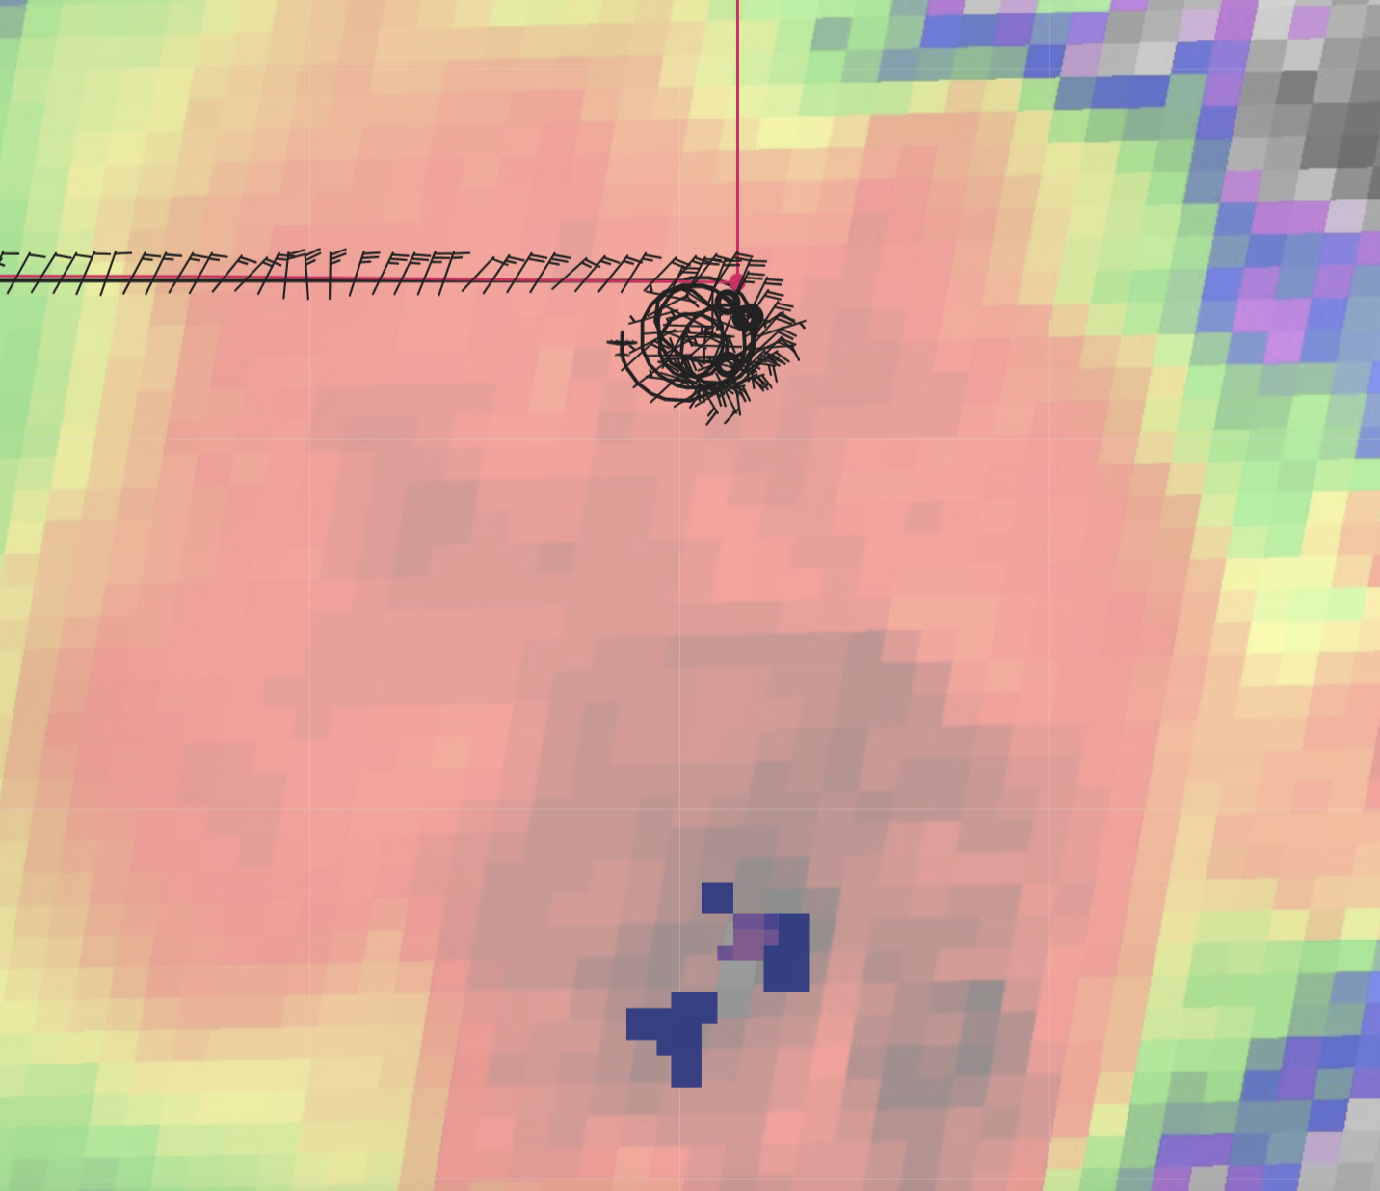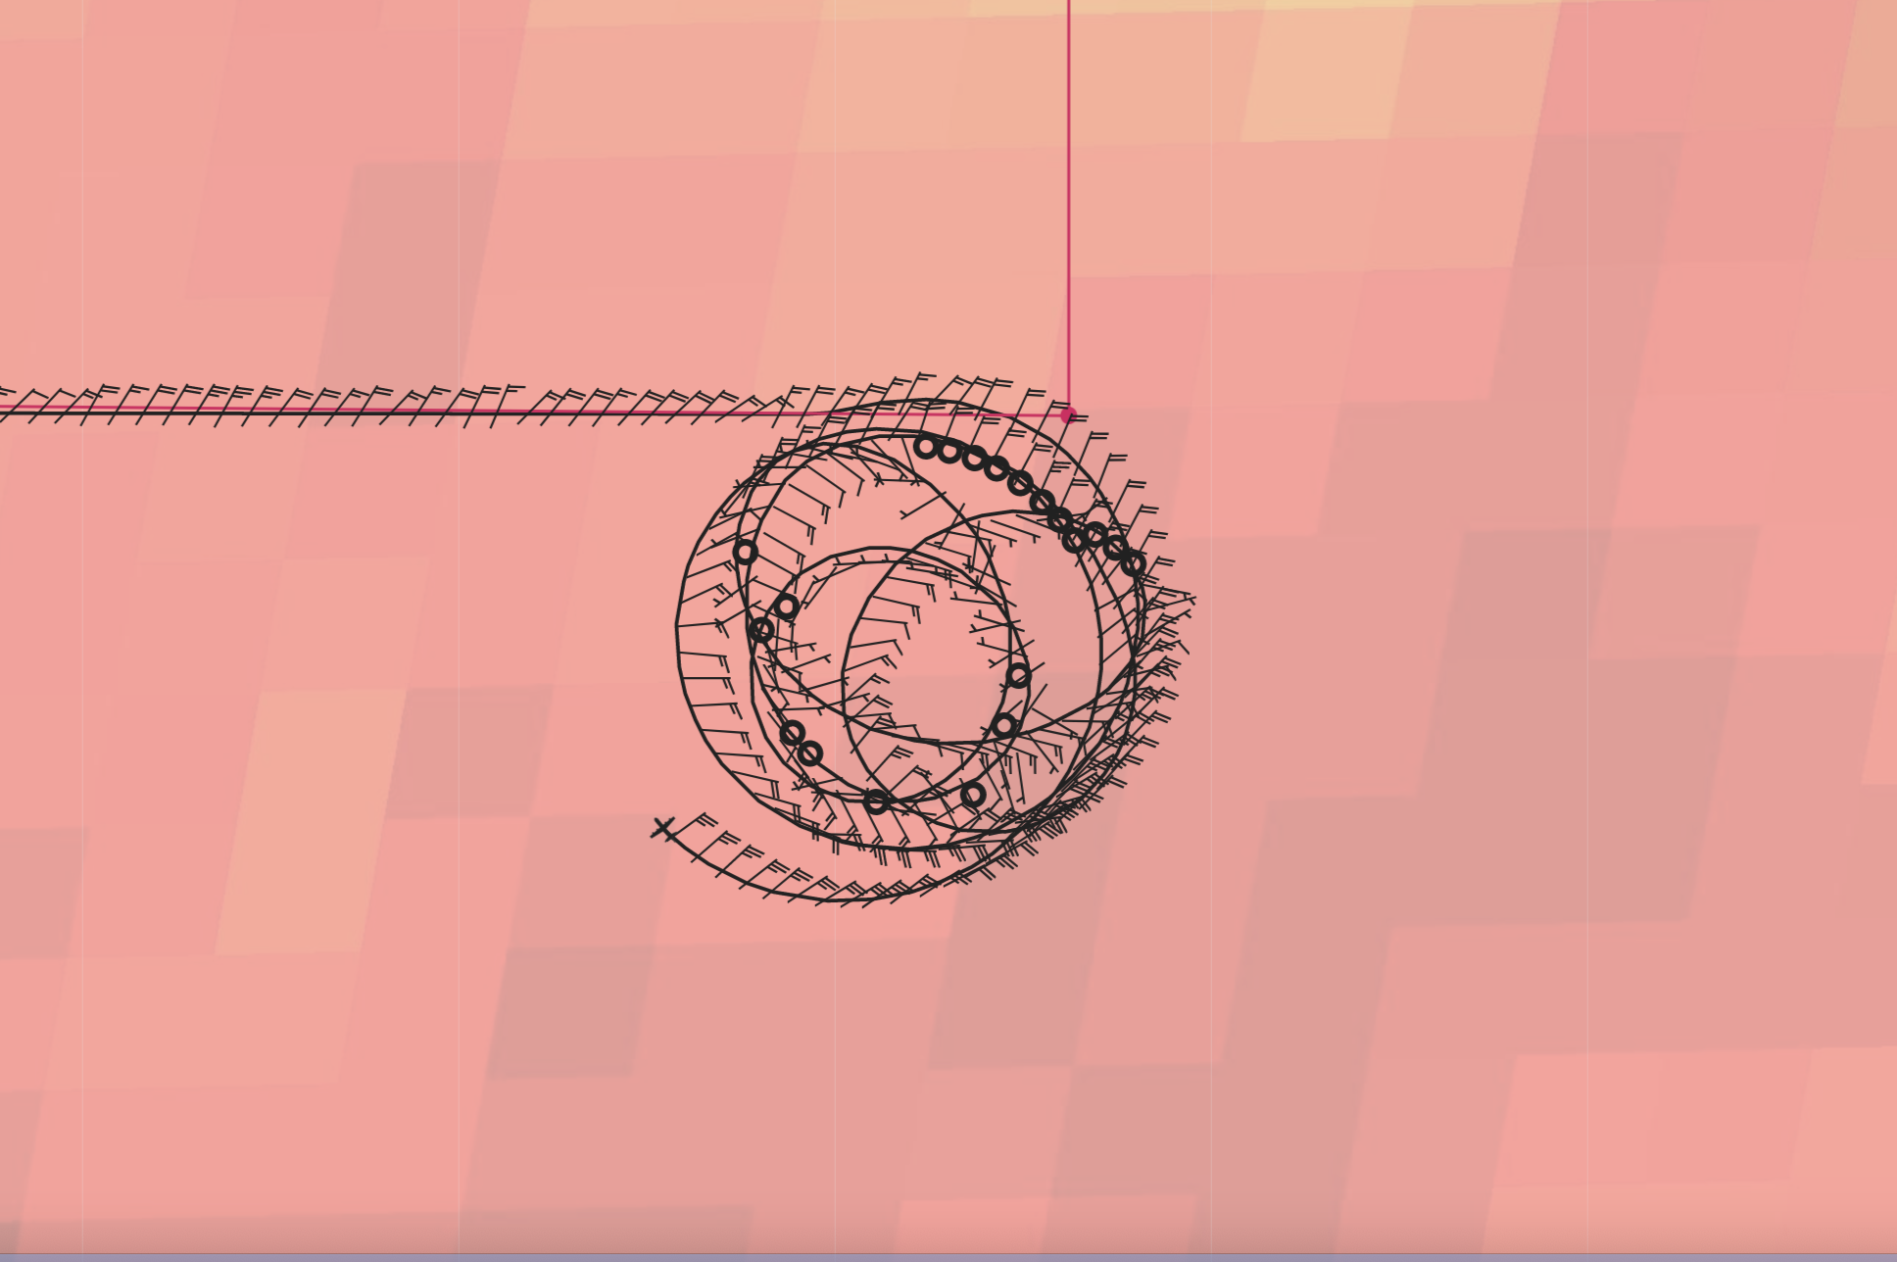
1429 | Ended spiral at 23000 ft. Heading north toward point 18. We encountered more snow up here as well as some supercooled water.  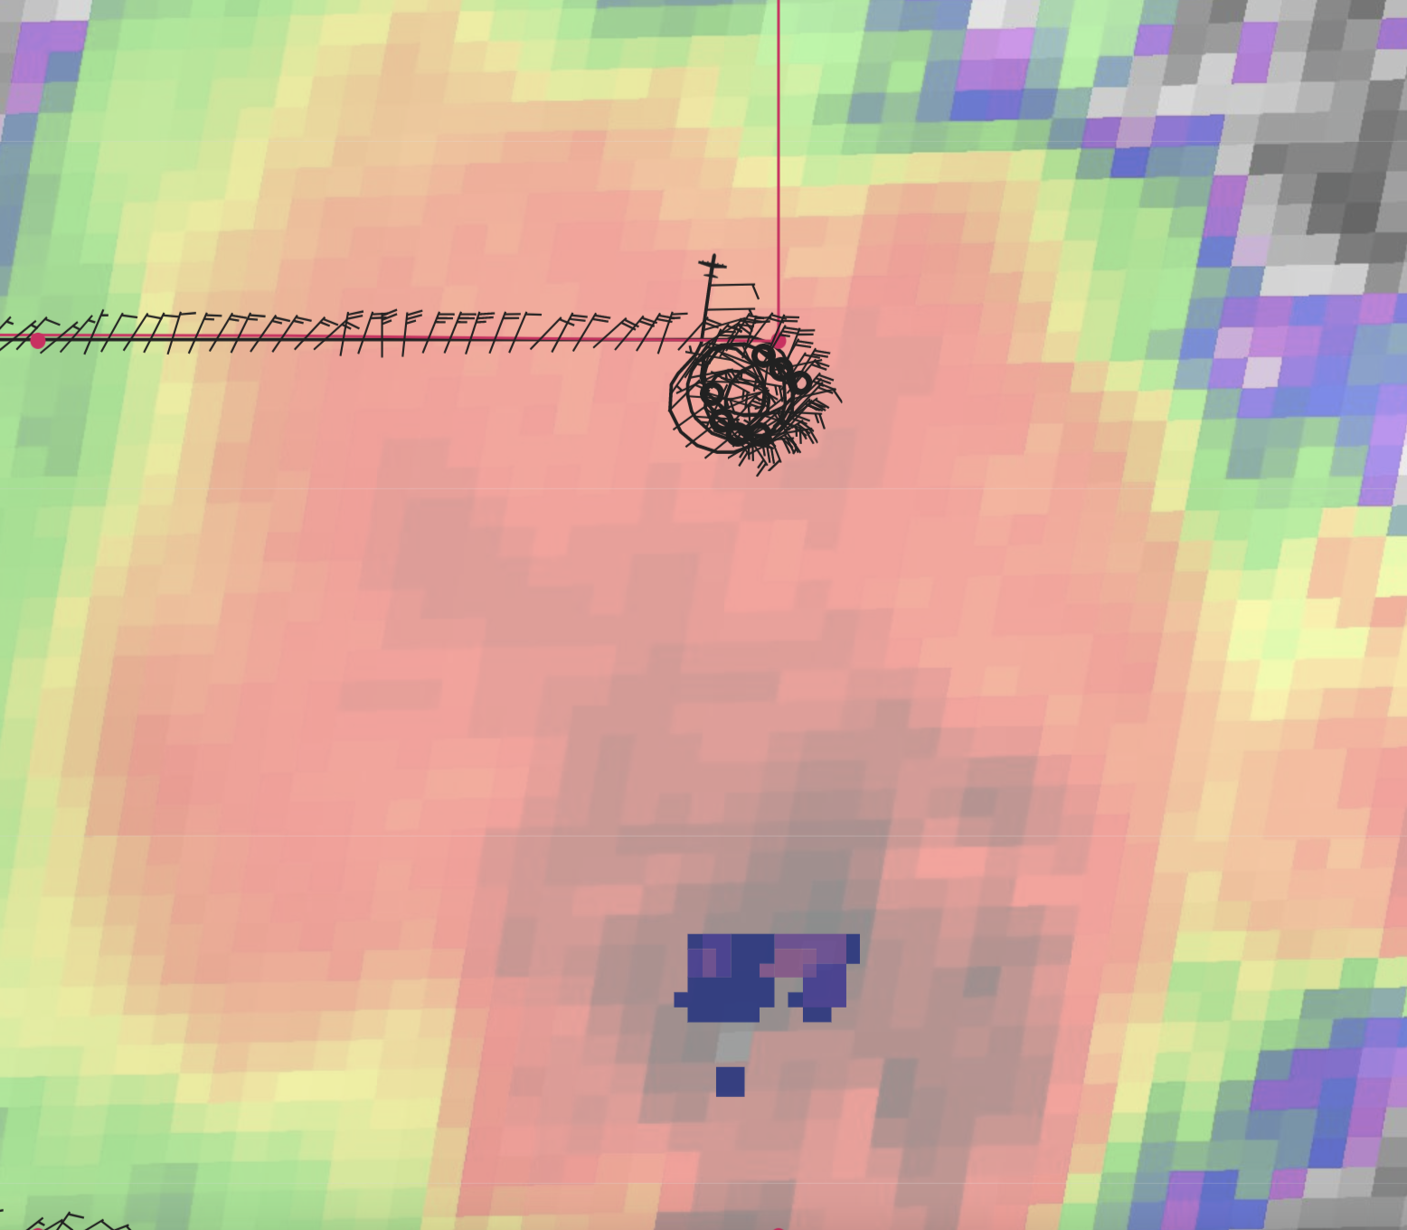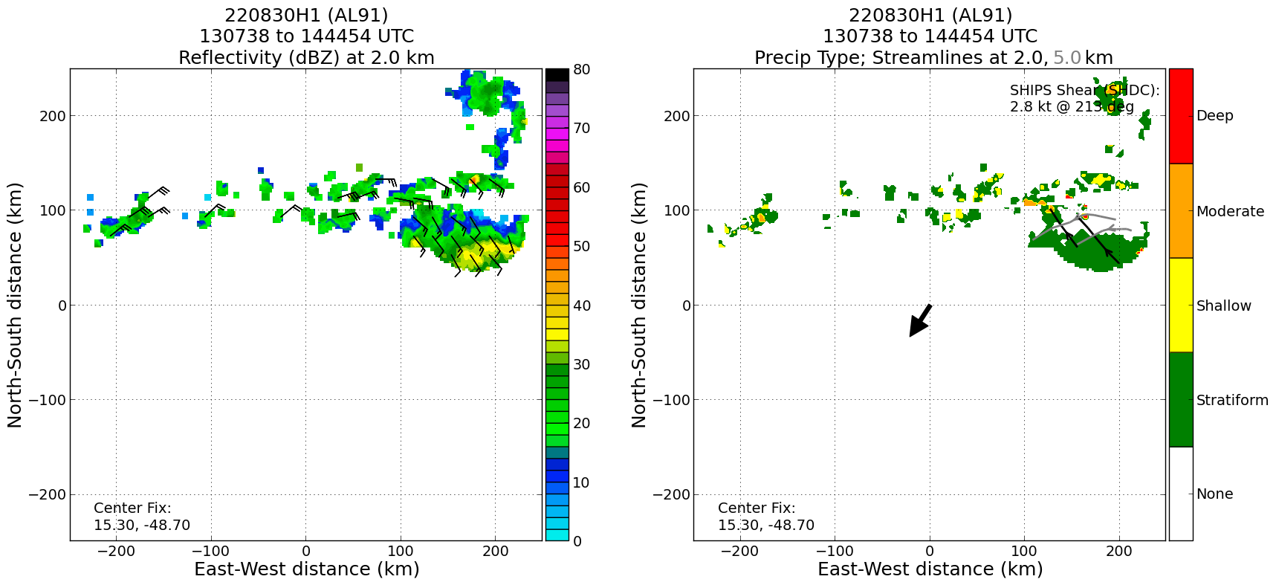Precip classification associated with spiral (on SE edge of swath)  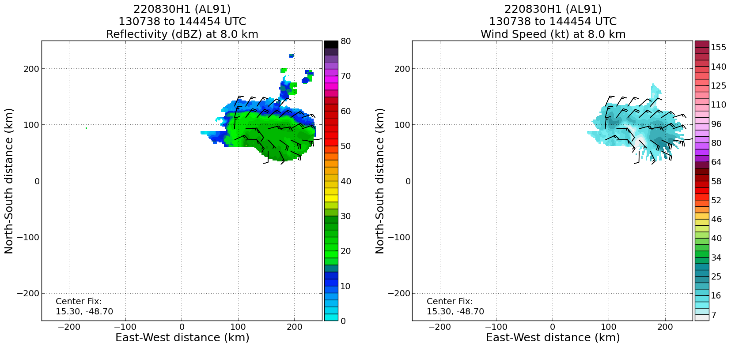  Midlevel vortex (at z=8 km here) associated with stratiform precipitation near spiral location  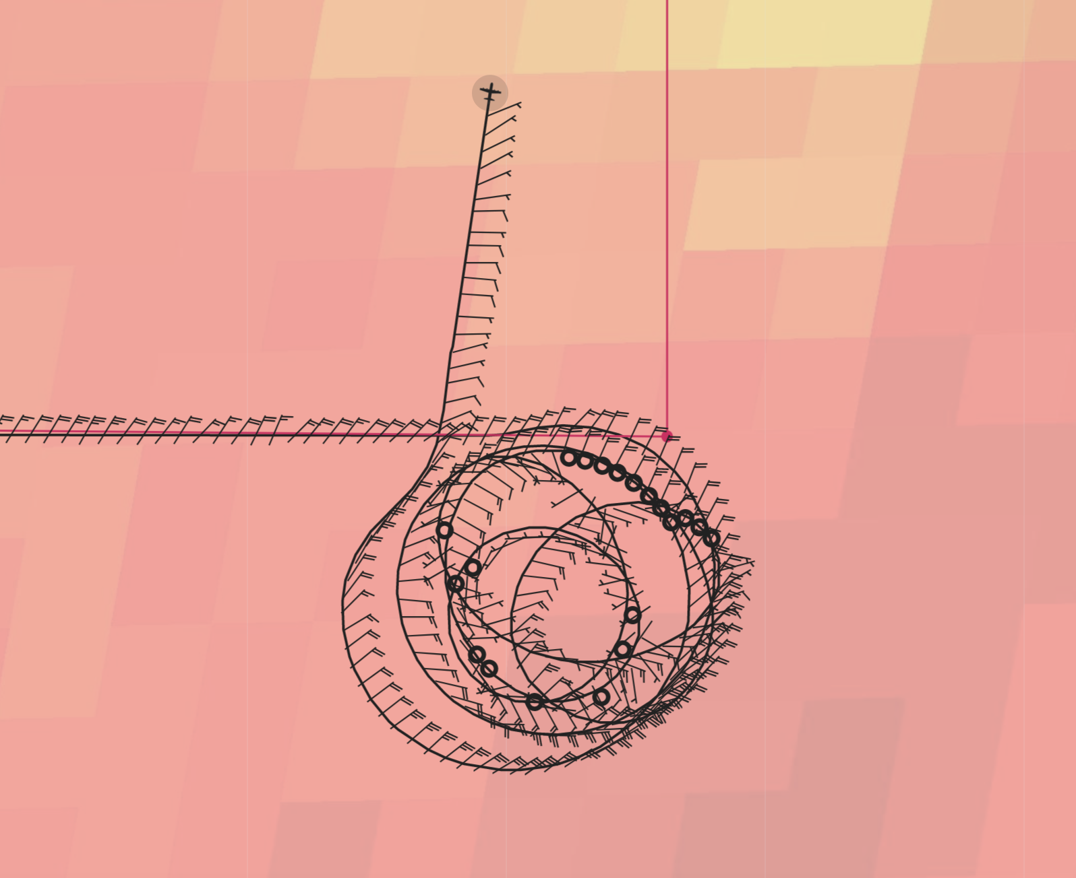  Satellite loops from the spiral…
1443 | Drop 18 at point 18
1454 | Drop 19 at point 19
1457 | ASCAT pass valid at 1320 UTC shows the surface structure of 91L while being sampled 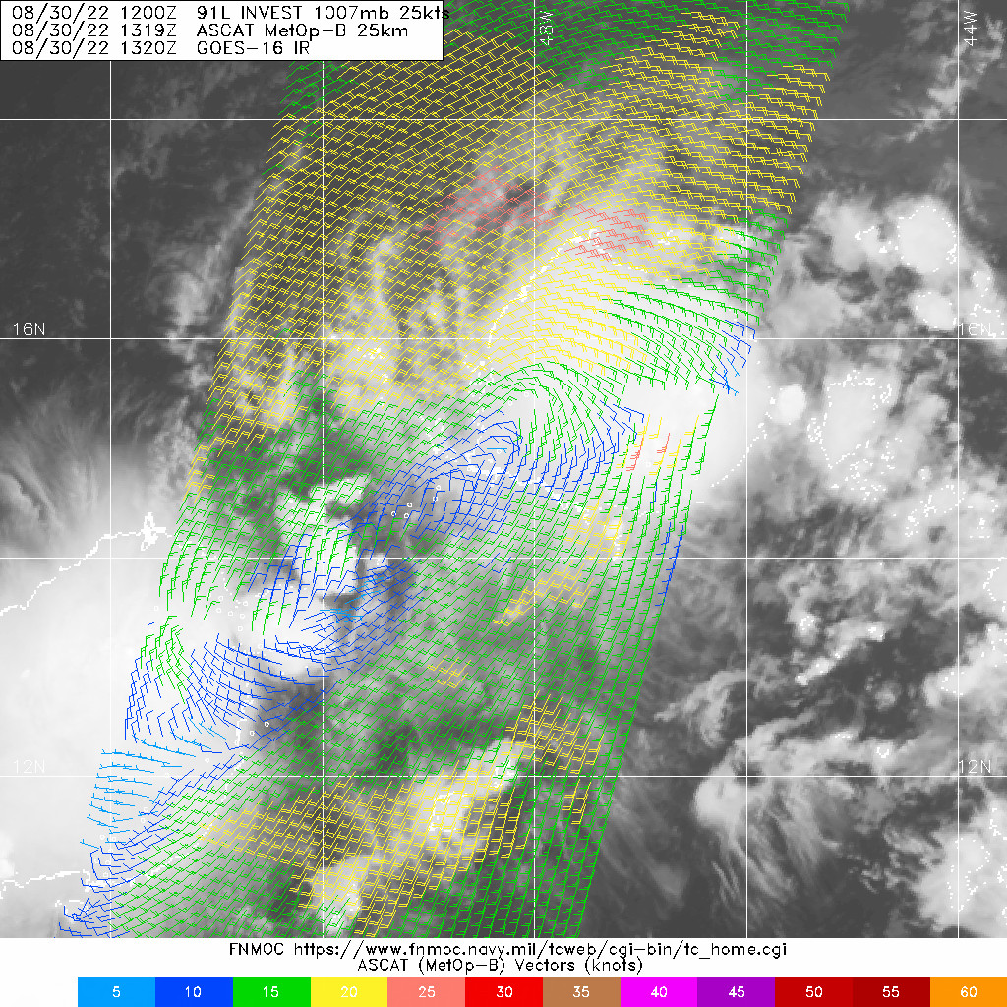
1509 | Drop 20 at point 20
1524 | Drop 21 at point 21 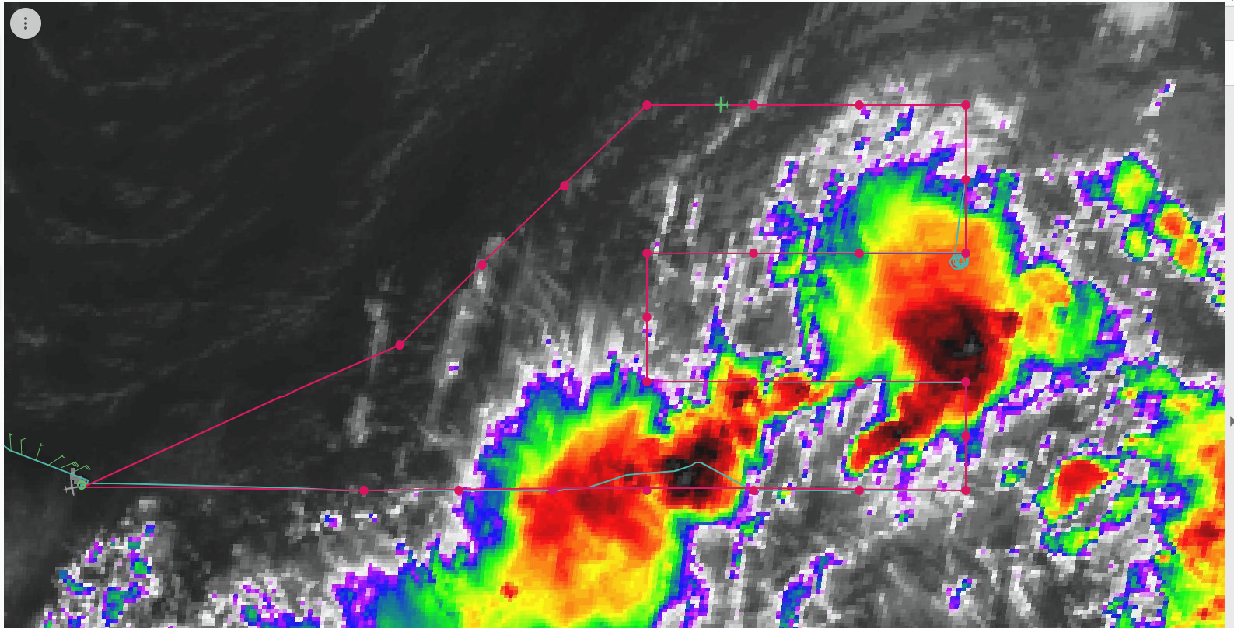
1538 | Drop 22 at point 22
1555 | Drop 23 at point 23
1610 | Drop 24 at point 24
1700 | 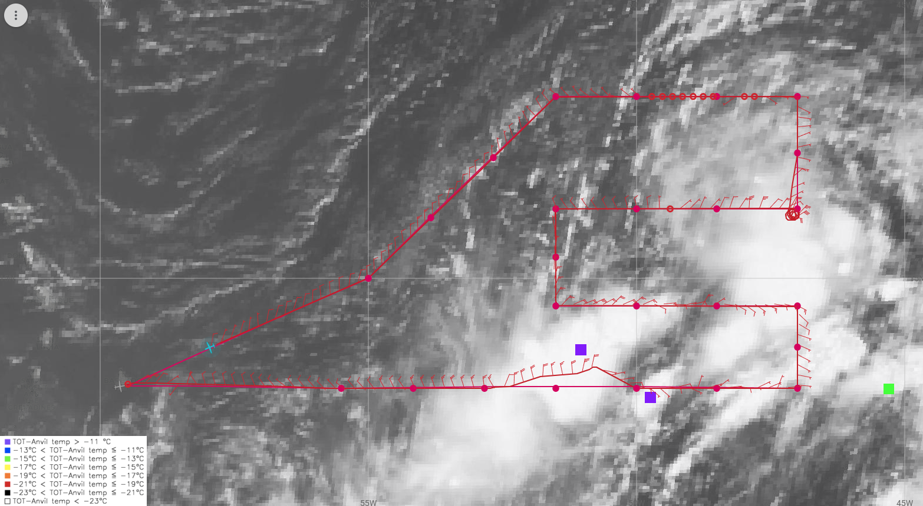  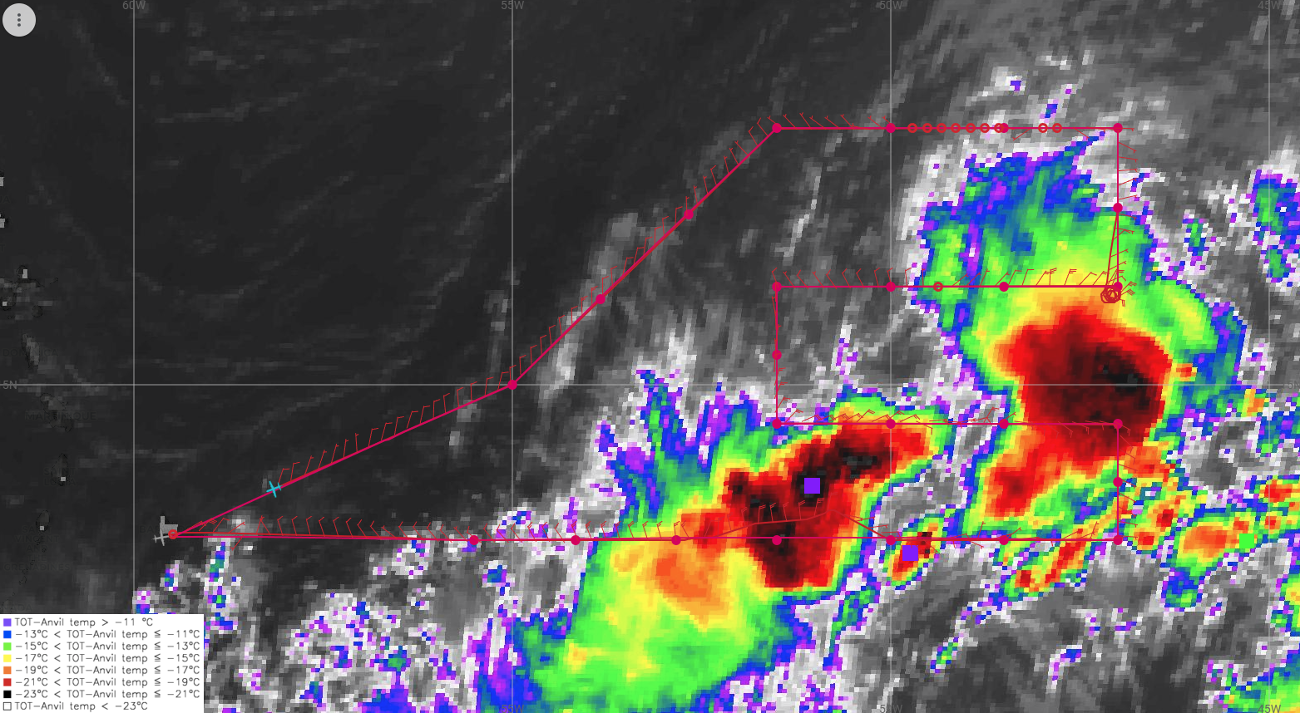

POST-FLIGHT
Mission Summary | Mission was successful. Planned pattern was flown, with only one fairly minor deviation along the first west-east leg to avoid deep convection there. We were able to perform a microphysics spiral as well, along the back edge of a convective burst developing near the northeast tip of the wave axis.  We were able to perform a microphysics spiral at the back edge of a convective burst in the northeast tip of the wave axis, which models suggest would be the region likely to spin up. We encountered snow at flight level at the start of our descent. Once we descended 5000 ft, however, we broke into clear air, indicating we were underneath anvil cloud. There was some virga off to our side as we descended, however, and some scatterers off our left wing. By the time we climbed back up to altitude, there was more snow and some supercooled water at about 22,000 ft. This indicated that perhaps we will see different hydrometeor profiles between the descent and the ascent.  Dropsonde synoptic maps showed very dry air above 700 hPa in the western through northern portions of the circulation. This dry air is the likely reason why convection has been unable to organize, along with the shear as mentioned earlier, partially from an upper-level low and partially from a strong African Easterly Jet on the north side, as indicated by the sondes.  Real-time radar analyses indicated there was some indication of a midlevel circulation near the region of the spiral (probably tied to the convective burst at the tip of the wave axis. There was no real indication of an amplification of vorticity, nor consolidation of a circulation, in the lower troposphere, however. It just seems like convection remains too transient and disorganized, limited by the dry mid- to upper-troposphere and shear.  It will be interesting to examine the evolution, if any, of the structure of the convection as this system potentially encounters a more moist environment, perhaps by analyzing CFADs of vertical motion and reflectivity, as well as divergence and mass flux profiles. Limited coverage will make this a challenge, however.  These sets of missions seem to have the potential to shed insight on the role of the environment, particularly the thermodynamic environment, on the structure and evolution of convection. This in turn may impact the prospects for tropical cyclogenesis, which we hope to capture with these sets of missions.  25 sondes dropped, no AXBTs. All sondes charged to NHC.
Actual Standard Pattern Flown | Lawnmower
APHEX Experiments / Modules Flown | Genesis Experiment: FAM and PREFORM, along with a Stratiform Spiral Module (SSM).
Plain Language Summary | - This flight was another in a series of flights sampling the environment and precipitation within a potentially developing tropical disturbance in the central Atlantic, AL91. The P-3 flew at a higher than typical altitude, at 25 kft, to obtain deeper observations of the humidity environment, which seems to be potentially inhibiting the formation of widespread precipitation and subsequent development of the storm.  - AL91 continues to experience lower relative humidity (dry air) in the lower to middle part of the troposphere, as well as vertical shear of the wind – both inhibiting factors towards storm development.  - The airplane spiraled downward, then up, between 10000 and 25000 ft to sample the snow and rain particles (“microphysics”) that make up some of what is called stratiform rain. This area trails the deeper thunderstorm clouds and can be a focal point for the spin-up of smaller-scale circulations that can help deepen a disturbance into a tropical cyclone.
Instrument Notes | All instruments functioned well. The WSRA was not producing analyses because the aircraft flew at an altitude above the operational range of the instrument.
Final Mission Track | 