MISSION PLAN
FLIGHT ID | 20220829I1 | STORM | AL91
MISSION ID | WBWXA | TAIL NUMBER | NOAA43
TASKING | HRD | PLANNED PATTERN | Lawnmower
MISSION SUMMARY
TAKEOFF [UTC] | 1905 | LANDING [UTC] | 0309
TAKEOFF LOCATION | Barbados | LANDING LOCATION | Barbados
FLIGHT TIME | 8.1 | BLOCK TIME | 8.3
TOTAL REAL-TIME RADAR ANALYSES  (Transmitted) | 1 | TOTAL DROPSONDES (Good/Transmitted) | 25 (25 / 23)  1 fast fall & 1 never produced a d-file
OCEAN EXPENDABLES (Type) | None | sUAS (Type) | None
APHEX EXPERIMENTS / MODULES | Genesis Experiment: FAM; Early Stage Experiment: ITOFS
HRD CREW MANIFEST
LPS ONBOARD | Frank Marks | LPS GROUND | Gus Alaka
TDR ONBOARD | Paul Reasor | TDR GROUND | Trey Alvey
ASPEN ONBOARD | Sim Aberson | ASPEN GROUND | None
NESDIS SCIENTISTS | Paul Chang, Joe Sapp
GUESTS (Affiliation) | None
AOC CREW MANIFEST
PILOTS | Doremus, Copare, Wood
NAVIGATOR | Utama
FLIGHT ENGINEERS | Darby, Pittman
FLIGHT DIRECTOR | Kalen, Holmes
DATA TECHNICIAN | Richards
AVAPS | Warnecke

PRE-FLIGHT
Flight Plan | 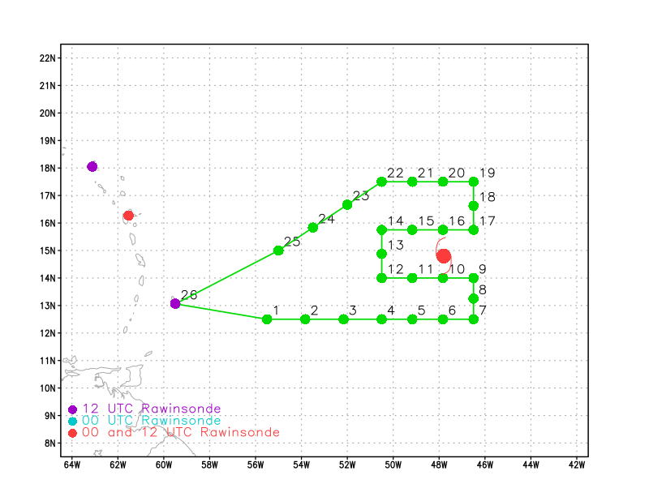  Pattern: Fly survey/lawnmower pattern  Altitude: 20 kft (pressure altitude) or as high as possible  Expendables: 25 sondes planned; no AXBTs for this mission  Notes:  - Intermediate dropsondes along the track may be requested to target gradient areas
Expendable Distribution | Load 30 sondes; release sonde at planned points (green dots above); no AXBTs for this mission.
Preflight Weather Briefing
Instrument Notes

IN-FLIGHT
Time [UTC] | Event
1905 | Takeoff from Barbados
 | Keyboard at Station 2 broken, but usable for ASPEN
1908 | Really hazy with dust after take off
1911 | RH around 40%
1919 | MMR is up and running in HWX mode
1921 | Tail radar (TDR) is up, but Paul is checking the sweeps. It appears that the master sweep ground clutter slopes down away from the radar, while the slave sweep slopes a bit upperward moving away from the radar. Makes me think that the range delays are not the same for both antennas.
1939 | TDR issue cleared up on its own. Likely cause was the steep climb out we did after take off. Once we leveled out at 21000 ft it went away.
1954 | Need a hard copy of the P-3 dropsonde processing document on N43!
1956 | Initial point (IP); Drop #1  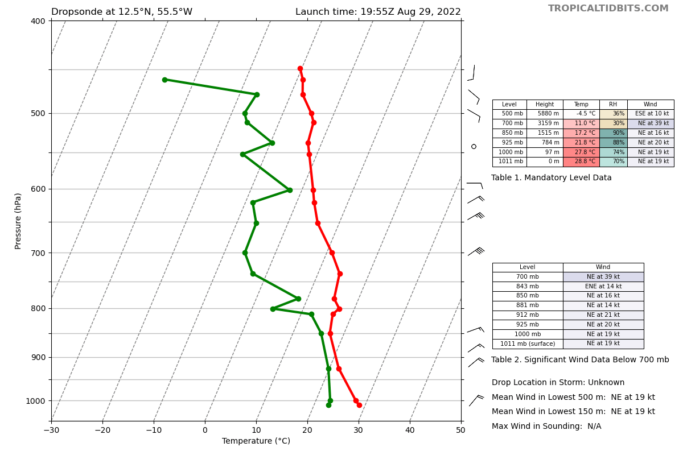
1957 | Having MMR issues. Will likely need to reset. TDR is working great.
1958 | MMR is showing an INS Warning, so the heading of the aircraft is screwed up in the display.
2011 | Picking our way through the SW-NE line of cells. Rebooting the MMR now.
2016 | Drop #2 20:15 UTC 12.7 N 53.75 W
2018 | We are under a huge anvil
2021 | The low-level circulation looks more symmetric, still broad.  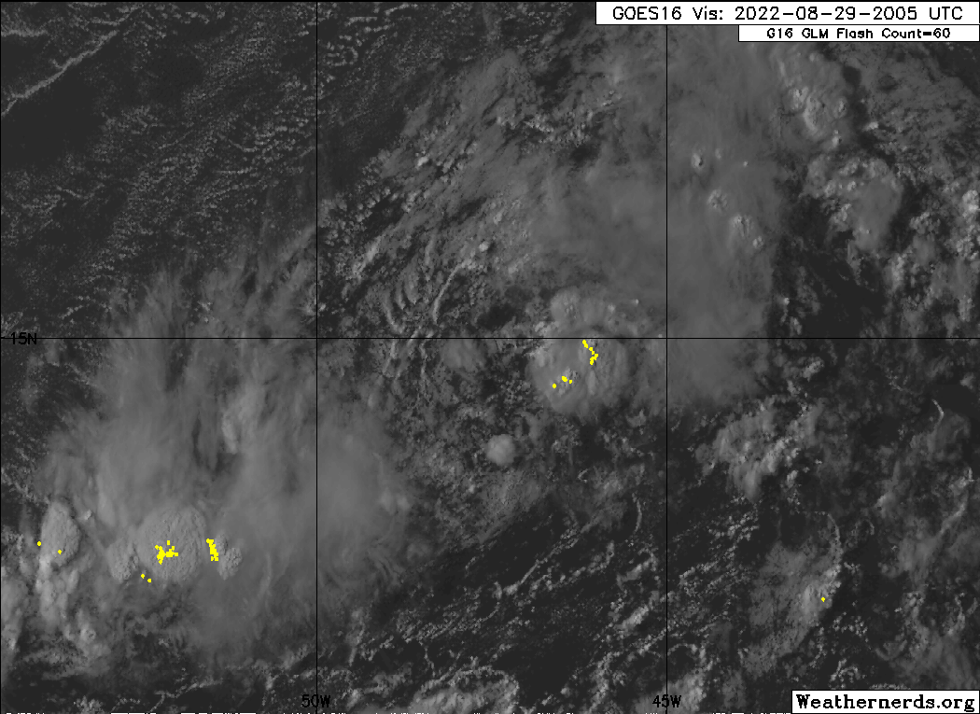
2026 | MMR did not come up any better than before. Checking with AOC to see if they can help troubleshoot. Might be an issue when it gets dark.
2027 | Descending below the anvil to track back to our track south of us. Will plan to drop at the planned longitude even if we are not at the latitude in the plan.
2029 | Marks: flying along the base of the anvil. a bit choppy. Convection is about 40-50 km to our south.  Alaka: I thought that convection might deviate the pattern north a bit. I was hoping you'd be able to tuck south of it to sample if any SAL was still wrapping all the way around (like we saw hints of in yesterday's N49 mission).  Marks: yep that is what is happening. once we turned to the north of the first cell we were trapped staying north.
2034 | Two more big cells 60 nmi ahead on our right of track.  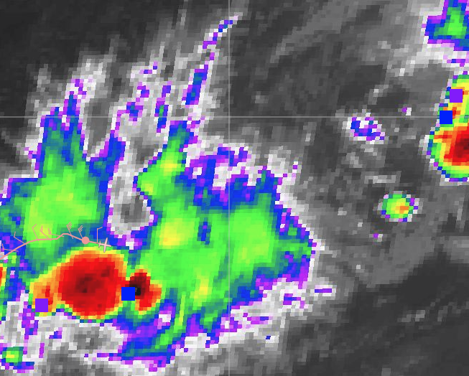
2037 | Drop #3 2036 13.1N, 52 W  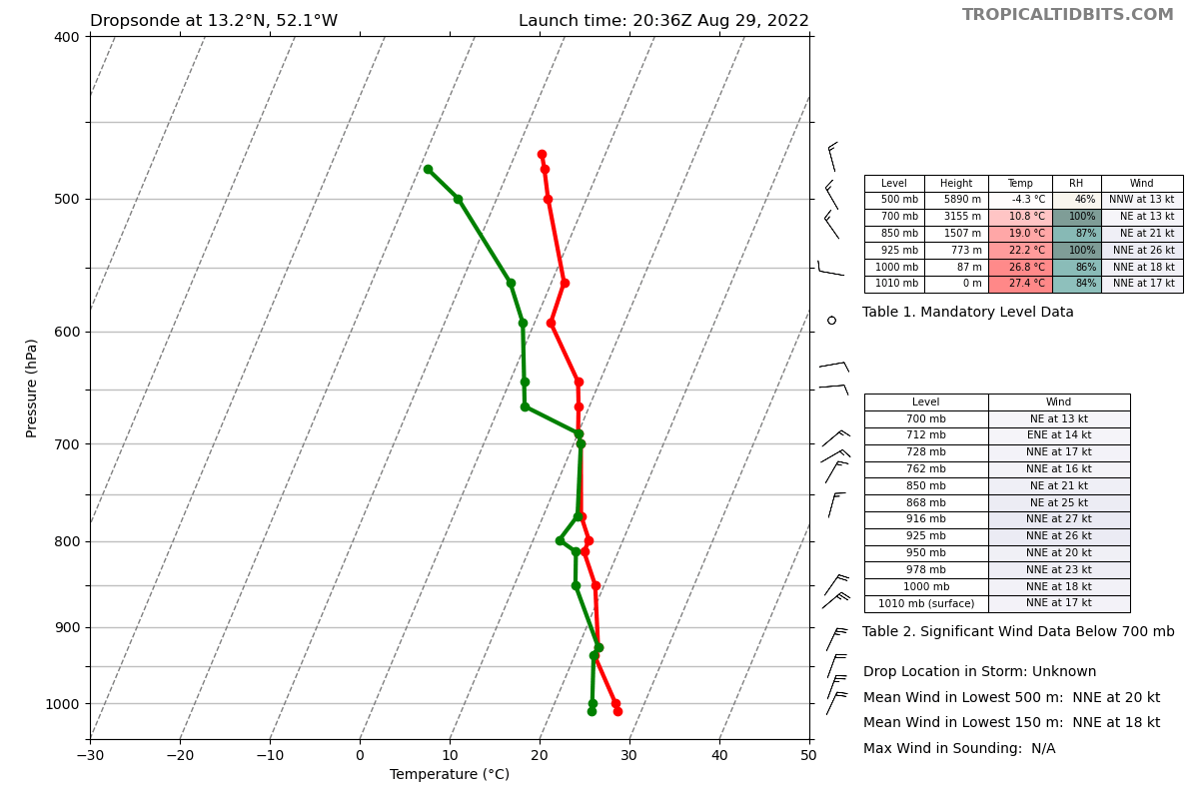
2038 | Marks: we are track toward 13 N and 46.5 W  Alaka: I hope we can observe how much dry air is still wrapping around to the south
2043 | MMR shut down entirely. Did not come back up even after a hard reboot.
2045 | Sonde 2 data did not get transferred after it was turned off. They will see if it still exists after working on MMR.
2045 | 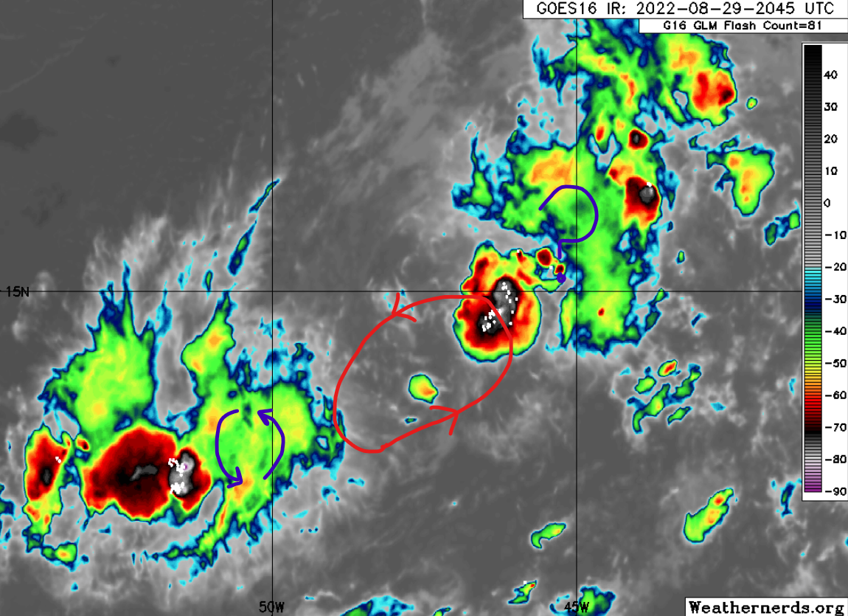  Flight level circulation/trough near 12.5N, 51W. Broad LLC centered near 14N, 47.5W. Assuming another mid-level center to the northeast, probably associated with the recent deep convection near 14.5N, 46.5W
2047 | Anticyclonic flow at 20 kft over the SW convection. Indicates that the mid-level center is to the NE, closer to the broad low-level center and the NE convection
2049 | Sim confirmed that Drop #3 worked, so the issue with Drop #2 was not indicative of a systematic issue.
2052 | We seem to be skirting the base of the anvil again. Light chop. Just passing big cells to our south. Should be a great TDR analysis on this leg.
2058 | Drop #4 2057 UTC 12.75 N, 50.5 W  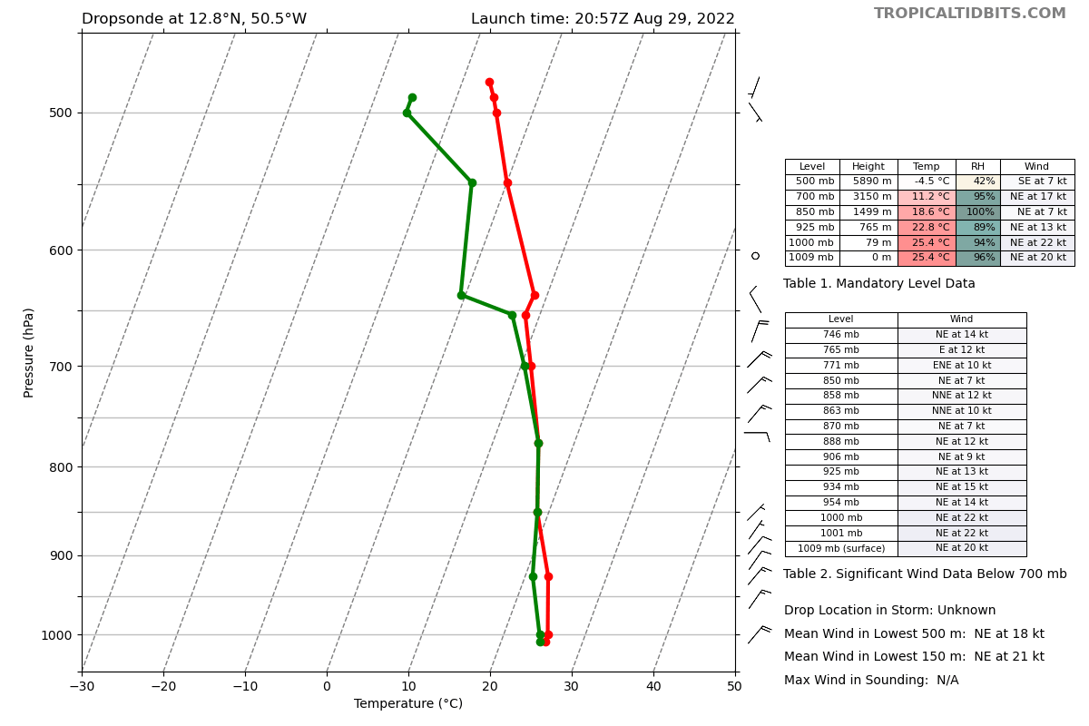
2103 | Marks: Definitely passed through the trough at flight level. TDR should be very interesting  Aberson: We see that wind shift in the sondes  Alaka: I wonder how connected that trough still is the rest of the system? Or is it being lopped off as things consolidate to the northeast?
2111 | Certainly looks like some interesting convection near 14.5N, 46.5W. It appears that a vort max rotated around to the side and is associated with this new deep convection.
2113 | Drop #5 12.5N, 49.2W  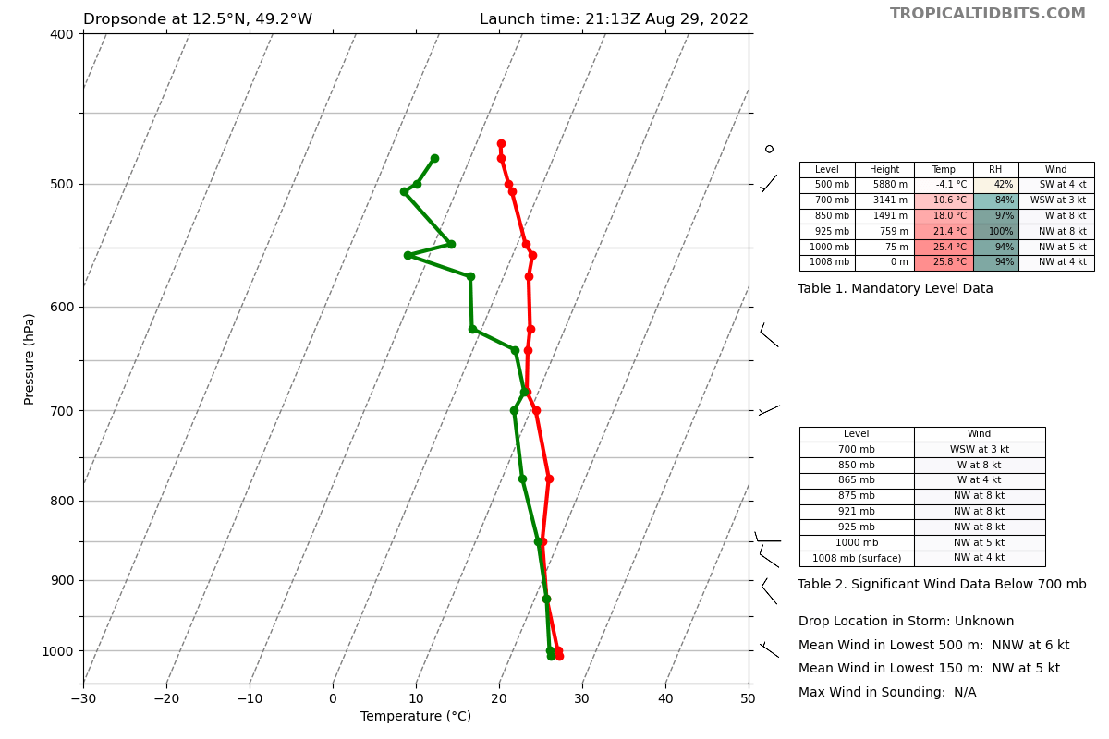
2115 | 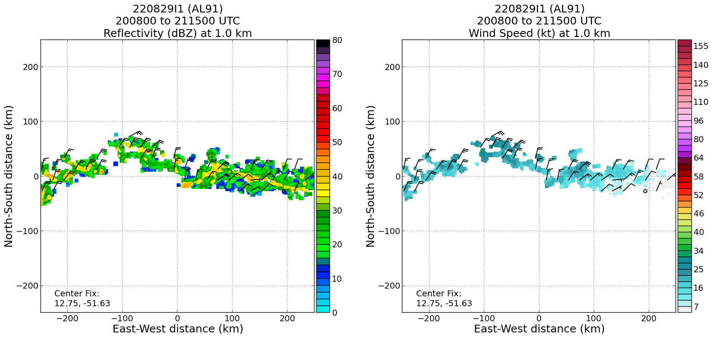
2122 | MMR is now working after troubleshooting by Mike Holmes and Dan.
2127 | Dropsonde #2 did not produce a d-file. AOC is checking why, but no drop #2 to transmit.
2129 | Drop #6 at 2129 UTC 12.5 N 47.75 W  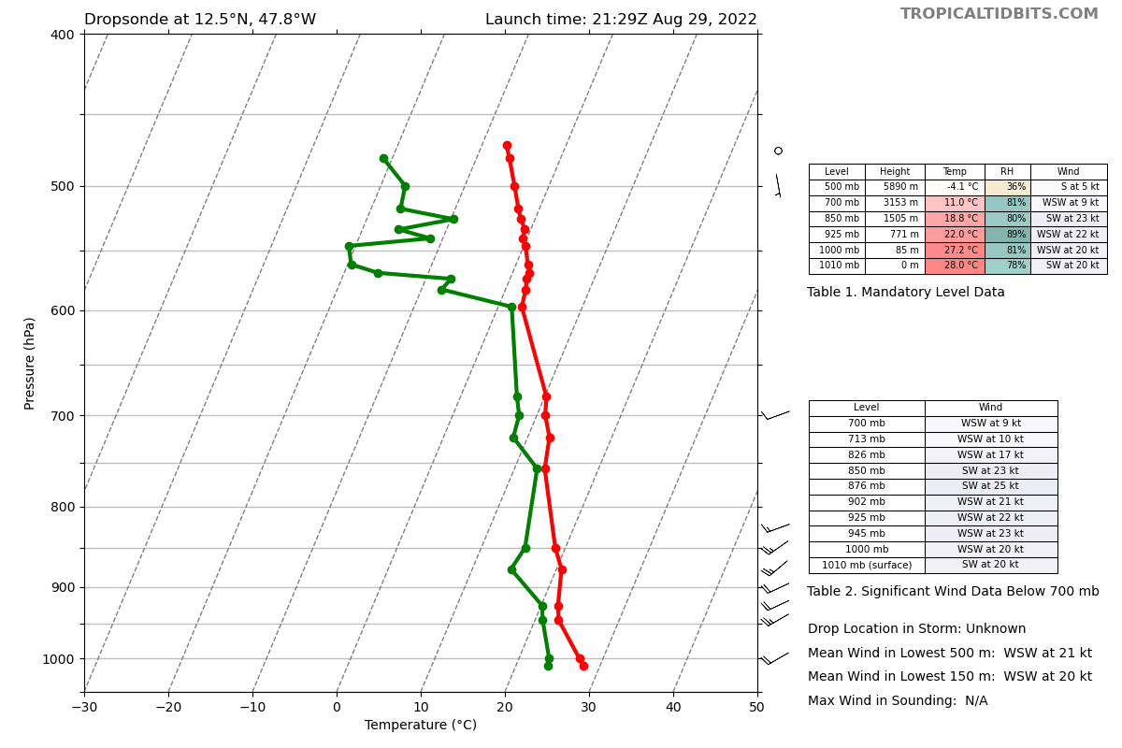
2145 | Turning N; Drop #7 2145 UTC 12.5 N, 46.5 W  (fast fall)  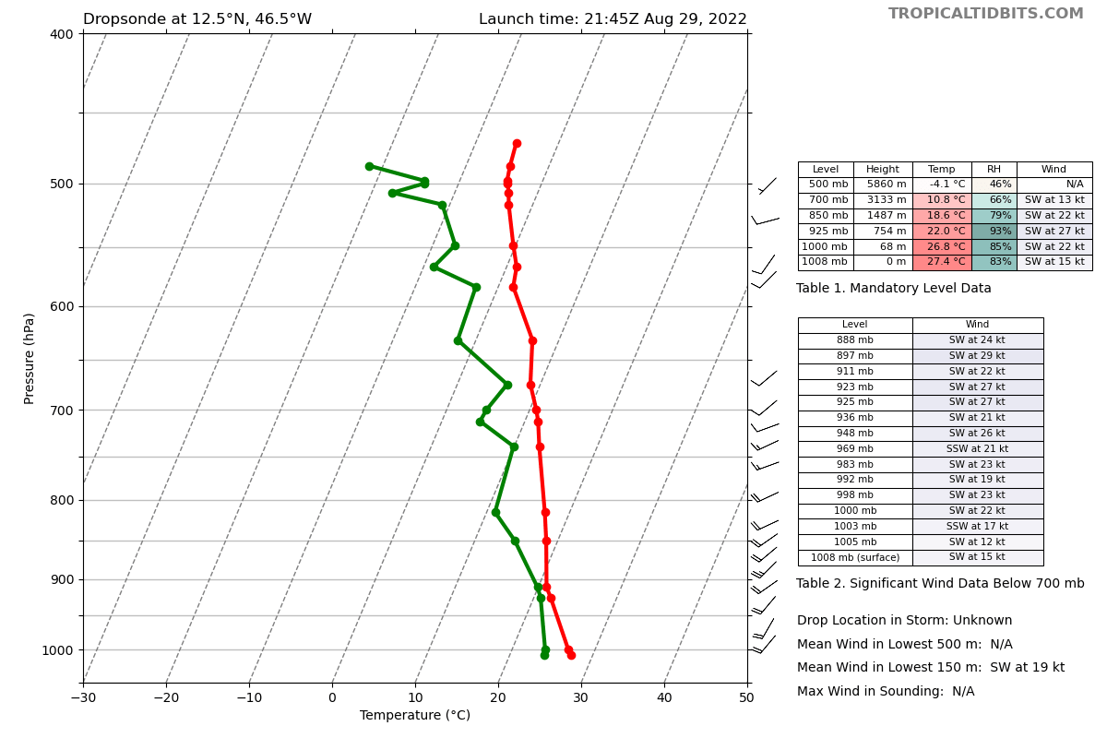
2155 | Drop #8 2154 UTC 13.3 N, 46.5 W  Aberson: Sonde 8 has 20% RH at 14 kft, first really dry air I've seen.
2204 | Turning W; Drop #9 2203 UTC 14.0 N, 46.5 W  Aberson: Sonde 9 not as dry, 40% RH at 13 kft  Marks: Makes sense with the absence of much convection in this area south of the NE blob  Aberson: Very thin dry layers with 70 - 100% RH above and below.
2205 | Request to move Drops 17, 18, 19 to 45.5W for better TDR coverage of the new deep convection.  We couldn’t bump Drops 17, 18, & 19 that far east because it will extend the mission to 8 h 35 min with no extra time for convective maneuvering. We will play it conservatively especially with the MMR issues earlier in the flight.  Marks: I think it may work out as the blob is advecting west and that leg looks like it is going right up the center of it on that N-S leg. So I will be recommending we go past and then turn N.  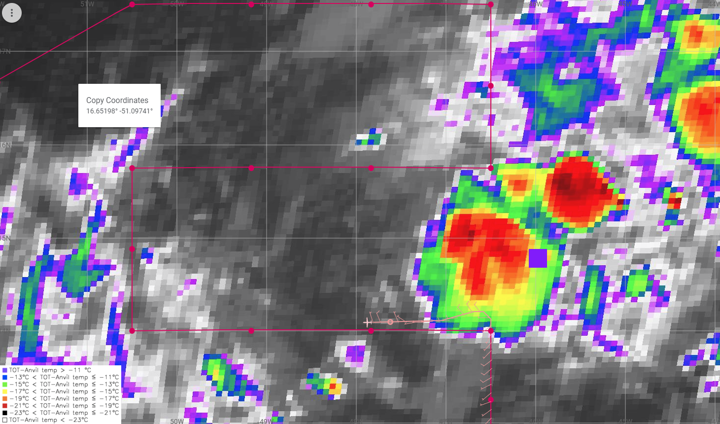
2217 | Looks like the internet is also back. Maybe solar flare activity is over.
2222 | Drop #10 2221 UTC 14.1 N 47.9W
2229 | Dropsondes are showing that the environment has moistened near the “center” of the disturbance. But, still a fair amount of dry air in the environment around the system, especially to the NW  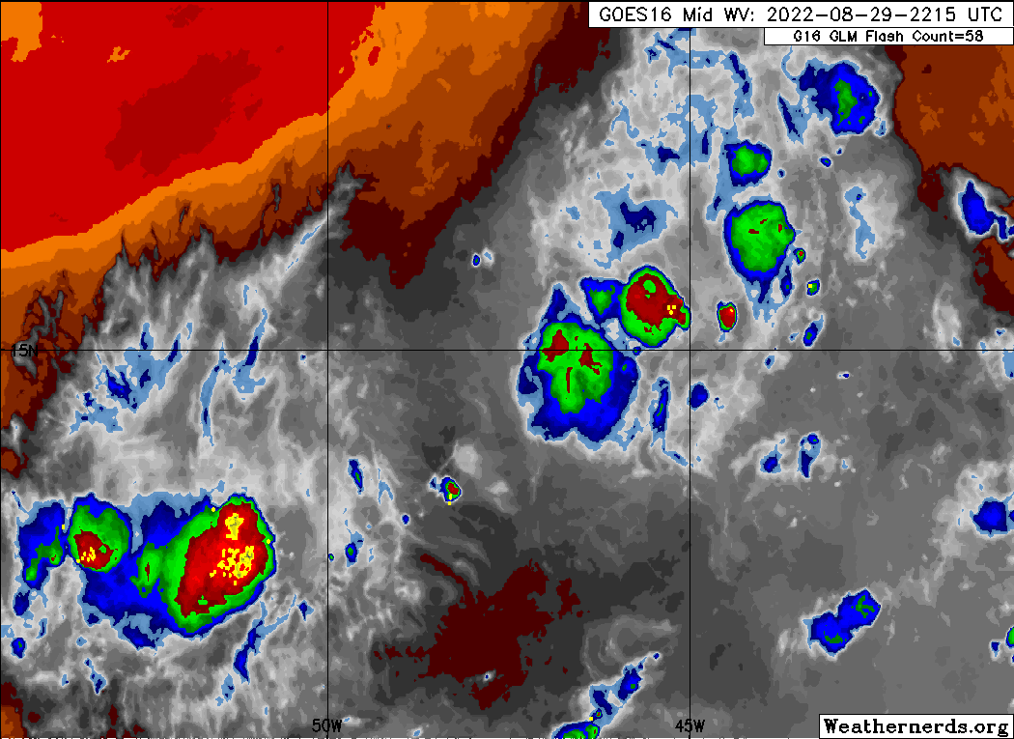
2233 | Alaka: The FL northerly flow is suggesting that the trough is consolidating toward the NE side of the broad circulation, as expected. Still deep convection associated and some cyclonic flow at FL with the SW area, but that appears to be a separate circulation now. What do you think?  Marks: The SW blob circulation was constrained to be above 6 km. no real wind shift below according to TDR, and jut N windshear at the surface
2237 | Drop #11 2237 UTC 14 N 49.2 W
2243 | 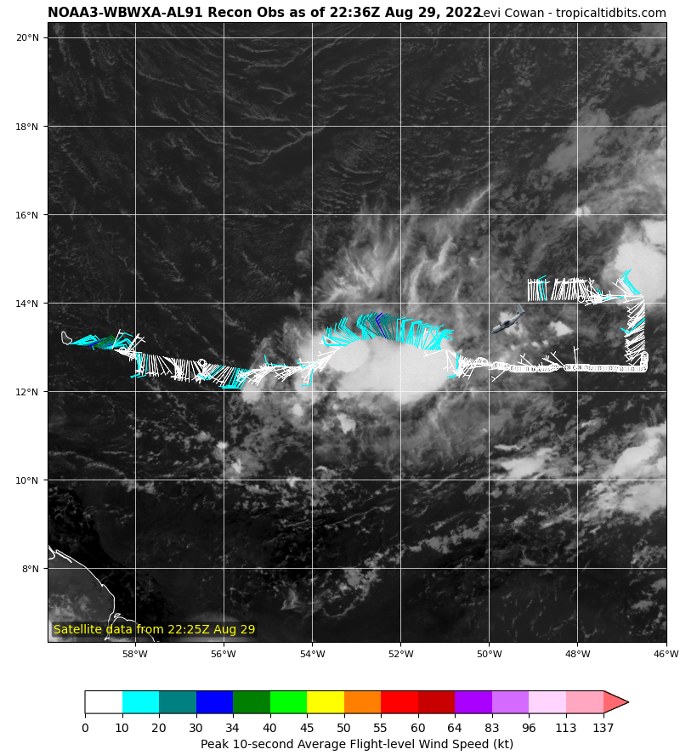
2251 | Turn track north
2252 | Drop #12 14.0 N 50.5 W
2300 | 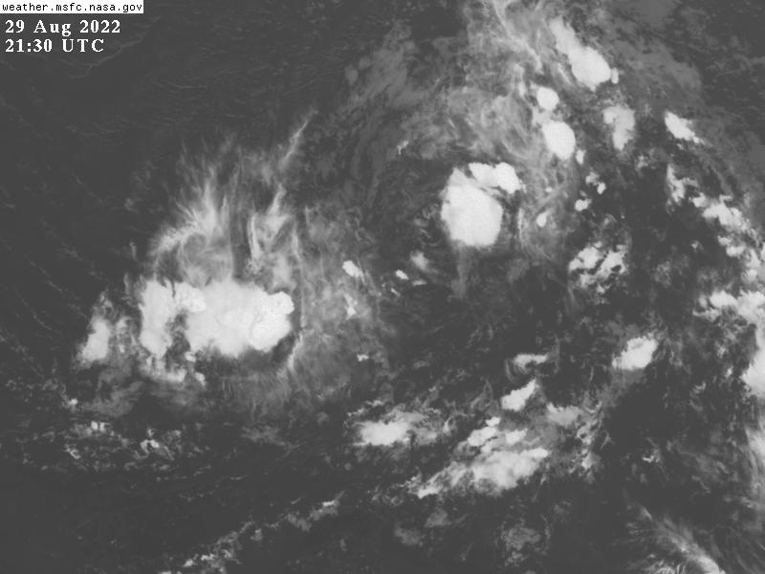  Looking at Shortwave IR loop appears as if the NE blob of convection is in the entrance region to the upper level jet to N
2302 | Drop #13 14.9 N, 50.5 W
2312 | Turned to track east
2312 | Drop #14 15.75 N, 50.5 W  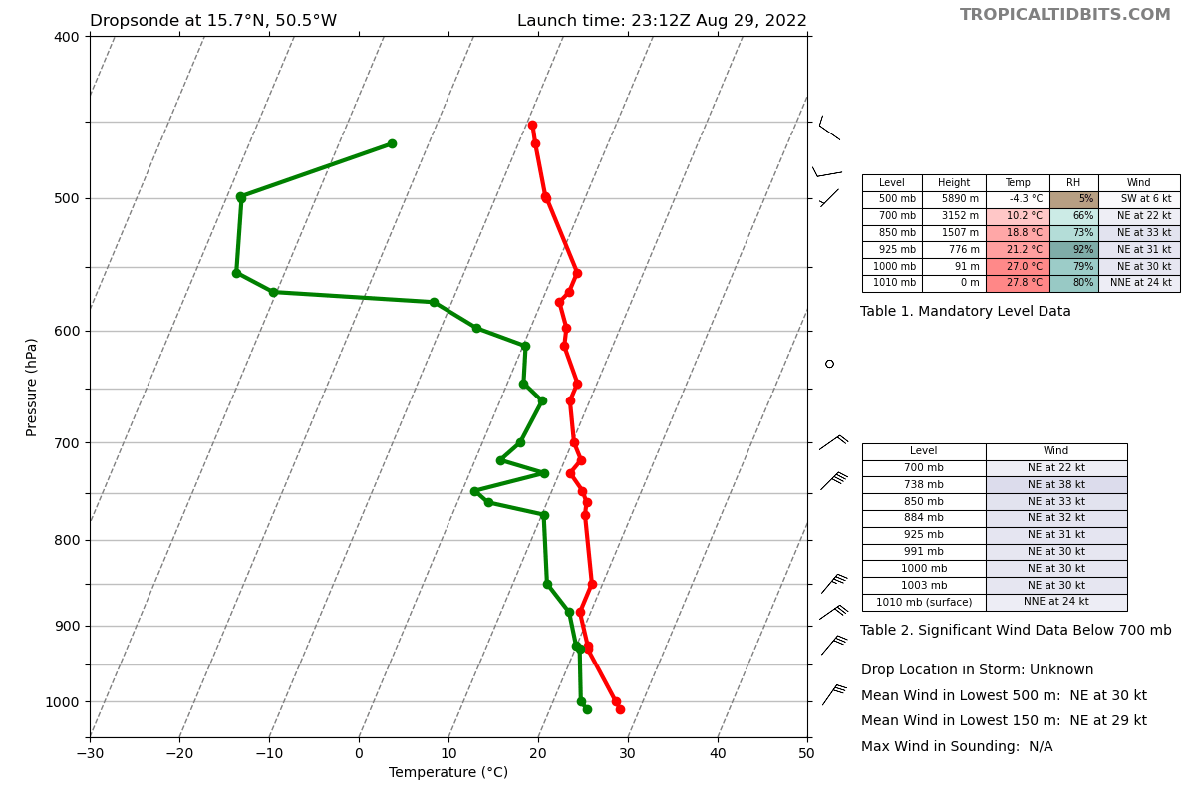
2255
2329 | Drop #15 15.75 N, 49.0 W  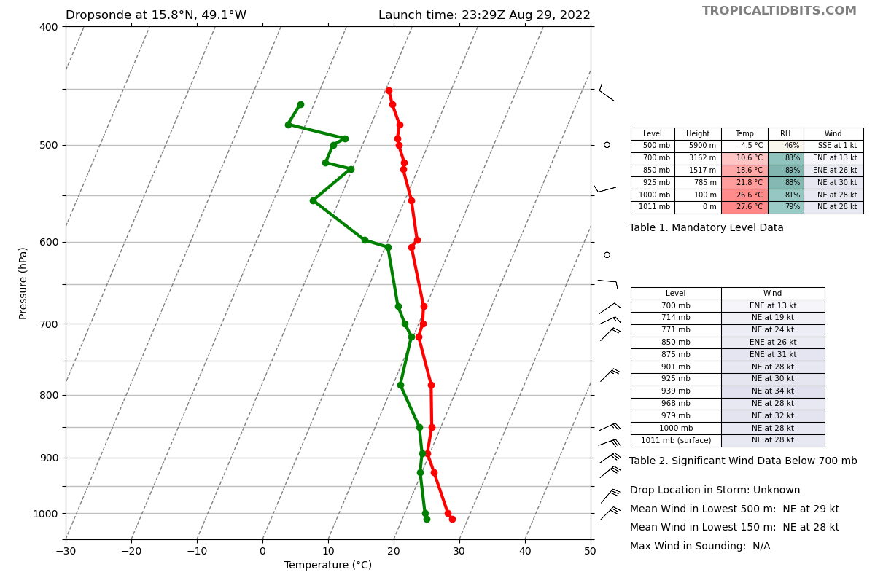
2343 | Drop #16 15.75 N, 47.75 W  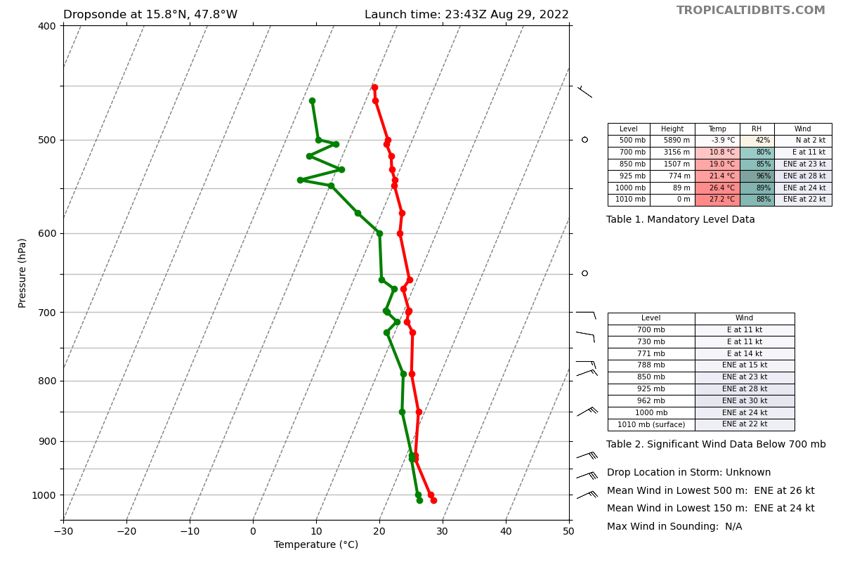
2358 | Turn track north, Drop #17 15.75 N, 46.5 W  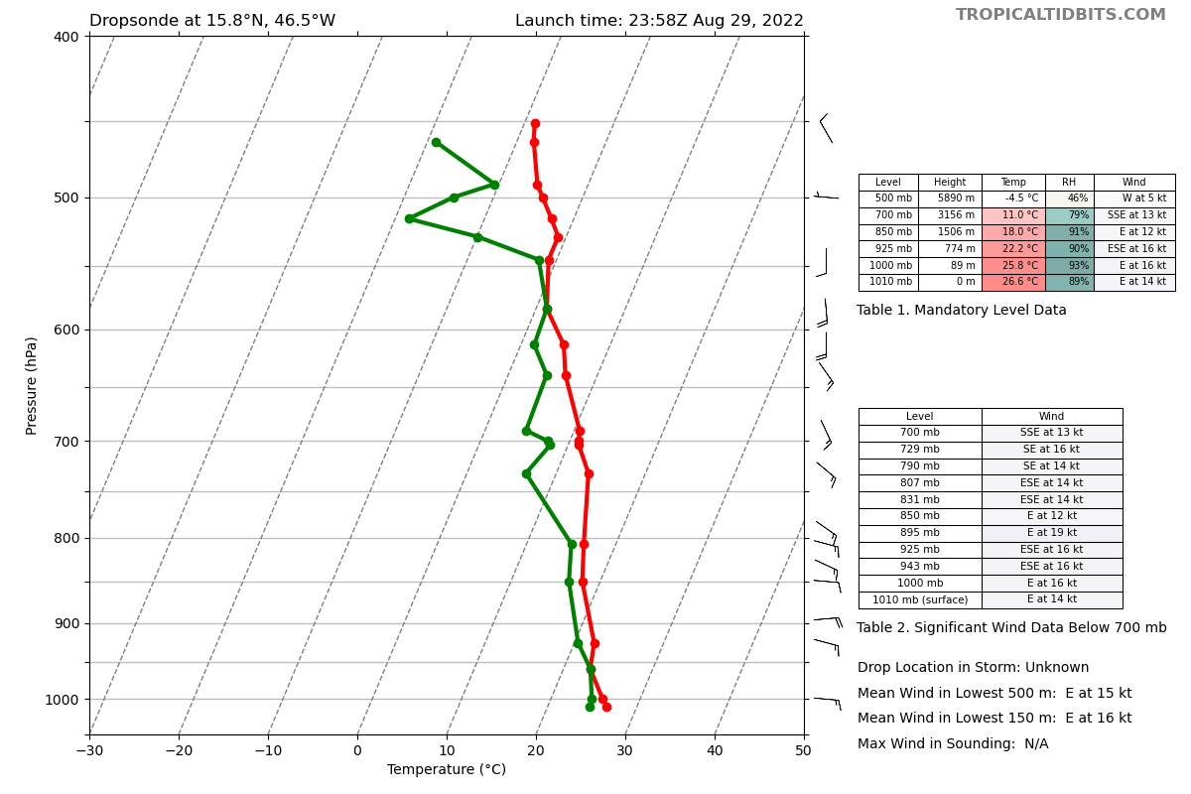
0009 | Drop #18 16.6 N, 46.5 W  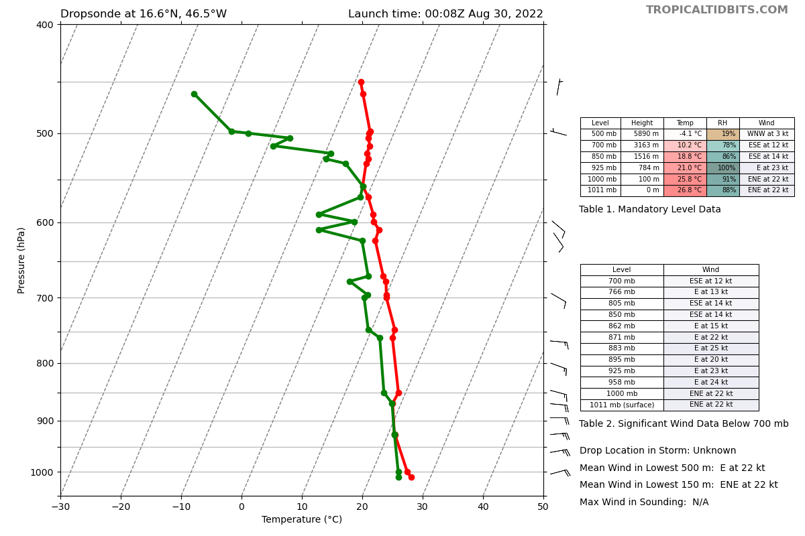
0019 | Turn track west; Drop #19 17.5 N, 46.5 W  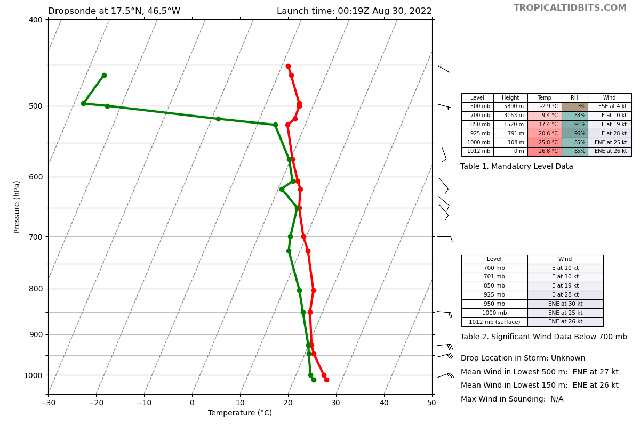
0034 | Drop #20 17.5 N, 47.8 W  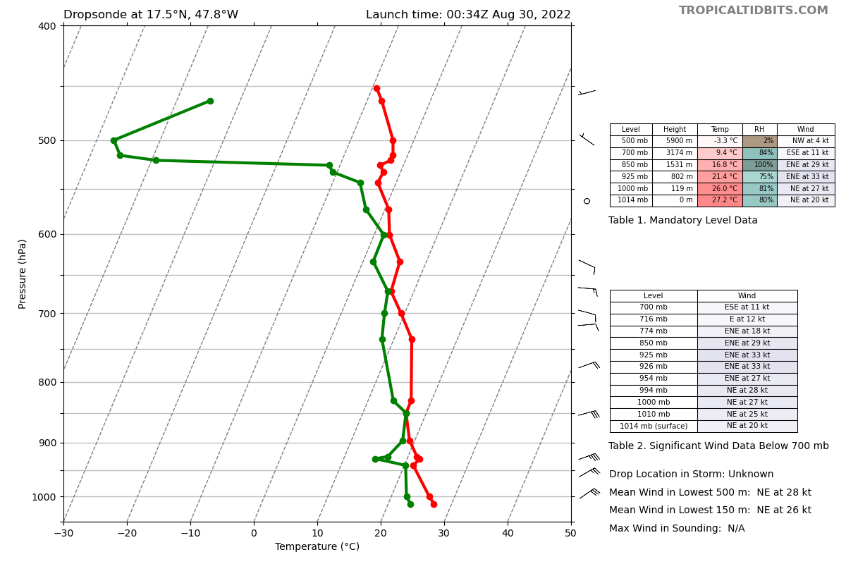
0050 | Drop #21 17.5 N, 49.2 W  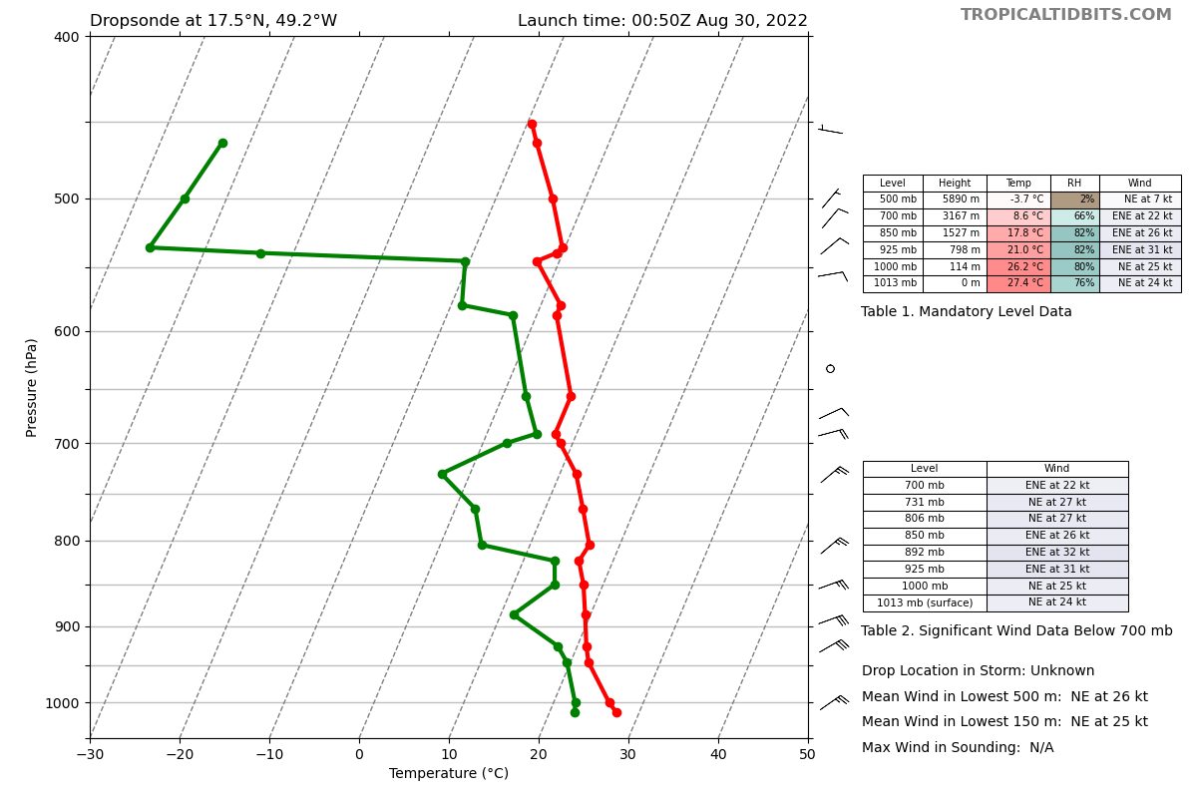
0102 | One of the interesting things about the sondes so far is that they consistently show a gentle (~1 m/s) downward motion.
0106 | Drop #22 17.5 N, 50.5 W. Turn track 240.  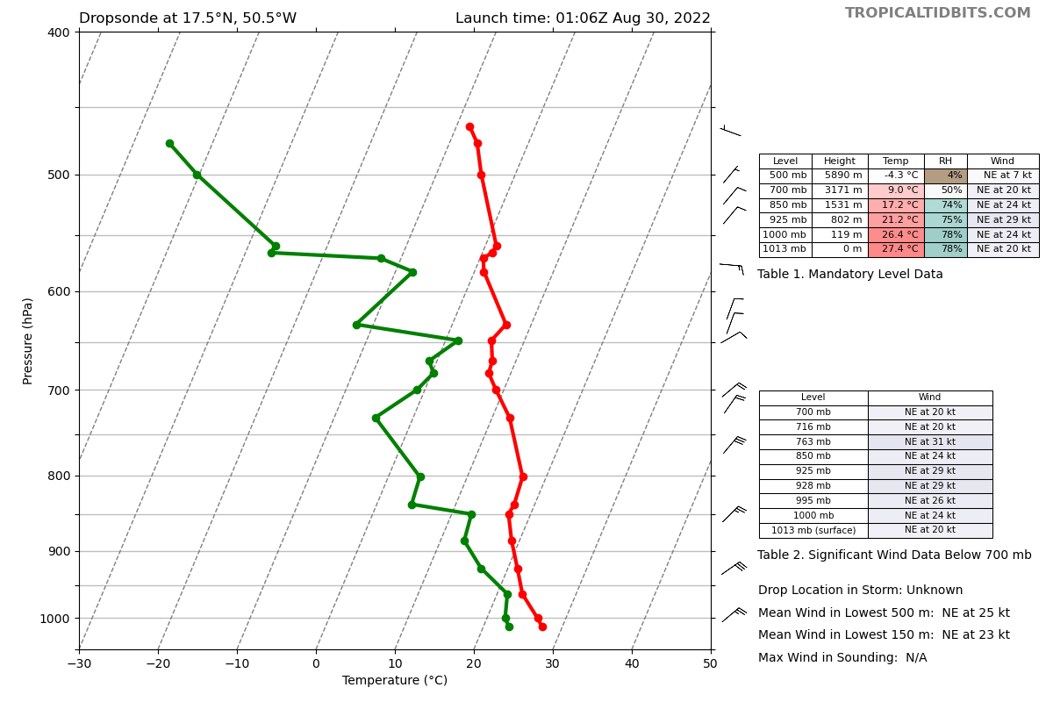
0126 | 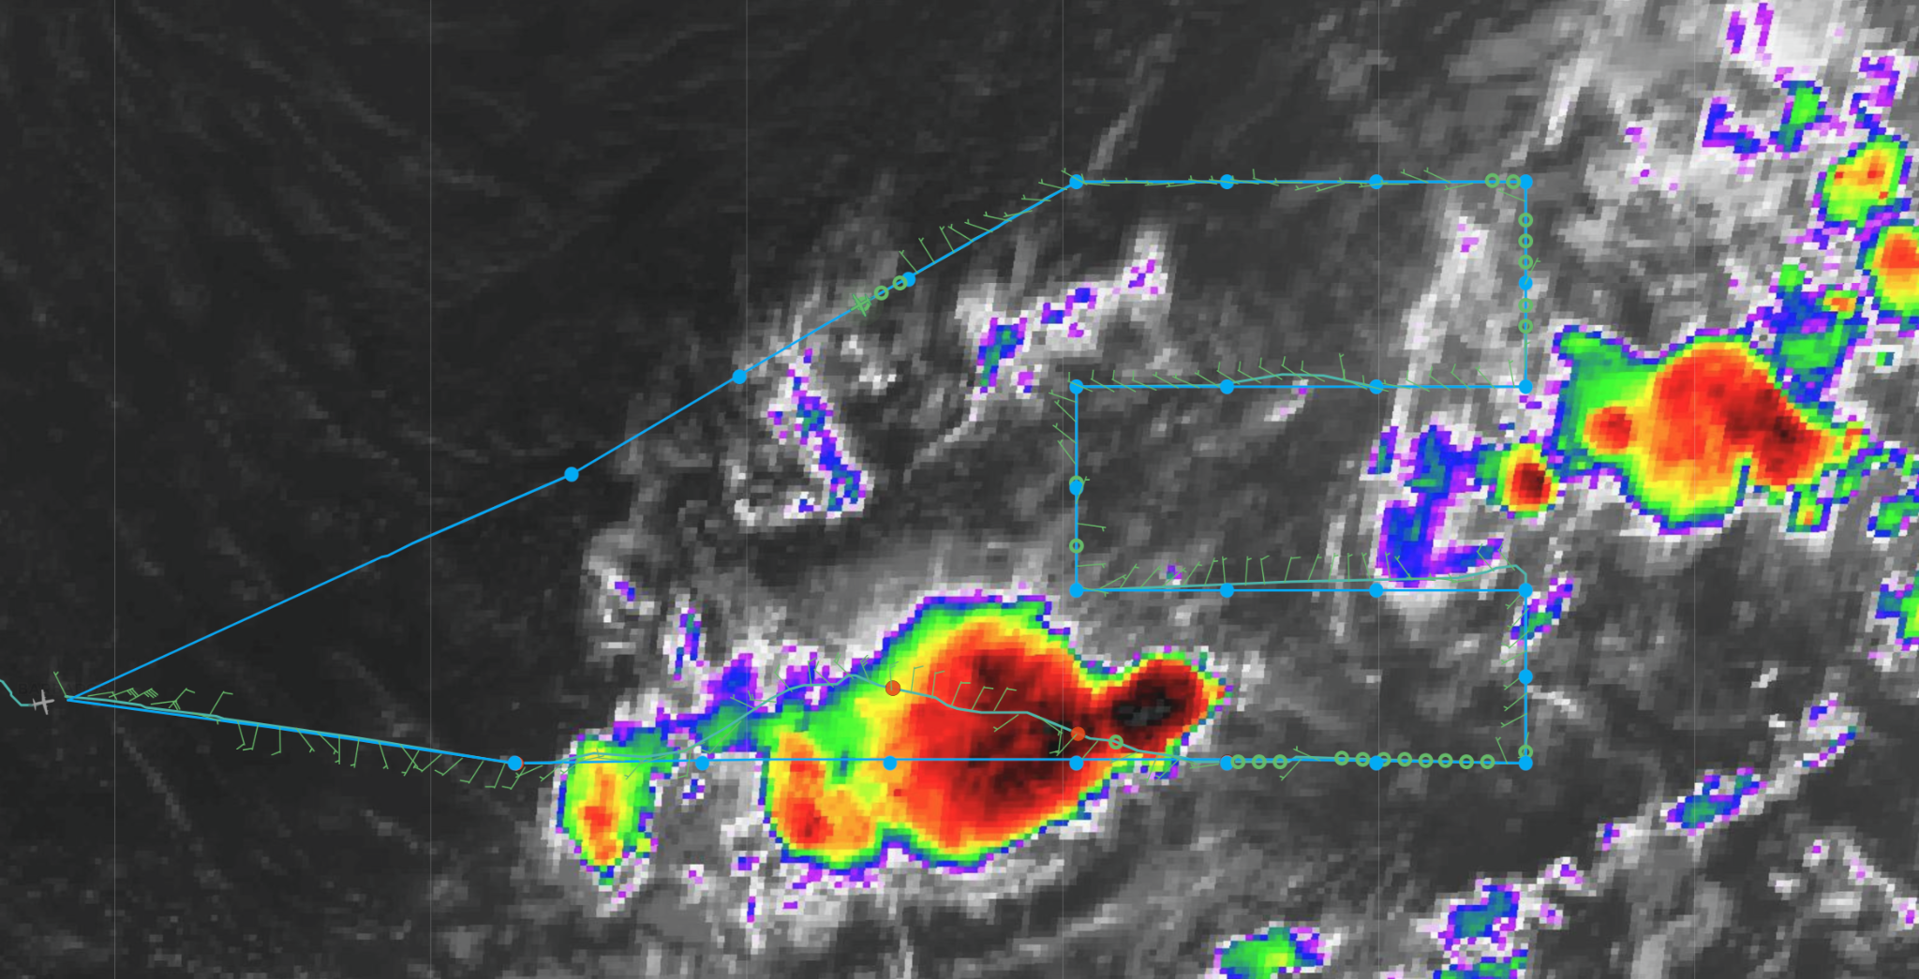
0126 | Drop #23 16.6 N, 52.0 W  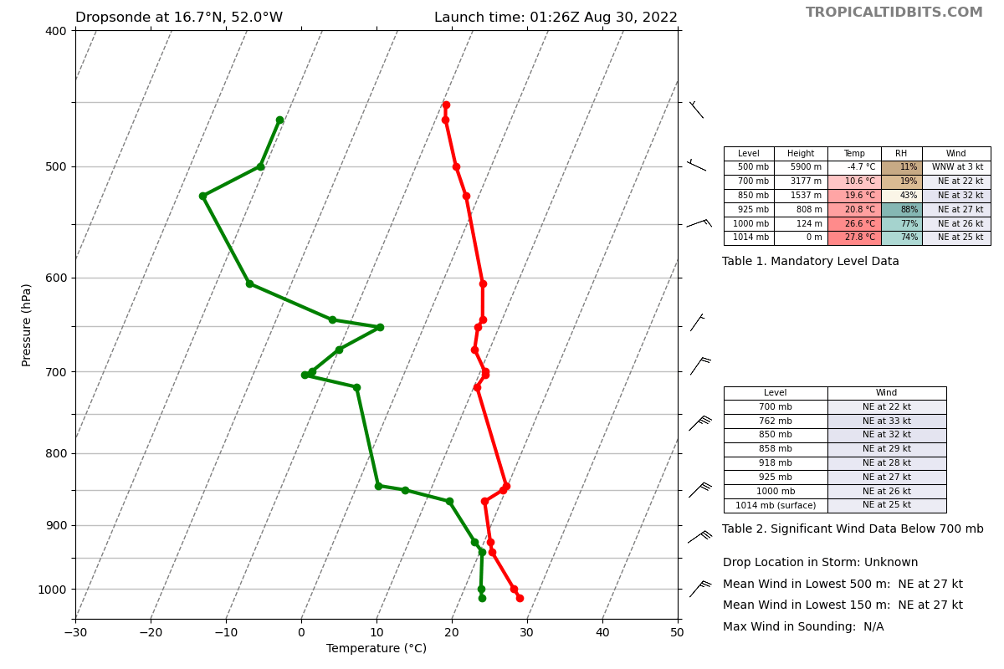
0141 | It's been a long time since I've seen air this dry on a P-3 flight.
0146 | Drop #24 15.8 N, 53.5 W  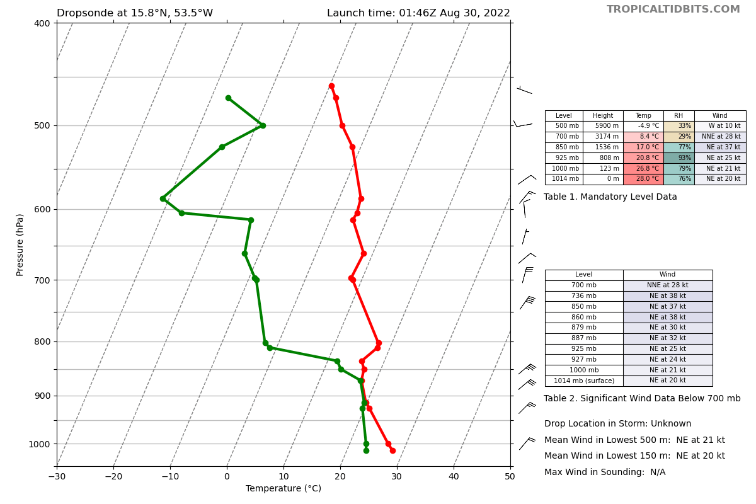
0206 | Drop #25 0206 UTC 15 N, 55 W; near 20% RH at 850 mb  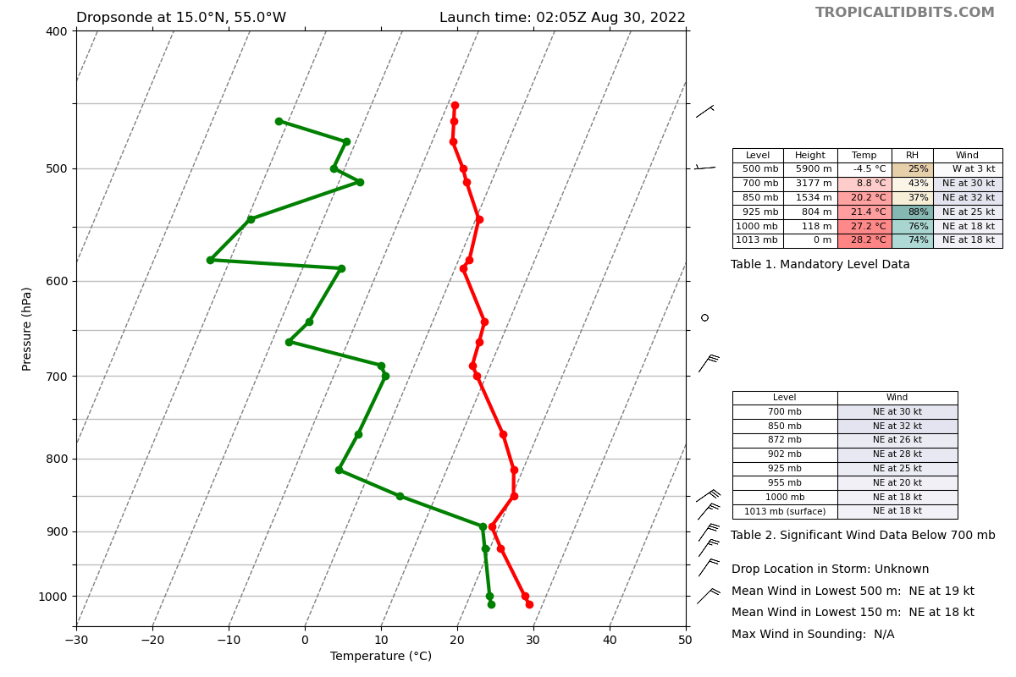
0220 | 25 total drops released on the mission  23 transmitted  1 fast fall  1 w/ lost data files (will try to recover)
0309 | Landed back at Barbados

POST-FLIGHT
Mission Summary | This was a pretty good mission in a struggling wave trough embedded in an extensive area of dry air. Because the wave was rather broad and extended we flew a lawnmower pattern at the highest altitude we could that turned out to be 21 kft to provide dropsonde coverage of the system for NHC and the numerical models.  There were two distinct convective areas along a SW-NE oriented trough straddling what appeared to be a broad low-level cyclonic circulation. Satellite imagery indicated numerous small low level cyclonic swirls along the trough axis that appeared to move NE toward the NE convective blob.  Our first west to east leg passed just north of the SW convective system, which erupted as we passed by forcing us to deviate north to stay below the expanding anvil from convection to our south. Flight-level data at about 450 hPa indicated a sharp cyclonic shear line on the eastern edge of the major convective blowup. The TDR analysis for this leg indicated that this cyclonic shear feature was confined to high altitude as a result of the convection. The TDR indicated large regions of NNE winds in the lower troposphere below the convection. The rest of the first W-E leg was characterized by relatively dry air around 700 hPa with interspersed higher humidity layers..  The NE convective blob and the broad circulation center were outside our TDR range or were pretty devoid of convection for the TDR to be effective. During the mission the NE convective region collapsed considerably. However, the dropsondes worked really well in that portion of the missions indicating extremely dry low-level humidity to the north and west of the wave trough, with RH in single digits and teens.  We had minor deviations to avoid deep convection in the pattern, but it did not affect the TDR or dropsonde patterns. We had a major issue with the MMR INE that forced a restart of the system after we passed through the SW convective feature. Todd found that using a different GPS/INE solved the issue and the MMR worked great after that.  A major issue was internet drop outs that plagued our comms and ability to use Google Docs for mission summaries and dropsonde logs. Thanks to our ground LPS (Gus Alaka) we were able to keep the logs up to date. We had a similar problem during the ferry where we even lost connection to the SEB server and XChat. There was a lot of solar flare activity the last few days that may have caused the problem.  On the ferry back we learned that N43RF has a windscreen issue of undetermined seriousness that could affect the next set of missions.  1 TDR analysis and superobs xmitted  23 of 25 dropsondes were xmitted  1 drop was a fast fall (#8)  1 drop sonde never produced a d-file (#2) - AOC will check to see if it can be recovered
Actual Standard Pattern Flown | Lawnmower
APHEX Experiments / Modules Flown | Genesis Experiment - Favorable Air Mass (FAM) and Impact of Targeted Observations on Forecasts (ITOFS-East)
Plain Language Summary
Instrument Notes | We had a major issue with the MMR INE that forced a restart of the system after we passed through the SW convective feature. Todd found that using a different GPS/INE solved the issue and the MMR worked great after that. We also lost the d-file for one dropsonde possibly due to solar flare activity or system error.
Final Mission Track | 