MISSION PLAN
FLIGHT ID | 20220828N1 | STORM | AL91
MISSION ID | WAWXA | TAIL NUMBER | NOAA49
TASKING | HRD | PLANNED PATTERN | Survey/Lawnmower
MISSION SUMMARY
TAKEOFF [UTC] | 1518 | LANDING [UTC] | 2250
TAKEOFF LOCATION | Barbados | LANDING LOCATION | Barbados
FLIGHT TIME | 7.5 | BLOCK TIME | 7.7
TOTAL REAL-TIME RADAR ANALYSES  (Transmitted) | 4 (4) | TOTAL DROPSONDES (Good/Transmitted) | 30 (30 / 30)
OCEAN EXPENDABLES (Type) | None | sUAS (Type) | None
APHEX EXPERIMENTS / MODULES | Genesis Experiment: FAM; Early Stage Experiment: ITOFS
HRD CREW MANIFEST
LPS ONBOARD | None | LPS GROUND | Dunion
TDR ONBOARD | None | TDR GROUND | Gamache
ASPEN ONBOARD | AOC FD | ASPEN GROUND | None
NESDIS SCIENTISTS | None
GUESTS (Affiliation) | None
AOC CREW MANIFEST
PILOTS | Mansour, Waddington
NAVIGATOR | None
FLIGHT ENGINEERS | None
FLIGHT DIRECTOR | Henning
DATA TECHNICIAN | Defeo
AVAPS | Lynch

PRE-FLIGHT
Flight Plan | 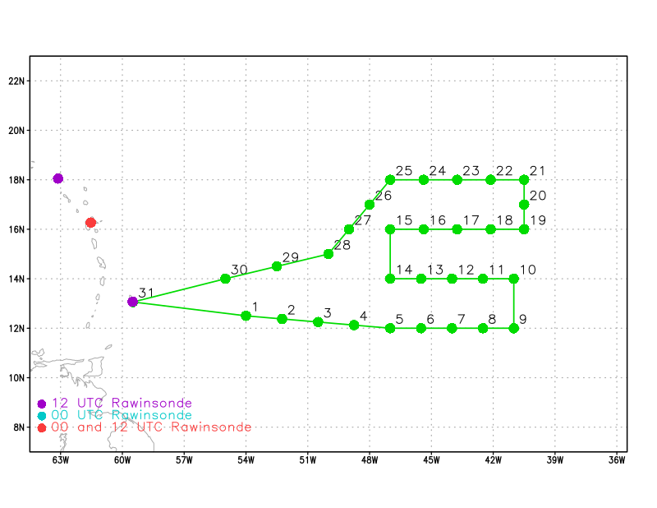
Expendable Distribution | Release a dropsonde at each of the green points in the above image
Preflight Weather Briefing | This is the 1st aircraft mission to sample the tropical wave that was designated as AL91 by NHC this morning. The targets are model ensemble sensitivity regions, a SAL outbreak to the north that is wrapping around the western semicircle of the disturbance, and the overall AEW structure. Although AL91 has been sputtering and struggling to consistently maintain deep convection, NHC now has a 40% (70%) chance for genesis in 2 days (5 days) - up from 20% and 50% yesterday evening).  The pattern is designed to release sondes in the ensemble sensitivity regions. Overview from Ryan Torn, Univ. at Albany/SUNY: “ECMWF sensitivity plots for 12z 28 August; For the wave position, the sensitivity is associated with the position of the wave and to the structure of the subtropical ridge to the north. In addition, there is some sensitivity to the moisture to the north of the wave.”  Sensitivity plots with the G-IV track overlaid (green curves).  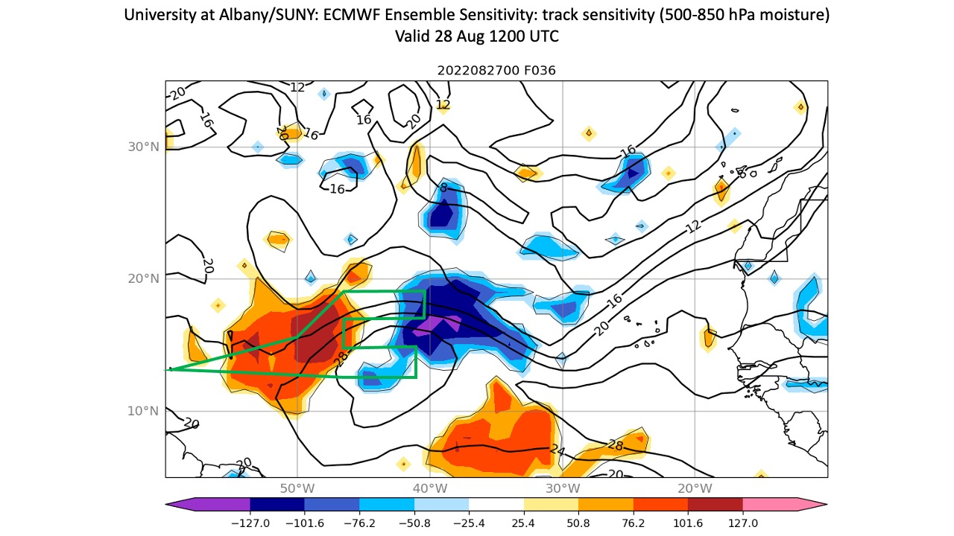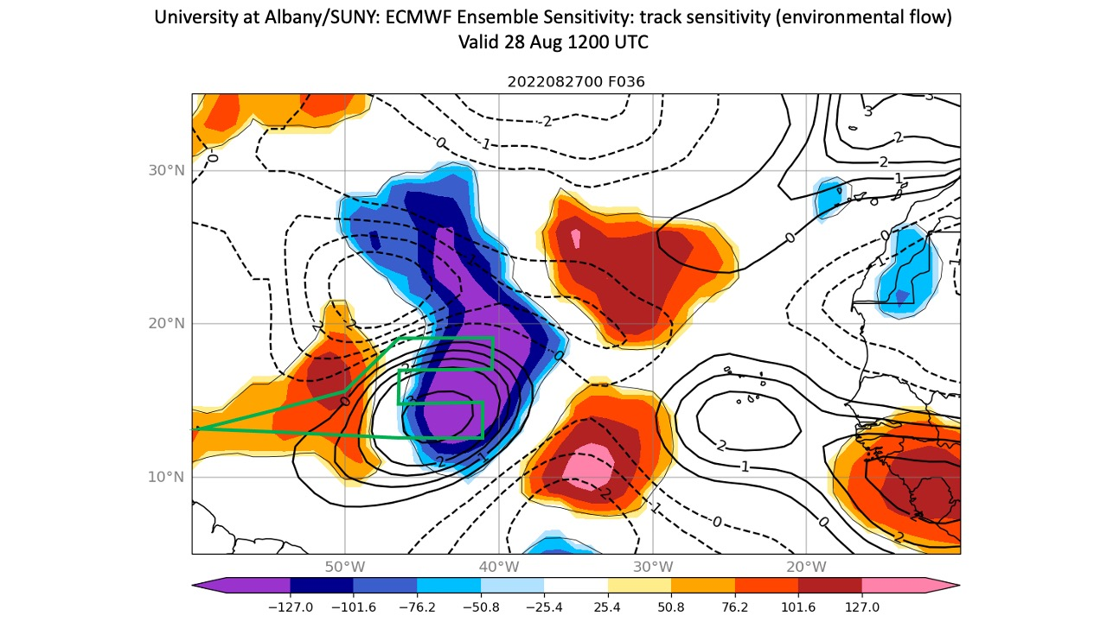
Instrument Notes | AVAPS and TDR operating normally.

IN-FLIGHT
Time [UTC] | Event
1645 | N49 FD informed us that our track is a bit too long and that we’ll need to trim a bit of the track. Removing WPs 9 & 10 from the plan. The updated WP sequence will be 7-8-11-12.
ECMWF 27 Aug 06z 36 hr forecast of TPW and 850 mb winds valid for 28 Aug 1800z (approximate center time for the G-IV mission). The image shows the planned sampling of the Saharan Air Layer (<45 mm TPW, yellow to orange shading) north and NW of the AEW.
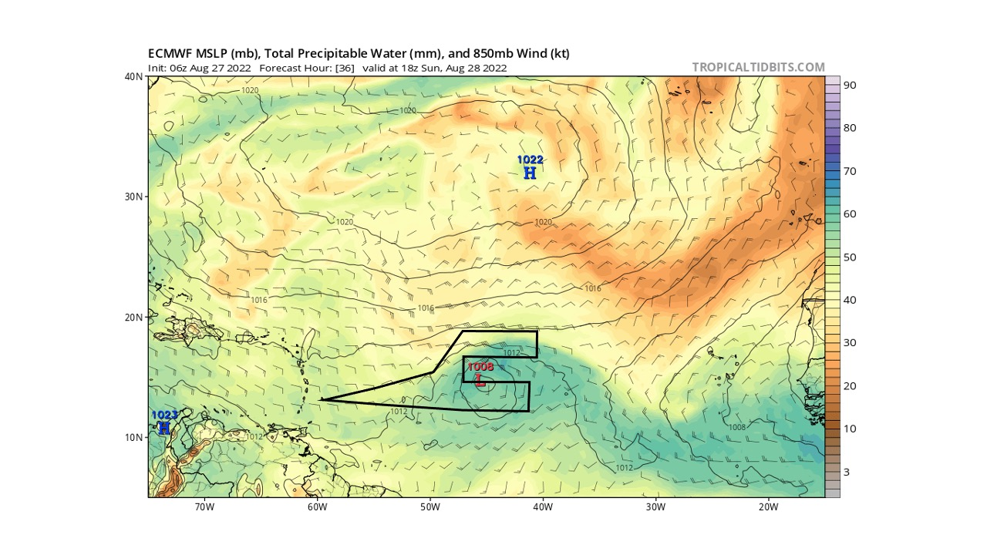

POST-FLIGHT
Mission Summary | 30 dropsondes were released (all were good, all were transmitted) and were all charged to NWS.
Actual Standard Pattern Flown | Survey / Lawnmower
APHEX Experiments / Modules Flown | Data collected supports APHEX’s Genesis Stage Experiment: Favorable Air Mass (FAM) as the G-IV collected date in the environment of AL91, including the moisture gradients associated with the Saharan Air Layer following the wave trough. Early Stage Experiment: ITOFS was also flown as dropsondes targeted model sensitivity regions.
Plain Language Summary | - A mission was flown in a disturbance designated AL91 with a moderate chance of formation in the near term by the National Hurricane Center. The G-IV surveyed the environment of AL91, sampling the moisture (including the Saharan Air Layer, a dry, dusty air mass that moves off Africa within what are called African easterly waves), shear, and relative humidity of the trough area to determine its favorability for developing into a storm.  - Observations were also targeted in areas in which global forecast models are most sensitive to receiving that wind and humidity information – this is called targeted observations. The goal is to improve the model forecast by strategically placing these observations (dropsondes) in the areas where they will make the most impact in the model after assimilation into the initialization of the model run.
Instrument Notes | N49’s comms dropped out from ~1747-1801z. The MTS flight track appears to have missed WP 11, but that was just because of the comms outage. Actual pattern flown was WP 7-8-11-12. TDR had some spotty returns where more coverage was expected along the S-N leg of WPs 14-15 near the main area of convection close the LLC- coverage was actually better on the W-E leg east of that area of convections (WPs 15-19…we’ll look into to double check), a lot variation in winds across the flights track at the melting level (W-E leg (WPs 15-19), jobfiles were not making it to the public server (Sonia and John G. troubleshooted and found a typo in the AOC script…should be fixed now).
Final Mission Track | 