MISSION PLAN
FLIGHT ID | 20220630H1 | STORM | AL94 / PTC02
MISSION ID | 0502A | TAIL NUMBER | NOAA42
TASKING | EMC | PLANNED PATTERN | Butterfly
MISSION SUMMARY
TAKEOFF [UTC] | 1341 | LANDING [UTC] | 2000
TAKEOFF LOCATION | St. Croix | LANDING LOCATION | St. Croix
FLIGHT TIME | 6.3 | BLOCK TIME | 6.5
TOTAL REAL-TIME RADAR ANALYSES  (Transmitted) | 3 (3) | TOTAL DROPSONDES (Good/Transmitted) | 15 (15/15)
OCEAN EXPENDABLES (Type) | None | sUAS (Type) | None
APHEX EXPERIMENTS / MODULES | Genesis Experiment: PREFORM
HRD CREW MANIFEST
LPS ONBOARD | Zawislak | LPS GROUND | Hazelton / Rogers
TDR ONBOARD | Zawislak | TDR GROUND | Gamache / Reasor
ASPEN ONBOARD | Zawislak | ASPEN GROUND | None
NESDIS SCIENTISTS | None
GUESTS (Affiliation) | None
AOC CREW MANIFEST
PILOTS | Abitbol, Copare, Rannenberg
NAVIGATOR | Urato
FLIGHT ENGINEERS | Darby, Stokes, Gee
FLIGHT DIRECTOR | Holmes, Kalen
DATA TECHNICIAN | McAlister
AVAPS | Hartberger

PRE-FLIGHT
Flight Plan | 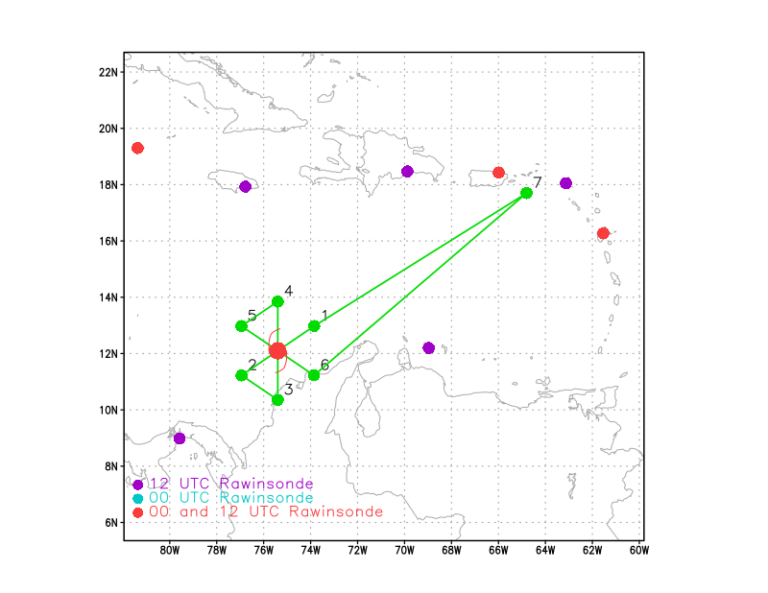  Fly a butterfly pattern oriented with the azimuths above, with 105 n mi radial legs, at 10 kft…addendum: higher altitude in clearer air, when possible with separation from Teal.
Expendable Distribution | Release a dropsonde at the endpoints (EP), midpoints (MP), and centers (CTR).
Preflight Weather Briefing | PTC02 remains quite disorganized as it continues to move quickly towards the west away from the South American coast. The forecast center position at 18Z is 12.0N / 75.3W, but that’s really just an estimate given the disorganization and translation speed. The midlevel wave trough certainly is still providing a focal point for potential organization. Convection is mainly on the western side of the wave trough, with very little cloud and precipitation on the west side. For today, the focus will be on radar coverage of the convection on the west side of the trough, and perhaps some higher altitude drops (deviating from the planned 10 kft for the entire pattern) in clearer air to the south to east. The first light visible imagery does suggest a fairly robust “swirl” moving off South America near 12.5N / 73.0W.  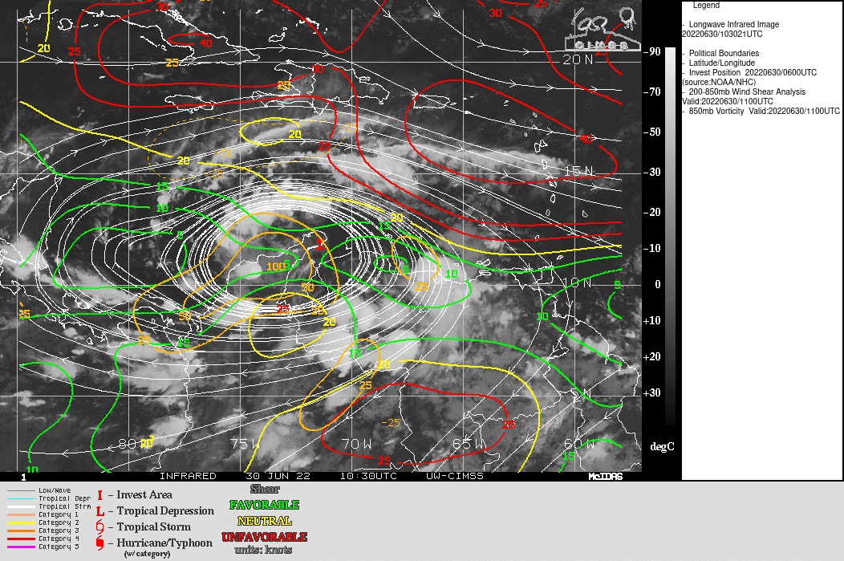
Instrument Notes | WSRA should be operational; CRL still not operational

IN-FLIGHT
Time [UTC] | Event
1341 | Takeoff from St. Croix
1434 | Earlier MW overpass shows a curved band but not much in the way of core convection  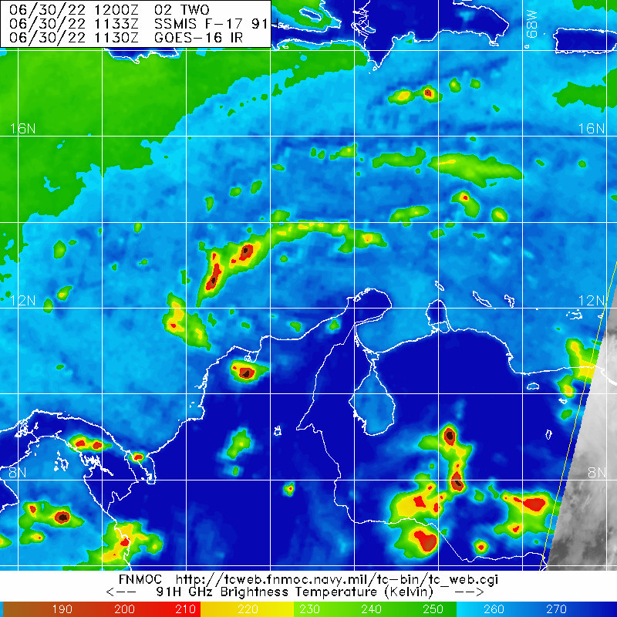
1500 | Initial plan request: Going for a point near 13.8N / 73.0W first; then head west to set up the butterfly anchored on a center of 12.5N / 74.5W, and begin a 045/225 radials for the first pass; try and get those drops higher as well
1518 | Trying to stay at 17 kft to get the deeper drops, heading to IP
1529 | Drop 1 IP NE
1530 | 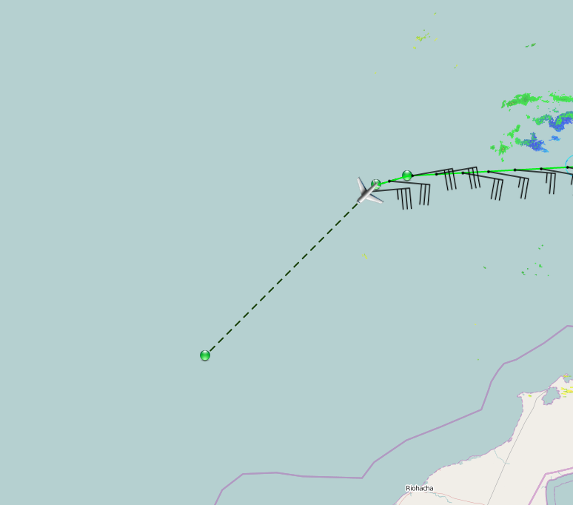
1538 | Some shallow convection firing in the “swirl”
1539 | Drop 2 midpoint NE
1544 | Skew-t for Drop 1…  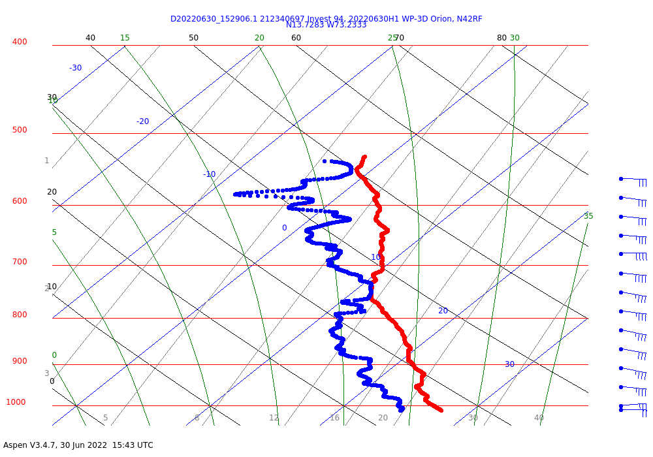
1549 | Drop 3 CTR
1551 | Center Appears S of 12N based on TEAL fix  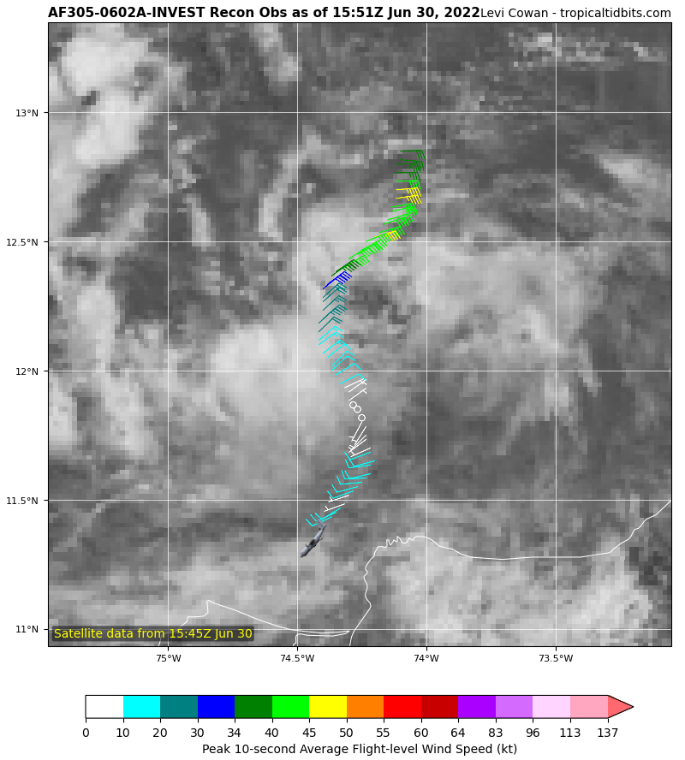
1552 | Skew-t for Drop 2…  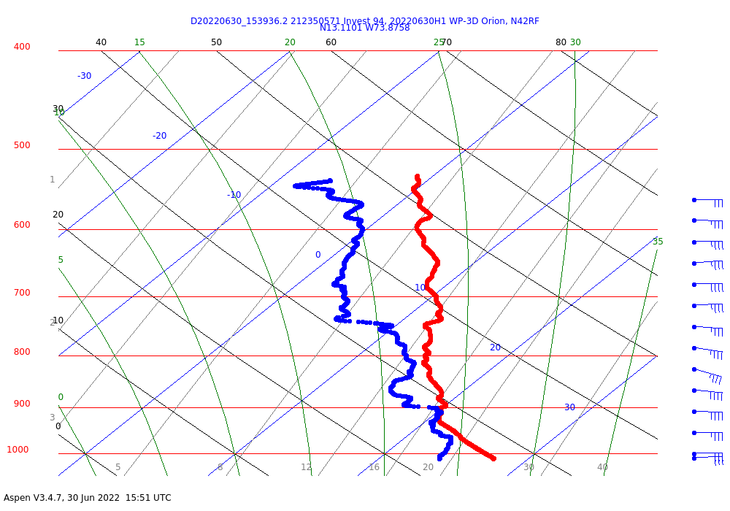
1559 | Inbound from the south will be a somewhat shorter leg
1559 | 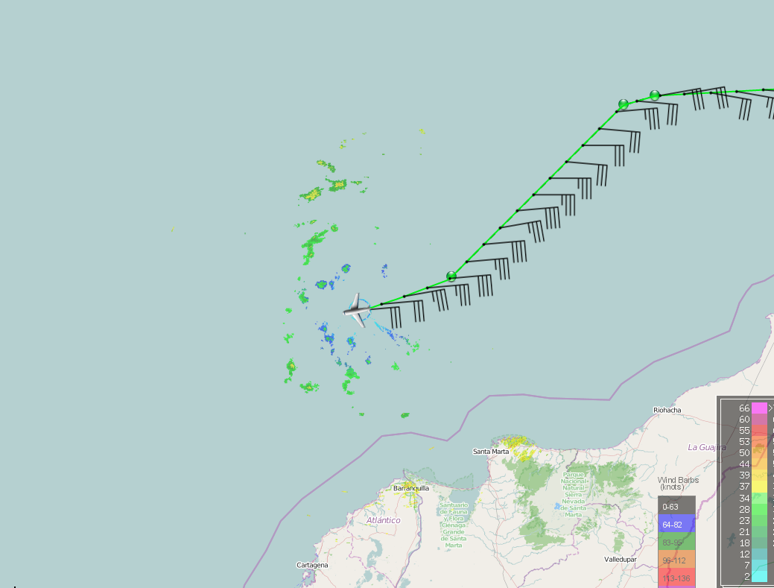
1600 | Drop 4 midpoint WSW
1605 | Skew-t for Drop 3…  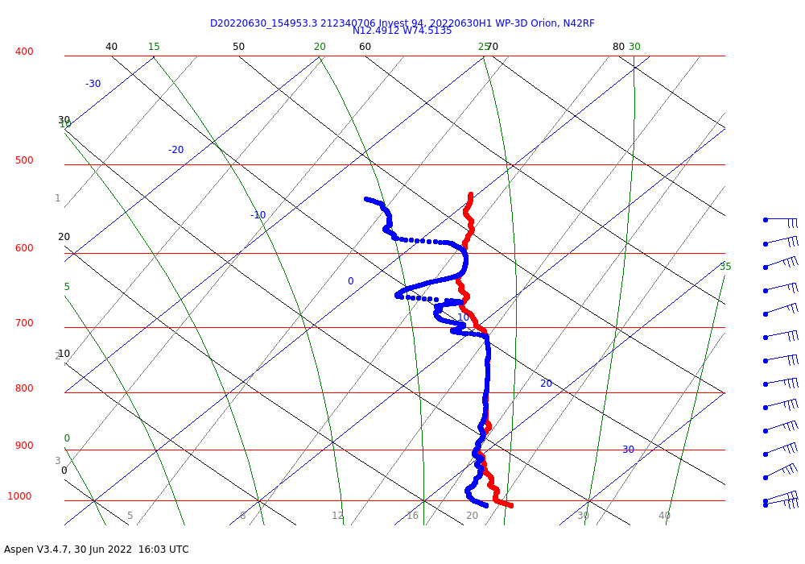
1610 | Drop 5 endpoint WSW
1614 | Skew-t at Drop 4…  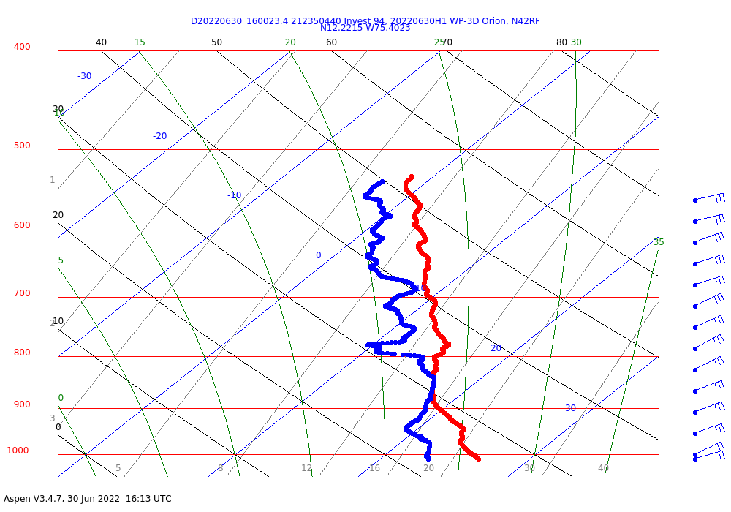  Fairly moist through the lower troposphere here.
1615 | 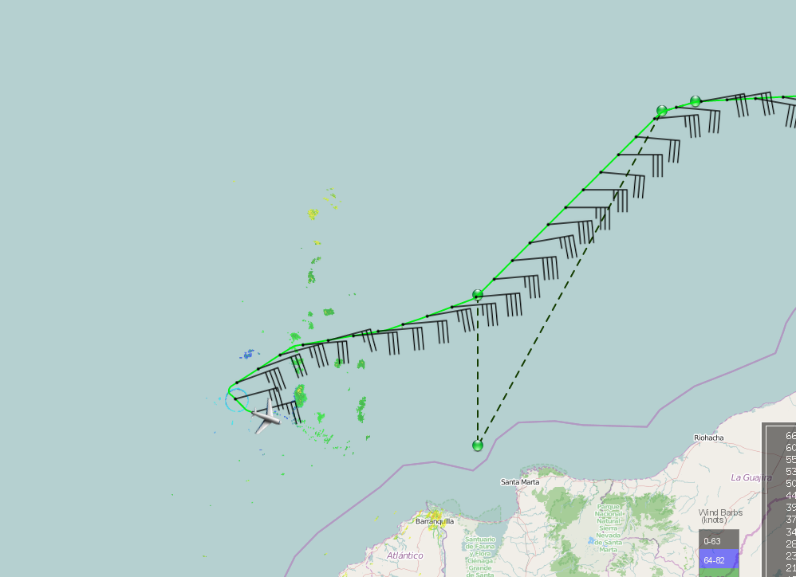
1622 | 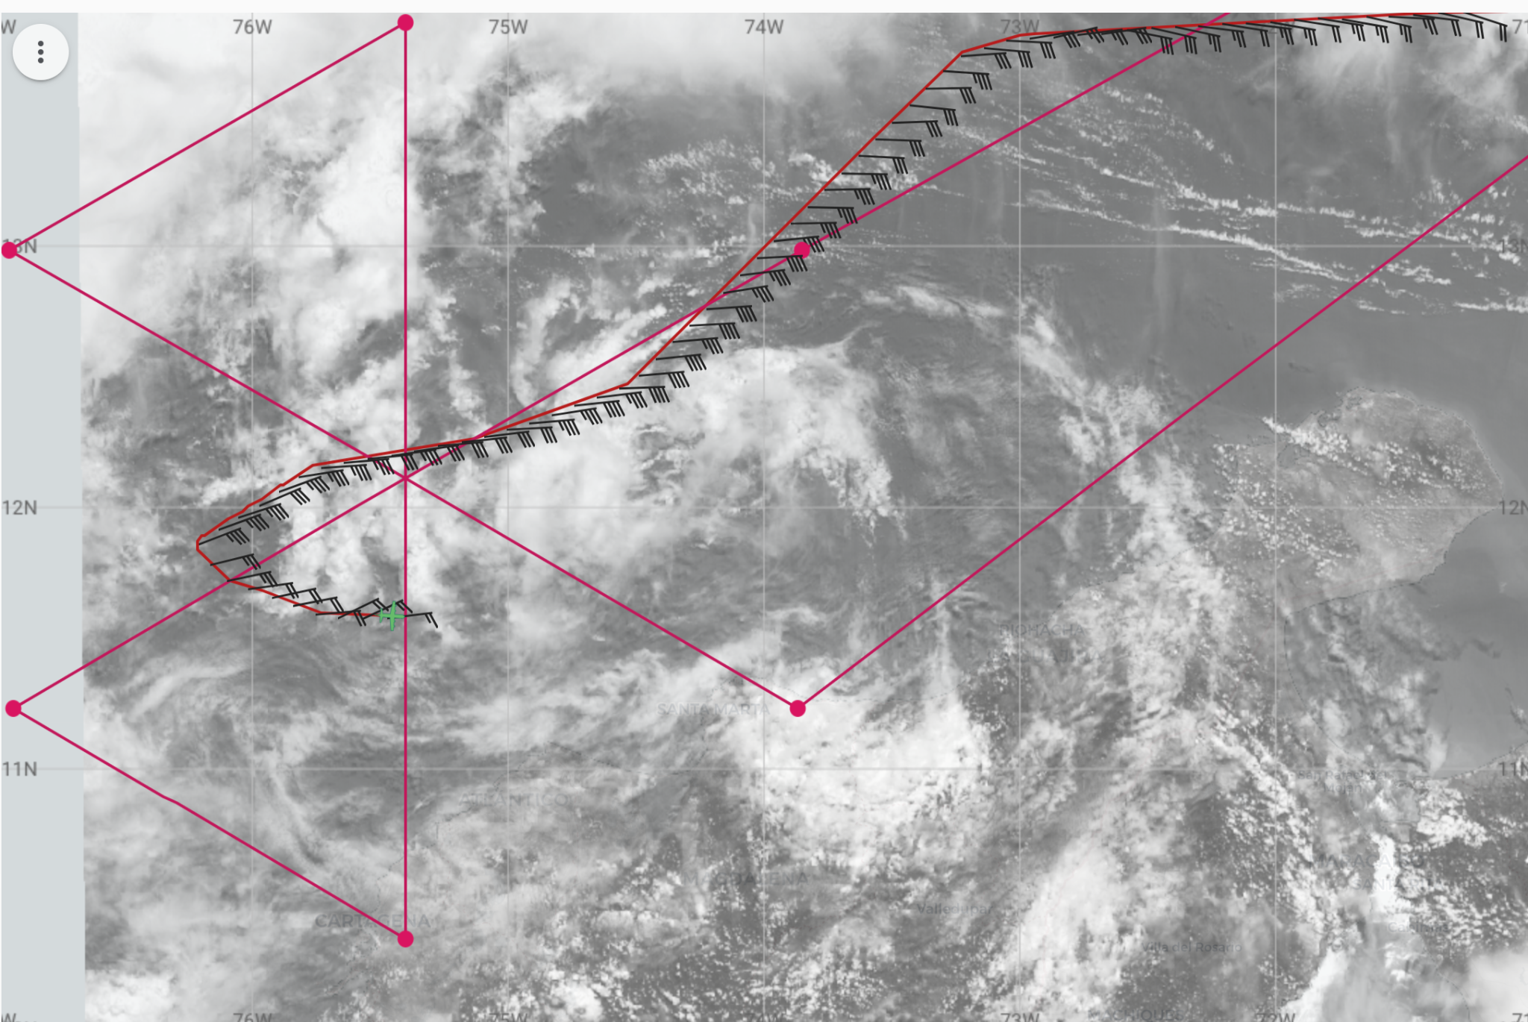  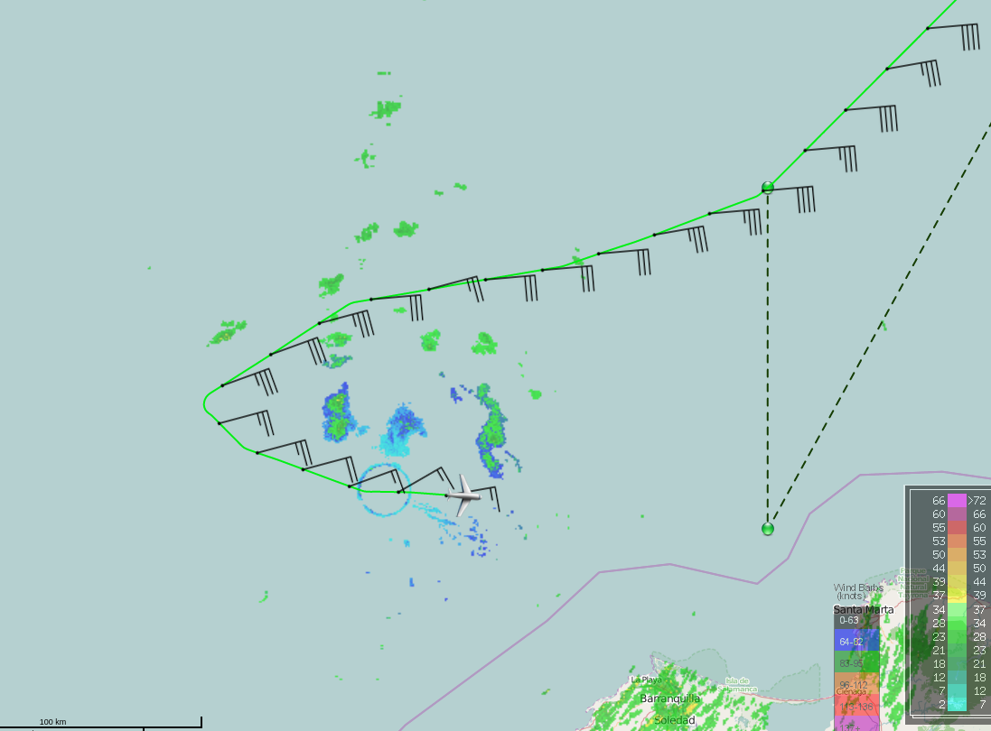
1632 | Skew-t at Drop 5…  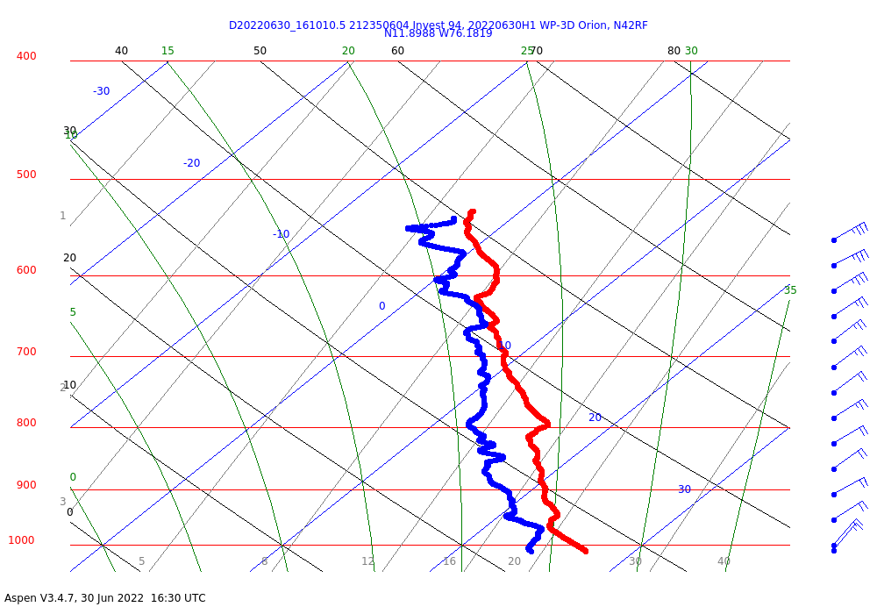
1637 | Drop 6 IP/MP (had to wait for TEAL to clear below)
1639 | First radar analysis:  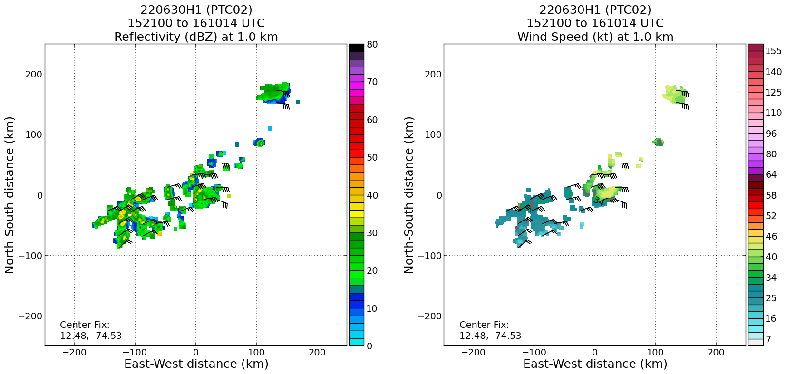  Limited scatterers on this first pass, sampling basically that leading convective line that’s been a persistent feature for at least the past two days, mostly east-northeasterly flow in swatch, with a hint of cyclonic curvature.
1646 | Drop 7 “Center”
1654 | Skew-t for Drop 6…basically a center sonde!  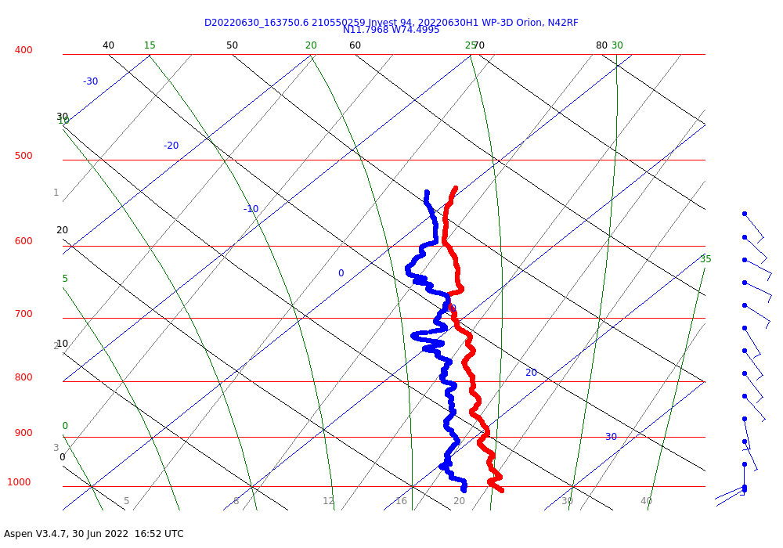
1657 | Drop 8 at MP north
1706 | Skew-t at Drop 7…  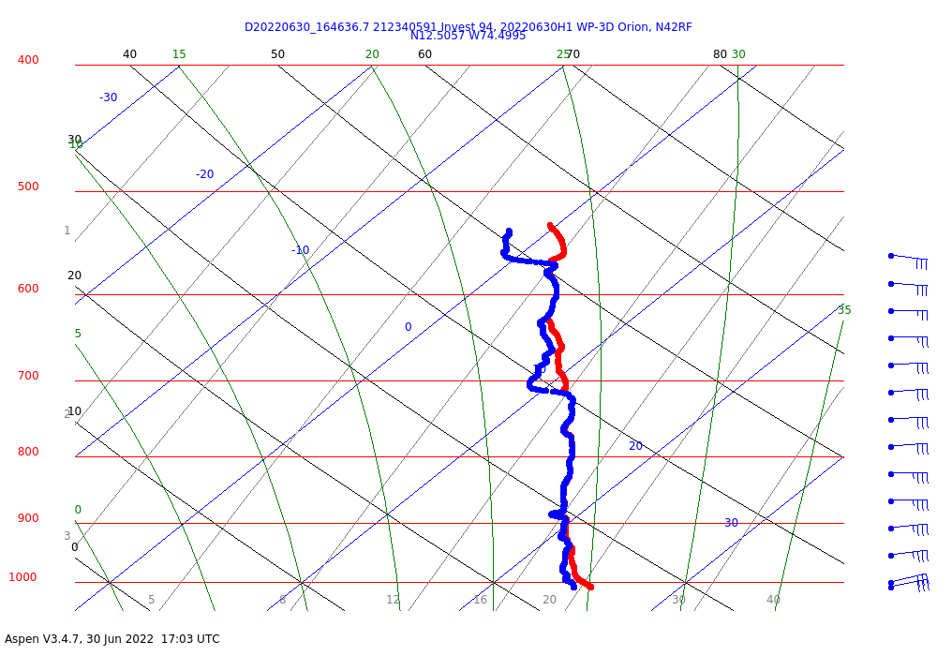
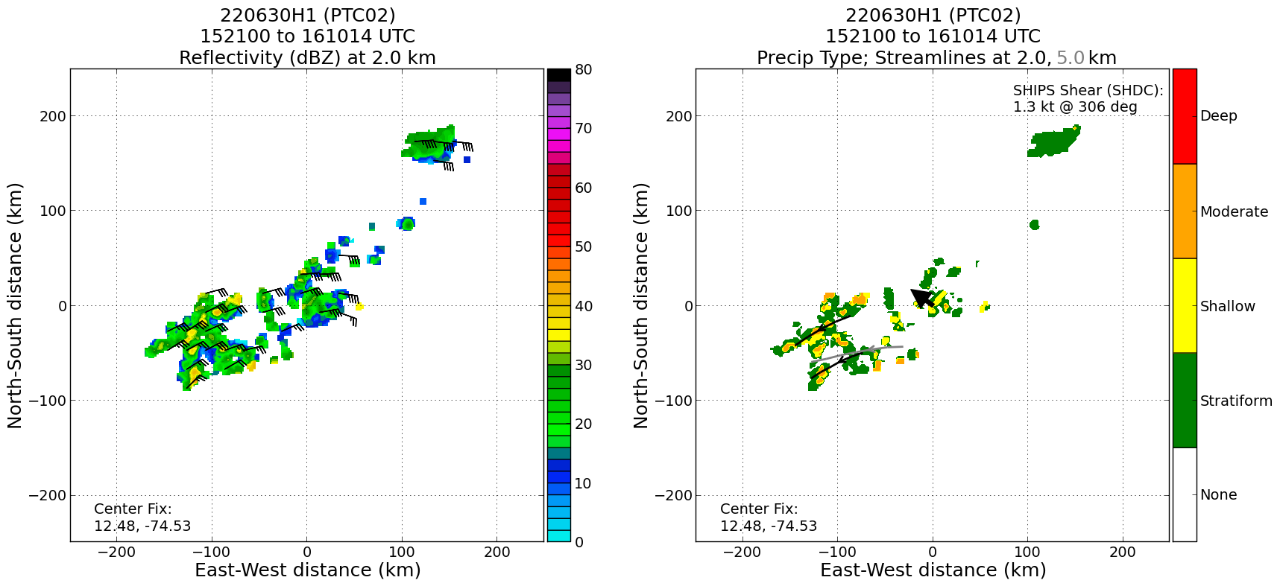
Precipitation mode from first pass shows shallow, moderate convection, and stratiform, but no deep convection. Perhaps not surprising given the phase of the diurnal cycle (i.e., local afternoon).
1704 | Drop 9 at end point on N side  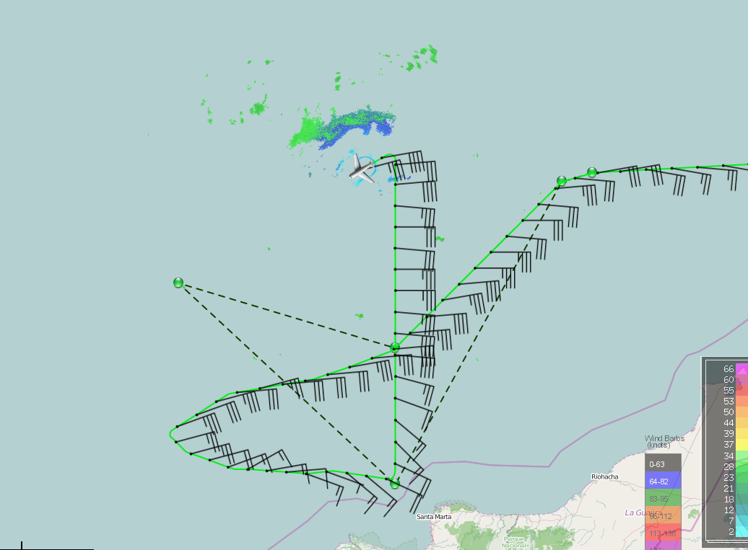  Picking up stratiform precipitation on the right side of aircraft
1713 | Skew-t for Drop 8…  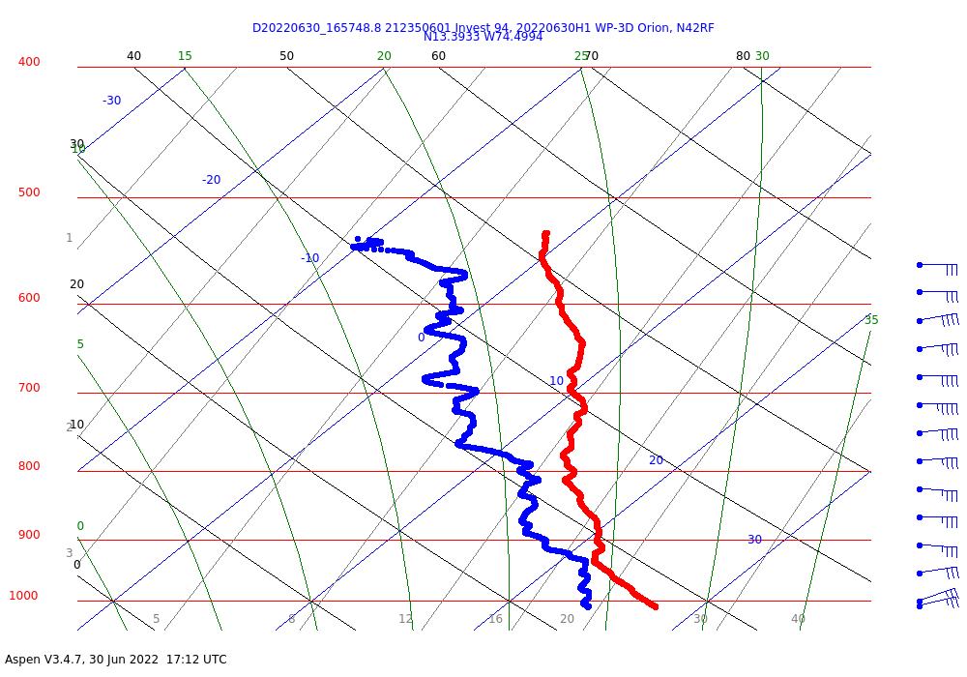
1717 | Swirl continues its march toward the west, getting over open water in SW Caribbean. Limited precipitation in the center of the swirl, but line of convection in an arc north and west.
1724 | Skew-t at Drop 9…  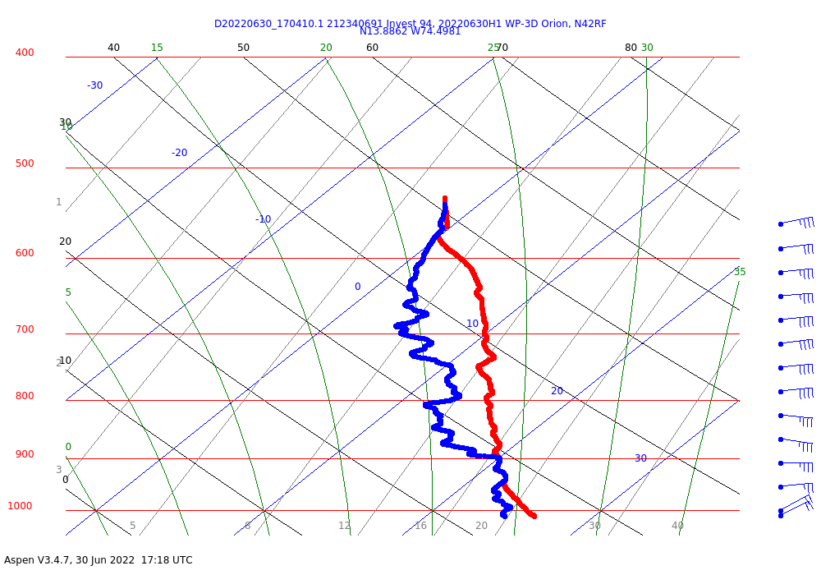
1724 | Drop 10 at NW IP
1727 | 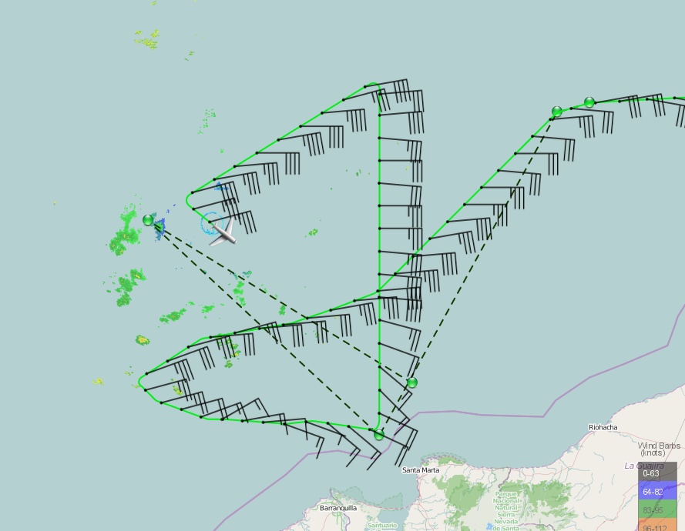  Turning inbound a little early to avoid significant deviations
1737 | Skew-t for Drop 10…  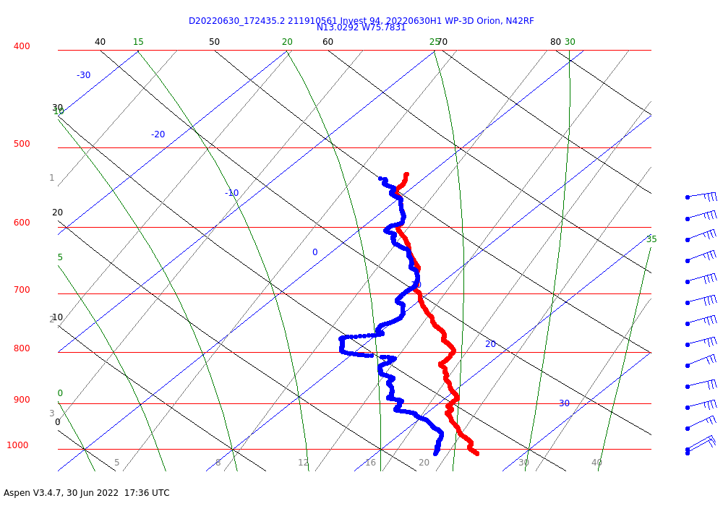
1738 | Drop 11 NW MP
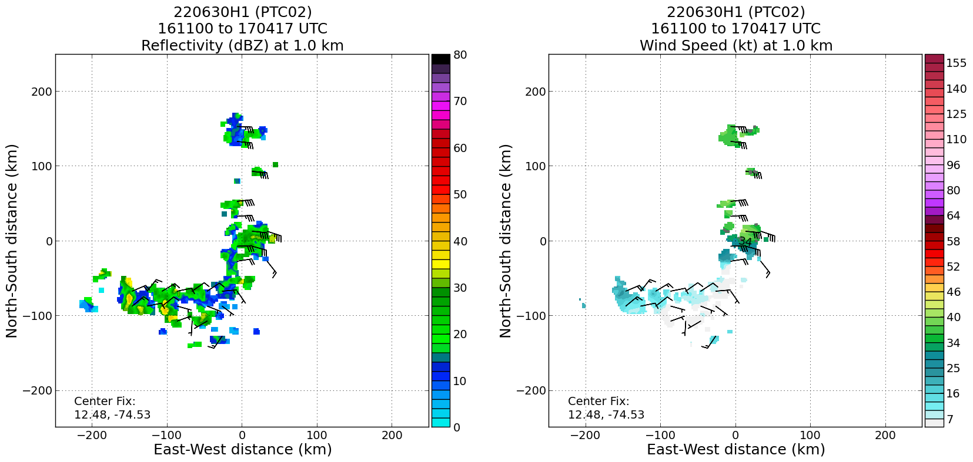

TDR analysis from second pass at 1 km shows a sharp trough axis, but not any obvious indication of a closed circulation. Lack of scatterers away from the leading line to the NW makes definitive determination with radar difficult, though.
1749 | Drop 12 (Center)
1756 | Drop 13 (Quarterpoint ENE)
1757 | Skew-t for Drop 11…  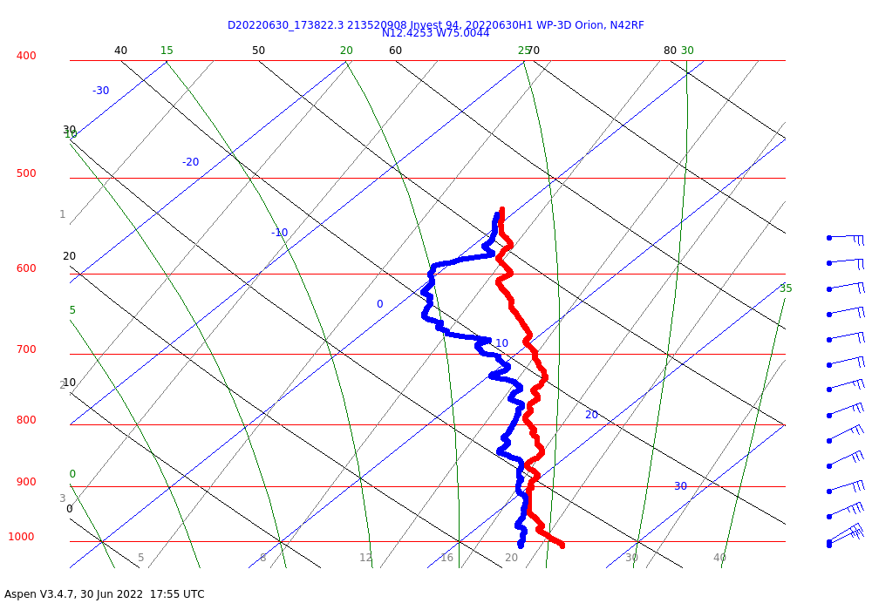
1803 | Skew-t at Drop 12…  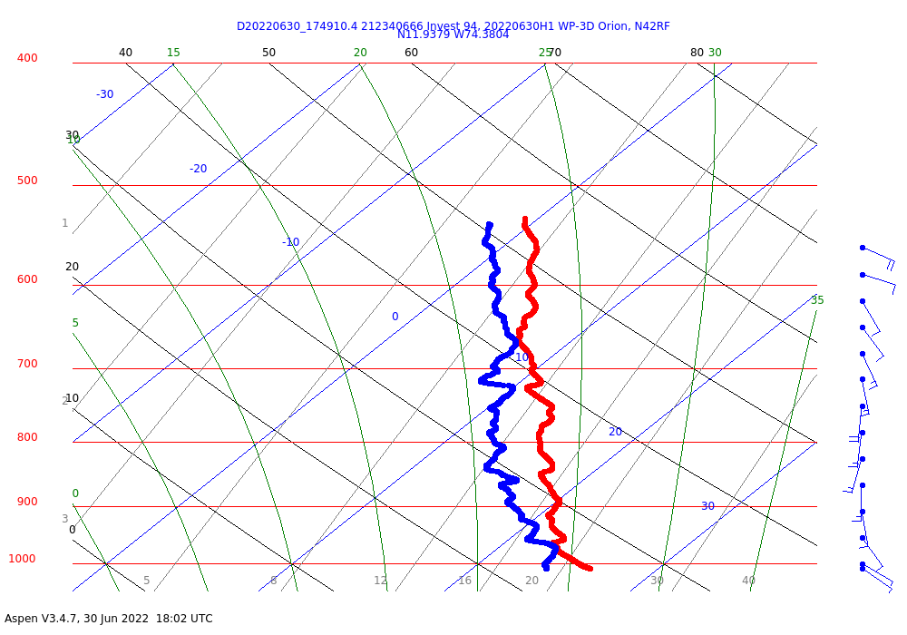
1805 | Drop 14 endpoint ENE
1811 | Skew-t at Drop 13…  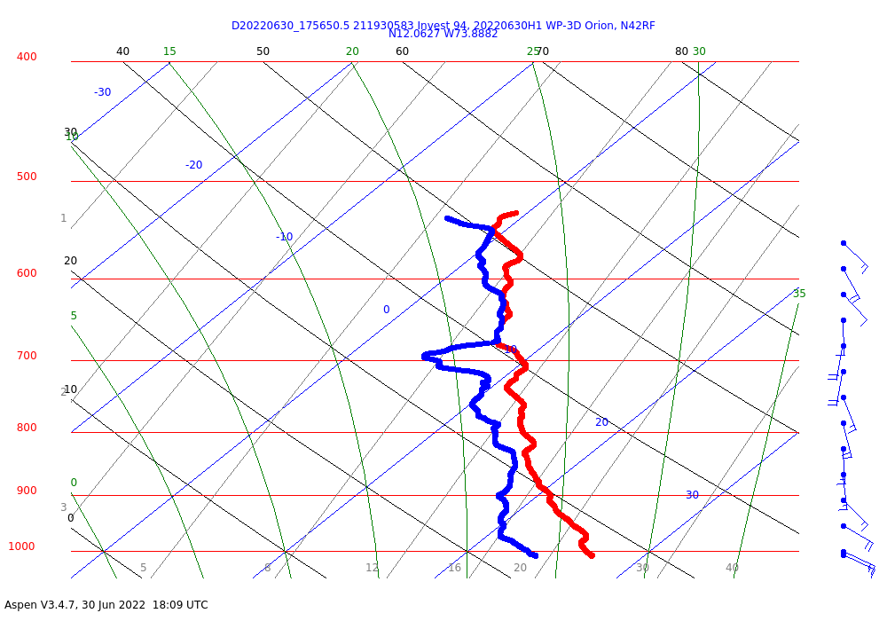
1814 | Drop 15 endpoint NE, final drop
1817 | 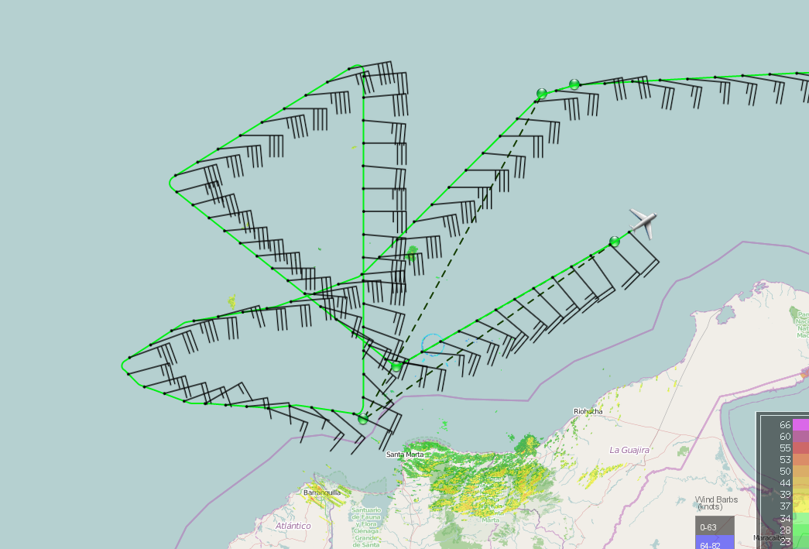
1821 | Skew-t at Drop 14…  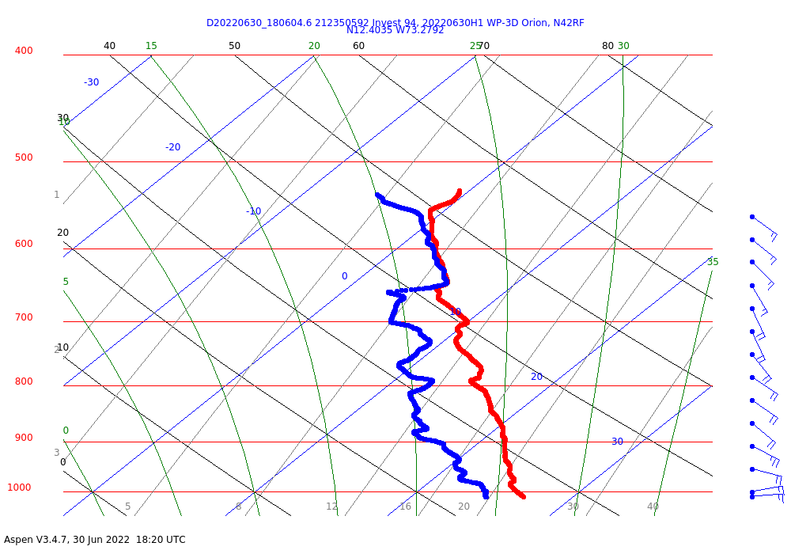
1825 | 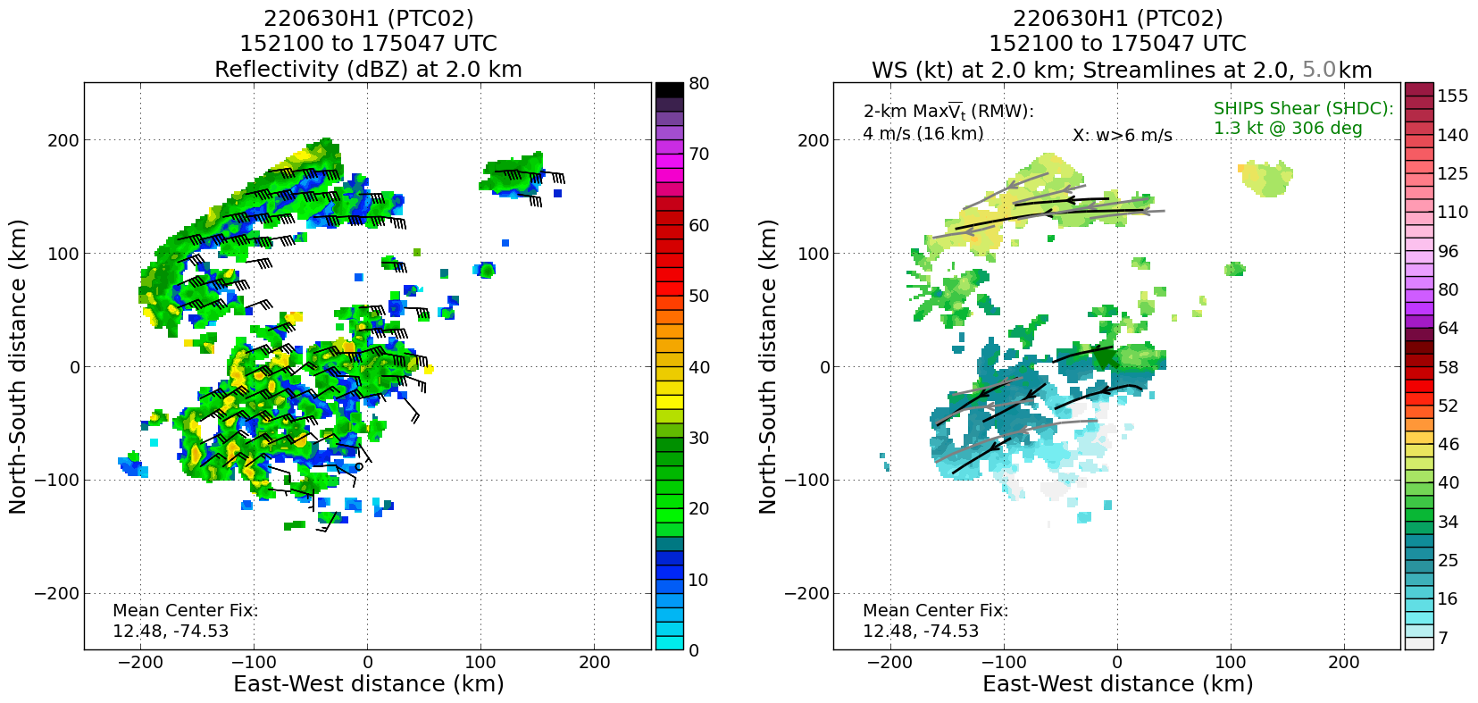  Final analysis: no clear circulation but there is a wave axis at 2 km  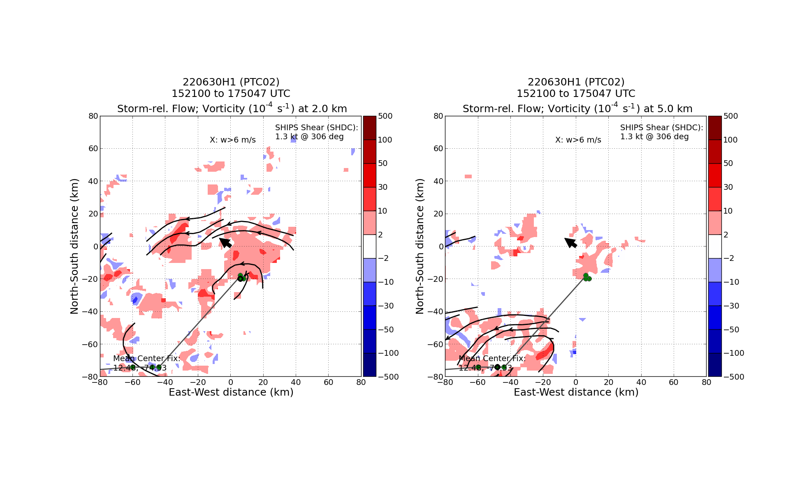  Not much data but definitely some vortex tilt. Mid-level circulation well SW of the apparent “LLC”.
1831 | Skew-t at Drop 15…  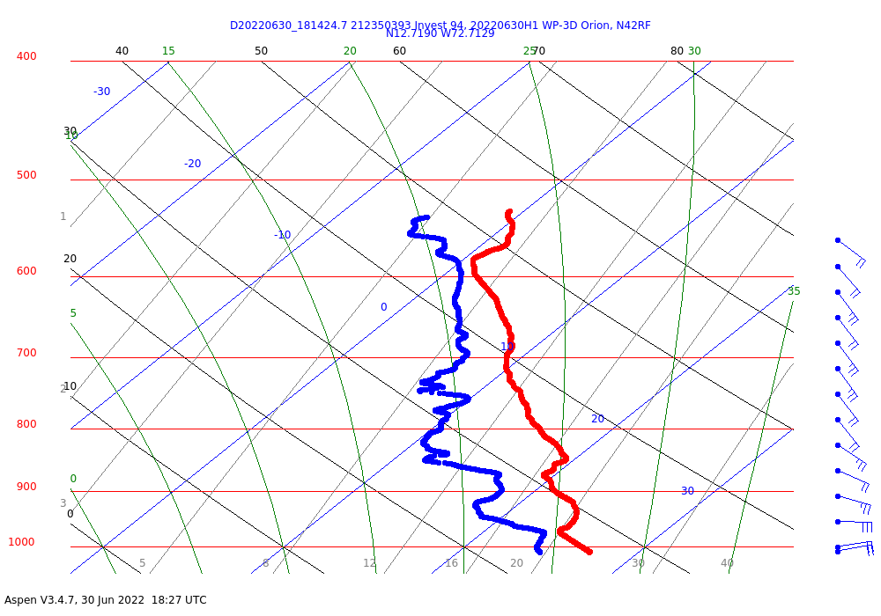
1838 | Synoptic Maps from the flight…  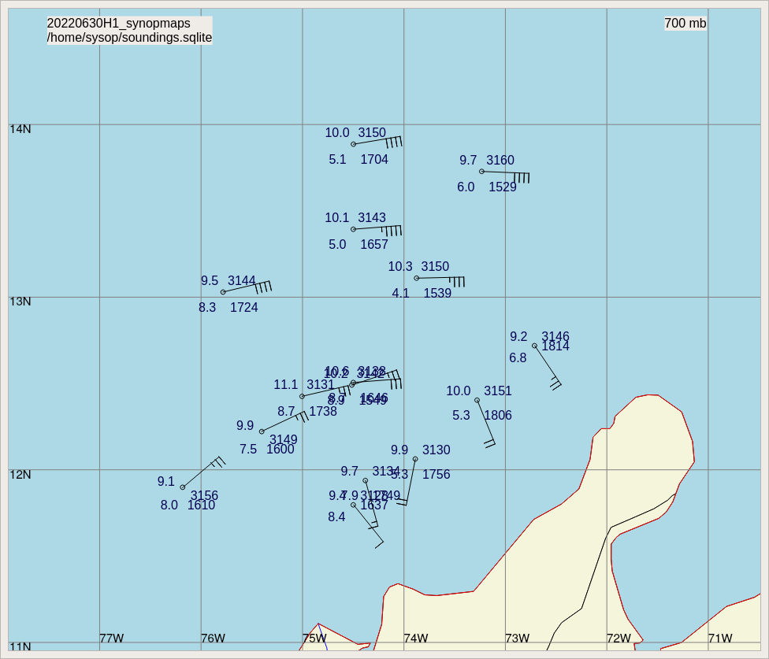  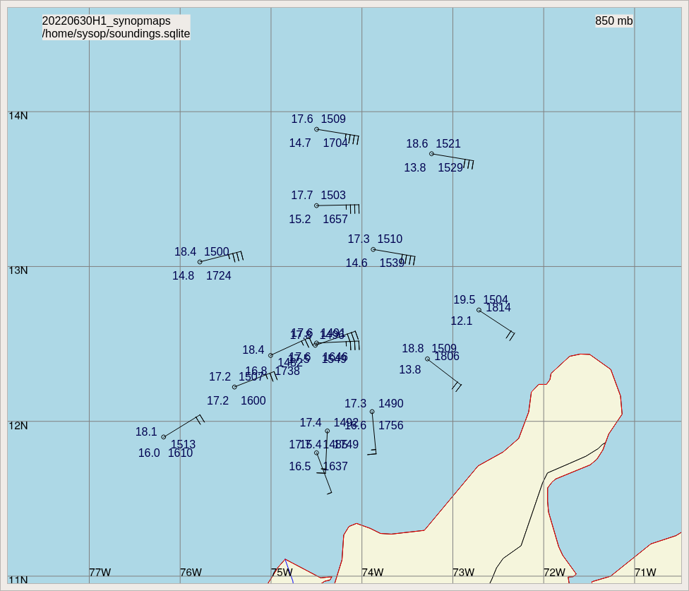  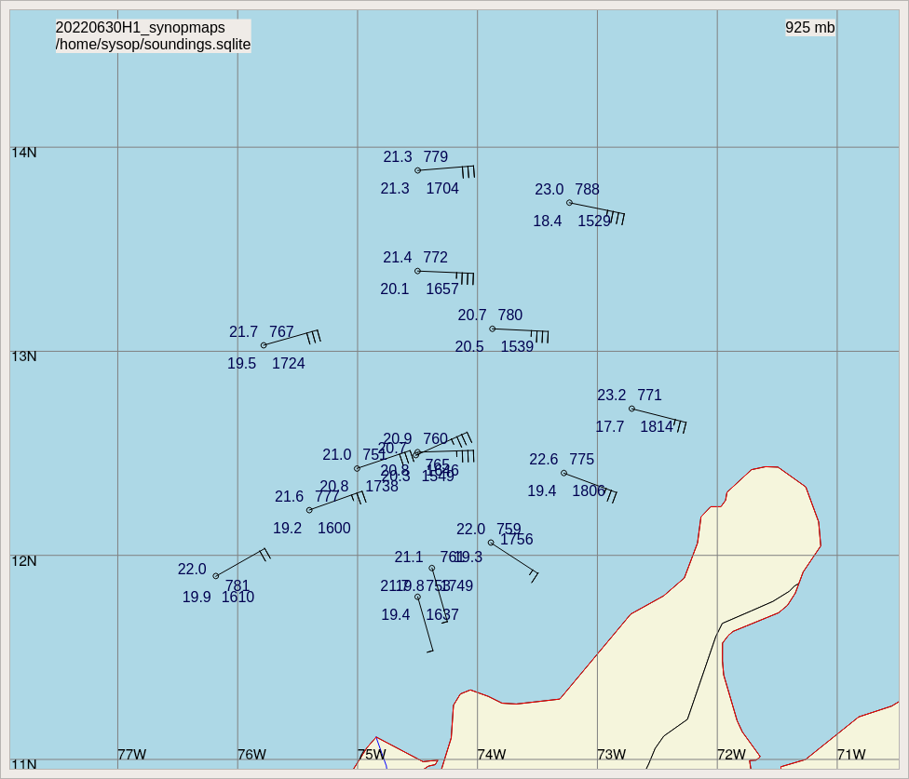  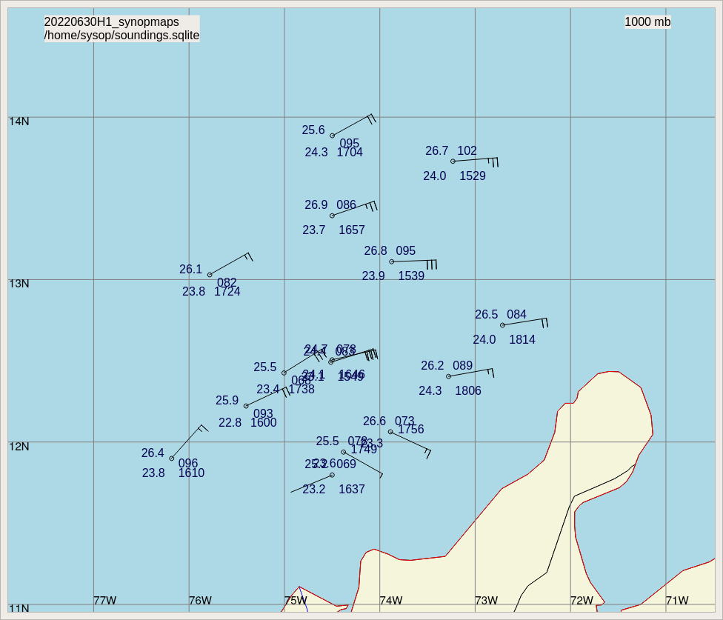  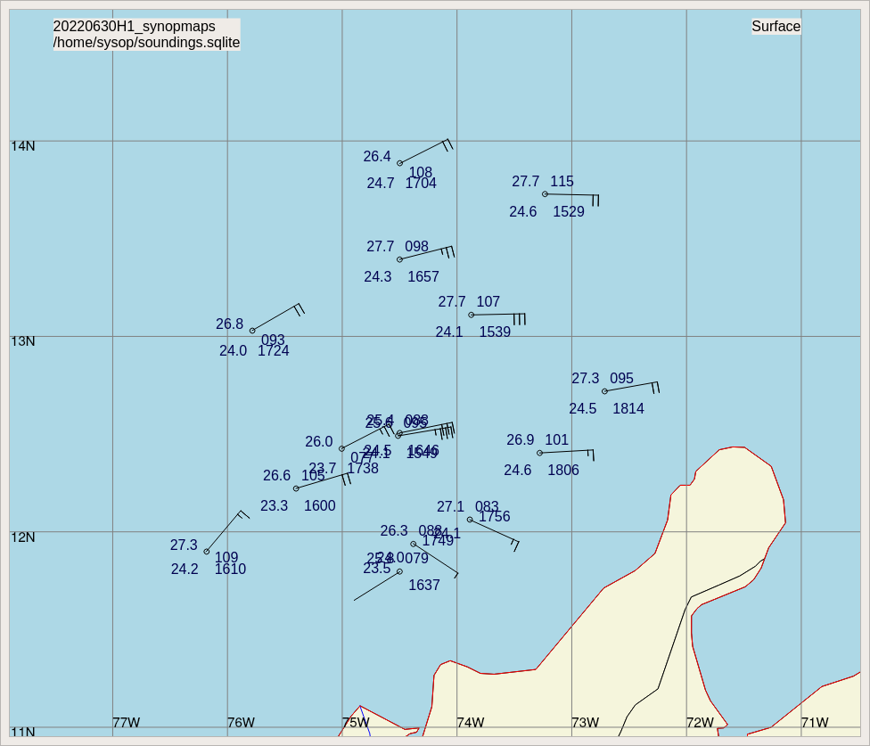
1926 | Post-mission satellite image  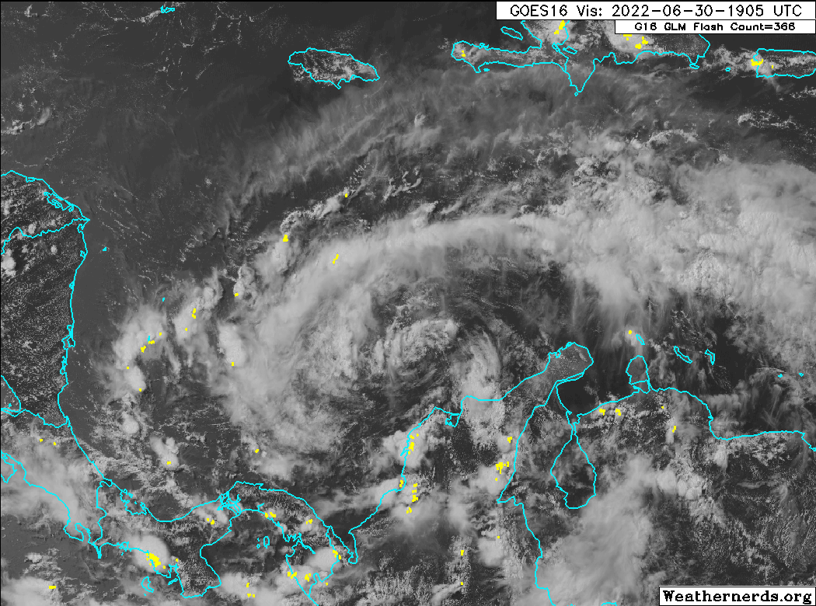
2000 | Landed back in St. Croix

POST-FLIGHT
Mission Summary | We flew a TDR mission (butterfly pattern) with some adjustments to legs on the south side due to land, and also some tweaks due to uncertainties in a possible center location.  There was some uncertainty with how to center the radar analysis, since the flight was at 17 kft and the low-level center was poorly defined.  Despite moving back over the warm water of the SW Caribbean, PTC2 continued to struggle to fire convection and fully close off the low-level center through the flight. TDR analyses suggested the presence of some vortex tilt, which was somewhat unexpected due to the lack of much deep-layer shear.  There was a low-level “swirl” sampled by the Air Force, and somewhat apparent in our Drop 12 with a slightly lower pressure and weak west wind, but neither their mission nor ours found a well-defined low-level circulation. Any circulation that does exist, based on the data, appears to be diffuse and quite shallow as neither the TDR or dropsondes from our mission indicate much circulation above about 1 km from the surface.  A total of 15 sondes were released, all good, all transmitted (all charged to NWS).
Actual Standard Pattern Flown | “Butterfly” with some modifications due to land.
APHEX Experiments / Modules Flown | Potentially good data for the Genesis Experiment: PREFORM, but with the lack of precipitation, the TDR data is rather thin. The dropsondes, though, being launched from a higher altitude does help add information on the structure that the TDR didn’t get with the lack of scatterers.
Plain Language Summary | - We flew a TDR mission collecting data in PTC2, data that will be ingested into numerical models to hopefully improve the representation of the storm and the forecast before it makes landfall in Central America.  - The system was still not very organized as it moved off of South America, with only some evidence of a weak, diffuse, shallow circulation near the surface.
Instrument Notes | WSRA was running, CRL was not
Final Mission Track | 