MISSION PLAN
FLIGHT ID | 20220629H1 | STORM | AL94 / PTC02
MISSION ID | 0402A | TAIL NUMBER | NOAA42
TASKING | EMC | PLANNED PATTERN | Lawnmower
MISSION SUMMARY
TAKEOFF [UTC] | 1453 | LANDING [UTC] | 2101
TAKEOFF LOCATION | St. Croix | LANDING LOCATION | St. Croix
FLIGHT TIME | 6.1 | BLOCK TIME | 6.3
TOTAL REAL-TIME RADAR ANALYSES  (Transmitted) | 3 (3) | TOTAL DROPSONDES (Good/Transmitted) | 15 (15/15)
OCEAN EXPENDABLES (Type) | None | sUAS (Type) | None
APHEX EXPERIMENTS / MODULES | Genesis Experiment: PREFORM
HRD CREW MANIFEST
LPS ONBOARD | Zawislak | LPS GROUND | Rogers
TDR ONBOARD | Zawislak | TDR GROUND | Gamache / Reasor
ASPEN ONBOARD | Zawislak | ASPEN GROUND | Henning
NESDIS SCIENTISTS | None
GUESTS (Affiliation) | None
AOC CREW MANIFEST
PILOTS | Abitbol, Copare, Rannenberg
NAVIGATOR | Hough
FLIGHT ENGINEERS | Darby, Stokes, Gee
FLIGHT DIRECTOR | Holmes, Kalen
DATA TECHNICIAN | McAlister
AVAPS | Hartberger

PRE-FLIGHT
Flight Plan | 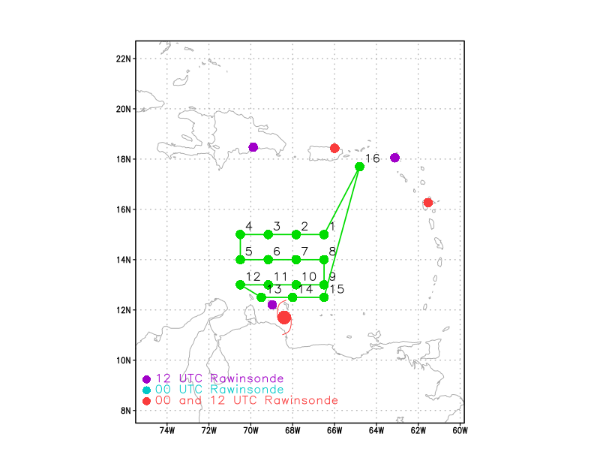  Lawnmower pattern flown at 17-18 kft, when possible given hazardous weather avoidance (likely only on the first and second legs of the lawnmower), then otherwise 10 kft.
Expendable Distribution | Release a dropsonde at each of the green points in the planned flight track
Preflight Weather Briefing | PTC02 has yet to be upgraded to a tropical storm, though there are tropical storm winds within the storm. It appears to be moving faster than expected, estimated moving west at 26 kt. It may be that the high translation speed may be limiting further development of the storm. The satellite picture at least presents curvature in the cloud field, though the convection appears to also be weakening as we head into the minimum of the diurnal cycle.  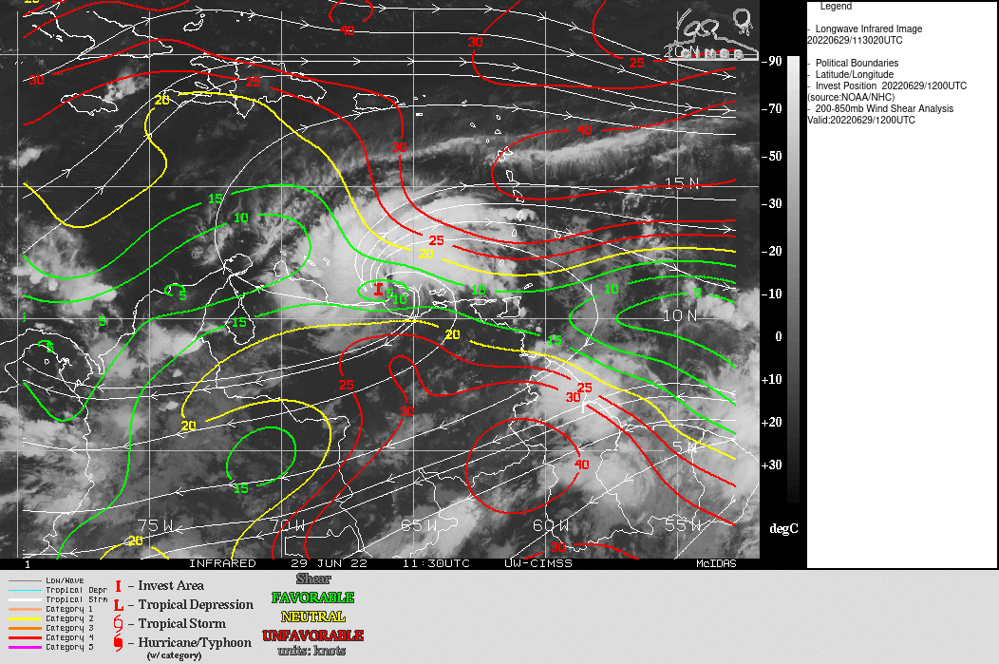
Instrument Notes | Will attempt a software upgrade on WSRA to make it operational; CRL not operational. There will be a test of the EDIS ground dropsonde transmission system by AOC using the last 4 points.

IN-FLIGHT
Time [UTC] | Event
1453 | Takeoff from St. Croix
1503 | IR presentation shows generally linear organization, but with a region of cold cloud tops in center. Possible MLC there? The mission will be operating during the diurnal minimum, so coverage of convection may be limited during the mission.
1531 | Approaching NE point; MMR indicates precip about 35 n mi south. Looks like scattered cells for now
1533 | At NE IP, Sonde #1 away at PTq. Cellular precipitation to the S of the aircraft, about 20-30 n mi away.
1542 | 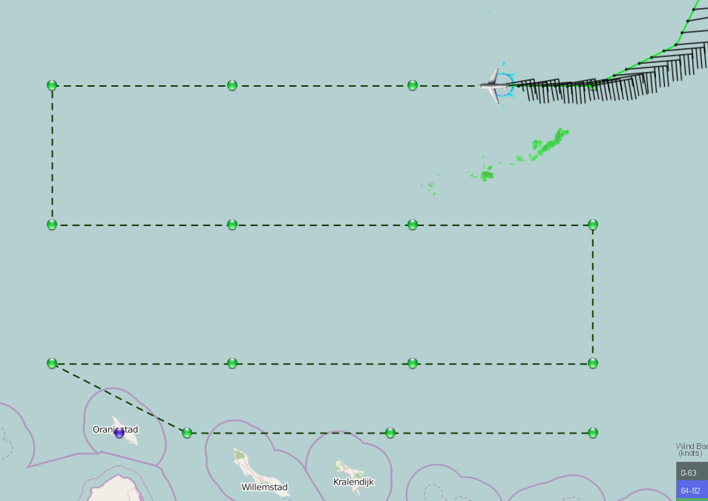
1546 | Visible animation shows curvature likely in the midlevels. Hard to see any closed (earth-relative) circulation, except maybe at the Venezuelan coast. Aircraft will not get to sample down there. System is translating so fast, though, that a closed circulation probably still is not present. Little to no lightning, except in the extreme eastern portions of the cloud shield.
1548 | Drop 2 at PT2
1558 | WSRA is up and running
1602 | Drop 3 at PT3
1609 | Skew-t for drop at PT1…  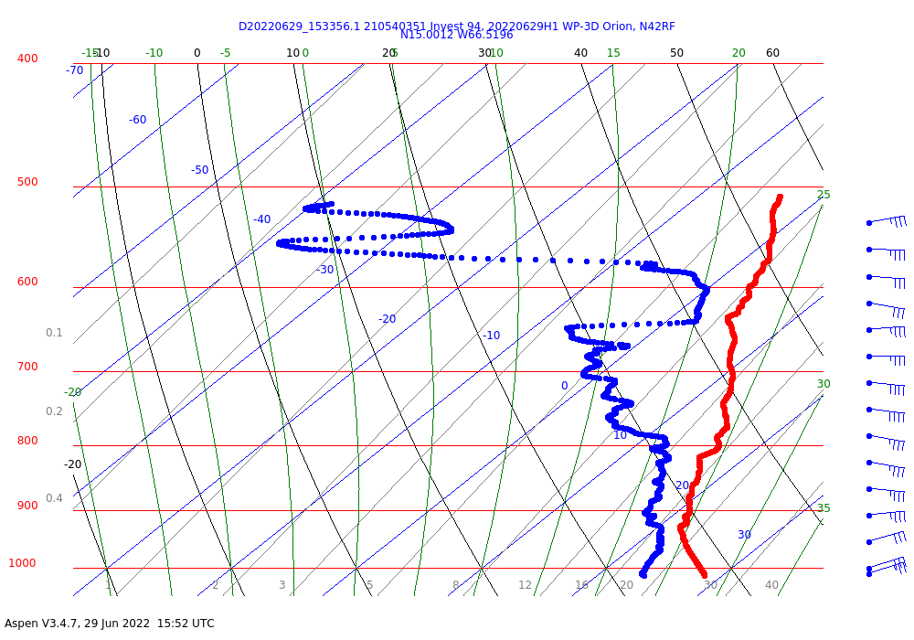
1610 | Skew-t for drop at PT2…  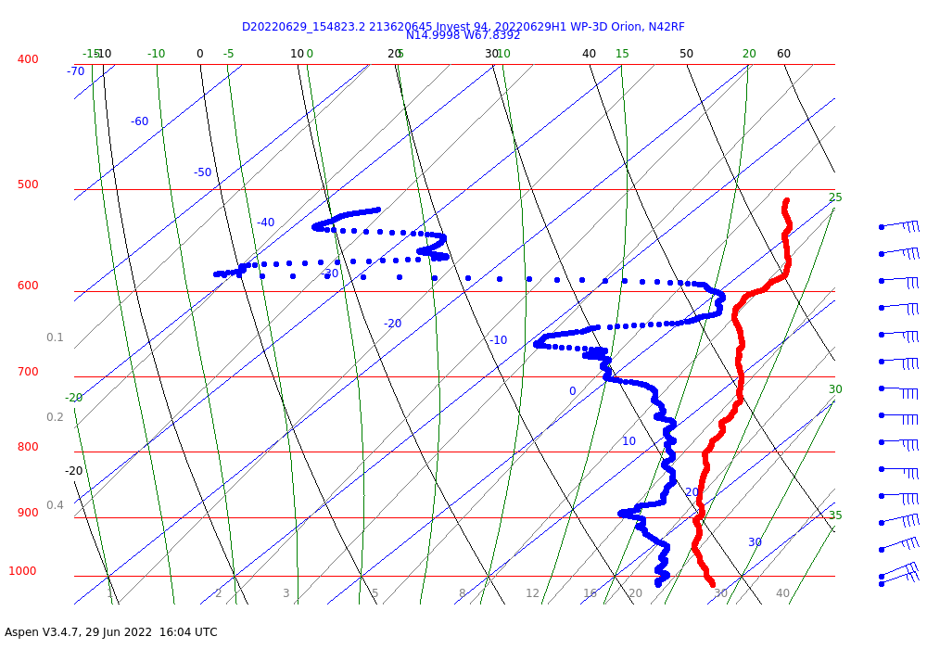  Both sondes show strong (40 kt) easterlies to the north of the system center. Decent moisture below 700 hPa, but becomes quite dry above that. That suggests significant entrainment of dry air in any convection that develops here.
1617 | Drop #4 at PT4 away
1620 | Skew-t for drop at PT3…  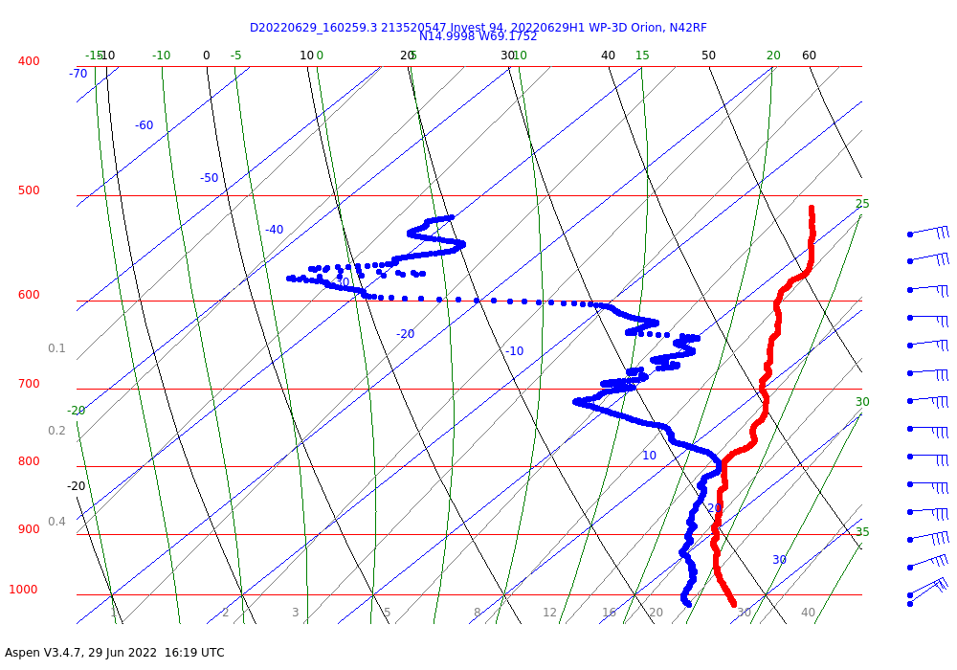
1228 | Drop 5 at PT5 away
1630 | 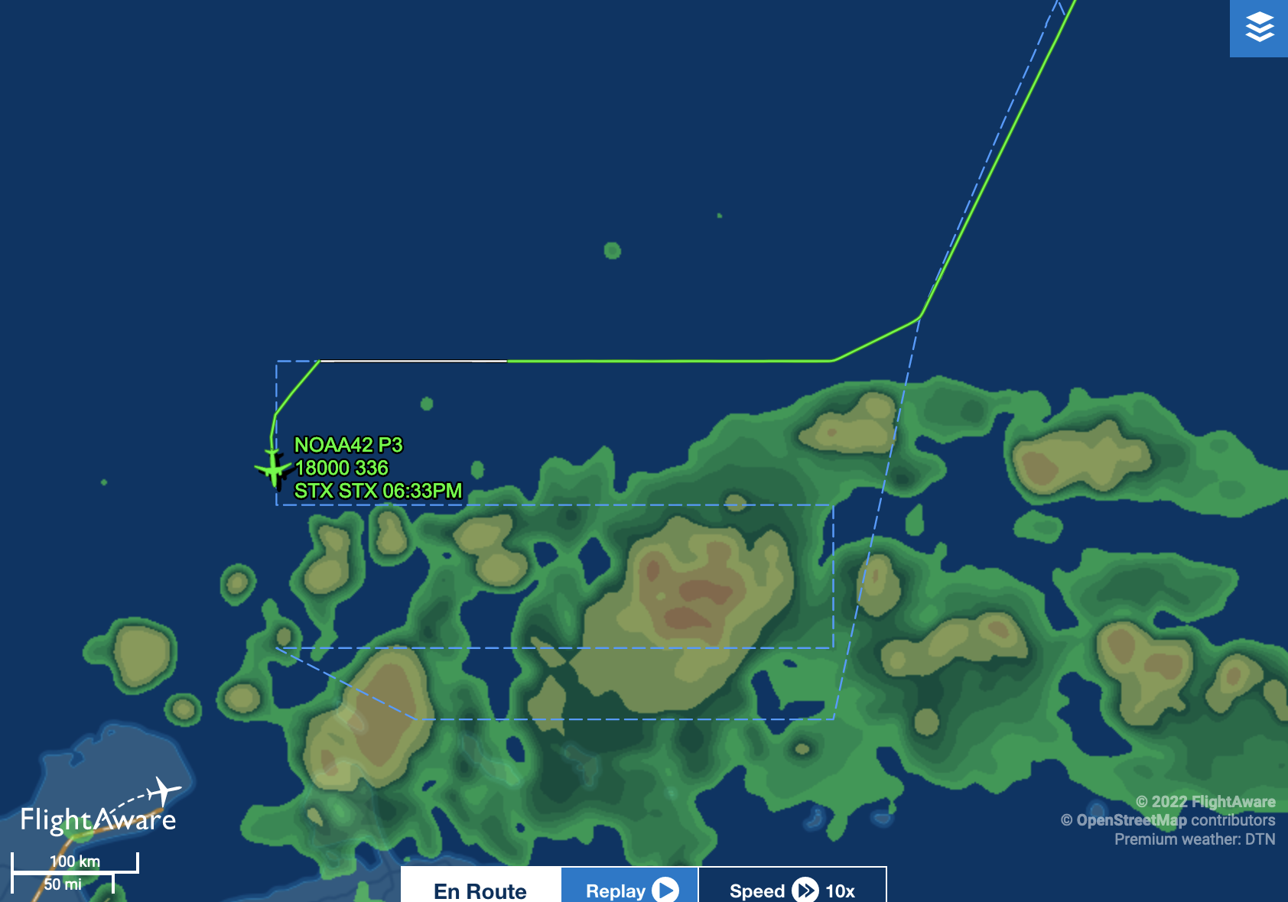  Aircraft beginning to the east, about 0.1 degrees north of planned latitude so that it can maintain altitude of 17 kft. Combination of radar and satellite image from Flight Aware shows significant precipitation along this west-east track. Should get good TDR coverage.
1633 | Skew-t for drop at PT4…  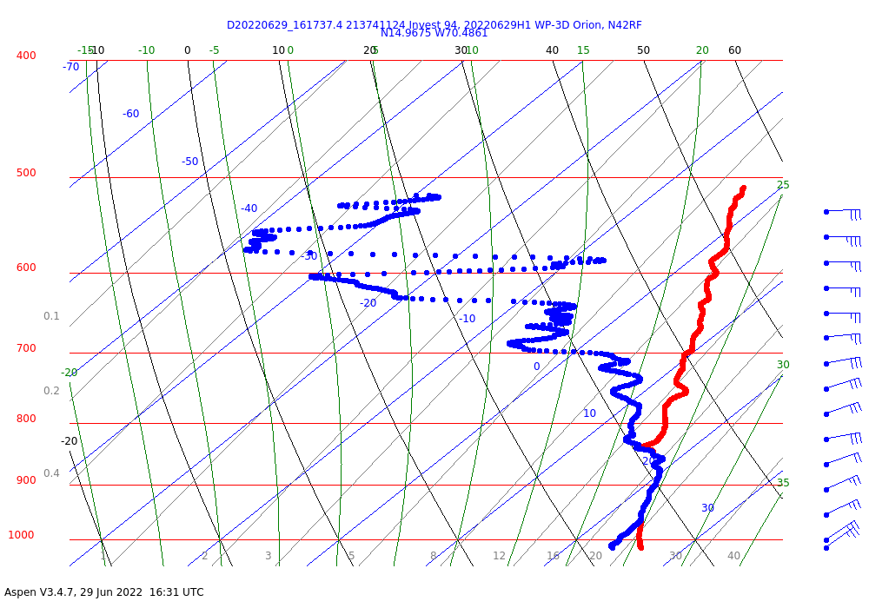  Air even drier above 700 hPa here on NW side of pattern
1635 | 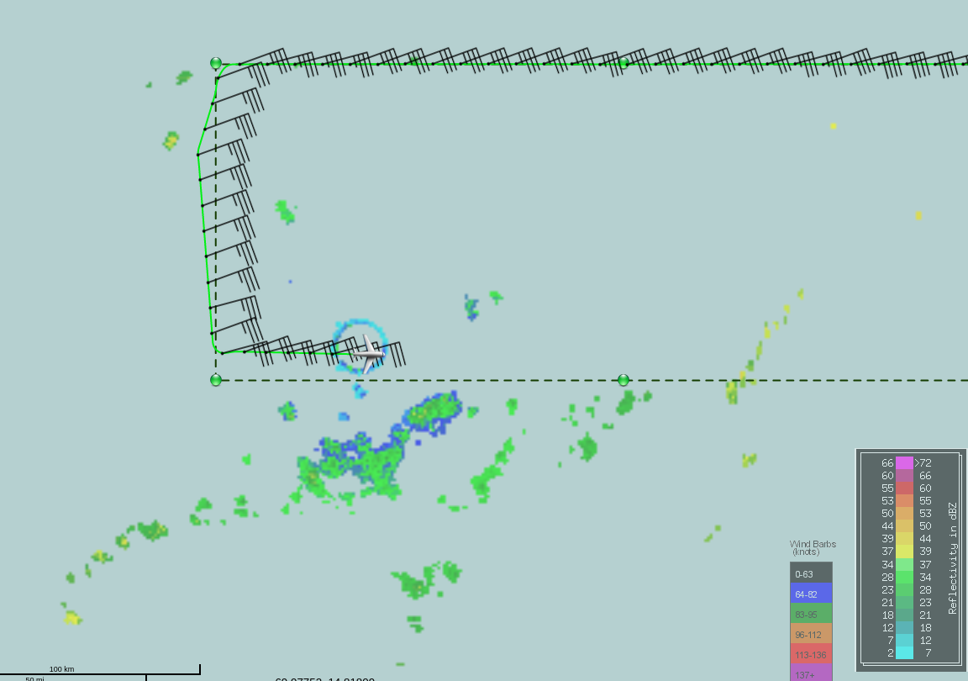  MMR image shows precipitation somewhat consistent with Flight Aware image above, but the precipitation is spottier, possibly because of the nature of the Flight Aware algorithm (blend of satellite and radar). Strong easterlies at flight-level (18 kft).
1644 | Skew-t for drop at PT5…  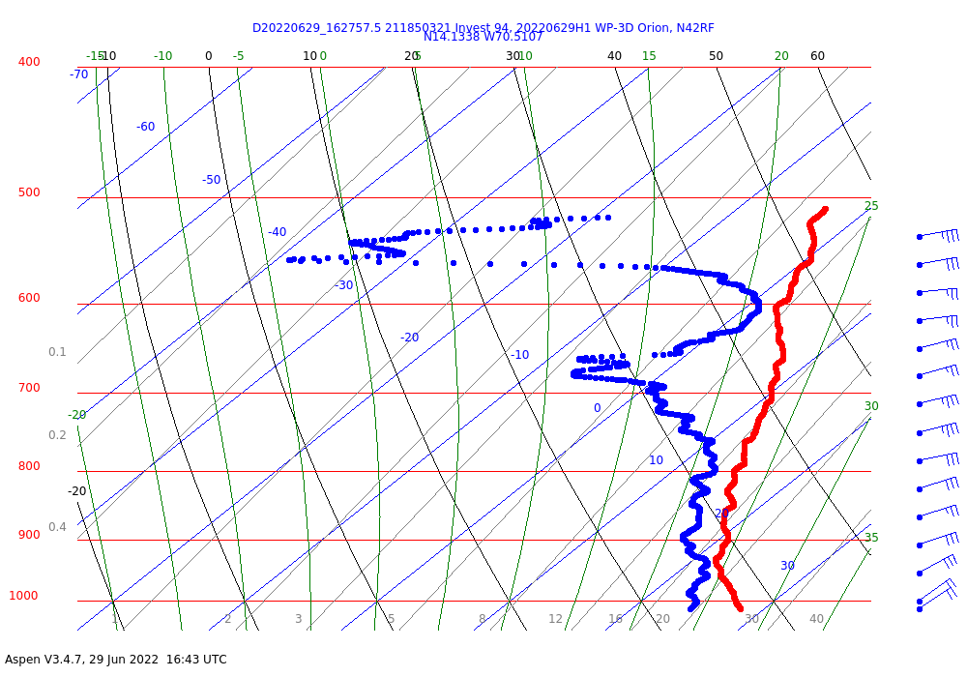
1647 | Deviating to avoid some convective cells  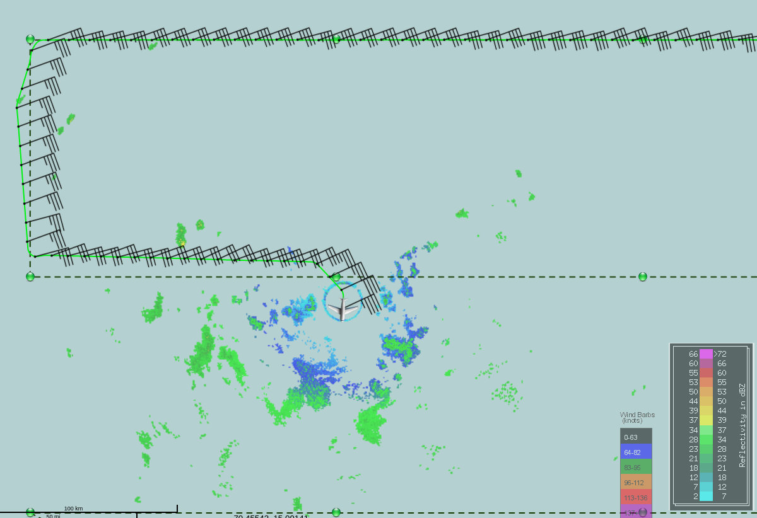  20 dBZ echo tops from TDR estimated at 10-15 km, which would classify as deep convection. Looks like a nice leading edge/trailing stratiform region, with leading edge on the west side.
1658 | 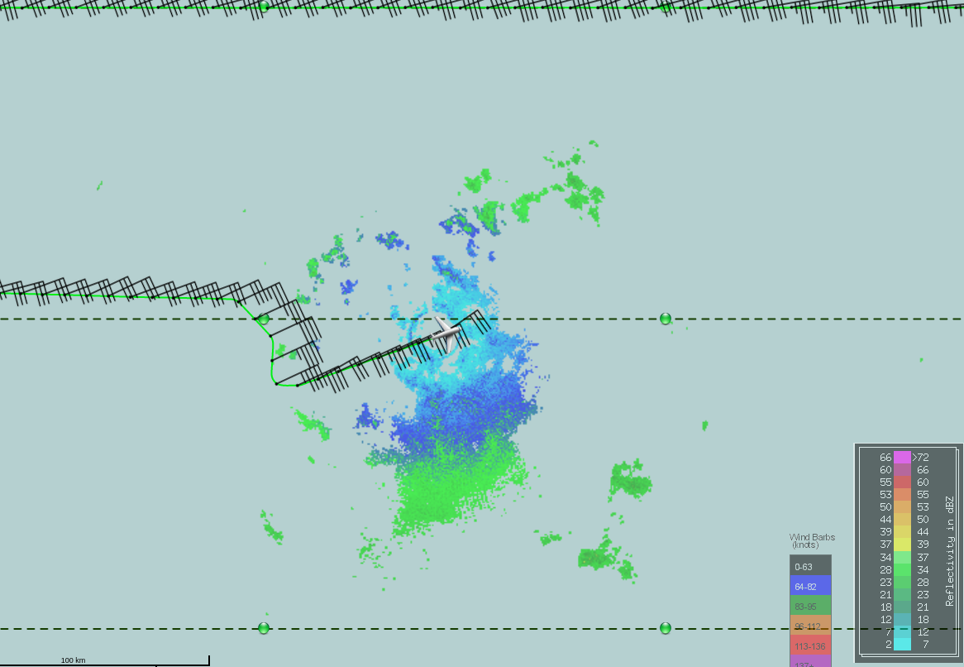
1702 | Skew-t for drop at PT6…  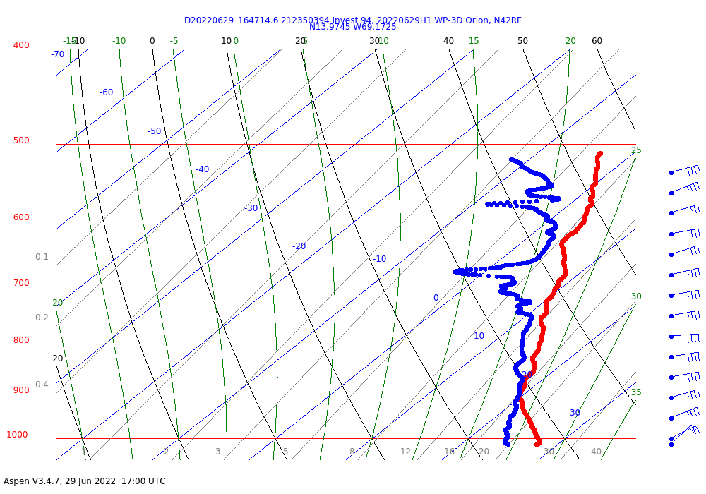  More moist environment here, further south and closer to the center of the midlevel trough axis
1709 | Drop 7 at PT7
1726 | Moving the third leg (east to west) north to 13.25N to maintain TDR swath separation
1726 | Skew-t for drop at PT7…  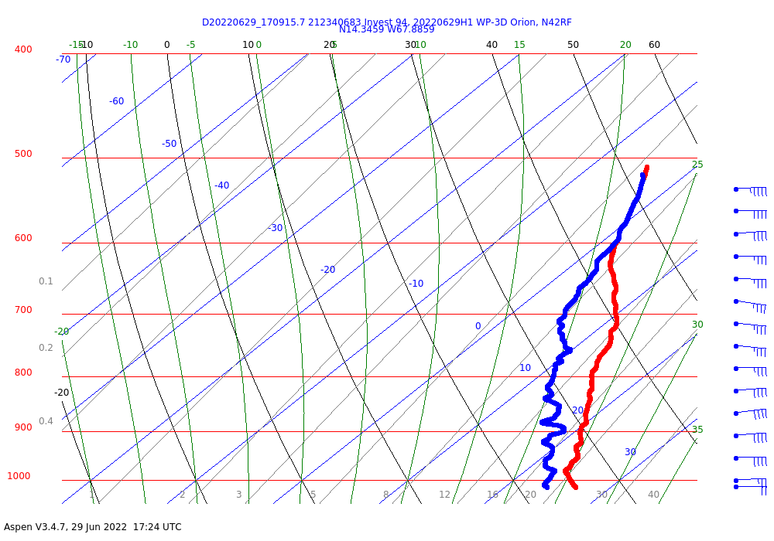
1729 | About to reach PT8, turn south and descend for the next leg  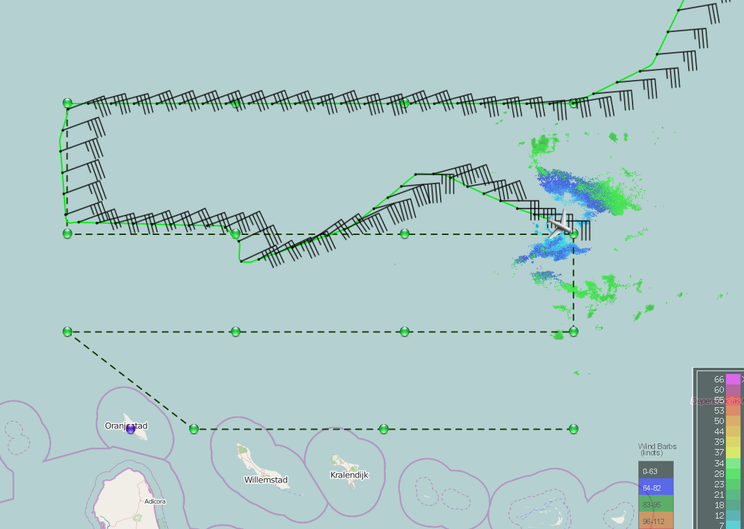
1736 | Visible animation shows a linear convective feature, what looks to be a midlevel circulation (at least in a Lagrangian sense) at the W and SW tip of the convective feature. Some hints of precipitation racing ahead of a trailing region of vorticity, altitude of vorticity maximum unknown.
1737 | 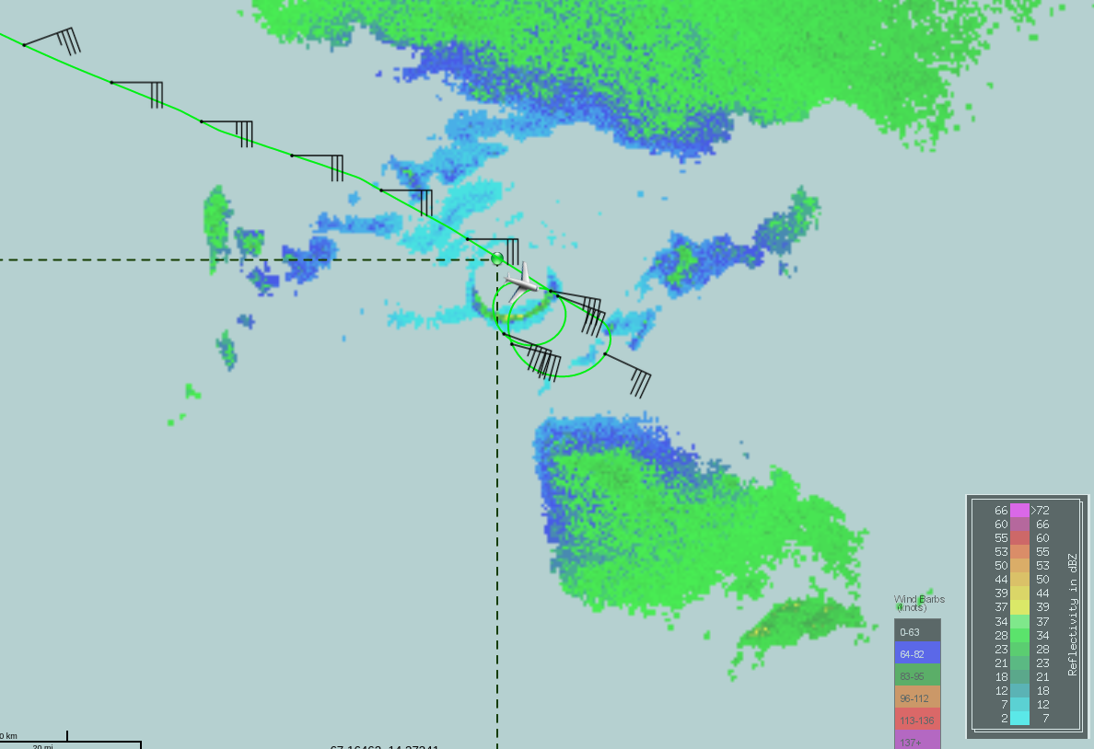  Spiral descent from 18kft to 10 kft, through light precipitation just outside stratiform precipitation
1746 | Skew-t for drop at PT8…  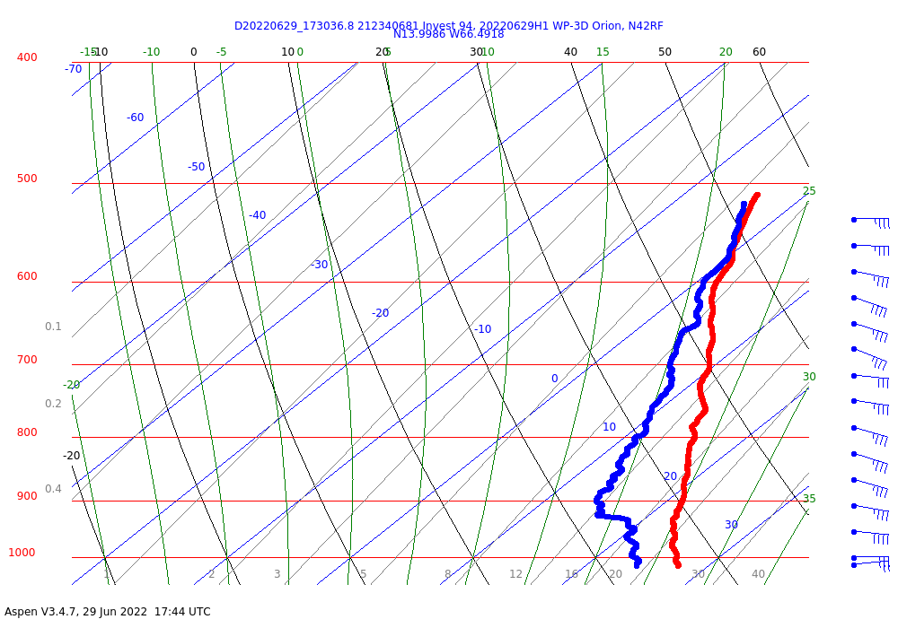  Skew-T suggests some subsidence in the lower troposphere, consistent with presence of stratiform anvil that aircraft was flying through in that eastern part of the pattern. The visible satellite animation was also showing this leading convective line wrapping from the east around to the northwest and west side of the system, with possible stratiform anvil trailing to the east of that line on the west side. Circulation suggested in that stratiform region as well. Will be interesting to look at TDR analysis to see if any type of circulation is evident.
1748 | On our way down to PT9 for the next east to west leg. Now at 10 kft.  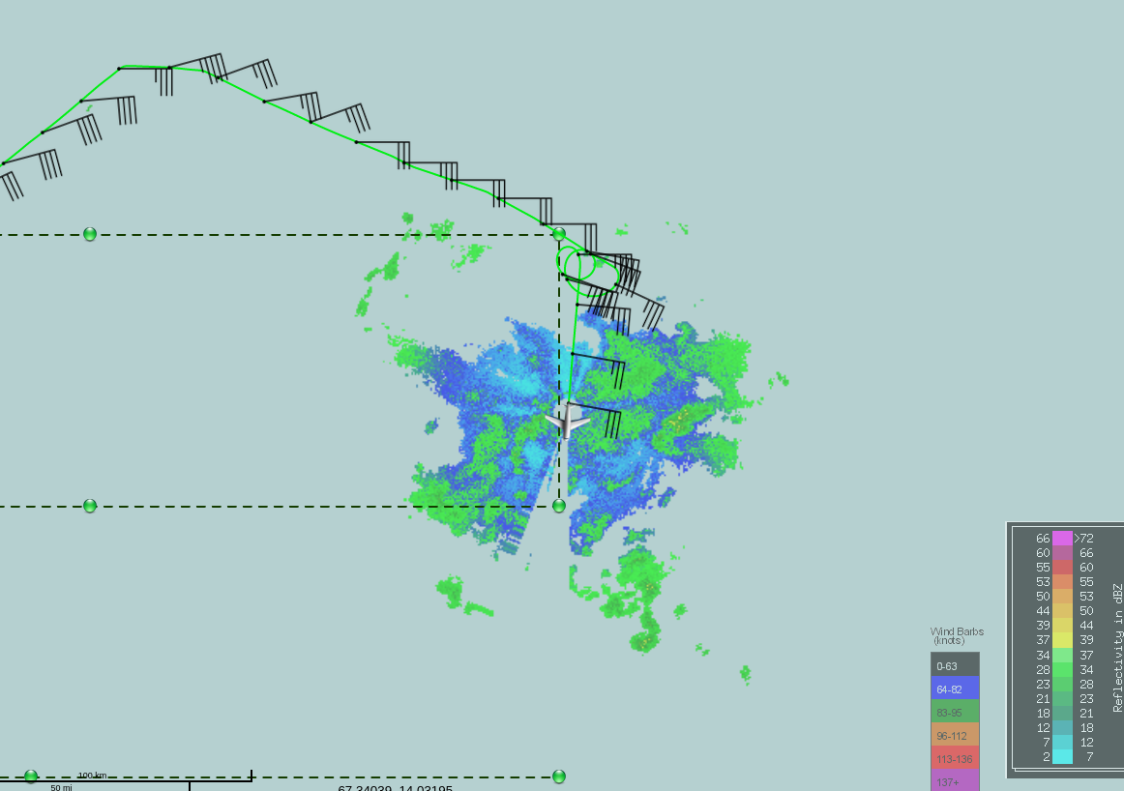
1751 | Drop 9 at PT9
1802 | Skew-t for drop at PT9…  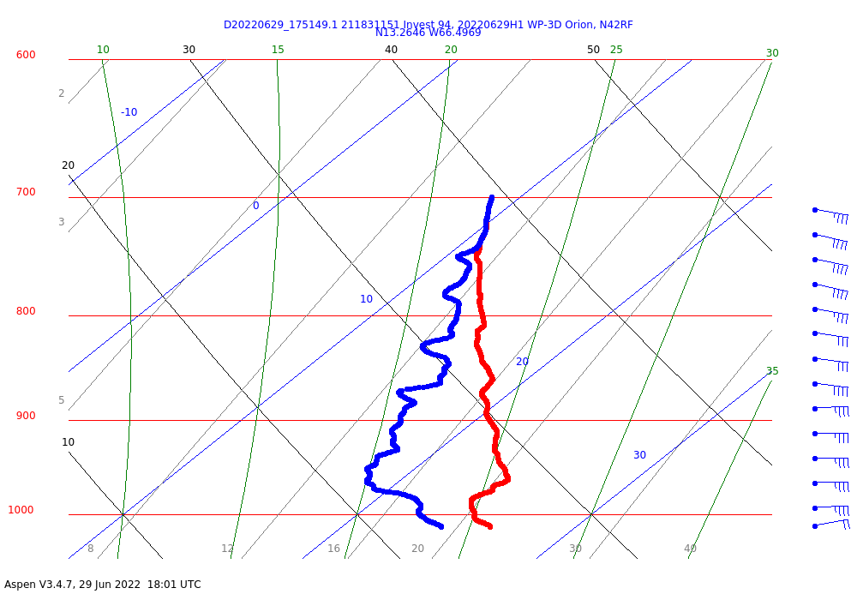  Even clearer indication of lower-tropospheric subsidence
1806 | 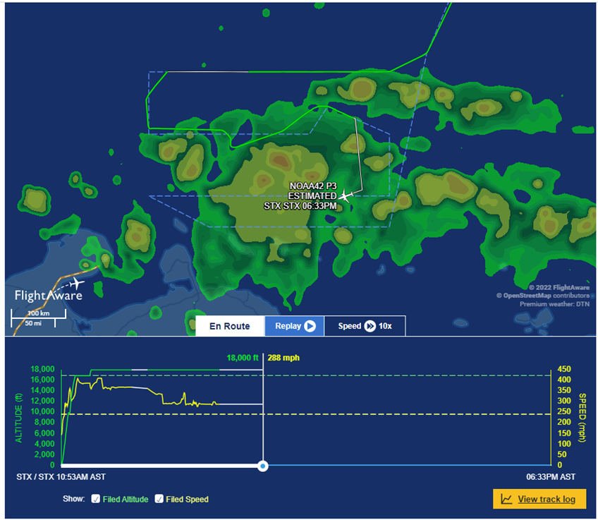  Flight aware image at 1806 shows the aircraft appears to be nearly encircling a broad region of high reflectivity (stratiform precipitation?)
1808 | 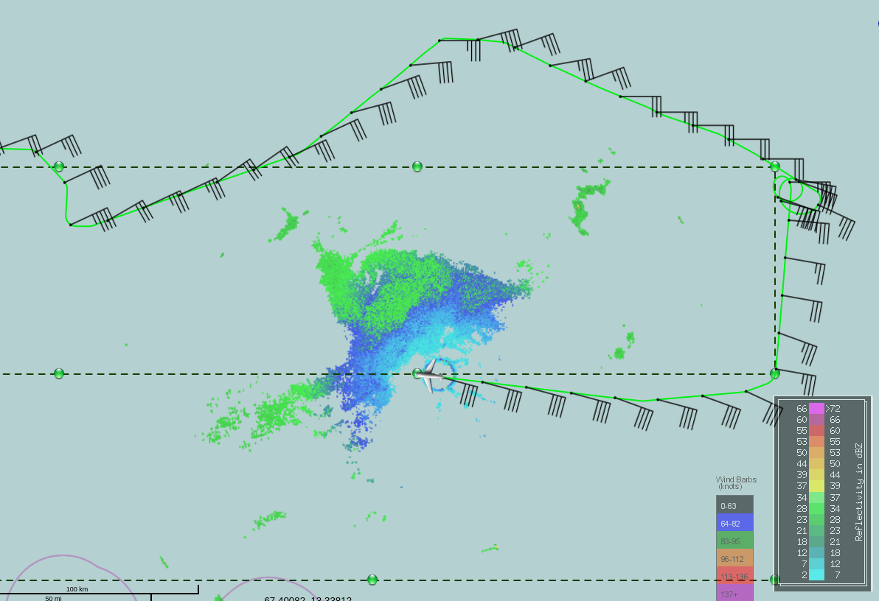
1808 | Drop 10 at PT10
1814 | 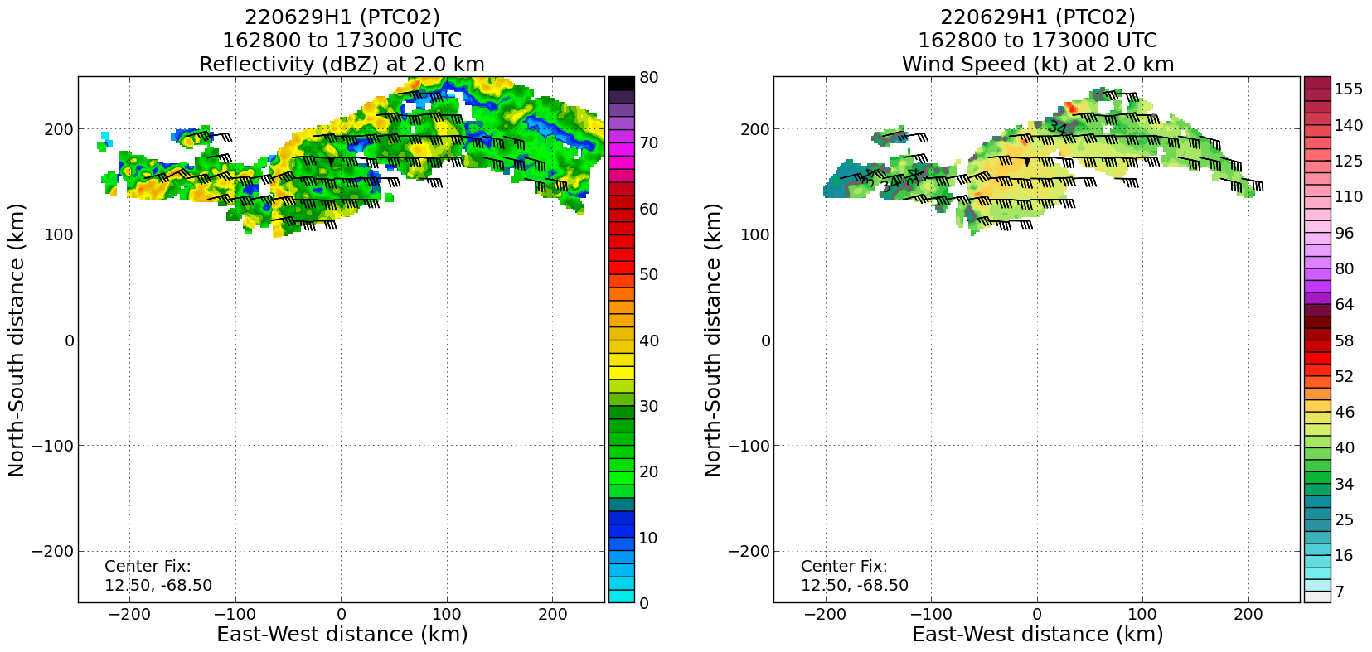  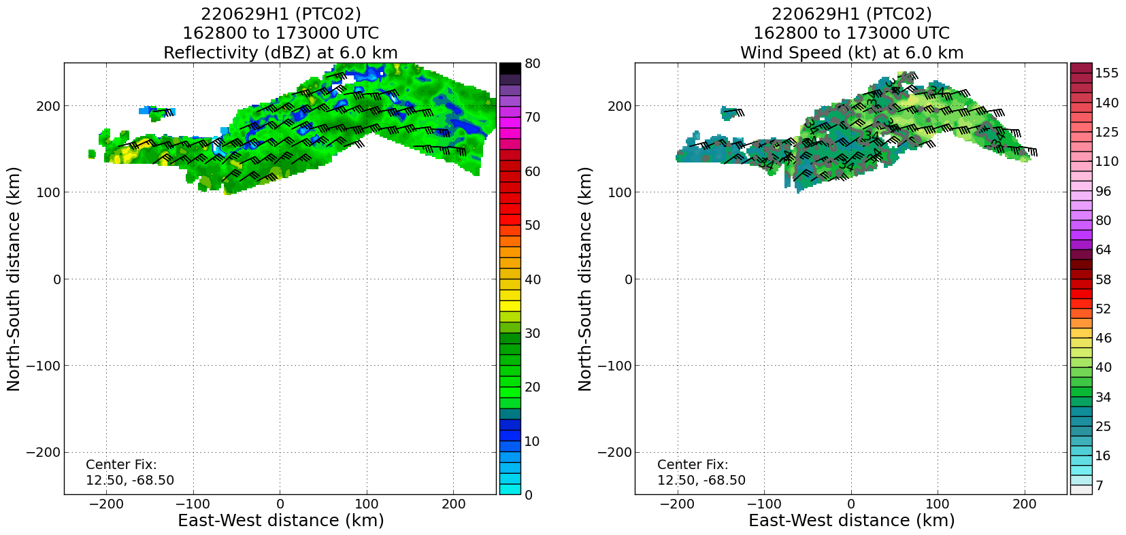  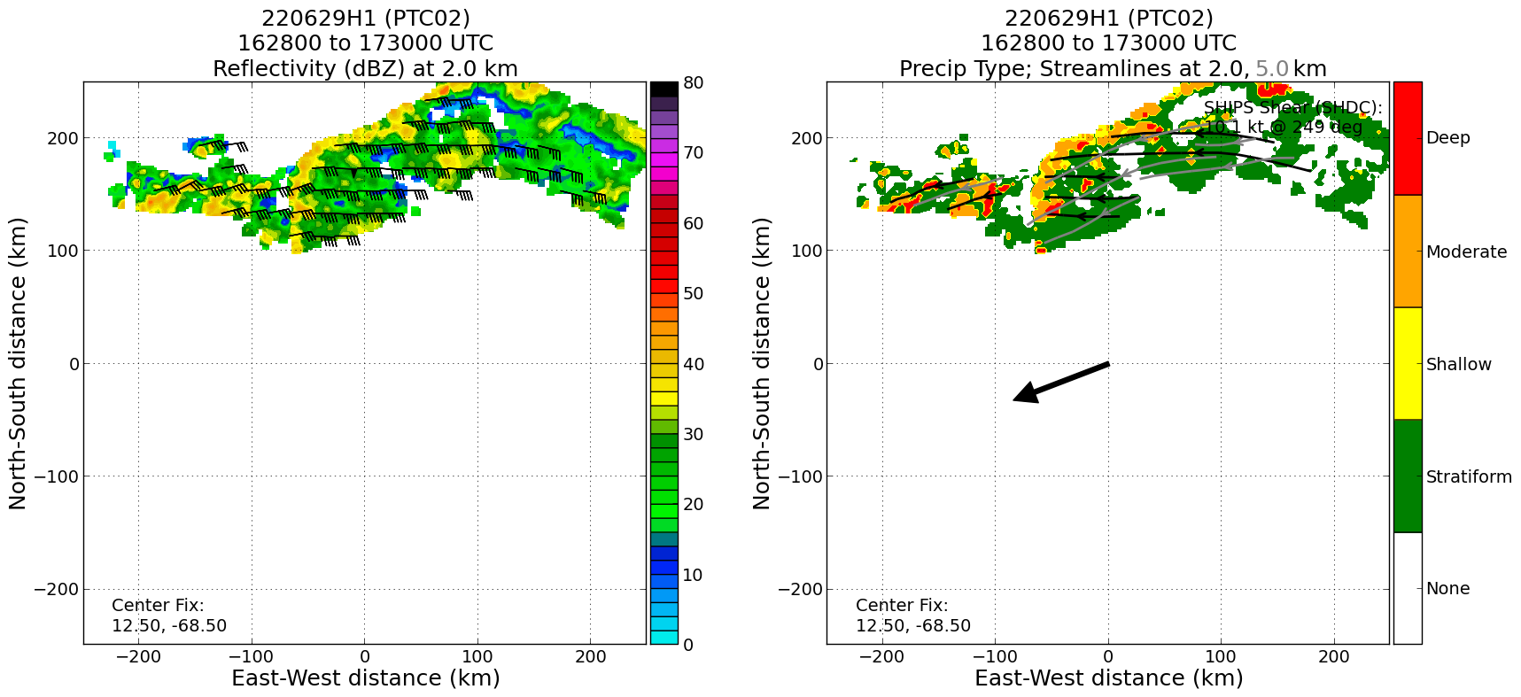  Real-time radar analyses from first west-east pass shown here (top row reflectivity and wind speed at 2 km; middle row reflectivity and wind speed at 6 km; bottom row reflectivity at 2 km and precipitation mode) show strong easterly flow in western edge of analysis, with winds near 50 kt there. No real indication of any circulation at either altitude. Precipitation mode shows line of deep and moderate convection along the western and northern boundaries of the analysis, and stratiform precipitation along the eastern and southern boundaries. The presence of the stratiform precipitation is consistent with the lower-tropospheric subsidence seen in drops #8 and 9 and also with visible animation shown above.
1816 | 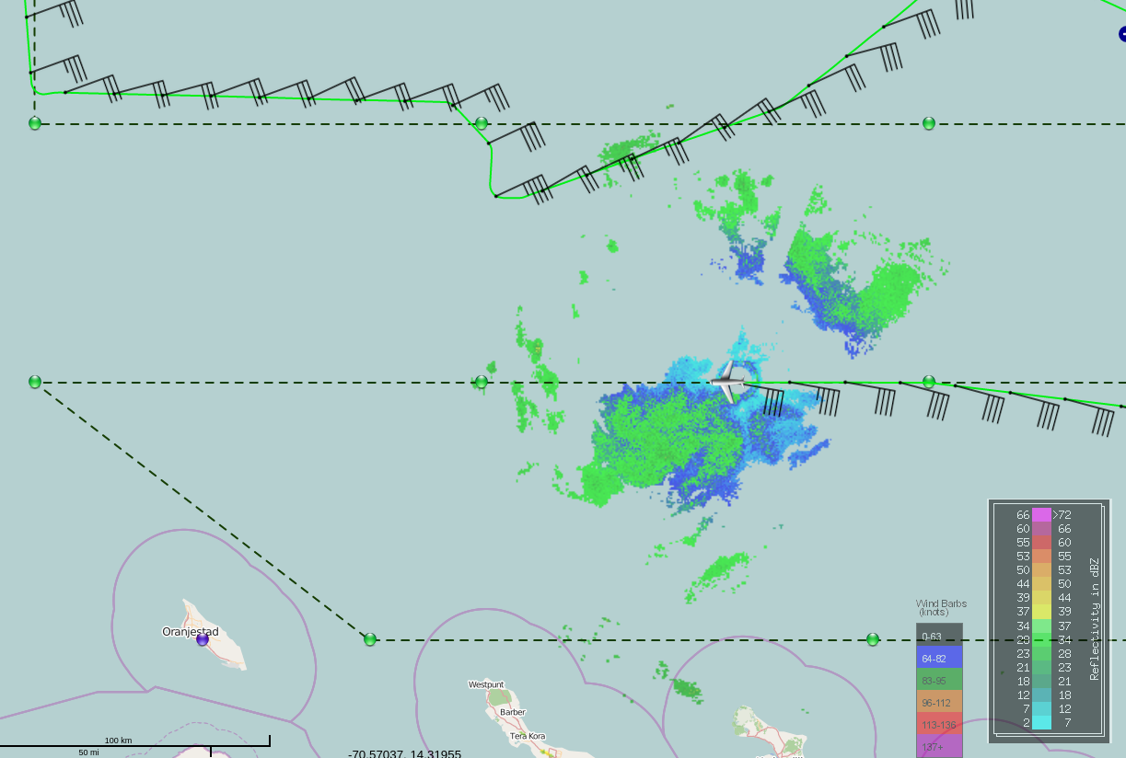
1822 | Skew-t for drop at PT10…  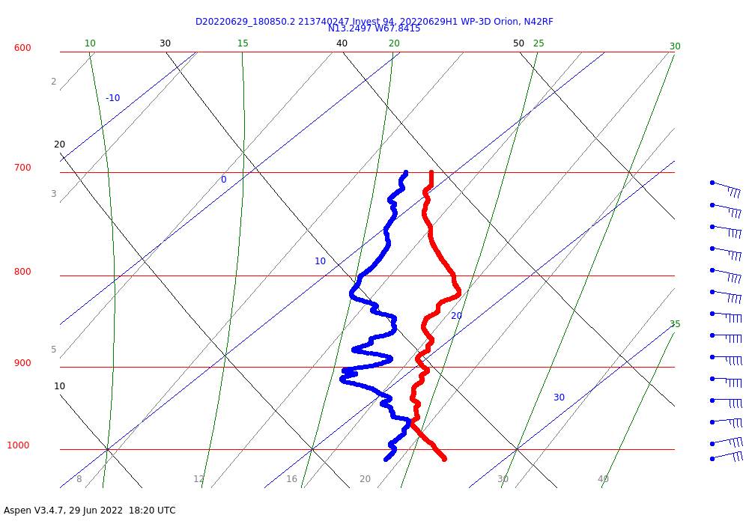
1827 | Drop 11 at PT11
1829 | 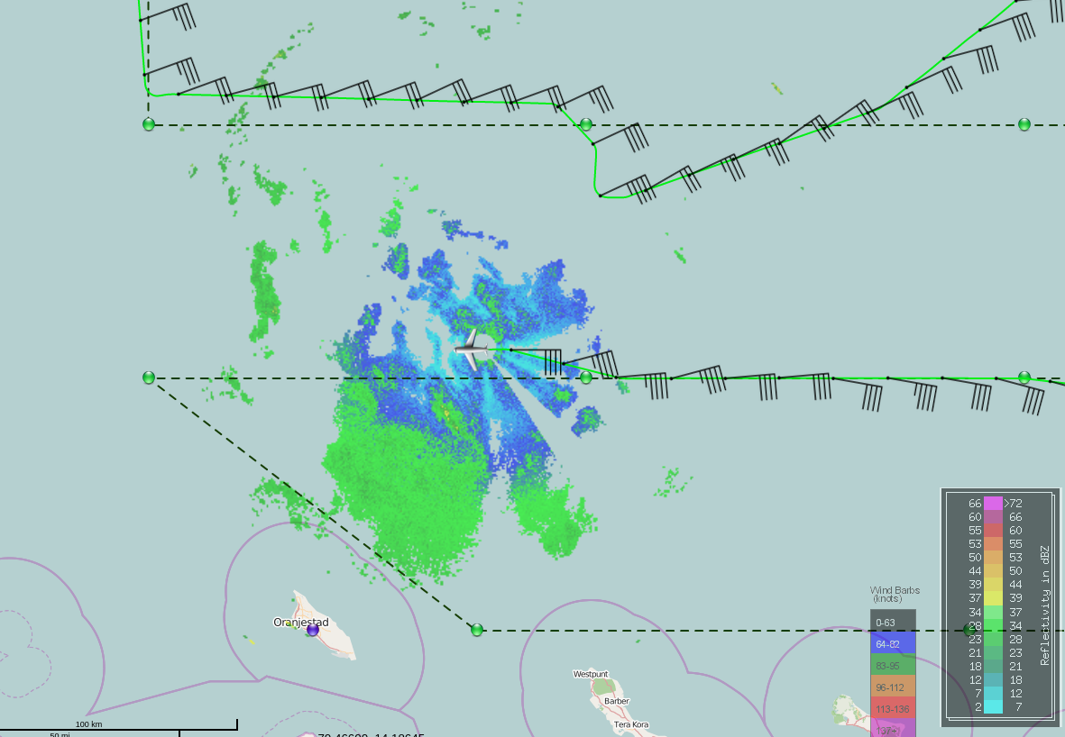
1837 | Skew-t for drop at PT11…  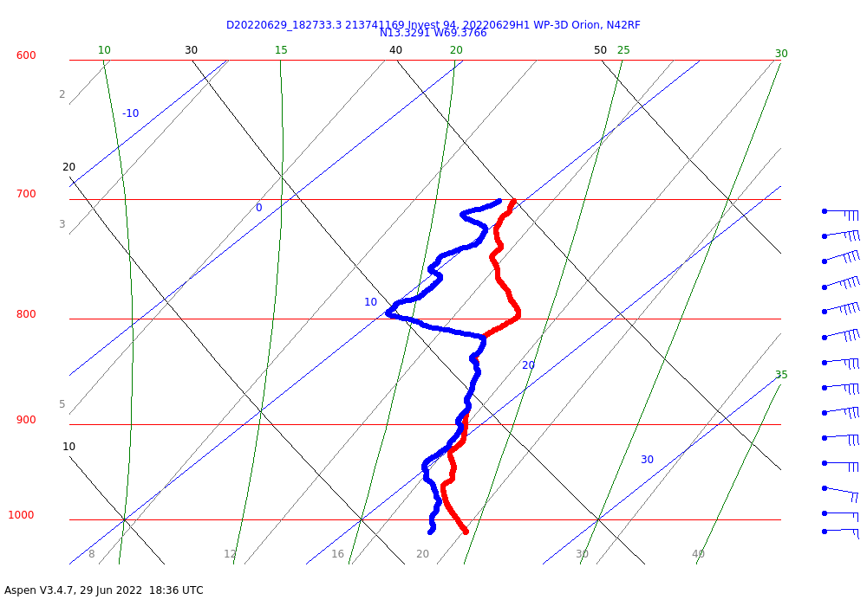  This drop is approaching the leading edge of the convective line seen in the satellite imagery and the precipitation mode analysis from the TDR. There remains a fairly shallow subsident layer above 800 hPa, but below that much of the profile is a nearly saturated moist adiabat. Classic signature of an “onion” sounding commonly-seen in stratiform precipitation, with possible PBL recovery below that as the area of convection is approached from the east.
1841 | Drop 12 launched at PT12
1853 | Skew-t for drop at PT12…AOC ground is now taking over the transmission, but onboard scientist will continue to run through ASPEN as a backup.  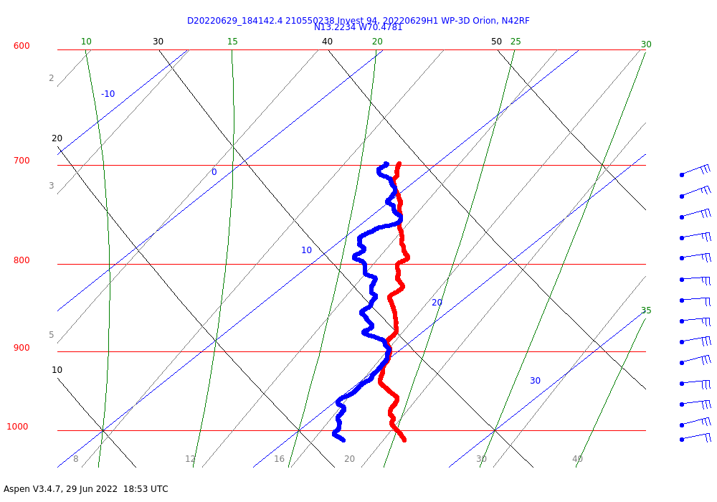
1855 | 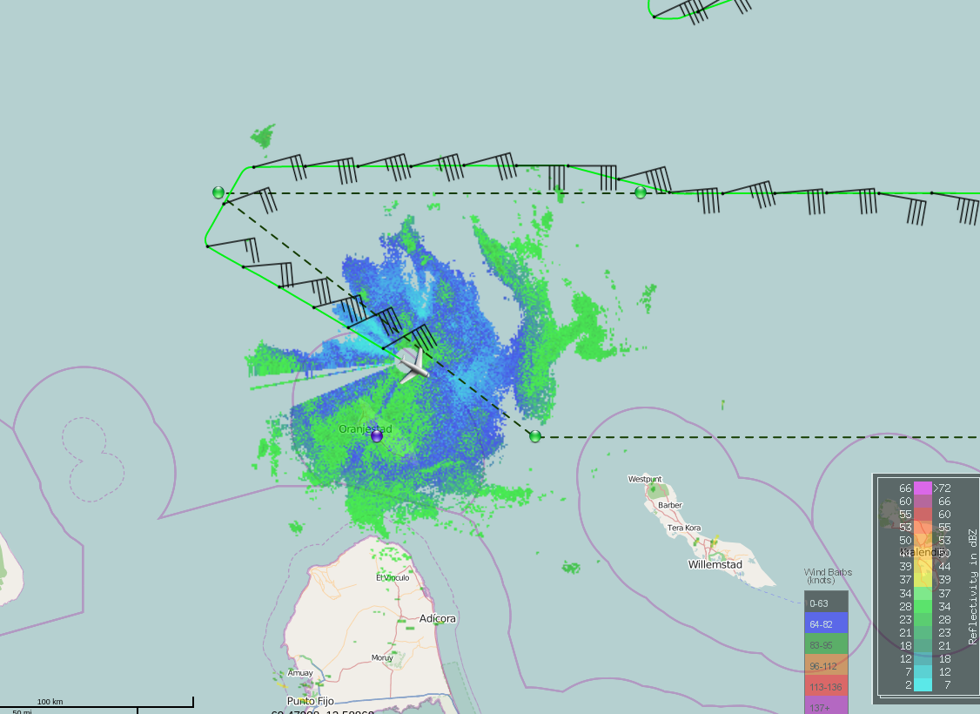
1901 | Zoomed-in visible animation shows numerous low-level swirls, declining coverage of substantial precipitation consistent with diurnal minimum. Possible midlevel circulation center generally along flight track here.
1902 | Turning east at P13
1905 | 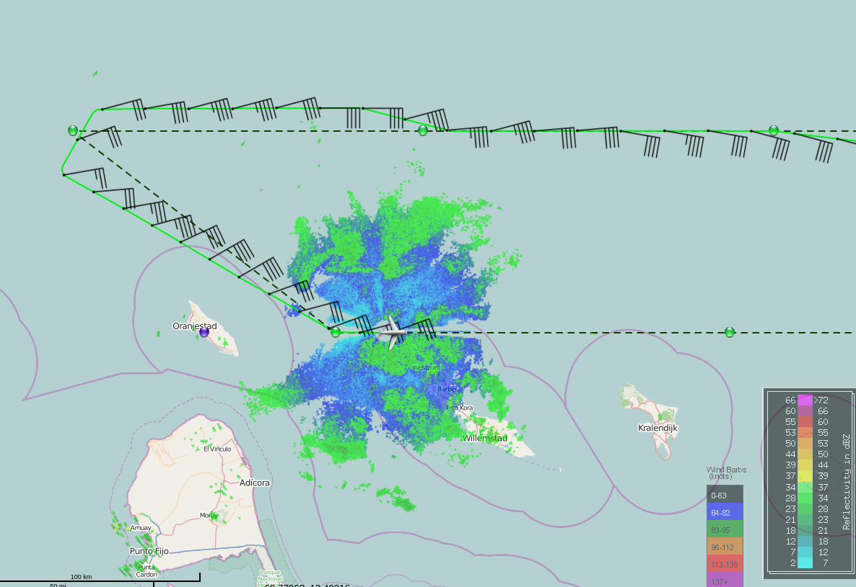
1912 | Skew-t for drop at PT13…  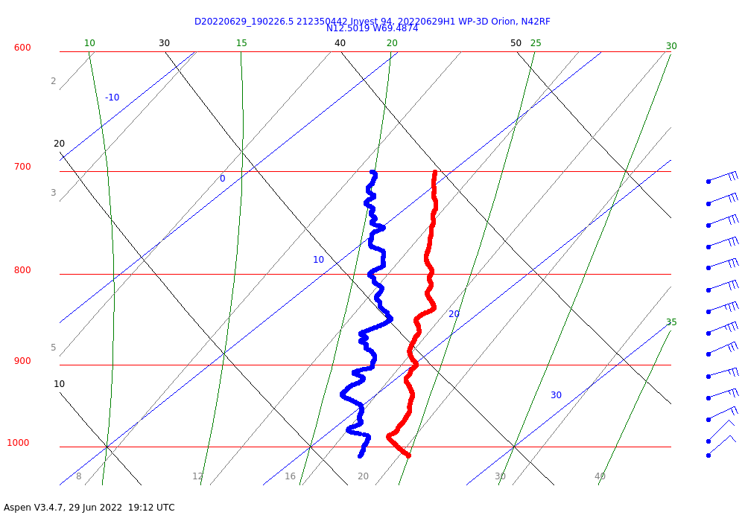  This drop showing slightly more northeasterly winds, and a sharper turn toward northeasterly flow in the last 25 hPa or so. Will be interesting to see if the next drop or two shows a shift to more southeasterly flow, indicative of crossing a trough axis.
1921 | 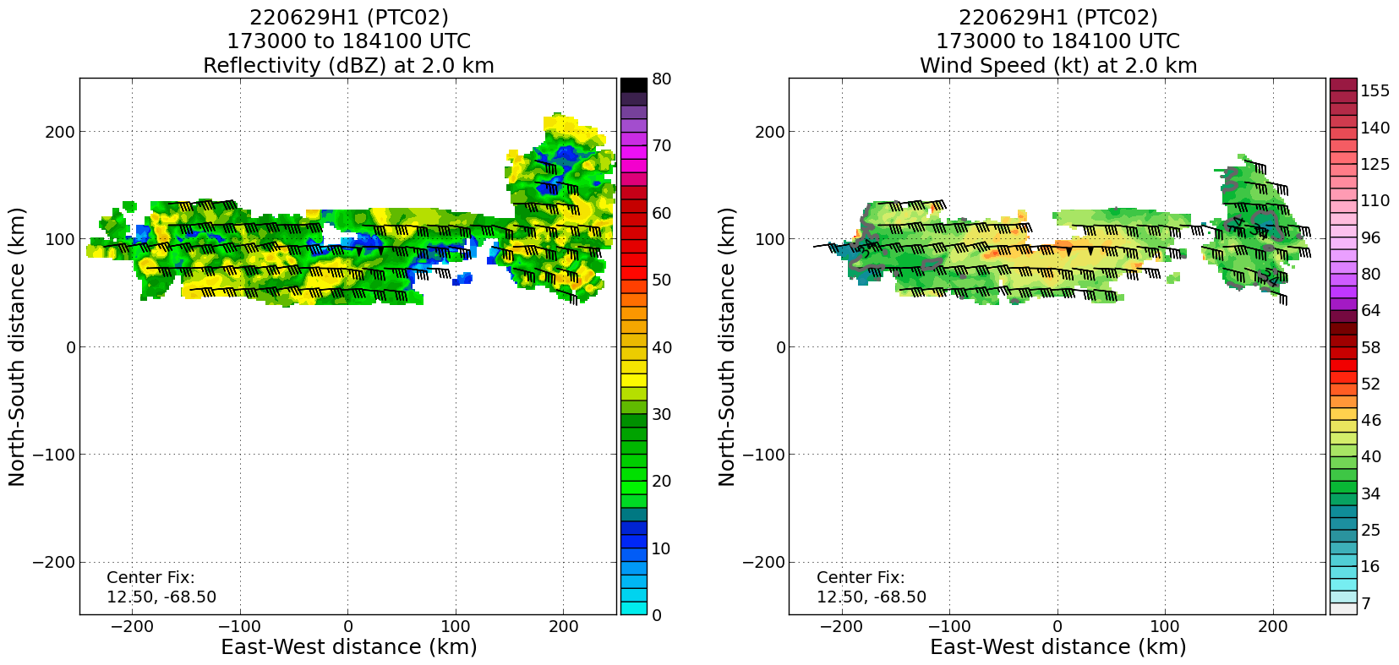  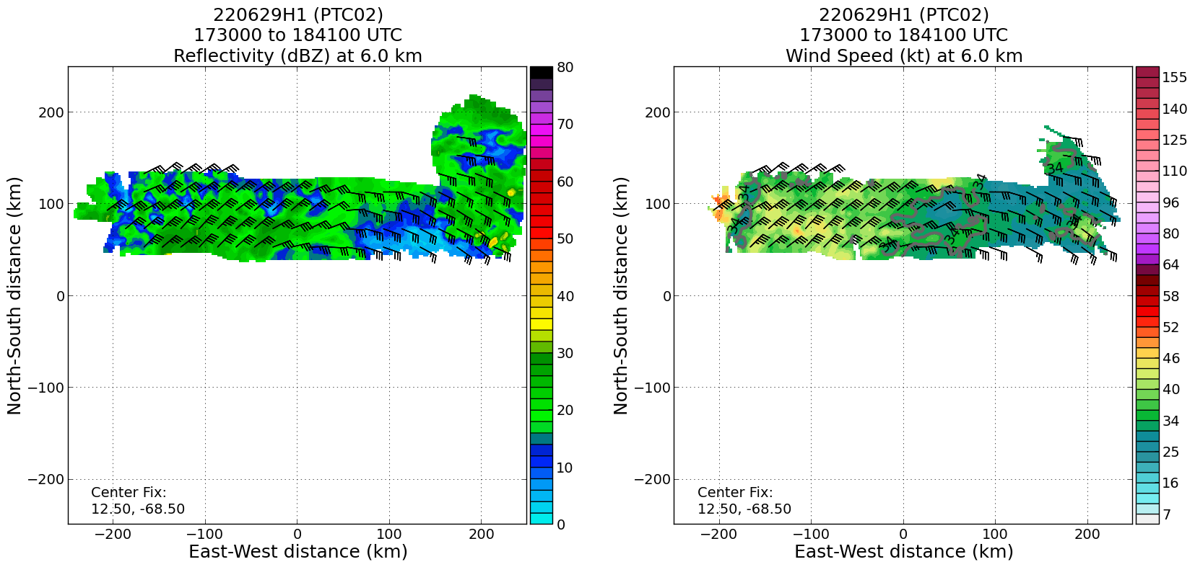  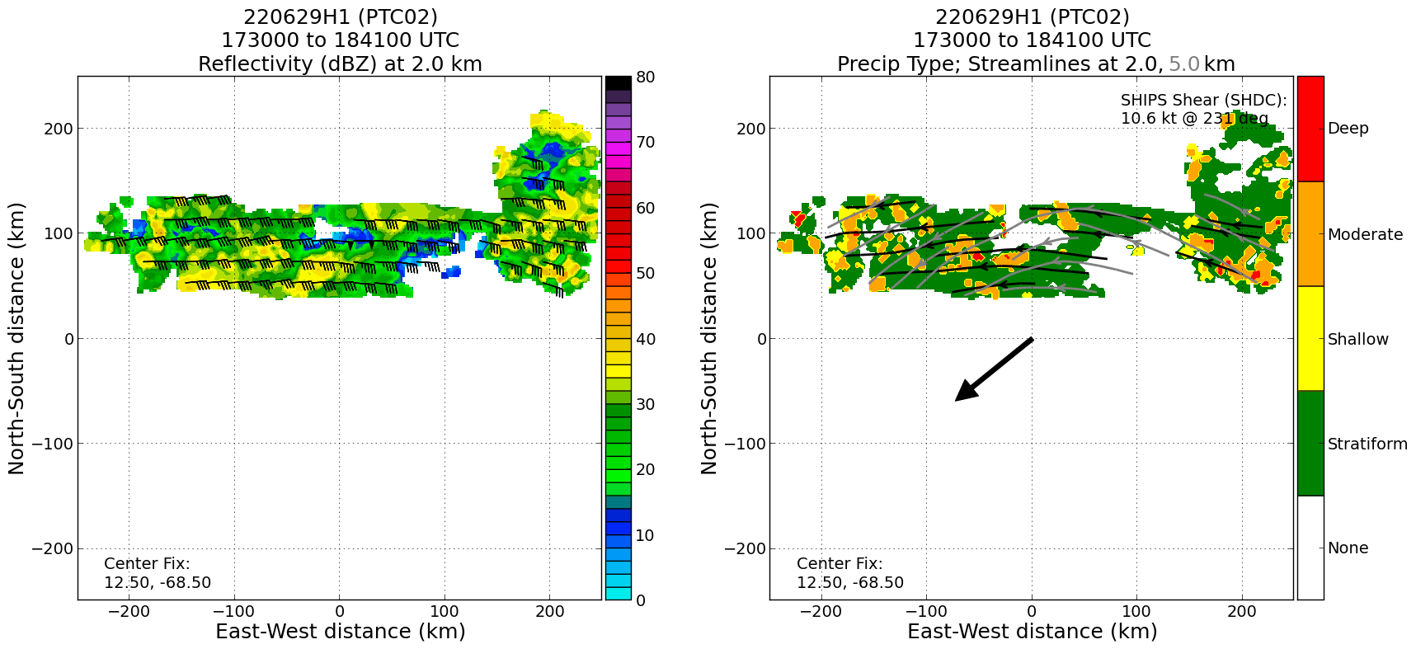  Real-time radar analyses from the second analysis (representing the third leg, from east to west) show straight easterly flow at 2 km (top row). At 6 km (middle row) there is a distinct cyclonic curvature. The precipitation mode (bottom row) shows convection scattered throughout the analysis domain. It’s less well-organized (in terms of being less linear), which is consistent with the degraded appearance on satellite imagery and the diurnal minimum.
1927 | Drop 14 at PT14 launched
1930 | 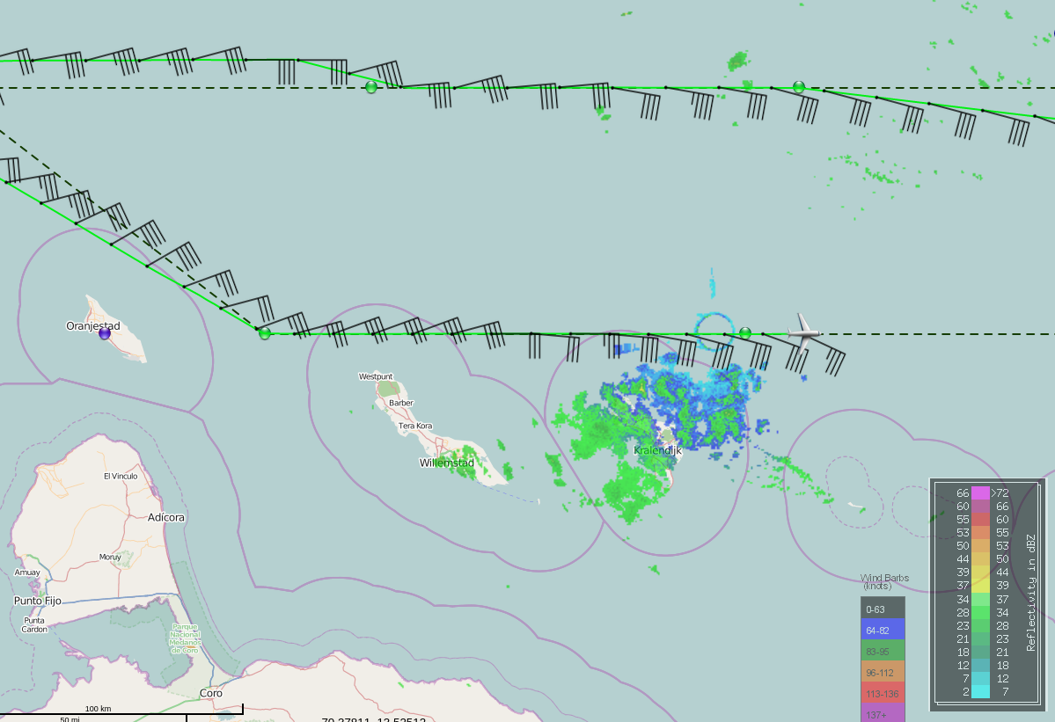
1940 | 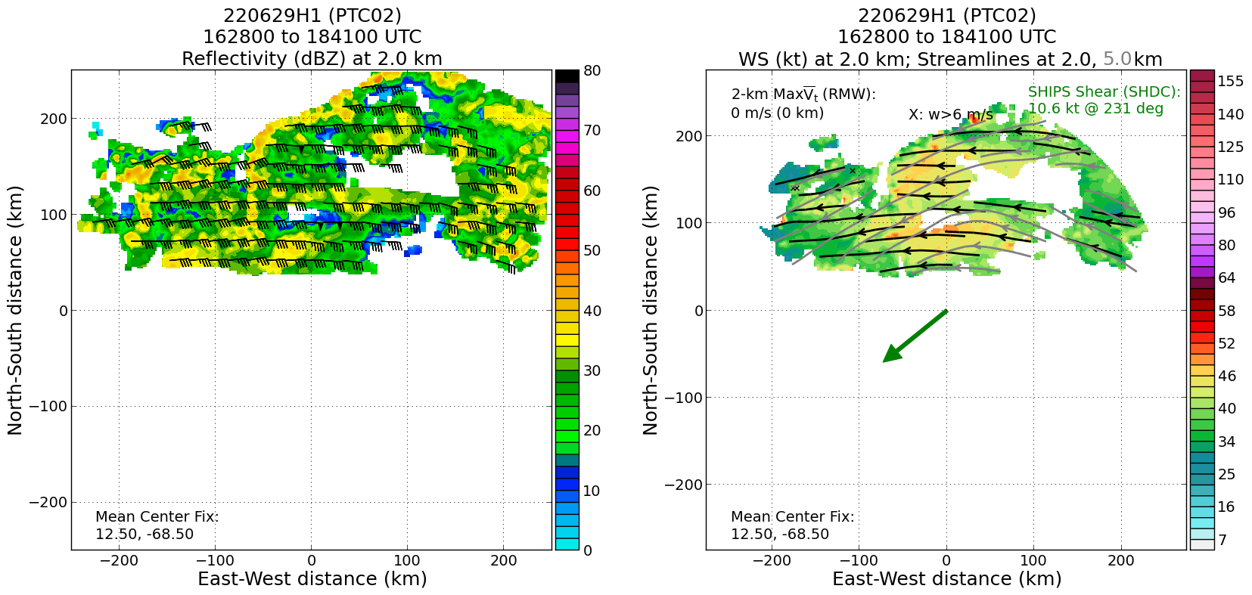  Composite analyses from the first two passes show nearly straight easterly flow at 2 km (right panel) and cyclonic curvature at 5 km. This is consistent with the analyses from the individual leg shown above.
1946 | 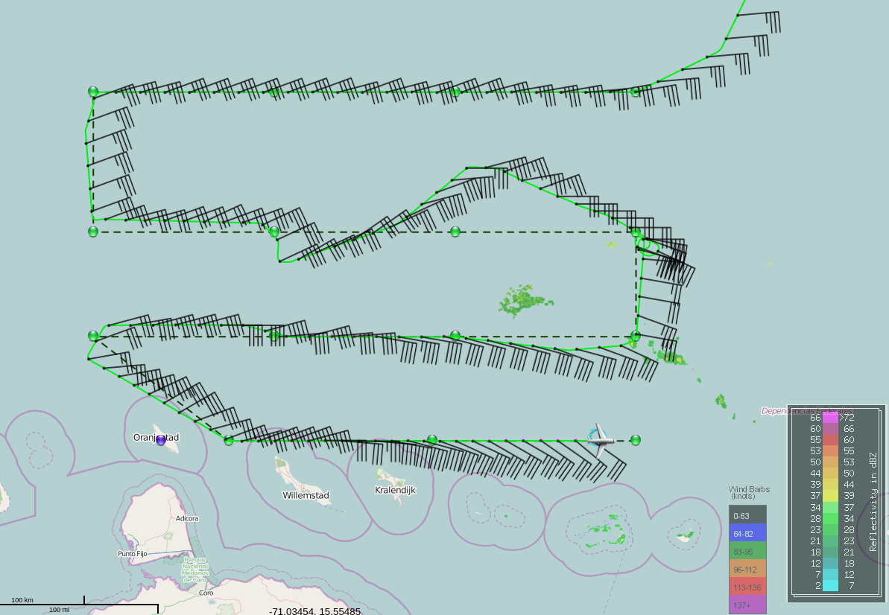
Skew-t for drop at PT14…
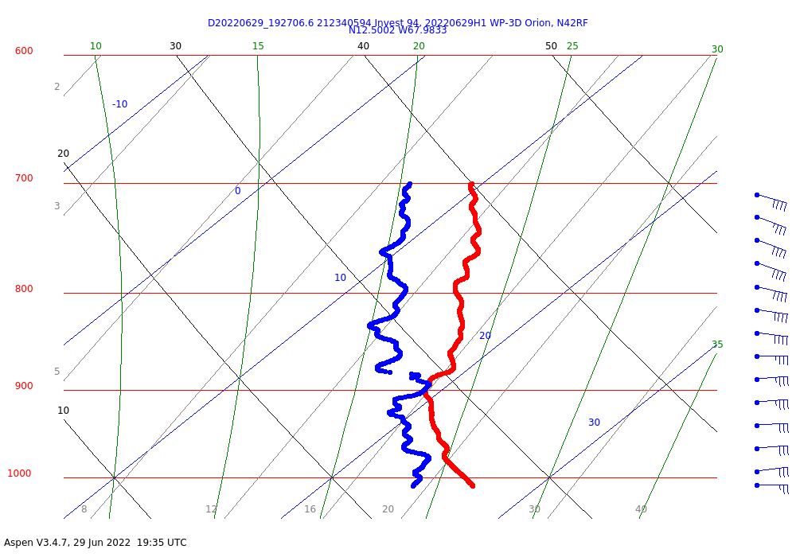
1950 | Drop 15 at PT15 launched
2005 | Skew-t for drop at PT15…  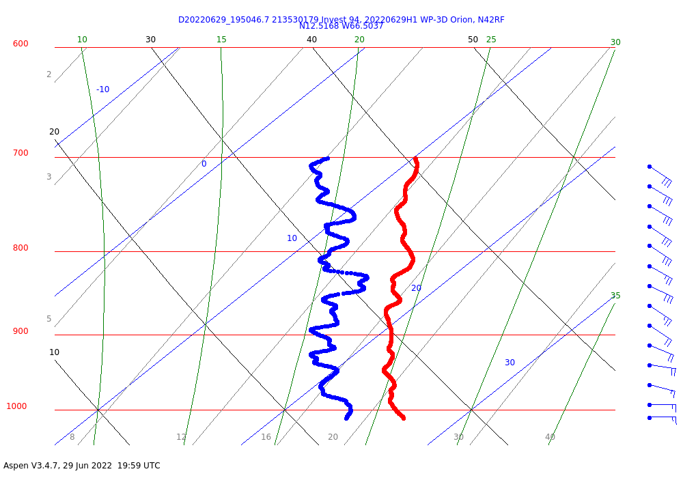
2008 | Synoptic Maps…  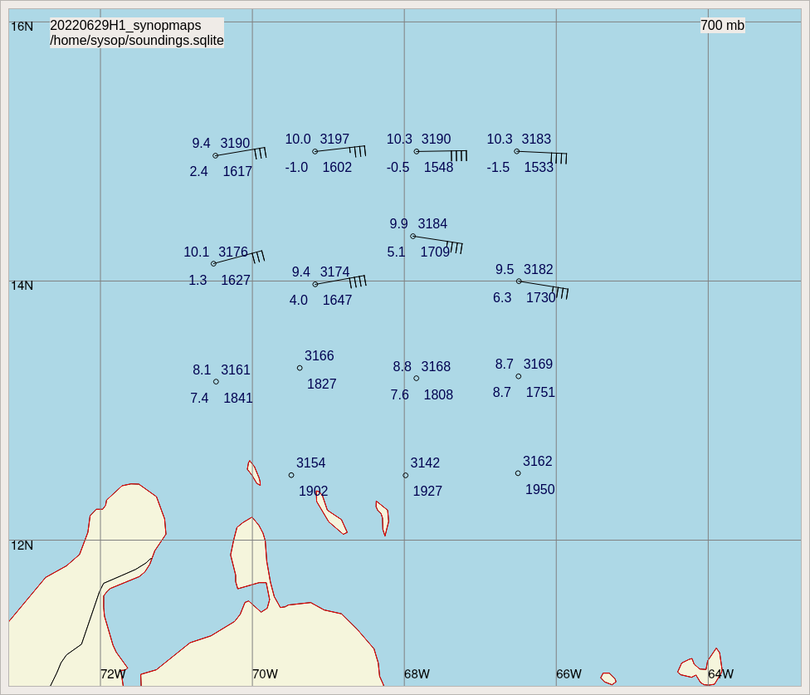  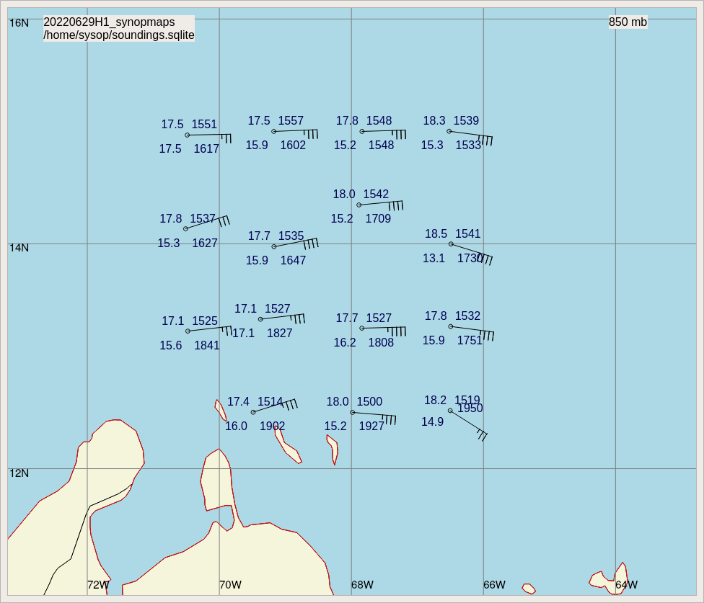  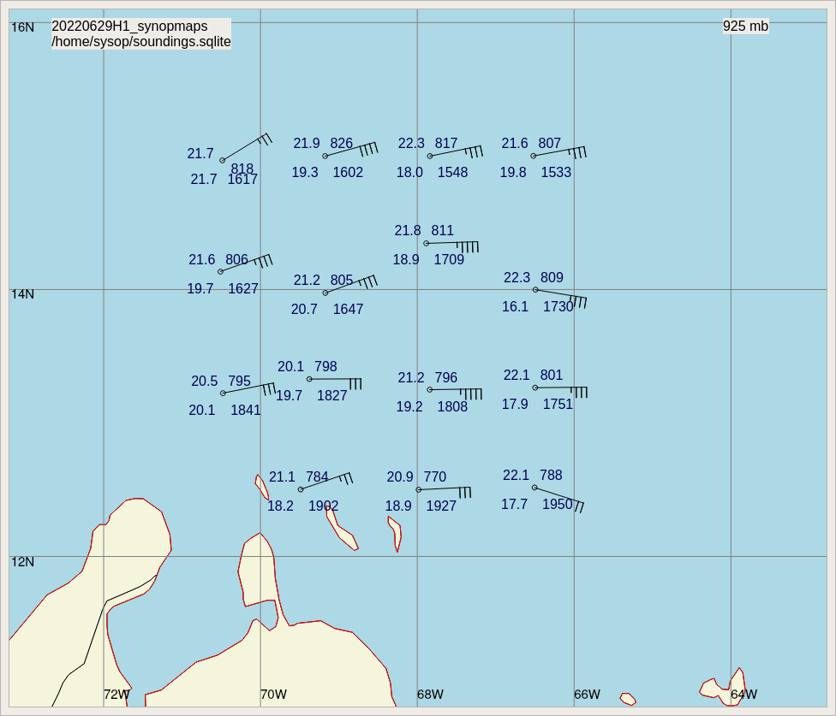  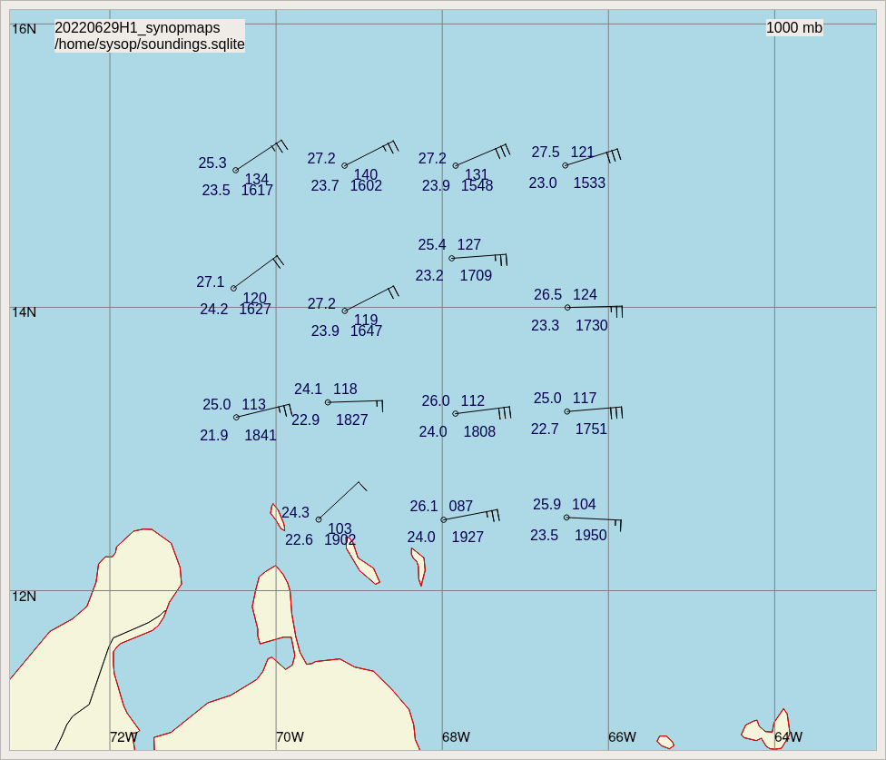  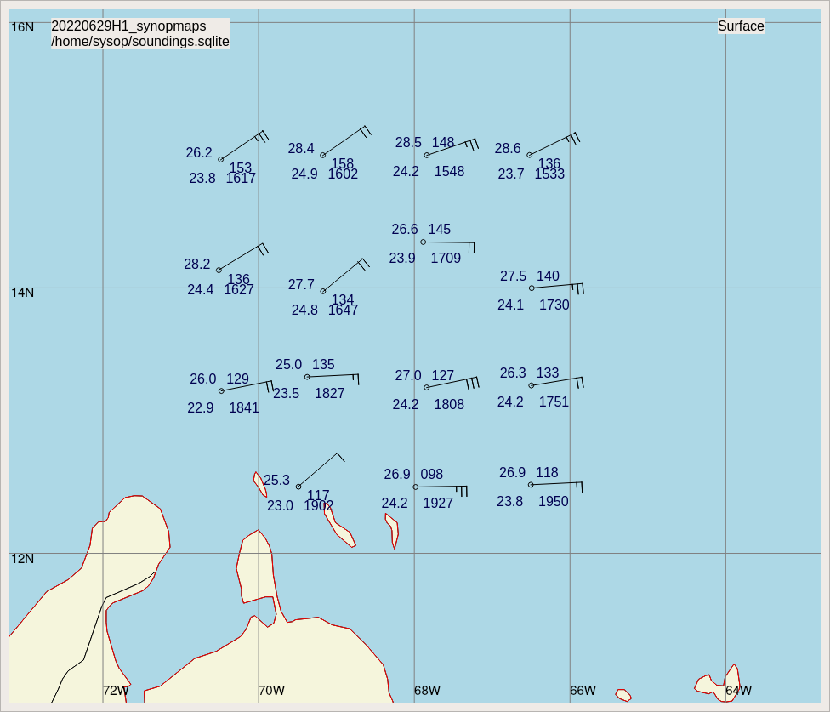
2101 | Landed at St. Croix

POST-FLIGHT
Mission Summary | “Lawnmower” pattern flown successfully. There were some deviations required to avoid convection, but those deviations did not negatively affect the TDR analyses. The first two legs were flown at 18 kft, providing deep-layer dropsonde measurements. The final two legs were flown at 10 kft, so drops were still released. The third leg was adjusted 0.25 degrees to the north of the plan because of the northward deviation during the second leg. There was a spiral descent at the end of the second leg. While the descent did not occur in much precipitation, the aircraft was between regions of stratiform precipitation and there may have been some sampling across the freezing level. The WSRA was up and running for this mission.  The system itself continues to show little in the way of organization. For the first half of the mission there was a fairly well-defined leading line of convection along the northern and western portions of the system with a trailing region of stratiform precipitation to the east and south. Dropsonde skew-T’s showed lower tropospheric subsidence structures consistent with stratiform precipitation, as did the precipitation mode plots from the TDR, at least for the first, west-east pass. As the afternoon progressed, however, the convection in the leading line waned. Some cold cloud tops and areas of lightning remained in the trailing regions to the northeast of the system.  The flow was generally easterly over the entire depth from the low- to the mid-levels. Radar analyses did show cyclonic curvature in the mid-levels (5 km; right panel below) with easterly flow below and a region of weaker cyclonic curvature in the extreme south portion of the analysis domain with a low-level axis perhaps slightly west of the midlevel trough axis.  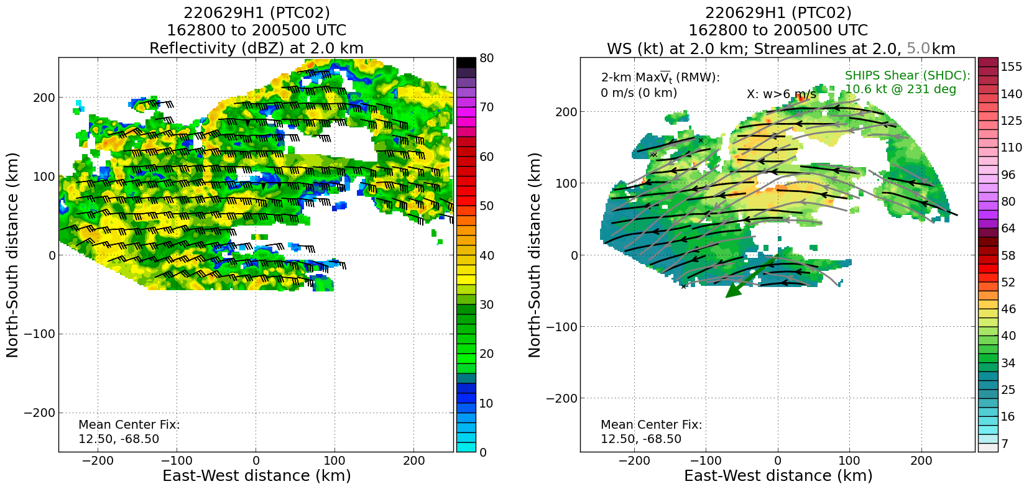  Synoptic maps from the dropsondes showed a similar curvature at 850 hPa. The aircraft was not high enough on the two southern legs to provide observations at 700 hPa and above for the synoptic maps.  15 dropsondes were released, all good, all transmitted (all charged to NWS)
Actual Standard Pattern Flown | “Lawnmower” invest pattern
APHEX Experiments / Modules Flown | Genesis Experiment: PREFORM (some of the TDR and dropsonde data will be helpful for context about the wave trough evolution). The plan is to fly this tomorrow, so there would be four missions separated by 24 h each. The first two missions were at low levels, while the third and fourth (planned) missions will be/were at 10-18 kft, where dropsonde measurements will be useful. This dataset may be useful for genesis studies, but with the rapid translation of the storm and close proximity to South America, it is unknown how likely the system will be to organize. The forecast still calls for it to slow down and intensify. Perhaps tomorrow this will happen.
Plain Language Summary | - A mission was flown in support of collecting data in PCT02 for NCEP’s Environmental Modeling Center, which will be assimilated into numerical forecast models to hopefully improve the forecast of this potentially intensifying storm.  - The mission did not observe a closed circulation at any level, but did once again sample well the wave trough from the low to middle levels of the troposphere. The wave appears to be moving rapidly west, which could be inhibiting further development.
Instrument Notes | The WSRA was operational; the CRL was not.
Final Mission Track | 