MISSION PLAN
FLIGHT ID | 20220628H1 | STORM | AL94 / PTC02
MISSION ID | 0302A | TAIL NUMBER | NOAA42
TASKING | NHC | PLANNED PATTERN | INVEST
MISSION SUMMARY
TAKEOFF [UTC] | 1502 | LANDING [UTC] | 1938
TAKEOFF LOCATION | Barbados | LANDING LOCATION | St. Croix
FLIGHT TIME | 4.6 | BLOCK TIME | 4.8
TOTAL REAL-TIME RADAR ANALYSES  (Transmitted) | 2 (2) | TOTAL DROPSONDES (Good/Transmitted) | None
OCEAN EXPENDABLES (Type) | None | sUAS (Type) | None
APHEX EXPERIMENTS / MODULES | Genesis Experiment: PREFORM
HRD CREW MANIFEST
LPS ONBOARD | Zawislak | LPS GROUND | None
TDR ONBOARD | Zawislak | TDR GROUND | Gamache / Reasor
ASPEN ONBOARD | None | ASPEN GROUND | None
NESDIS SCIENTISTS | None
GUESTS (Affiliation) | None
AOC CREW MANIFEST
PILOTS | Abitbol, Copare, Rannenberg
NAVIGATOR | Hough
FLIGHT ENGINEERS | Darby, Stokes, Gee
FLIGHT DIRECTOR | Holmes, Kalen
DATA TECHNICIAN | McAlister
AVAPS | Hartberger

PRE-FLIGHT
Flight Plan | Invest pattern, close to a Fig. 4, starting from the NW and heading towards the center point, then proceed to try and find a westerly wind.
Expendable Distribution | No dropsondes released unless we climb to 5000 ft
Preflight Weather Briefing | The overall organization of AL94/PTC02 seems to have improved some, with the satellite loops suggesting that perhaps a robust midlevel circulation has developed within the main convective area near 11N / 57W. The question is, is there an established low-level circulation center anywhere near the midlevel circulation? The environment remains favorable for further development.  Plan is to fly in from the NW towards 9.0N / 58.2W, which is the anticipated location of a “center”, then go from there to the south to see if there is a westerly wind. We’ll start at 1,000 ft and go from there.  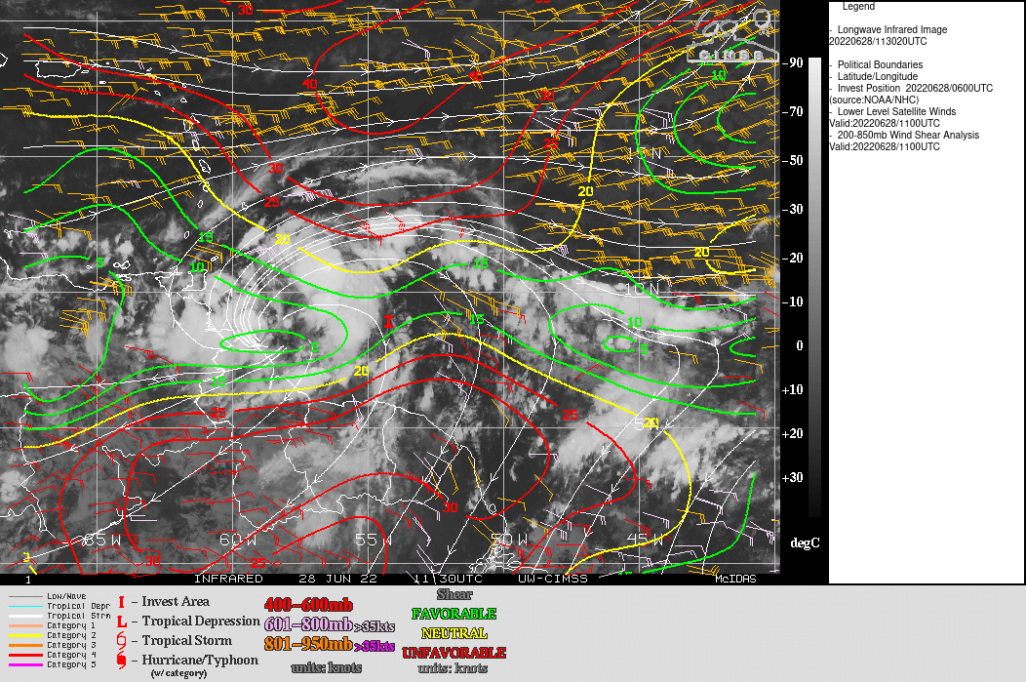
Instrument Notes | WSRA and CRL not operational

IN-FLIGHT
Time [UTC] | Event
1502 | Takeoff from Barbados
1531 | 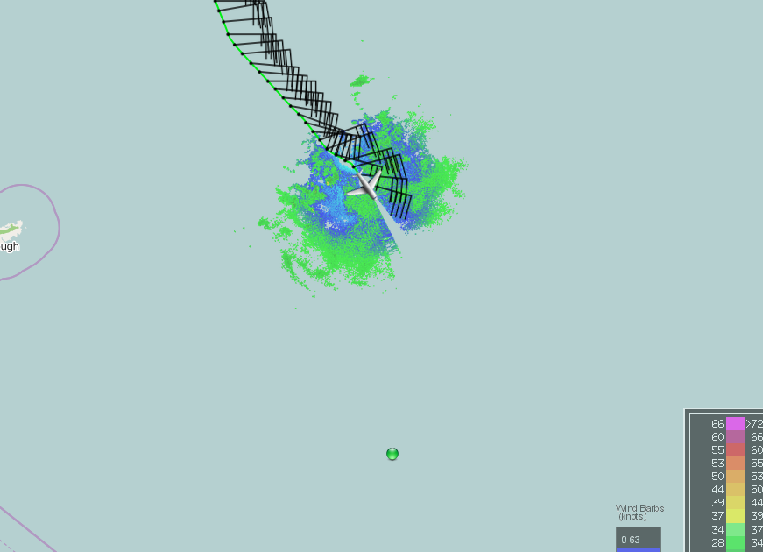
1539 | Interruption in IWG1 data flow
1544 | IWG1 flow is back, temporarily had ascended, but back down to 1000 ft  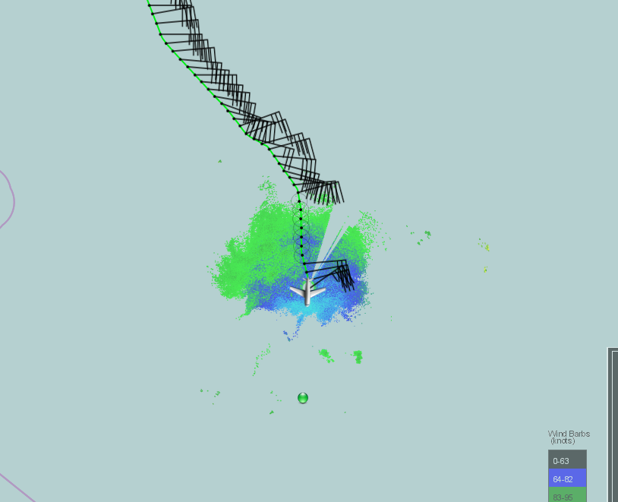
1558 | Interesting…the FL winds are about 15 kt, while the SFMR winds are aout 23-25 kt, so 8-10 kt higher! Even though we’re only 1000 ft above the surface. SFMR running high?  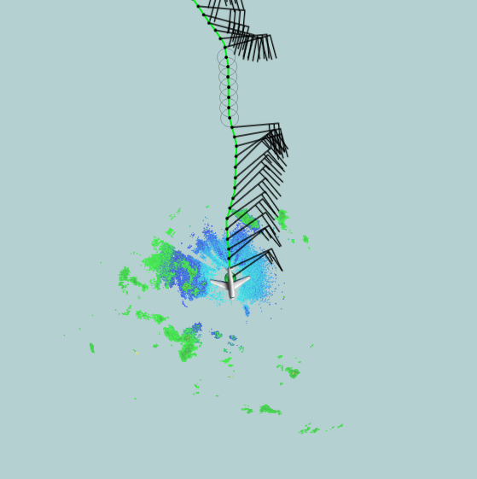
1613 | In the vicinity of a more intense convective line, so some shift in the winds  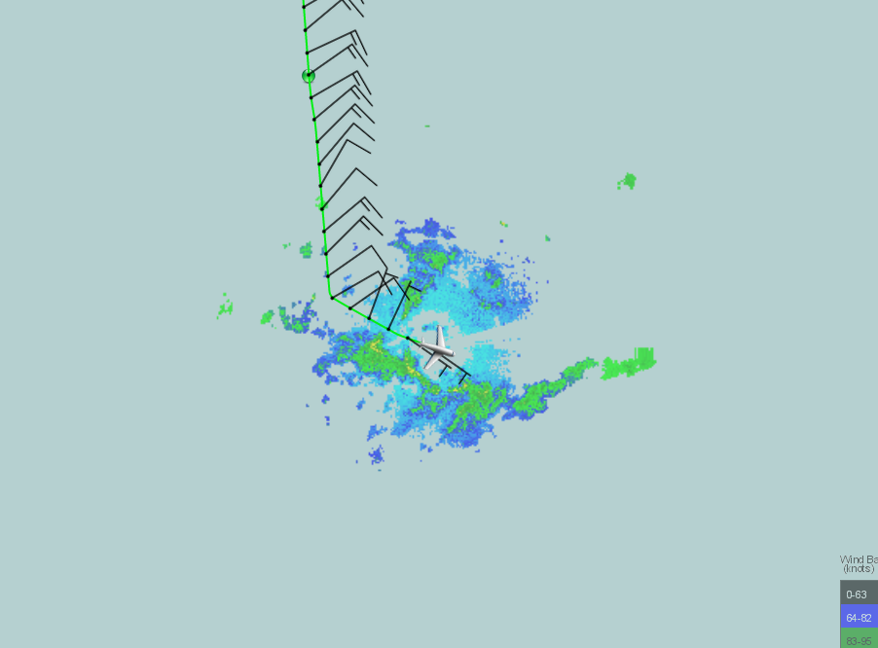  Paralleling a decent line of convection oriented east-west
1622 | 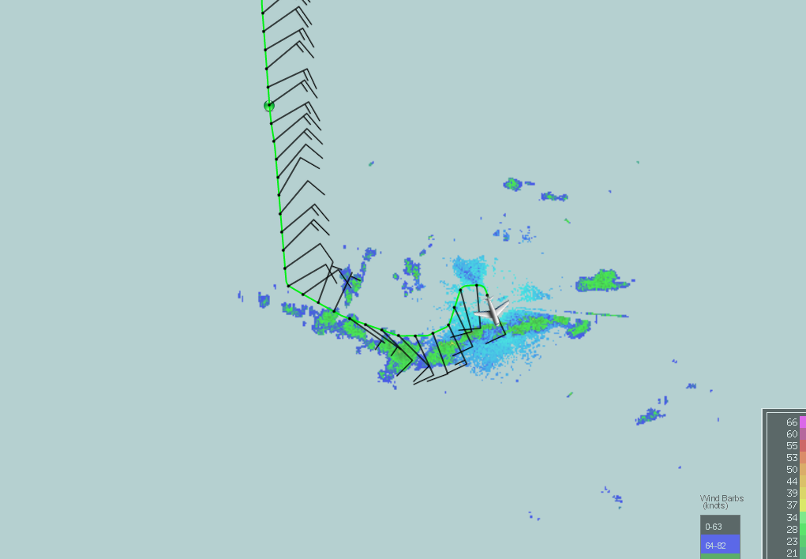
1632 | Headed west to attempt to find shift to northerlies
1637 | 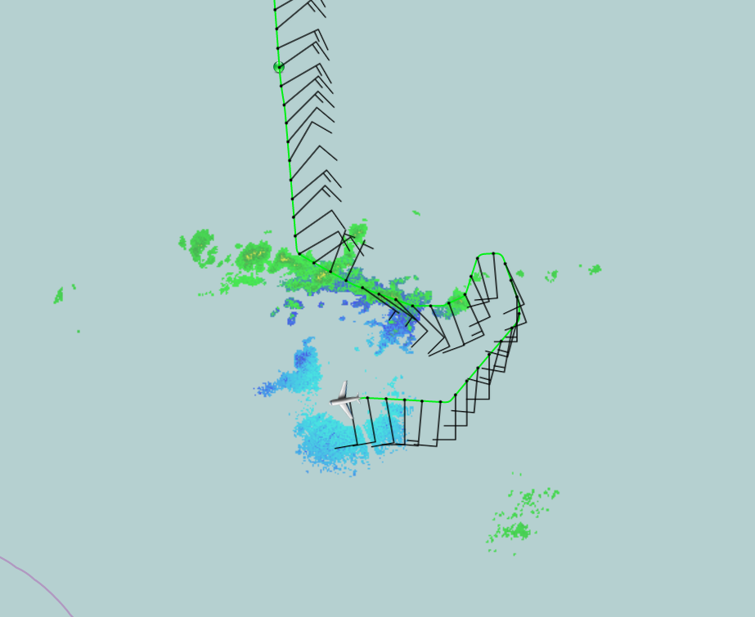
1643 | 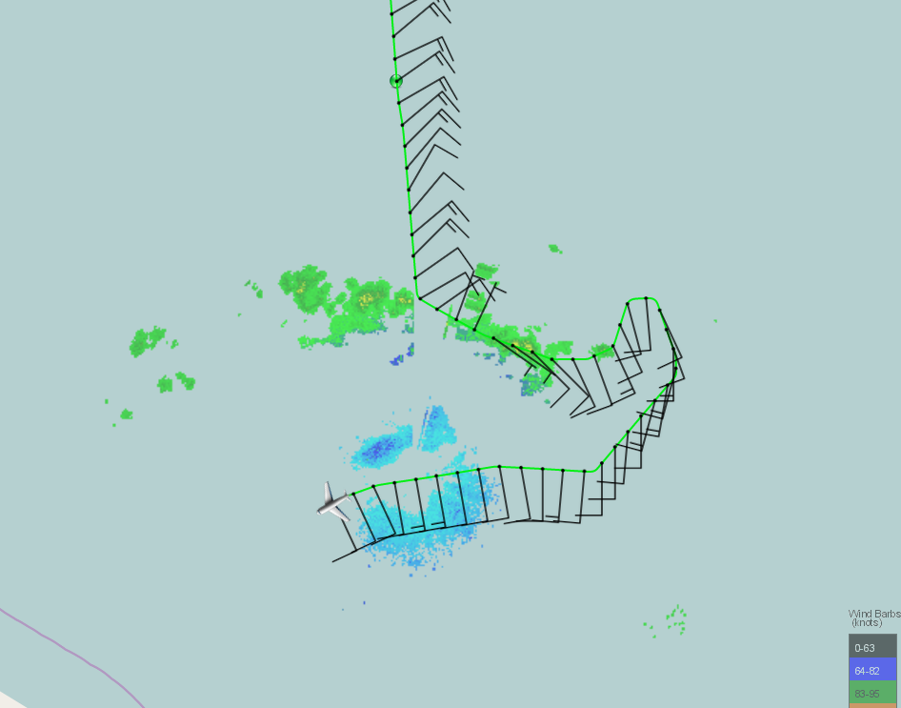  We’re just so far away from the midlevel circulation, and there is no sign of a low-level circulation down at 8.5N. The winds are southerly, and they’re feeding into the convective band to our north.
1705 | Turning due north at 59.5W  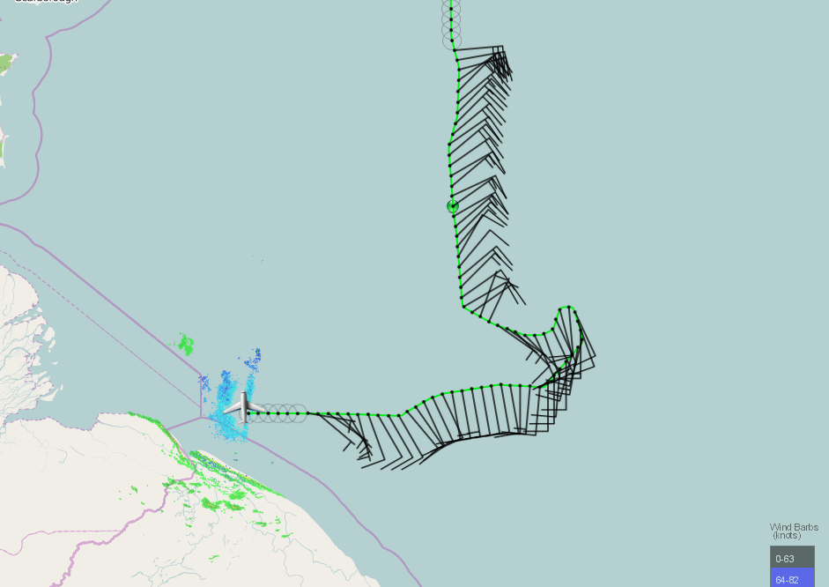
1717 | Should pass through the midlevel circulation on this track, if it’s present  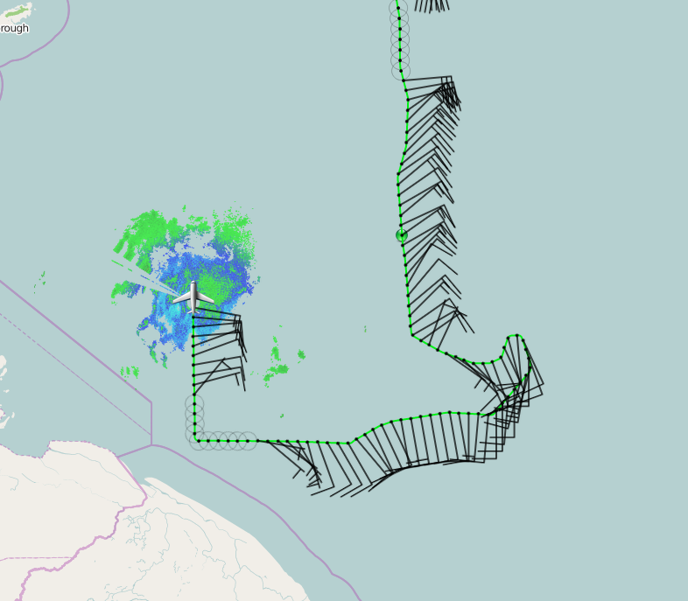
1720 | We’ll end the pattern at 12.5N. First TDR analysis shows the elongated, east to west trough axis at 1 km and some cyclonic curvature in the 5 km winds. Looking almost closed in the storm-relative reference frame.
1741 | Back into the widespread stratiform, and also likely in the area the midevel circulation exists, or is forming – the TDR analysis from this south to north should be very interesting.  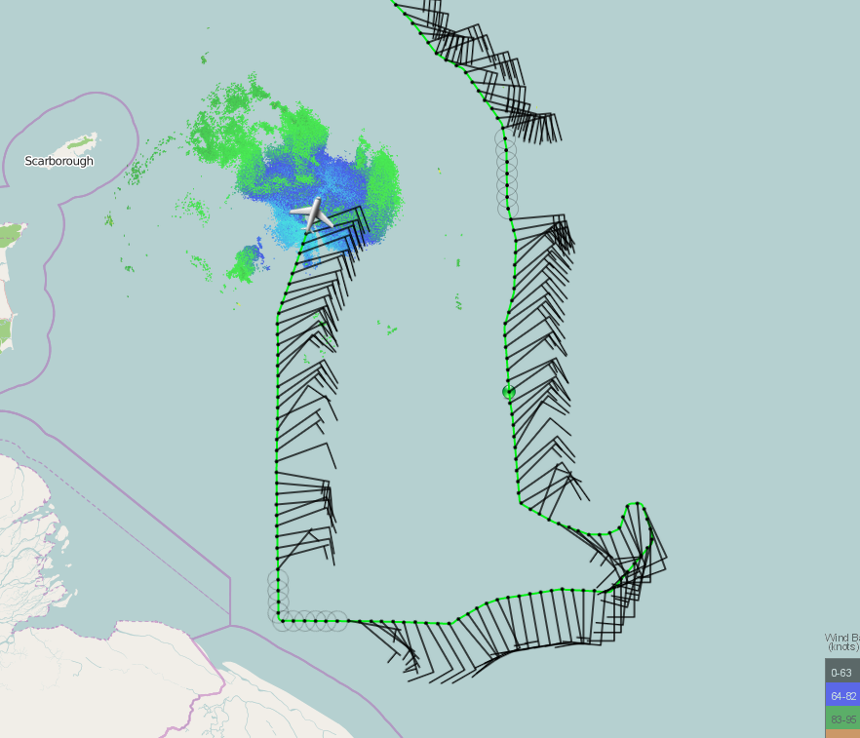
1802 | 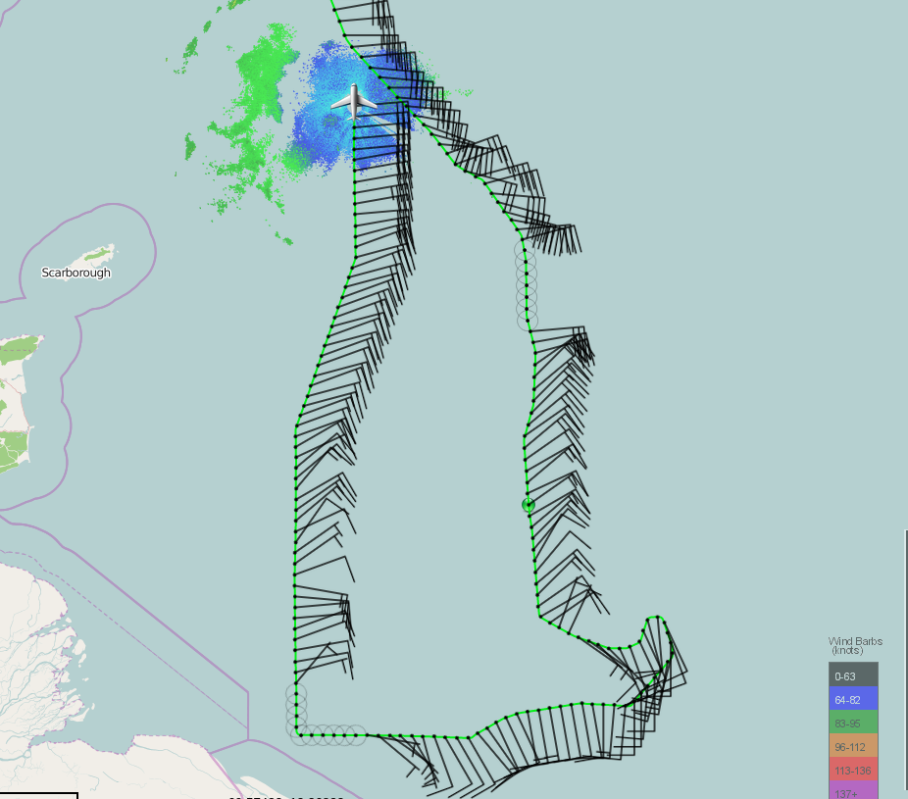
1815 | Based on the visible satellite, this south to north pass should have nicely painted a midlevel circulation, if it is present. Flew a considerably wide area of stratiform rain, trailing a leading convective line to our west.  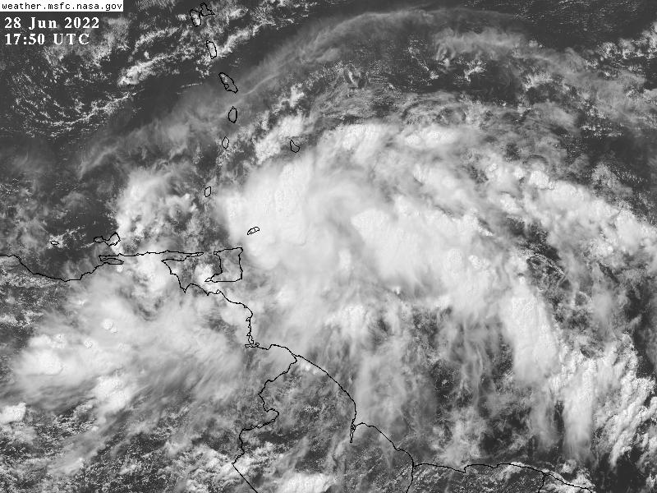
1816 | Headed to St. Croix  The final pattern…  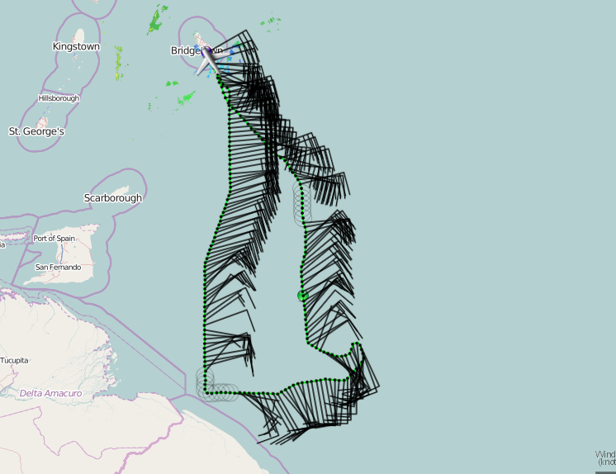  The final TDR analyses, which show we predominantly sampled the wave trough in the middle troposphere, and an elongated, east to west convergence/trough axis in the lower troposphere.  “Pass 1”...  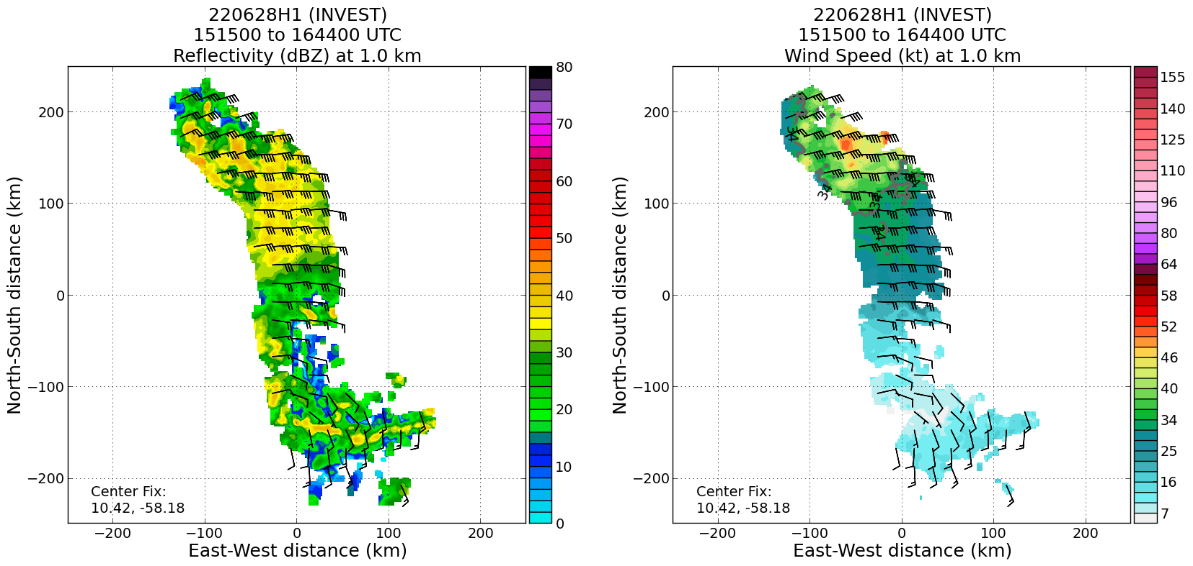  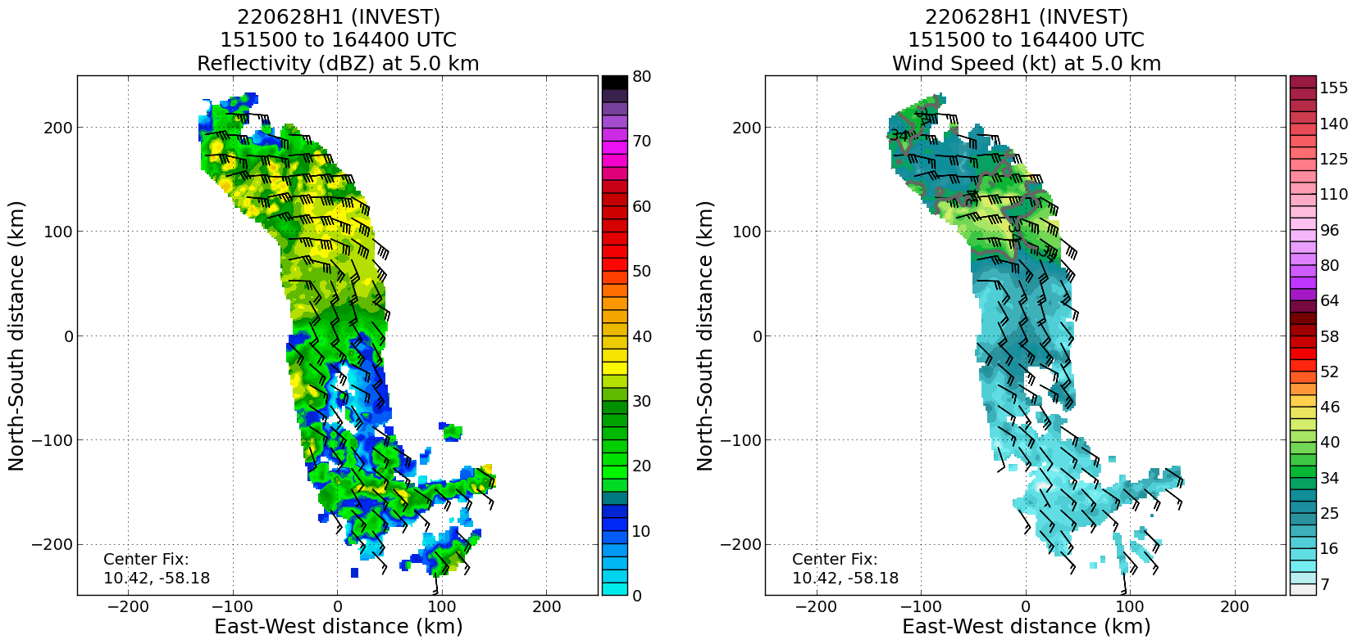  “Pass 2”...  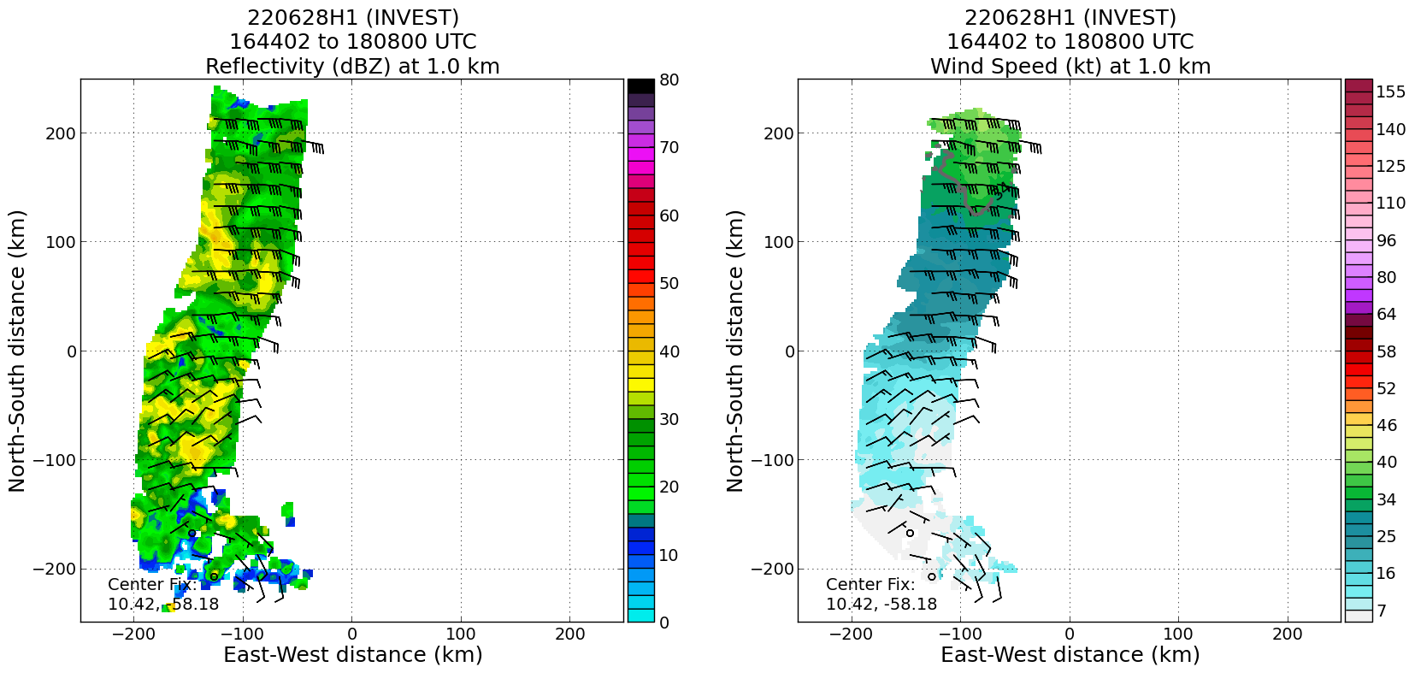  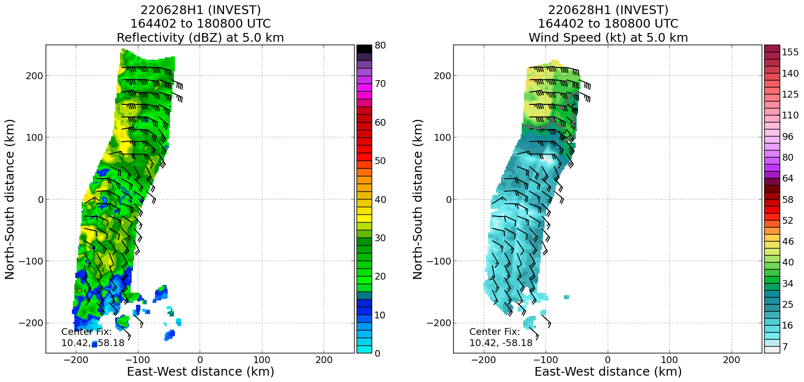

POST-FLIGHT
Mission Summary | We flew a fairly short “invest” mission into PTC02, in support of NHC. The pattern consisted of basically two “passes” through the PTC. One from the north to south, which seemed to pass just to the east of the midlevel wave trough, and sampled the lower troposphere (below 2 km) “trough” (or convergence) axis, oriented east-west. The second pass, from south to north (and further west than the first), we thought would pass through a midtropospheric circulation based on what we were seeing in the satellite loops, but it turned out to still just be the trough axis. So, while the environment remains favorable for further development, PTC02 continues to not have a closed circulation in the low to midlevels, at least in the Earth-relative reference frame. In the Lagrangian, storm-following reference frame, it does appear closed.  Because of our low flight altitude (1000 ft for the entire pattern), no dropsondes were released, nor AXBTS.
Actual Standard Pattern Flown | “Lawnmower” invest pattern
APHEX Experiments / Modules Flown | Genesis Experiment: PREFORM (some of the TDR data will be helpful for context about the wave trough evolution, if we fly subsequent missions, but otherwise not a substantial dataset for genesis studies)
Plain Language Summary | - An NHC Invest mission was flown to broadly investigate a potential developing area of convection associated with a wave trough in PTC02  - While there were only 2 “passes” through the disturbance (one north to south, and another further west from south to north), the TDR data did show that the disturbance remains an open wave from the low to middle troposphere, and as such has not developed a closed circulation near the surface.
Instrument Notes | The WSRA and CRL were not operational
Final Mission Track | 