MISSION PLAN
FLIGHT ID | 20220627H1 | STORM | AL94
MISSION ID | 01BBA | TAIL NUMBER | NOAA42
TASKING | NHC | PLANNED PATTERN | INVEST
MISSION SUMMARY
TAKEOFF [UTC] | 1503 | LANDING [UTC] | 2145
TAKEOFF LOCATION | Barbados | LANDING LOCATION | Barbados
FLIGHT TIME | 6.7 | BLOCK TIME | 7.0
TOTAL REAL-TIME RADAR ANALYSES  (Transmitted) | 3 (3) | TOTAL DROPSONDES (Good/Transmitted) | None
OCEAN EXPENDABLES (Type) | 2 AOC AXBTs | sUAS (Type) | None
APHEX EXPERIMENTS / MODULES | Genesis Experiment: PREFORM
HRD CREW MANIFEST
LPS ONBOARD | Zawislak | LPS GROUND | None
TDR ONBOARD | Zawislak | TDR GROUND | Gamache / Reasor
ASPEN ONBOARD | None | ASPEN GROUND | None
NESDIS SCIENTISTS | None
GUESTS (Affiliation) | None
AOC CREW MANIFEST
PILOTS | Abitbol, Copare, Rannenberg
NAVIGATOR | Hough
FLIGHT ENGINEERS | Darby, Stokes, Gee
FLIGHT DIRECTOR | Holmes, Kalen
DATA TECHNICIAN | McAlister
AVAPS | Hartberger

PRE-FLIGHT
Flight Plan | Plan is to fly an NHC INVEST mission into AL94, which is broadly located near 8.0N / 47.5W. The initial pattern will be a clockwise box around a point 8.5N / 51.0W, starting in the NW, about 60 n mi radius from that point. Altitude will be 1500 ft. Then NHC will provide guidance on any additional pattern.
Expendable Distribution | No dropsondes will be released unless we get above 5000 ft; enroute 1 AXBT to test ground transmission, or as many as we can, up to 3, until we get good data from one
Preflight Weather Briefing | Currently, the invest doesn’t appear to have a closed circulation, at least according to the most recent scatterometer pass, with low-level winds suggesting it’s still a wave trough. There is a fairly robust vorticity maximum, though, in the low to middle troposphere and plenty of convection in the vicinity and ahead of the wave trough. The moisture/RH environment is favorable, shear is relatively low within the wave trough environment. So, at this point conditions are favorable, and it could be just a matter of the convection developing in the right location.  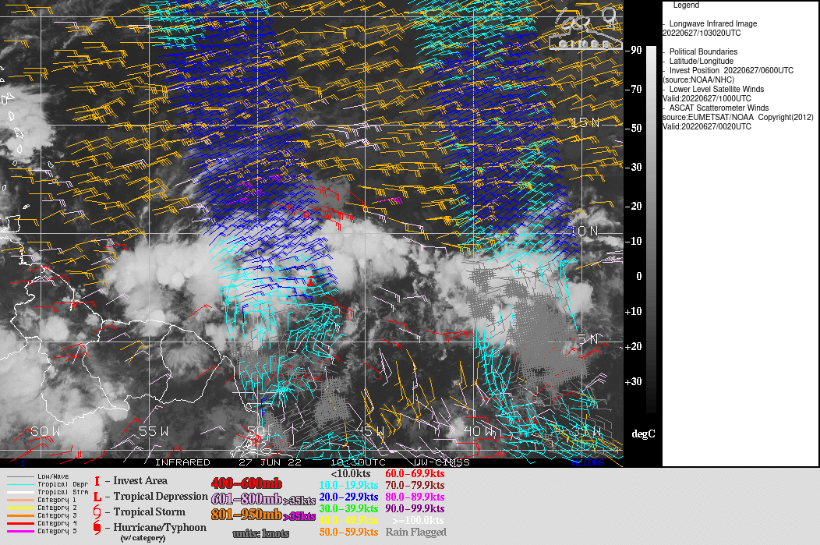  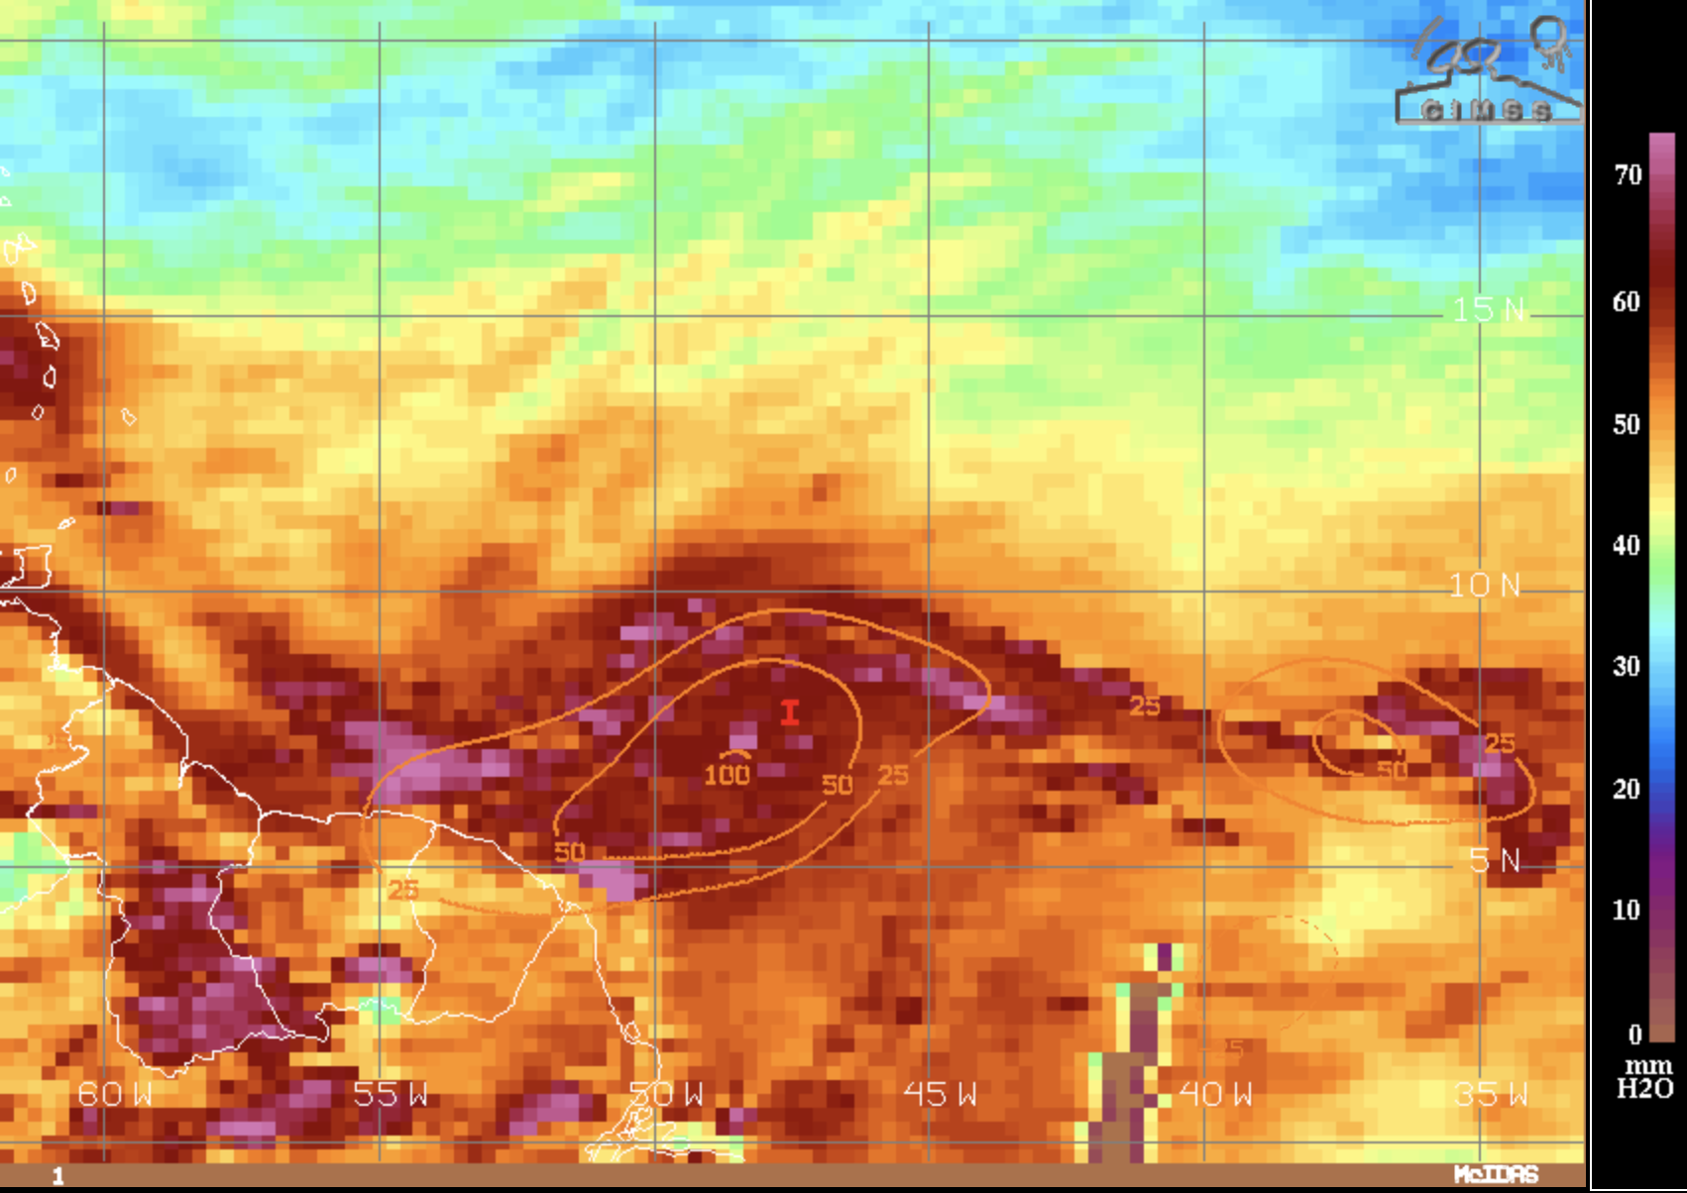
Instrument Notes | WSRA is not yet operational; CRL not operational

IN-FLIGHT
Time [UTC] | Event
1503 | Takeoff from Barbados
1615 | Enroute to IP and box pattern, no changes to the anticipated first clockwise box around the “center” of the invest. There will be up to 3 AXBT launches (based on whether data returns) to test the ground transmission of that data. This will occur in clear conditions once we are settled at 1500 ft after the IP from the forecast “center” of the invest.
1643 | AOC AXBT Launch #1 at 9 48.7 N 53 0.8 W – did not receive data
1651 | AOC AXBT Launch #2 at 9 53.1 N 52 37.0 W – getting data and seeing if the data will have transferred to the ground
1700 | Turned south to head to NW point of the box  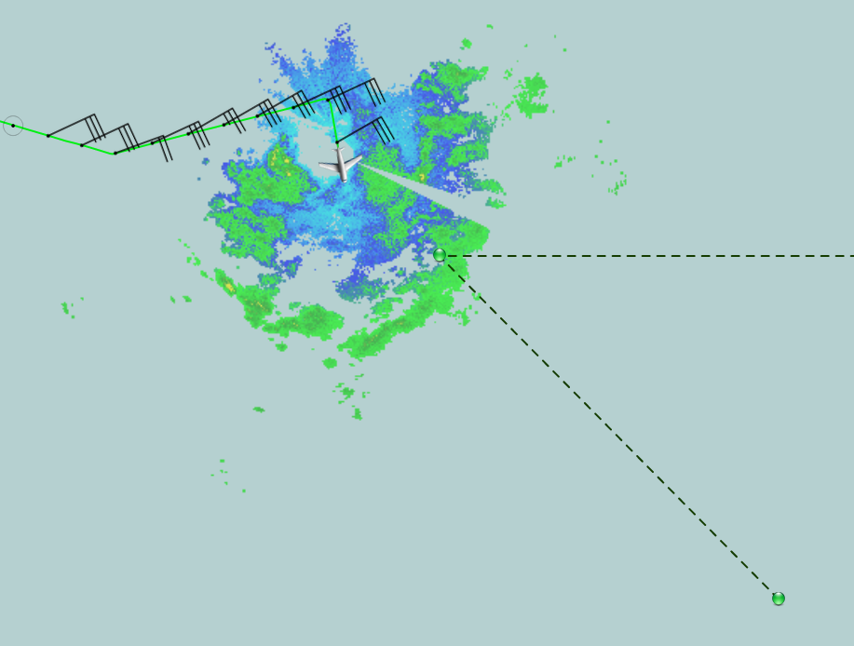
1712 | Descended to 1000 ft to get below cloud bases; working round convective cells near the NW point  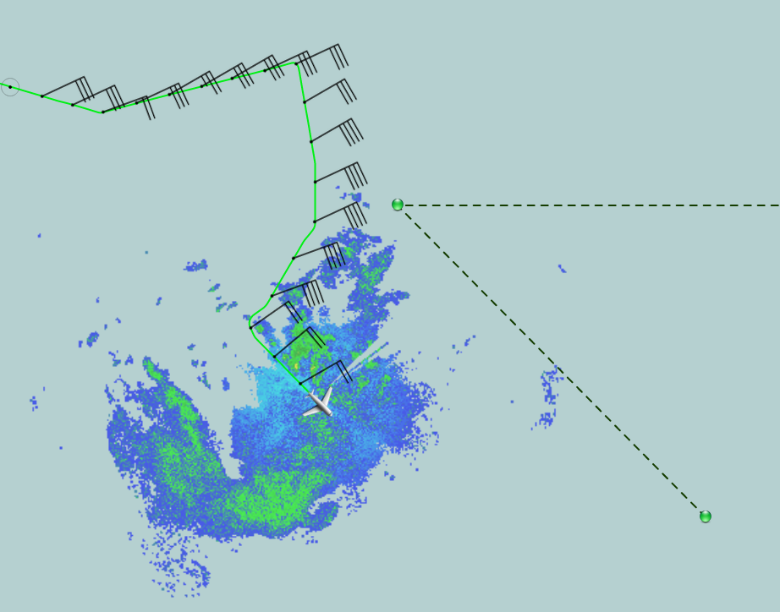
1717 | Turning back to north to get close to NW point after avoiding deeper cells to north of position
1728 | 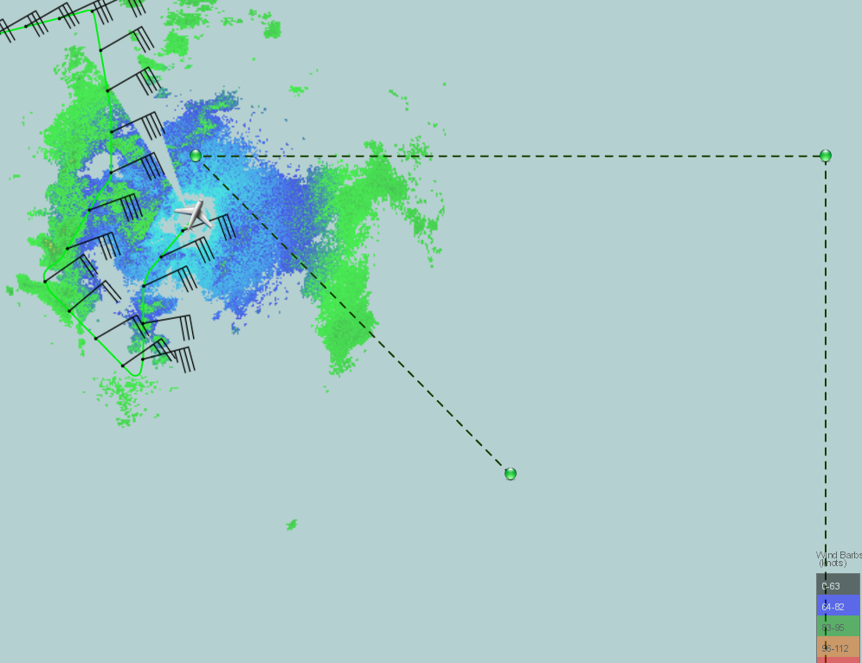
1732 | CPA NW point; Box covers an area between 50 and 52W and 7.5 to 9.5N
1740 | Widespread stratiform area, no evidence of a shift to more southeasterly yet  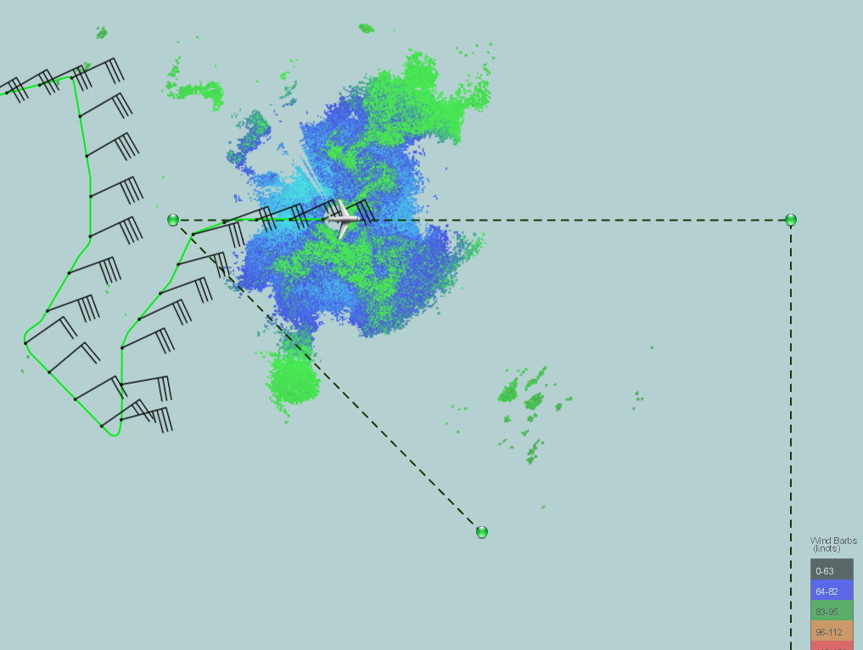
1800 | Turning south from the NE point  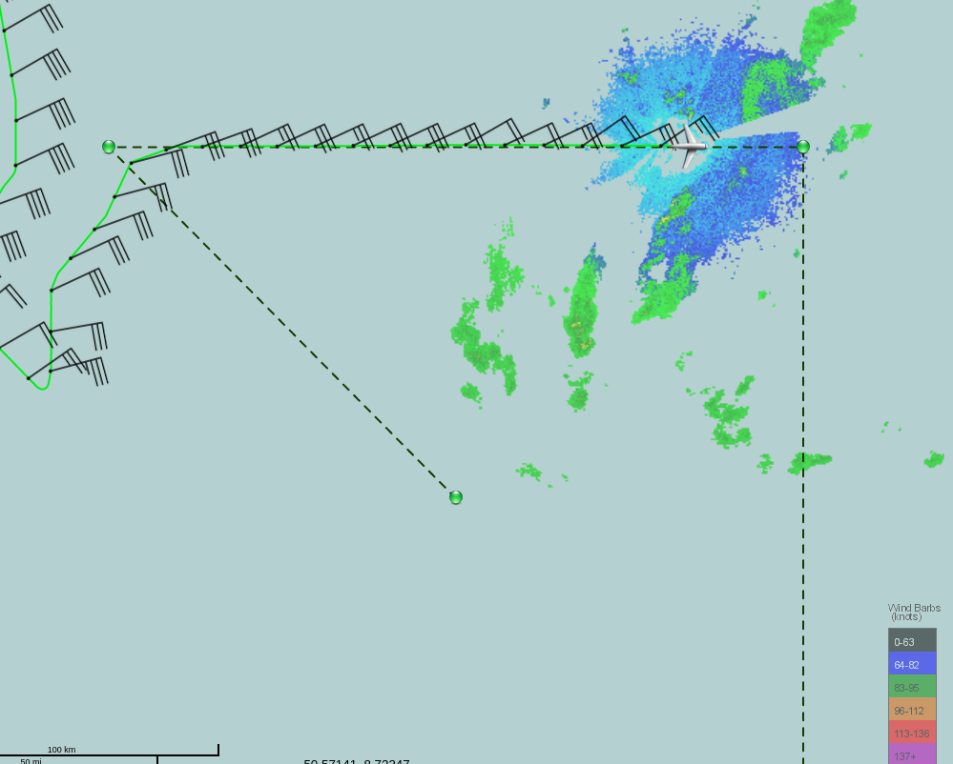  We’ll be passing east of a line of cells (below)
1807 | 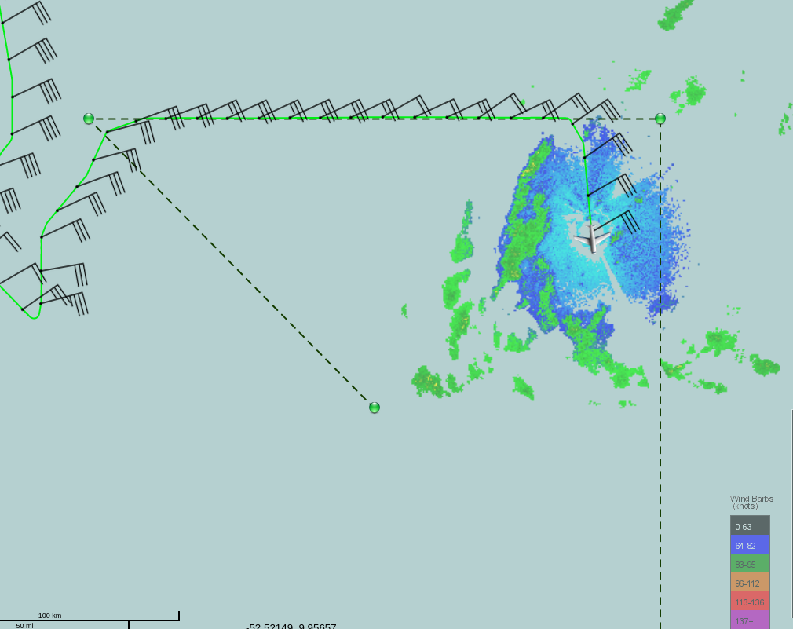
1818 | The line of cells we’re avoiding along the south track  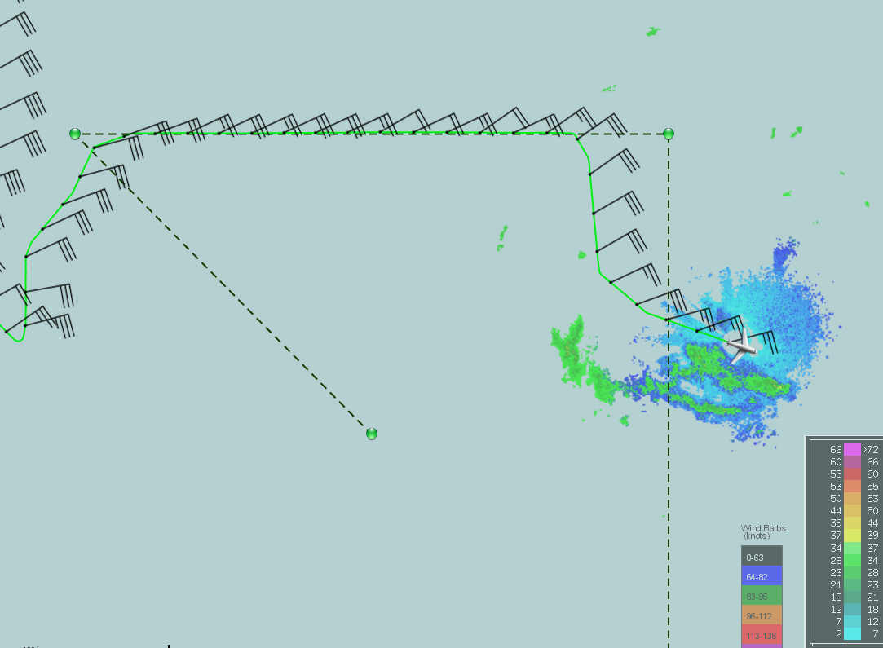
1823 | Flight-level winds actually turned southerly…looks like they create an east-west convergent line. Makes sense given the orientation of that line of convective cells we were avoiding.  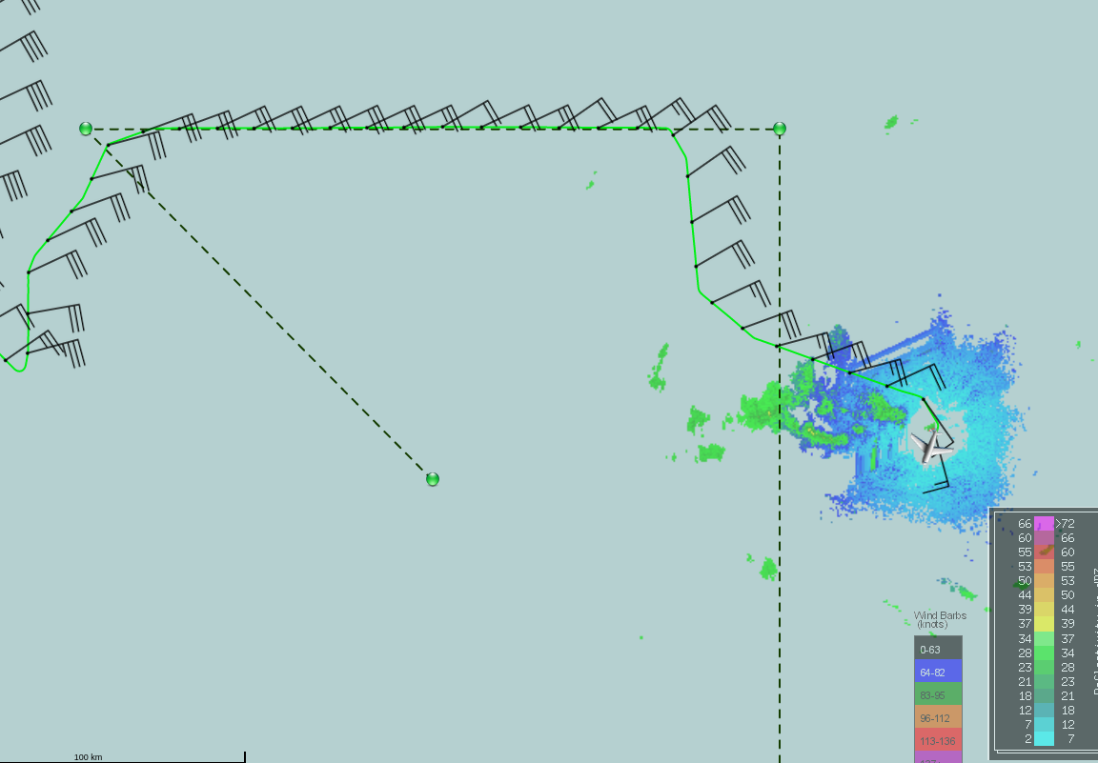
1839 | Much less precip down to the SE, continuing SW to see if there is a westerly wind  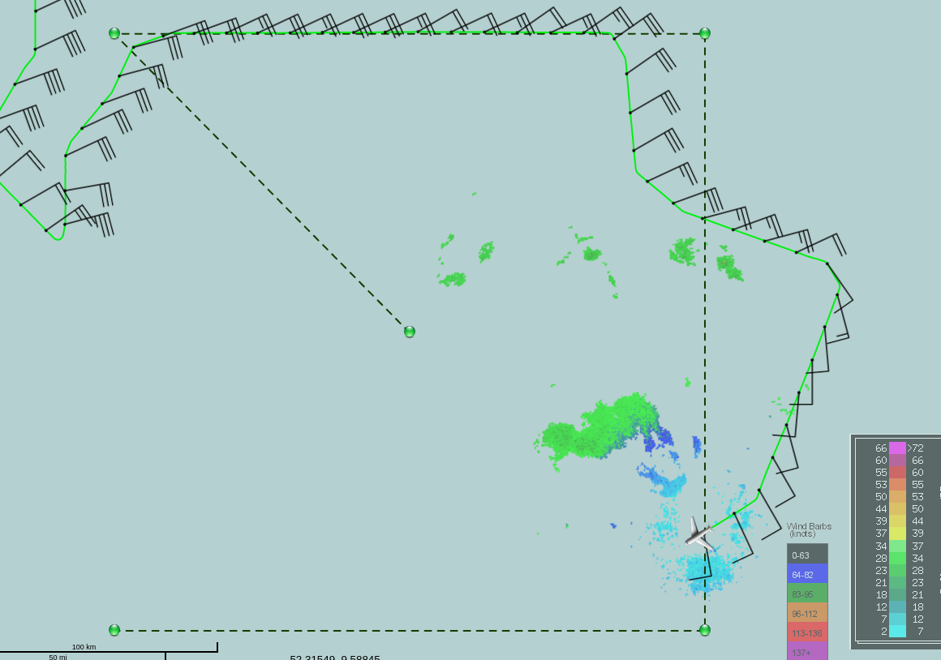  So far, just evidence of a convergent boundary in the middle of the box
1857 | Forecaster now requests we just fly NW. Not much precip, though MMR shows some cells to our north.  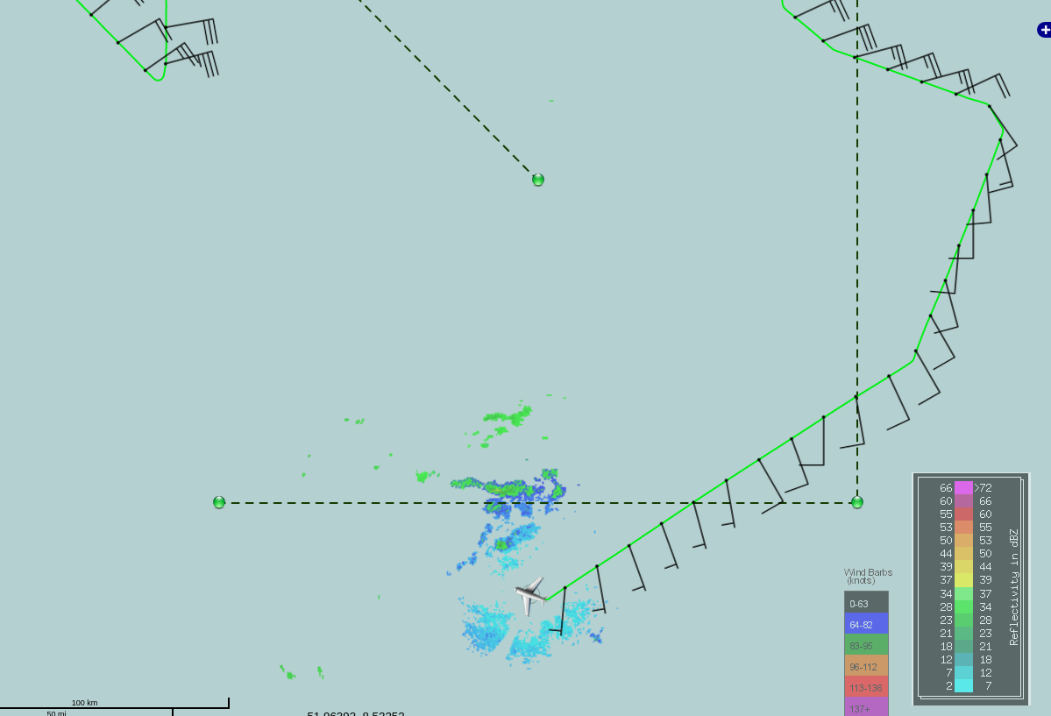
1915 | Continuing to the northwest, but winds at flight level have come back around to easterly  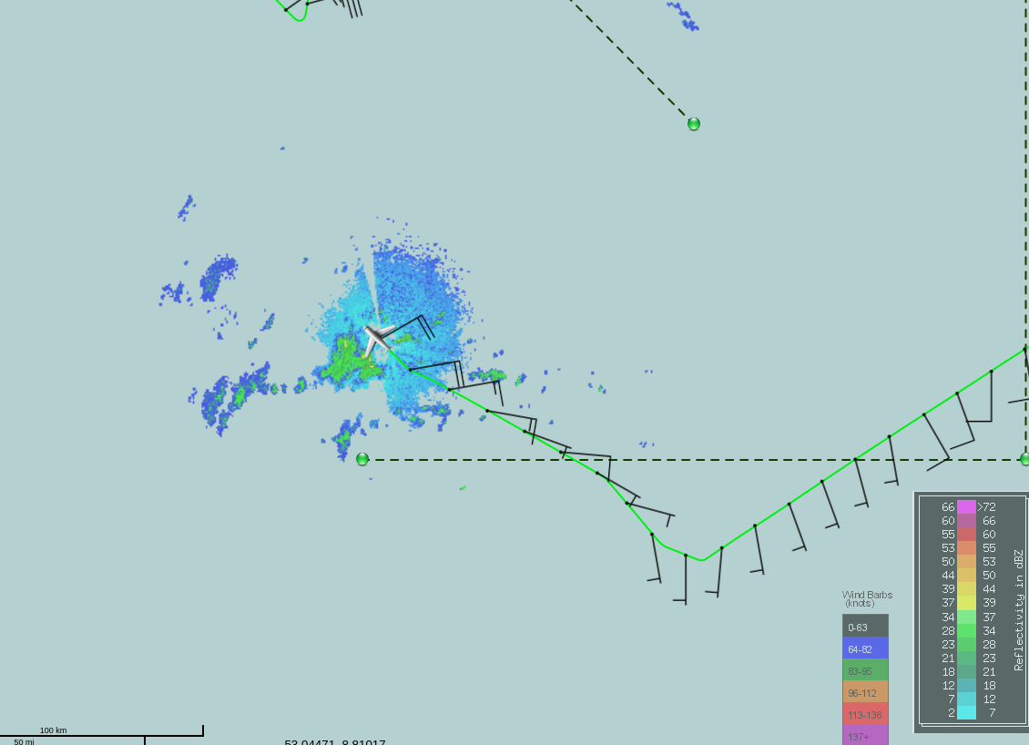
1935 | Continuing NW, but no sign of winds – just back into the easterles; so far probably spotted the wave trough aloft with the TDR, and just a SW to NE elongated convergence boundary near the surface.  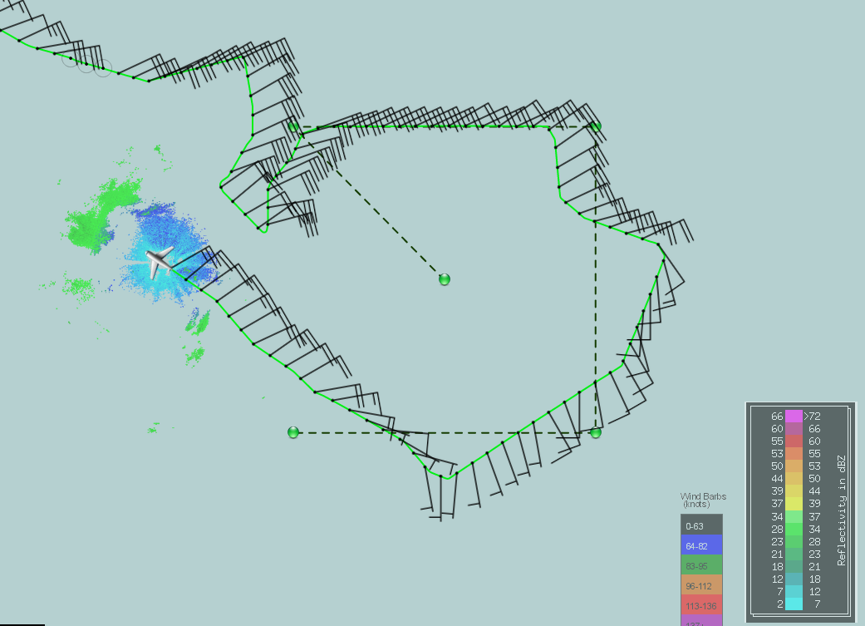
1942 | Forecasters request to head 045 to northeast to 10N to confirm the stronger winds we saw on the north side of the pattern previously, then cleared to head home. Currently flying on the periphery of a fairly widespread stratiform area:  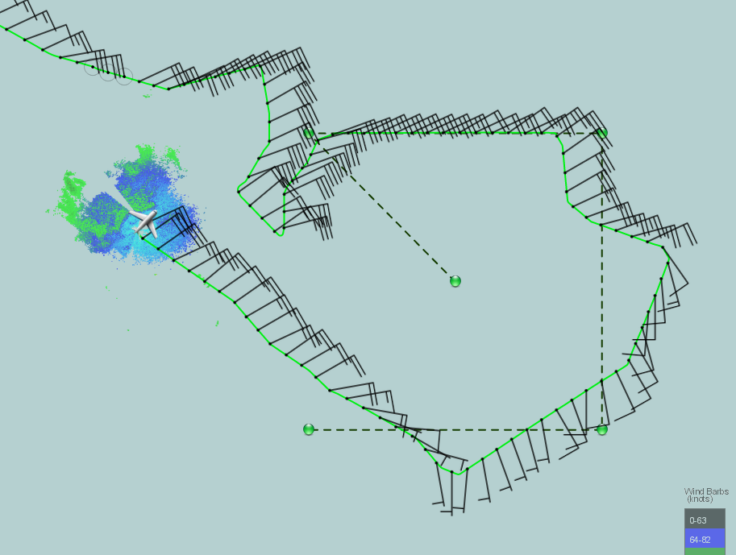
2021 | Starting to climb to work our way back to Barbados, but will pick around some cells to our W / NW. Nothing remarkable in the winds.  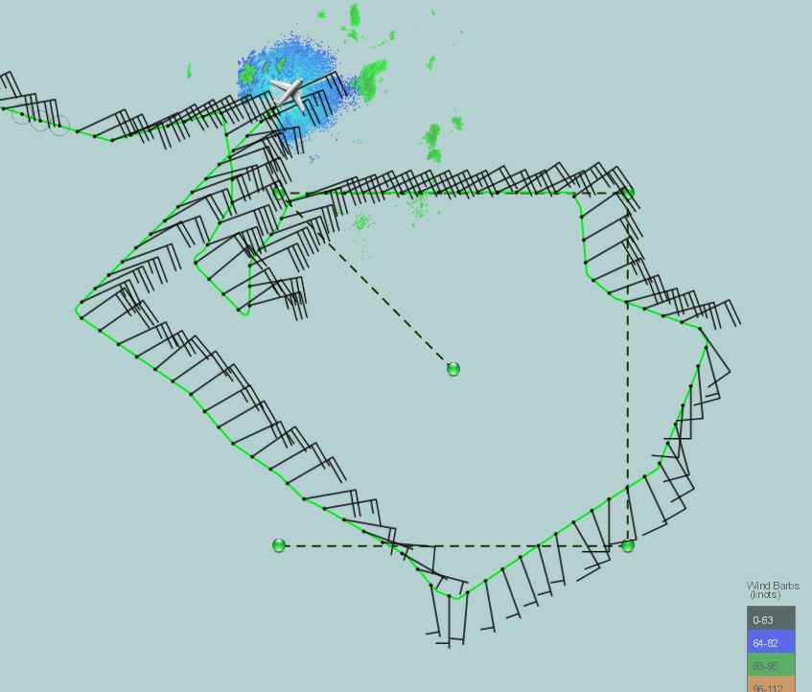
2030 | The final pattern…  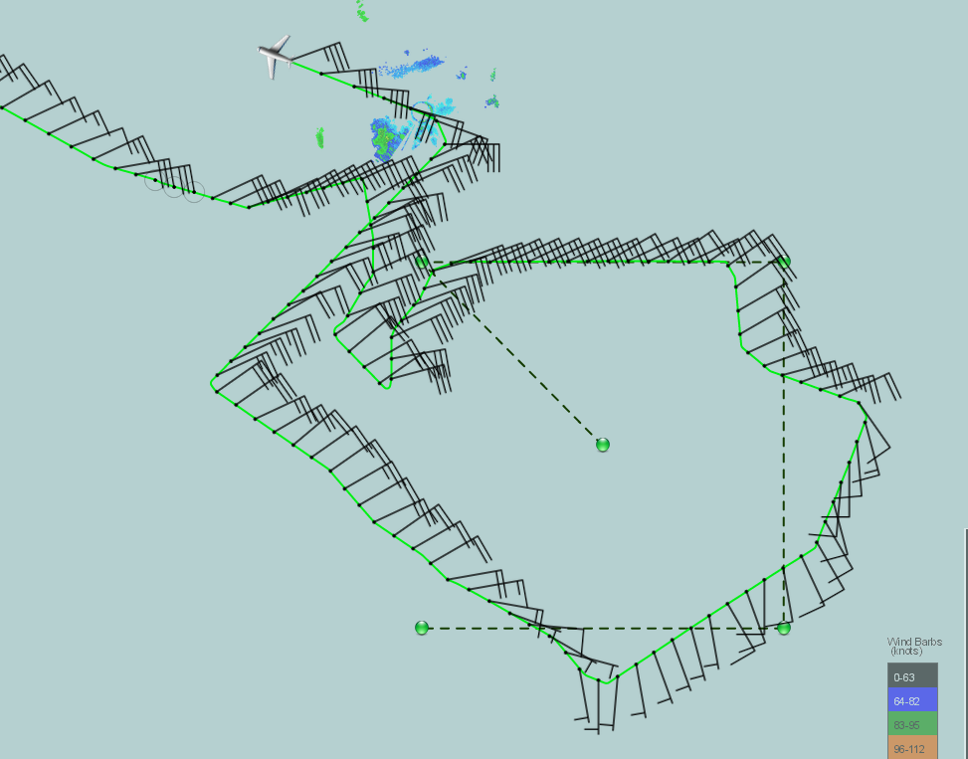  The final TDR swaths…  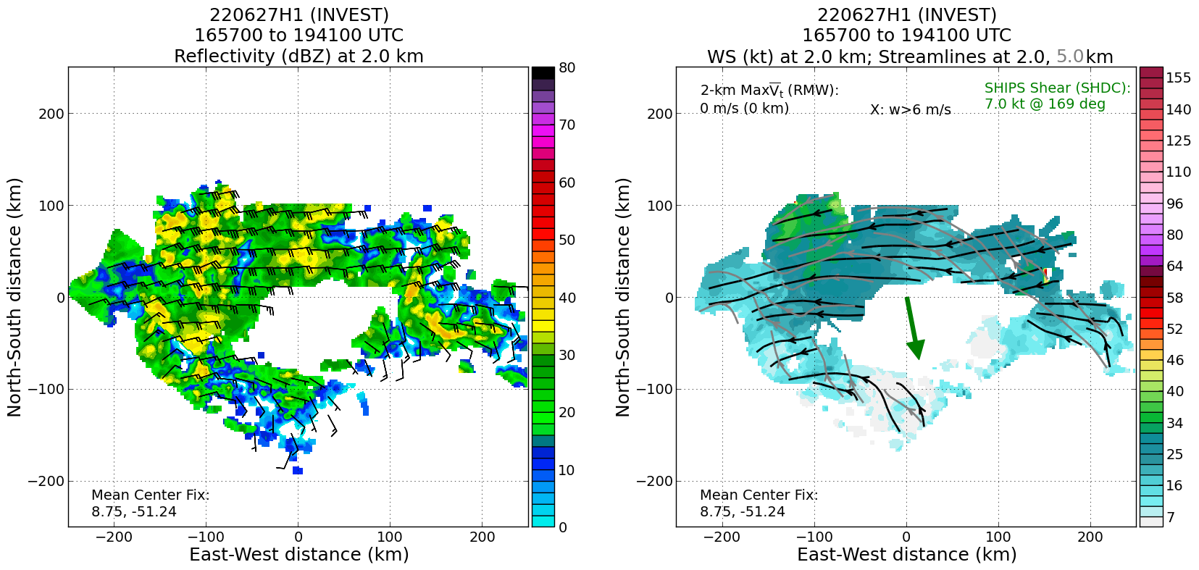  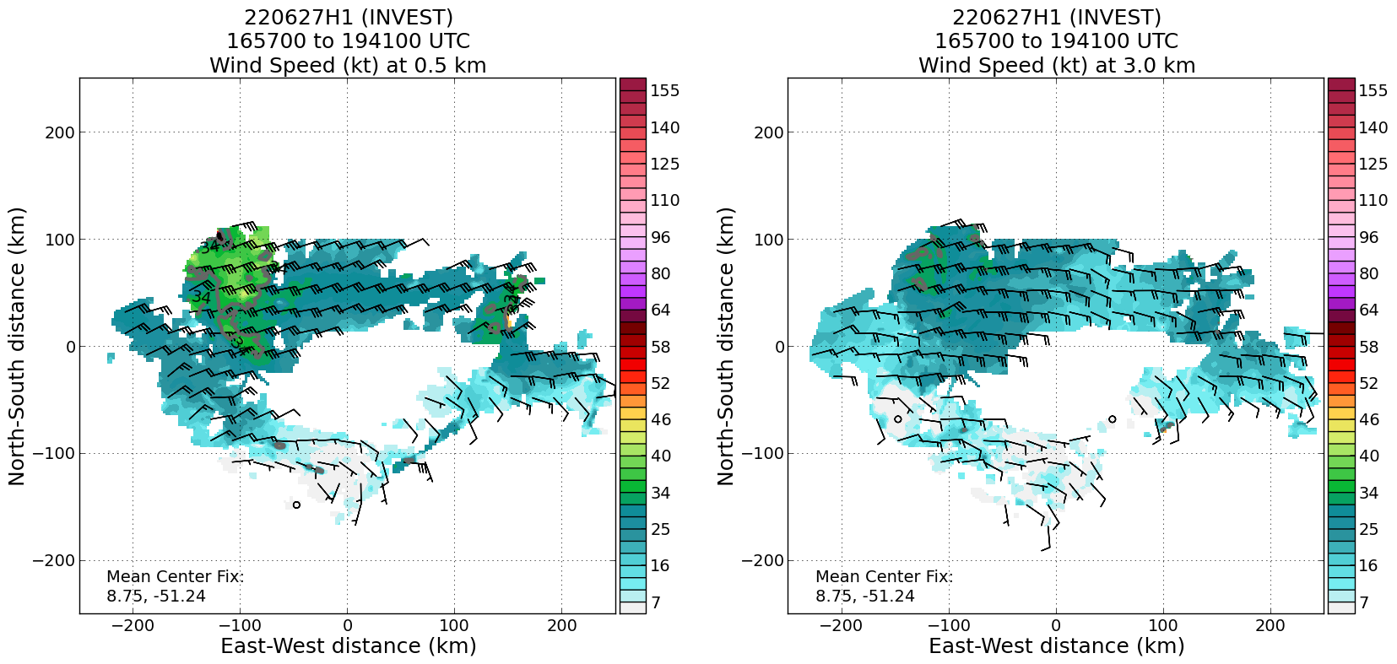  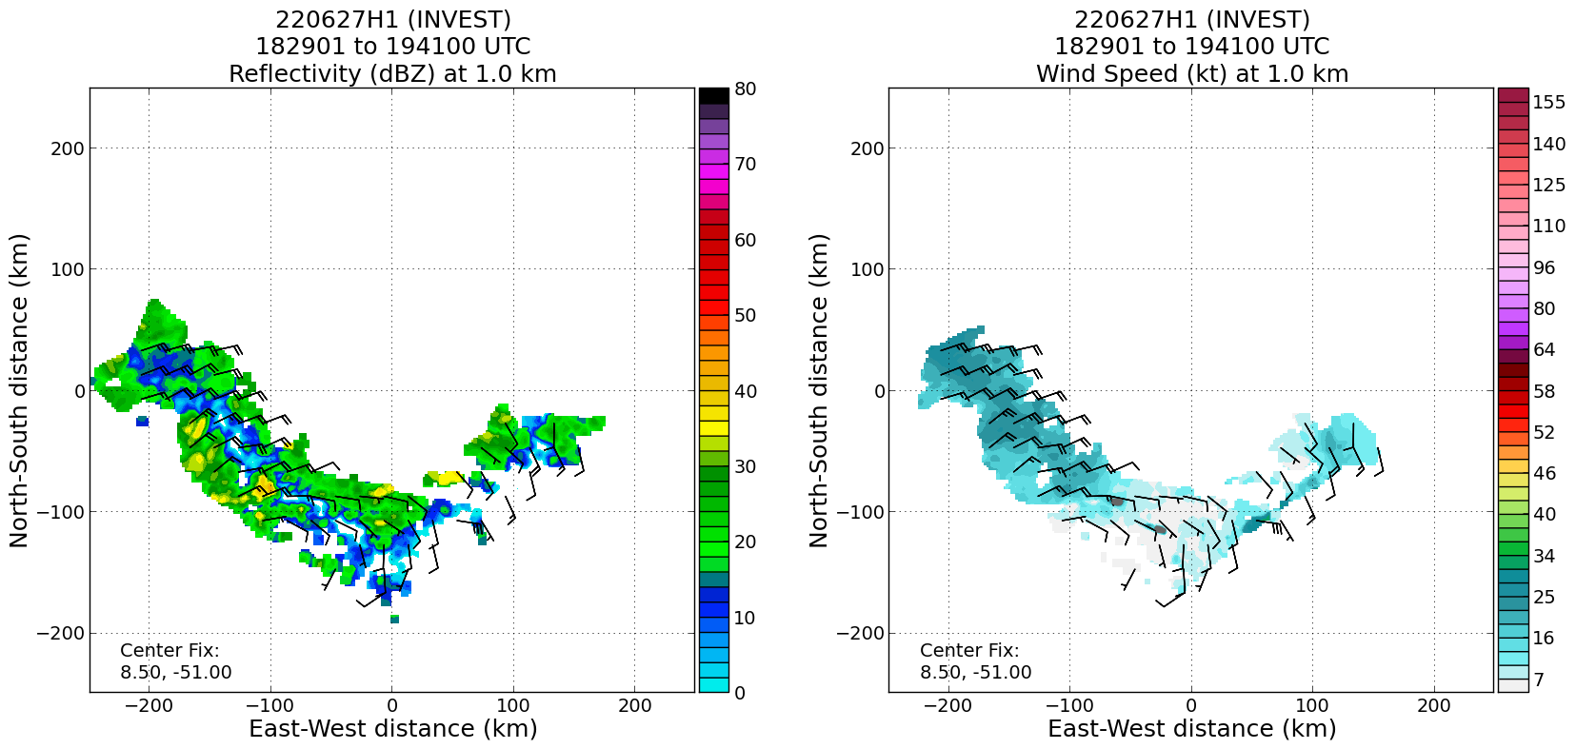  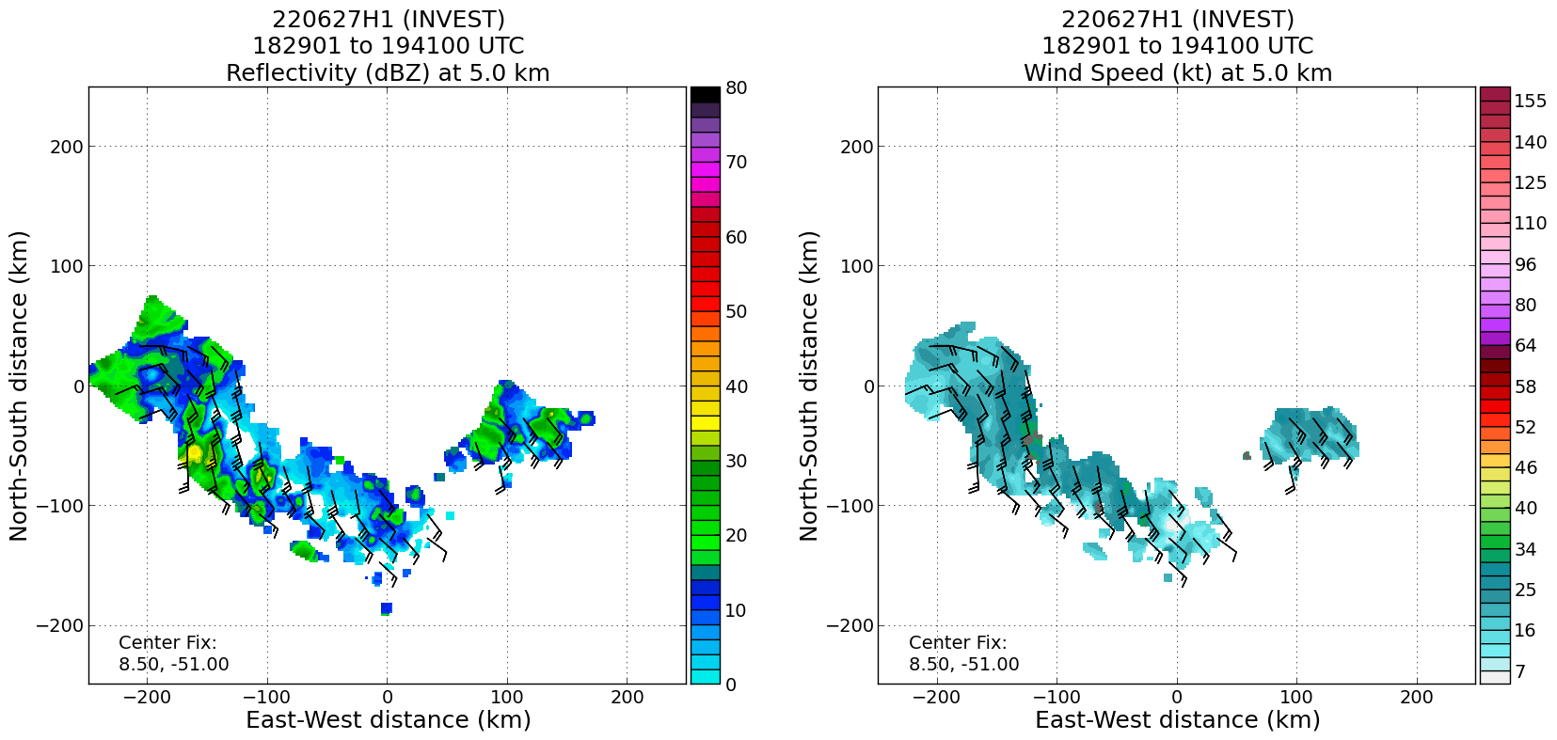  What stands out in the TDR analyses above is, 1) that SW to NE oriented trough axis at low levels (1 km), and a fairly robust wave trough at 5 km. It appears that we were just too far east, where the flow was mostly easterly in the northern part of the pattern, and converging southerlies on the southern portion of the pattern. Had we spent time further west, we would have observed the midlevel wave trough, and potentially something closer to a circulation near the surface.
2145 | Landed in Barbados

POST-FLIGHT
Mission Summary | The invest box pattern was flown, although with quite a few deviations due to cellular convection in the pattern area. We didn’t see westerly winds, but did observe two interesting features…an elongated trough axis (more or less oriented WSW-ENE) in the lower troposphere, and a robust trough axis oriented more or less SSW-NNE in the midtroposphere (5 km) in the western portion of our pattern. It appears that our pattern work was simply too far east. There is a decent midtropospheric wave trough, with a strong convergent boundary just to the southeast. Again, the surrounding environment is favorable for genesis to occur, and the convective activity near the midtropospheric wave trough may be key to the development of this potential storm.  We did observe tropical storm-force winds in the northern portion of the wave trough, which in part led NHC to upgrade the system to PTC02 in the 5pm ET advisory, despite the circulation not being “closed.”  Because of the low altitude, no dropsondes were launched. There were 2 AOC AXBTs launched in support of the effort to test the transmission of that data to the ground. The first AXBT did not collect data, but the second did.
Actual Standard Pattern Flown | Invest pattern, “box”, so it was non-standard
APHEX Experiments / Modules Flown | Genesis Experiment: PREFORM (some of the TDR data will be helpful for context about the wave trough evolution, if we fly subsequent missions, but otherwise not a substantial dataset for genesis studies.
Plain Language Summary | - An NHC Invest mission was flown to broadly investigate a potential developing area of convection associated with a wave trough in AL94.  - While the pattern appeared to be centered too far east, the tail Doppler radar data did show evidence of a strong, convergent trough axis in the lower troposphere (oriented from WSW-ENE through the pattern area) and a SSW-NNE oriented, robust trough axis in the middle troposphere.  - Tropical storm-force winds were observed near the surface, therefore providing some evidence for NHC to upgrade the system to a Potential Tropical Cyclone (PTC-02).
Instrument Notes | WSRA and CRL were not operational
Final Mission Track | 