MISSION PLAN
FLIGHT ID | 20210907I1 | STORM | AL12 / LARRY
MISSION ID | WE12A | TAIL NUMBER | NOAA43
TASKING | NESDIS | PLANNED PATTERN | Alpha
MISSION SUMMARY
TAKEOFF [UTC] | 1709 | LANDING [UTC] | 0108
TAKEOFF LOCATION | St. Croix | LANDING LOCATION | St. Croix
FLIGHT TIME | 8.0 | BLOCK TIME | 8.2
TOTAL REAL-TIME RADAR ANALYSES  (Transmitted) | 4 (4) | TOTAL DROPSONDES (Good/Transmitted) | 5 (4/4)
OCEAN EXPENDABLES (Type) | None | sUAS (Type) | None
APHEX EXPERIMENTS / MODULES | Mature Stage Experiment: NESDIS Ocean Winds
HRD CREW MANIFEST
LPS ONBOARD | Holbach | LPS GROUND | Zawislak
TDR ONBOARD | Holbach | TDR GROUND | Alvey, Gamache
ASPEN ONBOARD | Hazelton | ASPEN GROUND | None
NESDIS SCIENTISTS | Chang, Jelenak, Sapp
GUESTS (Affiliation) | None
AOC CREW MANIFEST
PILOTS | Didier, Copare, Stateler
NAVIGATOR | Hough, B. Richards
FLIGHT ENGINEERS | Darby, Bennet
FLIGHT DIRECTOR | Holmes
DATA TECHNICIAN | Mascaro
AVAPS | Warnecke

PRE-FLIGHT
Flight Plan | 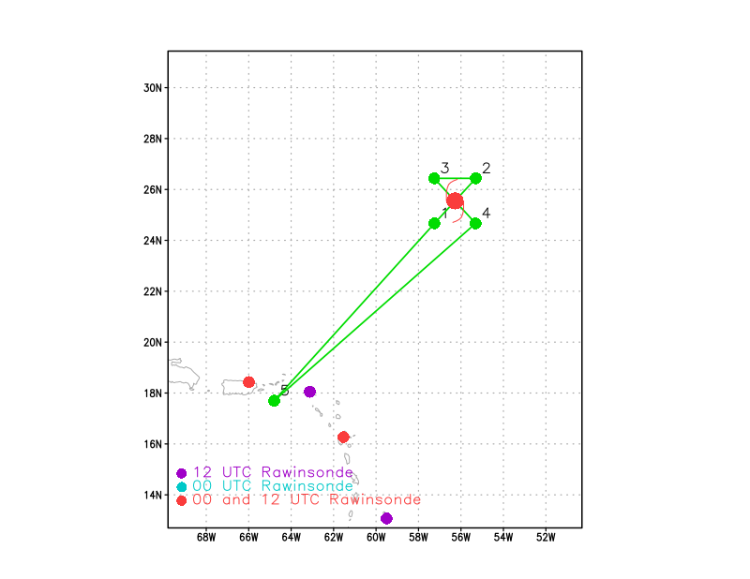  This is just the initial pattern for surveying the circulation and fixing the center. After completion of this Figure-4, then NESDIS Ocean Winds will proceed into it’s radial legs module. Also timed for an underpass of the Sentinel-1 overpass.
Expendable Distribution | Center sondes charged to NWS for NHC, all other sondes in RMWs for NESDIS Ocean Winds
Preflight Weather Briefing | As of the 2PM EDT NHC Advisory, Hurricane Larry is located near 24.8N / 55.8W, has maximum sustained winds of 100 kt, a central pressure of 967 mb, and is moving northwest at 8 kt. The storm appears to have weakened somewhat since yesterday with the Air Force finding somewhat lower winds and higher pressure in their fix flight this morning. The appearance of Larry has also degraded somewhat given that the inner core and eye has a more ragged appearance compared to yesterday. It’s possible that dry air may be reaching the eyewall region. The deep-layer shear appears low, instead the dry air and perhaps ocean cooling could be contributing to the slow weakening that is now occurring.
Instrument Notes | MMR reflectivity has been lower than expected.

IN-FLIGHT
Time [UTC] | Event
1709 | Takeoff from St. Croix
1718 | TDR online
1809 | Here is the recent satellite imagery of Larry as the P-3 ferries to the storm. Inner core convection appears to be bursting periodically, and spreading downstream before dissipating. So, the eyewall appears to have more transient convection, which is another significant difference from yesterday’s structure.
1813 | MMR online
1828 | Approaching outermost bands of Larry
1841 | Onboard scientist says that they won’t be flying inside the storm at night because of the issue with the MMR. So they took off early.
1844 | The P-3 and the G-IV are now passing in close proximity to each other.  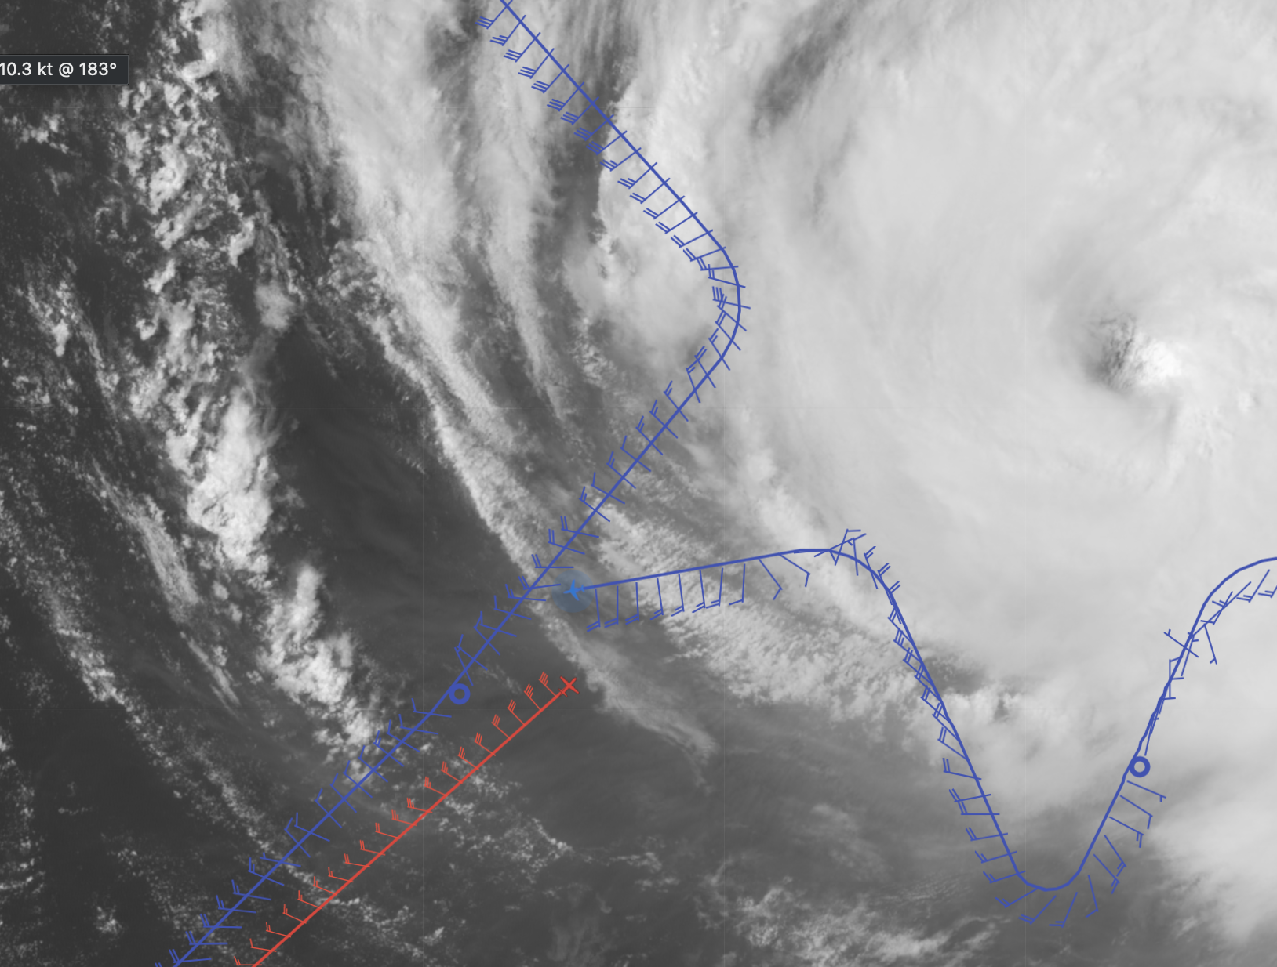  The P-3 is descending and approaching their inbound point. They will come in from the west-southwest.
1910 | Inbound from IP
1912 | GOES GLM showing lightning in SE eyewall
1917 | Flight director noted winds are shifting as we are entering the eye from the SW, which is unusual. Maybe a sign of a meso?
1920 | 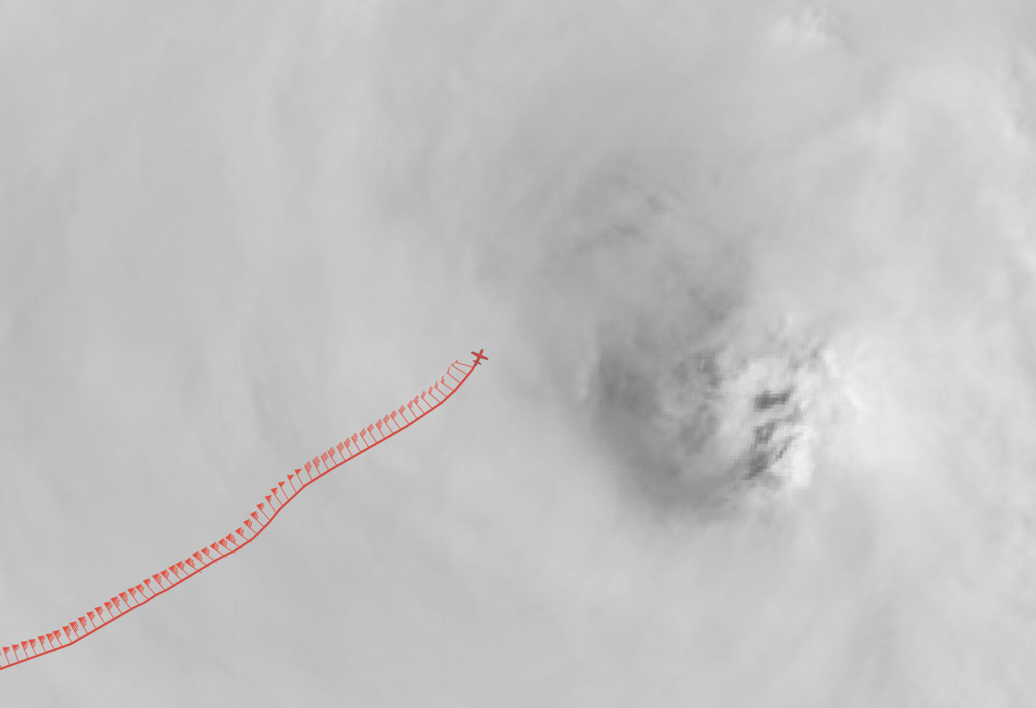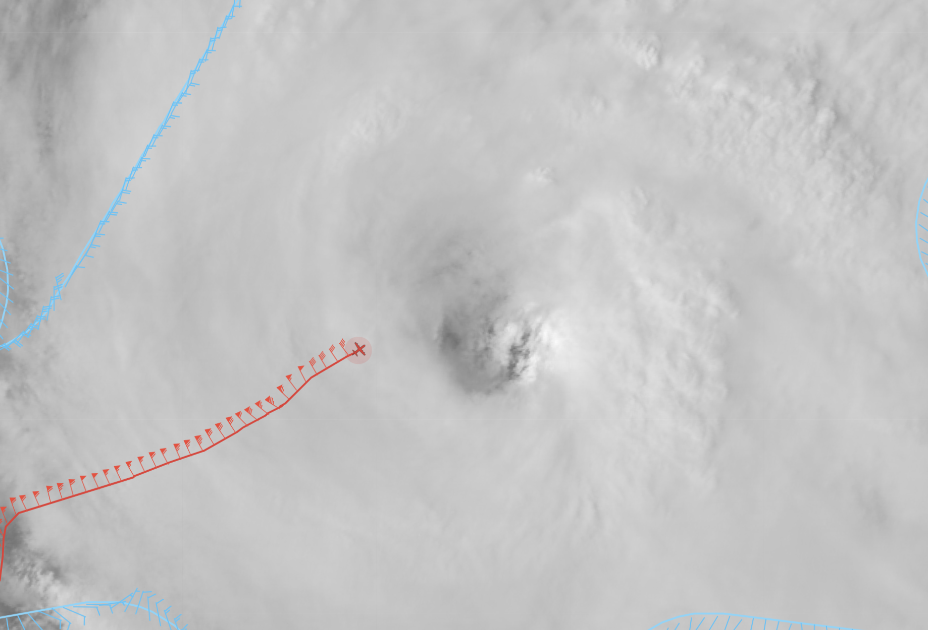  Interestingly the winds peaked about the midpoint of their inbound leg, but now as they approach the eyewall, the winds have dropped below 50 kt, so that means despite the smaller eye on this flight compared to yesterday that the RMW is likely still large.
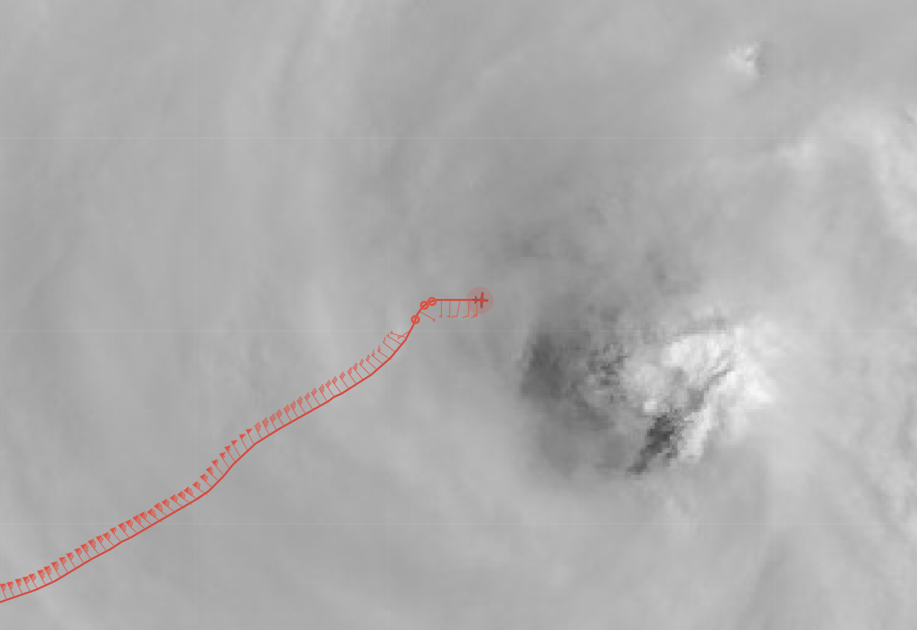
Odd place to mark the center in the above image -- perhaps a parallax in the satellite or perhaps just some cirrus camouflaging what is actually a bigger eye than it appears on the satellite. Considering where they fixed the center, that certainly implies the eye is still large like yesterday.
1922 | Dropsonde #1: Center #1 (NWS) 965 mb 2 kts
1934 | Very broad region of ~45 m/s SFMR outbound to NE
1936 | 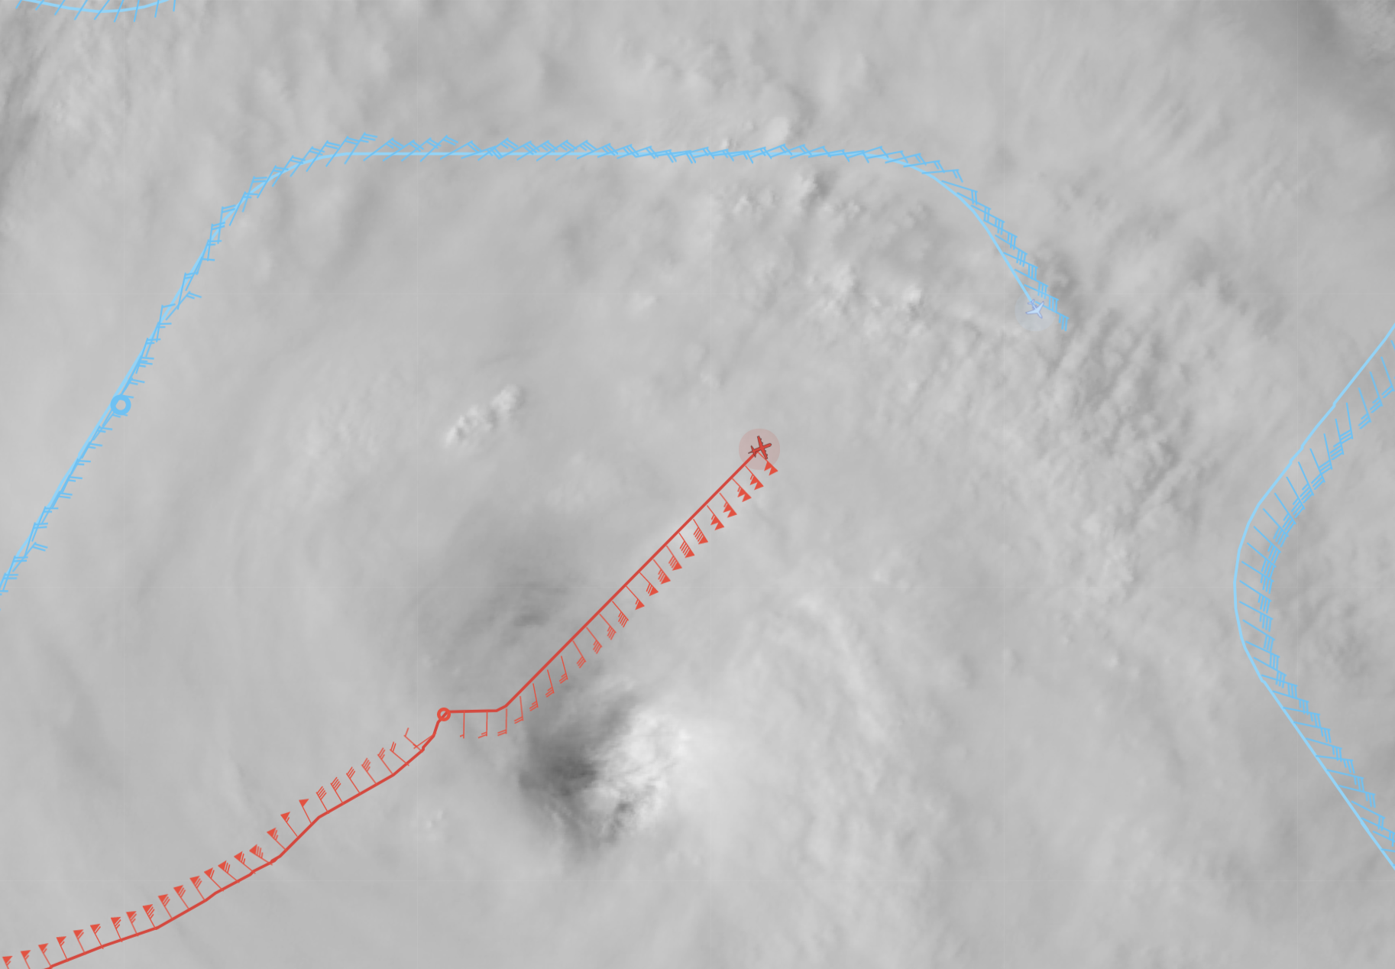  P-3 is now picking up 100+ kt flight level winds, and is approaching the point in the pattern in which the G-IV is on the NE portion of its inner circumnavigation of the inner core.
1945 | 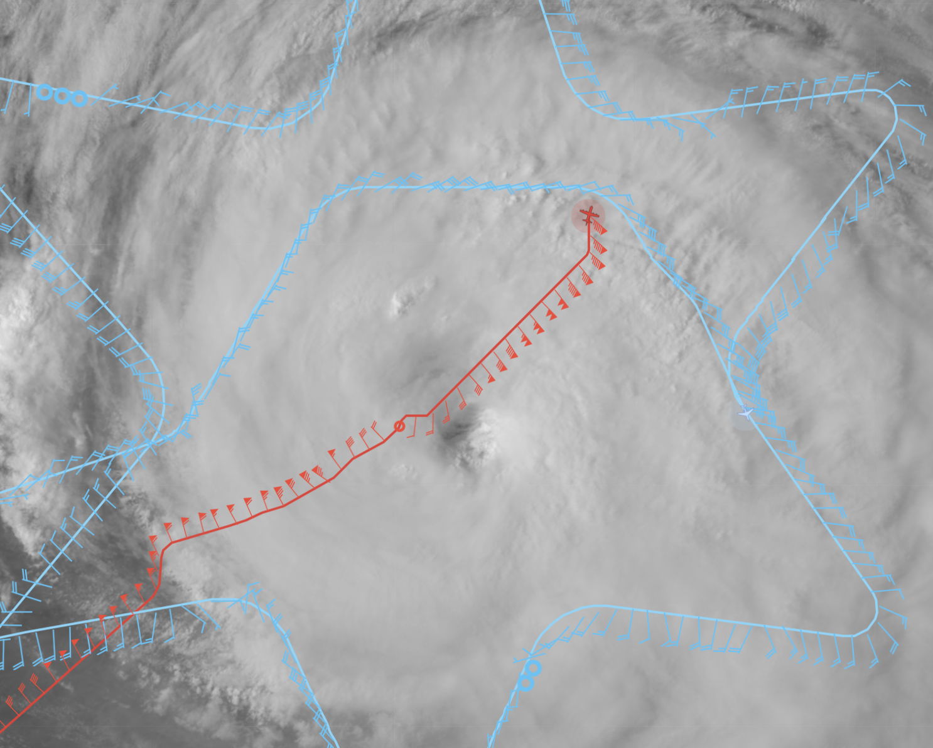  The P-3 is trying to get through a pretty significant outer band, so will exit the storm to the north.  The center sonde at 1922 UTC was 965 mb and only had 2 kt winds, so a good center sonde.
1956 | 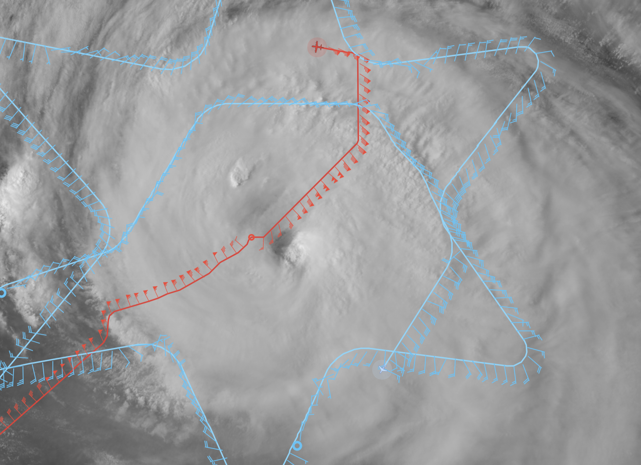  The P-3 is now downwind to the next cross from the NW to SE. The G-IV is completing the SE portion of the inner circumnavigation -- it looks like the G-IV has been flying through plenty of precipitation on the circumnav, although the cirrus is thinning out on the south side.
1958 | Flight level winds ~75 kts, SFMR ~26 m/s on downwind leg
2013 | 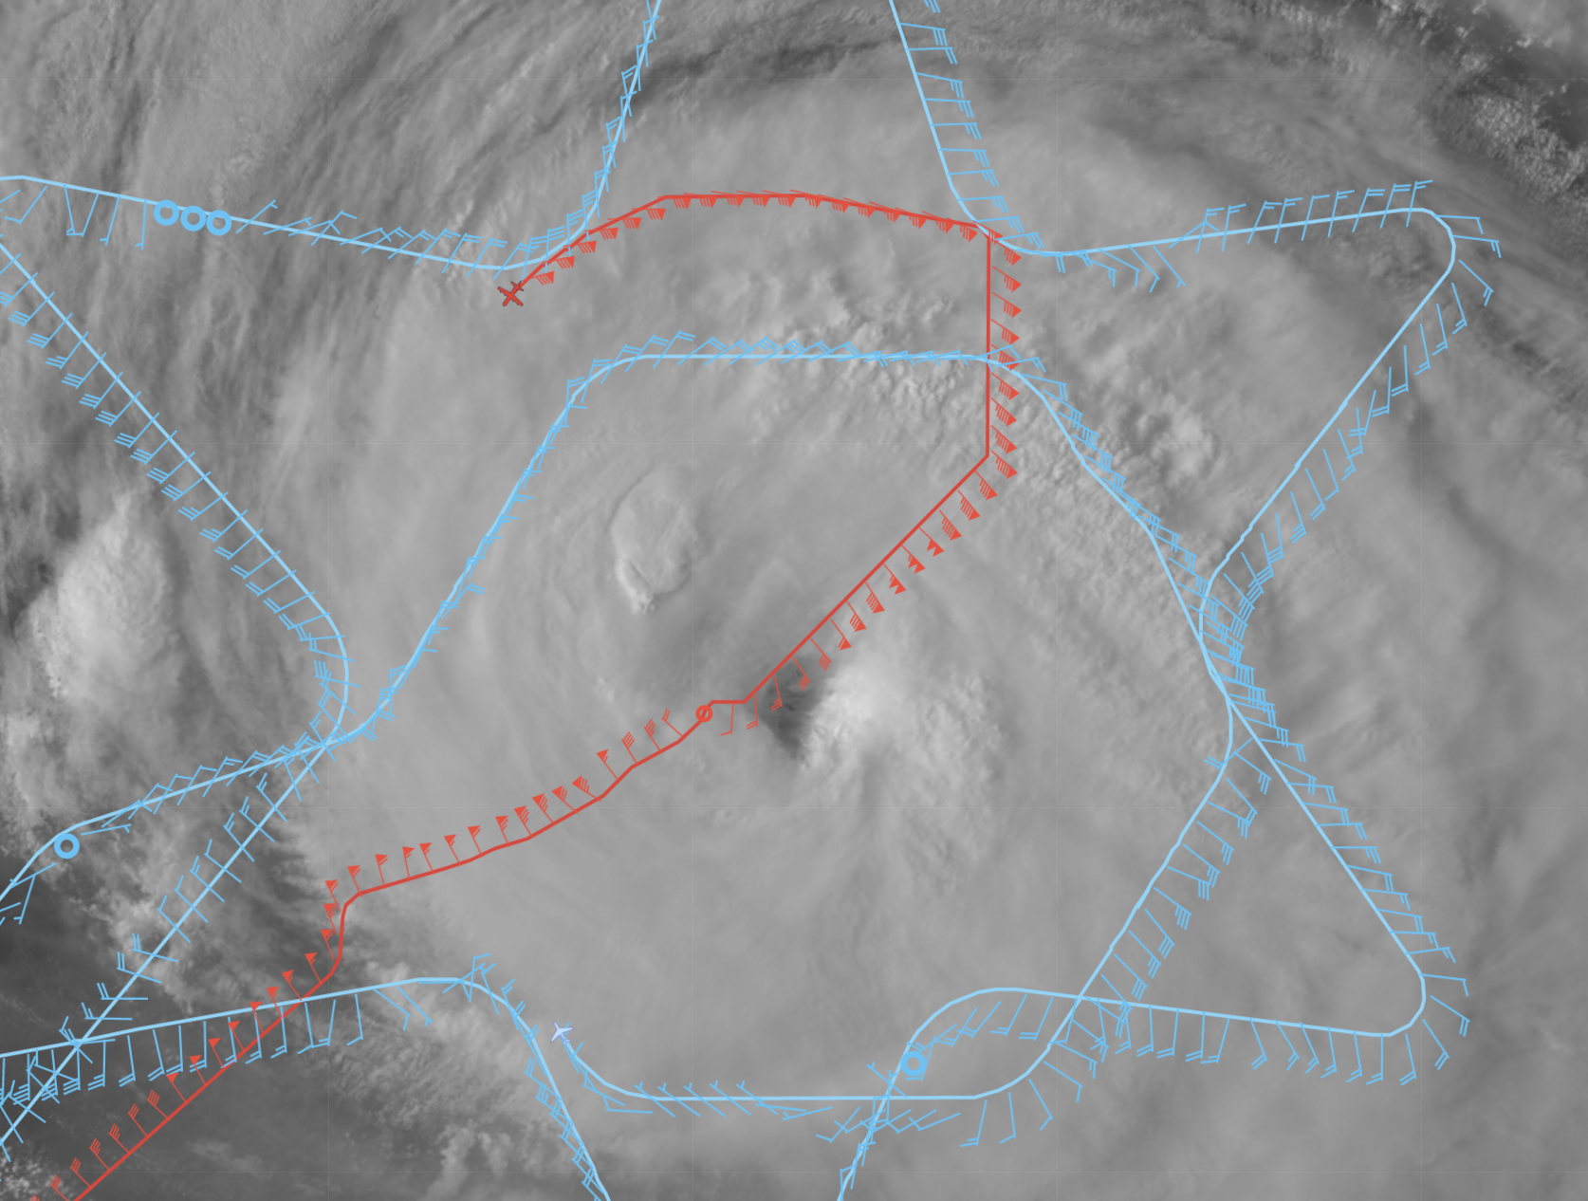  The P-3 flew a bit of curved downwind leg -- not really a band, but precipitation within range of the TDR. The next pass will be NNW and then outbound to the east.
2020 | 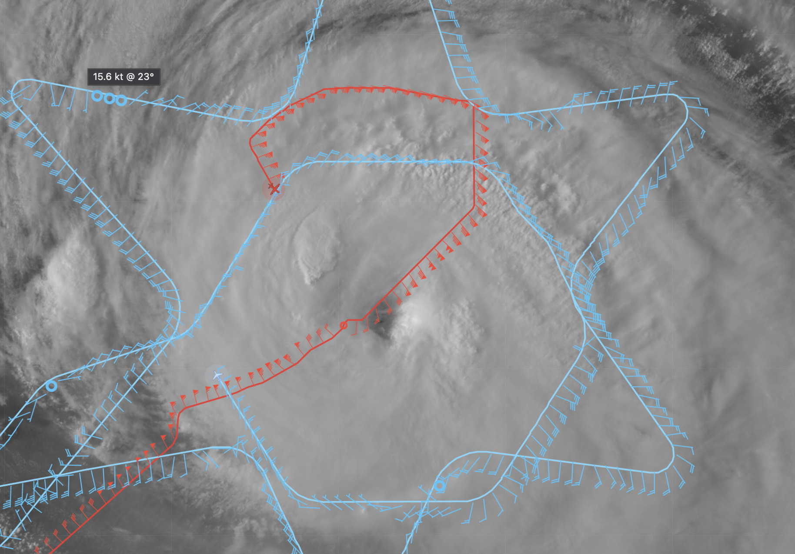  The P-3 now inbound from the NNW. In front of them on the inbound is a new convective burst in the eyewall. From this visible imagery it’s become clearer that the eye is much bigger than we believed earlier as the cirrus was just camouflaging it on the western side. Meanwhile, the G-IV is just about complete with its inner circumnavigation of the inner core. The precipitation coverage from the TDR on the western side appears to be somewhat less than the other sides of the storm.
2027 | 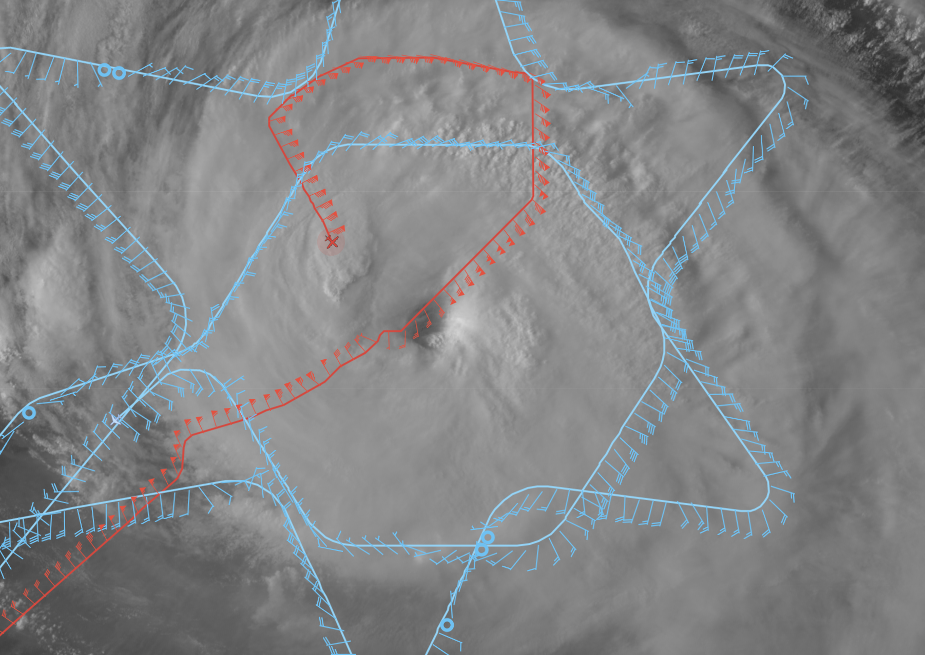  The G-IV has completed the inner core circumnavigation and is now on their way back to St. Croix. Meanwhile, the P-3 is approaching the eyewall, coming in on 330 degrees from the NNW.
2037 | Dropsonde #2: Center #3 (NWS) 965 mb 2 kts  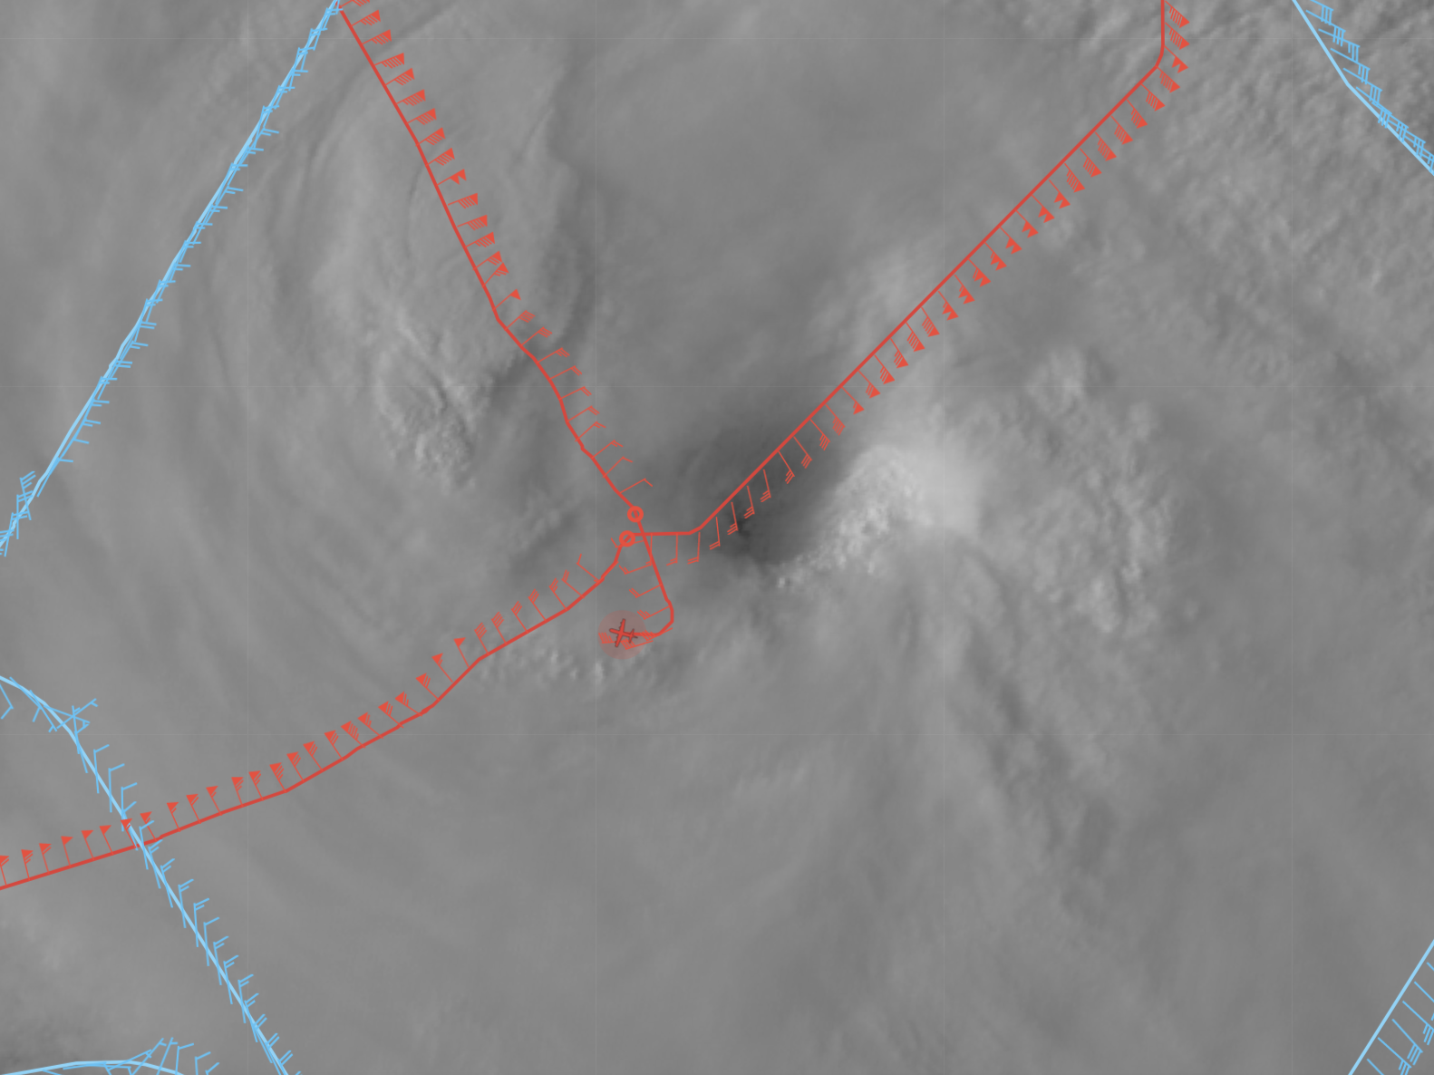  They got some good bumps through that convective burst to the NW. The onboard scientist also noted some “scallops” in the eye/eyewall interface when the MMR was in surface roughness mode.
2043 | TDR analysis of first leg had 115 kts at 0.5km on the NE side
2055 | Loitered briefly in the center to set up the next outbound to the east to complete the “alpha pattern” before heading into the NESDIS Ocean Winds legs.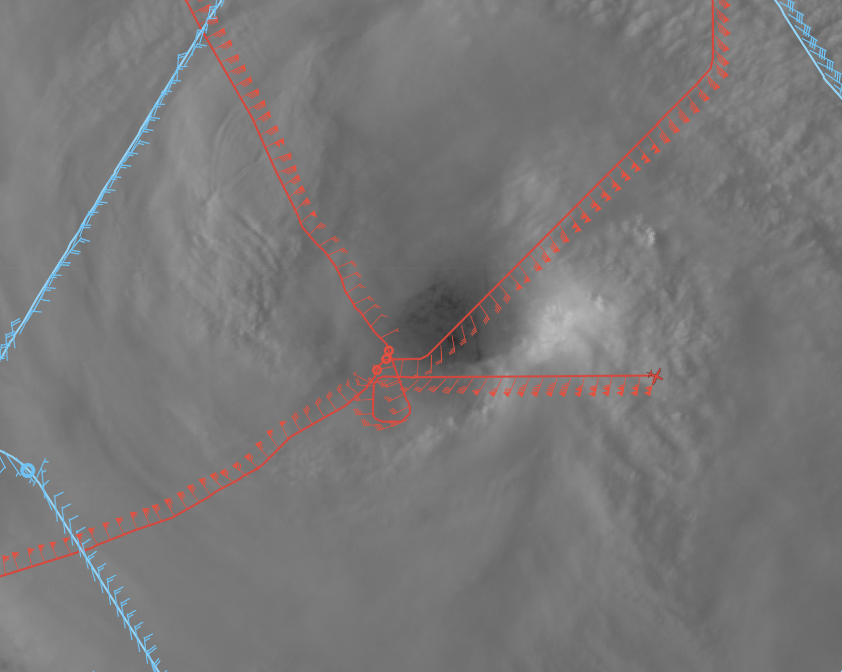
2108 | Very broad wind field with lots of precip containing embedded convective cells on the E side
2109 | Slowly turning downwind. Looking for a place to head inbound on the NE side for the Sentinel-1B overpass
2130 | The P-3 is now back inbound from the NNE for a look at what is likely the highest wind region of the storm -- this is the first of the NESDIS Ocean Winds-specific legs.  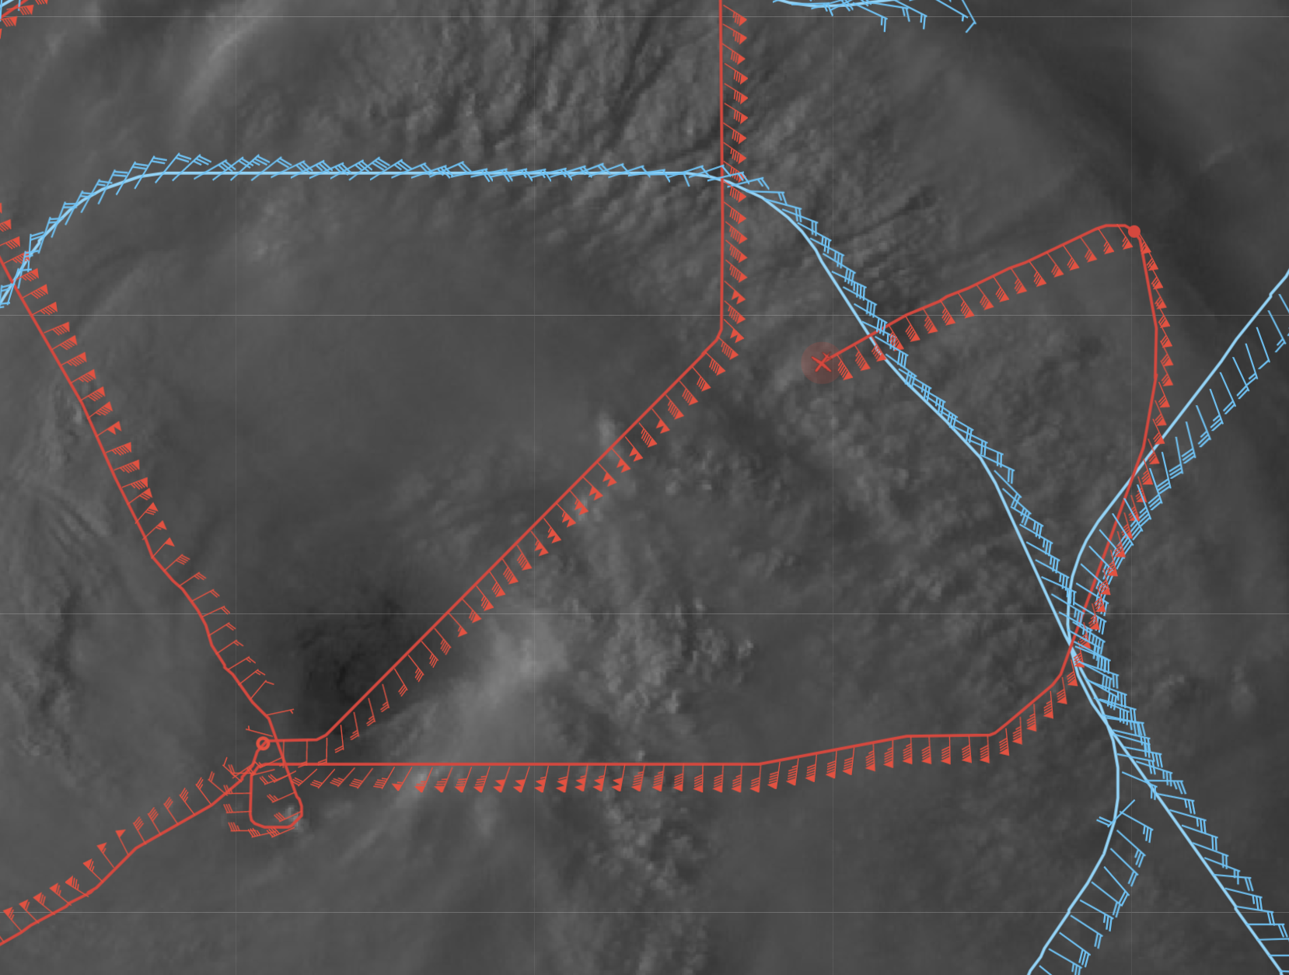
2137 | Dropsonde #3: ENE RMW/eyewall (NESDIS 1), backed up with Dropsonde #4 (NESDIS 2)
2145 | Dropsonde #5: (NESDIS 3)
2146 | Perfectly timed pass through the eyewall as Sentinel-1B passed over Larry
2206 | 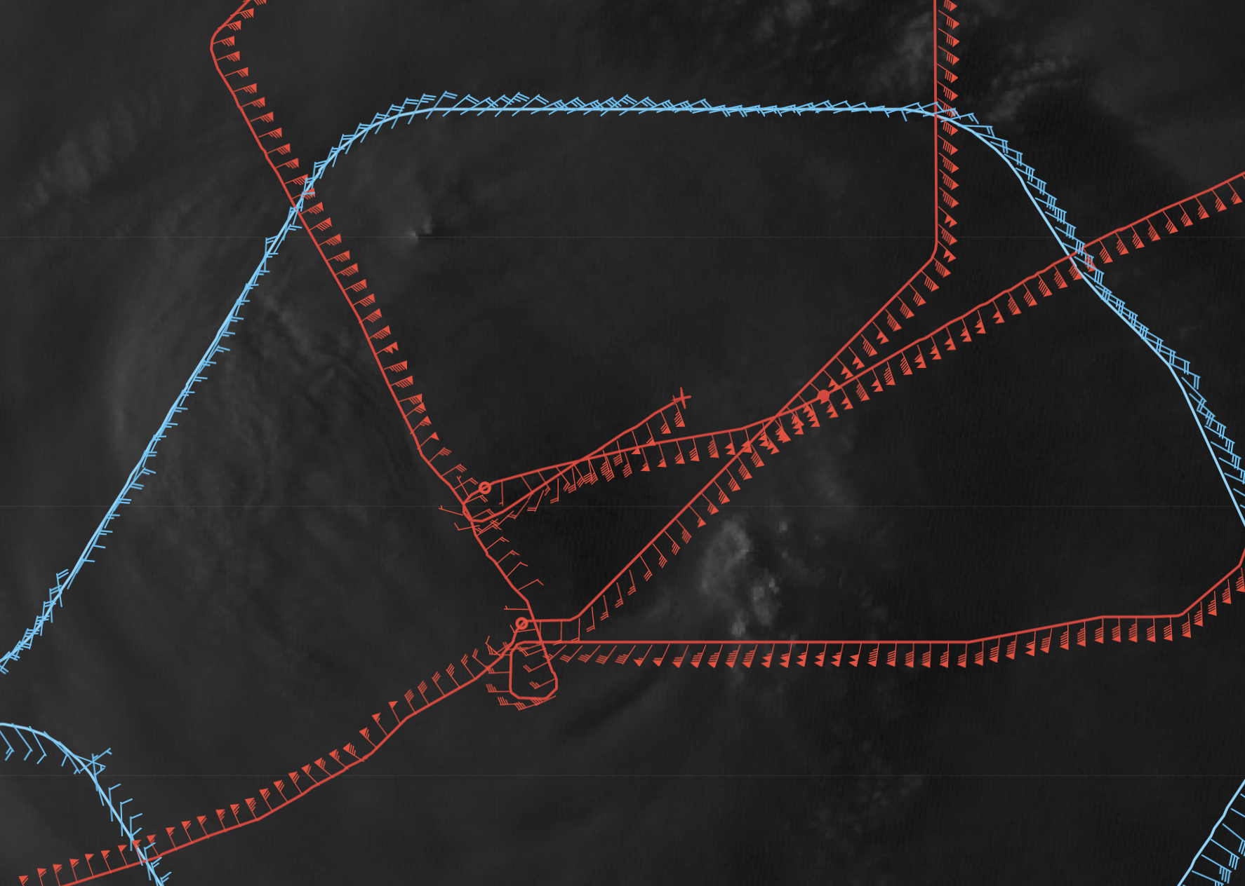  In the last light, the P-3 is now outbound back out to the ENE
2212 | Here’s the composite from the TDR so far after the Figure-4:  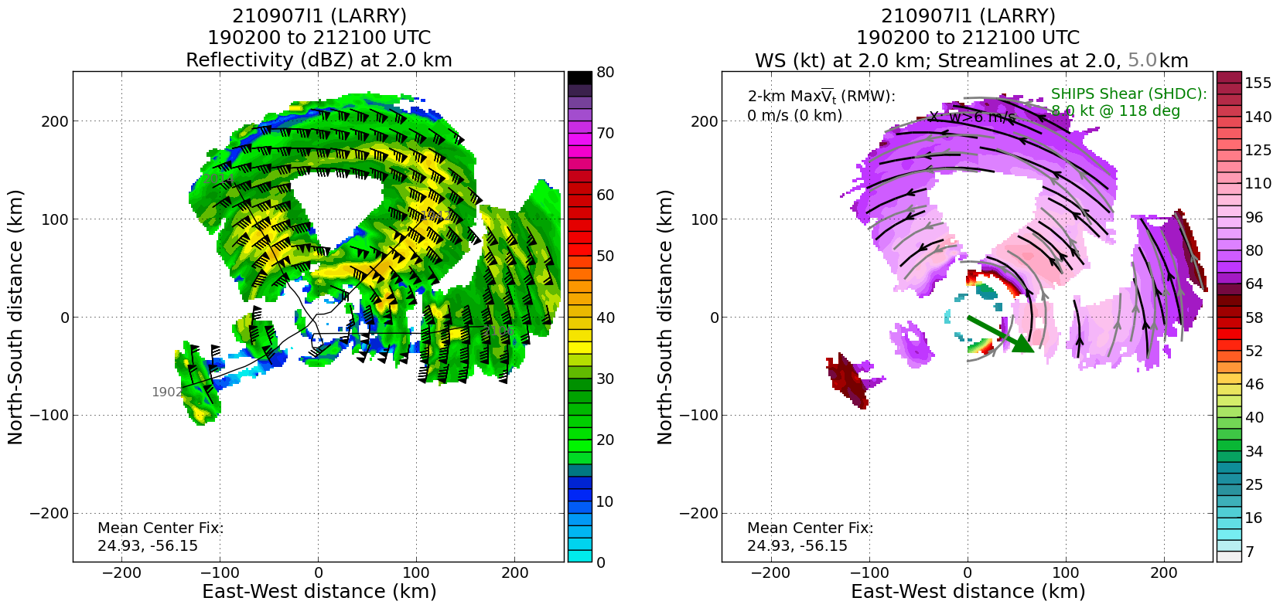  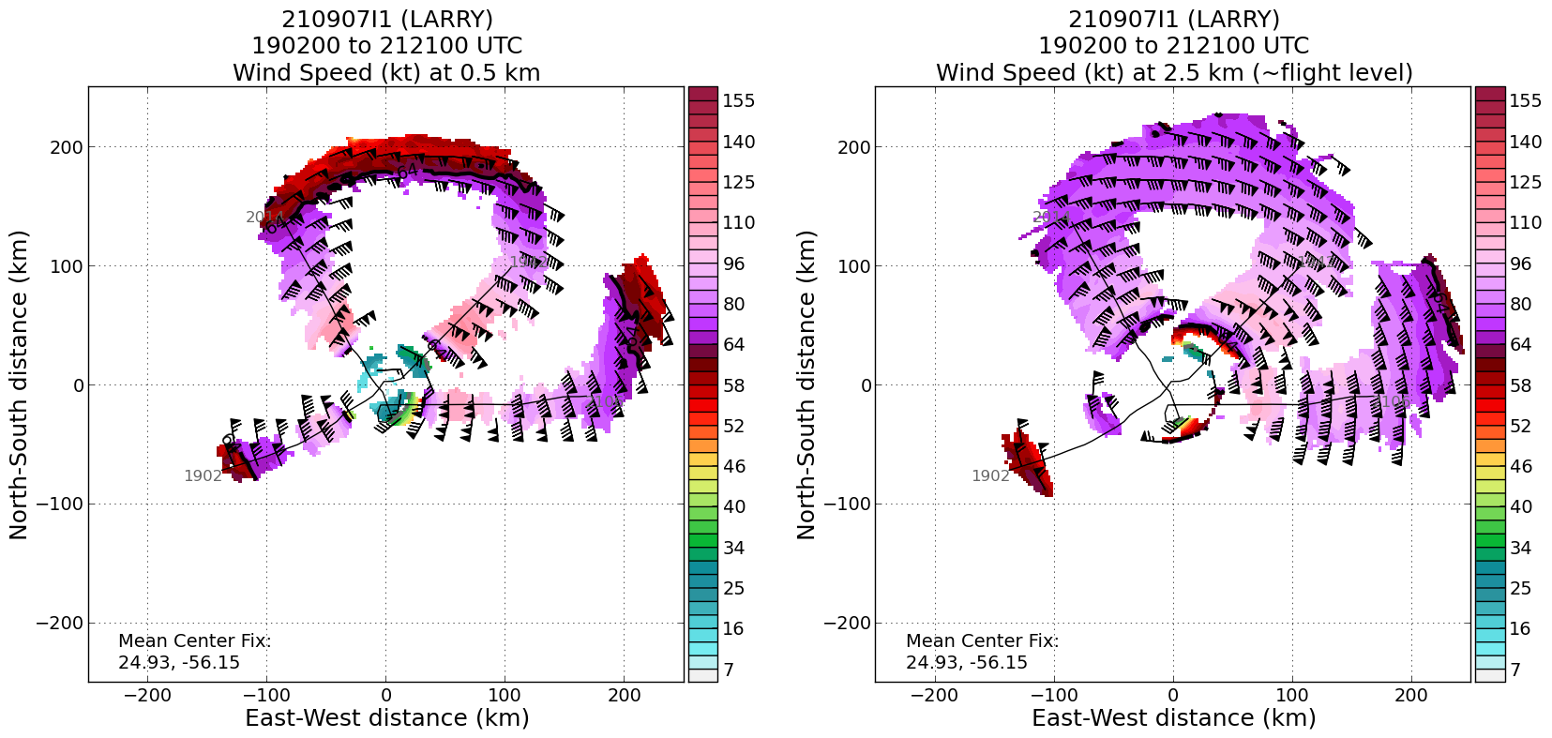
2216 | Onboard scientists say they overflew the splash of the first inbound from the ENE at 2204 UTC on the outbound leg just slightly azimuthal downwind and got a good comparison between SFMR and the splash winds:  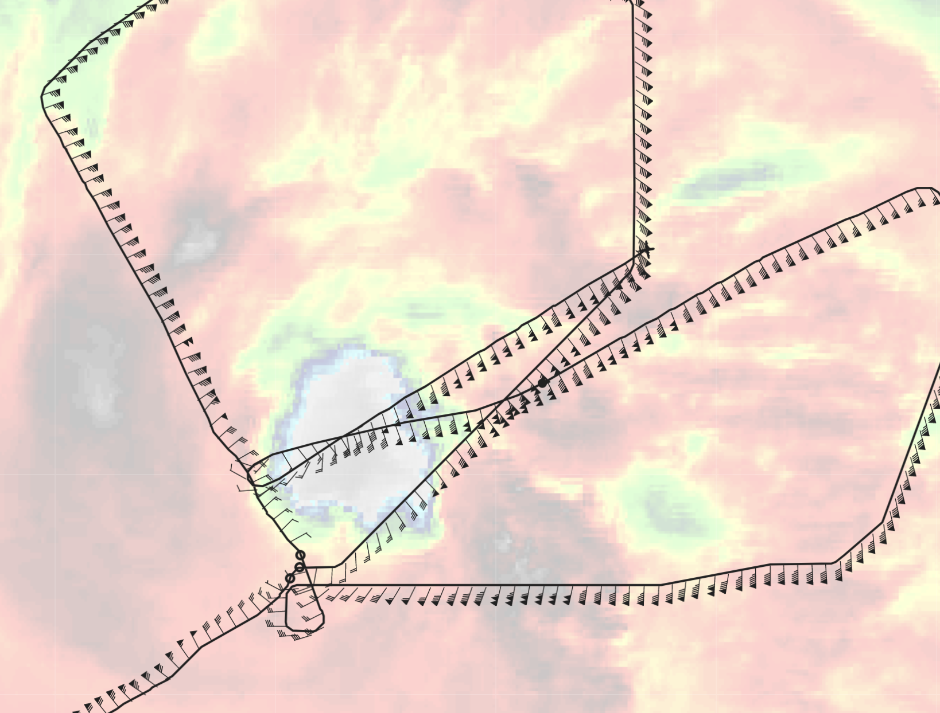  The plan is to fly back inbound over the same track that they just flew outbound on.
2224 | Turning back inbound to the center from the NE  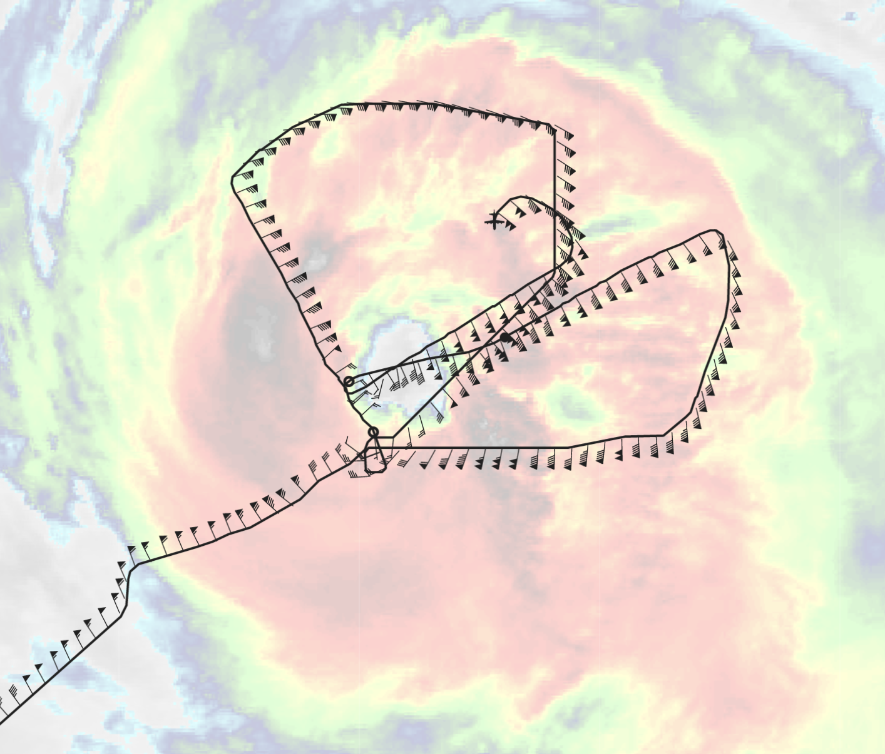  After passing through the center this fourth and last time, they will exit the storm to the southwest.
2243 | The fourth and final fix of the center as they now head outbound towards St. Croix:  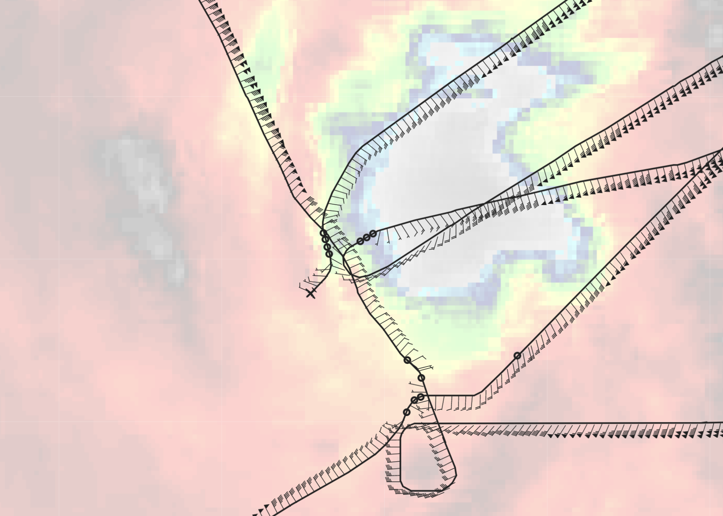
2249 | Onboard scientist is reporting that there isn’t much eyewall to the SW, although a decently formed eyewall was observed from the east side through the northeast. The Flight Director suggested that the western eyewall may be reforming.
2302 | The onboard scientist says that they are now making their way through a very cellular rainband, though from the IR satellite image below, it suggests it’s not particularly deep convection given the warmer cloud tops.  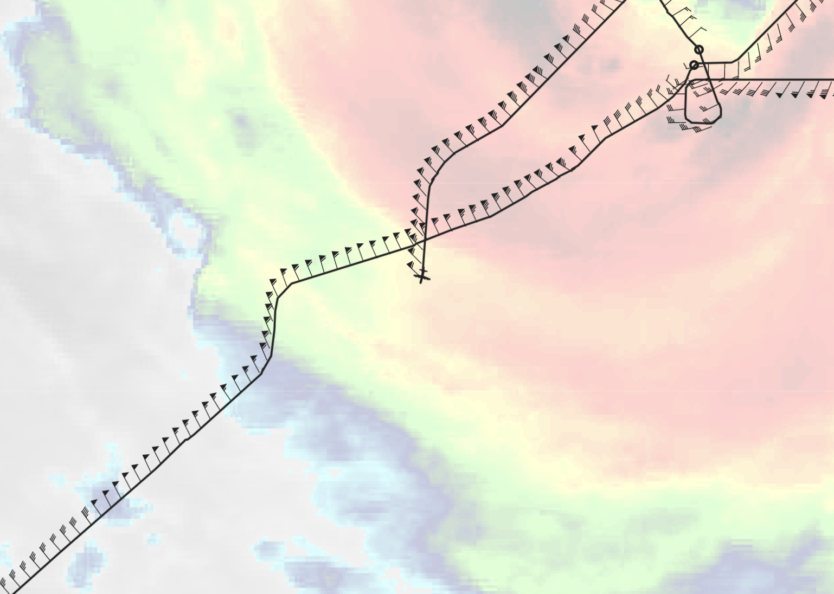
1908 | Climbing out of the pattern to head back to St. Croix. Here is the final image of the pattern:  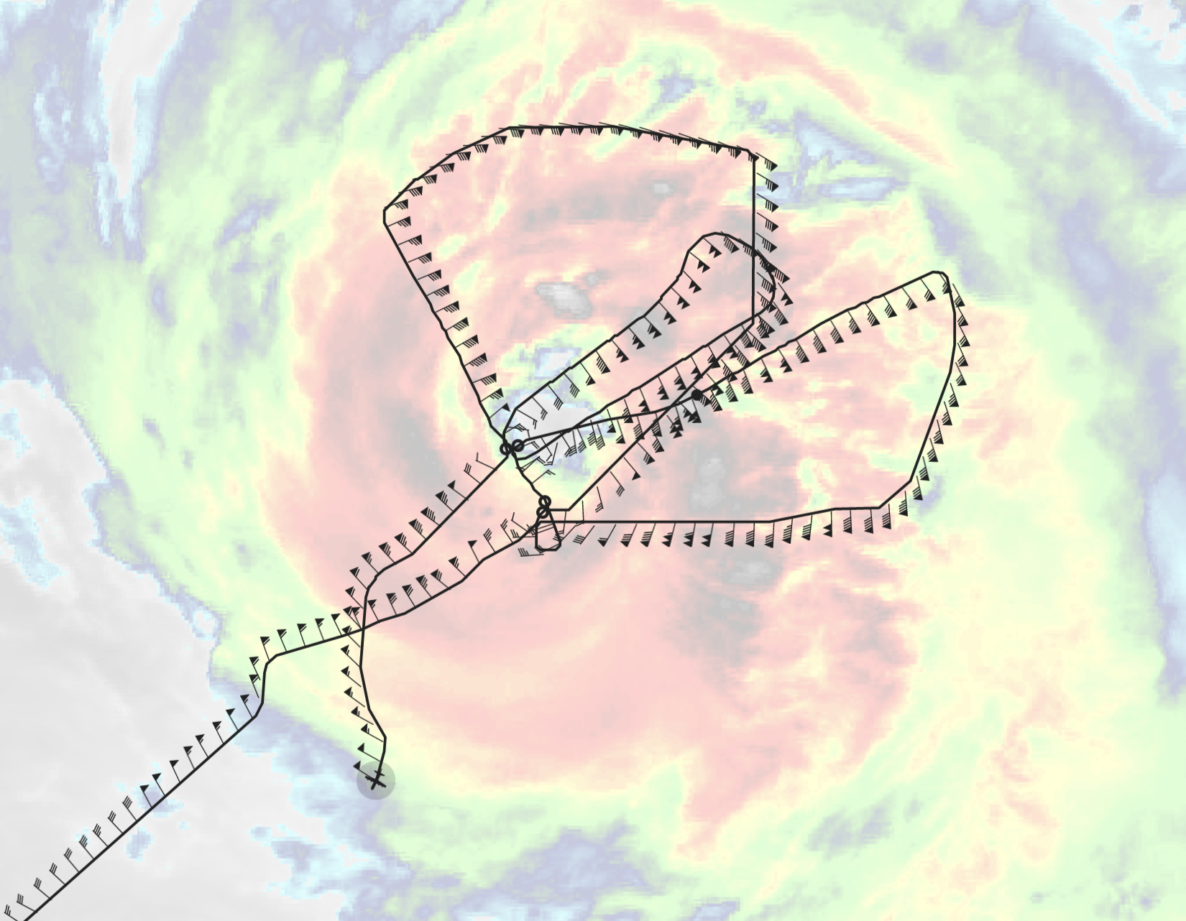
 | The final satellite loops encompassing the mission:
The final TDR composite analysis:

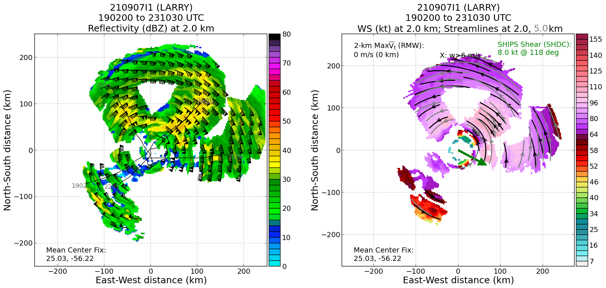
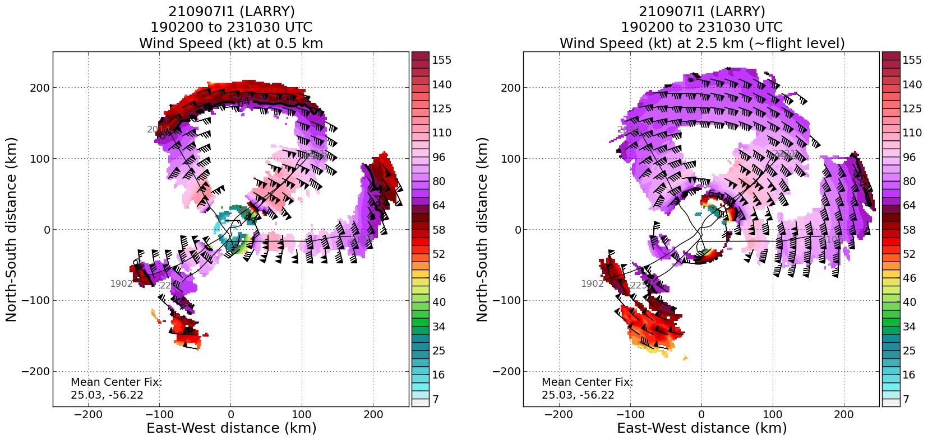

POST-FLIGHT
Mission Summary | This mission successfully sampled the inner core wind field and precipitation for the NESDIS Ocean Winds program, which involved flying an initial Figure-4 pattern from SW to NE, then inbound from the NW and out to the east. The mission was shortened because of the issues involving the MMR, so as to keep the passes of the storm in daylight. After completing the initial survey Fig. 4 pattern, the plan proceeded into the NESDIS Ocean Winds module, which involved flying inbound from the ENE (presumably close to the highest winds regions), dropping a sonde, then flying outbound from the center to the ENE just azimuthally downwind of the radial inbound in order to overfly the splash location of the inbound released dropsonde. They ended by flying back inbound from the ENE and out to the southwest.  5 dropsondes were released, 2 for NHC in the center, and 3 for NESDIS Ocean Winds near the ENE radius of maximum wind.
Actual Standard Pattern Flown | Figure-4 survey initially, then NESDIS Ocean Winds radial legs through the ENE eyewall
APHEX Experiments / Modules Flown | Mature Stage Experiment: NESDIS Ocean Winds; Surface Wind and Wave Validation
Plain Language Summary | - This mission into Hurricane Larry sampled the storm to improve our understanding of microwave retrievals of the ocean surface and atmospheric wind fields, and to evaluate new remote sensing techniques/technologies. And also to help validate satellite-based sensors of the ocean surface in extreme conditions and reduce risk for future satellite missions.
Instrument Notes | MMR was still showing very low reflectivities compared to the nose. It appeared to perform a little better on cellular precipitation that wasn’t embedded. Surface roughness mode was showing more details than NAW (HWX was even worse).
Final Mission Track | 