G-1.2. Provide a concise, technical description of the model including each major component of the model used to produce personal lines residential loss costs in the State of Florida. Describe the theoretical basis of the model and include a description of the methodology, particularly the wind components, the damage components, and the insured loss components used in the model. The description should be complete and not reference unpublished work.
The model is a very complex set of computer programs. The programs simulate and predict how, where and when hurricanes form, their wind speeds, intensities and sizes, etc., their tracks, how they decay and how they are affected by the terrains along the tracks after landfall, how the winds interact with different types of residential structures, how much they can damage house roofs, windows, doors, interior, and contents etc., how much it will cost to rebuild the damaged parts, and how much of the loss will be paid by insurers.

The model consists of three major components: wind hazard (meteorology), vulnerability (engineering), and insured loss cost (actuarial). It has over a dozen sub-components. The major components are developed independently before being integrated. The computer platform is designed to accommodate future hookups of additional sub-components or enhancements. Following is the description of each of the major components and their computer platforms.

Atmospheric Science Component
- Hurricane Track and Intensity
The storm track model generates storm tracks and intensities based on historical storm conditions and motions. The initial seeds for the storms are derived from the HURDAT database.For historical landfalling storms in Florida and neighboring states, the initial positions, intensities and motions are taken from the track fix 36 hours prior to first landfall. For historical storms that do not make landfall, the initial conditions are taken from the first track fix of the storm after it enters a threat area as a hurricane. The threat area is defined as the area enclosed by a circle of radius 560 sm centered at (83W, 29N). Small, uniform random error terms are added to the initial position, storm motion change and storm intensity change. The initial conditions derived from HURDAT are recycled as necessary to generate thousands of years of stochastic tracks. After the storm is initiated, the subsequent motion and intensity changes are sampled from empirically derived probability distribution functions over the model domain (Figure 1).

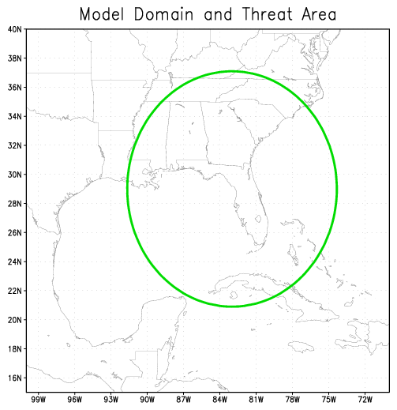
Figure 1. Florida Public Hurricane Loss Model domain and threat area

We derive discrete PDFs based on historical data from HURDAT to provide subsequent motion and intensity of the storm. A storm is simulated by repeatedly sampling from these PDFs via a Monte Carlo approach. These PDFs are derived for variable-sized regions centered at every 0.5 degree latitude and longitude in the hurricane basin. The size of these regions is determined to be that which gives a robust probability density function (PDF) for the quantities of interest (speed, direction, and intensity change), up to some maximum size. Once the storm has been given an initial condition, its subsequent evolution is governed by sampling the PDFs for change in intensity, change in translation speed, and change in heading angle in 24 hour increments. The time step is 1 hour, and storm position and velocity are determined using an assumption of constant acceleration consistent with the sampled 24 hour change. The PDFs described above were generated by parsing the HURDAT database and computing for each track the storm motion and relative intensity changes at every 24 hour interval and then binning them. Once the counts are tallied, they are then normalized to obtain the distribution function. For intensity reports for which pressure is not available, a wind pressure relation developed by Landsea et al. (2002) is used. In cases where there is no pressure report for a track fix in the historical data but there are two pressure reports within a 24 hour period that includes the track fix, the pressures are derived by linear interpolation. Otherwise the pressure is derived by using the wind-pressure relation. Extra-tropical systems, lows, waves and depressions are excluded. Intensity changes over land are also excluded from the PDFs. To insure a sufficient density of counts to represent the PDFs for each grid box, counts from nearest neighbor boxes, ranging up to 2 to 5 grid units away (both north-south and east-west direction), are aggregated. Thus the effective size of the boxes may range from 1.5 to 5.5 degrees, but are generally a fixed size for a particular variable. The sizes of the bins were determined by finding a compromise between large bin sizes which ensure a robust number of counts in each bin to define the PDF, and small bin sizes which can better represent the detail of the distribution of storm motion characteristics. Detailed examinations of the distributions as well as sensitivity tests were done. Bin sizes need not be of equal width, and a nonlinear mapping function is used to provide unequal-sized bins. For example, most storm motion tends to be persistent, with small changes in direction and speed. Thus the bins are more fine-grained at lower speed and direction changes to capture this detail.
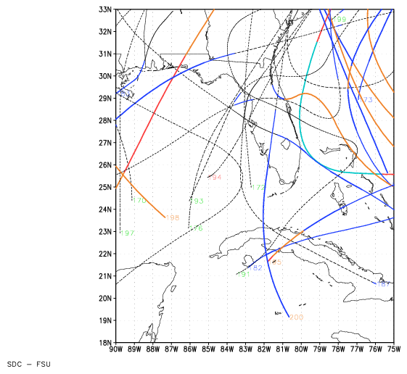

Figure 2. Examples of simulated hurricane tracks. Numbers refer to the stochastic track number, and colors represent storm intensity based on central pressure

The intensity parameter used in the wind model is DelP, the difference between the central minimum sea level pressure and an outer peripheral pressure (assumed to be 1013 mb in our model). Intensity change is modeled by using the observed geographic probability distribution of 24-hour changes of central pressure as related to the relative intensity (Darling 1990). Potential intensity takes into account the concept of the hurricane as a heat engine constrained by the input (sea surface) and outflow (upper troposphere) temperatures. Intensity change is limited so as to not exceed the maximum observed change for a particular geographic region. When a storm center crosses the coastline (landfall) the intensity change follows a pressure decay model (discussed below). If the storm moves back over the sea, the former intensity change model is reinstated. The PDFs for change in speed and direction depend on the current speed and direction (binned in discrete intervals), as well as geographic location (0.5 degree lat-lon location) and time of season (month). Storms that parallel the coast or make several landfalls can be properly simulated with our method.

Storm landfall and decay over land are determined by comparing the storm location (x,y) with a 0.6 sm resolution land-sea mask. This land mask is obtained from USGS land use cover data, and inland bodies of water have been reclassified as land in order to avoid spurious landfalls. Landfall occurs every time the storm moves from an ocean point to a land point as determined by this land mask. During landfall, the central pressure is modeled by a filling model described by Vickery (2005), and is no longer sampled from the intensity change PDFs. When the storm exits to sea, the land filling model is turned off and sampling of the intensity change PDFs begins again. A storm is dissipated when its central pressure exceeds 1011 mb.

- Wind field model
Once a simulated hurricane moves to within a threshold distance of a Florida zip code, the wind field model is turned on. The model is based on the slab boundary layer concept originally conceived by Ooyama (1969) and implemented by Shapiro (1983). Similar models based on this concept have been developed by Thompson and Cardone (1996) and Vickery et al. (1995, 2000). The model is initialized by a boundary layer vortex in gradient balance. Gradient balance represents a circular flow caused by balance of forces on the flow whereby the inward directed pressure gradient force is balanced by an outward directed Coriolis and centripetal accelerations. The coordinate system translates with the hurricane vortex moving at velocity c. The vortex translation is assumed to equal the geostrophic flow associated with the large scale pressure gradient. In cylindrical coordinates that translate with the moving vortex, equations for a slab hurricane boundary layer under a prescribed pressure gradient are:

(1)

(2)

where u and v are the respective radial and tangential wind components relative to the moving storm, p is the sea-level pressure which varies with radius (r), f is the Coriolis parameter which varies with latitude, φ is the azimuthal coordinate, K is the eddy diffusion coefficient, and F(c,u), F(c,v) are frictional drag terms (discussed below). All terms are assumed to be representative of means through the boundary layer. The motion of the vortex is determined by the modeled storm track. The symmetric pressure field p(r) is specified by the Holland (1980) pressure profile with the central pressure specified according to the intensity modeling in concert with the storm track. A model for the Holland B pressure profile parameter was developed based on a subset of the data published by Willoughby and Rahn (2004). The radius of maximum wind at landfall is modeled as a function of latitude and Pmin using a database constructed from a variety of landfall data including the NWS-38 publication, extended best track by DeMaria, and NOAA HRD archives. The wind field is solved on a polar grid with a 0.1 R/Rmax resolution. The input Rmax is adjusted to remove a bias caused by a tendency of the wind field solution to place Rmax one grid point radially outward from the input value. The slab mean boundary layer wind speed is adjusted to the surface based on reduction factors published in Powell et al., 2003 and is adjusted to maximum sustained and peak 3s gust values according to gust factors as described in Vickery and Skerlj 2005. Flow transition from marine to land or from one land roughness to another is dependent on aerodynamic roughness as modeled by Simiu and Scanlon (1996). The roughness database derived from Multi-Resolution Land Cover (MRLC) National Land Classification Database (NLCD) of 2001 (Homer et al., 2004) is used in association with the Source Area Model (Schmidt and Oke 1990, Axe 2004) to determine an upstream fetch dependent roughness value at all Florida zip codes. We corrected some anomalies where the population centroids were not near residential properties. To remedy this, we set a lower limit of roughness equivalent to that of a low intensity residential area to all land points within 0.311 miles of the centroid. For special cases where the centroid is over water, the roughness was set to that of a low intensity residential area for all points within 0.311 miles of the centroid. For coastal regions, we corrected the roughness by averaging the effective roughness for coastal fetches. Further details on the atmospheric component of the model are contained in Powell et al., 2005.

M-1 Base Hurricane Storm Set

A. Model validation shall be based upon the National Hurricane Center HURDAT starting at 1900 as of June 1, 2007 (or later), HURDAT as of June 1, 2005 plus the 2005 and 2006 seasons, or HURDAT as of June 1, 2006 plus the 2006 season. Complete additional season increments based on updates to HURDAT approved by the Tropical Prediction Center/National Hurricane Center are acceptable modifications to these storm sets. Peer reviewed atmospheric science literature can be used to justify modifications to the Base Hurricane Storm Set.

B. Any trends, weighting or partitioning shall be justified and consistent with currently accepted scientific literature and statistical techniques. Validation and comparison shall encompass the complete Base Hurricane Storm Set as well as any partitions.

- Identify the Base Hurricane Storm Set, the release date, and the time period included to develop and implement landfall and by-passing storm frequencies into the model.
The National Hurricane Center HURDAT file from 2007 for the period 1900-2006 is used to establish the official hurricane base set used by our model. All HURDAT storm tracks that have made landfall in Florida or bypassed Florida but passed close enough to produce damaging winds, are listed here...

- If the modeler has made any modifications to the Base Hurricane Storm Set related to landfall frequency and characteristics, provide justification for such modifications.

Not Done…

- Where the model incorporates short-term or long-term modification of the historical data leading to differences between modeled climatology and that in the entire Base Hurricane Storm Set, describe how this is incorporated.
Storm frequencies are based on historical occurrences derived from HURDAT, and thus implicitly contain any long or short term variation that are contained in the historical record. No attempt is made to explicitly model long or short term variations.

- Provide a completed Form M-1, Annual Occurrence Rates.

M2. Hurricane Parameters and Characteristics
Methods for depicting all modeled hurricane parameters and characteristics, including but not limited to wind speed, radial distributions of wind and pressure, minimum central pressure, radius of maximum winds, strike probabilities, tracks, the spatial and time variant wind fields, and conversion factors, shall be based on information documented by currently accepted scientific literature.

All methods used to depict storm parameters and characteristics are based on methods described in the peer-reviewed scientific literature. Data sets were developed by our scientists using data from published reports, the HURDAT database, archives, observations, and analyses at NOAA’s Hurricane Research Division, The Florida State University, Florida International University, and the Florida Coastal Monitoring Program.

- Identify the hurricane parameters (e.g., central pressure or radius of maximum winds) that are used in the model. Describe the historical data used for each of these parameters identifying all storms used.

The hurricane parameters modeled include the annual occurrence rate, seasonal genesis time, the storm track (translation speed and direction of the storm), radius of maximum wind (Rmax), Holland surface pressure profile parameter (B), the minimum central sea-level pressure (Pmin), the damage threshold distance, and the pressure decay as a function of time after landfall.

The annual occurrence rate, seasonal genesis time, and storm motion are modeled using the HURDAT database (June 2006). For pressure decay we use the Vickery (2005) decay model. Vickery developed the model based on pressure observations in HURDAT and NWS -38, together with Rmax and storm motion data as described in the publication. The radius of maximum winds at landfall is modeled by fitting a gamma distribution to a comprehensive set of historical data published in NWS-38 by Ho et al, (1987) but supplemented by the extended best track data of DeMaria, NOAA HRD research flight data, and NOAA-AOML-HRD H*Wind analyses (Powell et al., 1996, 1998).

Additional research was used to construct an historical landfall Rmax-Pmin database using existing literature (Ho et al 1987), extended best track data collected by Dr. Mark DeMaria, HRD Hurricane field program data, and the H*Wind wind analysis archive. We develop a new Rmax model using the revised landfall Rmax database which includes 108 measurements for storms up to 2005. We have opted to model the Rmax at landfall rather than the entire basin for a variety of reasons. One is that the distribution of landfall Rmax may be different than that over open water. An analysis of the landfall Rmax database and the 1988-2007 DeMaria Extended Best Track data shows that there appears to be a difference in the dependence of Rmax on central pressure (Pmin) between the two data sets. The landfall data set provides a larger set of independent measurements, more than 100 storms compared to about 31 storms affecting the Florida threat area region in the Best Track Data. Since landfall Rmax is most relevant for loss cost estimation, and has a larger independent sample size, we have chosen to model the landfall data set. Future studies will examine how the Extended Best Track Data can be used to supplement the landfall data set.

Based on the semi-boundedness and skewness of Rmax, we sought to model the distribution using either a log normal or gamma distribution. Using maximum likelihood estimators, we found the parameters for a log normal distribution to be µ=3.15, σ²=0.2327, and for the gamma distribution, k=5.53547, θ=4.67749. With these parameters, we show a plot of the observed and expected distribution for log normal and gamma in Figure 3. The Rmax values are binned in 5 sm intervals, with the x-axis showing the end value of the interval.
The gamma distribution proved to be a better fit. A Chi square goodness of fit test shows that using a log normal distribution yields a p-value of 0.41, while for a gamma distribution it is 0.71. The log normal also has a longer tail, which inflates the variance somewhat and leads to a greater probability of excessively large storms. On this basis, we have opted to use the gamma distribution function for the stochastic model.

Figure 3. Comparison of observed landfall Rmax (sm) distribution to Lognormal (left) and Gamma distribution fits of the data.

An examination of the Rmax database shows that intense storms, essentially category 5 storms, have rather small radii. Thermodynamic considerations (Willoughby, 1998) also suggest that smaller radii are more likely for these storms. Thus, we model category 5 (Delp>90 mb, where Delp=1013-Pmin and Pmin is the central pressure of the storm) storms using a gamma distribution, but with a smaller value of the θ parameter, which yields a smaller mean Rmax as well as smaller variance. We have found that for Category 1-4 (Delp<80) storms there is essentially no discernable dependence of Rmax on central pressure. This is further verified by looking at the mean and variance of Rmax in each 10 mb interval. Thus we model category 1-4 storms with a single set of parameters. For a gamma distribution, the mean is given by kθ, and variance is kθ². For category 5 storms, we adjust θ such that the mean is equal to the mean of the three category 5 storms in the database: 1935 No Name, 1969 Camille and 1992 Andrew. An intermediate zone between Delp=80 mb and Delp=90 mb is established where the mean of the distribution is linearly interpolated between the Category 1-4 value and the Category 5 value. As the θ value is reduced, the variance is likewise reduced. Since there are insufficient observations to determine what the variance should be for Category 5 storms, we rely on the assumption that variance is appropriately described by the re-scaled θ, via kθ².
A simple method is used to generate the gamma-distributed values. A uniformly distributed variable, a product of the random number generator that is intrinsic to the Fortran compiler, is mapped onto the range of Rmax values via the inverse cumulative gamma distribution function. For computational efficiency, a lookup table is used for the inverse cumulative gamma distribution function, with interpolation between table values. Figure 4 shows a test using 100,000 samples of Rmax for Category 1-4 storms, binned in 1 sm intervals, and compared with the expected values.

Figure 4. Comparison of 100,000 Rmax values sampled from the Gamma distribution for Cat 1-4 storms to the expected values.

For category 5 and intermediate category 4-5 storms, we utilize the property that the gamma cumulative distribution function is a function of (k,x/θ). Thus, by re-scaling θ, we can use the same function (lookup table), but just rescale x (Rmax). The rescaled Rmax will then still have a gamma distribution, but with different mean and variance.

The storms in the stochastic model will undergo central pressure changes during the storm life-cycle. When a storm is generated, an appropriate Rmax is sampled for the storm. In order to assure the appropriate mean values of Rmax as pressure changes, the Rmax is rescaled every time step as necessary. As long as the storm has Delp < 80 mb, there is in effect no rescaling. In the stochastic storm generator, we limit the range of Rmax from 4 sm to 60 sm.

Recent research results by Willoughby and Rahn (2004) based on the NOAA-AOML-HRD annual hurricane field program and Air Force reconnaissance flight-level observations are used to create the Holland B model. Ongoing research on the relationship between horizontal surface wind distributions (based on Stepped Frequency Microwave Radiometer observations) to flight level distributions is used to correct the flight level Rmax to a surface Rmax, when developing a relationship for the Holland B term. We multiply the flight level Rmax (from the Willoughby and Rahn (2004) data set) by 0.815 to estimate the surface Rmax (based on SFMR, flight level maxima pair data). This adjustment keeps the Holland pressure profile parameter consistent with a surface Rmax, and (due to the negative term in the equation) produces a larger value of B than if a flight-level value of Rmax were used. This is consistent with the concept of a stronger radial pressure gradient for the mean boundary layer slab than at flight level (due to the warm core of the storm), which agrees with GPS dropsonde wind profile observations showing boundary layer winds that are stronger than those at the 10,000 ft. flight level (which is the level for the most of the B data in Willoughby and Rahn 2004). The B adjustment for a surface Rmax produces an overall stronger surface wind field than if B were not adjusted. In addition, surface pressures from the “Best track” information on HURDAT are used to associate a particular flight-level pressure profile B with a surface pressure.

The NOAA-AOML- HRD H*Wind analysis archive was used to develop a relationship between Rmax and the extent of damaging winds to make sure that the model would only consider zip codes with potential for damaging winds. HRD wind modeling research initiated by Ooyama (1969), and extended by Shapiro (1983) has been used to develop the HRD wind field model. This model is based on the concept of a slab boundary layer model, a concept pioneered at NOAA-AOML- HRD and now in use by other modelers for risk applications (e.g. Thompson and Cardone 1996, Vickery and Twisdale 1995, 2000). The HURDAT historical database is used to develop the track and intensity model. Historical data used for computing the potential intensity is based on NCEP sea surface temperature archives and the NCEP reanalysis for determining the upper tropospheric outflow temperatures. Furthermore the ability of the model to simulate possible future climate scenarios of El Nino, La Nina, and warm or cold interdecadal periods is based on research on climate cycles including (Bove et al, 1998, Landsea et al., 1999, Goldenberg et al., 2001). Climate scenarios are disabled in Version 2.6 of the Florida Public Hurricane Loss Model. Use cases describing the various model functions and their research basis are available with the model documentation.

- Describe the dependencies among variables in the windfield component and how they are represented in the model, including the mathematical dependence of modeled windfield as a function of distance and direction from the center position.
B depends linearly on Pmin, latitude, and Rmax. The gradient wind for the slab boundary layer depends on Pmin (through DelP) and B, the mean slab planetary boundary layer (PBL) wind depends on the gradient wind, the drag coefficient (which depends on wind speed), the air density, the gradients of the tangential and radial components of the wind, and the Coriolis parameter (which also depends on latitude). The wind field model solves the equations of motion on a polar grid with a 0.1 R/Rmax radial grid resolution. The inpetut Rmax is reduced by 10% to correct a small bias in Rmax caused by a tendency of the wind field solution to place Rmax radially outward by one grid point. The wind field model terms and dependencies are further described in Powell et al., 2005.

Equation for the form factors Needed Here

3. For hurricane parameters modeled as random variables , describe the probability distributions. Identify any parameters that have fixed values and provide justification.

Initial storm positions and motion changes derived from HURDAT are modified by the addition of small uniform random error terms. Subsequent storm motion change and intensity are o btained by sampling from empirically derived PDFs as described in Section G-1.2. The random error term for the B parameter is a normal distribution with zero mean and a standard deviation derived from observed reconnaissance aircraft pressure profile fits for B (Willoughby and Rahn 2004). The radius of maximum winds is sampled from a gamma distribution based on landfall Rmax data.

New? 4.Describe how any hurricane parameters are treated differently in the historical and stochastic storm sets (e.g., has a fixed value in one set and not the other).

5. State whether the model simulates surface winds directly or requires conversion between some other reference level or layer and the surface. Describe the process for converting the modeled vortex winds to surface winds including the treatment of the inherent uncertainties in the conversion factor with respect to location of the site compared to the radius of maximum winds over time. Justify the variation in the surface winds conversion factor as a function of hurricane intensity.

Gradient winds are not converted to surface winds in this model. Gradient winds are used to help estimate the initial slab planetary boundary layer (PBL) winds in a given storm. The PBL winds depart from gradient balance due to the effects of friction and the radial advection of tangential momentum. The PBL winds are adjusted to the surface using recent results from Powell et al., 2003 which estimated a mean reduction factor of 77.5%, based on over 300 GPS sonde wind profile observations in hurricanes. The reduction factor is based on the ratio of the surface wind speed at 10 m to the mean wind speed for the 0-500 m layer (Mean Boundary Layer wind speed or MBL) published in Powell et al., 2003. This ratio is much more relevant to a slab boundary layer model than using data based on higher, reconnaissance aircraft flight levels. The depth of the slab boundary layer model is assigned a value of 450 m, which is the level of the maximum mean wind speed from GPS sonde wind profiles published in Powell et al., 2003. The uncertainty of the reduction factor is ~8% based on the standard deviation of the measurements, but no attempt is made to model this uncertainty. No spatial or intensity dependent variation of reduction factor is used at this time.

6. Describe how the windspeeds generated in the windfield model are converted from sustained to gust and identify the averaging time.

Wind speeds from the HRD slab boundary layer wind field model are assumed to represent 10 min averages. A sustained wind is computed by applying a gust factor to account for the highest 1 min wind speed over the 10 min period. A peak 3s gust is also computed. Gust factors depend on wind speed and the upstream fetch roughness which in turn depends on wind direction at a particular location. Gust factor calculations were developed using research in the Engineering Sciences Data Unit (ESDU) series papers as summarized and applied to tropical cyclones by Vickery and Skerlj (2005).

7. Describe how the asymmetric structure of hurricanes is represented in the model.
The asymmetry of the wind field is determined by the storm translation motion (right-left asymmetry), and the associated asymmetric surface friction. A set of form factors for the wind field also contribute to the asymmetry. The proximity of the storm to land also introduces an additional asymmetry due to the affect of land roughness elements on the flow. Azimuthal variation is introduced thru the use of two form factors (see Appendix of Powell et al., 2005 for more detail). The form factors multiply the radial and tangential profiles and provide a “factorized” ansatz for both the radial and tangential storm–relative wind components. Each form factor contains three constant coefficients which are variationally determined in such a way that the ansatz constructed satisfies (as far as its numerical degrees of freedom permit) the scaled momentum equations for the storm-relative polar wind components.

8. Describe the historical data used as the basis for the model’s hurricane tracks. Discuss the appropriateness of the model stochastic hurricane tracks with reference to the historical storm database.
The hurricane tracks are modeled as a Markov process. Initial storm conditions are derived from HURDAT. Small uniform random perturbations are added to the historical initial conditions, including initial storm location, change in motion, and intensity.
Storm motion is determined by sampling empirical distributions, based on HURDAT, of change in speed and change in direction, as well as change in relative intensity. These functions are also spatially dependent, binned in variable box sizes (typically 2.5 degree), and are enlarged as necessary to ensure sufficient density of storms for the distribution.
The model has been validated by examining key hurricane statistics at roughly 30 sm milepost locations along the Gulf and Atlantic coasts. The parameters examined include average central pressure deficit, average heading angle and speed, and total occurrence by Saffir-Simpson category.
Figure 3 shows a sample of the generated stochastic tracks.

.

Figure 5. Representative stochastic hurricane tracks simulated by the FPHLM

New? 9. If the historical data are partitioned or modified, describe how the hurricane parameters are affected.

- Describe how the coastline is segmented (or partitioned) in determining the parameters for hurricane frequency used in the model. Provide the hurricane frequency distribution by intensity for each segment.
The model does not use coastline segmentation to determine hurricane frequency.

- Describe any evolution of the functional representation of hurricane parameters during an individual storm life cycle.

Upon landfall, the evolution of the central pressure changes from sampling a PDF, to a decay model described in Vickery (2005). When the storm exits back over water, the pressure is again modeled via the PDF. After landfall, the slab boundary layer surface drag coefficient changes from a functional marine form to a constant based on a mean aerodynamic roughness length of 0.2 m. The slab boundary layer height increases from 450 m to 1 km after the center makes landfall, and decreases back to 450 m if the center exits land to go back to sea.

M3.
A. Modeled probability distributions for hurricane intensity, forward speed, radii for maximum winds, and storm heading shall be consistent with historical hurricanes in the Atlantic basin.

Hurricane motion (track) is modeled based on historical geographic and seasonal probability distributions of hurricane genesis locations (locations where hurricanes developed or moved into the threat area), translation velocity and velocity change, initial intensity, intensity change, and potential intensity. Monthly geographic distributions of climatological sea surface temperatures (Reynolds 1 degree resolution, Reynolds et al., 2002) and upper tropospheric outflow temperatures (NCEP REANALYSIS II 100 mb, Kanamitsu et al., 2002) are used to determine physically realistic potential intensities which help to bound the modeled intensity. The radius of maximum wind at landfall is modeled from a comprehensive set of historical data published in NWS-38 by Ho et al, (1987) but supplemented by the extended best track data of DeMaria, (Penington 2000), NOAA HRD research flight data, and NOAA-HRD H*Wind analyses (Powell et al., 1996, 1998). The development of the Rmax frequency distribution fit and it’s comparison to historical hurricane data is discussed in M-2.1. Comparisons of the modeled radius of maximum wind to the observed data are shown in Form M4. H*Wind wind field analyses of historical hurricanes are available from the NOAA-AOML-HRD web site: http://www.aoml.noaa.gov/hrd/data_sub/wind.html
Modeled probability distributions for hurricane intensity, forward speed, Rmax, and storm heading are consistent with historical hurricanes in the Atlantic basin.

B. Modeled hurricane probabilities shall reflect the Base Hurricane Storm Set used for category 1 to 5 hurricanes and shall be consistent with those observed for each coastal segment of Florida and neighboring states (Alabama, Georgia, and Mississippi).

As shown in Form M1 and the accompanying plots, our model reflects reasonably the Hurricane Set for 1900-2006 for hurricanes of Saffir-Simpson Categories 1-5 in each coastal region of Florida as well as the neighboring states. In addition, a finer scale coastal mile post study of model parameters (occurrence rate, storm translation speed, storm heading, and Pmin) was conducted during the development of the model.

1. List assumptions used in creating the hurricane characteristic databases.
The Holland B database is based on flight-level pressure profiles corresponding to constant pressure surfaces at 700 mb and below. Due to a lack of surface pressure field data, an assumption is made that the Holland B at the surface is equivalent to a B determined from information collected at flight level. The surface pressure profile uses Pmin, DelP, and Rmax at the surface. It would be ideal to have a B data set also corresponding to the surface but such data are not available. The best available data on B are flight-level data from Willoughby and Rahn 2004. Willoughby and Rahn 2004 discuss: “In major hurricanes... they almost invariably flew at 3km (700 mb) .” Few lower level data are available for mature hurricanes so their plot (Fig. 14) of B vs. flight-level “provide no information about average vertical structure”. In lieu of lower level data, we model B using flight data supplied by Dr. Willoughby, but with Rmax adjusted to a surface Rmax, and with surface DelP added from NHC best track for each flight. Since we are modeling hurricane winds during landfall, our Rmax model applies only to landfall and is not designed to model the lifecycle of Rmax as a function of intensity.

2. List data sources used in developing probability distributions for all hurricane parameters and characteristics.
M-4 Hurricane Windfield Structure

- Windfields generated by the model shall be consistent with observed historical storms affecting Florida.

- The translation of land use and land cover or other source information to geographic surface roughness distribution shall be consistent with current state-of-the-science.

- Provide a rotational windspeed (y-axis) versus radius (x-axis) plot of the average or default symmetric wind profile used in the model and justify the choice of this wind profile.
Plot the tangential wind (suv.pro)

- If the model windfield has been modified in any way from the previous submission, provide a rotational windspeed (y-axis) versus radius (x-axis) plot of the average or default symmetric wind profile for both the new and old functions. The choice of average or default shall be consistent for the new and old functions.
N/A

- If the model windfield has been modified in any way from the previous submission, describe variations between the new and old windfield functions with reference to historical storms.
N/A

- Describe the relevance of the formulation of gust factor(s) used in the model.

The gust factors used in the model were developed from hurricane data and the Engineering Sciences Data Unit methods as described in Vickery and Skerlj (2005).

- Identify all non-meteorological variables that affect windspeed estimation (e.g., surface roughness, topography, etc.).
Upstream aerodynamic surface roughness within fixed 45 degree sector extending upstream has an effect on the determination of wind speed for a given zip code centroid and is the primary variable that affects estimation of surface wind speeds. The upstream sectors are defined according to the Tropical Cyclone Winds at Landfall Project (Powell et al., 2004), which characterized upstream wind exposure for each of eight wind direction sectors at over 200 coastal automated weather stations (Figure 6).

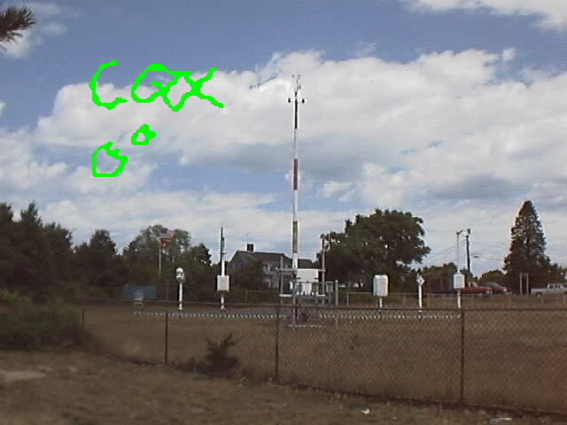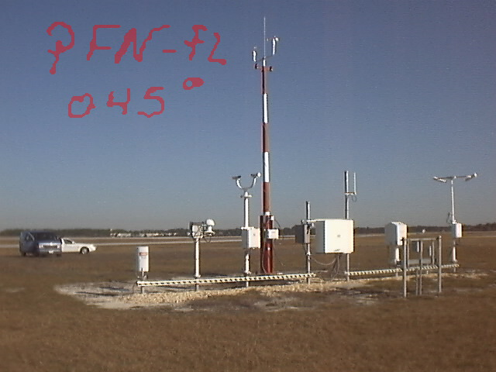

Figure 6. Upstream fetch wind exposure photograph for Chatham MS (left, looking north), and Panama City, FL (right, looking Northeast). After Powell et al., (2004)

- Provide the collection and publication dates of the land use and land cover data used in the model and justify their timeliness for Florida.

We use the 2001 Multi-Resolution Land Characteristics Consortium (MRLC) National Land Cover Database released April 25, 2007. To the best of our knowledge, this is the most recent, high resolution (30 m) land cover data set that covers not only Florida, but the entire U.S, and roughly depicts land characteristics circa 2001 (see Homer et al., 2004 for more details).

- Describe the methodology used to convert land use and land cover information into a spatial distribution of roughness coefficients in Florida and adjacent states.
New?

- Demonstrate the consistency of the spatial distribution of model-generated winds with observed windfields for hurricanes affecting Florida.
See comparisons of modeled and observed wind fields in Disclosure 2.10

- Describe how the model’s windfield is consistent with the inherent differences in windfields for such diverse storms as Hurricane Charley, Hurricane Katrina, and Hurricane Wilma.
The model can represent a wide variety of storms through variation of parameters for radius of maximum winds, central pressure deficit and Holland Beta (B). Snapshots of model wind fields at landfall are compared to NOAA-AOML-HRD H*Wind analyses below (for further details see disclosure 3 for Standard S1).

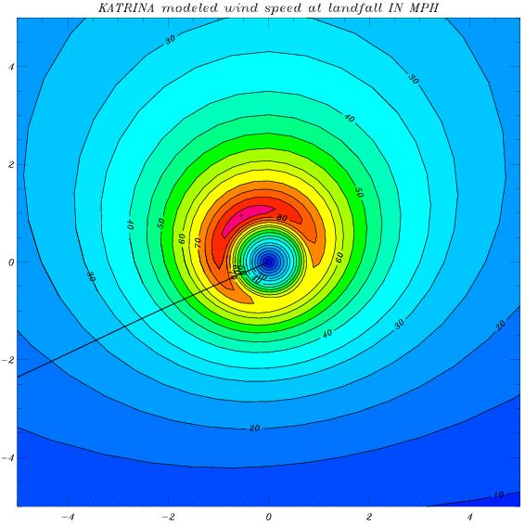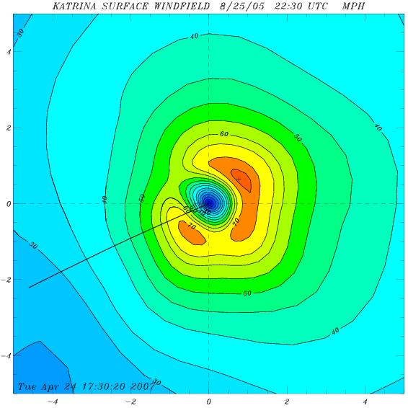
Figure 7. Comparison of observed (right) and modeled (left) landfall wind fields of Hurricanes Charley (2004, top), and 2005 Hurricane Katrina in south Florida (bottom). Line segment indicates storm heading. Horizontal coordinates are in units of R/Rmax and winds units of miles per hour.
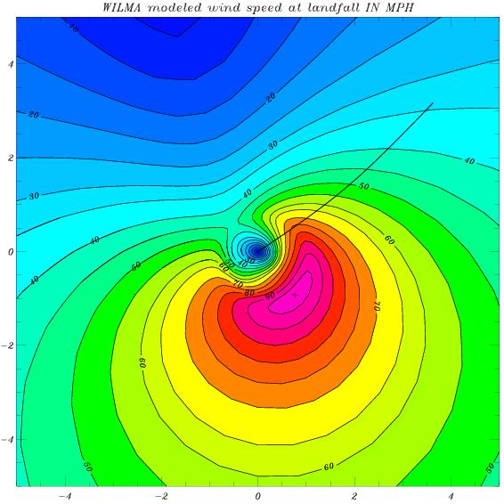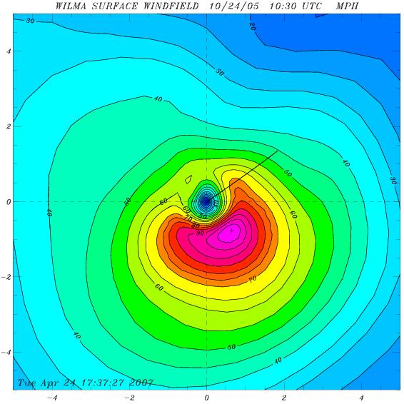
Figure 8. As in Figure 7 except for Hurricane Wilma of 2005.

- Describe any variations in the treatment of the model windfield for stochastic versus historical storms and justify this variation.

- Provide a completed Form M-2, Maps of Maximum Winds.
M-5 Landfall and Over-Land Weakening Methodologies*
(*Significant Revision)

- The magnitude of land friction coefficients shall incorporate current geographic surface roughness distributions and shall be implemented with appropriate geographic information system data.

- The hurricane over-land weakening rate methodology used by the model shall be consistent with historical records.

- Models shall use maximum one-minute sustained 10-meter windspeed when defining hurricane landfall intensity. This applies both to the Base Hurricane Storm Set used to develop landfall strike probabilities as a function of coastal location and to the modeled winds in each hurricane which causes damage. The associated maximum one-minute sustained 10-meter windspeed shall be within the range of windspeeds (in statute miles per hour) categorized by the Saffir-Simpson Scale.

Saffir-Simpson Hurricane Scale:

Category | Winds (mph) | Damage
1 | 74 – 95 | Minimal
2 | 96 – 110 | Moderate
3 | 111 – 130 | Extensive
4 | 131 – 155 | Extreme
5 | Over 155 | Catastrophic

- Land friction is modeled according to the currently accepted principles of surface layer similarity theory as described in the disciplines of micrometeorology, atmospheric turbulence, and wind engineering. The geographic distribution of surface roughness is determined by careful studies of aerial photography, site visits, and satellite remote sensing measurements used to create land use - land cover classification systems. We have now incorporated the MRLC NLCD 2001 land use data set. This data set became available in Spring, 2007, and provides detailed (30 m) land use characteristics circa 2001. All population-weighted zip code centroids are assigned roughness values as a function of upstream fetch for each wind direction octant. After landfall, the surface drag coefficient used in the hurricane PBL slab model changes from a marine value to a fixed value associated with a roughness of 0.2 m.
B. Overland weakening rates are based on a pressure decay model developed from historical data as described by a recent paper published in the peer-reviewed atmospheric science literature (Vickery 2005).

C. The HRD wind field model simulates landfall intensity according to the maximum 1 min sustained wind for the 10 m level for both stochastic simulations and the Official Hurricane Set. The Saffir-Simpson damage potential scale is used to further categorize the intensity at landfall and the range of simulated wind speeds (in miles per hour) is within the range defined in the scale.

- Describe and justify the functional form of hurricane decay rates used by the model.
The hurricane decay rate function acts to decrease the DelP with time after landfall. The functional form is an exponential in time since landfall and is based on historical data (Vickery 2005).

2. Provide a graphical representation of the modeled degradation rates for Florida hurricanes over time compared to wind observations. Reference to the Kaplan-DeMaria decay rates alone is not acceptable.
The degradation of the wind field of a landfalling hurricane is associated with the filling of the central sea-level pressure and the associated weakening of the surface pressure gradient, as well as the fact that the hurricane is over land, where the flow is subject to friction while flowing across obstacles in the form of roughness elements. Maximum wind degradation is shown according to how the maximum sustained surface wind (at the location containing the maximum winds in the storm) changes with time after landfall. At landfall the marine exposure wind is assumed to be representative of the maximum winds occurring onshore. After landfall the open terrain wind is chosen to represent the maximum envelope of sustained winds over land. The NOAA-HRD H*Wind system is used to analyze the maximum winds at a sequence of times following landfalls of Hurricanes Katrina, Charley, Frances, Jeanne, and Wilma. H*Wind uses all available wind observations. The landfall wind field is used as a background field for times after landfall and compared to the available observations at a sequence of times after landfall. An empirical decay is applied to the background field based on the comparisons to the observations. These data are then objectively analyzed to determine the wind field at each time. The model maximum sustained winds are compared to the maximum winds from the H*Wind analyses for the same times and roughness exposures. In general, points after landfall are given for open terrain exposure. At times, even though the storm center is over land, the maximum wind speed may remain over water. For example, in the Frances plot, the first three pairs of points represent marine exposure, the next three open terrain, and the final three marine exposure again, while all Wilma point pairs represent marine exposure. The plots indicate that the Public wind field model realistically simulates decay of the maximum wind speed during the landfall process, as well as subsequent strengthening after exit.
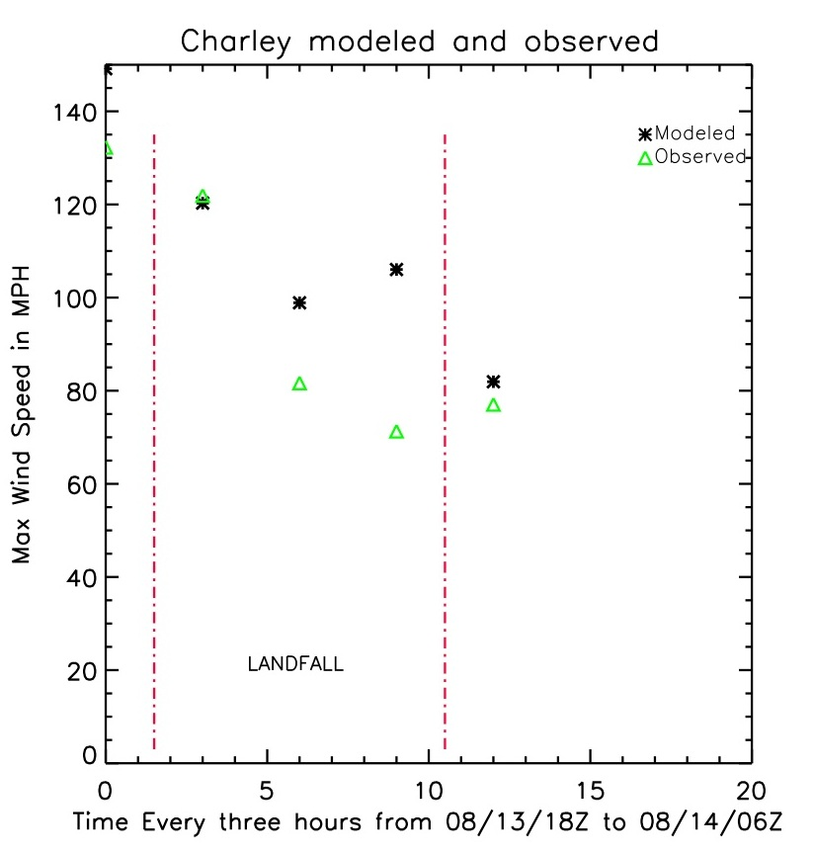
Figure 9. Observed (green) and modeled (black) maximum sustained surface winds as a function of time for 2004 Hurricanes Charley (left) and Frances (right). Landfall is represented by the vertical dash-dot red line at the left and time of exit as the red line on the right.
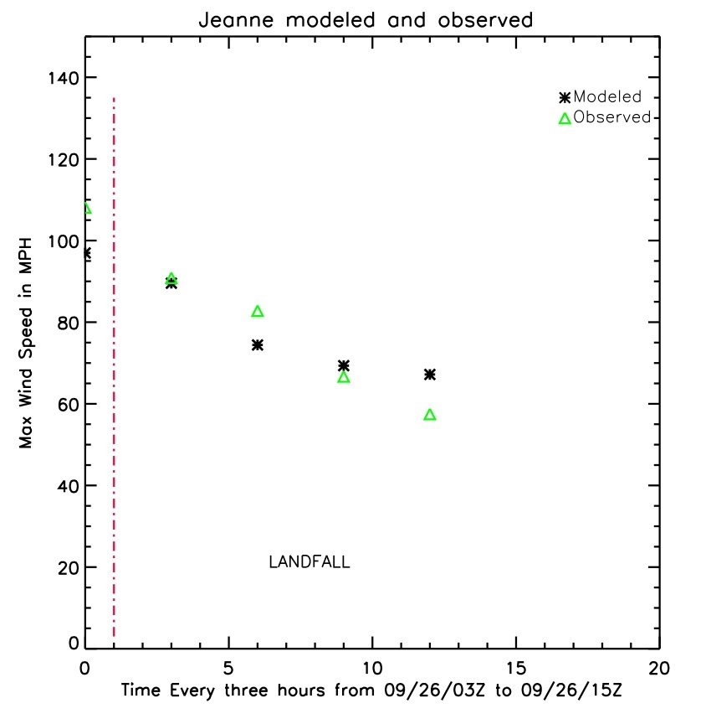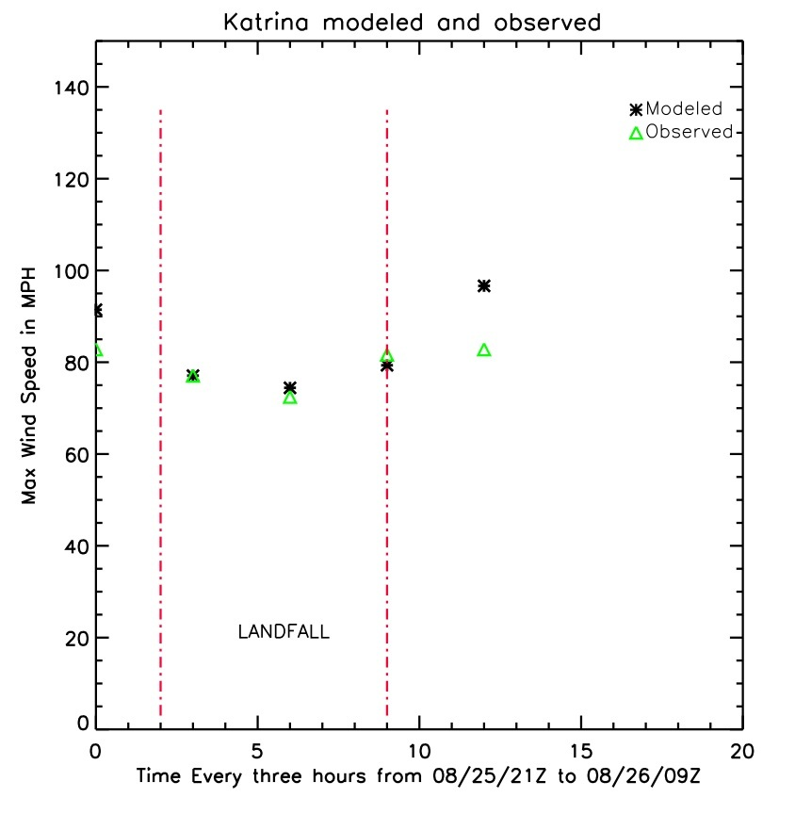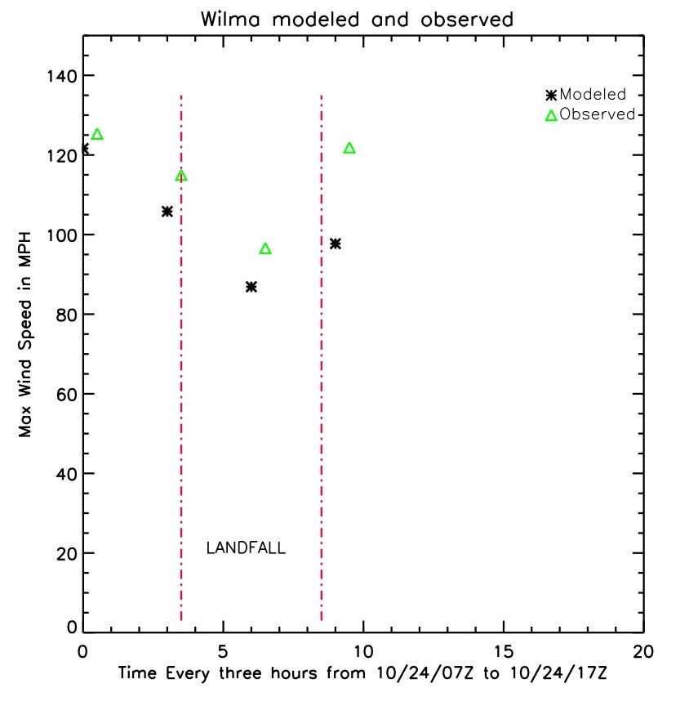

Figure 10. Observed (green) and modeled (black) maximum sustained surface winds as a function of time for Hurricanes Jeanne (2004, top left), Katrina (2005 in South Florida, top right), and 2005 Wilma (lower left). Landfall is represented by the vertical dash-dot red line at the left and time of exit as the red line on the right.

3. Describe the transition from over-water to over-land boundary layer simulated in the model.
New?

4. Document any differences between the treatment of decay rates in the model for stochastic hurricanes compared to historical hurricanes affecting Florida.

In the FPHLM model, decay is defined as the change in minimum sea-level pressure (Pmin) with time after landfall. The input file for the wind field model consists of a hurricane track file that contains storm position, Pmin, Rmax, and Holland B at 1h frequency. The wind field model is exactly the same for scenario (historical) or stochastic events. When running the model in scenario mode for historical hurricanes affecting Florida, we use a set of historical hurricane tracks as input to the model. When running the model in stochastic mode, the input hurricane tracks are provided by the track and intensity model. The track and intensity model uses the Vickery 2005 pressure decay after landfall. When a hurricane exits land, the Pmin over water is determined based on the Markov process as described in Disclosure G1.2

The historical tracks based on HURDAT are detailed on our web site at:

http://www.aoml.noaa.gov/hrd/lossmodel/

For historical hurricane tracks the landfall pressure is determined from HURDAT or from the Ho et al., (1987) report. If post-landfall pressure data are available in HURDAT, we interpolate pressure values over land. If post-landfall pressure data are not available, we apply the Vickery (2005) pressure decay model to the landfall pressure. After the storm exits land, the pressure is based on HURDAT data. Therefore, decay rates for historical hurricanes are based on HURDAT data if available, or the Vickery decay rate model applied to the HURDAT or Ho et al, (1987) landfall Pmin, while decay rates for stochastic hurricanes are based on Vickery 2005.
M6 Logical Relationships of Hurricane Characteristics

- The magnitude of asymmetry shall increase as the translation speed increases, all other factors held constant.

The storm translation speed causes a major right-left (looking in the direction the storm is moving) asymmetry in the wind field which in turn causes an asymmetry in surface friction since the surface stress is wind speed dependent. The magnitude of the asymmetry increases as the translation speeds increases; there is no asymmetry for a stationary storm except for possible land friction effects if a storm becomes stationary while a large percentage of its circulation is over both land and water.

- The mean windspeed shall decrease with increasing surface roughness (friction), all other factors held constant.

All other factors held constant, the mean wind speed decreases with increasing surface roughness. However, the gust factor, which is used to estimate the peak one min wind and the peak 3 s gust over the time period corresponding to the model mean wind increases as a function of turbulence intensity, which increases with surface roughness (Paulsen et al., 2003, Masters 2004, Powell et al., 2004). For roughness values representative of zip codes in Florida with residential roughness values on the order of 0.2 - 0.3 m, the roughness effect on decreasing the mean wind speed overwhelms the enhanced turbulence intensity effect that increases the gust factor.

Disclosure

1. Provide a completed Form M-3, Radius of Maximum Winds and Radii of Standard Wind Thresholds.

Form M-3 follows.

