GOMECC 2007 Cruise Summary for Underway Ammonia measurement

Introduction

The most common technique used to measure ammonia in seawater is the indophenol blue method (Berthelot reaction)^{1,2}. However, there are reports of difficulties³⁻⁵ with the technique because of highly susceptible to contamination and lack of sensitivity (LOD 0.6 μM). An ammonia electrode was found easy to operate⁶, but requires long equilibration times and provides low sensitivity (LOD 0.2 μM). To increase the sensitivity, a solvent extraction method⁷ was developed, but the procedure is time consuming and labor intensive. In addition, a long-path liquid waveguide capillary cell⁸ was using to improve the sensitivity (LOD 5 nM), but the problems of the indophenol blue have not been solved such as interferences and refractive index (especially measuring in seawater). In 1971, a fluorescent reaction was developed by Roth⁹ for ammonia or primary amino acid with o-phthaldialdehyde (OPA) and mercaptoethanol to produce strongly fluorescent compounds, which has been broadly used in measurement of amino acids. Other dialdehydes were also developed for the same purpose¹⁰⁻¹². In 1989, Dasgupta¹³ reported that using sulfite instead of mercaptoethanol provides higher sensitivity for ammonia measurement and greater selectivity over amino acids. The OPA-sulfite-NH₃ reaction has been modified for ammonia determination in seawater^{14,15}. Recently, Dasgupta¹⁶ reported a new version of ammonia determination in atmospheric, which can improve reagent stability that makes no need reagent replacement for at least two weeks. Moreover, the sensitivity has also been increased. Besides, this technique has no problems about refractive index and much less interference effect than the indophenol blue method.

Experimental Section

Flow Injection Analysis (FIA) technique is simply used for this work as shown in Figure 1. A peristaltic pump P (Ismatec) is used to pump water W (160 µL/min) as carrier through an electromechanically actuated six-port injection valve IV (V-1541-DC, Upchurch). The injection loop constituted a 1.0 x 1220 mm PTFE tube (Zeus Industrial Products, NJ); the measured injection volume was 958 µL, which is enough to get a flat-top peak for every concentrations. The sample or standard solution S is aspirated from an auto-sampler A (ASX-510HS, CETAC) by the pump P through the injection valve IV. The sulfite solution R2 merges with the OPA reagent stream R1 and merges again with the carrier stream. Then, the reaction stream passes through a heated reaction coil (65 ºC, 1.0 x 2000 mm) prior to entry into the fluorescence detector FL (F1080, Hitachi). To obtain data from the detector FL, automate the injection valve IV and control the auto-sampler, simple software was developed by LabVIEW programming.

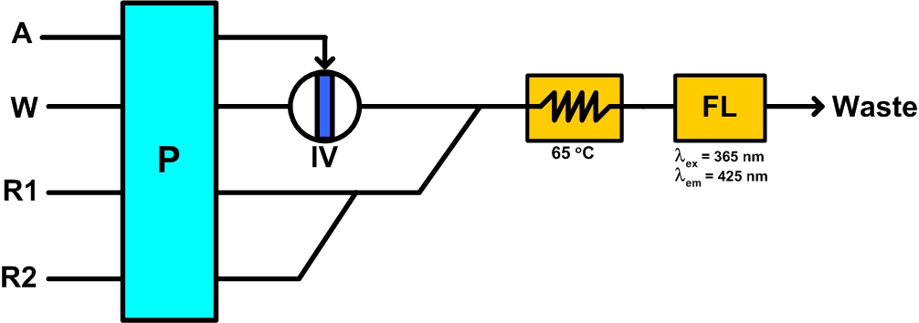

Figure 1. Flow Injection Analyzer for ammonia determination: A, Auto-sampler; W, Water; S, Sample/Standard; P, Peristaltic Pump; R1, Phthaldialdehyde (OPA) solution; R2, Sulfite in formaldehyde solution; FL, Fluorescent Detector; and IV, Injection Valve.

Underway method.

For operating as an underway mode, the autosampler A would be changed to connect with a U-pipe sampling system where the seawater continuously overflows all the time.

Sampling and Standards

Nutrient samples were drawn in 40ml HDPE sample bottles that had been stored in 10% HCl and rinsed 4-5 times with sample before filling. A replicate was always drawn from the deep Niskin bottle for analysis. All samples were brought to room temperature prior to analysis. The blanks were deionized water, and the standards were simply 500 nM NH₄⁺ in deionized water.

Data processing.

After each run, the peak information was processed with Microcal Origin Pro 7.0 and Excel to get the peak height of each peak. Ammonia concentration were reported in micromoles per liter, and then converted to micromoles per kilogram.

Totally 1,473 ammonia samples were analyzed during the GOMECC cruise.

The results for underway measurement of ammonium of the GOMECC cruise are shown in Figure 2.

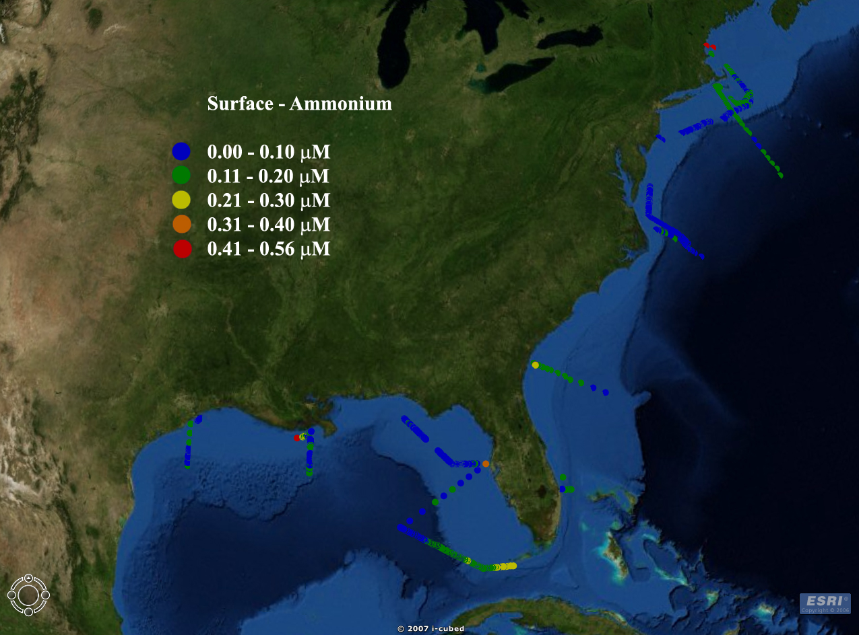
Figure 2. Underway measurement of surface ammonium concentrations during Gulf of Mexico and East Coast Carbon Cruise (GOMECC) from July 10 to August 4, 2007.

Reference:
(1) U.S. Environmental Protection Agency; Determination of Ammonia in Estuarine and Coastal Waters by Gas Segmented Continuous Flow Colorimetric Analysis, Method 349.0, 1997, Cincinnati, Ohio, USA.
(2) Grasshoff, K.; Ehrhardt, M.; Kremling, K. Method of Seawater Analysis, 2 ed.; Verlag Chemie GmbH. Weinheim, Germany., 1983.
(3) Aminot, A.; Kirkwood, D. S.; Kerouel, R. Mar. Chem. 1997, 56, 59 - 75.
(4) Willason, S. W.; Johnson, K. S. Mar. Biol. 1986, 91, 285 - 290.
(5) Kerouel, R.; Aminot, A. Mar. Chem. 1997, 57, 265 - 275.
(6) Garside, C.; Hull, G.; Murray, S. Limnol. Oceanogr. 1978, 23, 1073 - 1076.
(7) Brzezinski, M. A. Mar. Chem. 1987, 20, 277 - 288.
(8) Li, Q. P.; Zhang, J.-Z.; Millero, F. J.; Hansell, D. A. Mar. Chem. 2005, 96, 73 - 85.
(9) Roth, M. Anal. Chem. 1971, 43, 880 - 882.
(10) Roach, M. C.; Harmony, M. D. Anal. Chem. 1987, 59, 411 - 415.
(11) Montigny, P. d.; Stobaugh, J. F.; Givens, R. S.; Carlson, R. G.; Srinivasachar, K.; Sternson, L. A.; Higuchi, T. Anal. Chem. 1987, 59, 1096 - 1101.
(12) Gyimesi-Forras, K; Leitner, A; Akasaka, K; Lindner, W. J. Chromatogr. A 2005, 1083, 80 - 88.
(13) Genfa, Z.; Dasgupta, P. K. Anal. Chem. 1989, 61, 408 - 412.
(14) Aminot, A.; Kerouel, R.; Birot, D. Wat. Res. 2001, 35, 1777 - 1785.
(15) Watson, R. J.; Butler, E. C. V.; Clementson, L. A.; Berry, K. M. J. Environ. Monit. 2005, 7, 37 - 42.
(16) Amornthammarong, N.; Jakmunee, J.; Li, J.; Dasgupta, P. K. Anal. Chem. 2006, 78, 1890 - 1896.

