East Coast Ocean Acidification Cruise
(ECOA-2)

R/V Henry B. Bigelow (R225)
EXPOCODE: 33HH20180625
Project ID: OAP1812-1527
25 June – 29 July, 2018

Newport, RI – Miami, FL USA
PIs Joseph Salisbury (University of New Hampshire) and Wei-Jun Cai (University of Delaware)

Chief Scientists:
Leg 1: Joseph Salisbury (University of New Hampshire)
Leg 2: Joseph Salisbury (University of New Hampshire)

Table of Contents

1.- Summary 3
2.- Introduction 4
3.- Description of Measurements from Vertical Profiles 7
3.1 CTD/Hydrographic Measurements 7
3.2 Oxygen Measurements 19
3.3 Nutrient Measurements 21
3.4 DIC Measurements 22
3.5 Total Alkalinity Measurements 24
3.6 Seawater pH Measurements 25
3.7 Respiration/Bacteria Activity 30
3.8 Dissolved organic carbon (DOC), High-Performance Liquid Chromatography (HPLC), Colored Dissolved Organic Matter (CDOM), and Suspended material (TSM) 32
3.9 CH₄, pCO₂(at depth), and ¹⁸O 33
4.- Underway Measurements 34
4.1 Underway pCO₂ Analyses 34
4.2 Oxygen:Argon Ratio and Estimation of Net Community Production 36
4.3 Underway DIC 37
4.4 Underway pH 37
4.5 Underway TA 38
4.6 Underway CO₃²⁻ 38
4.7 Underway Phytoplankton Commmunity Measurements 38

5.- Ocean color Measurements 41
5.1 Apparent Optical Properties and Solar Irradiance 41
5.2 Inherent Optical Property (IOP) Profiles and Ancillary Measurements 42
6.- Gray's Reef Survey: 42
7.- Glider deployment with pH sensor: 43

- Summary

This report describes the second East Coast Ocean Acidification Cruise (ECOA-2). The effort was in support of the coastal monitoring and research objectives of the NOAA Ocean Acidification Program (OAP). The cruise was designed to obtain a snapshot of key carbon, physical, biogeochemical parameters and production rates as they relate to ocean acidification (OA) in the coastal realm. This was the fourth comprehensive occupation of the coastal waters, with the first occurring in 2007, the second in 2012, the third in 2015, and this effort in 2018. The previous efforts were named the Gulf of Mexico and East Coast Carbon cruises I, and II (GOMECC I and II), along with the first ECOA cruise. During each of these cruises key knowledge and data gaps were realized including: 1) a need to sample contributing Scotian Shelf and Labrador Slope waters, 2) a need to sample closer to the coast in order to better understand the effects of land fluxes on OA and 3) the need to characterize biological rate processes that affect distributions of carbonate parameters.

Our efforts are intended to complement mooring time series and other regional OA activities. The cruise included a series of transects complemented by lines laid out approximately parallel to the coast. A comprehensive set of underway measurements were taken between stations along the entire transect (Figure 1). Full water column CTD/rosette stations were occupied at 184 specified locations. A total of 17 scientists from UNH, UDEL, LDEO, Rutgers, University and AOML participated in the 29-day cruise, which departed from Newport, RI, on 25 June, and arrived on schedule in Miami, FL on 29 July. The cruise was delayed for 4 days in Newport due to an unexpected NOAA personnel issue. These days were lost from the mission and although nearly all primary stations were sampled, an impact was realized in the reduction of secondary activities such as optical characterization of the water column.

Water samples were collected from the 24-bottle rosette at each station and analyzed for salinity, oxygen, nutrients, dissolved inorganic carbon (DIC), total alkalinity, pH, dissolved organic matter, colored dissolved organic matter, phytoplankton pigments CH₄, discrete pCO₂, and ¹⁸O. Underway systems were in operation for measuring atmospheric CO₂ and near-surface water pCO₂, DIC, pH, bio-optical properties and acoustic Doppler current profiles (ADCP). Several members of the field party posted photographs and brief descriptions of science sampling and activities on:
https://www.facebook.com/EastCoastOA/.

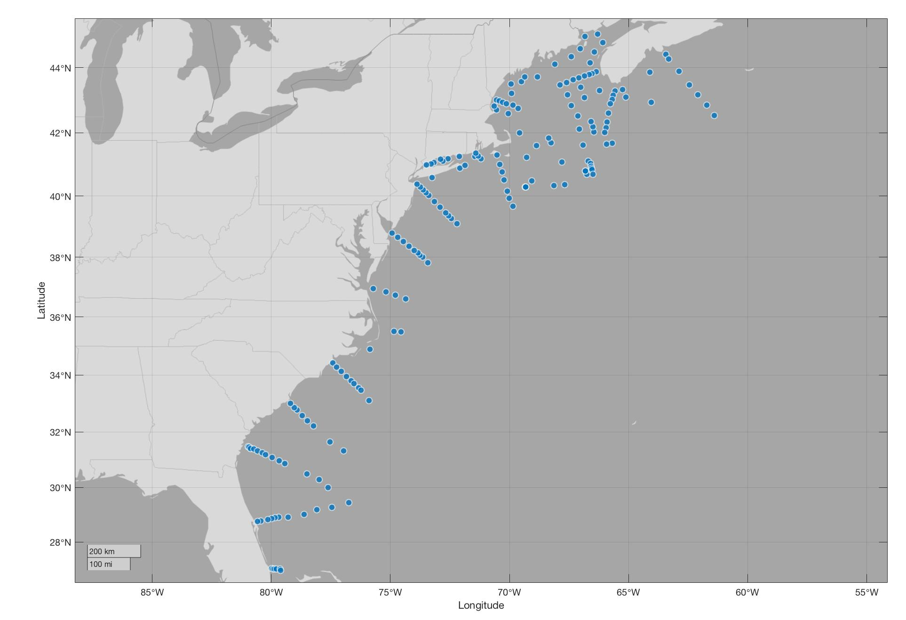

Figure 1 – ECOA-2 CTD stations

- Introduction

NOAA OAP and partners conducted the second East Coast Ocean Acidification cruise (ECOA-2) Cruise (Figure 1) along the East Coast of the United States, and the Canadian Maritimes. Its purpose was to document the status of ocean acidification (OA) by collecting a comprehensive dataset over a wide range of oceanographic and biogeochemical conditions. An important secondary goal was to collect an ancillary data set, including biological rate measurements that will enable a fuller understanding of processes affecting carbonate chemistry.

The coastal ocean is emphasized in NOAA OA monitoring and research as it is believed to be particularly vulnerable to ocean acidification processes and contains many ecosystems of great socioeconomic values. It is a conduit for transport of terrestrial material from the land to the open ocean and its specific biological productivity is on average about three times larger than the average open-ocean values. It is also the region where the interior ocean interacts with the bottom boundary, leading to enhancements of many chemical, biological and physical processes in mid-water regions of the ocean. These processes contribute to the large variability encountered and associated with ecosystem stress. The major goal of the cruise was to identify the magnitude and controls of ocean acidification in the Eastern North American coastal regime, along with their magnitudes, and scales of biogeochemical parameters impacting ocean acidification. The coastal zone must be well quantified regarding carbon speciation in order to make reasonable projections of future levels of ocean acidification. In addition, in coastal regions where net biological processes can dominate carbonate system variability over daily-monthly time scales, understanding the net biological rates of organic and inorganic carbon production is advised.

To address this problem, NOAA OAP, and its Marine CO₂ Programs at PMEL and AOML initiated dedicated coastal carbon research cruises for the West, East and Gulf Coasts. This program is designed to establish baseline observational fields for carbon system parameters, provide comparative data for observations from other projects, and develop a set of hydrographic transects of full water column measurements to be re-occupied over time for studies of inter-annual changes in physical, chemical and biological characteristics of the coastal ocean as they impact ocean acidification.

This ECOA cruise aboard the R/V Henry Bigelow, is the fourth of a planned sequence of observations and studies of carbon and related biogeochemical parameters in the dynamic coastal ocean region above/adjacent to the continental shelf along the coast of the Gulf of Mexico and East coast of the North American continent. Data from this cruise provide a robust observational framework to monitor long-term ocean acidification trends on inter-annual timescales, and determine the temporal variability of the inorganic carbon system and its relationship to biological and physical processes in the coastal ocean and their capacity to withstand the onset of ocean acidification.

The ECOA-2 cruise was supported by the NOAA/OAR Ocean Acidification Program (OAP). Seventeen scientists representing 5 universities, NASA, and 2 NOAA line offices participated on the cruise (Table 1) covering the North American continental shelf region from Miami Florida in the south to Halifax Nova Scotia in the north. The R/V Henry Bigelow departed Newport, RI on 25 June, 2018. The cruise completed a series of 14 transects, most intended to approximately orthogonal to the coast (Figure 1). Full water column CTD/rosette stations were occupied at specified locations along each of these transects. Twenty-four 10L Niskin-type bottles were used to collect water samples from throughout the water column at each station. Each Niskin-type bottle was sub-sampled on deck for a variety of analyses, including salinity, oxygen, nutrients, dissolved inorganic carbon, total alkalinity, pCO₂, dissolved organic matter, colored dissolved organic matter, and phytoplankton pigments. A total of 184 stations were occupied on the cruise (Table 2). East Coast transects occupied in ECOA 1 were revisited as well as several more transects that were added to the Northeast with the goal of understanding biogeochemical characteristics of Canadian-sourced waters influencing the US East Coast.

In addition to bottle-based measurements, underway measurements of salinity, temperature, dissolved oxygen, pCO₂ (air and water), DIC, pH, fluorescence of chlorophyll and colored dissolved organic matter (CDOM), light transmittance at 660nm, and the continuous oxygen/argon ratios were measured. When we had a considerable steam between stations, samples were taken every 2 hours from the underway-sampling line for discrete analyses of oxygen, dissolved inorganic carbon, total alkalinity, pCO₂ and pH. There were 100 sets of discrete samples taken from the underway line.

Table 1 - Scientific Cruise Participants

Name (First, Last) | Title | Date Aboard | Date Disembark | Sex | Affiliation
Joseph Salisbury | Field Party Chief CTD/Watch | 6/25/2018 | 7/29/2018 | M | UNH
Shawn Shellito | CTD/IOP/shift lead/ Underway alkalinity | 6/25/2018 | 7/29/2018 | M | UNH
Melissa Melendez | Filtration for CDOM/ Chlorophyll/ DFO sampling/ Oxygen analyses | 6/25/2018 | 7/29/2018 | F | UNH
Bror Jonsson | O2-Ar/CTD | 6/25/2018 | 7/29/2018 | M | UNH
Tyler Menz | Biological/Filtration/ DFO sampling | 6/25/2018 | 7/29/2018 | F | UNH
Joquim Goes | Biological Parameters | 6/25/2018 | 7/29/2018 | M | LDEO
Charles Kovach | AOP/General | 6/25/2018 | 7/29/2018 | M | NESDIS
Charles Featherstone | DIC | 6/25/2018 | 7/29/2018 | M | AOML
Dwight Gledhill | O2 | 6/25/2018 | 7/11/2018 | M | NOAA
Emma Pontes | O2 | 6/25/2018 | 7/29/2018 | F | UMiami
Boashan Chen | Spec-pH Durafet pH | 6/25/2018 | 7/11/2018 | M | UDel
Qipei Shangguan | Underway TA, pH, and CO32- | 7/13/2018 | 7/29/2018 | F | UDel
Xinyu Li | Spec-pH  O2-Ar/EIMS | 6/25/2018 | 7/29/2018 | F | UDel
Qian Li | TA | 6/25/2018 | 7/29/2018 | M | UDel
Yuanyuan Xu | TA | 6/25/2018 | 7/11/2018 | F | UDel
Junxiao Zhang | Spec-pH | 7/13/2018 | 7/29/2018 | F | UDel
Najid Hussain | TALK/pH | 6/25/2018 | 7/29/2018 | M | UDel
Elizabeth Wright-Fairbanks | Glider/Water sampling | 6/25/2018 | 7/11/2018 | F | Rutgers
Patrick Mears | DIC | 6/25/2018 | 7/29/2018 | M | AOML
Kui Wang | Spec-pH | 6/25/2018 | 7/11/2018 | M | UDel
Janet Reimer | Spec-pH | 7/13/2018 | 7/29/2018 | F | UDel
Chloe Baskin | Filtration for CDOM/ Chlorophyll/ | 7/13/2018 | 7/29/2018 | F | Volunteer

Affiliations:
NODC  OAR  OAP  PMEL | NOAA – National Ocean Data Center  NOAA – Oceanic and Atmospheric Research  NOAA – Ocean Acidification Program  NOAA Pacific Oceanographic and Meteorological Laboratory
AOML | NOAA Atlantic Oceanographic and Meteorological Laboratory
RSMAS  UMO | Rosenstiel School of Marine and Atmospheric Science/University of Miami  University of Maine, Orono
UDEL | University of Delaware – School of Marine Sciences
UNH | University of New Hampshire – Ocean Process Analysis Lab
Rutgers | Rutgers Marine and Coastal Sciences
DFO  NESDIS | Department of Fisheries and Oceanography (Canada)  NOAA National Environmental Satellite, Data, and Information Service
- Description of Measurements from Vertical Profiles

3.1 CTD/Hydrographic Measurements
Analysts: Shawn Shellito, Joseph Salisbury (UNH)

A total of 184 CTD/O2/Optics stations were conducted during the cruise (Table 2, Figure 1). At each station, profiles of temperature, salinity (conductivity), and dissolved oxygen concentration were collected from the surface to within approximately 20 m of the bottom for the majority of casts, using a Sea-Bird SBE-911plus CTD system. Water samples for calibration of the dissolved oxygen profiles as well as all the other parameters sampled on this cruise were collected using a 24-bottle Rosette system containing 10-liter Niskin bottles.

Table 2 – CTD station locations visited during the ECOA 2 cruise. Note: Station 008 was an AOP cast only and not included on this list

Station # | Date | Time | Latitude | Longitude | Bottom Depth (m)
1 | 6/25/18 | 20:11 | 41.31016 | -70.5345 | 26
2 | 6/25/18 | 22:22 | 41.00633 | -70.40182 | 42
3 | 6/26/18 | 0:19 | 40.76332 | -70.31582 | 49
4 | 6/26/18 | 2:13 | 40.51732 | -70.23866 | 64
5 | 6/26/18 | 5:03 | 40.147 | -70.099 | 117
6 | 6/26/18 | 7:05 | 39.928 | -70.00482 | 472
7 | 6/26/18 | 9:26 | 39.665 | -69.85117 | 2166
9 | 6/26/18 | 17:25 | 40.48182 | -69.073 | 78
10 | 6/26/18 | 23:37 | 41.23626 | -69.28746 | 65
11 | 6/27/18 | 5:08 | 41.99432 | -69.58182 | 215
12 | 6/27/18 | 9:45 | 42.6035 | -70.04716 | 125
13 | 6/27/18 | 12:25 | 42.70782 | -70.54832 | 81
14 | 6/27/18 | 14:20 | 42.82238 | -70.65182 | 75
15 | 6/27/18 | 16:17 | 43.01965 | -70.53883 | 70
16 | 6/27/18 | 19:20 | 42.98132 | -70.42432 | 106
17 | 6/27/18 | 20:21 | 42.93816 | -70.28566 | 146
18 | 6/27/18 | 21:32 | 42.8985 | -70.13266 | 64
19 | 6/27/18 | 23:02 | 42.8575 | -69.85379 | 257
20 | 6/28/18 | 1:09 | 42.755 | -69.63932 | 263
21 | 6/28/18 | 4:26 | 43.21482 | -69.91182 | 166
22 | 6/28/18 | 6:39 | 43.50382 | -69.92566 | 120
23 | 6/28/18 | 8:58 | 43.58266 | -69.49582 | 136
24 | 6/28/18 | 10:30 | 43.72032 | -69.35132 | 93
25 | 6/28/18 | 12:57 | 43.72468 | -68.81734 | 110
26 | 6/28/18 | 16:55 | 44.107 | -68.10382 | 104
27 | 6/28/18 | 21:59 | 44.33266 | -67.41032 | 84
28 | 6/29/18 | 1:27 | 44.56966 | -67.03316 | 88
29 | 6/29/18 | 4:02 | 44.93048 | -66.8413 | 103
30 | 6/29/18 | 6:39 | 45.00582 | -66.29282 | 105
31 | 6/29/18 | 9:11 | 44.75166 | -66.08816 | 104
32 | 6/29/18 | 12:11 | 44.47832 | -66.44348 | 200
33 | 6/29/18 | 15:50 | 44.15366 | -66.62232 | 100
34 | 6/29/18 | 18:55 | 43.87168 | -66.34885 | 63
35 | 6/29/18 | 20:59 | 43.8145 | -66.52782 | 100
36 | 6/29/18 | 22:02 | 43.78516 | -66.65432 | 100
37 | 6/29/18 | 23:38 | 43.74866 | -66.84866 | 163
38 | 6/30/18 | 1:15 | 43.68716 | -67.087 | 133
39 | 6/30/18 | 2:52 | 43.62834 | -67.31766 | 216
40 | 6/30/18 | 4:39 | 43.55432 | -67.60982 | 239
41 | 6/30/18 | 6:32 | 43.47982 | -67.87832 | 279
42 | 6/30/18 | 10:28 | 43.4095 | -67.01348 | 213
43 | 6/30/18 | 14:05 | 43.30582 | -66.22932 | 85
44 | 6/30/18 | 19:16 | 43.33766 | -65.2465 | 117
45 | 7/1/18 | 1:32 | 43.86016 | -64.1125 | 148
46 | 7/1/18 | 6:36 | 44.402 | -63.4375 | 86
47 | 7/1/18 | 9:40 | 44.26382 | -63.31166 | 155
48 | 7/1/18 | 12:50 | 43.88716 | -62.8855 | 268
49 | 7/1/18 | 17:06 | 43.47982 | -62.45432 | 86
50 | 7/1/18 | 20:18 | 43.181 | -62.102 | 101
51 | 7/2/18 | 0:12 | 42.85632 | -61.72332 | 1015
52 | 7/2/18 | 3:20 | 42.53308 | -61.3985 | 2210
53 | 7/2/18 | 16:26 | 42.94732 | -64.04232 | 101
54 | 7/2/18 | 22:22 | 43.109 | -65.11 | 153
55 | 7/3/18 | 0:52 | 43.28416 | -65.56182 | 48
56 | 7/3/18 | 2:00 | 43.162 | -65.63982 | 74
57 | 7/3/18 | 3:15 | 43.037 | -65.68816 | 113
58 | 7/3/18 | 4:42 | 42.90268 | -65.75691 | 145
59 | 7/3/18 | 6:05 | 42.771 | -65.79448 | 105
60 | 7/3/18 | 7:32 | 42.61432 | -65.8555 | 89
61 | 7/3/18 | 9:39 | 42.3305 | -65.89716 | 223
62 | 7/3/18 | 11:08 | 42.15366 | -65.93632 | 229
63 | 7/3/18 | 12:29 | 42.01766 | -66.001 | 102
64 | 7/3/18 | 15:28 | 41.6775 | -65.6855 | 1402
65 | 7/3/18 | 18:45 | 41.65064 | -65.92128 | 125
66 | 7/3/18 | 23:14 | 42.03166 | -66.4555 | 89
67 | 7/4/18 | 0:45 | 42.18632 | -66.49516 | 210
68 | 7/4/18 | 2:07 | 42.35245 | -66.57732 | 307
69 | 7/4/18 | 7:02 | 43.08382 | -66.84766 | 154
70 | 7/4/18 | 10:29 | 43.18082 | -67.56882 | 195
71 | 7/4/18 | 12:46 | 42.83666 | -67.39716 | 205
72 | 7/4/18 | 17:07 | 42.51816 | -67.13732 | 334
73 | 7/4/18 | 21:04 | 42.11516 | -67.07732 | 62
74 | 7/5/18 | 0:13 | 41.61782 | -66.90232 | 67
75 | 7/5/18 | 3:13 | 41.11382 | -66.702 | 83
76 | 7/5/18 | 4:18 | 41.03766 | -66.58632 | 90
77 | 7/5/18 | 5:24 | 40.94866 | -66.56832 | 116
78 | 7/5/18 | 6:51 | 40.89 | -66.54916 | 433
79 | 7/5/18 | 8:46 | 40.845 | -66.53832 | 1204
80 | 7/5/18 | 10:35 | 40.69616 | -66.49616 | 1954
81 | 7/5/18 | 13:54 | 40.6985 | -66.781 | 498
82_3 | 7/5/18 | 19:53 | 40.80325 | -66.80705 | 115
83 | 7/6/18 | 0:59 | 40.36632 | -67.67282 | 558
84 | 7/6/18 | 4:12 | 40.33082 | -68.13416 | 1032
85 | 7/6/18 | 9:00 | 41.075 | -67.79966 | 50
86 | 7/6/18 | 14:24 | 41.69632 | -68.25627 | 27
87 | 7/6/18 | 15:59 | 41.83516 | -68.35916 | 220
88 | 7/6/18 | 20:48 | 41.59382 | -68.86916 | 147
89 | 7/7/18 | 8:10 | 40.28332 | -69.31866 | 85
90 | 7/7/18 | 11:30 | 40.2845 | -69.33216 | 84
91 | 7/7/18 | 14:10 | 40.28566 | -69.3225 | 85
92 | 7/7/18 | 17:11 | 40.28082 | -69.31882 | 85
93 | 7/7/18 | 19:11 | 40.282 | -69.31916 | 86
94 | 7/7/18 | 22:09 | 40.28419 | -69.31684 | 85
95 | 7/8/18 | 1:05 | 40.28082 | -69.31416 | 85
96 | 7/8/18 | 14:55 | 39.09681 | -72.212 | 1509
97 | 7/8/18 | 18:34 | 39.26952 | -72.44701 | 154
98 | 7/8/18 | 20:01 | 39.36081 | -72.56716 | 130
99 | 7/8/18 | 22:25 | 39.45234 | -72.686 | 88
100 | 7/9/18 | 0:12 | 39.6375 | -72.91866 | 65
101 | 7/9/18 | 2:00 | 39.82582 | -73.16 | 49
102 | 7/9/18 | 3:53 | 40.0135 | -73.396 | 78
103 | 7/9/18 | 4:58 | 40.10166 | -73.51282 | 47
104 | 7/9/18 | 6:04 | 40.19117 | -73.63534 | 37
105 | 7/9/18 | 7:04 | 40.2845 | -73.74882 | 33
106 | 7/9/18 | 8:22 | 40.37532 | -73.87366 | 25
107 | 7/9/18 | 11:37 | 40.59282 | -73.253 | 20
108 | 7/9/18 | 17:02 | 40.89182 | -72.08316 | 32
109 | 7/9/18 | 19:03 | 40.97616 | -71.87132 | 28
110 | 7/9/18 | 22:56 | 41.263 | -71.45166 | 41
111 | 7/10/18 | 9:33 | 41.18348 | -72.57082 | 29
112 | 7/10/18 | 10:43 | 41.11816 | -72.79532 | 30
113 | 7/10/18 | 12:31 | 41.06366 | -73.171 | 24
114 | 7/10/18 | 13:41 | 41.02266 | -73.28132 | 40
115 | 7/10/18 | 15:38 | 40.99782 | -73.48716 | 28
116 | 7/10/18 | 19:03 | 41.17582 | -72.90232 | 16
117 | 7/11/18 | 1:11 | 41.26116 | -72.10882 | 33
118 | 7/11/18 | 5:09 | 41.18531 | -71.19665 | 41
119 | 7/11/18 | 6:15 | 41.268 | -71.3135 | 39
120 | 7/11/18 | 7:18 | 41.36827 | -71.40532 | 34
121 | 7/19/18 | 16:20 | 37.81298 | -73.42635 | 2085
122 | 7/19/18 | 19:35 | 38.00032 | -73.64666 | 1240
123 | 7/19/18 | 21:23 | 38.07116 | -73.75816 | 1020
124 | 7/19/18 | 23:32 | 38.15216 | -73.84982 | 565
125 | 7/20/18 | 0:56 | 38.22087 | -73.99766 | 76
126 | 7/20/18 | 2:32 | 38.3675 | -74.22766 | 58
127 | 7/20/18 | 4:05 | 38.51232 | -74.45982 | 40
128 | 7/20/18 | 5:36 | 38.659 | -74.69532 | 25
129 | 7/20/18 | 7:14 | 38.79382 | -74.92566 | 15
130 | 7/20/18 | 17:50 | 36.95 | -75.718 | 18
131 | 7/20/18 | 20:54 | 36.84566 | -75.1895 | 28
132 | 7/20/18 | 23:23 | 36.74082 | -74.79366 | 64
133 | 7/21/18 | 3:05 | 36.61482 | -74.35298 | 1895
134 | 7/21/18 | 11:56 | 35.48629 | -74.55116 | 2218
135 | 7/21/18 | 14:45 | 35.511 | -74.849 | 60
136 | 7/22/18 | 1:39 | 34.89632 | -75.86116 | 25
137 | 7/22/18 | 11:39 | 34.42066 | -77.427 | 14
138 | 7/22/18 | 13:00 | 34.2795 | -77.25726 | 22
139 | 7/22/18 | 14:32 | 34.12381 | -77.05381 | 31
140 | 7/22/18 | 16:15 | 33.953 | -76.84648 | 36
141 | 7/22/18 | 17:53 | 33.80469 | -76.63847 | 52
142 | 7/22/18 | 19:09 | 33.71014 | -76.53782 | 240
143 | 7/22/18 | 21:15 | 33.55582 | -76.3375 | 544
144 | 7/22/18 | 23:02 | 33.4705 | -76.2305 | 688
145 | 7/23/18 | 3:24 | 33.11264 | -75.89643 | 2761
146 | 7/23/18 | 20:40 | 31.31882 | -76.95866 | 2472
147 | 7/24/18 | 1:30 | 31.634 | -77.5365 | 1011
148 | 7/24/18 | 9:18 | 32.216 | -78.22966 | 370
149 | 7/24/18 | 12:23 | 32.38766 | -78.47898 | 254
150 | 7/24/18 | 14:33 | 32.57685 | -78.703 | 43
151 | 7/24/18 | 16:24 | 32.77282 | -78.9175 | 32
152 | 7/24/18 | 17:29 | 32.8685 | -79.03016 | 23
153 | 7/24/18 | 18:50 | 33.004 | -79.18482 | 13
154 | 7/25/18 | 7:19 | 31.48178 | -80.97524 | 15
155 | 7/25/18 | 8:46 | 31.413 | -80.85932 | 16
156 | 7/25/18 | 7:59 | 31.45793 | -80.9262 | 21
157 | 7/25/18 | 11:25 | 31.40182 | -80.864 | 20
158 | 7/25/18 | 13:28 | 31.39332 | -80.7412 | 23
159 | 7/25/18 | 14:32 | 31.32582 | -80.56882 | 27
160 | 7/25/18 | 15:43 | 31.24982 | -80.385 | 34
161 | 7/25/18 | 16:43 | 31.19366 | -80.25016 | 38
162 | 7/25/18 | 18:36 | 31.08566 | -79.96282 | 47
163 | 7/25/18 | 20:53 | 30.97082 | -79.66896 | 450
164 | 7/25/18 | 23:10 | 30.8625 | -79.4325 | 780
165 | 7/26/18 | 5:21 | 30.49666 | -78.50666 | 805
166 | 7/26/18 | 9:15 | 30.2885 | -77.98782 | 801
167 | 7/26/18 | 12:38 | 29.99986 | -77.6202 | 825
168 | 7/26/18 | 19:06 | 29.45032 | -76.74466 | 3555
169 | 7/26/18 | 23:57 | 29.272 | -77.44766 | 954
170 | 7/27/18 | 3:41 | 29.18282 | -78.08516 | 878
171 | 7/27/18 | 7:35 | 29.0175 | -78.61582 | 854
172 | 7/27/18 | 12:08 | 28.91924 | -79.29376 | 778
173 | 7/27/18 | 15:18 | 28.91316 | -79.69116 | 785
174 | 7/27/18 | 19:10 | 28.8935 | -79.84016 | 493
175 | 7/27/18 | 20:54 | 28.865 | -79.98282 | 240
176 | 7/27/18 | 22:23 | 28.82232 | -80.1325 | 68
177 | 7/28/18 | 0:14 | 28.77466 | -80.42948 | 24
178 | 7/28/18 | 1:16 | 28.75032 | -80.57 | 19
179 | 7/28/18 | 16:33 | 27.00732 | -79.98266 | 70
180 | 7/28/18 | 17:28 | 26.9875 | -79.9195 | 173
181 | 7/28/18 | 20:24 | 27.004 | -79.86048 | 280
182 | 7/28/18 | 22:02 | 26.99082 | -79.77967 | 393
183 | 7/28/18 | 23:53 | 26.991 | -79.62566 | 632
184 | 7/29/18 | 1:21 | 26.94453 | -79.6185 | 655

3.1.1 CTD Operations

CTD/rosette casts were performed with a package consisting of a 24-place, 10-liter rosette frame, a 24-place water sampler/pylon (SBE32) and 24, 10-liter Niskin-style bottles. The CTD/rosette consisted of a Sea-Bird Electronics (SBE) 9 plus CTD with dual pumps and the following sensors: dual temperature (SBE3), dual conductivity (SBE4), dual dissolved oxygen (SBE43), and a Teledyne Benthos altimeter. A replicate CTD was on loan from NOAA PMEL, but was not used. The other underwater electronic components involved an array of several optical sensors, consisting of a Biospherical QCP-2300 irradiance sensor, a Seapoint chlorophyll fluorometer, and a Seapoint ultraviolet fluorometer.

The CTD supplied a standard Sea-Bird format data stream at a data rate of 24 frames/second. The SBE9plus CTD was connected to the SBE32 24-place pylon providing for single-conductor sea cable operation. Power to the SBE9plus CTD, SBE32 pylon, auxiliary sensors, and altimeter was provided through the sea cable from the SBE11plus deck unit in the computer lab. The rosette system was suspended from a UNOLS-standard three-conductor 0.322" electro-mechanical sea cable.

The CTD was mounted horizontally attached to the bottom center of the rosette frame. All SBE4 conductivity and SBE3 temperature sensors and their respective pumps were mounted horizontally and plumbed as recommended by SBE outboard of the CTD. The Primary temperature, conductivity, and dissolved oxygen were plumbed on one pump circuit and secondary temperature and conductivity on the other. Pump exhausts were facing upwards at a slight angle to assure bubbles would exit the pump. The altimeter was mounted on the inside of a support strut adjacent to the bottom frame ring. The R/V Bigelow’s starboard CTD winch was used with the 24-position 10-liter rosette for all station/casts.

The deck watch prepared the rosette typically within a few minutes prior to each cast. All valves, vents, and lanyards were checked for proper orientation. The bottles were cocked and all hardware and connections rechecked. Once on station, the syringes were removed from the CTD sensor intake ports. Deck hands preferred that the CTD/Rosette be put in the water first before being powered-up. Once the CTD was powered the data acquisition system, Seasave V7, would be started. The CTD package was then put in the water and taken down to a depth of 10 m for 5 minutes to remove any air bubbles from the sensor lines. At the end of the cast the CTD was powered off before being put back on deck. Once on deck the bottles and rosette were examined before samples were taken, and anything unusual, such as open or leaking bottles, was noted on the sample log.

Routine CTD maintenance included soaking the conductivity and DO sensors in a solution of de-ionized water as recommended by Sea-Bird between casts to maintain sensor stability. Rosette maintenance was performed on a regular basis. O-rings were changed as necessary and bottle maintenance was performed each day to insure proper closure and sealing.

3.1.2 System Problems

During the cruise there were three known problems with the CTD. The first originated on station 047 when the primary conductivity sensor failed and had to be replaced by a recently calibrated spare carried by the ship. As the entire CTD/rosette lost power when the sensor failed the cast was redone. The second issue occurred on station 065 when it was noticed during the upcast that the primary conductivity sensor was responding differently than the down cast. It was decided to use the secondary set of sensors for the cast instead of redoing the cast. The third issue happened on station 077 when it was noticed that the secondary sensor had clogged. It was decided not to redo the cast since the data between the primary and secondary matched prior to clogging.

Post cruise analysis of the CTD data determined that even though two different conductivity sensors had been used for the primary set of sensors over all these 2 sensors performed as good if not better than the secondary sensors for the temp and salinity measurements. After post-cruise CTD oxygen comparison to discrete Winkler samples it was determined the oxygen sensor from the secondary set of sensors performed better than the primary set.

In addition to the CTD problems there were several instances when the Bigelow’s winch would overheat and become immobilized at depth for a short period of time. Depending on the length of time we would either continue with the cast or come back to the surface and repeat the cast.

It appears either wire angle, soft bottom, or acoustic interference with the depth finders would cause the altimeter not to find the bottom at times. In these situations, max wire payout would not be greater than depth, assuring a safety factor for the CTD package.

3.1.3 Real-Time CTD Data Acquisition System
The CTD data acquisition system consisted of an SBE-11plus (V1) deck unit and a networked generic PC workstation running Windows 7. SBE Seasave software version 7.23.2 was used for data acquisition and to trip (close) Niskin sampling bottles on the rosette. The CTD console watch initiated CTD deployments after the ship stopped on station. The watch maintained a console operations log containing a description of each deployment, a record of every attempt to close a bottle and any pertinent comments.

The deck watch leader would direct the winch operator to raise the package up and outboard with the J-frame. Once overboard the CTD/rosette would then be quickly lowered into the water and submerged to 10 meters. At that time the packaged was powered on and once data was streaming into the computer a 5 minute count down was initiated to let the pumps start and for the sensors to stabilize. The CTD console operator then directed the winch operator to bring the package close to the surface and wait while the cast was restarted to remove soak data. Once data was streaming again the descent would begin. The typical profiling rate was no more than 30 m/min to 100 m and then no faster than 45 m/min to bottom depth. The exception was when performing casts in fast moving currents. At those times the first 20 m was paid out at 30 m/min and then sped up to 50 m/min. This approached helped with getting the CTD deeper before wire angle became a problem.

The console watch monitored the progress of the deployment and quality of the CTD data through interactive graphics and operational displays. Additionally, the watch created a sample log for the deployment that would be later used to record the correspondence between rosette bottles and analytical samples taken. The altimeter channel, CTD pressure, wire-out and bathymetric depth were all monitored to determine the distance of the package from the bottom, usually allowing a safe approach to within 10 - 20 m.

On the up cast, the winch operator was directed to stop at each bottle trip depth. The CTD console operator waited 30 seconds before tripping a bottle using a “point and click” graphical trip button. The data acquisition system responded with trip confirmation messages and the corresponding CTD data in a rosette bottle trip window on the display. All tripping attempts were noted on the “bottle log”. The console watch then directed the winch operator to raise the package up to the next bottle trip location.

After the last bottle was tripped, the console watch directed the deck watch to bring the rosette on deck. However, before being brought on deck the console watch terminated the data acquisition and turned off the deck unit. Once on deck and secured sampling of the rosette would begin.

3.1.4 Navigation and Bathymetry Data Acquisition
Navigation data were acquired by the database workstation at 1-second intervals from the ship’s MX420 DGPS receiver. The ship conducted nearly continuous operations of Bathymettric mapping with the EK60-18Hz and depth estimations with a multibeam Simrad ME 70 (casrep) 3.5 kHz. All data were recorded into the ships SCS system. In addition, the multibeam system was used primarily during transits and the deeper stations.

3.1.5 Shipboard and Post Cruise CTD Data Processing

Shipboard CTD data processing was performed, usually at the end of each deployment, using SEABIRD SBE Data Processing version 7.22.5. The raw CTD data and bottle trips acquired by SBE Seasave on the Windows 7 workstation were processed from .hex files to .cnv files and then into bottle files.

Post cruise data processing was completed on a Windows 7 machine running SEABIRD SBE DATA Processing version 7.22.5 The Sea-Bird Data Processing for primary calibrated data (1-meter averages) uses the following routines in order:
- DATCNV - converts raw data into engineering units and creates a .ROS bottle file. Both down and up casts were processed for scan, elapsed time (s), pressure, t0 ITS-90 (°C), t1 ITS-90 (°C), c0 (mS/cm), c1 (mS/cm), and oxygen voltage (V), oxy voltage 2, altimeter, optical sensor, oxygen (umol/kg) and oxygen 2 (umol/kg). Optical sensor data were not carried through the processing stream. MARKSCAN was used to determine the number of scans acquired on deck and while priming the system to exclude these scans from processing.
- ALIGNCTD - aligns temperature, conductivity, and oxygen measurements in time relative to pressure to ensure that derived parameters are made using measurements from the same parcel of water. Primary and secondary conductivity sensors were automatically advanced by 0.073 seconds.
- BOTTLESUM - created a summary of the bottle data. Bottle position, date, and time were output automatically. Pressure, temperature, conductivity, salinity, oxygen voltage and preliminary oxygen values were averaged over a 2 second interval.
- LOOPEDIT - removes scans associated with pressure slowdowns and reversals. If the CTD velocity is less than 0.25 m/s or the pressure is not greater than the previous maximum scan, the scan is omitted.
- CELLTM - uses a recursive filter to remove conductivity cell thermal mass effects from measured conductivity. In areas with steep temperature gradients the thermal mass correction is on the order of 0.005 PSS-78. In other areas the correction is negligible. The value used for the thermal anomaly amplitude (alpha) was 0.03°C. The value used for the thermal anomaly time constant (1/beta) was 7.0°C.
- FILTER - applies a low pass filter to pressure with a time constant of 0.15 seconds. In order to produce zero phase (no time shift), the filter is first run forward through the file and then run backwards through the file.
- DERIVE - compute primary, secondary salinities, and DO concentrations.
- BINAVG - averages the data into 1 dbar bins. Each bin is centered on an integer pressure value, e.g., the 1 dbar bin averages scans where pressure is between 0.5 dbar and 1.5 dbar. There is no surface bin. The number of points averaged in each bin is included in the data file.
- STRIP - removes non-derived conductivities and other dependent variables.
- SPLIT - separates the cast into upcast and downcast values.
CTD data were examined at the completion of each deployment for clean corrected sensor response and any calibration shifts. As oxygen results became available, they were used to refine shipboard oxygen sensor calibrations.

A total of 183 casts were made.

3.1.6 CTD Calibration Procedures

Pre-cruise laboratory calibrations of the CTD pressure, temperature, conductivity, and oxygen sensors were all performed at SBE. The calibration dates are listed in Table 4.
Secondary temperature and conductivity (T2, C2) sensors served as calibration checks for the reported primary sensors. During the cruise, it was determined that the primary sensors were more stable during the cruise with the exceptions listed above. Dissolved O₂ check samples collected during each cast were used to check the dissolved O₂ sensor.

3.1.7 CTD Temperature
Temperature sensor calibration coefficients derived from the pre-cruise calibrations were applied to raw primary and secondary temperature data during each cast. Calibration accuracy was examined by comparing T1-T2 over a range of station numbers and depths (bottle trip locations) for each cast. For the entire cruise, only one set of temperature sensors were used, both tracked each other very well. These comparisons are summarized in Figure 2, which shows a median temperature difference between the two sensors of 0.0002 degree C.

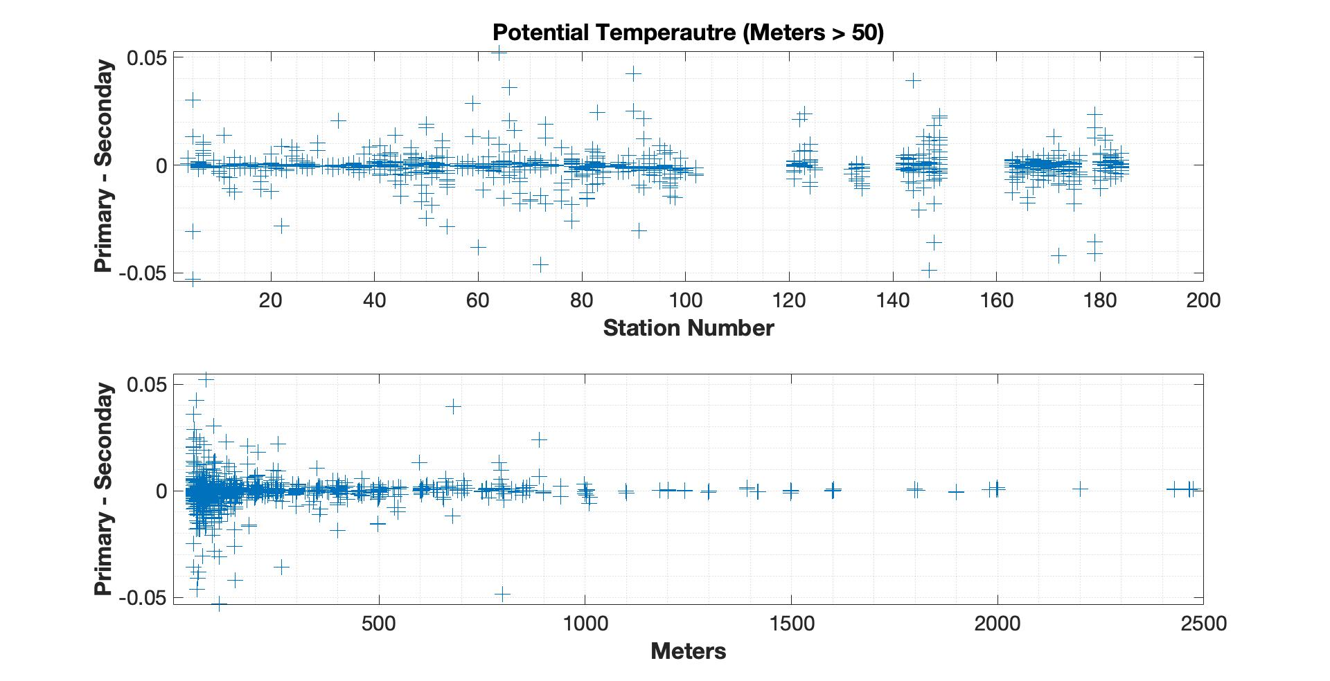

Figure 2: Uncalibrated potential temperature sensor differences between the primary and seconday sensors for depth greater the 50 meters.

3.1.8 CTD Salinity
Salinity sensor calibration coefficients derived from the pre-cruise calibrations were applied to raw primary and secondary conductivity data during each cast. Calibration accuracy was examined by comparing S1-S2 over a range of station numbers and depths (bottle trip locations) for each cast. For the entire cruise, three conductivity sensors were used, and all three tracked each other very well. These comparisons are summarized in Figure 3, which shows a median salinity difference between the sensors of 0.009 PSU.

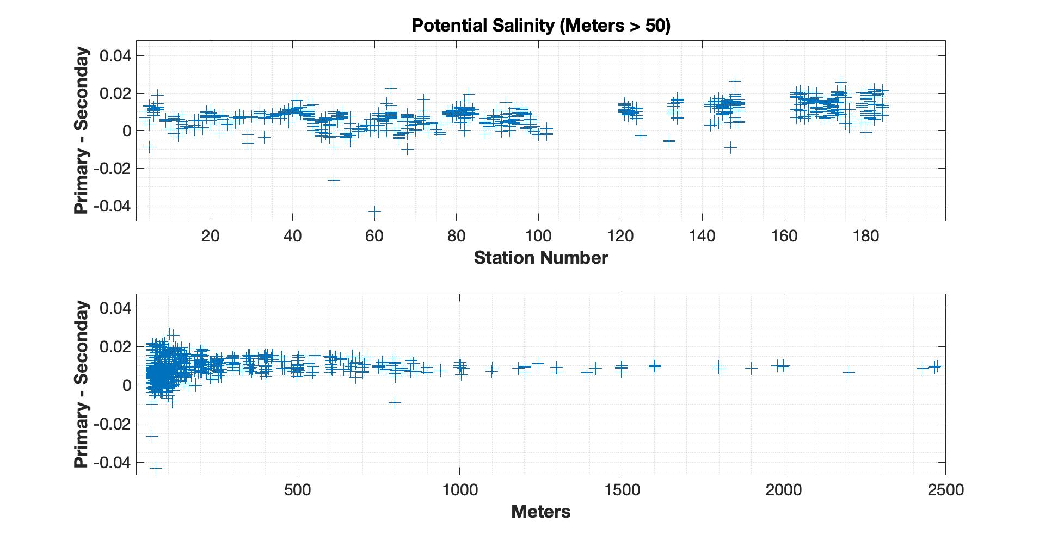

Figure 3: Uncalibrated salinity differences between primary and secondary sensor for pressures > 50.

3.1.9 CTD Dissolved Oxygen
Two SBE43 dissolved O₂ (DO) sensor was used on this cruise. Both sensors tracked each other well but there appeared to by an offset between the sensors of about -9.0 umol/kg.
Calibration accuracy was examined by comparing O1-O2 over a range of station numbers and depths (bottle trip locations) for each cast. These comparisons can be seen in Figure 4, which shows a median oxygen difference of -10.2050 umol/kg. During post cruise calibration of primary sensor (serial number 3669) it was discovered that the membrane may have been damaged prior to deployment. Because of this it was determine that it would be best to use the secondary oxygen sensor for Winkler comparisons and CTD profiles. Post cruise calibration of the sensor determined that there was minimal drift with a slope of 1.0026 ml/L between calibrations. Another check of the calibration of the DO sensor was to match up cast bottle trips (Winklers) to down cast CTD data along isopycnal surfaces. This produce a RMSE of 6.240 umol/kg. A future NOAA goal is to make DO data processing internally consistent between cruises. We note to the user that all raw CTD data are available for use in post-corrections.

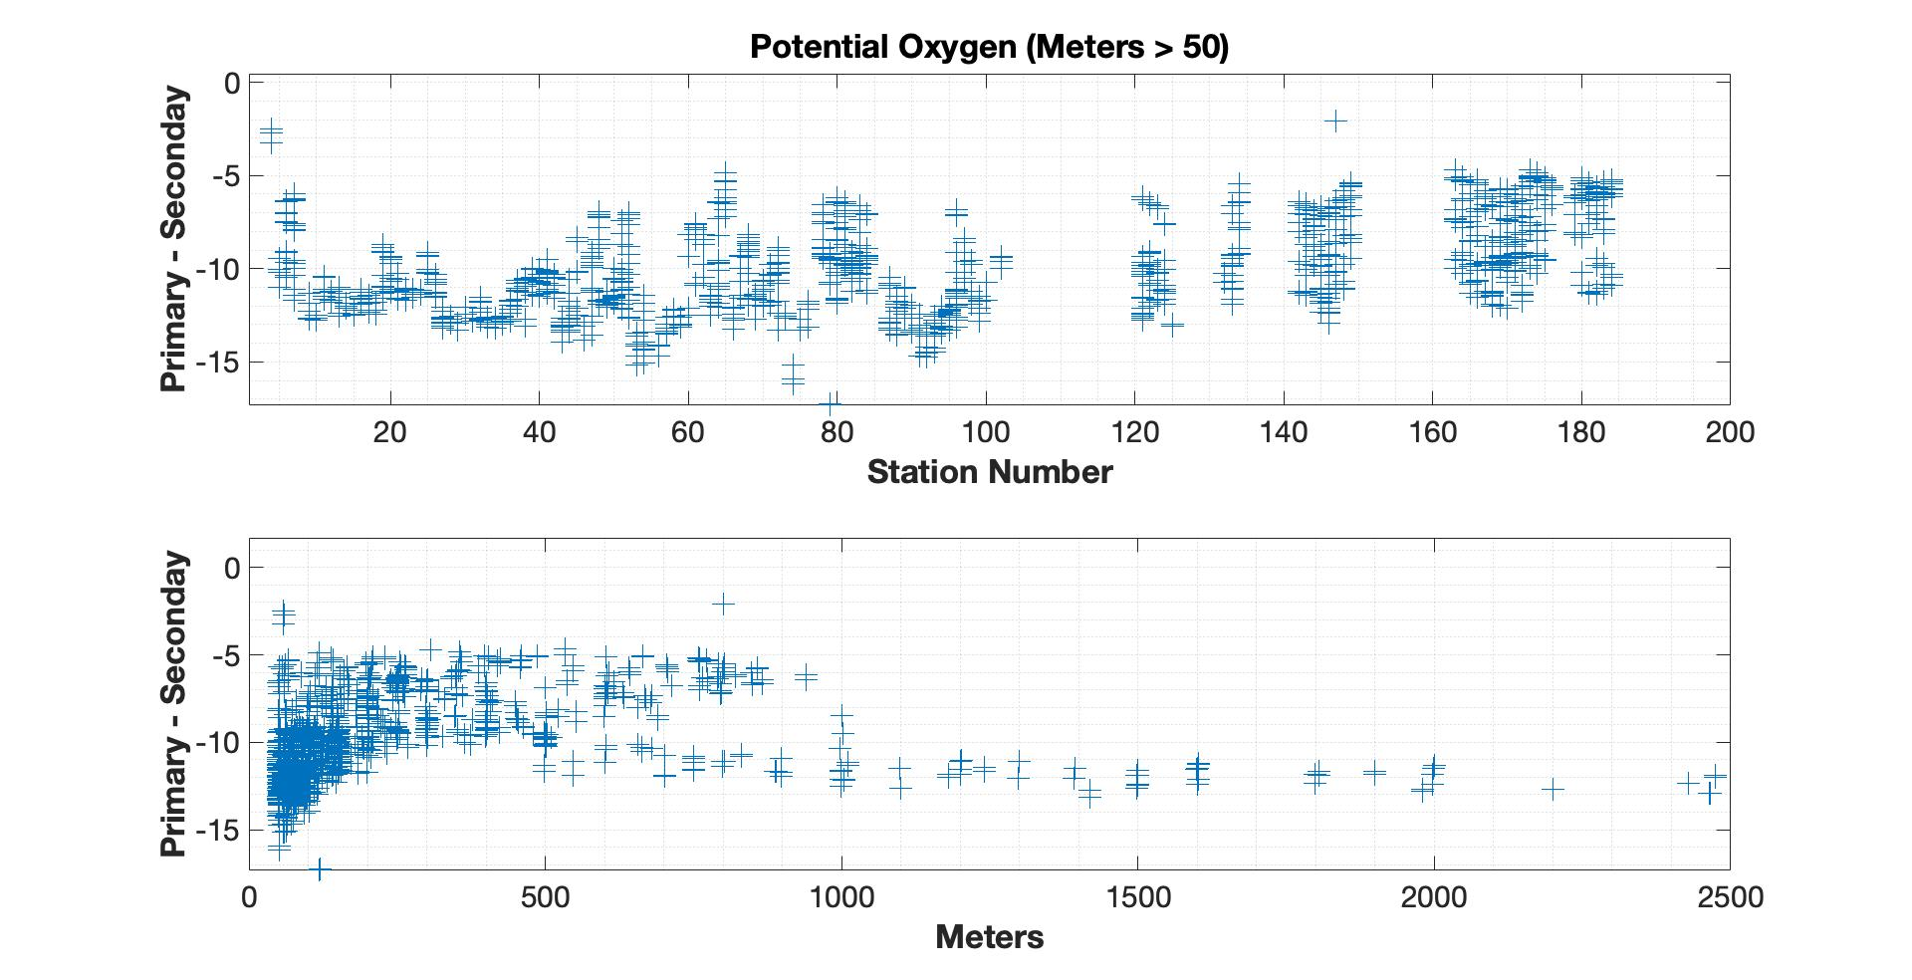
Figure 4: Uncalibrated oxygen differences between primary and secondary sensors for depths greater than 50 meters

Table 4: Equipment used during the cruise. Calibration and post calibration files available from Shawn Shellito UNH (shawn.shellito@unh.edu)

Instrument | S/N | Stations Used | Sensor Use | Pre-Cruise Calibration | Comment
Sea-Bird SBE32 24-place Carousel Water Sampler | 3260142-07163 |  |  | NA
Sea-Bird SBE9plus CTD
Paroscientific Digiquartz Pressure Sensor | 131732 |  |  | 15-Jan-18
Sea-Bird SBE3plus Temperature Sensor | 04981 |  | primary | 11-Jan-18
Sea-Bird SBE3plus Temperature Sensor | 0749 |  | secondary | 11-Apr-18
Sea-Bird SBE4C  Conductivity Sensor | 04385 |  | primary | 10-Jan-18 | Failed cast #47
Sea-Bird SBE4C  Conductivity Sensor | 2653 |  | secondary | 11-Jan-18
Sea-Bird SBE43 Dissolved Oxygen | 3669 |  | primary | 15-Apr-18
Sea-Bird SBE43 Dissolved Oxygen | 0792 |  | secondary | 06-Apr-18
Seapoint Fluorometer | SCF-2770 |  |  | NA
Seapoint CDOM | SUVF-6201 |  |  | NA
PSA-916 Altimeter | 73810 |  |  | 11-Jan-18
Biospherical QCP 2300 Irraddiance | 70550 |  |  | 01-Jan-18
Sea-Bird SBE4C Conductivity Sensor | 3741 |  | primary | 07-Jan-17 | Primary Replacement # 47

You can find the CTD data set at http://accession.nodc.noaa.gov/0194299

3.2 Oxygen Measurements
Analysts: Emma Pontes (RSMAS, University of Miami), Dwight Gledhill (NOAA-OAP), and Melissa Melendez-Oyloya (OPAL, University of New Hampshire)
Data oversight: Chris Langdon, (MBF/RSMAS, University of Miami)
3.2.1 Equipment and Techniques

Dissolved oxygen analyses were performed with an automated oxygen titrator using amperometric end-point detection (Langdon, 2010). Sample titration, data logging, and graphical display were performed on a PC running a LabView program written by Ulises Rivero of AOML. The titrations were performed in a climate controlled lab at 23.0°C-27.9°C. The temperature-corrected molarity of the thiosulfate titrant was determined as given by Dickson (1994). Thiosulfate was dispensed by a 2 ml Gilmont syringe driven with a stepper motor controlled by the titrator. The whole-bottle titration technique of Carpenter (1965) with modifications by Culberson et al. (1991) was used. Four to six replicate 10 ml iodate standards were run every seven days. The reagent blank was determined as the difference between V1 and V2, the volumes of thiosulfate required to titrate 1-ml aliquots of the iodate standard, was determined at the beginning and end of the cruise.

3.2.2 Sampling and Data Processing

Dissolved oxygen samples were drawn from Niskin bottles into volumetrically calibrated 125 ml iodine titration flasks using Tygon tubing with a silicone adaptor that fit over the petcock to avoid contamination of DOC samples. Bottles were rinsed three times and filled from the bottom, overflowing three volumes while taking care not to entrain any bubbles. The draw temperature was taken using an Oakton digital thermometer with a flexible thermistor probe that was inserted into the flask while the sample was being drawn during the overflow period. These temperatures were used to calculate micromole/kg (μmol kg⁻¹) concentrations, and a diagnostic check of Niskin bottle integrity. One ml of MnCl₂ and one ml of NaOH/NaI were added immediately after drawing the sample was concluded using a Repipetor. The flasks were then stoppered and shaken well. DIW was added to the neck of each flask to create a water seal. The flasks were stored in the lab in plastic totes at room temperature for at least 1 hour before analysis.

Samples plus duplicates were drawn from the full cast of each station except the shallow coastal stations where fewer samples were drawn depending on the depth or as directed by the chief scientist. The total number of hydrocast samples collected was 1376. Duplicate samples were drawn once every station. A total of 225 sets of duplicates were run. The preliminary difference between replicates averaged 0.86 μmol kg⁻¹ for stations 1-120 (Leg 1) and 0.39 μmol kg⁻¹ for stations 121-184 (Leg 2).

The total number of samples flagged after post-cruise quality control:
Questionable (n=11), Bad (n=14).

100 additional discrete oxygen samples including duplicates were drawn from the ship’s uncontaminated seawater line along the cruise track at specific times.

3.2.3 Problems

There were no problems with analysis equipment but on several occasions while sampling from the Niskins the temperature sensor stopped working. When this occurred, a note was made in the master Winkler sheet and instead of using the draw temp for analysis the temperature recorded at the bottle snap time was used. Also, towards the end of the cruise it become apparent that we were becoming low on thiosulfate titrant and the decision was made to slightly reduce the number of Winklers collected per station.

You can find the oxygen data set at http://accession.nodc.noaa.gov/0196419

References

Carpenter, J.H. (1965). The Chesapeake Bay Institute technique for the Winkler dissolved
oxygen method. Limnol. Oceanogr. 10: 141-143

Culberson, C.H. and Huang, S. (1987). Automated amperometric oxygen titration. Deep-
Sea Res. 34: 875-880.

Culberson, C.H.; Knapp, G.; Stalcup, M.; Williams, R.T. and Zemlyak, F. (1991). A
comparison of methods for the determination of dissolved oxygen in seawater.
WHP Operations and Methods.

Dickson, A. G., "Determination of dissolved oxygen in seawater by Winkler titration," WHP Operations and Methods (1994a).

Langdon, C. (2010). Determination of dissolved oxygen in seawater by Winkler titration
using the amperometric technique. The GO-SHIP Repeat Hydrography Manual: A Collection of Expert Reports and Guidelines. E. M. Hood, C. L. Sabine and B. M. Sloyan, IOCCP Report Number 14, ICPO Publication Series Number 134.

3.3 Nutrient Measurements

Analyst: David Townsend (UMaine)
Nitrate, Nitrite, phosphate and silicate are major inorganic nutrients that control oceanic primary production and carbon exports. Together with the measurements of inorganic carbon parameters, the observations will be used to estimate the effect of riverine input, air-sea CO₂ gas exchange, biological productivity and lateral carbon exchange on the coastal carbon dynamics.

Approximately 1300 nutrient vials were taken for analysis at the University of Maine. Nutrient samples were collected starting with the deepest Niskin bottle. A 60ml syringe and plunger were rinsed three times with the desired seawater. The plunger was then filled with the sample seawater, and a filter head (0.45micron disc) was attached. A small volume of seawater would then be dispensed into a cleaned acid washed, 20ml scintillation vial, the cap would then be replaced, and the vial shaken. After shaken several times the water would be discarded from the vial. This process would be repeated two more times. After the vial and cap have been rinsed, filtered seawater would slowly by dispensed into sample vial. The total volume needed was only 10ml (the vial would not exceed ¾ full). The vials would then be placed into a seawater ice bath until all the samples had been collected from the remaining Niskin bottles. The filter did not need to be changed in between depths only between stations. Once all the samples had been collected for the station, they then would be placed into a freezer and kept frozen until analysis.

3.3.1 Analytical Methods

The samples were analyzed at the David Townsend Lab (UMO) for nitrate plus nitrite, silicate and phosphate using a Bran-Luebbe Autoanalyzer 3 according to the procedures described by Whitledge et al (1986).

You can find the nutrient data set at http://accession.nodc.noaa.gov/0196419

References

Whitledge, T.E., D.M. Veidt, S.C. Mallow, C.J. Patton, C.D. Wirick. 1986. Automated nutrient analyses in seawater. Brookhaven National Laboratory, Publication BNL 38990, 177 p.

3.4 DIC Measurements
Analysts: Charles Featherstone (NOAA/AOML) and Patrick Mears (NOAA/AOML)

Samples for total dissolved inorganic carbon (DIC) measurements were drawn according to procedures outlined in the Handbook of Methods for CO₂ Analysis (DOE 1994) from Niskin bottles into cleaned 294-ml glass bottles. Bottles were rinsed and filled from the bottom, leaving 6 ml of headspace; care was taken not to entrain any air bubbles. After 0.2 ml of saturated HgCl₂ solution was added as a preservative, the sample bottles were sealed with glass stoppers lightly covered with Apiezon-L grease and were stored at room temperature for a maximum of 12 hours prior to analysis.

The DIC analytical equipment was set up in the CTD Lab on board the RV Henry Bigelow. The analysis was done by coulometry with two analytical systems (AOML3 and AOML4) used simultaneously on the cruise. Each system consisted of a CM5015 coulometer (UIC, Inc.) coupled with a Dissolved Inorganic Carbon Extractor (DICE) inlet system. DICE was developed by Esa Peltola and Denis Pierrot of NOAA/AOML and Dana Greeley of NOAA/PMEL to modernize a carbon extractor called SOMMA (Johnson et al. 1985, 1987, 1993, and 1999; Johnson, 1992). In coulometric analysis of DIC, all carbonate species are converted to CO₂ (gas) by addition of excess hydrogen ion (acid) to the seawater sample, and the evolved CO₂ gas is swept into the titration cell of the coulometer with pure air or compressed nitrogen, where it reacts quantitatively with a proprietary reagent based on ethanolamine to generate hydrogen ions. In this process, the solution changes from blue to colorless, triggering a current through the cell and causing coulometrical generation of OH⁻ ions at the anode. The OH⁻ ions react with the H⁺, and the solution turns blue again. A beam of light is shone through the solution, and a photometric detector at the opposite side of the cell senses the change in transmission. Once the percent transmission reaches its original value, the coulometric titration is stopped, and the amount of CO₂ that enters the cell is determined by integrating the total change during the titration.

The coulometers were calibrated by injecting aliquots of pure CO2 (99.99%) by means of an 8-port valve outfitted with two sample loops with known gas volumes bracketing the amount of CO2 extracted from the seawater samples for the two AOML systems.

The stability of each coulometer cell solution was confirmed three different ways: (1) two sets of gas loops were measured at the beginning, (2) The Certified Reference Material (CRM), Batch 121, supplied by Dr. Andrew Dickson of SIO, were measured at the beginning and (3) the duplicate samples at the beginning, middle and end of each cell solution. The coulometer cell solution was replaced after 25 mg of carbon was titrated, typically after 9-12 hours of continuous use.

The pipette volume was determined by taking aliquots at known temperature of distilled water from the volumes. The weights with the appropriate densities were used to determine the volume of the pipettes.

Calculation of the amount of CO₂ injected was according to the CO₂ handbook (DOE 1994). The concentration of CO₂ ([CO₂]) in the samples was determined according to:

[CO₂] = Cal. Factor * (Counts – Blank * Run Time) * K µmol/count
pipette volume * density of sample

where Cal. Factor is the calibration factor, Counts is the instrument reading at the end of the analysis, Blank is the counts/minute determined from blank runs performed at least once for each cell solution, Run Time is the length of coulometric titration (in minutes), and K is the conversion factor from counts to micromoles.

The instrument has a salinity sensor, but all DIC values were recalculated to a molar weight (µmol/kg) using density obtained from the CTD’s salinity. The DIC values were corrected for dilution by 0.2 ml of saturated HgCl2 used for sample preservation. The total water volume of the sample bottles was 288 ml (calibrated by Esa Peltola, AOML). The correction factor used for dilution was 1.0007. A correction was also applied for the offset from the CRM. This additive correction was applied for each cell using the CRM value obtained at the beginning of the cell. The average correction was 2.13 µmol/kg.

Underway samples were collected from the flow thru system in the CTD Lab during transits between lines. Discrete DIC samples were collected approximately every two hours with duplicates every fifth sample. A total of 103 discrete DIC samples including duplicates were collected while underway.

A total of 1467 samples including duplicates were analyzed for discrete dissolved inorganic carbon from 183 CTD casts. The total dissolved inorganic carbon data reported to the database directly from the ship are to be considered preliminary until a more thorough quality assurance can be completed shore side.

References

DOE (U.S. Department of Energy). (1994). Handbook of Methods for the Analysis of the
Various Parameters of the Carbon Dioxide System in Seawater. Version 2.0.
ORNL/CDIAC-74. Ed. A. G. Dickson and C. Goyet. Carbon Dioxide Information
Analysis Center, Oak Ridge National Laboratory, Oak Ridge, Tenn.

Johnson, K.M., Körtzinger, A.; Mintrop, L.; Duinker, J.C.; and Wallace, D.W.R. (1999).
Coulometric total carbon dioxide analysis for marine studies: Measurement and internal consistency of underway surface TCO2 concentrations. Marine Chemistry 67:123–44.

Johnson, K.M., Wills, K.D.; Butler, D.B.; Johnson, W.K.; and Wong, C.S. (1993).
Coulometric total carbon dioxide analysis for marine studies: Maximizing the
performance of an automated gas extraction.

Johnson, K.M. (1992). Operator’s Manual: Single-Operator Multiparameter Metabolic
Analyzer (SOMMA) for Total Carbon Dioxide (CT) with Coulometric Detection.
Brookhaven National Laboratory, Brookhaven, N.Y.

Johnson, K.M.; Williams, P.J.; Brandstrom, L.; and McN. Sieburth, J. (1987).
Coulometric total carbon analysis for marine studies: Automation and
calibration. Marine Chemistry 21:117–33.

Johnson, K.M.; King, A.E.; and McN. Sieburth, J. 1985. Coulometric TCO2 analyses for
marine studies: An introduction. Marine Chemistry 16:61–82.

3.5 Total Alkalinity Measurements

Analysts: Yuanyuan Xu, Qian Li, and Najid Hussain (UDel)

3.5.1 Determination of Total Alkalinity by Gran Titration

Gran titration is a method that linearizes the titration curve using the following function:

$$F=\left(v+V_{0}\right)* {10}^{E/a}$$

where F is the Gran Factor, $v$ is the volume of acid added to the sample vessel, $V_{0}$ is the sample volume, E is the electro motive force (EMF) measured, and a is the slope of electrode for pH buffers. On the v-F diagram a linear regression can be used to determine the intercept on the x-axis, which is the second end point of titration.

Sampling:

Samples for TA were drawn from Niskin bottles directly into 250 ml borosilicate glass bottles using flexible silicon tubing. Coastal waters with high particulate matter were filtered using 0.45 µm filter cartridge. Bottles were rinsed at least three times with sample water and care was taken to expel all air bubbles in the sample prior to filling. Samples were stored at room temperature and were analyzed within 6 hours of collection, then bottles were cleaned and reused. No HgCl₂ was added to samples. Samples were brought to 22.0 ºC for analysis.

3.5.2 Measurements, Precision, and Accuracy

For each measurement 25 ml of TA sample was titrated with 0.1M HCl solution. HCl stock solution was prepared in the laboratory at the University of Delaware (UD) as 0.1M HCl in 0.5M NaCl and allowed to age and stabilize for several weeks prior to the cruise. Our experience has shown aging the acid solution for TA analysis considerably reduces the variability of the results. This TA titration system has a precision >0.1% (Cai et al. 2010). Each TA measurement was repeated until two measurements were within 0.1% of each other. The pH electrode was calibrated using pH buffers (NBS) – 4.01, 7.0, and 10.01 – and pH recalibration is carried out underway every 12 to 24 hours.

Dickson Certified Reference Material was used to test the accuracy of the method. CRM was also used to determine the concentration of the acid solution approximately every 24 hours. Calibration checks are made at least twice between calibrations by running CRM standards of the same batch but with a different bottle.

Duplicate water samples were run on an average every 15 samples. The overall determined precision of this method is within 0.1%. Samples with repeatability exceeding 0.1% have been flagged in the master data file.

Underway TA samples were collected from the ship’s flow through system during longer transits between stations. A total of 1467 samples, including duplicates, were taken from Niskin bottles and 103 underway samples were analyzed.

You can find the TA data set at http://accession.nodc.noaa.gov/0196419

References

Cai, W.-J., X. Hu, W.-J. Huang, L.-Q. Jiang, Y. Wang, T.-H. Peng, and X. Zhang. 2010.
Alkalinity distribution in the western North Atlantic Ocean margins. J. Geophys. Res.
115, doi:10.1029/2009JC005482

3.6 Seawater pH Measurements

Analysts: Junxiao Zhang, Xinyu Li, Baoshan Chen, and Najid Hussain (UDel)

Seawater pH on the concentration scale can be defined as:

$$pH=-log\left(\frac{[H^{+}]}{mol∙{kg}^{-1}}\right)$$

where the hydrogen ion (H) concentration (in molar units of mols·kg⁻¹ SW) can be expressed as three different quantities depending on which concentration scale is being used to measure seawater pH. The most widely used concentration scale, and the one used for this cruise, is the total Hydrogen ion concentration scale or total scale, denoted pH_{T}, which uses a hydrogen ion concentration defined as:

$${\left[H^{+}\right]}_{T}={\left[H^{+}\right]}_{F}+\left[{HSO}_{4}^{-}\right]={\left[H^{+}\right]}_{F}+\left(1+\frac{S_{T}}{K_{S}}\right)$$

where ${\left[H^{+}\right]}_{F}$ is the concentration of free protons in seawater (as well as complexes with water molecules), $S_{T}$ is the total sulfate concentration in seawater, and $K_{S}$ is the dissociation constant bisulfate $\left({HSO}_{4}^{-}\right)$ (Zeebe & Wolf-Gladrow, 2001; Dickson et al., 2007).

Seawater pH can be measured via potentiometry using a wide array of electrodes and buffers (Zeebe & Wolf-Gladrow, 2001) or spectrophotometry using pH-sensitive colorimetric indicator dyes (Clayton & Byrne, 1993; Zhang and Byrne, 1996). The spectrophotometric pH method has been proven to yield much higher precisions (±0.0004-0.001 pH units) (Liu et al., 2006) than potentiometric pH methods that can only reach ±0.001-0.003 pH units (Millero et al., 1993). For the purposes of this cruise, and for testing a new setup, we have chosen to use a colorimetric spectrophotometric method since it is the most precise method.

3.6.1 Sampling

Samples for pH were drawn from Niskin bottles directly into 125 ml borosilicate glass bottles with GL45 screw caps, using flexible silicon tubing. Sample water was filtered with Waltman 0.45 µm filters and bottles were rinsed at least three times with sample with care taken to expel all air bubbles prior to filling. All visible air bubbles are allowed to escape from the filter prior to filling the bottles with sample water. The silicon tubing is placed at the bottom of the bottle and is tightly pinched to stop the water flow prior to removing it. The bottles were allowed to overflow with at least one and a half volumes worth of water before the final sample is collected, leaving no headspace in the bottle. Samples were placed in a water bath at 20 or 25 °C (water bath temperature was adjusted during the cruise due to bubble formation) directly after sampling and analyzed within 2-3 hours of collection. No HgCl₂ was added to samples.

3.6.2 Apparatus & Chemicals

The design and technical details of the spectrophotometric pH system used is described in detail by Carter et al. (2013). However, the automation software addressed in Carter et al. (2013) was abandoned in favor of a semi-automated measurement program modeled after the original automation software. While minimizing operator interaction with the system when making measurements would minimize the operator-derived error associated with making seawater pH measurements at sea (Cater et al., 2013). A fully automated arrangement severely limits the troubleshooting capabilities of the operator when problems arise within the system. Therefore, a fully automated system could result in degraded repeatability or the possible loss of single or multiple water samples. A computer with syringe pump control software and the Agilent ChemStation software is used to operate the spectrophotometric pH system that consisted of: 1) a Kloehn V6 automated syringe pump equipped with a water-jacketed 25 mL syringe; 2) a 4-port distribution valve and an Agilent 8453 UV-Visible Single-Beam Spectrophotometer equipped with an Agilent long path-length cell holder; and 3) a water-jacketed 10 cm flow-through cell kept at a measurement temperature of 20.0 ± 0.1ºC. The temperature is regulated using a thermal bath (VWR, Scientific Product).

Purified meta-cresol purple (mCP) from Robert Byrne, of the University of South Florida, along with CO₂-free pure water (Milli-Q) is used to prepare a 0.1% purified mCP dye solution. After preparation, the pH of the dye solution was checked with a 0.2 cm cell and adjusted to the recommended 7.9 ± 0.1 using low concentration HCl and NaOH. To protect the dye from degradation by UV light and prevent gas exchange between the dye and the laboratory atmosphere, the dye solution is stored in an aluminum foil bag (Manufacturer, Part #). Routine checks of dye pH using this method were performed at sea to ensure the dye pH remained unchanged. Deionized (DI) water and additional volumes of seawater taken directly from Niskin bottles were used during troubleshooting procedures.

3.6.3 Measurement

The samples are placed in the thermal bath set to 20.0 ± 0.1 ºC (or 25.0 ± 0.1 ºC) for 30 minutes to equilibrate to the measurement temperature prior to beginning the measurement sequence. Upon reaching the measurement temperature, each bottle is placed in a thermostatted bottle holder. A 95 second equilibration time is allowed in the analysis process to ensure the sample inside the cell reaches thermal and chemical equilibrium prior to collecting the background spectrum. While waiting for the sample to equilibrate in the flow cell, the sample and dye are mixed together. 30 µL of mCP dye is used for every injection. Because the volume of dye used can vary by up to 10% between successive injections, the recommendations made by Carter et al. (2013) were followed as well as recommendations for measured absorbances used in spectrophotometric pH calculations outlined in Dickson et al. (2007). For the sample+dye mixture, the 95 second equilibration period started immediately following the conclusion of the dispensing of the sample+dye mixture. After which, a series of 3-4 spectra are collected for the sample+dye mixture in quick succession. The second rinse that is performed at the end of each analysis sequence is performed to sufficiently flush the flow cell of all the sample+dye mixture. Measurements were taken using the tungsten lamp to prevent the degradation of the sample and the dye by UV light from the deuterium lamp.

The method of bubble control, described in Mosley et al. (2004), is employed and involves dispensing of the top and bottom 1 mL of solution during each filling cycle to waste as a means of preventing bubbles from entering the flow cell. By directing the top and bottom 1.5 mL of each syringe full of solution to waste, the transport and accumulation of bubbles inside the syringe, tubing, and flow cell is greatly reduced, which gives the operator better overall control of the system and measurements the operator makes. All samples are analyzed within two to three hours of collection. A total of 1467 samples were analyzed from Niskin bottles and 103 underway samples were analyzed.

3.6.4 Calculations

The absorbances recorded by the Agilent ChemStation software were saved and run through an Excel Spreadsheet programmed with the necessary equations to calculate the preliminary pH values for all of the water samples run during the cruise. The calculation for determining pH_{T} valid over 5 < T< 35 ºC and salinity of 20 < S < 40 developed by Liu et al. (2011) was applied to the absorbances.

$${pH}_{T}=\log\left(K_{2}^{T}e_{2}\right)+\log\left(\frac{R-e_{1}}{1-R∙\frac{e_{3}}{e_{2}}}\right)$$

where R it the ratio of absorbances measured at 578 nm and 434 nm, and e is the molar absorptivity ratio. The salinity (S), temperature (T), and temperature dependence of $K_{2}^{T}e_{2}$ can be expressed as:

$$-log\left(K_{2}^{T}e_{2}\right)=a+\left(\frac{b}{T}\right)+c\ln{T-dT}$$

where the coefficients a, b, c, and d are:

$$a= -246.64209+0.315971S+2.8855∙{10}^{-4}S^{2}$$

$$b=7229.23864-7.098137S-0.057034S^{2}$$

$$c=44.493382-0.052711S$$

$$d=0.0781344.$$

The temperature and salinity dependence of the molar absorptivity constants (e₁, e₂, e₃) can be expressed as:

$$e_{1}=-0.007762+4.5174∙{10}^{-5}T$$

$${e_{3}}/{e_{2}}=-0.020813+2.60262∙{10}^{-4}T+1.0436∙{10}^{-4}\left(S-35\right).$$

3.6.5 Repeatability, Reproducibility, Precision, and Accuracy

Duplicate water samples were collected 133 times throughout the cruise. The repeatability of other published spectrophotometric pH techniques is ± 0.0004 pH units (Clayton & Byrne, 1993; Carter et al., 2013; Hammer et al., 2014). For our purposes of obtaining climate quality data we set this value at ±0.001 pH units (Tapp et al., 2000; Hammer et al., 2014). The repeatability of all of the samples run on the spectrophotometer by all operators falls within published repeatability range of ±0.0004-0.001 pH units. Reproducibility is linked to repeatability.

Determining the measurement precision involves measuring the pH from repeated injections of a single sample of a known salinity and pH (i.e. TRIS Buffer) thermostatted at a constant temperature under carefully-controlled laboratory conditions such as those described in Hammer et al. (2014). Gauging the accuracy of pH values measured at sea is usually done via tests of internal consistency with measurements of the other parameters of the marine-CO₂ system using the DIC, TA, and pCO₂ or fCO₂ measured from samples taken from the same Niskin bottle at the same time as the pH samples (Millero, 2007; Hoppe et al., 2012). Using this method, an accuracy of 0.01-0.02 pH units is routinely achieved depending on which set of K₁ and K₂ values are used (Carter et al., 2013; Hammer et al., 2014). Using purified mCP, the errors associated with dye impurities that can result in pH offsets as high as 0.01 pH units depending on the dye manufacturer (Yao et al., 2007) can be avoided, and lead to more accurate pH measurements.

You can find the DIC data set at http://accession.nodc.noaa.gov/0196419

References

Carter BR, Radich JA, Doyle HL, Dickson AG (2013). An automated system for spectrophotometric seawater pH measurements. Limnology & Oceanography: Methods 11: 16-27.

Clayton TD, Byrne RH (1993). Spectrophotometric seawater pH measurements: Total hydrogen ion concentration scale calibration of m-cresol purple and at-sea results. Deep Sea Research Part I: Oceanographic Research Papers 40(10): 2115-2129.

Dickson A, Sabine C, Christian J (eds) (2007). Guide to best practices for ocean CO₂ measurements. PICES Special Publication 3, 191 pp.

Hammer K, Schneider B, Kulinski K, Schulz-Bull DE (2014). Precision and accuracy of spectrophotometric pH measurements at environmental conditions in the Baltic Sea. Estuarine, Coastal, and Shelf Science: 146: 24-32.

Hoppe CJM, Langer G, Rokitta SD, Wolf-Gladrow DA, Rost B (2012). Implications of observed inconsistencies in carbonate chemistry measurements for ocean acidification studies. Biogeoscience Discussions 9: 1781-1792.

Liu X, Wang ZA, Byrne RH, Kaltenbacher EA, Bernstein RE (2006). Spectrophotometric Measurements of pH in-Siut: Laboratory and Field Evaluations of Instrumental Performance Environ. Sci. Technol. 40: 5036-5044.

Millero FJ, Zhang JZ, Fiol S, Sotolongo S, Roy RN, Lee K, Mane S (1993). The use of buffers to measure pH for seawater. Marine Chemistry 22: 143-152.

Mosley LM, Husheer SLG, Hunter KA (2004). Spectrophotometric pH measurement in estuaries using thymol blue and m-cresol purple. Marine Chemistry 91: 175-186.

Tapp M, Hunter K, Currie K, Mackaskill B (2000). Apparatus for continuous-flow underway spectrophotometric measurement of surface water pH. Marine Chemistry 72: 193-202.

Yao W, Liu X, Byrne RH (2007). Impurities in indicators used for spectrophotometric seawater pH measurements: Assessment and remedies. Marine Chemistry 107: 167-172.

Zeebe RE, Wolf-Gladrow DA (2001). CO2 in seawater: equilibrium, kinetics, isotopes. vol 65. Elsevier Science.

Zhang H, Byrne RH (1996). Spectrophotometric pH measurements of surface seawater at in-situ conditions: Absorbance and protonation behavior of thymol blue. Marine Chemistry 5: 17-25.

3.7 Respiration/Bacteria Activity

Analyst: Kia Ziervogel, UNH
Sampling: Tyler Menz and Melissa Melendez (UNH)

3.7.1 Sampling

Seawater samples used to determine Electron transport system (ETS) activity were collected at 58 stations. ETS is used to estimate community respiration (R) These stations were sampled during daylight hours. Water samples were taken from 10 L Niskin bottles at the surface, chlorophyll maximum and 1% light level, and were transferred into plastic carboys in order to facilitate subsampling. A majority of the stations were not deep-water stations, so the depths sampled were generally above 200 m. Most surface samples were sampled at 2-3 m and a majority of the chlorophyll maximum samples were taken between 10 and 50 m. It is also important to note that the 1% light level was approximated at each station and may not be exact. 500 mL to over 1,000 mL of seawater were filtered through a GF/F placed on top of a 0.4 µm filter, to separate our size classes of microbes. The filters were separately wrapped in aluminum foil and immediately stored in liquid nitrogen until assayed at the University of New Hampshire several months later.

3.7.2 Analysis

ETS activity was determined both for the GF/F filter and the 0.4µm filter from each station. Three solutions were used for analysis. The first was a substrate made from NADH and NADPH (in a 3:1 ratio) and sodium succinate (these three components act as electron donors in the analysis), and a trace amount of Triton, all dissolved in a phosphate buffer. The phosphate buffer was made using Triton, PVP, MgSO4•7H20, and a trace amount of NaCN. Sodium cyanide was only added to the PO4 buffer in the first batch made, and in subsequent solutions it was excluded, as it was deemed unnecessary and a potential health hazard. The third solution needed for analysis was a 4 mM INT solution, made from INT (described below) and milli-Q water. This acted as the artificial electron acceptor in the analysis.

Each filter was cut in half, and using a tissue grinder, homogenized in 3 ml phosphate buffer for two minutes. During this time the sample was kept on ice to maintain the same temperature as it had been stored in. The homogenate liquid was transferred to a centrifuge tube and centrifuged for at least 5 minutes at 2000 rpm. In the case of the GF/F filters, which broke down more easily than the 0.4µm filters, the samples were usually centrifuged a second time to ensure all filter pieces settled to the bottom. The homogenate liquid was then carefully poured into a 15 ml glass tube and the total recovered volume was recorded. A plastic cuvette was prepared with 0.5 ml of the homogenate, 0.5 ml INT solution, and 1 ml substrate. Immediately after adding the substrate, the absorbance was measured on a spectrophotometer set to 490 nm. The absorbance was recorded a total of 5 times within a 10-minute period (approximately every two minutes) to observe the change in activity over time.

ETS was converted to R based on a ratio determined by Packard and Williams (1981) where R/ETS = 0.25 ± 0.05. A temperature correction was then applied to R values using the Q10 method from Apple et al., 2006 using the equation: R2 = R1(Q10) (T2-T1)/10, where R1 was the uncorrected R value, T2 was the temperature, in Kelvin, of the seawater from when the sample was collected, T1 was the temperature when the assay was performed and was constant at 293.15 K, and Q10 was assumed to be 2.2 based on the calculations performed by Apple et al. (2006).

3.7.3 Preliminary Results

Figure 5 shows that chlorophyll and R were fairly consistent at the surface and throughout a majority of the chlorophyll maximum. The two values began to diverge around 80 m when it is likely that light limitation began to be a factor for chlorophyll production.

Figure 5: Chlorophyll a and R vs Depth from GF/F filters. A majority of the chlorophyll is seen at the surface and decreases with depth, which is logical as it is a proxy for biomass, which has a light dependency for photosynthesis. Deeper waters have less light and therefore less chlorophyll a.

You can find the ETS data set at http://accession.nodc.noaa.gov/0196419

References

Apple, J.K., P.A. DelGiorgio, W.M. Kemp (2006). Temperature regulation of bacterial production, respiration and growth efficiency in a temperate salt-marsh estuary. Aquatic Microbial Ecology. V. 43:243-354, 2006

Packard, T. T., & Christensen, J. P. (2004). Respiration and vertical carbon flux in the
Gulf of Maine water column. Journal of Marine Research, 62(1), 93-115.

Packard, T. T., Devol, A. H., & King, F. D. (1975, April). The effect of temperature on
the respiratory electron transport system in marine plankton. In Deep Sea Research
and Oceanographic Abstracts (Vol. 22, No. 4, pp. 237-249). Elsevier.

Packard, T. T., & Williams, P. L. B. (1981). Respiration and respiratory electron
transport activity in sea surface seawater from the northeast Atlantic. Oceanol.
Acta, 4, 351-358.

Packard, T.T. (1985). Measurement of electron transport activity of microplankton.
Adv. Aquat. Mircobiol., 3, 207-261.

3.8 Dissolved organic carbon (DOC), High-performance liquid chromatography (HPLC), Colored dissolved organic matter (CDOM), and Suspended Material (TSM)

Sampling: Melissa Melendez, Tyler Menz, Elizabeth Wright-Fairbanks, and Chloe Baskin

All samples analyzed at NASA Goddard Ocean Ecology Lab (Antonio Mannino, PI).
.

The primary objective was to characterize carbon and ocean acidification properties in the coastal margin with observations of phytoplankton community structure across large spatial and environmental gradients. Water samples were taken from 10 L Niskin bottles at the surface, chlorophyll maximum and 1% light level, and were transferred into plastic carboys in order to facilitate subsampling. In the case of HPLC and POC sample seawater was immediately filtered onto Whatman 47mm GF/F filters using a vacuum pump <0.5 atm and then placed in foil and stored in LN2. The phytoplankton pigment analysis will follow the method described in Van Heukelem and Thomas (2001). Details of analysis precision will be provided during data submission. QA-QC protocols for pigments analysis will follow the steps mentioned in Hooker et al. (2005). POC analysis will follow methods described in Hedges and Stem (1984). DOC and CDOM sample seawater was filtered through 47mm GFF filters and separated into 2 or 3 (depending on depth) 40ml vials for DOC and one 125ml bottle for CDOM. The DOC vials were frozen and the CDOM bottles refrigerated. TSM sample seawater were filtered onto 0.7 µm (nominal size) GF/F filters. Pre-weighted and combusted GF/F’s were used for the collection of the TSS samples. Special care was taken to avoid sea-salt retention in the filters; sample filters were rinsed several times with deionized water to remove sea salt. Samples were frozen until the end of the cruise and then dried when back in the lab.

Data from this collaborative effort are also archived on the NASA Ocean Biology Processing Group’s SEABASS archive.

https://seabass.gsfc.nasa.gov/archive/NASA_GSFC/ECOA/ecoa-2/archive/ECOA_2018_pigments.txt
https://seabass.gsfc.nasa.gov/archive/NASA_GSFC/ECOA/ecoa-2/archive/ECOA_2018_DOC_TDN.txt

References

D. Van der Linde, Protocol for Total Suspended Matter estimate. JRC Technical Note.
June 1998.

Hedges, J.I. and J.H. Stern. 1984. Carbon and nitrogen determinations of carbonate-
containing solids. Limnol. Oceanogr. 29: 657-663.

Hooker, S.B.; VanHeukelem, L.; Thomas, C.S.; Claustre, H.; et al. (2005). The second
sea-wifs hplc analysis round-robin experiment (seaharre-2).

J.D.H. Strickland and T.R. Parsons, 1972. A practical Handbook of seawater Analysis, 8,
181-184.

Mannino, A., M. E. Russ, and S. B. Hooker (2008), Algorithm development and
validation for satellite-derived distributions of DOC and CDOM in the U.S.
Middle Atlantic Bight, J. Geophys. Res., 113, C07051, doi: 10.1029 /2007JC004493

Van Heukelem, L.; and Thomas, C.S. (2001). Computer-assisted high-performance liquid
chromatography method development with applications to the isolation and analysis of
phytoplankton pigments. Journal of Chromatography A 910:31-49.

3.9 CH₄, pCO₂ (at depth) and ¹⁸O

PI: Kumiko Azetsu-Scott
Sampling: Tyler Menz and Bror Jonsson

Samples for pCO₂/CH₄ were drawn from Niskin bottles directly into 160 ml serum glass bottles using flexible silicon tubing. Bottles were rinsed, filled, and then overflowed by two volumes making sure not to entrain any air bubbles. Completely full bottles were spiked with saturated mercuric chloride and then had a crimp seal crimped onto the bottle to seal it. O-18 samples were collected in a similar manner but instead of being crimped the 60 ml brown glass bottles had screw caps tighten upon them and then 2 wraps of electrical tape wrapped around each cap seal. A total of 294 pCO₂/CH₄ samples were collected while a total of 183 ¹⁸O samples were collected. Data and metadata has been submitted on the master sampling sheet to NCEI.

You can find the archival data set at http://accession.nodc.noaa.gov/0196419

References

Walker, S. A., K. Azetsu-Scott, C. Normandeau, D. E. Kelley, R. Friedrich, R. Newton, P. Schlosser, J. L. McKay, W. Abdi, E. Kerrigan, S. E. Craig and D. W. R. Wallace (2015) Oxygen isotope measurements of seawater ( H218O/ H216O): A comparison of cavity ring-down spectroscopy (CRDS) and isotope ratio mass spectrometry (IRMS), Limnol. Oceanogr.: Methods, DOI: 10.1002/lom3.10067

Punshon, S, O. Sherwood, E. Edinger, K. Azetsu-Scott (2019). Bottom water methane sources along the high latitude eastern Canadian continental shelf and their effects on the marine carbonate system. Marine Chemistry, 212, 83-95. DOI: 0.1016/j.marchem.2019.04.004.

4.- Underway data collection

4.1 Underway pCO₂ Analyses

Kevin Sullivan (CIMAS/RSMAS), Charles Featherstone (NOAA/AOML) and Rik Wanninkhof (NOAA/AOML)

During the ECOA 2 cruise, there was an automated underway pCO₂ system from AOML situated in the CTD Lab of the RV Henry Bigelow (Figure 6). The design of the instrumental system is based on Wanninkhof and Thoning (1993) and Feely et al. (1998), while the details of the instrument and of the data processing are described in Pierrot, et.al. (2009).

The repeating cycle of the system included 3 gas standards, 5 ambient air samples, and 60 headspace samples from its equilibrator every 3 hours. The concentrations of the standards range from 247 to 510 ppm CO₂ in compressed air. These field standards were calibrated with primary standards that are directly traceable to the WMO scale. A gas cylinder of ultra-high purity air was used every 18 hours to set the zero of the analyzer.

The system included an equilibrator where approximately 0.6 liters of constantly refreshed surface seawater from the bow intake was equilibrated with 0.8 liters of gaseous headspace. The water flow rate through the equilibrator was 1.5 to 3.0 liters/min.

The equilibrator headspace was circulated through a non-dispersive infrared (IR) analyzer, a LI-COR™ 7000, at 50 to 120 ml/min and then returned to the equilibrator. When ambient air or standard gases were analyzed, the gas leaving the analyzer was vented to the lab. A KNF pump constantly pulled 6-8 liter/min of marine air through 100 m of 0.95 cm (= 3/8") OD Dekoron™ tubing from an intake on the bow mast. The intake had a rain guard and a filter of glass wool to prevent water and larger particles from contaminating the intake line and reaching the pump. The headspace gas and marine air were dried before flushing the IR analyzer.

A custom program developed using LabView™ controlled the system and graphically displayed the air and water results. The program recorded the output of the IR analyzer, the GPS position, water and gas flows, water and air temperatures, internal and external pressures, and a variety of other sensors. The program recorded all of these data for each analysis.

4.1.1 Additional Information Leg 1

The analytical system operated well during this cruise. The ship's sensors were not being recorded for some short intervals. The 1-meter binned data for the up and down CTD casts were examined for variability vertically around 5-meter depth and for variability between up and down casts. The SST and SSS values with lesser variability were merged and then compared with the SST and SSS values that were measured on the flowing underway (UW) seawater system. For Leg1, the differences between the CTD and UW values were calculated for 161 matched values (up and down casts combined). Outlying differences (UW minus CTD) greater than 2-sigma from the average difference were eliminated. The resulting average differences were 0.036 (+/- 0.096) deg C, n=150 ; and 0.0068 (+/- 0.0174) psu, n=154 . For the 80 matched values for Leg2, the average differences were 0.010 (+/- 0.038) deg C, n=74 ; and -0.0146 (+/- 0.0227) psu, n=77. The UW sensors for SST and SSS matched the CTD sensors well, so not adjustment to the UW values were made. Original Data Location: http://www.aoml.noaa.gov/ocd/ocdweb/equinox/equinox_introduction.html Full unprocessed data files from analytical instrument including flow information plus meteorological and TSG data at time of sampling can be obtained upon request.

4.1.2

The analytical system operated well during this cruise. The chiller was not working during this cruise, but the Nafion tubes were able to keep the water vapor in samples acceptably low. The 1-meter binned data for the up and down CTD casts were examined for variability vertically around 5-meter depth and for variability between up and down casts. The SST and SSS values with lesser variability were merged and then compared with the SST and SSS values that were measured on the flowing underway (UW) seawater system. For Leg1, the differences between the CTD and UW values were calculated for 161 matched values (up and down casts combined). Outlying differences (UW minus CTD) greater than 2-sigma from the average difference were eliminated. The resulting average differences were 0.036 (+/- 0.096) deg C, n=150 ; and 0.0068 (+/- 0.0174) psu, n=154 . For the 80 matched values for Leg2, the average differences were 0.010 (+/- 0.038) deg C, n=74 ; and -0.0146 (+/- 0.0227) psu, n=77. The UW sensors for SST and SSS matched the CTD sensors well, so not adjustment to the UW values were made. The ship's sensors were not being recorded for some short intervals. Original Data Location: http://www.aoml.noaa.gov/ocd/ocdweb/equinox/equinox_introduction.html. Full unprocessed data files from analytical instrument including flow information plus meteorological and TSG data at time of sampling can be obtained upon request.

Standard Gas Cylinders
Cylinder# | ppm CO₂
JA02166 | 232.80
JB03651 | 306.46
JB03591 | 409.69
JB03285 | 565.58
LL100000 | 0.00
References

Pierrot, D.; Neill, C.; Sullivan, K.; Castle, R.; Wanninkhof, R.; Luger, H.; Johannessen, T.; Olsen, A.; Feely, R.A.; and Cosca, C.E. (2009). Recommendations for autonomous underway pCO2 measuring systems and data-reduction routines. Deep-Sea Res., II, v. 56, pp. 512-522.

Feely, R.A.; Wanninkhof, R.; Milburn, H.B.; Cosca, C.E.; Stapp, M.; and Murphy, P.P. (1998). A new automated underway system for making high precision pCO2 measurements onboard research ships. Analytica Chim. Acta, v. 377, pp. 185-191.

Wanninkhof, R., and Thoning, K. (1993). Measurement of fugacity of CO2 in surface water using continuous and discrete sampling methods. Mar. Chem., v. 44, no. 2-4, pp. 189-205.
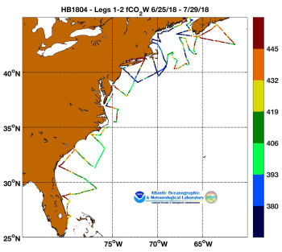

Figure 6: fCO2 readings from Legs 1 and 2 of ECOA2

4.2. Oxygen:Argon ratio and estimation of net community production

Bror Jonsson and Xinyu Li
Underway O₂/Ar ratios are measured using equilibrium inlet mass spectrometer (EIMS) and dissolved oxygen saturation (DO%) using Aanderaa oxygen optode (Model #4531). O₂/Ar ratios better reflect biological driven changes due to the similar physical characters of O₂ and Ar than the DO% method. For the EIMS water flows at a constant rate of 100 ml min⁻¹ through filters (5µm core size) and a gas-water exchange equilibrator to separate gasses. The quadrupole mass spectrometry (MQS 2000) measured O₂ and Ar ions once per second. Air was used as standard because of its stable O₂/Ar ratios, which were measured every 3 hours and lasted for 20 minutes (Cassar et al., 2009). The accuracy of this method is ± 0.02%. Once final QA/QC is complete data will be submitted to NCEI.

References

Cassar, N., Barnett, B. A., Bender, M. L., Kaiser, J., Hamme, R. C., and Tilbrook, B.: Continuous high-frequency dissolved O₂/Ar measurements by equilibrator inlet mass spectrometry, Anal. Chem., 81, 1855-1864, 2009.

4.3 Underway DIC

Qain Li and Qipei Shangguan
DIC was measured continuously via the underway surface water intake system. The DIC system was run on both legs of the ECOA-2 cruise continuously from Newport to Miami with the exception of short interruptions due to maintenance and temporary problems with the plumbing. CRMS standards were run about twice a day for calibration. We will also use the discrete underway measurements of DIC sampled by AOML. Once final QA/QC is complete data will be submitted to NCEI.

4.4 Underway pH

Boashan Chen and Qipei Shangguan
Underway pH was measured by a Honeywell Durafet® III pH electrode (Martz et al. 2010) on both legs of the ECOA-2 cruise. The Durafet pH sensor was placed in a flow-through cell, with a volume of ~500 mL, attached to the ship’s underway seawater intake line. Observations were recorded at 30 second intervals. The raw pH output is on the NBS scale at in situ temperature without calibration. Spectrophotometric pH_{T} analyses of water discrete samples were used to calibration the raw data. pH at in situ SST was calculated with temperature and salinity from a SBE 21 SeaCAT thermosalinograph and TA determined from a linear relationship between salinity using CO2SYS (Lewis and Wallace 1998). The underway pH is reported on the total scale at SST with an uncertainty of ± 0.005. Once final QA/QC is complete data will be submitted to NCEI.

References

Lewis, E., and D. Wallace. 1998. Program developed for CO2 system calculations, ORNL/CDIAC 105, Carbon Dioxide Information Analysis Center.

Martz, T. R., J. G. Connery, and K. S. Johnson. 2010. Testing the Honeywell Durafet for seawater pH applications. Limnol. Oceanogr. Methods 8: 172–184.

4.5 Underway TA

Qain Li and Qipei Shangguan
TA was measured continuously via the underway surface water intake system. The TA system was run on Leg 2 of ECOA2 continuously from Newport to Miami with the exception of short interruptions due to maintenance and temporary problems with the plumbing. CRMS standards were run about twice a day for calibration. We will also use the discrete underway measurements of TA sampled by uDEL. Once final QA/QC is complete data will be submitted to NCEI.

4.6 Underway CO₃²⁻

Qipei Shangguan and Qain Li
CO32 was measured continuously via the underway surface water intake system. The CO32 system was run on Leg 2 of ECOA2 continuously from Newport to Miami with the exception of short interruptions due to maintenance and temporary problems with the plumbing. CRMS standards were run about twice a day for calibration. We will also use the discrete underway measurements of TA sampled by uDEL. Once final QA/QC is complete data will be submitted to NCEI.

4.7 Underway Phytoplankton Community Measurements

Joaquim Goes, Helga do Rosario Gomes (LDEO), and Charles Kovach (NOAA/NESDIS)
During both legs of ECOA-2 distribution of phytoplankton communities were mapped using a FlowCAM™ (Fluid Imaging Technologies, USA), Advanced Laser Fluorometer Analyzer™ (ALFA) (Wet Labs Inc., USA) and an Algal Online Analyzer™ (AOA) (bbe Moldaenke, Germany). In addition to information on phytoplankton, the ALFA also provides measurements of CDOM. In addition, a Fluorescence Induction and Relaxation (FIRe)™, Satlantic, Canada was utilized to obtain estimates of the photosynthetic competencies of phytoplankton at 2-minute intervals over the entire cruise track. All instruments were plumbed to the ships underway flow through system allowing for continuous measurements along the ~ 9500 km cruise track.
With the exception of a few breaks for cleaning and conditioning, all of the instruments were operated throughout the cruise, providing near-real time distribution patterns of Chl a and CDOM fluorescence, phytoplankton functional types and estimates of phytoplankton photosynthetic competencies.
When on station all instruments were disconnected from the underway flow-through system to allow analysis of discrete samples collected via Niskin bottles on a Rosette/CTD cast.

4.7.1 FlowCAM measurements of phytoplankton community structure

The FlowCAM is a particle imaging and counting system. On board our cruise it was equipped with a 4X objective (UPlan FLN, Olympus®) and a 300 µm FOV flow cell. The instrument was operated in trigger mode so that only chlorophyll containing phytoplankton particles were counted as seawater moved through the flow cell. Cells will be classified to the genus level using the Visual Spreadsheet program (v. 2.2.2, Fluid Imaging). The instrument provides the total number of particles imaged, together with the dimensions of each particle allowing estimations of phytoplankton community structure, particle size distribution of both phytoplankton and of detrital particles.
Identification of individual phytoplankton cells up to the genus level together with their counts and size (ongoing at present) can be undertaken with the Visual Spreadsheet program (v. 2.2.2, Fluid Imaging). The FlowCAM can thus provide an estimate of the total number of particles imaged, together with the dimensions of each particle allowing estimations of phytoplankton community structure, particle size distribution of both phytoplankton and of detrital particles. During ECOA-2, the instrument was operated to sample every 20 mins.

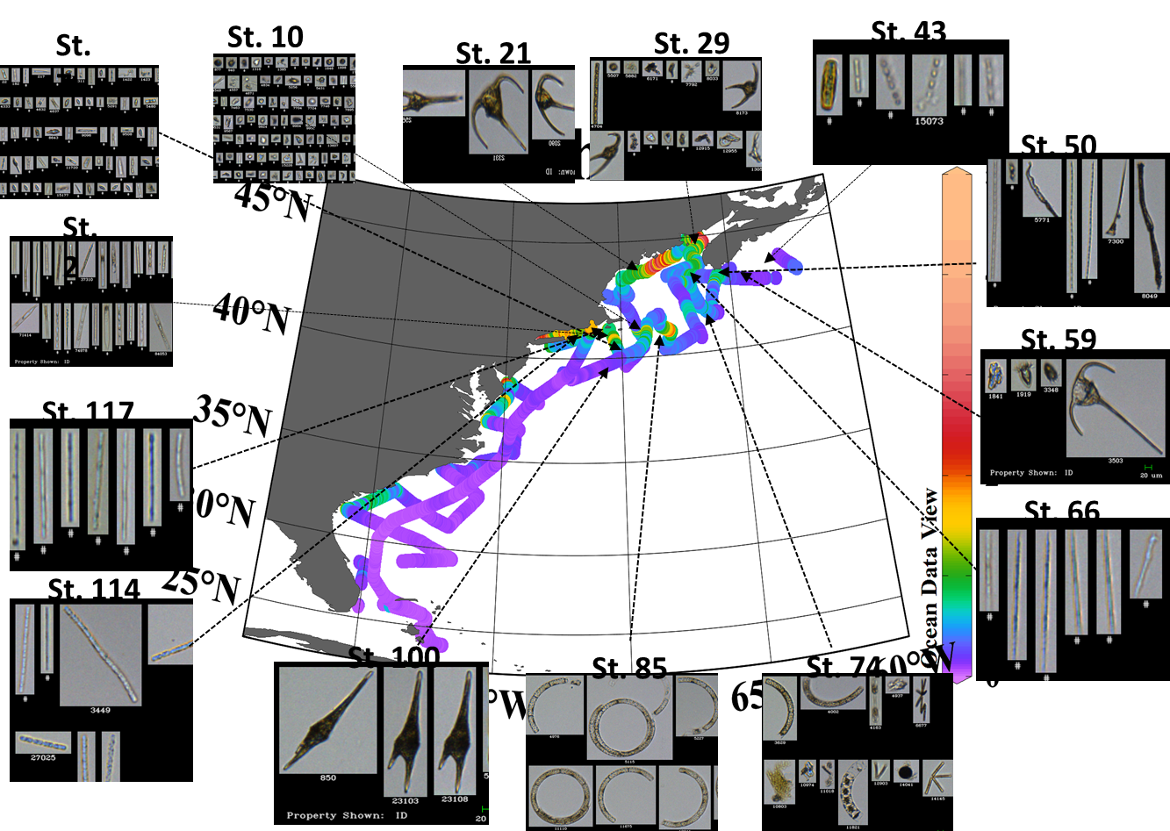

Figure 7: FlowCAM results of ECOA2 cruise.

4.7.2 Automated Laser Fluorescence Analyzer (ALFA) measurements of CDOM and phycobilipigment containing phytoplankton

The ALFA combines high-resolution spectral measurements of blue (405 nm) and green (532 nm) laser-stimulated fluorescence with spectral deconvolution techniques to quantify fluorescence of Chl-a (peak at 679 nm), three phycobilipigment types (PE-1, PE-2 and PE-3), CDOM (peak at 508 nm) and variable fluorescence (Fv/Fm). All fluorescence values obtained are normalized to the Raman spectra of seawater and generally expressed as relative fluorescence units (RFU), whereas Fv/Fm is unitless. PE-1 type pigments are associated with blue water or oligotrophic cyanobacteria with high phycourobilin/phycoerythrobilin (PUB/PEB) ratios, PE-2 type phytoplankton with low-PUB/PEB ratios are generally associated with green water cyanobacteria that usually thrive in coastal mesohaline waters, and PE-3 attributable to eukaryotic photoautotrophic cryptophytes RFU values for Chl-a can be converted into mg m⁻³ Chl-a values using least square regressions of fluorometric or HPLC measured Chl-a with RFU values for Chl-a measured by the ALFA.

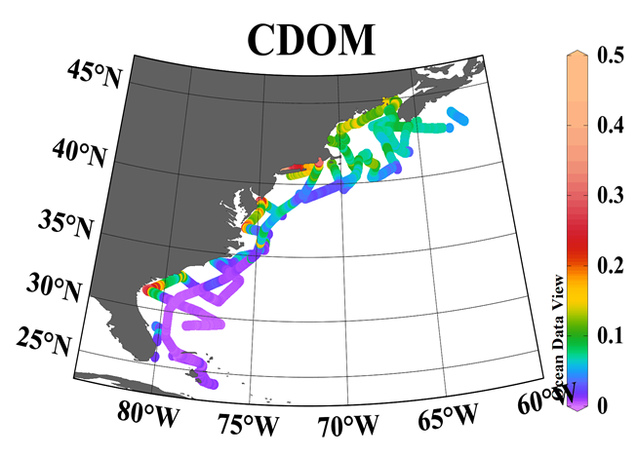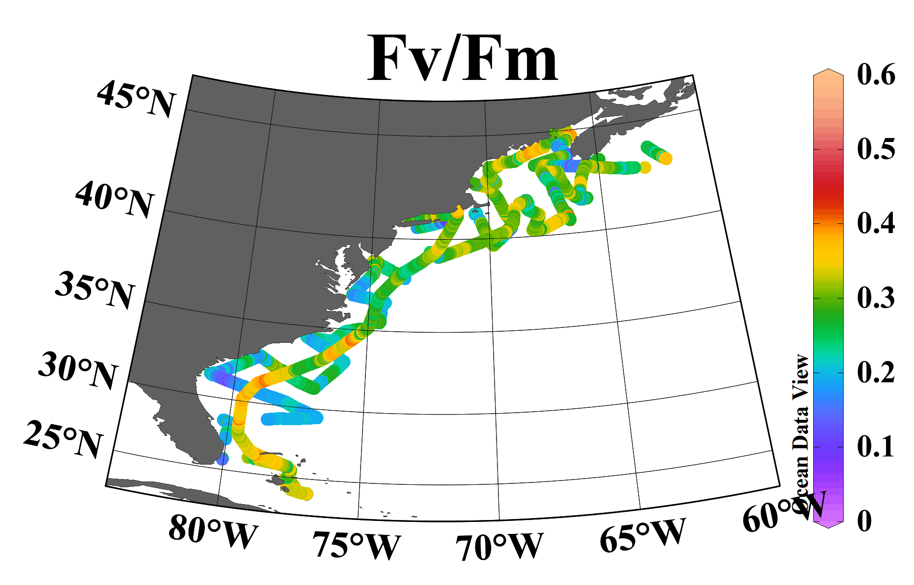

Figure 8: ALFA derived CDOM and Fv/Fm estimates along the ECOA-2 cruise track, showing coverage that was made possible with the underway system
4.7.3 Algal Online Analyzer (AOA) measurements of phytoplankton functional types

The AOA t provides fluorescence-based estimates of the biomass of cyanobacteria, green algae, brown algae (diatoms and dinoflagellates) and cryptophytes to the total biomass of phytoplankton. Inside the instrument, the sample is excited with light from colored light emitting diodes (370nm, 470nm, 525nm, 570nm, 590nm and 610nm) and the resulting excitation spectra are utilized for estimating total Chl a and relative concentrations of the aforementioned phytoplankton groups. Because of its configuration, this instrument could only be operated in flow through mode.

4.7.4 Fluorescence Induction and Relaxation (FIRe) measurements of photosynthetic competency

The FIRe technique was developed to measure a comprehensive suite of photosynthetic and physiological characteristics of photosynthetic organisms [Bibby et al., 2008; Gorbunov and Falkowski, 2004]. This technique provides a set of parameters that characterize photosynthetic light-harvesting processes, photochemistry in Photosystem II (PSII), and the photosynthetic electron transport down to carbon fixation. Because these processes are particularly sensitive to environmental factors, the FIRe technique can be utilized to provide a measure of natural (nitrate or iron stress, photoacclimation and photoinhibition, thermal and light stress, etc.) stress. One property that is unique and the most sensitive to environmental stressors is Fv/Fm (or the photosynthetic quantum yield of photochemistry in photosystem-II). In addition to Fv/Fm, we measured the functional absorption cross section of photosystem-II (σPSII, which is a product of the optical absorption cross section or the physical size of PSII unit and the quantum yield). These measurements can be used to calculate electron transport rates (ETR) for any given population of phytoplankton. All optical measurements by the FIRe are sensitive, fast, non-destructive, and can be done in real time and in situ and can provide an instant measure of the photosynthetic competency of the cells.

Preliminary FlowCAM data from ECOA-2 reveals largely cyanobacterial and weakly silicified diatom populations at locations away from the coast. Closer to the coast, phytoplankton communities were dominated by dinoflagellates. Large diatoms dominated stations along the edges of Georges Bank. FlowCAM data plotted on Chl a fluorescence data collected by ALFA.

All the underway data has been submitted to NASA SEABASS
5.- Ocean Color Measurements

5.1 Apparent optical properties (AOP) and solar irradiance

Michael Ondrusek (NOAA NESDIS) and Charles Kovach (NOAA NESDIS)
NOAA/NESDIS investigators conducted in situ optical measurements during the ECOA-2 cruise to support the primary cruise objectives of improving our understanding of ocean acidification and to provide ocean color satellite validation. One of the primary validation tools used by NOAA/STAR for in situ ocean color radiance validations is a Satlantic HyperPro Profiler II (http://www.satlantic.com). We also collected solar irradiance data. The HyperPro system has a downward looking HyperOCR radiometer that measures upwelling radiance Lu(λ) and an upward looking HyperOCI irradiance sensor to measure downwelling irradiance Ed(λ) in the water column. In addition there is an above-water upward looking HyperOCI irradiance sensor to measure downwelling surface irradiance Es(λ) . These measurements are used to calculate normalized water-leaving radiance nLw(λ) and remote sensing reflectance spectra observed by ocean color satellites. nLw(λ) spectra can be used to validate satellite ocean color radiances and develop ocean color derived products monitored during the ECOA investigations.
The HyperPro Profiler II is deployed in a free-falling mode where it is lowered and raised in the water column while keeping it away from the ship to avoid ship shadowing. The weight is adjusted on the profiler to allow a descent rate of 0.1 to 0.3 m s-1. Each HyperOCR or HyperOCI has 256 channels each with a 10 nm spectral resolution with a spectral sampling of 3.3 nm/pixel. The instruments are calibrated from 350 nm to 900 nm. The HyperOCRs have dark signal corrections using shutter dark measurements collected every 5th scan. The radiometers were calibrated before and after the cruise. The profiler is equipped with depth, temperature, tilt and one WET Labs ECO Puck Triplet sensor. The ECO Puck sensor measures fluorescence estimates of chlorophyll-a (mg m-3), and backscattering bb (m−1) at 440 nm, and 532 nm,
Direct solar radiation was measured at each station using a Microtops II sun photometer from Solar Light Co. These measurements are used to estimate atmospheric optical thickness is used to support the atmospheric correction process.
Data from this collaborative effort are archived on the NASA Ocean Biology Processing Group’s SEABASS archive.
https://seabass.gsfc.nasa.gov/archive/NOAA_NESDIS/ondrusek/ECOA/ECOA-2/archive/ECOA_18_1_Lwn_SB.txt
https://seabass.gsfc.nasa.gov/archive/NOAA_NESDIS/ondrusek/ECOA/ECOA-3/archive/ECOA_18_2_Lwn_SB.txt

5.2 Inherent Optical Property (IOP) profiles and ancillary measurements

Shawn Shellito and Joseph Salisbury (UNH)

IOP and ancillary measurements were collected at 36 stations during the ECOA-2 cruise. This number is far lower than what we had hoped but because of a delay of the ships departure caused by the termination of a ships employee these measurements had to be drastically reduced. The primary instruments used were are the WetlabsTM ac-s, which measures hyperspectral absorption and attenuation from 400-730nm, and the Wetlabs TMbb-9, which measures optical backscatter at 9 wavelengths. Additionally the profiler included CTD data, oxygen and fluorescence of chlorophyll a and CDOM (see table). All instruments were factory calibrated at the SeaBirdTM factory prior to the ECOA-2 cruise. Measurements were usually taken during daylight hours (1000-1500 local), and efforts were made to have the IOP measurements coincide with AOP measurements. All data will be delivered to the NASA Ocean Biology Processing Group’s SEABASS archive.

UNH Inherent optical property profiler measurements
Measurement | Equipment | unit | uncertainty
Hyperspectral attenuation and absorption | Wetlab ac-s | m⁻¹ | 0.01%¹
Spectral optical backscattering | Wetlab bb9 | m⁻¹ | 0.00002²
salinity/ temperature/depth | SBE 49 | psu/ºC/m | 0.01%¹
Dissolved oxygen | SBE 43 | umol/kg | 0.5%¹
Stim. Fluorescence of chlorophyll a | Wetlabs ECOFL Chl | mg/ m⁻³ | 0.02²
¹ Accuracy, ² Precision

6.- Gray’s Reef survey

Janet Reimer and Wei-Jun Cai (UDEL)

As part of an agreement with PMEL, the Cai laboratory group is responsible for ground truthing, or validation, of the Gray’s Reef (GR) coastal MAPCO₂ system time series. As part of our efforts for year 2018 we have included a three to four hour station at the mooring during the ECOA-2 cruise to obtain a full set of discrete measurements as well as underway pCO₂, O₂/Ar, and DIC measurements. All the parameters collected during ECOA-2 were collected at the GR mooring. Specifically, repeat measurements in triplicate were collected each hour for DIC, pH, TA, and dissolved oxygen in the surface at 17 minutes past the hour from 5 to 7 am at roughly the same time as the MAPCO₂ takes its measurement. For this exercise the mooring frequency was increased to once every hour, therefore we have three hours of data for validation between the mooring system, the underway system, and discrete bottle samples. We arrived at this station pre-dawn and took a water column CTD cast to get salinity and temp data. Once the cast was over we approach the buoy and as close as possible we would lower a Niskin from aft deck and collect a surface water sample. We then started our circle around the station and took a second full water column CTD. After this cast we approached the buoy once more for another surface Niskin sample. Following the approximately bi-monthly sampling during routine maintenance work at the GR mooring (by Scott Noakes, University of Georgia) we took triplicate samples over a three to four hour period. Following the final cast we completed a circle around the mooring before leaving for the next station. Due to the size and maneuverability limitation of the ship we were not able to get closer than 0.15 nautical miles (~0.3 km). Parameters measured underway are already included in the master files and upon receiving the rest of the data from the groups that will be processing data post cruise we will include all the parameters in a specific ground truthing spread sheet available to all participants including the group from NOAA PMEL.

7.- Glider deployment with pH sensor

Liz Wright-Fairbanks and Grace Saba (Rutgers)

Through related project, ECOA-2 personnel have modified and integrated a deep rated version of the Ion Sensitive Field Effect Transistor (ISFET)-based pH sensor, the Deep-Sea DuraFET pH sensor system, into a G2 Slocum Webb glider science bay. The DuraFET is fitted into a rectangular glider CTD port utilizing a pumped system to pull seawater in past both the pH and CTD sensor elements. Additional sensors on the same glider include a factory calibrated WET Labs BB2FL ECO puck configured for simultaneous fluorescence, CDOM, and optical backscatter measurements and an Aanderaa optode for measuring dissolved oxygen (DO).

On July 5th 2018 at 15:25 UTC, on the outer eastern edge of Georges Bank, pHoxy Lady (the Glider) was attached to the Rosette/CTD and a cast (ST #082a) was performed to calibrate her and make sure she was working correctly. Following the cast, pHoxy Lady was removed from the rosette on and transferred to a small boat on board the R/V Bigelow for deployment. At approximately 17:00 UTC near Georges Bank pHoxy Lady was deployed via small boat ops. Immediately after the recovery of the small boat a CTD was performed (ST 082_2). On this cast a full suite of discrete parameters where collected and will be used for in situ cross calibration of the pHoxy Lady's pH sensor.

Moving at 20 km per day, pHoxy Lady was only in close proximity to the R/V Bigelow for a short period of time. During this time sampling focused on ground truthing the glider pH data with discrete carbonate samples from the Rosette/CTD. Afterwards the pHoxy Lady’s path was programmed to follow the cross-shelf transects of the ECOA-2 research cruise track from Georges Bank to Tuckerton, NJ to observe changes in pH/Ω do to the time lag between measurements. Ultimately, pHoxy Lady was recovered via a small vessel off the coast of Tuckerton, NJ, for a total transect distance of about 1200 km.

Please note that glider pH/CTD data after July 18 should be treated as suspect due to heavy biofouling incurred after getting stuck a warm core ring for several days. We included a note about this in the global attributes on the ERDDAP page.

http://slocum-data.marine.rutgers.edu/erddap/search/advanced.html?page=1&itemsPerPage=1000&searchFor=ru30-20180705T1825&protocol=%28ANY%29&cdm_data_type=%28ANY%29&institution=%28ANY%29&ioos_category=%28ANY%29&keywords=%28ANY%29&long_name=%28ANY%29&standard_name=%28ANY%29&variableName=%28ANY%29&maxLat=&minLon=&maxLon=&minLat=&minTime=&maxTime=.

