Meeting notes

A16N (&S) logistics meeting/telecon Wednesday May 8, 2 PM (East coast time)
Website: www.aoml.noaa.gov/ocd/gcc/A16N
Action items and highlights of meeting
A. All gear can be loaded in Charleston before A16N. Loading days are Friday July 12 and Monday July 15, 2013. The ship’s crew and ship’s cranes will be available on these two days. Hand carry-able items can be put on the ship over the weekend. There will be no shoreside-covered storage. Bob Castle will be at the ship in Charleston during this time to oversee loading and logistics.
B. We have requested to decrease the length of leg 1 by one-day to 22 DAS (days at sea) and increase leg 2 by one day to 30 DAS. This will change the in-port in Madeira as reflected on our website, and listed below
C. There will be a meeting in Charleston on May 30 & 31 to discuss coordination between upcoming cruises. Let us know if there are any unresolved issues you’d like brought up. We hope to obtain permission to leave gear and haz mats on board for the cruises in between A16N and A16S, and after A16S till the ship reaches an US port.
D. There will be DI water on the ship that is provided by the Nutrient group. Please apprise the PI’s (C. Mordy, PMEL/ J-Z. Zhang AOML) if you hope to use DI on the cruise and the quantities you expect to use. If you are a large user, you should consider bringing your own system.
E. There is a walk-in cooler (≈40 F, 4 C) and a freezer (≈20 F, -7 C) on board dedicated for scientific use. We will make sure that they are both in working order. However, it should be noted that there have been problems with both the walk-in cooler and freezer in the past. There is NO communal ultra-low temperature freezer.
F. All participants should check VISA and immunization requirements. Federal employees travelling on official passports need VISAS for Portugal (Madeira) and Brazil. Participants traveling on USA personal passports need a TOURIST VISA for Brazil. Foreign nationals likely have different entry requirements and should check on needed paperwork. On request, we can provide a letter on official letterhead stating your purpose and port of entry into the country.
G. Please check website to be sure you are listed as participant. PI’s please provide names for slots listed as “?”
H. A schematic of locations of setup is shown below. If issues (or if you cannot figure it out) please let us know. There should be sufficient space for all.
I. Bob Castle, logistics and haz mat coordinator will be on vacation till June 9.
J. We are working on a Niskin water budget. It is apparent that we cannot take all samples from each Niskin bottle. However, with judicious rinsing of sample bottles and staggering sampling requirements we should keep everyone happy.
K. The “detail section” below is a repeat of the background material provided before the meeting. It has been updated and corrected for some inaccuracies

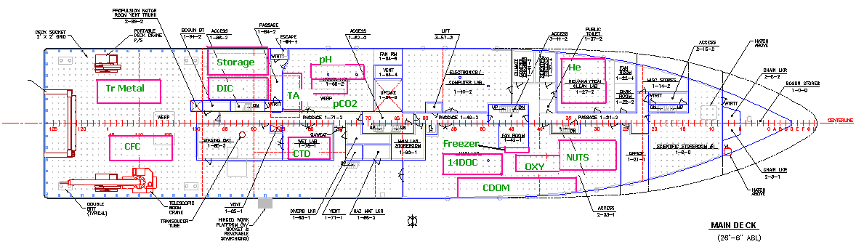

Discussion topics:
1. Cruise plan - times and clearances, country entry/exit requirements
Transit leg
Leg 1
Leg 2
A16S
2. Cruise plan – What information are we lacking (personnel, equipment, sampling scheme, water requirement)
3. Cruise plan – sampling and water requirements
4. Scientific personnel – number of scientists that can be accommodated and helping out on other projects
5. Scientific personnel - Medical forms, emergency contact, foreign national
6. Lab space assignments- where and how much
7. Shipping and storing equipment and vans

Details
1. Cruise plan - times and clearances country entry/exit requirements.
All participants should verify the following information:
US citizens with personal passports do not need a VISA for Iceland and Madeira.
A VISA, with a steep fee, is required for US citizens with personal passports entering Brazil. A tourist visa should suffice. We can provide a letter describing your participation on the cruise

US federal employees with official passports need a VISA Madeira and Brazil

The cruise plan for A16N and A16 S (tentative) is as follows. Clearances to work in EEZ of Canada, Greenland (Denmark), Iceland, Portugal (Madeira) have been applied for. Canadian clearance has been secured. Clearances for England, Argentina and Chile (for cruise A16S) will be requested shortly.

The cruise plan is a follows (note change in DAS for leg 1 and leg 2, and change of in-port days in Madeira)
DEP 7/16/13 Tues Charleston, SC RB 13-04 Transit
ARR 7/27/13 Sat Iceland, Reykjavik A16 North 12 DAS

DEP 8/1/13 Thur Iceland, Reykjavik RB 13-04 Leg 1
ARR 8/22/13 Thur Madeira, PO A16 North 22 DAS

DEP 8/27/13 Tues Madeira, PO RB 13-04 Leg 2
ARR 9/25/13 Wed Natal, Brazil A16 North 30 DAS

Tentative
DEP 12/6/13 Fri Natal, Brazil RB 14-03 - Leg 1
ARR 1/19/14 Sun Punta Arenas, Chile A16 South 45 DAS

DEP 1/25/14 Sat Punta Arenas, Chile RB 14-03 - Transit
ARR 2/2/14 Sun Valparaiso, Chile A16 South 9 DAS

2. Cruise plan –All those requesting ancillary water samples and those parameters with a “*” below should send a paragraph describing their sampling needs (total water volume, including rinsing; sample drawing procedures; number of samples, vertical and horizontal spacing; any other special requirements) to include in the project instructions.

3. Cruise plan – sampling and water requirements
Stations will occur every 0.5-degree surface – bottom, with narrower spacing over steep topography and equatorial Atlantic.

The following samples will be taken from the 24 (12 L) Niskins:
The parameters are listed in order sampled from the CTD/Rosette Niskins

CFC/SF6
He/Tr
O2
N2O*
pCO2
DIC
pH
TA
14DIC 13DIC
DOC
14DOC/black carbon
Nutrients
15N 18N of NO3*
Salinity
O2 isotope
CDOM

The following samples will be taken from trace metal cast:
Trace metals (separate casts every 1 degree)

- salinity
- nutrients
- trace metals

The following will be monitored from CTD package:
Load cell
Pressure
O2 (dual channel)
T (dual channel)
Slow response-high accuracy T
Conductivity/salinity (dual channel)
Transmissometry
Fluorometry
LADCP

The following will be monitored from the underway system:
T
Conductivity/salinity (2 locations)
Oxygen
pCO2
CDOM* (including transit leg)
During transit leg discrete samples will be taken from the underway line as well.

The following atmospheric sampling will be performed:
Aerosols
CO2
CFC
I-Met (ship)
Lightning*

*: PLEASE PROVIDE DETAIL ON SAMPLING INCLUDING WATER REQUIREMENT AND NUMBER AND SAMPLES/NUMBER OF CASTS

4. Scientific personnel (accommodations for 30)
Let us know if there are participants that will go on the Charleston Reykjavik transit.
The 14DOC/black carbon sampler on leg 1 will assist as watch stander during times when he is not engaged in his primary activity.

5. Scientific personnel - Medical form and emergency contact form.
The completed medical form can either be faxed (757-441-3760) or emailed (moa.health.services@noaa.gov) to NOAA Health Services. Specify the cruise name in the email subject line or fax cover sheet and request confirmation that the email or fax was received. The health forms need to be received by NOAA Health Services no later than a month before the beginning of the cruise. Send the emergency contact information form to Betty Huss.
Betty Huss is currently in the process of completing the foreign national clearance forms.

6. Lab space assignments- See schematic above

7. Shipping and storing equipment and vans.
- We need an inventory of all haz. Mats.
-All equipment can be loaded and if desired, set up in Charleston.
-We will have (at least) 1 person overseeing loading in Charleston
-Van will be powered up
- The working arrangement is that all science gear and haz. Mats need to be offloaded at the end of the project (Natal Sept 25). We expect though that the equipment and vans that will be used on A16S can stay on board, and equipment possibly remain set up.in interior labs. This depends on space needed for the following cruises and goodwill of chief scientists.
- The situation is less clear at the end of A16S and be prepared to ship from Valparaiso.

