Best Track Committee Re-Analysis Comments for 1962

Responses given by Chris Landsea and Sandy Delgado in boldface – February 2017

General comments:

1. At some point, HURDAT starts using analyzed pressures or satellite based pressures that give a continuous pressure record. Some of the storms of the current era have such records, but only in a few cases are they reliable. The Committee would like to get an idea of when it becomes feasible to include 6-hourly pressures that are analyzed or perhaps interpolated from existing measurements. This could give us an idea if it is time to change the current policy of removing central pressures if they are not directly supported by observations.

1979 was the first year in the existing Atlantic HURDAT that central pressures were routinely included for every six hour period. Based upon availability of six hourly Dvorak analyses and hourly satellite pictures, 1974 should be the first year that we will be able to routinely including central pressures for every time period in the reanalysis.

Note that the current policy – determined in the 1956 season comments/response – is to keep reasonable looking central pressures in HURDAT even if we are unable to identify a specific observation to directly support it. Thus we are not removing central pressures unless we have sufficient evidence that the value is incorrect.

2. There are some ships plotted on the Northern Hemispheric map series that for some of the cyclones that did not make it into the spreadsheets. Please check with Dave Roth for more information and to see if these ship reports made it to COADS.

The spreadsheets contain – among other items - all of the COADS data as well as supplemental marine observations of gale force or stronger from MWR, MWL, the Historical Weather Maps, and the NHC microfilm. We will include in any gale force or stronger additional marine observations into the spreadsheets.

1962 Storm #1 (new):

1. The Committee concurs with adding this system to HURDAT. Since the Historical Weather Map 500 mb chart shows an upper-level low directly over the system, there needs to be more emphasis on how this was likely a subtropical cyclone.

Agreed. Wording added into the writeup.

2. Please include the relevant 500 mb charts from the Historical Weather Maps (HWM) in the scanned materials.

These are now included.
3. Please add the records for the Frying Pan Shoals and Diamond Shoals light stations to the archive for this system. It is a little disconcerting to see those records for Alma in August and not see them for this system.

Records from Frying Pan Shoals and Diamond Shoals light stations are now included into the archive and they did allow for a slight change in intensity (55 kt down to 50 kt at 06Z) on the 1st and two additional central pressures at 00Z and 06Z on the 1st.

4. Please re-examine the extratropical phase portion of the track. While the proposed time of transition looks reasonable, the Committee has concerns that the track ends too soon as it is unclear whether the former tropical/subtropical cyclone absorbed the extratropical low or vice versa.

While it is unclear which system absorbed which, it is certain that they merged together. The former tropical/subtropical cyclone was weakening and was not as deep in central pressure in the last (06Z July 6th) analysis while the two were clearly separate systems. Thus it is our judgement that the merged system was primarily the extratropical low approaching from the south.

1962 Storm #2, Alma:

1. Please try to locate the satellite imagery and reconnaissance data mentioned in the daily write-ups for 14 August, 15 August, 18 August, and 22 August.

The satellite data mentioned on the 14th and 15th is unavailable, despite a thorough search of the NCDC archives. The reconnaissance data on the 15th is summarized in the microfilm note with no additional information available. The research aircraft data is plotted on the 12Z 18th microfilm, which shows no tropical storm force winds, low pressures, or well-defined center. Unfortunately, no reconnaissance data on the 22nd was located.

2. Please re-examine the location at the time of genesis. The Committee notes that the on the microfilm (MF) maps land station data from southeastern Florida supports a latitude of 26.1N or greater as proposed. However, there is a ship report with southeast winds that supports a position south of 26N near the original HURDAT.

Agreed to adjust the position at genesis (12Z 26th) to 25.7N as a compromise between these two options.

3. The daily write-up for 27 August mentions that a HURDAT central pressure of 1007 mb at 0600 UTC was removed due to surface obs indicating lower pressure values. What are these obs? They are not include in the write-up, listed in the spreadsheet, or obviously apparent on the MF map for that time.

Agreed to retain this 1007 mb value, as it appears to be plausible though there are no specific observations that confirm the value.
4. The Committee notes that at 1500 UTC 28 August there is also a ship with NW winds 50 kt and 993 mb on the MF map which may be worth mentioning in the ship highlights.

Agreed to mention this ship in the daily summary.

5. Please re-examine the removal of the 988 mb HURDAT central pressure at 0000 UTC 29 August. The Committee notes that in the ship highlights there is a report of 55 kt and 992 mb that could help determine the central pressure.

Agreed to retain the 988 mb central pressure in HURDAT at 00Z August 29th.

6. Please re-examine the proposed time of extratropical transition, as the data is sending conflicting signals. On one side, the lack of fronts on the MF maps and HWM, along with the plotted temperatures and motion back toward warmer sea surface temperatures, suggests a later transition than proposed. On the other side, on 29 August the structure of the cyclone had decayed to the point where the weather officer on a recon plane reported “no tropical storm characteristic” (see image below). If no consensus on this can be reached, the original HURDAT time will be used.

Agreed to retain the original extratropical transition time, but to also mention the comments from the reconnaissance weather officer on the 29th. This is what is now written: Note that the remarks from the recon weather officer suggested a structure that lacks spiral clouds with “no tropical storm characteristic.” It is possible that the system began extratropical transition (which was delayed until 18Z on the 30th) or that it lost deep convection and became a “Low”. Without satellite data to confirm, the system is retained on the 29th as a tropical cyclone.

6a. Please also re-examine the proposed intensities for the latter part of 29 August. Given the aircraft-reported structure and the motion over cool sea surface temperatures, should the intensities derived from the wind-pressure relationships be given less weight than usual?

Agreed to bring down the intensity at 18Z on the 29th to 65 kt (originally proposed 70 kt).

7. Please remove “although” from the first sentence of the 28 August re-analysis discussion.

So removed.
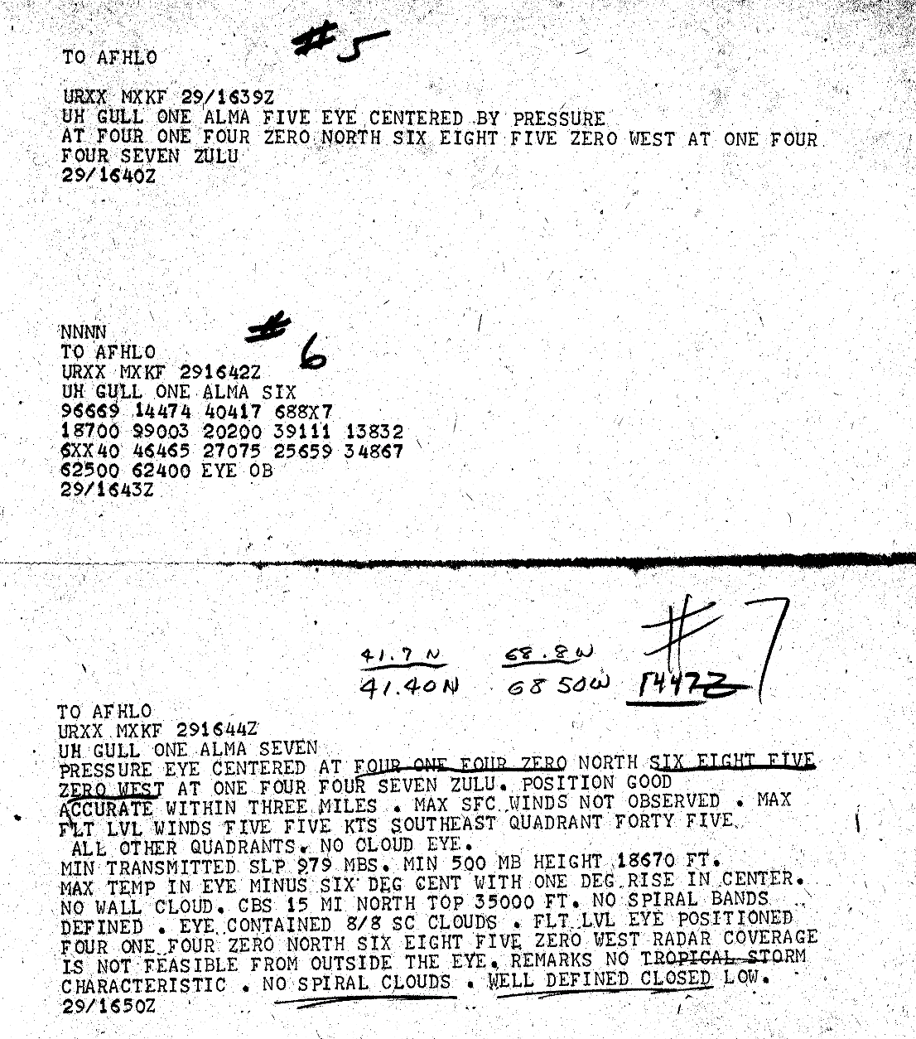

1962 Storm #3, Becky:

1. Has the data from the ship which reported 40 kt/1005 mb at 0600 UTC 27 August been quality controlled? Is it the same ship that reported 25 kt/1005 mb at 1800 UTC 27 August? Given the significant changes being made to the early portion of the track based on this ship, the data needs some extra scrutiny.

The ship reports for both were from COADS, but neither have a ship identification number. So we are unable to quality control the observations. It is possible that the 06Z and 18Z reports were from the same ship. However, examining all of the available observations, these two ship reports are consistent with other ships/station reports and thus appear to be reliable.

1a. it is noted that the 1800 UTC 27 August map shows a second ship with a pressure of 1005 mb. Please quality control this data as well.

This ship report from COADS also comes with no ship identification number.

2. In the re-analysis discussion for 28 August, please change “low tripping traffic” to “low shipping traffic”.

Done.

3. What is the basis for the significant shift in the track on 28-29 August? There do not seem to be any observations to justify this on any of the maps.

The largest change was made at 12Z 28th toward the east-northeast based ship and Cabo Verde island observations. The other changes later on the 28th and 29th were based upon interpolation from 12Z 28th through the next time with observations near the center - 12Z 30th. This is now explicitly mentioned in the writeup.

4. Please better explain the proposed peak intensity of 50 kt. The MF maps show a 50 kt ship report at 1200 UTC 30 August. However, this is contradicted by the Monthly Weather Review and the Annual Tropical Storm Report (ATSR), which indicate a ship report of 45 kt winds. What does COADS have for this observation? Unless all of these sources are wrong, the current 35 kt peak in HURDAT needs to be modified. However, what should it be modified to?

Unfortunately, this ship was not reported in COADS. It is now noted that the MWR and ATSR instead indicate that the ship reported 45 kt. It is uncertain which value is correct. However, even if the observation is actually 45 kt, assuming an intensity of slightly stronger – 50 kt – is reasonable.

5. The Committee notes that the ATSR excerpt for 31 August says “31st of September”. This error is present in the original text.

This error is now explicitly noted.

1962 Storm #4, Celia:

1. Please better explain the ship reports and the proposed intensities on 12 September. For example, the ship highlights section has a 35 kt report at 1200 UTC, while the re-analysis discussion says this was 45 kt. Which is correct? Also, if the 35 kt value is correct, should the intensities at and prior to that time be decreased?

The 45 kt was a typo and 35 kt is correct. However, given the 60 kt observation at 21Z on the 12th, tropical storm intensity is begun at 00Z on the 12th and is quickly ramped up to 55 kt at 18Z on the 12th and 60 kt at 00Z on the 13th.

1a. On a related note, what is the basis for the southward shift in the track on 12 September? There do not seem to be any observations on the MF maps to support this, and the aircraft fix at 2237 UTC is north of both the proposed track and the original HURDAT.

Agreed to bring the position back to the original latitude on the 12th. However, ship observations at 18Z suggest a farther south position than that indicated by the reconnaissance. Retaining the original latitude is the compromised reached between the two different platforms.

2. The spreadsheet and the MF map for 0600 UTC 15 September show a ship near the center with 1000 mb and 20 kt. While this data appears to be incorrect given the other data both spatially and temporally, it needs to be acknowledged in the write-up for this day.

Agreed, the likely low-biased pressure from the ship is mentioned.

3. In the last part of the re-analysis write-up for 15 September, it is mentioned that a 1010 mb pressure at 1200 UTC was remove due to lack of data. The very next sentence mentions a 35 kt/1013 mb ship at that time. Doesn’t that ship support a 1010 mb central pressure?

Agreed, the 1010 mb central pressure is retained.

3a. Is it also possible that the system had degenerated to a tropical wave at 1200 UTC 15 September as suggested by the MF map?
3b. If Celia did degenerate to a tropical wave at some point, what would be an appropriate regeneration time? Sometime on 17 September?

The 12Z September 15th microfilm map still indicating a SW 10 kt ship winds southeast of the center and there were no observations on the west side to know if a north wind – and thus a closed circulation - was absent. Likewise, there are still west and southwest winds at 18Z on the 15th and 18Z on the 16th that suggest the system still retained a closed circulation, though quite weak. However, it is now mentioned in the writeup that the system may have degenerated to a trough on the 15th or 16th.

4. In the last part of the re-analysis write-up for 17 September, it is mentioned that a 1010 mb pressure at 0000 UTC was remove due to lack of data. However, the MF map for that time shows an observation of winds WNW 10 kt and 1011 mb. Doesn’t that datum (ship or aircraft) support a 1010 mb central pressure?

Agreed, the 1010 mb central pressure is retained.

5. Please explain the basis for the earlier re-intensification to tropical storm strength on 18 September since there are no observations on that date to support that.

Celica is analyzed to have regained tropical storm status at 18Z on the 18th based upon susbsequent ship data (45 kt at 06Z on the 19th), twelve hours earlier than originally shown in HURDAT.

6. In the 19 September write-up, please enter the 30 kt/1008 mb ship into the ship highlights section given its importance in determining the central pressure.

Agreed and added in.

1962 Storm #5, (new):

1. The Committee does not concur with adding this system to HURDAT. The satellite images strongly suggest that the system does not have enough organized convection to be considered a tropical or subtropical cyclone. Please move the write-up to the additional systems section.

Agreed. The system is moved to the additional systems section.

1962 Storm #6, Daisy:

1. The MF maps are missing from the scans directory from 2-5 October.

These have now been added in.

2. If possible, please locate the satellite image for 28 September mentioned on the MF maps.

Unfortunately, this satellite image is not available.

3. On the MF map for 0600 UTC 30 September there is a ship report north of the cyclone that looks like a 50 kt report. However, next to it is a hand-written note saying COADS has 30 kt. Please resolve what wind speed this actually is. The Committee notes that this observation is not in the Mariners Weather Log.

It is believed that the 30 kt value is the correct one, as 50 kt does not match well the surrounding observations and 30 kt is what was found for this ships in COADS.

4. Please re-examine the time that the cyclone first became a tropical storm on 30 September, as there is conflicting evidence. On one side, the reconnaissance aircraft reported 1005 mb from a dropsonde near 1300 UTC. However, the position of the dropsonde may not be where the center was fixed. On the other side, the aircraft did not report tropical-storm-force winds during the first pass through the center, with all of the uncertainties that entails. Perhaps 1800 UTC would be a better time to show Daisy becoming a tropical storm?

Agreed to indicate 18Z on the 30th as the time for the system becoming a tropical storm.

4a. Even if 1200 UTC 30 September is a better time for the system to have become a tropical storm, please smooth through the 35-40-35 kt intensity variation on 30 September and 1 October. The data is not precise enough to include such changes, especially since the central pressure varied by only 1 mb.

These are now smoothed to show only a gradual increase in intensity from 30 to 35 kt, which no reduction on the 1st.

5. On the MF map for 0900 UTC 1 October, there is a 1002.5 mb pressure ob from what appears to be an island in the Lesser Antilles (Antigua?) which is not mentioned in the write-up. Is this data correct, and if so what does it mean for the track and intensity? Please contact the appropriate meteorological service for more information on this ob. At the very least, this needs to be included in the write-up with an explanation as to why it was not used in the re-analysis. It is noted that the San Juan storm reported on Daisy (see below) stated that the pressure on Antigua was 1008.3 mb as the center pass nearby, which is not readily reconcilable with the MF map.

This 1002.5 mb pressure observation was plotted incorrectly. While the correct value is unavailable, it likely was 1009.5 mb. No change is needed for the track/intensity proposed.
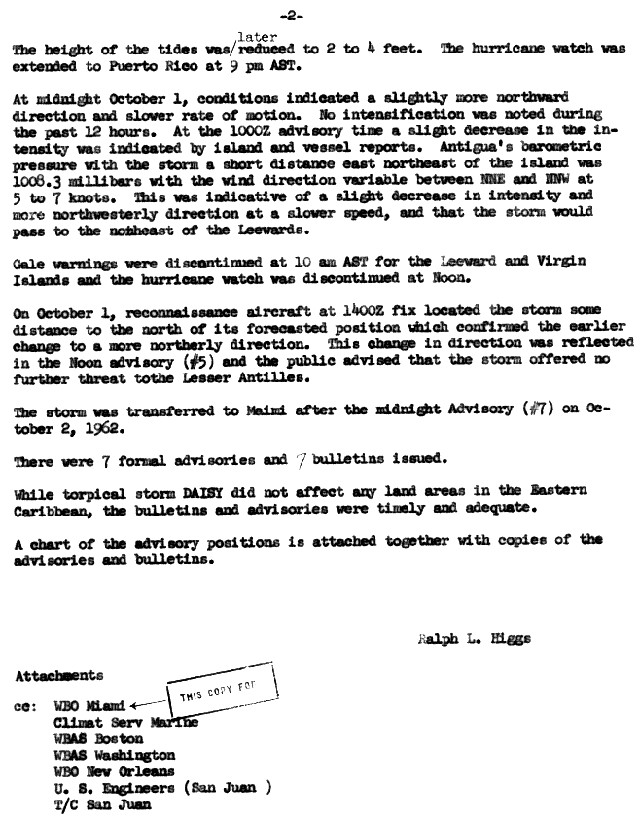
5a. In regards to the 1006 mb pressure reported by an aircraft at 1137 UTC 1 October, the Committee notes some issues. The fix message clearly states the minimum observed pressure is 1006 mb, and the data was taken at low level. However, an ob at 1045 UTC reported a 1006 mb pressure with southwest winds 15-20 kt at a position that doesn’t match the 1137 UTC fix, and a later dropsonde also reported 1006 mb at a location different from either of the fixes on that aircraft mission. Please check these pressures against the available surface obs.

Agreed to use 1004 mb as central pressure for the 12Z October 1st HURDAT position based upon the aircraft reported 20 kt SSW with 1006 mb southeast of the center.

6. In the 2 October re-analysis section, please change “first gale-force wind” to first non-aircraft gale-force wind”. Earlier aircraft had estimated winds tropical-storm force winds.

Agreed, so changed.

7. It is noted that there are several aircraft fixes on 5 October listed in the spreadsheet that are not included in the aircraft highlights, including a research flight that reported 80-kt flight-level winds at 7000 ft and a 35-40 n mi radius of maximum winds between 1430-1900 UTC. These data appear similar to what was used in the re-analysis, but they should be acknowledged in the write-up.

Agreed to add this research flight mission into the Aircraft Highlights section.

8. A couple of notes on aircraft data on 6 October: First, on a fix at 0030 UTC the 700 mb height and temperatures in the ATSR yield an extrapolated pressure of 970 mb using today’s formulas. Second, an Air Force mission in the storm wallet fixed the center at 1300 UTC with the 700 mb height and temperatures yielding an extrapolated pressure of 966 mb. Please include these in the write-up.

Agreed, these are now added into the analysis.

9. In the re-analysis section for 6 October, “down from the 85 kt” should read “up from the 85 kt”.

Agreed, so changed.

10. The Committee notes some major issues with the aircraft data on 7 October. First, the Navy aircraft flight near 0600 UTC reported two centers at 700 mb. The heights and temperatures for the southern center yield an extrapolated pressure of 963 mb. The subsequent 975 mb dropsonde in the northern center has an 80-m higher 700 mb height and a 2C warmer 700 mb temperature. Second, the Air Force flight that fixed the center near 1140 UTC has 700 mb heights and temperatures that extrapolate to a central pressure of 950 mb (see below) and states that the dropsonde failed before reaching the surface.

Agreed to add in the 963 mb and 950 mb central pressures based upon these aircraft reconnaissance extrapolations.
10a. On the 1200 UTC 7 October MF map, is there an observation of 959 mb near the center with no wind given?

Yes, this is now added into the excel database and the daily ship highlights.

10b. Based on the issues with the aircraft data, as well as 1200 UTC ship reports showing pressures of 963 and 960 mb with strong winds, please re-evaluate the intensities for this day and the timing of extratropical transition. The Committee notes that the original HURDAT has a much later transition on 8 October, and that operationally advisories continued until late on 7 October.

The intensity is now boosted to 90 kt at 06 and 12Z on the 7th and showing extratropical transition at 12Z on the 7th (six hours later than suggested in the first draft).

10c. Please also change “Ella” to “Daisy” in the 7 October re-analysis write-up.

Agreed, so changed.

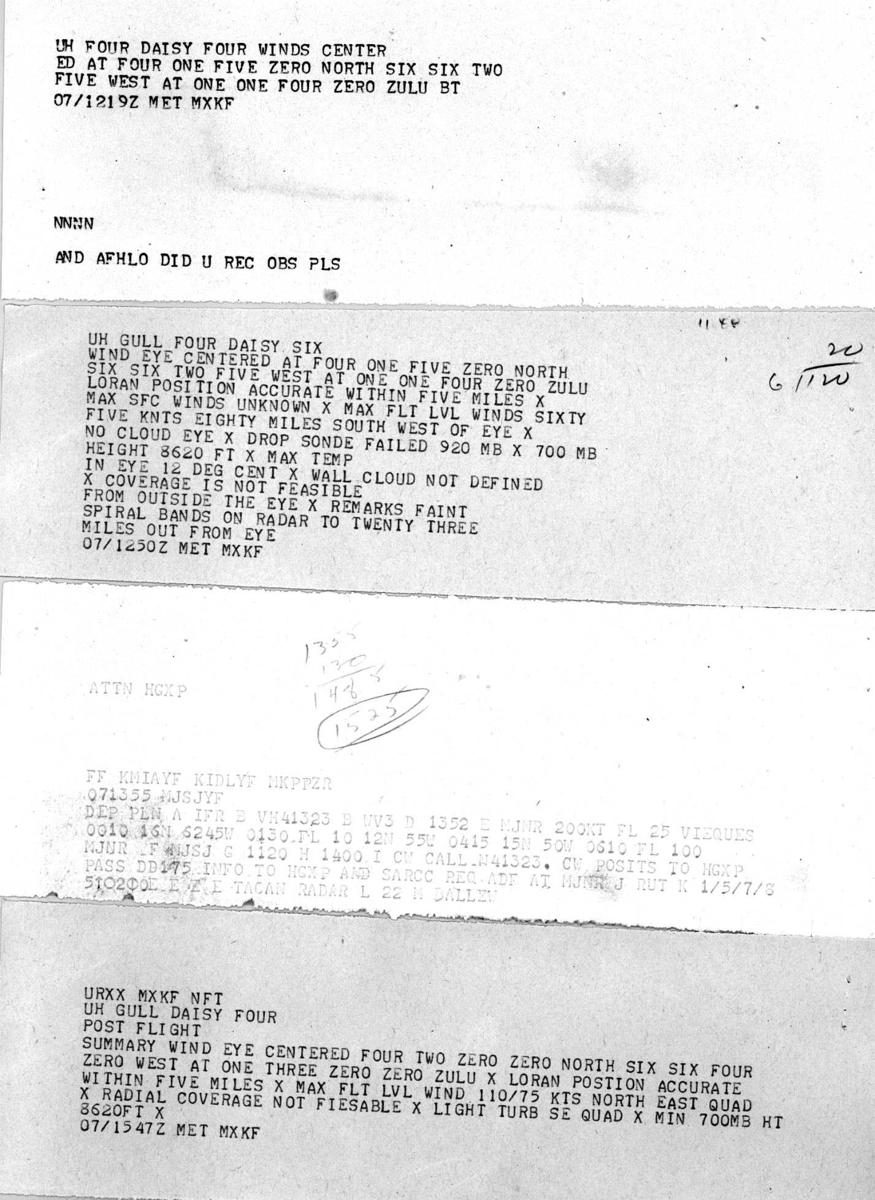
1962 Storm #7, Ella:

1. The Committee concurs with the earlier genesis time.

Agreed.

2. Given the mention of how an upper-level low was involved in the genesis, please provide the appropriate upper-air charts.

Agreed. 500 mb analysis from October 14th has been provided. However, October 15th was unavailable.

3. The HWM and the spreadsheet for 1200 UTC 16 October show a ship close to the center with a 1002 mb pressure. Please add this to the ship highlights for this day.

Agreed, this also allowed us to include a new central pressure at that time.

4. The Committee notes that for the aircraft fix at 1353 UTC 16 October, the 1006 mb pressure was measured at low level. The plane ascended to 700 mb for the second fix.

This is now so noted in the daily summary.

5. For the intensity at 1800 UTC 17 October, would 65 kt be more appropriate than 60 kt given a 60 kt ship report at that time?

Agreed.

6. In reference to the ship “CHRV” (possible “GHRV”?) mentioned in the 17 October re-analysis section, there is the following in the storm wallet:

This observation and its difference from what was plotted on the microfilm is included in the daily summary.
7. For the aircraft fix at 0100 UTC 19 October, the 700-mb heights and temperatures yield an extrapolated pressure of 974 mb.

Added in and included as the 00Z central pressure.

8. Data from the National Hurricane Research Project aircraft on 19 October (available in the Colorado State report by Shea and Gray) shows that the RMW was generally 30-35 n mi. Please modify the write-up to reflect this.

This is included into the daily summary and it concurs generally with the eye diameter derived RMW values.

9. The Committee concurs with the downgrade of the peak intensity below 100 kt, but it would prefer a 95 kt peak intensity rather than 90 kt.

Agreed.

10. Please re-examine the timing of extratropical transition and the evolution of Ella after transition. The proposed transition time is the same as in the original HURDAT at 0600 UTC 22 October. However, the MF map for that time appears to show Ella well embedded within the warm sector south of a frontal low near Newfoundland, and the MF map for 1200 UTC that day appears to show Ella merging with a warm front south of the Newfoundland low. Finally, the 1800 UTC MF map shows a single low pressure system, but it is not clear whether this is Ella or the second low. In addition, the North Hemisphere map series suggests the possibility that whatever the low on 22 October was, it didn’t survive past 0000 UTC 24 October.

Agreed to delay extratropical transition by six hours to 12Z on the 22nd. Our interpretation is that Ella was the dominant low at 18Z on the 22nd and should be continued to be tracked. The microfilm maps supplemented with COADS observations provides good continuity that the system continued to exist until after 06Z on the 25th.

1962 Storm #8, (new):

1. Please provide the appropriate upper-air maps for the life cycle of this system

Agreed.

2. The Committee concurs with the addition of this system to HURDAT, but it has concerns that the proposed tropical cyclone phase is too long and perhaps too simplistic. For example, it is clear from the ship reports and satellite imagery that a tropical cyclone-type inner core existed on 28 November. However, it is also apparent that abundant cold air is moving across the Florida Peninsula and the Bahamas, suggesting that baroclinicity was still playing a role. On 1-2 December, the surface obs again show an intense inner wind core, and the satellite imagery shows an eye. However, the surface obs also show very dry/cold air moving off of the coasts of North and South Carolina into the cyclone. Please re-examine how much of the cyclone’s life was actually as a full tropical cyclone, and regardless of the final determination on that please better emphasize in the write-up the likely hybrid nature of the system during much of its life.

Agreed. The possible role of baroclinicity is highlighted for the intense phases on November 28th and December 1st/2nd. It is also noted that the dewpoints in the inner core for these dates reached the 60s F, suggesting that sufficient modification of the air mass occurred to promote deep convective processes. The likely hybrid nature of the system during much of its lifetime has been highlighted.

3. Is any satellite imagery available for 1 December?

Unfortunately, no.

4. Given the large number of surface obs near the center, please try to analyze central pressures for as many times as the data will permit.

Several central pressures were added for those that could be confidently derived.

1962 Additional Notes:

1. The MF maps in the folder for the September suspect are actually from August. Please provide the correct maps.

A couple of the maps were mislabeled. These are for suspect system #6 from August 23rd to 25th.

2. In the write-up for suspect #6, “Island” should be “Islands”.

Corrected.

3. For suspect #6, the one ship report is likely not enough evidence to call it a tropical storm. However, has the ship data been quality controlled?

Only one observation (from microfilm) was available for this ship. Thus it is unknown the quality of the report.

4. For suspect #7, the 1200 UTC 28 August MF map appears to show data from a reconnaissance flight. However, this is not listed in the ATSR. Please do what you can to find the data from this flight. Also, the 0000 UTC 29 August MF map shows what looks like a 60 kt ship report near the center. Has this been quality controlled? Have the detailed observations from the landfall area been checked? Are there any satellite images available? It seems unlikely that this system was a tropical storm, but it needs a more thorough check.

Yes, an investigative reconnaissance mission took place on the 28th of August. As is typical for systems that were not operationally considered to be a tropical cyclone, nothing of these flights were recorded in the ATSR. The only available observations from this mission are plotted on the 12Z August 28th microfilm which does not indicate any tropical storm force winds or equivalent in pressure. The 60 kt ship report at 00Z August 29th is the only observation recorded from that ship. The wind appears erroneous, given the surrounding ship and coastal observations and it may have been 15 kt instead. No tropical storm force sustained winds or equivalent in pressure were recorded in coastal stations. There was one satellite picture available at 16Z August 29th, after the system apparently went inland.

5. For suspect #9 (now #10), reconnaissance missions for this are available in the wallet for Hurricane Daisy. Are any satellite images available for this system?

These reconnaissance mission data are now obtained and mentioned. They do not, however, indicate that the system became a tropical storm. As already mentioned, satellite pictures are available for October 1, 2, and 4.

6. For suspect #13 (now #14), are there any satellite images or microfilm maps available?

Unfortunately, no.

7. Pending the additional data requested above, the Committee concurs with leaving all of the suspect systems out of HURDAT.

Agreed.

