15. Tropical Cyclone Ocean Interaction Experiment

Principal Investigator(s): Nick Shay (U. Miami/RSMAS), Jun Zhang (NOAA/HRD), Rick Lumpkin (NOAA/PhOD), George Halliwell (NOAA/PhOD), Elizabeth Sanabia (USNA), and Benjamin Jaimes (UM/RSMAS)

Links to IFEX:
- Goal 1: Acquire observations that span the TC life cycle in a variety of environments for model initialization and evaluation.
- Goal 3: Improve understanding of the physical processes important in intensity change for a TC at all stages of its lifecycle.
Motivation:
Modeling studies show that the effect of the ocean varies widely depending on storm size and speed and the preexisting ocean temperature and density structure. The overarching goal of these studies is to provide data on TC-ocean interaction with enough resolution to rigorously test coupled TC models, specifically:

- Measure the two-dimensional SST cooling, air temperature, humidity and wind fields beneath the storm and thereby deduce the effect of the ocean cooling on ocean enthalpy flux to the storm;
- Measure the three-dimensional temperature, salinity and velocity structure of the ocean beneath the storm and use this to deduce the mechanisms and entrainment rates (shear-induced) of ocean cooling;
- Conduct these measurements at several points along the storm evolution therefore investigating the role of pre-existing ocean variability; and,
- Use these data to assess the accuracy of the oceanic component of the coupled model system.

Recent improvement in flux parameterizations has led to significant improvements in the accuracy of TC simulations. These parameterizations, however, are based on a relatively small number of direct flux measurements. The overriding goal of these studies is to make additional flux measurements under a sufficiently wide range of conditions to improve flux parameterizations, specifically:

- Measure the air-sea fluxes of enthalpy and momentum using ocean-side budget and covariance measurements and thereby verify and improve parameterizations of these fluxes.
- Measure the air-sea fluxes of oxygen and nitrogen using ocean-side budget and covariance measurements and use these to verify newly developed gas flux parameterizations.
- Measure profiles of ocean boundary layer turbulence, its energy, dissipation rate and skewness and use these to investigate the unique properties of hurricane boundary layers.
- Conduct the above flux and turbulence measurements in all four quadrants of a TC so as investigate a wide range of wind and wave conditions.

Background:
Substantial resources for this work will be funded by external sources. The HRD contribution consists of coordination with the operational components of the NHC and the 53rd AFR squadron and P-3 survey flights over the array with SFMR and SRA wave measurements and dropwindsondes.
If the deployments occur in the Gulf of Mexico, Loop Current area, this work will be coordinated with P-3 deployments of AXBTs and AXCPs to obtain a more complete picture of the ocean response to storms in this complex region including velocity shear which is key to understanding vertical mixing and SST cooling.

Working Scientific Hypotheses:
- Hypothesis 1: TC intensity is highly sensitive to air-sea fluxes; and ocean heat content.
- Hypothesis 2: Upper ocean properties and dynamics play a key role in determining TC intensity.
Experiment/Module Description:
This multi-aircraft experiment is ideally conducted in geographical locales that avoid conflict with other operational requirements, for example, at a forward/eastward-deployed base targeting a storm not imminently threating the U.S. coastline. As an example, an optimal situation is shown in Fig. 1, with missions operating from St. Croix, USVI. A TC of at least minimal hurricane intensity is desired. In this example, the hypothetical storm remains within 600 nmi (a reasonable maximum distance) for four days, and at no time is forecasted to be a threat to land, including the U.S. coast.

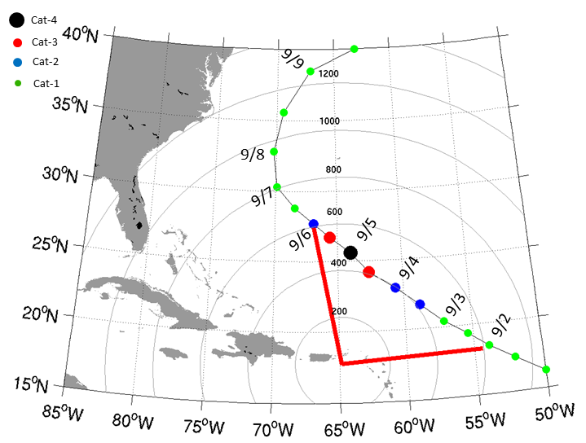
Figure 1: Storm track with locations plotted every 12 hours. of Range rings are 200 nmi relative to forward operating base at St. Croix, USVI (STX/TISX), and red line delineates storm locations within 600 nmi of STX. In this example, the storm center remains within 600 nmi for 4 days.

a) Expendable profiler surveys from P-3 aircraft

Flight sequence:

Pre-storm: To establish the pre-storm upper ocean thermal and mass structure prior to a storm’s arrival, a pre-storm expendable survey will be conducted. This mission will consist of deploying a large grid of AXCTDs/AXBTs to measure the three-dimensional temperature and salinity fields (Fig. 2). This flight would occur 48 hours prior to storm arrival, based primarily on the forecasted track, and optimally covers the forecast cone-of-error. A total of 50-60 probes would be deployed, depending on mission duration, and spaced approximate 0.5 deg. apart. The experiment is optimally conducted where horizontal gradients are relatively small, but AXCP probes may be included if significant gradients (and thus currents) are expected to be observed. Either P-3 aircraft may be used as long as it is equipped with ocean expendable data acquisition hardware.

Figure 2: Left: NHC official forecast track, which pre-storm ocean sampling region highlighted. Target region is centered ~48 hours prior to forecast arrival of storm. Right: P-3 flight track (red line) and ocean sampling pattern consisting of a grid of AXCTD/AXBT probes Probes are deployed at ~0.5 deg. intervals. Total time for this pattern is estimated to be ~9 hours.

In-storm: Next, a mission is executed within the storm over the ocean location previously sampled (Fig. 3). This flight shall by conducted by the P-3 carrying the Wide-swath Radar Altimeter (WSRA) for purposes of mapping the two-dimensional wave field. The flight pattern should be a rotated Figure-4, and up to 20 AXBTs should be deployed in combination with GPS dropwindsondes. Note that other experimental goals can and should be addressed during this mission, and a multi-plane mission coordinated with the other P-3, as well as G-IV, is desirable.

Figure 3: Left: NHC official forecast track at time of in-storm mission, with pre-storm sampled region highlighted. Right: P-3 in-storm flight pattern centered on storm and over previously-sampled ocean area. Typical pattern is expected to be a rotated Fig-4. Total flight time ~8 hrs.

Post-storm: A post-storm expendable survey shall be conducted over the same geographical location to assess ocean response, with slight pattern adjustments made based on the known storm track (Fig. 4). Approximately 60-70 probes would be deployed (depending on duration limits), consisting mainly of AXBTs/AXCPs to map the three-dimensional temperature and currents, ideally 1-2 days after storm passage. In the Figs. 3-8 example, the pattern extends 470 km along the storm track, which in this example is ~0.75Λ, where Λ = 2πV/f is the inertial wavelength. Ideally, the pattern should extend up to 1 Λ to resolve a full ocean response cycle. The storm speed V and flight duration limits will dictate whether this is possible. As for the pre-storm survey, either P-3 may be used since both of them have been equipped with new data systems as part of the HFIP program.
Figure 4: Left: Post-storm ocean sampling flight pattern (red line), over previously-sampled area (black box). In this example, the pattern extends around 470 km in the along-track dimension, or around 0.75 of a near-inertial wavelength. Right: Flight pattern with expendable drop locations, consisting of a combination of AXCP and AXBT probes.

b) Coordinated float/drifter deployment by AF C-130

Measurements will be made using arrays of drifters and E-M Apex (Gulf only) and Alamo (Beth) floats deployed by AFRC WC-130J aircraft in a manner similar to that used in the 2003 and 2004 CBLAST program. Additional deployments have since refined the instruments and the deployment strategies. These measurements provide the rapid time evolution of the response that will be coordinated with the synoptic snapshots of temperatures, salinities and currents from the P-3 deployments of AXBTs, AXCTDs and AXCPs to obtain a more complete picture of the mesoscale ocean response to storms.

MiniMet drifters measure SST, sea level air pressure and wind velocity. Thermistor chain Autonomous Drifting Ocean Station (ADOS) drifters add ocean temperature measurements to 150m. All drifter data are reported in real time through the Global Telecommunications System (GTS) of the World Weather Watch. An additional stream of real-time, quality controlled data is also provided by a server located at the Scripps Institution of Oceanography. A few E-M APEX Lagrangian floats will be deployed via the WC-130J that measure temperature, salinity and velocity profiles to as deep as 2000 m. Float profile data will be reported in real time on GTS via iridium. In addition, UM will have ten floats deployed in the northern Gulf of Mexico as part of a funded GoMRI study that measure these physical parameters as well as biogeochemical parameters.

Coordination and Communications

Alerts - Alerts of possible deployments will be sent to the 53rd AWRO up to 5 days before deployment, with a copy to CARCAH, in order to help with preparations. Luca Centurioni (SIO) and Rick Lumpkin (PhOD) will be the primary point of contact for coordination with the 53rd WRS and CARCAH.

Flights:

Coordinated drifter deployments would nominally consist of 2 flights, the first deployment mission by AFRC WC-130J and the second overflight by NOAA WP-3D. An option for follow-on missions would depend upon available resources.

Day 1- WC-130J Float and drifter array deployment- Figure 5 shows a possible nominal deployment pattern for the float and drifter array. It consists of two lines, A and B, set across the storm path with 8 and 4 elements respectively. The line length is chosen to be long enough to span the storm and anticipate the errors in forecast track, and the lines are approximately in the same location as the pre-storm P-3 expendable probe survey. Instrumentation should be deployed 24-48 hours prior to storm arrival. The element spacing is chosen to be approximately the RMW. In case of large uncertainties of the forecast track a single 10 node line is deployed instead. The thermistor chain drifters (ADOS) are deployed near the center of the array to maximize their likelihood of seeing the maximum wind speeds and ocean response. The Minimet drifters are deployed in the outer regions of the storm to obtain a full section of storm pressure and wind speeds. The drifter array is skewed one element to the right of the track in order to sample the stronger ocean response on the right side (cold wake).

Day 2. P-3 In-storm mission- The in-storm mission will be conducted by the P-3 as previously described. Efforts will be made to deploy AXBTs during the mission near the locations of drifters/floats as reported in real time. It is highly desirable that this survey be combined with an WSRA surface wave survey because high quality surface wave measurements are essential to properly interpret and parameterize the air-sea fluxes and boundary layer dynamics, and so that comparisons between the float wave measurements and the SRA wave measurements can be made. In addition, the directional wave measurements from the WSRA, when combined with current measurements from AXCPs or E-M Apex floats, provide structural observations of the effect of surface waves on the oceanic planetary boundary layer processes.

Figure 5: Drifter array deployed by AFRC WC-130J aircraft. The array is deployed ahead of the storm with the exact array location and spacing determined by the storm speed, size and the uncertainty in the storm track. The array consists of ADOS thermistor chain (A) and minimet (M) drifters, and EM-APEX Lagrangian floats (E). Two items are deployed at locations 3, 4 and 5, and one item elsewhere.

c) AXBT deployments by TROPIC on AF C-130

In addition to the P-3 expendable ocean probe deployments described above, additional ocean temperature profiles will be obtained by AFRC WC-130J aircraft as part of the Training and Research in Oceanic and Atmospheric Processes in Tropical Cyclones (TROPIC) program under the direction of CDR Elizabeth Sanabia, Ph.D. (USNA). Several overlapping mission goals have been identified providing an additional opportunity for collaboration and enhancing observational data coverage. See www.onr.navy.mil/reports/FY11/mmsanabi.pdf for details.

d) Loop Current Experiment

Pre- and post-storm expendable profiler surveys

Flight description:

Feature-dependent survey. Each survey consists of deploying 60-80 expendable probes, with take-off and recovery at AOC. Pre-storm missions are to be flown one to three days prior to the TC’s passage in the LC (Fig. 6). Post-storm missions are to be flown one to three days after storm passage, over the same area as the pre-storm survey. Since the number of deployed expendables exceeds the number of external sonobuoy launch tubes, profilers must be launched via the free-fall chute inside the cabin. Therefore the flight is conducted un-pressurized at a safe altitude (6-8k ft). In-storm missions, when the TC is passing directly over the observation region, will typically be coordinated with other operational or research missions (e.g. Doppler Winds missions). These flights will require 20-40 aircraft expendables deployed for measuring sea surface temperatures, salinity and currents underneath the storm.

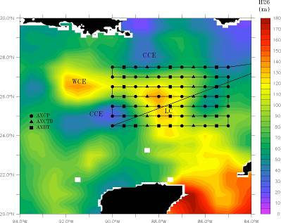

Figure 6: Typical pre- or post-storm pattern with ocean expendable deployment locations relative to the Loop Current. Specific patterns will be adjusted based on actual and forecasted storm tracks and Loop Current locations. Missions generally are expected to originate and terminate at KMCF.

Track-dependent survey. For situations that arise in which a TC is forecast to travel outside of the immediate Loop Current region, a pre- and post-storm ocean survey focused on the official track forecast is necessary. The pre-storm mission consists of deploying AXBTs/AXCTDs on a regularly spaced grid, considering the uncertainty associated with the track forecast. A follow-on post-storm mission would then be executed in the same general area as the pre-storm grid, possibly adjusting for the actual storm motion. Figure 7 shows a scenario for a pre-storm survey, centered on the 48 hour forecast position. This sampling strategy covers the historical “cone of uncertainty” for this forecast period.

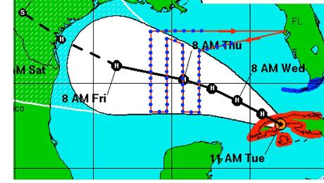

Figure 7: Track-dependent AXBT/AXCTD ocean survey. As for the Loop Current survey, a total of 60-80 probes would be deployed on a grid (blue dots).

Coordinated float/drifter deployment overflights:

Measurements will be made using arrays of drifters deployed by AFRC WC-130J aircraft in a manner similar to that used in the 2003 and 2004 CBLAST program. Additional deployments have since refined the instruments and the deployment strategies. MiniMet drifters measure SST, sea level air pressure and wind velocity. Thermistor chain Autonomous Drifting Ocean Station (ADOS) drifters add ocean temperature measurements to 150m. All drifter data are reported in real time through the Global Telecommunications System (GTS) of the World Weather Watch. An additional stream of real-time, quality controlled data is also provided by a server located at the Scripps Institution of Oceanography.

If resources are available from other Principal Investigators, flux Lagrangian floats will measure temperature, salinity, oxygen and nitrogen profiles to 200 m, boundary layer evolution and covariance fluxes of most of these quantities, wind speed and scalar surface wave spectra, while E-M APEX Lagrangian floats will measure temperature, salinity and velocity profiles to 200m. Float profile data will be reported in real time on GTS.

This drifter effort is supported by the Global Drifter Program. The HRD contribution consists of coordination with the operational components of the NHC and the 53rd AFRC squadron and P-3 survey flights over the array with SFMR and SRA wave measurements and dropwindsondes. If the deployments occur in the Gulf of Mexico, Loop Current area, this work will be coordinated with P-3 deployments of AXBTs, AXCTDs and AXCPs to obtain a more complete picture of the ocean response to storms in this complex region.

Coordination and Communications:

Alerts - Alerts of possible deployments will be sent to the 53rd AWRO up to 5 days before deployment, with a copy to CARCAH, in order to help with preparations. Luca Centurioni (SIO) and Rick Lumpkin (PhOD) will be the primary point of contact for coordination with the 53rd WRS and CARCAH.

Flights:

Coordinated drifter deployments would nominally consist of 2 flights, the first deployment mission by AFRC WC-130J and the second overflight by NOAA WP-3D. An option for follow-on missions would depend upon available resources.

Day 1- WC-130J Float and drifter array deployment- Figure 8 shows a possible nominal deployment pattern for the float and drifter array. It consists of two lines, A and B, set across the storm path with 8 and 4 elements respectively. The line length is chosen to be long enough to span the storm and anticipate the errors in forecast track. The element spacing is chosen to be approximately the RMW. In case of large uncertainties of the forecast track a single 10 node line is deployed instead. The thermistor chain drifters (ADOS) are deployed near the center of the array to maximize their likelihood of seeing the maximum wind speeds and ocean response. The Minimet drifters are deployed in the outer regions of the storm to obtain a full section of storm pressure and wind speeds. The drifter array is skewed one element to the right of the track in order to sample the stronger ocean response on the right side (cold wake). Three Lagrangian floats (E-M Apex) will be deployed along the track, 1-2 RMW and 3-4 RMW to measure the rapidly evolving velocity shear and extent of the vertical mixing and cooling of the surface mixed layer.

Day 2. P-3 In-storm mission- Figure 9 shows the nominal P-3 flight path and dropwindsonde locations during the storm passage over the float and drifter array. The survey should ideally be timed so that it occurs as the storm is passing over the drifter array.

The survey includes legs that follow the elements of float/drifter line ‘A’ at the start and near the end. The survey anticipates that the floats and drifters will have moved from their initial position since deployment and will move relative to the storm during the survey. Waypoints 1-6 and 13-18 will therefore be determined from the real-time positions of the array elements. Each line uses 10 dropwindsondes, one at each end of the line; and two at each of the 4 floats, the double deployments are done to increase the odds of getting a 10m data.

The rest of the survey consists of 8 radial lines from the storm center. Dropwindsondes are deployed at the eye, at half Rmax, at Rmax, at twice Rmax and at the end of the line, for a total of 36 releases. Aircraft expendables are deployed from the sonobuoy launch tubes at the eye, at Rmax and at 2 Rmax. This array is focused at the storm core where the strongest air-sea fluxes occur; the buoy and float array will fill in the SST field in the outer parts of the storm. In this particular example, the final two radials have been moved after the second float survey to avoid upwind transits. For other float drift patterns, this order might be reversed.

It is highly desirable that this survey be combined with an SRA surface wave survey because high quality surface wave measurements are essential to properly interpret and parameterize the air-sea fluxes and boundary layer dynamics, and so that intercomparisons between the float wave measurements and the SRA wave measurements can be made. In addition, the directional wave measurements from the WSRA, when combined with current measurements from AXCPs or E-M Apex floats, provide structural observations of the effect of surface waves on the oceanic planetary boundary layer processes.

Extended Mission Description:

If the storm remains strong and its track remains over water, a second or possibly third oceanographic array may be deployed, particularly if the predicted track lies over a warm ocean feature predicted to cause storm intensification (Fig. 10). The extended arrays will consist entirely of thermistor chain and minimet drifters, with 7-10 elements in a single line. As with the main mission, the spacing and length of the line will be set by the size of the storm and the uncertainty in the forecast track.

Mission timing and coordination will be similar to that described above. P-3 overflights would be highly desirable.

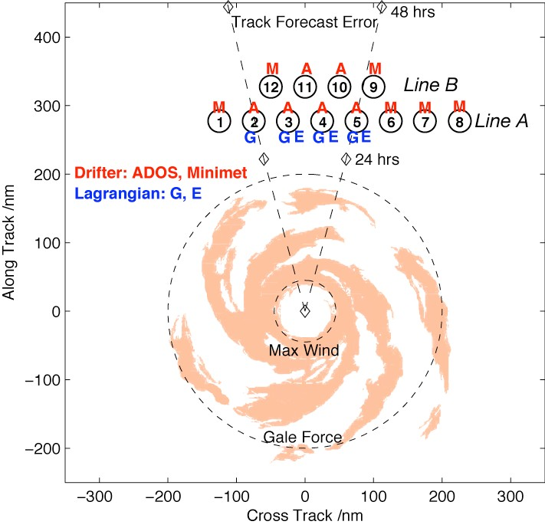

Figure 8: Drifter array deployed by AFRC WC-130J aircraft. The array is deployed ahead of the storm with the exact array location and spacing determined by the storm speed, size and the uncertainty in the storm track. The array consists of ADOS thermistor chain (A) and minimet (M) drifters. Gas (G) and EM (E) Lagrangian floats could be added if available. Three items are deployed at locations 3, 4 and 5, two items at location 3 and one item elsewhere.

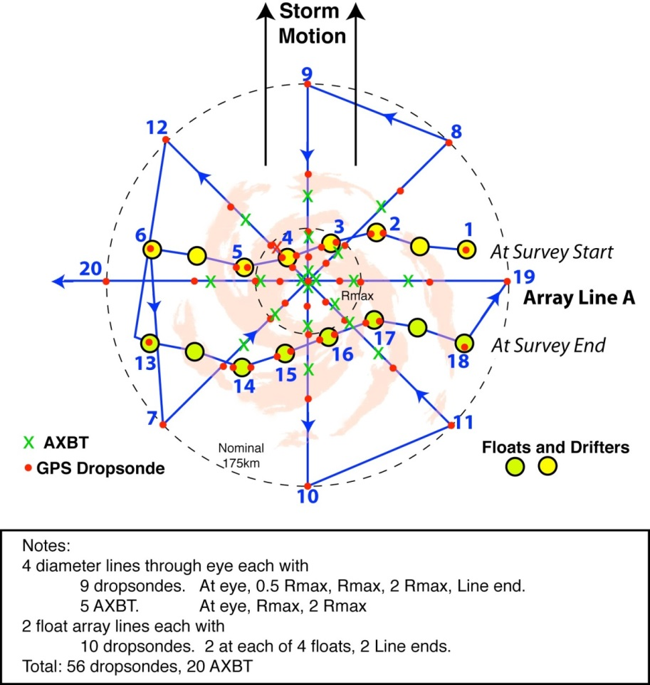

Figure 9: P-3 pattern over float and drifter array. The array has been distorted since its deployment on the previous day and moves relative to the storm during the survey. The pattern includes two legs along the array (waypoints 1-6 and 13-18) and an 8 radial line survey. Dropwindsondes are deployed along all legs, with double deployments at the floats. AXBTs are deployed in the storm core.

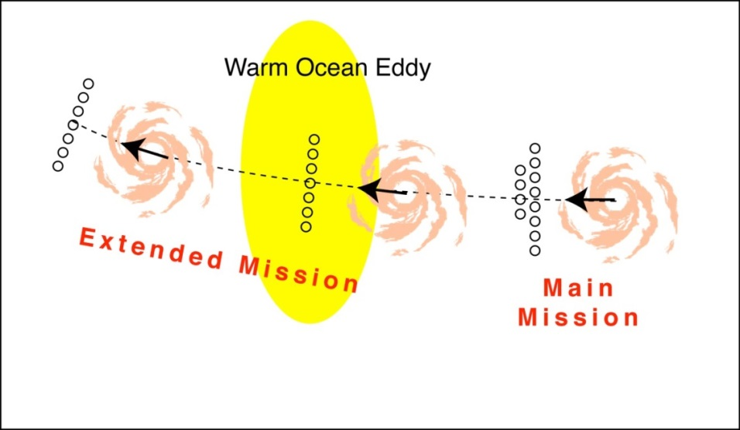

Figure 10: Extended Mission. Two additional drifter arrays will be deployed along the storm track.

Analysis Strategy:
Upper-ocean three-dimensional thermal, salinity, and current structures will be measured from P-3 aircraft with airborne expendable bathythermographs (AXBT), conductivity–temperature–depth sensors (AXCTD), and current profilers (AXCP). Specifically, AXBT data will be acquired to ~400-m depth, compared to 1000m and 1500m for AXTCD and AXCP data, respectively. Additionally, measurements will be made using arrays of profiling and Lagrangian floats (APEX-EM) and drifters deployed by AFRC WC-130J aircraft in a manner similar to that used in the 2003 and 2004 CBLAST program (Black et al. 2007). Additional deployments have since refined the instruments and the deployment strategies. MiniMet drifters will measure SST, surface pressure and wind speed and direction. Thermistor chain Autonomous Drifting Ocean Station (ADOS) drifters add ocean temperature measurements to 150m. All drifter data is reported in real time through the Global Telecommunications System (GTS). Flux Lagrangian floats will measure temperature, salinity, oxygen and nitrogen profiles to 200m, boundary layer evolution and covariance fluxes of most of these quantities, windspeed and scalar surface wave spectra. E-M Lagrangian floats will measure temperature, salinity and velocity profiles to 200m. Profile data will be reported in real time on GTS.
The basic analysis follows that presented in recent observational studies of TC-ocean interaction (Shay et al. 1992; 1994; 2000; Shay and Uhlhorn 2008; Halliwell et al. 2011; Zhang et al. 2011, 2013, 2015; Sanabia et al. 2013; Jaimes et al. 2015; 2016; Lumpkin 2016). These analyses include: estimate of sea surface cooling after the storm; estimate of change in the ocean mixed layer depth and ocean heat content (relative to the 26ºC isotherm depth) during and after the storm; computation of surface fluxes using the bulk method; estimate of ocean current change during and after the storm, with emphasis in upwelling processes and vertical shear development; and evaluation of the surface-layer and boundary-layer structure in operational hurricane models using the observational data collected in this experiment.

References:
Halliwell, G., L. K. Shay, J. K. Brewster, and W. J. Teague, 2011: Evaluation and sensitivity analysis to an ocean model to hurricane Ivan. Mon. Wea. Rev.139, 921-945.
Lumpkin, R.: Global Characteristics of Coherent Vortices from Surface Drifter Trajectories. J. Geophys. Res.-Oceans, 121, 1306–1321, http://dx.doi.org/10.1002/2015JC011435.
Jaimes, B., L. K. Shay and E. W. Uhlhorn, 2015: Observed enthalpy fluxes during the rapid intensity change of hurricane Earl. Mon. Wea. Rev., 131, 111-131.
Jaimes, B., L. K. Shay and J. K. Brewster, 2016: Observed Air-Sea Interactions in Tropical Cyclone Isaac Over Loop Current Mesoscale Eddy Features Dyn. Atmos. Ocean., 76, 306-324.
Sanabia, E. R., B. S. Barrett, P. G. Black, S. Chen, and J. A. Cummings, 2013: Real-time upper-ocean temperature observations from aircrafts during operational hurricane reconnaissance: AXBT demonstration project year one results. Wea. Forecasting, 28, 1404-1422
Shay, L.K., P.G. Black, A.J. Mariano, J.D. Hawkins and R.L. Elsberry, 1992: Upper ocean response to hurricane Gilbert. J. Geophys. Res., 97, 20,227 - 20,248.
Shay, L.K., E.J. Walsh and P.C. Zhang. 1994: Orbital velocities induced by surface waves. J. Atmos. Ocean. Tech., 11(4), Part 2, 1117 - 1125.
Shay, L.K., G.J. Goni and P.G. Black, 2000: Effects of a warm oceanic feature on Hurricane Opal. Mon. Wea. Rev., 125(5), 1366-1383.
Shay, L.K., and E. Uhlhorn, 2008: Loop current response to hurricanes Isidore and Lili, Mon. Wea Rev., 137, 3248-3274.
Zhang, J. A., R. F. Rogers, D. S. Nolan, and F. D. Marks, 2011: On the characteristic height scales of the hurricane boundary layer, Mon. Wea. Rev., 139, 2523-2535.
Zhang, J. A., R. F. Rogers, P. Reasor, E. Uhlhorn, and F. D. Marks, 2013: Asymmetric hurricane boundary layer structure from dropsonde composites in relation to the environmental vertical wind shear. Mon. Wea. Rev., 141, 3968–3984.
Zhang, J. A., D. S. Nolan, R. F. Rogers, and V. Tallapragada, 2015: Evaluating the impact of improvements in the boundary layer parameterization on hurricane intensity and structure forecasts in HWRF, Mon. Wea. Rev., 143, 3136-3155.

