13. Tropical Cyclone in Shear Experiment

Principal Investigator(s): Paul Reasor (lead), Jason Dunion, John Kaplan, Leon Nguyen, Rob Rogers, Jon Zawislak, Jun Zhang, Michael Riemer (Johannes Gutenberg-Universität)

Links to IFEX:
- Goal 1: Collect observations that span the TC life cycle in a variety of environments for model initialization and evaluation.
- Goal 3: Improve understanding of the physical processes important in intensity change for a TC at all stages of its lifecycle.
Motivation:
Forecasting of TC intensity remains a great challenge in which the gains in skill over the past decade have significantly lagged those of track at most forecast intervals (Rogers et al. 2006, DeMaria et al. 2005). As a multiscale atmospheric and oceanic problem, one of the constraints on TC intensity change is the vortex’s interaction with the evolving environmental flow. Vertically-sheared flow in particular is generally acknowledged to limit storm intensity, especially when combined with other environmental factors like low sea-surface temperature and mid-tropospheric dry air (e.g., Tang and Emanuel 2012). In observation-based statistical models of intensity prediction (Kaplan and DeMaria 2003; DeMaria et al. 2005), the vertical wind shear (VWS) is an important predictor.
Although most TCs in HRD’s data archive experience some degree of VWS, the timing of flights with respect to the shear evolution and the spatial sampling of kinematic and thermodynamic variables have not always been carried out in an optimal way for testing hypotheses regarding shear-induced modifications of TC structure and their impact on intensity change (see below). This experiment will sample the TC at distinct phases of its interaction with VWS and measure kinematic and thermodynamic fields with the azimuthal and radial coverage necessary to test existing hypotheses.
In addition to enhancing basic understanding, the dataset collected will guide improvements in initial conditions and the representation of moist physical processes in models. These improvements are likely necessary to increase the accuracy of short-term (<24 h) numerical intensity guidance for vertically sheared TCs. Initial conditions within the core region are important because the resilience of a TC (i.e., its ability to maintain a vertically-coherent structure under differential advection by the VWS) is sensitive to the strength, depth, and radial profile of the vortex (Reasor et al. 2004; Reasor and Montgomery 2015). Properly representing the flow outside the core region is also important since the flow topology there is critical to the thermodynamic interaction of the TC with surrounding dry environmental air (Riemer and Montgomery 2011). Physical processes in the model must also be well-represented so that 1) the structure on which the vortex resilience depends is not errantly transformed over short periods (< 6 h), 2) the convective response of the TC to vertical shearing and its feedback on vortex resilience are properly simulated, and 3) the shear-induced intensity modification mechanisms are permitted to operate as in nature.
Background:
Vertical wind shear impacts TC structure directly through vertical tilting of the vortex wind field and indirectly through modulation of the convective field (Black et al. 2002; Reasor et al., 2009; Reasor and Eastin 2012; Reasor et al. 2013). The impact of VWS on TC intensity is less certain and depends, in part, upon the timescale over which one considers the response (Frank and Ritchie 2001; Wang et al. 2004; Wong and Chan 2004; Riemer et al. 2010). The view of VWS as a generally negative influence on TC formation and intensification is supported by observational studies (e.g., Gray 1968) and observation-based statistical models of intensity prediction (Kaplan and DeMaria 2003; DeMaria et al. 2005). During the early stages of TC development, however, VWS can play a potentially positive role by organizing deep convection and vorticity production in the downshear region of the weak, pre-existing vortex (Molinari et al. 2004, 2006).
Early studies of shear-induced intensity change mechanisms focused on the role of VWS in ventilating the warm core (Simpson and Riehl 1958). Frank and Ritchie (2001) simulated the development of pronounced convective asymmetry in a vertically-sheared TC and argued that weakening occurs through the hydrostatic response to outward fluxes of upper-level potential vorticity (PV) and equivalent potential temperature. An alternative explanation by DeMaria (1996) focused on the balance-dynamics response of the vortex to vertical tilting. To maintain thermal wind balance as the wind structure is tilted, static stability must increase at low levels in the eyewall region. The negative impact on intensity was then hypothesized to arise through suppression of eyewall convection. Using a multi-level adiabatic primitive equation model, Jones (1995, 2000) demonstrated that low-level static stability evolves in a manner consistent with balance dynamics but does so asymmetrically within the eyewall. An asymmetrically balanced thermal anomaly develops in phase with the distortion of the wind field caused by vertical tilting, resulting in anomalously low (high) values of static stability located downtilt (uptilt). Thus, while convection might be suppressed on one side of the eyewall, it can be enhanced on the other. Jones additionally implicated the mesoscale transverse circulation (required to maintain asymmetric balance) in the development of convective asymmetry in the eyewall (see also Braun et al. 2006; Davis et al. 2008). The net impact of such static stability and vertical motion asymmetry on convective asymmetry and intensity change remains unclear.
Recently, Riemer et al. (2010) and Riemer et al. (2013) have proposed an intensity modification mechanism also rooted in a balance-dynamics framework. They argue that balanced vorticity asymmetry at low levels, generated outside the core through shear forcing, organizes convection outside the eyewall into a wavenumber-1 pattern through frictional convergence. Downdrafts associated with this vortex-scale convective asymmetry arise as precipitation generated by the convective updrafts falls into unsaturated air below. In their simulations, the downdrafts led to a vortex-scale transport of low equivalent potential temperature (θ_{e}) air into the inflow layer and disruption of the TC heat engine (Emanuel 1986, 1991). If particularly low θ_{e} air at lower to middle levels of the environment is able to reach the core region where convective enhancement occurs, the thermodynamic impacts of the downward transport of low θ_{e} air would be enhanced. Riemer and Montgomery (2011) proposed a simple kinematic model for this environmental interaction, quantifying the shear-induced distortion of the “moist envelope” surrounding the TC core as a function of shear strength, vortex size, and vortex intensity.
In the simulations of Riemer et al. (2010), the TC core region developed vertical tilt following its initial encounter with VWS, but then realigned, i.e., the vortex was resilient. The problem of dynamic resilience focuses on the ability of the TC to maintain a vertically-coherent vortex structure as it experiences vertical shearing. Jones (1995) found that coupling between vertical layers, and the tendency for the upper- and lower-level potential vorticity (PV) of the cyclonic core to precess upshear, restricts the development of vertical tilt that would otherwise occur through differential advection. For small-amplitude tilt, Reasor et al. (2004) developed a balance theory for the shear forcing of vortex tilt in which the tilt asymmetry behaves as a vortex-Rossby wave. In this vortex-Rossby wave framework, they developed a heuristic model for the TC in shear which predicts a left-of-shear tilt equilibrium. Furthermore, they demonstrated that the evolution towards this equilibrium tilt state depends not only on intrinsic scales of the flow (e.g., Rossby number and Rossby deformation radius), but also on the radial distribution of (potential) vorticity in the core region. Reasor and Montgomery (2015) have recently evaluated this heuristic model. The model is capable of predicting the enhancement of resilience that arises as the PV gradient outside the core increases. Even when moist neutral conditions exist within the eyewall, the model still describes the long-time evolution of the tilt asymmetry outside the eyewall.

Hypotheses:
- Hypothesis 1: Structure evolution: The vertically-tilted vortex structure which develops following a significant increase in VWS is governed by balance-dynamics theory. [There are two components here: 1) determine whether the wavenumber-1 vorticity and thermodynamic structures of the tilt asymmetry within the eyewall region are consistent with the expectations of asymmetric balance (see Background); and 2) document, to the extent possible, the structural evolution of the tilt asymmetry on the timescale of a vortex circulation period (~1 h) and over the longer timescale dictated by the mission frequency (~12 h), and then compare the observed evolution with expectations from idealized modeling (Reasor et al. 2004; Reasor and Montgomery 2015). Core-region kinematic structure is sampled out to 4-5xRMW with Doppler radar at specific times relative to the VWS evolution. Thermodynamic structure is sampled with flight-level instruments and closely-spaced dropsondes.]
- Hypothesis 2: Convective asymmetry: Eyewall convective asymmetry is organized by shear-forced, balanced mesoscale ascent. [Several explanations have been proposed for shear-forced convective asymmetry, including balanced ascent associated with vortex tilting, vorticity budget balance, and interaction of mesovortices with the flow outside the eyewall. While it may not be possible (given our current limited understanding of shear-forced eyewall convective asymmetry) to determine the predominance of one mechanism over another using only observed data, at a minimum we may assess whether each mechanism is plausible in a given case. This data will aid future theoretical and numerical investigations designed to understand why convection is preferred in shear-relative locations of the TC eyewall. Core kinematic and precipitation structures are sampled with Doppler radar during a period when VWS is the dominant forcing of low-wavenumber asymmetry. Thermodynamic structure is sampled with flight-level instruments and closely-spaced dropsondes. Satellite observations of convective activity should also be archived during the observation periods.]
- Hypothesis 3: Intensity modification: As stated in Riemer et al. (2010), VWS inhibits intensification through the downward transport of low-θ_{e} air into the inflow layer outside the core, brought on by the wavenumber-1 organization of convection outside the core via balance-dynamics mechanisms. [The proposed link between balance-dynamics mechanisms and weakening, through modification of inflow layer thermodynamic properties, has not been demonstrated in the observational context. Core-region kinematic structure of the vortex (e.g., the tilt asymmetry) must be sampled out to 4-5xRMW with Doppler radar at specific times relative to the VWS evolution. Reflectivity data collected during the flight will also provide insight into the convective structure outside the eyewall. Thermodynamic structure of the inflow layer is sampled with closely-spaced dropsondes. Near-core thermodynamic structure of the lower to middle troposphere is sampled by flight-level and dropsonde measurements, especially before and during the period of increasing VWS.]
- Hypothesis 4: TC isolation: As stated in Riemer and Montgomery (2011), the shape of the moist envelope (i.e., high-θ_{e} air) surrounding the eyewall above the inflow layer (and below the outflow layer) is at first approximation closely related to the horizontal flow topology, and is distorted by VWS; for environmental air to impact eyewall convection, time-dependent and/or vertical motions outside the core (see Hypothesis 3) are generally necessary for all but the weakest TCs in VWS. [For a strong hurricane in VWS, the closest approach of environmental air is expected to be well-removed from the eyewall. If low- to mid-level low-θ_{e} air intrudes far enough into the core region, and undercuts near-core convection, the mechanism identified in Hypothesis 3 may operate in an amplified manner. The moist envelope is defined using P-3 flight-level and P-3/G-IV dropsonde data within and surrounding the eyewall out to about 150 n mi, before and after the shear increase. Similarly, the low- to mid-level storm-relative horizontal flow topology outside the core is examined using flight-level, dropsonde, and Doppler radar measurements.]

Experiment/Module Description:
The experiment design is motivated through the use of fields from an example sheared hurricane simulated by HWRF. These fields will be treated as atmospheric observations for the purpose of the discussion below. The mission details at each stage of the experiment are also described below.
The optimal experiment is one in which the VWS increases significantly over a short period of time, approximating the canonical idealized numerical experiment of a TC in VWS (e.g., Bender 1997; Frank and Ritchie 2001; Riemer et al. 2010, 2013). A hurricane-strength TC encounters an instantaneous increase in VWS and undergoes an immediate structural change in response to sustained shear forcing. Figure R1 illustrates the large-scale, deep-layer VWS evolution in a case (Hurricane Michael, initialized at 00Z on 7 Sept., 2012) that would constitute an acceptable target for this experiment. The VWS increases approximately 30 kts over 24 h, or at a rate of 1.25 kts/h.
Figure R1: Ideal shear evolution from HWRF (purple).

Pre-shear sampling:
The TC is sampled prior to increasing shear (~48 h in R1) to obtain a reference vortex and environmental structure. Figure R2 shows a vertically aligned vorticity structure through a deep layer near this time.
Mission 1: The G-IV aircraft performs storm-relative environmental TDR and dropsonde sampling (G-IV Module 1) through clockwise circumnavigation, starting at 150 n mi, moving inward to 90 n mi, and finishing at 60 n mi. A coordinated P-3 aircraft performs a Figure-4 pattern (orientation chosen for efficiency) with TDR to obtain the TC core structure (P-3 Module 1). Radial legs are standard length for TDR missions, from 90-105 n mi. As time permits, the aircraft executes a second, rotated Figure-4 pattern. A primary objective of the P-3 and G-IV dropsonde sampling is to document the initial “pre-shear” moist envelope surrounding the core.
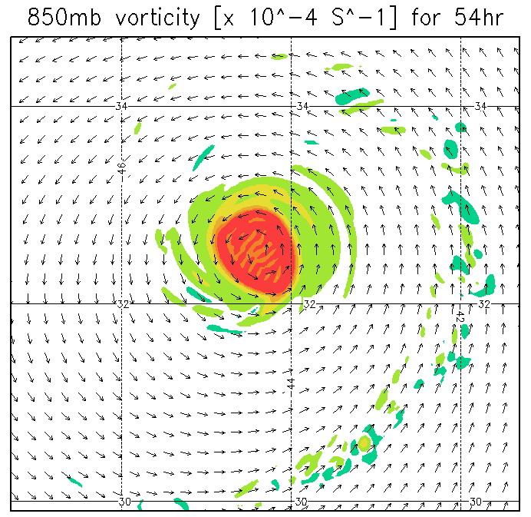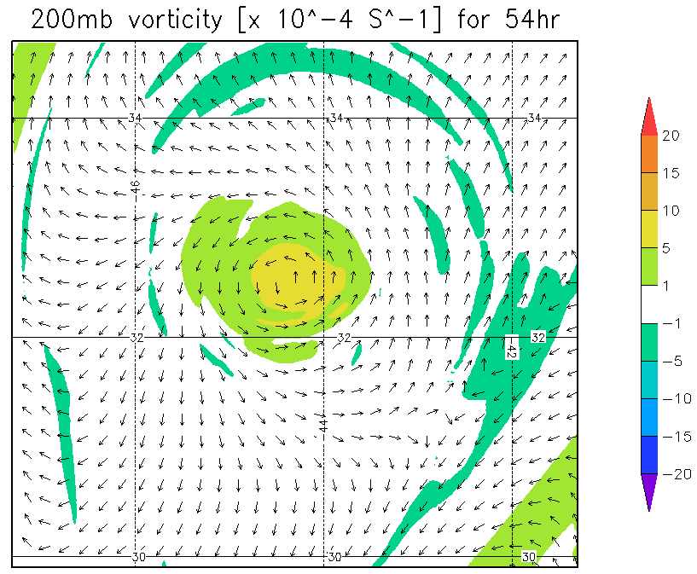
Figure R2: Anticipated “pre-shear” vortex structure from HWRF.

Threshold shear and large tilt sampling:
The TC’s kinematic structure responds to increasing VWS in one of three ways: 1) maintain a vertically upright vortex core throughout the troposphere, 2) develop significant tilt of the vortex core, but then realign into a steady-state tilt configuration (esp. if the shear is sustained), and 3) exhibit continuous and irreversible separation of the upper- and lower-level vortex cores, resulting in a shallow low-level circulation usually void of deep convection.
If a sufficiently high threshold value of VWS is employed, scenario 1) is least likely. For a TC that follows scenario 2), determining the target time of maximum tilt is critical. If the TC is sampled after realignment has already completed, the structural changes we wish to document may be greatly diminished. Furthermore, it would not be possible to fully test the intensity modification Hypothesis 3. For a TC that follows scenario 3), 12-h sampling of the TC until the low-level circulation becomes completely exposed (and void of deep convection) is adequate.
Since the possibility of scenario 2), and the precise timing of maximum tilt, depend on a variety of factors, as discussed in the Background, time series of forecast shear from a number of different sources (e.g., SHIPS, HWRF coarse grid, etc.) should be used in conjunction with a threshold shear value to guide the timing of flights subsequent to the pre-shear sampling. For the Category 2-3 hurricane in the example, a noticeable tilt of the circulation center with height becomes evident 18-24 h after the first mission, or when the shear approaches a value of 20 kts (not shown). An indication that the shear is beginning to strongly influence storm structure is the development of a pronounced convective asymmetry within the core region. Figure R3 illustrates this convective asymmetry at the time the shear threshold is reached (and the core begins to tilt). In this example, the second P-3 mission would commence ~12 h after the first.
Mission 2: A second P-3 will be prepared to sample the TC when the shear approaches a threshold value (~20 kts in the example). The objective is to document the initial development of shear-induced vertical tilt and the boundary layer response. The P-3 performs a single Figure-4 pattern (90-105 nmi legs) with TDR to obtain the TC core-region structure (P-3 Module 2). The P-3 then travels downwind to set up a rotated Figure-4 pattern with truncated radial legs. The radial legs should extend just outside the primary mesoscale region of convection radially beyond (~15-30 nmi) the eyewall. Dropsondes should be launched within and downwind of the convective region outside the eyewall in such a way as to sample low-θ_{e} air spiraling into the eyewall within the boundary layer.
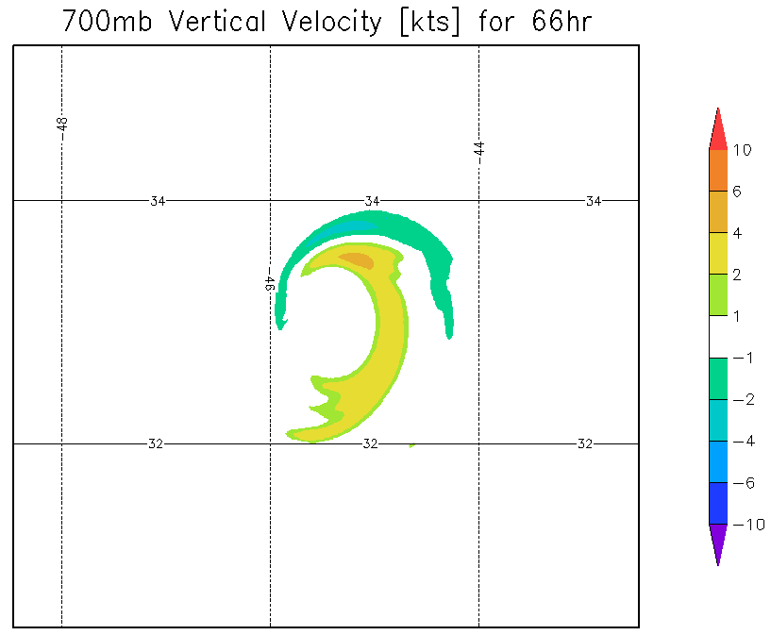
Figure R3: Anticipated “threshold shear” convective asymmetry from HWRF.

Figure R4 shows the tilted vorticity structure 12 h after the TC begins to develop a visible vertical tilt of the core (i.e., through the displacement of circulation centers with height). By this time, the shear magnitude is 30-35 kts. The vortex tilts to the left of the large-scale, deep-layer shear vector, as expected based upon work cited in the Background. In this example, the upper-level vorticity of the TC ultimately weakens and merges with an upper-level, north-south oriented vorticity feature to its west (not shown). This behavior is closest to that in scenario 3).
Mission 3: The P-3 used in the “pre-shear” mission will be prepared to sample (at least 24 h after the pre-shear mission) the TC when the vertical tilt of the core has reached a large value. The P-3 repeats the “threshold shear” sampling of the previous mission (P-3 Module 2). At the same time the G-IV repeats the “pre-shear” sampling pattern (G-IV Module 1).
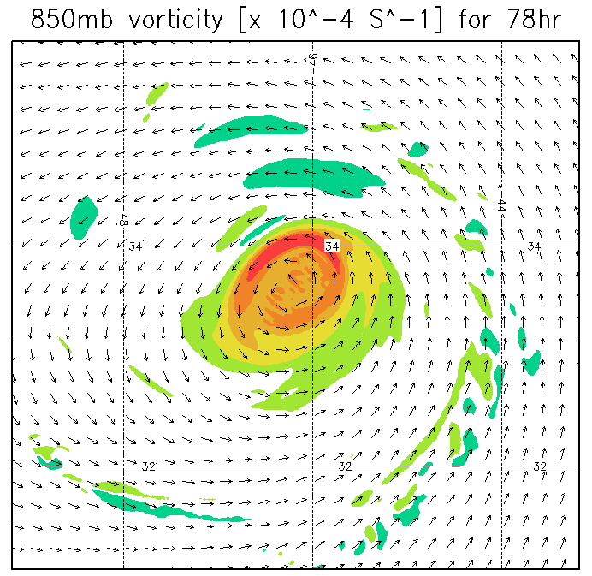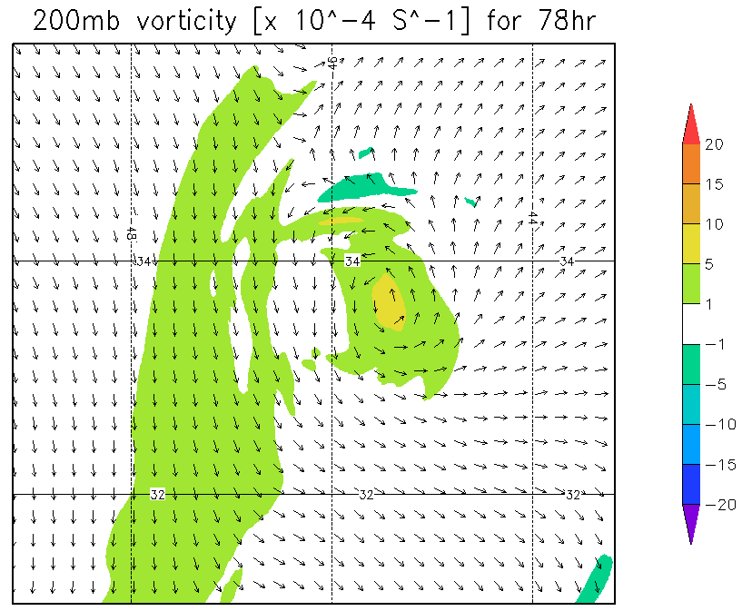
Figure R4: Anticipated “large-tilt” vortex structure from HWRF.

TC alignment and recovery sampling:
As discussed in the Background, some TCs are able to realign once tilted, even under sustained vertical wind shear. In the context of the intensity change Hypothesis 3, negative thermodynamic impacts on the TC should be reduced as the vortex aligns. In numerical simulations (e.g., Riemer et al. 2010), this is followed by re-intensification of the TC. In the example here, the vortex does not realign, and the primary circulation becomes increasingly shallow (not shown). The TC then continues to weaken (Figure R5). Whether the TC is resilient or is progressively sheared apart, a follow-up mission to investigate the continued evolution of the TC is important for a complete understanding of the life-cycle of a vertically-sheared storm.
Mission 4: The P-3 used in the “threshold shear” mission will be prepared to sample the TC after realignment has completed (or the vortex continues to be sheared apart). The objective is to verify vertical alignment in the kinematic field and the thermodynamic recovery of the boundary layer (or the continued deterioration of the circulation). The P-3 repeats the “threshold shear” and “large-tilt” sampling pattern (P-3 Module 2).

Figure R5: Anticipated weakening as shear-induced structure changes occur in HWRF (purple).

Analysis Strategy:
The basic analysis follows that presented in recent observational studies of the vertically sheared TC (Reasor et al. 2009; Reasor and Eastin 2012; Reasor et al. 2013; Rogers et al. 2013; Zhang et al. 2013). The analysis includes: low-wavenumber kinematic structure of the core region above the boundary layer, vortex tilt, and local VWS derived from airborne Doppler radar observations; low-wavenumber kinematic structure of the boundary layer derived from SFMR and dropsonde measurements; low-wavenumber thermodynamic structure within and above the boundary layer derived from dropsondes and flight-level measurements; and convective burst statistics derived from Doppler radar observations. New elements of the analysis will include: 3D kinematic structure out to at least 4-5xRMW using radar observations; low-wavenumber kinematic, thermodynamic, and moisture structures out to 150 n mi using G-IV radar and dropsonde observations; high azimuthal and radial representation of the inflow structure downwind of the mesoscale-organized convection radially outside the eyewall.
The above unprecedented dataset will be collected in the context of a TC encountering a large increase in VWS. We first document the basic kinematic evolution of the TC on both short (~1 h) and long (~12 h) timescales. For the optimal set of missions, the initial “pre-shear” vortex structure will be approximately axisymmetric and the vortex tilt should be a negligible fraction of the RMW. The core-region moisture envelope should also be approximately axisymmetric. The analysis may reveal horizontal inhomogeneities in θ_{e} at large distance from the core. Diagnostic analyses include: vertical tilt, local shear, 3D Doppler-derived vertical velocity and reflectivity, storm-relative streamline analyses out to 150 n mi, and 3D θ_{e} analyses below P-3 flight level within 4-5xRMW and below G-IV flight level between 60 and 150 n mi. These same diagnostics will also be computed at later stages of the sheared TC evolution.
Using the “threshold shear” mission data we document the development of tilt asymmetry out to 4-5xRMW, the distortion of the moist envelope, and the evolution of the near-core, storm-relative flow topology. Also at this stage, we document the development of convective asymmetry within and radially outside the eyewall, examine the shear-relative convective statistics (e.g., as in Eastin et al. 2005), and analyze changes in the boundary layer θ_{e} structure in relation to changes in convective organization outside the eyewall. At the “large tilt” stage, we anticipate asymmetric coverage of radar reflectors about the storm center. Where reflectors are, the analysis proceeds as above. Diagnostics relying on azimuthal coverage of the winds (e.g., the azimuthal-mean winds, tilt, and local shear) may be restricted to limited radial bands. If available, we will explore the benefits of Doppler Wind Lidar measurements in the echo-free regions of the storm. The objective at this stage is to examine whether the tilt asymmetry organizes convection on the vortex scale, how and where low θ_{e} air is transported into the near-core region, whether low θ_{e} air is transported into the boundary layer outside the eyewall, the modification of θ_{e} as parcels move inward towards the eyewall (if they do; see Zhang et al. (2013) and Riemer et al. (2013) for examples where the storm-relative core-region flow within the boundary layer of a sheared storm is radially outward), and changes in azimuthal-mean θ_{e} within the eyewall region and its relation to intensity change.
At the “realignment and recovery” stage, the optimal experiment will reveal a core kinematic and thermodynamic structure that more closely resembles the “pre-shear” structure than observed during the intermediate missions. The moist envelope may still be distorted, but the mechanism for downward transport of the low θ_{e} air will be diminished due to the reduction in vortex tilt. If the vortex continues to shear apart during this mission, the analysis will focus on the development of boundary layer “cold pools” using the dropsonde measurements, and, to the extent possible, the deterioration of the vertical structure of the TC’s primary circulation (e.g., Reasor et al. 2000; Sec. 4 of Riemer et al. (2013)).
References:
Bender, M. A., 1997: The effect of relative flow on the asymmetric structure in the interior of hurricanes. J. Atmos. Sci., 54, 703–724.
Black, M. L., J. F. Gamache, F. D. Marks, C. E. Samsury, and H. E. Willoughby, 2002: Eastern Pacific Hurricanes Jimena of 1991 and Olivia of 1994: The effect of vertical shear on structure and intensity. Mon. Wea. Rev., 130, 2291–2312.
Braun, S. A., M. T. Montgomery, and Z. Pu, 2006: High-resolution simulation of Hurricane Bonnie (1998). Part I: The organization of eyewall vertical motion. J. Atmos. Sci., 63, 19–42.
Davis, C. A., S. C. Jones, and M. Riemer, 2008: Hurricane vortex dynamics during Atlantic extratropical transition. J. Atmos. Sci., 65, 714–736.
DeMaria, M., 1996: The effect of vertical shear on tropical cyclone intensity change. J. Atmos. Sci., 53, 2076–2088.
DeMaria, M., M. Mainelli, L. K. Shay, J. A. Knaff, and J. Kaplan, 2005: Further improvements to the Statistical Hurricane Intensity Prediction Scheme (SHIPS). Wea. Forecasting, 20, 531–543.
Eastin, M. D., W. M. Gray, and P. G. Black, 2005: Buoyancy of convective vertical motions in the inner core of intense hurricanes. Part II: Case studies. Mon. Wea. Rev., 133, 209–227.
Emanuel, K. A., 1986: An air-sea interaction theory for tropical cyclones. Part I: Steady-state maintenance. J. Atmos. Sci., 43, 585–605.
Emanuel, K. A., 1991: The theory of hurricanes. Annu. Rev. Fluid Mech., 23, 179–196.
Frank, W. M. and E. A. Ritchie, 2001: Effects of vertical wind shear on the intensity and structure of numerically simulated hurricanes. Mon. Wea. Rev., 129, 2249–2269.
Gray, W. M., 1968: Global view of the origin of tropical disturbances. Mon. Wea. Rev., 96, 669-700.
Jones, S. C., 1995: The evolution of vortices in vertical shear. I: Initially barotropic vortices. Quart. J. Roy. Meteor. Soc., 121, 821–851.
Jones, S. C., 2000: The evolution of vortices in vertical shear. III: Baroclinic vortices. Quart. J. Roy. Meteor. Soc., 126, 3161–3185.
Kaplan, J., and M. DeMaria, 2003: Large-scale characteristics of rapidly intensifying tropical cyclones in the North Atlantic basin. Wea. Forecasting, 18, 1093–1108.
Molinari, J., D. Vollaro, K. L. Corbosiero, 2004: Tropical cyclone formation in a sheared environment: A case study. J. Atmos. Sci., 61, 2493-2509.
Molinari, J., P. Dodge, D. Vollaro, K. L. Corbosiero, F. D. Marks Jr., 2006: Mesoscale aspects of the downshear reformation of a tropical cyclone. J. Atmos. Sci., 63, 341-354.
Reasor, P. D., M. T. Montgomery, F. D. Marks Jr., and J. F. Gamache, 2000: Low-wavenumber structure and evolution of the hurricane inner core observed by airborne dual-Doppler radar. Mon. Wea. Rev., 128, 1653-1680.
Reasor, P. D., M. T. Montgomery, and L. D. Grasso, 2004: A new look at the problem of tropical cyclones in vertical shear flow: Vortex resiliency. J. Atmos. Sci., 61, 3–22.
Reasor, P. D., M. Eastin, and J. F. Gamache, 2009: Rapidly intensifying Hurricane Guillermo (1997). Part I: Low-wavenumber structure and evolution. Mon. Wea. Rev., 137, 603–631.
Reasor, P. D., and M. D. Eastin, 2012: Rapidly intensifying Hurricane Guillermo (1997). Part II: Resilience in shear. Mon. Wea. Rev., 140, 425–444.
Reasor, P. D., R. Rogers, and S. Lorsolo, 2013: Environmental flow impacts on tropical cyclone structure diagnosed from airborne Doppler radar composites. Mon. Wea. Rev.,141, 2949–2969.
Reasor, P. D., and M. T. Montgomery, 2015: Evaluation of a heuristic model for tropical cyclone resilience. J. Atmos. Sci., 72, 1765–1782.
Riemer, M., M. T. Montgomery, and M. E. Nicholls, 2010: A new paradigm for intensity modification of tropical cyclones: thermodynamic impact of vertical wind shear on the inflow layer. Atmos. Chem. Phys., 10, 3163–3188.
Riemer, M., and M. T. Montgomery, 2011: Simple kinematic models for the environmental interaction of tropical cyclones in vertical wind shear. Atmos. Chem. Phys., 11, 9395–9414.
Riemer, M., M. T. Montgomery, and M. E. Nicholls, 2013: Further examination of the thermodynamic modification of the inflow layer of tropical cyclones by vertical wind shear. Atmos. Chem. Phys., 13, 327–346.
Rogers, R., and Coauthors, 2006: The Intensity Forecasting Experiment: A NOAA Multiyear Field Program for Improving Tropical Cyclone Intensity Forecasts. Bull. Amer. Meteor. Soc., 87, 1523–1537.
Rogers, R., P. Reasor, and S. Lorsolo, 2013: Airborne Doppler observations of the inner-core structural differences between intensifying and steady-state tropical cyclones. Mon. Wea. Rev., 141, 2970–2971.
Simpson, R. H. and H. Riehl, 1958: Mid-tropospheric ventilation as a constraint on hurricane development and maintenance. Proc. Tech. Conf. on Hurricanes, Miami, FL, Amer. Meteor. Soc., D4.1-D4.10.
Tang, B., K. Emanuel, 2012: Sensitivity of tropical cyclone intensity to ventilation in an axisymmetric model. J. Atmos. Sci., 69, 2394–2413.
Wang, Y., M. Montgomery, and B. Wang, 2004: How much vertical shear can a well-developed tropical cyclone resist? Preprints, 26th Conference on Hurricanes and Tropical Meteorology, Miami, FL, Amer. Meteor. Soc., 100-101.
Wong, M. L. M. and J. C. L. Chan, 2004: Tropical cyclone intensity in vertical wind shear. J. Atmos. Sci., 61, 1859–1876.
Zhang, J. A., and E. Uhlhorn, 2012: Hurricane sea surface inflow angle and an observation-based parametric model. Mon. Wea. Rev., 140, 3587-3605.
Zhang, J. A., R. F. Rogers, P. D. Reasor, E. W. Uhlhorn, and F. D. Marks Jr., 2013: Asymmetric hurricane boundary layer structure in relation to the environmental vertical wind shear from dropsonde composites. Mon. Wea. Rev., 141, 3968–3984.

