11. Easterly Wave Genesis Experiment (GENEX)

Principal Investigator(s): Ghassan Alaka (Lead), Jason Dunion, Alan Brammer (U. Albany), Chris Thorncroft (U. Albany), Mark Boothe (NPS), Yuan-Ming Cheng (U. Albany)

Links to IFEX:
- Goal 1: Collect observations that span the TC life cycle in a variety of environments for model initialization and evaluation;
- Goal 3: Improve understanding of the physical processes important in intensity change for a TC at all stages of its lifecycle.

Background & Significance:
As early as the 1930s, westward propagating disturbances in the lower troposphere were identified as seed circulations for most tropical cyclones (TCs) in the North Atlantic Ocean (Dunn 1940). The origins of these disturbances were traced back to North Africa and are now known as African easterly waves (AEWs; Riehl 1945). About 70% of all TCs and, more impressively, 85% of major hurricanes in the North Atlantic Ocean have been found to initiate from AEWs (Landsea 1993). On average, sixty AEWs exit the West African coast each year. However, determining which of these AEWs will develop into TCs has proven to be a forecasting challenge. For example, over 50% of TC genesis events in the Atlantic main development region predicted by the Global Forecast System (GFS) from 2004-2011 were false alarms (Halperin et al. 2013).
Recent research has shed some light on the relationship between AEWs and TC genesis in the North Atlantic Ocean. The AEW-relative flow around an incipient disturbance has been hypothesized to be an important factor in protecting the disturbance from environmental intrusions and thus creating or maintaining a favorable environment for TC genesis to occur (Dunkerton et al. 2009). Brammer and Thorncroft (2015) have shown that, as AEWs leave West Africa, the troughs are sensitive to the low-level environment to their west and northwest (Fig. 1). Although the vortex at 700 hPa typically has closed circulation in the wave-relative reference frame, the AEW troughs are still cold-core in the lower troposphere and, therefore, there is relative westerly flow under the vortex and through the lower levels of the trough. In a composite analysis, significant differences in the moisture of the low-level environment to the northwest of the troughs were found between developing and non-developing waves. Favorable developing waves had significantly higher moisture content in the lower troposphere to the northwest of the trough as they exited the West African coast compared to favorable non-developing waves. Trajectory analysis for all the waves revealed that as the AEWs transition over the West African coast the troughs are typically open to the environment ahead and to the northwest of the trough. For developing waves this means that moist air (e.g. moist tropical sounding, Dunion 2011) is ingested into the lower levels of the system, while for non-developing waves dry air (e.g. SAL or mid-latitude dry air intrusion soundings) is ingested. At this stage in the AEW life cycle, moisture differences may be fundamental in determining whether a favorable wave will develop or not.
The depth and the integrity of the closed circulation around the pre-genesis disturbance is an important consideration for providing a convectively favorable environment for TC genesis. Freismuth et al. (2016) argue that the vortex of ex-Gaston (2010) was susceptible to dry air above the vortex maxima, which hindered deep convection and led to a weakening of the vortex. In addition, non-developing disturbance (AL90 2014) encountered lower tropospheric dry air to its west and northwest, which was ingested by the disturbance and was likely a major contributor in the failed genesis (Fig. 2). Preliminary results by Brammer (2015) suggest that as AEWs leave the West African coast, these troughs typically possess closed circulations at 700-600 hPa. Yet, these

troughs remain open to the environment both above and below the 700-600-hPa layer. As AEWs propagate across the North Atlantic, the troughs are more likely to exhibit closed circulations at low-levels due to either increased vorticity within the trough or the changing background shear profile over the central Atlantic. It was therefore hypothesized that AEWs are especially sensitive to the low-level environment to the west and northwest of the trough during the first three days after leaving the West African coast. Since AEWs typically propagate at 7.5 m s-1 over the Atlantic (Kiladis et al. 2006), these waves are typically located near 35°W after three days.

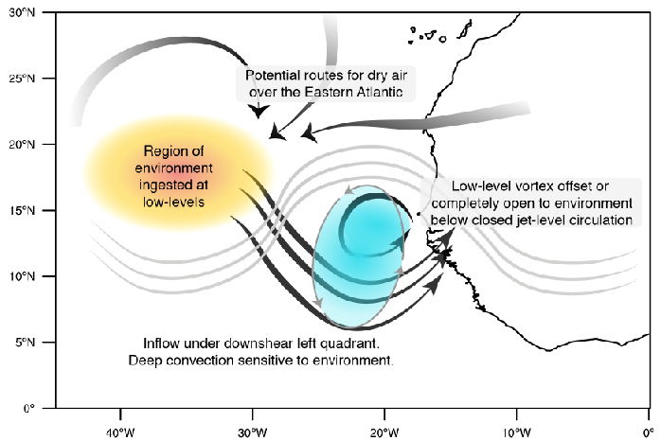
Figure 1. Schematic of the ingestion of dry environmental air by an African easterly wave.
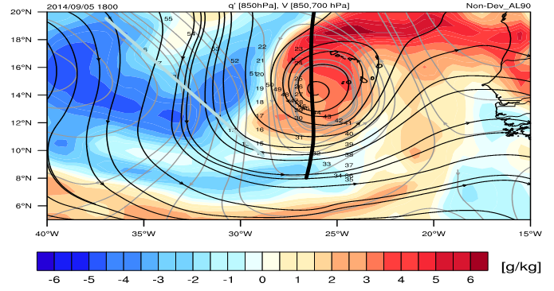
Figure 2. 850 hPa specific humidity anomalies (shading), 850 hPa streamflow (black contours) and 700 hPa streamflow (gray contours) are shown for a non-developing case (AL90) at 18Z 5 Sept 2014.

Objectives:
- Collect NOAA G-IV GPS dropwindsonde and flight level data in the environment to the west of an invest to improve model biases in temperature and humidity. This is known as the Environmental Survey option (Fig. 3). The invest should be an AEW that is expected to develop located at 35°W or further west. The target environment should be 5°-10° to the west of the approximate invest center.
- Collect NOAA G-IV and/or NOAA P-3 Doppler radar, GPS dropwindsonde and flight level data to assess the dynamic and thermodynamic structure of the invest to determine if environmental air was ingested into the disturbance once it has reached 40°W. This is known as the AEW Survey option (Fig. 4). Precise flight patterns will depend upon the developmental status of the invest. Two flight options are provided in Fig. 4.

Hypotheses:
- Hypothesis 1: Environmental air to the west and northwest of an AEW is ingested by an AEW, before the low-level circulation is closed, as it traverses the Atlantic Ocean.
- Hypothesis 2: Environmental air to the west and northwest of an AEW (i.e., TC seed) is vital to determine whether or not the disturbance will develop.
- Hypothesis 3: Dynamical models (e.g., GFS) are consistently too moist in the inflow layer to the west of the AEW, which incorrectly encourages genesis.

OSSE Evaluation:
Time and resource permitting, an OSSE will be performed to determine optimal flight patterns in order to maximize the impact of these observations on the GFS and HWRF systems. With the high genesis false alarm rate in the GFS, this data may be especially useful to that system in order to reduce the model bias for over-predicting TC genesis.
Experiment Description:
This is a multi-plane, multi-option experiment. The target of this experiment is an AEW that is deemed an “invest” (i.e., a disturbance that has a chance to become a TC) by the National Hurricane Center (NHC). In particular, priority will be given to AEW invests that have a high chance of development based on NHC probabilities and model forecasts. This experiment relies on the balance between sampling as far to the east as possible and optimizing on-station time. This balance highlights a region between 35°W ad 40°W as the optimal location to sample the AEW environment and the AEW itself. The NOAA G-IV is the primary aircraft for this experiment. However, the NOAA P-3 becomes an option for this experiment if the AEW approaches 45°W (~2.5 hr on-station time). When possible, the G-IV and P-3 will coordinate with NOAA Sensing Hazards with Operational Unmanned Technology (SHOUT) Global Hawk missions to optimize sampling of environmental targets of interest (see section: Coordination with Supplemental Aircraft).

This experiment will be broken up into two options:
OPTION #1 – G-IV – Environmental Survey
This option will sample the environment to the west of the AEW starting when the disturbance is near 35°W with the NOAA G-IV (Fig. 3 and G-IV Module 1). This experiment can be shifted to the west to accommodate AEWs that have propagated further without developing. Research shows that the disturbances typically close off in the low-levels by 35°W-40°W, so the number of candidates for this experiment decreases west of 40°W. This experiment will utilize GPS dropwindsonde and flight level data to document the thermodynamic properties of the AEW inflow region. In order to sample as much environmental moisture as possible, a Lawnmower Flight Pattern, rotated 90° for N-S orientation and with long meridional legs. The lawnmower pattern should be centered on the latitude of the approximate AEW center and should extend at least 3° to the north and to the south of that center. The zonal legs of this lawnmower pattern should be about 1°-2° (150 nm), while the meridional legs should be about 6°-10° (600-1000 nm). GPS dropwindsondes should be administered every 150-250 nm on each meridional leg, but this spacing is flexible based on dropwindsonde availability. See G-IV Module 1 for more information.
Importantly, the Environmental Survey option may be administered stand-alone experiment or may be included as a module in other experiments. If used as a module, the Environmental Survey would be administered as a “break-away module”. For example, the AEW Survey (see Option #2), which highlights the sampling of the actual AEW, may be altered to include the Environmental Survey as a module. In addition, the Environmental Survey may be added as a module within other NOAA P-3 and/or NOAA G-IV experiments or operational tasked missions. The proposed far-field sampling can often be performed during P-3 and G-IV aircraft ferries to and from the tropical disturbance. If a Saharan Air Layer outbreak is present in the far field environment, the DWL Experiment SAL module can be conducted.
Analysis Strategy:
NOAA G-IV (and, if applicable, NOAA P-3) GPS dropwindsonde and flight level data will be analyzed to determine the thermodynamic environment to the west of the AEW. NASA Global Hawk GPS dropwindsondes, if available, will be used in conjunction with NOAA aircraft data to observe the structure and evolution of the to-be-ingested environmental air. The vertical structure of specific humidity will be especially important in this environmental survey. These specific humidity measurements will be used to determine HWRF and GFS biases in the environment ahead of AEWs.
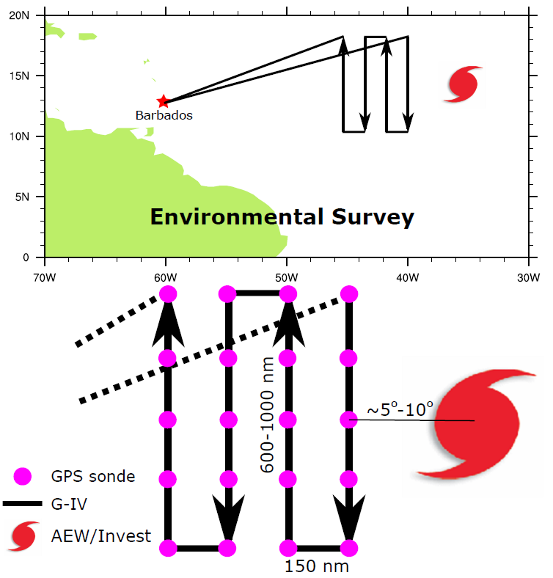
Figure 3. The Environmental Survey experiment (or module).

OPTION #2 – G-IV/P-3 – AEW Survey
This option will sample a developing AEW to determine if environmental air has been ingested and assess impacts on the structure and organization of the tropical disturbance. Once the AEW reaches 40°W, the disturbance may be investigated with the NOAA G-IV (Fig. 4, G-IV Module 2A, G-IV Module 2B). If the AEW reaches 45°W and has still not developed, the NOAA P-3 may also be used to carry out this experiment (P-3 Module 2). The AEW Survey experiment may incorporate the Environmental Survey (see Option #1), as shown by the dashed line in Fig. 4.
If the AEW is showing signs of genesis, the AEW Survey will focus on center fixes, as shown in the top of Fig. 4. This resembles the Butterfly Flight Pattern (see G-IV Module 2B, P-3 Module 2). If the AEW is disorganized, the AEW Survey will focus on a general survey pattern around the disturbance, as shown in the bottom of Fig. 4. This resembles the G-IV Circumnavigation (Hexagon) Flight Pattern, modified to remove the middle circle for time constraints. Regardless of the AEW developmental status, this experiment will employ Doppler radar, GPS dropwindsondes and flight level data to create a full picture of the dynamic and thermodynamic structure of the AEW. The strategy for GPS dropwindsonde sampling should be consistent with other survey or figure-four flight patterns.
Analysis Strategy:
NOAA G-IV and NOAA P-3 Doppler radar, GPS dropwindsonde and flight level data will be synthesized to assess the dynamic and thermodynamic structure of the AEW, with a focus on whether or not the previously-observed environmental air was ingested into the disturbance. In addition to searching for signs of development, evidence for the ingestion of environmental air observed in the previous flight will be sought out. In particular, the impact of this environmental air on the organization and the intensity of the system will be the focal point of this experiment. If the AEW is interacting with a Saharan Air Layer outbreak, GPS dropwindsonde sampling of the SAL’s low to mid-level dry air (~500-850 hPa) and mid-level easterly jet (25-50 kt near 600-800 hPa) should also be prioritized and the P-3 DWL Experiment SAL module can be conducted.
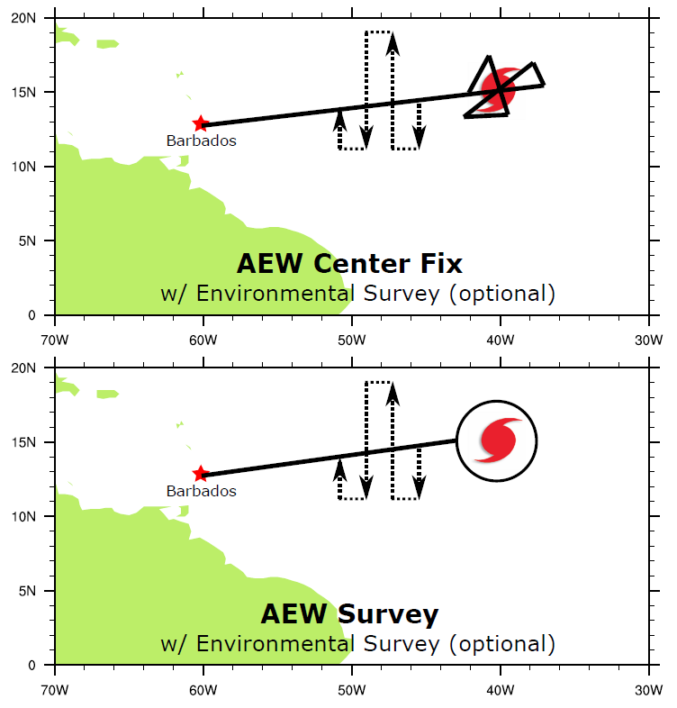
Figure 4. The AEW Survey experiment. (Top) AEW Center Fix option with optional Environmental Survey module. (Bottom) AEW Survey option with Environmental Survey module.

References:
Brammer A., (2015): Evolution of African easterly waves and their relationship to tropical cyclogenesis. Ph.D. thesis, SUNY at Albany. url: http://gradworks.umi.com/37/38/3738908.html
Brammer A., and C. D. Thorncroft, 2015: Variability and Evolution of African Easterly Wave Structures and Their Relationship with Tropical Cyclogenesis over the Eastern Atlantic. Mon. Wea. Rev. 143(12), 4975-4995.
Dunion, J.P., 2011: Re-writing the climatology of the tropical North Atlantic and Caribbean Sea atmosphere. J. Climate, 24 (3), 893-908.
Dunkerton, T. J., M. T. Montgomery, and Z. Wang, 2009: Tropical cyclogenesis in a tropical wave critical layer: Easterly waves. Atmos. Chem. Phys., 9, 5587–5646.
Dunn, G. E., 1940: Cyclogenesis in the tropical Atlantic. Bull. Amer. Meteor. Soc., 21, 215-229.
Freismuth, T. M., Rutherford, B., Boothe, M. A., and Montgomery, M. T, 2016: Why did the storm ex-Gaston (2010) fail to redevelop during the PREDICT experiment? Atmos. Chem. Phys. Discuss., doi:10.5194/acp-2015-692, in review.
Halperin, D. J., H. E. Fuelberg, R. E. Hart, J. H. Cossuth, P. Sura, and R. J. Pasch, 2013: An evaluation of tropical cyclone genesis forecasts from global numerical models. Wea. Forecasting, 28, 1423–1445, doi:10.1175/WAF-D-13-00008.1
Landsea, C. W., 1993: A climatology of intense (or major) Atlantic hurricanes. Mon. Wea. Rev., 121, 1703-1713.
Riehl, H., 1945: "Waves in the easterlies and the polar front in the tropics" Misc. Rep. No. 17, Department of Meteorology, University of Chicago, 79 pp.

