10. Underwater Glider Operations

Principal Investigator(s): Gustavo Goni (NOAA/AOML), Robert Todd (WHOI), Ruth Curry (BIOS), Steven DiMarco (TAMU), Stephan Howden (USM), Jordon Beckler (Mote), Scott Glenn (Rutgers University), Julio Morell (CARICOOS), Kevin Martin (USM), Carl Szczerchowski (NAVO)

Links to IFEX:
- Goal 1: Collect observations that span the TC life cycle in a variety of environments for model initialization and evaluation.
- Goal 2: Develop and refine measurement technologies that provide improved real-time monitoring of TC intensity, structure, and environment.
- Goal 3: Improve understanding of the physical processes important in intensity change for a TC at all stages of its lifecycle.
Motivation:
The upper ocean thermal structure has been shown to be linked to hurricane intensification provided that the appropriate atmospheric conditions are present. The upper ocean has been shown to improve intensity forecast in several intense hurricanes (Mainelli et al, 2008). To complement other ocean observations and aircraft-based experiments and observations, underwater glider operations in support of the Hurricane Field Program will be continued during the 2017 hurricane season. Underwater gliders are cost-effective observational platforms used for targeted and sustained upper-ocean temperature and salinity observations. These vehicles are operated remotely and efficiently collect observations in harsh open ocean conditions, including under hurricane force winds. Gliders can be navigated across moderately strong currents. Gliders can navigate approximately 4,000 km during one mission and collect and transmit thousands of profiles during a several-month deployment. While on the surface, they transmit the ocean profile data and can also download any new instructions for altering the navigation route or sampling configurations at any time during the mission. These underwater glider data are key to initialize ocean numerical models used in ocean-coupled hurricane intensification forecast models.

Background:
Underwater glider data provides surface and subsurface data along predetermined tracks, containing information of temperature and salinity gradients that, once assimilated in numerical models, have a persistent impact on forecasted fields, larger than observations obtained at single locations (such as Argo floats, moorings, etc).
The main objectives of the proposed work are to:

- Share information on synergies of the individual efforts that provide glider ocean data that can be used for tropical cyclone studies and forecasts,
- Obtain upper ocean temperature, salinity, and current velocity observations from underwater gliders,
- Improve understanding of and evaluate the impact of hurricane force winds on the upper ocean, and
- Assess the impact of assimilating underwater glider data on hurricane intensity forecasts.

Of critical importance will be the joint analysis of the data collected through this project with those obtained through 1) other targeted observations made from WP-3D and WC-130J flights that deploy a suite of atmospheric sensors and oceanographic probes, and 2) components of the sustained ocean observing system, such as surface drifters, Argo floats, eXpendable BathyThermographs (XBTs), etc.

Hypotheses:
- Hypothesis #1: Underwater glider data (together with other upper ocean thermal data) impact hurricane intensity forecasts by reducing errors in the initialization of upper ocean thermal conditions.

Experiment/Module Description:
The first hurricane underwater glider mission included in the Hurricane Field Program was carried out by the NOAA/AOML-CARICOOS network in 2014, and continued during the 2015, and 2016 Atlantic hurricane seasons. These missions were geared exclusively towards obtaining upper-ocean observations in support of hurricane studies and forecasts. The goal of this network is to enhance the understanding of air-sea interaction processes during hurricane force wind events by assessing the ocean response to hurricane force wind events, and by investigating the impact of underwater glider data (and other ocean profile data, such as Argo floats, XBTs, moorings, etc) on hurricane intensity forecasts using coupled numerical models.

The efforts of several Institutions that also carry out glider operations and whose observations will be help to improve spatial coverage by providing observations in several areas in the North Atlantic Ocean will be coordinated during the 2017 season. The area of operation of the gliders of each institution are shown in the Figure, while details of their operations are included in the Table and described here:

NOAA/AOML-CARICOOS Mission

During the first two Hurricane Missions of 2014 and 2015, two gliders, one in the Caribbean Sea and one in the tropical North Atlantic Ocean, off Puerto Rico, were used to collect temperature, salinity, and oxygen profiles in regions that are severely undersampled. Starting in the 2016 Atlantic hurricane season, the network was expanded to four gliders, with two deployed in the Caribbean Sea and two in the tropical North Atlantic Ocean. Approximately 14,000 have been collected to date in areas that were previously poorly sampled. Data are transmitted in real-time into the GTS, to the IOOS DAC, and submitted to data centers for assimilation in forecast models.

During the previous hurricane missions, gliders were piloted to obtain repeated upper ocean sections of temperature and salinity before, and after the passage of a hurricane. During the passage of a hurricane, the gliders were in general parked at a fixed location, collecting profile observations analogous to the data collected by a fixed mooring, however with very dense depth resolution. These data allow to analyze the response of the ocean to the passage of a hurricane and to assess the recovery of the ocean. All gliders are now also equipped with additional sensors, such as CDOM, chlorophyll-a, and backscatter. Data collected by these additional sensors will enable further studies focused on assessing the impact of hurricanes on ocean ecosystems and biochemistry.

WHOI Mission

WHOI will operate 1-2 Spray gliders in the Gulf Stream between Miami and New England throughout the year. WHOI will also have 1-2 Spray gliders surveying continuously near Cape Hatteras beginning in April 2017 for the NSF-funded PEACH field program that is focused on shelf-deep ocean exchange near Cape Hatteras. Each Spray glider will be equipped to measure profiles of temperature, salinity, absolute velocity, chlorophyll fluorescence, and 1-MHz acoustic backscatter; realtime temperature and salinity profiles will be transmitted to GTS via the IOOS Glider DAC.

Bermuda’s BIOS Mission

BIOS will operate 2 Slocum gliders (1000 m buoyancy engines) in the central subtropical gyre, near 32°N 64°W -- the Bermuda Atlantic Time Series (BATS) site. One will keep station as a virtual mooring while the other tracks back and forth along a 60-km section to survey the regional eddy field. Both gliders are equipped with a CTD, ECO puck (chlorophyll, backscatter, CDOM) and oxygen optode. One vehicle additionally carries an TRDI DVL ADCP for velocity and acoustic backscatter profiles, the other a Satlantic SUNA for nitrate measurements. Real-time temperature and salinity profiles will be transmitted to GTS via the IOOS Glider DAC.

Rutgers University Mission

Rutgers University is again coordinating glider flights in the Mid-Atlantic region for the 2017 spring through fall stratified seasons as part of MARACOOS. Initial glider deployments will be in April. Rutgers will deploy a near shore glider to zig-zag along the New Jersey on the inner shelf in April. UMaryland will deploy a glider in early May from Ocean City, MD, that will travel out to the shelf break and back to be recovered further south at Wachapreague. In May the UDelaware Biolume glider will be deployed to zig-zag along the Delaware & Maryland inner shelf. Three glider deployments are planned for August. Rutgers will repeat the inner shelf survey along the NJ coast. UMassachusetts will complete 4 cross-shelf lines in a full shelf zig-zag pattern that starts in new Bedford and ends in Atlantic City. Simultaneously, UMaryland will conduct a similar survey further south, with 4 cross shelf lines zig-zagging across the full shelf starting at Atlantic City and ending at Assateague. In October, both the Rutgers and UDelaware inner shelf zig-zaga are repeated. In November, VIMS will conduct a cross-shelf survey out to the shelf break and back between Norfolk and Ocean City.

Texas A&M University Mission

In 2017, TAMU will deploy four (Teledyne-Webb Research) G2 Slocum gliders in the Gulf of Mexico. All are equipped with Seabird CTD, Wetlabs EcoPuck fluorometer (chlorophyll, CDOM, and turbidity), and dissolved oxygen sensor (either Aanderaa optode or Rockland RINKO). We also have a Rockland Scientific MicroRider with microstructure probes and associated cradle to equip one glider. Two of the gliders are equipped with the hybrid thruster assembly. We have two deep water (1000 m) buoyancy pumps, two shelf buoyancy pumps, and two shallow (800 cc) pumps for inner shelf deployments. Pumps will be used that are appropriate to mission objectives. TAMU had several missions during the past two years that have been in the deep water north western/central Gulf of Mexico, and have also targeted the stratified deep waters of the Texas-Louisiana Shelf to investigate processes associated with the development of the Louisiana Deadzone. This summer (2017) TAMU plans on four deployments on the shelf/slope of the Texas-Louisiana Shelf (June-July) and two deployments (one with microrider) in deepwater (August-October). The objectives of the shelf missions are to investigate coastal water quality and cross shelf exchange. These missions are funded separately by the Texas OneGulf Center of Excellence (RESTORE Act) and by the NOAA Center for Sponsored Coastal Ocean Research. The objectives of the deepwater missions are to investigate microstructure and turbulence on the outer continental shelf and slope, provide spatial context of hydrographic parameters being collected aboard an associated research vessel, and to collect observations of upper ocean heat content. The deep missions are funded by the Gulf of Mexico Research Initiative under the GoMIX Project (WHOI lead). All planned TAMU missions will be hosted by the Gulf of Mexico Coastal Ocean Observing System (GCOOS) website (http://gcoos2.tamu.edu/gandalf/deployed/); all data will be transmitted to the GTS through the IOOS Glider DAC. Additional missions are possible if adequate funds are procured.

University Of Southern Mississippi (USM) Mission

USM is still waiting on funding for this 2017, however for the past 5 years USM, in conjunction with NOAA/NDBC, Navy Oceanographics and Shell Oil (funding source), has operated one glider in the Gulf of Mexico to look at Ocean Heat Content as well as loop current dynamics. USM anticipates this year continuing this project. Exact area of operation will be determined by which glider platform is used on the project. All data from these flights are hosted by the Gulf of Mexico Coastal Ocean Observing System (GCOOS) and displayed on their website (http://gcoos2.tamu.edu/gandalf/deployed/). From GCOOS the data is passed through the IOOS Glider DAC to the GTS.

Mote Marine Laboratory Mission

Mote will conduct six 15-day glider deployments per year to survey coastal waters for subsurface evidence of Florida Red Tide (Karenia brevis) bloom initiations and progressions. Routine surveys with glider-mounted instrumentation can address such research and management-oriented questions such as the purported transport of blooms via bottom waters during upwelling events, accumulation at sub surface density fronts, and the diurnal migration of phytoplankton with the possibility of bloom support from sediment nutrient flux. Glider surveys across regions of relative hydrodynamic uncertainty, such as the mouths of estuaries, can also provide increased detail for initiation conditions of forecasting models. Routine monitoring with a Teledyne-Webb Slocum glider equipped with a CTD and instrumentation for measurement of chromophoric dissolved organic matter (CDOM), Chl. a, and backscatter (turbidity) will be employed along offshore transects between the 10 m to 40 m isobaths. This transect has been flown regularly since 2014 and in turn has generated a large, seasonal data set for a bloom-initiation “hot-spot”. However, in the case of an active bloom, the routine transect may be modified to investigate any areas of interest between the area offshore of Clearwater and Englewood, Florida. Typical sampling density during glider deployments provides physical and chemical parameters roughly every 1 sec. Differentials between dead reckoning and observed positions on surfacing provide information on relative current strength and direction. All glider deployment data is available in near real-time from the GCOOS Gulf AUV Network and Data Archiving Long-Term Storage Facility (GANDALF) data portal and incorporated into the IOOS National Glider Data Assembly Center (NGDAC).

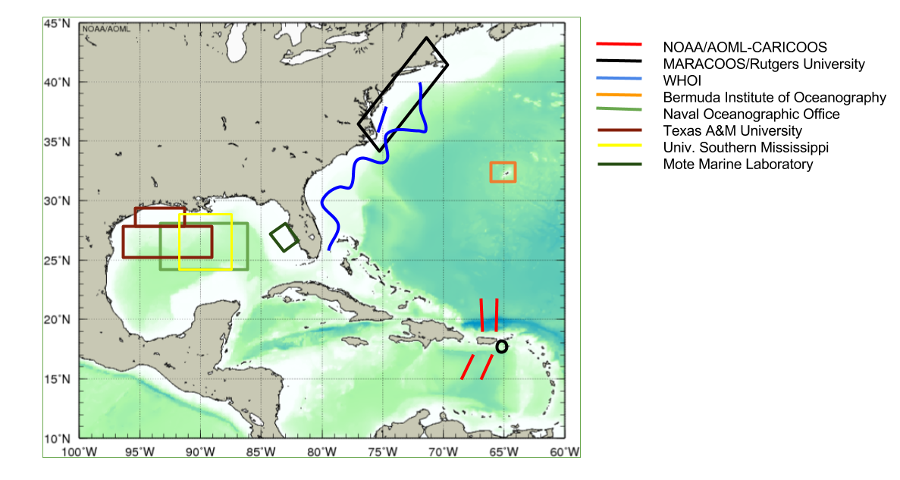
Figure 1. Location of planned underwater glider observations during the 2017 Atlantic hurricane season

Institution | Number of Gliders | Planned Observational Period | Planned Observational Region | Data Distribution | Project web site | Point of Contact
NOAA/AOML-CARICOOS | 4 | Jul-Nov 2017 | Tropical North Atlantic | GTS  IOOS DAC  AOML web pages | http://www.aoml.noaa.gov/phod/goos/gliders/ | Gustavo Goni  (Gustavo.Goni@noaa.gov)
 |  |  | Caribbean Sea
Rutgers University | TBD | Jun-Nov 2017 | Various regions in NE Atlantic Ocean |  |  | Scott Glenn (glenn@marine.rutgers.edu)
Woods Hole Oceanographic Institution | 2-4 | Jun-Nov 2017 | Gulf Stream (Miami to New England) | GTS  IOOS DAC  spraydata.ucsd.edu | gliders.whoi.edu | Robert Todd (rtodd@whoi.edu)
 |  |  | Cape Hatteras shelf/slope
BIOS (Bermuda) | 1 | Jul - Nov 2017 | Bermuda | GTS  IOOS DAC | magic.bios.edu | Ruth Curry  (ruth.curry@bios.edu)
Naval Oceanographic Office | TBD | Aug - Nov 2017 | Gulf of Mexico | GTS  NOAA/NDBC |  | Carl Szczechowski (carl.szczechowski@navy.mil)
Texas A&M University  Geochemical and Environmental Research Group | 4 | (2, shelf) Jun-Jul 2017  (2, deep) Aug-Oct 2017 | Gulf of Mexico | GCOOS/IOOS DAC | http://tabs.gerg.tamu.edu/tceq and  http://gcoos2.tamu.edu/gandalf/deployed/#6/25.016/-90.011 | Steve DiMarco (sdimarco@tamu.edu)
Univ. Southern Mississippi  Division of Marine Science | 1 | Jul-Nov 2017 | Gulf of Mexico | GCOOS/IOOS DAC | http://gcoos2.tamu.edu/gandalf/deployed/#6/25.036/-90.011 | Kevin.m.martin@usm.edu
Mote Marine Laboratory | 1 | 6 annually | Gulf of Mexico | GCOOS/IOOS DAC | http://gcoos2.tamu.edu/gandalf/deployed/#6/25.036/-90.011 | jbeckler@mote.org

Table 1: Underwater glider resources that will be in place during the upcoming 2017 Tropical Atlantic hurricane season.

Analysis Strategy:
The ocean data will be used to:
- Improve understanding of and evaluate the impact of hurricane force winds on the upper ocean (e.g. Domingues et al, 2015, Glenn et al, 2008, Glenn et al, 2016).
- Assess the impact of assimilating underwater glider data on hurricane intensity forecasts (e.g. Dong et al, 2017).

References:
Dong, J., R. Domingues, G. Goni, G. Halliwell, H-S Kim, S-K Lee, M. Mehari, F. Bringas, J. Morell, and L. Pomales (under review). Impact of assimilating glider data on Hurricane Gonzalo (2014) forecast, Weather Forecasting (in press).
Domingues, R., G. Goni, F. Bringas, S.-K. Lee, H.-S. Kim, G. Halliwell, J. Dong, J. Morell, and L. Pomales (2015), Upper ocean response to Hurricane Gonzalo (2015): Salinity effects revealed by targeted and sustained underwater glider observations, Geophys. Res. Lett., 42, doi:10.1002/2015GL065378.
Glenn, S. M., Jones, C., Twardowski, M., Bowers, L., Kerfoot, J., Kohut, J., Webb, D., Schofield, O. 2008. Glider observations of sediment resuspension in a Middle Atlantic Bight Fall Transition Storm. Limnology and Oceanography, 53(5, Part 2): 2180-2196.
Glenn, S., T. Miles, G. Seroka, Y. Xu, R. Forney, F. Yu, H. Roarty, O. Schofield & J. Kohut, 2016. Stratified coastal ocean interactions with tropical cyclones, Nature Communications, 7:10887 doi:10.1038/ncomms10887.
Mainelli, M., M. DeMaria, L. Shay, and G. Goni, 2008. Application of oceanic heat content estimation to operational forecasting of recent Atlantic category 5 hurricanes. Weather Forecast., 23(1):3-16.

