9. G-IV SFMR Validation Module

Principal Investigator(s): Brad Klotz (lead) and Heather Holbach

Links to IFEX:
- Goal 2: Develop and refine measurement technologies that provide improved real-time monitoring of TC intensity, structure, and environment.
Motivation: The stepped frequency microwave radiometer (SFMR) on the P-3 has a proven track record for providing surface wind data in tropical cyclones (Uhlhorn et al. 2007, Klotz and Uhlhorn 2014). However, there is no documentation of the G-IV SFMR data and its usefulness under the current specifications of the G-IV flight patterns. To our knowledge no data from the G-IV SFMR has been released or used in any research or operational capacity. This data could potentially provide important information about the tropical cyclone wind radii as well as for mapping the environmental surface winds. The goal of this module is to validate the G-IV SFMR data with reliable, coincident P-3 SFMR data in the full spectrum of wind speeds and rain rates.
Background: Historically, the SFMR has primarily served as a research instrument that measured surface wind speeds and rain rates in hurricanes. As early as 1980, data were collected to estimate surface wind speeds from the breaking waves on the sea surface, but they were used in a limited capacity due to various errors. Beginning in 1998-1999, SFMR data were regularly collected on the P-3 aircraft with reasonable estimates of wind speeds, but an algorithm upgrade in the mid-2000s significantly improved the data. The SFMR still struggled at the low wind regime and within rainy conditions, which prompted a second algorithm update that became operational in 2015.
An SFMR was also installed on the G-IV, but it has several additional factors with which to contend. Because of the aircraft altitude, the footprint size is ~4-5 times larger than the SFMR on the P-3. The SFMR on the P-3 was designed to only interpret rain below the melting level because the P-3 normally operates at those altitudes. The G-IV must not only interpret rain but ice particles in the column between the flight-level and melting level. The combined factors call into question the G-IV SFMR ability to produce reasonable wind speeds (and rain rates) along the flight track.
A third SFMR (upward looking) was installed on the P-3 to take measurements of the air column above the aircraft. This data has not been used in any research or operational capacity either but could prove very useful for this module. Figure 1 provides a schematic of the footprint size and coverage for the three SFMR instruments based on standard flight altitudes of 42,000 ft and 10,000 ft for the G-IV and P-3, respectively. Note that this schematic is not to scale.
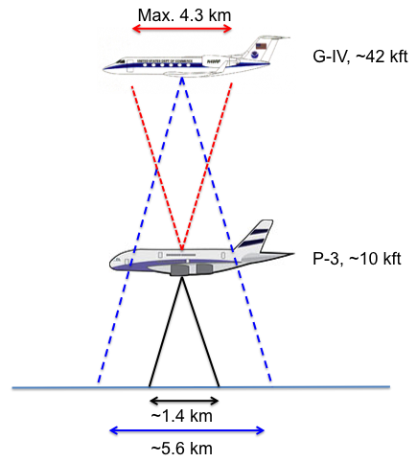
Figure 1. A schematic figure of the footprint coverage for the various SFMR instruments is provided. Also indicated are the normal operating altitudes of each aircraft. This schematic is not to scale.
Hypotheses:
- Hypothesis #1: Comparison with P-3 SFMR data will necessitate modifications to the G-IV SFMR processing and/or algorithm to account for the additional impacts on the received signal. It is expected that if the G-IV uses the P-3 processing algorithm, there will be noticeable deficiencies in the returned values.
Module Description: The premise behind this module is fairly simple: coordinate small sections of overlapping flight tracks between the G-IV and P-3. It is expected that this module should fit into a larger experiment so as not to interrupt the overall goals of said mission. Because the G-IV and P-3 often fly very different patterns, the best way to have the aircraft overlap is using the circumnavigation pattern (see flight pattern document). This flight option would coordinate along the inner circumnavigation (G-IV), targeting an area that is experiencing intermittent but occasionally moderate to heavy rain. This flight strategy allows for comparison of similar strength wind speeds (consistent radius) with a large variety of rain rates. If the G-IV can fly a radial pass in conjunction with the P-3 (maybe possible for a tropical storm), this would allow evaluation over a variety of wind speeds and rain rates. A third option would be to complete this module on a downwind leg of a P-3 TDR mission.
The two aircraft operate at different air speeds (~325 kt for the P-3 and ~440 kt for the G-IV), which limits the amount of time the aircraft will have reasonable coverage over the same portion of the ocean surface. Therefore, this module needs to be operated from the perspective of a preselected meeting point or midpoint of the pattern, which ensures both SFMR are observing the same portion of the ocean. The aircraft should be flying along the same heading during this coordinated overlap. For about 3-4 minutes prior to and after this midpoint, the two SFMR will have varying overlap in their footprints with the least overlap at the beginning and end of the module. A reasonable estimate of the duration of this module is ~8 minutes. Figure 2 is a schematic of the footprint coverage as a function time within the module centered on the preselected midpoint. As confirmation of the wind speeds observed at the midpoint, a dropsonde should be launched from the P-3.
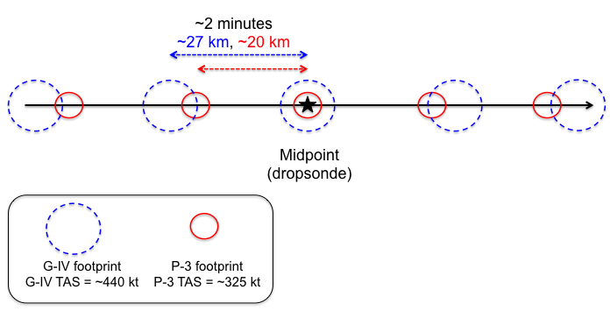
Figure 2. A schematic diagram of the flight path of the G-IV and P-3 aircraft during the module is provided. The red and blue circles indicate the P-3 and G-IV SFMR footprint size, respectively. The timing between successive locations in the figure is ~2 minutes with the distance covered by each aircraft noted. This figure is not to scale as the footprint size is emphasized for visibility.
Analysis Strategy:
Data that are collected during this module will first be post-processed and quality-controlled. The two downward looking SFMR will be compared and statistically evaluated depending on the overlapping footprint coverage and distance from the midpoint. From this perspective, differences can be determined based on coverage, wind speed, and rain rate. A surface-adjusted wind speed from the dropsonde will serve as the truth to validate both SFMR. A determination of the additional impacts of the air column above the P-3 on the G-IV SFMR results could prompt further investigation into changes for the G-IV processing or algorithm. Comparison of the upward looking P-3 SFMR will serve as an independent measure of the above aircraft air column and will help confirm any impacts the G-IV SFMR encounters.
References:
Klotz, B. W., and E. W. Uhlhorn, 2014: Improved Stepped Frequency Microwave Radiometer tropical cyclone surface winds in heavy precipitation. J. Atmos. Oceanic Technol., 31, 2392–2408.

Uhlhorn, E. W., P. G. Black, J. L. Franklin, M. Goodberlet, J. Carswell, and A. S. Goldstein, 2007: Hurricane Surface Wind Measurements from an Operational Stepped Frequency Microwave Radiometer. Mon. Wea. Rev., 135, 3070–3085.

