5. Small Unmanned Aerial VEhicle Experiment (SUAVE)
Principal Investigator and Co-Investigators: J. Cione, J, Zhang, L. Bucci, K, Ryan, E, Kalina, A. Aksoy, H. Holbach, G. Bryan, E. Konopleva

Links to IFEX:
- Goal 1: Collect observations that span the TC life cycle in a variety of environments for model initialization and evaluation.
- Goal 3: Improve understanding of the physical processes important in intensity change for a TC at all stages of its lifecycle.
Motivation:
In recent years, an increasing number of hurricanes have impacted the United States with devastating results, and many experts expect this trend to continue in the years ahead. In the wake of Hurricane Sandy (2012), NOAA is being looked at to provide improved and highly accurate hurricane-related forecasts over a longer time window prior to landfall. NOAA is therefore challenged to develop a program that will require applying the best science and technology available to improve hurricane prediction without placing NOAA personnel at increased risk. UAS are an emerging technology in the civil and research arena capable of responding to this need.

In late February 2006, a meeting was held between NOAA, NASA and DOE partners (including NOAA NCEP and NHC representatives) to discuss the potential for using UAS in hurricanes to take measurements designed to improve intensity forecasts. The group came to a consensus around the need for a UAS demonstration project focused on observing low-level (<200 meters) hurricane winds for the following reasons:

- Hurricane intensity and track forecasts are critical at sea level (where coastal residents live)
- The hurricane’s strongest winds are observed within the lowest levels of the atmosphere
- The air-sea interface is where the ocean's energy is directly transferred to the atmosphere
- Low-level observations will help improve operational model initialization and verification (especially boundary layer observations of temperature and moisture which are especially sparse)
- The low-level hurricane environment is too dangerous for manned aircraft

The potential importance of low-level UAS missions in hurricanes is further emphasized by the findings of the Hurricane Intensity Research Working Group established by the NOAA Science Advisory Board. Their recommendation is that:

“Low and Slow” Unmanned Aircraft Systems (UAS) have demonstrated a capacity to operate in hurricane conditions in 2005 and in 2007. Continued resources for low altitude UAS should be allocated in order to assess their ability to provide in situ observations in a critical region where manned aircraft satellite observations are lacking.

This effort is in direct support of NOAA’s operational requirements and research needs. Such a project will directly assist NOAA’s National Hurricane and Environmental Modeling Centers better meet several of their operational requirements by helping to assess:

The strength and location of the storm’s strongest winds
The radius of maximum winds
The storm’s minimum sea level pressure (potentially give forecasters advanced warning as it relates to dangerous episodes of tropical cyclone rapid intensification)
Thermodynamic conditions (particularly low level moisture) within the lower troposphere

In addition to these NOAA operational requirements, developing the capability to regularly fly low altitude UAS into tropical cyclones will also help advance NOAA research by allowing scientists to sample and analyze a region of the storm that would otherwise be impossible to observe in great detail (due to the severe safety risks associated with manned reconnaissance). It is believed that such improvements in basic understanding are likely to improve future numerical forecasts of tropical cyclone intensity change. Reducing the uncertainty associated with tropical cyclone intensity forecasts remains a top priority of the National Hurricane Center. Over time, projects such as this, which explore the utilization of unconventional and innovative technologies in order to more effectively sample critical regions of the storm environment should help reduce this inherent uncertainty.

Background:
Coyote is an aircraft platform that is built by the Raytheon Company (formerly Sensintel Corporation and British Aerospace Engineering (BAE)) and is currently being used by the US NAVY. The intended deployment vehicle for the Coyote is the P-3 Orion. The Coyote is a small electric-powered unmanned aircraft with 1-2 hour endurance and is capable of carrying a 1-2 lb payload. The Coyote can be launched from a P-3 sonobuoy tube in flight, and terrain-permitting, is capable of autonomous landing and recovery. The Coyote is supported by Raytheon’s integrated control station, which is capable of supporting multiple aircraft operations via touch screens that simultaneously show real-time video. This control station can also be incorporated onto the deployment aircraft (i.e. P-3), allowing for in-air command and control after launch. The Coyote, when deployed from NOAA's P-3's within a hurricane environment, provide a unique observation platform from which the low level atmospheric boundary layer environment can be diagnosed in great detail. In many ways, this UAS platform be considered a 'smart GPS dropsonde system' since it is deployed in similar fashion and currently utilizes a comparable meteorological payload (i.e. lightweight sensors for P, T, RH, V) similar to systems currently used by NOAA on the GIV and P-3 dropsonde systems. Unlike the GPS dropsonde however, the Coyote UAS can be directed from the NOAA P-3 to specific areas within the storm circulation (both in the horizontal and in the vertical). The Coyote payload will also be able to capture sea surface temperature (SST). Also unlike the GPS dropsonde, Coyote observations are continuous in nature and give scientists an extended look into important thermodynamic and kinematic physical processes that regularly occur within the near-surface boundary layer environment. Coyote UAS operations also represent a potentially significant upgrade relative to the more traditional "deploy, launch and recover" low altitude UAS hurricane mission plan used in the past (e.g. Aerosonde). By leveraging existing NOAA manned aircraft assets, Coyote operations significantly reduce the need for additional manpower. The Coyote concept of operations also reduces overall mission risk since there is no flight ingress/egress. This fact should also help simplify the airspace regulatory approval process. Specifications associated with the Coyote UAS are illustrated in Figure 1.

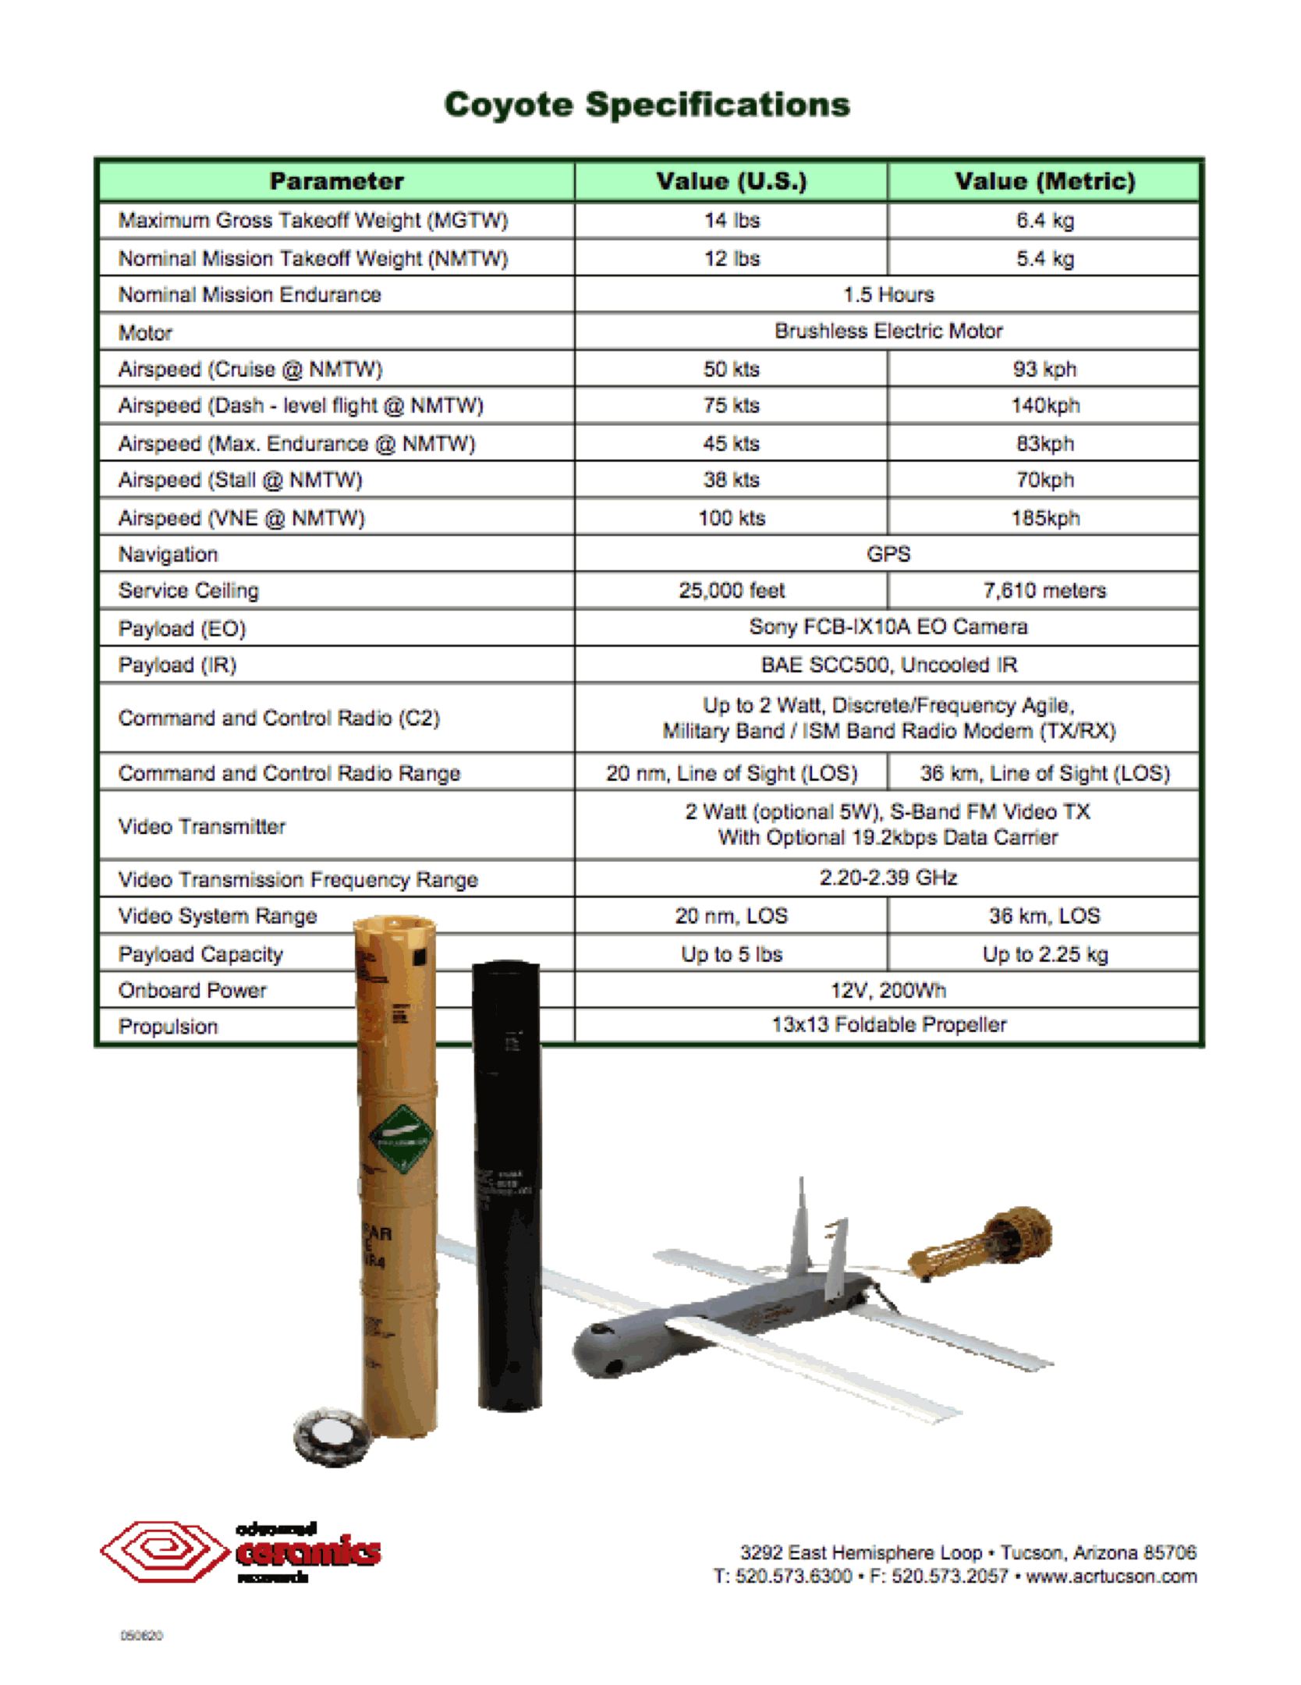
Figure 1. Coyote Unmanned Aerial System Specifications (Courtesy: Raytheon)

Hypotheses:
1. A more accurate estimation of the maximum 10m wind is possible using a continuously observing low altitude platform like the Coyote UAS (vs SFMR, Sondes alone)
2. A more accurate estimation of the Radius of Maximum Wind will be attained using a continuously observing low altitude platform like the Coyote UAS (vs SFMR, Sondes alone).
3. A more accurate estimation of the top of the hurricane boundary layer will be obtained.

Experiment/Module Description:
The primary objective of this experiment is further demonstrate and utilize the unique capabilities of a low altitude UAS platform in order to better document areas of the tropical cyclone environment that would otherwise be either impossible or impractical to observe. For this purpose, NOAA is proposing to use the Coyote UAS. Since the Coyote will be deployed from the manned P-3 aircraft, no UAS-specific forward deployment teams will be required. Furthermore, since the Coyote is launched using existing AXBT launch infrastructure, no special equipment is required beyond a ‘ground’ control station that Coyote operators will have onboard the P-3.

Module/Option 1a: UAS Eye/Eyewall with P-3 loiter
For this module the target candidate storm is a mature hurricane (likely strong category 2 or more) with a well-defined eye. Furthermore, since the P-3 will have to operate within the eye, daylight missions will be required so as to maintain P-3 visual contact with the eyewall at all times. In addition, other less restrictive Coyote-P3 modules are being developed and considered (see Module 1b). A 350-MHz communication stream between the UAS and the P-3 will be used to control the UAS flight characteristics and to receive data back from the Coyote. This capability will have the dual positive effect of minimizing risk to both science and safety, since the 350-MHz stream will permit communication over a range of at least 50 km. The immediate focus of this experimental module will be to test the operational capabilities of the Coyote UAS within a hurricane environment. Besides maintaining continuous command and control links with the P-3, these flights will test the accuracy of the new ITRI METOC payload by comparing UAS measurements with coincident observations taken from dropsondes released from the P-3. The UAS will be tested to see if it can maintain altitudes according to command. In addition, the Coyote UAS will attempt to fly at extreme altitudes (as low as 200 ft) in low (eye) and high (eyewall) wind conditions within the hurricane environment. The longer term goal for this UAS platform is to assist scientists so they can better document and ultimately improve their understanding of the rarely-observed tropical cyclone boundary layer. To help accomplish this, the UAS will make detailed observations of pressure, temperature, humidity, wind speed and wind direction (PTHU) at low altitudes within the hurricane eye and eyewall that will then be compared with multiple in-situ and remote-sensing observations obtained from manned aircraft (NOAA P-3 and as opportunities arise AFRES C-130, Global Hawk UAS) as well as select satellite-based remote sensor platforms. In addition, a primary objective (but not an immediate requirement) for this effort will be to provide real-time, near-surface wind observations to the National Hurricane and Environmental Modeling Centers in direct support of NOAA operational requirements. These unique data will also be used in a ‘post storm’ analysis framework in order to potentially assist in the numerical and NHC verification process.

For this experiment, the NOAA P-3 will descend to just above the top of the cloud layer in the eye, and return to the previous altitude when the module is concluded. Assuming multiple UAS are available, both (~1.5h duration) modules could be conducted on the same mission. The eye-only module would be conducted first, followed by the eye-eyewall UAS module. The P-3 flight pattern is identical for both eye and eye-eyewall UAS modules. GPS dropsonde and AXBT drop locations are also identical for each UAS module. AXBT and GPS drop locations are explicitly illustrated in the flight plan below. UAS deployment on leg 3-4 is also identical for both modules. UAS operational altitude will be entirely below 5000ft. UAS motor will not be activated until an altitude of 5000 ft is met. The UAS will be conducting a controlled, spiral glide (un-powered) descent from 10000 ft to 5000 ft.

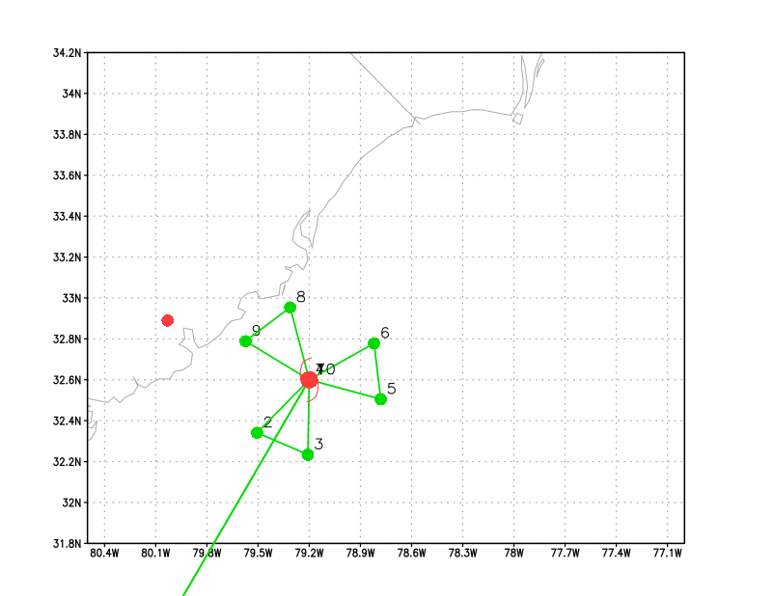
Figure 2. Pizza slice flight pattern for the eye/eyewall coyote experiment.

Module/Option 2: Enhanced Boundary Layer Inflow Sampling
At the IP the Coyote is released and slowly step descends down to 100m as it spirals inward. Once at 100m the UAS step ascends up to an altitude just above the inflow layer (~1.5km). Then again descends to 100m. This process continues until eyewall penetration occurs at 500m. Once in the eyewall the UAS step descends in 50m increments every 5 minutes until it reaches 50m and maintains altitude until battery failure.

This module extends work originally conducted by Cione et al. in 2000. It also expands the capabilities associated with the original BLI experiment by providing continuous (versus instantaneous) data at altitudes, radii and azimuths not previously sampled by GPS sonde deployments. In addition, these UAS data will help capture additional vertical variability associated with the inflow layer as a function of radius from the storm center. Once in the eyewall, UAS observations will provide wind and thermodynamic data utilizing a highly unique step descent eyewall orbiting sampling strategy.

Depending on storm conditions and other factors, it may be possible to combine portions of UAS Modules 2 and 3 into one UAS mission.

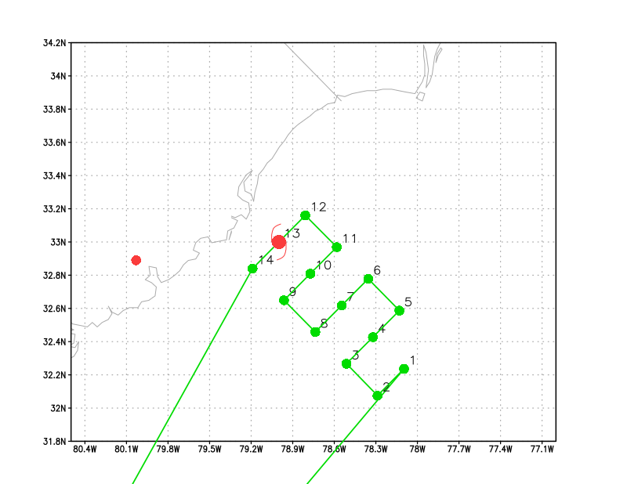
Figure 3. Lawn mower flight pattern for the inflow coyote experiment.

Module/Option 3: Boundary Layer Entrainment/Convective Downdraft module
This module builds upon and complements the existing ‘Boundary Layer Entrainment’ (see HFP 2013, experiment 14 for additional details). No modifications to the existing P-3 patterns are required for this module. Instead, the low flying Coyote UAS will conduct very low (down to 100m) stepped descents in addition to patterns flown by the P-3 manned aircraft (see Figure 4). These very low altitude UAS patterns should allow for (a more direct) estimation of surface fluxes. In turn, the UAS-derived estimates can then be compared with surface fluxes computed by sampling the top of the boundary layer (residual method). In addition, it is also possible to conduct a UAS box pattern at 100-120m to complement the P-3 1-2 km box pattern (not shown) that was designed to estimate divergence in precipitation-free areas.

It should also be noted that an additional goal of this module is to see how vertical mixing occurs above and within the boundary/surface layer just outside areas of active convection (e.g. near rainbands and radially outward of the TC’s primary convective envelope). A goal of this module is to compare observational details from these convectively driven processes with comparable output from high-resolution operational regional and global model simulations.

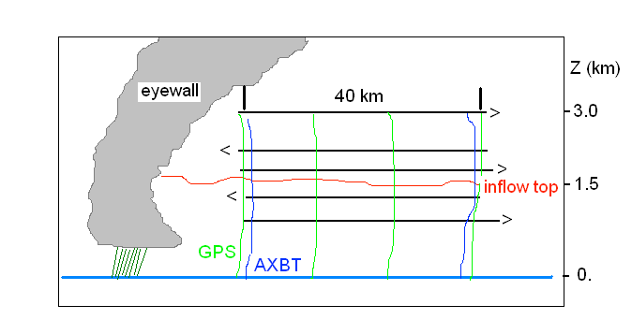
Figure 4. (From HFP Boundary Layer Entrainment Module) Vertical cross-section of the stepped-descent module. P3 pattern is in black, low altitude Coyote UAS in heavy blue.

Module/Option 4: Eddy Dissipation Rate Measurements
For this module, the target storm is a hurricane of any intensity, since low-altitude measurements of eddy dissipation rate and other turbulent quantities are rare in winds of 35 m s⁻¹ and greater. To complete this module, approximately 30 minutes of battery life are required. Therefore, this experiment does not need to be the sole focus of a particular Coyote flight. Instead, the eddy dissipation rate measurements can be made following a Coyote eyewall penetration (Module 1) or at the conclusion of the Boundary Layer Inflow experiment (Module 3) or the Radius of Maximum Wind Mapping experiment (Module 4), both of which terminate with the Coyote near or in the eyewall.
The objective is to collect measurements of eddy dissipation rate in strong wind conditions (35 m s⁻¹ or greater), with a focus on how the dissipation rate changes with altitude in the lower portion of the tropical cyclone boundary layer and in the surface layer. It is therefore preferable for the Coyote to remain at a constant radius from the tropical cyclone center (ideally at the radius of maximum wind) throughout the experiment. This will prevent the height-dependence of eddy dissipation from being confused with any dependence on distance from the tropical cyclone center.
Figure 5 is a schematic of the experimental design. The experiment will begin with the Coyote at a height of 350 m, in the eyewall and/or at the radius of maximum wind. The Coyote then will initiate and maintain a constant descent rate of 1/6 = 0.167 m s⁻¹. This descent rate was chosen because it will allow the Coyote to descend to a height of 50 m at the end of the 30-minute period. At this point, the Coyote may continue to descend at the constant rate, but errors in the GPS vertical position of up to 30 m and waves up to 20 m tall could end the Coyote flight shortly thereafter.
The only requirement of the P-3 flight pattern for this module is that the P-3 remains within 50 km of the Coyote position during the experiment (to prevent loss of communication between the two platforms). This proximity requirement can be satisfied either by the P-3 loitering within the eye (see Module 1a) or by the P-3 completing multiple passes through the eye and eyewall using a rotated figure-four pattern with shortened legs (see Module 1b). The second option may only be feasible in storms with a small radius of maximum wind (15 km or less), since the distance between the P-3 and the Coyote will at times exceed twice the radius of maximum wind when the P-3 samples the opposite side of the storm.

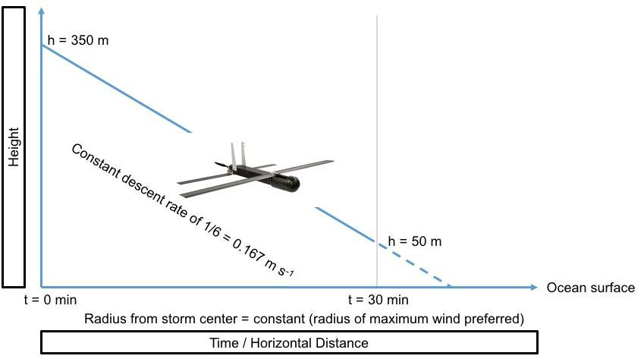

Figure 5. Eddy dissipation measurements. The Coyote begins the experiment at a height of 350 m, descends at a constant rate of 1/6 = 0.167 m s⁻¹, and reaches a height of 50 m after 30 minutes. The entire descent is conducted at a constant radius from the storm center (preferably at the radius of maximum wind).

Analysis Strategy:
The basic analysis follows that presented in recent observational studies of the COYOTE data (Zhang 2010; Zhang et al. 2008; 2011; Zhang and Drennan 2012: Cione et al. 2016). The analysis includes: validation of the wind, temperature and humidity measurements using the dropsonde data; validation of the wind measurements using the Doppler data; computation of turbulent fluxes using the eddy correlation method, estimation of the boundary layer height scales using the coyote data, estimation of vertical eddy diffusivity, and estimation of dissipation rate.
Optimization of Sampling Strategies:
Another goal of this experiment is to investigate how Coyote sampling strategies can be improved based on varying criteria. This will be carried out in an Observing System Simulation Experiment (OSSE) framework, where the “truth” is assumed to be known perfectly via a Nature Run (Nolan et al. 2013). The proposed plan of investigation is as follows:

- Analysis of existing Coyote flight track algorithms within the Nature Run framework: Here, the goal is to generate alternate Coyote flight tracks based on existing techniques and measure their effectiveness in achieving their objectives in a quantitative manner. Effectiveness, in this regard, can be measured by metrics such as percentage of completion of originally planned mission or percentage of flight duration within range of the P-3 for data coverage. By generating many possible flight tracks by varying inputs/assumptions of the flight track algorithm and embedding the resulting tracks within the high-resolution, three-dimensional wind field of the Nature Run, it is possible to accumulate statistics of failure/success and obtain how sensitive they are on the input parameters. Such statistical analysis is expected to inform operational decisions during the field program.

- Improving sampling strategies: An objective method for measuring the effectiveness of sampling strategies is to investigate the impact the data collected by the Coyote flights have on data assimilation and forecasts. This will be carried out by utilizing HRD’s in-house Hurricane Ensemble Data Assimilation System (HEDAS; Aksoy et al. 2013) for data assimilation and the HWRF model for forecasts. In the investigation, two alternative approaches to generating Coyote flight tracks will be tested:

  - Flight tracks described in this document to target data-void regions of the hurricane inner core.
  - Flight tracks that will be constructed to minimize the ensemble-based sensitivity of predetermined forecast metrics (e.g., intensity) and thus maximize the impact of observations collected by the Coyote. Two possible methods here include minimizing ensemble variance and minimizing ensemble sensitivity to observations.

References:
Aksoy, A., S. D. Aberson, T. Vukicevic, K. J. Sellwood, S. Lorsolo, and X. Zhang, 2013: Assimilation of high-resolution tropical cyclone observations with an ensemble Kalman filter using NOAA/AOML/HRD’s HEDAS: Evaluation of the 2008–11 vortex-scale analyses, Mon. Weather Rev., 141, 1842–1865, doi: http://dx.doi.org/10.1175/MWR-D-12-00194.1.
Cione, J. J., P. Black, and S. Houston (2000), Surface observations in the hurricane environment, Mon. Weather Rev., 128, 1550–1561.
Cione, J. J., E.A. Kalina, E.W. Uhlhorn, A.M. Farber, and A.B. Damiano, 2016: Coyote unmanned aircraft system observations in Hurricane Edouard (2014). Earth and Space Science, 3, 370-380, doi:10.1002/2016EA000187.
Nolan, D. S., R. Atlas, K. T. Bhatia, and L. R. Bucci, 2013: Development and validation of a hurricane nature run using the joint OSSE nature run and the WRF model, J. Adv. Model. Earth Syst., 5, 382–405, doi:10.1002/jame.20031.
Zhang, J. A., 2010: Estimation of dissipative heating using low-level in situ aircraft observations in the hurricane boundary layer. J. Atmos. Sci., 67, 1853–1862.
Zhang, J. a., and W. M. Drennan, 2012: An observational study of vertical eddy diffusivity in the hurricane boundary layer. J. Atmos. Sci., 69, 3223-3236.
Zhang, J. A., P. G. Black, J. R. French, and W. M. Drennan, 2008: First direct measurements of enthalpy flux in the hurricane boundary layer: The CBLAST results, 35, L14813, oi:10.1029/2008GL034374.
Zhang, J. A., F. D. Marks, M. T. Montgomery, and S. Lorsolo, 2011: An estimation of turbulent characteristics in the low-level region of intense Hurricanes Allen (1980) and Hugo (1989). Mon. Wea. Rev., 139, 1447–1462.

