**2017 Hurricane Field Program Plan**

**Part III: Appendices**

Table of Contents

**APPENDIX A**…………………………………………………………………………………………. 1

Decision and Notification Process………………………………………………………………. 1

**APPENDIX B: CALIBRATION**………….……….……….………….……….……….……….….. 5

B.1 En-route Calibration of Aircraft Systems…………………………………………………... 5

**APPENDIX C: DOD/NWS RAWIN/RAOB AND NWS COASTAL LAND-BASED RADARS**... 6

**APPENDIX D: PRINCIPAL DUTIES OF THE NOAA SCIENTIFIC PERSONNEL**………….. 8

**APPENDIX E: NOAA RESEARCH OPERATIONAL PROCEDURES AND CHECK LISTS**... 12

E.1 “Conditions-of-Flight” Commands…………………………………………………………. 13

E.2 Lead Project Scientist………………………………………………………………………. 14

E.3 Cloud Physics Scientist……………………………………………………………………... 21

E.4 Boundary Layer Scientist…………………………………………………………………… 23

E.5 Radar Scientist……………………………………………………………………………… 26

E.6 Dropsonde Scientist………………………………………………………………………… 29

**APPENDIX F: SYSTEMS OF MEASURE AND UNIT CONVERSION FACTORS**…………… 32

**APPENDIX G: AIRCRAFT SCIENTIFIC INSTRUMENTATION**……………………………… 33

**APPENDIX H: NOAA EXPENDABLES** ..................................................…………………………. 35

**APPENDIX I: OPERATIONAL MAPS** ……………………………………………………………. 36

Map 1: Primary Atlantic and East Pacific operating bases and operating ranges (P-3)……… 36

Map 2: Primary Atlantic and East Pacific operating bases and operating ranges (G-IV) …… 37

Map 3: Primary East Pacific operating bases and operating ranges (GH) …….......................... 38

**ACRONYMS AND ABBREVIATIONS**……………………………………………………………. 39

**2017**

**Hurricane Field Program Plan**

**Part III**

**Appendix A**

**DECISION AND NOTIFICATION PROCESS**

The decision and notification process is illustrated in Figs. A-1, A-2, and A-3. This process occurs in four steps:

1) A research mission is determined to be probable within 72 h [field program director]. Consultation with the director of HRD, and the AOC Project Manager determines: flight platform availability, crew and equipment status, and the type of mission(s) likely to be requested.

2) The Field Program Advisory Panel [F. Marks (Director, HRD), P. Reasor (Director, Hurricane Field Program), J. Dunion, M. Black, J. Cione, J. Gamache, J. Kaplan, R. Rogers, S. Murillo, J. Zhang and J. McFadden (or AOC designee) meets to discuss possible missions and operational modes. Probable mission determination and approval to proceed is given by the HRD director (or designee).

3) Primary personnel are notified by the Hurricane Field Program Director [P. Reasor].

4) Secondary personnel are notified by their primary affiliate (Table A-2).

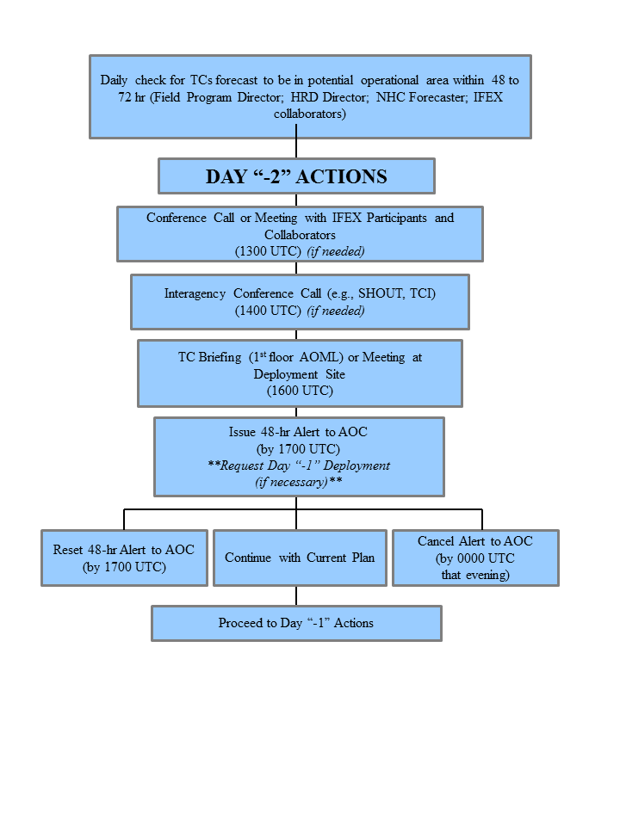

Fig. A-1: Decision and notification process for Day “-2”.

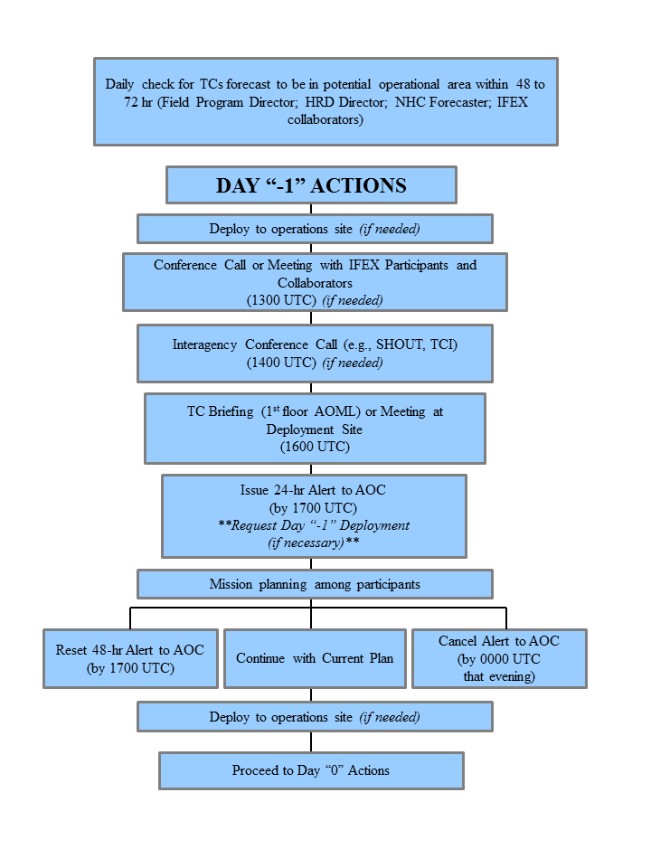

**Note: Time of briefings, conference calls, decisions, and deployments are dictated by timing limitations imposed by the AOC crew.

Fig. A-2: Decision and notification process for Day “-1”

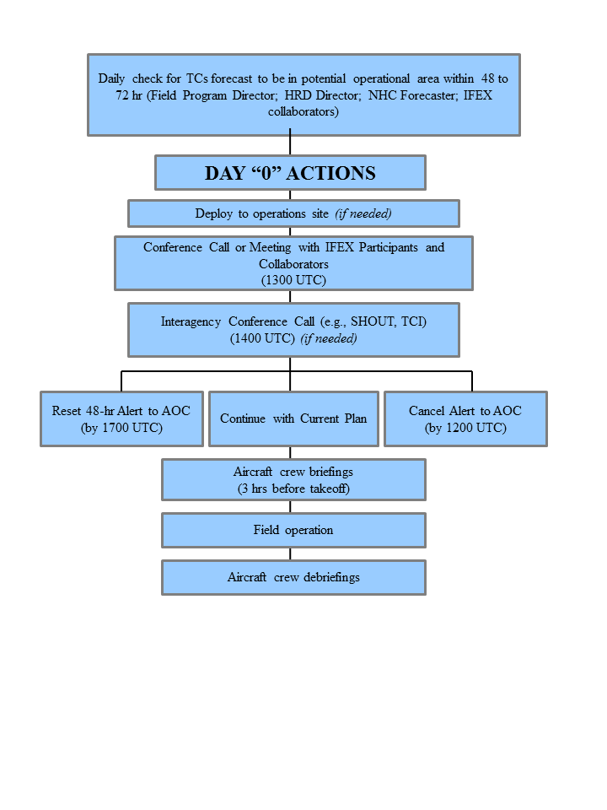

**Note: Time of briefings, conference calls, decisions, and deployments are dictated by timing limitations imposed by the AOC crew.

Fig. A-3: Decision and notification process for Day “0”

**Appendix B:** **Calibration**

**B.1 En-Route Calibration of Aircraft Systems**

Instrument calibrations are checked by flying aircraft intercomparison patterns whenever possible during the hurricane field program or when the need for calibration checks is suggested by a review of the data. In addition, an over flight of a surface pressure reference is advisable en route or while on station when practicable. Finally, all flights enroute to and from the storm are required to execute a true airspeed (TAS) calibration pattern. This pattern is illustrated in Fig. B-1.

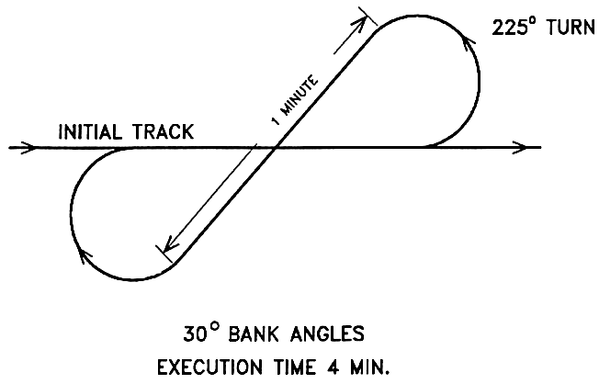

**Fig. B-1 En-Route TAS calibration pattern.**

Appendix C: DOD/NWS RAWIN/RAOB and NWS Coastal Land-based Radar Locations



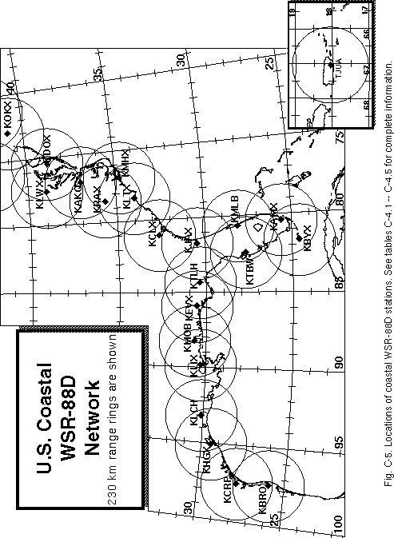

**APPENDIX D: PRINCIPAL DUTIES OF THE NOAA SCIENTIFIC PERSONNEL**

CAUTION

Flight operations are routinely conducted in turbulent conditions. Shock-mounted electronic and experimental racks surround most seat positions. Therefore, ***for safety*** ***onboard the aircraft all personnel should wear a flight suit and closed toed shoes***. For comfort, personnel should bring a jacket or sweater, as the cabin gets cold during flight.

Smoking is prohibited within 50 ft of the aircraft while they are on the ground. No smoking is permitted on the aircraft at any time.

Section 4-401, of the NOAA Safety Rules Manual state that: “Don’t let your attention wander, either through constant conversation, use of cell phone or sightseeing while operating vehicles. Drivers must use caution and common sense under all conditions. Operators and passengers are not permitted to smoke or eat in the government vehicles. Cell phone use is permitted while car is parked.”

GENERAL INFORMATION FOR ALL SCIENTIFIC MISSION PARTICIPANTS

Mission participants are advised to carry the proper personal identification [i.e., travel orders, "shot" records (when appropriate), and passports (when required)]. Passports will be checked by AOC personnel prior to deployment to countries requiring it. All participants must provide their own meals for in-flight consumption. AOC provides a refrigerator, microwave, coffee, utensils, condiments, ice, water, and soft drinks for a nominal fee per flight.

**D.1 Field Program Director/ IFEX Chief Scientist;**

(1) Responsible to the HRD director for the implementation of the Hurricane Field Program Plan.

(2) Only official communication link to AOC. Communicates flight requirements and changes in mission to AOC.

(3) Only formal communication link between AOML and CARCAH during operations. Coordinates scheduling of each day's operations with AOC only after all (POD) reconnaissance requirements are completed between CARCAH and AOC.

(4) Convenes the Hurricane Field Program Operations Advisory Panel. This panel selects missions to be flown.

(5) Provides for pre-mission briefing of flight crews, scientists, and others (as required).

(6) Assigns duties of field project scientific personnel. Ensures safety during the field program.

(7) Coordinates press statements with NOAA/Public Affairs.

**D.2 Assistant Field Program Director**

(1) Assumes the duties of the field program director in their absence.

**D.3 Named Experiment Lead Project Scientist**

(1) Has overall responsibility for the experiment.

(2) Coordinates the project and sub-project requirements.

(3) Determines the primary modes of operation for appropriate instrumentation.

(4) Assists in the selection of the mission.

(5) Provides a written summary of the mission to the field program director (or his designee) at the experiment's debriefing.

**D.4 Lead Project Scientist**

(1) Has overall scientific responsibility for his/her aircraft.

(2) Makes in-flight decisions concerning alterations of: (a) specified flight patterns; (b) instrumentation operation; and (c) assignment of duties to on-board scientific project personnel.

(3) Acts as project supervisor on the aircraft and is the focal point for all interactions of project personnel with operational or visiting personnel.

(4) Conducts preflight and post flight briefings of the entire crew. Completes formal checklists of safety, instrument operations - noting malfunctions, problems, etc.

(5) Provides a written report of each mission day's operations to the field program director at the mission debriefing.

**D.5 Cloud Physics Scientist**

(1) Has overall responsibility for the cloud physics project on the aircraft.

(2) Briefs the on-board lead project scientist on equipment status before takeoff.

(3) Determines the operational mode of the cloud physics sensors (i.e., where, when, and at what rate to sample).

(4) Operates and monitors the cloud physics sensors and data systems.

(5) Provides a written preflight and post flight status report and flight summary of each mission day's operations to the on-board lead project scientist at the post flight debriefing.

**D.6 Boundary-Layer Scientist**

(1) Insures that the required number of AXCPs, AXBTs, and AXCTDs are on the aircraft for each mission.

(2) Operates the AXCP, AXBT, and AXCTD equipment (as required) on the aircraft.

(3) Briefs the on-board lead project scientist on equipment status before takeoff.

(4) Determines where and when to release the AXCPs, AXBTs, and AXCTDs (as appropriate) subject to clearance by flight crew.

(5) Performs preflight, inflight, and post flight checks and calibrations.

(6) Provides a written preflight and post flight status report and a flight summary of each mission day's operations to the on-board lead project scientist at the post flight debriefing.

**D.7 Radar Scientist**

(1) Determines optimum meteorological target displays. Continuously monitors displays for performance and optimum mode of operations. Thoroughly documents modes and characteristics of the operations.

(2) Provides a summary of the radar display characteristics to the on-board lead project scientist at the post flight debriefing.

(3) Maintains tape logs.

(4) During the ferry to the storm, the radar scientist should record a tape of the sea return on either side of the aircraft at elevation angles varying from -20° through +20°. This tape will allow correction of any antenna mounting biases or elevation angle corrections.

**D.8 Dropsonde Scientist**

(1) Processes dropsondes observations on HRD workstation for accuracy.

(2) Provides TEMP drop message for ASDL, transmission or insures correct code in case of automatic data transmission.

**D.9 Workstation Scientist**

(1) Operates HRD's workstation.

(2) Runs programs that determine wind center and radar center as a function of time, composite flight-level and radar reflectivity relative to storm center and then process and code dropwindsonde observations.

(3) Checks data for accuracy and sends appropriate data to ASDL computer.

(4) Maintains records of the performance of the workstation and possible software improvements.

**APPENDIX E: NOAA RESEARCH OPERATIONAL PROCEDURES AND CHECK LISTS**

Hurricane Field Program Deployment Safety Checklist

The Field Program Director is responsible for making sure safety is enforced and ensuring necessary materials are in place and/or any actions have been completed before the start of the HFP. Field program participants are responsible for reviewing this checklist.

Scientist_______________________________ Date ______________

**Before leaving AOML**

_____ 1. Contact the HRD Field Program Director personnel to notify departure time.

_____ 2. Things to take

1. Flight bag (s)
2. Cell phone
3. List of HFP important numbers
4. HRD Field program plan
5. Flight suit

**Ground transportation**

_____ 1. Arrange for ground transportation

_____ 2. Visual inspection of government vehicle

1. Make sure tires do not appear to be flat
2. Check for any cracked/broken lights, windshield and mirrors
3. Check for any major dents around the vehicle

_____ 3. Inspection inside the government vehicle

1. Check all lights work properly (head and tail lights, dome lights, dashboard and turn signal lights)
2. Make sure the engine, oil, or temperature indicator light does not flash. *If so, contact facilities management.*

c. **Note** the gas and mileage

_____ 4. Contents inside the government vehicle

1. Make sure there is first aid kit and fire extinguisher
2. Proper jack and lug wrench
3. Spare tire
4. Basic auto repair kit (i.e. road hazard reflector or flares)
5. *Consider carrying a flashlight*

_____ 5. If possible, return vehicle with full tank (regular unleaded gasoline)

_____ 6. Contact the HRD Field Program Director personnel upon returning

**E.1 "Conditions-of-Flight" Commands**

Mission participants should be aware of the designated "conditions-of-flight." There are five designated basic conditions of readiness encountered during flight. The pilot will set a specific condition and announce it to all personnel over the aircraft's PA (public address) and ICS (interphone communications systems). All personnel are expected to act in accordance with the instructions for the specific condition announced by the pilot. These conditions and appropriate actions are shown below.

**CONDITION 1**: TURBULENCE/PENETRATION. All personnel will stow loose equipment and fasten safety belts.

**CONDITION 2**: HIGH ALTITUDE TRANSIT/FERRY. There are no cabin stations manning requirements.

**CONDITION 3**: NORMAL MISSION OPERATIONS. All scientific and flight crew stations are to be manned with equipment checked and operating as dictated by mission requirements. Personnel are free to leave their ditching stations.

**CONDITION 4**: AIRCRAFT INSPECTION. After take-off, crew members will perform wings, engines, electronic bays, lower compartments, and aircraft systems check. All other personnel will remain seated with safety belts fastened and headsets on.

**CONDITION 5**: TAKE-OFF/LANDING. All personnel will stow or secure loose equipment, don headsets, and fasten safety belts/shoulder harnesses.

**E.2 Lead Project Scientist**

**E.2.1 Preflight**

_____ 1. Participate in general mission briefing.

_____ 2. Determine specific mission and flight requirements for assigned aircraft.

_____ 3. Determine from field program director whether aircraft has operational fix responsibility and discuss with AOC flight director/meteorologist unless briefed otherwise by field program director.

_____ 4. Contact HRD members of crew to:

1. Assure availability for mission.
2. Review field program safety checklist

c. Arrange ground transportation schedule when deployed.

d. Determine equipment status.

_____ 5. Meet with AOC flight director and navigator at least 3 hours before take-off for initial briefing.

_____ 5. Meet with AOC flight crew at least 2 hours before take-off for crew briefing. Provide copies of flight requirements and provide a formal briefing for the flight director, navigator, and pilots.

_____ 6. Report status of aircraft, systems, necessary on-board supplies and crews to appropriate HRD Field Program Director.

_____ 7. Before take-off, brief the on-board GPS dropsonde operator on times and positions of drop times.

_____ 7. Make sure each HRD flight crew members have life vests

_____ 7. Perform a headset operation check with all HRD flight crew members. Make sure everyone can hear and speak using the headset.

_____ 8. Collect “mess” fee (generally ~$2.00) from all on-board HRD flight crew members as needed.

**E.2.2 In-Flight**

_____ 1. Confirm from AOC flight director that satellite data link is operative (information).

_____ 2. Confirm camera mode of operation.

_____ 3. Confirm data recording rate.

_____ 4. Complete Lead Project Scientist Form.

_____ 5. Check in with the flight director to make sure the mission is going as planned (i.e. turns are made when they are supposed to be made).

**E.2.3 Post flight**

_____ 1. Debrief scientific crew.

_____ 2. Report landing time, aircraft, crew, and mission status along with supplies (tapes, *etc.*) remaining aboard the aircraft to the HRD Field Program Director.

_____ 3. Gather completed forms for mission and turn in at the appropriate operations center. [**Note**: all data removed from the aircraft by HRD personnel should be cleared with the AOC flight director.]

_____ 4. Obtain a copy of the 10-s flight listing from the AOC flight director. Turn in with completed forms.

_____ 5. Obtain a copy of the radar DAT tapes and if possible a copy of the radar data-packet files should be copied onto a flash drive. Turn in with completed forms.

_____ 6. Obtain a copy of the all VHS videos form aircraft cameras (3-4 approx.). Turn in with completed forms.

_____ 7. Obtain a copy of CD with all flight data. Turn in with completed forms.

_____ 8. Determine next mission status, if any, and brief crews as necessary.

_____ 9. Notify HRD Field Program Director as to where you can be contacted and arrange for any further coordination required.

_____ 10. Prepare written mission summary using **Mission Summary** form (due to Field Program Director 1 week after the flight).

**Form E-2**

Page 1 of 5

**Lead Project Scientist Check List**

**Date _______________ Aircraft ______________ Flight ID ____________________**

**A. —Participants:**

|  |  |  |  |  |
| --- | --- | --- | --- | --- |
| **HRD** | |  | **AOC** | |
| **Function** | **Participant** |  | **Function** | **Participant** |
| Lead Project Scientist |  |  | Flight Director |  |
| Radar |  |  | Pilots |  |
| Workstation |  |  | Navigator |  |
| Cloud Physics |  |  | Systems Engineer |  |
| Photographer/Observer/Guests |  |  | Data Technician |  |
| Dropwindsonde |  |  | Electronics Technician |  |
| AXBT/AXCP |  |  | Other |  |

**B. Take-off and Landing Locations:**

Take-Off: ________ Location: _______________

Landing: ________ Location: _________________

Number of Eye Penetrations: ______

**C. Past and Forecast Storm Locations:**

|  |  |  |  |  |
| --- | --- | --- | --- | --- |
| **Date/Time** | **Latitude** | **Longitude** | **MSLP** | **Maximum Wind** |
|  |  |  |  |  |
|  |  |  |  |  |
|  |  |  |  |  |
|  |  |  |  |  |
|  |  |  |  |  |

**D. Mission Briefing:**

**Form E-2**

Page 2 of 5

**E. Equipment Status** (Up ****, Down ****, Not Available **—**, Not Used **O**)

|  |  |  |  |  |
| --- | --- | --- | --- | --- |
| **Equipment** | **Pre-Flight** | **In-Flight** | **Post-Flight** | # DATs / Cds  **/Expendables/Printouts** |
| Radar/LF |  |  |  |  |
| Doppler Radar/TA |  |  |  |  |
| Cloud Physics |  |  |  |  |
| Data System |  |  |  |  |
| GPS sondes |  |  |  |  |
| AXBT/AXCP |  |  |  |  |
| Ozone instrument |  |  |  |  |
| Workstation |  |  |  |  |
| Videography |  |  |  |  |

**REMARKS:**

**Form E-2**

Page 3 of 5

**Mission Summary**

**Storm name**

YYMMDDA# Aircraft 4 _RF

Scientific Crew (4 RF)

Lead Project Scientist

Radar Scientist

Cloud Physics Scientist

Dropwindsonde Scientist

Boundary-Layer Scientist

Workstation Scientist

Observers

*Mission Briefing: (include sketch of proposed flight track or page #)*

*Mission Synopsis: (include plot of actual flight track)*

*Evaluation: (did the experiment meet the proposed objectives?)*

*Problems:(list all problems)*

*Expendables used in mission:*

GPS sondes : ________________

AXBTs :__________________

Sonobuoys: _________________

**Form E-2**

Page 5 of 5

**Lead Project Scientist Event Log**

**Date ________________ Flight ________________ LPS _____________________**

|  |  |  |  |
| --- | --- | --- | --- |
| **Time** | **Event** | **Position** | **Comments** |
|  |  |  |  |
|  |  |  |  |
|  |  |  |  |
|  |  |  |  |
|  |  |  |  |
|  |  |  |  |
|  |  |  |  |
|  |  |  |  |
|  |  |  |  |
|  |  |  |  |
|  |  |  |  |
|  |  |  |  |
|  |  |  |  |
|  |  |  |  |
|  |  |  |  |
|  |  |  |  |
|  |  |  |  |
|  |  |  |  |
|  |  |  |  |
|  |  |  |  |
|  |  |  |  |
|  |  |  |  |
|  |  |  |  |
|  |  |  |  |
|  |  |  |  |
|  |  |  |  |
|  |  |  |  |

**E.3 Cloud Physics Scientist**

The on-board cloud physics scientist (CPS) is responsible for cloud physics data collection on his/her assigned aircraft. Detailed operational procedures are contained in the cloud physics kit supplied for each aircraft. General procedures follow. (Check off and initial.)

**E.3.1 Preflight**

_____ 1. Determine status of cloud physics instrumentation systems and report to the on-board lead project scientist (LPS).

_____ 2. Confirm mission and pattern selection from the on-board LPS.

_____ 3. Select mode of instrument operation.

_____ 4. Complete appropriate instrumentation preflight check lists as supplied in the cloud physics operator's manual.

**E.3.2 In-Flight**

_____ 1. Operate instruments as specified in the cloud physics operator's manual and as directed by the on-board LPS.

**E.3.3 Post flight**

_____ 1. Complete summary checklist forms and all other appropriate forms.

_____ 2. Brief the LPS on equipment status and turn in completed check sheets to the LPS.

_____ 3. Take cloud physics data tapes and other data forms and turn these data sets in as follows:

a. Outside of Miami-to the LPS.

b. In Miami-to AOML/HRD. [**Note**: all data removed from the aircraft by HRD personnel should be cleared with the AOC flight director.]

_____ 4. Debrief as necessary at HRD Field Program Director or the hotel during a deployment.

_____ 5. Determine the status of future missions and notify HRD Field Program Director as to where you can be contacted.

**Form E-3**

Page 1 of 2

**Cloud Physics Scientist Check List**

**Date ___________________ Aircraft ____________ Flight ID __________________**

**A. —Instrument Status and Performance:**

|  |  |  |  |
| --- | --- | --- | --- |
| **System** | **Pre-Flight** | **In-Flight** | **Downtime** |
| DMT CCP |  |  |  |
| DMT PIP |  |  |  |
| SEA LWC |  |  |  |
| King Probe |  |  |  |
| DRI Field Mills |  |  |  |
| King Probe |  |  |  |
| DMT PADS data system |  |  |  |

**B. —Remarks:**

**E.4 Boundary-Layer Scientist**

The on-board boundary-layer scientist (BLS) is responsible for data collection from AXBTs, AXCPs, AXCTDs, Buoys, and SST radiometers (if these systems are used on the mission). Detailed calibration and instrument operation procedures are contained in the air-sea interaction (ASI) manual supplied to each operator. General supplementary procedures follow. (Check off and initial.)

**E.4.1 Preflight**

_____ 1. Determine the status of equipment and report results to the on-board lead project scientist (LPS).

_____ 2. Confirm mission and pattern selection from the LPS.

_____ 3. Select the mode of operation for instruments after consultation with the HRD/BLS and the LPS.

_____ 4. Complete appropriate preflight check lists as specified in the ASI manual and as directed from the LPS.

**E.4.2 In-Flight**

_____ 1. Operate the instruments as specified in the ASI manual and as directed by the on-board LPS.

**E.4.3 Post flight**

_____ 1. Complete summary checklist forms and all other appropriate forms.

_____ 2. Brief the on-board LPS on equipment status and turn in completed checklists to the LPS.

_____ 3. Debrief as necessary at HRD Field Program Director or the hotel during a deployment.

_____ 4. Determine the status of future missions and notify HRD Field Program Director as to where you can be contacted.

**Form E-4**

Page 1 of 2

**AXBT and Sonobuoy Check Sheet Summary**

**Flight _________________ Aircraft _____________ Operator _________________**

Number

(1) Probes dropped _______

(2) Failures _______

(3) Failures with no signal _______

(4) Failures with sea surface temperature, but terminated above thermocline _______

(5) Probes that terminated above 250 m, but below thermocline _______

(6) Probes used by channel number CH12 _______

CH14 _______

CH16 _______

CH__ _______

**NOTES:**

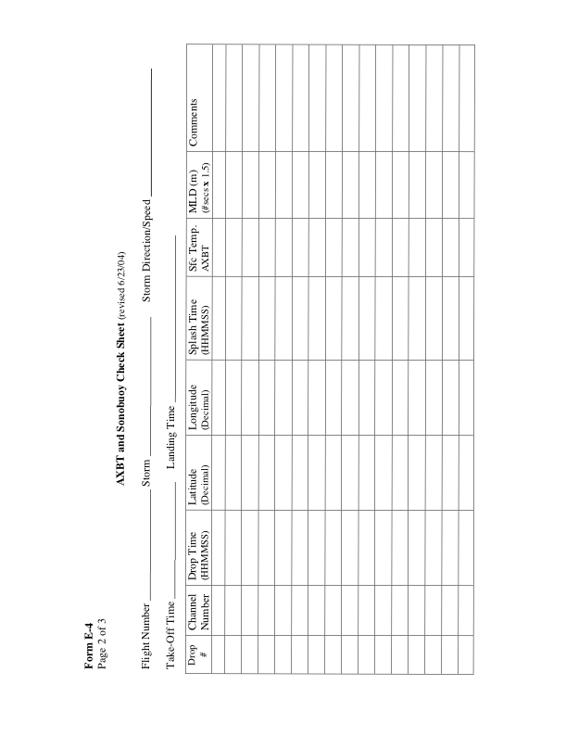 **E.5 Radar Scientist**

The on-board radar scientist is responsible for data collection from all radar systems on his/her assigned aircraft. Detailed operational procedures and checklists are contained in the operator's manual supplied to each operator. General supplementary procedures follow. (Check off and initial.)

**E.5.1 Preflight**

_____ 1. Determine the status of equipment and report results to the lead project scientist (LPS).

_____ 2. Confirm mission and pattern selection from the LPS.

_____ 3. Select the operational mode for radar system(s) after consultation with the LPS.

_____ 4. Complete the appropriate preflight calibrations and check lists as specified in the radar operator's manual.

**E.5.2 In-Flight**

_____ 1. Operate the system(s) as specified in the operator's manual and as directed by the LPS or as required for aircraft safety as determined by the AOC flight director or aircraft commander.

_____ 2. Maintain a written commentary in the radar logbook of tape and event times, such as the start and end times of F/AST legs. Also document any equipment problems or changes in R/T, INE, or signal status.

**E.5.3 Post flight**

_____ 1. Complete the summary checklists and all other appropriate check lists and forms.

_____ 2. Brief the LPS on equipment status and turn in completed forms to the LPS.

_____ 3. Hand-carry all radar tapes and arrange delivery as follows:

a. Outside of Miami-to the LPS.

b. In Miami-to AOML/HRD. [**Note**: all data removed from the aircraft by HRD personnel should be cleared with the AOC flight director.]

_____ 4. Debrief at AOML/HRD or the hotel during a deployment.

_____ 5. Determine the status of future missions and notify HRD Field Program Director as to where you can be contacted.

**Form E-5**

Page 1 of 2

**HRD Radar Scientist Check List**

Flight ID:

Aircraft Number:

Radar Operators:

Radar Technician:

Number of digital magnetic tapes on board:

Component Systems Status:

MARS __________________________ Computer ____________________________

DAT1___________________________ DAT2 _______________________________

LF _____________________________ R/T Serial # ___________________________

TA _____________________________ R/T Serial # ___________________________

Time correction between radar time and digital time:

**Radar Post flight Summary**

Number of digital tapes used: DAT1 _______________________

DAT2 _______________________

Significant down time:

DAT1 ______________________ Radar LF ____________________

DAT2 ______________________ Radar TA ____________________

**Other Problems:**

**Form E-5**

Page 2 of 2

HRD Radar Tape Log

**Flight ______________ Aircraft _______ Operator _______________** Sheet **____** of **____**

LF RPM _______________ TA RPM ______________

(Include start and end times of DATs, as well as times of F/AST legs and any changes of radar equipment status)

|  |  |  |  |
| --- | --- | --- | --- |
| **Tape #** | **F/AST**  **On?** | **Event Time**  **(HHMMSS)** | **Event** |
|  |  |  |  |
|  |  |  |  |
|  |  |  |  |
|  |  |  |  |
|  |  |  |  |
|  |  |  |  |
|  |  |  |  |
|  |  |  |  |
|  |  |  |  |
|  |  |  |  |
|  |  |  |  |
|  |  |  |  |
|  |  |  |  |
|  |  |  |  |
|  |  |  |  |
|  |  |  |  |
|  |  |  |  |
|  |  |  |  |
|  |  |  |  |
|  |  |  |  |
|  |  |  |  |
|  |  |  |  |

**Item List**: DAT1, DAT2, COMP, MARS, LF, and TA.

Include serial numbers of any new R/Ts.

**E.6 Dropsonde Scientist**

The lead project scientist (LPS) on each aircraft is responsible for determining the distribution patterns for dropwindsonde releases. Predetermined desired data collection patterns are illustrated on the flight patterns. However, these patterns often are required to be altered because of clearance problems, etc. Operational procedures are contained in the operator's manual. The following list contains more general supplementary procedures to be followed. (Check off and initial.)

**E.6.1 Preflight**

_____ 1. Determine the status of the AVAPS and HAPS. Report results to the LPS.

_____ 2. Confirm the mission and pattern selection from the LPS and assure that enough dropsondes are on board the aircraft.

_____ 3. Modify the flight pattern or drop locations if requested by AOC to accommodate changes in storm location or closeness to land.

_____ 4. Complete the appropriate preflight set-up and checklists.

**E.6.2 In-Flight**

_____ 1. Operate the system as specified in the operator's manual.

_____ 2. Ensure the AOC flight director is aware of upcoming drops.

_____ 3. Ensure the AVAPS operator has determined that the dropsonde is (or is not) transmitting a good signal. Recommend if a backup dropsonde should be launched in case of failure.

_____ 4. Report the transmission of each drop and fill in the Dropwindsonde Scientist Log.

**E.6.3 Post flight**

_____ 1. Complete Dropwindsonde Scientist Log.

_____ 2. Brief the LPS on equipment status and turn in reports and completed forms.

_____ 3. Hand-carry all dropwindsonde data tapes or CDs as follows:

a. Outside of Miami-to the LPS or PI.

b. In Miami-to AOML/HRD. [**Note**: all data removed from the aircraft by HRD personnel should be cleared with the AOC flight director.]

_____ 4. Debrief at the AOML/HRD or the hotel during a deployment.

_____ 5. Determine the status of future missions and notify HRD Field Program Director as to where you can be contacted.

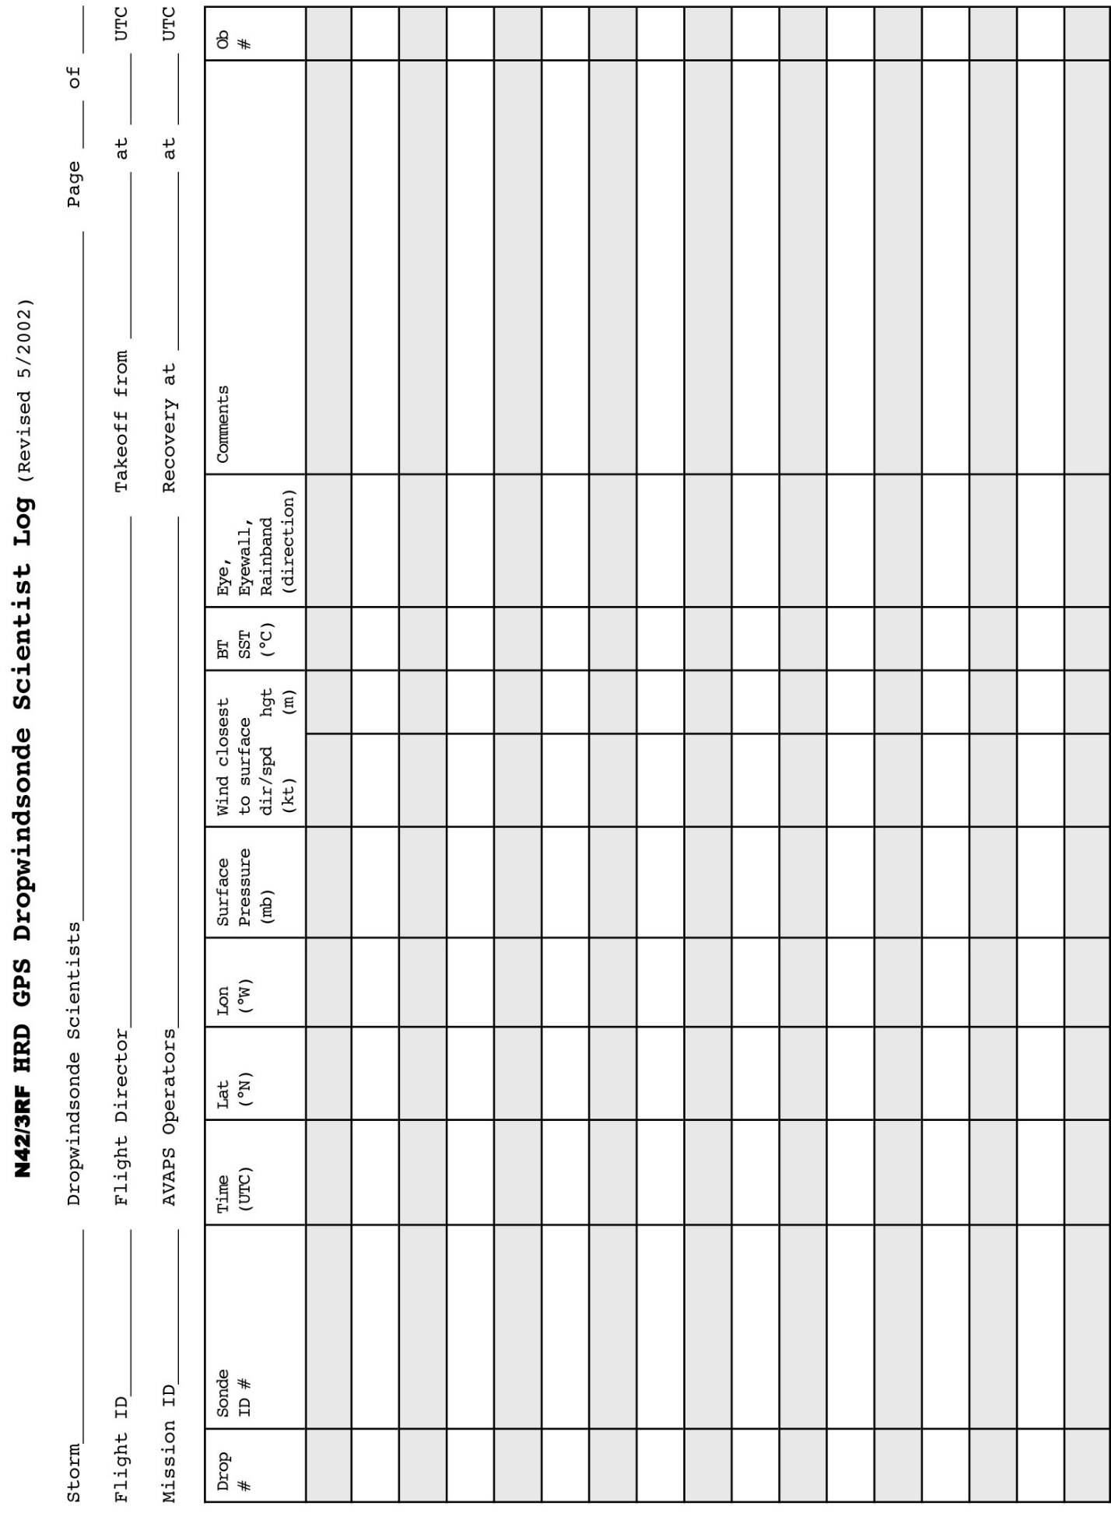

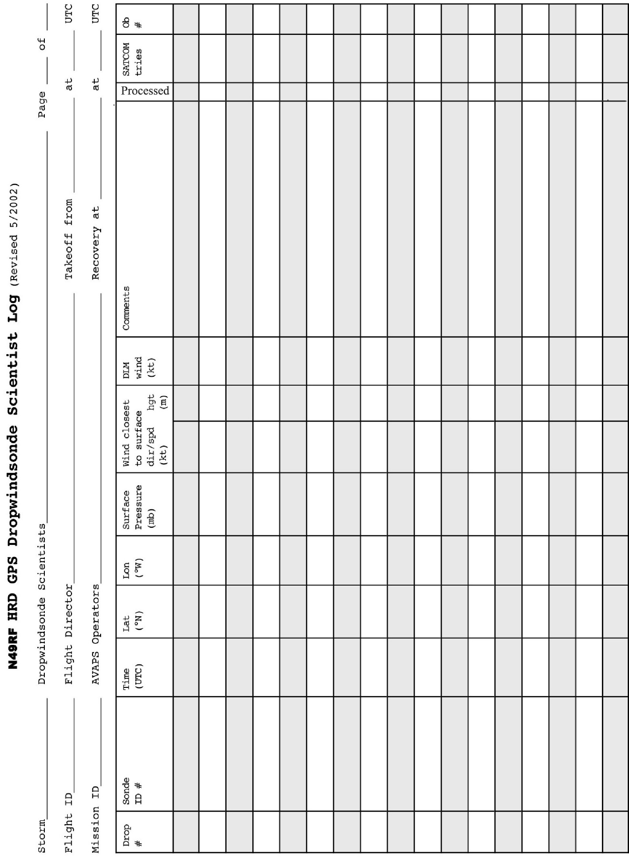

**APPENDIX F: SYSTEMS OF MEASURE AND UNIT CONVERSION FACTORS**

Table F-1 Systems of measure: Units, symbols, and definitions

|  |  |  |  |  |
| --- | --- | --- | --- | --- |
| **Quantity** | **SI Unit** | **Early Metric** | **Maritime** | **English** |
| *length* | meter (m) | centimeter (cm) | foot (ft) | foot (ft) |
| *distance* | meter (m) | kilometer (km) | nautical  mile (nm) | mile (mi) |
| *depth* | meter (m) | meter (m) | fathom (fa) | foot (ft) |
| *mass* | kilogram (kg) | gram (g) |  |  |
| *time* | second (s) | second (s) | second (s) | second (s) |
| *speed* | meter per second (mps) | centimeter per second (cm s-1) | knot (kt) (nm h-1) | miles per hour (mph) |
|  |  | kilometers per hour (km h-1) |  |  |
| *temperature*  *-­sensible* | degree Celsius (°C) | degree Celsius (°C) | --- | degree Fahrenheit (°F) |
| *-­potential* | Kelvin (K) | Kelvin (K) | --- | Kelvin (K) |
| *force* | Newton (N)  (kg m s-2) | dyne (dy)  (g cm s-2) | poundal (pl) | poundal (pl) |
| *pressure* | Pascal (Pa)  (N m-2) | millibar (mb)  (103 dy cm-2) | inches (in)  mercury (Hg) | inches (in)  mercury (Hg) |

Table F-2. Unit conversion factors

|  |  |  |
| --- | --- | --- |
| **Parameter** | **Unit** | **Conversions** |
| *length* | 1 in  1 ft  1 m | 2.540 cm  30.480 cm  3.281 ft |
| *distance* | 1 nm (nautical mile) | 1.151 mi  1.852 km  6080 ft |
|  | 1 mi (statute mile) | 1.609 km  5280 ft |
|  | 1° latitude | 59.996 nm  69.055 mi  111.136 km |
| *depth* | 1 fa | 6 ft  1.829 m |
| *mass* | 1 kg | 2.2 lb |
| *force* | 1 N | 105 dy |
| *pressure* | 1 mb | 102 Pa  0.0295 in Hg |
|  | 1 lb ft-2 | 4.88 kg m-2 |
| *speed* | 1 m s-1 | 1.94 kt  3.59 kph |
|  | 1° lat. 6 h-1 | 10 kt |

**APPENDIX G: AIRCRAFT SCIENTIFIC INSTRUMENTATION**



Table G.2: NOAA/AOC WP-3D (N42RF) instrumentation

**APPENDIX G: AIRCRAFT SCIENTIFIC INSTRUMENTATION (CONT’D)**



Table G.3 (Cont’d): NOAA/AOC G-IV (N49RF) instrumentation

**APPENDIX H: NOAA EXPENDABLE AND MEDIA**

|  |  |  |  |  |
| --- | --- | --- | --- | --- |
| **Experiment** | **GPS Dropwindsondes** | | **AXBTs** | **CADs** |
|  | *G-IV* | *P-3* | *P-3* | *P-3* |
| **P-3 3D Doppler Winds** | - | 20 | - | - |
| **G-IV Tail Doppler Radar** | 20 | - | - | - |
| **DWL** | - | 20 | - | - |
| **SUAVE** | - | 13 | 6 | 6 |
| **Ocean Winds** | - | 5 | - | - |
| **SFMR Hi-Incidence Ang** | - | 1 | 1 | 1 |
| **Offshore Wind** | - | 10 | - | - |
| **East Wave Genesis** | 25 | 15 | - | - |
| **Glider** | - | 10 | - | - |
| **AIPEX** | 24 | 28 | 20 | 20 |
| **TC in Shear** | 18 | 38 | - | - |
| **TC Diurnal Cycle** | 31 | 25 | - | - |
| **TC-Ocean Interaction** | - | 20 | 15 | 15 |
| **TC Landfall** | - | 20 | 5 | 5 |
| **SFMR-CYGNSS** | - | 20 | - | - |
| **Convective Burst** | - | 15 | - | - |
| **Eye-eyewall mixing** | - | - | - | - |
| **SEF/ERC** | 25 | 35 | 10 | 10 |
| **G-IV SFMR** | - | 3 | - | - |
| **ET** | 20 | 10 | 10 | 10 |
| **Arc Cloud** | - | 10 | - | - |

Table H-1: Estimates of maximum number of expendables needed for 2017 standalone experiments and modules for a single mission of the P-3 and the G-IV. Many of these experiments/modules will be combined with other experiments/modules; when this is the case the actual number of expendables used will be lower than a simple addition would suggest. For media, most data are now recorded on USB sticks.

**APPENDIX I: OPERATIONAL MAPS**

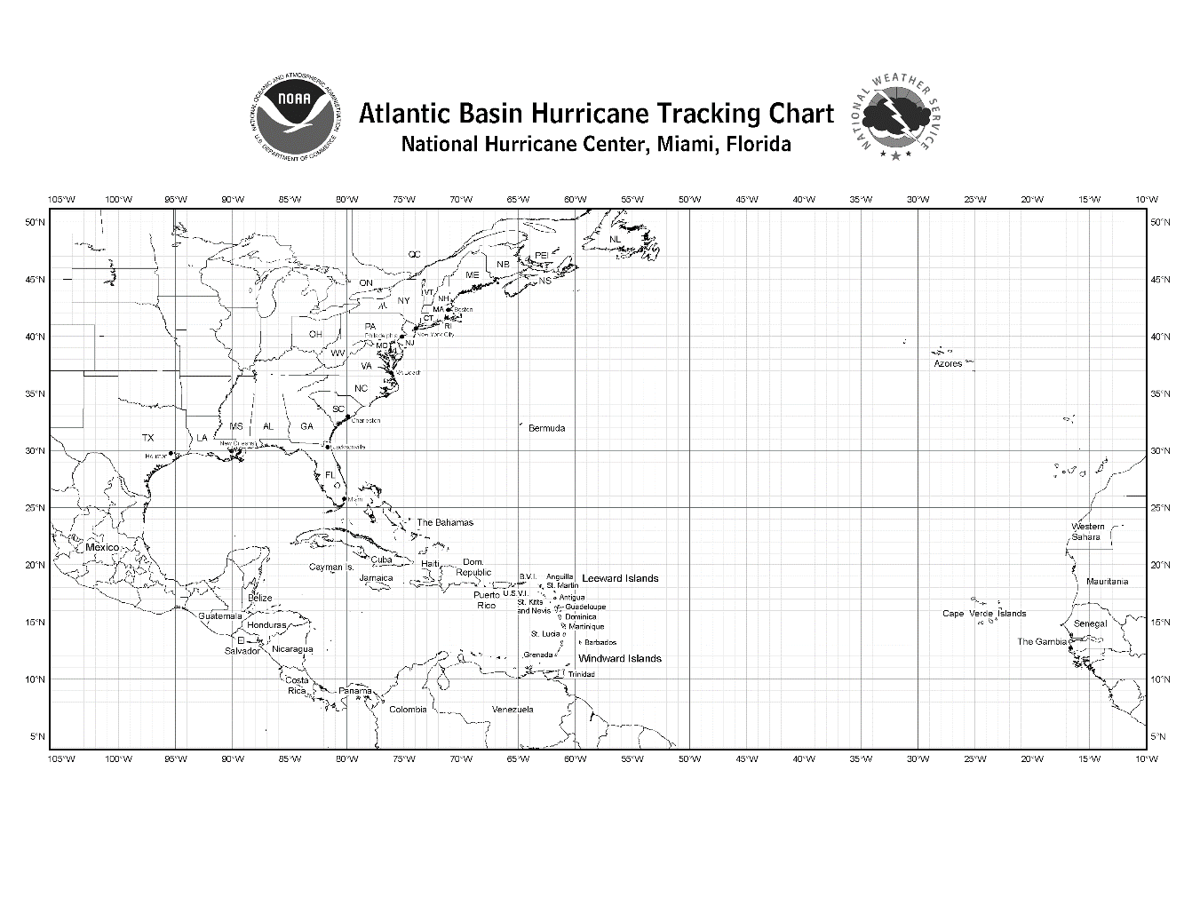

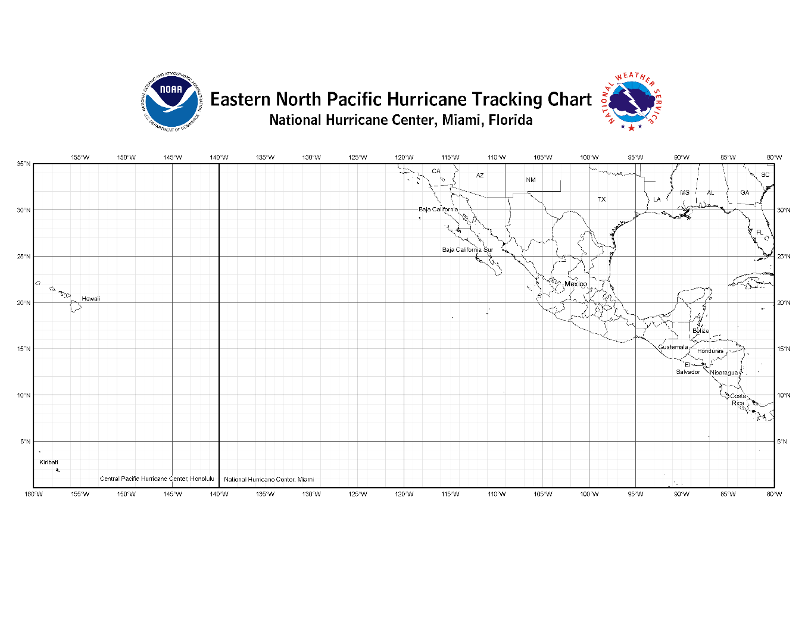

Bermuda

Lakeland

St. Croix

Barbados

Harlingen

La Paz

Map 1. Primary Atlantic and East Pacific operating bases and ranges (assuming ~2-h on-station time) for P-3.





Lakeland

Bermuda

St. Croix

Barbados

Harlingen

La Paz

Map 2. Primary Atlantic and East Pacific operating bases and ranges (assuming ~2-h on-station time) for G-IV.

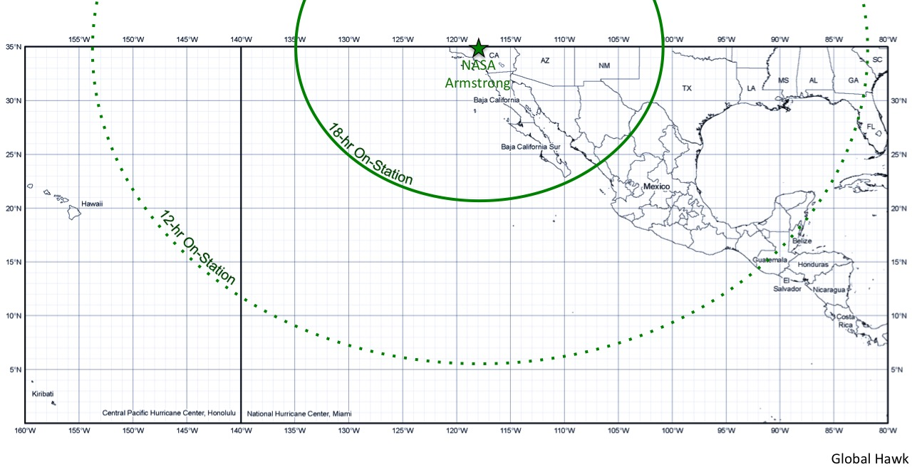

Map 3. Primary East Pacific operating base and ranges for Global Hawk.

**ACRONYMS AND ABBREVIATIONS**

e equivalent potential temperature

ABL atmospheric boundary-layer

A/C aircraft

ACLAIM Airborne Coherent Lidar for Advanced In-flight Measurements

AES Atmospheric Environment Service (Canada)

AFRES U. S. Air Force Reserve

AOC Aircraft Operations Center

AOML Atlantic Oceanographic and Meteorological Laboratory

ASDL aircraft-satellite data link

AXBT airborne expendable bathythermograph

AXCP airborne expendable current probe

AXCTD airborne expendable conductivity, temperature, and depth probe

CARCAH Chief, Aerial Reconnaissance Coordinator, All Hurricanes

CDO central dense overcast

CIRA Cooperative Institute for Research in the Atmosphere

C-MAN Coastal-Marine Automated Network

CP coordination point

CW cross wind

DLM deep-layer mean

DOD Department of Defense

DOW Doppler on Wheels

DRI Desert Research Institute (at Reno)

E vector electric field

EPAC Eastern Pacific

ETL Environmental Technology Laboratory

EVTD extended velocity track display

FAA Federal Aviation Administration

F/AST fore and aft scanning technique

FEMA Federal Emergency Management Agency

FL flight level

FP final point

FSSP forward scattering spectrometer probe

GFDL Geophysical Fluid Dynamics Laboratory

G-IV Gulfstream IV-SP aircraft

GOMWE Gulf of Mexico Warm Eddy

GPS global positioning system

HL Hurricanes at Landfall

HRD Hurricane Research Division

INE inertial navigation equipment

IP initial point (or initial position

IWRS Improved Weather Reconnaissance System

JW Johnson-Williams

Ku-SCAT Ku-band scatterometer

LF lower fuselage (radar)

LIP Lightning Instrument Package

LPS Lead Project Scientist

MCS mesoscale convective systems

MLD Mixed Layer Depth

MPO Meteorology and Physical Oceanography

NASA National Aeronautics and Space Administration

NCAR National Center for Atmospheric Research

NCEP National Centers for Environmental Prediction

NDBC NOAA Data Buoy Center

NESDIS National Environmental Satellite, Data and Information Service

NHC National Hurricane Center

NOAA National Oceanic and Atmospheric Administration

NWS National Weather Service

OML oceanic mixed-layer

PDD pseudo-dual Doppler

PMS Particle Measuring Systems

POD Plan of the Day

PPI plan position indicator

PV potential vorticity

RA radar altitude

RAOB radiosonde (upper-air observation)

RAWIN rawinsonde (upper-air observation)

RECCO reconnaissance observation

RHI range height indicator

RSMAS Rosenstiel School of Marine and Atmospheric Science

SFMR Stepped-Frequency Microwave Radiometer

SLOSH sea, lake, and overland surge from hurricanes (operational storm surge model)

SRA Scanning Radar Altimeter

SST sea-surface temperature

TA tail (radar)

TAS true airspeed

TC tropical cyclone

TOPEX The Ocean Topography Experiment

UMASS University of Massachusetts (at Amherst)

USACE United States Army Corps of Engineers

USAF United States Air Force

USWRP U. S. Weather Research Program

UTC universal coordinated time (U.S. usage; same as “GMT” and "Zulu" time)

VTD velocity-track display

**Acknowledgments**

The preparation of HRD's 2017 **Hurricane Field Program Plan** was a team effort. The authors would like to express their appreciation to: the HRD scientists that contributed information on specific experiments.