20. Arc Cloud Module

Principal Investigator: Jason Dunion

Mission Description: Sample the 3-dimensional wind, thermodynamics, and precipitation patterns of arc cloud features emanating from TCs.

P-3 Module 1
What to Target: Large arc cloud features (100s of km in length) emanating from the periphery of TCs.
When to Target: There are optimal times of day when large arc clouds occur and therefore preferred times of day for conducting this module. Arc clouds are linked to the position of radially propagating TC diurnal pulses that pass through areas of dry mid-level air (≤45 mm TPW) and therefore will tend to occur from ~0400-1200 LST in the approximate radial operating area of the P-3 (Fig. 1).

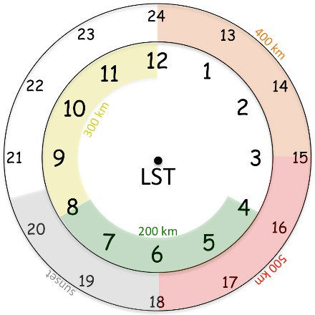
Fig. 1. Conceptual 24-hr TC diurnal cycle clock that estimates the radial location of TC diurnal pulses propagating away from storm.

Pattern: [Break-Away Pattern] Arc cloud transect.
Flight altitude: 10-12 kft or as high as possible to provide better vertical sampling of arc clouds by GPS dropsondes that are deployed.
Leg length or radii: Variable depending on the location of the arc cloud, but a transect through the arc cloud should be made that spans from the convective area where the arc cloud originated to at least 20 km beyond the leading edge of the arc cloud.
Estimated in-pattern flight duration: ~30-60 min added to the mission
Expendable distribution: GPS dropsonde spacing should be ~10 nm (20 km) [reduced to ~5 nm (10 km) spacing closer (≤10 nm (20 km)) to the arc cloud] and the transect can be made inbound (sampling in front of, across, and behind the arc cloud) or outbound (sampling behind, across, and then ahead of the arc cloud) relative to the convective core region of the AEW/TC.
Instrumentation Notes: Use TDR defaults. Use straight flight legs as safety permits.

P-3 Module 2
What to Target: Large arc cloud features (100s of km in length) emanating from the periphery of TCs.
When to Target: There are optimal times of day when large arc clouds occur and therefore preferred times of day for conducting this module. Arc clouds are linked to the position of radially propagating TC diurnal pulses that pass through areas of dry mid-level air (≤45 mm TPW) and therefore will tend to occur from ~0400-1200 LST in the approximate radial operating area of the P-3 (Fig. 1).
Pattern: [Break-Away Pattern]

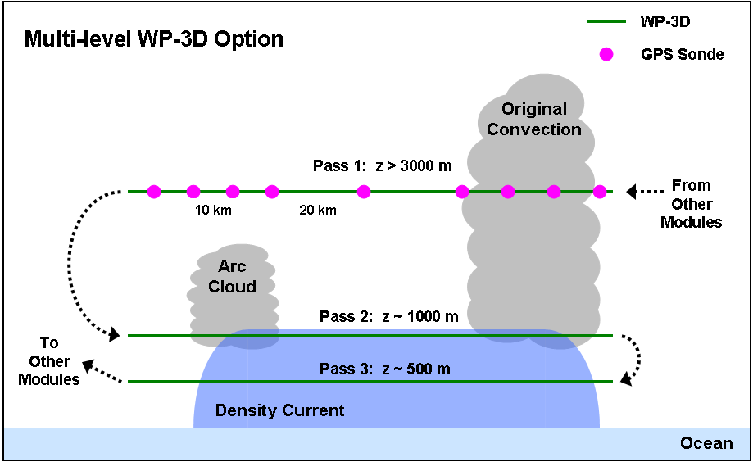
Figure 2: The P-3 flight track for P-3 Module 2. Azimuth and length of initial midlevel pass with GPS dropsonde sequence will be dictated by the pre-determined flight plan. Lengths of each of the 3 passes should span from the convective area where the arc cloud originated to at least 20 km beyond the leading edge of the arc cloud.

Flight altitude: 3 passes transecting the arc cloud will be made: 1st pass: 10-12 kft, 2nd pass: 3 kft, 3rd pass: 1.5 kft (Fig. 2). Note: if other experiment goals, time constraints, and/or aircraft safety would prevent the 2nd and 3rd low-level passes, this option could be altered to include only the 1st higher level pass and GPS dropsonde deployment sequence.
Leg length or radii: Variable depending on the location of the arc cloud, but each of the 3 transects through the arc cloud should extend from the convective area where the arc cloud originated to at least 20 km beyond the leading edge of the arc cloud.
Estimated in-pattern flight duration: ~45-60 min added to the mission
Expendable distribution: For the 1st pass, GPS dropsonde spacing should be ~20 km [reduced to ~10 km spacing closer (≤20 km) to the arc cloud] and the transect can be made inbound (sampling in front of, across, and then behind the arc cloud) or outbound (sampling behind, across, and then ahead of the arc cloud) relative to the convective core region of the AEW/TC (Fig. 2). No GPS dropsondes are required for the 2nd and 3rd passes and no AXBTs are required for this module.
Instrumentation Notes: Use TDR defaults. Use straight flight legs as safety permits.

G-IV Module 1
What to Target: Large arc cloud features (100s of km in length) emanating from the periphery of TCs.
When to Target: There are optimal times of day when large arc clouds occur and therefore preferred times of day for conducting this module. Arc clouds are linked to the position of radially propagating TC diurnal pulses that pass through areas of dry mid-level air (≤45 mm TPW) and therefore will tend to occur from ~0400-1500 LST in the approximate radial operating area of the G-IV (Fig. 1).
Pattern: [Break-Away Pattern] Arc cloud transect.
Flight altitude: 41–45 kft
Leg length or radii: Variable depending on the location of the arc cloud, but a transect through the arc cloud should be made that spans from the convective area where the arc cloud originated to at least 50 km beyond the leading edge of the arc cloud.
Estimated in-pattern flight duration: ~30 min added to the mission
Expendable distribution: GPS dropsonde spacing should be ~20 nm (~35 km) and the transect can be made inbound (sampling in front of, across, and behind the arc cloud) or outbound (sampling behind, across, and then ahead of the arc cloud) relative to the convective core region of the AEW/TC.
Instrumentation Notes: Use TDR defaults. Use straight flight legs as safety permits.

