18. Eye-eyewall Mixing Module

Principal Investigator(s): Sim Aberson (HRD)

Mission Description: Eyewall mesovortices have been hypothesized to mix high-entropy air from the eye into the eyewall, thus increasing the amount of energy available to the hurricane. Signatures of such mesovortices have been seen in cloud formations within the eyes of strong TCs, in radar reflectivity signatures (Hurricane Fabian), and from above during aircraft penetrations (Hurricanes Hugo and Felix). Doppler radar was able to sample such features in Hurricanes Hugo and Felix, though interpretation with sparse observations through the small features has been difficult. Dropwindsondes released in very intense tropical cyclones, in conjunction with large-eddy simulations, have provided some thermodynamic data. However, the kinematic and thermodynamic structures of these features have never been directly observed. Observations within the eye near or below the inversion can allow for the study of these mesovortices and improve knowledge of small-scale features and intensity changes in very strong TCs.

P-3 Module 1
What to Target: This module requires a TC with a clearly defined, visible eye, eyewall, and inversion and an eye diameter of at least 25 n mi.
When to Target: The module should only be attempted during daytime missions. It can be included within any missions during aircraft passage through the eye.
Pattern: This is a break-away pattern that is compatible with any standard pattern with an eye passage (all P-3 patterns except the square spiral or lawnmower). The P-3 will penetrate the eyewall at the standard-pattern altitude. Once inside the eye, the P-3 will descend to a safe altitude below the inversion while performing a figure-4 pattern. The leg lengths will be determined by the eye diameter, with the ends of the legs at least 2 n mi from the edge of the eyewall. Upon completion of the descent, the P-3 will circumnavigate the eye about 2 n mi from the edge of the eyewall in the shape of a pentagon or hexagon. Time permitting; another figure-4 will be performed during ascent to the original flight level. Depending upon the size of the eye, this pattern should take between 0.5 and 1 h.
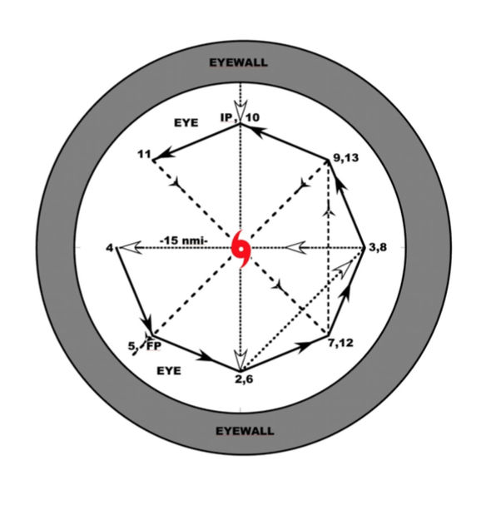

Flight altitude: The flight altitude will vary from just below the inversion inside the eye to the standard-pattern altitude.
Leg length or radii: The leg lengths will be determined by the eye diameter, with the ends of the legs at least 2 n mi from the edge of the eyewall. Upon completion of the descent, the P-3 will circumnavigate the eye about 2 n mi from the edge of the eyewall in the shape of a pentagon or hexagon.
Estimated in-pattern flight duration: Depending upon the size of the eye, this pattern should take between 0.5 and 1 h.
Expendable distribution: No expendables required
Instrumentation Notes: No special instructions for operation. If Doppler wind lidar is available, it should scan downward, though not exclusively, during the pattern. Each leg of the pattern should be straight within safety constraints.

