17. Convective Burst Module

Principal Investigator(s): Robert Rogers, Altug Aksoy,
Jon Zawislak (FIU/UM/CIMAS/HRD), Leon Nguyen (NRC/HRD)

Mission Description: Sample the wind, temperature, and moisture fields within and around an area of deep convection at high time frequency and to use them in high-resolution data assimilation experiments.

P-3 Module 1
What to Target: An area of vigorous, deep convection occurring within the circulation of a tropical cyclone (TC) (tropical depression or stronger).
When to Target: When deep convection is identified either by radar or satellite during the execution of a survey pattern at or near the radius of maximum wind (RMW) of a tropical depression, tropical storm, or Category 1 hurricane. Particular attention should be paid when a developing area of deep convection can be detected on the downshear (shear direction inferred by real-time SHIPS analyses) side of the storm.
Pattern: Series of inbound/outbound radial penetrations / bowtie pattern: Repeated sampling can allow for a following of the burst around the storm, or if the burst remains confined downshear.
- Repeat penetrations as long as time permits within the 1-2 h window
- When a high-altitude aircraft is present, efforts should be made to coordinate the pattern with the high-altitude aircraft, so that the two aircraft are as close to vertically stacked as possible.

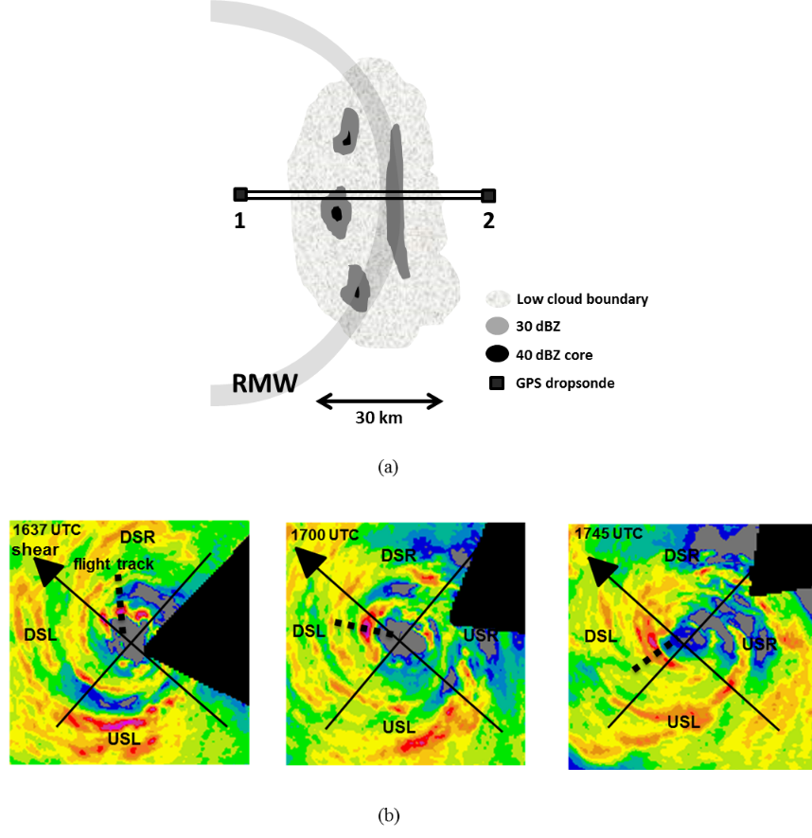
P-3 Convective burst module: (a) Radial penetrations / bowtie pattern. Black square denote locations of GPS dropsondes from P-3. This pattern should be repeated multiple times as time allows, following the CB around the storm or remains confined downshear. (b) Example of sampling strategy following CBs around the storm, beginning downshear right (DSR) and into the upshear quadrants. Each radial pass is separated by ~30 minutes.
Flight altitude: A constant altitude of 10-12 kft (radar or pressure altitude) is preferable
Leg length or radii: Variable depending on size of CB, but should extend at least 10 nm inside and 10 nm outside radar-defined edges of CB.
Estimated in-pattern flight duration: 1-2 h added to the mission
Expendable distribution: Dropsondes at turn points. No more than 15 dropsondes needed for this module.
Instrumentation Notes: Every effort made to fly the aircraft level for optimal Doppler radar sampling. The TDR should be operated in F/AST scan mode.

